 | Freedom of Information Response  Our reference: FOI 25-0949  Responded to: 09 April 2025
Your recent request for information is replicated below, together with our response.

The number of reported crimes in the Morningside area of Edinburgh for the years: 2023, 2024, 2025 to date. Broken down by crime classification (break-in etc.).

The number of reported crimes in the Bruntsfield area of Edinburgh for the years: 2023, 2024, 2025 to date. Broken down by crime classification (break-in etc.).
The areas which Police Scotland can provide data for are those which are defined as beat or multi-member ward areas. The ward of Morningside covers both of the areas set out in your request, as per the map below
The information sought is held by Police Scotland, but I am refusing to provide it in terms of section 16(1) of the Act on the basis that the section 25(1) and 27(1) exemptions apply:
“Information which the applicant can reasonably obtain other than by requesting it […] is exempt information”
Data for Morningside is publicly available: Crime data - Police Scotland
Information for quarter 4 (January to March) of 2024/25 will be published at the same link within 12 weeks of this response.
“Information is exempt information if it is held with a view to its being published […] at a date not later than twelve weeks after […] the request for the information is made”.
I believe it is reasonable in all the circumstances that the information be withheld from disclosure at this time and that maintaining the exemption outweighs any public interest in disclosure.

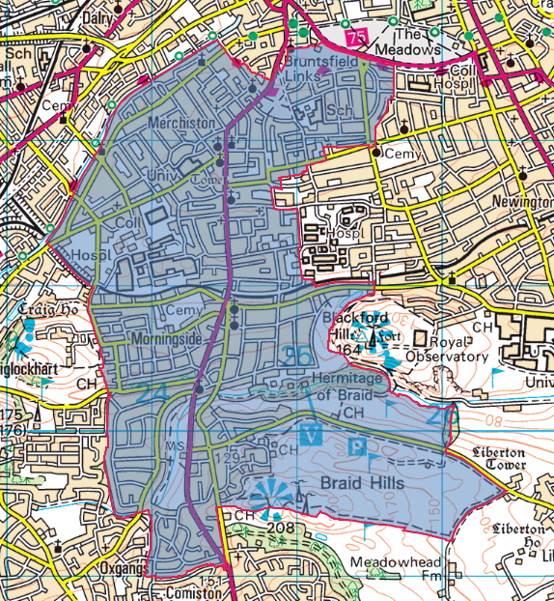

If you would like data for a particular other area, not defined in those terms, you could provide a list of streets, or a central point from which we could map a 2 mile radius etc.

If you require any further assistance, please contact us quoting the reference above.
You can request a review of this response within the next 40 working days by email or by letter (Information Management - FOI, Police Scotland, Clyde Gateway, 2 French Street, Dalmarnock, G40 4EH). Requests must include the reason for your dissatisfaction.
If you remain dissatisfied following our review response, you can appeal to the Office of the Scottish Information Commissioner (OSIC) within 6 months - online, by email or by letter (OSIC, Kinburn Castle, Doubledykes Road, St Andrews, KY16 9DS).
Following an OSIC appeal, you can appeal to the Court of Session on a point of law only.
This response will be added to our Disclosure Log in seven days' time.
Every effort has been taken to ensure our response is as accessible as possible. If you require this response to be provided in an alternative format, please let us know.

