

Our commitment to the safety and wellbeing of the people and communities of Forth Valley

­

**Clackmannanshire**

**Local Police Plan 2020 - 23**

**Performance framework**

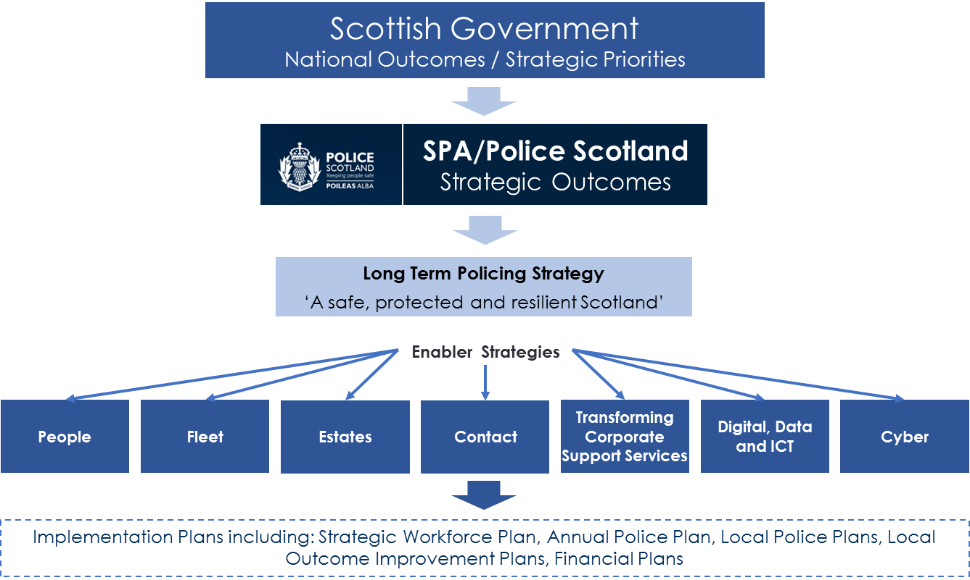

The Chief Constable has responsibility for the policing of Scotland as per S17 Police and Fire Reform (Scotland) Act 2012.

**Contents**

**Foreword…………………………………………………..4**

**Local policing arrangements………………………….5**

**Clackmannanshire Local Outcomes Improvement Plan (LOIP)……………………………………………………….7**

**Policing priorities for Clackmannanshire……………8**

**How we identified our priorities………………………..9**

**Plan on a page...…………………………………………10**

**Our priorities in detail……………………………………11**

**Performance and accountability……………………..23**

**Equality and diversity - Ethics and values…………..28**

**Local contact details……………………………………29**



**Foreword**

I am delighted to present our local policing plan to demonstrate our commitments and priorities for Clackmannanshire over the next three years.

On behalf of the Chief Constable, Police Scotland has published its national policing plan. This plan is designed to support that national approach by delivering action on local community based issues.

We have engaged with communities across Clackmannanshire to identify the issues that matter most and will build on the lessons learned from our previous policing plans to better inform how we will deliver our services.

We have learned the benefits of continuously engaging our communities and over the next three years will continue to do so as we deliver our plans. Clackmannanshire has a diverse, engaged and vibrant range of communities and we will aspire to meet the needs and interests of citizens’ right across the area, from the heavily populated urban towns to the most remote rural locations.

Over the last three years your local officers have delivered a range of services within communities with support from national and specialist divisions, ranging from roads policing and police dogs, to air support and specialist cybercrime investigators amongst many others. This support allows us to continue to tackle the changing demands on policing, particularly in the area of cybercrime as online crime continues to evolve.

Our partners play a vital role in supporting policing and we will continue to work together to tackle our joint objectives.

Through engagement with communities, and from our own analysis of the demands being placed on policing, we have identified the issues that matter most to you, the communities we serve.

We will strive to provide the highest standards of policing in your communities.

I recognise how important it is to you that you have community officers that you know and can contact and I will ensure we continue to place those officers at the hearts of the communities, working alongside our partners to provide the best possible service.

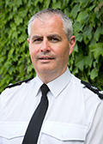

**Chief Superintendent Alan Gibson,**

Divisional Commander, Forth Valley

**Local policing arrangements**

Locally we work within the Community Planning Partnership framework, with all stakeholders, including the third sector, in order to address local concerns and ensure better outcomes for communities in Clackmannanshire.

Forth Valley Division is led by the Divisional Commander, a Chief Superintendent. The Commander is supported by four Superintendents and is directly responsible for delivery of policing within Forth Valley.

The divisional command team provides support and direction to the three local Area Commanders who are responsible for Falkirk, Stirling and Clackmannanshire.

In Clackmannanshire the local Area Commander, a Chief Inspector, has responsibility for the overview of local policing on a day to day basis.

She has access to various officers across the area responsible for investigating local crime, attending local events, working with communities and responding to concerns. They are supported by partners and also by volunteers, such as Special Constables.

Locally based officers are assisted in their activities by specialist teams with expertise in areas such as serious crime, event planning, counter terrorism, air support and armed policing.

**Local perspective: Area Commander**

Over the last three years, the Clackmannanshire team have been working to tackle the problems that you told us were of greatest concern to you.

Our team includes community and response officers, Schools Based Officers and our Divisional Alcohol and Violence Reduction officers.

We are aware of the local problems in each area and work with the community and other agencies to tackle these issues and provide long term solutions.  Based on previous feedback, we have focussed in recent years in tackling antisocial behaviour because you highlighted this to us as a priority.

In addition to our local team, we have been assisted by our licensing department and other specialised national resources, to address antisocial behaviour and drug related crime in Alloa town centre. We arrested a number of well-known repeat offenders and feedback from the local community, councillors and MSPs was very positive.

We continue to proactively police the 'night time economy' and licensed premises to ensure Clackmannanshire is a good place to live, work and be safe in. This activity reduced the number of antisocial behaviour incidents, serious violence and disorder in the town centre.

Drugs continue to blight the lives of families and communities in Clackmannanshire so we focussed on targeting drug dealers. Our communities worked with us to provide valuable information which we acted upon. This led to a 48% increase in offenders being charged with possession of drugs.  A number of warrants were also executed, resulting in several people being charged with drug dealing. This demonstrated that we listen to the public and disrupted the local drug trade.

We responded to local concerns regarding safety on our roads by developing the 'Young Driver Safe Driver' campaign, raising awareness of road safety, the dangers associated with driving and encouraging responsible driver and pedestrian behaviour.

We delivered the Scottish Qualifications Authority (SQA) 'Safe Road User' course to our three Clackmannanshire Academies, resulting in twenty five senior pupils achieving the SQA Award. This course is now available to senior pupils from fourteen years of age and includes various modules, including being a young driver, cyclist and pedestrian.

In order to highlight and support the new Domestic Abuse Act legislation that came into force in April 2019, we delivered presentations to local support organisations, including Clackmannanshire Women's Aid.

This was to increase public awareness that 'coercive and controlling behaviour' is now criminal and to empower victims to report domestic abuse or seek help.  Several victims approached our team personally after these events and disclosed ongoing domestic abuse that they then felt confident to report.

We endeavour to support the most vulnerable in the community and have commenced a short pilot called STRIVE - Safeguarding Through Rapid Intervention. This is a multi-agency approach that will quickly identify and assess child and adult concerns through collaboration, to deliver an appropriate early and effective intervention.

We aim to create better outcomes for such vulnerable individuals and families that would not be achieved by any one agency alone.

We will continue to reflect upon our policing activity and the feedback we receive from the public to strengthen our service delivery and improve the wellbeing of our diverse communities in Clackmannanshire.

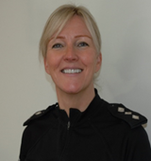

**Chief Inspector Audrey Marsh**

Area Commander for Clackmannanshire

**Clackmannanshire Local Outcomes Improvement Plan (LOIP)**

Our priorities for policing are aligned to the Clackmannanshire Local Outcomes Improvement Plan (LOIP), which is published by the Community Planning Partnership.

This plan describes how we will address these priorities to make our communities safer and deliver better, lasting outcomes for our communities by:

* Preventing crime and disorder and breaking the offending cycle;
* Minimising the impact of identified threats, risks and harm;
* Reducing vulnerability by protecting and supporting the most vulnerable and disadvantaged members of our society; and
* Ensuring we deliver an excellent policing service.

Our approach to delivering local policing services is aligned to, and contributes towards, the wider partnership ambitions described within the LOIP:

**Women and girls will be confident and aspirational, and achieve their full potential.**

**Outcome 3**

**Outcome 1**

**Outcome 2**

**Outcome 4**

**Clackmannanshire will be attractive to businesses and people; will create sustainable jobs, raise attainment and improve life skills to ensure fair opportunities for all**

**Our communities will be resilient and empowered so that they can thrive**

**Our families; children and young people will have the best possible start in life.**

**Outcome 4**

**Our communities will be resilient and empowered so that they can thrive**

**Policing priorities for Clackmannanshire**

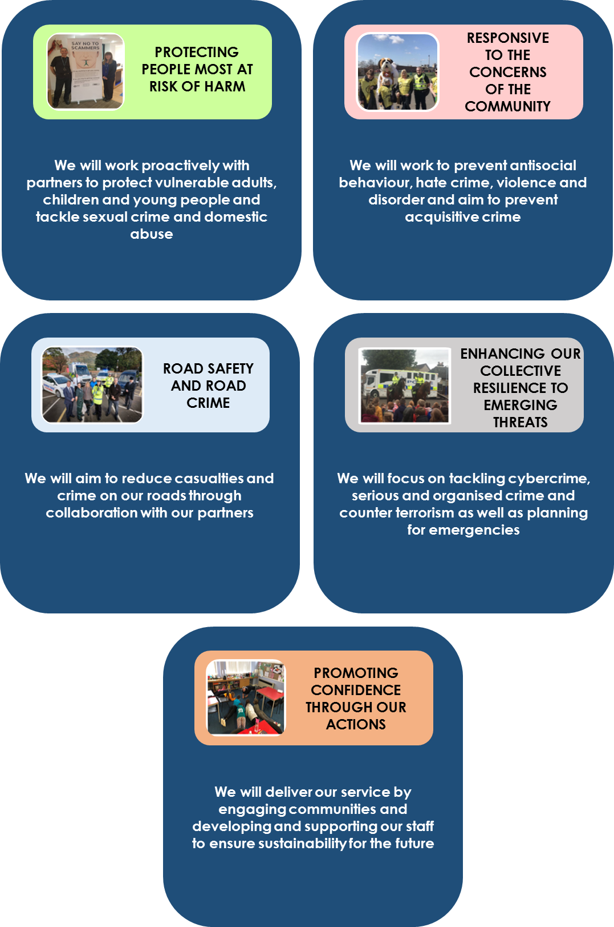

**How we identified our priorities**

Our priorities were identified through a number of sources and processes, which include:

* Clackmannanshire Alliance LOIP
* Community consultation (Your Police survey)
* Police Scotland Annual Police Plan 2019/20
* Police Scotland Strategic Assessment 2020/21
* *Policing for a safe, protected and resilient Scotland*, Joint Strategy for Policing (2020)

All of these sources have provided critical information in identifying what is important to the diverse communities within Clackmannanshire.

Whilst this plan spans a three-year period, we recognise that the issues affecting our communities and the associated demands on our service are changing.

This will require us to review our approach periodically throughout the duration of this plan to ensure that

* We are continuing to focus on the right things
* Our people are suitably equipped and supported to deal with these demands; and
* Our approach remains effective and sustainable for the future

We police with the consent and support of our communities so it is important that you continue to let us know what you think of policing in your area and what our areas of focus should be.

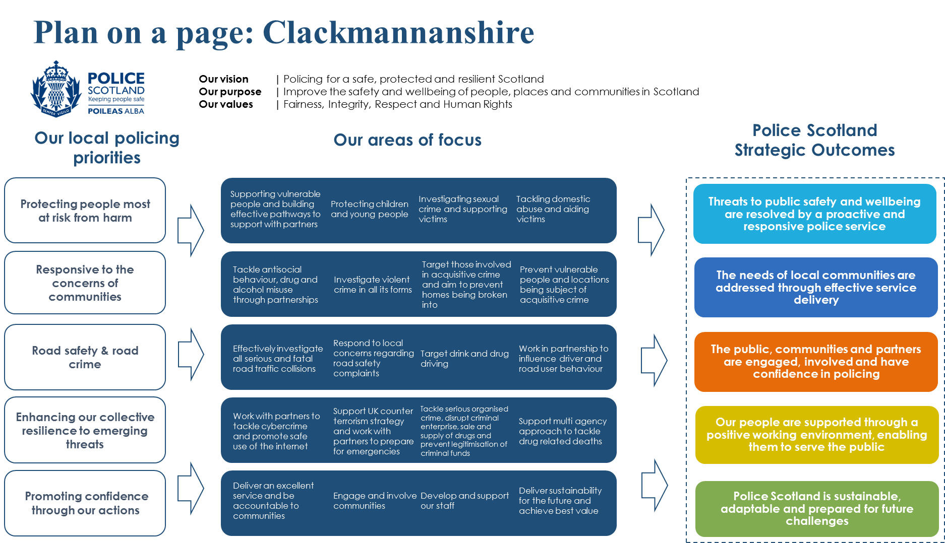

**Our priorities in detail**

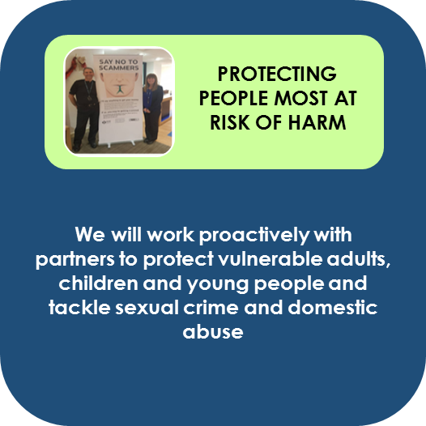

Clackmannanshire is home to a diverse community and landscape. Additionally, society is changing and policing is adapting to new challenges.

Along with our wider public sector partners, we are facing increased demand as a consequence of the vulnerability and inequality that exists within our communities.

Dealing with vulnerable people, particularly regarding mental health issues, now accounts for a significant portion of police time. We, along with our partners, are committed to focusing on tackling the root causes rather than the consequences of inequality in order that we can provide better, more targeted support to those who are in need and deliver lasting change in our communities.

Police encounter vulnerability in many different ways. This includes people who are experiencing crisis, physical illness or mental health problems, those who have gone missing or individuals at risk of harm, neglect or abuse.

We are committed to working in partnership to protect the most vulnerable and at risk members of our community, including victims or perpetrators of crime; ensuring that they receive the support they need to lead full and independent lives.

Every contact with a vulnerable person presents an opportunity to improve the outcome for the individual and we will signpost people to partners and agencies that can support them.

As members of the Clackmannanshire Alliance (community planning partnership) we help to protect children and young people from abuse; supporting the wellbeing of young people so that they can have the best possible start in life and fulfil their potential.

Child sexual exploitation presents a significant risk as some young people may not realise they are at risk from harm.

It can include them being coerced into sexual activity either online, through social media or in person. We will continue to further develop intelligence in this area and reduce the opportunities for such abuse to occur.

We recognise the devastating psychological, emotional and physical trauma that sexual crime causes to victims.  We are committed to working with our partners to provide victims with the confidence and support they need to report such impactful crimes and reduce the risk of those responsible from re-offending.

We know that serious sexual offences are predominantly carried out by someone known to the victim, which can often include those with whom the victim is in a relationship. Domestic abuse is not limited to physical or sexual violence; it can also include emotional, financial or psychological abuse. We are intent on preventing domestic abuse in all of its forms and targeting those offenders who pose the greatest risk of harm.

**Our approach**

We will regularly review our partnership approach; ensuring that we deliver services to vulnerable people in a co-ordinated, professional and sensitive manner. We will continue to share information to identify those most at risk of harm at the earliest opportunity and seek to safeguard these individuals by:

**Vulnerable persons**

|  |
| --- |
| * Utilising our risk and concern processes within the Concern Hub at the Public Protection Unit to ensure wellbeing concerns are identified, assessed and appropriately escalated at the earliest opportunity * Reviewing our response and improving safeguards for vulnerable people who are habitually reported as missing persons through our divisional Missing Persons Forum * Working with the Scottish Appropriate Adult Network to support our engagement and investigation of crimes affecting those who have difficulty in communicating. * Investing in training so that our officers are equipped to recognise and respond appropriately to individuals who are experiencing mental health problems |

**Children and young people**

|  |
| --- |
| * Holding Inter-Agency Referral Discussions to consider child protection concerns, identify risk factors and associated protective measures needed * Using early and effective intervention as an opportunity to promote the development of children and young people involved in low level offending behaviour * Raising awareness of the threats posed from online grooming and the sharing of self-generated indecent images amongst children and young people * Ensuring the preventative advice we give to children and young people is tailored to their age and level of understanding |

**Sexual crime**

|  |
| --- |
| * Supporting the Public Protection Unit to investigate non-recent instances of sexual violence and domestic abuse * Ensuring victims are aware of, and appropriately signposted to, the range of support mechanisms available in the Clackmannanshire area * Considering the feedback we receive from victims to improve our local service provision * Using multi-agency public protection arrangements to develop risk management plans to reduce the risk of individuals reoffending |

**Domestic abuse**

|  |
| --- |
| * Identifying and targeting the most harmful perpetrators of domestic abuse by examining the frequency and gravity of their offending behaviour * Supporting the ‘16 days of action for the elimination of violence against women and children campaign * Promoting awareness of the Disclosure Scheme for Domestic Abuse in Scotland (DSDAS); ensuring victims and those potentially at risk of becoming victims are empowered to make decisions to increase their safety * Protecting victims and intervening with offenders via the Multi Agency Tasking and Coordinating and Multi Agency Risk Assessment Conference processes |

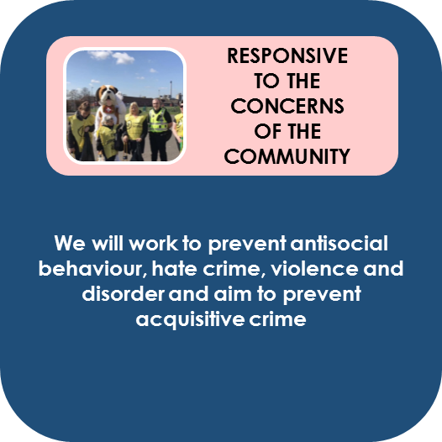

Our primary role is to keep our communities safe. In order that the Clackmannanshire area is a safe place to live, work, visit and do business, it is important that we listen to the views of the public and act on the local issues that you tell us cause you greatest concern.

You highlighted through ‘Your Police’ survey that tackling violence, disorder, antisocial behaviour and preventing acquisitive crime, such as homes being broken into, remain as important to you.

We will focus on preventing these crimes as a priority, recognising the lasting impact these have on our communities.

We will work with partners to tackle the root causes of crimes of violence and dishonesty to reduce repeat offending.

We will also seek to ensure that our residents continue to feel safe in their homes, however remote, and are supported to lead full and independent lives by working in partnership to prevent doorstep crime.

This includes bogus callers and rogue traders who often seek to target vulnerable people to steal money and valuables or charge inflated prices for poor quality or unnecessary work to their homes.

With Clackmannanshire having a significant rural area, which incorporates the extensive Ochil Hills amongst others, we will continue to focus pro-active work to tackle acquisitive crimes in isolated rural locations across Clackmannanshire.

In conjunction with our partners we are committed to promoting inclusivity and equity of opportunity for all. In support of our collective effort to build cohesive communities and reduce social isolation we will seek to reduce the harm caused by hate crime as no member of our community should fear hostility, abuse or violence because of an aspect of their identity.

**Our approach**

We will continue as active members of Clackmannanshire`s community safety partnership multi-agency tasking process to share information and examine emerging trends relating to the areas of concern highlighted by our communities.

Using a problem-solving approach, we will work together to prevent crime, reassure and protect our communities from harm by:

**Violence, disorder and antisocial behaviour**

|  |
| --- |
| * Providing a visible presence at problematic locations identified through intelligence and analysis to deter acts of violence, disorder and antisocial behaviour * Working to identify and address the root causes of such crimes; educating people and guiding them towards the support they need to make positive lifestyle choices and divert them from a cycle of offending behaviour * Making full use of all available options with partners to deal proportionately with issues including Acceptable Behaviour Contracts (ABCs), Antisocial Behaviour Orders (ASBOs), recorded police warnings and reports to the procurator fiscal. * Engaging with the Multi Agency Public Protection Arrangements process to effectively manage violent offenders who are most at risk of involvement in serious violence in order to prevent repeat offending and escalation * Working with Clackmannanshire`s Licensing Board and Licensing Forum to ensure our licensed premises are safe, well-regulated and supplying alcohol in a responsible manner * Continuously reviewing our activities and considering our approach to preventing incidents occurring in domestic premises and other private spaces * Continuing to engage with and develop the Social Work Group to progress interventions to reduce re-offending * Collaborate with partners in Criminal Justice to reduce re-offending |

**Acquisitive crime**

|  |
| --- |
| * Conducting proactive patrols at locations identified through intelligence and analysis * Raising awareness and providing practical support such as installing bogus caller buttons to make our communities less vulnerable to doorstep crime * Promoting understanding of the warning signs of doorstep crime amongst commercial and retail staff so they are able to take appropriate intervening action if it is suspected that an individual may be at risk of exploitation * Providing support for victims to survey properties to `target harden` to prevent repeat crime |

**Hate crime**

|  |
| --- |
| * Seeking to extend our ‘Safe Place’ initiative where local businesses provide support to vulnerable people who find themselves in challenging situations when they are out in our local area * Conducting local awareness campaigns to encourage those affected by hate crime or harassment to have the confidence to report what is happening * Continuing to engage with Central Scotland Regional Equality Council and promote the use of third party reporting * Engaging with all sections of our communities to support their individual needs |

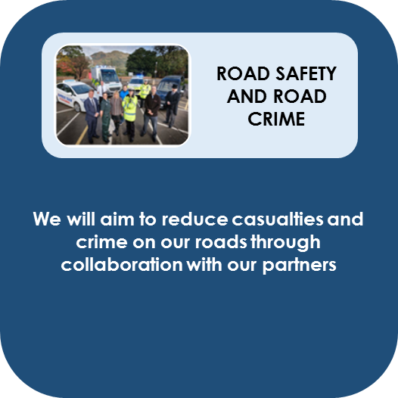

A significant part of keeping our communities safe extends to detecting and deterring criminality and improving safety on our roads network.

Evidence shows there is a link between criminal driving behaviour, such as driving whilst disqualified or without insurance, to instances of collisions. Such incidents are often traumatic and can be life changing for those involved and their families.

Clackmannanshire has a significant road network ranging from the new Clackmannanshire Bridge linking the motorway network to both Clackmannanshire and Fife, to small country roads all of which present their own unique challenges. Clackmannanshire comprises a mixture of larger towns and small rural villages and safety for all road users is of paramount importance.

We are committed to working with partners to positively influence the behaviour of drivers and road users to reduce the number of casualties on our roads as well as minimising the economic impact of criminality and disruption to our local road network.

Through the 'Your Police Survey' and local engagement you have told us that speeding, particularly in rural locations, as well as driver behaviour in the vicinity of schools is of particular concern.    As a result, this has been given specific priority within the policing plan.

**Our approach**

We will assist our partners to provide education for all road users and will share information so that analysis can identify locations where physical improvements can be made to promote road safety.

Our Roads Policing Unit will support us in taking part in national and local campaigns to improve road safety to reduce casualties by:

**Road safety**

|  |
| --- |
| * Influencing driver behaviour through engagement, education and proportionate enforcement of legislation * Deploying mobile safety cameras at priority locations identified through intelligence and analysis * Making full use of schemes to educate road users and divert them from prosecution * Sharing information with relevant partners to identify and target repeat offenders, maximising opportunities to seize their vehicles to ultimately make our roads safer * Continuing to promote the Junior Road Safety officer programme to educate children and drivers alike regarding safety near schools * Supporting our local school in the delivery of the Young Driver Safe Driver programme * Using speed enforcement to improve road safety using intelligence led tasking * Continue to progress actions via our divisional Road Safety Group to support local and national campaigns |

**Road crime**

|  |
| --- |
| * Continuing to target uninsured and unlicensed drivers * Targeting drink and drug drivers * Patrolling roads used by travelling criminals to disrupt their opportunities to commit crime in our area |

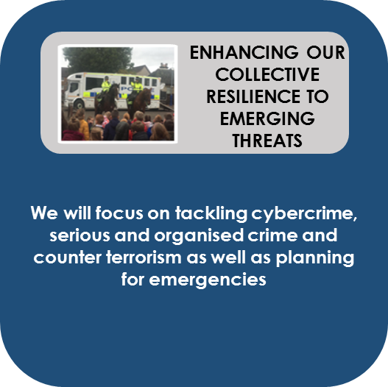

It is vital we remain informed and responsive to new and emerging threats.  National and local strategic assessments help our understanding of future challenges and provide an opportunity to work collaboratively with partners to protect our communities from the risks and harm posed.

The way in which we interact and do business is changing, with an increasing proportion of our daily life carried out online. Criminals are increasingly seeking opportunities to exploit technology, targeting both businesses and individuals.

Cybercrime can include the grooming of young people, financial fraud targeting business and extortion of money.   With the support of the national Cybercrime Unit, local business leaders, industry regulators and public sector partners we are committed to preventing such crimes.

Feedback from our recent Your Police survey and from local engagement highlights that tackling drug dealing and drug misuse are a concern for our communities and we remain committed to disrupting those involved in the production, sale and supply of drugs as well as diverting people from becoming involved in the activities of serious organised crime groups.

The harm caused by serious organised crime to our communities however extends beyond the availability of drugs. We are committed to tackling serious organised crime in all of its forms including the emerging issues of human trafficking and county lines drugs exploitation.

We will use all legitimate means to disrupt criminal enterprise, prevent attempts to legitimise criminal income and bring those who are involved in organised crime to justice.

At a local level, we have an important role to play in supporting the UK’s Counter Terrorism Strategy (CONTEST) in order that the people of our communities can go about their lives freely and with confidence.

Emergencies such as flooding, severe weather and other major incidents can happen at any time and affect the ability of our communities to go about their daily lives.

This was demonstrated in 2018 during the demands placed on us and our partners during the `Beast from the East` severe weather event. Local resilience partners worked together to support the most vulnerable people in our communities.

As emergency responders, we are members of the Local Resilience Partnership, working collaboratively to prepare and plan for such eventualities.

**Our approach**

We will continue to review emerging threats and seek the support of our communities to inform our intelligence requirements and develop our understanding of what is happening in our communities. Through our dedicated partnership meeting structures, we will share information and work together to protect our communities from the risk and harm of emerging threats by:

**Serious organised crime and drug misuse**

|  |
| --- |
| * Using intelligence to disrupt serious organised crime groups operating in our local area and seize their assets * Tackling the sale and supply of controlled drugs in Clackmannanshire * Supporting ‘Project Divert’ to identify and protect children who are exposed to organised criminal behaviour; utilising a partnership approach to initiate early interventions and challenge social norms to divert our young people from a life of organised criminality * Working with our partners to deprive serious organised crime groups access to legitimate business enterprise and public funds * Providing information about the local support mechanisms available to both drug users and their families; referring individuals who wish to make positive lifestyle changes to Change Grow Live * Tackling alcohol and drug abuse by being active members of the Alcohol and Drug Partnership * Responding to any actions evolving from the Drugs Death Taskforce |

**Cybercrime**

|  |
| --- |
| * Promoting the safe use of the internet and digital technology through community events * Raising awareness of, and providing safety advice in relation to, online fraud, gift voucher fraud, ATM fraud and card fraud * Continuing to support the Central E-Safety Partnership to promote safe use of the internet |

**Counter terrorism**

|  |
| --- |
| * Delivering protective security advice and training to enhance the protection of key strategic sites, public places and businesses within the Clackmannanshire area * Continuing to engage with communities to identify and support individuals who may be vulnerable to radicalisation * Seeking the support of communities to develop the national intelligence picture around terrorism, domestic extremism and potential protests |

**Planning for emergencies**

|  |
| --- |
| * Supporting the review of our local partnership plans as required, to ensure they remain fit for purpose * Actively participating in exercises to test the effectiveness of our local contingency plans * Encouraging and supporting community groups to develop resilience, prepare for and cope with emergencies * Engaging with local and regional resilience partnerships |

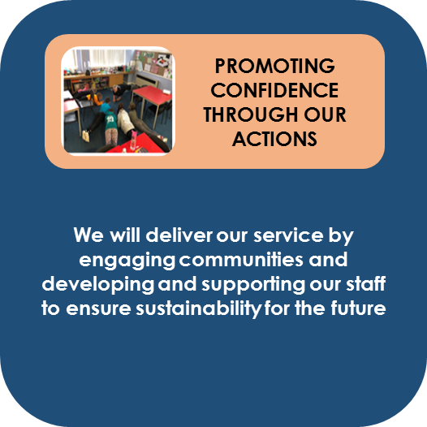

We police with the consent of the public, so to achieve the commitments in this plan we rely on the continued support and cooperation of Clackmannanshire`s communities.

We understand that how we deliver our service is just as important as the services we provide.

Our Code of Ethics explains the standards of behaviour you can expect from us; outlining our commitment to upholding your rights and treating everyone we encounter with Fairness, Integrity and Respect.

To ensure we deliver an excellent policing service we will continue to review our approach and make the best use of the resources available to us to target the areas of greatest need identified within our partnership locality plans, responding quickly and appropriately when you need us.

The Community Empowerment (Scotland) Act 2015 empowers communities to make decisions about local public services and put forward ideas about how outcomes could be improved for their area.

We recognise the importance of engaging and involving our communities to help shape our local policing priorities and are committed to providing feedback on the actions we have taken and the outcomes we have achieved. We want you to know your local policing team and be able to contact them easily.

Our people are our most valuable asset and it is important that we continue to invest in developing and supporting our staff in order that they are suitably trained, equipped and empowered to make the right professional choices for our communities. We will promote the wellbeing of our staff so that they are fit to come to work and carry out their responsibilities in their communities.

It is anticipated that demand for our services will continue to grow. We are committed to delivering a sustainable policing model for the future; seeking ways to respond to emerging threats.

Using our internal governance framework, we will consider the continued effectiveness of our approach and drive continuous improvement by:

**How we deliver our service**

|  |
| --- |
| * Working closely with our colleagues in Contact, Command and Control (C3) division to assess calls from the public to ensure we provide an appropriate and timely service. * Utilising national and specialist support to complement and enhance our local policing response * Working in partnership to deliver the Victims` Code for Scotland; ensuring victims are informed and supported through every stage of the criminal justice process * Respond to complaints we receive from communities, acknowledging and implementing any learning for our officers and staff * Regularly reviewing our approach to ensure we are continuing to provide a victim-orientated approach to crime recording and complying with national standards * Auditing our stop and search activity to ensure our actions have a legal basis and are both justified and proportionate |

**Engaging and involving communities**

|  |
| --- |
| * Deploying dedicated, visible community officers in our localities * Ensuring victims of crime can access information as to the progress of their enquiry * Working in collaboration with partners to maximise the benefits of service to communities * Continuing to engage with community forums and promote the use of social media to reach as many citizens as possible |

**Supporting and developing our staff**

|  |
| --- |
| * Utilising local wellbeing champions to provide first point of contact support to officers and staff in relation to wellbeing issues or concerns * Periodically reviewing our local training requirements; ensuring that we have an appropriate distribution of officers trained in a range of disciplines across Clackmannanshire * Intervening early and supporting staff who have been involved in a potentially traumatic incident |

**Sustainability for the future**

|  |
| --- |
| * Transforming our estate into one that is modern, flexible and fit for the future * Working with partners to consider how we can reduce collective demand and make efficiencies whilst promoting the ethos of collaboration and shared service * Engaging with minority communities in our area to encourage them to assist and participate in the delivery of local policing services * Reviewing our approach to ensure we are achieving best value |

**Performance and accountability**

At a local level, we are held to account for our performance by the Clackmannanshire Partnership and Performance Committee.

This group meets every six months to scrutinise how we are performing in relation to the commitments we have outlined within this plan and ensure we are fulfilling our statutory obligations to improve the safety and wellbeing of our communities.

If you would like to see what we have discussed at our scrutiny meetings, copies of the reports we submit and minutes from these meetings are available on the Clackmannanshire Council website.

In order to support effective scrutiny and determine whether our preventative approach is having a lasting positive impact, members of the Clackmannanshire Partnership and Performance Committee will consider information linked to the priorities outlined within this plan.

This includes, but is not limited to:

* Comparing information that shows how we are performing in relation to other areas
* Reoffending rates in our area
* Our approach to dealing with problematic licenced premises
* Qualitative information that demonstrates the impact of our preventative partnership initiatives, safety campaigns and intelligence led operations
* Crime trends relating to our areas of focus including violent crime, antisocial behaviour complaints, acquisitive crime and hate crime
* Crime detection rates

**RESPONSIVE TO THE CONCERNS OF OUR COMMUNITIES**

* Comparing information that shows how we are performing in relation to other areas
* Analysing trends relating to missing persons
* Qualitative information that demonstrates the effectiveness of our approach to keep vulnerable people safe and reduce repeat victimisation
* Obtain feedback from partners to assess the quality of service and support we provide to victims
* Trends relating to the uptake of the Disclosure Scheme for Domestic Abuse in Scotland
* Crime trends relating to our areas of focus including sexual crime, child sexual exploitation and domestic abuse
* Detection rates

**PROTECTING PEOPLE MOST AT RISK FROM HARM**

**ENHANCING OUR COLLECTIVE RESILIENCE TO EMERGING THREATS**

**ROAD SAFETY AND ROAD CRIME**

* Crime trends relating to cybercrime and online crime
* Drug related death statistics
* Our contribution towards directing those affected by drug misuse to the support that they need
* The effectiveness of our approach to reduce the threat of serious organised crime groups, seize their assets and deny them access to public funds
* Qualitative information that demonstrates the impact of our preventative partnership initiatives, and intelligence led operations in protecting our communities from identified threats, risk and harm
* Examining the work we have undertaken to test and enhance our collective response to emergencies
* Trends in relation to the number of persons killed or seriously injured on our roads
* Benchmarking information that shows how we are performing in relation to other areas
* Our approach to dealing with problematic repeat collision locations Qualitative information that demonstrates the impact of our preventative partnership initiatives, safety campaigns and intelligence led operations

**Equality and diversity**

* Levels of public confidence
* Levels of public satisfaction with the service they received as demonstrated through our user
* satisfaction survey results
* Our compliance rates in terms of recording crime in line with Scottish Crime Recording
* Standards
* Trends in the levels of dissatisfaction expressed in the form of police complaints
* Our responsiveness to calls for service from the public
* Staff absence rates
* Examining the work we are undertaking to ensure we continue to provide an effective,
* efficient and sustainable policing service

**PROMOTING CONFIDENCE THROUGH OUR ACTIONS**

Our work is underpinned by our commitment to equality and diversity in our interactions with the public we serve as well as our own staff.

Across Police Scotland we are committed to developing and promoting best practice in the advancement of our Equality Outcomes.

In Clackmannanshire committed to a policing style which meets the differing needs of the communities we serve and is dedicated to promoting equality within our own workforce.

We realise that every police officer, special constable and member of police staff is responsible for delivering a fair and professional service, promoting equality for all.

**Ethics and values**

A code of ethics was introduced in 2013 with the creation of Police Scotland and provides guiding principles that define how we perform our duties.

The code of ethics sets out the standards we expect of all our employees and the standards that the public can expect to ensure we provide a professional service to all.

Encompassing the values of the service and our commitment to human rights, the code is designed to help us provide positive outcomes and improve the safety and wellbeing of people, places and communities in Scotland.

Police Scotland’s values are:

* **Integrity**
* **Fairness**
* **Respect**
* **Human Rights**

We are continually working to ensure that these values and the code are understood by all our officers and staff and are preserved in all of our decisions and actions.

**Local contact details**

Police Scotland

Forth Valley Divisional Headquarters

Stirling Police Station

Randolphfield

2 St Ninians Road

Stirling

FK8 2HD

For more detailed information on how to contact your Local Policing Team please refer to our website at [www.scotland.police.uk](http://www.scotland.police.uk) or through our social media platforms.

We will continue to keep in touch with you to keep you updated on the ongoing work being done to tackle the issues that are affecting life for you and your community:

Dial **999 for an emergency** that requires urgent police attention.

For **non-emergency contact**, call **101**, the single non-emergency number.

If you have information about crime in your area and wish to provide it anonymously, call CRIMESTOPPERS on 0800 555 111.

Service users who are deaf or have a hearing impairment can contact Police Scotland via TextRelay on 18001 101 for non-emergency, or 18000 in an emergency.

Police Scotland social media channels provide a range of information and insight into policing and what we are doing both nationally and in your local area. A full list of our national and local social media accounts can be found on our website. Our main channels be found at:

 <https://twitter.com/policescotland> / @policescotland @ForthValPolice

https://en-gb.facebook.com/PoliceScotland/   
 **Please note that our social media channels are not monitored 24/7 and should not be used for reporting crime**