PSET Example Questions

Numerical
During an investigation, Officers recorded the number of housebreakings a gang had committed per month. Over a 6 month period, the numbers were recorded as: 7, 2, 3, 5, 2, and 5. How many housebreakings were committed on average per month?

Answer:
4

Information Handling

Study this chart carefully to answer this section’s questions.

Chart – Number of Full-time & Part-time Officers by Division

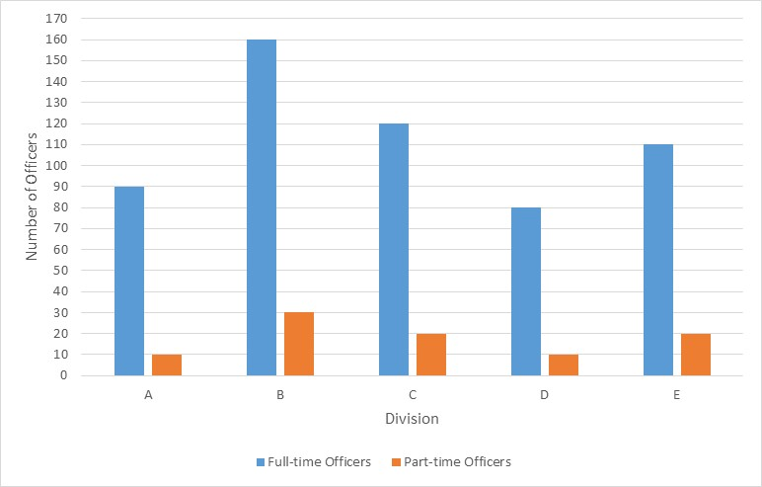

How many more full-time Officers than part-time Officers work in D division?
Answer:
70

Language
Read the following information about Police Scotland.

Police Scotland – About Us

Police Scotland was established on 1 April 2013 and is responsible for policing across the whole of Scotland, some 28,168 square miles, covering a third of the United Kingdom’s landmass with a unique range of urban, rural, island and remote communities. It is the second largest force in the UK after the Metropolitan Police with a workforce of 23,000 officers and staff working together for the people of Scotland. Police Scotland’s purpose is to improve the safety and wellbeing of people, places and communities in Scotland, focusing on Keeping People Safe in line with our values of Integrity, Fairness, Respect and Human Rights.

The Service is led by the Chief Constable, supported by a command team of Deputy Chief Constables, a Deputy Chief Officer, Assistant Chief Constables and Directors. There are 13 local policing divisions, each headed by a Chief Superintendent who ensures that local policing in each area is responsive, accountable and tailored to meet local needs. Each division encompasses response officers, community officers, local crime investigation, public protection and local intelligence. The local policing divisions are supported by a number of national specialist divisions.

Calls from the public are handled by our Contact, Command and Control Division with Area Control Rooms at four locations across the country which deploy resources. Our people are supported by corporate functions including People and Development, Finance and Corporate Communications. The headquarters of Police Scotland is based at the Scottish Police College, Tulliallan, in Fife. The Scottish Police Authority (SPA) was established at the same time as Police Scotland and it is responsible for maintaining policing, promoting policing principles and the continuous improvement of policing in Scotland.

Language Question Type 1
Please indicate whether you think the statement below is TRUE, FALSE or whether it is NOT POSSIBLE TO SAY from the information provided.

Police Scotland has Area Control Rooms across six locations.
TRUE / FALSE / NOT POSSIBLE TO SAY

Language Question Type 2
Give one word or a short phrase in answer to the following question. Where appropriate, you may use any words or phrases from the passage you have read in your answer.

What are the values of Police Scotland?
Answer:
Integrity, Fairness, Respect and Human Rights

