|  |  |
| --- | --- |
| **Overtime and TOIL (Authority/Police Staff)** | |
| **Notice:**  This document has been made available through the Police Service of Scotland Freedom of Information Publication Scheme. It should not be utilised as guidance or instruction by any police officer or employee as it may have been redacted due to legal exemptions. | |
|  | |
| **Policy:** | Pay and Reward |
| **Owning Department:** | People and Development |
| **Version Number:** | 3.00 |
| **Published Date:** | 01/10/2021 |
| **Theme(s):** | Your benefits and entitlements  Your work and life |

Contents

1 Overview 2

2 Officer/Staff 4

3 Manager 6

4 Resources 9

Appendices

|  |  |
| --- | --- |
| Appendix A | Overtime - Frequently Asked Questions |
| Appendix B | Overtime - Process Map |
| Appendix C | How to claim for working a meal break |
| Appendix D | How to claim for working additional hours and overtime if you work part time. |

# Overview

## What is this about?

### The information here sets out the framework to compensate anyone who works additional hours as either paid overtime or time off in lieu (TOIL) and outlines the process for requesting time off when additional hours are worked.

## Who is this for?

### This is for authority/police staff.

## Key information

* Where a department’s work, needs or involves, working outside normal office hours, Heads of Department should agree working arrangements through the consultative processes (JNCC and Workforce Agreements) to limit the impact and use of overtime working.
* The full time working week for staff is 35 hours per week and all overtime worked will be at plain time up to 35 hours, except where a standby or on call arrangement applies (see table below).
* Overtime after 35 hours and outwith the flexi-bandwidth (07:00 – 19:00) may be eligible for enhanced compensation dependent on grade as per the table below.
* Overtime needs should be met by seeking volunteers, using the most cost effective and practical methods.
* Individual TOIL balances should not exceed contracted weekly hours.
* Where an individual is prevented from taking a meal break at the request of management to meet the needs of the service, they may claim TOIL at plain time as compensatory rest regardless of whether they are working paid overtime.
* Those staff with two or more contracts of employment, will have each treated separately when calculating overtime.

|  |  |  |  |
| --- | --- | --- | --- |
| **Who can claim?** | **What can be claimed for:** | | |
| Additional hours on a normal working day | Additional hours on a rest day | Working a Public holiday |
| All non-shift workers placed on grade 6 or below working more than 35 hours. | Time and a half for any time worked outside the flexi time bandwidth of 07:00-19:00. | Time and a half for all time worked | Double time for all time worked |
| All shift workers placed on grade 6 or below working more than 35 hours. | Time and a half for all additional time worked outside a rostered shift. | Time and a half for all time worked | Double time for all time worked |
| All staff placed at grades 7-10 working more than 35 hours.* | Plain time for any time worked outside the flexi time bandwidth of 07:00-19:00. | Plain time for all time worked | Plain time for all time worked |
| All staff placed at grade 11 and above working more than 35 hours. | Record for Working Time Regulation (WTR) purposes only | Record for WTR purposes only | Record for WTR purposes only |
| Staff on standby, including those who are part-time are entitled to claim enhanced overtime for the entire period of any call-out including travel time.  * Enhanced overtime at time plus one half (double time on a PH) may be granted to grades between 7-10 in circumstances where the operational integrity of the service requires it e.g. Forensic staff working at a crime scene outside their normal shift or ICT out of hours repairs. | | | |

# Officer/Staff

## What you need to do

* Keep your manager informed about any workloads or demands that affect your ability to complete work within your normal working hours.
* Discuss any additional hours that you need to work with your manager in advance.
* Accurately record any overtime worked on SCoPE, and claim payment or time off in lieu (TOIL) at the correct rate.
* Make claims at the time overtime is worked or as soon as possible afterward.
* Proactively manage any TOIL balance.

## Overtime working

### You can make a claim for overtime whenever you need to work more than your normal working hours which are outside the flexi-bandwidth and you have been given permission to do so. You can make claims for:

* Working additional hours on a normal working day.
* Working additional hours on a non-working day.
* Working hours on a public holiday.

### Non-shift workers are expected to work within the flexi time system and cannot normally claim pay or TOIL for working any additional hours within the flexi-time bandwidth 07:00–19:00.

### There is an operational exception to this rule that your manager can authorise which involves you ‘clocking out’ of the flexi system and making a separate claim for overtime/TOIL but this will be an exception rather than the rule (refer to table within the overview section).

### Shift workers cannot use the flexi-time system and can request pay or TOIL for working additional hours. There are no restrictions on which time of day a claim for overtime or TOIL can be made.

## Making and recording claims

### Any overtime should be approved in advance.

### All claims must be made using the requests claim form in SCoPE by selecting:

* payment,
* TOIL; or
* 50/50 split between TOIL and payment.

## Making a request for time off

### You are allowed to hold a maximum TOIL balance equal to your contracted weekly hours (maximum 35 hrs) and it is your responsibility to manage this.

### All balances should be reduced as far as possible before:

* the 31st of March each year;
* transferring to another position; and
* must be cleared before leaving the organisation.

### Positive TOIL balances will not be lost in the situations above unless you leave employment and have not taken time owed before your leaving date. In these circumstances TOIL balances may be cleared by payment.

### Requests for TOIL should be made whenever possible with at least twice as much notice as the time off being requested through SCoPE. This means if you want to take one hour’s TOIL you should give at least two hours’ notice.

### Where this is not possible you must ensure that all efforts are made to advise an appropriate manager of your needs and that you are granted permission to leave work before doing so.

## Negative balances

### SCoPE will permit a negative TOIL balance if authorised by line management, however a positive or nil balance must be re-gained as soon as possible. This should be done at plain time. In all circumstances a maximum negative balance equal to one fifth of your contracted weekly hours is permitted, i.e. if you have a 35 hour contract, minus seven hours; if you have a 20 hour contract, minus four hours.

# Manager

## What you need to do?

* Manage workloads appropriately and redistribute work where possible to minimise the need for overtime.
* Agree any hours of overtime needed with the budget holder.
* Agree the method of compensation with anyone who has agreed to work overtime.
* Ensure any overtime worked is correctly recorded and claimed at the correct rate.
* Consider and authorise all time off requests as appropriate.
* Proactively manage team time off in lieu (TOIL) balances.

## Overtime working

### Where there is a need for overtime, team members should be provided with as much notice as possible, and any additional hours offered as widely as possible.

### Where TOIL or Flexi are not practical solutions to the resourcing issue, overtime worked may be paid subject to the availability of departmental budget.

### Compensation for all hours worked in addition to a team member’s working week are outlined within the table in the overview section.

## Authorising claims

### Any overtime should be agreed with team members in advance having considered the reason for overtime, the existence of any budget, current TOIL balance and/or future resource implications.

### All claims must be made using the request claim form in SCoPE and choosing:

* Payment;
* TOIL; or
* 50/50 split between TOIL and payment.

### Only hours in excess of 35 hours are eligible for enhancement in line with the table in the overview section. All claims up to the full time equivalent 35 hour working week must be claimed at plain time unless the team member is called out as part of a standby roster.

## Handling requests for time off

### Team members can accrue TOIL equal to their contracted weekly hours (maximum 35 hrs) and should proactively manage this balance. Requests for TOIL should be made, whenever possible, giving at least twice as much notice as the time off being requested.

### All requests for TOIL for additional hours worked should as far as reasonably practical be agreed in advance of any hours worked.

### Applications should be handled in the order they are received and take account of:

* any effect on working time regulations (WTR);
* reasons for the request;
* impact on service delivery; and
* ability of team members to maintain an appropriate TOIL balance.

## Negative balances

### SCoPE will permit a negative TOIL balance if authorised. In all circumstances a maximum negative balance equal to one fifth of a team member’s contracted weekly hours is permitted, i.e. those with a 35 hour contract, minus seven hours; those with a 20 hour contract, minus four hours.

### Negative balances must be settled as soon as possible at plain time.

## Maintenance and monitoring

### While overtime can occur at certain times, if not managed, this can become frequent and/or excessive, affecting health, morale and productivity. For these reasons:

* Team members should only work overtime where there is a real need.
* Workloads should be managed as far as possible so that they can be completed in normal working hours.
* Any overtime worked must be accurately and consistently recorded.

### Management should regularly review their overtime needs and consider how these can be better controlled by:

* reviewing existing work patterns;
* reviewing working practices;
* better planning to meet operational demand;
* reviewing any resource levels and considering increasing them.

# Resources

**Forms**

* All forms are electronic (SCoPE)

**How to Guides**

* How to claim for working a meal break
* How to claim for working additional hours and overtime if you work part time.

**Reference Documents**

* Overtime - Frequently Asked Questions
* Overtime - Process Map

**Related Procedures**

* Career Breaks
* Disability in Employment
* Flexi-Time
* Leavers
* Pay

**Useful Links**

* <https://spi.spnet.local/policescotland/applications/n-scope/UserGuide/Help/ScopeHelpHome.htm>

Compliance Record

|  |  |
| --- | --- |
| Equality Impact Assessment: Date ~~Completed~~/Reviewed: | 30/09/2021 |
| **Information Management Compliant:** | YES |
| **Health and Safety Compliant:** | YES |
| **Publication Scheme Compliant:** | YES |

Version Control Table

|  |  |  |
| --- | --- | --- |
| Version | History of Amendments | Date |
| 1.00 | First Publication | 01/04/2019 |
| 2.00 | Inclusion of key information about working a meal break and appendix C – Instructions on how to claim. | 01/11/2019 |
| 3.00 | Further revisions to appendix C following an audit of overtime claims. The amendments were consulted with the TUs in January 2020. Introduction of appendix D to support part time staff calculate the point at which ‘part time additional hours’ becomes ‘overtime’. | 01/10/2021 |

**Appendix A**

Overtime – Frequently Asked Questions

**Who is eligible to claim overtime?**

You may claim overtime as long as you are Grade 10 or below.

Enhanced rates will only apply to those staff below a Grade 7 except:

Where required and approved by a Head of Business Area for a Grade 7 to Grade 10 and above to work overtime where it is deemed in the interests of operational integrity e.g. forensic science roles working at crime scenes out with core hours or ICT specialists repairing network connections, or where an employee is contracted to work overtime as a result of Standby – these will be paid at an enhanced rate.

**What is the overtime rate for rest days and free days?**

The often complex and lengthy definitions of rest days and free days have been removed. These have been replaced with the simplified term of a Non-Working Day (NWD). If staff are required to work on a NWD they will receive time and half.

**Can I claim overtime for working on a public holiday?**

If you begin your rostered shift on a public holiday but end your shift on a normal working day you will be entitled to claim the public holiday enhanced payment rate for the whole shift. If you work additional hours to your rostered shift, you can also claim these hours using the PH Overtime rate.

If you begin your rostered shift on a normal working day but end your shift on a public holiday you will not be entitled to claim public holiday overtime rate.

**What if I am above Grade 10 but work overtime?**

You should record any additional hours worked for working time regulation (WTR) purposes but cannot claim payment or time off in lieu (TOIL).

**Can I claim overtime during the flexi time bandwidths?**

No - You cannot claim overtime during the flexi time bandwidths of 7.00 – 19.00.

In exceptional circumstances you may be required to ‘clock out’ after you have completed your normal working day and can claim overtime for additional hours worked to meet a specific organisational requirement.

**Is there a minimum time I must work before I can claim overtime?**

No

**Is there a minimum notice period I should get when being asked to work overtime?**

No – except for staff on Variable Shift Agreement (VSA) patterns.

**If I am receiving pay protection is my overtime based on my new rate of pay or protected rate of pay?**

You will receive overtime based on your new rate of pay.

**Can I claim TOIL instead of overtime?**

Yes – same rates would apply.

**What is the maximum TOIL balance I can accrue?**

TOIL balances are capped at your average weekly hours (i.e. if you are full time this is 35 hours).

**What is the maximum deficit TOIL balance I can have?**

You can have up to one fifth of your contracted weekly hours or seven hours if you are full time.

**What if I transfer to another division/department or leave employment?**

Your TOIL balance should be cleared prior to any transfer or leaving date. Where this has not been possible due to operational requirements payment may be made.

**I am on a standby rota and work part time, what overtime rate will I claim for hours worked connected with the callout activity?**

Due to the nature of standby, you will claim enhanced rates for all hours worked due to a callout, regardless if you have worked up to the Full Time Equivalent (FTE).

**Will any overtime payments be based on the acting up rate?**

Yes – Acting up is facilitated by means of a temporary transfer. Overtime should be claimed at the rate for the grade you are transferred to.

**Will I be paid for attending court while on any form of maternity, adoption or parental Leave types?**

Yes - You will be paid seven hours (a standard working day). If you are held at court longer than this, you can claim the appropriate overtime rate.

**If I am part-time and I work additional hours throughout the leave year will I be entitled to accrue additional annual leave?**

Yes - if you have worked authorised additional hours in accordance with the Overtime Procedure (pay or TOIL), you will be entitled to additional leave, pro rata to the additional hours worked. This will be calculated on an ongoing basis.

**When might I be asked to ‘clock out’ and claim overtime within the bandwidth?**

This can happen at times when a specific budget is provided to tackle pieces of work. This can be for work in your own department or to assist with a specific operation or special event e.g. T in The Park.

**When can a manager allow a team member go into a negative TOIL balance?**

A manager can allow a negative TOIL balance when staff have an emergency and do not have any flexi time credit (because they do not work flexi time), annual leave and do not qualify for special leave. This should only be approved in exceptional circumstances and where the individual will be in a position to work back the time taken within a reasonable period.

**Appendix B**

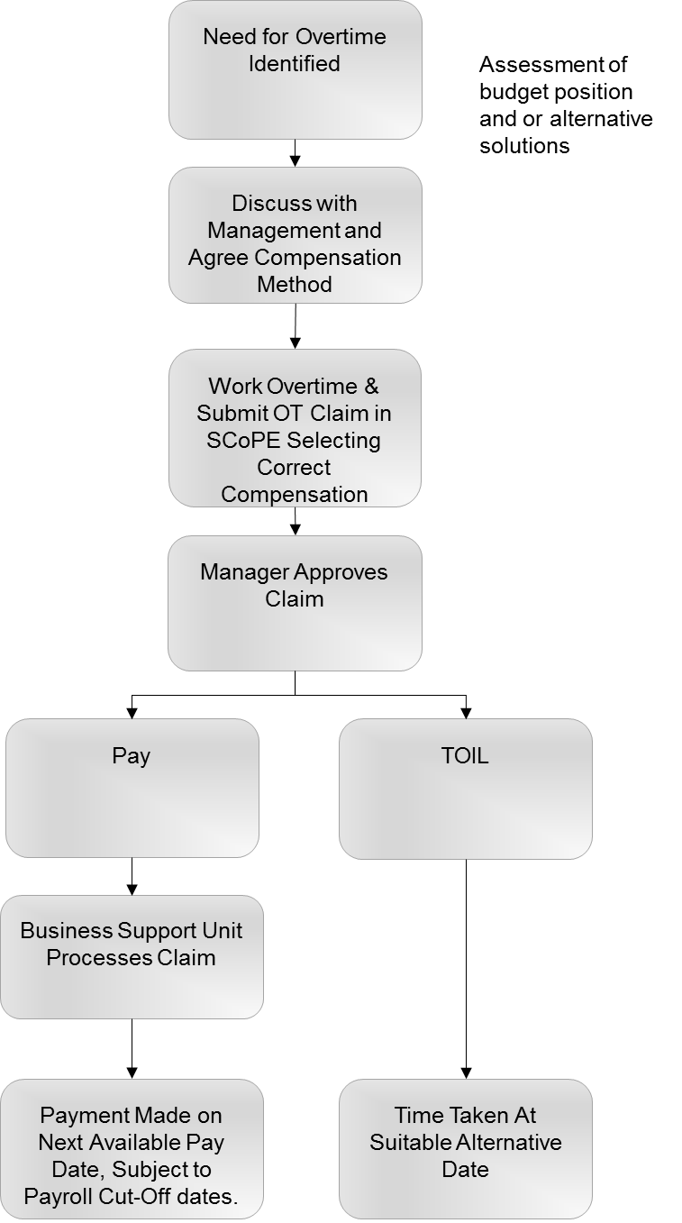Overtime - Process Map

Appendix C

How to claim for working a meal break

Authority/ Police staff normally have a rostered meal break (length of shift permitting) and this meal break must be taken. It is acknowledged that in some roles the meal break is not always possible at the time scheduled.

Where you have worked through your meal break due to operational reasons, managers have a role and duty of care to make sure that you receive an uninterrupted meal break as soon as possible thereafter, i.e. as soon as possible in the same shift.

Where, in exceptional circumstances, this is not possible and you are prevented from taking your meal break because of the exigencies of the service, you may claim this back via plain time TOIL only.

This will apply to both rostered shifts and overtime shifts. Where this is an overtime shift, claims will need to be broken into separate elements because SCoPE will not allow two claims for the same period.

To do this you must claim plain time TOIL recompense via the Overtime Claim Form on SCOPE using the following codes:



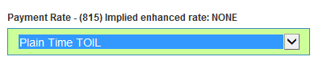

You must also select the 'time off in lieu' payment option at the bottom of the form.



Any claims for payment will be rejected.

You and your manager should ensure this TOIL is taken as soon as is practicably possible.

Under the Overtime and TOIL Procedure you are required to monitor your TOIL balance to have a maximum TOIL balance of 35 hours (pro rata for part time staff) and to reduce this balance as far as possible by the 31st March each year. The TOIL claimed for working lunches is captured in this balance.

**Appendix D**

How to claim for working additional hours and overtime if you work part time.

Index

Introduction

Working the same number of part time hours each week and do not work flexi-time?

Working with flexi-time

Working a variable number of hours each week as part of your agreed shift pattern

Occupying more than one post

Claiming on SCoPE

Introduction

If you work part time you have to work up to the Full Time Equivalent (FTE) 35 hours before you qualify for overtime. This is based on the hours worked during the agreed working week between Monday 07:00 and Monday 06:59.

The hours you work between your average contracted weekly hours (specified in your contract of employment and on SCoPE) and the FTE are called “**part time additional hours**” and are compensated at plain time. It is important that these are recorded accurately as **part time additional hours** count towards an additional annual leave allowance and are pensionable if claimed as pay. Additional overtime after 35 hrs is neither pensionable nor counts towards additional annual leave.

Additional hours worked as a consequence of responding to on call - as part of a contracted standby roster is compensated at the relevant overtime rate even if the FTE has not been reached. These hours do not count towards the part time additional hour’s weekly limit.

There is guidance at the end of this appendix on how to claim correctly using SCoPE. Please ensure you follow this carefully to ensure you receive your entitlement to additional annual leave and if appropriate, any pension contributions.

Working the same number of part time hours each week and do not work flexi-time?

If you do not work flexi-time and work the same number of contracted hours each week you can calculate your part time additional hours by simply deducting your weekly contracted hours from the FTE (35).

**Example**

If you are contracted, and work, 20 hours each week you would claim the first 15 hours overtime as **part time additional hours** starting Monday 07.00 and ending Monday 06.59 (35 hours – 20 hours = 15 hours). Any approved additional working over and above this would be claimed at the relevant overtime rate. Part time additional hours may be compensated at plain time as pay, Time off in Lieu (TOIL) or split 50/50 between pay and TOIL as agreed in advance with your line manager

Working with flexi-time

If you work flexi-time your approved extra hours will be recognised as flexi-time within the bandwidth 07.00 – 19.00.

**Working additional hours outside of the flexi bandwidth –** if you work additional hours outside of the flexi bandwidth, for example, work between 19.00-21.00 these should be claimed as **part time additional hours,** up to 35 hours,and may be compensated as pay, TOIL or split 50/50 between pay and TOIL as agreed in advance with your line manager. These hours contribute towards the 35 hours FTE. Any additional hours over 35 hours may be claimed at the relevant overtime rate.

**Working on your non-working days**

If you work on your non-working days these should be claimed as **part time additional hours** (up to 35 hours),and are compensated at plain time as pay, TOIL or split 50/50 between pay and TOIL which should be agreed in advance with your line manager. These hours contribute towards the 35 hours FTE.

**Business requirement for paid overtime**

If there is a specific business need, such as a project or other budgeted activity, your line manager may instruct you to log off from flexi-time and claim pay for **part time additional hours.** In these circumstances you must not claim Time off in Lieu (TOIL). These paid part time additional hours contribute towards the 35 hours FTE.

Working a variable number of hours each week as part of your agreed shift pattern

If you work a variable shift pattern (i.e. your hours vary each week) you must use the total of your contracted average working week to calculate the point overtime is payable.

Some shifts run mid-week to mid-week but the calculation for **part time additional hours** and overtime is based on the hours worked during the agreed working week Monday 07:00 – Monday 06:59.

**Example:**

An employee is contracted to work 20 hours a week and works the following four week variable shift pattern. Over the four week period the employee works:

* an average of 20 contracted hours per week (15+25+10+30 / 4)
* an average of 15 part time additional hours each week; (15+15+15+15 / 4)
* an average 35 hours per week.((15+15)+(25+15)+(10+15)+(30+15) / 4)

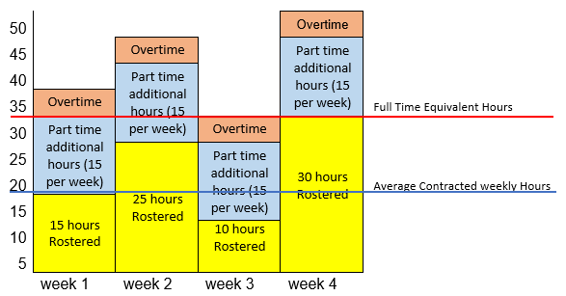

The part time worker in the example above would start to count the number of additional hours they work each week from Monday 07:00. Once they have worked 15 part time additional hours in that week they can start to claim overtime for additional hours at the appropriate overtime rate.

**Occupying more than one post**

There are a small number of part time staff who have more than one post. In these circumstances you add all of your weekly contracted hours for all of your posts together to give you the total weekly contracted hours. If this figure is less than 35 hours FTE then you subtract your total weekly contracted hours from 35.

Example, an employee has two posts one of 10 hours per week the other of 20 hours per week. This gives a total of 30 contracted weekly hours, therefore 35 hours – 30 hours = 5 hours. This means the employee must claim five hours at “part time additional hours” before they claim the relevant overtime rate.

When you making a claim for part time additional hours or overtime on SCoPE it is important that the correct post is selected. The option to select the correct post is at the top right hand side of the overtime form. This is particularly important if the posts you hold are for different grades or departments as you might not be compensated at the correct rate or against the correct budget.

**Claiming on SCoPE**

To claim **part time additional hours** you must complete the following fields on the Overtime claim form on SCoPE.

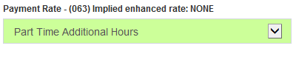

You must then select the relevant option of ‘time off in lieu', “payment” or “50% split between payment and TOIL” at the declaration at the bottom of the form. You must have agreed in advance with your line manager which of these options you are to claim before working the additional hours. Remember you cannot claim TOIL if the time you are claiming for is within the flexi bandwidths of 07:00-19:00.



**Additional Annual Leave**

By accurately completing the overtime claim form Resource Deployment Unit (RDU) will run a monthly SCoPE report which provides them with the data to calculate the additional annual leave to which you will be entitled and to adjust your SCoPE annual leave record. Those hours which are not correctly recorded as **part time additional hours** will not be captured and therefore you will lose your additional annual leave.