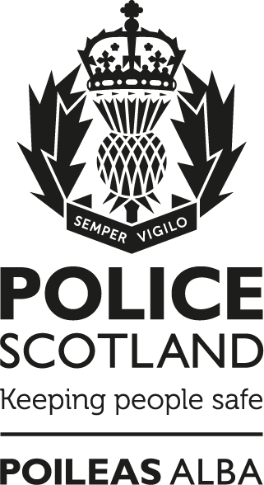

Remotely Piloted Aircraft Systems

(RPAS)
Code of Practice
Notice:
This document has been made available through the Police Service of Scotland Freedom of Information Publication Scheme. It should not be utilised as guidance or instruction by any police officer or employee as it may have been redacted due to legal exemptions
Owning Department: Department Name
Version Number: 1.0
Date Published: 29/09/2022
Contents
Remotely Piloted Aircraft Systems 1
1. Purpose and Use 2
Purpose of the Code 2
Principles of the Code 2
Use of Drones 2
Oversight and Monitoring 2
2. Remotely Piloted Aircraft System 2
Equipment and Scope of Deployment 2
Searches 2
Tasking and Co-ordination 2
Recording Imagery 2
Servicing and Maintenance 2
3. Human Rights, Privacy and Data Protection Legislation 2
European Convention on Human Rights (ECHR) 2
Privacy 2
Data Protection Legislation 2
4. Compliance, Operation and Training 2
Aviation Legislation and Regulation 2
Operation of Police Drones 2
Training 2
5. Non Operational Use 2
Research and Development 2
Future Technologies 2
6. Enquiries and Complaints, Access to Data 2
Enquiries and Complaints 2
Data Subject Access Requests 2
Compliance record 2
Version control table 2
Feedback 2

Purpose and Use

Purpose of the Code
The purpose of this Code of Practice is to inform the public of the nature, deployment and operational use of Remotely Piloted Aircraft Systems (RPAS), commonly known as “drones”. It also aims to provide reassurance in relation to considerations of human rights, privacy and data protection that may be impacted by the use of drones. The document will also outline guiding principles when drones are deployed by the Police Service of Scotland, hereafter referred to as Police Scotland.
Air Support in policing across Scotland and the wider UK is well established. Airborne camera systems on board helicopters have been used for a number of years. Drones are an extension of this capability, albeit they are relatively new technology.
A drone is a small, unmanned aircraft which carries a camera allowing the pilot and operator to view events on the ground from a different perspective, giving an unobstructed aerial view. The drone maintains flight through 4 rotors which are powered by a battery and allow the pilot to control the height, orientation and direction of the drone.
Police Scotland drones are operated from the ground at all times by two specially trained Police Officers who are both qualified drone pilots.
Police Scotland do not use drones covertly and our drones are not capable of facial recognition.
Drones are commonly used commercially for a variety of purposes including aerial photography, motion picture film making, aerial examinations of industrial sites, pylons or tall structures and to monitor areas following natural disasters such as landslides or flooding. Drones are increasingly used by Fire and Rescue Services in England and Wales, with 37 of the 48 Police forces in the UK now using drones. Police Scotland has a fundamental responsibility to protect the public and prevent crime.
Police Scotland uses drones at a variety of policing incidents, for example to search for missing persons, provide support to local officers on the ground, and obtaining aerial imagery for policing purposes. Our use of drones is explained in more detail in Section 2.
This Code of Practice aims to ensure that the public have confidence in our use of drone technology and can access information that illustrates how, why and when they are deployed. In addition, the Code lays out the ethical and legal considerations that are taken into account when using them.

Principles of the Code
The Code of Practice follows the principles below:-

- Drone use will always be for a legitimate policing purpose, proportionate and necessary;
- Prior to deploying drones, consideration must always be given to the potential impact on individuals and their human rights with regular review to ensure use remains justified;
- The use of a drone must be as transparent as possible with every effort made to notify the public of the deployment;
- There must be clear responsibility and accountability for all Police drone activities and a record held of deployments;
- All imagery that is viewed, recorded, retained and shared from any drone activity will be subject to the Police Scotland Record Management Policy and processed in accordance with UK General Data Protection Regulation (UK GDPR) and the Data Protection Act 2018;
- Images recorded through drones will be for a policing purpose only and for the investigation, detection and prosecution of criminal offences.
- Clear rules, policies and procedures must be in place before drones are used, and these must be communicated to all who need to comply with them.
- All drone pilots will be trained to a national standard and comply with aviation legislation and Civil Aviation Authority (CAA) regulations.
- All drone operations will comply with CAA regulations, aviation legislation and Police Scotland policies and procedures.

Use of Drones
Drones will only be deployed for a legitimate policing purpose when it is proportionate, necessary and legal to do so. A drone is an operational policing tool which can be used to provide assistance to any Police Officer, policing division or specialist department in Police Scotland.
Drones will be utilised at incidents similar to those already supported by the Police helicopter, although it is recognised that they are different assets with differing capabilities and resilience.
Any deployment of drones must be in support of policing duties under the Police Fire & Reform (Scotland) Act 2012 namely:
Section (20) Constables: General Duties

(1) It is the duty of a constable:
(a) To prevent and detect crime,
(b) To maintain order,
(c) To protect life and property,
(d) To take such lawful measures, and make such reports to the appropriate prosecutor, as may be needed to bring offenders with all due speed to justice.

Section (32) Policing principles: The policing principles are:

(a) That the main purpose of policing is to improve the safety and well-being of persons, localities and communities in Scotland, and
(b) That the Police Service, working in collaboration with others where appropriate, should seek to achieve that main purpose by policing in a way which:
(i) Is accessible to, and engaged with, local communities, and
(ii) Promotes measures to prevent crime, harm and disorder.

Drone pilots will undertake necessary assessments before making the final decision as to whether to conduct a flight or not, based on the information available and the conditions at the scene. They must ensure that the flight can be made safely at all times.

Oversight and Monitoring
All air support tasking, including drones, are monitored and reviewed by Air Support Unit (ASU) supervisors on a daily basis and the Operational Support Division (OSD) Senior Management Team monthly. An Air Support Monitoring Group, chaired by ACC Operational Support, meets quarterly and provides a strategic forum through which all Air Support policy, practice and technology is considered, developed and reviewed to ensure that the delivery of Air Support within Police Scotland is consistent and cognisant of Equality and Human Rights Impact Assessment (EqHRIA) considerations.
Police Scotland Air Support Unit drone operations are reviewed by the Civil Aviation Authority (CAA) on submission of our annual renewal of the Operational Safety Case and Operations Manual. Police Scotland will also be subject to a full regulatory audit as and when determined by the CAA. The last audit was conducted in 2019.

Remotely Piloted Aircraft System

Equipment and Scope of Deployment
Drones do not have a pilot on board and are controlled by a Police Officer on the ground. Police Scotland currently has two different types of drone which are used operationally and for training.

- M210 - The DJI Matrice 210 is the main operational drone which is a multirotor aircraft weighing approximately 7kg and is fitted with two camera sensors, including a thermal image sensor. The M210 has a number of safety features which include forward and downward anti-collision sensors, GPS module, and “Return to Home” function. Police Scotland operates M210s at Aberdeen, Inverness and Glasgow. It is black in colour with Police markings on the sides. It is the main operational device utilised.
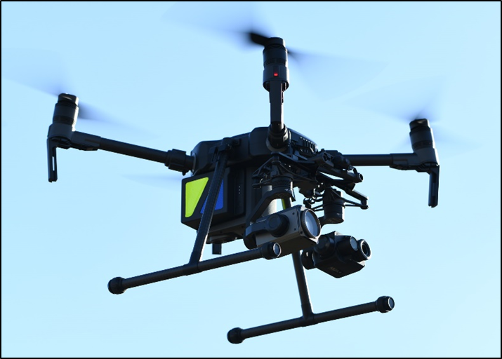
DJI M210

- M300 - The DJI Matrice 300 is our research & development multirotor drone weighing approximately 7kg and is fitted with a dual camera sensor, including a thermal image sensor. The M300 has identical safety features to the M210 and will also be used for operational deployments.
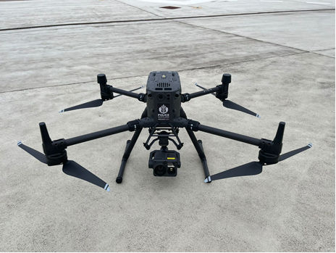

DJI M300

- Mavic Mini – The DJI Mavic Mini is also a multirotor aircraft weighing under 250g and is much smaller than the M210. The Mavic Mini is primarily used for training, however can also be utilised for aerial imagery. The Mavic Mini is fitted with a daytime camera sensor and is grey in colour.

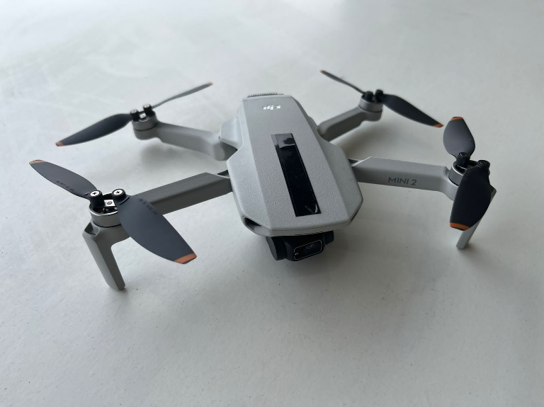
DJI Mavic Mini

All drones are registered with the CAA and display the Police Scotland Operator Identification Number. The DJI M210 platform carries two camera sensors, similar to those carried on the Police helicopter, although much smaller. One is an electro-optical (EO) camera for daylight hours and the other is an infra-red (IR) or thermal image sensor. The IR sensor detects heat which is essential in the search for missing persons. The DJI Phantom 4 platform carries a smaller EO camera which can be used for aerial imagery including crime scene analysis and post incident investigation. Police Scotland operates DJI Phantom 4’s at Aberdeen, Inverness and Glasgow.
For the purposes of this Code, reference to drones includes both types of device.
Drones may be deployed to a variety of policing incidents. Such incidents include:

Searches

Missing persons
- Suspect persons
- Evidence
- Property

Critical Incident Response
- Firearms
- Public Order
- Major Incident

Post Incident Investigation
- Scene overview and situational awareness for emergency services
- Aerial images for safety, analysis, strategy

Crime Scene Analysis Imagery
- Evidential imagery for criminal proceedings
- Road Traffic Collisions
- Serious Crime

Divisional initiatives supporting the local policing plan
- Aerial imagery for event planning
- Public safety
- Officer safety
- Public confidence

Similar to the Police helicopter, drones can act as an airborne command and control platform providing an overview of an incident. The drone can also stream live video footage from the camera over a secure network to any Police control room. This capability is called ‘downlink’ and similar to the existing technology on the Police helicopter. This provides Police Commanders with enhanced situational awareness allowing them to make informed decisions in response to an incident and to effectively deploy ground resources. The downlink can also be streamed securely to any Police Scotland networked computer and police officers mobile devices. The link is strictly controlled by the Air Support Unit and only provided to officers who are directly involved in the incident where downlink is required.
All Police drone activity is overtly visible and high profile. Police drones are not deployed covertly.

Tasking and Co-ordination
The flow chart below explains how the tasking process works.

The Police helicopter remains the primary air asset for Police Scotland. Drones fall under the remit of the Police Scotland (ASU) and any request for Police air support is reviewed and co-ordinated at the ASU. Depending on a number of factors, including the nature of the incident, the location, and weather conditions, ASU officers will determine the most appropriate air asset to deploy to that incident whether that be the Police helicopter or drone. Part of this decision making process will consider three criteria in relation to deploying a drone:

- Safe – Can the drone flight be made safely, minimising risk to the public? (as detailed in Compliance, Operation and Training – Operation of Police Drones’ section)
- Legal – To achieve the task, can the drone be flown legally, complying with aviation law and the relevant legislation to protect the rights of all individuals?
- Proportionate – is the deployment necessary, legitimate and proportionate?

Recording Imagery
All Police drone activity, and specifically the recording of images, are covered by UK General Data Protection Regulations (GDPR) and the Data Protection Act 2018 (DPA). Police Scotland annually reviews its drone Data Protection Impact Assessment (DPIA) to ensure its operations are appropriately considered and data recorded is lawfully managed.
Police drones are capable of recording aerial imagery either in the form of a still photograph or video footage. The camera operator can select to record at any time during the flight, with imagery being captured directly onto a memory card. If the imagery is required as evidence for criminal proceedings then it is downloaded from the memory card and retained as a production for the investigation and prosecution of crime.
Retention of any imagery is in compliance with the Police Scotland Records Retention Policy and processed in accordance with UK GDPR and the DPA 2018.
If the imagery is not required by the police for event planning, training or court purposes then it is immediately deleted.
Some imagery may also be obtained to assist in the planning for future events or operations, for example, the overview of a road network as part of the traffic planning for a major event. This imagery is only used for planning purposes and is then stored for future planning purposes.

Servicing and Maintenance
Police drones have to be maintained to a high standard. The drones are checked before and after every flight and if any issues are identified they are immediately withdrawn from service until these issues are resolved. The drones are serviced according to manufacturer’s guidelines and any repairs or alterations are carried out by trained personnel from the supplier.
The total time for each flight is recorded, along with the total flying hours for each system, and software updates are installed when released by the manufacturer. The drones are stored in custom made cases and are transported within a marked Police vehicle. They are operated by trained police personnel from the Air Support Unit at all times.

Human Rights, Privacy and Data Protection Legislation

European Convention on Human Rights (ECHR)
Human rights are basic rights and freedoms which we all have. They cannot be taken away, although they can be restricted in certain circumstances.
Police Scotland and the Scottish Police Authority have a duty to protect the Rights and Freedoms afforded to individuals under the ECHR and the Human Rights Act (HRA) 1998. There are 16 rights in total, and each one is referred to as a separate article.
An (EqHRIA) is a tool which public authorities can use to help ensure that any potential impact on Equality and Human Rights of a policy or practice is considered using relevant evidence in a structured way.
An EqHRIA has been completed for the Air Support Unit National Guidance and Code of Practice for Police Scotland’s use of drones. The assessment of Article 8 Rights (Right to Respect for Private and Family Life) found that there could be an infringement of an individual’s expectation of privacy.
Policies and decisions which interfere with Article 8 rights are allowed only if they are prescribed by law and the aim of the policy or decision is necessary in a democratic society in the interests of one or more of the following:

- National security;
- Public safety, including protection of health;
- The prevention of disorder or crime; and / or
- The protection of the rights and freedoms of others.

Police Scotland has a responsibility to ensure that air operations using Police drones comply with all of the necessary legislation. Where interference with a Human Rights Article is unavoidable, Police Scotland will try to minimise any interference. The Police drone will be deployed when necessary, proportionate, relevant and justifiable and always where there is a legitimate aim.
The EqHRIA will be reviewed annually and amended to reflect changes to policy, technology and legislation. A copy of the Air Support Unit National Guidance EqHRIA Summary of Results is available on the Police Scotland website.

Privacy
Drones have never been used for covert purposes and there are no plans to use them in that way. The devices are not designed nor suitable for such use. Looking to the future, aerial technology is advancing at great pace, and it is important that policing takes full advantage of any developments that support our efforts to protect the public. Should there be any consideration of drones being used for covert purposes there will be consultation and engagement with relevant stakeholders and a clear adherence to statutory legislation.
As current drone operations are overt, the provisions within the Regulatory Powers of Investigation (Scotland) Act 2000 (RIPSA) are not applicable.
However, it is recognised that a Police drone is potentially less visible than the Police helicopter due to its size and noise and the public may not be aware that it is being operated by the police. Police Scotland will, as far as is reasonably possible, alert the public to the operation of a drone. This will include, where possible:

- Use of social media prior to the activity;
- Local community engagement at private dwellings, land owners and business premises;
- Distribution of the Drone information leaflet;
- Police pilots in high visibility uniform utilising a marked Police vehicle;
- Police signage deployed at the take-off / landing area warning of drone activity.

By law, officers will maintain continuous visual line of sight with the drone when it is in flight. This means that the officers will always be in close proximity to the Police drone. For example, when deploying to an incident within an urban area, officers will attend there by vehicle and on arrival they will conduct a site survey, ensuring roads / streets are cordoned off and a sterile area created before deploying a Police drone. This allows officers to operate the drone safely and unhindered, while minimising the risk to the public in the vicinity.
These measures aim to increase the visibility of the Police drone activity and inform the public of the work being undertaken.

Data Protection Legislation
Police Scotland will only deploy a Police drone for a legitimate policing purpose, where it is considered necessary and appropriate to do so. Retention of any imagery is in compliance with the Police Scotland Records Retention Policy and processed in accordance with UK GDPR and the DPA 2018.
A DPIA is a legal requirement, when a controller of personal data (in this case Police Scotland) proposes to process personal data that could result in a high risk to the rights and freedoms of individuals and is a framework to identify and mitigate data protection risk. A DPIA describes proposed processing of personal data and captures details about its nature, scope, context and purpose.
Part 1 of the document allows Police Scotland to determine whether the proposed processing is likely to result in a high risk to the rights and freedoms of data subjects and Part 2 allows us to make an assessment of the legality of the processing, the governance arrangements around it and the associated risks. Where data protection risks are identified, these are scored by assessing the likelihood of them occurring and the impact on the individuals before and after mitigation measures are put in place. In the event that a risk remains “High” after all possible mitigations are put in place then the processing cannot commence and Police Scotland must self-refer to the Information Commissioners Office if we still wish to go ahead. No risks higher than “Medium” have been identified for the drones.
Within Police Scotland all DPIAs are approved and risks accepted by the Strategic Information Asset Owner for the particular data prior to any processing commencing.
As stated, the DPIA relating to drones will be reviewed annually to ensure that the information remains current. Future versions will include updated information pertaining to the operational use along with any concerns raised out with Police Scotland and how they are being addressed.

Compliance, Operation and Training

Aviation Legislation and Regulation
All Police air operations in the UK are governed by the aviation regulator, the Civil Aviation Authority (CAA). This includes air operations utilising Police drones.
Complying fully with the Air Navigation Order 2016, Police Scotland has been granted permission by the CAA to operate in both rural and urban areas since 2019. This involves the annual submission of an Operating Safety Case and Operations Manual which details how Police Scotland will operate drones safely with strict adherence to the CAA regulations.
Police Scotland has been granted permission to operate closer to people, buildings, vehicles and vessels than most other organisations including commercial operators.
Currently there are two distinct permissions – one is a “Standard Permission” and the other is a “Non-Standard Permission” or “Operational Authorisation” which is more commonly referred to as “exemptions”. Police Scotland has both these permissions.
The standard permission grants an applicant authorisation to operate in a congested area and requires the submission of an Operations Manual, along with evidence of pilot competency, risk assessments and specific details on how operations will be carried out. Each drone is clearly marked with the unique Police Scotland operator identification which, by law, must be displayed on the platform.

Operation of Police Drones
All Police drone operations will be conducted in line with CAA regulations and within the parameters set out in the Police Scotland Operations Manual and Operating Safety Case. The platforms will be operated at all times by two specially trained Police Officers who are both qualified Police drone pilots.
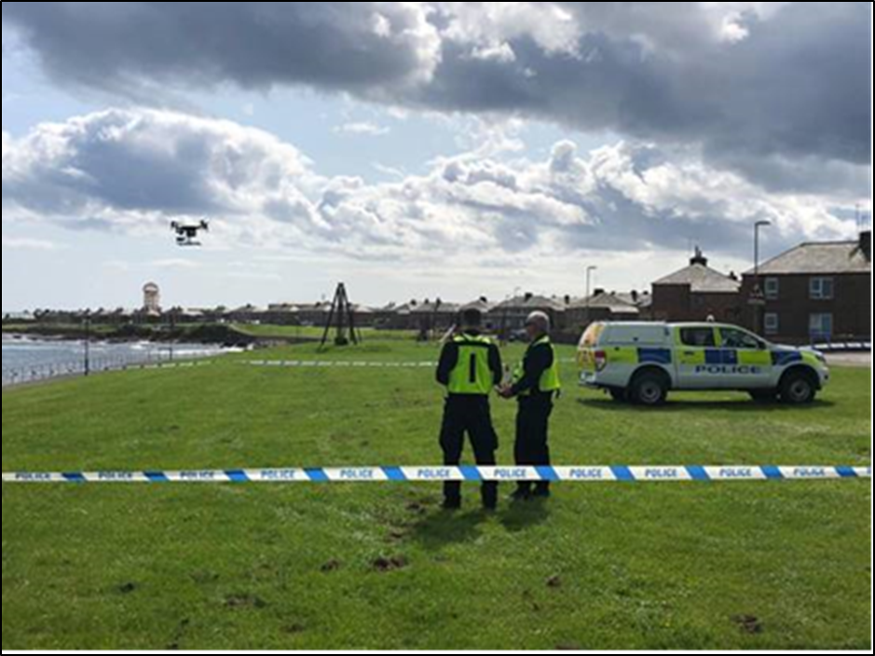
Before launching the drone, officers will conduct a site survey of the location to identify any hazards and obstacles such as pylons, wires, trees, etc. that may affect the safety of the flight. They will also establish a designated area in which the drone can take off and land. This area will be sterile and cordoned off where possible.
Police drones are always flown under strict rules. They will not be flown above 400 feet and the pilot will always maintain a visual line of sight. The drone will not be flown at distance greater than 500 metres from the pilot. Police drones will never knowingly be flown directly over people. The Police Scotland operations manual provides safe distances ensuring that the risk to the public and the officers is minimised as much as possible. Officers operating a Police drone will always be in uniform and work from a marked Police vehicle.
As detailed at on page 10, officers will undertake community engagement before a deployment where possible. This may involve speaking directly to householders, owners of business premises and land owners to inform them of the flight, address any concerns and provide reassurance.
Officers may also distribute information leaflets which explain the proposed drone activity. Police drone activity will be notified to the relevant local policing division and local authority, where appropriate.
Police drones have a single flight endurance of approximately 25 minutes. Sometimes, a drone may undertake multiple flights at the same location so they can provide support to the incident (but only for as long is as absolutely necessary).
Police drones will not be deployed in heavy rain, snow or fog.

Training
All Police Scotland drone pilots are trained to Civil Aviation Authority (CAA) national standards. The CAA require all pilots to complete at least two hours flight time in a rolling three month period. To further enhance this, Police Scotland drone pilots will complete one hour per month flight time, either in training or in an operational environment. This ensures that the highest standards of safety and operational competency are maintained.
All Police Scotland officers will complete mandatory online Data Protection training on an annual basis.
Continuous professional development forms part of the Police drone training and this is held annually or when a new piece of equipment or technique is introduced. Pilots also share their experiences and learning points from operational tasking with their colleagues.

Non Operational Use

Research and Development
Police Scotland will support research and development work. This work will be conducted in collaboration with academic partners, namely University of Glasgow and University of West of Scotland. Any data obtained as part of this research work will be shared with partners to assist with further development by emergency services and to keep pace with evolving technology. Any data shared will be non-operational and will not contain images of members of the public.

Future Technologies
As drone technology continues to evolve at pace Police Scotland will continue to monitor technological developments including enhancements, newer models of drone and safety features to ensure best value, compliance with legislation and operational effectiveness. Police Scotland engages regularly with partner Forces, industry and academia in this regard.
This Code of Practice will be reviewed in the event of future technology advancements that Police Scotland may consider to introduce or adopt.

Enquiries and Complaints, Access to Data

Enquiries and Complaints
Any person who has questions or concerns regarding the use of drones or wishes to make a complaint should, if appropriate and if possible, approach the drone officers and speak with them directly. They may be able to provide further information and reassurance regarding the Police drone activity.
If this is not possible at the time, then any enquiries or complaints can be made to Police Scotland by dialling 101, or in writing to:
Police Scotland RPAS
Accountable Manager
Operational Support Division
Air Support Unit
Clyde Heliport
16 Linthouse Road
Govan
Glasgow
G51 4BZ

Data Subject Access Requests
The UK GDPR and the Data Protection Act 2018 strengthen the rights of individuals, as data subjects, in relation to the personal data that Police Scotland holds about them.
If an individual wishes to exercise this right, Article 15 of the UK General Data Protection Regulation andda Section 45 of the Data Protection Act 2018 provide a right of access to the information Police Scotland holds about them. This process is known as a “Subject Access Request” and an individuals can submit a request by emailing Data Protection Subject Access.
Further information and guidance is also documented within the Police Scotland website.
The Air Support Unit or the appropriate division that holds the data will work with Information Management, who process such requests as a statutory obligation, and respond accordingly subject to certain restrictions. For example, restricting individuals rights may be necessary to protect the rights and freedoms of third parties or to avoid prejudicing the prevention and detection of criminal offences.
In addition, concerning the rights of individuals outlined within Section 46, 47 and 48 of the Data Protection Act 2018 (Right to Rectification, Erasure and Restriction), the Air Support Unit or the appropriate Division that holds the relevant data will work with Information Assurance, who process such requests as a statutory obligation, and respond accordingly. These rights, known as an ‘Individual Rights Request’ are subject to exemptions that we may apply, for example, if data is being processed for law enforcement purposes or under a legal obligation. Individuals can submit an Individual Rights request by emailing Information Assurance.

Compliance record
EqHIRA completion/review date: 11/08/2022
Information Management Compliant: Yes
Health and Safety Compliant: Yes

Version control table
Version | History of amendments | Approval date
1.00 | Initial Approved Version | 29/09/2022

Feedback
All Police Scotland service delivery Policies, Standard Operating Procedures (SOPs) and National Guidance are subject to regular reviews. It is important that user feedback is taken into account when documents are reviewed.
If any officer / staff member wishes to provide comment, or make suggestions for improvements to this or any associated document, Force Form 066-014 should be used.

