**Police Scotland**

**Body worn video camera**

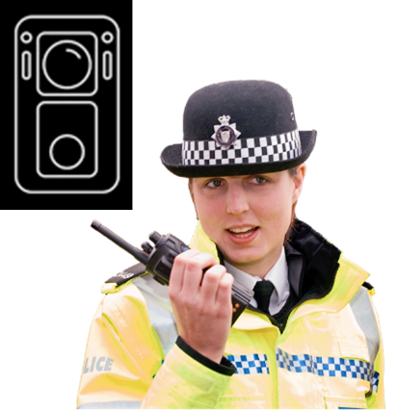

**Easy Read**





|  |  |
| --- | --- |
| **What is a Body Worn Video Camera?** | |
| an illustration of a body worn camera, next to a police officer. | Body Worn Video cameras are attached to the uniform of a police officer, staff or special constable.  They are light video cameras that can be switched on and off by the person wearing them.  They record sound and video. |
| a Police Officer wearing a uniform | They are usually worn on the chest.  Some police officers may use cameras attached to their hat. |
| **Why would Police Scotland record me using a Body Worn Video camera?** | |
| a frowning woman giving the thumbs down and holding a checklist with a large red cross on it.2 police officers speaking to two young men in hoodies. | A police officer, staff or special constable will sometimes use the camera to record what they see and hear so everyone knows what has happened.  It does not mean you have done anything wrong. |
| **How will I know when the camera is recording?** | |
| a police officer explaining something to 2 women. | The camera should not be turned on until the police officer, staff or special constable tells you it will be recording.  When it is recording it will have flashing lights and it will beep every 30 seconds. |
| an illustration of a body worn camera | It will be turned off when the incident has ended.  The camera will not be used in secret or to watch anyone. |
| **What happens to the video?** | |
| **a computer screen with the Police Scotland logo on it.** | Police officers, staff and special constables will download the video from the camera to a Police Scotland computer when they go back to the police station. |
| an illustration of a body worn camera next to film on a phone with a red line through it. | It will be kept safe.  The footage will be deleted from the camera. |
| March 2021 on a calendar showing 31 days. | The video that has been downloaded will be kept for 31 days and then deleted unless it is needed as evidence in an investigation. |
| a judge in a courtroom | **Evidence** means information that could be given to a court to see if someone is guilty or not guilty of a crime. |
| **What if I do not want to be filmed?** | |
| 2 police officers talking to 2 women. | If you are worried about being filmed please speak with the police officers who are there.  They may have to keep recording for safety reasons or to use the video as evidence. |
| **Can I ask to see the video?** | |
| a police officer explaining something to a young woman. | Yes you can.  Police Scotland can tell you how to do this.  There is information about this on their website too. |
| **Privacy information** | |
| A group of people around a table looking at a computer and information  a rulebook with a green tick and red cross on the cover | Information can only be shared with partners for agreed police work.  This includes the Crown Office and Procurator Fiscal Service if information is needed for evidence.  This must follow the rules in Information Sharing Protocols.  A **protocol** is a document that shows how something will be done. |

