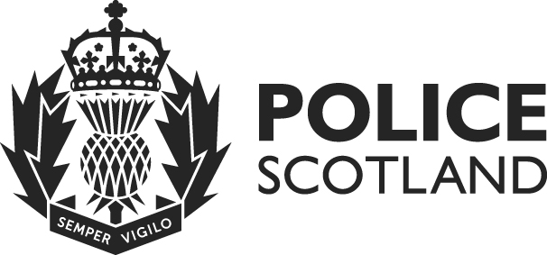
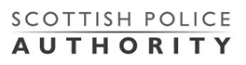

Equality and Human Rights Impact Assessment (EQHRIA)

Summary of Results

Policy / Practice | Vehicle Standards and Safety SOP v3.00
Owning Department | Road Policing
Date EQHRIA Completed | 25/11/2020

Purpose of Policy / Practice | The SOP aims to record the guidelines and operational procedures that require to be adhered to by Officers and Staff when using vehicles owned, leased or hired by Police Scotland.

- Summary of Analysis / Decisions - What the assessment found and actions already taken.
Equality Impact Assessment
Analysis of the Standard Operating Procedure revealed there to be the likelihood of a low impact within the Disability and Pregnancy & Maternity protected groups. By directing officers and support staff to the appropriate Standard Operating Procedure relevant to that individual this will remove any disadvantage and in addition advance equality thereby ensuring minimal potential for any negative impact.

Human Rights Impact Assessment
Analysis of the Standard Operating Procedure revealed that;

Article 2 (Right to Life) was protected by virtue of the provision of instructions, guidelines and considerations that may positively impact on the preservation of life and prevention of injury.

Article 7 (Punishment without Law) and Article 8 (Right to Respect for Private and Family Life) were infringed. Existing statutory obligations and Mous justified these infringements to facilitate a desired outcome.

- Summary of Mitigation Actions - What else we plan to do and how we are going to check that it has been done.
Owning Department will monitor changes in legislation/circumstances which may affect the SOP and assess how these changes may impact on the protected groups.

In addition they will be responsible for the cyclical review of both SOP and EqHRIA.

