East Dunbartonshire Local Policing Plan 2023-26

Contents
Chief Constable’s Foreword 3
Divisional Commander’s Foreword 5
Introduction 7
National strategic alignment 9
Police Scotland’s strategic objectives 10
Local policing delivery context 11
Local priorities 13
Crime – Reducing crimes that cause greatest concern and detecting offenders 13
Community wellbeing – Working with partners to improve the safety of people and places 14
Protecting vulnerable people – Working with partners and the most vulnerable to reduce harm 15
Serious and organised crime – Divert, Deter, Detect and Disrupt organised criminals in our communities 16
Local objectives and activity 18
Threats to public safety and wellbeing are resolved by a proactive and responsive police service 18
The needs of local communities are addressed through effective service delivery 21
The public, communities and partners are engaged, involved and have confidence in policing 23
Our People are supported through a positive working environment enabling them to serve the public 24
Police Scotland is sustainable, adaptable and prepared for future challenges 27
Governance and performance 29
Equality, diversity and inclusion 29
Engaging with us 30

Chief Constable’s Foreword
This Local Police Plan provides a clear statement to our citizens and partners about our commitment to developing our service and addressing areas that are of particular importance in this area. Throughout my time as Chief Constable, Police Scotland has continually developed to ensure we provide effective policing now and in the future.
Our communities are now better served and protected from the threats of today and of tomorrow. I have great confidence that the Police Service of Scotland will continue to build upon the progress made and the stability which now exists in policing.
In our recent Joint Strategy for Policing (2023), Policing for a Safe, Protected and Resilient Scotland, we describe how Police Scotland has people and communities at the heart of its vision for a better society, and will continue to provide modern, visible and accessible policing to local communities, supplemented with new support services that adapt and respond to societal shifts.
Policing in Scotland is incredibly varied, and we recognise the differences and strengths of communities across the country. Our people are vital members of those communities and our trusted relationship with the public and communities we serve is fundamental to maintaining their confidence in us to protect them at their most vulnerable and to keep us all safe from existing and emerging threats and harms.
This plan has been developed with partners and the local public using evidence, insights and professional expertise. We are committed to listening and responding to all communities across Scotland, including those who do not often engage with policing.
We understand our shared responsibility to ensure that our services are trauma-informed and person-centred as outlined in the Scottish Government’s Vision for Justice. Across society, and in part exacerbated by the challenging economic circumstances we all face, vulnerability, mental ill-health and substance misuse continues to impact on both individuals and wider society and on policing. We recognise that ours is very often not the most appropriate service to best support peoples’ needs and we will work our public sector partners to address challenges and support community wellbeing.
I am extremely proud of the service that we provide to our communities from Greater Glasgow Division and from the specialist and operational divisions that provide additional support to them. As colleagues deliver the priorities set out in this plan and respond to new developments, our commitment to keeping people safe and demonstrating our values of integrity, fairness, respect and to upholding human rights is unwavering.
Sir Iain Livingstone QPM
Chief Constable

Divisional Commander’s Foreword
As the Local Policing Commander for Greater Glasgow Division, I am delighted to introduce our East Dunbartonshire Local Police Plan for 2023-2026. This key document details our Policing Priorities for the three year period ahead, highlighting the fundamental outcomes we aim to achieve over that period. The plan is based on our priorities, those of our partners and the views of East Dunbartonshire’s communities on what matters to them.
Chief Constable Sir Iain Livingstone has overall responsibility for policing in Scotland in accordance with the Police and Fire Reform (Scotland) Act 2012. As well as being responsible for providing the best possible police service to the people of Scotland, he must designate local policing commanders and ensure that adequate arrangements are in place for the policing of each local authority area.
I am proud to be the Police Commander for Greater Glasgow Division, which is comprised of Glasgow City Local Authority, East Dunbartonshire and East Renfrewshire. Greater Glasgow is a rich and diverse place and somewhere I have been honoured to serve the public for the majority of my police career. The demands within Greater Glasgow for policing and other public services, exceeds that of anywhere else in Scotland, they can be complex, challenging and resource intensive. However our officers work tirelessly to deliver policing in collaboration with many partners across all sectors, and the public, to ensure Greater Glasgow is a safe and enjoyable place to live, visit and work.
One of our national priorities is to protect vulnerable people and our officers continue to respond to such situations and individuals with professionalism, empathy and compassion. The harm from drugs and mental health in our communities continues to cause concern, which is one of the reasons why Greater Glasgow Division is promoting, engaging and delivering a public health approach to policing, in collaboration with our partners to better protect the public.
The COVID-19 pandemic had a huge impact on our own workforce and communities in recent years and we will remain agile working closely with partners and the public to keep people safe and protected, whilst continuing to deliver policing services in response to community needs. Public confidence in policing rose during this period and I am determined to do all that we can to maintain and build on these levels of confidence in policing.
Our focus is on issues of greatest community concern, we are committed to being an accessible, visible and responsive police service. Our purpose is to improve the safety and wellbeing of people, places and communities in East Dunbartonshire. We deliver this through working collaboratively with partners in order to provide the best possible service to the public. As members of the local Community Planning Partnership, our priorities are linked closely to the Local Outcome Improvement Plan, with a key focus on the delivery of our shared outcomes.
The following plan covers the years 2023-2026 however it will be reviewed periodically ensuring its relevance, allowing us to identify and respond to emerging issues, and build on good practice. This will also make sure our policing activity compliments Local Community Planning.
I look forward to working closely with the people of East Dunbartonshire and with our partner agencies and stakeholders to ensure that Police Scotland and Greater Glasgow Division continues to deliver a professional, high quality service, upon which individuals and communities can have confidence in.

Chief Superintendent Mark Sutherland
Local Police Commander
Greater Glasgow Division

Introduction
This police plan relates to the East Dunbartonshire area which lies to the north of Glasgow, bordered by the Campsie Fells and the Kilpartick Hills. Local officers and staff provide policing to more than 108,750 people, over 77 square miles. The area covers a mix of urban and rural areas including commuter towns Bishopbriggs, Bearsden, Milngavie, Kirkintilloch and Lenzie and villages such as Milton of Campsie, Lennoxtown, Torrance and Twechar.
Kirkintilloch is known as the canal capital of Scotland with the Forth and Clyde Canal at the heart of the town. Boat building commenced here in 1866, continuing for nearly 100 years, until 1945. The annual Kirkintilloch Canal Festival is a very popular event with many residents and visitors enjoying activities, performances and fireworks.
East Dunbartonshire is part of Greater Glasgow Division which encompasses widely contrasting communities from densely populated areas such as Craigton, Drumchapel and Easterhouse to the semi-rural villages of Eaglesham and Twechar. Serving three local authorities, this policing plan relates to the East Dunbartonshire area.
East Dunbartonshire has a historical link to Roman times with the Antonine Wall, Fort sites and Baths. Many people begin their West Highland Way adventure here. There are also a wide range of parks such as Mugdock Country Park and Kilmardinny Loch. There are opportunities to enjoy a variety of sport and leisure facilities, art galleries and museums.
Like many other areas, it does have pockets of deprivation and associated social challenges. This local policing plan aims to highlight these challenges and some of the steps we intend to take to deal with them.
As key partners in the East Dunbartonshire Community Planning Partnership, we share the vision of working together to achieve the best with the people of East Dunbartonshire.
This Local Policing Plan sets out the local policing priorities for East Dunbartonshire for 2023-2026. The plan is a statutory requirement under the Police and Fire Reform (Scotland) Act 2012 and forms part of a broader planning process which takes account of other strategic plans.
It details local and national priorities identified as being significant to the communities of East Dunbartonshire and the way in which Greater Glasgow Division will respond to reduce the associated threat, risk and harm. The views of the community were obtained through community engagement via ‘Your Police’ survey, which was promoted via our social media channels and through interaction with our local communities and partners.
The plan is designed to deliver positive outcomes for the people of East Dunbartonshire and is closely linked to East Dunbartonshire Council’s Local Outcome Improvement Plan.

National strategic alignment
Our strategic outcomes provide a clear route from the Scottish Government’s outcomes and priorities, including the Justice Strategy, through Police Scotland’s strategies, plans and performance reporting, enabling us to demonstrate alignment and clearly articulate our ambitions and progress as demonstrated below. In addition to the Annual Police Plan, Police Scotland’s thirteen local policing divisions produce Local Police Plans which reference distinct priorities, objectives, outcomes and performance measures. They link to wider community planning arrangements, with Local Outcome Improvement Plans taken into account in their development.
- Scottish Government National Outcomes/Strategic Priorities/Justice Vision
- SPA/Police Scotland Strategic Outcomes
- Long Term Policing Strategy: Policing for a Safe, Protected and Resilient Scotland
- Enabler strategies including People, Fleet, Estates, Public Contact and Engagement, Enabling Policing for the Future, Digital Data and ICT, Cyber, Environmental, Procurement, Violence against Women and Girls, Equality Diversity and Inclusion
These are underpinned by plans including the Strategic Workforce Plan, Annual
Police Plan, Local Police Plans, Local Outcome Improvement Plans, and
Financial Plans.

Police Scotland’s strategic objectives
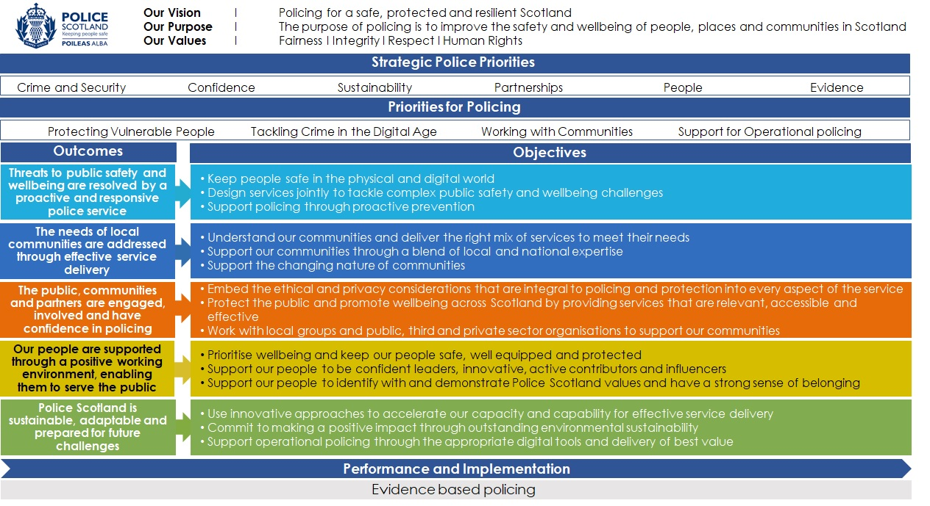

Local policing delivery context
Police Scotland’s purpose is to improve the safety and wellbeing of people and communities for a safe, protected and resilient Scotland. This is in line with our values of Fairness, Integrity and Respect and a commitment to upholding human rights.
This police plan relates to the East Dunbartonshire Local Authority, which is covered by Greater Glasgow Policing Division.
Greater Glasgow is led by a Local Policing Commander who holds the rank of Chief Superintendent. The Local Policing Command is supported by a command team of six Superintendents and two Detective Superintendents who each lead dedicated teams across various geographical or functional areas.
Uniformed policing is delivered in our communities through Chief Inspector rank Local Area Commanders [LAC], and their respective teams, who are responsible for delivering the Local Policing Plans in their geographical areas and responding to community concerns.
In East Dunbartonshire uniformed policing is delivered in the community by this Local Area Commander and dedicated community and response officers. In addition Greater Glasgow has a number of functional teams such as Divisional Violence Reduction Unit and Licencing.
The division has several specialist departments including Criminal Investigation, Serious Organised Crime, Intelligence and Public Protection lead by four Detective Chief Inspectors. The teams deployed in these specialist areas undertake investigations in relation to serious criminality, organised crime, sexual crime, domestic violence, exploitation and wider public protection concerns. Greater Glasgow Division is unique in having local resources dedicated to Human Trafficking and Economic crime.
Greater Glasgow Division is driving our innovative public health approach and we have appointed the first dedicated public health co-ordinator in local policing to ensure this work goes from strategy into making a difference in people’s every-day lives. This partnership approach, led by a Chief Inspector, working along-side multiple partners, is key to improved outcomes and better services for the most vulnerable in our communities.
A Local Authority Liaison Officer is co-located in the Council Headquarters and works with the Local Authority to deliver Community Planning Priorities.
Greater Glasgow Division has a number of school based officers who are engaging with and supporting our young people and education partners. This is an important role in delivering community reassurance, advice, and protecting young people from harm.
Collectively these officers, staff and departments ensure a co-ordinated and professional approach to policing built on core values of integrity, fairness and respect.

Local priorities

Crime – Reducing crimes that cause greatest concern and detecting offenders
Violence and Disorder - We will ensure our officers are effectively briefed, supported and deployed as part of a Multi-Agency Tasking and Coordinating approach. We will focus on prevention and developing all investigative opportunities to bring offenders to justice, making use of all appropriate legislation and policing tactics, to proactively manage known violent offenders, concentrating on the greatest community concerns and impact.
Crimes of dishonesty - We will identify crime patterns in relation to robbery, housebreaking and other acquisitive crimes. We maintain and will deploy specialist officers to ensure a knowledge of offences and offenders is developed and every effort is made to prevent crime by target hardening, raising awareness and managing known offenders.
Sexual Offences - We will be supportive and compassionate to individuals who have been subject of a sexual offence, working with partners in a joint approach. We will deploy specially trained staff and conduct robust investigation. A dedicated unit will monitor offenders in the community. We will maximise the use of Sexual Harm Prevention Orders.
Drug Offences – We will develop our approach to increase awareness of drug harm through a public health approach to policing. We will further develop our outreach and diversion activities through our Positive Outcomes Project and offer additional protection to vulnerable people through our Naloxone capability. We will provide methodical Senior Investigating Officer led investigations where deaths have occurred and work with other agencies to support affected families.

Delivering through our public health approach – We will endeavour to assess if vulnerability has been a contributory factor in offending behaviour. With a better understanding of the underlying reasons leading to involvement in criminality, we will seek support from our partners in an effort to reduce re-offending and promote rehabilitation.

Community wellbeing – Working with partners to improve the safety of people and places
Anti-Social Behaviour – We will engage with partner agencies to ensure that licensed premises are operating in a responsible manner and not selling alcohol to young people. We will maximise opportunities to reduce disorder and antisocial behaviour through our weekly Tasking and Coordinating Partnership meeting.
Hate Crime - We will work with partners to deliver a person centred approach to all reports of hate crime or hate incidents. We will identify vulnerable communities and individuals, providing appropriate advice, guidance and specialist support. Reports made to us will be prioritised and thoroughly investigated to obtain justice, where appropriate. Our approach will be compassionate and engage with those affected, ensuring safety and support.
Safer Public Spaces - We will ensure our officers are effectively deployed as part of our tasking and coordinating approach in priority locations. We will exploit investigative opportunities to bring offenders to justice. We will proactively manage known offenders in the community and we will make appropriate use of legislation and other more immediate options e.g. Fixed Penalty Notices.
Road Safety - We will utilise intelligence and analytical products to identify prominent crash locations and repeat offenders. We will communicate and engage with the public to improve driver behaviour, creating safer roads for our communities and using enforcement as a proportionate measure.

Delivering through our public health approach- We will focus on three key priorities namely drugs and harm reduction; mental health including adult support and protection, children and young people; and contributing to reducing poverty. Each of these areas focus on significant public health issues which can have a devastating impact on the wellbeing of the communities we serve. As an emergency service, we understand our role in identifying vulnerability through our daily interactions with members of the public. We are uniquely placed to recognise vulnerability and will continue to refer individuals for support from the right agency at the right time and promote positive outcomes for the citizens of Greater Glasgow.

Protecting vulnerable people – Working with partners and the most vulnerable to reduce harm

Violence Against Women and Girls – We will support and reassure the community to have the confidence to report to police. We will utilise intelligence and analytical products to identify and arrest offenders. We will robustly investigate all forms of violence and abuse of women and girls, including domestic and sexual crime, and work with partners to deliver safe spaces across East Dunbartonshire. Our compassionate person-centred approach will support the national strategy, which will contribute towards a society where women and girls are safe from harassment, abuse and exploitation.
Missing People - We will assess each missing person report, to allocate appropriate levels of priority and resources. A key consideration will be an ongoing assessment of the risk posed by the missing person to themselves or to others.
Adult and Child Protection – We will continue a multi-agency approach to adult and child protection, to ensure vulnerable adults, young people and children are protected and safeguarded. We will use all legislation and investigative opportunities to identify and arrest those involved in the exploitation of others.
Fraud and Bogus Callers – We will develop a dedicated team to tackle fraud and bogus crime. The team will work closely with Trading Standards and will target those responsible for committing these crimes, often against the most vulnerable members of the community. Support will also be provided to the victims of bogus crimes or fraud.

Delivering through our public health approach – As an emergency service, we understand our role in identifying vulnerability through our daily interactions with members of the public. We are uniquely placed to recognise vulnerability and will continue to refer individuals for support from the right agency at the right time and promote positive outcomes for the citizens of Greater Glasgow.

Serious and organised crime – Divert, Deter, Detect and Disrupt organised criminals in our communities

Feuds and Firearms – We will provide a consistent and robust response to serious violent crime by intelligently deploying resources to manage and detect offenders and provide reassurance to our communities. We will maximise any disruption and investigative opportunities to bring those involved in organised crime to justice. Our dedicated specialist officers will develop intelligence opportunities and proactively manage the threat posed from the criminal use of firearms.
Interventions – We will continue to develop collaborative working with partners to disrupt and disable organised crime groups by targeting their wealth, assets and businesses. Our specialist officers and departments will develop intelligence and deliver operations to detect and arrest offenders while diverting others away from a life of organised crime.
Cybercrime - We will continue to develop our skills in cyber enabled and dependent crime. Key areas of focus include online sexual, hate and financial crime.
Drug supply and manufacture - We will continue to gather intelligence and enforce legislation to arrest those involved in the manufacturing and supply of controlled drugs. We will encourage the public to speak with us to reduce the availability of drugs in the community and the harm they cause.

Delivering through our public health approach – Our approach will primarily focus on enforcement, however, we will continue to identify and work with those we can divert from serious and organised crime. Our Serious Crime Prevention Order Unit will continue to work with high tariff offenders through a public health lens, to support their rehabilitation and reintegration into our communities. We will continue to look at ways we can refer families to partner agencies following executive action, recognising the impact this can have on family generations, with a view to preventing others becoming involved in serious and organised crime.

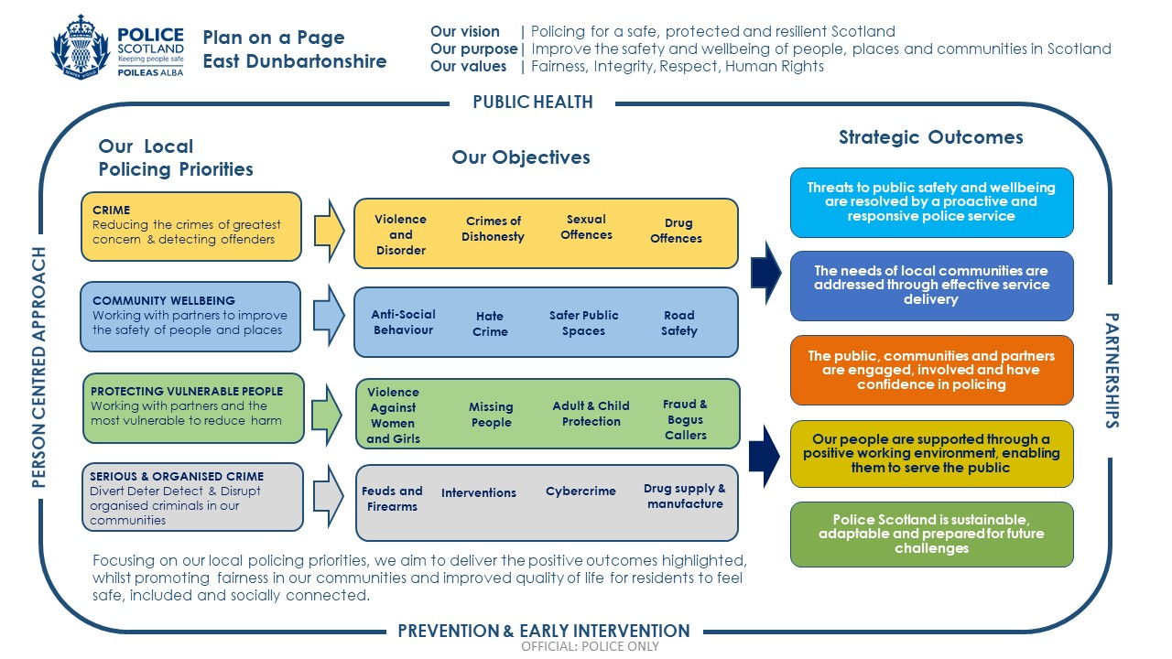

Local objectives and activity

Threats to public safety and wellbeing are resolved by a proactive and responsive police service
We find ourselves moving at an ever-increasing pace from the physical to the digital world; a move that creates new and complex crime types. It also affects traditional crime, much of which now has a digital element.
To protect our communities effectively, we will continue to explore innovative technologies and partnerships.
We will continue to be a key contributor to local joint planning and delivery, helping drive a shift to prevention and early intervention across services.

Objective: Keep people safe in the physical and digital world
Activity 1: Working with partners to improve the safety of public parks and open spaces within East Dunbartonshire.
Key Milestones:
- Uniform and plain clothed police deployments along the canal networks and within parks and open spaces of East Dunbartonshire.
- Enhance safety of canal network in partnership with Scottish Canals and East Dunbartonshire Council Community Safety.
- In consultation with East Dunbartonshire Council and Scottish Canals, deploy temporary mobile CCTV cameras within the canal network and parks and open spaces of East Dunbartonshire area.
Update expected: Y1, Y2 Y3 Q2 + Q4
Performance measures and insights:
- Have reported crimes in open spaces reduced?
- How has our approach contributed to public reassurance and increased trust and confidence?

Objective: Keep people safe in the physical and digital world
Activity 2: Providing support to adults, and families living with dementia.
Key milestones:
- Work with partners to identify and provide support to residents and families living with dementia.
- Promote and provide information on the Herbert Protocol within community groups, community councils and partner agencies.
Update expected: Y1, Y2 Y3 Q1 + Q3
Performance measures and insights:
- Has uptake in Herbert Protocol increased?
- How successfully have we engaged with support groups and families?

Objective: Keep people safe in the physical and digital world
Activity 3: Develop and enhance our engagement with children, young people and parents.
Key Milestones:
- Provide tailored advice, guidance and education for young people and parents.
- Provide educational inputs within schools and youth groups relative to keeping safe in the real and digital worlds.
- Utilise social media to promote safety advice around antisocial-behaviour, drugs and alcohol, hate crime, online vulnerabilities and domestic abuse.
Update expected: Y1, Y2 Y3 Q2 + Q4
Performance measures and insights:
- How many inputs were delivered by school link officers within educational settings?
- Have there been increased relevant postings on @EastDunbPolice twitter account?
- How many inputs were delivered to local youth groups?
- Has police engagement and activity positively influenced young person’s beliefs and attitudes around keeping safe in the physical and digital world?

Objective: Support policing through proactive prevention
Activity 4: Develop our approach to prevention and detection of acquisitive crime.
Key Milestones:
- Work with specialists resources to target acquisitive crime occurring in the communities of East Dunbartonshire.
- Maintain Operation Skipjack as our dedicated response to bogus criminality supported by East Dunbartonshire Council’s Trading Standards to develop intelligence, identify and apprehend offenders and reduce harm.
- Educate residents and raise awareness within our elderly and targeted communities of acquisitive crime trends.
Update expected: Y1, Y2 Y3 Q1 + Q3
Performance measures and insights:
- How has our approach affected levels of acquisitive crime?
- Has detection of offenders increased?
- How effectively have we targeted acquisitive crime?
- How successful have we been in publicising our success in detecting and deterring acquisitive crime?
- How many educational inputs and advice drop in sessions have we delivered within the East Dunbartonshire Council area?

The needs of local communities are addressed through effective service delivery
To create your Local Police Plan we have engaged and consulted with the public, stakeholders, community representatives and partners including other service providers to ensure we have a shared understanding of the local community and the role of policing within it.
We will continue to improve the services we provide as society evolves, embedding accessibility and inclusivity into all that we do.
We continue to be able to call upon additional operational support and specialist services to assist with incidents and investigations, large planned and unplanned events, and other situations where these resources are needed ensuring our focus remains on the needs of the local community.

Objective: Support our communities through a blend of local and national expertise
Activity 5: Work with partners to proactively engage with road users to reduce serious injury and death and improve the safety of the East Dunbartonshire road network
Key Milestones:
- Work with partners to deliver days of action to tackle road users involved in criminality within East Dunbartonshire.
- Work with partners to deliver days of action to tackle unsafe vehicles and/or drivers within East Dunbartonshire.
- Make the roads of East Dunbartonshire safer by positively influencing driver, cyclist, pedestrian behaviour through visibility patrolling by specialist Roads Policing officers and use of Operation Close Pass.
- Carry out high visibility speed detection in local communities at locations of most concern to those within each locality of East Dunbartonshire.
Update expected: Y1, Y2 Y3 Q2 + Q4
Performance measures and insights:
- Have detections for road related offences increased?
- How has our activity affected the detection of road-related offences?
- Has there been a reduction in casualties and fatalities?
- Have we increased multi agency days of action?
- Increase of deployments alongside support services and operation close pass?

The public, communities and partners are engaged, involved and have confidence in policing
Our values are at the heart of everything we do. Our human rights based approach to policing along with ethical and privacy considerations are of the utmost importance to the service we provide. The communities we serve should feel confident that we will always police in a way that is fully underpinned by our values of fairness, integrity, respect and a commitment to upholding human rights.
The safety and wellbeing of the people we serve are enhanced by providing services that work efficiently. We will listen and seek to understand the changing needs of diverse communities, bringing both professionalism and empathy to our interactions making changes to our services when required. Engaging with people strengthens relevance, responsiveness and accountability and builds trust. We will improve and refocus our engagement activities where these are not reaching diverse communities and are not representative of the society we serve.

Objective: Protect the public and promote wellbeing across Scotland by providing services that are relevant, accessible and effective
Activity 6: Contribute to improving the mental wellbeing of people in East Dunbartonshire through partnership working
Key milestones:
- Delivery of Mental Health (SAMH) and Suicide Prevention (ASIST) training to officers.
- Promote the Public Health approach to policing through identifying and signposting our community to services available through the East Dunbartonshire Asset Mapping.
- Promoting Health and Social Care services as appropriate lead service providers when delivering front line policing.
Update expected: Y1, Y2 Y3 Q1 + Q3
Performance measures and insights:
- Are we appropriately identifying and responding to those with identified Mental Health issues?
- Have we increased the number of officers trained in SAMH and suicide prevention?
- Have we increased volume and quality of VPD referrals?
- Have we increased the number of case conference meetings for those experiencing mental health crises?

Objective: Work with local groups and public, third and private sector organisations to support communities
Activity 7: Work with partners to reduce alcohol related harm amongst young people and reduce the associated negative impact on community wellbeing.
Key milestones:
- Delivery of alcohol related inputs within educational settings throughout East Dunbartonshire.
- Deliver training and support to off and on sales licensed premises within East Dunbartonshire through the Community Alcohol Partnership to increase diligence and responsible sale of alcohol.
- Influence partners to provide diversionary activities for young people within East Dunbartonshire such as the current Friday night football and free gym and swim for all primary and secondary school pupils.
Update expected: Y1, Y2 Y3 Q1 + Q3
Performance measures and insights:
- Have anti-disorder related incidents decreased?
- How many premises have received training?
- Have young person Community Alcohol Partnership survey results shown a change in attitude?
- Have residents’ surveys results shown a change in concern / experience?

Our People are supported through a positive working environment enabling them to serve the public
The safety and wellbeing of our officers and staff are at the heart of Police Scotland’s commitments. The challenges for policing are significant and the part policing plays in daily life will become ever more important as society faces huge challenges. Policing is also coming under increasing scrutiny and pressure in relation to our actions.
We will create the environment for our staff to be able to work effectively and equip them to make decisions, ensuring they are trusted and empowered to do so.

Objective: Prioritise wellbeing and keep our people safe, well equipped and protected
Activity 8: Deliver the Greater Glasgow Your Voice Matters (YVM) Implementation plans, developed in response to the survey results, to ensure that the desired outcomes and progress is achieved.
Key milestones:
- Implementation of sub groups to lead on key themes; resourcing, incivility, estates and equipment, well-being and fear of making mistakes.
- Regular review and governance.
- Implementation of YVM local intranet page to improve communication.
Update expected: Y1 - 3 Q2 + Q4
Performance measures and insights:
- How have YVM results informed Greater Glasgow division’s wellbeing approach?
- How are results and response rates reflecting the effectiveness of the action plans?
- What are our Staff Associations, Unions and Diversity Network Chairs telling us?

Objective: Support our people to be confident leaders, innovative, active contributors and influencers
Activity 9: Support colleagues’ performance and development through My Career, and associated promotion pathways.
Key milestones:
- Introduction of My Career Champions.
- Deliver Continuous Professional Development (CDP) events for officers involved in promotion processes.
- Monitor My Career training and completion rates
- Overview of progress and benefits.
Update expected: Y1 - 3 Q2 + Q4
Performance measures and insights:
- How effective is Greater Glasgow Divisions workforce development?
- How many CPD events have been delivered?
- How many officers have completed My Career Training?

Police Scotland is sustainable, adaptable and prepared for future challenges
Ongoing political, technological, economic and societal changes as well as unforeseeable emergencies on a local and global scale require the police service to adapt and respond to future challenges in order to maximise the benefits of future opportunities. This includes working to reduce the impact of our activity, estates and fleet on the environment. Police Scotland aims to make a significant contribution to the Scottish Government’s 2040 carbon neutral target and 2045 zero greenhouse gas emissions target.
Everyone has a role to play in improving financial sustainability, making efficient use of resources and eliminating waste to deliver best value. Procurement of and demand for goods and services will remain under scrutiny, ensuring resources are used in the most efficient way possible to meet the greatest need.

Objective: Use innovative approaches to accelerate our capacity and capability for effective service delivery
Activity 10: Improve and adapt our response and effectiveness in cyber dependent and cyber enabled crime.
Key milestones:
- Cyber Awareness Training for Workforce / Public / Business.
- Provide improved guidance to officers and staff via local channels.
- Work with partners to develop cyber-crime awareness training which will be embedded in our public health approach to policing.
Update expected: In format Y1 – Y3 Q1 + 3
Performance measures and insights:
- How effective is our Financial and Economic Crime Unit?
- How effective are we at dealing with cyber-enabled sexual related hate crime?
- What impact are we having to raise awareness to reduce harm surrounding cyber-enabled sexual & hate crime?

Objective: Support operational policing through the appropriate digital tools and delivery of best value
Activity 11: Effectively deliver the implementation of new technology across Greater Glasgow Division.
Key milestones:
- Delivery of Core Operational Solutions [COS].
- Training inputs for trainers on COS.
- Training sessions for our workforce on COS.
- Develop a cadre of local COS Champions.
Update expected: Y1- Y3 Q4
Performance measures and insights:
- What percentage of our workforce have received training awareness sessions in COS?
- What has been the impact of COS in divisional business?

Governance and performance
The Police and Fire Reform (Scotland) Act 2012 provides a framework for local scrutiny and engagement arrangements between Police, Fire and Rescue Service and the Local Authority.
The current format has been in place since April 2013 and will continue with annual meetings where the Local Policing Commander, supported by the Area Commander, presents a report to the Local Authority outlining police performance measured against the Local Policing Plan.
This provides opportunities for locally elected members to examine and hold police to account in relation to local policing services.

Equality, diversity and inclusion
Our work is underpinned by our commitment to equality, diversion and inclusion in our interactions with the communities we serve as well as our own staff.
Across Police Scotland we are committed to developing and promoting best practice in the refresh of our Equality Outcomes for the coming years. This plan was subject to an Equalities and Human Rights Impact Assessment (EqHRIA) in compliance with the Scottish Public Sector Equality Duty.
In East Dunbartonshire, we are committed to a policing style which meets the differing needs of the communities we serve and is dedicated to promoting equality within our own workforce.
We realise the every police officer, special constable and member of police staff is responsible for delivering a fair and professional service, promoting equality for all.

Engaging with us
Police Scotland
Kirkintilloch police Office
45 Southbank Drive
Kirkintilloch
G66 1XJ

Dial 999 for an emergency that requires urgent Police attention.
For non-emergency contact, call 101, the single non-emergency number.
If you have information about crime in your area and wish to provide it anonymously, call CRIMESTOPPERS on 0800 555111.
Service users who are deaf or have a hearing impairment can contact Police Scotland via TEXTRELAY on 18001 101 for non-emergency, or 18000 in an emergency.
For more detailed information on how to contact your Local Policing Team please refer to the ‘Your Community’ section of our website at Police Scotland – Your Community.
Meaningful and effective engagement involves genuine dialogue, respect, integrity, transparency and accountability. It provides an opportunity for people to shape our services and influence decisions made. Insight from effective engagement helps identify practical solutions and determine changes required to meet the needs of the communities we serve.
Police Scotland is committed to continuous improvement in all that we do. If you have something to tell us about our service, please contact us at Police Scotland – Contact Us.
Further information about our wider engagement can be found in our consultation and engagement hub at Police Scotland – Engagement Hub.
Police Scotland has a number of active social media channels that provide a range of information and insight into policing, both nationally and in your local area. A full list of our social media accounts can be found on our website. Our local channels can be found at:
Twitter: @http://www.twitter.com/EastDunbPol
Facebook: @Greater Glasgow Police Division
Please note that our social media channels are not monitored 24/7 and should not be used for reporting crime. Please dial 999 in an emergency, and 101 in a non-emergency situation.
Inclusive and accessible engagement
We aim to embed accessibility and inclusivity into our services to make them work for everyone.
This plan has been subject to an Equalities and Human Rights Impact Assessment (EqHRIA) in compliance with the Scottish Public Sector Equality Duty in its final iteration in 2023. Separate EqHRIAs will be undertaken for the activities described in this plan as required.
This Local Police Plan can be made available in various alternative formats. For more information, please contact us via our online form at Police Scotland – Contact Us.

