 | Freedom of Information Response  Our reference: FOI 25-2074  Responded to: 09 October 2025
Your recent request for information is replicated below, together with our response.

The number of times the police have been called out to Mill of Mains/ Claverhouse/ Emmock Woods in Dundee over the last two years for incidents related to anti-social behaviour.
Your request has been considered in relation to beat C43 which covers the area highlighted in the map below:
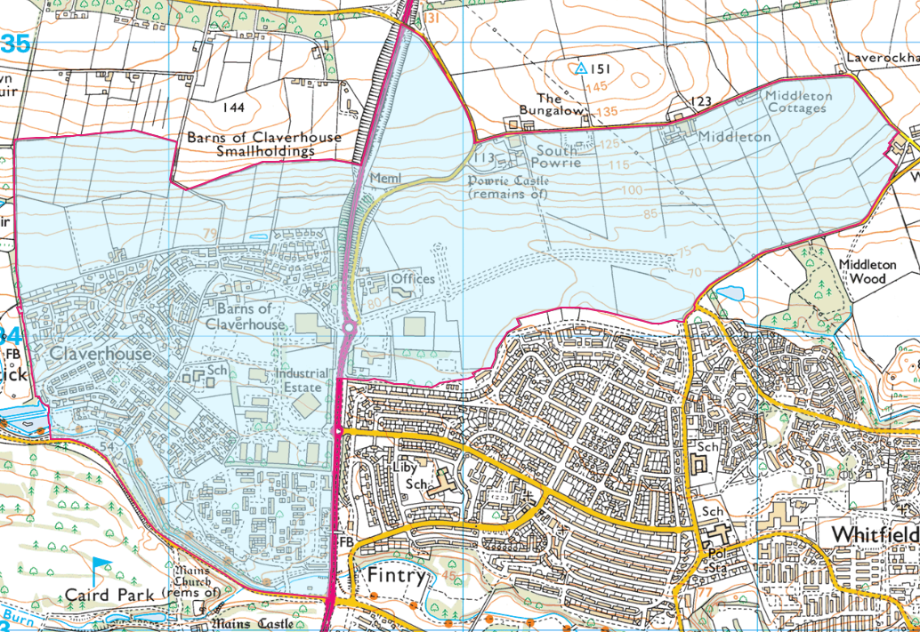
Between 1 January 2023 and 31 July 2025, there were 421 recorded Storm incidents for beat C43 during this time period which had initial incident classifications related to anti-social behaviour:
2023 – 149
2024 – 172
2025 – 100

All statistics are provisional and should be treated as management information.
Data was extracted from Police Scotland systems and are correct as at 21/08/2025.
Data was extracted using the incident's raised date.
Error and Transferred incidents have been removed.
Initial incident classifications that relate to Anti-Social Behaviour:
AB-24: Public Nuisance
AB-27: Drugs/Substance Misuse
AB-28: Disturbance
AB-53: Noise
AB-56: Neighbour Dispute
CR-71: Assault
CR-78: Damage

The number of times the police have been called out to Mill of Mains/ Claverhouse/ Emmock Woodsin Dundee over the last two years for incidents related to fire raising.
18 recorded incidents had a disposal classification of ‘Fireraising’.

The number of times the police have been called out to Mill of Mains/ Claverhouse/ Emmock Woods in Dundee over the last two years for incidents relating to drug use/offences.
32 of the incidents had either a disposal classification of ‘drugs/ solvent related’ or an initial incident type of ‘drugs/ substance misuse’.

If you require any further assistance, please contact us quoting the reference above.
You can request a review of this response within the next 40 working days by email or by letter (Information Management - FOI, Police Scotland, Clyde Gateway, 2 French Street, Dalmarnock, G40 4EH). Requests must include the reason for your dissatisfaction.
If you remain dissatisfied following our review response, you can appeal to the Office of the Scottish Information Commissioner (OSIC) within 6 months - online, by email or by letter (OSIC, Kinburn Castle, Doubledykes Road, St Andrews, KY16 9DS).
Following an OSIC appeal, you can appeal to the Court of Session on a point of law only.
This response will be added to our Disclosure Log in seven days' time.
Every effort has been taken to ensure our response is as accessible as possible.
If you require this response to be provided in an alternative format, please let us know.

