 | Freedom of Information Response  Our reference: FOI 25-2713  Responded to: 21 October 2025
Your recent request for information is replicated below, together with our response.
For the postcode area EH9 2HF, would you be able to provide a breakdown of crimes committed within a ¼ mile radius over the last 12 months, what kind of crimes there have been and how many there have been?
Map provided by applicant:
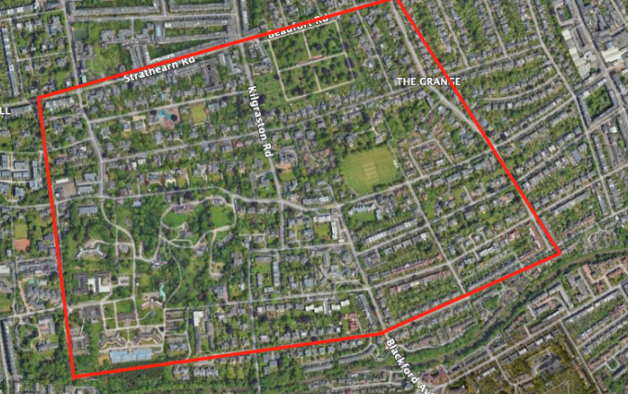
The table below details the information sought:
Crime Group | Recorded crimes - 1 Oct 2024 - 30 September 2025
Non-sexual crimes of violence | 2
Sexual Crimes | 0
Crimes of Dishonesty | 1
Damage and Reckless behaviour | 0
Crimes against society | 3
Antisocial Offences | 2
Miscellaneous | 1
Road Traffic Offences | 8
Total | 17
All statistics are provisional and should be treated as management information.
Data was extracted from Police Scotland systems and are correct as of 20 October 2025.
Data was extracted using the crime raised date.
Incidents were mapped to polygon between Greenhill, The Grange and Blackford.
If you require any further assistance, please contact us quoting the reference above.
You can request a review of this response within the next 40 working days by email or by letter (Information Management - FOI, Police Scotland, Clyde Gateway, 2 French Street, Dalmarnock, G40 4EH). Requests must include the reason for your dissatisfaction.
If you remain dissatisfied following our review response, you can appeal to the Office of the Scottish Information Commissioner (OSIC) within 6 months - online, by email or by letter (OSIC, Kinburn Castle, Doubledykes Road, St Andrews, KY16 9DS).
Following an OSIC appeal, you can appeal to the Court of Session on a point of law only.
This response will be added to our Disclosure Log in seven days' time.
Every effort has been taken to ensure our response is as accessible as possible.
If you require this response to be provided in an alternative format, please let us know.

