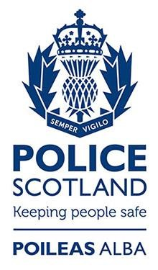

Police Scotland Officers & Staff

Quarterly Fact Sheets

Quarter 2 – 30/06/2020

Contents

About this document Page 2
Operating Model Page 3
Examples of Regional and National Resources Page 4
Police Officer Distribution Page 4
Police Staff Distribution Page 5

Fact Sheets

North Command
North East Page 6
Tayside Page 7
Highland and Islands Page 8

East Command
Forth Valley Page 9
Edinburgh City Page 10
The Lothians and Scottish Borders Page 11
Fife Page 12

West Command
Greater Glasgow Page 13
Ayrshire Page 14
Lanarkshire Page 15
Argyll and West Dunbartonshire Page 16
Renfrewshire and Inverclyde Page 17
Dumfries and Galloway Page 18
About this document
The number of full-time equivalent police officers in Scotland is published on a quarterly basis by the Scottish Government.
To complement these statistics, the Police Service of Scotland publishes information showing the number of police officers available to each of the 13 local policing divisions which cover Scotland. This information is available in the divisional fact sheets which are included in this document. In addition, the number of fulltime equivalent police staff working within the Police Service of Scotland has also been included in this publication.
Please note that in previous quarterly reports, road policing resources were included as part as of the local resource figure. These resources are now counted within regional resource figures although there has been absolutely no change to their local deployment.
The fact sheets in this document relate to the number of full time equivalent (FTE) police officers on 30th June 2020.

Police Officer Operating Model
Local policing is at the heart of the Police Service of Scotland and its operating model ensures there is a strong focus on local policing. Police officer resources are split over three tiers – local, regional and national.
Structuring the organisation in this way ensures there is a core complement of police officers dedicated to community and response policing who can then draw in specialist expertise and resources from a regional and national level wherever and whenever they are needed.
The model is demand-led, enabling Police Scotland to ensure it has the right people in the right place at the right time, keeping people safe and meeting the needs of local communities.
Each fact sheet explains the number of local, regional and national police officer resources which Divisional Commanders can access.
Local police officer resources are the core complement of officers under the direction of the Local Commander and include community and response policing. Also included in the local resource figures are officers within the divisional Criminal Investigation Department and Public Protection Units.
Local police officer resources are supplemented by specialist resources at a regional and national level. Nationally, there are further police officer resources available to divisions including specialist crime resources such as the National Rape Investigation Unit and Human Trafficking Unit and operational support resources such as Air Support and Mounted Unit. Examples of regional and national resources are given below.
As well as these specialist resources, operational assistance to divisions for the policing of major events or incidents is now more accessible and more easily arranged than with pre-reform mutual aid processes.
Examples of Regional and National Resources

Regional Resources
Specialist Crime Division: Major Investigation Teams, Forensic Gateways, E – Crime, Financial Investigations, Serious and Organised Crime Units, Counter Terrorism Units, Offender Management,
Border Policing Command, Technical Support Unit and Interventions. Operational Support: Road Policing Units, Event, Emergency and Resilience Planning (EERP), VIP Planning, Armed Policing Training, Road Policing Management & Policy, Armed Policing, Dogs, Trunk Roads Policing Group and Operational Support Units. Custody: Regional Custody Teams. Contact, Command and Control: Area Control Rooms and Service Centres.

National Resources
Specialist Crime Division: National Intelligence Bureau, Homicide Governance and Review, Prison Intelligence Unit, Human Trafficking Unit, National Rape Investigation, National Rape Review, Fugitive Unit and Scottish Protected Persons Unit, International Unit, HOLMES, Safer Communities Citizen Focus,
Preventions and Interventions, and Strategic Partnerships. Operational Support: Scottish Police
Information and Coordination Centre, Intelligence, Specialist Operations Training, Air Support, Dive/Marine Unit, Football Co-ordination Unit, Mounted Unit, Mountain Rescue, Motorcycle Unit. Custody: Area Command, Support.

Police Officer Distribution
The illustration below outlines the distribution of officers across each of the 13 local policing divisions together with the available regional and national resources:-

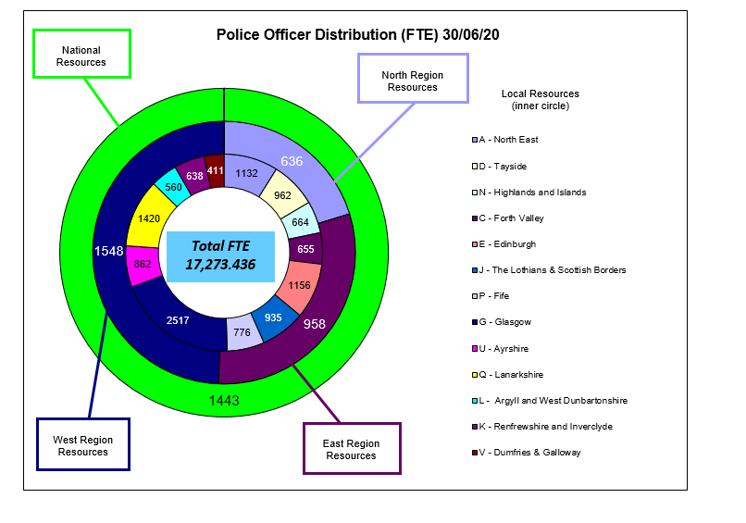

Police Staff Distribution
The illustration below shows the current number of Police Staff as of 30th June 2020. Members of our Police Staff perform a variety of vital functions at local, national and regional levels.

Within divisional areas our Police Support Staff work in a variety of roles - there are 66 different post titles. Examples of sections within divisions include, CID, Business Support, Courts, Divisional Coordination Units, Partnerships, Stations Assistants and Traffic.

Within the specialist function areas of Corporate Services, Operational Support, Criminal Justice Services, Contact, Command & Control and Specialist Crime Division there are 700 different post titles, there are 109 different sections, some examples include Analysis & Performance, Armed Policing, Business Support, Child Protection, Corporate Governance, Custody, Rape Task Force, Resource Management, Quality Assurance, People & Development, National Intelligence Bureau, Professional Standards, Safety Camera Partnership, Service Delivery and Training.

Within the Scottish Police Authority area there are 77 different post titles, there are 19 different sections, some examples include Biology, Business Services, Communications & Engagement, Complaints & Conduct, HR Governance, Quality, Risk & Policy, Scene Examination, SPA Executive and Strategy Programme.

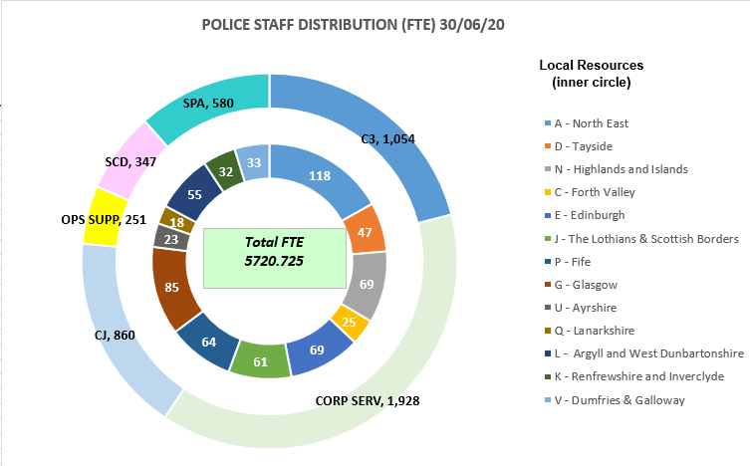

North East (A Division) – Resources

Divisional Policing

For North East division there are 3211 available police officers. The diagram below represents the availability of resources for the division.

Local police officer resources are the core complement of officers under the direction of the local commander and include community policing, response policing and divisional road policing teams. In the North East division, the total local resource complement is 1132 officers.

Included in the Local Resource figures are officers within the Divisional Criminal Investigation Department and Public Protection Units.

This includes specialised officers attached to Divisional Rape Investigation Units, Domestic Abuse Investigation Units and Divisional Violence Reduction Units.

Local police officer resources are supplemented by specialist resources at a regional and national level which each commander has access to. Regionally, there are 636 officers providing specialist support such as Major Investigation Teams and Armed Policing Units to local policing divisions within the North Command area. Nationally, there are a further 1443 resources working across Scotland including specialist crime resources such as the National Rape Investigation Unit and Human Trafficking Unit and operational support resources such as the Air Support and Mounted Unit.

As well as these specialist resources, the division can also request additional support to police large scale events or major incidents.

Tayside (D Division) – Resources

Divisional Policing

For Tayside division there are 3041 available police officers. The diagram below represents the availability of resources for the division.

Local police officer resources are the core complement of officers under the direction of the local commander and include community policing, response policing and divisional road policing teams. In the Tayside division, the total local resource complement is 962 officers.

Included in the Local Resource figures are officers within the Divisional Criminal Investigation Department and Public Protection Units.

This includes specialised officers attached to Divisional Rape Investigation Units, Domestic Abuse Investigation Units and Divisional Violence Reduction Units.

Local police officer resources are supplemented by specialist resources at a regional and national level which each commander has access to. Regionally, there are 636 officers providing specialist support such as Major Investigation Teams and Armed Policing Units to local policing divisions within the North Command area. Nationally, there are a further 1443 resources working across Scotland including specialist crime resources such as the National Rape Investigation Unit and Human Trafficking Unit and operational support resources such as the Air Support and Mounted Unit.

As well as these specialist resources, the division can also request additional support to police large scale events or major incidents.

Highland and Islands (N Division) – Resources

Divisional Policing

For the Highlands and Islands division there are 2743 available police officers. The diagram below represents the availability of resources for the division.
Local police officer resources are the core complement of officers under the direction of the local commander and include community policing, response policing and divisional road policing teams. In the Highlands and Islands division, the total local resource complement is 664 officers.
Included in the Local Resource figures are officers within the Divisional Criminal Investigation Department and Public Protection Units.

This includes specialised officers attached to Divisional Rape Investigation Units, Domestic Abuse Investigation Units and Divisional Violence Reduction Units.

Local police officer resources are supplemented by specialist resources at a regional and national level which each commander has access to. Regionally, there are 636 officers providing specialist support such as Major Investigation Teams and Armed Policing Units to local policing divisions within the North Command area. Nationally, there are a further 1443 resources working across Scotland including specialist crime resources such as the National Rape Investigation Unit and Human Trafficking Unit and operational support resources such as the Air Support and Mounted Unit.

As well as these specialist resources, the division can also request additional support to police large scale events or major incidents.

Forth Valley (C Division) – Resources

Divisional Policing

For Forth Valley division there are 3056 available police officers. The diagram below represents the availability of resources for the division.
Local police officer resources are the core complement of officers under the direction of the local commander and include community policing, response policing and divisional road policing teams. In the Forth Valley division, the total local resource complement is 655 officers.

Included in the Local Resource figures are officers within the Divisional Criminal Investigation Department and Public Protection Units.

This includes specialised officers attached to Divisional Rape Investigation Units, Domestic Abuse Investigation Units and Divisional Violence Reduction Units.

Local police officer resources are supplemented by specialist resources at a regional and national level which each commander has access to. Regionally, there are 958 officers providing specialist support such as Major Investigation Teams and Armed Policing Units to local policing divisions within the East Command area. Nationally, there are a further 1443 resources working across Scotland including specialist crime resources such as the National Rape Investigation Unit and Human Trafficking Unit and operational support resources such as the Air Support and Mounted Unit.

As well as these specialist resources, the division can also request additional support to police large scale events or major incidents.

Edinburgh (E Division) – Resources

Divisional Policing

For Edinburgh City division there are 3557 available police officers. The diagram below represents the availability of resources for the division.
Local police officer resources are the core complement of officers under the direction of the local commander and include community policing, response policing and divisional road policing teams. In the Edinburgh City division, the total local resource complement is 1156 officers.

Included in the Local Resource figures are officers within the Divisional Criminal Investigation Department and Public Protection Units.

This includes specialised officers attached to Divisional Rape Investigation Units, Domestic Abuse Investigation Units and Divisional Violence Reduction Units.

Local police officer resources are supplemented by specialist resources at a regional and national level which each commander has access to. Regionally, there are 958 officers providing specialist support such as Major Investigation Teams and Armed Policing Units to local policing divisions within the East Command area. Nationally, there are a further 1443 resources working across Scotland including specialist crime resources such as the National Rape Investigation Unit and Human Trafficking Unit and operational support resources such as the Air Support and Mounted Unit.

As well as these specialist resources, the division can also request additional support to police large scale events or major incidents.

Lothians and Scottish Borders (J Division) – Resources

Divisional Policing

For the Lothians and Scottish Borders division there are 3336 available police officers. The diagram below represents the availability of resources for the division.
Local police officer resources are the core complement of officers under the direction of the local commander and include community policing, response policing and divisional road policing teams. In The Lothians and Scottish Borders division, the total local resource complement is 935 officers.

Included in the Local Resource figures are officers within the Divisional Criminal Investigation Department and Public Protection Units.

This includes specialised officers attached to Divisional Rape Investigation Units, Domestic Abuse Investigation Units and Divisional Violence Reduction Units.

Local police officer resources are supplemented by specialist resources at a regional and national level which each commander has access to. Regionally, there are 958 officers providing specialist support such as Major Investigation Teams and Armed Policing Units to local policing divisions within the East Command area. Nationally, there are a further 1443 resources working across Scotland including specialist crime resources such as the National Rape Investigation Unit and Human Trafficking Unit and operational support resources such as the Air Support and Mounted Unit.

As well as these specialist resources, the division can also request additional support to police large scale events or major incidents.

Fife (P Division) – Resources

Divisional Policing

For Fife division there are 3177 available police officers. The diagram below represents the availability of resources for the division.
Local police officer resources are the core complement of officers under the direction of the local commander and include community policing, response policing and divisional road policing teams. In Fife division, the total local resource complement is 776 officers.

Included in the Local Resource figures are officers within the Divisional Criminal Investigation Department and Public Protection Units.

This includes specialised officers attached to Divisional Rape Investigation Units, Domestic Abuse Investigation Units and Divisional Violence Reduction Units.

Local police officer resources are supplemented by specialist resources at a regional and national level which each commander has access to. Regionally, there are 958 officers providing specialist support such as Major Investigation Teams and Armed Policing Units to local policing divisions within the East Command area. Nationally, there are a further 1443 resources working across Scotland including specialist crime resources such as the National Rape Investigation Unit and Human Trafficking Unit and operational support resources such as the Air Support and Mounted Unit.

As well as these specialist resources, the division can also request additional support to police large scale events or major incidents.

Greater Glasgow (G Division) – Resources

Divisional Policing

For Greater Glasgow division there are 5508 available police officers. The diagram below represents the availability of resources for the division.
Local police officer resources are the core complement of officers under the direction of the local commander and include community policing, response policing and divisional road policing teams. In the Greater Glasgow division, the total local resource complement is 2517 officers.

Included in the Local Resource figures are officers within the Divisional Criminal Investigation Department and Public Protection Units.

This includes specialised officers attached to Divisional Rape Investigation Units, Domestic Abuse Investigation Units and Divisional Violence Reduction Units.

Local police officer resources are supplemented by specialist resources at a regional and national level which each commander has access to. Regionally, there are 1548 officers providing specialist support such as Major Investigation Teams and Armed Policing Units to local policing divisions within the West Command area. Nationally, there are a further 1443 resources working across Scotland including specialist crime resources such as the National Rape Investigation Unit and Human Trafficking Unit and operational support resources such as the Air Support and Mounted Unit.

As well as these specialist resources, the division can also request additional support to police large scale events or major incidents.

Ayrshire (U Division) – Resources

Divisional Policing

For Ayrshire division there are 3853 available police officers. The diagram below represents the availability of resources for the division.
Local police officer resources are the core complement of officers under the direction of the local commander and include community policing, response policing and divisional road policing teams. In the Ayrshire division, the total local resource complement is 862 officers.

Included in the Local Resource figures are officers within the Divisional Criminal Investigation Department and Public Protection Units.

This includes specialised officers attached to Divisional Rape Investigation Units, Domestic Abuse Investigation Units and Divisional Violence Reduction Units.

Local police officer resources are supplemented by specialist resources at a regional and national level which each commander has access to. Regionally, there are 1548 officers providing specialist support such as Major Investigation Teams and Armed Policing Units to local policing divisions within the West Command area. Nationally, there are a further 1443 resources working across Scotland including specialist crime resources such as the National Rape Investigation Unit and Human Trafficking Unit and operational support resources such as the Air Support and Mounted Unit.

As well as these specialist resources, the division can also request additional support to police large scale events or major incidents.

Lanarkshire (Q Division) – Resources

Divisional Policing

For Lanarkshire division there are 4411 available police officers. The diagram below represents the availability of resources for the division.
Local police officer resources are the core complement of officers under the direction of the local commander and include community policing, response policing and divisional road policing teams. In the Lanarkshire division, the total local resource complement is 1420 officers.

Included in the Local Resource figures are officers within the Divisional Criminal Investigation Department and Public Protection Units.

This includes specialised officers attached to Divisional Rape Investigation Units, Domestic Abuse Investigation Units and Divisional Violence Reduction Units.

Local police officer resources are supplemented by specialist resources at a regional and national level which each commander has access to. Regionally, there are 1548 officers providing specialist support such as Major Investigation Teams and Armed Policing Units to local policing divisions within the West Command area. Nationally, there are a further 1443 resources working across Scotland including specialist crime resources such as the National Rape Investigation Unit and Human Trafficking Unit and operational support resources such as the Air Support and Mounted Unit.

As well as these specialist resources, the division can also request additional support to police large scale events or major incidents.

Argyll and West Dunbartonshire (L Division) – Resources

Divisional Policing

For Argyll and West Dunbartonshire division there are 3551 available police officers. The diagram below represents the availability of resources for the division.
Local police officer resources are the core complement of officers under the direction of the local commander and include community policing, response policing and divisional road policing teams. In the Argyll and West Dunbartonshire division, the total local resource complement is 560 officers.

Included in the Local Resource figures are officers within the Divisional Criminal Investigation Department and Public Protection Units.

This includes specialised officers attached to Divisional Rape Investigation Units, Domestic Abuse Investigation Units and Divisional Violence Reduction Units.

Local police officer resources are supplemented by specialist resources at a regional and national level which each commander has access to. Regionally, there are 1548 officers providing specialist support such as Major Investigation Teams and Armed Policing Units to local policing divisions within the West Command area. Nationally, there are a further 1443 resources working across Scotland including specialist crime resources such as the National Rape Investigation Unit and Human Trafficking Unit and operational support resources such as the Air Support and Mounted Unit.

As well as these specialist resources, the division can also request additional support to police large scale events or major incidents.

Renfrewshire and Inverclyde (K Division) – Resources

Divisional Policing

For Renfrewshire and Inverclyde division there are 3629 available police officers. The diagram below represents the availability of resources for the division.
Local police officer resources are the core complement of officers under the direction of the local commander and include community policing, response policing and divisional road policing teams. In the Renfrewshire and Inverclyde division, the total local resource complement is 638 officers.

Included in the Local Resource figures are officers within the Divisional Criminal Investigation Department and Public Protection Units.

This includes specialised officers attached to Divisional Rape Investigation Units, Domestic Abuse Investigation Units and Divisional Violence Reduction Units.

Local police officer resources are supplemented by specialist resources at a regional and national level which each commander has access to. Regionally, there are 1548 officers providing specialist support such as Major Investigation Teams and Armed Policing Units to local policing divisions within the West Command area. Nationally, there are a further 1443 resources working across Scotland including specialist crime resources such as the National Rape Investigation Unit and Human Trafficking Unit and operational support resources such as the Air Support and Mounted Unit.

As well as these specialist resources, the division can also request additional support to police large scale events or major incidents.

Dumfries and Galloway (V Division) – Resources

Divisional Policing

For Dumfries and Galloway division there are 3402 available police officers. The diagram below represents the availability of resources for the division.

Local police officer resources are the core complement of officers under the direction of the local commander and include community policing, response policing and divisional road policing teams. In the Dumfries and Galloway division, the total local resource complement is 411 officers.

Included in the Local Resource figures are officers within the Divisional Criminal Investigation Department and Public Protection Units.

This includes specialised officers attached to Divisional Rape Investigation Units, Domestic Abuse Investigation Units and Divisional Violence Reduction Units.

Local police officer resources are supplemented by specialist resources at a regional and national level which each commander has access to. Regionally, there are 1548 officers providing specialist support such as Major Investigation Teams and Armed Policing Units to local policing divisions within the West Command area. Nationally, there are a further 1443 resources working across Scotland including specialist crime resources such as the National Rape Investigation Unit and Human Trafficking Unit and operational support resources such as the Air Support and Mounted Unit.

As well as these specialist resources, the division can also request additional support to police large scale events or major incidents.

