| Police Scotland logo | Freedom of Information Response Our reference: FOI 23-1664  Responded to: 13 July 2023 |
| --- | --- |

Your recent request for information is replicated below, together with our response.

## 1) Do Police Staff need to complete or submit a Line Manager Endorsement form or similar/equivalent document to be able to submit an internal job application? If this isn’t required at the initial time of applying when is this required (if at all)?

Yes

## 2) Do Police Officers need to complete or submit a Line Manager Endorsement form or similar/equivalent document to be able to submit an internal job application? If this isn’t required at the initial time of applying when is this required (if at all)?

Yes

## 3) If applicable, do you have a copy of the endorsement form(s) or equivalent?

Extract of Internal Police Officer Application form:

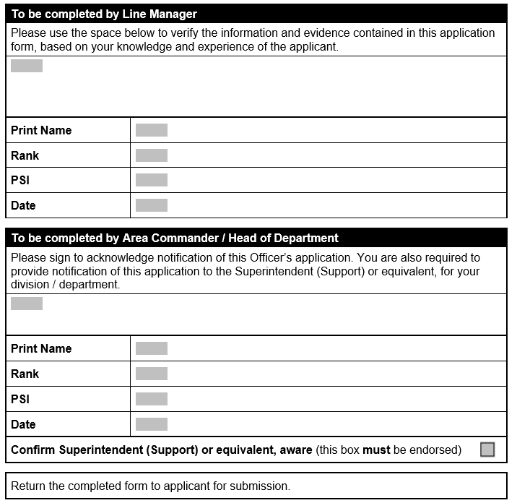

Police Staff recruitment is fully digitalised on Oleeo. There is no endorsement form, only a question in the application form:

If you are a permanent member of police staff and are applying for a temporary post or secondment your application requires your line manager’s approval before it can be considered. Please note – this will be verified by the recruitment team on receipt of your application.

Is your application supported by your line manager?

Line manager name and title

Line manager email

## 4) Do you have any policies regarding internal recruitment and if applicable specifically around the endorsement forms?

There currently is an Internal Recruitment (Police Officer) Standard Operating Procedure and a new recruitment policy currently being consulted on.

Extract regarding Applications as follows:

a) It is the responsibility of the applicant to ensure that they meet the criteria of the post. They must include evidence of their suitability for the role and how they meet the essential and desirable criteria on the application form.

b) The applicant is responsible for requesting management comments on their application, prior to submission. The applicant’s line manager should verify the contents of the application form (120-010) and may provide additional evidence of the officer’s suitability or otherwise for the post. The Equality and Diversity Employment Monitoring form (120-005) should not be seen by the line manager (See section 3.9)

c) The line manager should without delay send the form to the Area Commander/Head of Department for signature. The Area Commander/Head of Department will return the signed form to the applicant who will then forward the completed application form (120-010) together with completed Equality and Diversity Monitoring form (120-005) by email or post to (recruitment team).

d) Completed applications and associated paperwork require to be submitted to the Central Recruitment Team by the closing date advertised. Applications will be acknowledged, however the applicant is responsible for ensuring that their application has been received by the Central Recruitment Team. Applications received after the closing date will not normally be considered, and will be rejected in the first instance.

## 5) If applicable what is the procedure if a line manager and staff member disagree with the content of an endorsement form?

Application form is submitted regardless of support.

If you require any further assistance please contact us quoting the reference above.

You can request a review of this response within the next 40 working days by [email](mailto:foi@scotland.police.uk) or by letter (Information Management - FOI, Police Scotland, Clyde Gateway, 2 French Street, Dalmarnock, G40 4EH). Requests must include the reason for your dissatisfaction.

If you remain dissatisfied following our review response, you can appeal to the Office of the Scottish Information Commissioner (OSIC) within 6 months - [online](http://www.itspublicknowledge.info/Appeal), by [email](mailto:enquiries@itspublicknowledge.info) or by letter (OSIC, Kinburn Castle, Doubledykes Road, St Andrews, KY16 9DS).

Following an OSIC appeal, you can appeal to the Court of Session on a point of law only.

This response will be added to our [Disclosure Log](http://www.scotland.police.uk/access-to-information/freedom-of-information/disclosure-log) in seven days' time.

Every effort has been taken to ensure our response is as accessible as possible. If you require this response to be provided in an alternative format, please let us know.