Police Scotland Quarter 2 YTD Performance Report: April to September 2024
Contents
Introduction by the Deputy Chief Constable 2
Executive Summary 3
Performance Focus: Crimes of Dishonesty - Shoplifting 6
Key Insight: Increased User Experience Satisfaction Across All Regions 9
Vision 2030: Less Crime 11
Vision 2030: Safer Communities 25
Vision 2030: Supported Victims 42
Vision 2030: Thriving Workforce 46

This is the 2024/25 Quarter 2 performance report covering the period 01 April to 30 September 2024. All data is correct at the published date and was extracted at the start of October 2024. The data is extracted from Police Scotland internal systems which are dynamic and continuously updated as investigations progress.
This report contains the most up to date recorded crime data that was available at the start of October 2024 for Quarter 2 of the reporting year 2024/25. Further detailed Police Scotland Management Information can be found here: https://www.scotland.police.uk/about-us/what-we-do/how-we-are-performing/

Introduction by the Deputy Chief Constable
Our regular performance reports provide valuable insight into the increasingly complex nature of policing.
Policing is required to respond to community need and vulnerability as illustrated in the 2024/25 Quarter 2 Performance Report, which also details the scope of work our dedicated officers and staff deal with and how it supports our strategic outcomes.
A reduction in the number of murders, attempted murder and serious assaults, compared to last year, has contributed to an overall decrease in serious violent crime. Outstanding investigations by divisional, national and specialist teams has seen every homicide committed in the first two quarters of 2024/2025 solved.
The report highlights that, with levels now higher than seen pre-pandemic, shoplifting is the main contributor to the increase in crimes of dishonesty. This can be attributed to societal factors, including the cost of living and organised criminality, and officers continue to work in partnership to co-ordinate action and tackle the issue.
Our Policing in a Digital World programme is transforming how we are continuing to respond to the threat from cybercrime. Most recently, we announced our support for Police CyberAlarm – which helps businesses understand and monitor malicious cyber activity.
The report also details ongoing action by officers to disrupt the activities of serious organised crime groups. Pro-active, intelligence-led operations have resulted in millions of pounds of illegal drugs being seized and dozens of people being arrested. Work by our officers has also seen over £30 million being considered for forfeiture and confiscation under Proceeds of Crime legislation.


DCC Alan Speirs
Deputy Chief Constable Professionalism, Strategy and Engagement

Executive Summary

Introduction
This is the second Quarterly report of the 2024/25 performance cycle, reporting on our Performance and Accountability Framework. Our operational focus in 2024/25 is on threat, harm, and risk, focusing on prevention, problem solving and proactivity, and looking after our hard-working officers and staff to enable our people to deliver our vital public service. We will work to strengthen community policing across Scotland and engage widely as we begin to change the way in which we prioritise and deliver services to focus in the right areas.
Our outcomes focused Performance Framework is linked to our strategic planning processes and aligns to the Strategic Outcomes as detailed in the Annual Police Plan 2024/25, these being:
Strategic Outcome 1: Public Safety and Wellbeing – threats to public safety and wellbeing are resolved by a proactive and responsive police service
Strategic Outcome 2: Needs of Local Communities – the needs of local communities are addressed through effective service delivery
Strategic Outcome 3: Confidence in Policing – the public, communities and partners are engaged, involved and have confidence in policing
Strategic Outcome 4: Working Environment – our people are supported through a positive working environment, enabling them to serve the public
Strategic Outcome 5: Sustainable and Adaptable Service – Police Scotland is sustainable, adaptable and prepared for future challenges
The Chief Constable’s Priorities are at the centre of our approach to performance. Our Strategic Threat and Risk Assessment provides the evidence base for our areas of highest Threat, Harm and Risk (Force Control Strategy), Annual Policing Plan and Performance Framework.
Our Values and Code of Ethics underpin our approach to performance management which is vital to maintain and strengthen public confidence and trust in the Service. Learning from others and sharing best practice is critical and we will benchmark with other relevant bodies where possible, using the PEEL Assessment Framework as appropriate.
During this quarter, the Chief Constable has launched the Police Scotland 2030 Vision. Our Vision provides the service with a clear, aspirational direction of travel to shape the development of Police Scotland. Our 2030 Vision is for safer communities, less crime, supported victims and a thriving workforce. To achieve this, we will:
Support reductions in overall crime in Scotland;
Respond effectively to threats to public safety;
Deliver the best possible service for the public and communities of Scotland through effective community policing;
Ensure that victims are fully heard and supported, with our service more tailored to victim needs through our trauma informed approach;
Work with partners to ensure vulnerable people are able to access appropriate care at the right time;
Be an inclusive, anti-racist and anti-discriminatory organisation that takes a firm stance on inappropriate conduct;
Improve employee welfare and wellbeing, ensuring our diverse workforce is more supported in doing their best work each day.
The first section of the report provides a deep dive into crimes of dishonesty, with a focus on theft by shoplifting and key insights on overall satisfaction from our User Experience Survey. The report is structured under Less Crime, Safer Communities, Supported Victims and Thriving Workforce as per the Chief Constable’s Vision 2030 report.
Examples of good proactive/preventative policing activity has been highlighted in the following areas:
Young People and Violent Crime
Operation Moonbeam
- The Banking Protocol
High Harm Drugs
Substance Harm Prevention
Road Policing Campaigns
Local insights are provided within this report that include disaggregated data. The following is a key to each of the 13 local policing divisions included in these comparisons:

Divisional Identification Key
North Region | East Region | West Region
A – North East | C – Forth Valley | G – Greater Glasgow
D – Tayside | E – Edinburgh | U – Ayrshire
N – Highland & Islands | J – The Lothians & Scottish Borders | Q – Lanarkshire
 | P – Fife | L – Argyll & West Dunbartonshire
 |  | K – Renfrewshire & Inverclyde
 |  | V – Dumfries & Galloway
Crime and incident data is included within this report, illustrated in bar charts with sparklines, to show trend data where appropriate.
The period with the highest volume of crimes/incidents is highlighted in red in the bar chart sparkline. The six-month sparklines cover the period April to September 2024 whilst the five-year sparklines cover Quarter 2 YTD from 2020/21 to 2024/25.
This report provides insight into the complexities of delivering strong performance, aligned to areas of greatest threat, harm and risk, in line with our organisational values.
All data is classed as Management Information and is not considered official statistics. All data is sourced from Police Scotland internal systems.

Performance Focus: Crimes of Dishonesty - Shoplifting
The national strategic assessment 2023/2028 identified crimes of dishonesty as a Substantial Operational Policing Priority. Shoplifting crimes continues to be the main contributor to the increase in crimes of dishonesty and are now at higher levels than those seen pre-pandemic, with Retailers Against Crime (RAC) highlighting an increase in high-value thefts alongside escalations in violence against retail workers.
Key findings include:
22,806 shoplifting crimes have been recorded YTD, an increase of 18.8% on last year and up 60.5% on the five-year mean.
Shoplifting crimes have increased by 6,618 (up 40.9%) compared to the pre-COVID-19 year of 2019/20
The detection rate for theft by shoplifting sits at 48.1%, down 0.2 percentage points compared to the same period last year
Greater Glasgow Policing Division recorded the highest level of crime per division, accounting for 18.4% of all thefts by shoplifting. This is closely followed by Edinburgh Policing Division which accounts for 17.5% of the total.
Monday was the most common day for shoplifting, although the peak time for theft by shoplifting was Wednesdays between 1600 and 1700hrs. The daily peak is between 1500 and 1700hrs and which is potentially linked to retail establishments being targeted when schools close as secondary school student features as the second highest suspect/accused occupation.
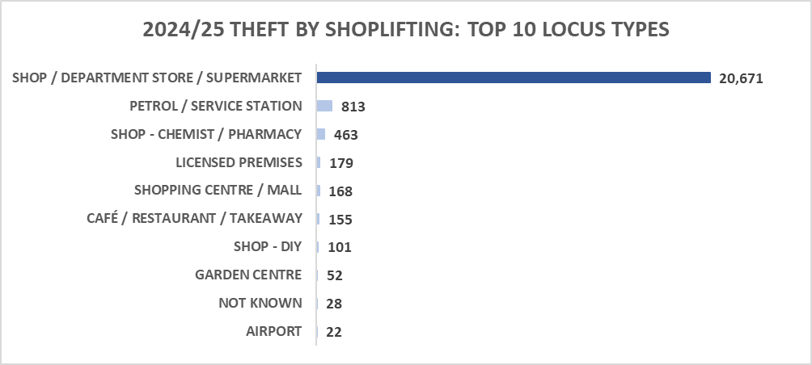
The majority of theft by shoplifting crimes continue to be committed at supermarkets/department stores with 90.4% of shoplifting crimes occurring at this locus.

Of the 10,963 crimes detected during the analysis period, 4,331 individuals were identified as accused.
Year-to-date, the reoffending rate has increased by 3.5% to 45.5% with 2,076 repeat offenders identified during this period.

Retail Crime Drivers
The cause of the rise in retail crime can be attributed to a number of societal factors;
Cost of Living - Our analysis indicates, the majority of the increase in shoplifting is within urban conurbations and there is correlation to Scottish Index of Multiple Deprivation.
Serious Organised Crime - Organised crime groups travel throughout the UK carrying out high-value and bulk thefts from retail outlets, often disguising themselves to prevent recognition.
Changes in Retail Environment - Self-checkout and non-confrontation policies increase the opportunity for shoplifting, and we continue to work collaboratively to adapt to the changing environment and target harden retail premises.
Peer Pressure - As shown by our data analysis, young people come into conflict with the law frequently regarding shoplifting. This may be directly linked to economic hardship but also as a result of peer pressure, gang involvement or opportunism. We are working with education colleagues to address the underlying issues that may lead young people into criminality.
Addiction - Addiction is a significant contributing factor to retail crime with some individuals committing retail crime to fund this.
Assaults of Retail Workers – There has been a 10.3% increase in common assaults of retail workers compared to the same period last year, increasing from 1,337 to 1,475. Of these assaults, 214 have been recorded as resulting in an injury. Specific crime types for the recording of serious assaults, common assaults and threatening or abusive behaviour of retail workers commenced from August 2021.

National Acquisitive Crime Group
Police Scotland Chair the National Acquisitive Crime Group working with external partner agencies across Scotland to identify issues, coordinate action and prevention opportunities.

National Rural, Acquisitive & Business Preventions Team
Police Scotland’s National Rural, Acquisitive & Business Preventions team (RAB-PT) along with the Children and Young People (CYP) Unit are progressing an education package in conjunction with RAC for school aged children. This will be rolled out at engagement days in secondary schools in response to this age group being the highest growing demographic for shoplifting.
De-escalation training and lone worker training has been developed by the RAB-PT and will be delivered by local prevention teams regionally to retail workers.

Key Insight: Increased User Experience Satisfaction Across All Regions
Overall satisfaction with Police Scotland is up 2.7% points on last year, this equates to over two-thirds of respondents to our User Experience Survey in the YTD. The six-month sparklines shows satisfaction levels have been going on an upward trend since Quarter 1 into Quarter 2 with over 70% satisfaction in August and September 2024.
A positive experience with police service is strongly associated with feelings of fair treatment, respect and being informed. This is linked to behaviours such as: listening without judgement; empathy and understanding; openness and transparency; showing respect in all actions; and apologising if a mistake has been made.
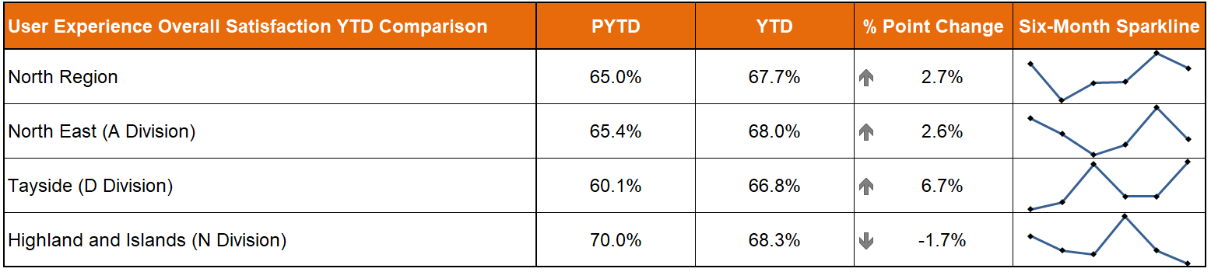
The North region is up 2.7% points on last year with increases noted in the North East (up 2.6% points) and Tayside (up 6.7% points). Tayside has recorded the third highest percentage point increase across all of Scotland.
Highland and Islands, whilst down on last year, have still recorded the highest satisfaction rate in the region at 68.3%. The division’s sparkline however is showing a downward trend in Quarter 2.
All three divisions have had at least one month this YTD where overall satisfaction was recorded above 75% with a high of 76.4% in North East in August, 76.8% in Tayside in September and 78.9% in Highland & Islands in July.
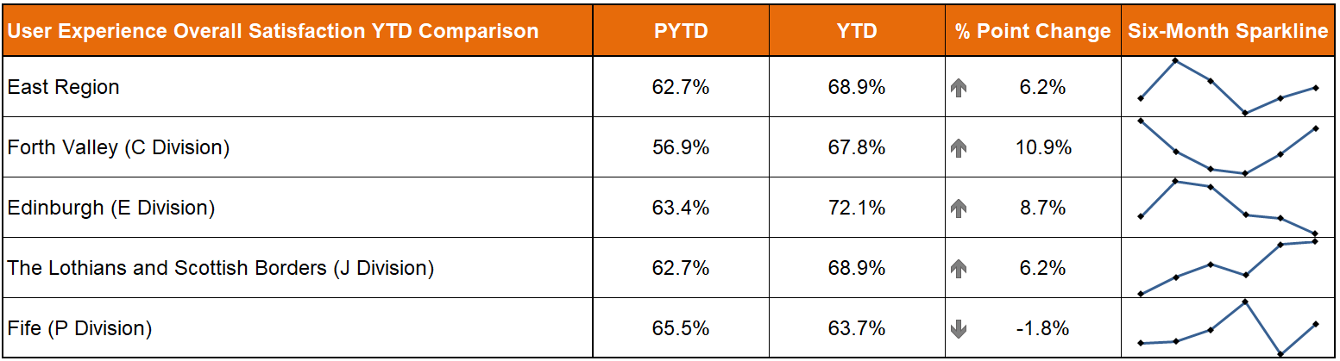
The East region is up 6.2% points on last year, which is the largest percentage point increase across all of the regions. Significant increases are noted in Forth Valley (up 10.9% points), Edinburgh (up 8.7% points) & The Lothians and Scottish Borders (up 6.2% points). These increases are the first, second and fourth largest respectively across the country. Edinburgh is one of only four divisions to record overall satisfaction levels above 70%.
All three divisions have had at least one month this YTD where overall satisfaction was recorded above 70% with a high of 75.0% in Forth Valley in April, 77.1% in Edinburgh in May and 72.1% in The Lothians and Scottish Borders in September.
Fife (down 1.8% on last year) has recorded the largest percentage point decrease in the country and has the lowest satisfaction amongst all 13 divisions. Satisfaction levels in Quarter 2 are however up slightly on Quarter 1 with a YTD high of 65.3% in July 2024.
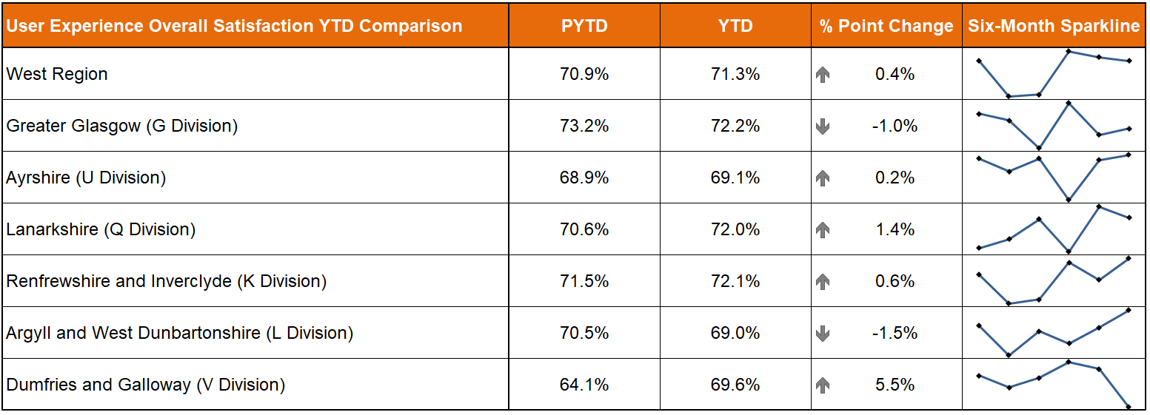
The West region is up 0.4% points on last year. Whilst this is the smallest percentage point increase of the three regions, the West still remains the region with the biggest satisfaction levels at 71.3%. Increases are noted in four of the six divisions within the region.
Greater Glasgow is down 1.0% points on last year however the division has still recorded the highest satisfaction rate of all 13 divisions with YTD overall satisfaction of 72.2%. Strong overall satisfaction levels are noted across the region with Lanarkshire (72.0%) and Renfrewshire & Inverclyde (72.1%) also above the Police Scotland satisfaction rate of 69.7%.
Ayrshire (69.1%), Argyll and West Dunbartonshire (69.0%) & Dumfries and Galloway (69.6%) are all just slightly below the force average but still performing strongly.
All six divisions have had at least one month this YTD where overall satisfaction was recorded above 70% with a high of 75.7% in Greater Glasgow in July; 71.4% in Ayrshire in September; 75.2% in Lanarkshire in August; 78.4% in Renfrewshire and Inverclyde in September; 73.3% in Argyll and West Dunbartonshire in September; and 76.5% in Dumfries and Galloway in July.

Vision 2030: Less Crime
The following sections have all been aligned under Vision 2030: Less Crime for the purposes of this Quarter 2 report. Some business areas however could potentially be aligned under multiple commitments. This will be developed further in future reporting.

Overall Crimes and Offences
The following table shows management information relating to Groups 1-8 crimes and offences, recorded by Police Scotland YTD at the end of Quarter 2, compared to the previous five years and the previous year-to-date.
The total number of overall crimes and offences shows an increase compared to last year, up 3.2%, (7,673 more crimes and offences) and has also increased against the five-year mean (up 2.4%, 5,802 more crimes and offences). All crime groups are up on last year bar Group 1 and 4. Whilst Group 1, 2, 3 and 7 crimes and offences are driving the increase against the five-year mean.
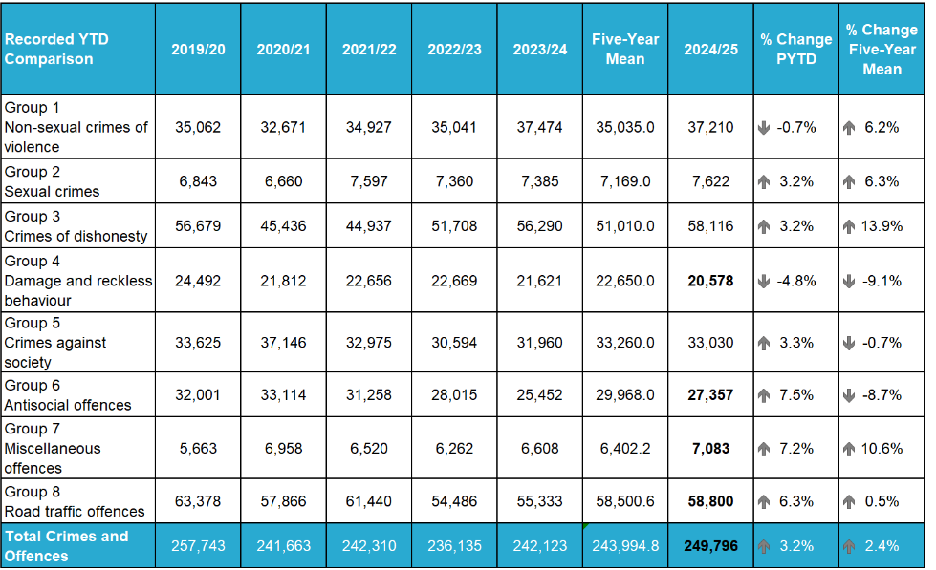
NOTE: Pentip is a cross-criminal justice platform used by all police forces in England, Scotland and Wales. It records and processes Fixed Penalty Notices (FPNs) and Conditional Offers for vehicle-based offences, such as speeding and red-light offences. Due to a technical issue, please note the figures shown in bold have been manually adjusted and work is ongoing to resolve recording issues.
The following table shows the detection rate over the last five years by group including the overall detection rate. The overall detection rate, for all crimes and offences, is showing an increase compared to the previous year (up 2.0 percentage points) but a decrease compared to the five-year mean (down 1.5 percentage points). Processes around detection rates are multi-faceted and complex. They can be split into three broad headings: Demand; Organisational and Audit. The following could be considered some of the influencing factors both in terms of time to detect, and capability to detect: increases in historical crimes; training; cyber-related crime; resourcing challenges; and evidential demand increase.
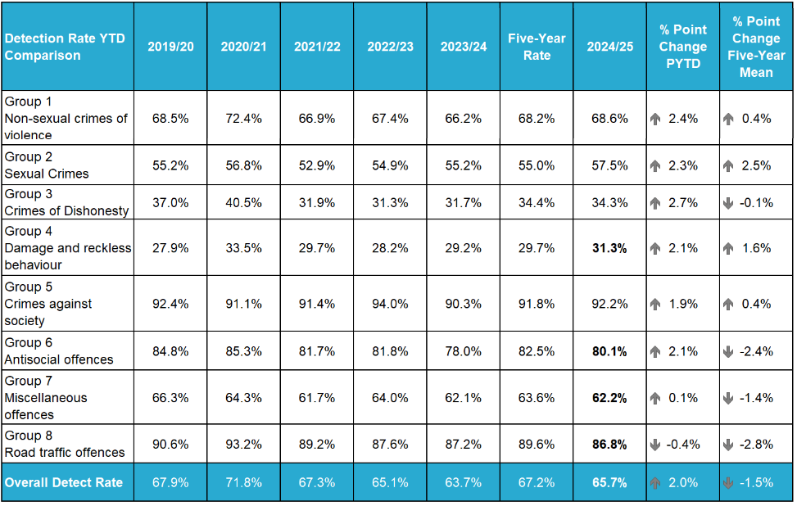

Benchmarking Overall Total of Reported Crimes
The crime statistics for England and Wales, covering the 2023/24 period (April 2023 to March 2024), indicated a 1% decrease in reported crimes. In contrast, when benchmarked to Police Scotland's data for the same period, reported crimes increased by 4% compared from the previous year.

Violent Crime (Strategic Outcome 1)
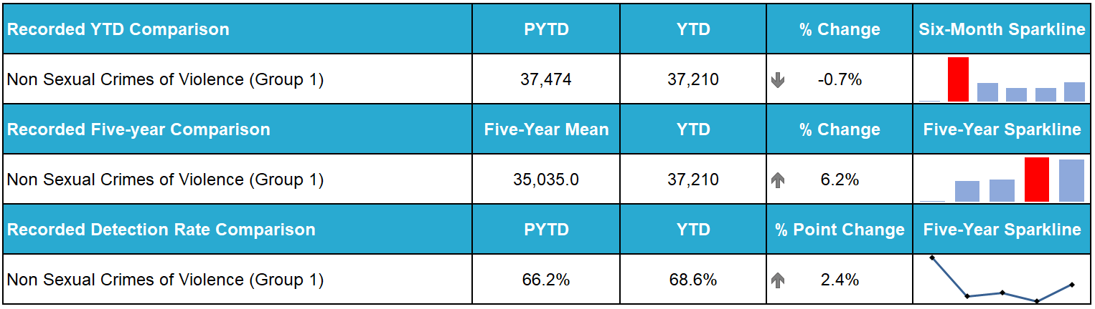
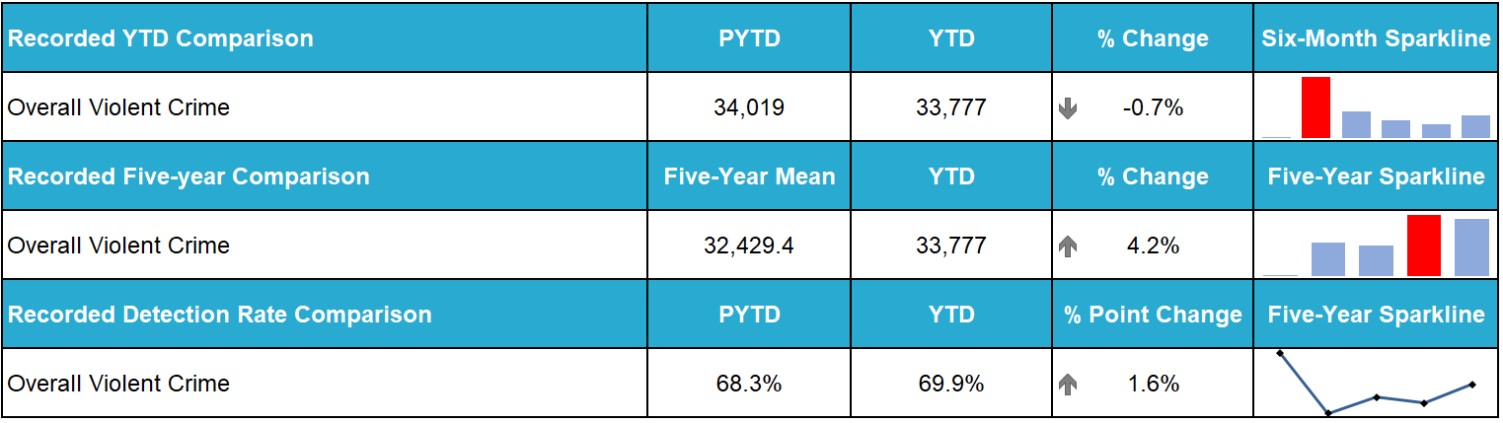
Non-sexual crimes of violence decreased by 0.7% (264 fewer crimes) compared to last year. This is largely shaped by the trends seen in common assault as these crimes account for 83.4% of all Group 1 crime. This also means Group 1 crime is up 6.2% compared to its five-year-mean. Within non-sexual crimes of violence, the following crime types are grouped together under the banner of overall violent crime: murder, culpable homicide (common law), attempted murder, serious assault, robbery, common assault and common assault (of emergency worker).
Serious violent crime, such as homicide, attempted murder and serious assaults, have all decreased when compared to last year and the five-year mean.
There were 21 homicides recorded during the first half of 2024/25 compared to 33 in the same period in 2023/24. This crime has a five-year-mean of 33 for April to September. This notable reduction is, in large part, due to there only being five during the Quarter 2 period (June to September 2024). This is the lowest recorded number of homicides for this period since the inception of Police Scotland in 2013 – the previous lowest being 13 homicides in April to June 2022.
All homicides recorded in the first two quarters of 2024/25 have been detected.
Higher volume violent crime has, however, shown an increase long-term. Despite a 0.2% decrease from last year, the 31,039 common assaults recorded between April and September represents a 5.1% increase on the five-year-mean.
While the impact of COVID-19 and related lockdowns does skew the five-year-mean downwards due to lower than usual volumes of crime in 2020/21, this year’s common assault figure is still the second highest in the last six years.
The detection rate for common assaults has also improved this year, with 69.1% of these crimes being detected – an increase of 1.5% points from last year and 0.8% points from the five-year-mean detection rate.
Robberies, of which 968 were recorded, also saw a decrease from last year (down 2.6%) however an increase of 14.2% on the five-year-mean. Robberies currently have a 75.3% detection rate, which is a slight decrease from last year (down 0.1% points) and the five-year-mean (down 0.3% points). A summary of recent robbery analysis was included in the Quarter 1 report.
In addition to the crimes above which comprise overall violent crime, non-sexual crimes of violence also include a variety of other crime types such as Domestic Abuse Scotland Act offences (covered later in the report under domestic abuse update), stalking, cruel & unnatural treatment of children and threats & extortion.
Stalking and cruel & unnatural treatment of children continue to show increases. Greater detail on these crime types and the reasons for these increases can be found in the Quarter 1 report.
Threats and extortion crimes, of which 880 were recorded between April and September, are down 38.0% from last year. 2024/25 is the first year since counting rules for this crime type were updated in 2020/21 to see a decrease from the previous year.
Proactive/Preventative Policing – Young People and Violent Crime
Over the last quarter, the Scottish Violence Reduction Unit (SVRU) launched the “Quit Fighting For Likes” social media campaign. This campaign gained significant traction and media coverage. A training product created in line with the campaign will be delivered to Campus Officers at development events being arranged for December 2024.
Members of the SVRU, along with various other organisations and charities, met with King Charles at an event at Dumfries House for a “round table” discussion on the importance of opportunities for young people. Media coverage of the event provided promotion opportunities of the approach being undertaken by SVRU and a follow up meeting has been scheduled with the Princes Trust to discuss future partnership working opportunities.
The “You, Me Together” resource has been rolled out on the I AM ME Scotland Platform for use by police, education and health care workers. This resource is designed to help discuss matters such as domestic abuse, teenager relationships and coercive and controlling behaviours with young people.
Digital World, a joint campaign being run by Police Scotland and Fearless, is due to commence on 18 November 2024 and is being delivered from the Scottish Prevention Hub at the Edinburgh Futures Institute in the University of Edinburgh (more details regarding this can be found in the Quarter 1 report).

Public Protection (Strategic Outcome 1)
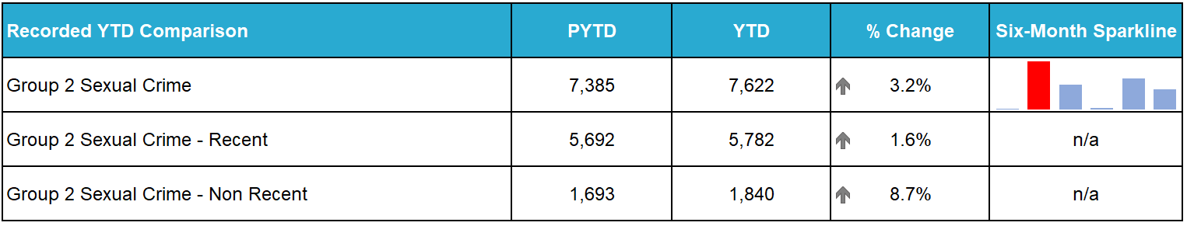
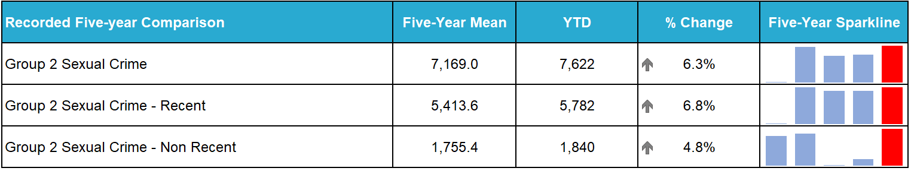
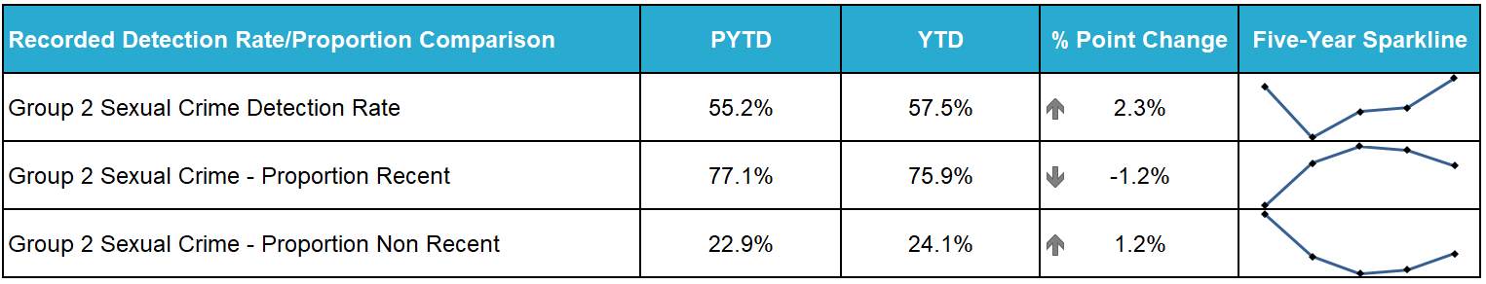
Note: Detection rate comparison used for Group 2 Sexual Crime. Proportion comparison used for Group 2 Sexual Crime – Recent and Group 2 Sexual Crime – Non-Recent.
Overall sexual crime noted an increase compared to last year, up 3.2%, (237 more crimes) and increased against the five-year mean (up 6.3%, 453 more crimes).
The detection rate of overall sexual crime is 57.5%, an increase of 2.3 percentage points against last year.
Non-recent sexual crime continues to increase with the proportion of non-recent sexual crime recorded increasing from 22.9% last year to 24.1% during the reporting period this year.

Rape (Strategic Outcome 1)
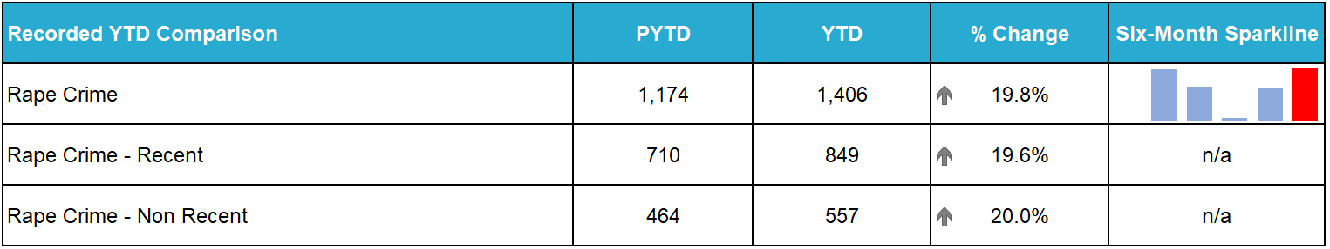
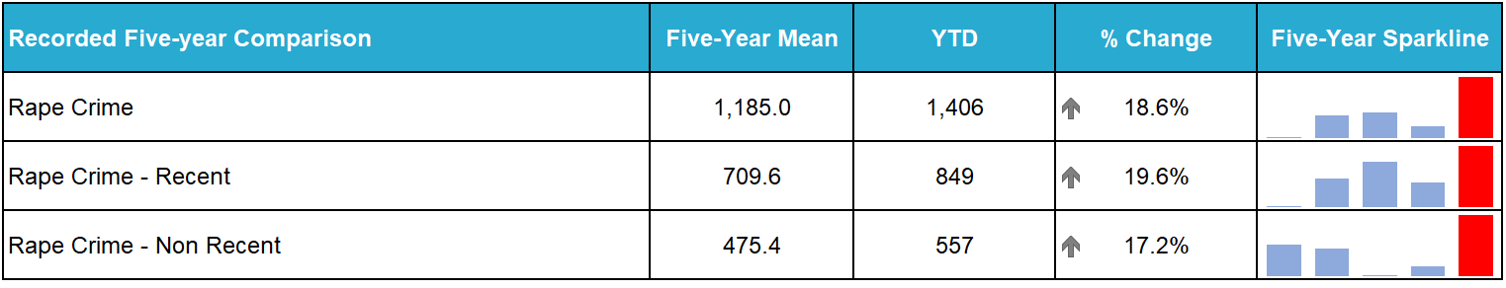
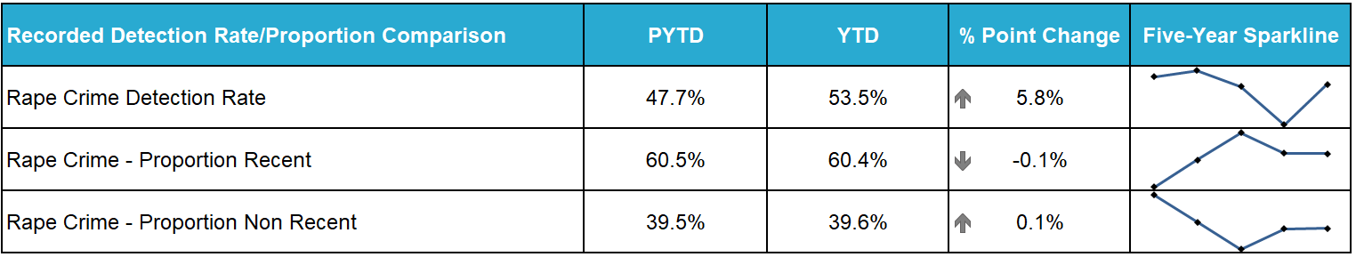
Note: Detection rate comparison used for Rape Crime. Proportion comparison used for Rape Crime - Recent and Rape Crime - Non-Recent.
Rapes reported to police increased during Quarter 2 compared to last year by 19.8% (232 more crimes) and increased against the five-year mean by 18.6% (221 more crimes). Rape of a female over 16 continues to drive the increase in overall rape (up 16.4% 134 crimes against last year). All crime categories within rape note an increase compared to last year with the exception of females under 13, decreasing against last year and the five-year mean.
Greater Glasgow and The Lothians and Scottish Borders Divisions have recorded the highest volume of rapes than in the same period in any other year and continue to have the greatest increase compared to any other division across the Force.
Analysis is ongoing to better understand increases in volumes of rape across the Service.

Child Sexual Abuse Online (Strategic Outcome 1)
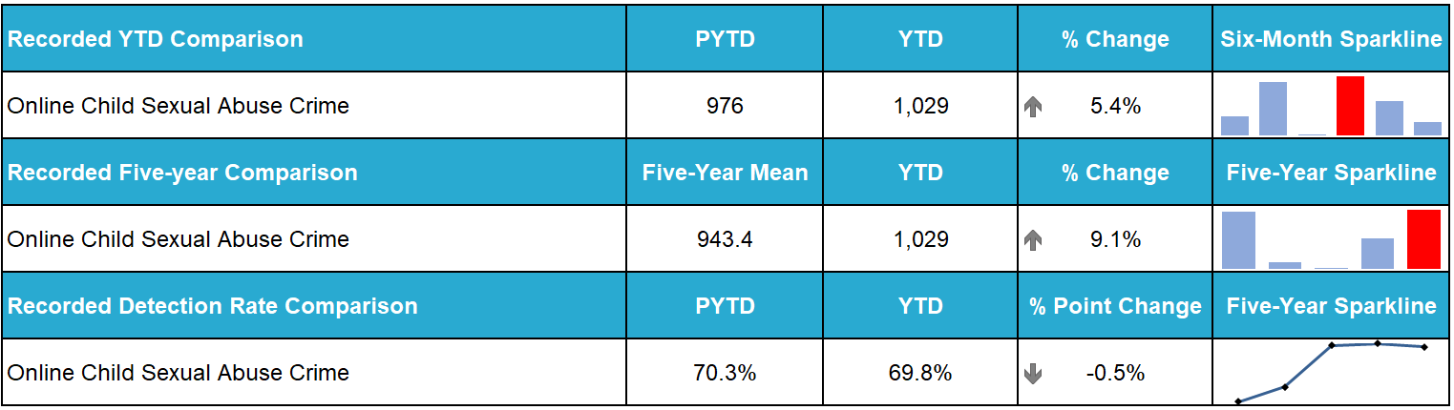
Online child sexual abuse crimes increased compared to the same period last year (up 5.4%, 53 crimes) and against the five-year mean (up 9.1%, 86 crimes).
The number of online child sexual abuse crimes recorded each month from April to September have been relatively static.
Overall, the detection rate for online child sexual abuse is 69.8%, a slight decrease compared to last year (70.3%) and an increase compared to the five-year mean (66.3%).

Child Sexual Abuse Online – Crime Types
All classifications of online child sexual abuse noted an increase compared to last year, except for grooming and communicating indecently male and female under 13. Grooming of children for the purposes of sexual offences decreased by seven crimes compared to last year and by 15 crimes against the five-year mean. The number of communicating indecently with male / female under 13 crimes are down 16.5% (27 crimes) compared to last year and also down slightly against the five-year mean.

Domestic Abuse (Strategic Outcome 1)
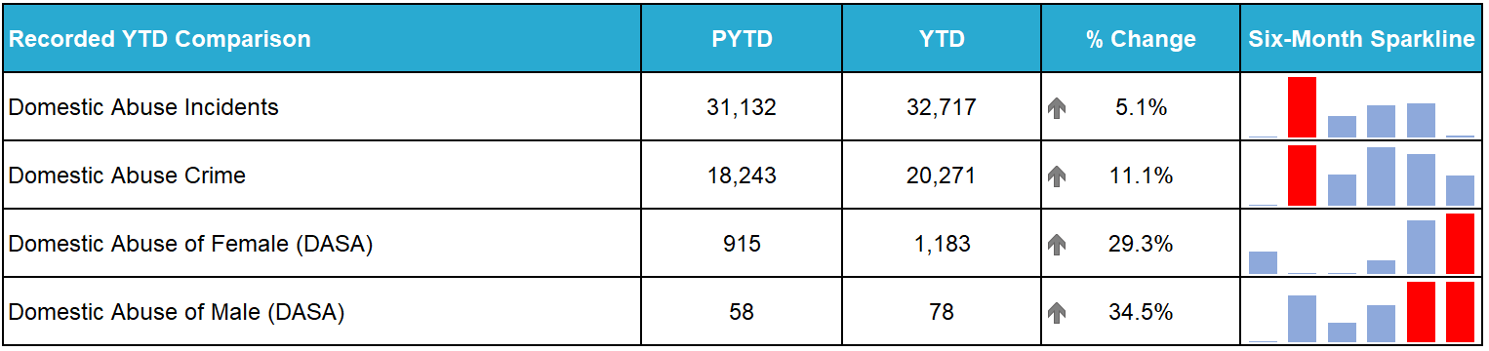
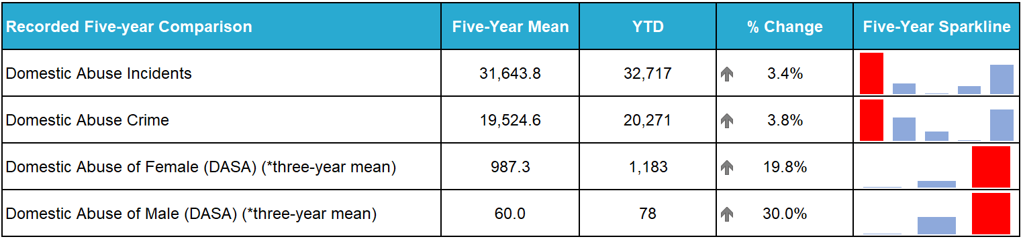
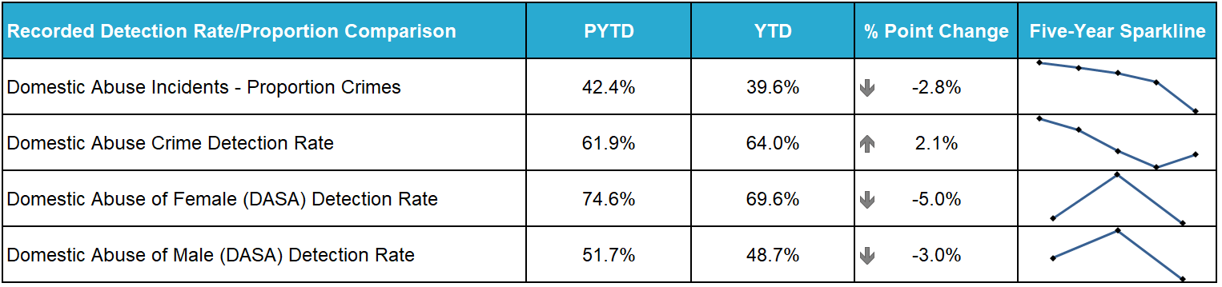
Police Scotland has moved to a new single national crime recording system (National Unifi), which is capable of recording domestic related crimes. Previously, due to limitations in legacy crime recording systems, domestic crime was recorded and counted in the Vulnerable Person Database. From 01 April 2024, all crime data (including domestic abuse) now comes from the same system. Please refer to the Quarter 1 SPA Performance Report for an example of the differences in methodology.
Domestic abuse crimes have increased compared to last year, up 11.1% (2,028 crimes) and against the five-year mean (up 3.8%, 747 crimes), Domestic incidents also noted an increase, up 5.1% (1,585 incidents) against last year and up 3.4% (1,074 incidents) against the five-year mean.
Overall DASA crimes increased by 29.6% (288 crimes) with DASA of a female increasing by 268 crimes and DASA of a male increasing by 20 crimes compared to last year.
Two domestic homicides were recorded during the reporting period, both of which were committed in June 2024. Both domestic homicides have been detected.

Disclosure Scheme for Domestic Abuse Scotland (DSDAS)
During the reporting period DSDAS applications have increased by 30.8% overall, with a 21.6% increase in Power to Tell (PTT) applications and a 52.2% increase in Right to Ask (RTA) applications, compared to the same period last year. Traditionally, the larger increase is noted in the PTT pathway (Police Generated) however, this year the largest increase has been noted in the RTA pathway. This may suggest an increase in awareness and/or confidence in our approach to domestic abuse.

Hate Crime (Strategic Outcome 2)
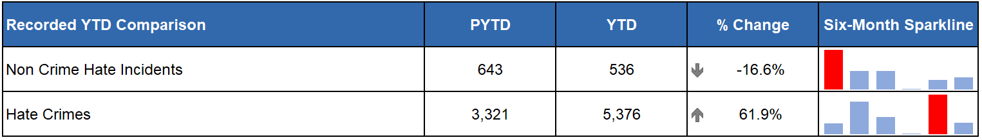
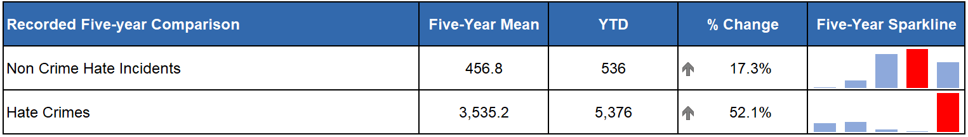
Please note due to changes in legislation introduced on 01 April 2024, direct comparisons to previous years should not be made and are for illustrative purposes only.
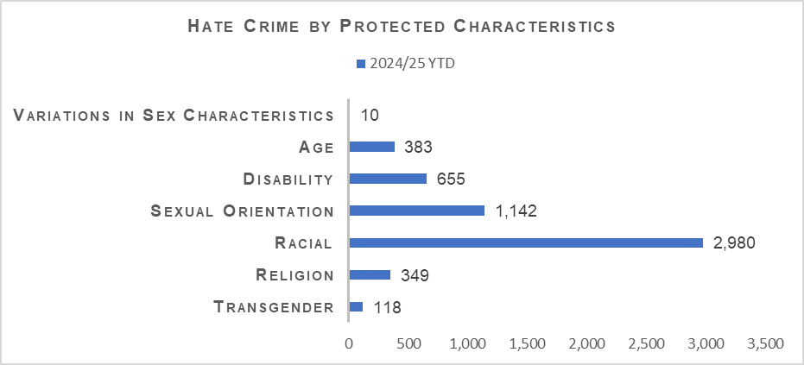
Hate crime continues to be that which is predominantly aggravated by racial or sexual orientation, amounting to 52.9% and 20.3% of total aggravators across the reporting period.
Despite the significant increase in recorded hate crimes this year the detection rate has also increased (up 3.3% points from PYTD).

Hate Strategy for Scotland
A dedicated team of staff was pulled together to develop a new Responding to Hate Policy and supporting Standard Operating Procedure (SOP). There were 19 recommendations identified during the development of the SOP and consultation phases. The Hate Crime Working Group will now be reinvigorated for discussion of the 19 recommendations with a view to remain a forum for hate crime discussion going forward. There is a planned six-month review to take place of the SOP which will be due in February 2025.
Work is also ongoing with Scottish Government in partnership with the Hate Crime Strategic Partnership Group to undertake meaningful lived experience engagement to further understand how we can best tackle hatred and prejudice.

British Sign Language (BSL)
ACC Policing Together has signed off the BSL face to face interpreting Data Protection Impact Assessment (DPIA) allowing the Video Remote Interpreting (VRI) work to progress. Part 1 of a VRI DPIA has been drafted and is currently with Information Assurance for review and the team are awaiting update.
Human Resources are currently reviewing their section from the action plan and once complete this can then be published. The team are awaiting update from Smart Thinking in respect of the BSL training bid submitted. At present the team are working with procurement and interpreter agencies to identify service improvements for face-to-face deployments following feedback from other Divisions.
Work is ongoing with the Domestic Abuse Coordination Unit on promotion of the new BSL domestic abuse resources with support from corporate communications.

Anti-social Behaviour and Disorder (Strategic Outcome 2)
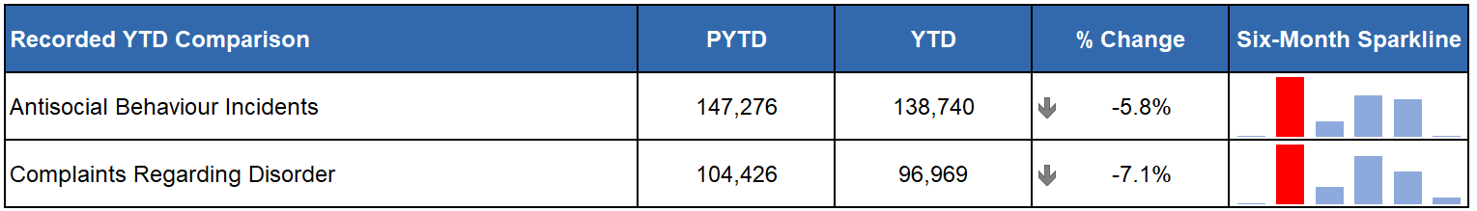
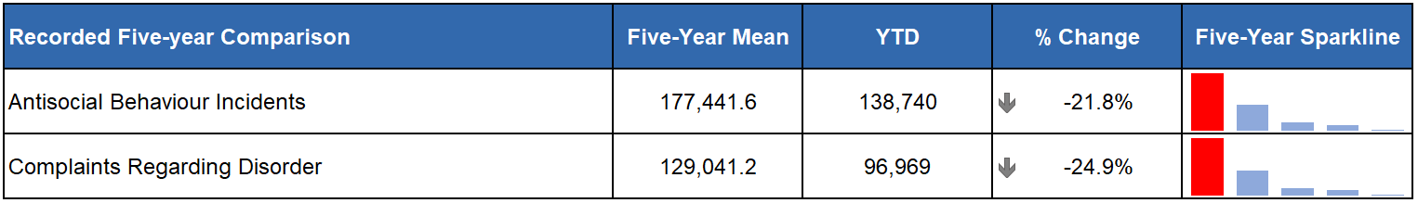
The number of incidents of anti-social behaviour (ASB), and the number of complaints of disorder, recorded by Police Scotland continue to be at their lowest levels for the period in recent years. With the exception of Dumfries & Galloway, which saw a very slight (2.6%) increase in complaints of disorder from last year (and which was still 17.6% lower than their five-year mean) every police division saw decreased levels of ASB incidents and complaints of disorder short and long-term this period.
There were a total of 27,357 anti-social offences recorded during the April to September period. This represents an increase of 7.5% from last year, however a reduction from the five-year mean of 8.7%. Anti-social offences include breach of the peace, consuming alcohol in designated places, drunk & incapable behaviour, hate aggravated conduct, threatening or abusive behaviour, urinating in public and other alcohol related offences.
Threatening or abusive behaviour made up most of the total anti-social offences, accounting for 81.6% of the crimes in this category.
Proactive/Preventative Policing – Operation Moonbeam
Policing Together’s Violence Prevention and Licensing Coordination Unit (VPLCU) continue to support Operation Moonbeam (the national public order response to prevent violence and disorder over the bonfire period) in both the prevention phase and the implementation of Firework Control Zones.
As part of this, VPLCU will provide an on-call service during key dates throughout the bonfire period to offer legislative advice. In collaboration with Scottish Fire and Rescue Service and Fearless, we are delivering safety inputs to children on the dangers of fireworks and pyrotechnics.

Crimes of Dishonesty (Strategic Outcome 2)
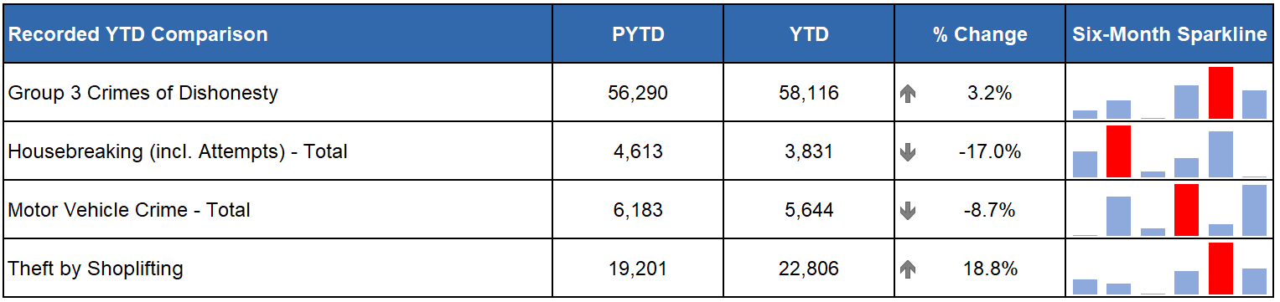
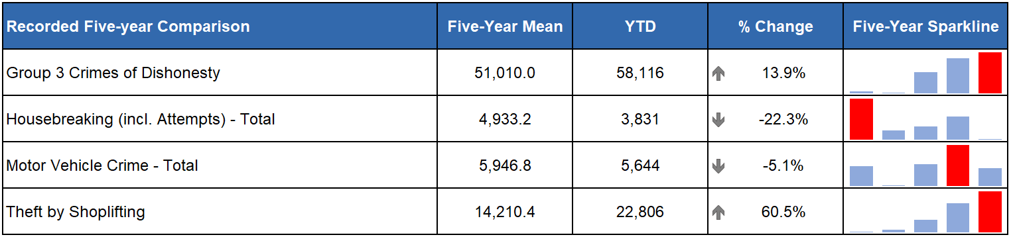
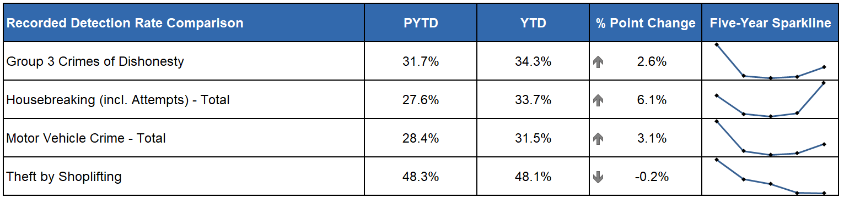
Crimes of dishonesty continue to increase compared to the previous year (up 3.2%) and the five-year mean (up 13.9%). It should be noted that the five-year mean has been affected by the COVID-19 period where there was a significant decrease in the number of crimes of dishonesty recorded. Comparing to the first year before COVID-19 (2019/20) the current figures are slightly increased (1,437 more, up 2.5%).
If Theft by Shoplifting is removed from the overall crimes of dishonesty total, there is a decrease of 1,779 crimes (down 4.8%) compared to the previous year. Aside from Theft by Shoplifting, which has risen by 18.8% compared to the previous year, there have also been significant increases in Attempted Theft of a Motor Vehicle (62 more crimes, up 24.7%) and Opening Lockfast Places (not motor vehicle) which increased by 135 crimes (up 20.2%).
Despite the overall increase in crimes of dishonesty there were decreases in Overall Housebreaking crimes, which decreased by 782 (down 17.0%), Opening Lockfast Places (motor vehicle), down 174 crimes (13.6%) and in Theft from a Motor Vehicle, insecure, which decreased by 213 (down 9.8%).

Shoplifting
Crimes of shoplifting account for 39.2% of all crimes of dishonesty and are continuing the upwards trend observed in the previous two years. Shoplifting crimes have increased by 6,618 (up 40.9%) compared to the pre-COVID-19 year of 2019/20. Compared to the same period last year there has been an increase of 3,605 crimes (up 18.8%) and all regions of Scotland are continuing to experience increases for this crime type.
The detection rate for shoplifting crimes has decreased by 0.2 percentage points to 48.1%. This is despite an increase in detections YTD, rising 18.3% (1,697 detections) to 10,963.

Housebreaking
Overall housebreaking crimes have decreased by 782 crimes (down 17.0%) on last year and decreased by 1,102 crimes (down 22.3%) compared to the five-year mean. When compared to the pre-COVID-19 year of 2019/20, there has been an overall decrease of 2,571 (down 40.2%) crimes.
Detections have increased 1.4% (18 more detections) compared to the same period last year, leading to a 6.1 percentage point increase in detection rate which now sits at 33.7%.

Vehicle Crime
Motor vehicle crime has decreased compared to the previous year (539 fewer, down 8.7%) and compared to the five-year mean (303 fewer, down 5.1%). There has been a significant decrease in motor vehicle crime compared to the pre-COVID-19 period, with 1,232 (down 17.9%) fewer crimes. The only crime under this grouping which has increased compared to the previous year is Attempt Theft of Motor Vehicle which has observed an increase of 62 crimes (up 24.7%). Detections for motor vehicle crimes have slightly increased by 1.1% with the detection rate up 3.1% points on last year.

Fraud
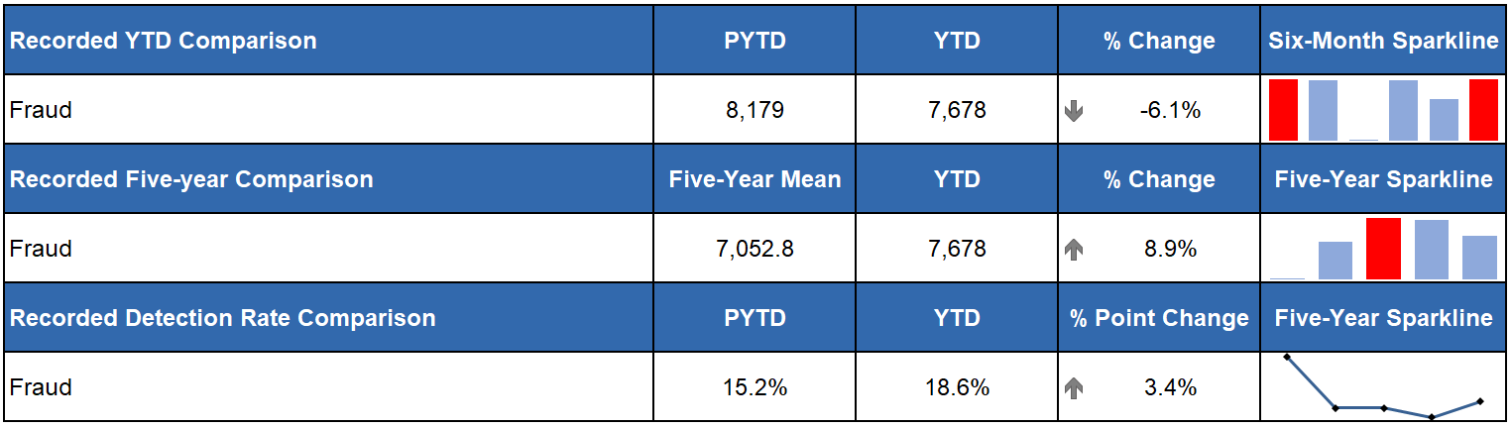
The decrease in recorded fraud crimes has continued this quarter and are now down 6.1% on the same period last year (501 fewer crimes). Compared to the five-year mean there remains an increase of 8.9% and the current total is still higher than the pre-COVID-19 period by 2,586 (up 50.8%). The detection rate for fraud has seen an 3.4% point increase compared to the same period last year, however this remains 12.7% points below the pre-COVID-19 detection rate in 2019/20.
In September 2024, Policing in a Digital World Project (PDWP) began the governance journey that describes Police Scotland’s vision to enhance its current model to improve the investigation and response to the threat of Fraud through the Fraud Strategy and Operating Model Project.
Support and engagement continue with the NPCC Lead for Cyber and Fraud, the City of London Police, in relation to their delivery of the new Fraud and Cybercrime Reporting and Analysis Service (FCCRAS).
It has been recognised that to support the organisation’s ability to effectively and efficiently respond to Fraud and Cyber incidents, Police Scotland should seek to align our approach along with other UK LEA’s. This will include changing our internal structures to create a Fraud Cyber Command.
Proactive/Preventative Policing - Identifying Vulnerable Victims of Fraud: The Banking Protocol
The Banking Protocol is a multi-agency initiative between law enforcement, banking institutions and Trading Standards. Its aim is to identify vulnerable victims at the earliest opportunity, who are in the process of being defrauded of funds from their bank accounts by unscrupulous criminals and to intervene to prevent these crimes.
If staff suspect customers are being coerced or the transaction is as a result of fraud, the transaction is stopped, and the Police are contacted.
The Protocol is designed to provide a standardised method for how these concerns are dealt with and reported to police and to stop multiple victimisations.
In terms of Quarter 2 of the reporting year 2024/25, the Banking Protocol recorded 265 incidents accounting for £946,930 of fraud being prevented.
This initiative continues to succeed in protecting the vulnerable victims of fraud and its success demonstrates the value of the public / private partnership model.
YTD there have been 495 incidents accounting for £2,090,467 of fraud prevented.
A recent example during September involved a 61-year-old female who fell victim to a romance scam. She attended the branch requesting to send £45,000 to a third party in Türkiye providing multiple explanations including building work and sending funds to her husband.

Cybercrime (Strategic Outcome 2)
Policing in a Digital World (PDWP) aims to transform how Police Scotland respond to the evolving threat of cybercrime. The following details several of the current projects and workstreams that have developed over the last quarter.
The Police Cyber Alarm (PCA) was launched across Scotland in August 2024. So far approximately 70 organisations have requested to join the programme, with five organisations having completed the sign-up process and are sharing live data.
Both Cyber Harm Prevention and Cyber Investigations teams have been trained on the capability and use of the PCA dashboard with continued follow up sessions being delivered as and when necessary.
Despite PCA being in its infancy, the first analytical document has been produced which has already highlighted suspicious activity allowing Police Scotland to engage and mitigate an organisation from becoming a victim of cybercrime.
The Cyber Training and Capability Project continue their work following a workshop held in August 2024 with key business stakeholders, developing a new approach to training in this space. A plan to roll out bitesize training to all officers and staff over the rest of the financial year is under development. This will complement the launch of a Cyber and Digital Knowledge Hub for the Force provided by our internal training team.
The Cyber Choices Scotland (CCS) project is currently being developed for delivery across Scotland in April/May 2025. This project takes the framework of the Cyber Choices programme in England and Wales to identify, engage and divert young and vulnerable people who may be susceptible to be drawn into cyber criminal behaviour to make more positive choices.
The CCS project is firmly within the Cyber Prevent space and is being developed to be a collaborative partnership approach with CyberFirst, YouthLink Scotland, Young Scot and others.

Ransomware
Ransomware continues to pose a significant threat to businesses across the United Kingdom, with Ransomware-As-A-Service (RaaS) groups such as Lockbit, Ransomhub and Play continuing to cause disruption to companies in several key industry areas including construction, the legal profession and the healthcare sector.
During this reporting period, Police Scotland received seven new reports of ransomware, which is consistent with the number reported during the same period in 2024. Whilst the number of reported incidents has remained static, the number of active ransomware groups continues to increase year-on-year and ransomware continues to be the most significant cyber threat facing United Kingdom organisations.

Cyber Kiosks
Police Scotland has refreshed its training programme to increase the capability of officers to utilise Cyber Kiosks to triage devices seized in relation to ongoing investigations. This has increased our capability to triage digital devices, enabling investigators to secure evidence quicker and minimise what is processed through our digital forensic labs.
During this reporting period, 26 training courses have been delivered, 231 staff have been trained in Kiosk examination and 245 Cyber Kiosk examinations were conducted relating to 616 devices.

Cryptocurrency Tracking
Investment scams involving cryptocurrency continue to be a common threat to communities, with criminals actively using social media to advertise fraudulent investment platforms.
Police Scotland continues to develop its recently expanded cryptocurrency tracking capability, with several officers across the country receiving training in the use of specialist tools and techniques to trace the movement of cryptocurrency assets. By analysing transaction patterns, these specialist investigators can identify suspects, uncover criminal networks, and potentially identify opportunities to seize illicit funds.
During this reporting period, Police Scotland have supported 34 cryptocurrency tracking enquiries across the country.

Digital Forensics
Police Scotland’s Digital Forensic Labs continue to experience significant demand requesting examination of electronic devices seized during investigations. During this reporting period, 268 Electronic Request Forms (ERFs) were approved by the Cybercrime Gateway. These related to 2,606 electronic devices. Over the same three-month period there were 1,175 cases completed and 5,575 devices examined.
Cybercrime Digital Forensics continue to receive a significant number of time-critical requests from COPFS via Standard Forensic Instructions (SFIs). During this reporting period, 70% of ERFs approved by the Cybercrime Gateway were submitted because of an SFI issued by COPFS.

Vision 2030: Safer Communities
The following sections have all been aligned under Vision 2030: Safer Communities for the purposes of this Quarter 2 report. Some business areas however could potentially be aligned under multiple commitments. This will be developed further in future reporting.

Drugs Harm/Supply (Strategic Outcome 1)

Naloxone Administrations
The national rollout of Naloxone to all operational officers, up to and including the rank of Inspector, concluded on 31 August 2023. Funding for 2024/25 has been approved by Scottish Government and provided to local NHS Health Boards. Local Policing divisions have been advised accordingly to permit maintenance of Naloxone stocks. At the time of writing there have been 581 naloxone administrations by Police Scotland.

Drug Related Death Dashboard
The latest Scottish Government Drug Related Deaths (DRD) dashboard was published on 10 September 2024. During the period March to June 2024 Police Scotland recorded 269 suspected drug deaths. There were 1,186 suspected drug deaths over the 12 months to June 2024, 5% (56) more than the 12 months to June 2023.
In August 2024, the National Records for Scotland (NRS) published the drug related deaths figures for 2023, where 1,172 drug misuse deaths were registered in Scotland. This was an increase of 12% (121 deaths) compared with 2022. Whilst drug misuse deaths in Scotland have generally been increasing over the last two decades, this is the second lowest number in the last six years. The next annual drug misuse deaths National Statistics publication from NRS is due to be released in August 2025.
Proactive/Preventative Policing – High Harm Drugs
Nitazenes are synthetic opioids which have been recovered in Scotland and across the UK. There is a continuing threat of nitazenes in the Scottish drug supply where they are being mixed to varying degrees with other drugs, most commonly heroin, resulting in a higher strength, unpredictable product.
Due to their unexpected presence in the drug supply and high potency, nitazenes pose a substantial risk of overdose, drug-related hospitalisation and drug-related death.
Public Health Scotland released an updated alert on Nitazenes in July 2024, stating that, based on post-mortem toxicology testing, nitazenes have been detected in 38 deaths (to 31 December 2023). They have been detected a total of 56 times, because in 18 deaths, two different types of nitazene were detected.
In the last quarter Police Scotland and partner agencies have been successful in seizing large amounts of nitazenes across the country, disrupting the supply of the drug within Scotland.
We are also seeking to increase public awareness of the dangers of this high harm drug through a bespoke Crimestoppers campaign and the cascading of information products to local policing divisions.
We will continue our prevention activity across the Education and Health Sectors through contributing to Public Health Scotland RADAR (Rapid Action Drug Alerts and Response) alerts, attending Children and Young people meetings, and School Engagement Forums.

Safer Drug Consumption Facilities
Glasgow City Health and Social Care Partnership, supported by the Scottish Government, have proposed the introduction of a Safer Drug Consumption Facility (SDCF) in Glasgow City Centre.
A Policy document has been developed to provide guidance and direction for officers in terms of policing approach, the Statement of Prosecution Policy, the Lord Advocate’s guidance, recording and reporting processes.
In September 2024, the proposer of the SDCF placed into the public domain that the facility would seek to be operational in October 2024.
Proactive/Preventative Policing – Events and Conferences
Policing Together Division, Substance Harm Prevention (SHP), held two continuous professional development events in Glasgow and Perth to mark International Overdose Awareness Day 2024. The event is the world’s largest annual campaign to end overdoses and remember without stigma those who have died, whilst acknowledging the grief of family and friends left behind.
Officers who attended the events received information from SHP about the use of Naloxone, non-fatal overdoses, emerging threats, risks, and trends. Inputs were also provided from support agencies about their work in the community, as well as people with lived and living experiences.
SHP will also be delivering a Promising Practices conference on Wednesday 04 December 2024 in Stirling, bringing together strategic police and harm reduction partners. The event aims to explore emerging drug threats and trends across Scotland, highlighting good practice and encouraging delegates to participate in high level discussions to counter stigma surrounding substance harm prevention.

Serious Organised Crime Groups (SOCGs)
Serious Organised Crime Group Mapping (SOCGM) is a tool used by law enforcement in Scotland to map the characteristics of the individuals and groups that are known through intelligence and operational activity. The following figures are reflective of the SOCGM picture in Scotland as at 2024/25 Quarter 2.
The number of mapped operations has not changed since Quarter 1 and remains at 108. The number of individuals being investigated by police and partners in Scotland has increased by 1.0% to 1,372.
Between Quarter 1 2024/25 and Quarter 2 2024/25, 35 mapped operations experienced a decrease in their risk score. During this quarter, nine mapped operations were archived at the SOCG Management Board (SOCGMB) as a result of successful operational activity.

Proceeds of Crime
Mechanism | Amount
Proceeds of Crime Act (POCA) – Year to date figures for POCA represent those provided to COPFS and CRU for consideration of confiscation and forfeiture | £28,724,048
Confiscations Orders | £3,872,284
Civil Recoveries Unit | £2,511,179

Disruption Activity
Alongside this disruption activity, there were successful outcomes in court cases this quarter. At the High Court in Glasgow six males were convicted of serious and organised crime and drug offences after concealing around a tonne of cocaine within a consignment of bananas. This joint operation with the National Crime Agency (NCA) saw the seizure of 119 packages in September 2020 on a vessel from Ecuador, leading to an estimated £100 million of cocaine being discovered.
A large-scale fraud investigation was also concluded at Edinburgh High Court with a man and woman sentenced to 13 years, six months and two years, six months respectively for offences including fraud, theft and impersonating a police officer. The pair were responsible for the theft of over £214,000 from members of the public across Scotland.
In 2020 Police Scotland found pill presses used by an organised crime group to produce Etizolam, a drug which was a factor in more than 800 drug related deaths in Scotland that year. Alongside partner agencies such as NCA, the investigation led to a male being arrested at his home in Wiltshire in 2022 and the recovery of pill press stamps, Scottish bank notes and tablets with Etizolam and MDMA. At Swindon Crown Court he was sentenced to 13 years imprisonment after pleading guilty to all charges against him.
July 2024
Officers in Barmulloch, Glasgow, recovered nine kilograms of cocaine worth over £400,000. A man has since plead guilty to drug dealing and was sentenced to five years and four months imprisonment.
Officers attended and arrested a male in Glasgow last year, recovering 13 viable homemade firearms and a quantity of ammunition. In July this year the man pled guilty and was sentenced to five years in prison.
On 28 June officers attended an address in Glasgow and recovered various Class A and B drugs, worth over £290,000 including cocaine and cannabis. A firearm, ammunition and a five-figure sum of cash were also recovered. Two men, aged 19 and 34 years were arrested and charged.
August 2024
Drugs with an estimated street value of over £490,000 were recovered from an address in Buckie. An extensive cannabis cultivation was found and a male was arrested and charged with drug offences.
On 07 August cocaine worth £1.1 million was seized following a house search in Giffnock. Two men aged 29 and 35 years old were arrested and charged in connection.
A 34 year old man was arrested and charged in connection with drugs offences following the discovery of a cannabis cultivation in Spean Bridge. The cannabis had an estimated street value of more than £700,000.
September 2024
In September Greater Glasgow’s Human Trafficking Unit arrested and charged a man and woman in connection with human trafficking offences.
A cannabis cultivation was discovered in Irvine with an estimated street value of between £1.2 and £1.8 million. Three men were arrested and charged in connection with drugs offences.
On 25 September five men were arrested following the discovery of a cannabis cultivation in West Calder estimated to be worth £1.2 million.
Cocaine worth an estimated street value of £486,000 was recovered in Dundee, with two men arrested in connection.
An extensive cannabis cultivation was discovered on 18 September in Peterhead. Worth an estimated street value of £1.5 million, two men were traced within the premises and arrested and charged with drugs offences.

Missing Persons (Strategic Outcome 1)
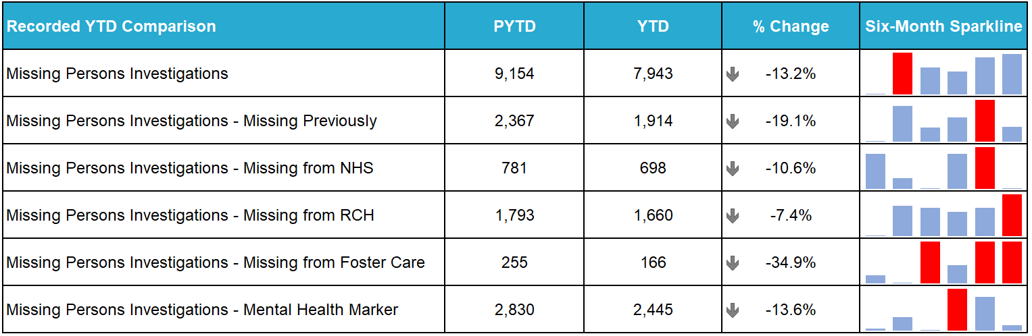
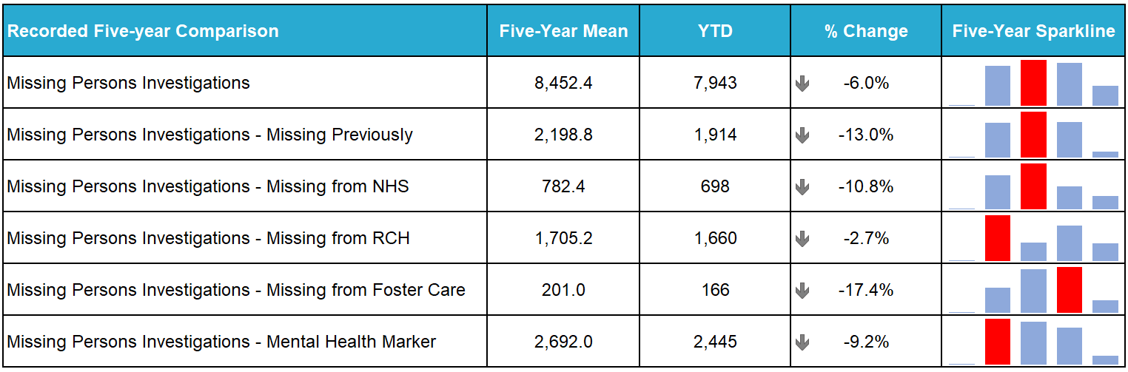
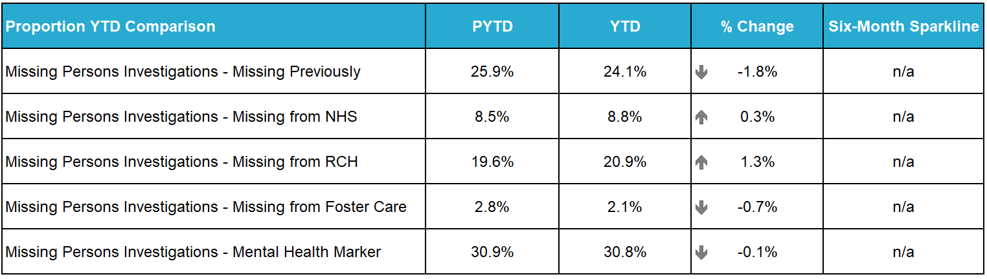
The number of missing person investigations has significantly decreased by 928 (down 19.3%) compared to the same period last year. The number of missing persons missing previously and the number of investigations with a mental health marker have all decreased compared to the same period last year and from the five-year mean.
There has been a gradual increase in missing persons from the last three quarters; an increase of 205 more missing persons than the previous quarter and an increase of 419 from Quarter 1 2024/25. This increase can be attributed to the quality assurance methods established ensuring a more accurate reflection of demand. Police Scotland’s business rules provide guidance as to how and when a missing person incident is recorded on both the command-and-control system (STORM) and the National Missing Person Application (NMPA).
The notable decreases can be found when considering what ‘type’ of person goes missing. Adult (400 less, down 13.6%), Care Experienced Young People (263 less, down 11.2%), and Child (343 less, down 11.0%) are recording the most significant decreases compared to the same period last year.
When considering what ‘type’ of person goes missing, the majority of children and care experienced young persons go missing from Lanarkshire. This has changed from the previous year where the majority of children and care experienced young persons in 2023/24 were missing from Edinburgh City followed by Fife. The City of Edinburgh division have developed their working relationship with care providers in Childrens Houses over the last year attributing to the reduction in reports of care experienced children going missing.
Children and care experienced young persons missing from Renfrewshire and Inverclyde, Lanarkshire, and North East all recorded significant increases from the previous year to date.
Situated within Renfrewshire and Inverclyde Division is the largest childrens care provider in Scotland, the division continue to work with our partners to reduce the volume of missing person reports, using a person-centred approach and the available protocols to reduce the threat of risk and harm to vulnerable care experienced children.
The smaller increases in Lanarkshire are attributed to the increased reports coming from three Childrens Houses and in North East Divisions the increase can be partly attributed to five individuals who have been reported as missing on multiple occasions.

Road Safety (Strategic Outcome 1)
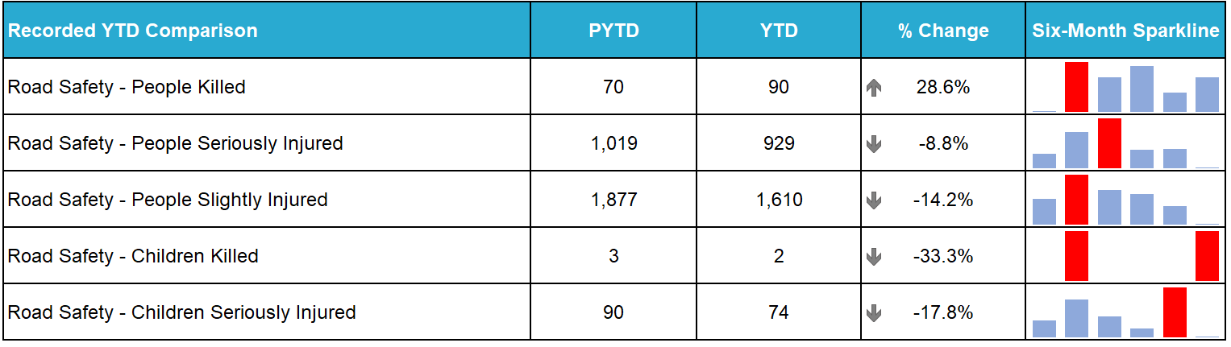
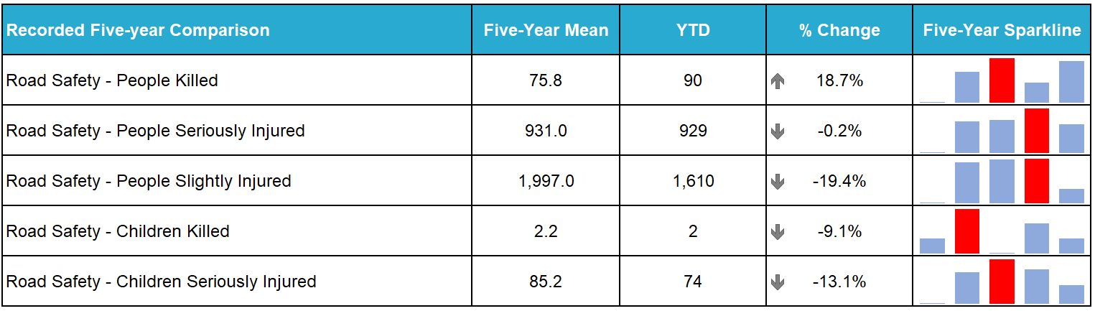
In the current period there has been an increase of 20 road fatalities (up 28.6%) compared to the previous year. The number of children killed has decreased by one, and there have been decreases in the number of people seriously and slightly injured (90 fewer, down 8.8% and 267 fewer, down 14.2% respectively). It should be noted that at the time of writing some of those killed in the current figures are being investigated for medical or other causational factors and may be removed from total figures.
The Scottish Government published the fatality and injury statistics for the year 2023. These were:
155 fatalities in 2023 compared to 171 in 2022, a decrease of 16 (down 9%).
1,930 seriously injured in 2023 compared to 1,778 in 2022, an increase of 152 (up 9%).
5,788 overall casualties in 2023 compared to 5,630 in 2022, an increase of 158 (up 3%).
In May this year the Cabinet Secretary for Transport, alongside the publishing of the casualty figures, reaffirmed the Scottish Government’s commitment to attain road safety targets and to achieve the Vision Zero goal of no-one being seriously injured or killed on Scotland’s roads by 2050.
Proactive/Preventative Policing – Road Policing Campaign Updates
During this quarter several campaigns have been resulted, all of which are aimed at proactively preventing fatalities and injuries on Scotland’s roads with a strong focus on protecting Vulnerable Road Users and/or targeting motorists committing Fatal 5 offences.
Motorcycle Safety Campaign – Timed to run throughout the peak spring/summer riding period (29 March to 27 September 2024) Road Policing and the National Motorcycle Unit carried out dedicated patrol activity on popular biker routes, with a strong focus on the contribution all road users can make to reducing rider casualties by adopting the right attitude and driving behaviours. A total of 2,259 riders were stopped, with 309 offences detected amongst them. An additional 72 offences committed by other road users were also detected during these initiatives.
Summer Drink Drug Drive Campaign – This campaign ran from 01 to 14 July 2024 and resulted in a total of 357 drink and drug driving offences being recorded. This campaign was analysis and intelligence led.
Mobile Phone Campaign – Running from 22 to 28 July 2024 Road Policing carried out engagement and enforcement amongst motorists to encourage wider compliance, with supporting social media work ahead of and during the initiative. A total of 27 offences were reported during the course of the campaign.
Vulnerable Road Users, Child Safety Return to School Campaign – The campaign ran from 12 to 25 August 2024 and focused on speed enforcement in the vicinity of schools and on high active travel routes. A total of 124 offences were detected by officers, with our Safety Camera Unit colleagues detecting 1,701 offences.
Drug Driving Week – Between 19 and 25 August 2024, this campaign saw 193 drink and drug driving offences recorded, with social media utilised to improve road user engagement throughout.
National Speed Campaign – Running between 09 to 15 September, there were a total of 399 speeding offences detected by officers during the course of this campaign, with Safety Camera Units detecting an additional 718 offenders.
There are several ongoing campaigns at this time:
Driver Engagement North, which initially launched in the Highlands and Islands and has since been extended to the rest of the North of Scotland, sees participants using a desktop driving simulator to assist older road users and their families make informed choices about their fitness to drive safely. The project has evaluated well and further funding has now been secured from Transport Scotland to expand Driver Engagement into the East and West of Scotland.
Fitness to Drive Matters sees us working with our partners and older road users to reduce numbers killed or seriously injured in collisions. Funding has been secured from Transport Scotland’s Road Safety Framework Fund to cover 100 assessments in the North of Scotland.
The New Driver Early Intervention Scheme is being rolled out nationally and partners, such as Scottish Fire and Rescue Service, have adopted the scheme to deliver it as part of their work. The scheme is aimed at 17-25 year-olds to positively influence this vulnerable group of road users, whilst providing a reminder of their responsibilities toward themselves and other road users. Several local authorities have adopted the scheme for delivery to modern apprentice/skills and employability students. Empowering young people with information allows them to make informed decisions when starting their driving careers, with a view to improving road safety for all.

Ongoing Operations
There are also several ongoing operations:
Operation TUTELAGE: This is a UK-wide initiative aimed at reducing the number of uninsured drivers. A Criminal Justice led initiative, uninsured vehicles are identified using Automatic Number Plate Recognition (ANPR) to generate ‘Insurance Advisory Letters’ to registered keepers to inform them that an offence has occurred. From launch in 2021 to 30 September 2024 a total of 41,000 letters have been issued in Scotland. The compliance rate is 82.5%.
Operation TRAMLINE: Police Officers are deployed on busy commuter routes in vehicles that drivers would not typically associate with police, such as lorry tractor units and minibuses. This provides high vantage point observation of driver behaviour with the aim to engage, educate and enforce legislation in respect of the Fatal 5, in particular distraction offences such as using a handheld mobile phone.
Operation CLOSE PASS: This operation sees a Community Police cyclist and supporting Road Policing officers deploy to monitor driver behaviour in the vicinity of cyclists, particularly when carrying out passing manoeuvres. Drivers passing too closely, or otherwise placing the cyclist at risk, are predominantly provided with guidance during a ‘chat on the mat’, but may also be issued with a fixed penalty or reported to the Procurator Fiscal, depending on the presenting circumstances.

Stop and Search (Strategic Outcome 1)
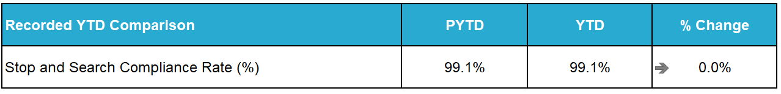
18,998 stop and search incidents were recorded by Police Scotland during the April to September period. This includes 735 searches under warrant. The number of searches recorded this year was 15.7% more than last year but 9.5% fewer than the five-year mean.
25.2% of searches recorded during the period were positive – this is a decrease in the positive rate from this period last year of 5.4% points and a decrease of 9.5% points from the five-year mean positive rate. 3,771 searches led to the recovery of drugs, 472 recovered weapons and 420 recovered stolen property. Of the searches that recovered weapons, 76 involved weapons being recovered from 12-15 year olds, and a further 47 from 16-17 year olds.
25 of the searches that recovered weapons were conducted for a care & welfare reason, and a further five were conducted for the protection of life search reason.
During the first half of the year, 16,839 stop and search records were audited for compliance. An audit involves the records being reviewed by line managers and thereafter quality control checked by the National Stop and Search Unit to ensure their adherence to the Stop and Search Code of Practice introduced in May 2017.
Of the stop and searches reviewed this year, 14,913 (88.6%) were deemed compliant and recorded correctly on the stop and search database. A further 1,767 (10.5%) were compliant with the code of practice but required amendment to their details to ensure they were appropriately recorded.
159 (0.9%) records were deemed as not recordable under the code of practice or recorded in error and deleted from the database. The typical reasons for deletion include where a person is searched after being arrested, as a result of a duplicate record or where no physical search of a person has actually taken place.
It should be noted that the total number of records audited for compliance will be lower than the total number of searches raised during the period due to the timescales required to fully review all records.
More information about stop and search statistics as well as stop and search data files can be found on the Police Scotland website: Stop Search Data.

Criminal Justice (Strategic Outcome 2)
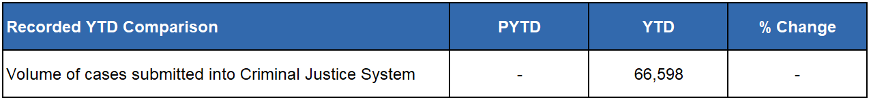
The number of cases is now being provided from the single National Case Management system. A comparison with previous years is not advisable due to the different case management systems which were being tallied to provide the data in earlier years. The structure and components of the new system represent a significant upgrade but means that data is not advisedly comparable for these purposes. This data will be available for comparison from the next reporting year.

Police Custody

Arrested Persons
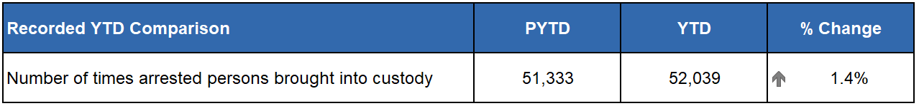
Custody throughput continues to rise steadily. This is the tenth consecutive quarter where custody throughput has risen since the pandemic. The rise is modest. The continued increase in arrests on warrant may account for some of this increase as there were almost 800 additional warrant arrests during the first two quarters of the year.
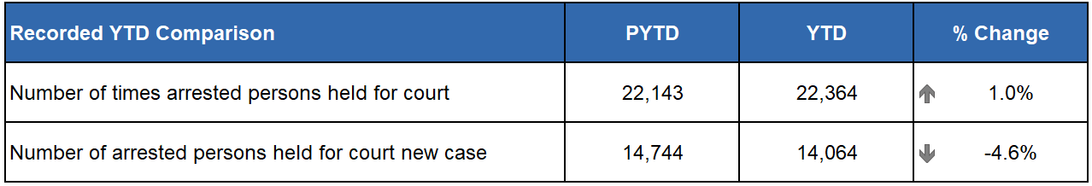
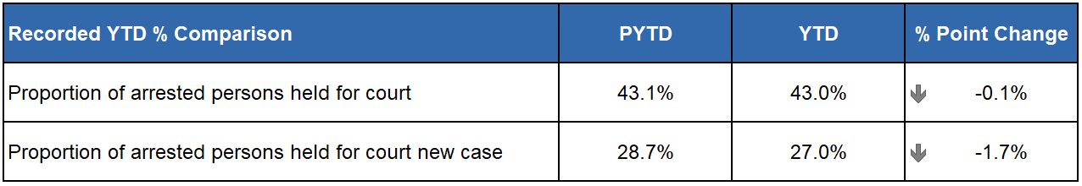
The number of persons held for court has held broadly static. Workshops are ongoing at present for CJSD Custody Supervisors aimed at reducing the gap between the numbers being held for court and the number for whom COPFS subsequently oppose bail. These workshops are running through October into January 2025.
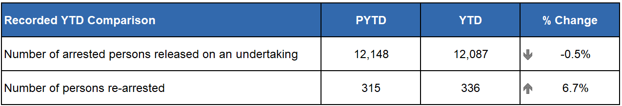
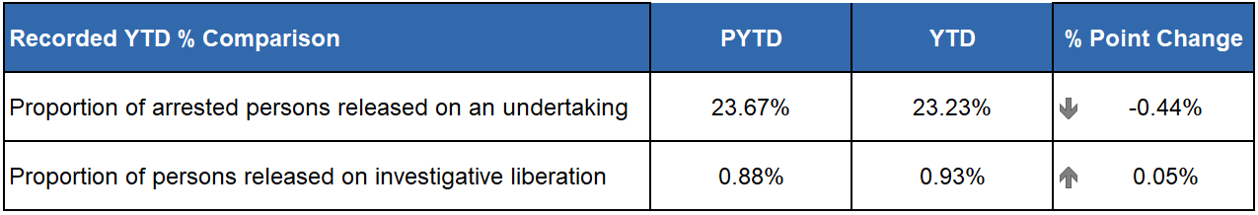
Use of Investigative Liberation continues to rise and although small as a percentage of total throughput it is a very positive rise which demonstrates the increased use of this investigative tool and corresponds with the now concluded education and communication piece with colleagues in Local Policing Divisions. The use of undertaking remains fairly static.

Children brought into Police Custody / Held for Court
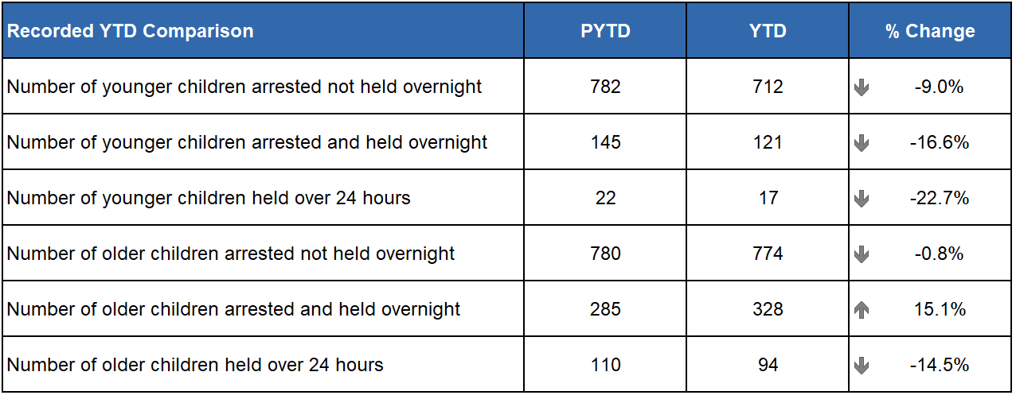
The number of younger and older children being brought into custody has decreased with positive trends in all categories with the only notable exception of older children being held overnight. Significant scrutiny is routinely placed on any decision to hold a child in custody overnight and this increase will be monitored over the next quarters.
Work is ongoing with the Children and Young People's Centre for Justice (CYCJ) to develop a programme of work to examine a child's journey through police custody and review any changes that could be made to processes and facilities to improve this.
An element of the Children's Care and Justice (Scotland) Act 2024 which continues to be implemented in stages, and in line with UNCRC will see all under 18s being treated as children through the Criminal Justice journey.
This phase of CCJ Act implementation will likely become live as we enter 2025 and will impact how this data can be reported in the next financial year.

Police Direct Measures
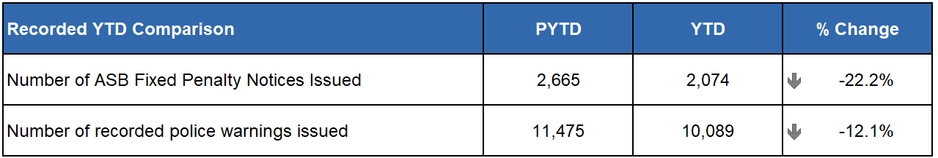
In September 2024, a new training package was launched to support officers in the use of direct measures, in line with Lord Advocates Guidelines which were recently updated. This includes upgraded functionality on mobile devices to make the process more efficient.
The new process and upgraded LAGs also enable a broader range of offences to be considered under Direct Measures as well as changing the criteria and timescales for issuing.
Whilst the implementation of this new process was too late to see any effect in Quarter 2, it is anticipated that increases in the use of Direct Measures will be seen going forwards.

Vulnerability
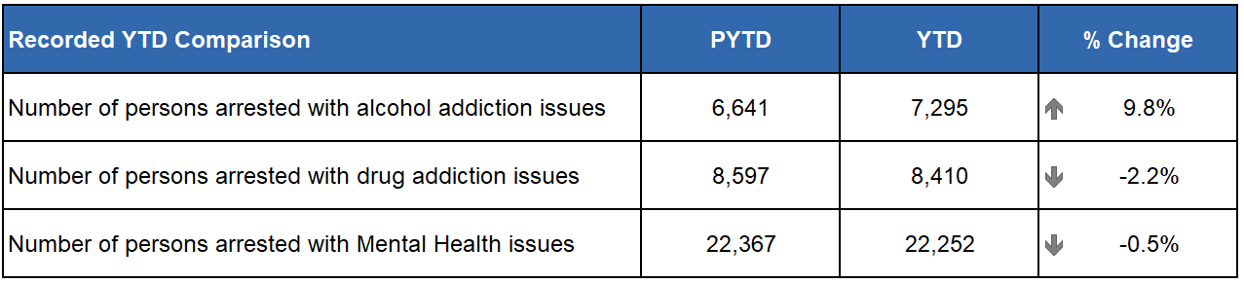
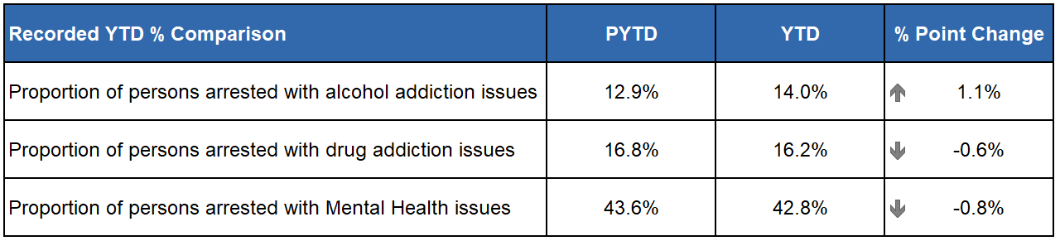
Vulnerability figures are broadly very stable with the only notable exception being another modest but significant increase in the number of individuals declaring current or historic alcohol issues. This has been steadily on the increase for several quarters and is generally fluctuating between the 9% and 12% increase mark.
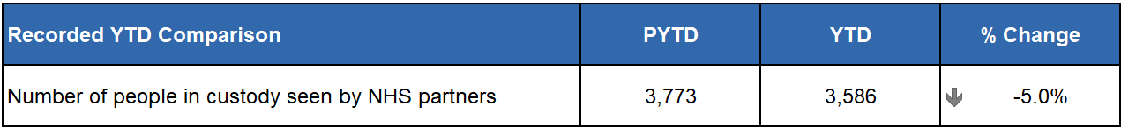
This is the second consecutive decrease in subsequent quarter submissions and it is unclear whether this is being driven by a reduction in referrals to healthcare professionals or a reduction in the number of times an individual in custody requires to be seen. The trend will continue to be monitored.
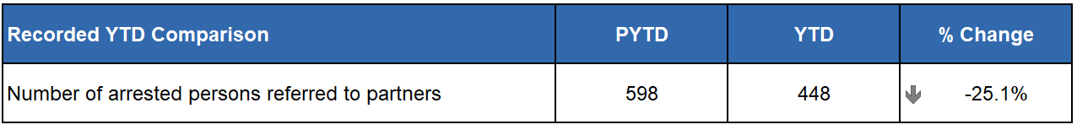
The number of partner referrals YTD has dropped on the previous year however remains consistent and steady since Quarter 1. The signing off of the new consent-based referral pathway at the start of July coincided with a re-launch of the arrest referral process. This has involved not only increased internal staff training and awareness raising, but also includes the re-building of existing pathways and the creation of new ones.
It is anticipated that in time, these new pathways, combined with continued education of our staff, will form the foundations of a future rise. In addition, CJSD is also working with support services to increase the number of link workers visiting the cells providing in-reach support which are not always counted within the data due to the requirement for accurate third sector reporting of such referrals.

Productions
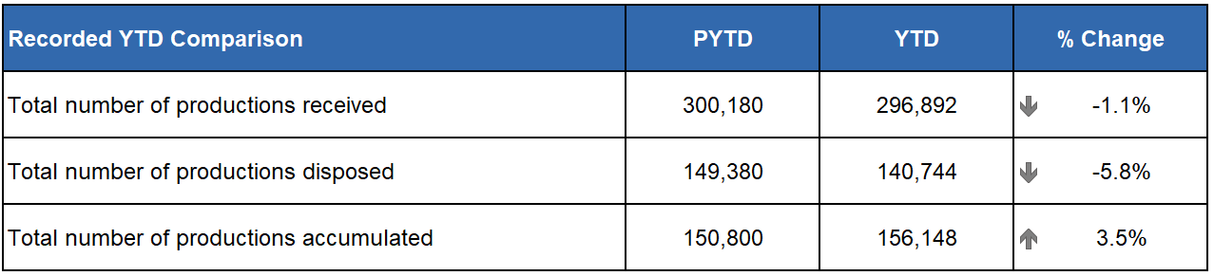
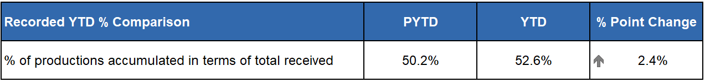
A slight decrease in productions received may be directly attributed to the initial rollout of Digital Evidence Sharing Capability (DESC) which is negating the need for the physical retention/lodging of CCTV as productions. Revenue Income Generation (RIG) funds have now been received with permission to recruit two further productions purge teams. This is over and above existing disposal teams. In addition, there is now recruitment ongoing to fill Production Management Officer (PMO) posts.

Public Confidence and Experience of Policing (Strategic Outcome 3)
Police Scotland continues to measure and enhance understanding of public confidence, trust, and user experience within local and specialist policing – delivering engagement and insights for performance, scrutiny, local police planning, and service improvement across portfolios.
This work includes keeping public, colleagues, and communities engaged and involved with financial and proposed service changes so that the service can continue to police by consent and ensure our policing model meets the needs of communities. Our focus is on high risk, threat and harm in adapting how we do things to connect with communities for enhancing safety and protection.
We are able to adapt our policing approaches, online reporting, and communications to address public concerns and respond to individuals and communities fairly and sensitively, with our values and human rights at the centre.
The areas we know impact public confidence, trust and user experience can be addressed by focusing on:
Police culture, values, and behaviours particularly how we show up for and support victims and communities.
Ease of contact, accessibility, and availability of local and specialist police services.
Community safety and resilience through crime prevention and protection.
Keeping communities informed about what policing is doing to manage crime and concerns within local communities.

Research and Engagement Activities
Our continuous national surveys, community engagement, and research enable the service to understand what we do well, what is influencing confidence, and where we need to focus efforts for enhancing the user experience.
Your Police 2024-25 survey – our local police survey is open to anyone who lives in Scotland at any time to share their views and feedback on policing in their area, including feelings of safety. The survey is one of the largest of its kind in the UK, with our current survey having 10,690 total responses so far. It is broadly representative of Scotland’s population.
User Experience Surveys – our independent surveys to measure and enhance people’s experience of contacting Police Scotland. The local policing experience survey is sent via text message to 12,000 people who have contacted the police each month, 3,912 responses were received in Quarter 2. The methodology for capturing user experience feedback now includes victim-survivors of sexual and domestic crime and hate crime. Our victim-survivor feedback has received 25 responses in Quarter 2; our hate crime user experience survey received 276 responses. A survey is in development to be launched in Quarter 3 to gather people’s feedback about their experiences of police custody.
Last year we introduced a public Trust Index survey to a broadly representative sample of around 1,000 adults in Scotland each quarter. Respondents are asked about the service to understand their sentiment towards policing and what may be impacting trust in Police Scotland as an institution or brand.
Estates engagement – an open and inclusive national conversation and local building consultations as part of our National Estates, launched on our public Engagement Hub in December 2023. This will continue to support all proposals within local areas. 33 bespoke local consultations about police buildings have been completed so far since launch.
Our public Engagement Hub provides visibility and transparency of national and local engagement activities including ‘you said, we listened, we did / doing’ feedback. The engagement hub also shows case studies of community engagement within local policing, including police-academic research collaborations, aligned to the drivers of public confidence.

Key Findings
There are differences between confidence, trust, and user experience, which considered together, provide a rich story about how policing is perceived and experienced. Public confidence is about our legitimacy and enables us to continue to police by consent. Public trust is about our brand and reputation, associated with organisational competence i.e. professionalism, responsiveness, reliability, and knowledge. User experience measures satisfaction with contacting the police across critical elements in the end-to-end journey.
Public confidence, trust, and user experience are summarised in the following figure. There is a moderate increase in user experience (up 1% point) and a significant increase in public confidence (up 7% points) on the previous quarter, while public trust remains unchanged. While overall user experience and trust remains broadly consistent over time, public confidence in local policing can fluctuate.

Experience of contact and determinants of user satisfaction
Findings show high and stable levels of satisfaction with contact. Figures for Quarter 2 are summarised as follows and where there have been changes on the previous quarter:
Ease of contact – 73% (down 1% point)
Treatment by staff member during initial contact – 85% (down 1% point)
Staff understanding what they needed – 88% (up 1% point)
Police providing the appropriate response – 66% (up 1% point)
Treatment by officers who attended the incident - 83% (up 1% point)
Being adequately informed about progress – 51% (up 1% point).
Positive experiences are correlated most strongly with receiving an appropriate response, satisfaction with attending officers, and feeling adequately informed about case progress. Users tell us their experience was positive because contact was ‘easy’ with quick answer times using 101/999; service advisors and attending officers took the time to listen and understand their needs, bringing empathy to interactions.
Since 2020, the percentage of users feeling the police provided the appropriate response to their reported incidents decreased from 70% to 63% in 2023. However, in 2024 this has started to increase to 66% (July to September 2024).
In contrast, satisfaction with attending officers and feeling staff properly understood needs has remained high and stable since 2020, at 83% and 88% respectively.
The percentage of respondents who feel they were adequately informed about the progress made with what they reported has fallen, from a high of 58% in 2020, dropping 3% every year to 49% so far in 2024 (the percentage “Not sure” has remained stable at 7-8%).
Respondents highlight having an expectation for more follow-up information after a crime or incident had been reported to know that it was being dealt with and to avoid having to call again, to avoid putting more strain on the system. The importance of adhering to timeframes in relation to when feedback has been promised was also mentioned by some respondents.
Our Modernised Contact and Engagement (MCE) Programme is developing our capability to enhance ‘self-service’ opportunities as set out within our Public Contact and Engagement Strategy.

Factors influencing confidence in local policing
We know that confidence is closely affected by how policing is experienced and perceived locally. In Quarter 2, 84% (up 9% points from the previous quarter) of survey respondents reported feeling very safe or fairly safe in their area; 66% (up 9% points) agreed that local police are friendly and approachable; and 35% (up 8% points) agree local police listen to local concerns.
Pearson correlation analysis in Quarter 2 shows public confidence is associated with further areas measured using our Your Police survey. There is a strong positive relationship between public confidence and people’s perception of police doing a good job in their local area (r = 0.852). The public’s awareness of police activity in their local area has decreased in Quarter 2, with 9% more respondents agreeing their local police are doing a good job in their local area than in the previous quarter.
Open-text feedback indicates an increased awareness about police activities locally. However, roughly a third of respondents remain not certain about whether the police are addressing local concerns and how they are keeping people safe.
People who self-reported as having recently (in the past 12 months) been a victim or witness of crime (n=3,270) and those living in areas most affected by poverty (n=1,418) reported the least confidence in local police. When asked what the police could do to support the community more, the key themes for these groups were related to visibility and policing and partner responses for tackling crime/harm in communities.

Public trust score and predictors
Results have remained relatively stable, between 75%-80% since the Trust Index survey was introduced in June 2022. The Trust Index score in September 2024 was 79%, in line with the previous quarter. The Trust Index score combines data from eight organisational characteristics (professionalism, compassion, responsiveness, reliability, knowledge, experience, trustworthiness, and modernity).
Most people continue to feel Police Scotland upholds its core values, with the proportion of respondents who felt police uphold the values of Respect (68%), Human Rights (69%), Fairness (68%), and Integrity (69%) with a significant increase in protecting human rights compared to this time last year. This will continue to be monitored to identify and understand contributing factors.
The Trust Index Survey in Quarter 2 asked 1,001 participants to provide an example of something in the media that had impacted their opinion of policing and Police Scotland in the news recently. The most common response at 38% (n=311) was categorised as “No / None / Unsure / NA etc.” This aligns with what we know from our Your Police survey.
It shows the importance of enhancing local communication and visibility of policing in the physical and online space – demonstrating effective policing, as people often have little awareness of what their local police or Police Scotland are doing in terms of their business-as-usual activities.
The second most frequent response (4% n=34) was in reference to positive sentiment about Police Scotland’s approach in response to the anti-immigration riots elsewhere in the UK, and a further 4% (n=32) generally reflecting that Police Scotland was doing a good job.
Other comments with negative sentiment referenced respondents feeling unsafe in their community, with perceptions of high crime (4% n=32); feeling police don’t investigate or solve crimes (3% n=28); or lack resources or reference budget cuts (3% n=27).
Other themes with positive sentiment towards trust in policing included references to “Fast / effective response” and “Good communication” (inc. social media); or believe the media to be biased, showing Police Scotland negatively when the issue does not relate to police decision-making or powers (2% n=16).

Vision 2030: Supported Victims
The following sections have all been aligned under Vision 2030: Supported Victims for the purposes of this Quarter 2 report. Some business areas however could potentially be aligned under multiple commitments. This will be developed further in future reporting.

Call Handling (Strategic Outcome 2)
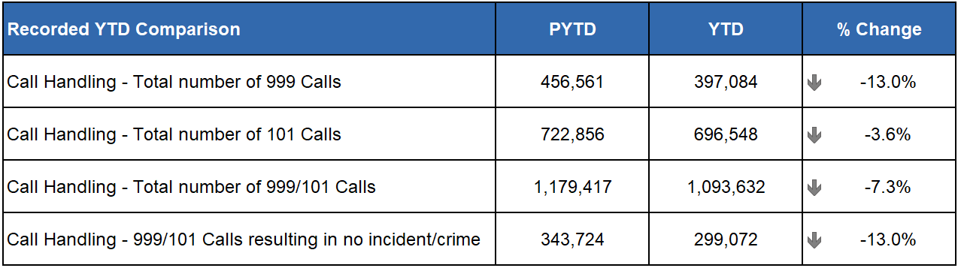
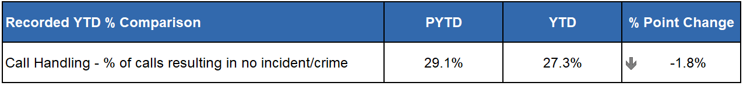
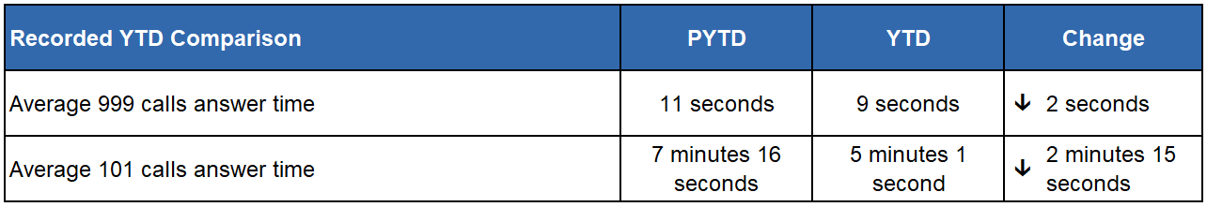
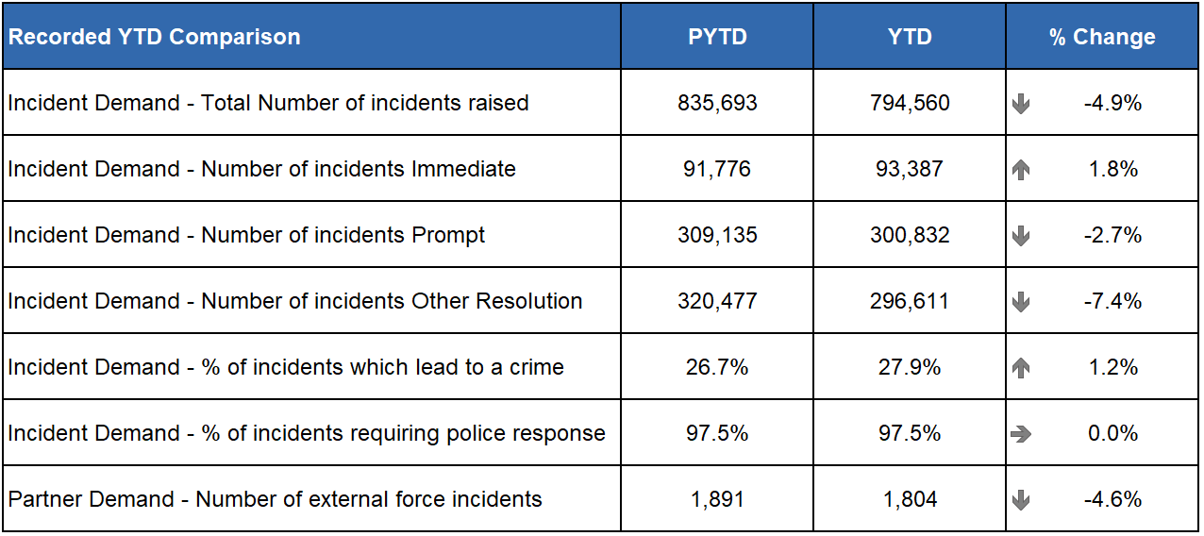
During this reporting period, Police Scotland received a total of 1,093,632 calls, a decrease of 7.3% when compared to the same period last year. Of these calls, those routed via 999 decreased by 13.0% when compared to the same period last year (down from 456,561 to 397,084). The volume of 101 calls received also decreased, down 3.6% (722,856 to 696,548).
It is worth noting, during this same period in 2023, Police Scotland experienced a significant increase in 999 calls (up 20.5%), as such comparisons to 2023 are set against what was a historically high level of demand in 2023 for Police Scotland and all UK Forces.
When compared to same reporting period in 2022, 999 calls have seen an increase of 4.8% for Police Scotland (up from 378,959 to 397,084), a similar increase to the UK average of 5.4%.
The handling of 999 calls remains the highest priority for Police Scotland’s Service Centre. We aim to achieve an average speed of answer for 999 calls within 10 seconds, a standard for all 44 Police Forces across Scotland, England and Wales. During the reporting period Police Scotland achieved an average answer time of 9 seconds which is 2 seconds quicker than the same period last year.
The summer reporting period is traditionally our higher volume months and can cause increases in call volumes impacting on our average speed of answer. This year several factors impacted demand, such as changes to legislation, high-profile sporting events and various festivals across the country.
In April 2024 the Hate Crime and Public Order (Scotland) Act 2021 came into effect. While having a significant impact on demand across Police Scotland in general, the new Act had a minimal impact on call handling demands due to the facility to report Hate Crime online. In July 2024 an amendment to the Dangerous Dogs Act, controlling ownership of XL Bully dogs also came into effect.
Positively, the average answer time for 101 calls decreased by 2 minutes 15 seconds to 5 minutes 1 seconds. It is important to note that it is the same Service Advisors who handle all 999/101 calls and ContactUs Emails. When there is a surge in 999 calls, we will re-prioritise Service Advisors from Non-Emergency (101) calls and emails as we aim to answer the 999 calls under 10 seconds. Therefore, there is a direct link between any increase in 999 volumes and the average speed of answer for 101 – non-emergency calls.
Our call volumes and trends continue to be monitored closely to ensure that we are prepared for any unexpected changes in demand and maintain average speed of answer times within targets.

Service Demand – Additional Contact Methods
C3 Division handles additional contacts such as incoming calls from other partner agencies and alarm calls. There has been 61,873 of these types of contact for this reporting period, representing a small decrease of around 0.5% in emergency service partner calls and a decrease of around 13.4% in total alarms calls when compared to 2023.
Emergency service partner calls are received via dedicated numbers from Scottish Fire and Rescue, Scottish Ambulance Service, Mountain Rescue, Coast Guard, Mental Health Pathway (NHS 24), OmniCrash and Oil Industry Agency. The reason for such calls varies and each is dealt with by a Service Advisor in the most appropriate manner.
A total of 24,665 calls were received in response to Media Appeals (Option 1 on 101). The percentage of these calls to 101 remains consistent at 3.5% for the reporting period which is the same for the same period last year.
A total of 129,346 calls were received for Incident Updates (Option 3 on 101). The percentage of these calls to 101 has increased slightly to 18.6% for the reporting period compared with 17.9% for the same period last year.
Efforts continue to signpost callers to more appropriate methods of contact, including via “Contact Us – email facility” and the online reporting facilities via the force website.
“Contact Us” emails and online reports, for some crime types, can be completed online. Each one of these reports is assessed by a Service Advisor using the Threat Harm Risk Investigation Vulnerability and Engagement (THRIVE) model.
The use of “Contact Us” emails has seen a slight increase in demand different to the reduction in call volumes. Police Scotland received 102,895 emails in this reporting period, a 0.9% increase compared to the same period last year (up from 101,965 to 102,895). Emails are assessed the same way as calls using the THRIVE assessment.
Despite this there was an overall 6.2% reduction of contacts handled by the C3 Division when compared with the same period last year.

HMICS Assurance Review of Police Scotland Contact Assessment Model (CAM)
C3 Division are leading Police Scotland’s response to the HMICS Assurance Review of the Contact Assessment Model (CAM). Excellent progress has been made over this quarter with two further recommendations having been discharged by HMICS and three Evidence Submission Forms being authorised by the Chief Superintendent for transmission to HMICS for review and consideration for closure.
The current position, therefore, is that of the eight recommendations contained in the report, four have been discharged, three have been submitted to HMICS for closure, and one final recommendation remains in progress but is at an advanced stage with submission for closure anticipated in the coming weeks.

HMICS Thematic Inspection of Police Response to Missing Persons in Scotland
Following C3’s engagement in supporting the HMICS inspection earlier in 2024, the report has now been published and contains positive feedback in relation to C3.
The report suggests that Police Scotland should examine the level of access to the National Missing Person Application required by Service Advisors and ensure that they are aware of national and local protocols and their benefits.
C3 are part of a Short Life Working Group led by the National Missing Person Unit to support the Police Scotland response to the published report.

Policing Together Campaign
C3 ONE is C3 Division’s commitment to Police Scotland’s EDI Strategy - ‘Policing Together’. Its vision is to ensure that C3 Division is welcoming, inclusive, and representative of the communities we serve and that our people demonstrate our values.
In December 2023, C3 Division launched a four-year plan for Equality, Diversity and Inclusion, aligned with Policing Together, and Police Scotland’s Equality and Diversity Strategy. The C3 ONE strategy was approved at the Policing Together Tactical Group following extensive consultation with the Diversity and Staff Associations.
To identify and support work in this area, focus groups are being established to bring together practitioners to share lived experiences and provide direction in to how we progress change under the framework, including the establishment of an Inclusion Advisory Panel.
Following a successful pilot, C3 Division have implemented Welcome Back Week nationally to provide support to officers and staff who are returning to work after an extended period of absence following maternity leave, paternity leave, adoption leave or a career break.
In this quarter, C3 Division have continued working with the British Sign Language (BSL) working group, actively seeking to improve the service delivered to BSL communities and promptly reviewing incidents from which learning could be derived. C3 have published on the C3 ONE intranet site the Deaf and Deafblind BSL Awareness Guidance to support staff.
Further to the C3 ONE framework, C3 Division has hosted a number of events, including a further Neurodiversity drop-in session and events for Mental Health Awareness Week, while collaborating with Policing Together to mark Black History Month.

Quality Assurance Application
C3 Division Quality Assurance Unit (QAU) have developed and implemented a bespoke, standalone digital solution which allows for the efficient completion of Quality Assurance (QA) activity across C3 Division. The team collaborated with Digital Division and created a bespoke digital application at zero cost. This has enabled all operational areas in the Division to achieve 100% completion rates, which demonstrates a significant improvement in completion rates when compared to the previous manual system.
The bespoke application enables immediate feedback with team members, enhancing service delivery and improving performance. The new question set contained in the application focuses heavily on each individual strand of THRIVE, our incident and response risk assessment matrix, which allows for an enhanced analytical review by the QAU at the end of each month.
The QAU have also undertaken benchmarking with other forces from England and are looking to enhance our divisional QA provision in the near future by expanding the scope of QA activity to include cross team marking and supervisory QA.

Vision 2030: Thriving Workforce
The following sections have all been aligned under Vision 2030: Thriving Workforce for the purposes of this Quarter 2 report. Some business areas however could potentially be aligned under multiple commitments. This will be developed further in future reporting.

C3 Complaints and Allegations (Strategic Outcome 2)
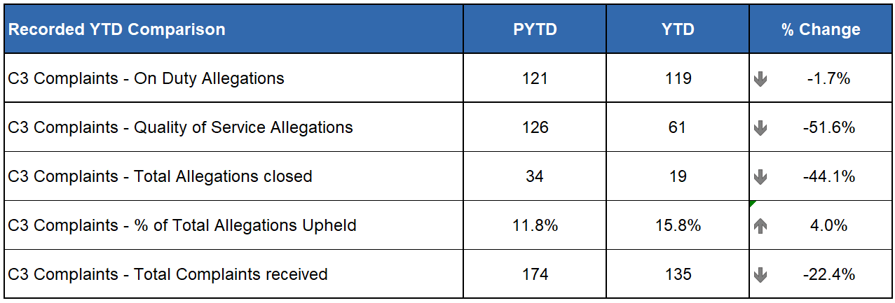
In total, 73.3% of complaint cases received year-to-date for C3 Division were Frontline Resolved by the PSD National Complaints Assessment and Resolution Unit (NCARU). This rate rises to 74.1% when early and subsequent resolution by PSD or Specialist officers are included. These figures demonstrate that most complaints against C3 Division during this period have been non-criminal and non-serious in nature, with a majority resolved through simple explanation, apology or assurance.
The volume of complaints against C3 Division has decreased by 22.4% YTD, with a total of 135 received compared to 174 received PYTD. Decreases are visible across all three Command Areas: North (down 18.5%, 22 fewer cases), East (down 3.8%, 51 fewer cases) and the West (down 34.0%, 62 fewer cases).
Incivility (89) remains the most common allegation type. However, those have decreased by 4.3% from the same period in 2023/24, which accounts for four less allegations.
An increase was identified in relation to Irregularity in Procedure allegations (up four from 2023/24). This is linked to the allegation sub type ‘Provide insufficient explanation regarding police procedures’ (up four from 2023/24). However, this is a low volume category, with five allegations received YTD in total.

Complaints about the Police (Strategic Outcome 3)

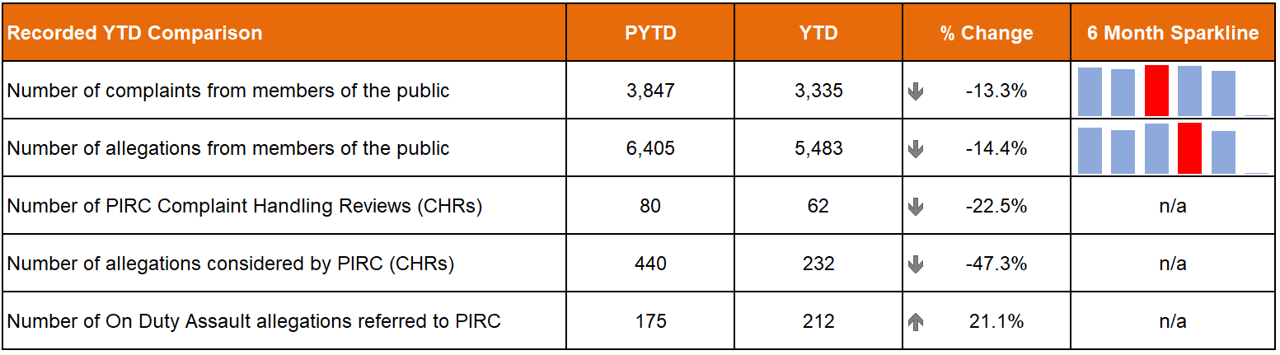
The total number of complaints from members of the public are down 13.3% (512 fewer complaints) on last year whilst allegations are down 14.4% (922 fewer allegations) on the same period. The six month sparklines show that the most complaints were received in June 2024 (647 complaints) whilst the most allegations were received in July 2024 (1,081 allegations).
The Professional Standards Department (PSD) has resolved 1,551 complaints (46.5%) by Frontline Resolution (FLR) compared with 52.1% in the same period last year. This includes early resolution and subsequent resolution by PSD / specialist officers.
PIRC submitted 62 Complaint Handling Reviews (CHRs) to Police Scotland for consideration during this period. This notionally equates to 1.9% of all complaints.
Allegations of On Duty Assault (breaches of Article 3 of the European Convention on Human Rights), plus any associated criminal allegations, are now referred to the PIRC. In total, 212 allegations of On Duty Assault referrals were made to the PIRC during this period (up 21.1% on last year). Of those, 45 are subject to the Police Investigations & Review Commissioner (PIRC) investigation (21.2%). However, as of 01 October 2024, 61 of these referrals are awaiting a decision from PIRC regarding possible investigation. The remaining 106 cases have been marked as no investigation by PIRC.
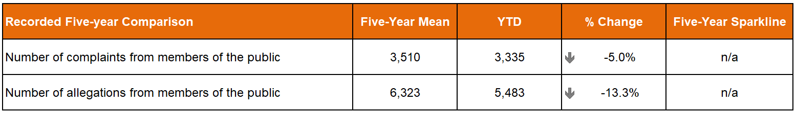
The total number of complaints from members of the public are down 5.0% (175 fewer complaints) on the five-year mean whilst the total number of allegations are down 14.4% (922 fewer allegations) compared to the same period.
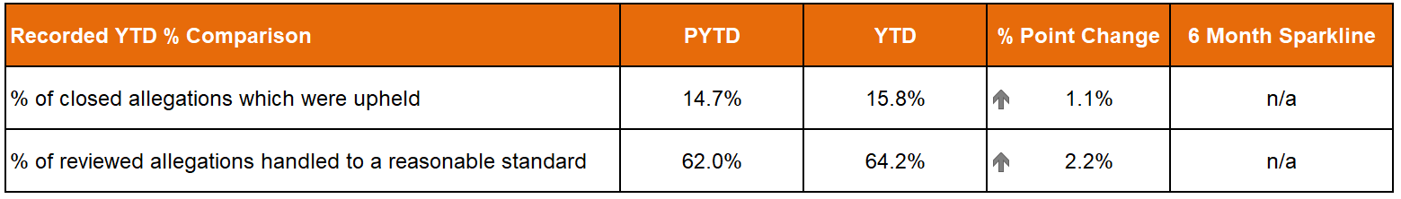
There were 1,890 allegations attached to completed complaint investigations (criminal and non-criminal) with 15.8% of these being upheld.
The 62 CHRs received from PIRC considered 232 allegations, with 149 (64.2%) assessed to have been handled to a reasonable standard. This is an increase of 2.2% points from the same period in 2023/24. These CHRs included 71 recommendations.
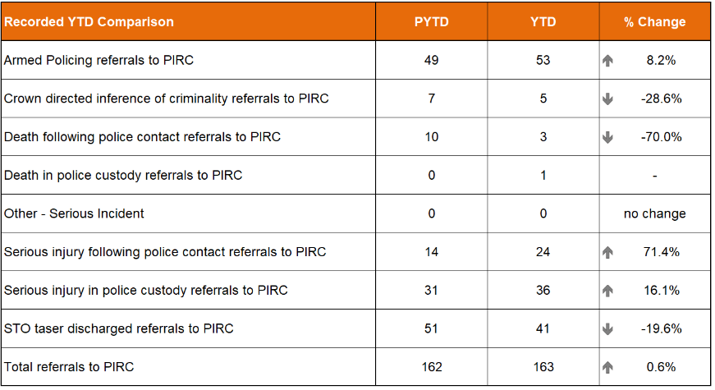
Statutory referrals to PIRC facilitate independent and transparent scrutiny in relation to serious incidents involving the police. Police Scotland made 163 referrals to PIRC resulting in 14 investigations (8.6%). This is a decrease of 5.6% points compared to the same period last year.
Referrals increased compared to the PYTD for armed policing (up four referrals), serious injury following police contact (up ten referrals) and serious injury in police custody (up five referrals).
Decreases are however noted for crown directed inference of criminality (down two referrals), death following police contact (down seven referrals) and STO taser discharged (down ten referrals) when compared to the same period last year.
Overall this equates in an increase of one referral to PIRC compared to the PYTD.
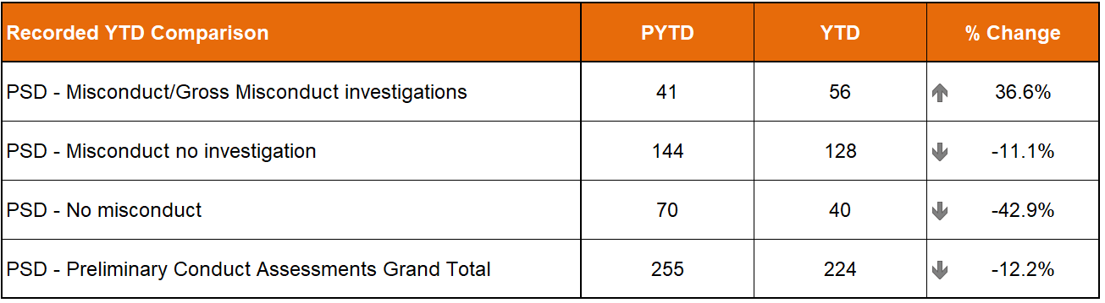
There were 224 preliminary conduct assessments undertaken YTD which is down 12.2% (31 fewer assessments) on the same period last year. 56 assessments (25.0%) have required a misconduct/gross misconduct investigation, this is up 15 investigations (36.6%) compared to last year. The remaining assessments resulted in either misconduct – no investigation (128) or no misconduct (40).

PSD Disseminated Learning during this Quarter
PSD is committed to promoting a culture of organisational and individual learning. Learning from CHRs and other sources are disseminated through bulletins, individual feedback and used to inform training packages. This learning can therefore influence and improve our service.
In the last quarter, PSD has disseminated learning from a variety of incidents. The following learning outcomes are of particular note:
Dog Handlers on mobile patrol, carry and have immediate access to specialist equipment within their vehicles to immediately deploy in such circumstances, to avoid any unnecessary delays in such high-risk incidents. Police Scotland should consider drafting a protocol that establishes procedures for contacting a veterinary surgeon or other appropriate authority to attend such incidents and provide viable options for the safe management of dangerous animals.
In the absence of guidance within national Covert Policing manuals in relation to the identification of plain clothes officers when deployed during armed operations, Police Scotland should consider drafting specific guidance that stipulates the requirement to carry out dynamic risk assessments in such circumstances and mirrors guidelines set out within both the Armed Policing Operations Standard Operating Procedures and National Police Firearms Training Curriculum (NPFTC), specifically: ‘Officers deployed in plain clothes at a firearms incident need to be clearly identifiable as police officers’ ‘Plain clothed officers who are unarmed will be issued with a high visibility (bright yellow) baseball cap with police markings’ ‘If plain clothed officers are deployed to provide observations or visual containment this information, their deployment positions and any subsequent changes must be clearly and unambiguously relayed to firearms officers and the TFC. This is especially important on any occasion where plain clothes officers do not have possession of the approved high visibility ‘Police’ baseball caps’. Any decision to deviate from this should be recorded and a rationale provided.

Assaults on Police Officers and Police Staff (Strategic Outcome 4)
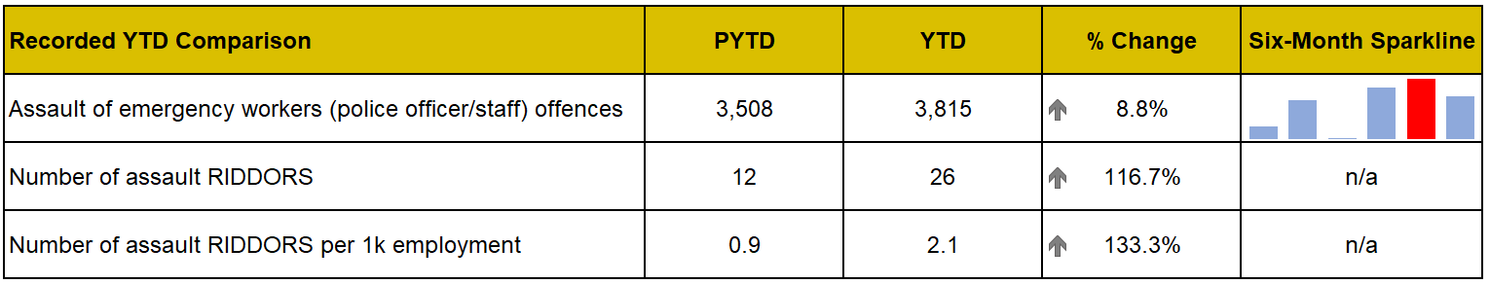
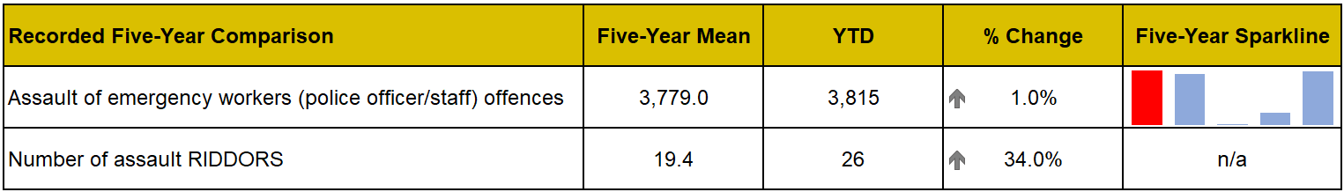
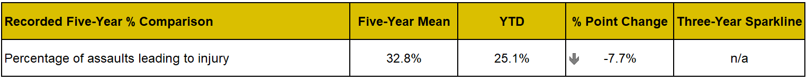
At the end of Quarter 2 YTD there have been 3,815 assaults on officers/staff. This is an average of 20 assaults per day and an increase of 307 assaults (up 8.8%) compared to the previous year. Assaults on officers/staff have also increased compared to the five-year mean with 36 more assaults (up 1.0%).
The percentage of assaults leading to injury (25.1%) has however decreased by 0.7% points in the YTD compared to the PYTD. This is down significantly on the five-year mean with a decrease of 7.7% points recorded.

People and Development (Strategic Outcome 4)

Prioritise Wellbeing (People Strategy Objective 1)

Absence

This quarter, there is no significant change in working days lost (WDL) per cent compared to last quarter with only small per cent increases recorded when looking at the total absences and a breakdown of long-term absence (LTA) or short-term absence (STA).
For the Psychological Disorder absence category, comparing Quarter 2 to the previous year shows there has been an increase of 0.3% for police officers and a decrease of 0.2% for police staff.
In Quarter 2, the top three reasons for LTAs, for both officers and staff were Psychological Disorders, Musculo-skeletal and Miscellaneous. This is a long-standing pattern over time.
Every local senior management team has access to dynamic dashboards providing local absence data. This can be interrogated to show local trends and hotspots, to give an understanding of what absence looks like locally.
Our People Partners work closely with Command teams to identify areas of concern and take appropriate action to support staff who are absent, to keep our absence levels to a minimum. Where people who are absent need support, we have a comprehensive range of interventions, including our employee assistance and occupational health programmes.

Supporting our workforce
Our Wellbeing and Health & Safety teams also work to offer a suite of offerings to keep our people healthy and prevent ill-health and injury. Since April we have new and improved contracts in place for our occupational health (OH) and employee assistance programmes (EAP).
Early data tells us that our new occupational health provision:
has had 3,180 touch points with Occupational Health through management referrals since 01 April.
supported increase numbers of physiotherapy assessments and treatments – 1,249 since 01 April.
had 2,140 accounts created since 03 September to the new OH portal.
Early data tells us that since 01 April, for our Employee Assistance Programme:
92% of clients receiving therapy were experiencing positive outcomes after the therapy.
we have had 901 officer and staff contacts with the EAP service.
2,507 sessions of support have been delivered, these vary from in-the-moment support via telephone, to virtual and face to face.
now includes more specialist support in the form of Pure Cognitive Behavioural Therapy (CBT) and Eye Movement Desensitisation and Reprocessing therapy (EMDR) with over 90 sessions delivered to officers and staff.

Support our people (People Strategy Objective 3)

Turnover

Police staff voluntary turnover is at its highest when compared across the previous two years. With a total voluntary turnover of 2.7%, our planned voluntary redundancy and voluntary early retirement (VR/VER) programme is responsible for 1.49%. For police officers, the lowest percentage turnover is recorded since Quarter 1 2022/23. Retirement represents the majority of turnover this quarter with 0.54% attributed to the total of 1.03%. The percentage turnover of probationers has also decreased in comparison to previous quarter.
The percentage of WDL related to stress has increased year on year for police officers when comparing the position for Quarter 2 only, although only slight increases are recorded in the upward trend. For staff, a 0.1% reduction has been recorded for percentage of WDL related to stress.

Capacity and Efficiency (Strategic Workforce Plan Objective 1)

Re-rostered rest days (RRRD) & Time Off in Lieu (TOIL)

The chart show that RRRD and TOIL banks continue to trend positively downward this quarter. In comparison to previous year position, the number of RRRD has decreased by 45 per cent and TOIL banks by 21 per cent. Police officer average overtime hours have increased by 3.39 hours in comparison to previous quarter, but in relation to the same period of time on the previous year has only increased by 0.63 hours.

Officer and Staff FTE

In Quarter 2, officer numbers have increased from Quarter 1 to 16,426.73 FTE. An intake of 385 probationers this quarter has resulted in an overall increase of 219.51 FTE after accounting for leavers. This is a positive trend towards our baseline of 16,600 police officers. Staff FTE continues to reduce in comparison to the previous quarter as those who successfully got VR/VER began leaving the organisation.

VR/VER
The scheme was open for applications between 08 January 2024 and 09 February 2024 to support the required 3.7% reduction of staff pay bill for Financial Year 2023/24. Despite short project timescales, the release of 102 police staff posts through VR/VER has achieved recurring savings of £9.5m. However, confirmed totals have yet to be issued as pension figures are still being processed. A full closure report detailing lessons learned, successes and areas for improvement has been submitted to the private session of this committee.

Ensuring our officers with duty modifications are meaningfully deployed

The number of officers requiring duty modifications has increased this quarter in comparison with the same time last year (2,072 v 1,914 officers PYTD), the percentage of officers who are ‘deployable with restrictions’ has also increased. In Quarter 2 last year, 35.2% of all modified duties officers were deployable with restrictions. In Quarter 2 this year, this figure has increased to 37.8% demonstrating the early positive impact of our work in this area.
Significant efforts have been taken to ensure we have a consistent, transparent and rigorous approach across the organisation in terms of how we assess and deploy employees who require duty modifications. People Partners continue to support and highlight the new process for duty modifications throughout the organisation. A National Duty Modifications Panel (NDMP) provides an additional layer of support and reviews modification requests where it has not been possible to find a suitable alternative post at a local level.

Attract and Retain Talent (Strategic Workforce Plan Objective 3)

Intake
Police Scotland recorded our highest ever intake of probationers in Quarter 2, moving positively toward replenishing turnover of officers. Staff recruitment has also been trending upward following the recruitment embargo since Quarter 3 2023/24.

Increasing our candidate pipeline
At the beginning of September colleagues from Recruitment and Corporate Communications launched our biggest ever campaign to attract new police officers.
The campaign aims to attract applicants into our e-recruitment national pipeline with suitable candidates to feed our intake requirements for November, January and March. In total we are looking to recruit around 1,300 new officers this financial year, which would be our largest ever total.
We have collaborated with an external consultant to re-brand our campaigns using a more engaging style across a range of channels. A key part is the stories from serving officers who are using their lived experience to explain how they have been able to apply their life skills and experience to the role of police officer and why policing is a job like no other. These real and authentic lived experiences of serving officers makes a huge difference to the quality and authenticity of our efforts to reach the right type of candidate.

Improving our candidates’ experience
Aligned to this we have also launched a new recruitment website, which offers many improvements:
a streamlined user journey with the candidate at its heart from the point of seeing an initial advert (on social media or other platforms), through to the Police Scotland website and then to our e-recruitment system to apply.
consistency of brand proposition and language across website and all other recruitment marketing materials.
increased visibility of apply now button / link on all police officer recruitment web pages meaning fewer clicks for candidates to access Police Scotland’s e-recruitment system to apply.
easier-to-digest content on job of a police officer, eligibility / skills needed, and rewards – all displayed in a mobile-friendly format with functionality to avoid users being discouraged by long pages of copy.
true insight into the realities of police officer role through sharing of real officers’ stories and experiences on meet our officers web page.
Our efforts are showing encouraging early results, and we are seeing an increase in applications. Notably, we received 270 high-calibre applications for one role that had been difficult to fill.
We have now also started using e-recruitment for our internal promotion processes. It’s modern and efficient and is a positive step for the following reasons:
It allows officers on maternity leave/ absence to see and apply in the comfort of their own home for national roles – previously people would have had to come into the office to complete applications
It allows us to manage the end-to-end process much more efficiently – booking interviews online, and uploading interview schedules
It allows for anonymised sifting – this links to our cultural audit
It allows for much easier reporting on data around service level agreements, diversity statistics, etc.
It allows us to advertise internal adverts using our gender bias tool on Oleeo and encourages females to apply for roles they may not have considered before
Longer term, it will also allow us to use AI for shortlisting, saving the hiring managers spending time on this.

Finance (Strategic Outcome 5)

Maintaining a Balanced Budget / Financial Sustainability
The 2024/25 budget was approved by the Board at the Authority meeting held on 21 March 2024.
The budget report highlighted the key budgeting assumptions that are sensitive to change, and which could result in a material change to the 2024/25 budget. The overall financial position will continue to be monitored and reported throughout the year.

Revenue
The Quarter 2 forecast is reporting an overall breakeven position against funding.
There are a number of significant offsetting variances that form part of the Quarter 2 forecast. The main underspends of £15.8m relate to Police Officer pay costs (£5.8m) and Police Staff pay costs (£4.5m), as both officer and staff numbers are running below the budgeting assumptions; over-recovery of income (£2.2m) and reduction in other costs (£3.3m).
Against these underspends, there is an increase in expenditure of £7.9m relating to bids approved by the Revenue Investment Group predominately supporting overtime, staffing divisional uplifts, workforce modernisation, learning training & development, and other items; additional non-pay costs (£7.9m) - supplies & services (£3.2m), third-party payments (£3.2m) and other cost pressures (£1.5m).
A number of threats and opportunities are being monitored, some of which may crystallise in the Quarter 3 forecast.
At the end of Quarter 2 we are reporting a £6.3m year-to-date underspend against budget.

Capital
The capital forecast at Quarter 2 is £69.3m, £3.2m (fully funded) above the budget position of £66.1m.
Full year budgeted slippage of £6.5m has been identified by the end of Quarter 2. In order to mitigate against potential risk of further slippage in 2024/25, an overallocation of up to £22.0m has been approved by Capital Investment Group in October to be managed across financial years.
Committed and uncommitted spend will continue to be monitored throughout the year.
The year-to-date capital spend at Period 6 is under budget by £15.6m (net of slippage).

Reform
The reform forecast at Quarter 2 of £25.1m, £0.1m (fully funded) above the budget position of £25.0m.
The Quarter 2 reform forecast has resulted in the reduction of Financial Year slippage of £5.4m, bringing the total slippage down to £0.1m from the budgeted amount of £5.5m.
Committed and uncommitted spend will continue to be monitored throughout the year.
The year-to-date capital spend at Period 6 is over budget by £0.4m (net of slippage).

Environmental
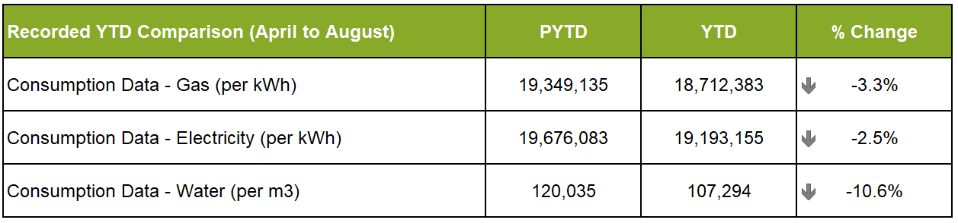
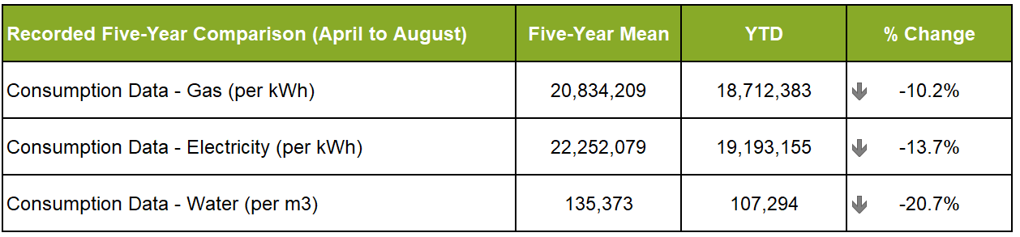
Please note that complete Quarter 2 data is not yet available and so we have provided information based on April to August of Financial Year 2024/25 with a comparison over the same time period for previous years. Considering this, all figures provided above should be taken as indicative, until the Quarter 2 data set is complete.
As with the Quarter 1 report, we continue to see a downward trend in consumption of utilities in comparison to the same period last year and the five-year mean.
We continue to see reduction in electricity consumption in comparison with the same time last year, and a more significant reduction against the five-year mean. This points to a long-term reduction driven by previous and current Estate rationalisation and upgrade of electrical infrastructure and office equipment.
Gas consumption has also reduced slightly against the same time last year and more significantly against the five-year mean. This reflects the work done on reducing estate footprint and continuing improvement of heating and hot water infrastructure across the portfolio.
Consumption of water has followed the same trend as gas and electricity. This is likely due in part to the same driver of estate rationalisation, and low occupancy levels within some buildings. However, we continue to see spikes in consumption within the data. This could be reflective of more intensive use of buildings during periods of high activity. Continual improvement in monitoring will help to determine whether these spikes can be explained as legitimate use or due to leakage.
In addition, we have completed our Public Bodies Duties Climate Change Report, where we have once again shown a reduction in our CO2e emissions against our annual total for last year. Our emissions total for 2023/24 was 39,377 tCO2e. The Report, which was approved by the SPA Board in September, sets out our intention to publish our Net Zero Plan this year, and to take forward our Climate Change Adaptation Strategy. As part of the Board discussion, there was a request from the Chair to include benchmarking data within Quarterly reporting. The Sustainability Team is currently reviewing this action and will be in a position to provide this additional assessment at the next update.

Fleet
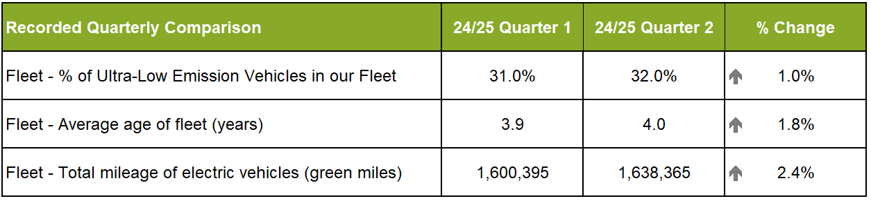
Police Scotland is working towards implementing the move to an Ultra-Low Emission Fleet as part of the Scottish Police Authority (SPA) approved Fleet Strategy. In Quarter 2 2024/25, 1,142 ULEV vehicles make up 32% of Police Scotland’s overall fleet (an increase of 1% point from the previous quarter). 46% of the unmarked fleet are ULEV (ultra-low emission vehicles). This figure remains the same as last quarter.
The total mileage of electric vehicles (green miles) during Quarter 2 2024/25 was 1,638,365. This has increased from 1,600,395 in Quarter 1 2024/25 and is up 2.3%.
The current average Fleet age for Police Scotland fleet is four years. This fluctuates from one day to the next as it is a live figure taking on the day, considering vehicles awaiting to be replaced and sold. This will reduce as new vehicles are introduced to the fleet and if the level of capital investment on the fleet is maintained in future years.

