 | Freedom of Information Response  Our reference: FOI 25-3380  Responded to: 7th January 2026
Your recent request for information is replicated below, together with our response.
I would like to request a list of reported incidents that have taken place on the Kilpatrick Hills between October 2022 and October 2025.
Please provide the information broken down into the date and time of the report and the nature of the incident reported.
Unfortunately, it would cost more than the FOI threshold of £600 to process your request and I am therefore refusing to do so in terms of section 12(1) of the Act.
To explain, whilst we do appreciate the additional clarification and map provided, we are unable to definitively identify the area in question on our systems, in a way that would allow us to search for incidents falling within the scope of your request.
To be of assistance, I would suggest a new request for all incidents in the beat locations listed below (with accompanying maps) may be of some interest.

BF82:
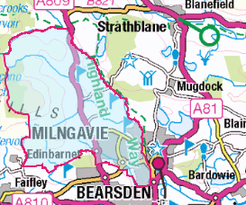
LA57:
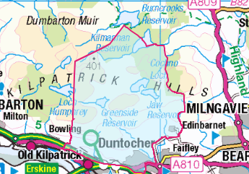

LA4:
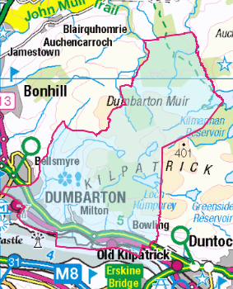
KF10:
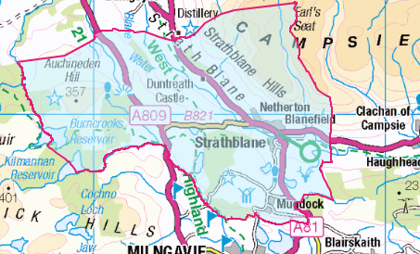

If you require any further assistance, please contact us quoting the reference above.
You can request a review of this response within the next 40 working days by email or by letter (Information Management - FOI, Police Scotland, Clyde Gateway, 2 French Street, Dalmarnock, G40 4EH). Requests must include the reason for your dissatisfaction.
If you remain dissatisfied following our review response, you can appeal to the Office of the Scottish Information Commissioner (OSIC) within 6 months - online, by email or by letter (OSIC, Kinburn Castle, Doubledykes Road, St Andrews, KY16 9DS).
Following an OSIC appeal, you can appeal to the Court of Session on a point of law only.
This response will be added to our Disclosure Log in seven days' time.
Every effort has been taken to ensure our response is as accessible as possible.
If you require this response to be provided in an alternative format, please let us know.

