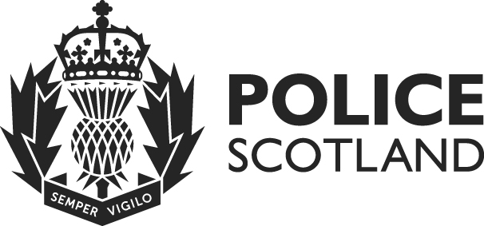


Equality and Human Rights Impact Assessment (EqHRIA)

Summary of Results

Policy / Practice | Trauma Risk Management (TRiM) V7.00
Owning Department | People and Development
Date EqHRIA Reviewed | 04/08/2021

Purpose of Policy / Practice | - The purpose of the Trauma Risk Management (TRIM) Standard Operating Procedure (SOP) is to provide guidance in relation to the provision of support for and the early identification of individuals who are impacted by traumatic incidents during the course of their work. The intended outcome of the SOP is to protect the physical and mental wellbeing of staff who have been exposed to traumatic operational incidents.  - Review of this SOP is being undertaken to ensure that the content remains up to date and to take into account any changes in legislation, policies, practices and resources. This will ensure that the SOP meets all legislative requirements and provides the best possible access to support services for all officers and staff.  - Original EIA conducted 27/11/2014. Content reviewed and transferred to current EqHRIA document in conjunction with the review of the SOP.  - EqHRIA updated 05/12/2017 as part of policy simplification review.  - EqHRIA reviewed 04/08/2021 due to change to TRiM process by licencing body.

- Summary of Analysis / Decisions - What the assessment found and actions already taken.
TRiM provides peer led intervention following direct involvement in operational and potentially traumatic incidents for all officers and staff across the organisation. Involvement in the TRiM process is voluntary.

It is anticipated that this SOP will have an overall positive impact by providing individuals and line managers with information and contact details to ensure access to TRiM interventions as required.

The redesign of the TRiM SOP, with new intranet tabular layout and simplified language will make this more accessible to everyone, which enhances the positive impact. This may particularly benefit individuals with learning difficulties such as dyslexia.

There is not expected to be any negative impact on individuals with one or more protected characteristics as a result of this SOP. Limited changes have been made to the content and there were no concerns previously.

- Summary of Mitigation Actions - What else we plan to do and how we are going to check that it has been done.
Occasionally information in relation to an individual’s psychological/post incident health may need to be disclosed to a line manager within the organisation in order to reduce potential risks and maintain the safety of our officers and staff and the wider organisation and community.

By operating in line with current legislation and in the interests of national security and public safety and for the prevention of disorder or crime and for the protection of the rights and freedoms of others. Established processes are in place to ensure that all data is protected and dealt with responsibly in line with legislation and these appear to be functioning well with no issues reported to date.

This is a legitimate aim in line with legislation.

