Police Scotland

Performance & Accountability Framework 24/25
Contents
Policing Scotland in 2024/25 2
Performance Approach 3
Performance Management 5
Evidencing Strategic Framework: Strategies and Plans 6
Performance Framework: Reporting 6
Benchmarking 7
Performance Measures and Evidence 7
Confidence Limits 8
Chief Constables Priority: Trust and Confidence 9
Operational Objective: Threat, Harm and Risk 18
Operational Objective: Prevention, Problem Solving & Proactivity 32
Operational Objective: Our People 37
Chief Constables Priority: Performance - Enabling Services 45

Policing Scotland in 2024/25
Our operational focus in 2024/25 is on threat, harm, and risk, focusing on prevention, problem solving and proactivity, and looking after our hard-working officers and staff to enable our people to deliver our vital public service. We will work to strengthen community policing across Scotland and engage widely as we begin to change the way in which we prioritise and deliver services to focus in the right areas.
Police Scotland's officers and staff and their commitment to serving our communities are the bedrock of the service's success. From tackling crime, roads policing, missing persons, proactive prevention, partnership working, dealing with increasing vulnerability in communities, and across many other areas, we will work every day to deliver successfully.
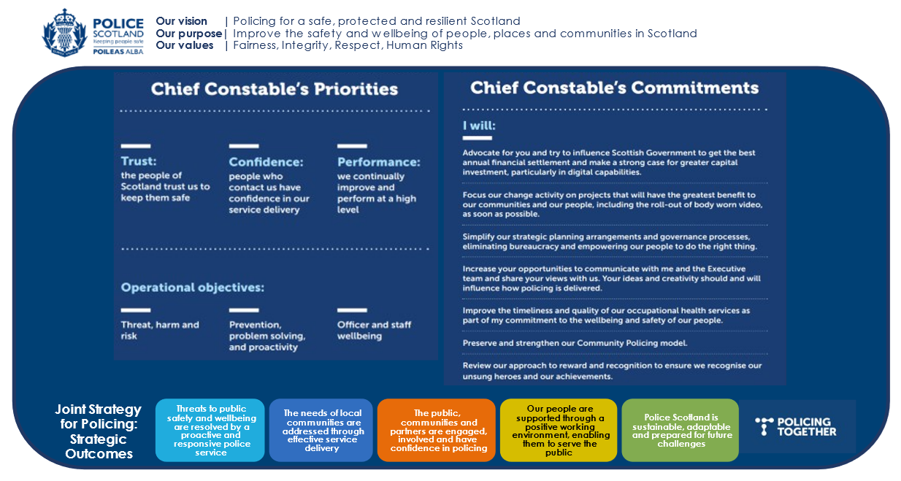

Performance Approach
The Chief Constable’s Priorities are at the centre of our approach to performance. Our Strategic Threat and Risk Assessment provides the evidence base for our areas of highest Threat, Harm and Risk (Force Control Strategy), Annual Policing Plan and Performance Framework. Our Values & Code of Ethics underpin our approach to performance management which is vital to maintain and strengthen public confidence and trust in the Service. Learning from others and sharing best practice is critical and we will benchmark with other relevant bodies where possible, using the PEEL Assessment Framework as appropriate.
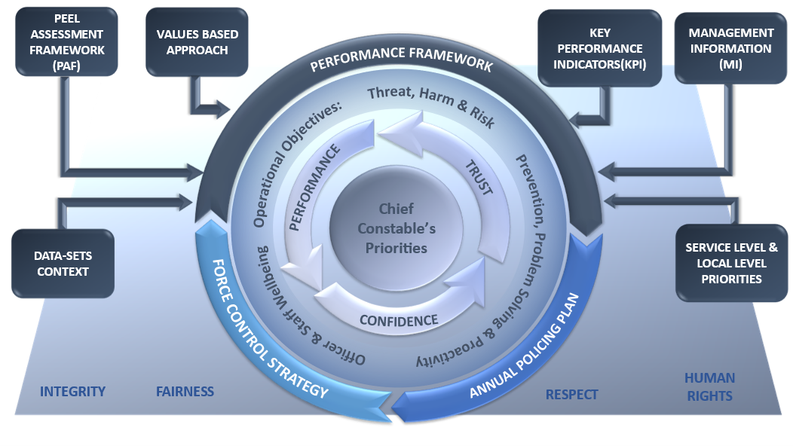

The Chief Constable’s Priorities align to the Strategic Outcomes set out in the Joint Strategy for Policing. Although reporting will be displayed against the priorities, this alignment ensures Police Scotland will continue to operate, evidence progression and contribute to the overarching outcomes.
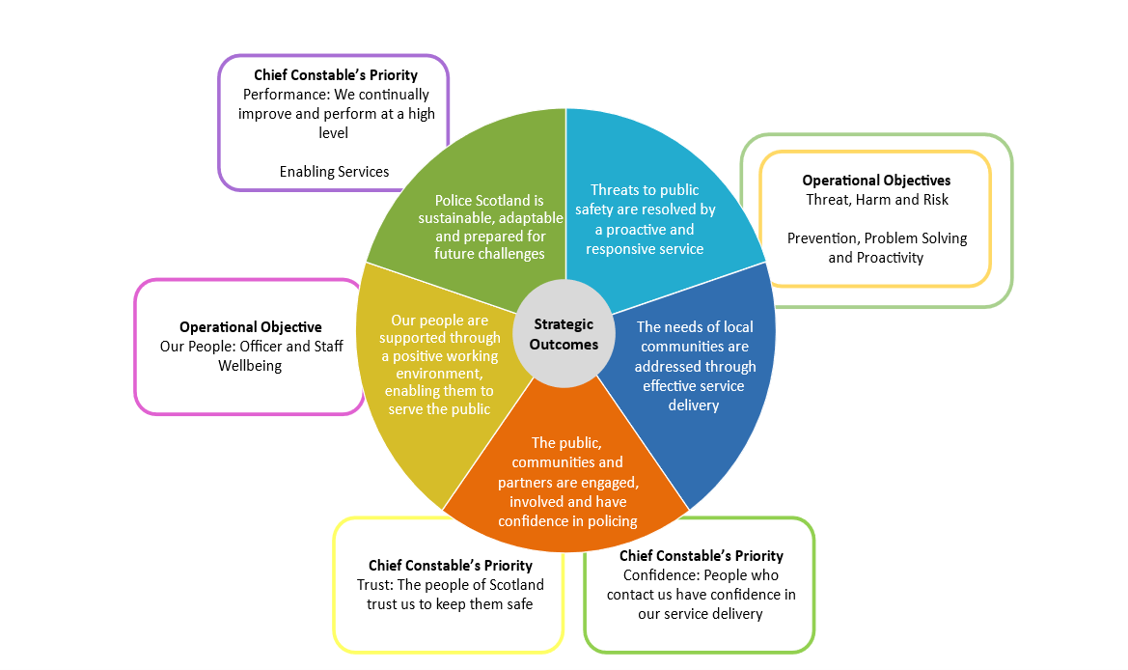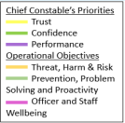

Performance Management
A consistent and values based approach to performance management is central to service delivery and maintaining public confidence and trust. Learning from others has also informed our approach. HMICFRS recommend the use of the National Decision making Model as a blueprint for good strategic Performance Management in their Police Performance – Getting a Grip report.
This informed with our new approach to Tasking and Co-ordination across the Service has improved and streamlined how we identify and escalate threat, harm and risk and make the most effective use of our resources which, in turn, provides a more focused service delivery to communities, monitored through our Performance Framework.
We are implementing a new approach to Performance with the development of Key Performance Indicators (KPI) and Management Information (MI). These have been strengthened with enhanced insights from national systems, including the new National Crime System that has now been rolled out across the Service.
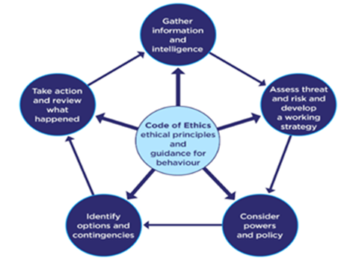
Coupled with this we have utilised new data analytics to build a new suite of PowerBI Performance Dashboards. These dashboards enable instant access to a wide range of data across priority areas and flag performance exceptions at a glance. They also provide a single source of truth Service wide in relation to data and provide ‘drill down’ to inform problem solving approaches.

Evidencing Strategic Framework: Strategies and Plans
Key Performance Indicators (KPI) and Management Information (MI) within our Performance Framework align to our strategies and plans, providing a barometer of progress, supported by context and evidence of delivery of the commitments contained therein, including:
- Policing Together
- Sex Equality and Tackling Misogyny
- People Strategy
- Culture Review
- Strategic Workforce Planning

Performance Framework: Reporting
Reporting using the refreshed performance framework will help the Scottish Police Authority and the public to understand the complexities of delivering an effective police service and ensure we are delivering performance in line with our organisational values.
To support delivery against our priorities, strategies and implementation plans, the identified KPI and MI will be used to assess progress and the impact of activities and actions – with a balance of quantitative measures (the numbers) and qualitative measures (the story) used to help understand and articulate the differences being made from a local to national perspective.
To support this further, the dashboards will be used as a tool to encourage everybody to ask the right questions and generate the right information to support evidence-based performance management internally and externally, while also promoting learning in delivering continuous improvement.
Commitments relating to change portfolio programmes or projects (including milestone achievement and benefits realisation) will be reported outside of quarterly and end of year data based performance reporting that this framework relates to.

Benchmarking
With the key outputs of the Benchmarking Framework Short Life Working Group now met, the group itself has now concluded and benchmarking activities have moved to business as usual. This will be led by Police Scotland, with support from Authority staff, with comparisons in different areas of focus reported to Policing Performance Committee as part of existing performance and operational reports.
Benchmarking reporting will focus on what can be learned from other forces performing well in specific areas, to inform continuous improvement. Benchmarking measures will be identified in each refresh of the annual Performance Framework. The following link provides an overview of the work delivered by the Benchmarking Short Life Working Group and a plan for continuous development of benchmarking metrics in the year ahead: item-2-2-benchmarking-progress-update-v0-1.pdf (spa.police.uk).

Performance Measures and Evidence
The detailed Performance Framework illustrates the breadth of measures we are tracking as a Service. Our performance framework is ambitious and we are continuing to develop a number of new measures in support of our strategic landscape. Collaborative engagement with key strategic groups and stakeholders further enables us to continually improve our performance coverage and identify suitable performance metrics for inclusion.
We have introduced a number of key core questions to better connect the Chief Constable’s priorities and operational objectives to the KPI’s/MI’s aligned to the PEEL Assessment Framework PEEL Assessment Framework (PAF) 2023–2025 (justiceinspectorates.gov.uk). Key Performance Indicators (KPI) and Management Information (MI) data have been identified to provide a high level temperature gauge of how we are performing as a Service.
The KPI will be key to delivering ‘what good looks like’ and these should be regarded as high-level indicators that identify areas of best practice and areas for improvement across the priorities.
MI are supplementary measures that will support our understanding and identify exceptions to focus performance conversations to areas in need of support. In addition, context and evidence alongside the datasets will remain a key component to informing performance management both internally and externally.
The following section provides a suite of KPI/MI aligned to the Chief Constable’s Priorities. Baseline information and potential forward looking factors are included alongside each indicator to inform progress across priority areas.

Confidence Limits
Using Confidence Intervals, with 95% confidence, to identify potential data outliers:
Upper Limit = 5 Year mean + (Z Score (1.96) * (Standard Deviation / Square Root of Observations (i.e. Standard Error)))
Lower Limit = 5 Year mean – (Z Score (1.96) * (Standard Deviation / Square Root of Observations (i.e. Standard Error)))
It should be noted that confidence limits are only intended to be a first or primary indicator. If the level of recorded crime is out with the confidence limits it should be a trigger for further research.
In these circumstances, additional research should be conducted around the outlier or exception to understand what may have caused it.
Questions relating to the data should be asked, such as;
- Is the potential issue isolated to one Division/Sub Division and can they explain the local pattern?
- Does it appear as though there is a national level change in a particular crime?
- Is there anything in the media or horizon scanning that could potentially influence recorded crime levels i.e. new legislation or changes to Scottish Crime Recording System (SCRS)?
- What other indicators can be used to examine the time series?
- Are there any social, political or environmental issues that may have impacted recorded crime?

Key
Cell denotes measure replicated in Local Level KPI/MI

Note: Baseline – denotes that this is the first time the measure will be reported on – we are creating baseline data.

Chief Constables Priority: Trust and Confidence
Core Questions
How good is Police Scotland at treating the public fairly, appropriately and respectfully?
How good is Police Scotland’s service for victims of crime?
What does good look like?
Officers and staff treat each individual with integrity, fairness and respect.
The public is satisfied with the response from the police service.
There is public confidence in policing across Scotland.
The public view Police Scotland as an organisation they can trust.

Key Performance Indicators (KPI)
Indicator | Current Position (as at 31 Dec 2023) | Compared to PYTD | Forward Looking Factors
% respondents that agree/strongly agree they have confidence in local policing | 33.4% | ↓ -1.1% points | There are a number of factors that influence confidence in local policing including visibility of local police officers. To improve this position local policing should continue to take cognisance of and respond to local feedback. Recognising that there will be other factors that influence public confidence such as high profile / Large scale enquiries and public enquiries that may influence public opinion going forward.
Based on your overall experience, how satisfied are you with your police service? | 69.3% | ↓ -0.2% points | This KPI directly relates to those who have come into contact with the police. It is expected that this will remain at higher levels than general confidence KPIs based on historical data.
Number of 999 calls | 641,905 | ↑ +14.5% | The volume of calls is impacted by many factors including large scale events, media campaigns, extreme weather. It is expected that call demand will continue to remain at higher levels.
Number of 101 calls | 1,050,025 | ↓ -4.5% | The volume of 101 calls is impacted by many factors including large scale events, media campaigns, extreme weather. It is expected that 101 calls will remain at higher levels.
Average call answer time for 999 calls | 10 seconds | ↔ No Change | Answer times are affected by the volume of calls to police. Other factors impacting answer time include service centre absence levels, nature of calls, service centre abstractions. 999 calls are prioritised which has a direct impact on answer times for 101 calls.
Average call answer time for 101 calls | 6 minutes 4 seconds | ↑ +1 minute 47 seconds | Answer times are affected by the volume of calls to police. Other factors impacting answer time include service centre absence levels, nature of calls, service centre abstractions. 999 calls are prioritised which has a direct impact on answer times for 101 calls.
Percentage of incidents that lead to a crime being recorded | 26.9% | ↓ -0.3% points | This measure is dependent on various influencing factors and is expected to fluctuate throughout year.
Percentage of incidents requiring police response | 97.4% | ↑ +0.4% points | This measure is dependent on various influencing factors and is expected to fluctuate throughout year.
Partner Demand - Number of external force requests | 2,836 | ↑ +24.7% | This measure is dependent on various influencing factors and is expected to fluctuate throughout year.
Number of calls by call result | Baseline | Baseline | This provides an indicator of C3 performance. This is a baseline indicator.
Local Policing Appointments made | 94,401 | - | Currently there are around 120K LPAs per year but C3 are keen to increase this volume.
Local Policing Appointments cancelled | Baseline | Baseline | Cancellations occur for several reasons including by C3, Local Policing and the public. New recording of cancellation reasons will provide valuable context to inform our approach.
The % of contact us emails that have come via 101 | 28.1% | - | Where appropriate callers are advised to disconnect and use the email service. This measure will be reported alongside total number of 101 calls and average answer time to provide a wholistic view of demand.
The % of discontinued calls | 19.0% | - | This is a key failure demand performance indicator but it is important to note that we advise the public to end their calls when busy and call back later, as well as hang up and use the Contact Us email if non urgent.
Incidents resolved by C3 Division | Baseline | Baseline | This provides an indicator of C3 performance. This is a baseline indicator.
Number of complaints | 5,512 | ↑ +10.7% | PSD is committed to promoting a culture of organisational and individual learning from CHRs and other sources. This learning can influence and improve our service to help reduce the number of complaints received against police officers and police staff.
Total number of allegations from members of the public | 8,235 | ↓ -7.3% | PSD is committed to promoting a culture of organisational and individual learning from CHRs and other sources. This learning can influence and improve our service to help reduce the number of allegations received against police officers and police staff.
% of complaints handled within statutory timescales | 11.7% | ↓ -6.4% points | The percentage of non-criminal complaints closed within the 56 day statutory timescale is down significantly on last year though steady this year.
% of complaints concluded at Front Line Resolution (FLR) | 49.7% | ↑ +0.5% points | The percentage of complaints concluded at FLR is relatively steady with a slight upward trend noted.
% of closed allegations which were upheld | 15.6% | ↓ -0.6% points | The percentage of upheld closed allegations is relatively steady with a slight downward trend noted.
Number of PIRC Complaint Handling Reviews (CHRs) | 112 | ↓ -22.2% | PSD is committed to promoting a culture of organisational and individual learning from CHRs and other sources. This learning can influence and improve our service to help reduce the number of PIRC CHRs submitted to Police Scotland for consideration.

Management Information (MI)
Indicator | Current Position (as at 31 Dec 2023) | Compared to PYTD | Forward Looking Factors
Your Police: % respondents agree/strongly agree that police listen to concerns of local people | 23.3% | ↓ -1.5% points | It is important that we demonstrate our values and behaviours in everyday interactions, officer attendance when necessary and keep people informed and updated, as these are key drivers of both positive perceptions and user experience.
Your Police: % respondents who feel very safe/fairly safe in their area | 77.4% | ↓ -0.6% points | Factors affecting feeling of safety and areas highlighted as important include anti-social behaviour. Enhanced visibility within communities is the top theme where the public feel we could be doing better.
Trust Index: Overall perceptions of Police Scotland | 78% | ↔ No Change | Results have remained relatively stable, between 75%-80% since the public trust survey was introduced in June 2022.
Trust Index: Attitudes towards crime | Force (46%)  Local (49%) | Force ↓ -9%  Local ↓ -6% | Results are showing a downward trend quarter on quarter from those satisfied with what we do to deter/prevent crime both nationally and locally.
Trust Index: Upholding our values | Respect (71%)  Human Rights (70%)  Fairness (69%)  Integrity (70%) | All ↑ +1% point  (bar Fairness – no change) | Most people continue to feel Police Scotland upholds its core values. The proportion of respondents who felt police uphold the values Respect, Human Rights, Fairness and Integrity continues on an upward trend.
Trust Index: Confidence in reporting crime | 62% | ↓ -5% points | Confidence in reporting crime can be impacted by a number of reasons including people’s perceptions of the Police. The majority however feel confident in reporting crime (ranging from 61% to 68%).
User Experience: Ease of contact | 74.1% | ↑ +0.7% points | User experience measures satisfaction with contacting the police across critical elements in the end-to-end journey. Findings show high and stable levels of satisfaction with initial contact. Positive experiences are correlated most strongly with the ease of contact.
User Experience: Treatment by staff member during initial contact | 84.4% | ↓ -0.7% points | User experience measures satisfaction with contacting the police across critical elements in the end-to-end journey. Findings show high and stable levels of satisfaction with treatment during initial contact.
User Experience: Staff understanding what they needed | 86.3% | ↑ +0.1% points | User experience measures satisfaction with contacting the police across critical elements in the end-to-end journey. Findings show high and stable levels of satisfaction with staff understanding what they needed.
User Experience: Police providing the appropriate response | 64.1% | ↑ +0.5% points | User experience measures satisfaction with contacting the police across critical elements in the end-to-end journey. Findings show stable levels of satisfaction with police providing the appropriate response. Positive experiences are correlated most strongly with receiving an appropriate response.
User Experience: Treatment by officers who attended the incident | 82.0% | ↑ +0.7% points | User experience measures satisfaction with contacting the police across critical elements in the end-to-end journey. Findings show high and stable levels of satisfaction with treatment by attending officers. Positive experiences are correlated most strongly with satisfaction with attending officers.
User Experience: Being adequately informed about progress | 50.2% | ↓ -0.4% points | User experience measures satisfaction with contacting the police across critical elements in the end-to-end journey. Findings show stable levels of satisfaction with being adequately informed about progress. Positive experiences are correlated most strongly with feeling adequately informed about case progress.
Number of allegations considered by PIRC (CHRs) | 608 | ↓ -12.3% | Organisational and individual learning from CHRs and other sources can influence and improve our service to help reduce the number of allegations considered by PIRC.
Percentage of these allegations assessed as handled to a reasonable standard | 58.2% | ↓ -15.0% points | Organisational and individual learning from CHRs and other sources can influence and improve our service to help increase the percentage of allegations handled to a reasonable standard.
Level of complaints received relative to C3s handling of 999/101 calls | 208 | ↔ No Change | Factors affecting the fluctuation of these numbers are average answer times, dispatch times etc.

Operational Objective: Threat, Harm and Risk
Core Questions
How good is Police Scotland at investigating crime?
How good is Police Scotland at protecting vulnerable people?
How good is Police Scotland at disrupting serious and organised crime?
What does good look like?
The force consistently carries out thorough investigations, which lead to satisfactory results for victims.
The force achieves good results for victims by pursuing evidence-led investigations when appropriate. It actively pursues prosecution on behalf of the victim.
The force works to reduce the threat, risk and harm posed by serious organised crime groups.
The force makes sure that the risk of further and/or increased harm to vulnerable victims is reduced via timely and appropriate safeguarding activity.

Key Performance Indicators (KPI)
Indicator | Current Position (as at 31 Dec 2023) | Compared to PYTD | Forward Looking Factors
Number of and detection rates of crimes (Group 1-5) | 185,078 | ↑ +7.2% | The forward looking factors will vary across the crime groups and will be referenced via other indicators.
Accused outcomes (Top 3) | Detected summons 44,495  Detected custody 27,300  Detected undertaking 17,569 | Baseline | This is a new indicator and we will continue to baseline and monitor this data.
Undetected crime outcomes (Top 3) | Undetected no further lines 41,708  Undetected live 35,694  Undetected uncoop witness 3,116 | Baseline | This is a new indicator and we will continue to baseline and monitor this data.
Number of Suspected Drug Related Deaths | 900 (Jan-Sep) | ↑ +13% | Figures taken from ScotGov latest quarterly publication. Police Scotland's focus in the area of drug related deaths is on identifying primary prevention and intervention opportunities. Through working with partners, we can reduce the harm caused by substance use to individuals and communities.
Number of naloxone administrations by police officers | Baseline | Baseline | As the roll-out of Naloxone concluded on 31 August 2023 this is a baseline measure. The number of administrations is likely to increase due to all officers and relevant staff now being equipped.
Number of VPD Concerns by Adult, Child, Domestic Abuse, Youth Offending, Hate, ACRA Child) | 231,290 | ↑ +1.6% | With the introduction of the automated escalation process and other improvements to iVPD, we hope to facilitate earlier interventions and therefore reduce demand. A measure of that success will be a reduction in the number of Concern Reports being raised on iVPD. Identifying concerns enables Police Scotland and its partners to proactively consider the wellbeing of individuals and communities.
Missing Person Demand - Number of missing persons investigations | 12,700 | ↓ -5.4% | The outlook for missing persons remains challenging. While overall investigations are decreasing the number of children going missing remains high and continues to rise slightly. Police Scotland continue to work in partnership with care homes to promote use of the Not at Home policy. This is an area of partnership working that continues to be addressed and led by police.
Number of missing persons from NHS locations | 1,080 | ↓ -20.5% | As per Missing Person Demand outlook.
Number of missing persons from YPU locations | 2,454 | ↑ +5.5% | As per Missing Person Demand outlook.
Number of missing persons from Foster Care locations | 331 | ↓ -5.2% | As per Missing Person Demand outlook.
Missing Person Demand - Number of missing persons with mental health marker | 3,974 | ↓ -5.8% | As per Missing Person Demand outlook.
Number of mental health incidents | 181,068 | ↑ +9.7% | As per Missing Person Demand outlook.
Number of domestic abuse crimes | 26,300 | ↓ -5.1% | Research indicates that Domestic Abuse is under-reported and Police Scotland will continue to encourage people to report. Factors that will influence the fluctuations are campaigns, media attention, best practice, education/further awareness.
Domestic abuse crimes detection rate | 61.2% | ↓ -3.2% points | Domestic abuse detection rate for the last six years has, in general, been between 64% and 71%.
% of crimes against a female that are domestic related | Baseline | Baseline | This is a new indicator and we will continue to baseline and monitor this data.
Number of rape crimes | 1,805 | ↓ -0.1% | Police Scotland continue to encourage reporting of sexual crimes and will continue to work with partners and examine available data to establish if reporting is increasing.
Rape detection rate | 49.6% | ↓ -3.4% points | Rape detection rate has fluctuated between 50%-60% over the past five years (60% was 2020/21, with fewer crimes during COVID).
Number of sexual assault crimes | 11,142 | ↑ +3.1% | Police Scotland continue to encourage reporting of sexual crimes and will continue to work with partners and examine available data to establish if reporting is increasing.
Sexual assault crimes detection rate | 55.7% | ↑ +1.1% points | Sexual assault detection rate has fluctuated between 52%-60% over the past five years.
Number of crimes where victim is female | Baseline | Baseline | This is a new indicator and we will continue to baseline and monitor this data.
Number of online child sexual abuse crimes | 1,472 | ↑ +5.4% | Police Scotland continue to encourage reporting of sexual crimes and will continue to work with partners and examine available data to establish if reporting is increasing.
Online child sexual abuse crimes detection rate | 70.2% | ↑ +1.8% points | Child sexual abuse detection rate has fluctuated between 62%-73% over the past five years.
Number of Sex Offender Notification Requirements (SONR) offences committed | Baseline | Baseline | This is a new indicator and we will continue to baseline and monitor this data.
Number of Preventative Order offences committed (SHPO, SRO and equivalent orders issued) | Baseline | Baseline | This is a new indicator and we will continue to baseline and monitor this data.
Number of offenders who have sexually reoffended | Baseline | Baseline | This is a new indicator and we will continue to baseline and monitor this data.
Overall number of offenders (to provide context with regard to the sexual reoffending above) | Baseline | Baseline | This is a new indicator and we will continue to baseline and monitor this data.
Number of county lines groups | 55 | ↑ +59.8% | Continued Operational activity as well as events such as County Lines Intensification weeks have proven successful in identifying and tackling county lines/SOCG groups and are likely to lead to further increases in nominal arrests and identifying new groups.
Number of Serious Organised Crime Group (SOCG) nominal arrests | 365 | ↑ +129.6% | Continued Operational activity as well as events such as County Lines Intensification weeks have proven successful in identifying and tackling county lines/SOCG groups and are likely to lead to further increases in nominal arrests and identifying new groups.
Number of operations recorded by Serious Organised Crime Mapping | 106 | ↑ +3.9% | Changed measure from Number of groups and individuals on SOCG map - SOC Mapping now includes groups, priority individuals and vulnerabilities.
Percentage of mapped SOC operations which had a reduction in their MoRiLE tactical risk score. | 31% | ↑ +12% points | This will continue to be compared quarter on quarter rather than against PYTD due to the potential for risk score fluctuating throughout the year.
Percentage of mapped SOC operations which were disrupted, dismantled and archived. | 24% | ↑ +4% points | This will continue to be compared quarter on quarter rather than against PYTD due to the potential for risk score fluctuating throughout the year.
Percentage of police led mapped SOC operations vs partner led mapped SOC operations. | 76% | ↔ No Change | This will continue to be compared quarter on quarter rather than against PYTD due to the potential for risk score fluctuating throughout the year.
Number of Group 3 crimes linked to SOC | Baseline | Baseline | This is a new indicator and we will continue to baseline and monitor this data.
Group 3 crimes detection rate linked to SOC | Baseline | Baseline | This is a new indicator and we will continue to baseline and monitor this data.
Number of fraud crimes linked to SOC | Baseline | Baseline | This is a new indicator and we will continue to baseline and monitor this data.
Fraud crimes detection rate linked to SOC | Baseline | Baseline | This is a new indicator and we will continue to baseline and monitor this data.
Value of Proceeds of Crime Act (POCA) seizures | £19,428,880 | ↑ +19.7% | There has been a gradual decrease in the value of Proceeds of Crime Act seizures over the past three years.
Number of cybercrimes | 11,243 | ↑ +24.7% | This figure will become more accurate over the coming years as the use of the marker becomes more consistent across divisions.
Cybercrimes detection rate | Baseline | Baseline | This is a new indicator and we will continue to baseline and monitor this data.
Number of fraud cybercrimes | 5,138 | ↑ +17.4% | This is a new indicator and we will continue to baseline and monitor this data.
Fraud cybercrimes detection rate | Baseline | Baseline | This is a new indicator and we will continue to baseline and monitor this data.
Number of sexual cybercrimes | 3,569 | ↑ +33.4% | This is a new indicator and we will continue to baseline and monitor this data.
Sexual cybercrimes detection rate | Baseline | Baseline | This is a new indicator and we will continue to baseline and monitor this data.
Number of people killed (Road Safety) | 119 | ↓ -13.1% | Police Scotland works in partnership to help prevent road deaths. Several areas of work have been identified moving forward to mitigate road deaths and injuries, including safety of vulnerable road users such as cyclists and motorcyclists, identifying trends in relation to all collision classes, and our targeted campaigns which run throughout the year.
Number of children killed (Road Safety) | 4 | ↑ +100.0% | Police Scotland works in partnership to help prevent road deaths. Several areas of work have been identified moving forward to mitigate road deaths and injuries, including safety of vulnerable road users such as cyclists and motorcyclists, identifying trends in relation to all collision classes, and our targeted campaigns which run throughout the year.
Number of overall violent crimes | 49,774 | ↑ +4.4% | Overall violent crime levels have increased slightly due to higher levels of common assault. As a result of improved data via National UNIFI work is underway to look at issues such as youth crime and night time economy related violence to better understand shifts in violent crime levels.
Overall violent crime detection rate | 69.7% | ↑ +0.6% points | As per number of overall violent crimes factors
Number of homicide crimes | 41 | ↑ +28.1% | Last year saw a record low number of homicides recorded. Police Scotland will continue to work to prevent and detect homicides.
Homicide detection rate | 112.2% | ↑ +9.1% points | As per number of homicide crimes factors
Number of hate crimes | 4,931 | ↑ +0.5% | The introduction of new hate crime legislation (including new categories) will see crimes increase.
Hate crime detection rate | 57.4% | ↓ -6.6% points | As per number of hate crimes factors

Management Information (MI)
Indicator | Current Position (as at 31 Dec 2023) | Compared to PYTD | Forward Looking Factors
Proportion of rape non-recent | 41.6% | ↑ +5.1% points | Police Scotland continue to emphasise a level of under reporting of sexual crimes. These crimes are not expected to fall significantly in the near future as we continue to encourage victims to come forward.
Proportion of group 2 crime non-recent | 24.2% | ↑ +2.4% points | Police Scotland continue to emphasise a level of under reporting of sexual crimes. These crimes are not expected to fall significantly in the near future as we continue to encourage victims to come forward.
Supply of drugs - total - number of crimes | 3,106 | ↑ +2.4% | Our work in tackling drug supply has been complimented through projects such as our county lines operations which have been successful in disrupting drug supply networks in the country.
Number of people seriously injured (Road Safety) | 1,389 | ↑ +10.1% | Police Scotland works in partnership to help prevent road deaths. Several areas of work have been identified moving forward to mitigate road deaths and injuries, including safety of vulnerable road users such as cyclists and motorcyclists, identifying trends in relation to all collision classes, and our targeted campaigns which run throughout the year.
Number of children seriously injured (Road Safety) | 131 | ↓ -0.8% | Police Scotland works in partnership to help prevent road deaths. Several areas of work have been identified moving forward to mitigate road deaths and injuries, including safety of vulnerable road users such as cyclists and motorcyclists, identifying trends in relation to all collision classes, and our targeted campaigns which run throughout the year.
Number of attempted murder crimes | 195 | ↓ -4.4% | As a result of improved data via National UNIFI work is underway to look at violent crimes such as attempted murders in a more detailed manner. Factors such as extent of injuries, victim/offender profiles and connections to night-time-economy, serious organised crime, youth violence etc can all now be better analysed.
Attempted murder detection rate | 94.4% | ↓ -2.2% points | Detection rate has fluctuated between 90%-97% over the past five years.
Number of serious assault crimes | 2,467 | ↓ -1.6% | As a result of improved data via National UNIFI work is underway to look at violent crimes such as serious assaults in a more detailed manner. Factors such as extent of injuries, victim/offender profiles and connections to night-time-economy, serious organised crime, youth violence etc can all now be better analysed.
Serious assault detection rate | 77.8% | ↑ +0.1% points | Detection rate has fluctuated between 73%-78% over the past five years (78% was 2020/21, with fewer crimes during COVID).
Number of robbery crimes | 1,507 | ↑ +29.4% | As a result of improved data via National UNIFI work is underway to look at robbery crimes in a more detailed manner. This will improve our understanding of offender and victim profiles. Location types and what sort of items (drugs, mobile devices, money) are being targeted on a national level.
Robbery detection rate | 74.4% | ↑ +1.6% points | Detection rate has fluctuated between 71%-80% over the past five years (80% was 2020/21, with fewer crimes during COVID).
Number of common assault crimes | 45,463 | ↑ +4.2% | As a result of improved data via National UNIFI work is underway to look at violent crimes such as common assaults in a more detailed manner. Factors such as extent of injuries, victim/offender profiles and connections to night-time-economy, serious organised crime, youth violence etc can all now be better analysed.
Common assault detection rate | 68.9% | ↑ +0.6% points | Detection rate has fluctuated between 66%-72% over the past five years (72% was 2020/21, with fewer crimes during COVID).
Number of hate incidents | 5,587 | ↓ -0.2% | The introduction of new hate crime legislation (including new categories) will see incidents increase.

Operational Objective: Prevention, Problem Solving & Proactivity
Core Questions
How good is Police Scotland at preventing and deterring crime?
How good is Police Scotland at managing offenders and suspects?
How good is Police Scotland at utilising partnership-orientated evidence-based problem-solving?
What does good look like?
The force mitigates repeat offenders in a fair and proportionate manner.
The force reduces the backlog of outstanding suspects and wanted persons and has processes in place to monitor performance.
The force understands and demonstrates a long-term commitment to problem-solving and evidence-based policing. It maximises opportunities to prevent public harm and reduce demand through working with partner organisations.

Key Performance Indicators (KPI)
Indicator | Current Position (as at 31 Dec 2023) | Compared to PYTD | Forward Looking Factors
Number of repeat offenders | 31,205 | ↔ No Change | This is a new indicator and we will continue to baseline and monitor this data.
Number of new offenders | 53,571 | Baseline | This is a new indicator and we will continue to baseline and monitor this data.
% of repeat offenders | 33.3% | ↓ -1.3% points | This is a new indicator and we will continue to baseline and monitor this data.
Re-offending rate by crime group | G1 - 12.9%  G2 - 22.0%  G3 - 35.0%  G4 - 19.8%  G5 - 32.0%  G6 - 29.2%  G7 - 16.6% | G1 - ↑ +1.8%  G2 - ↑ +3.3%  G3 - ↑ +2.1%  G4 - No Change  G5 - ↓ -0.6%  G6 - ↓ -0.9%  G7 - ↑ +0.4% | This is a new indicator and we will continue to baseline and monitor this data.
Number of repeat victims within defined time period | Baseline | Baseline | This is a new indicator and we will continue to baseline and monitor this data.
Proportion of persons arrested with mental health issues (tabular model should be ready 2024/25) | 42.9% | ↑ +0.6% points | Could/will depend on the overall change in number of custodies
Volume of cases submitted into criminal justice system (tabular model should be ready 2024/25) | 97,308 | ↑ +5.2% | Drives in areas around direct measures, investigative liberation and alternative pathways to prosecution could see a reduction in this.
Number of times arrested persons brought into custody (tabular model should be ready 2024/25) | 75,870 | ↑ +3.8% | Drives in areas around direct measures, investigative liberation and alternative pathways to prosecution could see a reduction in this.
Proportion of arrested persons held for court (tabular model should be ready 2024/25) | 42.3% | ↑ +1.8% points | Drives in areas around direct measures, investigative liberation and alternative pathways to prosecution could see a reduction in this.
Proportion of arrested persons released on an undertaking (tabular model should be ready 2024/25) | 23.2% | ↓ -0.8% points | Drives in areas around direct measures, investigative liberation and alternative pathways to prosecution could see a reduction in this.
Proportion of arrested persons released on investigative liberation (tabular model should be ready 2024/25) | 0.9% | ↑ +0.3% points | Drives in areas around direct measures, investigative liberation and alternative pathways to prosecution could see a reduction in this.

Management Information (MI)
Indicator | Current Position (as at 31 Dec 2023) | Compared to PYTD | Forward Looking Factors
Number of younger / older children arrested (held/not held/overnight/over 24hrs) (tabular model should be ready 2024/25) | Over 24hrs for illustrative purposes  Younger 29  Older 136 | Over 24hrs for illustrative purposes  Younger  ↑ +38.1%  Older  ↓ -26.1% | Drives in areas around direct measures, investigative liberation and alternative pathways to prosecution could see a reduction in this.
Number of Police Direct Measures issued (ASB, FPN and RPW) (tabular model should be ready 2024/25) | ASB FPNs 3,456  RPWS 14,425 | ASB FPNs  ↓ -11.5%  RPWs  ↓ -6.5% | New legislation may come in to place adding more crime types where an FPN/RPW can be issued (s.38 currently under review). This will lead to an increase.  Conversely, when people meet the threshold of having 3 FPN/RPWs issued, they are no longer eligible – this will lead to a reduction in the number of persons eligible and usage.
Number stop and searches | 23,818 | ↑ +10.3% | The focus of stop and search remains adherence to the Code of Practice, ensuring ethical, intelligence led and proportionate use of this tactic.
Proportion of stop and searches that are positive | 29.8% | ↓ -3.5% points | While the positive rate of stop and searches has decreased in recent years this can also be linked to improved accuracy of recording and increased confidence in the use of stop and search by officers. It is expected that the positive rate will continue to decrease slightly in the coming year but factors such as the number of items, particularly weapons and drugs, recovered from these searches should also be considered.
Stop and search compliance rate (%) | 99.2% | ↑ +0.3% points | Compliance with the Stop and Search Code of Practice remains the most important measurement of stop and search activity by Police Scotland. This has stayed at close to 100% in recent years and is expected to remain so.
Number of bail offences | 9,393 | ↑ +13.4% | Police Scotland will continue to monitor bail offences and work with criminal justice partners as necessary.
Number of possession of offensive weapons | 8,433 | ↑ +14.2% | Commencement number 3 of the Offensive Weapons Act 2019 took effect in March 2023 creating new offences regarding the possession of weapons. It is likely that the number of possession of offensive weapons crimes will increase compared to recent years as a result.

Operational Objective: Our People
Core Questions
How good is Police Scotland at building, developing and looking after its workforce and encouraging an ethical, lawful and inclusive workplace?
What does good look like?
The force is taking effective action to address any well-being challenges it has identified. It provides a good range of preventative and supportive measures, including enhanced support to those in high-risk roles or those experiencing potentially traumatic incidents.
The force’s occupational health service provides support and interventions that improve officer and staff well-being.

Key Performance Indicators (KPI)
Indicator | Current Position (as at 31 Dec 2023) | Compared to PYTD | Forward Looking Factors
FTE/Headcount against budgeted establishment | 16,312.75 FT vs 16,634 BE | ↓ -1.9% | Budget constraints will continue to prove challenging in the forthcoming year.
Modified duties by deployability | Baseline | Baseline | This is a new indicator and we will continue to baseline and monitor this data.
Modified Duties by category | Adjusted – 1555  Ill Health Retiral Retained – 54  Protected – 177  Recuperative - 906 | Baseline | This is a new indicator and we will continue to baseline and monitor this data.
Force profile by protected characteristics | Awaiting 2023/24 figures | Awaiting 2023/24 figures | We are bringing more focus on how policing in Scotland reflects, represents and serves our communities under the Policing Together initiative and we will continue to seek improvement in this area.
Recruitment profile by protected characteristics | Awaiting 2023/24 figures | Awaiting 2023/24 figures | We are bringing more focus on how policing in Scotland reflects, represents and serves our communities under the Policing Together initiative and we will continue to seek improvement in this area.
Promotion profile by protected characteristics | Awaiting 2023/24 figures | Awaiting 2023/24 figures | We are bringing more focus on how policing in Scotland reflects, represents and serves our communities under the Policing Together initiative and we will continue to seek improvement in this area.
Leavers Profile (overall rate/resignation rate/average length of service) (Top 3) | Retirement 25-30yrs 1.74%  Resign Other Employment  1.18%  Resign Personal 0.94% | Baseline | This is a new indicator and we will continue to baseline and monitor this data.
Average working days lost from sickness absence), short-term/long-term split | Police Officers 1.2  Police Staff 1.4 | Baseline | This is a new indicator and we will continue to baseline and monitor this data.
Sickness absence by reason (short-term/long-term split) (Physical/Mental) (Top 3) | Stress 1.1%  WDL Flu 0.5%  Surgery 0.4% | Baseline | This is a new indicator and we will continue to baseline and monitor this data.
% total working time lost (Abstraction rates) | 2023 % hours remaining 71.12% | Baseline | This is a new indicator and we will continue to baseline and monitor this data.
Volume of Ill Health Retirals (IHR) | Baseline | Baseline | This is a new indicator and we will continue to baseline and monitor this data.
Volume of Injuries on Duty (IOD) | Baseline | Baseline | This is a new indicator and we will continue to baseline and monitor this data.
Length of time to process Ill Health Retirals (IHR) | Baseline | Baseline | This is a new indicator and we will continue to baseline and monitor this data.
Length of time to process Injuries on Duty (IOD) | Baseline | Baseline | This is a new indicator and we will continue to baseline and monitor this data.
Uptake of Employee Assistance Programme | Baseline | Baseline | This is a new indicator and we will continue to baseline and monitor this data.
Number of Occupational Health Referrals | Baseline | Baseline | This is a new indicator and we will continue to baseline and monitor this data.
Number of grievances | Baseline | Baseline | Data possibly available but not recorded on SCOPE. Would need to verify if recorded by when grievance raised or concluded.
Police Officer and Staff discipline cases by category | Baseline | Baseline | This is a new indicator and we will continue to baseline and monitor this data.
Assaults on Officers/Staff | 5,164 | ↓ -1.1% | Police Scotland has brought additional focus to violence and abuse against officers and staff under the Your Safety Matters initiative. Guidance for officers and staff has also been published to support better reporting of health and safety incidents and assaults, as well as data dashboard to enable in-depth analysis and identify repeat offenders.
% of police assaults leading to injury | 25.8% | ↓ -1.0% points | As per Assaults on Officers/Staff factors
% of police assaults leading to injury that are referred to OHU | Baseline | Baseline | This is a new indicator and we will continue to baseline and monitor this data.
Number of use of force reports | 5,701 | ↑ +29.2% | As per Assaults on Officers/Staff factors
Number of assault RIDDORS | 26 | ↑ +4.0% | As per Assaults on Officers/Staff factors
Number of assault RIDDORS per 1k employment | 1.1 | ↑ +10.0% | As per Assaults on Officers/Staff factors

Management Information (MI)
Indicator | Current Position (as at 31 Dec 2023) | Compared to PYTD | Forward Looking Factors
TOIL balances | 10,698.6 Positive TOIL Balances | Baseline | This is a new indicator and we will continue to baseline and monitor this data.
Number of rest days disrupted | Baseline | Baseline | This is a new indicator and we will continue to baseline and monitor this data.
Percentage of cancelled rest days that are reallocated within 17 weeks | Baseline | Baseline | This is a new indicator and we will continue to baseline and monitor this data.
Percentage of cancelled rest days that are reallocated within 12 months | Baseline | Baseline | This is a new indicator and we will continue to baseline and monitor this data.
Percentage of cancelled rest days placed in bank (breaching policy) | Baseline | Baseline | This is a new indicator and we will continue to baseline and monitor this data.
Exit Survey leaving factors other than retirement | Career Change 17.5%  Lack of Resources 13.8%  Other  13.2% | Baseline | This is a new indicator and we will continue to baseline and monitor this data.
Cost of absence (current and predicted annual) | Baseline | Baseline | This is a new indicator and we will continue to baseline and monitor this data.
Trim referrals by type | Baseline | Baseline | This is a new indicator and we will continue to baseline and monitor this data.
Exit survey view on most useful support mechanisms | Support mechanisms 30.8%  Colleagues  69.5%  Line Manager  59.0% | Baseline | This is a new indicator and we will continue to baseline and monitor this data.
Promotion - Breakdown of officers successful / unsuccessful | Baseline | Baseline | This is a new indicator and we will continue to baseline and monitor this data.
Success Rates (overall) | Baseline | Baseline | This is a new indicator and we will continue to baseline and monitor this data.
Probationer success rate (comparing with overall success rate) | Baseline | Baseline | This is a new indicator and we will continue to baseline and monitor this data.
Number of Police Officers / Staff working part time or compressed hours | Baseline | Baseline | This is a new indicator and we will continue to baseline and monitor this data.
Average hours for part time working by Police Officers / Staff | Baseline | Baseline | This is a new indicator and we will continue to baseline and monitor this data.
Rank ratios | Baseline | Baseline | This is a new indicator and we will continue to baseline and monitor this data.
Number of hours worked by Special Constables | Baseline | Baseline | This is a new indicator and we will continue to baseline and monitor this data.
Police Staff retention rates | Baseline | Baseline | This is a new indicator and we will continue to baseline and monitor this data.
Number of days per employee who participate in training per year | Baseline | Baseline | This is a new indicator and we will continue to baseline and monitor this data.
Mandatory training uptake | Baseline | Baseline | This is a new indicator and we will continue to baseline and monitor this data.
Retention Rates following maternity leave (resignation rate within 12 months of return) | Baseline | Baseline | Data might not be available
Staff supernumerary pool number / cost | Baseline | Baseline | This is a new indicator and we will continue to baseline and monitor this data.
Cost of pay protection | Baseline | Baseline | This is a new indicator and we will continue to baseline and monitor this data.

Chief Constables Priority: Performance - Enabling Services
Core Questions
How good is the force at planning and managing its organisation efficiently, making sure it achieves value for money both now and in the future
What does good look like?
The force provides value for money and can demonstrate continuous improvement, efficiency savings and improved productivity.

Key Performance Indicators (KPI)
Indicator | Current Position (as at 31 Dec 2023) | Compared to PYTD | Forward Looking Factors
Financial Sustainability – Maintaining a balanced budget: Revenue, Capital and Reform | Revenue forecast  £1,357.8m  Capital forecast  £54.9m  Reform forecast  £20.3m | Not applicable | Mitigating actions and savings are being managed and delivered to bring spend back in line with the funded position.
Fleet – Average age of fleet | 3.75 years | ↓ -15.1% | The age of fleet will reduce if the level of investment is maintained, whilst both the proportion of ULEV and green miles will increase for the same reason.
Fleet – Proportion of vehicles that are ULEV (%) | 30.0% | ↑ +4% points | The age of fleet will reduce if the level of investment is maintained, whilst both the proportion of ULEV and green miles will increase for the same reason.
Fleet – Total mileage of electric vehicles (green miles) | 4,245,116 | ↓ -3.3% | The age of fleet will reduce if the level of investment is maintained, whilst both the proportion of ULEV and green miles will increase for the same reason.
Estates - % footprint of the estate which is co-located/shared with our partners | 23% | ↑ +2% points | The number of sites will drop slightly before the end of the financial year and co-locations will be up very slightly. The current increase is through an adjustment down in the number of sites due to disposals and accounting for more recent co-locations not previously included.
Estates - % footprint of the estate that is in good or better condition (annual update) | 89.4% | Not available | The estate whilst in poor condition has seen elemental improvements predominantly due to the M&E works carried out. This figure represents an improvement, not the condition of the estate overall. We do not have comparable information in relation to the previous years’ data.
Environment – Consumption data for Gas, Electricity, Water | Gas 37,038,380  Elec 31,314,279  Water 191,634 | Gas ↑ +0.8%  Elec ↓ -4.4%  Water ↓ -12.1% | Police Scotland continues to aim to reduce our energy consumption through measures such as co-location with partner agencies. This should see continued reductions in energy reduction.

