Cyber Kiosk Management Information

Public Document

February 2021

Contents
Introduction 3
Cyber Kiosks 3
Cyber Kiosk Public Commitment 3
Examination Request Form (ERF) Process Map 4
Cyber Kiosk Management Information 5
Table 1 - Status of Owner / Power of Seizure – National Totals – February 2021 7
Table 2 - Status of Owner / Reason for Device Examination – National Totals – February 2021 8
Table 3 - Cyber Kiosk Examination Requests – East Region – February 2021 9
Table 4 - Cyber Kiosk Examination Requests – North Region – February 2021 10
Table 5 – Cyber Kiosk Examination Requests – West Region – February 2021 11
Table 6 - Cyber Kiosk Examinations – Crime Group & Crime Type – National Totals – February 2021 12
Cyber Kiosk Examinations – Crime Group & Crime Type – National Totals – February 2021 (cont.) 13

Introduction

Cyber Kiosks
Also known as a ‘Digital Triage Device’, a Cyber Kiosk is a desktop computer specifically designed to view data stored on a digital device in a targeted and focused way. Cyber Kiosks are operated by Kiosk Operators who are responsible for carrying out the 'triaging' of devices. Kiosk Operators can set parameters e.g. restricting searches to a date/time range, searching only text messages/photographs. If, after examination, no evidence is found, the device may be returned to the owner. There are 41 Cyber Kiosks located in Police Scotland buildings across Scotland.

Cyber Kiosk Public Commitment
Police Scotland has made a public commitment to publish data relating to the use of Cyber Kiosks. This data is referred to as Management Information (MI) and is taken on a monthly basis from the Cybercrime Case Management System (CMS); a system used by Police Scotland to record all requests for digital device examination, document the required approval process and to record the number and type of devices examined. This information is recorded on an Examination Request Form (ERF).

The Cybercrime Case Management System (CMS) records information entered by the Investigating Officer at the time of initial submission. Management Information from the CMS is accurate at the time of retrieval however may not reflect any operational developments or administrative amendments which occur following submission, for example the status of a Subject changing as an enquiry develops.

The following flow diagram details the submission and approval process for all digital device examinations:

Examination Request Form (ERF) Process Map
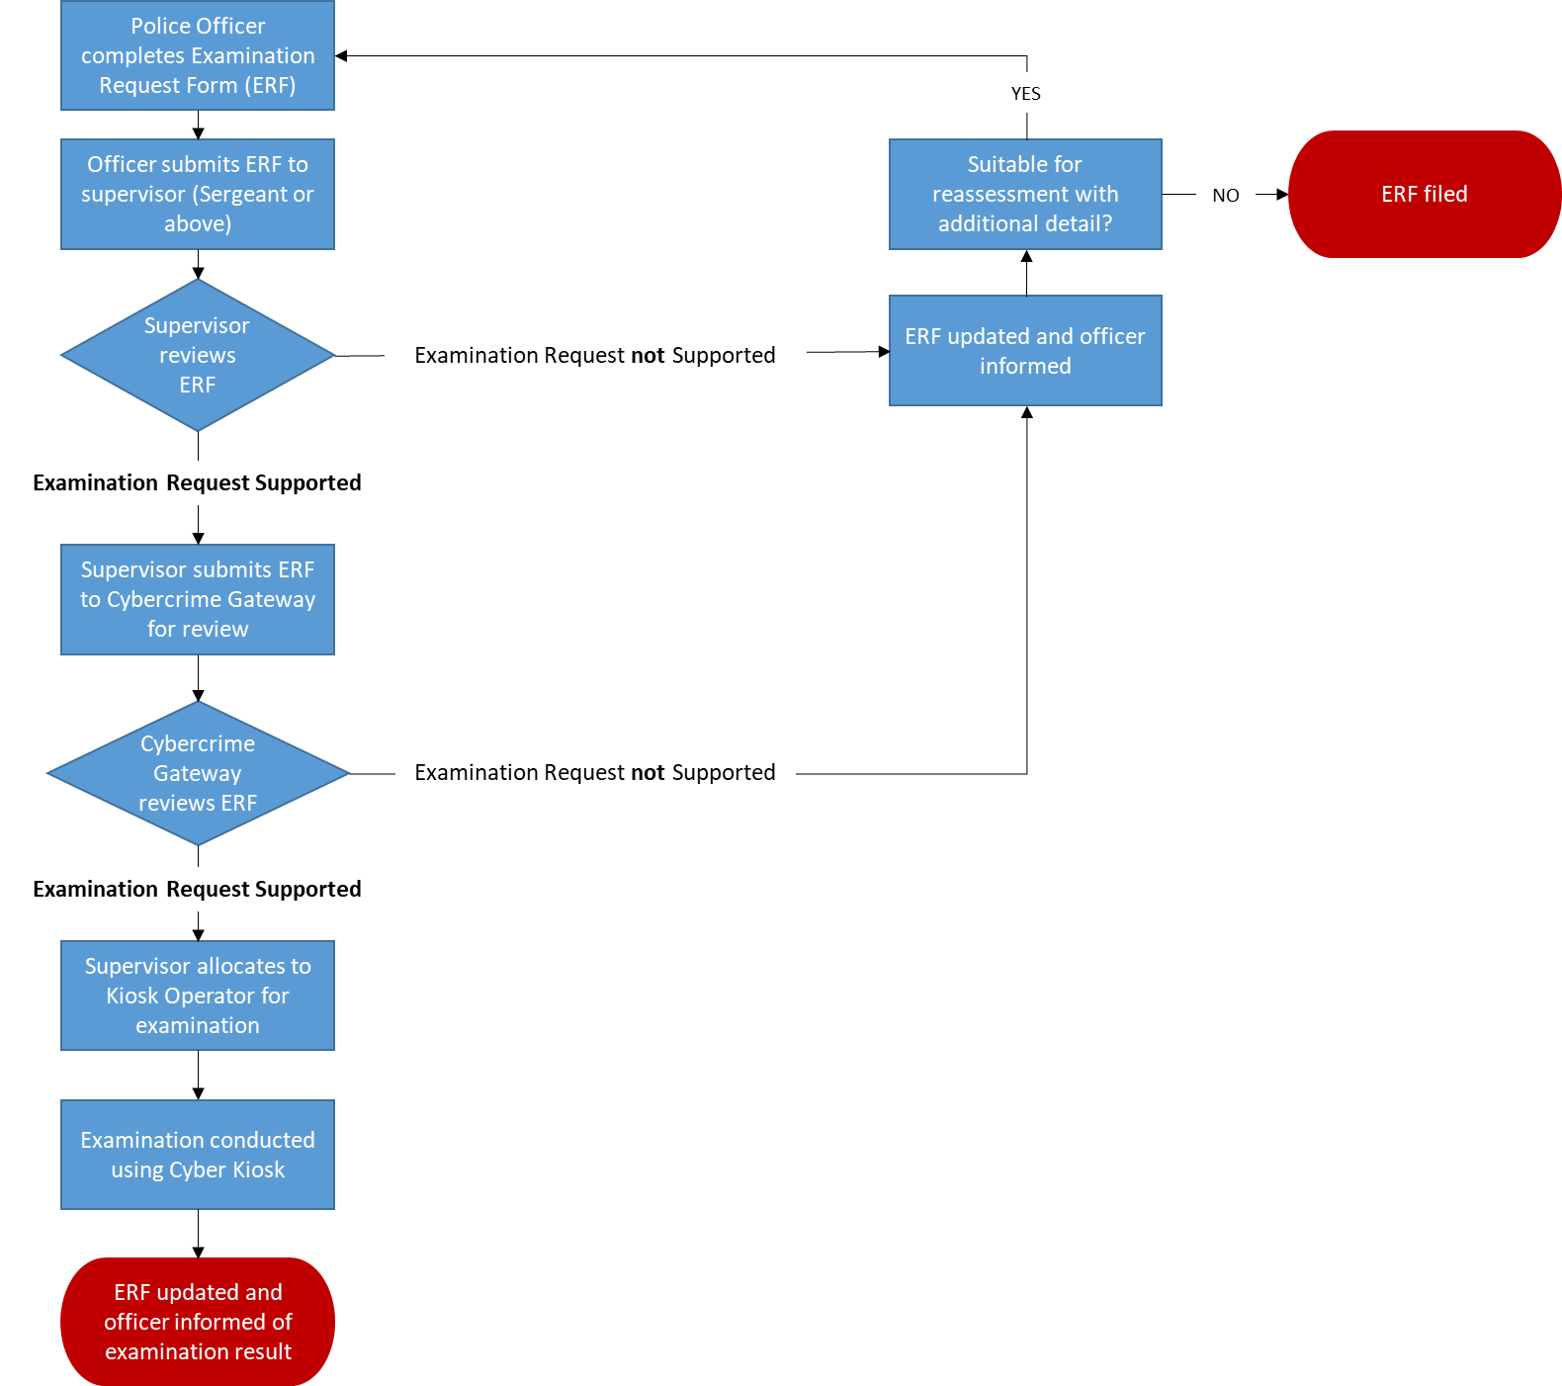

Cyber Kiosk Management Information

Police Scotland undertake to each calendar month collate and present in a clear and precise manner the number of Kiosk examinations which have taken place. As an ERF can contain more than one device for examination, both the total number of ERFs and the number of devices examined will be presented. Information from the Cybercrime Case Management System (CMS) will be collated at the start of the calendar month and is accurate as of the specific time and date of retrieval.
In addition to the overall numbers, the following will also be reported on:
- Status of Owner – whether the device owner is a Complainer, Deceased, Missing Person, Not Officially Accused, Officially Accused or a Witness.
- Power of Seizure – the authority under which Police have taken possession of the device; Common Law, under Warrant, Statutory or Voluntary (consent).
- Reason for Device Examination – criminal investigation, death enquiry, instructed by Procurator Fiscal, missing person or National Security.
- Declined Forms – the number of examination requests declined by either Supervisory officer or the Cybercrime Gateway. Forms can be declined for many reasons, including the test of necessity and proportionality not having been met, but more commonly this is for administrative reasons such as the form containing insufficient detail or being incorrectly completed. In many cases amendments will be made and the form re-submitted.
- Region / Division / Kiosk – breakdown of kiosk location by territorial Division and region; East, North or West.
- Device Type – the type of device; phone, tablet or SIM card.
- Crime Group & Crime Type – Crime Group is the overarching crime category and the Crime Types are sub-categories of the Group. For example, ‘Crimes of Dishonesty’ is a Crime Group with the sub-categories – the Crime Types – including Theft, Fraud and Housebreaking.

For ease of reference, the Management Information has been laid out in six tables, grouped as follows:

Table 1 – Status of Owner / Power of Seizure – National Totals
Table 2 – Status of Owner / Reason for Device Examination – National Totals
Table 3 – Cyber Kiosk Examination Requests – East Region
Table 4 – Cyber Kiosk Examination Requests – North Region
Table 5 – Cyber Kiosk Examination Requests – West Region
Table 6 – Cyber Kiosk Examinations – Crime Group & Crime Type – National Totals

Table 1 - Status of Owner / Power of Seizure – National Totals – February 2021

Power of Seizure
Status of Owner |  | Common Law |  | Under Warrant |  | Statutory |  | Voluntary (Consent) |  | Missing Data
 |  | ERFs | Devices | ERFs | Devices | ERFs | Devices | ERFs | Devices | ERFs | Devices
 | Complainer | 1 | 1 | 1 | 1 | - | - | 5 | 5 | - | -
 | Deceased | 37 | 48 | - | - | 1 | 1 | - | - | - | -
 | Missing Person | 1 | 1 | - | - | - | - | 2 | 2 | - | -
 | Not Officially Accused | 43 | 52 | 24 | 65 | 13 | 19 | 1 | 1 | - | -
 | Officially Accused | 4 | 4 | 8 | 13 | 1 | 2 | - | - | - | -
 | Witness | 4 | 4 | 2 | 2 | - | - | 5 | 5 | - | -
 | Unidentified | 9 | 13 | 7 | 16 | 1 | 1 | - | - | - | -
The above information is accurate as extracted from the Cybercrime Case Management System (CMS) on 1st March 2021 and may be subject to change due to operational or investigative developments.

Table 2 - Status of Owner / Reason for Device Examination – National Totals – February 2021

Reason for device examination
Status of Owner |  | Criminal Investigation |  | Death Enquiry |  | Instructed by Procurator Fiscal |  | Missing Person |  | National Security |  | Missing Data
 |  | ERFs | Devices | ERFs | Devices | ERFs | Devices | ERFs | Devices | ERFs | Devices | ERFs | Devices
 | Complainer | 7 | 7 | - | - | - | - | - | - | - | - | - | -
 | Deceased | 1 | 1 | 37 | 48 | - | - | - | - | - | - | - | -
 | Missing Person | - | - | - | - | - | - | 3 | 3 | - | - | - | -
 | Not Officially Accused | 77 | 134 | 1 | 1 | - | - | - | - | - | - | 1 | 2
 | Officially Accused | 12 | 18 | - | - | 1 | 1 | - | - | - | - | - | -
 | Witness | 2 | 2 | 5 | 5 | - | - | 2 | 2 | - | - | - | -
 | Unidentified | 14 | 26 | 2 | 3 | - | - | 1 | 1 | - | - | - | -

The above information is accurate as extracted from the Cybercrime Case Management System (CMS) on 1st March 2021 and may be subject to change due to operational or investigative developments.

Table 3 - Cyber Kiosk Examination Requests – East Region – February 2021

Division | Declined by Supervisor |  | Declined by Gateway |  | Kiosk Location | Completed |  | Device Type - Completed Tasks
 | ERFs | Devices | ERFs | Devices |  | ERFs | Devices | Mobile Phones | Tablets | SIM Cards | Missing Data
C | 1 | 6 | 10 | 24 | Larbert | 1 | 1 | 1 | - | - | -
 |  |  |  |  | Stirling | 4 | 9 | 9 | - | - | -
E | 2 | 9 | 17 | 42 | Gayfield | 9 | 12 | 12 | - | - | -
 |  |  |  |  | Fettes | 5 | 6 | 6 | - | - | -
 |  |  |  |  | Corstorphine | 3 | 3 | 3 | - | - | -
 |  |  |  |  | Craigmillar | - | - | - | - | - | -
J | 2 | 5 | 19 | 32 | Livingston | 3 | 3 | 3 | - | - | -
 |  |  |  |  | Dalkeith | - | - | - | - | - | -
 |  |  |  |  | Galashiels | 2 | 5 | 3 | 2 | - | -
P | 1 | 2 | 10 | 20 | Glenrothes | 4 | 6 | 6 | - | - | -
 |  |  |  |  | Dunfermline | 6 | 13 | 13 | - | - | -
SCD (E) | - | - | - | - | N/A | - | - | - | - | - | -
 |  |  |  |  | No Data | 2 | 2 | 2 | - | - | -

The above information is accurate as extracted from the Cybercrime Case Management System (CMS) on 1st March 2021 and may be subject to change due to operational or investigative developments.

Table 4 - Cyber Kiosk Examination Requests – North Region – February 2021

Division | Declined by Supervisor |  | Declined by Gateway |  | Kiosk Location | Completed |  | Device Type - Completed Tasks
 | ERFs | Devices | ERFs | Devices |  | ERFs | Devices | Mobile Phones | Tablets | SIM Cards | Missing Data
A | 4 | 7 | 22 | 45 | Kittybrewster | 3 | 4 | 4 | - | - | -
 |  |  |  |  | Queen Street | 5 | 5 | 5 | - | - | -
 |  |  |  |  | Elgin | 7 | 17 | 17 | - | - | -
 |  |  |  |  | Fraserburgh | 5 | 7 | 7 | - | - | -
 |  |  |  |  | Bucksburn | 3 | 3 | 3 | - | - | -
D | - | - | 18 | 36 | Dundee HQ | 10 | 12 | 12 | - | - | -
 |  |  |  |  | Dundee Downfield | - | - | - | - | - | -
 |  |  |  |  | Perth | 3 | 13 | 13 | - | - | -
 |  |  |  |  | Arbroath | 1 | 2 | 2 | - | - | -
N | 2 | 7 | 10 | 18 | Fort William | 4 | 7 | 7 | - | - | -
 |  |  |  |  | Inverness | 8 | 17 | 16 | 1 | - | -
 |  |  |  |  | Alness | - | - | - | - | - | -
 |  |  |  |  | Wick | 1 | 1 | 1 | - | - | -
SCD (N) | - | - | 4 | 6 | N/A | - | - | - | - | - | -
 |  |  |  |  | No Data | 4 | 6 | 6 | - | - | -

The above information is accurate as extracted from the Cybercrime Case Management System (CMS) on 1st March 2021 and may be subject to change due to operational or investigative developments.

Table 5 – Cyber Kiosk Examination Requests – West Region – February 2021
Division | Declined by Supervisor |  | Declined by Gateway |  | Kiosk Location | Completed |  | Device Type – Completed Tasks
 | ERFs | Devices | ERFs | Devices |  | ERFs | Devices | Mobile Phones | Tablets | SIM Cards | Missing Data
G | 4 | 6 | 26 | 32 | Glasgow – Shettleston | 5 | 8 | 8 | - | - | -
 |  |  |  |  | Glasgow Stewart St. | 2 | 2 | 2 | - | - | -
 |  |  |  |  | Glasgow Helen St. | 11 | 22 | 20 | 1 | 1 | -
K | 1 | 2 | 22 | 31 | Paisley | 9 | 24 | 24 | - | - | -
 |  |  |  |  | Greenock | 6 | 6 | 6 | - | - | -
L | 2 | 2 | 10 | 17 | Dumbarton | 2 | 2 | 2 | - | - | -
 |  |  |  |  | Clydebank | 4 | 4 | 4 | - | - | -
Q | 2 | 2 | 19 | 26 | East Kilbride | 2 | 2 | 2 | - | - | -
 |  |  |  |  | Motherwell | 5 | 6 | 6 | - | - | -
 |  |  |  |  | Hamilton | 5 | 8 | 7 | - | 1 | -
 |  |  |  |  | Coatbridge | - | - | - | - | - | -
U | - | - | 7 | 13 | Ayr | - | - | - | - | - | -
 |  |  |  |  | Kilmarnock | 3 | 3 | 3 | - | - | -
 |  |  |  |  | Saltcoats | 2 | 2 | 2 | - | - | -
V | 1 | 1 | 9 | 22 | Dumfries | 2 | 4 | 3 | - | 1 | -
 |  |  |  |  | Stranraer | 4 | 9 | 9 | - | - | -
SCD (W) | - | - | 2 | 3 | N/A | - | - | - | - | - | -
 |  |  |  |  | No Data | - | - | - | - | - | -
The above information is accurate as extracted from the Cybercrime Case Management System (CMS) on 1st March 2021 and may be subject to change due to operational or investigative developments.

Table 6 - Cyber Kiosk Examinations – Crime Group & Crime Type – National Totals – February 2021
Crime Group | ERFs | Devices | Crime Type | ERFs | Devices
GROUP 1: NON SEXUAL CRIMES OF VIOLENCE | 13 | 21 | Murder | - | -
 |  |  | Attempted Murder | 3 | 4
 |  |  | Culpable Homicide | - | -
 |  |  | Serious Assault | 3 | 9
 |  |  | Robbery | 1 | 1
 |  |  | Threats and Extortion | 3 | 3
 |  |  | Miscellaneous | 3 | 4
GROUP 2: SEXUAL CRIMES | 21 | 24 | Rape | 6 | 7
 |  |  | Attempted Rape | 1 | 1
 |  |  | Sexual assault | 3 | 4
 |  |  | Public Indecency | - | -
 |  |  | Voyeurism | 3 | 4
 |  |  | Brothel Keeping / Prostitution | - | -
 |  |  | Indecent Images of Children (IIOC) | - | -
 |  |  | Extreme Pornography | 1 | 1
 |  |  | Grooming of Children | - | -
 |  |  | Sextortion | - | -
 |  |  | Communication Offences | 7 | 7
GROUP 3: CRIMES OF DISHONESTY | 4 | 4 | Housebreaking / Opening Lockfast Places | 2 | 2
 |  |  | Theft | 1 | 1
 |  |  | Fraud | 1 | 1
The above information is accurate as extracted from the Cybercrime Case Management System (CMS) on 1st March 2021 and may be subject to change due to operational or investigative developments.

Cyber Kiosk Examinations – Crime Group & Crime Type – National Totals – February 2021 (cont.)
Crime Group | ERFs | Devices | Crime Type | ERFs | Devices
GROUP 4: FIRE-RAISING, MALICIOUS MISCHIEF etc. | 5 | 8 | Fireraising | 2 | 4
 |  |  | Vandalism | - | -
 |  |  | Computer Misuse Act | - | -
 |  |  | Culpable and reckless conduct | 3 | 4
GROUP 5: OTHER (PRO-ACTIVITY) CRIMES | 57 | 131 | Human Trafficking | 1 | 3
 |  |  | Offensive Weapons | - | -
 |  |  | Drug Supply | 54 | 126
 |  |  | Serious & Organised Crime | 2 | 2
GROUP 6: MISCELLANEOUS OFFENCES | 12 | 13 | Bail / Licence / SOPO Offences | 5 | 5
 |  |  | Assault | 1 | 1
 |  |  | Breach of the Peace | - | -
 |  |  | Threatening & Abusive Behaviour | 4 | 4
 |  |  | Stalking | 1 | 1
 |  |  | Hate Crime | - | -
 |  |  | Wildlife offences | 1 | 2
GROUP 7: OFFENCES RELATING TO MOTOR VEHICLES | 3 | 5 | Fatal RTC | - | -
 |  |  | Road Traffic | 3 | 5
GROUP 8: AREAS OUTWITH THE CONTROL STRATEGY | 40 | 50 | National Security | - | -
 |  |  | Missing Persons | 6 | 6
 |  |  | Death - Unexplained | 2 | 3
 |  |  | Death - Suspected Drugs | 32 | 41
 |  |  | Fatal Accident | - | -
 |  |  | Anti Corruption | - | -
The above information is accurate as extracted from the Cybercrime Case Management System (CMS) on 1st March 2021 and may be subject to change due to operational or investigative developments

Police Scotland remain committed to ensuring that Cyber Kiosks are used legally and proportionately to support victims and witnesses of crime and to bring offenders to justice. All examination requests are subject to a robust two-stage assessment and approval process, with an initial assessment made by an officer of at least the rank of Sergeant and the second by specialist officers and staff within the Cybercrime business area. Each assessment considers the legality, necessity, proportionality and justification of the examination request, and examination cannot proceed until the request has been approved at both stages.
The integration of Cyber Kiosks into Police Scotland presented unique opportunities to engage with stakeholders in critical partner agencies including the Crown Office and Procurator Fiscals Service (COPFS), Scottish Institute for Police Research (SIPR), Privacy International, Scottish Human Rights, Information Commissioners Office (ICO) and victim and witness advocacy groups and organisations who represent some of the most vulnerable members of our communities.
The creation of the Cyber Kiosk Stakeholders Group and the Cyber Kiosk External Reference Group allowed Police Scotland to gain a comprehensive understanding of the key concerns which existed in relation to the use of Cyber Kiosks and to develop revised processes in partnership with members. The lessons learned during public engagement events enhanced a number of existing processes, including how and when informed consent for digital examination is requested and recorded from victims and witnesses of crime, and detailed information regarding this is now published on the Police Scotland website.
Police Scotland will continue to publish this information on a monthly basis.

The Cyber Kiosk locations displayed are correct for this Reporting Period.
Previously located at St Leonard’s Police Station.
Specialist Crime Division (SCD) do not have dedicated Kiosks and therefore utilise Cyber Kiosks based within territorial Divisions as required.
The Cyber Kiosk locations displayed are correct for this Reporting Period.
Previously located at Inverurie Police Station.
Specialist Crime Division (SCD) do not have dedicated Kiosks and therefore utilise Cyber Kiosks based within territorial Divisions as required.
The Cyber Kiosk locations displayed are correct for this Reporting Period.
Specialist Crime Division (SCD) do not have dedicated Kiosks and therefore utilise Cyber Kiosks based within territorial Divisions as required.

