Management and Development of Probationary Sergeants
Procedure

Policy: Training, Leadership and Development
Owning Department: People and Development
Version Number: 3.00
Date Published: 09/12/2022
Theme(s): Your development and career; our standards and expectations

Contents
1. Overview 3
1.1. What is this about? 3
1.2. Who is this for? 3
1.3. Key information 3
2. Staff/Officer 5
2.1. What you need to do: 5
2.2. Leadership programme (Sergeants) 5
2.3. Reflection logs 6
2.4. Probationary periods 6
2.5. Considering reasonable adjustments 6
2.6. Unsatisfactory or unacceptable performance 6
2.7. Confirmation 7
3. Manager 8
3.1. What you need to do: 8
3.2. Leadership programme (Sergeants) 8
3.3. Reflection log submissions 9
3.4. Considering reasonable adjustments 9
3.5. Probationary periods – extensions 9
3.6. Unsatisfactory or unacceptable performance 10
3.7. Confirmation 10
4. Resources 12
4.1. Forms 12
4.2. Related Procedures 12
4.3. Useful Links 12
Appendix A 14
Probationary Sergeants’ Summary 14
Probationary Sergeants’ Process Map 15

Overview

What is this about?
This information sets out the areas of training and development that new Sergeants must complete during their probation and explains how we manage these.

Who is this for?
This applies to all officers in the rank of Sergeant and those with a role in their confirmation. This includes officers who have completed the Police Promotion Exams (pre 2007) and those who have completed the Diploma in Police Service Leadership & Management (DPSLM). It also includes officers undertaking the role of Temporary Sergeant as part of the Police Leadership Development Programme (PLDP).

Key information
- A Constable promoted to the rank of Sergeant will be on probation for a period of at least one year from the date of promotion. This can be extended to a period of no more than two years;
  - in the case of a part time officer, so that they receive an equivalent pro-rated probationary period;
  - as a reasonable adjustment;
  - because of restricted duties and supported by advice from Occupational Health and/or People and Development; or
  - to rectify areas of underperformance or unsatisfactory behaviour.
- Probationary Sergeants' performance will be measured against the Competency and Values Framework (CVF) for operational effectiveness.
- To ensure all training and development needs are met, probationary periods will be extended for periods of absence lasting more than 28 days due to:
  - sickness absence;
  - adoption leave;
  - adoption or maternity support leave;
  - career break or other service break;
  - fertility treatment leave;
  - parental leave;
  - pregnancy and maternity leave; or
  - shared parental leave.
- Leadership & Talent (L&T) Department and Divisional Commanders will identify and provide a Single Point of Contact (SPoC) to help coordinate and manage all aspects of this process.
- For officers who are undertaking the PLDP, the probationary Sergeant period is incorporated into the 12 months’ duration of the course. Further information on the requirements for these officers is available in the PLDP Procedure on the Policy Hub.
- A probationary Sergeant will not be promoted to the rank of Inspector, even on a temporary basis.
- There is no dedicated appeal process within this procedure and any complaints will be addressed using the Grievance Procedure.

Staff/Officer

What you need to do:
- Complete the mandatory First Line Managers’ (FLM) course within the 12- month probationary period.
- Arrange a MyCareer discussion with your line manager at 20 weeks (5 months) and 40 weeks (10 months) to discuss your progress.
- Submit a minimum of one reflection log against each of the six competencies from the Competency and Values Framework (CVF) during your probationary Sergeant’s period.
- Consider any reasonable adjustments necessary to support you during your probation and tell us if you need support.

Leadership programme (Sergeants)
Probationary Sergeants must undertake the mandatory FLM programme. On commencement of your probationary Sergeant post, the Leadership & Talent (L&T) Department will notify you of your designated course including dates and venues.
All modules are aligned to the CVF.
If you have undertaken a temporary Sergeant role and have already attended the course, you can request an exemption using the Leadership Programme Excusal Form (021-029) and send this to the L&T administrators.

Reflection logs
During your probation you must submit at least one reflection log against each of the six competencies from the CVF. Three reflection logs should be submitted before your 5 months’ (20 weeks) MyCareer discussion with your line manager and a further 3 logs before your 10 months’ (40 weeks) discussion.

Probationary periods
A one-year probationary period applies to all newly appointed Sergeants and we will not routinely extended this except in situations outlined in the overview.
Probationary Sergeants may apply to work in another area or department and can apply for flexible working at any point during their probationary period.
Where an extension is required, officers and their managers must discuss the reasons for the request, document these and submit all the relevant information to the Divisional Commander/Head of Department for a decision.

Considering reasonable adjustments
As a disability confident employer, we aim to recruit and retain people for their skills and talent. Our Disability in Employment Procedure tells you what to do if you have a disability and explains what we do to support those with disabilities to make sure they are not disadvantaged while at work. You can access this information using the link in the Resources section.

Unsatisfactory or unacceptable performance
If you consistently perform to an unsatisfactory or unacceptable standard, your line manager will likely consider application of the Capability
(Attendance and Performance) (Officers) Procedure or the Police Service of Scotland (Conduct) Regulations 2014.
We may grant an extension to probation if your performance is likely to improve. However, the Chief Constable may demote you to the rank of Constable at any time during your probation if they believe that you are not likely to meet the standards of the rank or are unlikely to improve sufficiently over a given time to reach these standards.
As a probationary Sergeant, we expect you to conduct yourself in an appropriate manner and not take part in any activity that may compromise you or the service. Acts that may constitute misconduct are defined within the Police Service of Scotland (Conduct) Regulations 2014 and a link to this legislation is available in the Resources section.
If you are under investigation, we will discuss your situation with your Divisional Commander/Head of Department and we may extend your probation to allow this to conclude.

Confirmation
If your line manager is content at your final MyCareer discussion that you are competent, they will sign off your confirmation form and return this to the L&T Department. Once Divisional Commander sign off and management checks are complete, L&T will be in touch with you to confirm you in the rank of Sergeant.

Manager

What you need to do:
- Provide support and guidance as necessary.
- Ensure performance is consistent with the rank.
- Assess all reflection logs submitted to you.
- Hold a MyCareer discussion with your probationary Sergeant at 5 months (20 weeks) and 10 months (40 weeks) to discuss their performance.
- Complete the Probationary Sergeant - Interim Progress Form (021-028A) after the first six months and forward this to Leadership & Talent (L&T).
- Discuss and document any performance issues and advise Divisional Commanders of any concerns.
- Contact Leadership & Talent (L&T) and arrange an extension to probation or reasonable adjustments as necessary.
- If you are supervising a Temporary Sergeant who is undertaking the Police Leadership Development Programme (PLDP), hold regular meetings with them (in addition to MyCareer discussions) to ensure progress and to identify assistance requirements and development needs.

Leadership programme (Sergeants)
Probationary Sergeants must undertake the mandatory First Line Managers’ (FLM) programme. When your probationary Sergeant commences their post, the L&T Department will notify them of their designated course including dates and venues. You should check that the officer is available for the programme dates and arrange the necessary adjustments with Resource Management to facilitate their release.

Reflection log submissions
You should meet with your probationary Sergeant as regularly as possible but you must meet with them at 5 months (20 weeks) and 10 months (40 weeks) to hold a MyCareer discussion.
Your Sergeant should submit at least three reflection logs prior to each of these discussions.
In total, your Sergeant should submit a minimum of one reflection log against each of the six competencies during their probationary period. You must review and assess each reflection log for competence. After the first six months you should complete the Probationary Sergeant - Interim Progress Update Form (021-028A) and return this to L&T.
At the final MyCareer discussion you should record whether your probationary Sergeant has evidenced sufficient competence to confirm them in the rank.

Considering reasonable adjustments
If a probationary Sergeant tells you, or you become aware, that they have a disability which is affecting, or could affect, their probationary period you should refer to the Disability in Employment Procedure. This explains what you can do to support those with disabilities and a link to the document is available in the Resources section. You must record any reasonable adjustments implemented on SCoPE and tell L&T about these.

Probationary periods – extensions
There are circumstances when something happens that means an individual might not successfully complete a probationary period and where it is appropriate to consider an extension.
Extensions to probationary periods must be discussed with the probationary Sergeant and the reason for the extension formally recorded by the Divisional and L&T Single Point of Contact (SPoC).
We will not extend probation beyond the two-year anniversary of appointment and you must tell L&T when an extension is granted so that they can update the relevant systems and records.
Extensions for up to six months can be authorised by Divisional Commanders/Heads of Department using the Request for Extension Form (021-037). A further six month extension can be authorised by an Assistant Chief Constable.

Unsatisfactory or unacceptable performance
Line Managers are accountable for the management and development of their officers. Where a probationary Sergeant consistently fails to perform the duties of a Sergeant to a satisfactory standard, you should consider the application of the Capability (Attendance and Performance) (Officers) Procedure.
At the end of a Sergeant’s probationary period, management checks will be sought by L&T and carried out by the Professional Standards Department (PSD) Gateway Unit and the Anti-Corruption Unit (ACU).

Confirmation
We will confirm officers in the rank of Sergeant when the following elements are satisfactorily completed:
- The FLM programme.
- Six competent MyCareer reflection logs.
- Management checks.
L&T will tell each Divisional SPoC who within their divisions can be confirmed in the rank of Sergeant on completion of six reflection logs and two MyCareer discussions.
The Divisional SPoC will complete the Officer to be Confirmed in the Rank of Sergeant Form (021-028) for probationary Sergeants in their Division and forward this and MyCareer reflection logs to the Divisional Commander/Head of Department.
Divisional Commanders/Heads of Department will complete the relevant section of the form (021-028) indicating whether they support confirmation of the officer. Once signed, return these in electronic format to L&T.
Probationary Sergeants will receive an e-mail verifying their confirmation.

Resources

Forms
- Officer to be Confirmed in the Rank of Sergeant (021-028)
- Probationary Sergeant – Interim Progress Update (021-028A)
- Leadership Programme Excusal (021-029)
- Request for Extension (021-037)

Related Procedures
- Capability (Attendance and Performance) (Officers)
- Disability in Employment
- MyCareer
- Police Leadership Development Programme
- Grievance

Useful Links
- MyCareer - Probationary Sergeants

- The Police Service of Scotland (Conduct) Regulations 2013

- The Police Service of Scotland (Conduct) Regulations 2014

- The Police Service of Scotland (Promotion) Regulations 2013

Compliance Record
EqHIRA completion/review date: 30/11/2022
Information Management Compliant: Yes
Health and Safety Compliant: Yes
Publication Scheme Compliant: Yes
Version Control Table
Version | History of Amendments | Approval Date
V1.0 | Initial approved version. | 23/08/2017
V2.0 | Policy simplification project. Procedure reformatted to support modernisation and 2026 objectives. | 29/07/2019
V3.0 | Procedure updated to align with the implementation of MyCareer, the Competency and Values Framework and the Police Leadership Development Programme. | 30/11/2022
Feedback
All Police Scotland People Policies and Procedures are subject to regular reviews. It is important that user feedback is taken into account when documents are reviewed. If anyone wants to provide comment, or make suggestions for improvements to this any associated document, please email: Exempted Section 30 (c) – Prejudice to the Effective Conduct of Public Affairs.

Appendix A

Probationary Sergeants’ Summary
- Promotion Parade: Resource Planning and Coordination Team send details of those promoted to Leadership & Talent (L&T).
- Initial Manager Meeting: Manager and Probationer Sergeant meet to discuss support requirements.
- Reflection Logs: Probationer Sergeant submits a minimum of 3 competent Reflection Logs aligned to the competencies of the CVF in the first 5 months and a further 3 reflection logs by month 10 of their probationary period.
- Review Meeting: Line manager meets with Probationer Sergeant to hold MyCareer discussion (at month 5 and month 10). Any performance issues should be highlighted to the SPoC and forwarded to the Divisional Commander for discussion/action.
- Management Checks: PSD Gateway and ACU checks completed and returned to L&T.
- Divisional Sign-off: Divisional SPoC prepares papers for Divisional Commander’s consideration. These are then returned to L&T.
- Confirmation Confirmed: Officer informed of outcome by email.

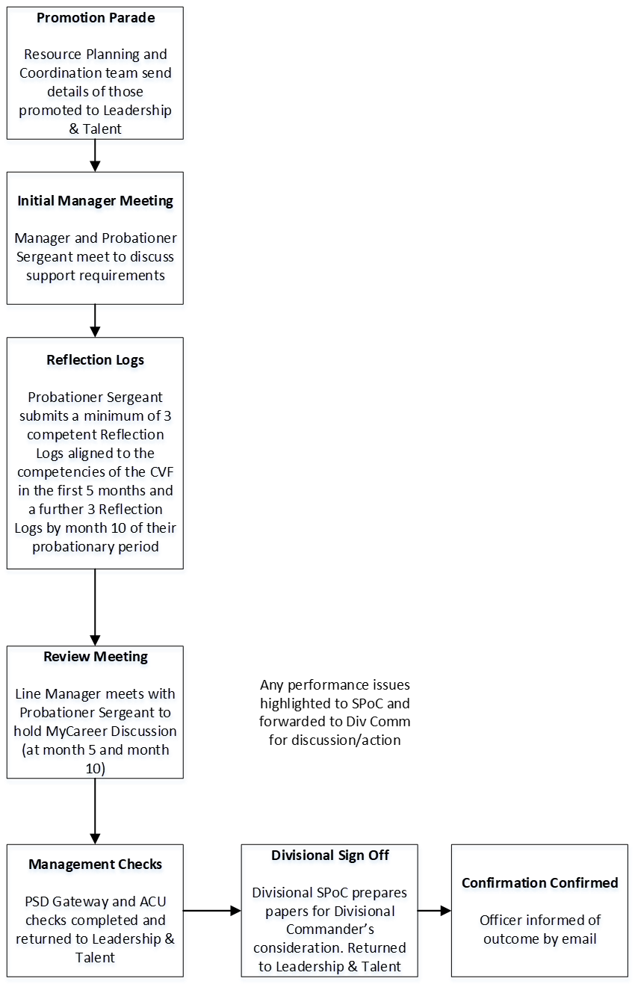
Probationary Sergeants’ Process Map

