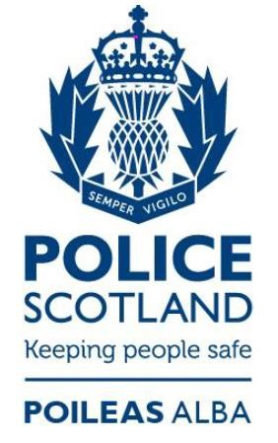

Firearms and Explosives Licensing Service – User Satisfaction 21/22
Police Scotland recognises the importance of understanding the views and priorities of those who use the firearms and explosives licensing service. Whilst our primary aim will always focus on public safety as part of our statutory responsibilities, we are keen to gauge user satisfaction, and wherever possible, enhance and improve the service provided.
This year marks the third year of us conducting an annual survey with firearms licensing service users. Over the last three years, over 600 people have completed the survey, with each year seeing improvement in the overall levels of satisfaction.

What the public said
In 2021/22, we received 161 responses to the survey, which only represents a small percentage of our certificate holders, but the responses were very useful in gauging the level of satisfaction with the service as well as identifying areas where it is perceived improvements can be made.
We received a good spread of response from across Scotland: 25% from the North Command area, 25% from the East Command area and 48% from the West Command area.
55% of respondents said they were applying for the renewal of their certification; 16% applying for a grant for the first time; 13% were amending the number/type of weapons or volume of ammunition held; 6% were applying for a change of address; 5% for an additional certificate; and 5% selected “other.”
A strong majority of respondents (89%) said they were satisfied or very satisfied with the overall application process whilst 6% said they were dissatisfied or very dissatisfied with the service.
Over 89% said it was easy to get information from Police Scotland about how to apply for the grant, renewal or variation of a Certificate/Permit or other service they applied for. 88% said it was easy or very easy to fill in the application forms. 83% said it was easy or very easy to contact Police Scotland's Firearms and Explosives Licensing Unit. 83% stated they were satisfied with the speed and efficiency of the service whilst 13% said they were not satisfied.
The majority of the respondents (91%) felt that the officers and staff they dealt with were knowledgeable and professional whilst 4% were dissatisfied with the interaction with officers and staff.
Respondents were thereafter given the opportunity to comment on how the service could be improved or provide and further relevant feedback.
181 comments overall were received from the two free-text questions, 56% of which contained positive feedback on the service received which has been conveyed to individual staff members where they are have been named.
Where respondents felt improvements were necessary, the following areas were highlighted:
- Poor Police Scotland website – 10%
- Application process too slow – 13% (with issues relating to Covid-19 being highlighted in responses)
- Legislative issues in relation to the requirement for an Air Weapons Certificate – 3%
- The costs associated with providing information from their General Practitioner (GP) – 4%
- Inconsistencies in Firearms Enquiry Officer’s knowledge and experience of engaging with them – 2%
- Difficulty in contacting both the licensing function and Firearms Enquiry Officers – 8%

Message from Superintendent Steven Duncan
“I want to thank everyone who took the time to participate in the survey and I am delighted that satisfaction with our service remains high.
“Over the last few years, we have introduced technological advancements to our administrative processes which have improved our speed and efficiency.
“As we move forward, we are keen to work with a wide range of stakeholders in firearms licensing, to continue improving safety whilst continuing to drive efficiency and deliver a high level of service to those who use the firearms licensing service.
“Our new survey for 2022/23 is now open and can be accessed throughout the year at the following web address https://consult.scotland.police.uk/surveys/fc3405d9 and I would encourage anyone using the firearms licensing service to complete one.”

