Police Scotland Quarter 2 YTD Performance Report: April 2022 to September 2022
Contents
Police Scotland Quarter 2 YTD Performance Report: April 2022 to September 2022 1
Introduction by the Deputy Chief Constable 2
Executive Summary 3
Performance Framework Outcomes and Objectives 14
Policing during Quarter 2 2022/23 – Key Insights 16
Operation Unicorn 19
Public Confidence and Experience of Policing 21
Measures of Progress towards Strategic Outcomes 32
Strategic Outcome 1 32
Strategic Outcome 2 74
Strategic Outcome 3 103
Strategic Outcome 4 118
Strategic Outcome 5 131

Introduction by the Deputy Chief Constable
Our second Performance Report of 2022/23 covers an extremely busy and demanding period for policing in Scotland.
With great sadness we learned of the death of Her Majesty The Queen in September. Operation Unicorn was initiated and this report reflects our role in ensuring that important and significant ceremonial events across the country were delivered safely and with dignity.
Our national roll-out of Naloxone is ongoing and our officers have administered the life-saving nasal spray on over 80 occasions.
In the report figures show that the numbers of crimes reported have returned to levels we saw before the COVID pandemic.
Violent crimes, such as homicides, serious assaults and robberies, remain at the lowest level since comparable records began and the number of attempted murders are lower than last year.
The rise in non-sexual violent crimes is being driven by offences committed under the Domestic Abuse Scotland Act as well as those involving threats and extortion and drugging.
The level of reported sexual crime continues to be at a high level. We are committed to tackling sexual offences of any kind and to ensuring that victims have confidence to come forward, knowing that they will be treated professionally and with dignity and respect.
We launched the second phase of our award-winning Don’t Be That Guy campaign as we seek to contribute to changing attitudes on domestic abuse and violence - a key strand in the development of our Violence Against Women and Girls strategy.
The long-term trend of increasing reports of fraud continues, particularly those committed online, which is why we continue to invest in people and equipment to keep people safe on their computers, tablets and smartphones wherever they are in the country as part of our Policing in a Digital World programme.
While we have also seen acquisitive crime, particularly theft, increasing, the number of detections for these crimes has also increased significantly and the number of housebreakings remains low.
However, there has been a significant reduction in the number of anti-social behaviour and disorder complaints.
Throughout the summer months we saw a high number of serious road traffic collisions, including a number of fatal crashes on the A9. This underlines the importance of our commitment to working in partnership with a wide range of agencies to contribute to making our roads safe.
Our Performance Reports provide evidence of progress against the strategic outcomes in our Annual Policing Plan, as well as information and statistics which provide insight into Police Scotland’s work.

Fiona Taylor QPM
Deputy Chief Constable Professionalism, Digital and Transformation

Executive Summary

Introduction
This is the second Quarterly report of the 2022/23 performance cycle, reporting on our revised Performance Framework and Measures of Progress. We continue to mature our approach with the introduction of benchmarking and a number of new measures in relation to demand. We made further improvements in relation to Equality, Diversity, Inclusion and Human Rights with better alignment of metrics to our Equality Outcomes.
Our outcomes focused Performance Framework is linked to our strategic planning processes and aligns to the Strategic Outcomes as detailed in the 2022/23 Annual Police Plan, these being:
Public Safety and Wellbeing – threats to public safety and wellbeing are resolved by a proactive and responsive police service
Needs of Local Communities – the needs of local communities are addressed through effective service delivery
Confidence in Policing – the public, communities and partners are engaged, involved and have confidence in policing
Working Environment – our people are supported through a positive working environment, enabling them to serve the public
Sustainable and Adaptable Service – Police Scotland is sustainable, adaptable and prepared for future challenges
Throughout the document we have highlighted any updates that are linked to our new Joint Equality Outcomes.
Police Scotland remain committed to understanding demand in policing and as part of our progression towards this we have developed new ways to present demand data. Additional new metrics around demand have been added to the Performance Framework, some of which are included as follows.

Policing Demand during Quarter 2 2022/23
Over the last quarter, Police Scotland continued to engage and involve the public, communities and partners while facing a number of challenges in our operating environment.

Operation Unicorn
A unique challenge during this period was Operation UNICORN, the response to the death in Scotland of Her Majesty the Queen. Throughout this operation, the nation was watching Police Scotland’s response as it unfolded on different media platforms, while continuing to manage the needs and police local communities.
Operation UNICORN involved one of the largest policing operations in history, having been planned by many agencies over many years. Police Scotland had an important role to play to ensure significant events relating to Her Majesty’s death could be held safely, securely and with dignity. In the days following, officers and staff from every local policing division and national department were deployed in support of Operation UNICORN.
The close bond between Her Majesty and communities in Scotland was demonstrated through the memorial events across the country and by the many members of the public paying their respects. On 11 September, 4,000 officers were deployed to Operation UNICORN, as over 100,000 people gathered along the 175-mile route of the cortege from Balmoral to the Palace of Holyroodhouse in Edinburgh.
Safety and security were fundamentally paramount to this enormous operation. During this time, there were no security breaches; no significant violence or disorder; no safety issues and we recorded just 13 arrests for offences such as low level disorder; violence; abusive and threatening behaviour; and the illegal use of drones. One of those arrests has already resulted in a conviction at court.
Our experience throughout Operation UNICORN was that communities supported their police service during a large number of events and public gatherings across the country. The rapid activation and delivery of an enormous and complex operation was greatly enabled by our structure as a single police service and continues to underline the significant benefits that the Police Service of Scotland brings.

Officer and Staff Wellbeing / Resources / Recruitment
The wellbeing of Police Scotland’s officers and staff continues to be a key area of focus for the organisational response. When benchmarked against England and Wales, Police Scotland’s officers and staff have scored similarly across most categories for wellbeing. Police Scotland officers gained the classification of ‘High’ for Job Satisfaction and England and Wales scored ‘Moderate’. While Police Scotland’s staff scored the same classifications against England and Wales, notable both scoring ‘High’ on Job Satisfaction. These trends are explored further in Key Insight 1.
A pay increase has been agreed for police officers and staff in Scotland which is cognisant of the current cost of living impact and recognises the valuable contribution that police officers and staff continue to make in keeping people and communities across Scotland safe.
Police Officer turnover rates decreased through July to September and the most recent headcount is at its lowest point over the last 12 months, this is largely linked to retirements following the pension changes implemented on 01 April 2022.
Police Scotland continue to proactively address resource challenges and the second phase of our recruitment campaign has been launched ahead of our 2023 intake of new police officers. This aims to attract candidates with a broad range of life experience, from school and university leavers, to those who may be considering a career change.
The first phase of our recruitment campaign saw an increase in the number of police officer applicants. We will look to build on this success and encourage a broad range of candidates to join Police Scotland.

Cost of Living Impact
Police Scotland are conducting ongoing research and analysis to increase our understanding of the impact the cost of living has on the communities we police. This presents significant organisational capability and capacity challenges to address growing demand in vulnerability, traditional crime types and cybercrime.
Levels of Group 3 (acquisitive) Crimes have increased in Quarter 2 2022/23, 17.6% increase compared to the previous year. Of all acquisitive crime, common theft accounted for 28.8% in 2022/23, an increase of 29.4% compared to the previous year. A contributory factor for this increase is fuel thefts / drive offs relating to the cost of living impact and increase in fuel prices / banning of red diesel. These trends are explored further in Key Insight 2.

Demand
With the return of pre-pandemic event schedules and the completion of Operation UNICORN, we are now approaching Bonfire Night, which is typically one of the most demanding periods of time for police and other emergency services. The Halloween and Bonfire season sees a marked rise in antisocial activity and disorder along with associated criminality across the Service.
We launch Operation MOONBEAM, our public order response to support local policing divisions deter and/or address fireworks-related disorder and criminal activity. This behaviour can be highly disruptive and potentially dangerous, particularly in relation to the lighting of bonfires and the use of fireworks.
There is a marked increase of youth disorder related to incidents ranging from minor incidents involving throwing of eggs to the more serious and hazardous misuse of fireworks, which in more recent times has seen these increasingly powerful items re-purposed as incendiaries or projectiles.
New legislative changes to the Fireworks and Pyrotechnic Article (Scotland) Act, introduced in October, outline it is an offence for anyone to purchase fireworks for those under the age of 18 and carries additional charges for assaults against emergency workers.
Work continues towards the development of a Violence against Women and Girls Strategy for policing in Scotland. Rape crimes continue to be a challenge for Police Scotland with the volume of recorded rapes increasing month on month throughout Quarter 2. The volume of sexual crimes, along with legislative changes in the public protection arena, has led to an increased demand and expectation on operational and non-operational policing teams.
The Domestic Abuse (Protection) (Scotland) Act 2021 (DAPS) 2021 remains a substantial demand for Police Scotland. The implementation of the legislation, will present significant resource and financial challenges for Police Scotland. These challenges have been highlighted to Scottish Government.
Reduced recruitment within C3 Division continues to contribute to capacity challenges, increasing average call answer times. This is being experienced nationally across the UK. Further remedial action continues to be implemented to try and ensure resourcing levels are increased at periods of high demand. In order to better understand and interpret call handling performance, benchmarking has been introduced and carried out on response times with forces in England and Wales (see Key Insight 3).
Hate incidents have decreased compared to last year however have increased against the five year mean. Similar trends are shown for ‘transgender prejudice’ aggravated hate crimes, while lower than last year have increased against the five year mean. Engagement with the ‘Equality Network’ in addition to content of the LGBT Youth Scotland, Life in Scotland report; highlighted a lack of trust in police from the transgender community.
The recent Your Say Matters Survey shows a drop in confidence in police from the transgender community in addition to the lack of uptake of participation from the transgender community. A Transgender Action Plan focusing on building engagement and public confidence with the Trans community as well as encouraging the reporting of hate crime is in development.
Safety in the digital world is an increasing risk area due to the scale of social and financial transactions occurring online. Increased digitalisation will influence how criminals seek to operate during the cost of living situation. Fraud crimes, particularly those with a cyber element, have increased not only against the five year mean but also from last year.
In response to this growth area of cyber-enabled crime the ‘#CostofLivingScams’ Campaign was delivered by local policing divisions working with local and national trading standards support. The four week campaign included events held in person along with supporting social media messaging. This campaign has been evaluated as the most impactive following the success of the ‘Shut out Scammers’ events at the beginning of the year.
This report comprises of four sections:
Policing During Quarter 2 2022/23 – Key Insights
Operation UNICORN
Public Confidence and Experience of Policing
Measures of Progress towards Strategic Outcomes – Full Picture

Measures of Progress towards Strategic Outcomes
Measures of Progress towards Strategic Outcomes have been identified by Police Scotland in collaboration with the Scottish Police Authority. This new suite of key measures have been identified from the available management information and aims to support consistent reporting from the Performance Framework. The following is a synopsis of exceptions identified with the Quarter 2 report.

Sexual Crimes (Further details here)
Challenge: In Quarter 1 the volume of recorded rapes appeared to return to levels noted pre-pandemic. However, by the end of Quarter 2 the volume of reporting rape crimes returned to the exceptionally high levels noted during 2021/22.
Rapes increased month on month throughout the last quarter with August and September recording the greatest number of crimes in the 12 month period.
This, along with the significant external changes to the public protection arena, translates to an increased demand and expectation on operational policing as well as non-operational teams.
Response: Following the success of last years’ That guy campaign, the next phase launched on 18 October 2022 which is urging men to take responsibility for their actions and language to help affect a culture change to tackle sexual crime against women.
The Public Protection Development Programme (PPDP), in collaboration with National and Local Policing, can deliver significant organisational change in a critical and high risk area of operational policing. PPDP provides an opportunity for Police Scotland to design and deliver an innovative, forward thinking and ground breaking PP model, recognised nationally and internationally.

Drugs Harm (Further details here)
Challenge: Tackling substance use and the harms they cause is part of Police Scotland’s duty towards ensuring the safety and wellbeing of people within our communities. Issues such as the cost of living exacerbate problems related to drugs harm such as access to addiction services, poverty, and mental health vulnerabilities.
Response: Police Scotland adopts a public health, whole system approach. We work alongside multiple external agencies to address longstanding issues and improve the life chances of individuals we interact with frequently. An array of workstreams have been progressed in response to the drugs harm challenge, including the Pathfinder project and Positive Outcomes Project.
Additionally, Police Scotland is also in discussion with the Scottish Government around Safe Drug Consumption facilities. In preparation we have established a strategic working group and a tactical working group as well as participating in a number of workshops hosted by the Scottish Government.
We are also providing data for the Scottish Government Drug Related Dashboard to aid in the creation of a public facing report. Our workstreams aim to work in partnership with external agencies to provide early intervention and support where required.
The roll-out of naloxone to all police officers began on 31 August 2022 and will progress into early 2023. Officers involved in the Test of Change are currently still using naloxone as part of their work.
Impact: National Records of Scotland published drug related death figures for 2021 in July, showing a total of 1,330 recorded deaths. Although this is under a 1% reduction in the number of deaths in Scotland, it is the first year-on-year fall since 2013.
Recent figures provided to the Scottish Government Drug Related Dashboard for the last quarter show there is a reduction of 13 drug related deaths between January to March 2022 compared to October to December 2021 (275 compared to 288).
To date officers from the naloxone Test of Change have administered 82 doses of naloxone to people experiencing an overdose. All people have shown a sufficient recovery and have went on to either received further medical attention by medical professionals or have left the scene of their own volition.

Drugs Supply (Further details here)
Challenge: Tackling Serious and Organised Crime (SOC) is a priority for Police Scotland and our officers continue to severely disrupt the activities of organised criminals and reduce the harm caused within our communities.
Despite significant progress, we must constantly adapt to the complexities of current and future threats, and have a framework designed to respond.
This work was recently brought to the fore with the changing environment posed by the global pandemic and exit from the EU, in which Police Scotland’s response was required to be dynamic and innovative.
Response: Given the changes in society following COVID-19, EU Exit, and cost of living, Police Scotland’s operational response has adapted rapidly and provided resilience to ensure public confidence is maintained.
In particular, the response to dealing with drug supply and distribution, money laundering, County Lines, SOC related violence and cybercrime by serious and organised criminals, remains dedicated and driven at a national level.
Impact: Police Scotland continue to respond to the full range of SOC threats by utilising our capabilities and have seen a significant number of results through major drug recoveries, cash seizures, and SOC related arrests. This is shown through the discovery of two large cannabis cultivations this quarter with estimated street values of £800,000 each.
An investigation into a Serious Organised Crime group resulted in the recovery of cocaine and cannabis worth an estimated street value of £800,000, with one male being arrested and charged with drug supply.

Call Handling (Further details here)
During the reporting period, our service advisors received 1,145,543 calls via 999 or 101, a decrease of 203,058 on the same period last year. Alongside incoming calls, there have been over 133,000 additional public contacts dealt with by Contact, Command and Control (C3) Division during the reporting period, including online reports, alarm calls, partner demand and “Contact Us” emails.
Challenge: The average call answer time for 999 calls increased from 7 seconds to 10 seconds during the reporting period. In addition the average call answer time for 101 calls increased from 3 minutes 54 seconds to 4 minutes 28 seconds during the reporting period.
This continues to be highlighted as a challenge for the division and measures have been put in place to alleviate this as detailed in the response. It is of note that BT have also reported increased 999 call demand nationally.
Response: C3 Division continues to feel the impact of reduced recruitment due to the current recruitment market and is looking at proactive social media to increase interest in posts. Absence levels of COVID-19 follow the national trend and have been continually observed into Quarter 2.
Although average call answer time for 999 calls has increased, and this is being experienced nationally across the UK, the handling of 999 calls remains our highest priority and additional steps have been put in place to ensure resourcing levels are increased at periods of high demand, both with staff incentives, resource and ICT changes.
Efforts continue to signpost callers to more appropriate methods of contact, including via “Contact Us” and the Police Scotland website. Social media is used during periods of high demand to inform the public and provides the opportunity to educate the public on the correct use of 101 non-emergency number. Online contacts continued to rise during this reporting period, indicating the success of this approach.

Hate Crime (Further details here)
Challenge: Hate crimes aggravated by transgender prejudice, although lower than last year has increased against the five year average. Engagement with the ‘Equality Network’ as well as the recent content of the LGBT Youth Scotland, Life in Scotland report; highlighted that there is a lack of trust in police from the transgender community. In addition; the recent Your Say Matters Survey revealed a drop in confidence in police from the Trans community as well as a lack of uptake from the Trans community to participate in the Survey.
Response: A Transgender Action Plan focusing on building public confidence and engagement with the Trans community as well as to encourage reporting of hate crime is currently being developed.
A national hate crime campaign budget has been allocated for early 2023. Partnerships, Prevention and Community Wellbeing (PPCW) Equality and Diversity (E&D) have requested early engagement to ensure the campaign focus is in line with current priorities and on increasing public confidence in police in particular with the Trans community.

Cybercrime (Further details here)
Challenge: The global increase in Cyber Dependant crime has resulted in a 1,262% increase in these & crypto currency investigations from 2019 to 2022. This demand shows no sign of easing, with cyber investigations in July 2022 double that of the same period the previous year.
With regards to cryptocurrency assistance to policing in Scotland, Cyber Investigations has the only capability, going from zero requests for assistance in 2019, to 118 in 2022 so far. On average one request takes around four days to complete, this has a significant impact on resources as they support front line Policing. Finally, Digital Forensics and mobile triage trained officers face an unprecedented demand, increasing year on year.
Response: Police Scotland have invested in uplifting the resource levels for hub based Digital Forensics and, whilst all new posts have been filled, there will be at least a six month lead in time for staff to receive minimum standards in their training following on from which they can build their skills and productivity. This uplift has not included mobile triage staff, which is still at a high risk level.
In order to maximise productivity, until such a time as resources can be uplifted, an evolved model for staff deployment has been designed with hub staff supporting this enforcement and technical processes being fully reviewed. This is being done in conjunction with Intelligence and Online Child Sexual Abuse and Exploitation (OCSAE) enforcement resources.
With regards to Cyber Investigations, focus is continually required to establish a timeframe for resource uplift, particularly with regards to Dark Web capability, which will then lead to proactive enforcement opportunities, the benefits of which will be felt across Child Exploitation and Public Protection, as well as Serious and Organised crime.

Maintaining a Balanced Budget (Further details here)
Challenge: The Scottish Government’s Resource Spending Review (RSR) published in May 2022 and the Capital Spending Review (CSR) published in January 2021 and updated in May 2022 provides a comprehensive picture of the likely funding available to policing over a five year period.
The RSR indicated that the Authority should plan for a flat cash funding settlement up until Financial Year 2026/27. This essentially removes the “real terms protection” commitment that has been the key underlying financial planning assumption for all our recent short, medium and longer term financial planning. The CSR also indicated a flat cash capital settlement over the next five years, representing a £200m shortfall in our overall capital requirements.
Response: The introduction of flat cash, particularly in a high inflation environment, represents a significant real-terms reduction in funding. Police Scotland will continue to seek ongoing savings and efficiencies, however, efficiency alone is not sufficient to deliver the significant savings required to manage a flat cash funding position. Managing a flat cash position will have considerable operational implications and would require a major strategic shift in what and how Police Scotland provides and delivers policing services to Scotland.
The immediate focus is on developing the annual budget for Financial Year 2023/24 and updating the medium term financial plan in line with the strategic direction following the publication of the RSR and CSR, adjusted for notification of our actual funding allocation for 2023/24 which is expected December 2022.
Although there is great value in longer term financial planning, it is very difficult in the current economic and political environment, both of which would need to stabilise to allow reasonable financial planning assumptions to be developed to inform longer term financial planning.

Performance Framework Outcomes and Objectives
The following is a summary of the strategic outcomes and objectives contained within the Annual Police Plan 2022/23.
Strategic Outcome 1: Threats to public safety and wellbeing are resolved by a proactive and responsive police service.
Objectives:
Keep people safe in the physical and digital world
Design services jointly to tackle complex public safety and wellbeing challenges
Support policing through proactive prevention

Strategic Outcome 2: The needs of local communities are addressed through effective service delivery.
Objectives:
Understand our communities and deliver the right mix of services to meet their needs
Support our communities through a blend of local and national expertise
Support the changing nature of communities

Strategic Outcome 3: The public, communities and partners are engaged, involved and have confidence in policing.
Objectives:
Embed the ethical and privacy considerations that are integral to policing and protection into every aspect of the service
Protect the public and promote wellbeing across Scotland by providing services that are relevant, accessible and effective
Work with local groups and public, third and private sector organisations to support our communities

Strategic Outcome 4: Our people are supported through a positive working environment, enabling them to serve the public.
Objectives:
Prioritise wellbeing and keep our people safe, well equipped and protected
Support our people to be confident leaders, innovative, active contributors and influencers
Support our people to identify with and demonstrate Police Scotland values and have a strong sense of belonging

Strategic Outcome 5: Police Scotland is sustainable, adaptable and prepared for future challenges.
Objectives:
Use innovative approaches to accelerate our capacity and capability for effective service delivery
Commit to making a positive impact through outstanding environmental sustainability
Support operational policing through the appropriate digital tools and delivery of best value

Evidencing progress towards our outcomes
Gathering our data, narrative and insights together provides us with an evidence base that demonstrates how we are achieving our outcomes

Policing during Quarter 2 2022/23 – Key Insights

Key Insight 1: Police Officers / Staff Wellbeing Benchmark
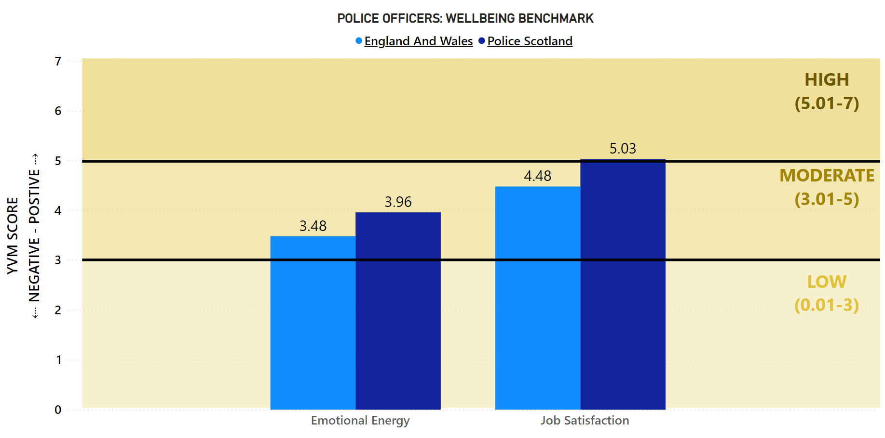
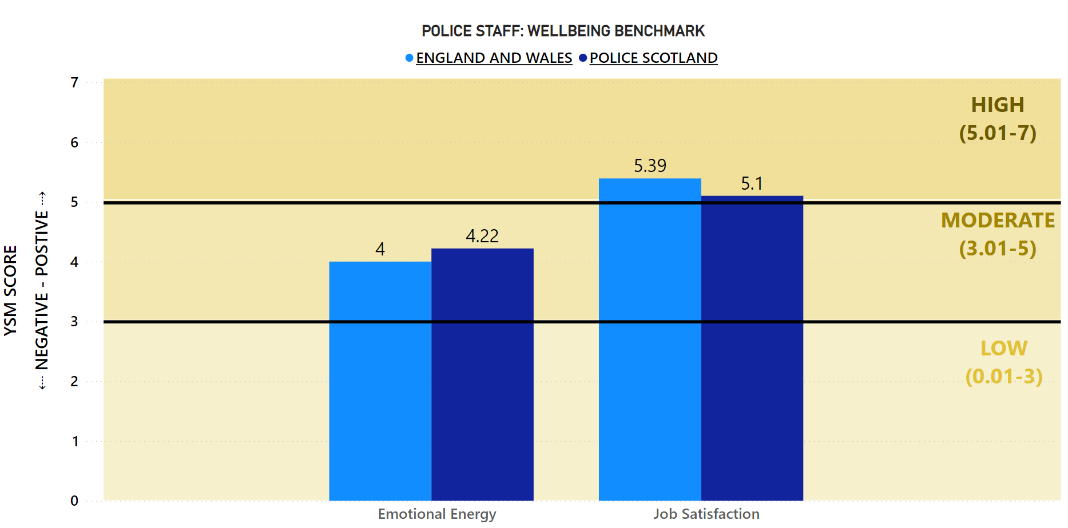
The wellbeing of officers and staff continues to be a key area of focus for Police Scotland and this benchmark has been developed to track this and identify opportunities to learn and share best practice. The wellbeing measures are scored on a scale of one to seven (one being low, seven being high).
Police Scotland officers scored high for Job Satisfaction and officers in England and Wales scored moderate. Police staff in Scotland and in England and Wales scored high for job satisfaction, with staff in England and Wales having a slightly higher point score, indicating some opportunity for learning.
In relation to emotional energy, officers and staff in Scotland and in England and Wales scored moderate, with Scotland showing slightly higher points that England and Wales.

Key Insight 2: Group 3 (Acquisitive) Crimes Increase
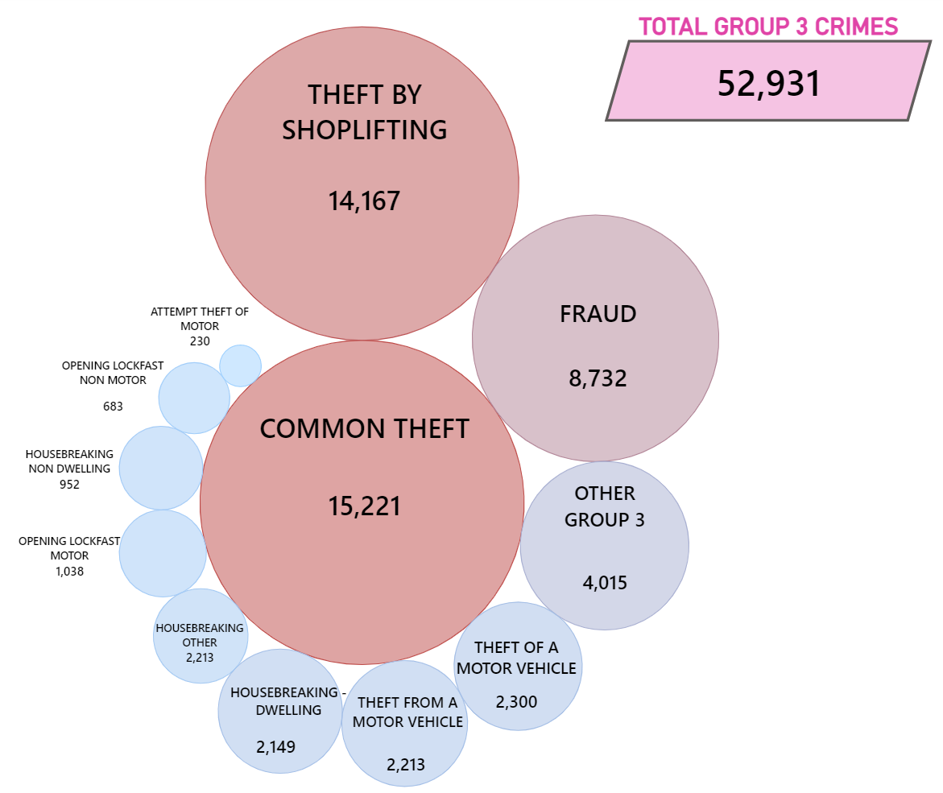
In 2022/23 there were 52,931 Group 3 crimes. That is an increase of 17.6% (7,936 crimes) compared to the previous year. The majority of Group 3 crimes have shown an increase.
Common theft accounted for 28.8% of all acquisitive crime in 2022/23 (15,221) and has increased by over a quarter (up 3,457, 29.4%) compared to the previous year. A contributory factor to the increase in common theft is fuel thefts / drive offs which are likely influenced by the cost of living impact and increase in fuel prices / banning of red diesel.
Theft by Shoplifting (14,167) has also had a notable increase of around a quarter (up 3,068, 27.6%). A contributory factor to these increases are the lockdowns which were in place last year. When compared to the most recent pre-pandemic year in 2019/20, Common Theft has decreased by 962 (down 5.9%) and Theft by Shoplifting has decreased by 1,962 (down 12.2%).
Housebreaking (incl. attempts) to a dwelling house were down by 2.1%, (45 crimes) and Other Group 3 crimes were down by 13%, (600 crimes) compared to the previous year.

Key Insight 3: Benchmarking: % of 999 Calls Answered in Under 10 Seconds
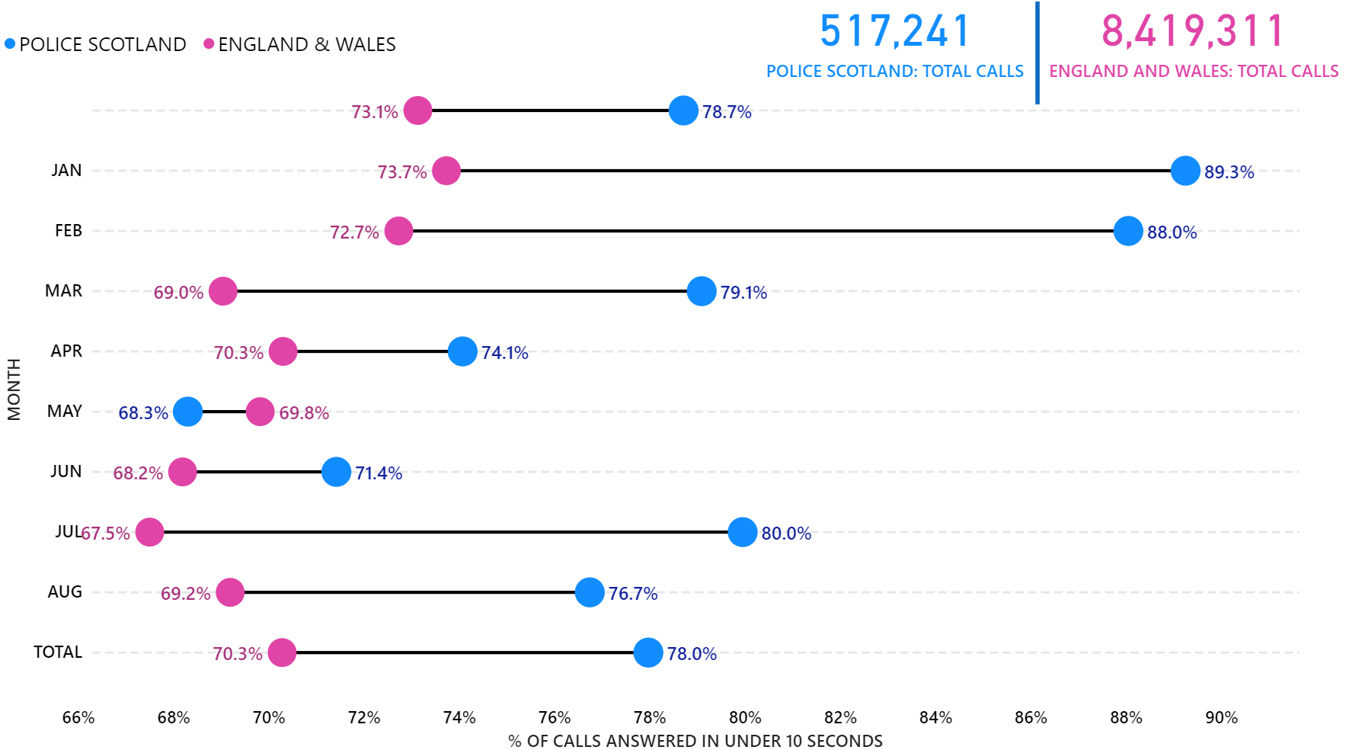
Call handling and answering 999 calls is a key priority for Police Scotland. In order to better understand and interpret call handling performance, this benchmark tracking 999 calls answered in under 10 seconds was introduced.
Police Scotland is performing well when benchmarked against police services in England and Wales. During this calendar year, we have answered 78.0% of our 999 calls in under 10 seconds (403,315 out of 517,241 calls). In comparison, England and Wales answered 70.3% (5,917,301 out of 8,419,311 calls) of their 999 calls in under 10 seconds during the same period.

Operation Unicorn
Operation UNICORN is the first time Police Scotland has implemented a no notice mass mobilisation of its officers and staff. The activation process was successful, with all divisions and areas of business providing crucial roles throughout the five days of the Operation. Further to this, Operation UNICORN was the first time deployed officers have performed ceremonial roles of this nature, including the swapping in and out process in conjunction with the Royal Company of Archers.
From the initial activation to the end of the Operation there were 5,705 conventional deployments in Scotland and assistance from across Police Scotland in various frontline and support roles. The biggest single deployment was 3,779 officers for the day Her Majesty the Queen’s coffin was transferred from Balmoral to the Palace of Holyroodhouse. Mutual aid deployments across the Operation totalled 498.
Over the course of the Operation people from across the UK and abroad attended Scotland to pay their respects. The day Her Majesty the Queen’s coffin was transferred saw estimated numbers of 107,000 people in the Edinburgh area, 85,000 and 22,000 in the Aberdeen / Aberdeenshire areas respectively, and 46,000 people in surrounding regions. Outside St Giles’ Cathedral a total of 34,600 wristbands were issued for the Vigil queue, with an estimated 33,000 entering.
Protest Liaison Officers (PLO) were deployed throughout in order to engage with different groups and individuals. These specially trained officers often adopt a watching or observation brief prior to engagement, ensuring protests could come to a natural and calm conclusion. There were no public order tactics deployed as part of the Operation.
A total of 229 incidents were logged by Police Scotland related to Operation UNICORN, with 13 arrests made. The majority of arrests were for Criminal Justice and Licensing (Scotland) Act 2010 Section 38 and Breach of the Peace. Four arrests were linked to protest activity. A further nine persons were reported for offences linked to breaching Air Navigation Orders through the use of drones and minor public order offences, amongst others.
Going forward Police Scotland has begun engaging with all who were involved in Operation UNICORN, including officers, staff, and partners at all levels, to learn best practice and areas for improvement. The findings from these engagements will assist in developing a formalised approach to mass mobilisation and similar events in the future.

Professional Standards
A total of nine complaints have been received to date in relation to Operation UNICORN, the policing response to events following the death of Her Majesty the Queen. The vast majority of these were non-criminal, non-serious and non-complex in nature, with 55.6% successfully concluded by Frontline Resolution (FLR). However, a number of complaints remain subject to live enquiry.
Given the complexity and scale of the associated events, the relatively low volume of complaints reflects very positively on the policing operation and the professionalism of the officers involved.
All relevant complaints have been reviewed to ensure learning has been recorded and actioned.

Public Confidence and Experience of Policing
Police Scotland’s Public Contact and Engagement Strategy sets out how we envisage our public contact / engagement activities and approaches to look now, and in the future. We have been clear in setting out what the public should expect from their police service and how we will continue to engage and involve communities and our partners.
Our Public Engagement and Participation Framework sets out the ways in which we will seek to engage with communities so that their insights can be utilised in meaningful ways. Working in this way aims to aid operational and strategic decision-making, ensuring that Police Scotland operates using evidence-led principles in line with our values.
The Public Confidence Governance Board oversees the development of our engagement approaches to understand public confidence within communities and act on public feedback. We are paying particular attention to how we reach those who are often seldom-heard; by understanding where there are opportunities to enhance engagement and working with organisations with relevant expertise.

High-level overview
We continue to engage and involve the public, communities and partners in policing through our continuous national surveys and other engagement activities.
Your Police 2022/23 survey – our local police survey for this year continues to receive a robust and representative response from the public and communities. Anyone who lives in Scotland can influence local policing in their area through this survey. We use the feedback to understand public confidence, where we can improve and build on what we are doing well, and inform opportunities for partnership working and collaboration.
User Experience Survey – our independent survey to measure and enhance people’s experience of contacting Police Scotland, administered by Progressive Partnership Ltd. The survey is sent via text message to a sample of people who have made contact with police each month. This survey receives approximately 1200-1400 responses each month and was expanded to include those engaging with our complaints process. A new survey is in development with Specialist Crime Division (people who are victims and witnesses of serious crime) and Criminal Justice Services Division (people in police custody).
The public insights are considered at the Strategic Leadership Board for executive oversight and action. Data and insights are shared with Regional Delivery Boards and local policing for improvement planning and scrutiny, and working with partners and other relevant stakeholders. Feedback and insight helped shape the Annual Police Plan for 2022/23 and work is underway to ensure that data from communities informs the development of new Local Police Plans, as engagement on their renewal commences.
Other research and engagement activities to support policing in applying public insights in practice and responding to the needs of communities include:
Commissioned academic research within seldom-heard communities to understand how we can improve our engagement practice in supportive and appropriate ways. The joint research fund between Police Scotland, the Scottish Institute of Policing Research and the SPA awarded four studies which will be completed by November 2022. These include policing with empathy in conversation with LGBTQ and young people from disadvantaged backgrounds (Abertay University); refugee and asylum-seeker experiences, trust and confidence with Police Scotland (Queen Margaret University); inquiring together - collaborative research with BAME communities and serving officers (Dundee University); and, accounting for complexities - an intersectional approach to enhancing police practitioner reform (University of Glasgow). The studies are near completion and will provide practical guidelines and approaches for policing to enhance engagement and confidence within communities.
Established reference sub-groups to implement actions for enhancing public and community engagement. Emerging activities include:
Enhancement of local communications to inform local communities about policing in their areas and how local concerns are being addressed;
Colleague engagement and involvement through an internal campaign to recognise and reinforce positive behaviours that are valued by the public and communities;
Capturing colleague experience of managing public contact and community engagement to ensure colleagues are well equipped and to address any gaps in service;
Shared learning of practice through greater visibility and organisational oversight of activities within communities to measure outcomes and progress; and
Ongoing development of our public engagement and participation framework to support operational colleagues policing in a diverse Scotland – the framework is co-designed with officers, staff and communities.
Piloting of innovative approaches to build solutions together. For example, Police Scotland is working with Scottish Government and Caithness Voluntary Group to pilot a participatory grant scheme in the Caithness area within Highland and Islands Division. This involves communities coming together to respond to local needs and inspire collective action to improve safety and wellbeing within the local area.
Your Police continues to be the largest of its kind in the UK and involves the public in a conversation about policing and their local community. Responses are being reviewed regularly by our Executive and service leads and have helped us act quickly in relation to emerging issues and community concerns.
We have compared our data with other national public surveys to ensure that Your Police continues to provide robust insights which support effective and high quality policing appropriate to the needs of communities throughout Scotland. Key activities have included.
Enhanced local police presence at identified locations with a focus on crime prevention and road safety. Police visibility and presence is important in making people feel safe.
Keeping local community partners engaged and involved on a regular basis, through local police scrutiny boards in each local authority area – using the data to design an appropriate policing response for local needs and providing a multi-agency response to cross sector themes.
Shaping our communications and advice in local areas in response to concerns and feedback from the public – helping people to stay safe.
Providing information and advice on issues like hate crime, housebreaking and responsibly use of vehicles (including off-road bikes and scooters) to reassure all communities.

Your Police Survey
Your Police received 10,243 responses between 01 July 2022 and 30 September 2022. This included 60 British Sign Language (BSL) responses. The survey continues to be representative of the population by age, gender, disability and geography. The Your Police survey influences local policing by enabling the public to highlight areas of concern, good practice and informs our approach to working with local partners. We gather data on public confidence and perceptions of local policing levels through this survey.
The Research and Insight team is responsible for the design and delivery of this survey. Promotion is supported by Corporate Communications; Partnerships, Prevention and Community Wellbeing, local policing, and many external partners in maximising engagement with Scotland’s diverse communities. It is important to us that we make our public engagement activities inclusive so that our services meet the needs of the communities we serve.

Public Confidence
Your Police survey continues to receive a high number of comparable responses every quarter and is representative of age, region, gender and disability at a national level. From April 2022, the survey received 945 responses in Quarter 1 and 10,243 responses in Quarter 2, with public confidence levels recorded at 51% and 52% respectively.
In April 2022, a public confidence index score was introduced to be comparable with how confidence is measured in the Scottish Crime and Justice Survey, YouGov and The Mayor’s Office for Policing and Crime (MOPAC). The index score accounts for all of the responses (from ‘strongly disagree’ to ‘strongly agree’) excluding the ‘don’t know’ responses by assigning numerical values and converting the overall response average into a percentage value.
Comparatively, 51% (n=5,378) of YouGov survey respondents across the UK thought that “generally speaking, police were doing a good job” in Quarter 2. The YouGov figure for Scotland in Quarter 2 was 52% (n=463).
To measure confidence in policing, YouGov survey asks respondents about “confidence in the police to deal with crime in local area”. In Quarter 2, the YouGov figure for Scotland was 44% (respondents who had a lot of confidence and respondents who had a fair amount of confidence).
The confidence level derived from Your Police is also comparable to confidence measures in the Scottish Government’s Scottish Crime and Justice Survey and from other UK policing organisations, most notably the Mayor’s Office for Policing and Crime (MOPAC).
We know from our own research and academic studies that wider public confidence and experience of contacting and interacting with police are not always connected. While confidence is likely to fluctuate, satisfaction scores gathered by our independently administered User Experience Survey remain positive and consistent. Overall satisfaction with contacting the police was at 66% in Quarter 2.
One third (33%) of respondents reported they ‘didn’t know’ or ‘neither agreed nor disagreed’ that they were confident in their local police. This proportion reflects that a substantial number of respondents who completed the survey had not interacted with police recently or had no opinion regarding their confidence in policing.
These findings show that although public confidence is important to measure, it is not a reliable indicator of operational performance. Service quality has remained consistent even though confidence levels have fluctuated throughout each Quarter. Public confidence is not always based on contact and engagement with police, but instead, on perceptions of local policing and crime, and to a lesser extent, the wider policing narrative in society, nationally and internationally.
Public confidence is associated with other factors measured in Your Police survey. There is a strong relationship between public confidence and perception of police doing a good job in local area, perception of police listening to concerns of local people, and perception of police dealing with issues affecting local area. As these perceptions change, public confidence is likely to be affected.
A moderate relationship exists between public confidence and perceptions of police officers being friendly and approachable, levels of respect for local police, feeling of safety and concern about crime. Moderate correlations indicate that while there exists a relationship between factors, they affect each other to a lesser extent compared to strongly related variables.

Strong Correlation with Public Confidence
Public Opinion Statements | Quarter 1 2022/23 (n=945) | Quarter 2 2022/23 (n=10,243) | Change from last Quarter
Police doing a good job in local area | 30% | 32% | +2% point
Listening to concerns of local people | 31% | 32% | +1% point
Dealing with issues affecting local areas | 24% | 23% | -1% point

Medium Correlation with Public Confidence
Public Opinion Statements | Quarter 1 2022/23 (n=945) | Quarter 2 2022/23 (n=10,243) | Change from last Quarter
Police officers being friendly and approachable | 64% | 64% | No change
Having respect for police in local area | 73% | 72% | -1% point
Feeling safe in local area | 81% | 85% | +4% point
Concern about crime | 61% | 56% | -5% point
Our findings show that confidence can be influenced by geographic and demographic factors. Whilst we capture a national level of confidence, there is much nuance within this picture. We know, for example, that people living in areas affected by poverty and where there are higher numbers of people affected by social injustice are less likely to feel confident in the police.
This is reflected across the UK and is evidenced-based. Work continues, in partnership with the Scottish Institute for Policing Research, the Centre for Policing Research and Learning, the Scottish Police Authority, and alongside community organisations to enhance our understanding of public confidence and trust in policing.
Understanding public confidence is important to us as it is one of the ways that we respond to emerging issues within communities. Maintaining confidence in policing is vital to ensure that we are policing in line with our values whilst maintaining or building trust and legitimacy for every person in our society.

Factors influencing public perceptions and confidence in local police
Survey respondents in Quarter 2 2022/23 who said they feel unsafe in their local area (n=1,405) raised similar themes as in Quarter 1 2022/23. The following themes remain important, on which we are taking action and using to inform local and strategic decision-making, with plans and projects for sustaining change over the long term:
Police visibility and presence
57% of respondents who felt unsafe in their local area highlighted greater police visibility as a way of making them feel safer and providing reassurance. Police presence is often mentioned within the context of prevention and targeting of drug-related crime and anti-social behaviour.
“Be around a lot more. People feel safer with more police patrols”
The type of visibility or accessibility (e.g. physical, online and virtual) was not always specified in the responses but a majority specifically mentioned physical presence including more foot patrols in local areas, at specific times (e.g. after dark/weekends) and locations (e.g. in parks, around transport hubs, and local crime ‘hot spots’) where communities tend to feel less safe.
“Communicate better, have police on foot or bicycle not always in a car cruising the area. More communication online on what the police have been tackling or an online webpage that could be accessed to keep in touch with policing matters in my general area”.
The importance of police visibility in local areas was most prevalent across respondents from areas of Scotland most affected by poverty (people living in SIMD 1 and 2 areas), with 59% of respondents living in these areas mentioning police visibility, compared to 49% of respondents from more affluent areas (people living in SIMD 4 and 5).
“More presence. Seeing police officers walking around increases confidence”
Community engagement and being kept informed
17% of respondents who felt unsafe in their local area highlighted community policing and local engagement as important. This is highlighted alongside police visibility by respondents - for example, informal and friendly conversations with police officers on what matters to communities in local areas. Respondents highlight the importance of policing being accessible locally, having staff who are familiar with local needs and for training to be relevant to the specific issues affecting local communities. The public would like to be familiar with local officers and seek effective and trusting relationships.
“Community engagement! If we have this, we know what they are facing and this creates an understanding between us. It is core. It is very much needed.”
10% of respondents who felt unsafe in their local area highlighted that how we ‘show up’ is important. Police officers and staff should continue to bring empathy and understanding to their interactions with the public. Respondents expect people working in Police Scotland to be adequately trained, caring and professional. This includes cultural intelligence in understanding the lived experiences of communities. Respondents refer to how we are building trust and positive changes within seldom-heard communities.
“In general, the police is supposed to help the most vulnerable, so they should show their alliance to these people by training their staff in trauma-awareness and an intersectional approach…”
4% of respondents who felt unsafe in their local area highlighted communicating what we are doing as important. Respondents identified taking action on local issues as one of the key communication priorities. The public expect police to react promptly to reports and would like to be informed about when and if police are attending. Respondents also want to be updated on the course of action of their incident.
“Community relations would be a helpful start. Engage in open, honest, regular, visible communication with the community…”
Work is progressing through local divisions to respond to these concerns in local areas. For example, divisions are keeping their local communities informed about how crime is being managed and prevented, including you said we’re doing feedback on social media channels.

Main areas of concern for local communities
There were 7,564 responses in Quarter 2 to the open-ended question – “What, if anything, worries you about your local area?” The common themes that emerged from analysis of these responses are set out as follows:
38% of respondents mention anti-social behaviour with alcohol, littering / fly tipping, young people causing disturbances and noise complaints. It’s important to have clear and accessible signposting to support and connect individuals with the right services delivered by a range of community partners. People may ask police to help with matters which are important to them, but a police response might not be the appropriate service or be able to help in ways which are required.
“Young people getting drunk in the park and subsequent vandalism.”
25% of responses highlight speeding and driving related offences – ‘boy racers’, motorised scooters and dirt bikes were cited by respondents who also commonly express their concerns with speeding and reckless driving in their local area.
“Youths riding motorcycles around this area with no crash helmets and seem to think it’s smart doing wheelies when overtaking you they wear full face masks and can be very dangerous and intimidating to other road users”
21% of respondents mention drug crime and related harms – the presence and effects of drugs within local communities and how local police are tackling drug dealing is crucial for community safety. The increased visibility of drug dealing and drug taking, particularly during the pandemic, has been a consistent theme over previous quarters, too.
“Violent and gang-related crime. The prevalence of drugs, which are freely available, even on my own and surrounding streets by well-known vendors and dealers. I'm afraid to venture our when its dark…”
13% of respondents are concerned with little physical presence of the police – people would like to see regular foot and cycle patrols in their local areas. Several comments mentioned the need for police being visible and easily accessible within local communities.
“Whilst I feel fairly safe and understand that policing is under pressure. I would feel safer if possible to see more of a police a presence in the area…”
13% of respondents express concern about local theft and break-ins and want to be aware of the preventative measures they can take to keep their homes and businesses safe.
“Continued attempted burglaries. Thieves trying doors and cars. Approximately monthly there is a spate of them.”

What we are doing well:
Your Police enables the public to tell us about our approach, which includes what we are doing well and getting right. In Quarter 2, there were 7,895 open-ended comments to the question - “What are the police doing well in your local area?”
Police visibility, presence and accessibility
Responses relate to the impact of police visibility presence and accessibility. Respondents’ value consistent service delivery in the difficult circumstances policing is operating in. There is appreciation for local policing and the job they do within local communities to keep people safe, including crime prevention and protecting people who may be vulnerable.
“They understand the issues locally and keep victims well informed. They maintain a visible presence without spoiling local events. They seem enthusiastic about their jobs.”
Many responses commend the enhanced visibility of police in some areas over recent months and highlight this as positive. Comments commonly mention increased responsiveness and appropriate action to reported crimes and other incidents.
“There is a noticeable increase in police presence in the area. The police are polite friendly and courteous when you are dealing with them.”
Community engagement and being kept informed
Respondents highlighted the value of community policing and what community officers are doing to understand and tackle challenges in local areas together with partners and communities. There is appreciation for being kept up to date with the reported issues. Respondents value police informing the communities on local initiatives and being kept up to date with the work of the police.
“They [local police] are engaged with local partnerships and are pushing forward to make real and effective changes within the local area by supporting the work around these groups.”
“Good relationship with the community - Facebook updates are good way to keep informed with what they are doing in local area.”
Values and behaviours
Respondents highlighted professionalism, compassion and care of the officers as an important factor, having an impact on their perception of the local police. Positive values and behaviours, particularly friendly and approachable policing, showing an understanding and knowledge of the issues affecting local communities, was observed and appreciated by respondents.
“Often very approachable and friendly, experience through work has been increasingly positive over the past year with larger understanding and knowledge of trauma and young people's services.”
“When the police are needed, they are quick to respond. When officers are seen, they are friendly and take their time to speak, wave or smile.”

User Experience Survey

How the public are experiencing their police service
The User Experience Survey, administered by Progressive Partnership Ltd, reaches a representative sample of 1,200 individuals monthly. The survey is delivered via SMS to those who have contacted Police Scotland in the previous month. In this quarter, 3,783 respondents were surveyed about their experience of the policing service provided, from initial contact through to overall satisfaction.
The findings show continued high levels of satisfaction with contacting the police as follows:
Ease of contact – 69%
Initial contact treatment by C3 staff – 84%
Feeling properly understood – 86%
Being provided with the appropriate response – 61%
Satisfaction with attending officers – 80%
Feeling adequately informed about case progress – 45%
Overall satisfaction with Police Scotland – 66%

Measures of Progress towards Strategic Outcomes

Strategic Outcome 1
Threats to public safety and wellbeing are resolved by a proactive and responsive police service.
Objectives:
Keep people safe in the physical and digital world
Design services jointly to tackle complex public safety and wellbeing challenges
Support policing through proactive prevention
All data is classed as Management Information and is not considered official statistics. All data is sourced from Police Scotland internal systems.

Violent Crime
Overall violent crime | 2021/22 YTD | 2022/23 YTD | % Change from Previous Year | 5 Year Mean | % Change from 5 Year Mean
Number of crimes | 32,468 | 32,393 | -0.2% | 32,308.0 | +0.3%
Number of detections | 21,879 | 22,353 | +2.2% | 22,437.6 | -0.4%
Detection rate | 67.4% | 69.0% | +1.6% point | 69.4% | -0.4% point
Note: Overall violent crime is comprised of: murder, culpable homicide (common law), attempted murder, serious assault, robbery, common assault and common assault (of emergency workers).
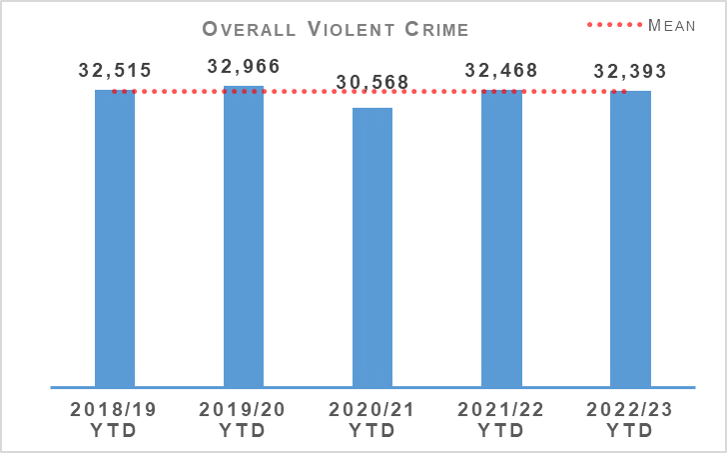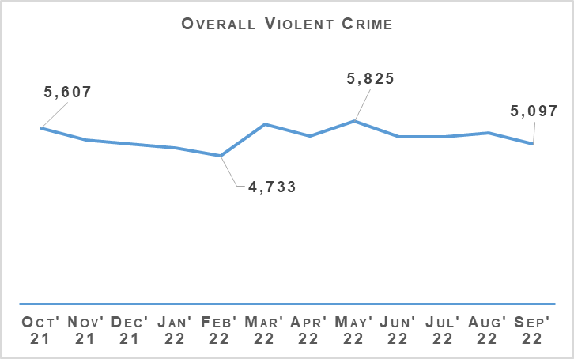
Overall violent crime levels continue to be at a broadly similar level to recent years. The exception to this was in 2020/21 COVID-19 and related lockdowns led to a reduction. April to September 2022 has seen recorded violent crime levels consistent with pre-pandemic years. Common assaults account for 91.6% of overall violent crime.
There have been 23 homicides recorded during the April to September 2022 period. This is six fewer than last year, and 10 crimes fewer than the five year mean. The 144 attempted murders recorded during the first two quarters of this year is one fewer than last year and the five year mean. Detection rates for both homicide and attempted murder continue to be very high.
Serious assaults have reduced, down 9.5% from last year and 15.3% below the five year mean year. Common assaults are at a similar level to last year. While they are up 1.7% on the five year mean, this figure is skewed by the significantly reduced number of assaults recorded in 2020/21. Included in these figures are 8 crimes of serious assault of a retail worker and 754 common assault of a retail worker. There have also been 891 recorded crimes of threatening and abusive behaviour of a retail worker during the first two quarters of 2022/23.
There were 739 robberies recorded during the first two quarters, 89 fewer than last year and 97.8 fewer than the five year mean.
Partnerships, Prevention & Community Wellbeing (PPCW) Division continues to support Scottish Government in the implementation of the Offensive weapons Act 2019. Ahead of the implementation of relevant provisions of Part 4 of the Act, the Offensive Weapons Surrender and Compensation Scheme ran from 01 July 2022 to 30 September 2022.
This was a Scottish Government led scheme with the surrender of weapons being facilitated by Police Scotland. A total of 153 offensive weapons were surrendered during the campaign. Of these, 42 were on the list of newly proscribed weapons. Compensation was claimed for 39 of these. The remaining 111 weapons surrendered were also disposed of.
PPCW currently have a temporary Inspector seconded to the Violence Against Women and Girls Taskforce at the National Police Chiefs Council (NPCC) for and directly involved in the `5 Nations approach` which aims to build trust and confidence in policing. The ‘5 Nations’ referred to are Scotland, England, Wales, Northern Ireland and the Republic of Ireland. It is recognised that despite barriers, including numerous jurisdictions, VAWG exists across all organisations and communities and therefore activities are planned in all nations.
The 5 Nations approach being developed by VAWG NPCC Taskforce will seek to explore opportunities for sharing practice across the nations with the assistance of the College of Policing. This will take the form of regular short workshops which will cover practice gleaned from the Force Plans submitted by England and Wales and welcome the sharing of practice from the other nations.
The focus of this information sharing will be improving policing culture, involving women and girls in decision making and ensuring engagement with black and minority individuals. As well as the workshops there are plans to develop other practice sharing opportunities in consultation with the NPCC VAWG Communications lead and force corporate communications departments such as newsletters and podcasts.

Non Sexual Crimes of Violence (Group 1)
Non Sexual Crimes of Violence (Group 1) | 2021/22 YTD | 2022/23 YTD | % Change from Previous Year | 5 Year Mean | % Change from 5 Year Mean
Number of crimes | 4,980 | 5,058 | +1.6% | 4,438.6 | +14.0%
Number of detections | 3,327 | 3,150 | -5.3% | 3,215.0 | -2.0%
Detection rate | 66.8% | 62.3% | -4.5% point | 72.4% | -10.2% point
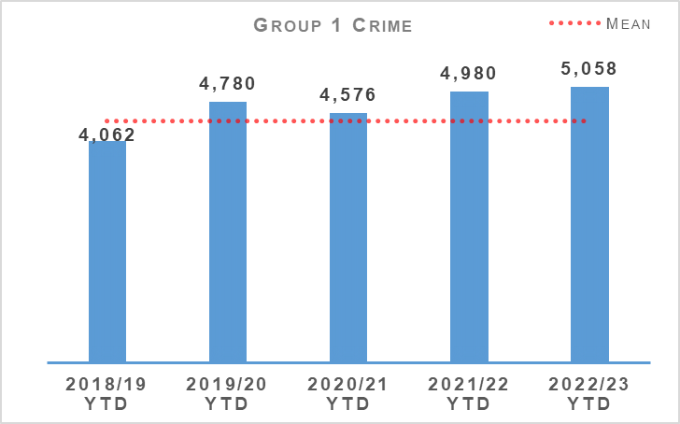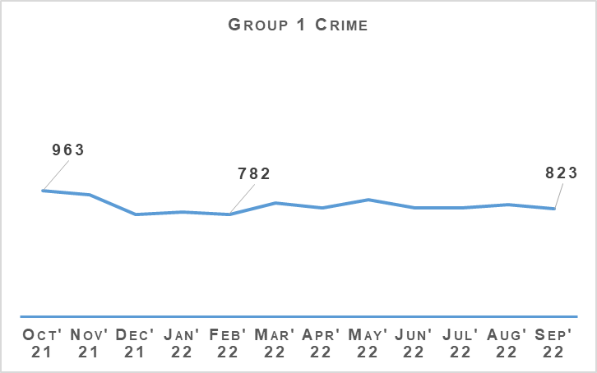
Non sexual crimes of violence increased by 1.6% compared to last year. While this crime group is at the highest level in recent years and 14.0% above the five year mean there are some important caveats to consider in relation to this increase. Serious violent crimes such as homicide, serious assault and robbery are all at their lowest level in recent years and attempted murders are also below last year and the five year mean.
The rise in total Group 1 crime is coming from other crime types recorded under this group with Domestic Abuse Scotland Act (DASA), threats & extortion and drugging crimes all having a noticeable impact as detailed as follows.
During this period 911 DASA crimes have been recorded. This is the highest number of DASA crimes in the April to September period since the crimes were introduced in April 2019. If DASA crimes are not included when considering total Group 1 crime figures then there has only been a 5.3% increase compared to the five year mean.
Changes in recording standard brought in at the start of 2020/21, as well as many people spending increasing amounts of their time online, continues to contribute to an increase in crimes of threats and extortions. There have been 822 of these crimes recorded between April and September 2022 compared to 665 last year and a five year average of 313.8.
As has been previously highlighted, these figures include attempted threats and extortions where no financial harm took place. The public reporting these attempts, even where they have not been harmed, is useful for identifying new methods and trends being used by online offenders and update and improve preventative messaging accordingly.
Higher levels of drugging crimes than usual continue to be recorded following national media reporting of concern around drugging by injection since October / November 2021. There have been 131 drugging crimes recorded in the April to September 2022 period compared to a five year mean for this period of 11.8.
The increases in crimes such as drugging and threats & extortion, which are difficult to successfully detect, is a contributing factor in the decrease in the overall detection rate for Group 1 crime.
In advance of Fresher’s Week and to continue the promotion of our messaging in regards to spiking, Police Scotland Corporate Communications updated the previously circulated communications toolkit. The revised toolkit has been shared with strategic partners including the night time economy and licensed trade.
Engagement has taken place with the Night Time Industries Association who in turn engaged with Scottish Universities to progress advertising materials, safety kits and awareness inputs. Briefing materials were prepared outlining ByStander theory for event planners and organisers which were positively received and have now been shared with the wider events industry via the Events Industry Advisory Group.

Public Protection – Equality Outcome 4
Overall Sexual Crime (Group 2) – Equality Outcome 4 | 2021/22 YTD | 2022/23 YTD | % Change from Previous Year | 5 Year Mean | % Change from 5 Year Mean
Number of crimes | 7,584 | 7,318 | -3.5% | 6,818.6 | +7.3%
Number of detections | 4,017 | 4,030 | +0.3% | 3,889.0 | +3.6%
Detection rate | 53.0% | 55.1% | +2.1 % point | 57.0% | -1.9 % point
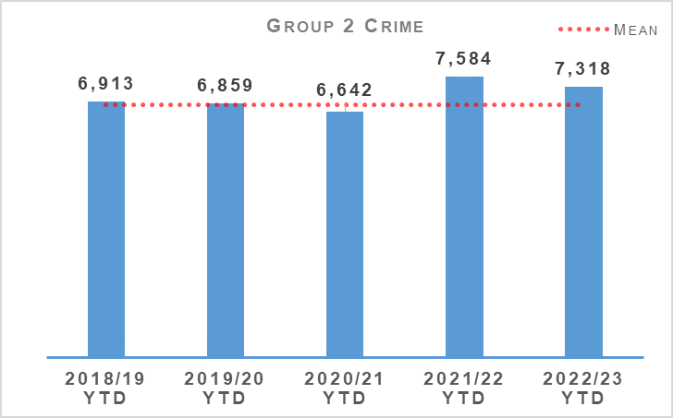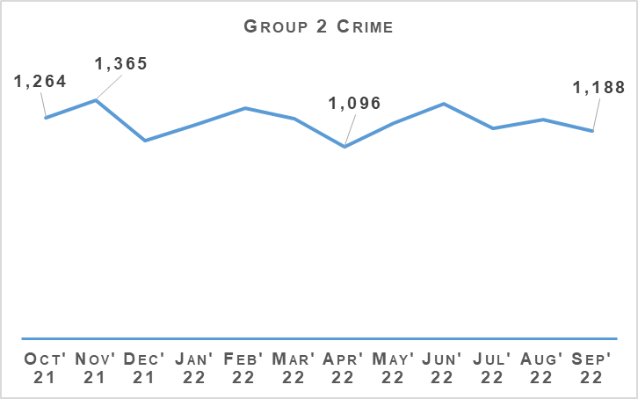
Sexual crime decreased during the reporting period compared to the same period last year. Between April and September 2022, sexual crimes decreased by 3.5% (266 crimes) when compared to last year however increased against the five year mean (up 7.3% or 499 crimes). April 2022 remains the month where the fewest number of sexual crimes (1,096 crimes) were recorded over the 12 month period. November 2021 was the month that recorded the most sexual crimes in the 12 month period.
Detections increased compared to last year, up 0.3% (13 detections) and also noted an increase against the five year mean (up 3.6%).
The decrease in sexual crimes is driven by decreases in communicating indecently (down 58 crimes, 7.3%), communicating indecently/cause see/hear indecent communication M&F under 13 (down 35 crimes, 18.6%), cause to be present sex act / to look at sex image – M&F (<13) (down 33 crimes, 18.3%) and coercing a person into being present / looking at sexual activity (101 crimes, 16.4%).
Taking, distribution, possession etc. of indecent photos of children increased during the reporting period by 82 crimes (29.6%). Overall sexual assaults increased by 2.5% (up 67) with sexual assault of a male 13 – 15 up by 24 crimes (61.5%) and sexual assault of a female 13 – 15 up by 35 crimes (12.4%). Sexual assault of a female over 16 noted the greatest numerical increase, up by 135 crimes (15.5%) on last year and recorded the highest number of crimes noted over the previous six years.
However also within the group, decreases were noted in sexual assault of a female under 13 and sexual assault of a male under 13, down 30 crimes (13.0%) and 3 crimes (5.2%) respectively.

Demand
External changes to the Public Protection arena have been significant over recent years, including a complex and increasing legislative landscape designed to improve services to victims and increase powers to pursue and prosecute offenders alongside an increase in volume and complexity of Public Protection investigations.
This combined picture translates to increased demand and expectation on operational policing as well as non-operational teams who are charged with design, delivery and implementation of new powers and procedures such as Age of Criminal Responsibility (Scotland) Act 2019 (ACRA), Vulnerable Witnesses (Criminal Evidence) (Scotland) Act 2019, Domestic Abuse Prevention Orders and Notices, the Scottish Child Interview Model and Sexual Offences Liaison Officer (SOLO) Visually Recorded Interview (VRI).
In order to meet this increasing expectation and keep pace with the modernisation of the policing response to crime, protection and vulnerabilities, it is vital that the interdependencies within Police Scotland are understood and areas work collaboratively to develop long-term solutions.
The Public Protection Development Programme (PPDP), in collaboration with national and local policing, can deliver significant organisational change in a critical and high risk area of operational policing. PPDP provides an opportunity for Police Scotland to design and deliver an innovative, forward thinking and ground breaking Public Protection model, recognised nationally and internationally.
The foundations have now been laid with a better understanding of the current response in terms of structures, remits and processes. As we move forward user research is critical to keep our citizens at the heart of what we do whilst providing our officers and staff the facilities, processes and support to deliver a high quality service alongside our partners.
Overall Sexual Crime (Group 2) – Equality Outcome 4 | 2021/22 YTD | 2022/23 YTD | % Change from Previous Year | 5 Year Mean | % Change from 5 Year Mean
Number of recent crimes | 5,784 | 5,701 | -1.4% | 5,080.0 | +12.2%
Number of non recent crimes | 1,800 | 1,617 | -10.2% | 1,738.0 | -7.0%
Proportion of Group 2 crime non recent | 23.7% | 22.1% | -1.6% point | 25.6% | -3.5% point
Note: Non-recent sexual crimes are defined as crimes that were reported more than one year after they were committed.
Recent and non recent sexual crimes decreased compared to the same period last year with the overall proportion of non recent also decreasing.
Non recent reporting noted the greatest decrease, down 10.2% (183 crimes) while recent reporting remained stable with a decrease of 1.4%. The proportion of non recent reporting of sexual crime continues to narrow, indicating recent reporting being the driver behind sexual reporting.

Rape
Rape – Equality Outcome 4 | 2021/22 YTD | 2022/23 YTD | % Change from Previous Year | 5 Year Mean | % Change from 5 Year Mean
Number of crimes | 1,226 | 1,229 | +0.2% | 1,144.2 | +7.4%
Number of detections | 681 | 647 | -5.0% | 607.6 | +6.5%
Detection rate | 55.5% | 52.6% | -2.9% point | 53.1% | -0.5% point
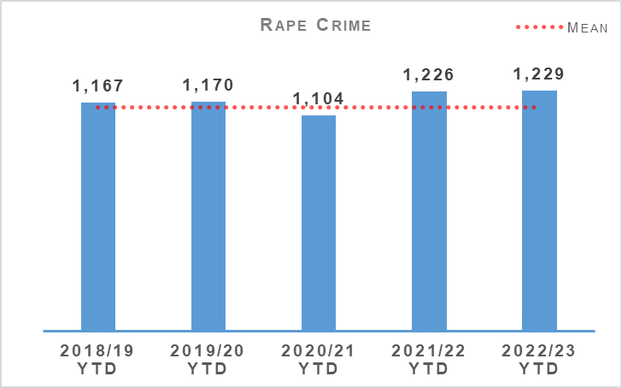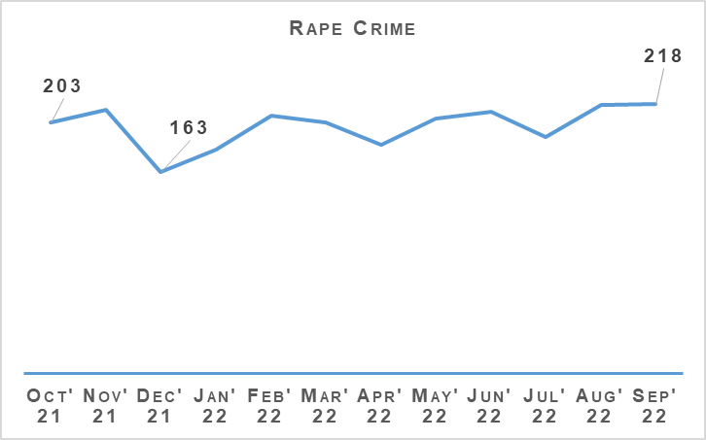
Recorded rapes are up 0.2% (three crimes) compared to last year and up 7.4% (84 crimes) on the five year mean. Last quarter, we noted recorded rapes had returned to levels of reporting experienced pre pandemic, however during this quarter reporting levels are similar to the exceptionally higher levels noted last year. Rapes increased monthly throughout the last quarter with August and September recording the greatest number of crimes in the 12 month period.
Rape of a female over 16 and rape of a male 13 – 15 were the only classifications of rape to note an increase compared to last year, up 3.5% (27 crimes) and 200.0% (eight crimes) respectively. Rape of a female over 16 also notes a significant increase compared to previous years.

THAT Guy Campaign
Last year, Police Scotland's viral THAT Guy campaign challenged men's attitudes and behaviour towards women. It put the cause of sexual offending where it belongs – with men.
This year's campaign, launched on 18 October 2022, and urges men to be the solution to preventing sexual offending by having those difficult conversations with a friend who may have crossed the line.
THAT GUY builds on previous Police Scotland sexual crime prevention campaigns, targeting men aged 18 – 35 years who are most likely to commit sexual offences. The campaign features a new advert which will run on several online platforms, including social media.
Rape – Equality Outcome 4 | 2021/22 YTD | 2022/23 YTD | % Change from Previous Year | 5 Year Mean | % Change from 5 Year Mean
Number of recent crimes | 734 | 790 | +7.6% | 684.0 | +15.5%
Number of non recent crimes | 492 | 439 | -10.7% | 460.0 | -4.6%
Proportion of Group 2 crime non recent | 40.1% | 35.7% | -4.4% point | 40.2% | -4.5% point
Note: Non-recent rape crimes are defined as crimes that were reported more than one year after they were committed.
Non recent reporting of rape decreased by 10.7% (53 crimes) compared to last year and by 4.6% against the five year mean. The proportion of non recent rape has also decreased, down 4.4 percentage points on last year and down 4.5 percentage points on the five year mean.
Recent rapes increased by 7.6% (56 crimes) against last year and by 15.5% against the five year mean.

Forensic Nurse Examiner Pilot
Police Scotland are a key stakeholder in the ongoing Scottish Government Chief Medical Officer’s (CMO) Taskforce Test of Change process. Forensic Nurse Examiners (FNEs) undertake forensic medical examinations on adult victims of rape and give evidence in court as skilled witnesses. During the Test of Change process, a Sexual Offences Examiner (Doctor) will oversee the forensic medical examinations. The pilot commenced at Archway, Glasgow and is being expanded to include NHS Lothian and NHS Highland, from Monday 03 October 2022 for a six month period.
The overall aim of the pilot is to provide a more effective and efficient national service to victims of sexual crime and in doing so, create more female forensic examiners to improve the choice for victims.

SOLO VRI Pilot
The visual recording of SOLO statements has been piloted in three local policing divisions. The SOLO VRI Pilot has entered the evaluation stage and feedback is already showing that the less time a victim has to spend recounting a traumatic incident, the less they are re-traumatised.

Partner’s Intelligence Portal (PIP) Training
Police Scotland work collaboratively with universities and colleges to deliver the Scottish Government’s Equally Safe campaign supporting the Violence Against Women and Girls national strategy. Recently it was identified that staff working in the university and college setting may benefit from PIP as a means of sharing intelligence from the student population with Police Scotland. As a result, representatives from Strathclyde University agreed to host a pilot of the PIP system with a view to a national roll-out across all Scottish Universities and colleges.
PIP training has also been delivered to NHS staff nationally to support the roll-out of Sexual Assault Response Coordination Services (SARCs) across all 14 health boards.
The training stresses the importance of sharing intelligence in terms of the evolving nature of policing although it is heavily emphasised that PIP is not a crime reporting tool and any crimes should be reported through the 101 and 999 system.

Crown Office and Procurator Fiscal Service
Work continues to assist COPFS in supporting vulnerable witnesses through the judicial process in the submission of Victim Strategy Memos within seven days of submitting a Standard Prosecution Report (SPR2). The document outlines the witnesses support mechanism and other areas where the victim could be supported to ensure minimal re-traumatisation and also ensure continued victim engagement.

Rape Crisis Scotland Direct Referral Form
In line with a recent Information Sharing Agreement (ISA) between Police Scotland and Rape Crisis Scotland (RCS), as well as reforms in the legal basis for sharing information with third party organisations, a new Direct Referral Form was created. Officers speaking with victims of rape and sexual crime will seek their views on the sharing of their details with RCS. If the victim decides they would like the police to share their details with RCS, the new form will be submitted by the SOLO officer.
If the victim does not wish their details to be shared, Police Scotland will no longer share their details. This is seen as a redress of the imbalance of power a victim of rape and serious sexual crime may feel when speaking with the police.

Sexual Assault Response Co-ordination Services (SARCS) – Self Referral
The implementation of SARCS allow victims of rape to arrange a forensic medical examination, while still within the forensic window, without having to make a report to the police (self-referral). This provides the victim with the time they need to report the incident to the police while maintaining the forensic evidence which would otherwise be lost.

Child Sexual Abuse (online)
Child Sexual Abuse (Online) – Equality Outcome 4 | 2021/22 YTD | 2022/23 YTD | % Change from Previous Year | 5 Year Mean | % Change from 5 Year Mean
Number of crimes | 942 | 936 | -0.6% | 879.8 | +6.4%
Number of detections | 599 | 640 | +6.8% | 580.6 | +10.2%
Detection rate | 63.6% | 68.4% | +4.8% point | 66.0% | +2.4% point
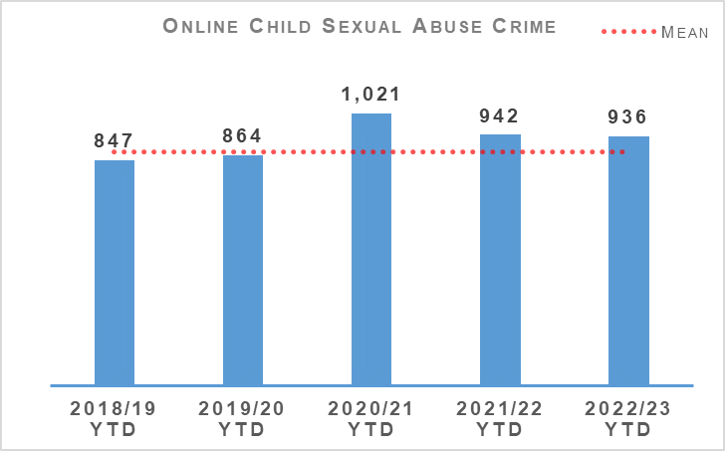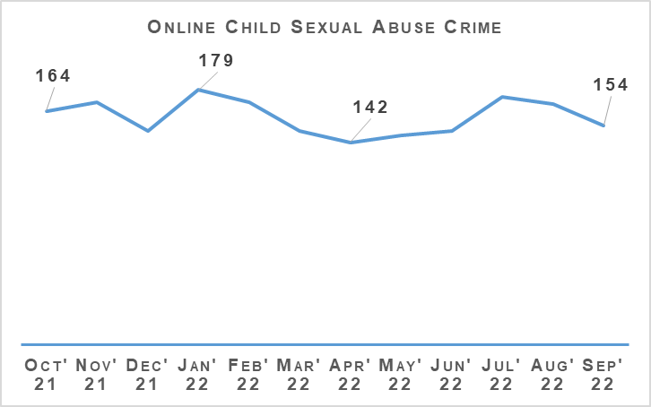
Between April and September 2022, 936 online child sexual abuse crimes were recorded in Scotland, a decrease of 0.6% (six fewer crimes) compared to last year and an increase of 6.4% (56 crimes) on the five year mean.
The detection rate has increased compared to the previous year, up 4.8 percentage points to 68.4% and is also up compared to the five year mean (2.4 percentage points).

Child Sexual Abuse (online) – Crime Types
Child Sexual Abuse (Online) – Equality Outcome 4 | 2021/22 YTD | 2022/23 YTD | % Change from Previous Year | 5 Year Mean | % Change from 5 Year Mean
Cause to be Present Sex Act/To Look at Sex Image -M&F (< 13) | 180 | 147 | -18.3% | 152.4 | -3.5%
Cause to be Present Sex Act/Look at Sex Image -M&F (13-15) | 88 | 81 | -8.0% | 89.2 | -9.2%
Communicate Indecently/Cause see/hear Indec Comm - M&F (< 13) | 188 | 153 | -18.6% | 148.4 | +3.1%
Communicate Indecently/Cause see/hear Indec Comm – M&F (13-15) | 143 | 155 | +8.4% | 140.6 | +10.2%
Grooming of children for the purposes of sexual offences | 66 | 41 | -37.9% | 50.2 | -18.3%
Taking, distribution, possession etc. of indecent photos of children (from Apr 2011) | 277 | 359 | +29.6% | 299.2 | +20.0%
Taking, distribution, possession etc. of indecent photos of children (from Apr 2011) again accounts for the largest proportion of online CSA crimes and is one of only two crime types showing an increase (up 29.6%, 82 crimes) along with Communicate Indecently/Cause see/hear Indec Comm – M&F (13-15) (up 8.4%, 12 crimes).
The overall decrease in online CSA is driven by decreases in Communicate Indecently/Cause see/hear Indec Comm – M&F (<13) (down 18.3%, 33 crimes), Cause to be Present Sex Act/To Look at Sex Image -M&F (< 13) (down 18.6%, 35 crimes) and Grooming of children for the purposes of sexual offences (down 37.9%, 25 crimes).

Demand
Like all UK law enforcement, Police Scotland continues to experience sustained increases in Online Child Sexual Abuse & Exploitation (OCSAE) cases. We proactively continue with our established National Online Child Abuse Prevention (NOCAP) process and investigations.
The premise of NOCAP is to prevent online child abuse by targeting those individuals who are suspected to have a sexual interest in children. This is achieved by developing intelligence from certain types of Online Child Sexual Abuse and Exploitation (OCSAE) referrals, known as industry or volume referrals, which originate from the National Centre for Missing & Exploited Children (NCMEC) and are referred into Police Scotland via the National Crime Agency (NCA). These referrals have risen significantly in recent years:
OCSAE Referrals via NCA | 2015 | 2016 | 2017 | 2018 | 2019 | 2020 | 2021 | 2015 – 2021 % Change
Total referrals | 509 | 817 | 1,581 | 1,346 | 1,961 | 2,422 | 3,111 | n/a
% change from previous year | n/a | +60.5% | +93.5% | -17.5% | +45.6% | +23.5% | +28.5% | +511.2%
This table highlights an increase of 511.2% from 2015 to 2021.
Between 2019 and 2021, these referrals generated a total of 2,498 investigations.
75.8% of these were suspect investigations.
24.2% were Child at Risk enquiries (often a child uploading imagery themselves where it is not clear if there is associated criminality such as grooming behaviour).
These do not account for the significant number of OCSAE investigations that arise from calls from members of the public. It is more challenging to quantify these definitively. Routine daily monitoring by the National Child Abuse Investigation Unit (NCAIU) typically shows between four and ten such calls a day, but assumes accurate placement of ‘Cyber’ or ‘OCSAE’ markers on systems to allow incidents to be counted. Another feature is that a report of a contact sexual offence might not highlight that the initial contact was in fact online.
Both types (industry referrals and calls from the public) are reflected in the 6.4% increase in OCSAE crimes against the five year mean.

Investigations
OCSAE investigations are conducted by both Police Scotland’s local policing teams and the National Child Abuse Investigation Unit (NCAIU). During the pandemic, Police Scotland transformed its approach to the OCSAE investigations generated through the NCMEC referrals process.
Prior to the pandemic approximately 80% of the investigations generated through this process were allocated to local policing. Now the NCAIU takes 85% of these investigations, helping to bring national consistency to risk assessment, triage and prioritisation. Part of this transformation was a result of Operation PARROR task force which operated from September 2020 until the end of March 2021 and resulted in a permanent small uplift in staff to the NCAIU.
Work continues in 2022/23 under Operation PARROR with enforcement action undertaken in respect of 341 NOCAP investigations since 01 April 2022. A total of 52.2% of these enforcements have led to the recovery of online Child Sexual Abuse Material (CSAM), 37.5% no recovery, and in 10.3% device examination remains ongoing. We have protected 380 children through this work and made 204 arrests.
These investigations can vary hugely in complexity. Some are comparatively straightforward whilst others can be complex with UK or international dynamics, requiring protracted investigation across jurisdictions. Many can lead to real time child protection enquiries requiring immediate safeguarding. A sizeable minority have sensitivities due to the nature of employment or degree of local public prominence. These investigations are almost exclusively taken on by the NCAIU.

Victim Identification (VID)
Over the past 18 months we have professionalised our approach to OCSAE Victim Identification, moving this role under Public Protection and the NCAIU. In doing so Police Scotland has improved efficiency and support to ongoing UK wide VID investigations.
OCSAE investigations are not without enduring challenges and the increased demand continues to place a strain on finite resources. A robust triage and risk assessment process exists with resources deployed against those offenders assessed to present the greatest risk. With the increase in use of digital devices, the essential onsite triage and full device examination, requirements to evidence this type of offending all remain enduring challenges.
Recruitment continues to enhance certain key technical posts whose presence is vital to effective enforcement. Consideration also remains ongoing through the Strategic Workforce Plan to secure support for appropriate allocation and deployment of resources to this high risk area of Public Protection.

Partnership
We continue to enhance our partnership approach to OCSAE through our multi-agency Preventing OCSAE Group. This coordinates and develops learning, and seeks to mutually support partners’ campaigns to maximise exposure. This group has helped build new relationships with academia and third sector organisations as well as the South West Grid for Learning, the UK Child Internet Safety - Early Warnings Group and with the Ofcom Scotland team with whom Police Scotland is working closely to develop process and procedure in anticipation of the new Online Safety Bill.
Police Scotland is connected with the EU Horizon 2020 i-LEAD project which brings together a diverse group of partners from law enforcement, industry, and academia to promote innovation through dialogue and ongoing discussions. In turn this led to Police Scotland’s successful involvement in a Horizon EU funded consortium aimed at tackling CSAE through prevention and support. Police Scotland delegates will travel to Warsaw in October 2022 to deliver a key note presentation on our award winning multi-agency developed campaign aimed at tackling online grooming.
In 2022/23 our continued intention is to convey to perpetrators/potential offenders that grooming children for sexual purposes is not acceptable whether online or otherwise and that they will be caught. The purpose of our #GetHelporGetCaught campaign was to prevent the online grooming of children and young people in preparation for in person offences/the sharing of images by directing offenders and potential perpetrators to Stop It Now! Scotland. This continued phase includes further targeted platform activity and aims to achieve greater reach within the medical profession. This will be supported by our future Image Based Sexual Abuse Campaign.

Sex Offender Notifications
Registered Sex Offenders (RSOs) | 2021/22 YTD | 2022/23 YTD | % Change from Previous Year | 5 Year Mean | % Change from 5 Year Mean
Number of Sex Offender Notification Requirements (SONR) offences committed | 111 | 131 | +18.0% | 125.0 | +4.8%
Number of RSO's who committed SONR offence | 104 | 110 | +5.8% | No Count | No Count
Number of Preventative Order offences committed (SOPO, RoSHO and equivalent issued out with Scotland) | 53 | 55 | +3.8% | 49.0 | +12.2%
Number of RSO’s who committed a Preventative Order offence | 40 | 38 | -5.0% | No Count | No Count
During the reporting period 110 registered sex offenders committed a total of 131 Sex Offender Notification Requirements (SONR) offences. This is an increase compared to the same period last year where 104 registered sex offenders committed a total of 111 SONR offences. This rise is consistent with the rise seen in RSO numbers.
Most common offences relate mainly to failing to notify of address change and banking information.
38 Registered sex offenders committed preventative order offences which is lower than last year when 40 registered sex offenders committed offences.

Preventative Measures
Sexual Offences Prevention Order (SOPO) - Where information suggests an RSO or an individual with a sexual conviction may be at risk of offending sexually, we can and will seek a Sexual Offences Prevention Order (SOPO).
SOPOs are granted by a Sheriff after careful consideration of proportionality balanced with an individual’s human rights. They can be granted on conviction or at sentencing where the court is satisfied that it is necessary to protect the public or a particular member of the public from serious sexual harm.
They can also be granted by Civil Summary Application where the offender has, since the date of conviction for their relevant offence, acted in such a way as to give reasonable cause to believe that it is necessary for a SOPO to be made.
A SOPO imposes conditions on an offender, either prohibiting them from doing something or placing an obligation on them to comply with a relevant direction. Dedicated police officers in local Sex Offender Policing Units (SOPUs) across Scotland, assisted by partner organisations, monitor SOPOs. Their purpose is to assist in the management of RSOs and to protect the public from the serious sexual harm.
Risk of Sexual Harm Order (RoSHO) - A Risk of Sexual Harm Order (RoSHO) is a Civil Order created under the Protection of Children and Prevention of Sexual Offences (Scotland) Act 2005, designed to protect children under 16 from those who present a risk of sexual harm towards them. It is a preventative order which prohibits the person to whom it applies from doing anything and/or obliges them to do anything specified within the order. The conditions requested must, however, be necessary to protect children generally or any child from harm from the person subject to the order.

Domestic Abuse
Domestic Abuse – Equality Outcome 4 | 2021/22 YTD | 2022/23 YTD | % Change from Previous Year | 5 Year Mean | % Change from 5 Year Mean
Number of incidents | 32,073 | 31,427 | -2.0% | 31,599.4 | -0.5%
Number of crimes | 20,865 | 19,246 | -7.8% | 20,114.0 | -4.3%
Number of detections | 14,327 | 12,416 | -13.3% | 13,895.2 | -10.6%
Detection rate | 68.7% | 64.5% | -4.2% point | 68.2% | -3.7% point
Proportion of incidents resulting in a crime | 42.7% | 41.7% | -1.0% point | 44.5% | -2.8% point
DASA (of female) – Number of crimes | 795 | 830 | +4.4% | n/a | n/a
DASA (of male) – Number of crimes | 63 | 81 | +28.6% | n/a | n/a
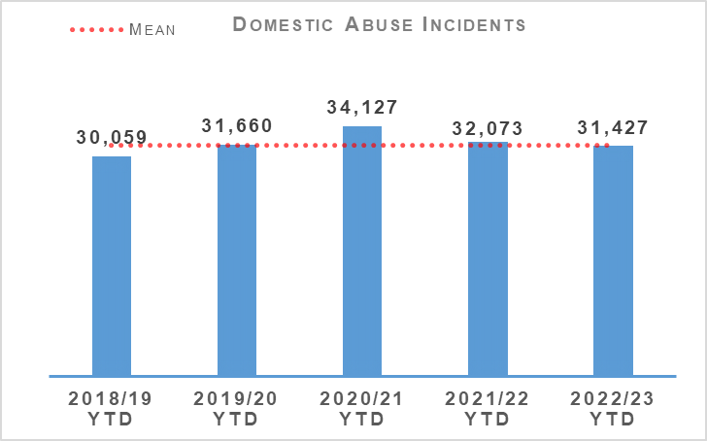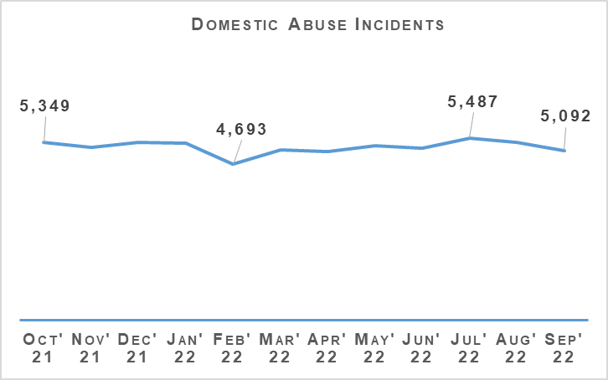
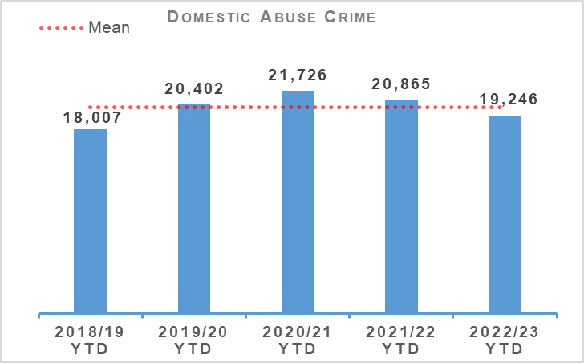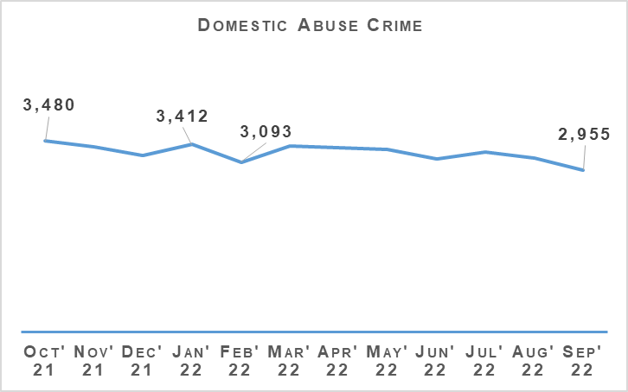
Domestic incidents decreased by 2.0% (646 incidents) compared to last year and are down by 0.5% compared to the five year mean. Domestic crimes decreased by 7.8% (1,619 crimes) compared to last year and are also down 4.3% on the five year mean. Throughout the last quarter, the number of domestic crimes and incidents have decreased month on month.
DASA crimes continue to increase with DASA of a female increasing by 4.4% (35 crimes) compared to the same period last year and DASA of a male up 28.6% (18 crimes).
There have been two domestic murders recorded during the reporting period, none of which were recorded during Quarter 2.
Disclosure Scheme for Domestic Abuse Scotland (DSDAS) applications have increased by 14.0% overall with a 12.0% increase in Power to Tell (PTT) applications and a 19.0% increase in Right to Ask (RTA) applications compared to the same period last year.

Violence Against Women and Girls
On 27 July 2022, the inaugural meeting of Police Scotland’s Violence Against Women and Girls Strategic Engagement Forum (SEF) took place. The purpose of the group is to create a collaborative environment where stakeholders can contribute to the design and delivery of Police Scotland’s strategic approach to Violence Against Women and Girls.
The SEF will provide a platform and structure for public and private sector partners, academia and subject matter experts to significantly contribute to the shape and strategic approach of Police Scotland in tackling Violence Against Women and Girls. It is hoped that through open and transparent communication, Police Scotland can work collaboratively with key stakeholders to deliver an approach that is both current and resilient to future long-term societal changes.

You, Me, Together (Pilot)
You, Me, Together is a resource that targets Domestic Abuse (including themes of coercive control, inappropriate relationships and peer pressure) in young persons’ relationships.
The resource forms part of a national standardised interactive educational workshop delivered in schools to educate students around the issues of Domestic Abuse and its correlation with Violence Against Women and Girls.
In total, the resource was presented to 1,100 students with 574 students and 31 teachers completing the evaluation.
The evaluation feedback was positive with 96% of students finding the input impactful, 95% left with a better understanding of Domestic Abuse and 92% had an improved understanding of coercive control within a relationship.
Following the success of the You, Me, Together pilot, final engagement with partners from the Domestic Abuse Forum (DAF) and the Violence Against Women and Girls network is scheduled for October 2022. At this time, any additional comments / feedback on the content of the resource will be welcomed and duly considered.
It is hoped the You, Me, Together resource will, in partnership with Education Scotland, be rolled out across Scotland later this year.

16 Days of Activism Campaign 2022
The theme of Police Scotland 16 Days of Activism Campaign 2022 is currently being planned, but will be supportive of key messages regarding Domestic Abuse.
Each day of the campaign will focus on different aspects and will seek to encourage the public, including friends and family and those at risk, to engage with police. It will highlight services available to victims to support them.

Modern Slavery and Exploitation
On 29 September 2022, a meeting took place between the National Human Trafficking Unit (NHTU) and International Justice Mission (IJM) who are a Third Sector NGO, primarily focused on the prevention of Violence Against Women and Girls and tackling modern slavery and exploitation. They have offices in a number of countries, including the UK, Romania, Netherlands, Germany, Ghana and the Philippines.
Their function is to support victims, strengthen justice systems through collaboration with local governments and other NGOs, work alongside prosecutors and police to bring criminals to justice and lobby Governments for the required policy changes to assist in this. They offer an intelligence function via there Data Fusion Centre based at their headquarters in Washington DC.
IJM can provide support to victims and also support to investigations particularly where there is an international footprint. Work to be undertaken regarding the sharing of information between Police Scotland and IJM.

Drugs Harm / Supply

Drugs Related Deaths
Police Scotland continues to work hard at fulfilling its duty to ensure the safety and wellbeing of all people within our communities. Tackling substance use and the harms they cause is complex, with COVID-19 restrictions having further exacerbated the issue. The restrictions caused disruption to addiction services, poverty due to economic difficulties, and mental health vulnerabilities as a result of isolation.
Recent increases in the cost of living will have unfortunately compounded these issues further. It is acknowledged that it is necessary to adopt a public health, whole system approach. We work alongside multiple external agencies to address longstanding issues and improve the life chances of individuals we interact with frequently.
Our focus in the area of drug related deaths is on identifying primary prevention and intervention opportunities. Through working with partners we can reduce the harm caused by substance use to individuals and communities. These aims are forwarded through major internal and external forums such as the National Drug Strategy Board, the Drug Harm Prevention Group, and the multiagency Scottish Drugs Deaths Taskforce.
Numerous other work streams continue across the service and are detailed as follows.

Drug Related Death Dashboard
Police Scotland and the National Records for Scotland provide the Scottish Government information to produce a public facing drug related death dashboard. This information is provided on a quarterly basis, one quarter in arrears. This provides partners, working in the drug treatment and harm prevention roles, a greater opportunity for earlier intervention. Partners are also afforded the opportunity to align their substance harm prevention work streams to current issues.
The latest Scottish Government Drug Related Deaths (DRD) dashboard was published on 14 June 2022. Information provided by the Substance Harm Prevention team to the Scottish Government for the period January to March 2022 showed Police Scotland recorded 275 suspected drug deaths. This is down from 288 suspected drug deaths over the period of October to December 2021.
In July 2022 the National Records for Scotland published the drug related deaths figures for 2021. There were 1,330 drug related deaths recorded, which is the first year-on-year fall in drug related deaths since 2013. This figure is however under 1% lower than the previous year, with 1,339 drug related deaths recorded in 2020.
Please note that numbers of suspected drug deaths fluctuate from quarter to quarter. Care should be taken not to interpret movements between individual calendar quarters as indicative of any long term trend.

National Naloxone roll-out
The national roll-out of Naloxone to all operational officers, up to and including the rank of Inspector, began on 31 August 2022. As part of the roll-out probationer officers will receive training during their initial SPC course and all officers will complete online training. Divisional champions will also be provided with a two hour face-to-face training delivery plan supported by the Scottish Drugs Forum and a Naloxone refresher segment will be included in OST annual training. The phased roll-out will continue into early 2023.
Administrations of Naloxone have continued since the conclusion of the Test of Change, with 82 Naloxone interventions on people experiencing an overdose to date. There have been no issues raised with regards to any of the administrations with all persons showing sufficient recovery to either receive further medical attention by medical professionals or leave the scene of their own volition.

Pathfinders
Funded by the Drug Death Task Force, the Pathfinder Project commenced on 05 July 2021. The project runs in parallel with the established Criminal Justice process and allows officers to refer relevant individuals into support services from the initial point of contact (as opposed to being considered by Procurator Fiscal or Court at a later stage in the process).
The service introduces people referred into the project to persons acting as ‘pathfinders’ who then provide guidance, advice and support, directing them to appropriate relevant support agencies. This is not an alternative to justice, but will run in parallel and allow COPFS to make more informed decisions regarding cases, by taking into account the success or not of engagement with treatment services.
An interim report was supplied by the Pathfinders project to Police Scotland during February 2022 which drew from information asked by the first contact reporting system which is in place. This highlighted that 60 people had been referred to the service with 58 engaging. Further to this, an additional report was supplied by the Pathfinders project to the CORRA Foundation with the information within being aligned to the CORRA evaluation framework.
Further analysis on the ongoing work with service users was also supplied, this has enabled the pathfinder’s project to address specific questions that CORRA had posed in relation to their ongoing evaluation. Discussions within the Criminal Justice and the Law Sub Group touched upon the possible expansion of the Pathfinders project to other areas in Scotland during 2022.
Medics against Violence/Pathfinder collated evaluative data for use in further Test Bed Areas to ensure progressive learning. Discussions have begun with Tayside Division senior management with a view of launching the Pathfinder project within this division.

Substance Education Package
Police Scotland aims to create a universal, corporate package to be delivered to every secondary school pupil each year. Work with the registered charity ‘I Am Me’ and the Substance Harm Prevention Team is now complete and awaits the official launch by ‘I Am Me’. A programme of relevant themes and a delivery method has been agreed for each year group and work around specific content for each subject is now in place.
The aim remains that every pupil across Scotland will receive at least one input per year, delivered by either teachers, Police or, on some occasions, peers. This will provide an appropriate and incremental level of knowledge on substance (drugs, alcohol and tobacco) harm and the wider impacts around community and environmental impact, stigma, risks and personal safety.
‘I Am Me’ is planning an official launch during September 2022 with the package thereafter being promoted to Police Scotland’s officers via the force intranet.

Probationer Training (Tackling Stigma)
Work continues between the Substance Harm Prevention Team and COPFS with a view to enhancing current probationer training on substance misuse and misuse of drugs offences.
The aim is to highlight the challenges of stigma and the positive impact police officers can have on individuals with drug or alcohol problems by signposting them to support and treatment services; highlighting the benefits of preventative as well as an enforcement approach to policing.
The Substance Harm Prevention Team have created an article for publication on the force intranet, reminding all officers and staff that people struggling with an alcohol or drug problem should have access to the same support and treatment as those with any other health condition. This should be without fear of judgement or criticism.

Support Services Directory
To enhance partnership working and promote support services available to people with addiction and their families, a support services directory has been published on the PPCW page of the intranet. The directory also offers details for other areas of support such as bereavement, mental health, homelessness and financial concerns, amongst others. This will be for the use of all officers and can be accessed via their personal handheld device.
The directory will allow police officers to signpost persons during instances of normal community engagement, often during their most vulnerable time to an appropriate local support service. This approach will provide an earlier form of intervention, with the aim of diverting people who use drugs into recovery and treatment, or those experiencing trauma or serious life concerns into support prior to them reaching crisis point. The directory launched during August 2022 with all local policing divisions being made aware through a latest news article on the intranet and a divisional briefing.

County Lines
County Lines is a method of dealing drugs that relies heavily on the criminal exploitation of children and vulnerable adults. There are a number of actions and operations to tackle county lines being progressed across Scotland.
Police Scotland monitors the number of county lines which operate throughout the country and seeks ways to tackle the issue. In response we have a number of ongoing projects. The following are updates from the previous quarter on some of the work carried out:
Multi-agency intervention and support visits are continuing across Police Scotland in relation to communities and individuals impacted by county lines. Specific partnership days of action are planned to raise awareness of county lines and highlight supports available locally.
Month long Crimestoppers Scotland county lines campaign launched at the end of September with a focus on exploitation and cuckooing. In support of this launch, a joint operation between Police Scotland and British Transport Police Officers took place across key train stations and cities including Edinburgh, Glasgow, Perth, Dundee and Aberdeen with engagement with members of the public and heightening awareness through poster and leaflet distribution. A number of arrests were also made of individuals making use of the rail network in furtherance of drug dealing activities.
Multi force and agency engagement around exploitation and youth trafficking involving county lines from key exporting areas including London, Merseyside and West Midlands. This continuous joint work and information sharing aims to identify those youths at risk of harm enabling key multi agency supports to be put in place.

County Line – Impact
During this quarter, four days of partnership operations, under ‘Operation PROTECTOR’, were undertaken in Aberdeenshire and Moray in order to proactively address the effects of drug related harm on our communities. During these ‘Days of Action’, a total of 246 outreach visits were conducted, with a large number of individuals being brought into service.
Over 100 positive interactions at dedicated support hubs were set up in the communities targeted; and in excess of 500 pieces of specially designed safeguarding/support literature were distributed. In addition, approximately 15 naloxone kits have been provided to service users by NHS partners.
Working with local British Transport Police officers, over 45 trains were checked/patrolled to deter individuals from using the rail network for county lines activities and to safeguard any individual identified as being the victim of county lines activity. No victims were identified.

Positive Outcomes Project
Positive Outcomes Project (POP) continues to work in partnership with Scottish Association for the Care and Resettlement of Offenders (SACRO) and have transferred the employment of the Recovery Co-ordinator over accordingly. A Memorandum of Understanding (MOU) is due to be signed and an Information Sharing Agreement has been agreed by all parties.
In conjunction with SACRO, the Positive Outcomes Project (POP) has been progressing the recruitment of two new Peer mentors to work in the Glasgow Custody Suites. Suitable candidates have been identified and vetting is being progressed.
As part of Recovery Month, to engage with potential clients and improve links with Glasgow Recovery network, POP has participated in events in HMP Low Moss and Barlinnie. POP has also attended networking events organised by the CORRA Foundation and Glasgow Alcohol and Drug Partnership.

Drug Crimes
Total Drugs Supply | 2021/22 YTD | 2022/23 YTD | % Change from Previous Year | 5 Year Mean | % Change from 5 Year Mean
Number of crimes | 2,128 | 2,067 | -2.9% | 2,285.4 | -9.6%
Number of detections | 1,877 | 1,787 | -4.8% | 2,030.8 | -12.0%
Detection rate | 88.2% | 86.5% | -1.8% point | 88.9% | -2.4% point
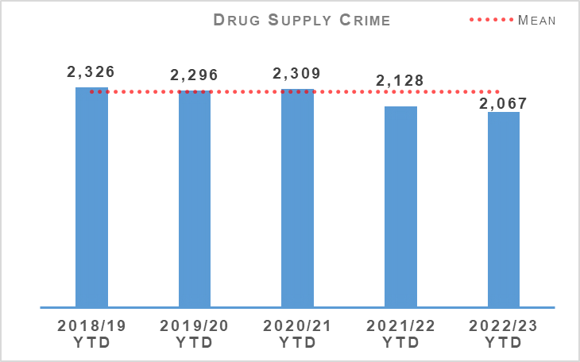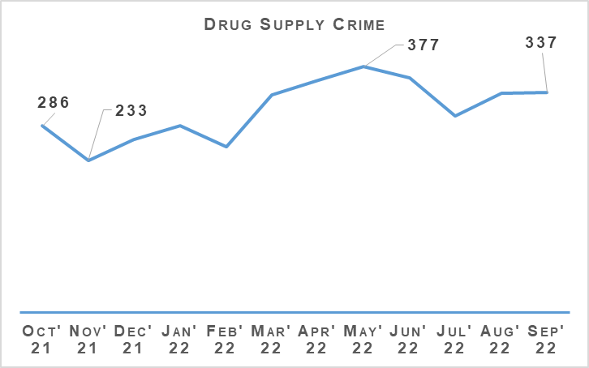
Crimes of drug supply have decreased by 2.9% (61 crimes) compared to the same period last year, and have also decreased by 9.6% (218 crimes) compared to the five year mean. Within this group, the number of crimes of supply of drugs (including possession with intent) has increased from 1,731 the previous year to 1,773 in the current period (an increase of 42 crimes). The number of production, manufacture or cultivation of drugs crimes has decreased by 96 crimes (323 in 2021/22 and 227 in 2022/23).

Serious Organised Crime Groups (SOCGs)
Serious Organised Crime Group Mapping (SOCGM) is a tool used by law enforcement to map the characteristics of the individuals and groups that are known through intelligence and operational activity. There are 104 known Serious Organised Crime Groups (SOCGs) comprising of 1,917 individuals being investigated by police and partners in Scotland. The greatest prevalence of SOCGs remains in the west of Scotland: 61% of groups are located in the west, 17% in the north of Scotland and 22% in the east.
Management of Risk in Law Enforcement (MoRiLE) is the methodology used to assess impact, physical, psychological and financial harm to individuals, the community, public expectation and environmental impact; likelihood, confidence and organisational position, taking account of an organisation’s capacity and capability to address the threat.
MoRiLE is a tool to enable law enforcement agencies to understand their operational and tactical risk. This facilitates the interoperability between law enforcement agencies whilst prioritising use of resources. This ensures resources are used to target the issues causing the greatest risk. During Quarter 2 2022/23, 28% of SOCGs have experienced a reduction in tactical risk score from Quarter 1 2022/23.
The risk posed by SOCG related violence remains high. Violent incidents relate to long running feuds between rival families, personal grievances and retribution for perceived disrespect or previous violent acts. The demand for firearms relates mostly to SOCG drug activity and violence/feuds. Despite robust police disruption tactics, enforcement action and firearms seizures, SOCGs continue to have access to firearms.
Drug trafficking is the largest criminal market in Scotland where SOCGs are involved in the production, procurement and distribution of illegal drugs. Cocaine, cannabis and heroin are the most commonly trafficked commodities. SOCGs continue to manufacture illicit benzodiazepine pills. Opiates/opioids and benzodiazepines are present in a high number of drug related deaths.
In September 2022, the NCA held the first meeting of the National Benzodiazepine Working Group. This is a multi-agency initiative including UK Police, Border Force and Public Health Partners. The aim is to align the UK response to the manufacture, supply and use of illicit benzodiazepines through a collaborative approach to prevention, intelligence (development and sharing) and enforcement, while strengthening referral pathways for the provision of addiction support.
The Scottish Multi-Agency Strategic Threat Assessment 2022 was launched at the Serious Organised Crime Task Force on 06 October 2022. The report aims to provide a collaborative multi-agency strategic threat assessment to present a comprehensive picture of the scale and nature of the threat from SOC, significant vulnerabilities and emerging threats and to demonstrate successful partnership working.
The purpose is to provide a joint assessment of the strategic threats, drive forward operational business by identifying areas of threat, risk and vulnerability, highlight changes in the intelligence picture, identify and assess current and emerging trends affecting Scotland and assist the Multi-agency Tasking and Delivery Board (MATDB) to focus business on the key threats, make informed decisions and direct resources to areas of highest threat.
During Quarter 2, the MATDB agreed to commence a new threat theme where a number of law enforcement agencies will work together on a cross-cutting threat enabler to tackle serious organised crime in Scotland. This work will take place over a six month period and include focused intelligence gathering, multi-agency response and disruption.
Mechanism | Amount
Proceeds of Crime Act (POCA) – Year to date figures for POCA represent those provided to COPFS and CRU for consideration and forfeiture | £18,511,264
Confiscations Orders | £810,479.84
Civil Recoveries Unit | £2,998,828

Drugs Possession
Drugs Possession | 2021/22 YTD | 2022/23 YTD | % Change from Previous Year | 5 Year Mean | % Change from 5 Year Mean
Number of crimes | 13,285 | 11,910 | -10.4% | 14,710.0 | -19.0%
Number of detections | 12,465 | 11,956 | -4.1% | 13,520.8 | -11.6%
Detection rate | 93.8% | 100.4% | +6.6% point | 91.9% | +8.5% point
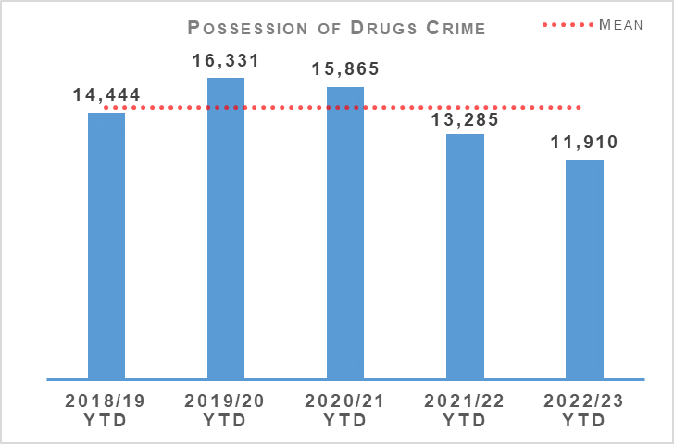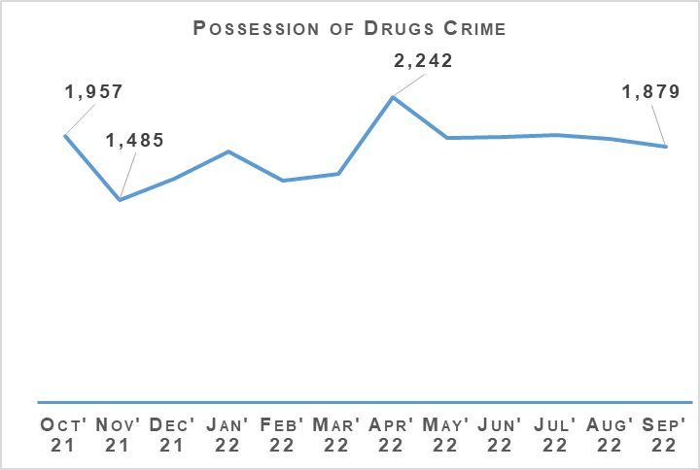
Crimes of drug possession have decreased by 10.4% (1,375 crimes) compared to the same period last year. Compared to the five year mean, there has also been a decrease of 19.0% (2,800 crimes). The numbers of drug possession and drug supply crimes have both decreased compared to the previous year and the five year mean. These reductions are likely due to shifts in focus in the market towards a more synthetic drug, as well as counting of Recorded Police Warnings for drugs possession.

Disruption Activity
Over recent months our officers have continued to work to severely disrupt the activities of organised criminals operating within Scotland. Some examples of recent work are outlined as follows:
July 2022:
Investigation in a Serious & Organised Crime group involved in the large scale distribution of cocaine throughout the West of Scotland resulted in a search warrant being executed, quantities of cocaine and herbal cannabis were recovered, with a total estimated street value of £800,000. One male was arrested and charged with drug supply.
Five warrants were executed in Dumfries resulting in quantities of herbal cannabis and amphetamine being seized with a total street value of £60,000. Three arrests were made with one male being charged at this time.
August 2022:
A cannabis cultivation of approximately 1,330 plants with an estimated street value of £800,000 was discovered within a disused school building in Kilmarnock.
September 2022:
A male was discovered by an off duty police officer unresponsive in his car in Bonnyrigg. Officers attended and found (using S23 MDA detention) in the males possession of a number of wraps of diamorphine and cocaine. A warrant was then executed at the male’s home address. Quantities of heroin, cocaine and cash were recovered. The controlled drugs have an estimated street value of £146,422. Following a warrant execution at an address in East Lothian, quantities of heroin, cocaine, cannabis and diazepam tablets were recovered with a combined estimated street value of around £10,000. Three men were arrested and charged in connection with drugs offences before being released on undertaking.
A male was arrested and charged for production of a large cultivation within an industrial estate in Hamilton. A total of 1,336 plants were found within with a value of £800,000.
While executing a warrant within a business premises in Lothian and Borders Policing Division, quantities of cocaine and cannabis with an estimated street value of £643,769 along with £128,382 in cash were seized. A named suspect is sought.
One male was stopped travelling North near Lockerbie and found to be in possession of 10 kilograms of herbal cannabis. The seized drugs had a total street value of £100,000.
Two males were stopped in their vehicle in relation to Road Traffic Offences. They were found with six kilograms of herbal cannabis, worth an estimated street value of £60,000.

Operation ERSO
ERSO is the multi-agency taskforce established by Police Scotland. Under Operation ERSO the Drug Harm Tactical Taskforce leads the national focus to enhance our understanding and examine the harm associated with the illegal consumption of synthetic drugs, particularly Benzodiazepines, across Scotland.
This allows for continuous improvement in the investigation of Drug Related Deaths (DRDs), to include evidence capture, information sharing and collaboration across the Service to maximise intelligence development and operational opportunities.
Current intelligence provides that there are numerous SOCGs involved in the manufacture, distribution and supply of Benzodiazepines within Scotland. Benzodiazepines being used by the Scotland based groups include Diazepam/Valium, Etizolam and Alprazolam (Xanax). We have also seen a rise in the number of groups manufacturing their own illicit tablets.
Since January 2020, a total of 25 Pill Presses have been recovered in Scotland as a result of operational activity carried out. Pill presses recovered through operational activity vary in technology and production capacity from manually operated pill presses capable of producing 1,000 pills per hour to automated industrial scale presses with an output in excess of 100,000 pills per hour.
Provided that raw materials are available, it is possible for these high end presses to produce approximately one million pills in a typical working day. Recovery of these presses is likely to significantly impact the manufacture, supply and availability of illicit pills, including benzodiazepines, in our community.
Activity in September 2022 saw a drug search warrant resulting in the recovery of over 11,000 Diazepam tablets, 2.4kg of cocaine, £119,000 cash and steel hydraulic press places with the stamps. Also in September, two other drug search warrants results in the recovery of 48,500 Valium tablets, 3.6kg of herbal cannabis and 250 edible cannabis bars with an estimated street value of £70,500.

Missing Persons
Missing Persons – Equality Outcome 3 | 2021/22 YTD | 2022/23 YTD | % Change from Previous Year
Number of missing persons investigations | 8,968 | 9,282 | +3.5%
Number of people who have gone missing previously | 2,187 | 2,060 | -5.8%
Percentage of people who have gone missing previously | 39.1% | 37.6% | -1.5% point
Average length of time missing (hrs) | 18.1 | 15.8 | n/a
Total number of missing persons from NHS | 872 | 973 | +11.6%
Total number of missing persons from YPU | 1,873 | 1,668 | -10.9%
Total number of missing persons from Foster Care | 200 | 250 | +25.0%
Percentage of overall missing persons that go missing from NHS | 9.7% | 10.5% | +0.8% point
Percentage of overall missing persons that go missing from YPU | 20.9% | 18.0% | -2.9% point
Percentage of overall missing persons that go missing from Foster Care | 2.2% | 2.7% | +0.5% point
Number of missing persons investigations with mental health marker | 2,951 | 2,902 | -1.7%
Missing Person Demand - Total FTE demand of missing persons investigations | 467.6 | 451.0 | -3.6%
Missing Person Demand - Children generated FTE demand of missing persons investigations | 182.3 | 206.7 | +13.4%
Missing Person Demand - Total FTE demand of missing persons investigations from Home Address | 263.9 | 246.2 | -6.7%
Missing Person Demand - Total FTE demand of missing persons investigations from Care Setting (Foster Care/Adult Care Home/Young Persons Unit/NHS) | 132.6 | 137.0 | +3.3%
The number of missing person investigations has increased by 314 compared to the same period last year. The number of repeat missing persons, the average length of time missing and the number of investigations with a mental health (MH) marker have all decreased compared to the same period last year.
The notable increases can be found when considering what ‘type’ of person goes missing. Children and Looked after Children are recording significant increases as illustrated in the following chart.
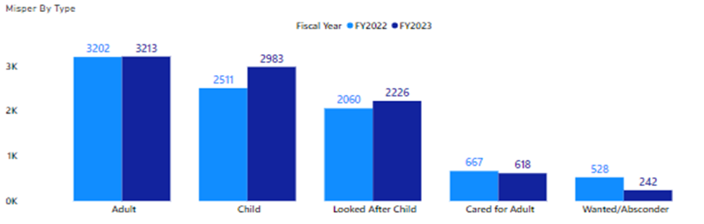
The large increases in number of children and looked after children could be attributed to certain lockdown restrictions being in place in Quarter 1 2021/2022 that were not in place in Quarter 1 2022/23. The next graph illustrates that the most significant differences are when comparing the months of April/May. In April/May 2021 (Financial Year 2022), due to the COVID-19 pandemic there were still ongoing travel restrictions, entertainment/sports venues were closed and there was still some degree of disruption to ‘normal life’.
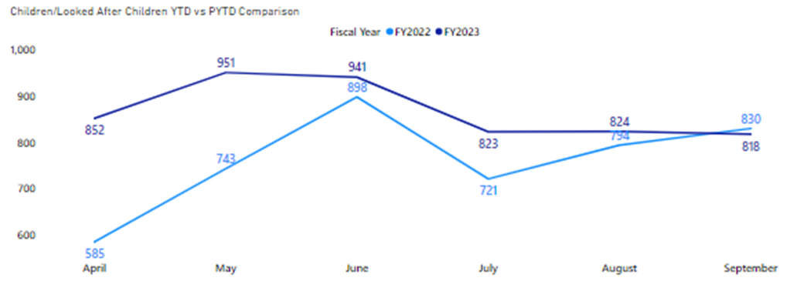
A similar pattern is observed when considering children that go missing from Foster Care (as follows).
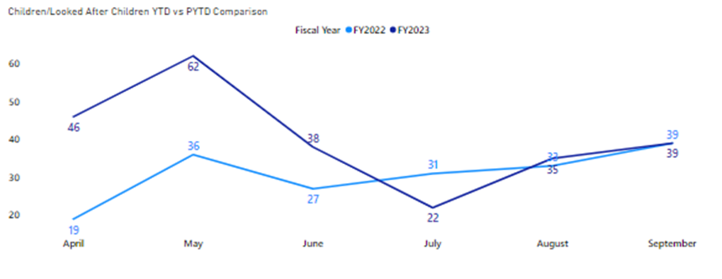

Missing Persons Demand
The FTE demand is reflective of the previous findings. The FTE demand increase in the number of missing persons investigations of children is 13.4% above that of last year, however the demand was 29.9% above last year at the end of Quarter 1.
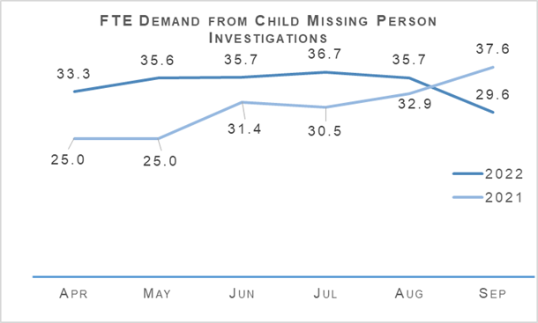

Road Safety
Road Casualties | 2021/22 YTD | 2022/23 YTD | % Change from Previous Year | 5 Year Mean | % Change from 5 Year Mean
People Killed | 80 | 97 | +21.3% | 75.6 | +28.3%
People Seriously Injured | 943 | 817 | -13.4% | 880.6 | -7.2%
Children (aged <16) Killed | 4 | 1 | -75.0% | 2 | -50.0%
Children (aged <16) Seriously Injured | 87 | 86 | -1.1% | 81.6 | +5.4%
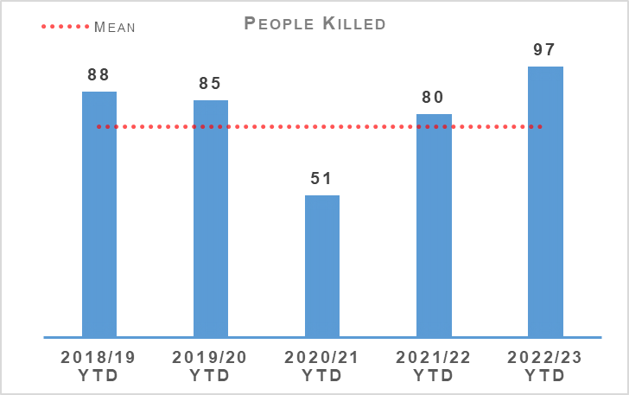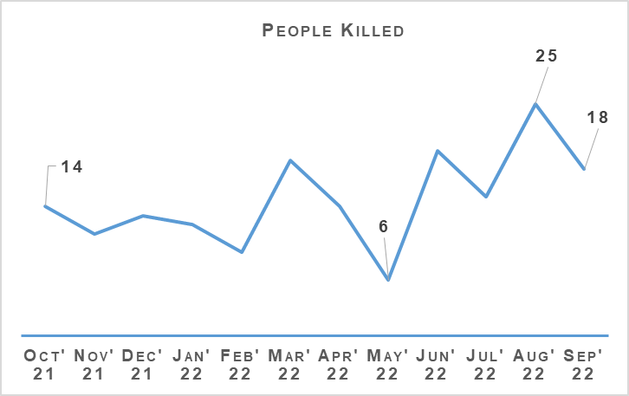
Year to date there have been 97 fatalities on Scotland’s roads. This is an increase of 17 (21.3%) fatalities compared to the same period last year. Compared to the five year mean this is an increase of 28.3%, although it should be noted that the five year mean and previous year are affected by the lower number of fatalities due to COVID-19 restrictions.
Compared to 2019/20 figures (the most recent pre-COVID-19 year) there has been an increase of 12 fatalities. August 2022 saw 25 fatalities, some of which are still being investigated for possible medical-related causes, and several collisions resulting in multiple fatalities. Serious injuries have decreased by 13.4% (126) compared to the previous year and decreased by 7.2% compared to the five year mean. Updates are awaited on the system which logs serious injuries and this will likely raise the total observed this year to date.
There has been one child killed this year to date, which is a reduction of three compared to the previous year. Against the five year mean this is a decrease of one fatality. The number of children seriously injured has reduced by one (-1.1%) compared to the previous year and decreased by 5.39% compared to the five year mean.

Scottish Road Safety Targets 2020
Transport Scotland have published key road casualties figures showing the progress made against the Road Safety Framework targets that ran from 2010 to 2020. All five targets have been met as per following table:
Scottish Road Safety Targets 2020 | Target Reduction | Actual Reduction
People Killed | -40% | -52%
People Seriously Injured* | -55% | -68%
Children (aged <16) Killed | -50% | -76%
Children (aged <16) Seriously Injured* | -65% | -77%
Slight Injury | -10% | -67%
Please note that due to changes in severity recording the number of seriously and slightly injured people cannot be directly compared to those reported in previous years. Progress against these targets has been calculated on the basis of adjusted figures provided by the Department for Transport.

Road Safety Framework (RSF)
The new Road Safety Framework (RSF) with interim targets to 2030, RSF2030, has been published along with the 2021/22 delivery plan (updated 2022/23 plan awaited). The following interim reductions in those killed and seriously injured on Scotland’s roads, from a 2014/18 baseline, are sought:
50% reduction in people killed
50% reduction in people seriously injured
60% reduction in children (aged under 16) killed
60% reduction in children (aged under 16) seriously injured
The interim reductions are challenging - as they should be - as we work with our partners toward Vision Zero - no deaths and no serious injuries on Scotland’s roads by 2050.
A few key risks have been identified via analysis and we will seek to mitigate these as we move forward:
The number of cyclists on our roads was boosted by the COVID-19 pandemic and, more generally, by people opting toward more eco-friendly sustainable modes of transport. Cycling is anticipated to further increase as a consequence of recent fuel price rises. We recognise the potential for collisions also increase, with cyclist collisions often resulting in serious injury.
Motorcycle casualties have remained steady over the past few years, aside from the drop in 2020/21 due to the reduced traffic during COVID-19 restrictions.
With an ageing population, who remain mobile longer and continue to drive, it is anticipated that there may be an increase in older casualties.
In an effort to mitigate the risks identified and reduce collisions on the road network, Police Scotland have identified a number of key opportunities.

Quarter 2 Activity
An in-depth fatality study in partnership with Transport Scotland, with a dedicated analyst and Road Policing Sergeant, continued through Quarter 2. This affords an opportunity to identify learning from previous collisions which will assist Police Scotland and partners to introduce preventative measures to further mitigate road risk across all road users groups.
Road Policing works closely with Transport Scotland to understand trends and identify emerging threats in relation to all collision classes. Police Scotland analysts produce detailed problem profiles identifying specific casualty types, with particular focus on vulnerable road users.
The information is shared with partners at forums such as the Tactical Options Working Group and Road Safety Governance Board. This sharing allows resources to be allocated to the greatest areas of risk in an effort to reduce harm on our road, in partnership with local policing and assisted where appropriate by our key partners.
Driver Engagement North initiatives were undertaken during Quarter 2, with the aim of reducing casualties and collisions suffered by older drivers in the north of Scotland via interactive workshops with a safety and welfare focus at their core. Participants use a desktop driving simulator designed to assess anticipation, hazard and speed awareness and attentiveness, highlighting actual/potential vulnerabilities. This is currently a pilot project supported by funding from Transport Scotland’s Road Safety Framework Fund and if successful will be extended to other areas throughout Scotland.
New Driver Early Intervention Scheme (NDEIS) initiatives were also carried out during Quarter 2. Partners such as the Scottish Fire and Rescue Service have adopted the scheme and deliver it in conjunction with Police Scotland to internal and external groups. NDEIS is aimed at 17-25 year olds, to positively educate and influence this vulnerable group of road users. Several local authorities have adopted the scheme for delivery to modern apprentice / skills and employability students.
Acknowledging motorcyclists are a challenging group to engage with, the Scottish Government in partnership with Police Scotland have developed a working group to explore opportunities and develop engagement strategies moving forward. One existing example is Rider Refinement North, an initiative providing rider training by Police and Institute of Advanced Motorists instructors, which we will seek to roll-out across Scotland.
All of the deliverable commitments that Police Scotland has made to the Road Safety Framework 2030 have been completed to date. Our commitment within the RSF to incorporate specific campaigns, initiatives & directed activity targeting the safety of vulnerable road users - including cyclists, motorcyclists and pedestrians – continues to be met.
All Quarter 2 road safety campaigns on our National Calendar of Road Safety Activity were completed with the exception of two initiatives coinciding with Operation UNICORN, one of which has been incorporated into Quarter 3 campaign calendar. The majority of Quarter 2 campaign work was Fatal-Five focused and all initiatives were supported by Corporate Communications/Social Media.

Road Policing Campaign Updates

Operation TUTELAGE
Operation TUTELAGE is an ongoing initiative aimed at reducing the number of uninsured drivers on the UK’s roads. Police Scotland joined the initiative on a project basis. It remains to be ratified by the Executive but continues on a full time basis meantime.
Operation TUTELAGE centres on identifying uninsured vehicles using ANPR and subsequently writing an ‘Insurance Advisory Letter’ to the registered keepers to inform them that driving without insurance is an offence. Working on the principle of behavioural compliance, the operation is designed to encourage the majority of complaint individuals to insure their vehicles.
In March 2022, National Roads Policing Operations, Intelligence & Investigations (NRPOII) conducted a Tutelage control group exercise that illustrated the effectiveness of this initiative. NRPOII randomly selected identified vehicles and monitored their insurance status when a Tutelage letter was not issued. Only 31.5% of those selected became insured, compared against the 63.6% compliance (insured after 14 days) achieved by Police Scotland Tutelage that month from 1,221 letters issued.
By 19 September 2022 a total of 35,009 letters had been issued by Police Scotland, with an overall compliance rate of 70.4%.
Key road safety benefits include:
Contribution to reducing the amount of uninsured vehicles utilising Scotland's road network using positive engagement and resolution.
Allowing for more focused and targeted enforcement.
Optimising the Police Scotland investment in upgrading our ANPR capability / infrastructure.
Operation TUTELAGE also generates actionable intelligence/supports pro-active Road Policing initiatives across Scotland.

Operation Close Pass - Ongoing
Road Policing work alongside local policing, with support from Cycling Scotland, to carry out pro-active initiatives during which a trained police cyclist uses cycle-cams to corroborate observations of careless or dangerous driving, including failing to afford her/him sufficient road space. Quarter 2 examples include:
11 July 2022 - Seven careless driving warnings were issued at Grampian Road, Aviemore with a press release issued summarising activity and providing guidance to motorists.
23 August 2022 - An Operation Close Pass in Montrose saw eight careless driving warnings given out plus a mobile phone offence detected, with accompanying social media / Facebook work.
26 August 2022 - A late shift initiative on the A85 at Perth led to four reports for careless driving plus five warnings. Release provided to regional newspapers.

Drive on the Left – Ongoing
The 2022 Drive on the Left campaign continues. Leaflets, wrist bands and stickers are given out to foreign drivers hiring a car whilst visiting Scotland. Bikers are also given reservoir covers as a visible aid to them regarding driving on the left. The campaign has received support from leading hire companies and funded by Road Safety Scotland.

National Summer Drink and Drug Drive Campaign – 04 to 17 July
A total of 585 roadside breath screening tests were carried out across Police Scotland during the campaign. Also 152 roadside drug screening tests were conducted by Road Policing officers. These tests resulted in 295 drink/drug driving offences being detected.

Drug Driving Campaign – 15 to 28 August
During this campaign 127 roadside Drug Wipe procedures were carried out with 70 of these providing a positive indication for cannabis/cocaine. A total of 267 drink/drug impairment and fail to provide offences were detected, including 66 offences of driving or being in charge of a motor vehicle while under influence of a controlled drug above prescribed limit.

Road Safety Campaign – Impact
The 2022 Motorcycle Safety Campaign ran from 15 April to 30 September with the intention of promoting safe and responsible riding and driving across Scotland’s road network. Officers carried out dedicated patrol activity on popular biker routes to engage, educate, encourage and enforce, with a strong focus on the contribution all road users can make to reducing rider casualties by adopting the right attitude and driving behaviours. Road Policing carried out 183 periods of activity, ranging from an evening to entire weekends, with 1,850 motorcycle riders being stopped.

Stop and Search
Stop Search | 2021/22 YTD | 2022/23 YTD | % Change from Previous Year
Stop Search Compliance Rate (%) | 99.0% | 99.1% | +0.1% point
13,952 stop and search incidents have been recorded by Police Scotland so far this year. This is a decrease of 21.4% compared to the same period last year. Just over one in three (34.1%) stop and searches between April and September 2022 had a positive result although this was a slightly lower (-0.5% points) positive rate than April to September 2021. 375 of these searches have led to the recovery of offensive weapons.
13,027 stop and search records were audited for compliance during the first two quarters of 2022/23. This involves the records being reviewed by line managers and thereafter quality control checked by the National Stop and Search Unit to ensure their adherence to the Stop and Search Code of Practice introduced in May 2017.
Of the stop and searches reviewed during the quarter, 11,425 (87.7%) were deemed compliant and recorded correctly on the stop and search database. A further 1,484 (11.4%) were compliant with the code of practice but required amendment to their details to ensure they were appropriately recorded.
118 (0.9%) records were deemed as not recordable under the code or practice or recorded in error and deleted from the database. Typical reasons for deletion include where a person is searched after being arrested, as a result of a duplicate record or where no physical search of a person has actually taken place.
It should be noted that the total number of records audited for compliance will be lower than the total number of searches raised during the period due to the timescales required to fully review all records.

Change Projects

Digital Evidence Sharing Capability (DESC)
The Digital Evidence Sharing Capability (DESC) Project is ongoing and is in design. As agreed with all partners, the Pilot Go-live date is delayed from October 2022, which necessitates the requirement for a significant re-baselining / planning exercise.

Cyber Kiosks
The Cyber Kiosks Phase 2 is a Business as Usual change activity.

Borders Policing Command
The Borders Policing Command Project to create a more compliant, modern, secure and easily managed process for the storage of digital data retained at Airport and Seaports was rolled out to five ports nationally and concluded in February 2021. An End Project Report was approved at Police Scotland Change Board in July 2021 and a Post Implementation Review has been conducted.
Despite challenges relating to infrastructure and COVID-19, which extended timelines, the strong BPC Project team enabled delivery of five benefits.
Alignment with Nationally Consistent Processes and procedures.
Improved Data Security and Disaster Recovery.
Improved Maintenance and Support re Hardware and Software.
Improved Interconnectivity between the Five Networked Sites.
Full Audit Capability.

Vulnerable Witnesses Act
The Vulnerable Witnesses (Criminal Evidence) (Scotland) Act 2019 (VW) Project is currently in design with a decision to be made regarding whether VW remains in Project status or transfers to Business as Usual.
The VW Business Justification Case (BJC) is in development.

United Nations Convention on the Rights of the Child (Incorporation) (Scotland) Bill (UNCRC)
The Initial Business Case (IBC) for the United Nations Convention on the Rights of the Child (Incorporation) (Scotland) Bill (UNCRC) Project is currently in development.

Age of Criminal Responsibility Act (ACRA)
The ACRA Project is in delivery and basic Moodle completions is in excess of 83%. AIM Moodle package is now quality assured and dates for ACRA Investigative Training are to be confirmed.

Strategic Outcome 2
The needs of local communities are addressed through effective service delivery.
Objectives:
Understand our communities and deliver the right mix of services to meet their needs
Support our communities through a blend of local and national expertise
Support the changing nature of communities

Call Handling
Call Handling | 2021/22 YTD | 2022/23 YTD | Change from Previous Year
Total Number of 999 calls | 368,789 | 378,959 | +2.8%
Total Number of 101 calls | 979,812 | 766,584 | -21.8%
Average 999 calls answer time | 7 seconds | 10 seconds | +3 seconds
Average 101 calls answer time | 3 mins 54 seconds | 4 mins 28 seconds | +34 seconds
Number of 999/101 calls that do not result in an incident/crime | 577,272 | 384,307 | -33.4%
Percentage of 999/101 calls that do not result in an incident/crime | 42.8% | 33.5% | -9.3% point
Note: Following the nationwide rollout of CAM, new call gradings are being used. These were updated again during August 2020, this is reflected in the table above. A small percentage of incidents are still being categorised under the old grading and are therefore not included in the above figures. Comparison data is not available.
The total number of calls to Police Scotland decreased by 203,058 (from 1,348,601 to 1,145,543). This is a decrease of 15.1% compared to last year. As shown in the previous table there has been an increase of 2.8% for 999 calls received, however, the volume of 101 calls received is showing a decrease of 21.8%, both being compared to the same period last year. Of the calls received, 33.5% did not result in an incident or crime being raised. The total number of incidents has decreased by 192,965 (from 577,272 to 384,307) compared to the same period last year.
The handling of 999 calls remains our highest priority. Between 01 April 2022 and 31 March 2022, our service centres maintained an average speed of 10 seconds for answering 999 calls, this has increased compared to the same period last year. The average call answer time for 101 calls has also increased by 34 seconds compared to the same period last year. Having previously been highlighted as a challenge for the division, further measures have been put in place to try and alleviate this and reduce the average call answer time.
These include an extension of the Temporary Retain on Duty and Business Continuity payments which support retaining staff on duty during periods of high demand to assist with reducing average speed of answer. Review of staffing levels has led to a temporary realignment of posts to different shift patterns and increasing part time staff hours to support resourcing challenges.
C3 Division has removed questioning of callers around COVID-19 status and implemented a change to the verbal introductions (whisper) for geographical location of 999 callers. This is anticipated to improve average call answer time going forward.
Efforts continue to signpost callers to more appropriate methods of contact, including via “Contact Us” and the force website, and likewise social media is used during periods of high demand to inform the public and provides the opportunity to educate the public on correct use of 101. Online contacts continued to rise during this reporting period, indicating the success of this approach.

Incident Demand
Incident Demand | 2021/22 YTD | 2022/23 YTD | % Change from Previous Year
Incident Demand – Total Number of incidents raised | 799,320 | 761,236 | -4.8%
Number of incidents by response type - Immediate | 107,667 | 82,509 | -23.4%
Number of incidents by response type - Prompt | 358,272 | 311,334 | -13.1%
Number of incidents by response type – Standard Local Policing Appointment | 38,577 | 39,030 | +1.2%
Number of incidents by response type – Standard Direct Crime Recording | 37,939 | 39,445 | +4.0%
Number of incidents by response type – Standard Resolution Team Involvement | 18,206 | 18,361 | +0.9%
Number of incidents by response type - Other Resolution | 221,722 | 252,547 | +13.9%
Incident Demand - % of incidents which lead to a crime | 25.8% | 27.2% | +1.4% point
Incident Demand - % of incidents requiring police response | 97.0% | 97.0% | No change
Partner Demand – Total number of external force request incidents | 1,478 | 1,502 | +1.6%
Note: A small percentage of incidents are still being categorised under the old grading and are therefore not included in the above figures.
During the reporting period 96,836 standard incidents were recorded in total, an increase of 2.2% (2,114 more incidents) from the same period last year. The new process involves the allocation of local policing appointments, direct crime recording and resolution team involvement to standard incidents. This has now been fully integrated into daily business, leading to this continued increase. During the reporting period the most common crime types recorded for standard incidents are theft, road traffic collisions, assist member of the public, damage and neighbour dispute.
Looking at incident demand for the reporting period compared to the previous year, the percentage of incidents which lead to a crime report being raised and that require police attendance are consistent. Due to the process changes a comparison against the five year mean is not available. Demand from partners, in terms of external force request incidents, has risen 1.6% (24 more incidents) compared to the same period last year.

C3 Division Demand
In addition to the call numbers, there have been over 133,700 additional public contacts dealt with by Contact, Command and Control (C3) Division during the reporting period. C3 Division does not only deal with incoming calls from the public. Service advisors also deal with incoming calls from other partner agencies and alarm calls.
There have been over 50,000 of these types of calls for this reporting period, although a slight decrease of around 13.0% in Emergency Service Partner calls. Emergency Service Partner calls are received via dedicated numbers from Scottish Fire and Rescue, Scottish Ambulance Service, Mountain Rescue, Coast Guard, Mental Health Pathway (NHS 24), OmniCrash and Oil Industry Agency. The reason for such calls vary and each are dealt with by a service advisor in the most appropriate manner.
“Contact Us” emails and online reports, for some crime types, can be completed online. Each one of these reports is assessed by a service advisor using the Threat Harm Risk Investigation Vulnerability and Engagement (THRIVE) model. Over 79,000 “Contact Us” emails and 4,500 online reports have been submitted since 01 April 2022.
Overall, additional public contacts are down slightly (2.7%) from 2021/22.

Contact, Engagement and Resolution Project (CERP)
The Contact, Engagement and Resolution Project (CERP) was formed in 2021 and will seek to make improvements in service through Police Scotland's response to vulnerability, risk and public need at the earliest opportunity; maximising opportunities for remote engagement and resolution; reducing local policing demand and directing appropriate incidents to the right agency through pathway referrals and enhanced collaborative working.
The project is working on a number of changes that will improve the effectiveness of various business areas in C3 Division and will enhance the service provided to the public. Essential to this is refreshed training for C3 staff on the use of THRIVE. We are in the final stages of completing a training needs analysis which will be used to inform who receives what training and in what format.

Modernised Contact and Engagement
Work to progress the outputs from various workshops held in the last few months to identify what a future target operating model should look like for C3 Division is ongoing. A service design approach is being used to inform this work with an understanding that the work should take a whole systems approach to modernise Police Scotland’s contact and engagement and must not be considered as replacements to ICT systems.
National Integrated Communications Control System (NICCS) and Unified Communications & Contact Platform (UCCP) form part of the wider MCE Programme. The roll-out of training for NICCS continues across the country and plans for the delivery of UCCP to C3 Division and other business areas are in advanced stages of development.

Complaints
C3 Complaint Allegations | 2021/22 YTD | 2022/23 YTD | % Change from Previous Year
Complaint Allegations received relative to C3 – on duty | 113 | 80 | -29.2%
Complaint Allegations received relative to C3 – Quality of Service | 110 | 105 | -4.5%
Total Allegations closed - relative to C3 | 215 | 214 | -0.5%
Percentage of total Allegations closed which were upheld – relative to C3 | 9.3% | 6.5% | -2.8% point
Complaints against C3 Division have decreased by 13.0% in the year-to-date, with a total of 147 received during this period. Decreases are visible in the North (-31.3%, 11 cases in total), East (-25.0%, 51 cases in total), with no change in the West (0.0%, 85 cases in total).
Service Delivery (65) and Incivility (65) are the most common allegation types, together accounting for 70.3% of all allegations received during this period. However, both categories have registered a decrease against the comparable period in 2021/22, by 4.4% and 15.6% respectively.
Consistent with the corresponding decrease in complaint cases, decreases are visible across almost all allegation categories. The only increase identified was in relation to Corrupt Practice, with one allegation received YTD (from zero in the comparable period of 2021/22). As this relates to a single allegation, this is assessed to represent a low volume increase and is not indicative of a broader uptick in this particular category.
In total, 61.9% of complaint cases received year-to-date for C3 Division were Frontline Resolved by the PSD National Complaints and Resolution Unit (NCARU). This rate increases to 66.7% when early and subsequent resolution by PSD or Specialist officers are included. These figures demonstrate that most complaints against C3 Division during this period have been non-criminal and non-serious in nature, with the majority resolved through simple explanation, apology or assurance.

Hate Crime
Hate Crime – Equality Outcome 1 | 2021/22 YTD | 2022/23 YTD | % Change from Previous Year | 5 Year Mean | % Change from 5 Year Mean
Number of incidents | 4,147 | 3,898 | -6.0% | 3,638.8 | +7.1%
Number of crimes | 3,835 | 3,383 | -11.8% | 3,585.2 | -5.6%
Detection rate | 64.6% | 59.7% | -4.9% point | 68.4% | -8.8% point
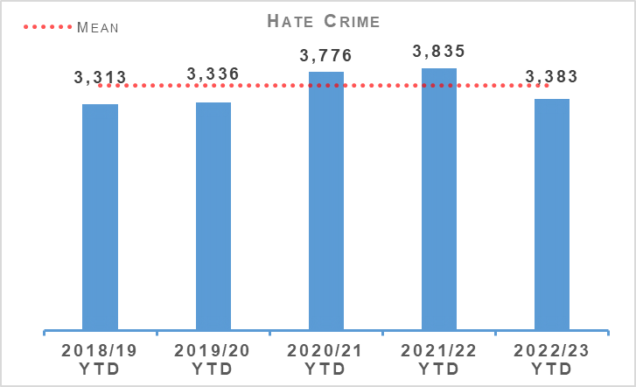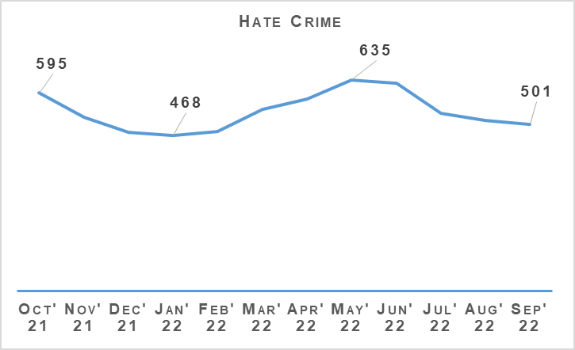
Hate incidents have now decreased compared to the same period last year (had been 27 more at end of Quarter 1). Hate crimes have decreased significantly compared to last year (452 fewer). The 12 month graph illustrates that crimes peaked in May this year and have gradually declined over the summer months.
The hate crime detection rate is 4.9% lower than the previous year and 8.8% below the five year average. Analysis is ongoing to ascertain if any common themes are attributing to a lower detection rate.

Hate Aggravators
Aggravator | 2021/22 YTD | 2022/23 YTD | % Increase | % of Total Hate Crimes (2022/23)
Race | 2,253 | 1,916 | -15.0% | 56.6%
Religion | 220 | 225 | +2.3% | 6.7%
Race & Religion | 36 | 24 | -33.3% | 0.7%
Multiple aggravators including Race & Religion | 131 | 111 | -15.3% | 3.3%
Disability | 227 | 226 | -0.4% | 6.7%
Sexual Orientation | 851 | 780 | -8.3% | 23.1%
Transgender | 77 | 51 | -33.8% | 1.5%
Multiple aggravators excluding Race & Religion | 40 | 50 | +25.0% | 1.5%
Total Hate Crime | 3,835 | 3,383 | -11.8% | 100.0%
Hate crime with a race aggravator accounts for over 50% of all hate crimes. These crimes are decreasing compared to the same period last year (337 fewer) and this is largely the reason for the overall decrease in hate crimes. Only religion and hate crimes with multiple aggravators (excluding race & religion) are increasing.
These numbers are relatively small and thus it is difficult to attribute any specific explanation to the increases this year. Anecdotally this may be a result of an increase in Orange Order / Republican Marches and the large scale return of fans to football games.

Black History Month
PPCW Equality and Diversity Unit are in the process of organising an online event for Black History Month due to take place in October 2022.
Plans are progressing to invite an external keynote speaker, retired Chief Superintendent Dr Victor Olisa, previous head of diversity within Metropolitan Police to attend the event. Dr Olisa is also a Police Scotland IRG member.

Upcoming Hate Crime Campaign
A national hate crime campaign budget has been allocated for early 2023. Initial discussions with Corporate Communications has revealed an intention to pursue a perpetrator focused campaign, however PPCW E&D have requested early engagement to ensure the campaign focus is in line with current priorities and focus which is on increasing public confidence in police, in particular with the Trans community.
Further, a deep dive in third party reporting is ongoing and a recommendations party being submitted to the Equality and Diversity Service Delivery team which could be implemented to an upcoming Hate Crime Campaign to again increase public confidence and accessible reporting.

Transgender Action Plan
Hate crimes aggravated by transgender prejudice has increased against the five year average. Engagement with the ‘Equality Network’ as well as the recent content of the LGBT Youth Scotland, Life in Scotland report; highlighted that there is a lack of trust in police from the transgender community. This view has been further supported by NISAG (National Independent Strategic Advisory Group) engagement.
The recent Your Say Matters survey also revealed a drop in confidence in police from the Trans community as well as a lack of uptake from the Trans community to participate in the survey. As such a Transgender Action Plan; focusing on building public confidence and engagement with the Trans community as well as to encourage reporting of hate crime, is being developed by PPCW E&D in consultation with Trans partners and the LGBTI Staff Association.

Anti-social Behaviour and Disorder
Anti-social Behaviour and Disorder | 2021/22 YTD | 2022/23 YTD | % Change from Previous Year
Number of antisocial behaviour incidents reported by the public | 180,992 | 150,539 | -16.8%
Number of complaints regarding disorder | 131,577 | 106,528 | -19.0%
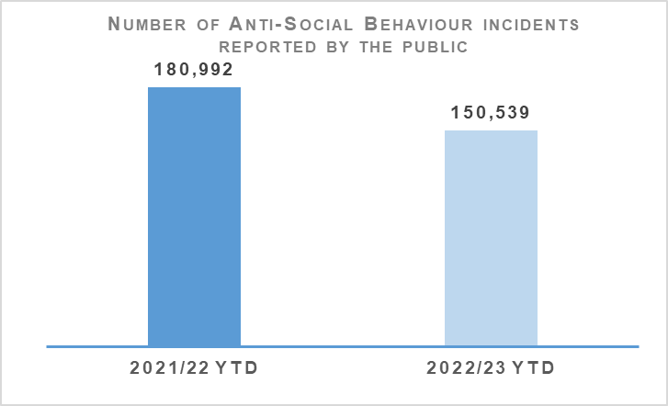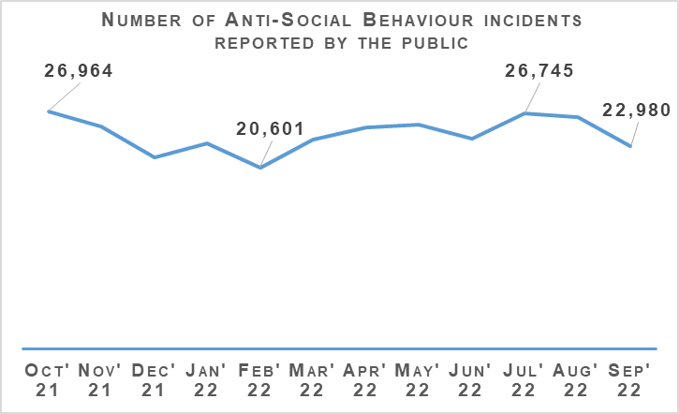
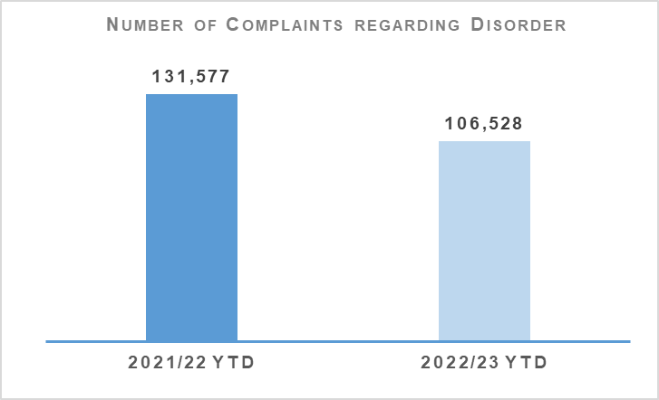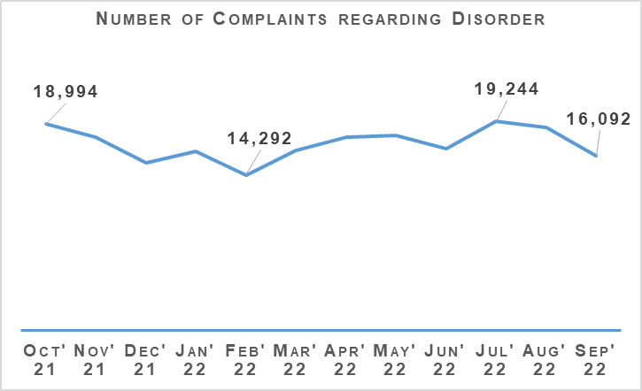
Both complaints of disorder and incidents of anti-social behaviour have been lower in the first two quarters of 2022/23 than in the same period last year.
The Fireworks and Pyrotechnic Articles (Scotland) Act received Royal Assent on 10 August 2022 and will be introduced in stages throughout 2022 and 2023. PPCW Division and National Football Information Point – Scotland (NFIP-Scotland) continue to work collaboratively with the Scottish Government in respect of implementation of the new legislation.
The proxy offence (Section 21 of the Act) is scheduled to go live on 10 October 2022 ahead of Bonfire Night. Additionally Section 44 of the Act provides an aggravation of offences against emergency workers which will also go live on this date. This is particularly welcome to support front line emergency service workers.
The provisions on prohibiting pyrotechnic articles in public and at certain places and events will require further legislation and scrutiny and as such will most likely commence in early 2023. The further remaining provisions including the introduction of ‘no firework zones’ and a fireworks licensing regime will be introduced thereafter.
PPCW Division have established, and chair, the Fireworks Short Life Working Group and will continue to progress actions to manage the impact of the new legislation on Police Scotland, ensuring sufficient guidance is issued to officers and police staff. PPCW Division are also engaging with the British Fireworks Association in this regard.
The 2022 proxy purchase of alcohol campaign ‘It’ll Cost You’ ran from 16 May – 14 August 2022 and an evaluation report is currently being prepared by the Scottish Alcohol Industry Partnership (SAIP). This is the first time the campaign has been launched on a Scotland-wide scale.
Key findings thus far are:
The paid-for social media campaign reach was over 1.5 million with Facebook and Instagram being the most effective platforms.
Good feedback from local policing divisions as to the effectiveness of the campaign and likewise positive feedback from retailers and various partners.
The campaign underpinned the partnership working which exists between the retail trade and local policing.
This year’s campaign has provided a sound platform for future campaigns and there is a real appetite to run it again in 2023. Police Scotland have been invited to present on the delivery of the campaign at an SAIP event on 16 November 2022 to an audience of MSPs and Licensed Trade partners.

Acquisitive Crime
Group 3 Crime | 2021/22 YTD | 2022/23 YTD | % Change from Previous Year | 5 Year Mean | % Change from 5 Year Mean
Number of crimes | 44,995 | 52,931 | +17.6% | 52,492.8 | +0.8%
Number of detections | 14,338 | 16,384 | +14.3% | 19,237.6 | -14.8%
Detection rate | 31.9% | 31.0% | -0.9% point | 36.6% | -5.7% point
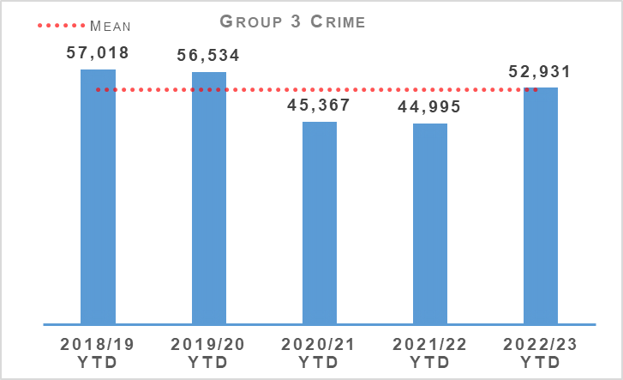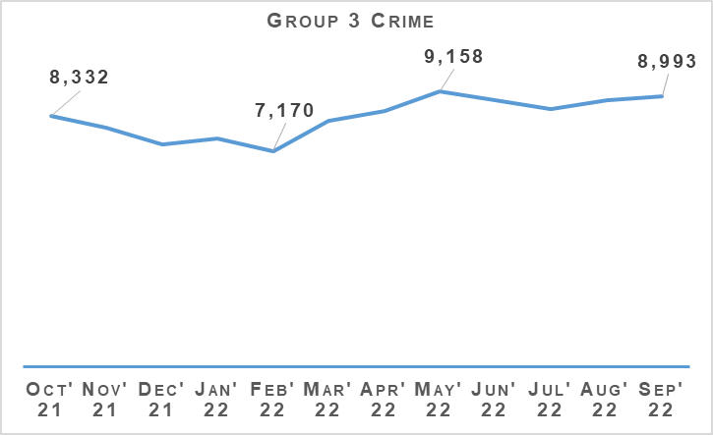
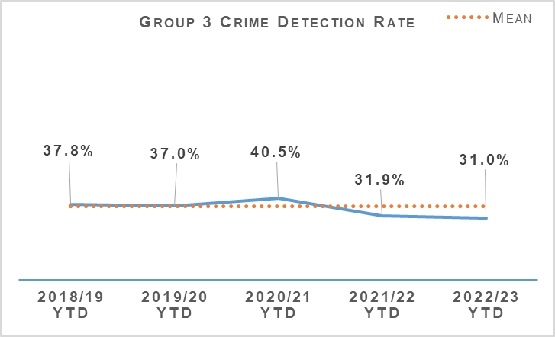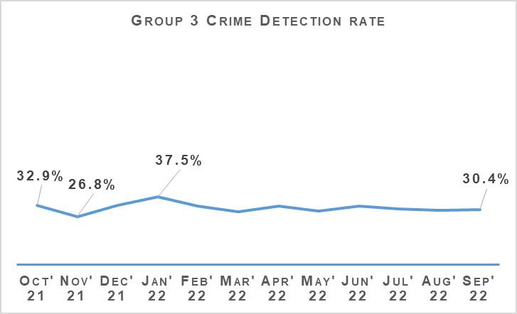
Acquisitive crime has increased significantly compared to the same period last year but remains similar to the five year mean and lower than pre-pandemic levels. Between April and September 2022 there has been 7,936 more crimes compared to the same period the previous year, and 438.2 more than the five year mean. Group 3 crimes are now following similar monthly and seasonal patterns to that seen pre-pandemic. When compared to 2019/20 Quarter 1, 2019/20 Quarter 2 showed a 1.4% decrease to 27,427 (403 crimes). Comparison of the same periods this year have shown a 0.4% decrease (94 crimes).
If fraud is excluded, Group 3 crimes have still risen by 18% (6,758 crimes). Common theft and shoplifting crimes continue to be the main contributors to this increase from the previous year, with common theft increasing by 3,457 crimes and shoplifting by 3,068 crimes. Despite the overall increase, some aspects of acquisitive crime have continued to fall compared to the same period last year.

Shoplifting
Shoplifting crimes have continued rising to levels closer than those seen pre-pandemic. Between April and September 2022 there has been 14,167 crimes, 27.6% (3,068 crimes) higher than the same period last year and 1.4% (202 crimes) higher than the five year mean. This is still 1,962 crimes lower than during the same period in 2019. This increase is expected to continue as levels are still 12.2% lower than the most recent pre-pandemic year and the rise in this crime type could be accelerated by the current cost of living situation.
Detections over the period have increased from 6,322 to 7,661 compared to the same period last year. The rate is 54.1%, 2.9 percentage points lower than the same period last year and 11.0 percentage points lower than the five year mean.

Housebreaking
Housebreaking has experienced an increase year to date of 4.9% (202 more crimes) compared to last year. Over the period there has been a total of 4,332 housebreaking crimes. Despite this year to date increase, housebreaking is 28.4% lower than the five year mean and 32% lower than levels seen pre-pandemic (2019/20).
The main increase can be seen in non-dwelling domestic housebreakings, rising from 811 in 2021/22 to 952 in 2022/23. Commercial housebreakings have also experienced an increase, with 1,125 crimes recorded between April and September 2021, rising to 1,231 crimes in the same period this year.
Domestic housebreakings remain slightly lower than the same period last year, decreasing by 2.1% (45 crimes). Between April and September 2022, 2,149 domestic housebreaking crimes were recorded, compared to 2,194 crimes last year and the five year mean of 2,956.4 crimes.
Domestic housebreaking remains at a much lower level than pre-pandemic, there has been 1,067 less crimes in 2022/23 than over the same period in 2019/20. The continued reduction in housebreakings over the last year can largely be attributed to the changes seen over the pandemic. With large numbers of the population continuing to work from home and the increase in ownership of technology such as video doorbells this has meant neighbourhoods have been better guarded, making housebreaking less attractive to criminals.

Vehicle Crime
Between April and September 2022 there has been 5,781 crimes, 10.5% (547 crimes) more than the same period last year and 11.3% (736 crimes) less than the five year mean. This increase has been due to rises in theft of a motor vehicle (297 more crimes), theft from a motor vehicle (161 more crimes) and opening lockfast place – motor vehicle (51 more crimes).
Detections over the period have increased from 1,526 to 1,622 compared to the same period last year which has had an impact in the detection rate. The rate is 28.1%, 1.1 percentage points lower than the same period last year and 0.2 percentage points above the five year mean.
On 18 May 2022, officers from OCCTU Small Ports team attended Grangemouth Port and identified two containers which had discrepancies on the manifest around weight and content resulting in the examination of these containers. On opening the first container they were confronted by what appeared to be a container full of old bicycles, not the home furniture listed on the manifest.
A full review of the containers found that six high value vehicles were located behind a large amount of low value household goods, each vehicle bearing false plates. This was followed by a thorough investigation including assistance of partners such as OCCTU Small Ports, UK Border Force (UKBF), Scottish Environmental Protection Agency (SEPA) and Forth Ports. Through these investigations a suspect was identified as being principally involved in the arrangement and loading of the containers as well as the logistics surrounding their onward travel to The Gambia.
On Wednesday 21 September 2022, a police operation, supported by OCCTU Small Ports and the Glasgow Pro-Active policing team executed simultaneous warrants at two addresses in Glasgow. During the search further evidence was obtained including additional evidence of other containers dating back several years and further lines of enquiry highlighted several well-known recidivists involved in the theft of high value vehicles, potentially to order.
Enquiries continue to target those stealing high value vehicles and utilising shipping containers to transport these vehicles abroad. All intelligence was shared with wider UK partners.

Rural Crime
The number of rural offences recorded has increased from 315 to 323 compared to the same period last year. The total cost of rural crime for April to September 2022 totalled £1,628,927 with a total of £206,837 recovered, the majority of which relates to stolen agricultural machinery and quad bikes. This compares to a total reported rural crime figure of £2,391,944 and a total of £715,922 recovered over the same period last year. This increase highlights the continued criminal interest in more expensive and sophisticated machinery within rural locations.
Over the summer months of Quarter 2, the Acquisitive Crime Prevention Team have supported colleagues at various rural events across Scotland. At nine agricultural events for a cumulative 20 days from locations such as Turriff Show, Border Union and the Royal Highland Show to name a few. Public engagement sharing prevention messaging on the hot topics such as fuel theft, plant and quad thefts along with any other concerns raised in relation to crime prevention steps to consider to protect property.

Fraud
Fraud | 2021/22 YTD | 2022/23 YTD | % Change from Previous Year | 5 Year Mean | % Change from 5 Year Mean
Number of crimes | 7,554 | 8,732 | +15.6% | 5,448.2 | +60.3%
Number of detections | 1,286 | 1,440 | +12.0% | 1,574.4 | -8.5%
Detection rate | 17.0% | 16.5% | -0.5% point | 28.9% | -12.4% points
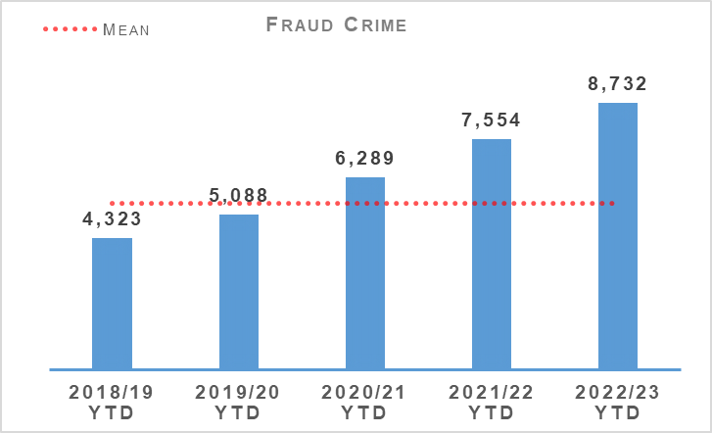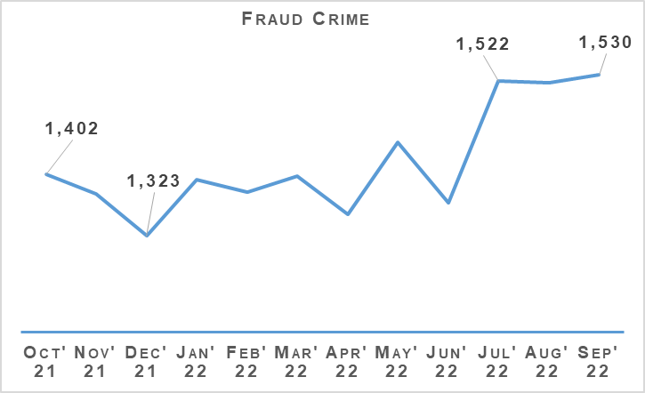
Fraud continues through this quarter to be at a high level across the entire United Kingdom and in line with this trend Scotland has suffered with large numbers of the population falling victims to a variety of frauds, particularly those with a cyber element. Compared to last year, fraud has increased by 15.6% (1,178 crimes) and sits 60.3% (3,283.8 crimes) higher than the five year mean.
The ‘#CostofLivingScams’ Campaign was delivered across Scotland by the 13 Local Policing Divisions working with local and national trading standards support. During the campaign there were events held in person along with supporting social media messaging raising awareness of the campaign.
This was another four week campaign which has been evaluated as the most impactive after the success of the ‘Shut out Scammers’ events at the beginning of the year. More detailed measures of impact and reach will be done by TSS and shared in the next report. The campaign focused on one topic per week:
Week 1 Impersonation Scams.
Week 2 Energy Efficiency Grant Scams.
Week 3 Finance Scams.
Week 4 Counterfeit Goods/ Illicit Trade / Online Shopping.
Successful events were held in each of the main Airports in Scotland engaging with the public traveling, private businesses and specialists based within the airports. Aberdeen, Edinburgh and Glasgow highlighting the illicit trade in fake goods with Police Scotland, TSS, Private industry and local authority TS all present.
Operation HATPIN investigation continues with engagement across a number of Financial Institutions and Law enforcement partners. Following engagement with UK Finance Fraud Working Group in June 2022, data was shared which facilitated the internal review of victims accounts across a range of Financial Institutions. These reviews did not show any access that would indicate an internal threat within the respective institutions.
Engagement has been undertaken with COPFS to facilitate action against individuals who have benefited from illegal funds procured through the Operation Hatpin methodology and moved to cryptocurrency beneficiary accounts. Warrants are currently being craved in respect of three individuals in the London area and all action will be co-ordinated with the Metropolitan Police.
In recent weeks extensive engagement has been undertaken with the North East Regional Organised Crime Unit in respect of high value frauds identical to those investigated under Hatpin and two individuals in the Uddingston area of Lanarkshire have been identified with further police action being developed.
On 03 October 2022 a male was arrested in respect of six offences committed in Fife Policing Division and was interviewed under caution and released to facilitate further enquiry. A range of enquiries continue in an effort to trace and arrest two other males currently in the Bradford area. Liaison continues with West Yorkshire Police, Organised Crime Team who have carried out a significant amount of activity on behalf of Police Scotland.
This has led to a number of high value frauds being uncovered across the Yorkshire area which are being progressed separately. Operation Hatpin meetings continue on a fortnightly basis to ensure that capability across Specialist and Local Policing Divisions continues to be co-ordinated to yield maximum results

Cybercrime
Cybercrime Investigations are currently based across three hubs aligned with the territorial command areas. Cybercrime Investigations are responsible for investigating all cyber-dependent high tariff cybercrimes. They also support every Police Scotland officer due to the complex nature of crimes committed and the detailed understanding off offences and investigative opportunities are not always clear or easily understood. The department provides the only capability in relation to tracking cryptocurrencies. This rises year on year and recently reporting of cryptocurrency frauds have accelerated.
Recent pro-active successes have highlighted there are clearly increasing numbers of individuals and SOCG’s committing cybercrime. This area of criminality is notoriously a closed community and all intelligence opportunities should be exploited to help tackle this harmful crime. Cybercrime Investigations have recently begun generating more actionable intelligence due to their recent success and key partner engagement. With more and more technology utilised daily, this creates increased opportunities for criminals to exploit and commit crime. The complex nature continues to present a significant challenge to tackling crime in a digital age.
The global increase in cyber-dependant crime is reflected here in Scotland and across the UK. Between 2019/21 cyber investigations in Police Scotland have recorded a 1262% increase in cyber dependent & cryptocurrency investigations since the inception of the unit in 2019 until the current date.
The knowledge and experience now possessed by CIU staff in relation to cryptocurrency has also resulted in COPFS tasking CIU staff to provide expert witness evidence for Scottish Prosecutions. This demand on our capacity which is expected to increase. Out with cryptocurrency investigations, the team provide support to frontline and specialist officers on all aspects of cybercrime including fraud, business email compromise, sextortion’s and all other cyber enabled crime.

The Banking Protocol
The Banking Protocol is a multi-agency initiative between law enforcement, banking institutions and Trading Standards. Its aim is at the earliest opportunity to identify vulnerable victims who are in the process of being defrauded of funds from their bank accounts by unscrupulous criminals and to intervene to prevent these crimes. If staff suspect customers are being coerced or the transaction is as a result of fraud, the transaction is stopped and the Police are contacted. The Protocol is designed to provide a standardised method for how these concerns are dealt with and reported to police and to stop multiple victimisation.
In terms of Quarter 2 of the reporting year 2022/23, the Banking Protocol recorded 313 incidents accounting for £852,910 of fraud being prevented. Year to Date the Banking Protocol recorded 617 incidents accounting for circa £2.13 million worth of fraud being prevented.
This initiative continues to succeed in protecting the vulnerable victims of fraud and its success demonstrates the value of the public/private partnership model.
Police Scotland continue to be a key partner on the Fraud Strategic Governance Group. This group, involving police, partners (including third sector) and the Scottish Government has been set up to understand and direct activity at a strategic level to combat the threats posed by the increases in fraud. The group continues looks to provide a coordinated public awareness raising initiative to prevent fraud from being committed and also ensure appropriate governance around a consistent and joined up strategy across agencies and organisations is undertaken.
Engagement in these groups continues to ensure that fraud investigation is undertaken from a multi-disciplinary perspective and recognises the vital contribution that each partner can play in tackling fraud.

Detection Rates
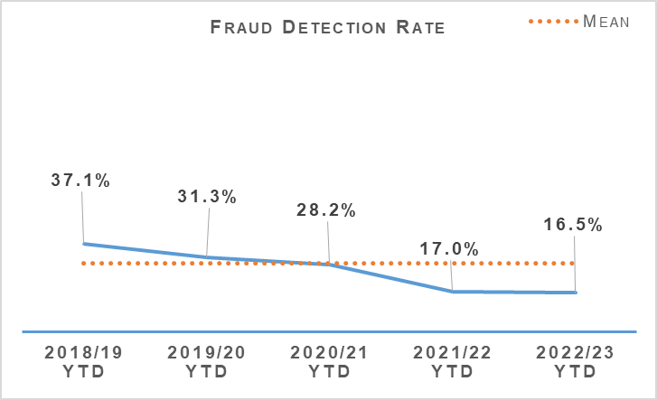 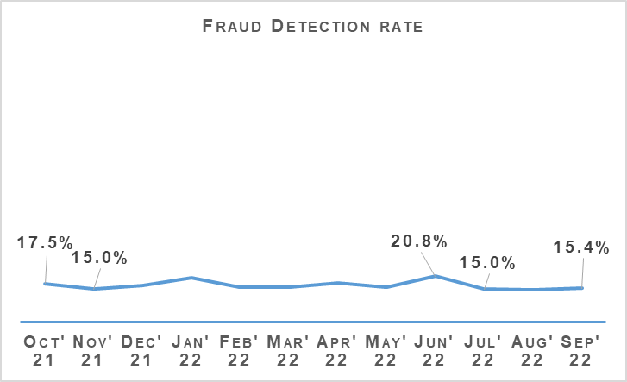 The fraud detection rate currently stands at 16.5%, down 0.5 percentage points on last year and 12.4 percentage points lower than the five year mean. This decrease has been driven by a significant rise in recorded crimes compared to the rise in detections.
There has been 1,440 crimes detected between April and September 2022 compared to 1,286 last year. This is 12% (154) more than the same period last year and 8.5% (134.4) less than the five year mean. This is not an issue unique to Police Scotland and remains a challenge across UK forces due to how quickly the cyber-enabled element of fraud is evolving.

Police Custody

Criminal Justice
Criminal Justice | 2021/22 YTD | 2022/23 YTD | % Change from Previous Year
Volume of cases submitted into Criminal Justice System | 68,122 | 60,534 | -11.1%
There is a consistent national downward trend emerging in reported cases and whilst effective use of direct measures and alternatives to prosecution are a contributing factor, it is likely that Case Management Unit (CMU) resourcing challenges are playing a part. Work is underway to urgently address this.

Arrested Persons
Arrested Persons Brought into Custody | 2021/22 YTD | 2022/23 YTD | % Change from Previous Year
Number of times arrested persons brought into custody | 48,134 | 49,343 | +2.5%
It is important to note that that number of arrested persons includes individuals who have appeared in custody on more than one occasion within the reporting period. This excludes voluntary attendance, S.23 MDA 1971 detentions and those in transit.
Custody throughput, having decreased steadily year on year, is now showing signs of levelling off as we emerge from the COVID-19 pandemic. This is the second quarter which has seen an increase on throughput since 2016 and is up further from the 1.4% increase recorded in Quarter 1 2022/23.
Arrested Persons Held for Court | 2021/22 YTD | 2022/23 YTD | % Change from Previous Year
Number of arrested persons held for court | 17,356 | 20,055 | +15.6%
Proportion of arrested persons held for court | 36.1% | 40.6% | +4.6% point
Number of arrested persons held for court in relation to a new case | 12,848 | 13,619 | +6.0%
Proportion of arrested persons held for court in relation to a new case | 74.0% | 67.9% | -6.1% point
Similar to Quarter 1, the proportion of arrested persons held for court has increased in comparison to last year’s period. This has been impacted considerably by the numbers being arrested on warrant issued and then executed as the pandemic recedes.
This will continue to be monitored closely in the coming months to establish whether this is an increasing or continuing trend however, it is worth considering that this is still down significantly on the percentage to court pre-pandemic which generally fluctuated around 50-52%. This appears supported by the 6.1% reduction in persons appearing in relation to a new case.
The Audit and Compliance Sergeants (ACS) are now fully embedded and are averaging circa 200 full, end-to-end custody records audits per week. This continues to represent just over 10% of all custody records (total throughput) from the time they took up post and introduces a previously unprecedented level of quality assurance which also includes disposals around those held for court.
Arrested Persons Released / Re-arrested | 2021/22 YTD | 2022/23 YTD | % Change from Previous Year
*Number of persons on electronic bail | n/a | 144 | n/a
Number of arrested persons released on an undertaking | 12,903 | 11,873 | -8.0%
Proportion of arrested persons released on an undertaking | 26.8% | 24.1% | -2.8% point
Proportion of persons released on investigative liberation | 0.6% | 0.6% | No change
Number of persons re-arrested | 255 | 302 | +18.4%
The term ‘re-arrested’ is defined as any occasion whereby a person, previously released without charge as a ‘Not-Officially Accused’ person, is subsequently re-arrested for the same offence due to the presence of further evidence. This is not to be confused with a person arrested more than once within a specified period on separate charges as defined by recidivism.
*Electronic Bail was introduced May 2022, therefore figures for year 2021/22 are not available.
Use of undertakings have decreased and this coincides with the increase in percentage to persons held for court. Other disposals such as persons released for report also contribute to this.
Use of investigative liberation has also improved and this may be impacted by a recent well publicised staff communications drive on the use / benefits of investigative liberation related to investigations. A CJ Act targeted staff communications package is planned in this regard which is likely to land in Quarter 3/4 which will hopefully continue this trend.
The increase in the number of persons re-arrested may be partially explained as a result of staff using the powers afforded by the Criminal Justice (Scotland) Act more effectively following increased guidance and communications about how and when powers can be used most effectively. Re-arrest can increase investigative opportunities and should be viewed in this context.
Children brought into Police Custody / Held for Court | 2021/22 YTD | 2022/23 YTD | % Change from Previous Year
Number of Younger Children Arrested and Accepted into Police Custody (not held overnight) | 640 | 724 | +13.1%
Number of younger children arrested and held overnight | 85 | 90 | +5.9%
Number of younger children held over 24 hours | 28 | 13 | -53.6%
Number of Older Children Arrested and Accepted into Police Custody (not held overnight) | 895 | 886 | -1.0%
Number of Older Children Arrested and Held Overnight | 255 | 247 | -3.1%
Number of Older Children Held Over 24 hours | 104 | 133 | +27.9%
Definitions for clarity: Adult being defined as 18 or over; Older Child being defined as 16/17 and Not under Supervision; Younger Child being defined as Under 16 or 16/17 but subject to a Compulsory Supervision Order. The number listed as held over 24 hours are those who were held in a police cell and had a relevant certificate in terms of S.22 of the Criminal Justice (Scotland) Act 2016 issued indicating why they were so held and not at a place of safety. **Overnight is determined as the period of time spent in custody which exceeds four hours and includes the period between 0000 and 0400 hours.
The definition of children in this context is a complex one but includes those aged 18 and under in circumstances described above. Police Scotland have no desire to hold children in our care and custody and only do so where there is no other alternative place of safety available or a requirement to facilitate proportionate investigation of crime. Only in the most serious of cases and where there is no other appropriate place of safety will a child be held in police custody and the figures reflect this.
On every occasion we work with our partners in the Local Authority to identify any other suitable alternatives. Where these cannot be provided it is sometimes necessary to keep children in our care and custody. Police Scotland are working with the Scottish Police Authority and partners to ensure that there is an appropriate provision of alternatives to custody available across Scotland.
We have seen a very significant reduction in the number of younger children held over 24 hours although an increase in older children held over 24 hours is apparent. There have been modest increases in numbers coming into custody which is broadly consistent with the transition out of pandemic arrangements and the wider increase in throughput observed.
CJSD have arranged a “Children in Conflict with the Law” Round Table Event on 15 November, co-sponsored by the Scottish Police Authority and Police Scotland to mark International Children’s Day. Invitations have been sent to a number of stakeholders across Police Scotland, the Scottish Government, Chief Social Workers, the Children’s Commissioner and organisations providing advocacy for children.
The event is shaping up to be a positive session and due to the sensitive nature of the subject, is likely to be led by an impartial moderator. The SPA Chair, Martyn Evans and DCC Malcolm Graham will open the event which is expected to attract media attention. The event will feature two table top exercises which will allow Police Scotland to surface the limited choices available other than to bring children into custody and will encourage an initial discussion between key parties as to how we can improve the outcomes for children going forward.

Police Direct Measures
Police Direct Measures | 2021/22 YTD | 2022/23 YTD | % Change from Previous Year
Number of ASB Fixed Penalties issued | 6,761 | 2,923 | -56.8%
Number of Recorded Police Warnings issued | 10,461 | 10,670 | +2.0%
A significant proportion of the Fixed Penalties issued in 2020/21 relate to the Health Protection (Coronavirus) (Restrictions) (Scotland) Regulations 2020. The decrease in the issuing of ASB Fixed Penalty Tickets will be as a direct result in the easing of these restrictions which no longer create an offence for certain activities previously subject to such penalties.
Accordingly the decrease is anticipated in the circumstances.

Vulnerability
Vulnerability | 2021/22 YTD | 2022/23 YTD | % Change from Previous Year
Number of persons arrested who have declared current or historic alcohol addiction issues | 5,542 | 5,997 | +8.2%
Proportion of persons arrested who have declared current or historic alcohol addiction issues | 11.5% | 12.2% | +0.6% point
Number of persons arrested who have declared current or historic drug addiction issues | 7,540 | 7,556 | +0.2%
Proportion of persons arrested who have declared current or historic drug addiction issues | 15.7% | 15.3% | -0.4% point
Number of persons arrested who have declared current or historic Mental Health issues | 20,030 | 20,849 | +4.1%
Proportion of persons arrested who have declared current or historic Mental Health issues | 41.6% | 42.3% | +0.6% point
Please note, each custody may have reported "yes" to each of the above categories.
The proportion of persons declaring one / multiple vulnerabilities remains broadly stable although increases can be seen in total numbers which may be partially explained by the increase in throughput. The numbers declaring previous or current alcohol addiction issues is perhaps the most noteworthy followed at some distance by those declaring Mental Health issues.
NHS Partners in Custody Centres | 2021/22 YTD | 2022/23 YTD | % Change from Previous Year
Number of people in custody seen by NHS partners in custody centres | 3,457 | 3,478 | +0.6%
Figures provided represent the numbers marked out of cell for medical assessment (excluding those to hospital). They do not include those individuals who are subject to several medical assessments as is often the case during longer periods in custody.
There continues to be a drive to make optimal use of Health Care Professionals for healthcare and welfare decisions and risk assessment. Figures from this area are difficult to interpret owing to the complex nature of the healthcare needs of those in custody.
We are committed to ensuring the safety and wellbeing of those in our care and custody. However, it is important to recognise that many of these people are vulnerable and have complex needs. As such, we work closely with healthcare professionals to provide an appropriate level of care based on an assessment of these needs and risks.
Police Scotland have highlighted that despite our national approach to police custody, the healthcare provision is supplied by 14 Health Boards each of whom provide Police Scotland with differing levels of service or delivery methods. We welcome the ongoing inspection by Her Majesty’s Inspectorate of Constabulary Scotland and Healthcare Improvement Scotland who will consider the provision available across Scotland and make appropriate recommendations.
Partner Referrals | 2021/22 YTD | 2022/23 YTD | % Change from Previous Year
Number of arrested persons referred to partners | 638 | 756 | +18.5%
Quarter 2 2022/23 figures have decreased from levels seen in Quarter 1 however this phenomenon was also replicated in Quarter 2 of 2021/22, and YTD figures actually show an increase in referrals from last year.
With regard to arrest referrals from custody there have been several new referral pathways added which include Edinburgh Violent Offenders Watch, Edinburgh Sheriff Court Liaison and Diversion team and also a new navigator style service based in Greenock - the Early Help Team. There is also now a signposting service to the mental health support group "Andy's Man Club".
There is a renewed drive to work with existing services as well as engaging with new ones to ensure we are providing the best possible quality and range of services tailored to local availability and needs. Examples of this include Change Grow Live (CGL) in Edinburgh bringing in more link workers to boost and support their email referral service and in other areas modifying the hours third sector staff attend in an attempt to increase referrals
Work continues to promote the arrest referral scheme across the country.

Productions
Productions | 2021/22 YTD | 2022/23 YTD | % Change from Previous Year
Total number of productions received | 308,155 | 303,528 | -1.5%
Total number of productions disposed | 159,281 | 150,974 | -5.2%
Total number of productions accumulated | 148,874 | 152,554 | +2.5%
% of productions accumulated in terms of total received | 48.3% | 50.3% | +2.0% point
The productions disposal rate is down compared to previous years however this has been impacted by reduced staffing owing to COVID-19 related absences within Productions Stores. This is something which is forecast to improve as the year continues.

Criminal Justice Recovery
As part of the Justice Recovery Programme, the Scottish Government is providing necessary targeted resources towards courts, Crown Office and Procurator Fiscal Service (COPFS), Police and Community Justice to support the recovery programme.
The Scottish Government and Justice Partners have a number of existing commitments which will help deliver against the new Vision for Justice as detailed in the Programme for Government.
Action to deliver these commitments will span several years. The year one delivery plan highlights the actions being taken forward in 2022/23 to help deliver the aims of the new Vision for Justice.
There will be an opportunity to review this one-year plan with our third sector partners, local authority partners and wider public sector in the subsequent development of a three-year delivery plan.
This three-year plan will seek to set the short, medium and long term actions required to accomplish the new Vision for Justice Plan. The work to develop this will be undertaken over the coming months.
A number of work streams under “Recover, Renew, and Transform” are focusing on supporting Criminal Justice recovery:

Summary Justice Reform – Summary Case Management Pilots
Work on the Summary Case Management Pilot has been continuing with weekly working group meetings with Scottish Courts and Tribunals Service (SCTS) and COPFS.
Stemming from this, we have now established full end to end process maps along with participation from relevant partners. Consultation has been undertaken with all internal and external stakeholders seeking views and opinions on the planned processes.
Local implementation teams have been created and are being led by a local Sheriff. Digital editing suites will be situated in each of the pilot areas to assist with key productions.
The pilots commenced on 05 September 2022 in Dundee, Hamilton and Paisley. Police and COPFS input has been positive. There have been limited examples of success and cases being resolved early which support the approach being taken however there is an ongoing challenge and lack of engagement from defence agents due to disputes over funding. Efforts are ongoing to resolve this in order to encourage fuller engagement with the pilots.

Witness availability and citations
A new court scheduler is being developed, with a full service request submitted to ICT for its development. This scheduling tool will integrate with COPFS and SCTS IT enabling the most appropriate date for a trial to be set. This will hopefully help ensure all police witnesses can be accommodated.
There has also been work undertaken to assess what Local Policing (LP) divisions have done and are doing to try and minimise the level of abstractions experienced at the front line.
This exercise has resulted in a communication being sent out to LP divisions highlighting good practice. Engagement with COPFS in areas where success has been achieved has begun to map out the process, also highlighting good practice with COPFS staff in these areas.
This has additional benefits through good practice solutions being circulated to other COPFS offices to establish if similar localised working successes can be achieved.

Remote Provision of Witness Evidence (RPWE)
This business area is continuing to be developed with a view that the current model will be evaluated prior to being proposed for business as usual.
This area of work is well supported by judicial sponsors (Lord Mathews / Lord Beckett) and work is ongoing to refine processes and ensure this approach is adopted as a BAU activity across the High Court. It is intended that this will now be routinely considered at each preliminary hearing with prosecution and defence expected to identify essential police witnesses and those which can provide evidence remotely as part of the minute of agreement.
A number of workshops have been held with divisional management and SPOCS which included partners from COPFS. The workshops were well received and generated a lot of constructive feedback. In the main RPWE is being well received throughout the force area.
At present there are 45 Evidence Giving Rooms in operation across the Service area. There are still a number of occasions officers are being asked to attend in person and the working group is working through each scenario as it arises to minimise these requests.

Change Projects

Offender Management Unit (OMU)
On the Sex Offenders Policing Unit (SOPU) / Offender Management Unit (OMU) Project, Digital Division has updated Commander and Pathfinder software, tested and deemed five laptops to be operational with completion of the remaining laptops in progress. Full training for new staff and refresher training for existing staff has still to take place.

Contact Assessment Model (CAM)
The CAM Project delivered an enhanced assessment and decision-making model using criteria such as risk and threat and vulnerability, to enable identification and direction of the most appropriate policing response at first point of contact. The project was closed in December 2020.
There were five benefits realised:
Improved service delivery to the public.
Significantly improved assessment of threat, harm, risk and vulnerability at first point of contact.
Improved management of demand.
An empowered and enabled workforce.
Increased productivity.

Local Policing Programme (LPP)
Part of the Local Policing Programme (LPP), the North East Division Integration Project (NEDIP), which sought to enhance the strong collaborative and integrated partnership working that exists across the North East by providing opportunities for greater collaboration, integration and co-location, was closed after the Evidence and Procedural Review (EPR was approved at Change Board in July 2022.
Cashable Benefits were realised and remain ongoing. Qualitative benefits included increased collaboration and co-location gains. CAM, as detailed, was also part of LPP.

Strategic Outcome 3
The public, communities and partners are engaged, involved and have confidence in policing.
Objectives:
Embed the ethical and privacy considerations that are integral to policing and protection into every aspect of the service
Protect the public and promote wellbeing across Scotland by providing services that are relevant, accessible and effective
Work with local groups and public, third and private sector organisations to support our communities

Public Confidence and Satisfaction
Insight into Police Scotland’s approach to addressing public confidence and the importance the organisation places on this key aspect of policing and community engagement is detailed in the Public Confidence and Experience of Policing section at the beginning of this report.
The following table provides the survey results that have been identified by Police Scotland and the Scottish Police Authority as key measures of progress towards achieving this strategic outcome.
Public Opinion Statements | Q1 2021/22 (n=3819) | Q2 2021/22 (n=1289) | Q3 2021/22 (n=822) | Q4 2021/22 (n=14094) | Q1 2022/23 (n=945) | Q2 2022/23 (n=10243) | Change from last Quarter
Feel either ‘very safe’ or ‘fairly safe’ in their area | 80% | 73% | 72% | 84% | 79% | 83% | +4% point
Strongly agree or agree that the police listen to concerns of local people | 33% | 29% | 36% | 29% | 31% | 32% | +1% point
Strongly agree or agree that local police are friendly and approachable | 67% | 65% | 64% | 61% | 64% | 64% | No change
Note: Confidence refers to how those who may not have directly engaged with the organisation feel about Police Scotland. This is intended to reflect public mood and sentiment towards the organisation.
User Experience – Equality Outcome 2 | Q1 2021/22 | Q2 2021/22 | Q3 2021/22 | Q4 2021/22 | Q1 2022/23 | Q2 2022/23 | Change from last Quarter
Percentage callers saying it was easy or very easy to contact the police | 75% | 67% | 75% | 76% | 72% | 69% | -3% point
Percentage callers satisfied or very satisfied with the way they were treated by staff member during initial contact | 85% | 82% | 86% | 87% | 84% | 84% | No change
Percentage callers who felt staff properly understood what they needed | 86% | 84% | 87% | 89% | 86% | 86% | No change
Percentage callers feeling that the police provided the appropriate response | 66% | 62% | 65% | 68% | 62% | 61% | -1% point
Percentage callers felt satisfied with the way they were treated by the officers who attended the incident (where applicable) | 81% | 78% | 80% | 83% | 81% | 80% | -1% point
Percentage callers felt they were adequately informed about the progress made (where applicable) | 59% | 55% | 60% | 63% | 47% | 45% | -2% point
Based on overall experience, percentage callers satisfied or very satisfied with Police Scotland | 68% | 64% | 68% | 70% | 67% | 66% | -1% point
Note1: Satisfaction refers to those who have contacted the police. This reflects on the organisation’s ability to handle individual incidents for an effective outcome for people, the police service and communities.
Note2: From April 2022, a new question has been added to the survey. Before question 6A within the survey is asked (about whether respondents feel they have been adequately informed about progress), respondents now answer a ‘screener question’ which asks “Did you expect to receive an update on the incident you contacted police about?” If respondents answer ‘yes’ they are asked if they feel they had been adequately informed. If ‘no’ they are skipped on to the next question. This means that people who did not expect to receive a response to the issue they made contact with police about are now excluded.

Quarterly Comparison
Since April 2020 measures of satisfaction with Police Scotland have remained consistently high. The change of survey methodology (from phone interviews to text in April 2020 due to the pandemic) resulted in changes in the data. It’s important to note that these data changes do not always indicate a trend; overall satisfaction has remained between 64%-73% in each Quarter over the past two years.
There has been a decrease in the number of respondents reporting it is ‘easy’ or ‘very easy’ to contact Police Scotland (69%) compared to Quarter 1 2022/23 (72%). This decrease is also reflected in levels of overall satisfaction, which saw a slight decrease (66%) compared to the previous quarter (67%).
To understand the reasons for initial contact being easy or difficult, an open-ended survey question was introduced to the local policing User Experience Survey in September 2021. 3,782 responses were received to this additional question in Quarter 2 2022/23.
Among respondents who found it easy to contact police (n=2,611), qualitative analysis of responses has highlighted the following as reasons why contact was easy:
Service Accessibility. 56% (n=1,473) of respondents highlighted fast 101 / 999 answer times and found the automated menus easy to navigate. Respondents were also satisfied if they were able to report incidents online.
“Call was answered very quickly and my query was dealt with immediately.”
“Didn’t take long for someone to answer, take my details and sort my issue and couple of days later kept up to date with the progress, brilliant”
“Online form easy to fill in and was contacted quicker than expected.”
Effective Communication. 18% (n=467) of respondents praised service advisers for their ability to be helpful under pressure, whilst also helping keep the caller calm, providing advice and making them feel safe .
“I had no issues with 1st. I received a call back when I was told. And was kept informed. But every interaction was friendly and I was offered help. Very impressed. Thank you.”
“I found the telephone number easily and my call was answered promptly. The police officer was very thorough and she listened carefully to information I gave which was passed on and acted upon quickly.”
Police Presence. 11% (n= 287) of respondents mentioned appreciating officers attending incidents in a timely response which they perceive to be appropriate. Responses also mentioned attending officers being attentive and helpful.
“I called Police Scotland they attended promptly and then dealt with the incident in a kind professional way as the person causing the issue was in distress and in need of help which the attending officers provided.”
“It was a quick response, the person that spoke to me was very pleasant and listened to what I was saying the police arrived not long after, and I was very happy with what was said they were lovely officers.”
Among respondents who found it difficult to contact police (n=683), qualitative analysis of responses has highlighted the following as reasons why contact was difficult:
Difficulties with connecting to a service advisor. 52% (n=353) of respondents referred to long waiting times using the 101 service for non-emergency incidents, the inability to connect to staff on their first attempt or giving up calling 999 instead.
“The time to wait (101) was very long and it took days if not a week to speak to a local policeman.”
“Far too long a wait on phone (101) for someone to answer. Gave up waiting after half an hour.”
Being kept up to date after initial contact. 22% (n=148) highlighted a lack of updates / follow up to their cases to know what was happening, with no call-backs or updates about their reported incident.
“Long waits on hold. Also I didn't receive the requested call back even if the Police told me that they tried to call me several times on a specific day and time frame (I didn't even have a missed call on my phone). In addition, I requested twice for an update but I was never contacted about that.”
“Call handlers didn’t take my attempts to report a theft seriously. Took three attempts to get a crime number. Nearly 4 weeks on, am still waiting for an update on what’s been done e.g. checking CCTV. Have requested update but heard nothing in nearly 2 weeks.”
Further comments provided by survey respondents highlight the importance of:
Listening to understand needs to provide the appropriate response.
Making access to the police service as easy and intuitive as possible.
The need for multiple ways of online (email, website), virtual (video calling) and in person (easy access to and relationships with local officers) contact with police.
Consistency of service delivery, with a high standard of service from all staff and officers in all parts of Scotland.
Being able to communicate with a call handler who has adequate geographical knowledge of where the incident is being reported.
Being informed and updated on aspects of work that Police Scotland is doing to respond to local areas of concern and reported incidents; highlighting the importance of a continuous engagement with the public.

Public Contact and Engagement Strategy
Ease of contact is a key area of focus in the Public Contact and Engagement Strategy. The introduction of accessible new contact channels and enhancement of how Police Scotland communicates and engages, will help to improve public experience and confidence in reporting crime and other incidents, enabled by digital services. For example, key programmes are continuing to ensure people are able to contact police in ways which are most accessible for individuals:
Fully accessible online reporting for getting information and advice, reporting low level crime and other incidents, receiving updates, and sharing evidence.
Investing in the replacement of our national contact platform (UCCP) to sustain contact assessment and call triage and to ensure our technology is a platform for innovation and supportive technologies i.e. ‘next generation 999’ for connecting with mobile technology. Policing of the future in Scotland is expected to use video and text, activated by service advisors for easing emergency contact, in addition to phone contact.
Ensuring the public can reach us using voice assisted technologies e.g. smart home devices and smart watches, in situations where they might not be able to reach a phone to dial 999.

Complaints about the Police
Complaints | 2021/22 YTD | 2022/23 YTD | % Change from Previous Year | 5 Year Mean | % Change from 5 Year Mean
Total number of complaints from members of the public | 3,525 | 3,343 | -5.2% | 3,368 | -0.7%
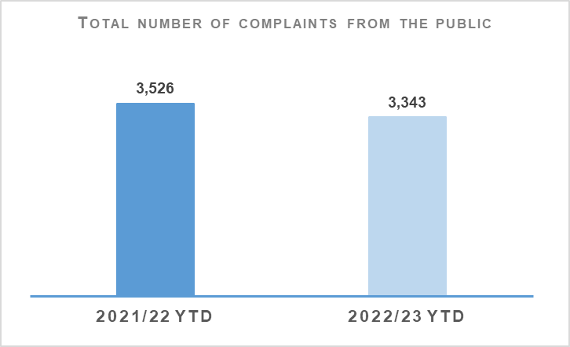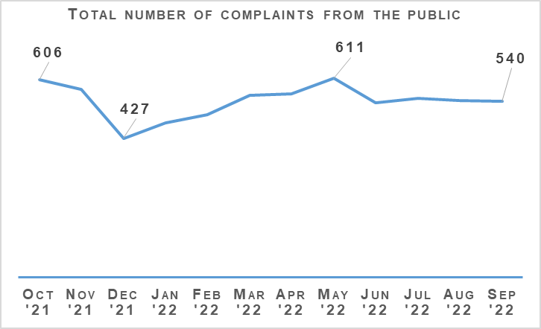
Complaints from members of the public decreased by 5.2% (183 fewer complaints) to 3,343 at the end of Quarter 2 compared to the same period last year and are down 0.7% (25 fewer complaints) on the five year mean.
The decrease in complaints in Quarter 2 compared to the same period last year is influenced by an elevated level of complaints in 2021/22 linked to Quality of Service related allegations. In particular, Service Outcome allegations, which have decreased notably from this period. Substantial decreases in Incivility and Irregularity in Procedure allegations have further impacted in this regard.
The professional Standards Department (PSD) has resolved 1,436 complaints (43.0%) by Frontline Resolution (FLR) during the year to date 2022/23, compared with 45.9% in the same period last year. This includes early resolution and subsequent resolution by PSD/Specialist officers.
Due to the launch of a new complaint handling model on 03 May 2021, FLR rates cannot be directly compared to data prior to this date. This is due to the provision of additional complaint categories which will provide PSD with more detailed analysis and understanding of the overall complaint handling process.

Allegations about the Police
Allegations | 2021/22 YTD | 2022/23 YTD | % Change from Previous Year | 5 Year Mean | % Change from 5 Year Mean
Total number of allegations from members of the public | 6,531 | 5,157 | -21.0% | 5,843 | -11.7%
% of closed allegations which were upheld | 7.9% | 6.6% | -1.3% point | 9.0% | -2.4% point
Note: A complaint case may include multiple allegations. A ‘Complaint’ relates to the overall expression of dissatisfaction provided by the complainer about an act or omission by the police or Quality of Service received. Allegations are the component parts of a complaint, which categorise what has happened and are separated to those capable of being independently Upheld or Not Upheld.
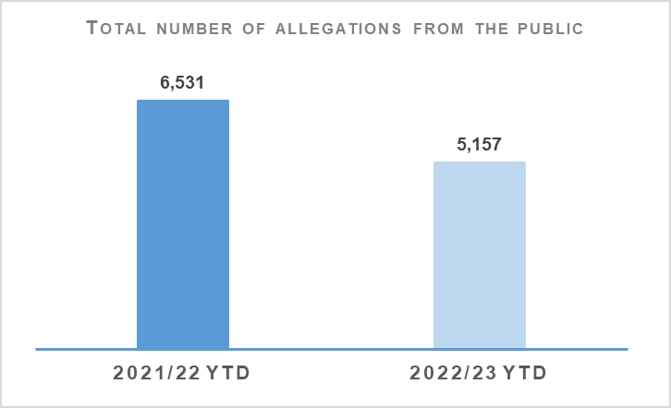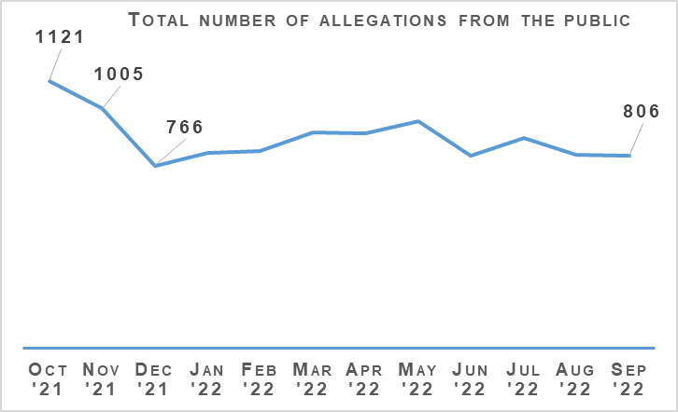
The total number of allegations has decreased by 21.0% (1,374 fewer allegations) compared to the same period last year, with 5,157 allegations recorded at the end of Quarter 2 2022/23. The number of allegations is also down 11.7% (686 fewer allegations) when compared to the five year mean.
Allegations closed totalled 5,253 at the end of Quarter 2 with 6.6% of these being upheld. Allegation outcomes (e.g. upheld) are based on closed allegations within the year to date period. Closure dates vary from the received dates, therefore closed and received data may not be directly comparable.
During this period, there were 2,092 non-criminal and Frontline Resolved (FLR) complaints closed with 67.0% closed within the 56 day statutory timescale. This is a 0.4 percentage point increase from the same period in 2021/22. FLR complaints are now included in this measure to better reflect the overall demand in complaint handling. Moreover, this further reflects the key aim of frontline resolution in providing an informed response within a shorter timescale, whilst also enabling an amicable conclusion for both complainers and subject officers.

Police Investigations and Review Commissioner (PIRC)
Police Investigations and Review Commissioner | 2021/22 YTD | 2022/23 YTD | % Change from Previous Year
Number of PIRC Complaint Handling Reviews (CHRs) | 115 | 97 | -15.7%
Number of allegations considered by PIRC (CHRs) | 452 | 434 | -4.0%
% of reviewed allegations assessed as handled to a reasonable standard | 66.2% | 72.1% | +6.0% point
Number of On Duty Assault cases referred to PIRC | n/a | 165 | n/a
% of these cases subject to PIRC investigations | n/a | 19.4% | n/a
Note: Allegations of On Duty Assault – plus any associated criminal allegations have been referred to the PIRC since 04 October 2021. As such, Police Scotland are currently unable to make any comparisons to the previous YTD.
In total, 165 allegations of On Duty Assault referrals were made to the PIRC during the period April to September 2022. Of those, 32 are subject to PIRC investigation (19.4%). However, as at 24 October 2022, 69 of these referrals are awaiting a decision from PIRC regarding possible investigation.
The Police Investigations & Review Commissioner (PIRC) submitted 97 Complaint Handling Reviews (CHRs) to Police Scotland for consideration during this period. This equates to 2.9% of all complaints. The 97 CHRs received from PIRC considered 434 allegations, with 313 (72.1%) assessed to have been handled to a reasonable standard. This is an increase of 6.0 percentage points from the same period in 2021/22. These CHRs included 114 recommendations.
Statutory referrals to PIRC facilitate independent and transparent scrutiny in relation to serious incidents involving the police. Police Scotland made 167 referrals to PIRC resulting in 25 investigations (15.0%) at the end of Quarter 2 of this reporting year. This is a decrease of 18.6 percentage points compared to the same period last year. Those referred to PIRC include:
Referrals to PIRC | 2021/22 YTD | 2022/23 YTD | % Change from Previous Year
Armed Policing Presentation of Firearm | 36 | 65 | +80.6%
Crown Directed Inference of Criminality | 19 | 13 | -31.6%
Death following Police Contact | 6 | 9 | +50.0%
Death in Police Custody | 1 | 1 | No Change
Serious Injury Following Police Contact | 16 | 17 | +6.3%
Serious Injury in Police Custody | 21 | 33 | +57.1%
STO Taser Discharged | 32 | 29 | -9.4%
Total Referrals to PIRC | 131 | 167 | +27.5%
Total referrals to PIRC have increased by 27.5% compared to the same period last year with the largest increases recorded in Armed Policing Presentation of Firearm referrals and Serious Injury in Police Custody referrals.
Armed Policing Presentation of Firearm referrals have increased by 80.6% (29 more referrals) when compared to the same period last year. By way of context, the monthly average of Armed Policing referrals during 2021/22 overall was six, with a comparative monthly average of 11 during 2022/23 to date.
Each individual month during the YTD has been above the 2021/22 monthly average, with further spikes during July (14), August (12) and September (13). The latter three are the highest monthly totals registered for Armed Policing referrals going back to April 2019. Key themes of note amongst these referrals include:
Spontaneous incidents account for 51 (78.5%) of referrals compared to 11 (16.9%) planned operations and three (4.6%) accidental discharge in training environmental / humane dispatch of an animal.
Individuals with a mental health concern and in possession of an offensive weapon account for 63.1% of total referrals
Subjects in possession of bladed weapons alone feature in 30 (46.2%) of referrals, reported firearms possession in 15 (23.1%) and referrals involving both in seven (10.8%).
The majority of referrals relate to the presentation of firearms (89.2%, 58 in total). The remaining seven referrals involved the discharge of firearms, four of which were Taser discharges by armed officers in response to non-compliant subjects threatening officers with bladed weapons. The remaining three relate to accidental discharges in the Police training/armoury environment and the humane dispatch of an animal.
Of these 65 Armed Policing related referrals YTD, one is subject to PIRC investigation with a further five awaiting PIRC decision. This provides further independent assurance that the use of Armed Policing resources in response to these events, broadly, have been proportionate and justified.
The comparative volume of Serious Injury in Police Custody referrals is influenced by zero such referrals made during June 2021. The average number of those referrals across the full 2021/22 reporting year was four per month, with the YTD (April to September only) having an average of six.
However, it should be noted that the monthly total during August and September 2022 was four such referrals respectively, hence below the YTD average and consistent with the overall 2021/22 average. This continues to be assessed as a relatively low volume increase and is not yet indicative of a broader uptick within this referral category.

Organisational Learning
PSD is committed to promoting a culture of organisational learning. Learning from CHRs and other sources are disseminated through bulletins, individual feedback and are also used to inform training packages. This learning can therefore influence and improve our service.
In Quarter 2 2022/23, PSD has disseminated learning from a variety of incidents with the following learning outcomes of particular note:
In line with PIRC Statutory Guidance, officers should be named in any response letters or their badge numbers referred to unless there is a specific officer safety reason for not doing so.
Officers are reminded of the definition of a ‘missing person’ as set out in the Missing Person SOP: - ‘Anyone whose whereabouts is unknown and: Where the circumstances are out of character, or; The context suggest the person may be subject to crime, or; The person is at risk of harm to themselves or another’.
As per section 6.7.5 of Complaints About the Police Standard Operating Procedure (CAP SOP), officers should establish clear understanding between the police and the complainer regarding the complaints that are to be investigated. This will help to ensure that the complaint investigation is sufficient and that the subsequent response is comprehensive.
The importance of completing the heads of complaint form and also obtaining a statement of complaint from the complainer as per the CAP SOP has been emphasised, taking account of the applicant’s needs or circumstances.
Officers must ensure that Standard Prosecution Reports (SPR) contain valid and factual information that accurately reflects events and the evidence gathered during an investigation.
Statements must be based on an officer’s own words and not merely a copy and paste from the original SPR.
Complaints records should be updated timeously and not retrospectively. This will help to ensure that the complaints and their outcomes are recorded correctly, including the dating of letters.
Where the complaint investigation took longer than the 56-day timescale, as per the provisions of the CAP SOP, the final response letter should acknowledge the delay and provide the applicant with an apology.
As per Section 6.9.4 of the CAP SOP, auditable records should be kept in respect of all complaints detailing enquiries undertaken and significant steps taken during the complaint enquiry.

Change Projects

Unified Communications and Contact Platform (UCCP)
As part of the Modernised Contact and Engagement (MCE) Programme, the UCCP Project draft Customer Relationship Management System (CRM) paper is in review, pending final financial and schedule input. Custody call routing flow has been agreed with CJSD and ICT service desk design specification, C3 success workshop and recommendations from recent Technical Assurance Framework (TAF) Review are progressing.

Chief Data Officer Target Operating Model (CDO TOM)
The CDO TOM Project within the Data Drives Digital (DDD) Programme provides the foundational services to deliver people, processes and training to provide best practice data management services and is progressing to closure with an Evidence and Procedural Review (EPR) in development.

Master Data Management
The MDM Project, also within the DDD Programme, seeks to provide the technology and processes to enable a single-view of key data, initially focussing on person data, and is progressing with a decision made on approach for location services.

Body-Worn Video
As part of the Digitally Enabled Policing Programme (DEPP), the BWV (Armed Policing) Project equipped Armed Policing teams with Body Worn Video in time for COP26 Climate Change Conference, with an End Project Report approved at Change Board in July 2022.
The BWV (National) Project is currently in Initial Business Case (IBC) Development.

The Contact Engagement and Resolution Project (CERP)
The Contact Engagement and Resolution Project (CERP), within the MCE Programme, will build on processes and capabilities established by CAM and use them to further improve outcomes for the public through strengthened pathways options, whilst reducing demand.
Currently, Retailer Direct Crime Reporting software is under review and documentation is in progress relating to the suitability of software and any amendments.

National Integrated Communications Control Systems (NICCS)
Also part of MCE Programme, the NICCS Project will facilitate control of Police Scotland’s operational communications via Airwave and C3 systems.
Documentation required for Home Office approval has been issued, the 360 touch screens that are required have been received and a patch release to resolve emergency activation concerns has been issued, with remaining issues to be resolved by a further patch, to be released this quarter.

Strategic Outcome 4
Our people are supported through a positive working environment, enabling them to serve the public.
Objectives:
Prioritise wellbeing and keep our people safe, well equipped and protected
Support our people to be confident leaders, innovative, active contributors and influencers
Support our people to identify with and demonstrate Police Scotland values and have a strong sense of belonging

Assaults on Police Officers and Police Staff
Assaults of emergency workers (police officer / police staff) | 2021/22 YTD | 2022/23 YTD | % Change from Previous Year | 5 Year Mean | % Change from 5 Year Mean
Assault of emergency workers (police officer/police staff) - number of offences | 3,785 | 3,410 | -9.9% | 3,490.0 | -2.3%
Percentage of assaults leading to injury | 32.0% | 28.2% | -3.8% Point | 38.6%* | -2.4% point*
Number of assault RIDDORS | 28 | 17 | -39.3% | 22.7* | -25.1%*
Number of assault RIDDORS per 1k employment | 1.2 | 0.7 | -41.7% | n/a | n/a
Note: The figures for crime incidents and injuries to officers / staff are obtained from two separate systems / databases and do not directly correlate, but that are representative of the issue.*Figures marked with an asterisk relate to the 3 year mean rather than 5 year.
Note: Prior to 21 March 2021 Highland and Islands Division data only includes detected assaults.
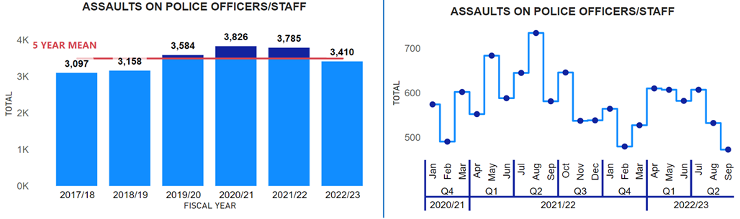
Assaults against officers/staff have continued to decrease in Quarter 2 for the second consecutive year, to the lowest level since 2018/19. Assaults against officers /staff in 2022/23 have fallen by 9.9% (375 fewer) from the previous year. Assaults against officers / staff have now decreased from the five year mean by 2.3% (80 fewer).
The injury rate of assaults this year (28.6%) has decreased compared to the previous year (38.0%, down 3.9 percentage points) and the three year mean (40.1%, down 10.4 percentage points). Therefore, not only are the number of assaults falling compared to the previous year and the 5 year mean, but the percentage that are resulting in an injury are also decreasing.
Police Scotland through Your Safety Matters conducted analysis examining the effectiveness of Police Scotland’s OST two day training course in preventing injury from assaults. The analysis found that the effectiveness of the training decreased as time went on. The OST two-day training course was most effective in reducing injuries within the first 30 days of the training being completed (40% less likely to be injured from an assault compared to someone who has not received the training). However, when an officer / staff was assaulted a year after completing the training, the estimated effectiveness of the training decreased to 7% (less likely to be injured compared to someone who has not received the training). Therefore, the OST two day training course is seen a contributory factor in the decrease in the injury rate.
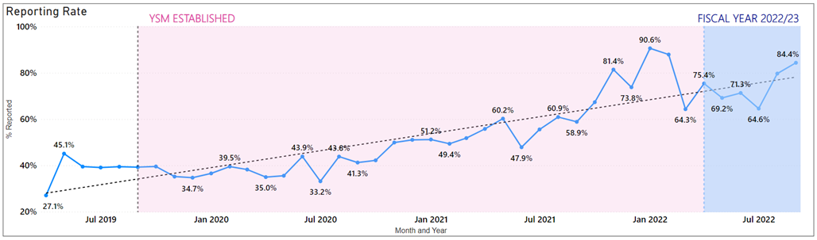
Police Scotland has maintained a high reporting rate in both Health and Safety and crimes of assault on officers / staff in 2022/23, with no month dropping below a 60% reporting rate. The improvement in the reporting can be seen from the previous graph, as before YSM was established, the highest reporting rate of assaults was below 50% (May 2019, 45.1%).
YSM is committed to maintaining a high reporting rate as this provides an enriched dataset for Police Scotland to analyse, which has enabled YSM to better understand assaults on officers / staff. YSM is also committed to expediting support given to officers/staff who have experienced hate crime. Work is currently underway to engage with staff associations to encourage reporting of hate crime by officers/staff and ensure they get the support that is required.

People and Development

Equality, Diversity and Inclusion
Our ambition is to have a workforce that fully reflects and represents our communities, from whose consent we draw our legitimacy. We aim to provide a workplace that is welcoming and inclusive to all and which supports our people to thrive, flourish and be truly themselves. During the summer of 2022 Police Scotland launched a new officer recruitment campaign with these messages at its heart and it is pleasing that it has generated a significantly higher level of interest in candidates applying to our Service from across our communities.
So far this financial year, 600 new Police Officer recruits have been appointed to Police Scotland.
Comprising 361 males and 239 females, proportionally representing 60% male and 40% female; with this intake we continue to drive an upward trend in the number of women recruited into Police Scotland and recognise the impact that this is having to balance the gender profile of our officers. Over the past five years Police Scotland has increased the proportion of female recruits by 13% points, as can be seen in the following graph. Women now represent a third of our police officer workforce.
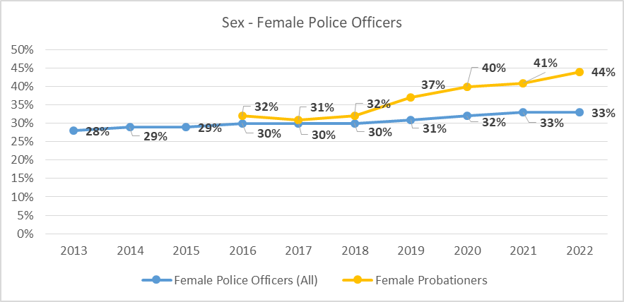
8% of our intakes so far this financial year have been from minority ethnic backgrounds, which continues to strengthen the number of officers from under-represented groups in line with our ambition. With the exception of 2020 during COVID-19, during which time PAT activity was restricted, the following graph illustrates steady progress over the past five years of the increasing proportion of probationer constables recruited from minority ethnic groups. This demonstrates the value that the PAT team bring to our ability to attract people form our harder to reach communities.
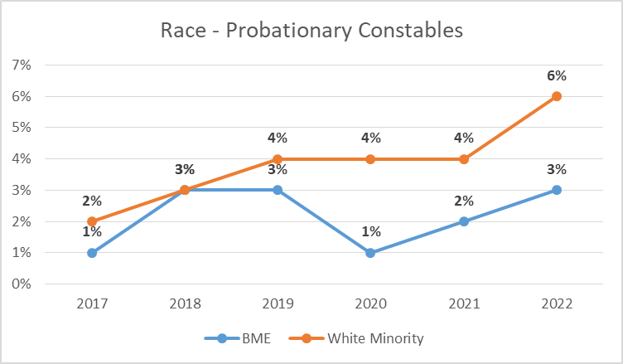

Positive Action
Considerable work continues to ensure Police Scotland attracts and recruits the very best talent from across all of our communities. One element of recent focus has been to ensure that our recruitment process is inclusive and mitigates against barriers to potential recruits from under-represented communities. Following Scottish Government approval, an 18-month pilot continues on a new police officer Standard Entrance Test (SET) designed to minimise unconscious bias and to ensure inclusivity of language for all our communities.
This follows an analysis of SET performance across 2018/19 which showed a variance in the pass rate for White Scottish candidates compared to BME candidates. We also recently commissioned independent research, which is ongoing, to identify barriers to recruitment and retention faced by under-represented groups from which we will take learning and improvement activity from where identified.
The Recruitment, Selection and Promotion department’s Positive Action Team continue to work diligently to reach out to all our communities from under-represented groups across the country. During Quarter 2 2022/23 alone, just under 100 people attended 5 online BME/WME events and over 80 people attended online events for women. Other successful events were held for people identifying as LGB, for our European communities and for our Armed Forces personnel.
Whilst it is acknowledged that our journey continues to achieve the ambition of a balanced workforce, more representative of the communities we serve, our workforce profile is changing steadily as a direct consequence of the proactive drive of our Positive Action Team to attract diverse talent and our Recruitment, Selection and Promotion Team to ensure transparent and inclusive selection and promotion processes.

Police Officer Profile
In terms of our officer workforce profile, the following trends are evident.
Whilst statistically the proportion of those identifying as BME remains static at 1%, and 2% for those identifying as White Minority, the following table shows that numerically our officer numbers in these under-represented groups continues to increase year-on-year.
It is notable that the percentage of officers and staff who chose not to disclose information through our equality and diversity monitoring process has been gradually falling since 2017.
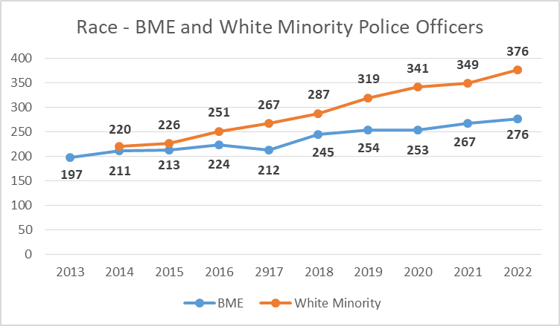
The number of police officers identifying as LGB has increased by 39 in the year to 31 March 2022, from 644 to 683. Our data shows that there has been a slow and steady increase in the proportion of officers identifying as LGB since reporting began is 2013. Our insights show a higher proportion of female to male officers who identify as LGB; further that those identifying as LGB are younger in age and shorter in service. The following graph shows the proportion of police officers overall and probationary constables who identify as LGB.
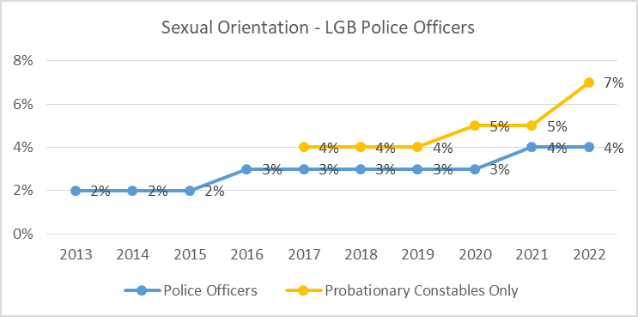
With regard to disability, the following graph shows that the number of police officers with a recorded disability. Proportionally, this remains at 3%, which has been the trend since 2017.
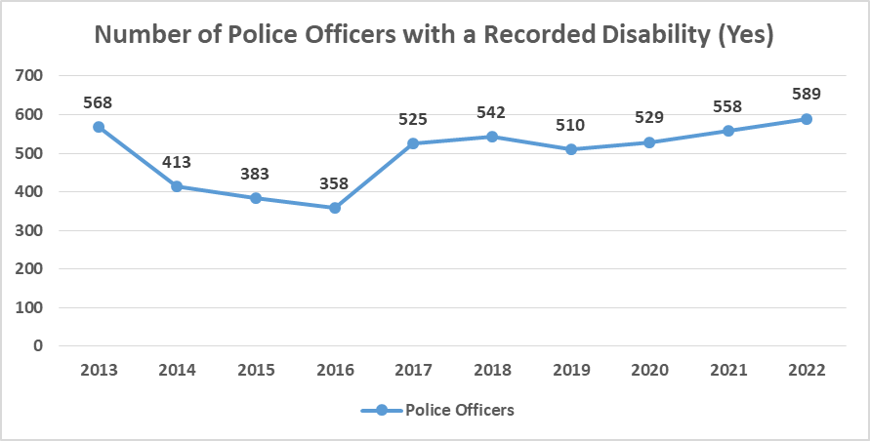
The ‘normal’ profile of an officer recording a disability is at 11-15 years’ service and within the age bracket 45-54 with no difference in gender. Clearly this means older officers with significant experience are within this demographic. Within Police Scotland, it is important to retain knowledge and experience by providing appropriate and proportionate duty modifications to ensure meaningful employment within policing. Work to enhance our capability to support and offer our officers such reasonable adjustments continues, however, where this is not possible we to strive to ensure that that our ill-health retirement processes are compassionate and efficient.

Police Officer Promotions
Around a third of our promoted officers are female which is reflective of the overall proportion of female officers, and there is no statistically significant differentiation between sexes in terms of length of service before promotion which currently stands at an average of 14 years. The following graph is helpful in showing the journey made since reporting commenced in terms of increasing the proportion of females in promoted posts to a level more aligned to the overall proportion of female officers in the organisation.
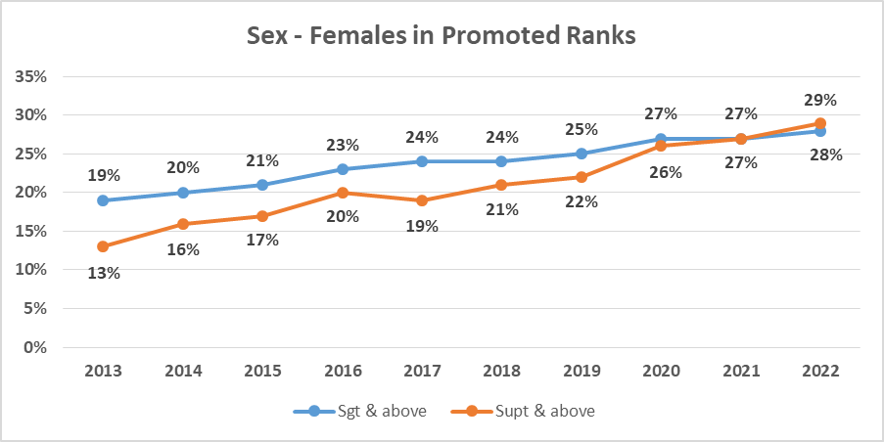
Similarly, the race profile of promoted officers remains broadly in proportion with the percentage of each ethnic origin across all officer ranks, although we are determined to continue substantial efforts to increase this figure.
The profile of those promoted officers with a recorded disability continues to reflect the Police Scotland profile of 3%.
Lastly, of those officers identifying as LGB, 3% are in promoted ranks, and again is reflective of the Police Scotland profile of 3%. Given that our officers who identify as LGB are younger in age and shorter in service we anticipate that as their length of service increases we will begin to see a proportionate increase in the ranks of Sergeant and above.

Police Officer Leavers
Since the success of Police Scotland is reliant on the dedication, commitment and professionalism of our workforce it is important that we understand and learn from any information that those leaving our organisation can offer us. In the spring of 2022 the organisation’s exit survey and process was refreshed. The number of surveys undertaken is as yet too low to provide us with meaningful trends and insight, however it is anticipated that over the course of the forthcoming 12 months we will be able to glean valuable insight into some of the following observations.
Existing protected characteristics data tells is that the proportion of female officers leaving the organisation is lower than the Police Scotland profile of 33% at 31 March 2022. There has been a similar trend since 2013-2014. However, whilst the majority of all officers continue to leave due to retiral, data shows us that 27% of female leavers resigned compared to 16% of male leavers. The following graph demonstrated that whilst the disparity exists, it is closing.
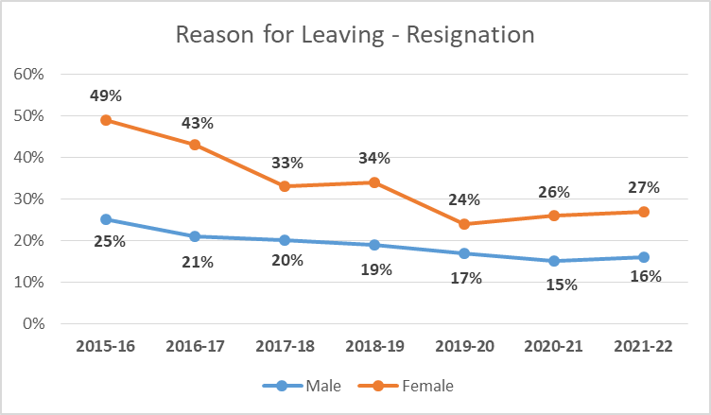
Age, race and sexual orientation data shows no unexplained trends:
Resignation is most common in our younger age groups and retirement most common within older age groups.
The race and sexual orientation profile of our leavers is broadly reflective of the overall Force profiles for those protected characteristics.
In terms of the disability profile for police officer leavers between 2021 and 2022, the higher proportion of leavers with a Recorded Disability is likely to be linked to the most common age group of leavers who are in the 45-54 age group and who retire. The most common age group in the Workforce Profile for those with a Recorded Disability is 45-54.
Finally in terms of our leavers, retiral was the most common reason across all of the religion or belief categories, with the exception of ‘All Other Religions’ and ‘Not Recorded’ where resignation was the most common reason.
Note: ‘The Scottish Equality and Human Rights Commission produce guidance for the public sector in Scotland to support them in fulfilling their equality duties. Within this guidance the Commission direct the public sector in Scotland to use the same terminology for categories as used in the Scottish Census. This provides a consistent approach across Scotland for the public sector. The Scottish Census uses the terms Black Minority Ethnic (BME) and White Minority Ethnic (WME) which is therefore the terminology used by Police Scotland. England and Wales have their own respective Equality and Human Rights Commission and Census and so the terminology used in England and Wales can differ from that in Scotland including the use of BAME where Scotland uses BME.

BME - Mixed or Multiple Ethnic Group, Asian Pakistani, Asian Indian, Asian Bangladeshi, Asian Chinese, Asian Other, African, African Other, Caribbean, Black, Caribbean or Black Other, Arab and Other Ethnic Group.
White Minority - White Irish, White Gypsy/Traveller, White Polish and White Other.
The graphs used within the report are linked to the equality & diversity employment monitoring for the protected characteristics outlined within the Equality Act 2010. The categories used for Sexual Orientation employment monitoring (as noted on the approved Police Scotland E&D Monitoring Form) are as follows:
Bisexual
Gay/Lesbian
Heterosexual
Other
Choose not to Disclose

Absence
Absence data below shows an increase for both officers and staff against the same period last year. However, due to changes in recording conventions and reporting methodology at the beginning of this financial year, the value in comparisons against previous year’s data is limited.
Absence Management | 2021/22 YTD | 2022/23 YTD | Change from Previous Year
Percentage of working days lost for police officers | 6.8% | 7.3% | +0.5% point
Percentage of working days lost for police staff | 7.3% | 7.3% | No change
Average working days lost for police officers (Annualised)* | 14.2 | 15.3 | +0.9
Average working days lost for police staff (Annualised)* | 17.8 | 17.8 | No change
Percentage of work days lost due to Psychological Disorders for police officers | 1.3% | 1.7% | +0.4% point
Percentage of work days lost due to Psychological Disorders for police staff | 1.8% | 1.7% | -0.1% point
Percentage of work days lost due to COVID Related respiratory conditions for police officers | 2.1% | 1.6% | -0.5% point
Percentage of work days lost due to Non-COVID Related respiratory conditions for police officers | 0.3% | 0.5% | +0.2% point
Percentage of work days lost due to COVID Related respiratory conditions for police staff | 1.7% | 1.6% | -0.1% point
Percentage of work days lost due to Non-COVID related respiratory conditions for police staff | 0.4% | 0.6% | +0.2% point
Absence data this quarter highlights that for police officers, the percentage of working days lost has increased against the same period last year by 0.5% to 7.3% and for police staff this percentage has remained the same at 7.3%.
COVID-related absence has reduced for both officers and staff from the same period last year, 0.5% and 0.1% respectively. It can also be noted that COVID-related absence has dropped by 0.4% to 1.6% this quarter in comparison to the position at end of Quarter 1 2022/2023 for both officers and staff.
In terms of non-COVID-19 related absence, ‘Psychological Disorders’ remains the highest cause of sickness absence across both groups this quarter at 1.7%.
Police Scotland’s research into long term absence due to psychological issues is ongoing, with a 9-year data set now being considered. People, Health and Wellbeing plan to present a paper, providing an overview of the research findings, at the February 2023 SPA People Committee.
The priorities emerging from the health and wellbeing team’s organisation-wide evaluation and review very much consider the significant moments our people experience such as absence and our approach to support our people. The review, which aimed to understand the current health and wellbeing (HWB) needs of officers and staffs, has identified priority areas that provide us with a strategic focus and act as the foundation of a health and wellbeing framework, more info on the priority areas is provided as follows:
Bringing the health & wellbeing of our people to the top of the organisations agenda.
Developing a coordinated national approach to health and wellbeing, which is robust and driven by investment.
Proactively engaging with our people in an ongoing health and wellbeing conversation through listening and understanding their needs.
Recognising the significant pressures on our people and develop the support of our people enabling them to achieve a better work / life balance.
Adopting a person-centred approach to all support pathways and programmes i.e. our employee assistance and occupational health programmes, our trauma risk-assessment process and our Wellbeing Champions.
Making prevention a primary focus.
Reducing the stigma which still exists around health and wellbeing, particularly mental health and the seeking of support.
Development and training of all officers and staff, with a specific focus on those in line management and senior ranks.
Recognising the importance and role of peer support amongst our people.
The health and wellbeing team are currently working on the roll-out and implementation of the health and wellbeing action plan and evaluation structures.
The Health and Wellbeing advisory group, which will sit under the Wellbeing Governance Board, has its membership now in place. An inaugural meeting took place on October 2022. The main business of the group will be to drive delivery against the priority areas, considering and developing solutions.
Its purpose is to ensure that our workforce feels supported, engaged and valued and has access to appropriate health and wellbeing services. Nominations have been received from all local policing divisions, specialist divisions and corporate functions including SPA / Forensics. The group will also have representation from across our range of our staff associations.

Change Project

Mobile Working (delivered/closed)
Within the Digitally Enabled Policing (DEP) Programme, the Mobile Working (MW) Phase 1 Project rollout is now complete and moving towards closure.
The MW Phase 2 Project has been extended, via a Change Board approved Change Request (CR), to end-December 2022.

P&D: My Career
MyCareer is being delivered under the Leadership Project, within the P&D Programme, and is an integrated system on SCoPE to replace the Performance Development Conversation (PDC).

Leadership
Also under the P&D Programme, The Leadership Project will introduce:
MyCareer.
A new qualification to replace the Diploma in Police Service Leadership and Management (DPSLM).
Leadership Pathways/Accelerated Leadership Pathways to replace the current promotion process.
Competency Values Framework (CVF), a nationally recognised behaviours and values framework.

Strategic Outcome 5
Police Scotland is sustainable, adaptable and prepared for future challenges.
Objectives:
Use innovative approaches to accelerate our capacity and capability for effective service delivery
Commit to making a positive impact through outstanding environmental sustainability
Support operational policing through the appropriate digital tools and delivery of best value

Finance

Maintaining a Balance Budget
The Corporate Finance and People Board monitor financial performance on a monthly basis and the overall financial position is regularly reported to the Scottish Police Authority (SPA) and Scottish Government.
There is also frequent engagement throughout the year to ensure that the accountable officer is aware of the overall financial position and seek their views on how any emerging issues should be dealt with.
The approved budget is reforecast on a quarterly basis to ensure the financial position continues to reflect what is actually happening across the organisation to enable better informed decisions.
The Board approved the 2022/23 budget on 23 March 2022. Despite setting a balanced budget, there are a number of significant challenges facing Police Scotland, including:
Officer and staff pay claims were not affordable within the original budget envelope – pay award has now been agreed at 5% with additional funding underwritten by SG.
Current levels of inflation cannot be managed within the current budget allocation. Although some provision has been included in the 2022/23 revenue budget, inflation is running significantly higher than anticipated. The most significant revenue impact is in utilities, fuel and supplies & services.
Officer attrition is significantly higher in 2022/23 due to changes in the Police pension regulations. As well as the operational consequences, this has significant financial implications for the organisation that will require careful management throughout the year.
Capital and reform funding allocations have been proposed as flat cash for 2022/23. When combined with capital receipts, the capital allocation for 2022/23 is £52.6m and reform is £25m.
Challenges faced in securing certain goods and services due to global supply-chain shortages will impact the speed of delivering planned investment. Similar to revenue, given the current impact of inflation, a flat cash settlement for capital and reform represents a real terms reduction in funding which will now pay for significantly less than the previous year.

2022/23 Quarter 2 Forecast
The Quarter 2 forecast break even position for revenue remains in line with budget.
The net expenditure forecast is £1.9m under revised budget due mainly to an over-recovery of airport income (£2.8m) offset by other funded pressures (£0.9m), both of which are compensated by a corresponding movement in GiA funding to be agreed through Autumn Budget Revision (ABR) and Spring Budget Revision (SBR) transfers.
There are also a number of significant offsetting variances that form part of the Quarter 2 forecast, with £28.9m of cost pressures funded by equivalent underspends of £28.9m. The main variances are an underspend in police officer pay costs as a result of recent pension changes and an over-recovery of airport income, offset by an increase in police officer overtime costs to support officer strength, unbudgeted legal costs and ongoing inflationary pressures.
A number of threats and opportunities are being monitored, some of which may crystallise in the Quarter 3 forecast.
The estimated operational costs associated with the passing of Her Majesty the Queen are being considered separately and it is assumed that these additional costs will be funded in full.
The Quarter 2 reform forecast is £22.2m, £2.8m under the approved budget. This £2.8m will be re-directed to support capital expenditure investment.
The Quarter 2 capital forecast is £61.4m, £3.6m above the revised budget position of £57.8m, mainly due to additional fleet investment to purchase cell vans (£2.8m) and other items (£0.8m).

Maintaining Financial Sustainability
Financial sustainability has been the primary objective of the medium/long term financial strategies developed since 2016, all of which highlighted the significant funding challenges facing the service.
Additional recurring funding was provided to policing in Financial Year 2021/22 which allowed the service to set a balanced budget without the requirement for any workforce reductions. The balanced budget along with the commitment to real terms protection formed the basis of the five year financial plan that was approved by the Authority in September 2021.
The Scottish Government’s Resource Spending Review (RSR) published in May 2022 and the Capital Spending Review (CSR) published in January 2021 and updated in May 2022 provides a comprehensive picture of the likely funding available to policing over a five year period.
The RSR indicated that the Authority should plan for a flat cash funding settlement up until Financial Year 2026/27. This essentially removes the “real terms protection” commitment that has been the key underlying financial planning assumption for all our recent short, medium and longer term financial planning. The CSR also indicated a flat cash capital settlement over the next five years, representing a £200m shortfall in our overall capital requirements.
The introduction of flat cash, particularly in a high inflation environment, represents a significant real-terms reduction in funding. Police Scotland will continue to seek ongoing savings and efficiencies, however, efficiency alone is not sufficient to deliver the significant savings required to manage a flat cash funding position. Managing a flat cash position will have considerable operational implications and would require a major strategic shift in what and how Police Scotland provides and delivers policing services to Scotland.
The immediate focus is on developing the annual budget for Financial Year 2023/24 and updating the medium term financial plan in line with the strategic direction following the publication of the RSR and CSR, adjusted for notification of our actual funding allocation for 2023/24 which is expected December 2022.
Although there is great value in longer term financial planning, it is very difficult in the current economic and political environment, both of which would need to stabilise to allow reasonable financial planning assumptions to be developed to inform longer term financial planning.

Procurement
Compliance | 2022/23 Q1 YTD
% of regulated spend undertaken compliantly in line with purchasing policy | 94.5%
Police Scotland report retrospectively on spend compliance as a result of the data requiring to be analysed after the end of each quarter. The figure provided is an analysis of Quarter 1 2022/23. The compliance rate is unchanged from what was recorded in the previous quarter. Data for Quarter 2 2022/23 will be available in the 2022/23 Quarter 3 report.

Fleet
Fleet | 2022/23 YTD
% of Ultra-Low Emission Vehicles (ULEV) in our fleet | 21%
Average age of fleet | 4.62 years
Average % of vehicle availability | 96.88%
Police Scotland is working towards implementing the move to an Ultra-Low Emission Fleet as part of the Scottish Police Authority (SPA) approved Fleet Strategy. Work is ongoing with the Ultra-Low Emission Vehicle (ULEV) Board and the Fleet Implementation Group and key stakeholders. These include internal stakeholders and external agencies such as Transport Scotland, Scottish Fire and Rescue Service, Scottish Ambulance Service and city councils where sharing of resources is possible.
Our fleet is the first blue light fleet in the UK to make that commitment of greening the entire fleet of approximately 3,500 vehicles. The approved Fleet Strategy is to move to fully ULEV by 2030 in line with Scottish Government recommendations.
ULEV vehicles currently make up 21.0% of Police Scotland’s overall fleet at the end of Quarter 2 2022/23 (up 3.0 percentage points from the previous quarter). 31% of the ULEV vehicles are unmarked.
Work is ongoing with the roll-out of a Police Scotland dedicated charging infrastructure across our estate with a number of large sites completed. This will continue across Scotland from the central belt up to the Highlands and Islands as we move into phase two and three.
Police Scotland has currently ULEV vehicles in stock and on order and are allocated as charging sites are completed. Training is complete for all fleet staff on ULEV vehicle maintenance and repair.
Fleet is continuing to work with Health and Safety, Scottish Police Federation, Driver Training and other key stakeholders to have right vehicle, right place, right time.
The average age of the Police Scotland fleet in Quarter 2 2022/23 is 4.62 years (down 0.18 years from the figure reported last quarter). This will reduce further as new vehicles are introduced to the fleet and if the level of capital investment on the fleet is maintained in future years.
The average percentage of vehicle availability was 96.88% in Quarter 2 2022/23, this is up 0.74 percentage points from the average percentage available in Quarter 1.
Fleet is currently reviewing its Target Operating Model as we move to ULEV as there is a different skill required in ULEV vehicles. As the vehicle becomes the office and technology increases, and with less moving parts in a ULEV more mobile servicing will be the future.
This will ensure our vehicles are replaced in line with the Police Scotland Fleet Strategy to have a fit for purpose modern fleet.

Estates Co-locations / Collaborations
Shared Occupancy | 2022/23 YTD
% footprint of the Estate which is co-located/shared with our partners | 21%
As per recent discussions with DCO Corporate Services, People & Strategy, we are now reflecting our co-locations based on the number of sites, as being a more representative metric. Our current number of co-locations with our public sector partners has just increased to 65 with the recent addition of Maybole co-locating with South Ayrshire Council from 12 October 2022. This therefore represents 21% of our Estate based on number of sites.

Environmental - Total carbon emissions per m2 of estates
Buildings 2022/23 Quarter 1 Data | Total | Cost
Buildings – Gas | 14,801,997 kWh | £1,289,145
Buildings - Electricity | 12,373,397 kWh | £2,385,552
Buildings – Water | 104,877 m3 | £435,176
Buildings – Fuels | 541,400 kWh | £50,739
Buildings – Total CO2e | 8,271 tCO2e | £3,556,913

Fleet 2022/23 Quarter 1 Data | Total | Cost
Fleet – Diesel | 1,068,389 litres | £1,662,349
Fleet – Petrol | 177,097 litres | £254,866
Fleet – Total CO2e | 3,117 tCO2e | n/a

Emissions per m2 | Buildings | Total
Emissions as at July 2022 | 19.4 kg/m2 | 26.7 kg/m2

Environmental – Reduction in Co2 emissions
Our consumption of gas and electricity has reduced in comparison to the same quarter last year. However our costs have increased substantially.
At the end of the 2022/23 Quarter 1 period, Police Scotland’s gas and electricity consumption had decreased by 25.6% and 2.9% respectively compared to the same period in 2021/22.
Despite the significant reduction in our gas consumption, costs have increased by 54.4% (circa £700,500) compared to the same period last year. Likewise, our electricity costs have increased by 10.4% (circa £248,000) despite the decrease in consumption.

Change Projects

Purchase to Pay (P2P)
The Procure to Pay (P2P) Project has delivered Procure to Pay in all Divisions / Areas within Police Scotland and has been handed over to Business as Usual with an End Project Report in progress.

Middle Office, Custody and Productions Remodelling
The Criminal Justice Services Division (CJSD) Programme encompasses the Middle Office Remodelling Project, the Custody Remodelling Project and the Productions Remodelling Project.
MOR: A Project to accommodate the forthcoming changes from CRASH, Direct Measures, Records Management, Warrants and Case. Pen-tip is now live in the West, Case Assessment unit resource remains unresolved with a decision likely in the near future to allow Case to progress and COPFS Cohort group set up to support improved reporting.
Custody: A Project to redesign and deliver a sustainable model for custody which is resilient and future-proof. Project is paused pending direction on next steps.
Productions: A Project to develop a single consistent process of National Productions Management. Phase 2 prioritisation now complete, with a plan in place.

Transforming Corporate Support Services (TCSS)
The TCSS Programme’s Electronic Document Records Management System (EDRMS) Project and E-Recruitment Project are both in closure with Evidence and Procedural Reviews (EPRs) approved at Change Board in October 2022.

Resource Deployment Unit (RDU)
The Resource Deployment Unit Redesign (RDU) Project is in initiation with work ongoing on the Initial Business Case (IBC).

Crime Management System (CMS)
Within the Technical Surveillance Programme (TSP), the Case Management System (CMS) Project is progressing, with a Procurement transaction process defined to procure additional licenses and associated development and configuration.

Analysis and Demand Transformation (ADT)
ADT is currently on hold.

Digitally Enabled Policing Programme (DEPP)
The DEPP Programme encompasses Core Operational Solutions (COS), Mobile Working (MW) and Body-Worn Video (BWV).
COS: A group of Projects make up the COS Project / Sub-Programme:
Insight – Delivery plan to be rebaselined;
Data Migration – in full delivery the next key implementation is Forth Valley Division Go-live scheduled for November 2022;
Case and Direct Measures – delivery plan to be rebaselined;
Productions – in full delivery with Forth Valley and Fife Divisions scheduled Go-live November 2022 – January 2023; and
Crime and Warrants - delivery plan to be rebaselined
The Project aims to deliver a national integrated and modular Core Operational Solution to replace the disparate information management legacy systems utilised by Police Scotland.
MW / BWV: refer to previous information.

Emergency Services Mobile Communications Programme (ESMCP)
The ESMCP Programme is a Home Office Programme to deliver the next generation of mission-critical communications, the Emergency Services Network (ESN) to replace the Airwave Communications Network used by the three emergency services.
The Police Scotland ESMCP Project is currently under review.

Natnet (delivered/closed)
This project was delivered last year and will be removed from future reports.
The National Network (NatNet) Project delivered a Home Office compliant Wide Area Network (WAN) across 350 sites and transformed Police Scotland communication and service to the public by increasing network capacity, capability, performance and stability. An Evidence and Procedural Review (EPR) was approved at Change Board in February 2021.

MS Teams and 365
Under the Digital Division Programme, the MS Teams Project has now closed with an Evidence and Procedural Review (EPR) approved at Change Board in August 2022. Within the same Programme, the Office 365 Project Full Business Case (FBC) is progressing and due to be presented to Change Board in the coming month.

