 | Freedom of Information Response  Our reference: FOI 25-1589  Responded to: 7th October 2025
Your recent request for information is replicated below, together with our response.
I am looking to find out statistics for all road traffic incidents for the Blair Drummond area. See the attached map showing the area of interest in the red rectangle.
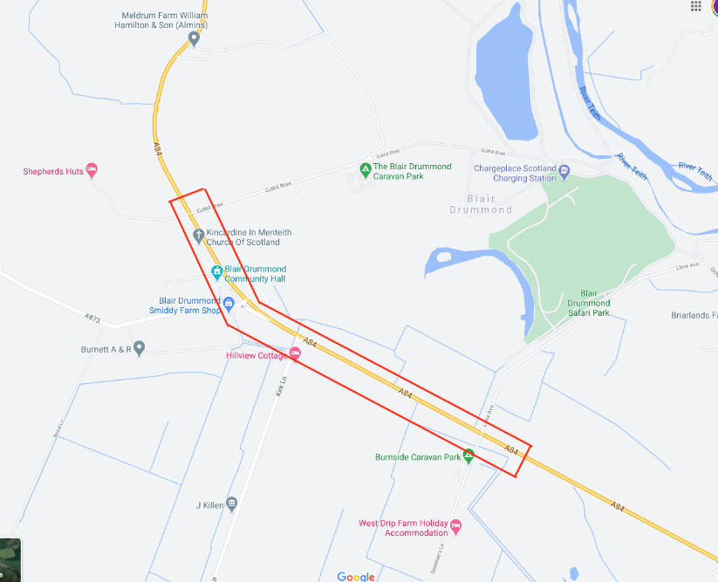

The table below details recorded Road Traffic Collisions in the Blair Drummond area (mapped section on A84) broken down by severity, from 1st January 2010 to 31st August 2025, inclusive.
Collisions | 2010 | 2011 | 2012 | 2013 | 2014 | 2016 | 2019 | 2020 | 2023 | 2024
Serious | 1 | 1 | 0 | 2 | 1 | 0 | 2 | 1 | 1 | 0
Slight | 2 | 3 | 2 | 3 | 4 | 1 | 3 | 0 | 1 | 1
Total | 3 | 4 | 2 | 5 | 5 | 1 | 5 | 1 | 2 | 1
All statistics are provisional and should be treated as management information.
Data was extracted from Police Scotland systems and are correct as of 24/09/2025.
Data excludes non-injury collisions as per standard operating procedure.
Areas selected using the Ordnance Survey National Geographic Database.
A 30-metre buffer was placed on the selected area(s) to return relevant records.
Following implementation within D Division on 12 June 2019, CRaSH was implemented across all other Divisions on 3 July 2019, replacing the existing RTC recording procedures.
The data is subject to change and will be updated on the next extract of data from CRaSH on 3rd October 2025.
The table below details the associated casualties:
Casualties | 2010 | 2011 | 2012 | 2013 | 2014 | 2016 | 2019 | 2020 | 2023 | 2024
Serious | 2 | 1 | 0 | 2 | 1 | 0 | 3 | 1 | 1 | 0
Slight | 4 | 3 | 3 | 6 | 6 | 2 | 6 | 0 | 1 | 1
Total | 6 | 4 | 3 | 8 | 7 | 2 | 9 | 1 | 2 | 1

Please could you provide a list with the time and location of any road traffic incidents logged by police Scotland from 1st January 2010 that relate to the section of the A84 between the safari park entrance (Lime avenue Sommers Lane to Cuthill Brae).
The table below details the recorded date, time and location (Eastings and Northings) of each Road Traffic Collision.
Date | Time | Eastings | Northings
08/01/2010 | 05:58 | 272150 | 698570
08/01/2010 | 08:00 | 272080 | 698630
16/04/2010 | 11:54 | 272100 | 698620
03/04/2011 | 15:10 | 272340 | 698430
09/07/2011 | 17:40 | 273130 | 697980
15/07/2011 | 16:08 | 273040 | 698030
23/07/2011 | 18:20 | 271860 | 699030
26/01/2012 | 18:45 | 272122 | 698602
07/11/2012 | 18:20 | 272345 | 698438
06/04/2013 | 10:10 | 273125 | 697992
16/05/2013 | 11:50 | 272650 | 698265
02/08/2013 | 14:00 | 271880 | 698996
07/08/2013 | 10:00 | 272339 | 698442
14/09/2013 | 11:40 | 273125 | 697992
23/03/2014 | 11:00 | 271893 | 698970
05/04/2014 | 15:55 | 271963 | 698835
20/06/2014 | 09:25 | 273129 | 697990
23/08/2014 | 13:35 | 273130 | 697990
02/09/2014 | 09:20 | 271961 | 698839
22/03/2016 | 12:16 | 272339 | 698442
17/01/2019 | 15:45 | 272338 | 698436
26/03/2019 | 14:50 | 272118 | 698612
30/03/2019 | 14:00 | 272742 | 698212
30/05/2019 | 14:15 | 271968 | 698836
27/07/2019 | 11:30 | 272337 | 698440
01/07/2020 | 07:50 | 271885 | 698991
13/01/2023 | 00:15 | 272338 | 698452
02/09/2023 | 16:20 | 272333 | 698432
27/12/2024 | 14:20 | 272120 | 698609

If you require any further assistance, please contact us quoting the reference above.
You can request a review of this response within the next 40 working days by email or by letter (Information Management - FOI, Police Scotland, Clyde Gateway, 2 French Street, Dalmarnock, G40 4EH). Requests must include the reason for your dissatisfaction.
If you remain dissatisfied following our review response, you can appeal to the Office of the Scottish Information Commissioner (OSIC) within 6 months - online, by email or by letter (OSIC, Kinburn Castle, Doubledykes Road, St Andrews, KY16 9DS).
Following an OSIC appeal, you can appeal to the Court of Session on a point of law only.
This response will be added to our Disclosure Log in seven days' time.
Every effort has been taken to ensure our response is as accessible as possible.
If you require this response to be provided in an alternative format, please let us know.

