Police Scotland and Scottish Police Authority

Joint Equality Outcomes

for Policing 2025
Contents
Chief Constable and Scottish Police Authority Chair Foreword 4
Introduction 5
Our Responsibility as a Public Body 5
Shaping our Equality Outcomes 5
Delivery and Measuring Progress 6
Performance and Accountability 7
Joint Equality Outcomes 2025 8
Equality Outcome 1 9
Equality Outcome 2 10
Equality Outcome 3 11
Equality Outcome 4 12
Equality Outcome 5 13
Equality Outcome 6 14
Equality Outcome 7 15
Appendix A – Strategic Alignment 16
Appendix B - Evidence Sources 17
Engaging with us 19
We want to hear from you 19
Public engagement and insight 19
Social media 19
Inclusive and accessible engagement 20
Contact us 20

Chief Constable and Scottish Police Authority Chair Foreword
The relationship we have with the public we serve, our fellow citizens, is the foundation of police legitimacy and vital to our ability to keep people safe.
The onus is on policing to continue to earn and maintain the trust, support and co-operation of all communities. It is our moral duty. It is an operational necessity.
Policing can, and must, continue to improve to ensure that it is delivering a service which fully represents and reflects all the communities it serves. Everyone should feel able to speak to the police, to report a crime or to share information.
We want people from all backgrounds to see policing as a potential career in which they can thrive and flourish and know they are valued for themselves.
Over the years difficult messages have been received, whether from listening to our own colleagues, or through independent reviews and reports and court and conduct cases. It has been clear that policing has not always provided a service which represents and reflects all the diverse communities of Scotland.
With important progress already made, and more work underway, there is a continued determination to listen to these messages and take action to drive sustainable and meaningful change to ensure that our mission to keep people safe applies to everyone.
Police Scotland and the Scottish Police Authority’s Equality Outcomes for 2025- 2029 will provide a refreshed focus to help us improve equality within the workplace for our officers and staff, as well as in the communities we serve.
The outcomes are published as part of our duty under the Equality Act 2010, and in support of the Police Scotland Vision 2030, and the SPA’s Corporate and Forensic Services Strategies.
During the development of these outcomes, we have to listened and engaged with a wide range of external stakeholders, including an online survey open to the public, as well as our diversity staff associations, unions and statutory associations.
This insight has helped us to incorporate the views and experiences of our workforce and the public, ensuring policing is focusing on the issues which matter most.
Our commitment to equality and diversity lies at the heart of the public service policing provides and success will be measured by the improved experiences of our officers and staff, and of all the communities, all our fellow citizens, who we serve.

Introduction

Our Responsibility as a Public Body
As public bodies, Police Scotland and the Scottish Police Authority (the Authority) have a duty to ensure that we pay due regard, in line with the Equality Act 2010, to the need to:
- Eliminate discrimination, harassment, victimisation and any other conduct that is prohibited by or under the Act;
- Advance equality of opportunity between people who share a relevant protected characteristic and persons who do not share it; and
- Foster good relations between persons who share a relevant protected characteristic and persons who do not share it.
To help us meet the general equality duty, there is also a specific duty to publish a set of Equality Outcomes at least every four years and report progress at least every two years.
An equality outcome is a result that a public authority aims to achieve to further one or more of the needs mentioned in the general equality duty.
This document contains policing equality outcomes for 2025-2029, covering Police Scotland, and both the corporate and forensic services functions of the Authority.

Shaping our Equality Outcomes
To develop our Joint Equality Outcomes for Policing for 2025 – 2029 progress towards our 2021 outcomes has been considered, to understand what has been delivered and where further work is required. Extensive internal and external engagement has been carried out to capture the views and experiences of our workforce and our communities. This has included internal engagement sessions with key stakeholders and executive and senior leaders and engagement with our statutory staff associations, diversity staff associations, and trade unions. We have listened to the voices of communities via our User Experience Survey, Your Police Survey, and the Authority’s public polling. Our partners have been engaged through the Scottish Government Strategic Partnership Forum. In addition, a range of evidence sources have been used to inform our outcomes such as our workforce survey, equality and diversity workforce monitoring data, external audit and review reports and recommendations and our evidence supporting the development of recent strategies such as the Violence against Women and Girls Strategy and People Strategy.
Further details on the engagement and evidence sources that have shaped our Equality Outcomes are included in Appendix B.

Delivery and Measuring Progress
Police Scotland’s Policing Together Strategy and its accompanying Implementation Plan is the most prominent mechanism for delivering the Equality Outcomes within Police Scotland and is how the effectiveness of delivery will be measured and reported on. In addition, the Hate Crime Strategy for Scotland, Corporate Communications Accessibility Strategy, the Public Contact and Engagement Strategy and the Violence against Women and Girls’ Strategy will support delivery of the service delivery outcomes. The People Strategy and People Plans across Police Scotland will incorporate and support delivery of our Equality Outcomes relating to employment at both national and local level. For the Authority, the Corporate Strategy and Annual Delivery Plan, and Forensic Strategy and Business Plan, perform this function.
Within this document we have set out our Equality Outcomes and the underpinning objectives which support delivery of these outcomes.
Police Scotland report progress through existing performance reporting structures on a quarterly and annual basis. A Police Scotland Policing Together Performance Report is scrutinised internally and presented to the Policing Together Oversight Group and the People Committee of the Authority on a six-monthly basis. This report details progress towards the Equality Outcomes and its format is consistent with the two-yearly Mainstreaming and Equality Outcomes Progress Report.
Reports relating to the Authority’s Corporate and Forensics performance and strategic plans are presented quarterly to Audit, Risk and Assurance Committee and Forensic Services Committee respectively. These reports include activities and measures that relate to the Equality Outcomes.
A full update on the progress towards delivery of the Joint Equality Outcomes 2025 - 2029 and wider mainstreaming activity will be published in our next joint Mainstreaming and Equality Outcomes Progress Report in 2027.

Performance and Accountability
The Police Scotland Performance and Accountability Framework (PAF) is currently being refreshed and due to go live on 01 April 2025. The PAF will build upon the established Key Performance Indicators (KPIs) and Management Information (MI) to measure performance, progress and impact across all areas of the Equality Outcomes for Policing. Performance reporting against the equality outcomes will be supported by the roll out of the culture dashboard that is also due to go live on 01 April 2025. The culture dashboard will help us to establish baseline figures, monitor trends and provide the statistical data for reporting on the impact of the work being undertaken in the equality outcomes.
The Authority’s Corporate Scorecard will report quarterly on agreed KPIs, including those related to equality outcomes. The Forensic Services Performance Framework, refreshed in February 2025, will also be reported on quarterly. The Framework includes an updated section on equality, diversity and inclusion, with measures in place and aligned to the overall strategic outcomes.

Joint Equality Outcomes 2025
Having reviewed our progress towards our Joint Equality Outcomes for Policing 2021 to 2025, considered relevant evidence and carried out extensive engagement both internally and externally, we have developed the following Equality Outcomes for 2025 to 2029.
The Equality Outcomes have been developed to align to the Joint Strategic Outcomes for policing and are underpinned by the Police Scotland 2030 Vision and the Policing Together Strategy as well as the Forensic Services Strategy and Corporate Strategy of the Authority. In addition, the service delivery focused outcomes align to the commitments made in the Hate Crime Strategy, Corporate Communications Accessibility Strategy, Public Contact and Engagement Strategy, and the Violence against Women and Girls (VAWG) Strategy. The employment focused outcomes are aligned to Police Scotland’s People Strategy and Strategic Workforce Plan. The details of this alignment can be found in Appendix A.
For each outcome we have provided a set of objectives to support delivery of the outcomes.
The evidence base used for developing our new outcomes can be found in Appendix B.

Equality Outcome 1
Reporting Crime and Community Concerns – Confidence and Support
Equality Outcome | By 2029, minoritised communities will have greater confidence to report crime and community concerns.
Objectives | - We have a better understanding of our communities and the complex social and cultural challenges they face which impact/influence decisions to report crime and concerns.  - We have clear governance structures in place for local policing partnerships, aimed at enhancing third party reporting.  - We have robust mechanisms in place to monitor community tensions.  - We have improved experience and awareness for victims and witnesses, detailing processes involved from initial report, investigation and accessing tailored support.
Link to Strategic Outcomes | Strategic Outcome 1: Threats to public safety and wellbeing are resolved by a proactive and responsive police service.  Strategic Outcome 2: The public, communities and partners are engaged, involved and have confidence in policing.  Strategic Outcome 3: Public and Communities are engaged, involved and have confidence in Policing.
Inequality Identified | Crime and community concerns remain under-reported within minoritised communities. It is recognised that trust and confidence, along with lack of awareness are barriers to victim reporting.
General Equality Duty | This outcome will predominately aim to help eliminate discrimination.
Protected Characteristics | All

Equality Outcome 2
Accessibility of Services and Communications
Equality Outcome | By 2029, people will have improved access to information and be able to communicate with us in ways that meet their diverse needs.
Objectives | - We have an increased awareness of the barriers people face accessing our services and used lived experience to shape our approach and improve access.  - We have reviewed practices and policies regarding mechanisms for minoritised communities to report crime and reduced practical and accessibility barriers.  - We have delivered accessible and online reporting options as laid out within our Public Contact and Engagement Strategy.  - We have ensured all Police Scotland documents available online are fully accessible and updated as per the document review lifecycle.
Link to Strategic Outcomes | Strategic Outcome 1: Threat to Public Safety and Wellbeing are resolved by a responsive police service.  Strategic Outcome 2: The needs of local communities are addressed through effective service delivery.  Strategic Outcome 3: The public, communities and partners are engaged, involved and have confidence in policing.
Inequality Identified | There are barriers which prevent some members of our communities being able access our services in a way that meets their needs.
General Equality Duty | This outcome will predominately aim to advance equality of opportunity.
Protected Characteristics | Age, disability and race.

Equality Outcome 3
Meaningful Engagement
Equality Outcome | By 2029, we will have improved engagement with our communities, using their insights and experience to shape how best to deliver services and work with partners to keep people safe.
Objectives | - We have provided opportunities for people to engage with us and participate in local and national decision making.  - We have evolved and enhanced effective partnership relationships focused on improving community engagement.  - We have delivered services using lived experience from people within protected groups and those who represent their interests.  - We have resources, training and opportunities for policing to connect and engage with diverse communities.
Link to Strategic Outcomes | Strategic Outcome 1: Threat to Public Safety and Wellbeing are resolved by a responsive police service.  Strategic Outcome 2: The needs of local communities are addressed through effective service delivery.  Strategic Outcome 3: Public and Communities are engaged, involved and have confidence in Policing.
Inequality Identified | Diverse communities have different needs and issues which may be unheard. Robust approaches to meaningful engagement must be in place to understand the challenges faced and strive to achieve equality in the level of service they receive.
General Equality Duty | This outcome will predominately aim to foster good relations.
Protected Characteristics | All

Equality Outcome 4
Violence against Women and Girls
Equality Outcome | By 2029, we will have supported societal change in ending Violence against Women and Girls, support those at risk of becoming victims of violence, and those facing violence are safer and confident that the police will be responsive to their needs.
Objectives | - We will continue to secure the trust and confidence of Women and Girls to ensure they report violence, abuse, exploitation and harassment to the Police.  - We will continue to support Women and Girls who are affected and/or are survivors of violence, abuse, exploitation and harassment.  - We will continue to ensure our partnerships are effective and are focused on Harm Prevention and seeking Justice for Women and Girls who are affected and/or are survivors of violence, abuse, exploitation and harassment.  - We will continue to ensure our partnerships are effective and are focused on creating safe spaces for Women and Girls to report and receive support regarding being affected and/or are survivors of violence, abuse, exploitation and harassment.
Link to Strategic Outcomes | Strategic Outcome 1: Threats to public safety and wellbeing are resolved by a proactive and responsive police service  Strategic Outcome 2: The needs of local communities are addressed through effective service delivery.  Strategic Outcome 3: The public, communities and partners are engaged, involved and have confidence in policing
Inequality Identified | It is recognised there are challenges and barriers preventing the reporting of violence perpetrated against women and girls, which will be addressed in this equality outcome
General Equality Duty | Will help to eliminate discrimination and advance equality of opportunity.
Protected Characteristics | The key focus of this outcome will be regarding sex, age and sexual orientation however the intersectionality with other protected characteristics will also be considered where relevant.

Equality Outcome 5
Representation and colleague voice
Equality Outcome | By 2029, minoritised groups are better represented in policing, and have improved colleague voice.
Objectives | - We have inclusive recruitment practices that remove barriers and support improving representation in the workplace.  - We have fair career development practices that support colleagues in their career journey.  - We have a better understanding of the needs of minoritised groups through improved colleague engagement mechanisms.  - We have reduced EDI data gaps and improved workforce EDI data and insights which inform our decision making.
Link to Strategic Outcomes | Outcome 4: Our people are supported through a positive working environment, enabling them to serve the public
Inequality Identified | Unemployment affects some groups more than others and not everyone has the opportunity to work in higher paid occupations. Young people, disabled people, black people, those in the non-white group and women are more likely to work in low-pay occupations. Some groups also feel less heard in the workplace due to lack of representation.
General Equality Duty | This outcome will predominantly aim to advance equality of opportunity in the workplace.
Protected Characteristics | The key focus of this outcome will be race and sex but intersectionality and other protected characteristics will also be considered where relevant.

Equality Outcome 6
Leadership and colleague experience
Equality Outcome | By 2029, colleagues from minoritised groups have an improved colleague experience through the enhanced equality, diversity and inclusion knowledge, skills and behaviours of our people leaders.
Objectives | - We have training and development programmes which increase the EDI knowledge and skills of our leaders and improve the experience of our diverse workforce.  - We have improved evaluation mechanisms that allow better understanding of the impact of our training and development programmes.  - We have leaders who know and behave in line with our values at all times.  - We have organisational learning mechanisms that support continuous learning of our leaders.
Link to Strategic Outcomes | Outcome 4: Our people are supported through a positive working environment, enabling them to serve the public
Inequality Identified | Some groups are more likely to experience discrimination and harassment or feel like they cannot be themselves in the workplace.
General Equality Duty | This outcome will predominately aim to eliminate discrimination and advance equality of opportunity in the workplace.
Protected Characteristics | All

Equality Outcome 7
Colleague support
Equality Outcome | By 2029, colleagues from minoritised groups have their needs met more proactively through improved accessibility, technology, equipment, facilities and family friendly provisions.
Objectives | - We have internal polices, guidance, systems and communications that are more accessible.  - Our people have better access to technology, facilities, equipment, and reasonable adjustments that meet their needs.  - We have an improved range of family friendly provisions and support.  - We have appropriate flexibility that supports our people while meeting operational requirements.
Link to Strategic Outcomes | Outcome 4: Our people are supported through a positive working environment, enabling them to serve the public.
Inequality Identified | Some groups have specific needs that have not been recognised or addressed in the workplace. This may include areas such as family friendly provisions, accessibility needs, equipment, uniform, facilities and technology.
General Equality Duty | This outcome will predominately aim to advance equality of opportunity.
Protected Characteristics | The key focus of this outcome will be disability, pregnancy/maternity and sex but some work will also be undertaken in relation to race, religion or belief, sexual orientation, and transgender identity.

Appendix A – Strategic Alignment

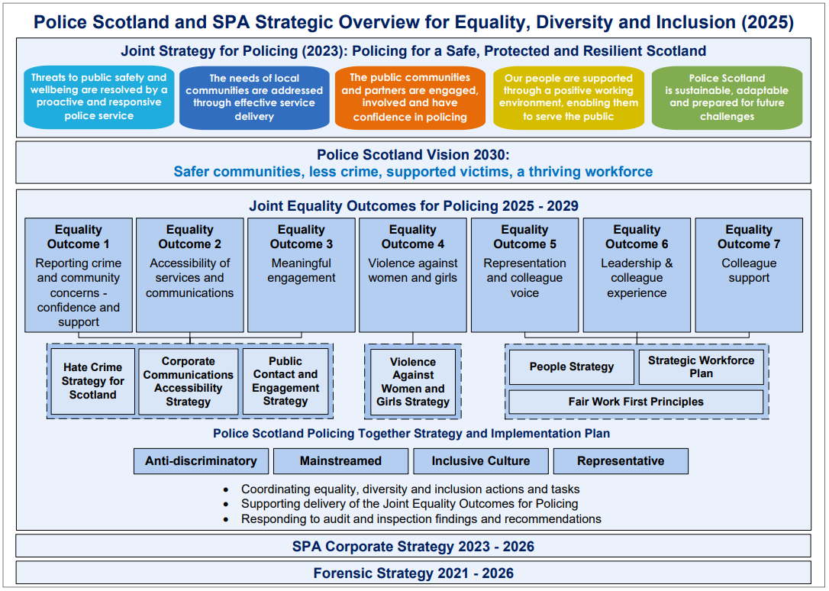

Appendix B - Evidence Sources
The Joint Equality Outcomes for Policing have been developed following extensive engagement and by reviewing a wide range of evidence sources. The below lists our sources of evidence.

- Ongoing engagement
- Internal engagement sessions (with stakeholders including Divisional/Dept Representatives, Diversity Staff Associations, the Federation, ASAP and trade unions),
- Engagement with divisional EDI single points of contact.
- Engagement with partner organisations
- Engagement with Community Advisors and Strategic Advisors

- Monitoring and Data
- Equality and diversity workforce monitoring reports.
- Themes from Freedom of Information requests and data requests.
- Internal grievance themes
- Internal disciplinary themes
- Human resources support and enquiry themes
- Exit interview findings

- Internal Engagement Mechanisms / Surveys
- Organisational People Survey Results,
- Institutional discrimination research findings
- Sex equality and tackling misogyny research
- Creating a Positive Workplace research
- Recruitment survey
- Involve survey findings

- Benchmarking
- Other Public Sector Equality Outcomes
- Environmental Scanning
- Operation Soteria – England and Wales - Review of policing culture corelated to VAWG implementation plans

- Action Plans / Priorities
- Policing Together Implementation Plan activities and progress
- People and Development Delivery Plan and progress updates
- Updates from local people plans.
- Relevant Risk, Audit & Assurance Review Updates
- HMICS Thematic Inspection of Organisational Culture
- HMICS Inspection of Hate Crime
- EDI & HR Independent Review Group final report and practical steps
- The Baseline Assessment of Human Rights
- EqHRIA internal audit.
- BSL Action Plan
- Relevant internal risks and control measures

- External sources
- Community Confidence Project
- Diffley polling
- Empirical data (Crime Figures)
- Victim Support Scotland feedback
- Victim-Survivor Feedback Form
- SafeLives feedback
- Engagement with 3rd Sector agencies supporting victims/survivors

- Public feedback
- Your Police Survey results,
- User Experience Survey results
- Trust Index results
- Themes from complaints against the police,
- National Independent Strategic Advisory Group Feedback.

Engaging with us

We want to hear from you
Meaningful and effective engagement involves genuine dialogue, respect, integrity, transparency and accountability. It provides an opportunity for people to shape our services and influence decisions made. Insight from effective engagement helps identify practical solutions and determine changes required to meet the needs of the communities we serve.
Police Scotland is committed to continuous improvement in all that we do. If you have something to tell us about the Annual Police Plan or our service, please Contact Us.

Public engagement and insight
Police Scotland recognises the importance of understanding the views and priorities of Scotland’s diverse communities.
Your Police is a continuous and anonymous survey which provides a platform for the public to tell Police Scotland about their views and experience of the police service, what is going well and where policing can do better.
Further information about this platform and our wider engagement can be found on the Police Scotland website and Engagement Hub.

Social media
Police Scotland has a number of active social media channels that provide a range of information and insight into policing, both nationally and in your local area. A full list of our social media accounts can be found on the Police Scotland website.

Inclusive and accessible engagement
We aim to embed accessibility and inclusivity into our services to make them work for everyone. Our Joint Equality Outcomes 2025-29 were subject to an Equality and Human Rights Impact Assessment (EqHRIA) and other Impact Assessment as appropriate.
A summary of the EqHRIA is published alongside the document on the Police Scotland website. The document can also be made available in alternative formats on request.
Contact us
Always dial 999 in an emergency
By phone – 101 for non-emergencies (+44 (0) 141 308 1070 if calling from outwith the UK. Network charges may apply).
Online – for issues of a non-serious nature using our Contact Us form.
In person – details of Police Stations and Public Counter opening hours can be found on our website or by contacting us.
Text Relay – 18001101 for deaf, deafened, hard of hearing or speech-impaired callers.
Scotland’s British Sign Language (BSL) Interpreting Video Relay Service (VRS) – enables contact with all of Scotland’s public bodies and third-sector organisations. BSL users can contact them directly.
In writing – to PO BOX 2460, Dalmarnock, Glasgow, G40 9BA.

