Notice:
This document has been made available through the Police Service of Scotland Freedom of Information Publication Scheme. It should not be utilised as guidance or instruction by any police officer or employee as it may have been redacted due to legal exemptions.

Flexible Working (Staff)
Procedure

Policy: Resourcing
Owning Department: People and Development
Version Number: 6.00
Date Published: 21/11/2022
Theme(s): Your work and life
Contents
1. Overview 3
1.1. What is this about? 3
1.2. Who is this for? 3
1.3. Key information 3
2. Staff 5
2.1. What you need to do: 5
2.2. Making a request 5
2.3. Short term flexible working requests 6
2.4. Handling requests to work flexibly 6
2.5. Cancelling and withdrawing a request 7
2.6. Application outcomes 7
2.7. Appeals 9
3. Manager 10
3.1. What you need to do: 10
3.2. Receiving a request to work flexibly 10
3.3. Handling requests to work flexibly 11
3.4. Cancelling and withdrawing a request 12
3.5. Reviewing flexible working 12
3.6. Appeals 13
4. Resources 14
4.1. How to Guides 14
4.2. Reference Documents 14
4.3. Related Procedures 14
4.4. Useful Links 15
Appendix A 18
Appendix B 19
The different types of flexible working 19
Appendix C 21
How to conduct a flexible working appeal 21
Appendix D 23
SCoPE Flexible Working Module – how to apply 23
Appendix E 32
SCoPE Flexible Working Module – guidance notes for Line Managers 32
Appendix F 39
SCoPE Flexible Working Module – Senior Manager Decision 39
Appendix G 42
Questions and Answers 42

Overview

What is this about?
Every year Police Scotland and the Scottish Police Authority help staff work more flexibly. We see the benefits of doing this, and the information here tells you how we can work together to find practical solutions to work/life balance.

Who is this for?
This is for all authority/police staff.

Key information
- This process is for permanent and temporary changes to working arrangements (e.g. hours of work, location, or work pattern).
- We believe that anyone should be able to ask for flexible working and we are prepared to allow anyone to apply regardless of service and may allow more than 1 application in a 12 month period in certain circumstances.
- An approach that starts with `yes’ and moves to `no’ where there are justifiable reasons is encouraged.
- Each request is looked at on a case by case basis.
- We will offer trial periods when we are not sure a flexible working request is practical.
- Agreeing one request does not set precedence for others. Not all flexible working options are suitable for all roles and business context changes all the time.
- All requests will be looked at in the order they are received. Where we get multiple applications from the same area, we will make no judgements about which is most deserving and each one will be looked at against the circumstances that exist at the time.
- Health and Safety has an active part to play in this process and can provide advice on lone working, Display Screen Equipment (DSE), equipment and security.

Staff

What you need to do:
- Check you have not submitted another request in the last 12 months unless your request is for 1 of the permitted reasons. The permitted reasons are:
  - You are making a request as a reasonable adjustment for a disability.
  - You have changed job.
  - There are exceptional circumstances that you need assistance with.
- Submit your request in good time, telling us what you need and when you want to start.
- Outline what effect the requested change will have on the business and colleagues, and how any effect might be dealt with.
- Think of alternative solutions in case your request can’t be supported or can only be partly met.
- Appeal the decision if you feel it has been unfairly reached.

Making a request
Requests for flexible working should be made as soon as possible, and ideally between 12 and 5 weeks before the start date, using the Flexible Working module in the Human Resource (HR) System (SCoPE). SCoPE stands for System to Co-ordinate Personnel and Establishment. There are guidance notes on how to use the module. If you are unable to access SCoPE, contact your line manager who will be able to raise a request on your behalf.
Resource Deployment Units can provide general advice and support to anyone considering an application, but they will not be able to comment on whether they will be approved or not once formally submitted.
A new shift allowance calculator is available in SCoPE to check the effects of new patterns on the allowances you receive. This should be used to check the financial impact of Staff patterns. Guidance notes on how to use the calculator are available on the Intranet.
Salary, benefits and allowances will be changed to match the new working pattern for all requests. These changes may not show in your pay straight away. There can be a delay depending on your start date and the amount of notice we can give to payroll. Any corrections will be applied to your next pay. It is your responsibility to check your payslip in the month(s) following any change and to notify People Direct if changes have not been properly applied.
Staff must be aware that any changes to their working hours, pay or allowance is a permanent change to their pay, terms and conditions and there is no right to return to previous working arrangements, except in the case of trial periods or short term requests as outlined below.

Short term flexible working requests
If you are looking to change your working pattern for a short period to cope with a change in domestic circumstances, or undertake caring responsibilities, treatment or training, we may allow you to go back to your original terms and conditions. You must speak to your manager to see if this is practical and the best way for us to support you.

Handling requests to work flexibly
We expect our managers to fully consider all applications received and deal with them in a fair and timely manner. When we get your request to work flexibly, your line manager will review your application as soon as possible and may discuss it with their leadership team. They might ask to meet with you so that they can talk about it in more detail. You should be ready to talk about and consider alternative options that address any business concerns. If you are able to adjust your request or make compromises, your request is more likely to be approved. You can ask to take someone to the meeting with you if you want.
If your line manager is not sure whether the request is practical, a short trial period of up to 12 weeks may be agreed.

Cancelling and withdrawing a request
The processes of cancelling and withdrawing requests are distinctly different within the application process.
You can cancel a request to work flexibly so long as you have not submitted the application. This is where you may have started to fill in an application and saved it, but haven’t yet sent it to your line manager. There are no restrictions in respect of further applications being lodged at a future date if you cancel a request.
Once submitted you can only withdraw a request by letting your manager know and contacting People Direct, telling them the reason for your withdrawal. People Direct will mark the request as withdrawn on SCoPE. Staff should be aware that they may not be able to make another request for 12 months if they do this.

Application outcomes
Once your application has been reviewed your line manager will let you know the outcome. All outcomes will be delivered in writing through the application system. There are three possible outcomes:
- Your application is agreed on a permanent basis.
You’ll receive a letter updating your contract of employment. It will set out details of the change agreed with your manager and relevant dates. If your hours/days of work have changed please ensure your new pattern is correctly shown in SCoPE.
As this change is permanent you wouldn’t be able to revert back to your previous pattern unless it’s agreed with your manager through a further flexible working application.
- Your application is agreed on a temporary basis.
You’ll receive a letter confirming the temporary amendment to your terms and conditions of employment. It will set out details of the change agreed with your manager and relevant dates. If your hours/days of work have changed please ensure your new pattern is correctly shown in SCoPE.
Applications can be granted on a temporary basis for a number of reasons, for example to see how arrangements will work or where there are a number of arrangements in your team already.
All temporary changes will have a trial period so that you and your manager can discuss whether the new arrangement is working, and what will happen at the end of the trial period (e.g. temporary period extended, revert to your previous arrangements, try an alternative flexible working arrangement or the flexible working becomes permanent). Again, please ensure your working pattern is correctly shown in SCoPE after the review period, if it has changed.
Should the situation arise where the flexible working arrangement doesn't continue past the review date you can raise an appeal against that decision.
- Your application is rejected.
Sometimes it won't be possible to agree the change you've asked for, or any alternatives discussed during the process. Where this happens your manager will explain why your request can't be supported.
The reasons for rejection are set out in law and must fall into at least one of the following:
- The burden of the extra costs being unacceptable;
- Detrimental effect on ability to meet customer demand;
- Inability to re-organise work among colleagues;
- Inability to recruit additional staff;
- Negative impact on quality or performance;
- Not enough work during proposed periods of work; and/or
- Planned structural changes.
Throughout your application your manager will have been supported by People Services to help them consider the request fully as well as any alternatives, either suggested during this process or implemented in the wider business.

Appeals
If we turn down your request to work flexibly, you can appeal in writing to People Direct within seven days of getting our written decision. You have to give the reasons for your appeal and provide any new information that should be considered.
You will be invited to a meeting, normally within 14 days of the date we get your appeal. This will be held by a Head of Department or Area Commander not involved in the original decision.
You will get a decision, in writing, within seven days of the appeal meeting.

Manager

What you need to do:
- Consider all requests fairly and objectively, balancing the needs of the individual and the business.
- Deal with requests quickly and keep applicants informed.
- Consider all solutions and promote cooperation and compromise so that individual and business needs are met.
- Complete the paperwork at each stage of the process and fully evidence any decision or recommendation.
- Review plans as necessary.

Receiving a request to work flexibly
When you get a request to work flexibly, you should tell the applicant that you have got it, review its contents, and decide whether you need to discuss it with them further.
You don’t need to have a discussion if you intend to approve the request, but it can help make sure the team member understands how their request will affect their pay, terms and conditions. It also gives you the chance to check that there isn’t an underlying issue that could be better supported in a different way.
In all other circumstances you need a meeting. You should agree a suitable time and private place with them ensuring they know that they can bring someone along if they want. You should allow them to explain what changes they want, give their reasons, and tell you how they think the request could be met. This is also your opportunity to talk about any issues there may be, and to explore other options, compromises or adjustments.

Handling requests to work flexibly
The Flexible Working Regulations 2014 set out the rules for flexible working allowing anyone to ask for flexible working for any reason. The law requires that we must give staff a decision within three months of the date we receive the request including any appeal.

Process
As part of our efforts to create a positive environment for our people to perform, an approach that starts with `yes’ and moves to `no’ where there are justifiable reasons is encouraged.
You must consider a request carefully looking at the benefits for the individual and the business. Weigh these against any harmful business impacts, and decide whether to support the request. You may need to discuss these with your leadership team. Requests should be completed within three months and where delays occur, an extension to timescales should be agreed in writing with the applicant.
If the request is to support a disability or any of the protected characteristics under the Equality Act 2010, then you should seek advice from a People Services Advisor or an Equality Advisor.
After thinking about the advantages, costs and effects of granting the request you must tell your team member your decision. This should be to either:
- Accept the request and verify a start date and any other actions.
- Confirm a trial period or compromise.
- Reject the request, telling them the reason, and the appeal process
You must seek the advice of a People Services Advisor before telling a team member that you are rejecting their request by contacting People Direct.

Staff
Reasons for rejection are set out in law. These are:
- The burden of the extra costs being unacceptable
- An inability to reorganise work amongst existing staff
- An inability to recruit extra staff
- A detrimental impact on quality (e.g. quality of service)
- A detrimental impact on performance
- A detrimental effect on our ability to meet customer demand
- Insufficient work for the periods the team member wants to work
- Planned structural changes

Cancelling and withdrawing a request
The processes of cancelling and withdrawing requests are distinctly different within the application process.
A team member can cancel a request to work flexibly using SCoPE, so long as they have not formally submitted their application to you. This does not restrict their ability to make another application later.
Once submitted, a formal request can only be withdrawn by letting you know and contacting People Direct, telling them the reason for the withdrawal. Try to find out why the applicant wants to do this, and work to overcome any organisational barriers.

Reviewing flexible working
You will need to review flexible working arrangements:
- where a trial period has been applied
- where a team member needs changes to a reasonable adjustment
You should meet with the team member to look at the arrangements before updating SCoPE. There are guidance notes on how to use the module.

Appeals
Appeals can be raised if:
- there are details that were not available when the original decision was made; or
- the team member thinks their request was not handled fairly or reasonably in line with this process
Appeals must be submitted within 7 days and an appeal meeting should be held within 14 days of the date the appeal is submitted.
Appeals must be completed within three months of the original request date unless an extension has been agreed with the team member.
All outcomes must be recorded on SCoPE using the work life balance tab.

Resources

How to Guides
- How to Conduct a Flexible Working Request Appeal

Reference Documents
- Questions and Answers
- SCoPE Flexible Working Module guide.
- The Different Types of Flexible Working
- The Right To Be Accompanied

Related Procedures
- Annual Leave and Public Holidays (Staff)
- Capability (Attendance and Performance) (Staff)
- Career Break
- Disability in Employment
- Pay Protection
- Special Leave
- Stress Management

Useful Links
- Acas code of practice on handling in a reasonable manner requests to work flexibly.
- Employment Rights Act 1996, especially sections 80F to 80I
- Employment Act 2002, especially Section 47
- Children and Families Act 2014
- Employment Act 2002 (Commencement No.3 and Transitional and Saving Provisions) Order 2002 (SI 2002/2866)
- Menopause Toolkit
- The Flexible Working Regulations 2014 (SI 2014/1398)
- The Apprenticeships, Skills, Children and Learning Act 2009
- Working Forward Video – Listen to members from Ford UK and John Lewis Partnership offer their advice on how they approach Flexible Working.
Compliance Record
EqHIRA completion/review date: 12/04/2018
Information Management Compliant: Yes
Health and Safety Compliant: Yes
Publication Scheme Compliant: Yes
Version Control Table
Version | History of Amendments | Approval Date
1.00 | Initial approved version | 29/11/13
2.00 | Revised incorporating national process for PSOS | 14/10/14
3.00 | Reformatted to new template and aligned to corporate identity. Updated to reflect cross reference to current SOPs. | 14/10/16
4.00 | Removal of old form links | 06/08/19
5.00 | Policy Simplification Project. Procedure stripped back and written with customer focus to support modernisation and 2026 objectives. | 01/04/19
6.00 | Removal of Officers from this process.  Introduction of additional text to address SWDF Action Plan.  Link to menopause toolkit added to resources.  Application process updated to reflect new SCoPE module to process applications.  Accessibility standards applied | 21/11/2022

Feedback
All Police Scotland People Policies and Procedures are subject to regular reviews. It is important that user feedback is taken into account when documents are reviewed.
If anyone wants to provide comment, or make suggestions for improvements to this or any associated document, please email HRPolicy@scotland.police.uk .

Appendix A
The right to be accompanied
You have the right to bring someone with you to any formal meetings e.g. disciplinary, grievance, capability etc. This could be a work colleague or a representative of: a Trade Union, Staff Association, Scottish Police Federation or Association of Scottish Police Superintendents. You have to make your own arrangements if you want to bring someone with you.
You have to tell us the name of the person at least 24 hours before the meeting.
The work colleague or representative is entitled to take a reasonable amount of paid time off to attend the meeting. They should also be allowed time off to get to know the case and discuss any related matters before and after the meeting.
The work colleague or representative can address the meeting to: sum up the case; respond to any views discussed at the meeting; confer with you during the meeting or ask for a break. They cannot answer questions on your behalf.
Sometimes, you might be able to bring a work colleague or representative to an informal meeting. You have to be careful when asking or agreeing to this though, as it could make the meeting seem more formal than it has to be. You would have to talk this over with your manager before any arrangements are made.
At times, you might be able to bring a non-work colleague. This could be if you need additional support because of a disability or you might need an interpreter if there are difficulties with understanding or language. You would have to talk this over with your manager before any arrangements are made.
If the work colleague or representative is unable to attend, the meeting can be rearranged. This will normally be within five working days of the original date.
If they are unable to attend the re-arranged meeting you might have to ask someone else.

Appendix B

The different types of flexible working
There are many different forms of flexible working. Flexible working can cover the way our working hours are organised during the day, week or year. It can also describe the place of work- such as homeworking – or the kind of contract - such as a part time contract. Here are some examples but this is not an exhaustive list nor does it illustrate that different forms of flexible working can be combined. E.g. Part time, compressed.

Part Time Working
This covers any setup where you are contracted to work anything less than full time hours.

Compressed Hours
This is where you work your usual hours in fewer and/or longer blocks during the week. Through starting early and/or finishing late, you can build up additional hours which are taken as alternative time away from work.

Fixed Shifts
Fixed shifts are where you work either:
- A fixed pattern of days/shifts every week; or
- A set shift rather than working a rotating or alternating pattern

Annualised Hours
An annualised hour’s system is where the total number of hours to be worked over the year is fixed but there is flexibility over your daily and weekly working patterns. Typically, the times you are contracted to work are split into:
- set shifts which cover the majority of the year
- unallocated shifts which you can be asked to work at short notice

Term Time Working
Term-time working gives you the opportunity to reduce your hours or take time off, usually unpaid, during any school holidays. Salary can be paid either in 12 equal monthly instalments or for time worked and when annual leave is actually taken.

Home Working
Homeworking can be when you regularly carry out all, or part of, your duties from home rather than a Police Office. Or it could be the occasional agreed day.
Although advances in technology make it far simpler to keep in touch and work away from our premises, it does require a working relationship that is based upon trust and the effective management of your own work.
Due to the sensitivity of the type of work we do, there are only a few posts that will be suitable for a home working arrangement. Advice must always be sought from the Information Security Officer and you should be prepared for assessments of your home and facilities to determine if security restrictions or working arrangements need to be put in place.

Change of Location
This is where you work at a different location from the one your terms and conditions state either on a part time or full time basis.

Appendix C

How to conduct a flexible working appeal

Introduction
- You should open the meeting by thanking those present for attending and confirming their right to be accompanied.
- If accompanied you should confirm the role of the work colleague or representative i.e. they can address the meeting to: sum up the case; respond to any views discussed at the meeting; confer with the team member during the meeting or ask for a short break. They cannot answer questions on behalf of the team member.

Format of the meeting
- Provide an overview of the structure for the meeting and any provisions there are for consideration, intermissions and providing a response.
- In respect of structure, as there are no specific grounds of appeal under the Flexible Working Procedures it is recommended that you consider any appeal in its broadest terms but with particular reference to:
- Each parties compliance with the procedures
- The evidence in respect of each party’s contribution to finding a mutually agreeable solution.
- The reasonableness upon which the rejection was reached
- Any further information that could not have reasonably been known at the time of the decision
- Ask specific questions with reference to the appeal text to extract the relevant information you need to make a decision. You should let them know that if at any point during the proceedings either party wishes to have an adjournment then they should say so and identify any provisions made for breakout rooms.

Ending the meeting and confirming your decision
- At conclusion of meeting state that you have three options available to you:
- Uphold the appeal and allow the flexible working proposal to progress
- Support a trial period of the proposal but state that if approved this would not guarantee a permanent solution. State that the pattern may be removed at the end of the trial or substantiated but if an Officer, reviewed annually with no guarantee of retention.
- Reject the appeal. State that even if it is your decision to do this that there are no restrictions in respect of further applications being lodged at a future date, subject to the 12 month rule.
- Give an indication of when you will have made your decision (must be within seven days) and the process by which they will be informed.
Remember Staff applications must be completed in their entirety within three months from the date of submission. This includes any appeal unless an extension has been agreed.
The outcome must be reported to People Services who will recorded it on SCoPE using the work life balance tab.

Appendix D

SCoPE Flexible Working Module – how to apply
To request flexible working, go to Requests in the front page of SCoPE and select ‘Flexible Working Request.’ A blank Flexible Working Request form will appear on screen with your details.
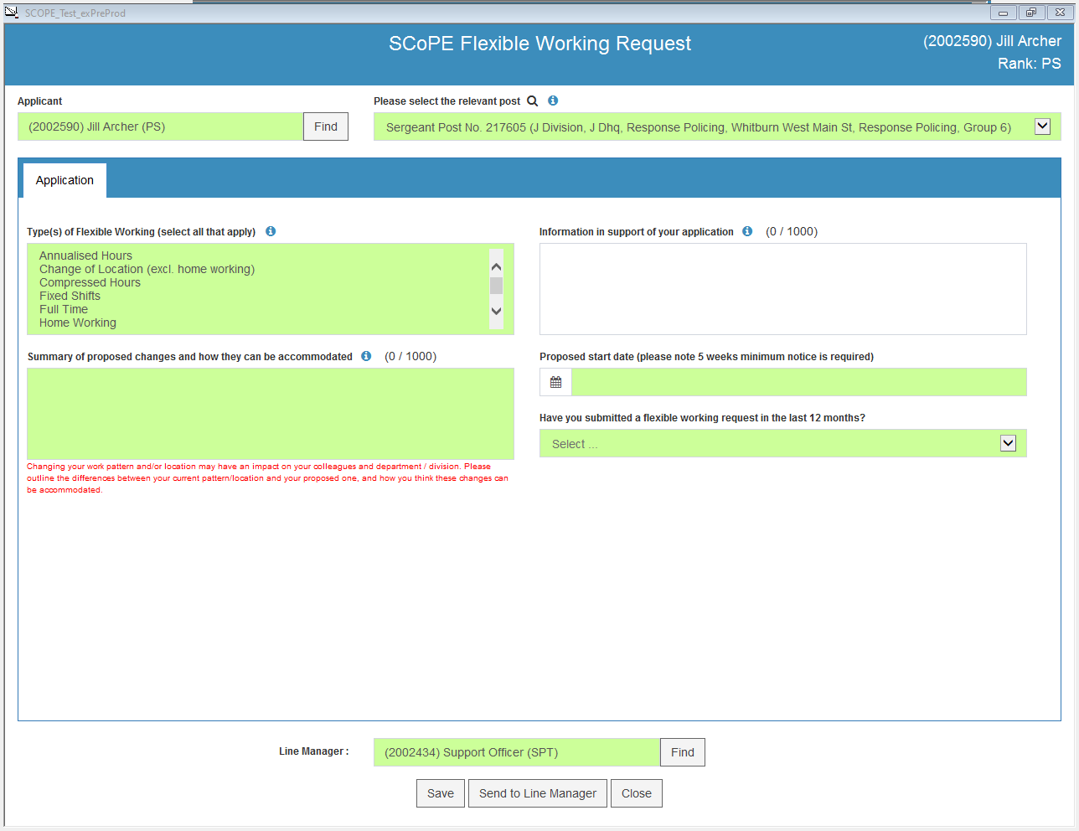

Application
Complete the Application tab. You can select as many types of flexible working as are relevant to your request. When you start to select them, the Proposed Pattern tab will become available (see below).
The text boxes and fields which are green are mandatory. You will not be able to submit your request unless they are all filled in.

Information icons
For advice on how to complete each section, please click on the information icons on the form.

Proposed pattern tab
It is very important that you fill this in correctly. Remember - you can save your form for completion later.
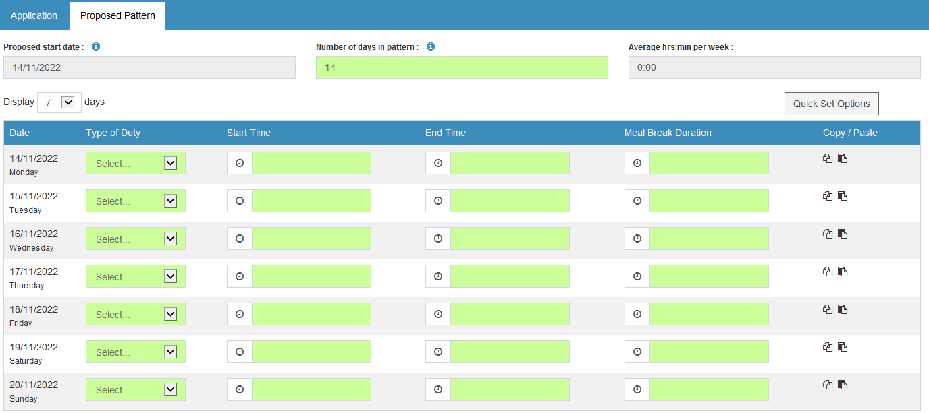

Proposed start date and rotation
The proposed start date from the Application tab will pull through to the Proposed Pattern tab and the shift pattern dates will be based on this. It is very important that you select the correct start date, as this forms the basis of the shift pattern.

Changing the date
If you need to change the date, you have two options:
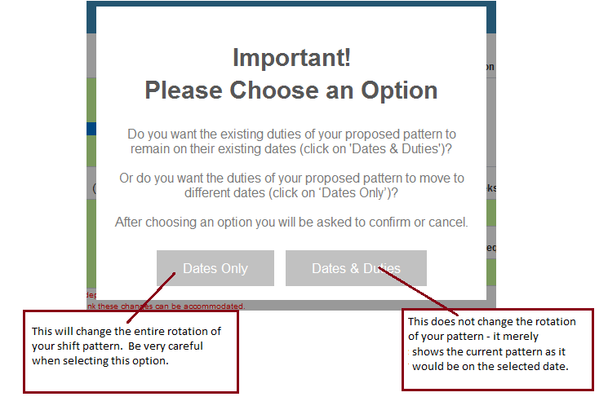

Examples
Below is an example of what happens if you change the start date from 10/11/2022 to 14/11/2022. The first example shows what happens if you select to change dates and duties. Nothing in the rotation of the pattern changes. It just starts from 14/11 (a Monday) instead of 10/11 (a Thursday).
The second example shows what happens if you select to change dates only. The entire rotation changes, so that what was the Thursday shift (a rest day) now falls on a Monday (which was previously a night shift).
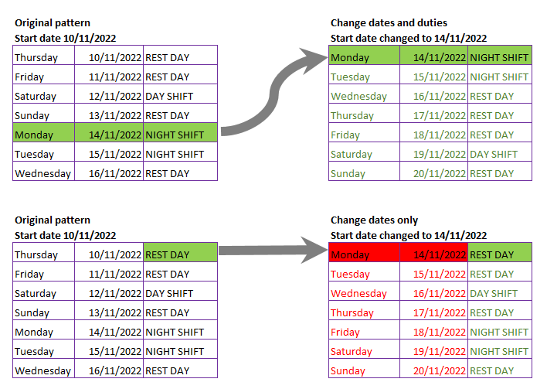
Handy tip! If you are uncertain, save your form before changing the date. Then try changing the date. If it does not look right, close your form without saving it, then go into your workbasket and open the saved version.

Completing your proposed pattern
Decide whether you want to create a new shift pattern from start or whether your shift pattern is based on an existing pattern (e.g. that of your department or shift, or your current flexible working pattern). The SCoPE Help Pages provide full guidance on how to perform both these functions under the Flexible Working menu.

How to create a new shift pattern
- Make sure the start date of the shift pattern is correct. Most shift patterns start on a Monday, although the system will not block you from selecting a different day of the week.
- Type in the number of days in the pattern. Patterns should be multiples of seven days.
- If most of the days in your proposed pattern are very similar, make sure there are no shortcuts you can use in Quick Set Options before proceeding.
- Select the duty type which best describes that day’s shift from the dropdown.
- Select the start time from the time picker.
- Select the end time from the time picker.
- If you are a member of staff, select the meal break duration.
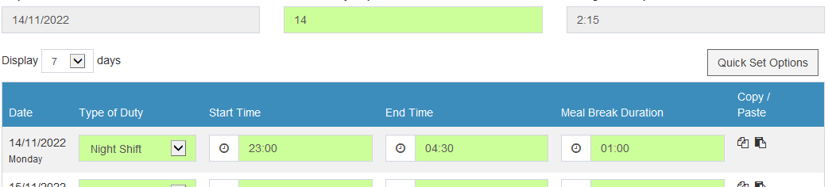
- If other days in your pattern match the one you have just created, you can copy it and paste it into the other days to save time. Click on the left icon to copy, then the right icon to paste into the blank day.
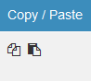
- Non-working days also need to have (matching) start and end times (and meal breaks of zero hours if you are staff). They are usually set to 07:00 07:00 with a meal break of 00:00. They can also be copied and pasted.

Quick set options menu
This is at the top right of your screen and has a number of shortcuts to make it easier for you to complete your shift pattern.

Clear all days
Use this to clear everything you have already set. When you use this, you cannot retrieve what you previously had unless you saved your form first.

Set all days
Use this to set all your days to the same duty type, start and end times, and meal break. This is useful if most of your shift pattern consists of the same, or similar, times. You can then edit the days or times which are different on an individual basis. Remember to amend non-working days!

Set meal breaks
This is only available for members of staff. You can set all working days to have the same meal break. All non-working days will be set to a meal break of 00:00 if you use this option. Any differences can be edited on an individual basis.

Import pattern
If you know that your shift pattern is to be very similar to an existing pattern, you should use the Import Pattern functionality.
- Find out what the name of the existing pattern is on SCoPE. If it is a shift pattern that you have worked, you can find it in your Personal Record Postings tab under the Shift Pattern heading:

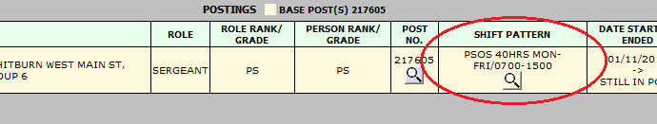
- If you have never worked this shift pattern, you will need to ask someone (eg RDU) to find out the name of the pattern for you.
- Click on the Import Pattern option in your flexible working request form and wait for all existing patterns to load on screen.
- When they have loaded, type the shift pattern name into the Filter at the top right. All shift patterns that match that text will be listed.
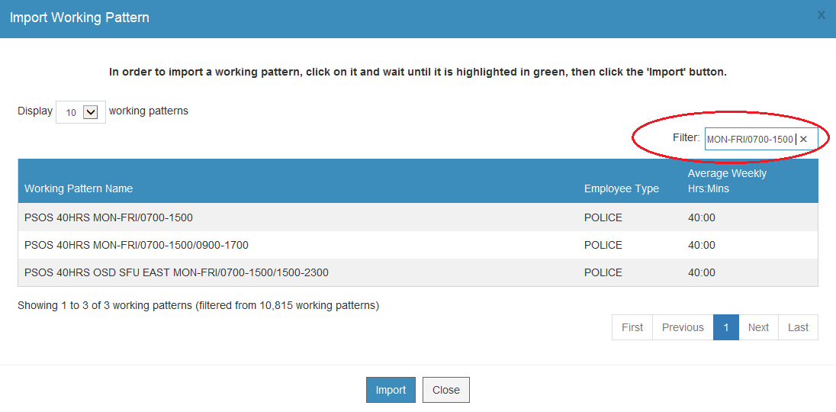
- Click on the shift pattern you want to copy, wait until it highlights in green, then click the Import button at the bottom. The pattern will populate your form. You can then edit individual days and duties as required.

Submitting your request
Once you are satisfied that the contents of your form are correct, you should submit it to your line manager. If your line manager is off, you can choose an alternative to send your form to. Use the Find button at the bottom of the form.

Save your form
If you want to save your form to complete later, you can save it. Once you have saved it, you can access it from your personal Workbasket.

Cancel your request
If you have saved your request and wish to cancel it, you can do so from your personal Workbasket. If you wish to withdraw the request at any other stage of the process, you will need to speak to People Direct.

Progress
Once you have submitted the form, it should normally progress as follows:
The form can only be sent back to you, the applicant, from your line manager.

Work life balance tab
Once you have saved or submitted your request, you can follow its progress from the Work Life Balance tab in your Personal Record. Click on Options to see the form. Once the form is submitted, an audit trail is created which you can also see from here. You cannot edit the form in any way from Personal Record.
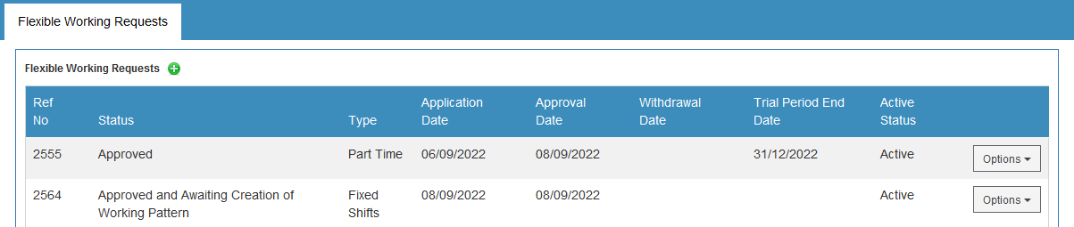
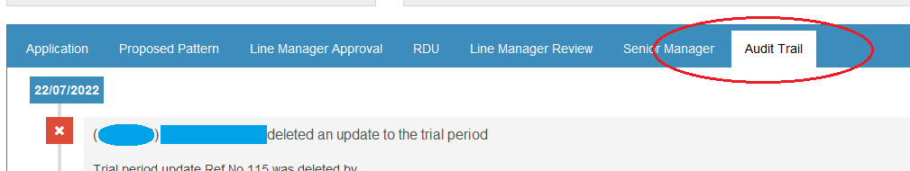

Appendix E

SCoPE Flexible Working Module – guidance notes for Line Managers

Requesting flexible working on behalf of another person
If somebody you manage is unable to access SCoPE (e.g. they are long-term sick, or on maternity leave), you will be able to raise a flexible working request on their behalf. If they do not have a posting on SCoPE (e.g. they are on career break), please speak to People Direct for advice.
Use the FIND button next to the Applicant field in the form to change the name from your own to the person you are raising the form on behalf of.
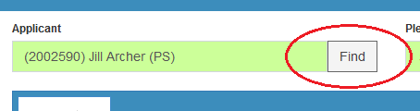
You can submit the form to yourself as line manager if required. You will receive notifications as both line manager and requester from here on. You cannot submit the form to yourself if you are the applicant.

Line Manager Approval
When the application is submitted to you as line manager, you will be able to access it in your Personal Workbasket from the front page of SCoPE.
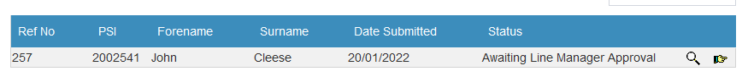
Use the magnifying icon to open the form; the forward icon to send the form to an alternative line manager instead.
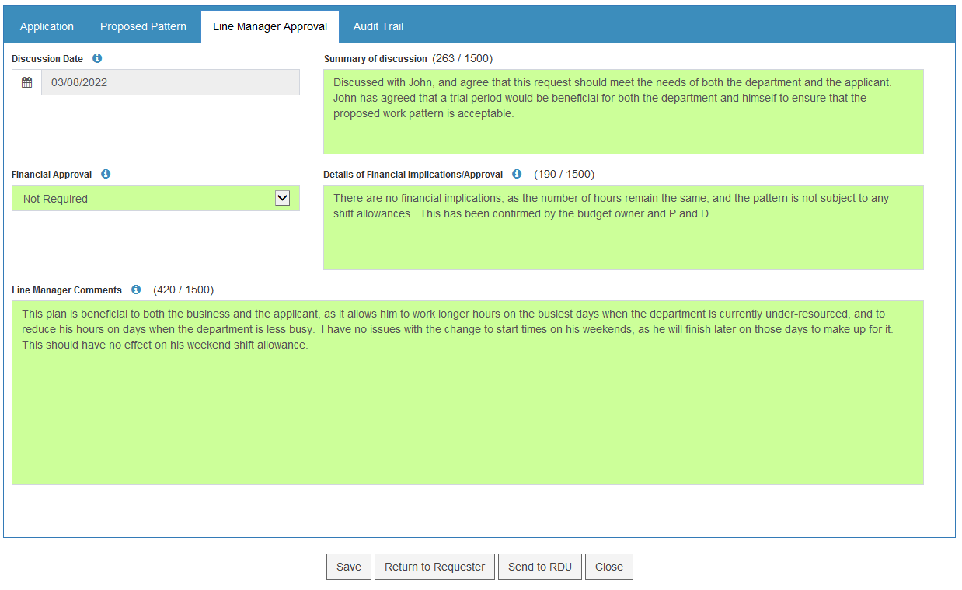
When you open the form, you must:
- Review the Application tab in detail
- Review the Proposed Pattern in detail
- If the application and pattern need changed in any way, you should select Return to Requester. You will need to provide a reason for returning the form, and this will thereafter be recorded in the Audit Trail.
- If the application and pattern are correct, complete the Line Manager Approval tab.
Remember you can save the form for completion at a later time if necessary.

Information icons
For advice on how to complete each section, please click on the information icons on the form.

Discussion date and Summary of Discussion
It is not mandatory to record a discussion with the applicant. If you choose to record this, select the date, and type up a summary of the discussion. To remove, use the backward space key to delete the date.

Financial Approval
This section is critically important and it is important to be on the front foot about the true extent of costs. Any increase in establishment is a cost and must be approved by the budget holder in agreement with Finance. Costs can also be affected by changes in allowances or the cost of equipment, facilities or services and should be factored in to any application.

Line Manager Comments
Complete this section with your comments on the proposed pattern. These will be available to read by all involved, including the applicant.
Once you have completed the Line Manager Approval section, you should click on Send to RDU.

Line Manager Review
When RDU have completed their section of the form and submitted it, you will be able to access it in your Personal Workbasket from the front page of SCoPE.
Use the magnifying icon to open the form; the forward icon to send the form to an alternative line manager instead. Remember you can save the form to complete later.
When you open the form, read the RDU comments carefully. Depending on what they advise, you may need to select Return to Requester.
You will need to provide a reason for returning the form, and this will thereafter be recorded in the Audit Trail.
If, however, you are satisfied that that the request can be sent to the Senior Manager for the final decision to be made on it, complete the Line Manager Review tab and use the Find button to identify the Senior Manager.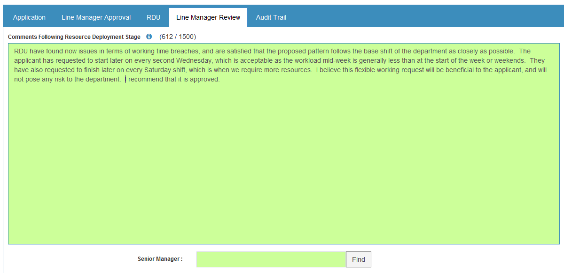

Proposed alternative
Depending on circumstances, the Senior Manager may propose an alternative to the current request. If they do so, the form will be returned to you, and you will need to discuss the alternative proposal with the applicant.
Use the magnifying icon to open the form; the forward icon to send the form to an alternative line manager instead.
When you open the form to record the response to the alternative proposal, you must read the senior manager’s comments carefully.
When you have finished discussing the proposal with the applicant, click on Respond to Alternative Proposal.
Select the appropriate response from the dropdown and click Save.
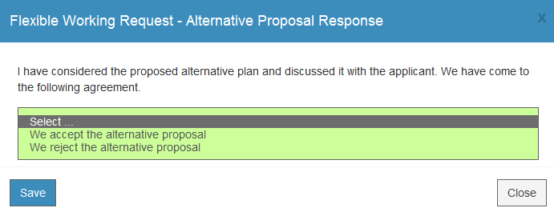
If the applicant has agreed to accept the alternative proposal, the request will be sent back to their workbasket for amendment. Thereafter the form will go through the request process again.
If the applicant rejects the alternative proposal, the form will be returned to the Senior Manager to make the final decision on the request.

Work Life Balance tab
You can follow the progress of a request from the Work Life Balance tab in the applicant’s Personal Record. Once the form is submitted, an audit trail is created which you can also view from within the Work Life Balance tab. You cannot edit the request form in any way from Personal Record.

Trial Periods
If a flexible working request is approved on a trial basis, you and the applicant will be sent an automatic reminder 5 weeks before the end date of the trial period. This is to give you enough time to review the plan and discuss any changes or extensions to the trial period.
Once you have reviewed the plan, you MUST record the outcome on SCoPE.
- Go to the Work Life Balance tab within the applicant’s Personal Record.
- Click on the Option menu adjacent to the flexible working request and select Add Trial Period Update from the menu.
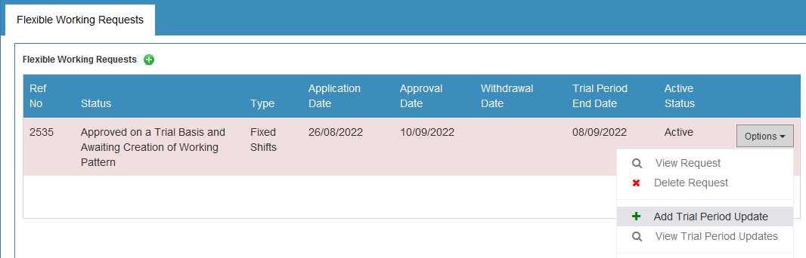
- Complete the date of the decision and who provided the update, then select the Type of Update from dropdown:
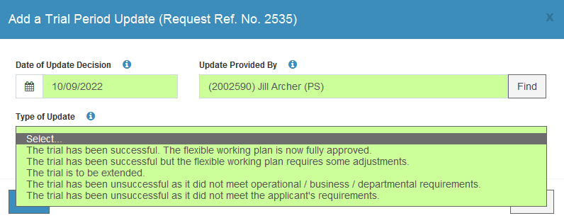

Type of Update
- The trial has been successful. The flexible working plan is now fully approved.
This will update the status of the request to fully approved and notifications will be sent to relevant departments to update payroll and contracts.
- The trial has been successful but the flexible working plan requires some adjustments.
You will need to provide a summary of the adjustments. Once they have been signed off by all interested parties, you must use the Propose a Change to Actual Pattern option in the Options menu to submit an amended version of the shift pattern to RDU for creation.
- The trial is to be extended
You must enter the date the trial period has been extended to. You will be sent a reminder of this five weeks prior to the new extension end date.
- The trial has been unsuccessful as it did not meet …
Select the appropriate option and provide a summary of why it was unsuccessful.

Appendix F

SCoPE Flexible Working Module – Senior Manager Decision

Senior Manager Decision
By the time the request reaches senior manager stage, it has been fully reviewed by both the line manager of the applicant and RDU/RMU.
Open the form from your Personal Workbasket.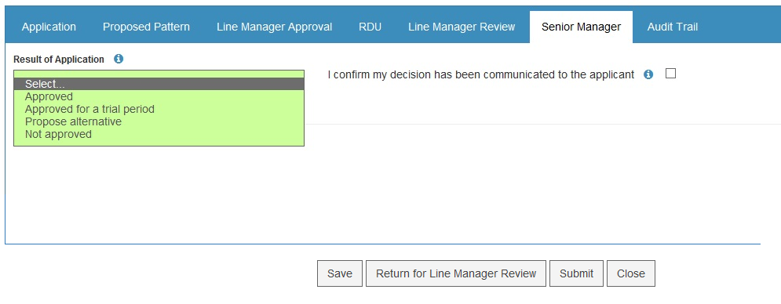
Before making a final decision on the request, you must review the Application, Proposed Pattern, Line Manager Approval, RDU, and Line Manager Review tabs. Guidance on what to take into consideration in order to make the decision is found in the information icon.
You can view the previous progress of the form in the Audit Trail.
If you believe something is wrong, you can return the form to the line manager review stage. They can either return the form to the requester, or clarify the issue with you and return the form.
You must ensure that your decision has been communicated to the applicant before you submit your section of the form on SCoPE. Ticking the checkbox confirms that you have done so, and you will not be able to submit the form unless it is completed.
You can save the form for completion later.
Please note that once you submit your decision, it cannot be returned or amended in any way.

Result of Application

Approved
If the request is fully approved, you must select an approved start date. This is the date any salary changes and leave entitlements become effective from, so please ensure it is the correct date.

Approved for a Trial Period
If the request is approved on a trial basis, you must select an approved start date and a trial period end date. The trial period end date must be at least five weeks after the start date. The approved start date is the date any salary changes and leave entitlements become effective from, so please ensure it is the correct date.

Propose Alternative
You should discuss any proposed alternative to the requested plan with the line manager and applicant first. Complete the form with the details and click on the Submit button (not the Return for Line Manager Review button). This will send the request to the line manager to record whether the proposal is accepted or rejected. If it is accepted, the form will be returned to the applicant for amendment and will thereafter go through the full approval process again based on the proposed amendments. If the proposal is rejected, it will be returned to you to deal with accordingly.

Not Approved
If the request is not approved, you must select the reason(s) for it not being approved, and provide an explanation. Rejecting the request will close the form and prevent it from being amended and resubmitted.
Any comments that you make on the request will be available to read by all involved, including the applicant.

Return the form to the line manager
If you need to return the form for a reason other than proposing an alternative, you should click on the Return for Line Manager Review button and complete the reason for returning the request. If necessary, the Line Manager can then return the form to the applicant.

Submit your decision
Once you have completed the form based on your decision, select Submit. This will send notifications to all involved, including details of start dates and trial dates in order to amend the applicant’s salary accordingly.
If you have approved the request, whether fully or on a trial basis, the shift pattern will be sent to RDU to create as a full shift pattern to be added to the individual’s SCoPE posting.

Appeals
The flexible working appeals process is unchanged. The only difference is that the result of any appeal on a flexible working request is recorded on SCoPE. This allows the organisation to easily report on statistics, but also means that any requests which are successfully appealed can use the SCoPE functionality available to all approved requests (e.g. trial periods, annual reviews etc.)

Appendix G

Questions and Answers

Do I have the right to work flexibly?
No, you do not have a right to work flexibly. You have a right to formally request more flexible working arrangements – We have a duty to consider the request in a reasonable way and we successfully help our officers and staff to work more flexibly every year.

Can I undertake flexible working in a promoted post?
Yes, there are no restrictions on application to do with the role you undertake or the level you may be working at. Each application for flexible working will be considered at on a case by case basis.

What affect will working flexibly have on my salary?
Sadly we cannot tell you how a flexible working arrangement might affect your salary. You can work out a rough annual salary based on the hours you might be thinking of asking for. The calculation is as follows:
Annual Salary (which can be found on your wage-slip)/35 or 36 or 37hrs (depending on legacy force) = ‘Y’
‘Y’ multiplied ‘Z’ (proposed new hours) = new annual salary

When will my salary, benefits and allowances change?
We will apply the changes to your salary, benefits and allowances from the date your new working arrangements start. Depending on the amount of notice we can give to payroll there are times when you may not see the changes in your pay straight away. Any corrections will normally be applied to your next pay.

What affect will working flexibly have on my pension?
Unfortunately we cannot tell you how a flexible working arrangement might affect your pension. You should seek independent advice or speak to your pension provider for details about how your request might affect your benefits at retirement.

Can I go back to a previous working arrangement at a later date? (Authority/Staff)
No, generally speaking you have no right to return to previous contractual rights. A flexible working agreement is normally a permanent contractual change. However, you can make an application and it may be considered.

If my request is part of a reasonable adjustment do I have to fill in the Flexible Working request form?
Changes that are likely to become a permanent feature of our support to you have to be commented on from an organisational perspective. Completing the Flexible Working application allows your manager to have all the information necessary to complete the Reasonable Adjustment Decision Making form 060-001.
Your manager can make short-term changes to support you with a disability without consulting Resource Deployment for up to 12 weeks but if the change is to become more permanent, filling in the form at the beginning saves you having to do it at a later date.

