| Police Scotland logo | Freedom of Information Response Our reference: FOI 25-2219  Responded to: 20 August 2025 |
| --- | --- |

Your recent request for information is replicated below, together with our response.

**Follow up to FOI Response 25-1834**

**Re the top 2 rows of table 3, please provide an anonymised summary of the circumstances for the 4 matters where action was taken at misconduct hearing**

We understand you to be referring to the information below:

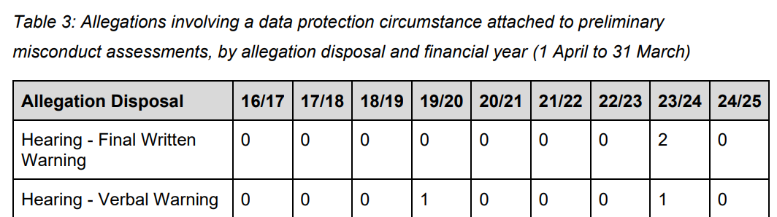

We can provide the following summaries:

* You did behave in an improper manner by accessing and viewing information [redacted] without a valid policing purpose and outwith the proper course of your duties.
* You acted in an inappropriate manner in that you viewed [redacted], otherwise than in the proper course of your duties and thus did fail to respect Confidentiality.
* You did behave in an improper manner in that you did send via [redacted], sensitive police information you obtained during the course of your duties pertaining to [redacted] and you did fail to treat this information with respect and did disclose said information out with the proper course of your duties.
* You did behave in an improper manner and access STORM Unity System and view [redacted] without a policing purpose, and in so doing you did access information out with the proper course of your duties.

The content marked [redacted] is held by Police Scotland, but I am refusing to provide it in terms of section 16(1) of the Act on the basis that the following exemptions apply:

* Section 38(1)(b) - Personal data

Personal data is defined in Article 4 of the General Data Protection Regulation (GDPR) as:

‘Information relating to an identified or identifiable natural person (“data subject”); an identifiable natural person is one who can be identified, directly or indirectly, in particular by reference to an identifier such as a name, an identification number, location data, an online identifier or to one or more factors specific to the physical, physiological, genetic, mental, economic, cultural or social identity of that natural person’.

Section 38(2A) of the Act provides that personal data is exempt from disclosure where disclosure would contravene any of the data protection principles set out at Article 5(1) of the GDPR which states that:

‘Personal data shall be processed lawfully, fairly and in a transparent manner in relation to the data subject’.

Article 6 of the GDPR goes on to state that processing shall be lawful only if certain conditions are met. The only potentially applicable condition is Article 6(1)(f) which states:

‘Processing is necessary for the purposes of the legitimate interests pursued by the controller or by a third party, except where such interests are overridden by the interests or fundamental rights and freedoms of the data subject which require protection of personal data, in particular where the data subject is a child’.

Whilst I accept that you may have a legitimate interest with regards the disclosure of this information, I do not agree that disclosure could be considered necessary in the circumstances.

Notwithstanding, I am further of the view that your interests are overridden by the interests or fundamental rights and freedoms of the data subjects.

On that basis, it is considered that disclosure of the information sought would be unlawful.

It is further assessed that the exemptions set out at sections 35(1)(g) and 2(a) would apply.

If you require any further assistance, please contact us quoting the reference above.

You can request a review of this response within the next 40 working days by [email](mailto:foi@scotland.police.uk) or by letter (Information Management - FOI, Police Scotland, Clyde Gateway, 2 French Street, Dalmarnock, G40 4EH). Requests must include the reason for your dissatisfaction.

If you remain dissatisfied following our review response, you can appeal to the Office of the Scottish Information Commissioner (OSIC) within 6 months - [online](https://www.foi.scot/appeal), by [email](mailto:enquiries@foi.scot) or by letter (OSIC, Kinburn Castle, Doubledykes Road, St Andrews, KY16 9DS).

Following an OSIC appeal, you can appeal to the Court of Session on a point of law only.

This response will be added to our [Disclosure Log](http://www.scotland.police.uk/access-to-information/freedom-of-information/disclosure-log) in seven days' time.

Every effort has been taken to ensure our response is as accessible as possible. If you require this response to be provided in an alternative format, please let us know.