Police Scotland Quarter 3 YTD Performance Report: April 2022 to December 2022
Contents
Police Scotland Quarter 3 YTD Performance Report: April 2022 to December 2022 1
Introduction by the Deputy Chief Constable 2
Executive Summary 4
Performance Framework Outcomes and Objectives 11
Policing during Quarter 3 2022/23 – Key Insights 13
Public Confidence and Experience of Policing 16
Measures of Progress towards Strategic Outcomes 28
Strategic Outcome 1 28
Strategic Outcome 2 69
Strategic Outcome 3 97
Strategic Outcome 4 111
Strategic Outcome 5 117

Introduction by the Deputy Chief Constable
Our third Performance Report of 2022/23 underlines community need and the breadth and depth of Police Scotland’s response in the year up to December 2022.
Reports of sexual crime continue to be at a very high level. This is an area where we have made significant improvements in how we serve the public and we are resolute in our determination to further build confidence in victims to come forward. We want women to have confidence to speak with police, knowing they will be treated with dignity and respect and that their report will be investigated professionally.
Non-sexual crimes of violence continue to be high compared to the five year average, driven by crimes under the Domestic Abuse Scotland Act (DASA) such as threats and extortion. Crimes, such as homicides, serious assaults and robberies, remain at the lowest level since comparable records began and the number of attempted murders are lower than last year.
Complaints of disorder and incidents of anti-social behaviour continue to decrease while reports of acquisitive crimes, which have increased compared to the same period last year, remain lower than the five year average and compared with pre-pandemic levels. Domestic housebreaking continues to be significantly lower than pre-pandemic levels, while shoplifting and vehicle crime remain lower than the five year average despite year on year increases.
Despite significant reductions in road fatalities between 2010 and 2020, 2022/23 has seen a concerning increase on recent years and against the five year average. We continue to work with the Scottish Government, Transport Scotland and a range of other road safety partners to improve road safety in Scotland. Our commitment is clear – road safety is a priority and our officers are supporting this every single day through education and enforcement.
The performance report highlights significant fraud investigation outcomes, including five men who were found guilty at the Glasgow High Court for money laundering charges linked to four separate incidents of fraud. This enforcement underlines our response to the continued rise of recorded frauds, the vast majority of which have a cyber element.
To enable us to keep Scotland’s people, communities, businesses and assets safe in the physical and virtual world, we continue to invest in our Policing in a Digital World programme.
The efforts of officers working to disrupt the activities of those involved in serious organised criminality is underlined through a number of significant seizures of illegal drugs and arrests detailed in the report.
Equally, we are committed to playing our part in preventing the terrible harm of drugs on communities and individuals. In this regard, the report shows that the life-saving nasal spray Naloxone has now been administered on more than 100 occasions and our national roll-out is almost complete, equipping 12,500 officers with the treatment.
Our Performance Reports seek to provide meaningful and accessible insight into the work of policing in Scotland as we work to keep people safe.

Fiona Taylor QPM
Deputy Chief Constable Professionalism, Strategy and Engagement

Executive Summary

Introduction
This is the third Quarterly report of the 2022/23 performance cycle, reporting on our revised Performance Framework and Measures of Progress. We continue to mature our approach with the introduction of benchmarking and a number of new measures in relation to demand. We made further improvements in relation to Equality, Diversity, Inclusion and Human Rights with better alignment of metrics to our Equality Outcomes.
Our outcomes focused Performance Framework is linked to our strategic planning processes and aligns to the Strategic Outcomes as detailed in the 2022/23 Annual Police Plan, these being:
Public Safety and Wellbeing – threats to public safety and wellbeing are resolved by a proactive and responsive police service
Needs of Local Communities – the needs of local communities are addressed through effective service delivery
Confidence in Policing – the public, communities and partners are engaged, involved and have confidence in policing
Working Environment – our people are supported through a positive working environment, enabling them to serve the public
Sustainable and Adaptable Service – Police Scotland is sustainable, adaptable and prepared for future challenges
Police Scotland remain committed to understanding demand in policing and as part of our progression towards this we have developed new ways to present demand data. Additional new metrics around demand have been added to the Performance Framework, some of which are included as follows.

Policing Demand during Quarter 3 2022/23
Throughout Quarter 3 there have been numerous and overlapping demand pressures for Police Scotland within our operating environment. In December 2022, the Scottish Government announced the Scottish Budget for 2023/24. Following this announcement, it has been recognised that the delivery of effective policing and the progression of improvements to our technology, buildings and vehicles will be challenging as we move forward into the tenth year of Police Scotland.
In recognition of the ongoing financial pressures upon individuals, families and within the public sector in the United Kingdom and Scotland, we regularly conduct research and analysis to try and increase our understanding of the impact the cost of living has on the communities we police. While inflation has slightly reduced from its peak in October, there remains an overall increase in housing costs, mortgage rates, potential rent increases for social housing and a reduction in product availability, resulting in financial difficulty for some. The cost of living has led to an increase in vulnerability which continues to present organisational capability and capacity challenges for Police Scotland. This is in addition to the increasing demand of policing traditional crime types and cyber related crimes.
To illustrate this increasing demand in providing assistance to vulnerable people and other incidents, Key Insight 2 shows the number of hours spent dealing with the top 20 different types of incidents raised. As this insight is only showing time deployed at incidents, it does not account for all of the demand that falls on police officers in our local policing divisions.
Overall recorded crime and offences in Scotland have decreased compared against last year and against the five year mean (see Key Insight 3). Group 1 is up compared to both previous year and the five year mean, mainly driven by increases in drugging, Domestic Abuse (Scotland) Act 2018 crimes and threats and extortion. There have been 1,380 threats and extortion crimes recorded during this period. These figures include attempted threats and extortions even when there has been no financial harm which helps improve our preventative messaging by identifying new trends used by online offenders.
While up 13.5% compared to last year, Group 3 crime is however down 1.0% on the five year mean. Compared to last year common theft (+4,016 crimes), shoplifting (+3,904 crimes), motor vehicle crime (+790 crimes) and fraud (+1,385 crimes) are showing increases. This could be influenced by the continued rise in the cost of living.
Scotland continues to experience large numbers of the population falling victim to a variety of frauds including investment, romance and social engineering frauds with a similar trend experienced in the United Kingdom. Cyber fraud is the most common form of financial crime directed towards individuals, with ransomware threats and attacks typically directed towards businesses and organisations. Advances and increased uses in technology, continue to translate into significantly more cyber-enabled crime presenting a persisting and evolving threat to our communities. Police Scotland, along with partners, remain dedicated to providing a coordinated public awareness raising initiative to prevent fraud.
Police Scotland are committed to listening to the experiences of our communities and, following a survey to capture the experience and insights of victims, we are now at the implementation plan stage of developing our Violence against Women and Girls Strategy.
The volume of recorded rape crimes continue to increase, presenting a challenge to Police Scotland (see Key Insight 1). Compared to the five year mean, rape and overall sexual crime note an increase in recent crimes and a decrease in non recent crimes, indicating that recent reporting is the driver behind sexual crime recording levels. We continue to experience increased demand and expectations on both operational and non-operational policing teams.
Police Officer turnover rates decreased with a 12 month low headcount of 16,454 in October 2022, rising to 16,592 in December 2022. As before this is this is largely linked to retirements following the pension changes implemented on 01 April 2022.
Police Scotland has invested in the department responsible for vetting to support strengthened vetting measures, including the introduction of additional checks for new recruits and will also commence a rolling programme to review vetting decisions for existing staff and officers this year. Ongoing consultation with stakeholder groups being undertaken in respect of this process.
This report comprises of three sections:
Policing During Quarter 3 2022/23 – Key Insights
Public Confidence and Experience of Policing
Measures of Progress towards Strategic Outcomes – Full Picture

Measures of Progress towards Strategic Outcomes
Measures of Progress towards Strategic Outcomes have been identified by Police Scotland in collaboration with the Scottish Police Authority. This new suite of key measures have been identified from the available management information and aims to support consistent reporting from the Performance Framework. The following is a synopsis of exceptions identified with the Quarter 3 report.

Sexual Crimes (Further details here)
Challenge: At the end of Quarter 3, rape reporting was noted to be at the highest level over the last six year period. Rape of a female over 16 is the driver behind the increase in overall rape. This classification accounts for the biggest proportion of rape and also notes the highest level of reporting over the six year period.
Compared to the five year mean, rape and overall sexual crime note an increase in recent crimes and a decrease in non recent crimes, indicating that recent reporting is the driver behind sexual crime recording levels.
While the increase in the reporting of these crimes places a high demand on Police Scotland, we remain committed to working with our partners to provide the best possible care to victims reporting sexual crime and robustly targeting perpetrators.
Response: The second phase of the ‘That Guy’ campaign launched in October 2022, with the aim of urging men to take responsibility for ending sexual violence by changing their attitudes and behaviours towards women and by challenging those of their peers. Police Scotland have collaborated with Scottish Rugby to push our messaging to a wider audience and recently participated in an Official Scottish Rugby podcast. The evaluation of the second phase of the campaign continues and will hopefully be reported on in the Quarter 4 report.
The Public Protection Development Programme (PPDP), in collaboration with National and Local Policing, can deliver significant organisational change in a critical and high risk area of operational policing. PPDP provides an opportunity for Police Scotland to design and deliver an innovative, forward thinking and ground breaking PP model, recognised nationally and internationally.

Drugs Harm (Further details here)
Challenge: Tackling substance use and the harms they cause is part of Police Scotland’s duty towards ensuring the safety and wellbeing of people within our communities. Issues such as the cost of living exacerbate problems related to drugs harm such as access to addiction services, poverty, and mental health vulnerabilities.
Response: Police Scotland adopt a whole system approach towards public health. We work alongside multiple external agencies to address longstanding issues and improve the life chances of individuals we interact with frequently. An array of workstreams have been progressed in response to the drugs harm challenge, including the Pathfinder project and Positive Outcomes Project.
Police Scotland and the National Records for Scotland provide the Scottish Government with information for the public facing drug related death dashboard. The latest dashboard was published on 13 December 2022 showing a total of 797 suspected drug deaths from January to September 2022. This is down from 1,007 suspected drug deaths compared to the same period the previous year.
The Naloxone roll out to all operational officers began on 31 August 2022. The full national roll out to all 12,500 officers is on course to be completed during February 2023. To date, 111 Naloxone interventions have been conducted, with 107 persons showing sufficient recovery to either receive further medical attention by medical professionals or leave the scene of their own accord.
Four people have succumbed to the effects of the overdose, with three believed to have already been deceased on police attendance, and one person being conveyed to hospital who later died due to further health complications. There have been no concerns raised with regards to agreed processes involving police administering Naloxone or any of the post administration actions.

Road Safety (Further details here)
Challenge: The number of fatalities on Scotland’s roads has increased by 25.2% (29 fatalities) compared to the same period last year. Whilst the number of fatalities decreased during COVID-19 lockdown periods, this number remains 24 fatalities higher than the same period pre-COVID-19 in 2019/20.
Response: The new Road Safety Framework (RSF) with interim targets to 2030 has been published, with the 2022/23 plan awaiting update. The RSF has challenging reductions in the number of adults and children killed and seriously injured from a 2014/18 baseline, working towards the Vision Zero target of no deaths and no serious injuries on Scotland’s roads by 2050.
Police Scotland has been identifying and mitigating risks to all road users to meet these targets, including an in-depth fatality study in partnership with Transport Scotland which continued in Quarter 3; analytical problem profiles to identify specific casualty types with a particular focus on vulnerable road users; working with motorcyclists to explore opportunities and develop engagement strategies; and a range of road safety campaigns which ran throughout Quarter 3 focusing on the Fatal-Five main causes of fatal collisions.
Results from Quarter 3 campaigns include 2,838 speeding offences detected during the National Speeding Campaign, 2,695 vehicles stopped and the drivers educated on winter road risks during the Get Ready for Winter Campaign, and 516 offences of failing to insure against third party risks identified during Operation Drive Insured.

Call Handling (Further details here)
During the reporting period, our service advisors received 1,665,411 calls via 999 or 101, a decrease of 224,226 on the same period last year. Alongside incoming calls, there have been over 206,000 additional public contacts dealt with by Contact, Command and Control (C3) Division during the reporting period, including online reports, alarm calls, partner demand and “Contact Us” emails.
Challenge: The average call answer time for 999 calls increased from 7 seconds to 10 seconds during the reporting period. In addition the average call answer time for 101 calls increased from 3 minutes 17 seconds to 4 minutes 17 seconds during the reporting period.
This has been highlighted as a challenge for the division every quarter this year and measures have been put in place to alleviate this as detailed in the response. It is of note that BT have also continued to report increased 999 call demand nationally. Our response to Operation URRAM during Conference of the Parties 26 in November 2021 showed a decrease in demand which may have impacted the difference in average speed of answer for same quarter this year.
Response: Continued measures to alleviate average speed of answer include use of the Temporary Retain on Duty and Business Continuity payments which support retaining staff on duty during periods of high demand to assist with reducing the average speed of answer. Review of staffing levels has led to permanent re-alignment of posts to our higher demand periods to improve resource availability to better meet call demand.
Efforts continue to signpost callers to more appropriate methods of contact, including via “Contact Us” and the force website. Social media is used during periods of high demand to inform the public and provides the opportunity to educate the public on correct use of our 999 and 101 contact methods. Online contacts continued to rise during this reporting period, indicating the success of this approach.

Maintaining a Balanced Budget (Further details here)
Challenge: Scottish Government’s 2023/24 draft budget published on 15 December 2022 confirmed a £80m core funding uplift for policing in Financial Year 2023/24 (6.4%).
Although this is a welcomed improvement on the flat cash position indicated by the Resource Spending Review, £37m of the uplift is ring-fenced to support the ongoing cost of the 2022/23 pay award, leaving only £43m for allocation in Financial Year 2023/24.
This level of funding represents a real terms reduction when set against unavoidable inflationary and other cost pressures, along with the expectations for 2023/24 pay award requiring difficult decisions to be made.
Response: The immediate focus of financial planning is developing the annual budget for 2023/24. Although there is great value in longer term financial planning, it is very difficult in the current environment, which need to stabilise, to allow reasonable financial planning assumptions to be developed to inform longer term financial planning.
Finance will continue to develop scenario modelling to understand the impact of 2023/24 funding settlement and future financial challenges.

Performance Framework Outcomes and Objectives
The following is a summary of the strategic outcomes and objectives contained within the Annual Police Plan 2022/23.
Strategic Outcome 1: Threats to public safety and wellbeing are resolved by a proactive and responsive police service.
Objectives:
Keep people safe in the physical and digital world
Design services jointly to tackle complex public safety and wellbeing challenges
Support policing through proactive prevention

Strategic Outcome 2: The needs of local communities are addressed through effective service delivery.
Objectives:
Understand our communities and deliver the right mix of services to meet their needs
Support our communities through a blend of local and national expertise
Support the changing nature of communities

Strategic Outcome 3: The public, communities and partners are engaged, involved and have confidence in policing.
Objectives:
Embed the ethical and privacy considerations that are integral to policing and protection into every aspect of the service
Protect the public and promote wellbeing across Scotland by providing services that are relevant, accessible and effective
Work with local groups and public, third and private sector organisations to support our communities

Strategic Outcome 4: Our people are supported through a positive working environment, enabling them to serve the public.
Objectives:
Prioritise wellbeing and keep our people safe, well equipped and protected
Support our people to be confident leaders, innovative, active contributors and influencers
Support our people to identify with and demonstrate Police Scotland values and have a strong sense of belonging

Strategic Outcome 5: Police Scotland is sustainable, adaptable and prepared for future challenges.
Objectives:
Use innovative approaches to accelerate our capacity and capability for effective service delivery
Commit to making a positive impact through outstanding environmental sustainability
Support operational policing through the appropriate digital tools and delivery of best value

Evidencing progress towards our outcomes
Gathering our data, narrative and insights together provides us with an evidence base that demonstrates how we are achieving our outcomes

Policing during Quarter 3 2022/23 – Key Insights

Key Insight 1: Recent Rape Continues to Increase
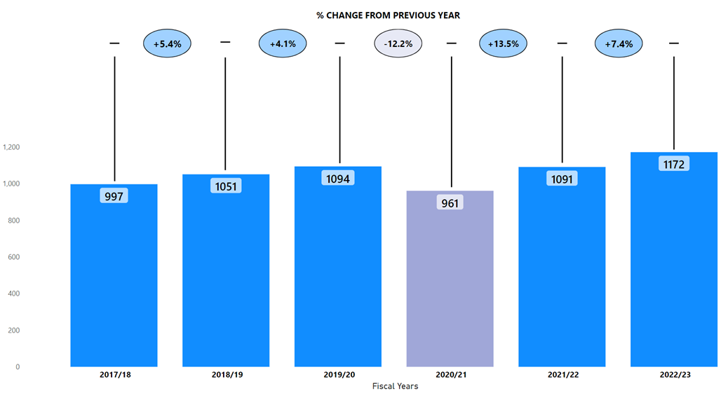Recent rape (rape that has occurred within a year of being reported to Police Scotland) is at its highest level over the reporting period (see above). There have been a total of 1,172 recent rapes in 2022/23 which is an increase of 12.8% (133.2) from the five year mean and an increase of 7.4% (81) from the previous year.
Understanding the association between increased reporting and increased crime is a complex area of analysis. Police Scotland remain committed to understanding the root causes and associations between increased crime and increased reporting in order to keep people safe.

Key Insight 2: Time Spent at Incident Types
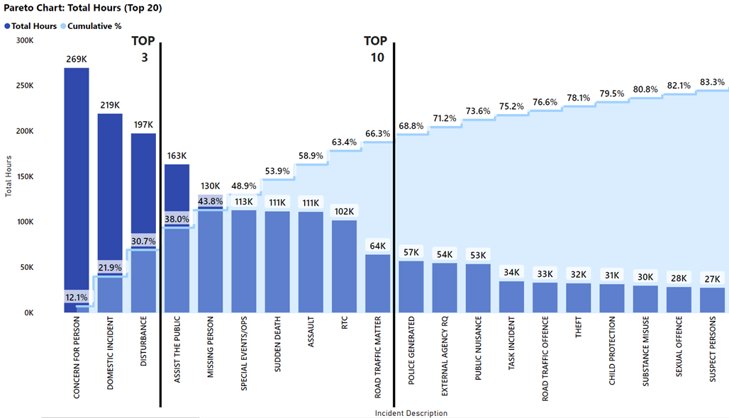
The previous chart can be used to identify and focus improvement work on demand intensive incidents in terms of the time deployed at different incident types. In 2022/23, around 80% of the total hours at incidents was spent at the 20 incident types shown above.
Further exploration highlights that the top ten incident types account for around 66% of this total hours at incidents and Police Scotland’s top three incident types account for almost a third of this time spent at incidents. Police officers were deployed for around 269,000 hours to concern for person incidents, of which only around 9% result in a crime being raised.

Key Insight 3: Overall Crime Decreases from Previous Year and Five Year Mean
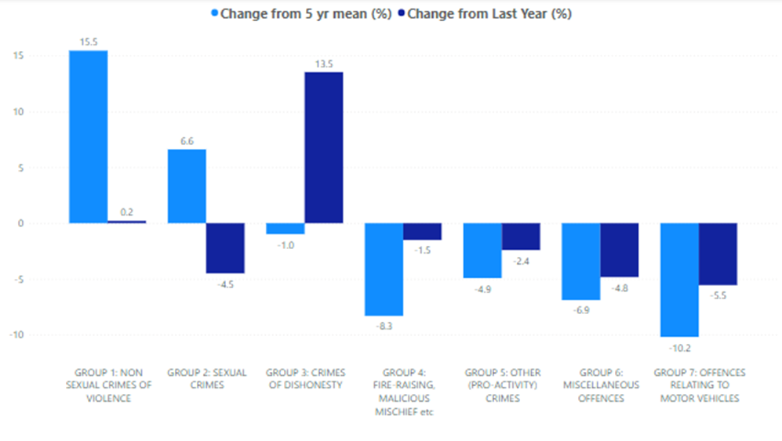
There have been a total of 350,590 crimes and offences recorded in 2022/23, this is a decrease from the previous year of 0.7% (2,405 fewer) and a decrease from the five year mean of 5.6% (20,638 fewer).
Only two crime groups have seen an increase from the previous year; Group 1: Non Sexual Crimes of Violence (up 0.2%, 16 more) and Group 3: Crimes of Dishonesty (up 13.5%, 9,287 more). However, while Group 1 has also increased from the five year mean, Group 3 has not – having decreased from the five year mean.
The decrease in Group 3 from the five year mean can be largely attributed to housebreaking (including attempted) decreasing year on year until 2022/23, where Police Scotland have seen an increase from the previous year (up 1.2%, 76 more). Housebreaking (including attempts) would have also contributed to the overall increase from the previous year for Group 3.
The increase in Group 1 is largely driven by the introduction of Domestic Abuse Scotland Act crimes in 2019 as well as more recent increases in the number of drugging crimes and threats & extortion crimes being recorded.
Although overall Group 2 crimes decreased against last year (down 4.5%, 510 crimes) it is worth highlighting that during 2022/23, rape recording noted the highest level of recording over the last six years and increased against last year (up 0.7%, 13 crimes) and the five year mean (up 6.9%, 118 crimes). Group 4, Group 5, Group 6 and Group 7 crimes are all showing decreases compared to both the previous year and the 5 year mean.

Public Confidence and Experience of Policing
Police Scotland’s Public Contact and Engagement Strategy sets out how we envisage our public contact, engagement activities and approaches to look now, and in the future. We have been clear in setting out what the public should expect from their police service and how we will continue to engage and involve communities and our partners.
Our Public Engagement and Participation Framework sets out the ways in which we will seek to engage with communities so that their insights can be utilised in meaningful ways. Working in this way aims to inform operational and strategic decision-making, ensuring that Police Scotland operates using evidence-led principles in line with our values.
The Public Confidence Governance Board oversees the development of our engagement approaches to understand public confidence within communities and inspire action, utilising robust insights from the public.
We are paying particular attention to how we reach those who are often seldom-heard or find police hard to reach; by understanding where there are opportunities to enhance engagement and working with organisations with relevant expertise.
For example, we have recently completed our public engagement activities to inform the development of our Violence against Women and Girls Strategy utilising the relationship and expertise of third sector colleagues and their networks in communities.

High-level overview
We continue to engage and involve the public, communities and partners in policing through our continuous national surveys and other engagement activities.
Your Police 2022/23 survey – our local police survey for this year continues to receive a robust and representative response from the public and communities. Anyone who lives in Scotland can influence local policing in their area through this survey. We use the feedback to understand public confidence, where we can improve and build on what we are doing well, and inform opportunities for partnership working and collaboration.
User Experience Survey – our independent survey to measure and enhance people’s experience of contacting Police Scotland, administered by Progressive Partnership Ltd. The survey is sent via text message to a sample of people who have made contact with police each month. This survey receives approximately 1,200-1,400 responses each month and was expanded to include those engaging with our complaints process. We are actively exploring ways to expand our engagement with people who contact policing in a range of contexts using this approach, for example, victim-survivors of domestic abuse.

Public Insights, Research and Engagement Activities
Public insights are considered at the Strategic Leadership Board for executive oversight and action. Data and insights are presented to Regional Delivery Boards which include local policing divisions in the north, east and west regions and directly with local policing divisions for improvement planning and scrutiny.
We continue work with partners and other relevant stakeholders to enhance our reach. Feedback and insight helped shape the Annual Police Plan for 2022/23 and all 32 Local Police Plans as they launch in April 2023 for 2023-26.
Other research and engagement activities to support policing in applying public insights in practice and responding to the needs of communities include:
Commissioned academic research We have supported research with seldom-heard communities to understand how we can improve our engagement practice in supportive and appropriate ways. The joint research fund between Police Scotland, the Scottish Institute of Policing Research and the SPA awarded four studies which will be reported on in Quarter 4. These include:
Policing with Empathy: In conversation with LGBTQ and young people from disadvantaged backgrounds (Abertay University);
Refugee and asylum-seeker experiences, trust and confidence with Police Scotland (Queen Margaret University);
Inquiring together - collaborative research with BAME communities and serving officers (Dundee University); and,
Accounting for complexities - an intersectional approach to enhancing spolice practitioner reform (University of Glasgow).
The studies provide practical guidelines and approaches for policing to enhance engagement and confidence within communities and work is underway throughout the service and through the Public Confidence Governance Board to utilise the research outputs and learning in the most appropriate ways.
Established reference sub-groups to implement actions for enhancing public and community engagement. Emerging activities include:
Enhancement of local communications to inform local communities about policing in their areas and how local concerns are being addressed;
Colleague engagement and involvement through an internal campaign to recognise and reinforce positive behaviours that are valued by the public and communities;
Capturing colleague experience of managing public contact and community engagement to ensure colleagues are well equipped and to address any gaps in service;
Shared learning of practice through greater visibility and organisational oversight of activities within communities to measure outcomes and progress; and
Ongoing development of our public engagement and participation framework to support operational colleagues policing in a diverse Scotland – the framework is co-designed with officers, staff and communities.
Piloting of innovative approaches to build solutions together. For example, Police Scotland is working with Scottish Government and Caithness Voluntary Group to pilot a participatory grant scheme in the Caithness area within Highland and Islands Division. This has involved communities coming together to respond to local needs and inspire collective action to improve safety and wellbeing within the local area. £33,815 was distributed to 14 community groups in December 2022 to fund their ideas seeking to respond to community need and safety and wellbeing challenges. We are reviewing this pilot and are aiming to develop other initiatives that build collaborative relationships with communities in the future.
Our Your Police survey continues to be the largest of its kind in the UK and involves the public in a conversation about policing and their local community. Responses are reviewed regularly by our Executive and service leads and have helped us act quickly in relation to emerging issues and community concerns.
We have compared our data with other national public surveys to ensure that Your Police continues to provide robust insights which support effective and high quality policing appropriate to the needs of communities throughout Scotland. Key activities have included:
Enhanced local police presence at identified locations with a focus on crime prevention and road safety. Police visibility and presence is important in making people feel safe.
Keeping local community partners engaged and involved on a regular basis, through local police scrutiny boards in each local authority area – using the data to design an appropriate policing response for local needs and providing a multi-agency response to cross sector themes.
Shaping our communications and advice nationally and in local areas in response to concerns and feedback from the public – helping people stay safe. A new video on what happens when someone calls 101 was promoted online in November and December 2022 in response to public feedback about long wait times and police accessibility.
Providing information and advice on issues like hate crime, housebreaking and responsible use of vehicles (including off-road bikes and scooters) to reassure all communities.

Your Police Survey
Your Police received 14,969 responses between 12 April 2022 when it opened and 31 December 2022. This includes 85 British Sign Language (BSL) responses. The survey continues to be representative of the population by age, gender, disability and geography. The Your Police survey influences local policing by enabling the public to highlight areas of concern, good practice and informs our approach to working with local partners. We gather data on public confidence and perceptions of local policing levels through this survey.
The Research and Insight team is responsible for the design and delivery of this survey. Promotion is supported by Corporate Communications; Partnerships, Prevention and Community Wellbeing, local policing, and many external partners in maximising engagement with Scotland’s diverse communities. It is important to us that we make our public engagement activities inclusive so that our services meet the needs of the communities we serve.

Public Confidence
Our Your Police survey continues to receive a high number of comparable responses every quarter. From April 2022, the survey received 945 responses in Quarter 1 and 10,243 responses in Quarter 2, with public confidence levels recorded at 51% and 52% respectively. Quarter 3 received 3,781 responses with public confidence levels recorded at 49%.
In April 2022, a public confidence index score was introduced to be comparable with how confidence is measured in the Scottish Crime and Justice Survey, YouGov and The Mayor’s Office for Policing and Crime (MOPAC). The index score accounts for all of the responses (from ‘strongly disagree’ to ‘strongly agree’) excluding the ‘don’t know’ responses by assigning numerical values and converting the overall response average into a percentage value.
For comparison, a YouGov survey asks respondents about “confidence in the police to deal with crime in local area”. In Quarter 3, the YouGov figure for Scotland was 46% (respondents who had a lot of confidence and respondents who had a fair amount of confidence).
In addition, 49% (n=5,350) of YouGov survey respondents across the UK thought that “generally speaking, police were doing a good job” in Quarter 3. The YouGov figure for Scotland in Quarter 3 was 49% (n=460).
The confidence level derived from Your Police is also comparable to confidence measures in the Scottish Government’s Scottish Crime and Justice Survey and from other UK policing organisations, most notably the Mayor’s Office for Policing and Crime (MOPAC).
We know from our own research and academic studies that levels of public confidence and experience of contacting and interacting with police are not always connected. While confidence is likely to fluctuate, levels of satisfaction with the service Police Scotland provides in communities is gathered by our independently administered User Experience Survey. Levels remain positive and consistent. Overall satisfaction with contacting the police was at 69% in Quarter 3.
Figures gathered via Your Police shows just under one third (31%) of respondents reported they ‘didn’t know’ or ‘neither agreed nor disagreed’ that they were confident in their local police. This proportion reflects that a substantial number of respondents who completed the survey had not interacted with police recently or had no opinion regarding their confidence in policing.
These findings show that although public confidence is important to measure, it is not a reliable indicator of policing performance. Service quality has remained consistent even though confidence levels have fluctuated throughout each Quarter, and over recent years. Public confidence is not always based on contact and engagement with police, but instead on perceptions of local policing and crime, and to a lesser extent, the wider policing narrative in society, nationally and internationally.
Our statistical analysis shows public confidence is associated with other factors measured in our Your Police survey. There is a strong relationship between public confidence and someone’s perception of police doing a good job in local area, perception of police listening to concerns of local people, and perception of police dealing with issues affecting local area. As these perceptions change, public confidence is likely to be affected.
A moderate relationship exists between public confidence and perceptions of police officers being friendly and approachable, levels of respect for local police, feeling of safety and concern about crime. Moderate correlations indicate that while there exists a relationship between factors, they affect each other to a lesser extent compared to strongly related variables.

Strong Correlation with Public Confidence
Public Opinion Statements | Quarter 1 2022/23 (n=945) | Quarter 2 2022/23 (n=10,243) | Quarter 3 2022/23 (n=3,781) | Change from last Quarter
Police doing a good job in local area | 30% | 32% | 29% | -3% point
Listening to concerns of local people | 31% | 32% | 28% | -4% point
Dealing with issues affecting local areas | 24% | 23% | 21% | -2% point

Medium Correlation with Public Confidence
Public Opinion Statements | Quarter 1 2022/23 (n=945) | Quarter 2 2022/23 (n=10,243) | Quarter 2 2022/23 (n=10,243) | Change from last Quarter
Police officers being friendly and approachable | 64% | 64% | 60% | -4% point
Having respect for police in local area | 73% | 72% | 68% | -4% point
Feeling safe in local area | 79% | 83% | 78% | -5% point
Concern about crime | 61% | 56% | 58% | +2% point
Our findings show that confidence can be influenced by geographic and demographic factors. Whilst we capture a national level of confidence, there is much nuance within this picture. We know, for example, that people living in areas affected by poverty and where there are higher numbers of people affected by social injustice are less likely to feel confident in the police.
This is reflected across the UK and is evidenced-based. Work continues, in partnership with the Scottish Institute for Policing Research, the Centre for Policing Research and Learning, the Scottish Police Authority, and alongside community organisations to enhance our understanding of public confidence and trust in policing.
Understanding public confidence is important to us as it is one of the ways that we respond to emerging issues within communities. Maintaining confidence in policing is vital to ensure that we are policing in line with our values whilst maintaining or building trust and legitimacy for every person in our society.

Factors influencing public perceptions and confidence in local police
Survey respondents in Quarter 3 2022/23 who said they feel unsafe in their local area (n=699) raised similar themes as in Quarter 2 2022/23. The following themes remain important, on which we are taking action and using to inform local and strategic decision-making, with plans and projects for sustaining change over the long term:
Police visibility and presence
51% of respondents who felt unsafe in their local area highlighted greater police visibility as a way of making them feel safer and providing reassurance. Police presence is often mentioned within the context of prevention and targeting of drug-related crime and anti-social behaviour.
“A visible presence on the streets would be reassuring”
The type of visibility or accessibility (e.g. physical, online and virtual) was not always specified in the responses but a majority specifically mentioned physical presence including more foot patrols in local areas, at specific times (e.g. after dark/weekends) and locations (e.g. in parks, around transport hubs, and local crime ‘hot spots’) where communities tend to feel less safe.
“More of an approachable presence - not just sitting in cars. Engage with locals”
The importance of police visibility in local areas was most prevalent across respondents from areas of Scotland most affected by poverty (people living in SIMD 1 and 2 areas), with 46% of respondents living in these areas mentioning police visibility, compared to 39% of respondents from more affluent areas (people living in SIMD 4 and 5).
“I think police on the beat walking around has more of an impact because you physically see them, you get to know them, you feel safer, have a gab with them.”
Community engagement and being kept informed
21% of respondents who felt unsafe in their local area highlighted community policing and local engagement as important.This is highlighted alongside police visibility by respondents - for example, informal and friendly conversations with police officers on what matters to communities in local areas. Respondents highlight the importance of policing being accessible locally, having staff who are familiar with local needs and for training to be relevant to the specific issues affecting local communities. The public would like to be familiar with local officers and seek effective and trusting relationships.
“Be more visible. Target Social Media more as a means of communication. There’s lots of local knowledge out there however this appears to be overlooked. Engage more with communities.”
11% of respondents who felt unsafe in their local area highlighted that how we ‘show up’ is important. Police officers and staff should continue to bring empathy and understanding to their interactions with the public. Respondents expect people working in Police Scotland to be adequately trained, caring and professional. This includes cultural intelligence in understanding the lived experience of every individual. Respondents refer to how we are building trust and positive changes within seldom-heard communities.
“Continue to work with partners, supporting vulnerable people to access support. Continue to increase visibility, not just when events on or beach busy.”
7% of respondents who felt unsafe in their local area highlighted communicating what we are doing as important. Respondents identified taking action on local issues as one of the key communication priorities. The public expect police to react promptly to reports and would like to be informed about when and if police are attending. Respondents also want to be updated on the course of action of their incident.
“The police need to communicate with communities and we know there are some amazing officers only because we have happened upon them! Most people - unless they are on some local community group do not get to hear about local initiatives/plans”
“Better communication - more updates for the community via Police website or Facebook as to what is being/has been done regarding various incidents, and better updates for the victims of thefts themselves. Knowing about or reporting incidents and having no follow-up is disheartening and does not lead to trust in the police.”
Work is progressing through local divisions to respond to these concerns in local areas. For example, divisions are keeping their local communities informed about how crime is being managed and prevented, including you said we’re doing feedback on social media channels and in local newspapers via Divisional Commander columns.

Main areas of concern for local communities
There were 3,177 responses in Quarter 3 to the open-ended question – “What, if anything, worries you about your local area?” The common themes that emerged from analysis of these responses are set out as follows:
39% of respondents mention anti-social behaviour involving alcohol, littering and fly tipping, young people causing disturbances and noise complaints. It’s important to have clear and accessible signposting to support and connect individuals with the right services delivered by a range of community partners. People may ask police to help with matters which are important to them, but a police response might not be the appropriate service or be able to help in ways which are required.
“Organised groups of youths visiting various towns and villages causing damage to property and littering. Broken glass from drink and drugs sessions in the park, Buckfast bottles etc. left almost weekly in their wake that local volunteers have to clean up.”
28% of responses highlight speeding and driving related offences – including use of motorised scooters and dirt bikes cited by respondents who also commonly express their concerns with speeding and reckless driving in their local area.
“Young children running wild and free, going up and down the streets on motorbikes with no helmets on”
23% of respondents mention drug crime and related harms – the presence and effects of drugs within local communities and how local police are tackling drug dealing is crucial for community safety. The increased visibility of drug dealing and drug taking, particularly during the pandemic, has been a consistent theme over previous quarters.
“The amount of heroin addicts around that have no concern for hiding what they do. Needles lying around, people going to doors at all hours of the night shouting what they are doing. Fighting, knife crime.”
15% of respondents are concerned with little physical presence of the police – people would like to see regular foot and cycle patrols in their local areas. Several comments mentioned the need for police being visible and easily accessible within local communities.
“Low police visibility. Visibility of uniformed officers is reassuring and can and may be preventative.”
12% of respondents express concern about local theft and break-ins and want to be aware of the preventative measures they can take to keep their homes and businesses safe.
“As with most rural communities, thefts are a concern.”
“People trying doors and cars in the early hours of the morning.”

What we are doing well:
Your Police enables the public to tell us about our approach, which includes what we are doing well and getting right. In Quarter 3, there were 2,472 open-ended comments to the question - “What are the police doing well in your local area?”
Police visibility, presence and accessibility
Responses relate to the impact of police visibility presence and accessibility. Respondents’ value consistent service delivery in the difficult circumstances policing is operating in. There is appreciation for local policing and the job they do within local communities to keep people safe, including crime prevention and protecting people who may be vulnerable.
“Assisting with local events, taking patrols per day, protecting locals against crime, great sensitive approach to crime victims.”
Many responses commend the enhanced visibility of police in some areas over recent months and highlight this as positive. Comments commonly mention increased responsiveness and appropriate action to reported crimes and other incidents.
“Police station very close by. You can see police walking the streets keeping an eye on the community. Also I know they hold cups of tea and blether sessions with the local community which helps build positive relationships.”
Community engagement and being kept informed
Respondents highlighted the value of community policing and what community officers are doing to understand and tackle challenges in local areas together with partners and communities. There is appreciation for being kept up to date with the reported issues. Respondents value police informing the communities on local initiatives and being kept up to date with the work of the police.
“They are responding to local concerns. Working in partnership with other agencies and are generally approachable and personable.”
“The community police are really active and try to show a presence in local areas. They develop excellent relations with other services.”
Values and behaviours
Respondents highlighted professionalism, compassion and care of the officers as an important factor, having an impact on their perception of the local police. Positive values and behaviours, particularly friendly and approachable policing, showing an understanding and knowledge of the issues affecting local communities, was observed and appreciated by respondents.
“On a few occasions where I’ve had the need to contact them, officers have been approachable and friendly whilst remaining professional and being extremely helpful/reactive - I feel that if I needed to call them in an emergency, they would be there quickly and with a genuine desire to help.”
“Tbh I've only had one encounter and the police were friendly and professional, and the matter dealt with quickly - even a follow up call to let us know what was happening. Otherwise, out of sight out of mind, and when in sight always professional and friendly!”

User Experience Survey

How the public are experiencing their police service
The User Experience Survey, administered by Progressive Partnership Ltd, reaches a representative sample of 1,200 individuals monthly. The survey is delivered via SMS to those who have contacted Police Scotland in the previous month. In this quarter, 3,933 respondents were surveyed about their experience of the policing service provided, from initial contact through to overall satisfaction.
The findings show continued high levels of satisfaction with contacting the police as follows:
Ease of contact – 73%
Initial contact treatment by C3 staff – 85%
Feeling properly understood – 86%
Being provided with the appropriate response – 64%
Satisfaction with attending officers – 81%
Feeling adequately informed about case progress – 51%
Overall satisfaction with Police Scotland – 69%

Measures of Progress towards Strategic Outcomes

Strategic Outcome 1
Threats to public safety and wellbeing are resolved by a proactive and responsive police service.
Objectives:
Keep people safe in the physical and digital world
Design services jointly to tackle complex public safety and wellbeing challenges
Support policing through proactive prevention
All data is classed as Management Information and is not considered official statistics. All data is sourced from Police Scotland internal systems.

Violent Crime
Overall violent crime | 2021/22 YTD | 2022/23 YTD | % Change from Previous Year | 5 Year Mean | % Change from 5 Year Mean
Number of crimes | 48,424 | 47,882 | -1.1% | 47,897.0 | 0.0%
Number of detections | 32,627 | 33,177 | +1.7% | 33,269.0 | -0.3%
Detection rate | 67.4% | 69.3% | +1.9% point | 69.5% | -0.2% point
Note: Overall violent crime is comprised of: murder, culpable homicide (common law), attempted murder, serious assault, robbery, common assault and common assault (of emergency workers).
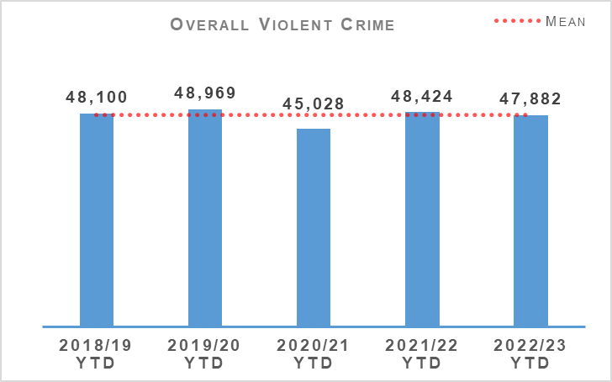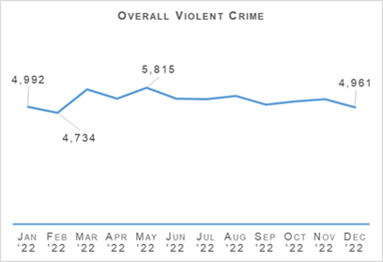
The number of overall violent crimes recorded in April to December 2022 continue to be broadly similar to recent years. The year 2020/21 remains an exception to this due to COVID-19 and related lockdowns leading to a reduction. April to December 2022 has seen recorded violent crime levels consistent with pre-pandemic years. Common assaults account for 91.9% of overall violent crime.
There have been 31 homicides recorded during the April to December 2022 period. This is ten fewer than last year, and sixteen crimes fewer than the five year mean. The detection rate for homicides in this period is 103.2% (rate is above 100% due to one homicide crime recorded before April 2022 being marked as detected during the current period).
There have been 200 attempted murders recorded during this period. While this is seven more than in the same period last year, it is down 3.5% from the five year mean. The detection rates for attempted murder is at 98% which is an increase from last year and the five year mean.
The number of serious assaults recorded this year is fewer than last year by 11.0% and also fewer than the five year mean by 15.9%. The detection rate for serious assaults has improved this year and currently sits at 78.4% - an increase of 4.7% points from last year and 2.8% points from the five year mean.
There were 0.3% fewer common assaults recorded in this period than the same period last year. The level of common assaults between April to December 2022 is consistent with this period over recent years with the exception of 2020/21. The detection rate for common assaults is 68.5% which is an increase of 1.9% points from last year.
Included in these figures are nine crimes of serious assault of a retail worker and 1,162 common assault of a retail worker. There have also been 1,452 recorded crimes of threatening and abusive behaviour of a retail worker during this period.
There have been 1,166 robberies recorded so far this year. This is 7.1% fewer than last year, 7.5% fewer than the five year mean and the lowest number of robberies recorded in this period for the last six years.
Partnerships, Prevention & Community Wellbeing (PPCW) Division continues to support Scottish Government in the implementation of part 4 of the Offensive Weapons Act 2019 which has been delayed until 27 March 2023. Part 4 will make the possession of certain offensive weapons illegal in both a private and public place, hence the reason the Scottish Government led Offensive Weapon Surrender and Compensation Scheme earlier this year.

Non Sexual Crimes of Violence (Group 1)
Non Sexual Crimes of Violence (Group 1) | 2021/22 YTD | 2022/23 YTD | % Change from Previous Year | 5 Year Mean | % Change from 5 Year Mean
Number of crimes | 7,650 | 7,666 | +0.2% | 6,639.8 | +15.5%
Number of detections | 4,909 | 4,736 | -3.5% | 4,735.4 | +0.0%
Detection rate | 64.2% | 61.8% | -2.4% point | 71.3% | -9.5% point
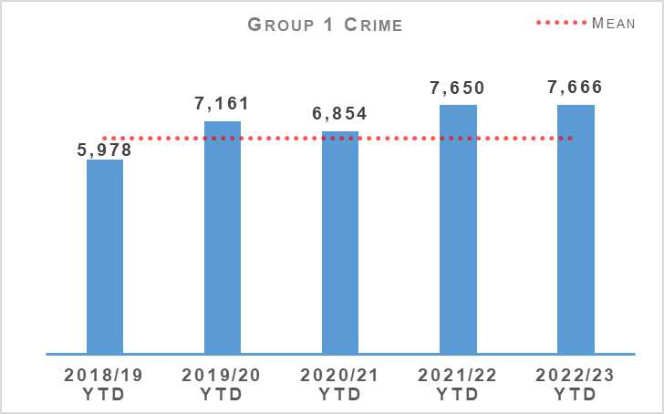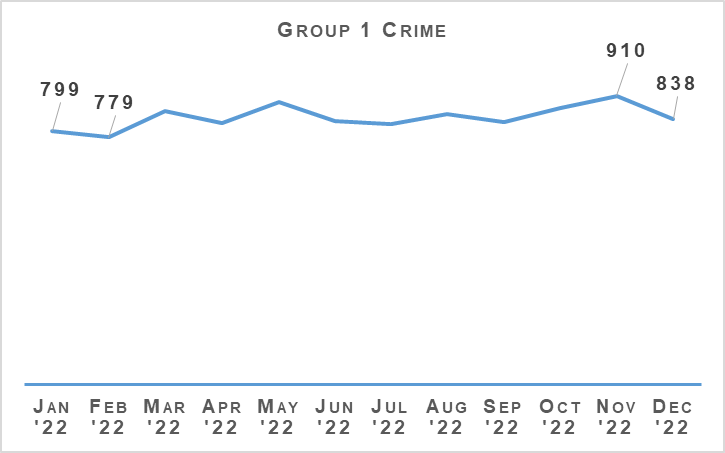
The number of non sexual crimes of violence is broadly similar (+0.2%) compared to last year. While this crime group is at the highest level in recent years and 15.5% above the five year mean it is important to note that this rise in total Group 1 is predominantly coming from crimes such as those under the Domestic Abuse Scotland Act (DASA), threats & extortion and drugging, all having a noticeable impact as detailed as follows.
During this period 1,341 DASA crimes have been recorded, 19 more than last year. This is the highest number of DASA crimes in the April to December period since the crimes were introduced in April 2019. If DASA crimes are not included when considering total Group 1 crime figures then there has only been a 7.8% increase compared to the five year mean.
There have been 1,380 threats and extortion crimes recorded between April and December 2022 which is an increase of 38.6% from last year and 187.3% from the five year mean. As has been previously highlighted, these figures include attempted threats and extortions where no financial harm took place.
Reporting of these attempts, even where there has been no harm, is useful for identifying new methods and trends being used by online offenders and in updating and improving preventative messaging accordingly.
Higher levels of drugging crimes than usual continue to be recorded following national media reporting of concern around drugging by injection since October/November 2021. There have been 228 drugging crimes recorded in the April to December 2022 period. While this is fewer than the 261 crimes recorded last year it continues to be significantly higher than the five year mean for this period of 65.2 which is itself significantly skewed by 2021/22 figures.
The increases in crimes such as drugging and threats & extortion, which are difficult to successfully detect, continues to be a significant contributing factor in the decrease in the overall detection rate for Group 1 crime.

Public Protection – Equality Outcome 4
Overall Sexual Crime (Group 2) – Equality Outcome 4 | 2021/22 YTD | 2022/23 YTD | % Change from Previous Year | 5 Year Mean | % Change from 5 Year Mean
Number of crimes | 11,347 | 10,837 | -4.5% | 10,164.4 | +6.6%
Number of detections | 6,027 | 5,895 | -2.2% | 5,842.0 | +0.9%
Detection rate | 53.1% | 54.4% | +1.3% point | 57.5% | -3.1% point
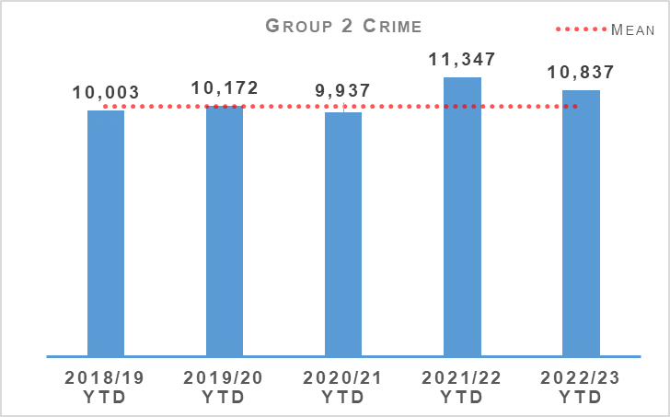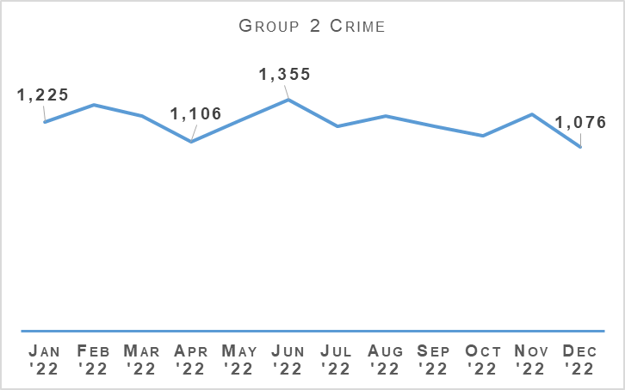
Sexual crime decreased during the reporting period compared to the same period last year. Between April and December 2022, sexual crime decreased by 4.5% (510 fewer crimes) when compared to last year. However sexual crimes, like previous quarters, increased against the five year mean (up 6.6% or 672 more crimes). December 2022 is the month where the fewest number of sexual crimes (1,076 crimes) were recorded over the 12 month period. June 2022 was the month that recorded the most sexual crimes in the 12 month period.
The number of detections decreased compared to last year, down 2.2% (132 fewer detections) however, noted an increase against the five year mean (up 0.9%).
The decrease in sexual crimes is driven by reductions in sexual assault of a female under 13, communicating indecently, cause to be present sex act/to look at sex image – M&F (<13), coercing a person into being present/looking at sexual activity and threatening to disclose an intimate image. Voyeurism and Conspiracy to commit a sex act outside the UK also contributed to the overall decrease in sexual crime.
Taking, distribution, possession etc. of indecent photos of children, sexual assault of male and female over 16 and rape of a female over 16 recorded notable increases when compared to the same period last year.
Overall Sexual Crime (Group 2) – Equality Outcome 4 | 2021/22 YTD | 2022/23 YTD | % Change from Previous Year | 5 Year Mean | % Change from 5 Year Mean
Number of recent crimes | 8,712 | 8,538 | -2.0% | 7,669 | +11.3%
Number of non recent crimes | 2,635 | 2,299 | -12.8% | 2,496 | -7.9%
Proportion of Group 2 crime non recent | 23.2% | 21.2% | -2.0% point | 24.6% | -3.4% point
Note: Non-recent sexual crimes are defined as crimes that were reported more than one year after they were committed.
Recent and non recent sexual crimes decreased compared to the same period last year with the overall proportion of non recent also decreasing.
Non recent reporting noted the greatest decrease, down 12.8% (336 crimes) while recent reporting remained stable with a decrease of 2.0% (174 crimes). The proportion of non recent reporting of sexual crime continues to narrow, indicating recent reporting being the driver behind sexual crime.
When comparing the change against the five year mean, non recent crimes also note a decrease (down 7.9%) however recent crimes are up (11.3%), emphasising the increase in recent reporting of sexual crime.

Rape
Rape – Equality Outcome 4 | 2021/22 YTD | 2022/23 YTD | % Change from Previous Year | 5 Year Mean | % Change from 5 Year Mean
Number of crimes | 1,807 | 1,820 | +0.7% | 1,702.0 | +6.9%
Number of detections | 961 | 946 | -1.6% | 932.0 | +1.5%
Detection rate | 53.2% | 52.0% | -1.2% point | 54.8% | -2.8% point
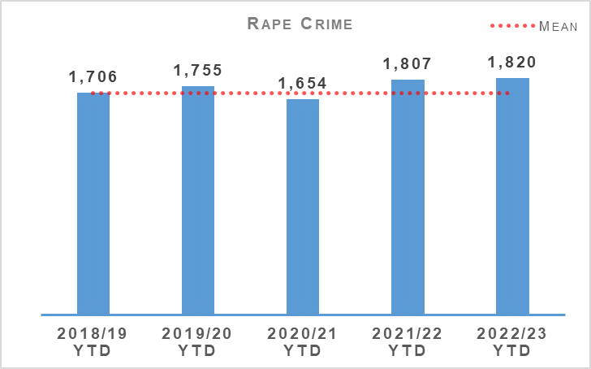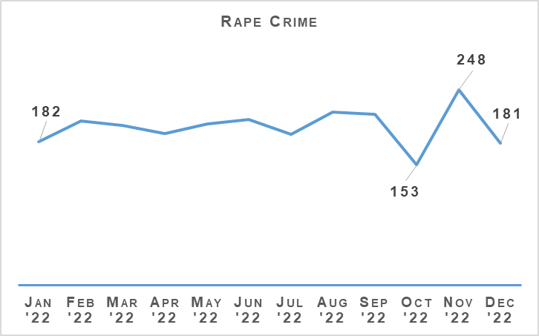
Year to date, 2022/23 has noted the highest level of recorded rapes over the last six years. During the reporting period rapes have increased 0.7% (13 crimes) compared to last year and also increased by 6.9% (118 crimes) on the five year mean.
In the last quarter we have noticed both the lowest and highest monthly figure noted during the 12 month period. Monthly rape levels fell to the lowest point during October 2022 (153 crimes) in contrast to November where 248 crimes were recorded, the highest noted in the 12 month period.
Rape of a female over 16 is the driver behind the overall increase (up 55 crimes, 4.8%) of rape. Rape of a female over 16 continues to rise noting the highest level of reporting over the last six years.

Rape – Equality Outcome 4 | 2021/22 YTD | 2022/23 YTD | % Change from Previous Year | 5 Year Mean | % Change from 5 Year Mean
Number of recent crimes | 1,091 | 1,172 | +7.4% | 1,039 | +12.8%
Number of non recent crimes | 716 | 648 | -9.5% | 663 | -2.3%
Proportion of Group 2 crime non recent | 39.6% | 35.6% | -4.0% point | 39.0% | -3.4% point
Note: Non-recent rape crimes are defined as crimes that were reported more than one year after they were committed.
Non recent reporting of rape decreased by 9.5% (68 fewer crimes) compared to last year and by 2.3% against the five year mean. The proportion of non recent rape has also decreased, down 4.0 percentage points on last year and down 3.4 percentage points on the five year mean.
Recent rapes increased by 7.4% (81 more crimes) against last year and by 12.8% against the five year mean.

SOLO VRI Upskill Course
As part of the SOLO VRI Upskill Short Life Working Group an agreement was reached that the SOLO VRI upskill course would be a one day course at various training facilities throughout the force. The course provides learners with the requisite skills and knowledge required to conduct investigative interviews of survivors of rape and sexual offences under VRI conditions.
Following the course, students will undergo a skills based practical exercise within their division and also have their first two interviews validated. The skills based practical exercise and validation processes will be conducted by Divisional PPU supervisors and coordinated by National Rape Review Team.
On the 05 December 2022, approximately 90 conventional SOLO officers attended the first upskill course. Approximately 100 students will attend the next course in March 2023.

Revised Rape Crisis Scotland (RCS) Feedback process
RCS feedback process has been expanded to include survivors who are supported via the National Advocacy Project (NAP) as well as the RCS helpline. The NAP feedback questions focus on exploring survivors’ experiences with the investigation and progression of the case to COPFS.
The survivor will also be provided the option to complete the RCS Helpline questions if they have not had the opportunity to do so before. The aim of the feedback questions are to explore with the survivor whether the Police were trauma-informed in their approach, with the aim of improving on best practice.

Child Sexual Abuse (online)
Child Sexual Abuse (Online) – Equality Outcome 4 | 2021/22 YTD | 2022/23 YTD | % Change from Previous Year | 5 Year Mean | % Change from 5 Year Mean
Number of crimes | 1,425 | 1,433 | +0.6% | 1.328.2 | +7.9%
Number of detections | 911 | 954 | +4.7% | 896.2 | +6.4%
Detection rate | 63.9% | 66.6% | +2.6% point | 67.5% | -0.9% point
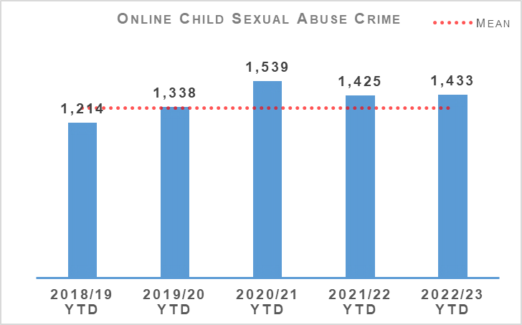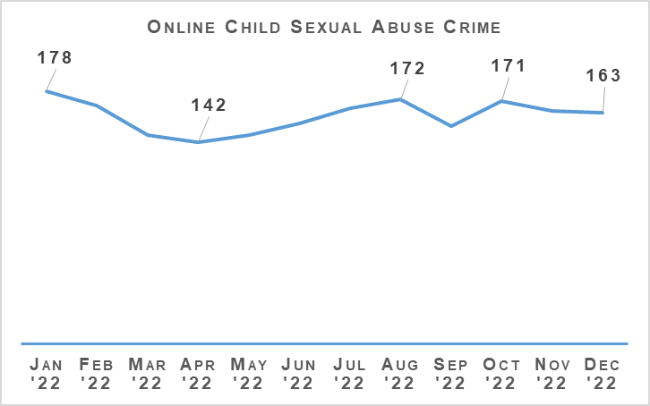
During the period April and December 2022, 1,433 online child sexual abuse crimes were recorded in Scotland, an increase of 0.6% (eight more crimes) compared to last year and an increase of 7.9% (105 crimes) on the five year mean.
The detection rate has increased compared to the previous year, up 2.6 percentage points to 66.6% but decreased compared to the five year mean (down 0.9 percentage points).

Child Sexual Abuse (online) – Crime Types
Child Sexual Abuse (Online) – Equality Outcome 4 | 2021/22 YTD | 2022/23 YTD | % Change from Previous Year | 5 Year Mean | % Change from 5 Year Mean
Cause to be Present Sex Act/To Look at Sex Image -M&F (< 13) | 273 | 223 | -18.3% | 235.8 | -5.4%
Cause to be Present Sex Act/Look at Sex Image -M&F (13-15) | 123 | 132 | +7.3% | 123.0 | +7.3%
Communicate Indecently/Cause see/hear Indec Comm - M&F (< 13) | 287 | 210 | -26.8% | 223.8 | -6.2%
Communicate Indecently/Cause see/hear Indec Comm – M&F (13-15) | 200 | 235 | +17.5% | 203.0 | +15.8%
Grooming of children for the purposes of sexual offences | 81 | 60 | -25.9% | 68.6 | -12.5%
Taking, distribution, possession etc. of indecent photos of children (from Apr 2011) | 461 | 573 | +24.3% | 474.0 | +20.9%

Taking, distribution, possession etc. of indecent photos of children (from Apr 2011) continues to note high levels of reporting, increasing by 24.3% (112 crimes) compared to last year and is similar to the highest level reported in 2020 (577 crimes). An increase on the five year mean is also noted, up 20.9% (99 crimes).
Communicate Indecently/Cause see/hear Indec Comm – M&F (13-15) (up 17.5%, 35 crimes) and Cause to be Present Sex Act/To Look at Sex Image - M&F (13-15) (up 7.3%, 9 crimes) are the other classifications within online child sexual abuse to increase compared to the previous year.
Decreases against last year have been noted in the following; Communicate Indecently/Cause see/hear Indec Comm – M&F (<13) (down 26.8%, 77 crimes), Cause to be Present Sex Act/To Look at Sex Image -M&F (< 13) (down 18.3%, 50 crimes) and Grooming of children for the purposes of sexual offences (down 25.9%, 21 crimes).

Demand
Police Scotland continues to experience sustained increases in Online Child Sexual Abuse & Exploitation (OCSAE) cases. This is statistically mirrored across wider UK Law Enforcement. We proactively continue with our established National Online Child Abuse Prevention (NOCAP) process and investigations.
The premise of NOCAP is to prevent online child abuse by targeting individuals who are suspected of posing a risk to children by committing sexual offences.
This is achieved by developing intelligence from certain types of Online Child Sexual Abuse and Exploitation (OCSAE) referrals, known as industry or volume referrals, which originate from the National Centre for Missing & Exploited Children (NCMEC) and are referred into Police Scotland via the National Crime Agency (NCA).
These referrals have risen significantly in recent years albeit 2022 shows an initial plateau as per the following table:

OCSAE Referrals via NCA | 2015 | 2016 | 2017 | 2018 | 2019 | 2020 | 2021 | 2022 | 2015 – 2022 % Change
Total referrals | 509 | 817 | 1,581 | 1,346 | 1,961 | 2,422 | 3,111 | 3,054 | n/a
% change from previous year | n/a | +60.5% | +93.5% | -14.9% | +45.7% | +23.5% | +28.4% | -1.8% | +500.0%
Between 2019 and 2022, these referrals generated a total of 4,427 investigations (equates to 41.7% allocation from the 10,610 referrals received over same time period).
3,312 or 74.8% of these were suspect investigations.
1,115 or 25.2% were Child at Risk enquiries (often a child uploading imagery themselves where it is not clear if there is associated criminality such as grooming behaviour).
These do not account for the significant number of OCSAE investigations that arise from calls from members of the public. It is more challenging to quantify these definitively.
Routine daily monitoring by the National Child Abuse Investigation Unit (NCAIU) typically shows between four and ten such calls a day, but assumes accurate placement of ‘Cyber’ or ‘OCSAE’ markers on systems to allow incidents to be counted.
Another feature is that a report of a contact sexual offence might not highlight that the initial contact was in fact online.
Both types (industry referrals and calls from the public) are reflected in the 7.9% increase in OCSAE crimes against the five year mean.

Investigations
OCSAE investigations are conducted by both Police Scotland’s local policing teams and the National Child Abuse Investigation Unit (NCAIU). During the pandemic, Police Scotland transformed its approach to the OCSAE investigations generated through the NCMEC referrals process.
Prior to the pandemic approximately 80% of the investigations generated through this process were allocated to local policing. Now the NCAIU takes 84% of these investigations, helping to bring national consistency to risk assessment, triage and prioritisation.
Work continues in 2022/23 under Operation PARROR with enforcement action undertaken in respect of 555 NOCAP investigations since 01 April 2022. A total of 54.4% of these enforcements have led to the recovery of online Child Sexual Abuse Material (CSAM), 34.6% no recovery, and in 11% device examination remains ongoing. We have protected 621 children through this work and made 342 arrests.

Victim Identification (VID)
As per previous updates, we have professionalised our approach to OCSAE Victim Identification, moving this role under Public Protection and the NCAIU. In doing so Police Scotland has improved efficiency and support to ongoing UK wide VID investigations.
During Quarter 3, 33 VID Referrals were provided to the NCA, with 109 Referrals submitted year to date. This represents a 42% increase in referrals compared to the same period last year.

Looking Forward
OCSAE investigations are not without enduring challenges and the increased demand continues to place a strain on finite resources. Allocation and deployment of resources to this high risk area of Public Protection remains a daily task and priority. Various staff uplift proposals have been submitted via Crime and Operations Management Board (COMB) and Strategic Workforce Pan (SWP).

Partnership
Enhancement to our partnership approach to OCSAE continues, through our multi-agency Preventing OCSAE Group.
A bi-monthly meeting with Stop-it-Now!, a child protection charity who seeks to prevent OCSAE, has been implemented with NCAIU to strengthen the support and guidance that can be offered to perpetrators and their families following NOCAP enforcement.

Sex Offender Policing
Registered Sex Offenders (RSOs) | 2021/22 YTD | 2022/23 YTD | % Change from Previous Year | 5 Year Mean | % Change from 5 Year Mean
Number of Sex Offender Notification Requirements (SONR) offences committed | 365 | 408 | +11.8% | 375 | +8.0%
Number of RSO's who committed SONR offence | 331 | 351 | +6.0% | No count | No count
Number of Preventative Order offences committed (SOPO, RoSHO and equivalent issued out with Scotland) | 135 | 143 | +6.0% | 135 | +6.0%
Number of RSO’s who committed a Preventative Order offence | 109 | 100 | -8.3% | No count | No count
During the reporting period 351 registered sex offenders committed a total of 408 Sex Offender Notification Requirements (SONR) offences. This is an increase compared to the same period last year where 331 registered sex offenders committed a total of 365 SONR offences.
The number of RSOs (Registered Sex Offenders) in the community continues to grow year on year. Police Scotland’s robust and investigative approach to the policing of offenders continues to ensure that the majority are compliant with requirements and conditions imposed on them. Those who fail to comply are identified, fully investigated, and reported to COPFS by divisional Sex Offender Policing Units.
100 RSOs committed preventative order offences which is lower than last year when 109 registered sex offenders committed offences.
Engagement with Partners
The task of policing RSOs is complex, and effective engagement with partners is critical to its success. Police Scotland continue to work with other designated responsible authorities and duty to co-operate authorities under the Multi Agency Public Protection Arrangements (MAPPA).
During this quarter, the National Sex Offender Policing Unit (NSOPU) delivered a presentation to 40 Local Authority housing Sexual Offences Liaison Officers (SOLOs), and social landlord link officers. The presentation focused on how agencies could effectively work together to provide stable housing for RSOs and to mitigate the risks to the community.
A further presentation was delivered to 30 Sheriffs from Glasgow Sheriff Court at their annual CPD conference. The focus of this presentation was on how the police manage risk in the community and the benefits of Sexual Offences Prevention Orders (SOPOs).
A number of meetings with the Scottish Catholic Safeguarding Agency took place with a view to:
Formalising/strengthening/renewing links between Safeguarding Advisors and Coordinators in Dioceses and divisional sex offender policing teams.
Finalising the Information Sharing Agreements with each Dioceses.
Ensuring their policy around Safe Worship Plans in relation to RSOs is fit for purpose.
Multi-Agency Public Protection System (MAPPS)
MAPPS is a joint Home Office and Ministry of Justice programme to deliver a subject (offender) management solution which will be transformative, strategic, national and multi-agency. MAPPS will provide a step change in offender management functionality, as required by users across all agencies and areas.
Ultimately, MAPPS will replace all current ViSOR functionality and eventually allow ViSOR to be decommissioned. MAPPS will look to support Counter Terrorism Offender Managers and MARSOC (Multi-Agency Response to Serious Organised Crime) users.
Police Scotland continue to attend, and contribute to, the various groups covering planning, security and training relating to MAPPS development. Work has continued in this quarter to work alongside the Scottish Government and MAPPA partners to promote MAPPS as the means of information sharing/risk management tool in Scotland.
This work includes a bespoke Scottish Users Working Group which is an opportunity for all agencies to positively influence the development of MAPPS to ensure it suits all organisational needs for the efficient and effective joint management of the risk presented by RSOs.

Domestic Abuse
Domestic Abuse – Equality Outcome 4 | 2021/22 YTD | 2022/23 YTD | % Change from Previous Year | 5 Year Mean | % Change from 5 Year Mean
Number of incidents | 47,963 | 46,684 | -2.7% | 46,932.0 | -0.5%
Number of crimes | 30,982 | 28,500 | -8.0% | 29,798.6 | -4.4%
Number of detections | 20,265 | 17,943 | -11.5% | 19,964.0 | -10.1%
Detection rate | 67.5% | 65.0% | -2.5% point | 69.1% | -4.1% point
Proportion of incidents resulting in a crime | 42.9% | 41.5% | -1.4% point | 44.4% | +2.9% point
DASA (of female) – Number of crimes | 1,224 | 1,192 | -2.6% | n/a | n/a
DASA (of male) – Number of crimes | 98 | 149 | +52.0% | n/a | n/a
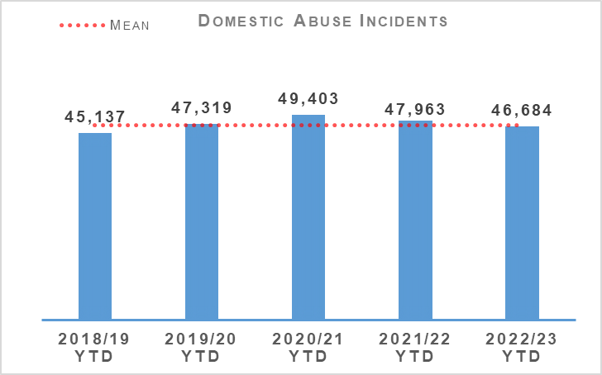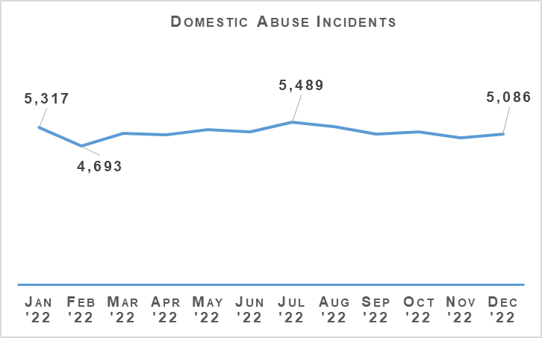
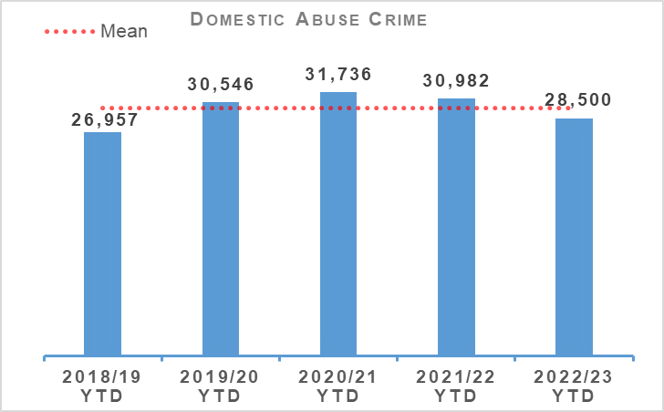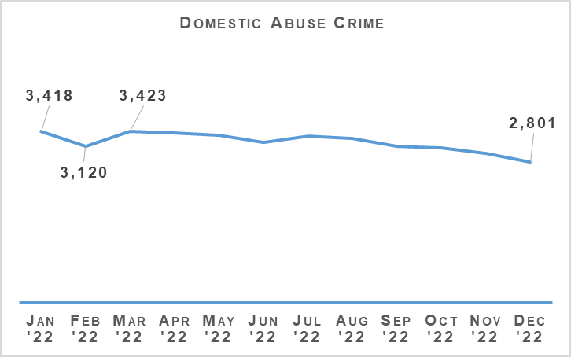
Domestic incidents and crimes remain down on last year and the five year mean. Incidents decreased by 2.7% (1,279 incidents) compared to last year and are down by 0.5% compared to the five year mean. Domestic crimes decreased by 8.0% (2,482 crimes) compared to last year and are also down 4.4% on the five year mean. Throughout the last quarter, the number of domestic crimes have decreased month on month.
Overall DASA crimes increase by 1.4% (19 crimes) driven by an increase in DASA of a male, up 52.0% (51 crimes). DASA of a female decreased by 2.6% (32 crimes) compared to the same period last year.
There have been three domestic murders recorded during the reporting period, one of which was recorded during Quarter 3.
Disclosure Scheme for Domestic Abuse Scotland (DSDAS) applications have increased by 12.1% overall with a 10.3% increase in Power to Tell (PTT) applications and a 16.3% increase in Right to Ask (RTA) applications compared to the same period last year.

Violence Against Women and Girls

16 Days of Activism
Every year from 25 November (the International Day for the Elimination of Violence against Women) to 10 December (Human Rights Day) the 16 Days of Activism raises awareness of Violence Against Women and Girls around the world.
The global campaign sees communities, non-governmental organisations and charities holding events aimed at raising awareness of Violence Against Women and Girls in an effort to influence behaviour and secure political commitment to ending it.
Police Scotland is a recognised supporter of the 16 Days of Activism Campaign with representatives from various business areas attending local and national events organised by partner agencies.
The theme of Police Scotland’s 16 Days of Activism was ‘Femicide #whatsnext’ and was supportive of key messages regarding domestic abuse. Each day of the campaign focused on different aspects and sought to encourage the public, including friends and family and those at risk, to engage with police. It highlighted services available to victims to support them.
The following are some of the events which took place, coordinated by the Domestic Abuse Coordination Unit (DACU);

Justisigns
The JUSTISIGNS 2 project is led by a consortium of European experts from Ireland, Belgium, Spain and the UK who are collaborating to undertake research within the deaf community and investigate the experiences of victims of sexual violence and crime when they interact with the police and the legal process.
DACU and Partnerships Prevention & Community Wellbeing (PPCW) have worked closely with Heriot-Watt University and their partners to deliver a number of surveys, interviews and workshops to develop a British Sign Language (BSL) glossary.
A masterclass with Police, BSL interpreters and deaf women who have experienced Gender Based Violence (GBV) was organised to endeavour to provide a better response to deaf women.
The masterclass took place as part of the 16 Days of Activism at Dalmarnock on 28 November 2022, which was very successful with a number of key learning points and best practices identified, which will be recommended.

Freedom Project – Dogs Trust
DACU have been working in partnership with the Dogs Trust Freedom Project to deliver awareness inputs to police officers about the project which supports survivors fleeing domestic abuse by offering a free and confidential dog fostering service. The project now operates across the whole of Scotland.
As well as delivering the specialist dog fostering service, the project also work to raise awareness of the connection between domestic abuse and pets, such as how they can be used as a tool for coercive control.
On 08 December 2022, as part of the 16 Days of Activism, 30 police officers from across the force attended an open day at the Glasgow rehoming centre. The feedback received from those that attended the open day was extremely positive. DACU are currently working with the project to facilitate inputs in the most rural areas of Scotland.

Foreign Nationals Video
To empower foreign national women entering the country, the DACU have worked closely with Hemat Gryffe Women’s Aid, in the development and delivery of a one minute animated video resource. This animation aims to provide support to female migrants who may not be aware they are immediately protected by law from abuse and exploitation as soon as they set foot in Scotland.
Women from minority ethnic and seldom heard communities, including women who may be refugees or recently migrated to Scotland, can be especially vulnerable to threats of exploitation and abuse.
They may be isolated by their abuser, they may not speak English as a first language and they may be reliant on their abuser as their intermediary. Their abusers may use threats of deportation or that their children will be taken from them if they report their abuse to the police.
This resource encourages women and girls who experience violence, abuse and exploitation, and those who think they may be at risk, to tell police officers, who will be able to help.
It is available in 12 languages: English (available with or without subtitles), Urdu, Arabic, Punjabi, Mandarin, Hindi, Russian, Ukrainian, Polish, Bengali and British Sign Language: however the number of languages can be increased at minimal cost should additional languages be considered necessary.
The video was launched across Police Scotland’s social media platforms on 25 November 2022 as part of Police Scotland’s 16 days of Activism Campaign.

DA Festive Campaign
On 13 December 2022, the new Domestic Abuse Campaign was launched. The Campaign named ‘Is That Me’ will run for six weeks on social media platforms including YouTube, TikTok, Snapchat, in PureGyms and Tinder and is publicised on the Force Intranet.
The Campaign encourages all men to stop and think about their own behaviour towards their partners, as they do not always see the man they might become at the start of the relationship. The hashtag #IsThatMe has been created to allow staff and officers to play their part and share the content on social media.

VAWG Strategy development
The Strategy, Insight and Engagement team led on a programme of engagement activity to inform the development of our forthcoming Violence against Women and Girls Strategy. A range of voices have been brought together to inform a number of stakeholder events as well as a series of public and internal engagement activities.
The Research and Insight Team conducted trauma-informed, survivor-centred engagement to inform the development of our strategy. This engagement was intended to enable spaces for open and safe conversations and feedback on Violence against Women and Girls, inviting the public, communities and victim-survivors to share their views, experiences and ideas.
There was a range of participants, including ethnic minority women and women with Autism. There were a number of participants in focus groups and interviews, survivors shared their stories and raised ideas for change.
The insights gathered highlight what makes for a positive interaction with police in response to Violence against Women and Girls. They also highlight what is important to victim-survivors in terms of the behaviours, values and skills of police officers.
We have learned more about what is needed for people who have experienced trauma from their initial contact, barriers to reporting and the negative impacts associated with both evidence gathering and the wider criminal justice system.
A series of Academic Challenge Sessions brought together leading academics in the field to share their findings and offer their challenge to policing. The sessions focused on equality, diversity and inclusion, stalking and harassment as well as online and digital harm and understanding the experiences of black and minority ethnic women. The insights gained during these engagement sessions are key to driving the strategic direction of our services to meet the needs of the public, communities, partners and stakeholders.
Together with research, horizon scanning, futures analysis and professional expertise, this work is contributing to the development of the draft and supporting implementation plan. The strategy is being reviewed with partners and will be presented to the SPA and launched to the public in due course.

Drugs Harm / Supply

Drugs Related Deaths
Police Scotland continues to work hard at fulfilling its duty to ensure the safety and wellbeing of all people within our communities. Tackling substance use and the harms they cause is complex. Poverty due to ongoing economic difficulties, and any mental health vulnerabilities can add to these complexities.
Recent increases in the cost of living will have unfortunately compounded these issues further. It is acknowledged that it is necessary to adopt a public health, whole system approach when addressing the harms caused by problematic substance use. We work alongside multiple external agencies to identify opportunities in which we can improve the wellbeing of those people that we come into contact with.
Our focus in the area of drug related deaths is on identifying primary prevention and intervention opportunities. Through working with partners we can reduce the harm caused by substance use to individuals and communities. These aims are forwarded through major internal and external forums such as the National Drug Strategy Board, the Drug Harm Prevention Group, and the multiagency Scottish Drugs Deaths Taskforce.
Numerous other work streams continue across the service and are detailed as follows.

Drug Related Death Dashboard
Police Scotland and the National Records for Scotland provide the Scottish Government information to produce a public facing drug related death dashboard. This information is provided on a quarterly basis, one quarter in arrears. This provides partners, working in the drug treatment and harm prevention roles, a greater opportunity for earlier intervention. Partners are also afforded the opportunity to align their substance harm prevention work streams to current issues.
The latest Scottish Government Drug Related Deaths (DRD) dashboard was published on 13 December 2022. Information provided by the Substance Harm Prevention team to the Scottish Government for the period January to September 2022 showed Police Scotland recorded 797 suspected drug deaths. This is down from 1,007 suspected drug deaths over the period January to September 2021.
In July 2022 the National Records for Scotland published the drug related deaths figures for 2021. There were 1,330 drug related deaths recorded, which is the first year-on-year fall in drug related deaths since 2013. This figure is however under 1% lower than the previous year, with 1,339 drug related deaths recorded in 2020.
Please note that numbers of suspected drug deaths fluctuate from quarter to quarter. Care should be taken not to interpret movements between individual calendar quarters as indicative of any long term trend. The data are for suspected drug related deaths and is before any confirmation after toxicology/pathology.

National Naloxone roll-out
A lifesaving nasal spray, Naloxone is safely administered and can reverse the effects of an opioid-related overdose. After a successful Test of Change the phased national rollout of Naloxone to all operational officers, up to and including the rank of Inspector, began on 31 August 2022.
The roll out process will see the procurement, training and delivery of Naloxone to around 12,500 Operational officers. The project is fully funded by the Scottish Government as part of their commitment to reduce Drug Related Deaths.
The roll out includes:
Probationer Officers receiving training during the initial SPC course.
All officers completing a Moodle online training package.
Divisional Champions being in place (minimum rank of Inspector) who will provide Divisional support to Officers.
Inclusion of a Naloxone refresher segment within OST annual training.
The Naloxone Coordination Team worked in partnership with the Scottish Drug Forum to create a bespoke training package and a four-stage training delivery plan. Training delivery commenced during August 2022, with the phased national rollout following throughout late 2022 into early 2023.
Administrations of Naloxone have continued since the conclusion of the Test of Change, with to date 111 Naloxone interventions on people experiencing an overdose. 107 persons have showed a sufficient recovery to either receive further medical attention by medical professionals or leave the scene of their own volition.
Four people have succumbed to the effects of their overdose. Three of these people died at scene but were believed to have already been deceased on Police attendance. One person was conveyed to hospital but died one month later in the care of the hospital, due to further health complications having not regained consciousness. Naloxone was administered to all four people in order to give the best opportunity to protect life.
Following on from the Test of Change, there have been no concerns raised with regards to agreed processes involving Police administering Naloxone or any of the post administration actions.
The procurement process and delivery of the first 3,000 Naloxone pouches was complete during December 2022. A full national roll out to around 12,500 officers is on course to be complete during February 2023.

Pathfinders
Funded by the Drug Death Task Force, the Pathfinder Project runs in parallel with the established Criminal Justice process and allows officers to refer relevant individuals into support services from the initial point of contact (as opposed to being considered by Procurator Fiscal or Court at a later stage in the process).
The service introduces people referred into the project to persons acting as ‘pathfinders’ who then provide guidance, advice and support, directing them to appropriate relevant support agencies. This is not an alternative to justice, but will run in parallel and allow COPFS to make more informed decisions regarding cases, by taking into account the success or not of engagement with treatment services.
An interim report was supplied by the Pathfinders project to Police Scotland during February 2022 which drew from information asked by the first contact reporting system which is in place. This highlighted that 60 people had been referred to the service with 58 engaging. Further to this, an additional report was supplied by the Pathfinders project to the CORRA Foundation with the information within being aligned to the CORRA evaluation framework.
Medics against Violence and Pathfinder collated evaluative data for use in further Test Bed Areas to ensure progressive learning. Discussions have begun with Tayside senior management with a view of launching the Pathfinder project within this area during 2023.

Substance Education Package
Work with registered charity ‘I Am Me’ and the Substance Harm Prevention Team is now complete. A programme of relevant themes and a delivery method has been agreed for each year group and work around specific content for each subject is now in place.
The aim remains that every pupil across Scotland has access to delivery by either teachers, Police or on occasions their peers. This will provide an appropriate and incremental level of knowledge on substance (drugs, alcohol and tobacco) harm and the wider impacts around community, environmental impacts, stigma, risks and personal safety.
Access to the resources can be found on Police Scotland’s intranet and is obtained by contacting the Substance Harm Prevention team. Currently 340 Police officers have access to deliver the substance awareness education pack. The majority of these officers currently carry out some form of youth/school engagement as a part of their role.
It is anticipated that this number will increase throughout 2023 as the package will be re-promoted during the school summer break 2023.

Probationer Training (Tackling Stigma)
On 06 December 2021 the Scottish Government launched a national campaign calling for drug and alcohol problems to be treated as a health condition. Part of this campaign urges people to stop using inappropriate terminology when discussing people who use drugs or alcohol. It is recognised that stigma is a barrier to a person seeking or receiving appropriate support and affects individuals, families and communities.
In response to this, the Substance Harm Prevention Team created an article for publication on the Force Intranet, reminding all officers and staff that people struggling with an alcohol or drug problem should receive the same level of respect and have access to the same support and treatment services as those with any other health condition.
A probationer training substance awareness package has been developed with the first delivery to take place during the first quarter of 2023.
This work has involved the Substance Harm Prevention Team, COPFS, National Substance support organisations and the Scottish Police College, with a view to enhancing current Probationer training on problematic substance use. The aim is to highlight the challenges of stigma and the positive impact police officers can have on individuals with drug or alcohol problems, by signposting them to support and treatment services; highlighting the benefits of a preventative as well as an enforcement approach to policing.

Support Services Directory
To enhance partnership working and promote support services available to people with addiction and their families, a support services directory has been created, published on the PPCW page of the Intranet.
The Directory also offers details for other areas of support such as bereavement, mental health, homelessness, financial concerns and similar issues. This will be for the use of all officers and can be accessed via their personal handheld device.
The directory will allow police officers to signpost persons during instances of normal community engagement to an appropriate local support service. The provision of details does not replace a VPD being submitted if required.
This approach will provide an earlier form of intervention, with the aim of diverting people who use drugs into recovery and treatment, or those experiencing trauma or serious life concerns, into support prior to them reaching crisis point.
The directory launched during August 2022, with all divisions being made aware through the latest news article on the Police Scotland intranet and a divisional briefing circulated for inclusion in daily briefings around the country.

County Lines
County Lines is a method of dealing drugs that relies heavily on the criminal exploitation of children and vulnerable adults. There are a number of actions and operations to tackle county lines being progressed across Scotland.
Police Scotland monitors the number of county lines which operate throughout the country and seeks ways to tackle the issue. In response we have a number of ongoing projects. The following are updates from the previous quarter on some of the work carried out:
Multi-agency intervention and support visits are continuing across Police Scotland in relation to communities and individuals impacted by county lines. Specific partnership days of action are planned to raise awareness of county lines and highlight supports available locally.
Police Scotland continues to work closely with UK partners and the National County Lines Coordination Centre as part of the forces response to County Lines, where best practice, national intelligence sharing and safeguarding opportunities can be explored.
Police Scotland are working with local authorities and a UK charity to improve drug education delivery in schools, with a pilot in the North East area and inclusion of development for professionals, parents and young people.
Police Scotland have established a partnership with the Scottish Prison Service, Scottish Fire and Rescue, Scottish Ambulance Service and Local Authorities to jointly deliver a ‘Positive Lifestyles’ Programme within HMP Grampian. This awareness educational input focuses on exploitation and deterrence from County Lines criminality within the prisoner community.
Police Scotland is working in partnership with local authorities to develop tailored accommodation for victims of county lines exploitation who have been trafficked to the North East. This accommodation will act as a safe space with victim led support and comfortable surroundings where safety plans can be implemented in partnership with other forces and social work and repatriation home can be organised.

County Line – Impact
During this quarter, five days of partnership operations, under ‘Operation PROTECTOR’, were undertaken in Aberdeen City, Aberdeenshire and Moray in order to proactively address the effects of drug related harm on our communities. During these ‘Days of Action’, a total of 343 outreach visits were conducted, with a large number of individuals being brought into service. Over 200 positive interactions at dedicated support hubs were set up in the communities targeted.

Positive Outcomes Project
The Positive Outcomes Project (POP) and Sacro have now confirmed the appointment of two new Custody Peer Mentors as part of the POP Plus initiative after they successfully passed Police Vetting (NPPV-1).
The Peer Mentors will start their induction with Sacro on 09 January 2023. This will include a week working with Sacro, learning internal processes and contacts and a couple of weeks with the POP team, making new contacts and referral routes within the Greater Glasgow Division, GCHSCP and third party organisations across Glasgow. The Peer Mentors will then start working within the custody suites offering support and advice to detainees.
POP has continued its networking this time focusing on referral pathways for local officers. POP is establishing SPOC’s within each of the Local Problem Solving Teams within Glasgow City. In the new year, POP will start contacting local engine rooms to brief staff on the POP, POP Plus and COS and the services each can offer to local officers.

Drug Crimes
Total Drugs Supply | 2021/22 YTD | 2022/23 YTD | % Change from Previous Year | 5 Year Mean | % Change from 5 Year Mean
Number of crimes | 2,909 | 3,007 | +3.4% | 3,380.8 | -11.1%
Number of detections | 2,651 | 2,632 | -0.7% | 3,025.2 | -13.0%
Detection rate | 91.1% | 87.5% | -3.6% Point | 89.5% | -2.0% Point
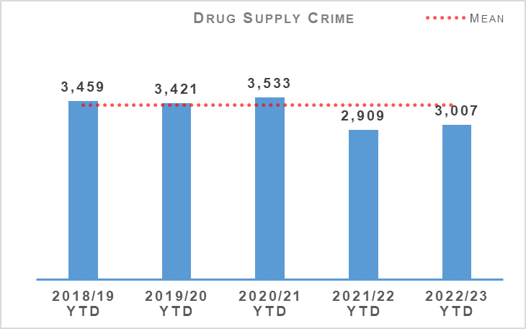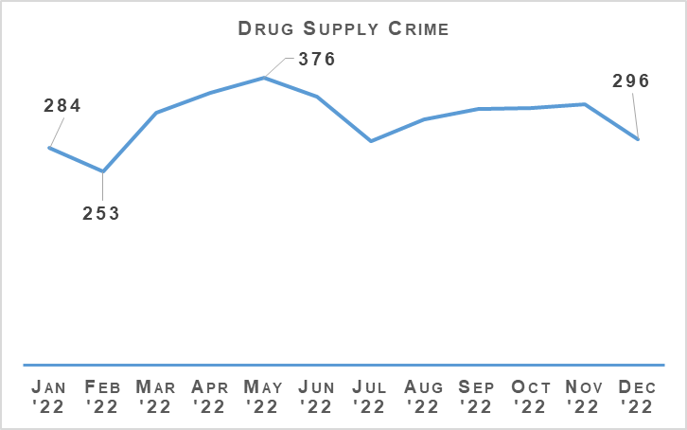
The number of drug supply crimes has increased by 3.4% (98 crimes) compared to the same period last year. In comparison to the five year mean there has been a decrease of 11.1% (373 crimes).
Within this grouping, the number of supply of drugs (including possession with intent) has increased by 248 crimes compared to the same period last year (2,619 in 2022/23 compared to 2,371 in 2021/22), whilst the production, manufacture or cultivation of drugs offences have decreased by 133 (307 in 2022/23 compared to 440 in 2021/22).
The number of detections for drug supply crimes has decreased by 0.7% (19 detections) compared to the same period last year, whilst in comparison to the five year mean there has been a decrease of 13% (393 detections). The detection rate decreased by 3.6 percentage points comparing to last year, with a decrease of 2.0 percentage points compared to the five year mean.

Serious Organised Crime Groups (SOCGs)
The most common criminality undertaken by mapped SOCGs continues to be drugs, money laundering, violence and fraud.
During 2022/23 Quarter 3, 18% of SOCGs experienced a reduction in tactical risk score. 8% of SOCGs were disrupted and archived as a result of successful operational activity.
The risk posed by SOCG related violence remains high. Violent incidents relate to long running feuds between rival families, personal grievances and retribution for perceived disrespect or previous violent acts. The demand for firearms relates mostly to SOCG drug activity and violence/feuds. Despite robust police disruption tactics, enforcement action and firearms seizures, SOCGs continue to have access to firearms.
Drug trafficking continues to be the largest criminal market in Scotland where SOCGs are involved in the manufacture, importation and distribution of illegal drugs. Cocaine, cannabis and heroin are the most commonly trafficked commodities. SOCGs continue to manufacture illicit benzodiazepine pills. Opiates/opioids and benzodiazepines are present in a high number of drug related deaths.
During Quarter 2, the MATDB agreed to commence a new threat theme where a number of law enforcement agencies are working together on a cross-cutting threat enabler to tackle serious organised crime in Scotland. This work will take place over a six month period and has continued in Quarter 3 which includes focused intelligence gathering, multi-agency response and disruption.
Mechanism | Amount
Proceeds of Crime Act (POCA) – Year to date figures for POCA represent those provided to COPFS and CRU for consideration and forfeiture | £24,562,611
Confiscations Orders | £1,325,737
Civil Recoveries Unit | £4,378,975

Drugs Possession
Drugs Possession | 2021/22 YTD | 2022/23 YTD | % Change from Previous Year | 5 Year Mean | % Change from 5 Year Mean
Number of crimes | 18,325 | 17,312 | -5.5% | 21,328.0 | -18.8%
Number of detections | 17,476 | 17,643 | +1.0% | 19,958.6 | -11.6%
Detection rate | 95.4% | 101.9% | +6.5% Point | 93.6% | +8.3% Point
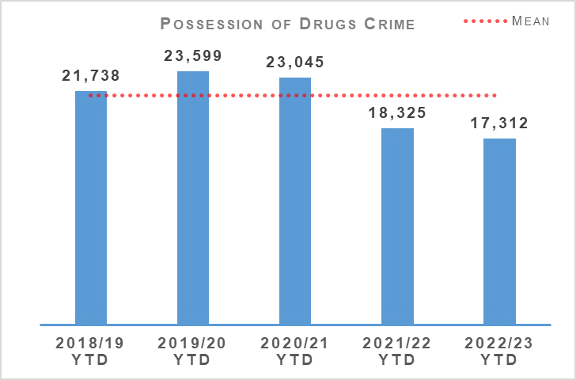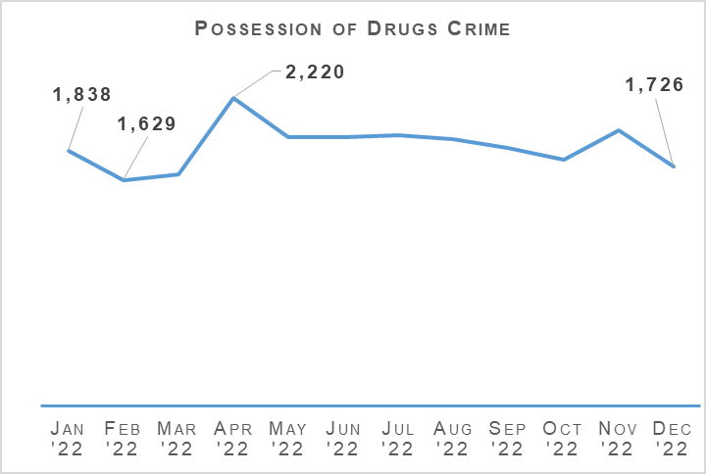
Drug possession crimes have decreased by 5.5% (1,013 crimes) compared to the same period last year, and decreased by 18.8% compared to the five year mean.
Detections have increased by 1.0% (167 detections) compared to the previous year but decreased 11.6% compared to the five year mean, whilst the detection rate has increased by 6.5 percentage points and 8.3 percentage points respectively compared to last year and the five year mean.
The reduction in drug possession crimes is likely due to shifts in focus in the market towards a more synthetic drug, as well as counting of Recorded Police Warnings for drugs possession.

Disruption Activity
October 2022:
Police attended an address in the East of Glasgow and encountered a property converted to grow a large quantity of cannabis plants. In total 664 plants were recovered with an estimated street value of £265,000. A male was arrested and charged under the Misuse of Drugs Act 1971.
A Community Policing Team Officer was driving past an unused property in Falkirk where persons were seen exiting the premises. The officer engaged with the persons and a search warrant was sought for the premises. A cannabis cultivation was discovered where approximately 1,700-2,000 plants with an estimated street value of £800,000 to £1million were recovered. Two arrests have been made.
A male was arrested after being stopped in a motor vehicle in Glasgow. He was found to be in possession of cocaine and cannabis resin, worth an estimated total of £20,100.
A search warrant was executed in Paisley where bags containing approximately £100,000 cash were recovered. During a search of the premises 14kg of cocaine (street value £560,000), 2kg of diamorphine (street value £40,000) and an additional £30,000 cash was recovered. A male was arrested and charged with supply of controlled drugs.
Two vehicle stops in the Aberdeenshire area resulted in the recovery of 15kg and 10kg of cannabis respectively.
Roads policing officers stopped a vehicle on the A74 and discovered 10kg of herbal cannabis with an estimated street value of £100,000. Three males were arrested.
November 2022:
The execution of two search warrants on premises in Glasgow saw the recovery of 758g of cocaine and £153,395 cash. One male was arrested.
Officers executed a search on a premises in Edinburgh where £67,000 cash, 3kg diamorphine and a tub containing 318g of cocaine, with a total estimated street value of £229,800, was recovered. One male was arrested.
Two males were detained and two vehicles searched under Misuse of Drugs Act in Glasgow. 13.5kg of cannabis (with a street value of between £81,000 - £108,000) and £1,670 cash was recovered.
A premises in Dunfermline was searched after a vehicle stop, whereby approximately 500,000 tablets were recovered alongside 1kg of diamorphine. The total estimated street value was £270,000.
A premises in the East End of Glasgow was searched, whereby a significant amount of items were seized connected to supply of controlled drugs. This included 7.4kg of cocaine, 2g of cannabis and £4,920 cash recovered. The estimated street value was £295,000.
A vehicle was stopped travelling north on the A74(M) near Lockerbie. As a result of a search 7kg of cannabis in vacuum sealed bags, including a large sum of cash, was recovered. One male was arrested.
December 2022:
Two vehicles were searched under Section 23 of the Misuse of Drugs Act 1971 and two premises were searched under warrant in the Crookston area of Glasgow. Police recovered 3.5kg of cocaine, 1kg of benzocaine and £800 in cash. One male was arrested.
While responding to a building fire at a premises in Arbroath officers discovered a cannabis cultivation of approximately 800 plants with an estimated street value exceeding £50,000. Enquiries are ongoing to identify a suspect.
Officers within the West of Glasgow executed a search warrant on premises believed to be used to store controlled drugs. 1.5kg of controlled drugs with an estimated street value of £15,000 was recovered.
Officers attended at a premises in Lanarkshire and discovered a cannabis cultivation of approximately 850 plants with an estimated street value between £170,000 and £510,600. Also recovered was 45kg of herbal material with an estimated street value of £171,000.
An investigation into a serious and organised crime group resulted in the deployment of a drugs dog in a rural area of Aberdeen. This resulted in the recovery of 1.75kg of cocaine with a street value of £245,000.
A vehicle was stopped on the M74 in Dumfries and Galloway. Discovered within the vehicle was 10kg of cannabis with an estimated street value of £100,000. A male was arrested.

Operation ERSO
ERSO is the multi-agency taskforce established by Police Scotland. Under Operation ERSO the Drug Harm Tactical Taskforce leads the national focus to enhance our understanding and examine the harm associated with the illegal consumption of synthetic drugs, particularly Benzodiazepines, across Scotland.
This allows for continuous improvement in the investigation of Drug Related Deaths (DRDs), to include evidence capture, information sharing and collaboration across the Service to maximise intelligence development and operational opportunities.
Current intelligence provides that there are numerous SOCGs involved in the manufacture, distribution and supply of Benzodiazepines within Scotland. Benzodiazepines being used by the Scotland based groups include Diazepam/Valium, Etizolam and Alprazolam (Xanax). We have also seen a rise in the number of groups manufacturing their own illicit tablets.
Since January 2020, a total of 27 Pill Presses have been recovered in Scotland as a result of operational activity carried out. Pill presses recovered through operational activity vary in technology and production capacity from manually operated pill presses capable of producing 1,000 pills per hour to automated industrial scale presses with an output in excess of 100,000 pills per hour.
Provided that raw materials are available, it is possible for these high end presses to produce approximately one million pills in a typical working day. Recovery of these presses is likely to significantly impact the manufacture, supply and availability of illicit pills, including benzodiazepines, in our community.
Activity in October 2022 saw a drug search warrant resulting in the recovery of over 12,000 white tablets, Heroin and Amphetamine.
In November 2022 the execution of a drug search warrant resulted in the recovery of 14kg of Cocaine, 2kg of Diamorphine, a hydraulic press with a street value of £590,000 and cash amounting to £131,400.
November also saw the recovery of 500,000 tablets, assessed to be Diazepam/Etizolam, Diamorphine, Cocaine and Cannabis, the recovery of 50,000 Valium tablets, a large quantity of Cannabis and over £2,000. Also recovered was approximately 2,500 street Valium tablets.
Activity in December 2022 saw a drug search warrant resulting in the recovery of a black coloured hydraulic press and 224 grams of white powder, suspected to be a cutting agent. Other work resulted in the recovery of over 6,000 white tablets, the recovery of 2,000 tablets, and the additional recovery of over 13,500 white tablets.

Missing Persons
Missing Persons – Equality Outcome 3 | 2021/22 YTD | 2022/23 YTD | % Change from Previous Year
Number of missing persons investigations | 13,020 | 13,401 | +2.9%
Number of people who have gone missing previously | 2,820 | 2,722 | -3.5%
Percentage of people who have gone missing previously | 21.7% | 20.3% | -1.4% point
Average length of time missing (hrs) | 18.7 | 15.9 | n/a
Total number of missing persons from NHS | 1,248 | 1,358 | +8.8%
Total number of missing persons from YPU | 2,692 | 2,328 | -13.5%
Total number of missing persons from Foster Care | 311 | 349 | +12.2%
Percentage of overall missing persons that go missing from NHS | 9.6% | 10.1% | +0.5% point
Percentage of overall missing persons that go missing from YPU | 20.7% | 17.4% | -3.3% point
Percentage of overall missing persons that go missing from Foster Care | 2.4% | 2.6% | +0.2% point
Number of missing persons investigations with mental health marker | 4,295 | 4,217 | -1.8%
Missing Person Demand - Total FTE demand of missing persons investigations | 676.5 | 644.3 | -4.8%
Missing Person Demand - Children generated FTE demand of missing persons investigations | 269.5 | 287.4 | +6.6%
Missing Person Demand - Total FTE demand of missing persons investigations from Home Address | 382.5 | 370.0 | -3.3%
Missing Person Demand - Total FTE demand of missing persons investigations from Care Setting (Foster Care/Adult Care Home/Young Persons Unit/NHS) | 191.8 | 179.6 | -6.4%
The number of missing person investigations has increased by 381 compared to the same period last year. The number of repeat missing persons, the average length of time missing and the number of investigations with a mental health (MH) marker have all decreased compared to the same period last year.
The notable increases can be found when considering what ‘type’ of person goes missing. Children (not including Looked after Children) are recording significant increases as illustrated in the following chart.
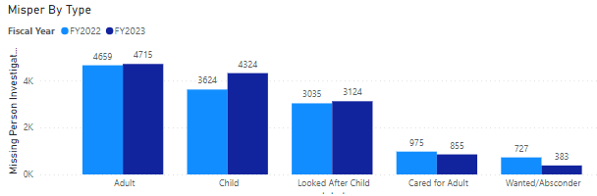
The large increases in number of children going missing could be attributed to certain lockdown restrictions being in place in Quarter 1 2021/2022 that were not in place in Quarter 1 2022/23. The following graph illustrates however that the gap has narrowed only slightly since Quarter 1 and the number of children that go missing is consistently higher than it was last year.
Wanted absconders have reduced by 344 this year and this is down to changing of legacy terms and the education of using the correct terminology. This has seen a slight increase in the child category due to this.
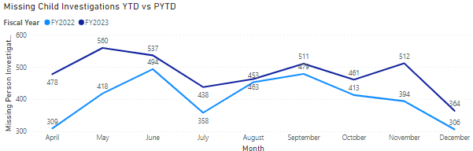
When considering where people go missing from it remains that the majority of people go missing from their home address. This is increasing significantly along with missing from NHS and missing from Foster Care.
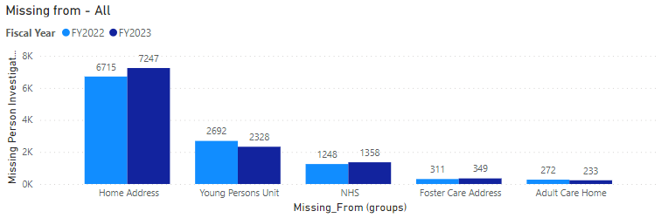

The Herbert Protocol
The Herbert protocol is now in the process of being rolled out throughout the entire force by each divisional missing person co-ordinator. A knowledge pack and terms of reference are being developed to assist with this process.
Alzheimer’s Scotland have concluded the consultation process re dementia advisors completing return discussions with persons living with a diagnosis of dementia.
This pilot took place in Edinburgh and proved to be a tremendous success. A PhD student at the University of Edinburgh completed the academic report in respect of this for Alzheimer’s Scotland.
This process will now be rolled out to each division, which ensures both the person living with dementia receives the most appropriate service and police officers time is able to be utilised elsewhere.
Argyll and West Dunbartonshire Division has successfully rolled out the use of the dementia safeguarding tag. A consultation is underway with a view to adopting this force wide.
The Highland and Islands Division has received a number of child asylum seekers (17 but deemed as a child due to the process). These children have subsequently had a missing episode involving a significant enquiry.
The division have been informed by Aberlour care services that they have the capacity to house a further 42 of such children thus work has been ongoing with the NCA and West Midlands police in order to develop best working practice in such cases.

Road Safety
Road Casualties | 2021/22 YTD | 2022/23 YTD | % Change from Previous Year | 5 Year Mean | % Change from 5 Year Mean
People Killed | 115 | 144 | +25.2% | 115.2 | +25.0%
People Seriously Injured | 1,370 | 1,262 | -7.9% | 1,304 | -3.2%
Children (aged <16) Killed | 5 | 2 | -60.0% | 2.6 | -23.1%
Children (aged <16) Seriously Injured | 120 | 132 | +10.0% | 119 | +10.9%
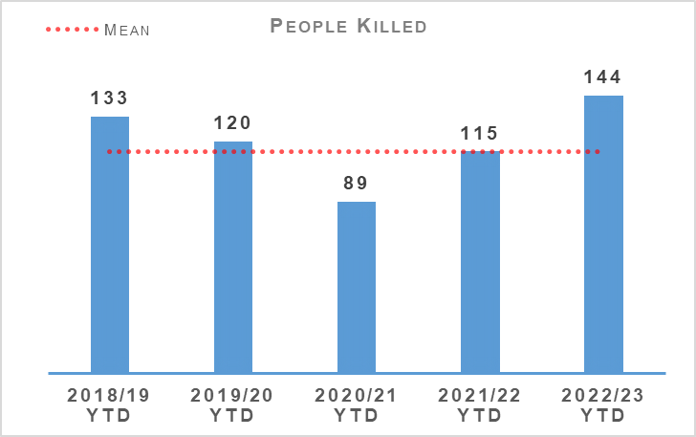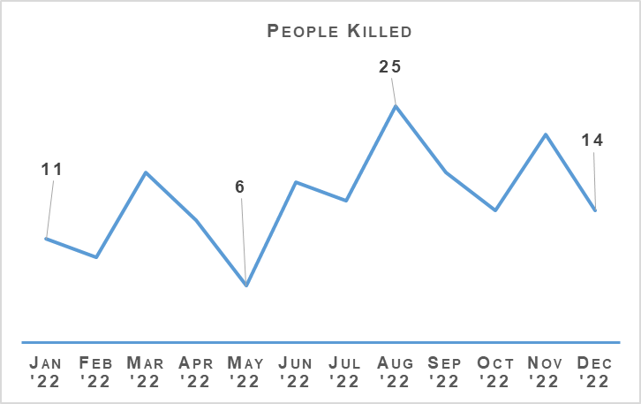
In the current reporting period there have been 144 fatalities on Scotland’s roads. This is an increase of 25.2% (29 more fatalities) compared to the same period last year. When compared to the five year mean, this is also an increase of 25.0% (29 more fatalities).
Whilst there was a decrease in fatalities during the COVID-19 lockdown period which reduced the five year mean, when comparing the current figures against the last pre-COVID period (2019/20) there has still been an increase of 24 fatalities (120 casualties in 2019/20 for this reporting period).
There were 50 recorded fatalities in Quarter 3, although some of these are still being investigated for possible medical-related causes or suicide.
The number of persons seriously injured has decreased by 7.9% (108 serious injuries) compared to the same period last year, and have decreased by 3.2% (42) compared to the five year mean.
The number of children killed this year has decreased by three compared to the same period last year. Children seriously injured has increased by 10% (12) compared to last year.

Road Safety Framework (RSF)
Transport Scotland have published key road casualties figures showing the progress made against the Road Safety Framework targets that ran from 2010 to 2020. All five targets have been met as per following table:
Scottish Road Safety Targets 2020 | Target Reduction | Actual Reduction
People Killed | -40% | -52%
People Seriously Injured* | -55% | -68%
Children (aged <16) Killed | -50% | -76%
Children (aged <16) Seriously Injured* | -65% | -77%
Slight Injury | -10% | -67%
Please note that due to changes in severity recording the number of seriously and slightly injured people cannot be directly compared to those reported in previous years. Progress against these targets has been calculated on the basis of adjusted figures provided by the Department for Transport.
The new Road Safety Framework (RSF) with interim targets to 2030, RSF2030, has been published along with the 2021/22 delivery plan (updated 2022/23 plan awaited). The following interim reductions in those killed and seriously injured on Scotland’s roads, from a 2014/18 baseline, are sought:
50% reduction in people killed
50% reduction in people seriously injured
60% reduction in children (aged under 16) killed
60% reduction in children (aged under 16) seriously injured
The interim reductions are challenging, as they should be, as we work with our partners toward Vision Zero - no deaths and no serious injuries on Scotland’s roads by 2050.
A few key risks have been identified via analysis and we will seek to mitigate these as we move forward:
The number of cyclists on our roads was boosted by the COVID-19 pandemic and, more generally, by people opting toward more eco-friendly sustainable modes of transport. Cycling is anticipated to further increase as a consequence of recent fuel price rises. We recognise the potential for collisions also increase, with cyclist collisions often resulting in serious injury.
Motorcycle casualties have remained steady over the past few years, aside from the drop in 2020/21 due to the reduced traffic during COVID-19 restrictions.
With an ageing population, who remain mobile longer and continue to drive, it is anticipated that there may be an increase in older casualties.

Quarter 3 Activity
In an effort to mitigate the risks identified and reduce collisions on the road network, Police Scotland have identified a number of key opportunities.
An in-depth fatality study in partnership with Transport Scotland, with a dedicated analyst and Road Policing Sergeant, continued through Quarter 3. This affords an opportunity to identify learning from previous collisions which will assist Police Scotland and partners to introduce preventative measures to further mitigate road risk across all road users groups.
Road Policing works closely with Transport Scotland to understand trends and identify emerging threats in relation to all collision classes. Police Scotland analysts produce detailed problem profiles identifying specific casualty types, with particular focus on vulnerable road users.
The information is shared with partners at forums such as the Tactical Options Working Group and Road Safety Governance Board. This sharing allows resources to be allocated to the greatest areas of risk in an effort to reduce harm on our road, in partnership with local policing and assisted where appropriate by our key partners.
Acknowledging motorcyclists are a challenging group to engage with, the Scottish Government in partnership with Police Scotland have developed a working group to explore opportunities and develop engagement strategies moving forward. One existing example is Rider Refinement North, an initiative providing rider training by Police and Institute of Advanced Motorists instructors, which we will seek to roll-out across Scotland.
All of the deliverable commitments that Police Scotland has made to the Road Safety Framework 2030 have been completed to date. Our commitment within the RSF to incorporate specific campaigns, initiatives and directed activity targeting the safety of vulnerable road users - including cyclists, motorcyclists and pedestrians – continues to be met.
All Quarter 3 road safety campaigns on our National Calendar of Road Safety Activity were completed. The majority of Quarter 3 campaign work was Fatal-Five focused and all initiatives were supported by Corporate Communications/Social Media.

Road Policing Campaign Updates

Operation Close Pass - Ongoing
Road Policing work alongside local policing, with support from Cycling Scotland, to carry out pro-active initiatives during which a trained police cyclist uses cycle-cams to corroborate observations of careless or dangerous driving, including failing to afford her/him sufficient road space. Quarter 3 examples include:
03 October 2022 - Four ‘Chat on the Mat’ warnings regarding manner of driving were issued during an Operation Close Pass at Western Road, Kilmarnock.
07 October 2022 - Operation Close Passes at Gilmerton Station Road and Balcarres Street in Edinburgh led to three construction and use offences being identified plus three warnings regarding manner of driving.
16 November 2022 - Community and Road Policing officers utilised a Close Pass demonstration at the Meadows, Edinburgh to support the Be Bright, Be Seen campaign.

Drive on the Left - Ongoing
The 2022 Drive on the Left campaign continues. Leaflets, wrist bands and stickers are given out to foreign drivers hiring a car whilst visiting Scotland. Bikers are also given reservoir covers as a visible aid to them regarding driving on the left. The campaign has received support from leading hire companies and funding from Road Safety Scotland.

National Speeding Campaign - 10 to 30 October 2022
This campaign, ran in partnership with Safety Camera Units, included a focus on speeding hotspots, community complaint locations and areas with high volumes of vulnerable road users. During the campaign, 2,838 speeding offences were detected, 689 by police officers and 2,149 by our SCU colleagues.

Get Ready For Winter Campaign - 31 October to 06 November 2022
The Transport Minister participated in the launch for this campaign. Static road checks and social media engagement across all channels were amongst its key elements. With a focus on education around increased winter road risks and encouraging proper vehicle preparation, 2,695 vehicles were stopped during the campaign.

Operation Drive Insured - 14 to 27 November 2022
This is a national education, engagement and enforcement campaign targeting uninsured drivers. 516 offences of failing to insure against third party risks were detected during the campaign.

Road Safety Campaign - Impact
Road Policing's efforts to address disproportionate casualty levels amongst the vulnerable includes the Older Road User Group, gaining valuable insight and input from representatives including Age Scotland, Senior Citizens Network Co-ordinators, Road Safety Scotland and the NHS to inform and enhance our partnership road safety approach.
Quarter 3 saw pro-active work on older road user initiatives including Driver Engagement North, a pilot previously launched in the north of Scotland and subsequently extended to surrounding areas.
Participants in this person-centred initiative utilise a desktop driving simulator, with a fitness to drive input also included.
The final external evaluation report is ongoing, following which Transport Scotland will decide whether to fund additional simulators, permitting further roll-out.

Stop and Search
Stop Search | 2021/22 YTD | 2022/23 YTD | % Change from Previous Year
Stop Search Compliance Rate (%) | 99.0% | 99.1% | +0.1% point
21,539 stop and search incidents have been recorded by Police Scotland so far this year. This is a decrease of 9.4% compared to the same period last year. One in three (33.3%) stop and searches between April and December 2022 had a positive result although this was a slightly lower (-1.5% points) positive rate than April to December 2021. 557 of these searches have led to the recovery of offensive weapons.
20,665 stop and search records were audited for compliance during the first three quarters of 2022/23. This involves the records being reviewed by line managers and thereafter quality control checked by the National Stop and Search Unit to ensure their adherence to the Stop and Search Code of Practice introduced in May 2017.
Of the stop and searches reviewed during the quarter, 18,193 (88.0%) were deemed compliant and recorded correctly on the stop and search database. A further 2,283 (11.0%) were compliant with the code of practice but required amendment to their details to ensure they were appropriately recorded.
189 (0.9%) records were deemed as not recordable under the code or practice or recorded in error and deleted from the database. Typical reasons for deletion include where a person is searched after being arrested, as a result of a duplicate record or where no physical search of a person has actually taken place.
It should be noted that the total number of records audited for compliance will be lower than the total number of searches raised during the period due to the timescales required to fully review all records.

Strategic Outcome 2
The needs of local communities are addressed through effective service delivery.
Objectives:
Understand our communities and deliver the right mix of services to meet their needs
Support our communities through a blend of local and national expertise
Support the changing nature of communities

Call Handling
Call Handling | 2021/22 YTD | 2022/23 YTD | Change from Previous Year
Total Number of 999 calls | 536,267 | 560,838 | +4.6%
Total Number of 101 calls | 1,353,370 | 1,104,573 | -18.4%
Average 999 calls answer time | 7 seconds | 10 seconds | +3 seconds
Average 101 calls answer time | 3 mins 17 seconds | 4 mins 17 seconds | +59 seconds
Number of 999/101 calls that do not result in an incident/crime | 749,490 | 822,087 | +9.7%
Percentage of 999/101 calls that do not result in an incident/crime | 39.7% | 49.4% | +9.7% point
Note: Following the nationwide rollout of CAM, new call gradings are being used. These were updated again during August 2020, this is reflected in the table above. A small percentage of incidents are still being categorised under the old grading and are therefore not included in the above figures. Comparison data is not available.
The total number of calls to Police Scotland decreased by 224,226 (from 1,889,637 to 1,665,411). This is a decrease of 11.9% compared to last year. As shown in the previous table there has been an increase of 4.6% for 999 calls received, however, the volume of 101 calls received is showing a decrease of 18.4%, both being compared to the same period last year. Of the calls received, 49.4% did not result in an incident or crime being raised. The total number of incidents has decreased by 10,601 (from 1,140,147 to 1,129,546) compared to the same period last year.
The handling of 999 calls remains our highest priority. Between 01 April 2022 and 31 December 2022, our service centres maintained an average speed of 10 seconds for answering 999 calls, this has increased compared to the same period last year. The average call answer time for 101 calls has also increased by one minute, however continued measures are in place to try and alleviate this and reduce the average call answer time. Our response to Operation URRAM for Conference of the Parties 26 in November 2021 showed a decrease in demand which will have impacted the difference in average speed of answer for same quarter this year.
Continued measures to alleviate average speed of answer include use of the Temporary Retain on Duty and Business Continuity payments which support retaining staff on duty during periods of high demand to assist with reducing the average speed of answer. Review of staffing levels has led to permanent re-alignment of posts to our higher demand periods to improve resource availability to better meet call demand.
Efforts continue to signpost callers to more appropriate methods of contact, including via “Contact Us” and the force website. Social media is used during periods of high demand to inform the public and provides the opportunity to educate the public on correct use of our 999 and 101 contact methods. Online contacts continued to rise during this reporting period, indicating the success of this approach.

Mental Health Pathway
In March 2022 a pilot was introduced to the C3 Division in West Command.
This project piloted an additional phase of the Mental Health Pathway whereby NHS 24 Mental Health Nurse Practitioners worked in collaboration with Resolution Team officers to triage callers in order to provide them with appropriate support and prevent deployment, where possible.
The Test of Change period ended on 08 December 2022 and the model will now be evaluated to gain insights and lessons learned.
The nurses remain working with the MCE Programme and C3 Division in order to develop and evolve the current Mental Health Pathway, but for now no clinical assessment will be conducted by the nurses and C3 West will revert back to how it operated beforehand, just as they currently do in the North and East.

Incident Demand
Incident Demand | 2021/22 YTD | 2022/23 YTD | % Change from Previous Year
Incident Demand – Total Number of incidents raised | 1,140,147 | 1,129,546 | -0.9%
Number of incidents by response type - Immediate | 132,688 | 122,697 | -7.5%
Number of incidents by response type - Prompt | 491,301 | 457,180 | -7.0%
Number of incidents by response type – Standard Local Policing Appointment | 56,954 | 57,049 | +0.2%
Number of incidents by response type – Standard Direct Crime Recording | 57,098 | 58,426 | +2.3%
Number of incidents by response type – Standard Resolution Team Involvement | 26,485 | 26,436 | -0.2%
Number of incidents by response type - Other Resolution | 344,090 | 381,765 | +11.0%
Incident Demand - % of incidents which lead to a crime | 26.50% | 27.21% | +0.7% points
Incident Demand - % of incidents requiring police response | 97.00% | 97.00% | 0.0% points
Partner Demand – Total number of external force request incidents | 2,158 | 2,274 | +5.4%
Note: A small percentage of incidents are still being categorised under the old grading and are therefore not included in the above figures.
During the reporting period 141,911 standard incidents were recorded in total, an increase of 1.0% (1,374 more incidents) from the same period last year.
The new process involves the allocation of local policing appointments, direct crime recording and resolution team involvement to standard incidents. This has now been fully integrated into daily business, leading to this continued increase.
During the reporting period the most common crime types recorded for standard incidents are theft, assist member of the public, damage, road traffic collisions, fraud and neighbour dispute.
Looking at incident demand for the reporting period compared to the previous year, the percentage of incidents which lead to a crime report being raised and that require police attendance are consistent. Due to the process changes a comparison against the five year mean is not available. Demand from partners, in terms of external force request incidents, has risen by 5.4% (116 more incidents) compared to the same period last year.

C3 Division Demand
In addition to the call numbers, there have been over 206,000 additional public contacts dealt with by Contact, Command and Control (C3) Division during the reporting period. C3 Division does not only deal with incoming calls from the public. Service advisors also deal with incoming calls from other partner agencies and alarm calls.
There have been almost 77,000 of these types of calls for this reporting period, although a slight decrease of around 7.3% in Emergency Service Partner calls and a decrease of around 14.3% in total alarms.
Emergency Service Partner calls are received via dedicated numbers from Scottish Fire and Rescue, Scottish Ambulance Service, Mountain Rescue, Coast Guard, Mental Health Pathway (NHS 24), OmniCrash and Oil Industry Agency. The reason for such calls vary and each are dealt with by a service advisor in the most appropriate manner.
“Contact Us” emails and online reports, for some crime types, can be completed online. Each one of these reports is assessed by a service advisor using the Threat Harm Risk Investigation Vulnerability and Engagement (THRIVE) model. Over 122,000 “Contact Us” emails and 6,600 online reports have been submitted since 01 April 2022.
Overall, additional public contacts are up slightly (around 2.0%) from 2021/22.

Contact, Engagement and Resolution Project (CERP)
The Contact, Engagement and Resolution Project (CERP) was formed in 2021 and will seek to make improvements in service through Police Scotland's response to vulnerability, risk and public need at the earliest opportunity; maximising opportunities for remote engagement and resolution; reducing local policing demand and directing appropriate incidents to the right agency through pathway referrals and enhanced collaborative working.
The project is working on a number of changes that will improve the effectiveness of various business areas in C3 Division and will enhance the service provided to the public. Essential to this is refreshed training for C3 staff on the use of THRIVE. Following approval of the Training Needs Analysis work has now commenced on the development of training delivery plans with training likely to start in C3 Division in February 2023.

Modernised Contact and Engagement
The MCE and Service Design team continue to work closely with C3 in the creation of a Current Operating Model (COM) for C3 which will lay the foundation for the future target operating model (TOM). Service designs blueprints have now been created for the division and these together with the playbacks from the insight sessions will be presented to the C3 SMT in January 2023.
An options paper, prepared by the Unified Communications and Contact Platform (UCCP) Project, on whether to integrate or remove Aspire Customer Relationship Management software, used by the Service Centre, and procure an alternative was submitted and approved by the UCCP Steering Group & MCE Programme Board.
This includes a re-phased project timeline and authority to proceed with procurement. Four Data Protection Impact Assessments (DPIAs) have been submitted to Information Assurance and the development of an EqHRIA continues as planned.
The National Integrated Communications Control Systems (NICCS) project is still in its testing phase and continues to work with the supplier, Frequentis, to address the remaining defects prior to moving into further integration testing.
The C3 training team continue to deliver relevant training packages and as the end of year approaches, training of users in the West is nearing completion. The training of North and East users will commence early in the New Year 2023.
The project team continue to work closely with C3 in regards to implementation dates, however until the defects are addressed and testing is completed we are unable to provide definitive dates for implementation.

C3 Complaints and Allegations
C3 Complaint Allegations | 2021/22 YTD | 2022/23 YTD | % Change from Previous Year
Complaint Allegations received relative to C3 – on duty | 182 | 119 | -34.6%
Complaint Allegations received relative to C3 – Quality of Service | 156 | 143 | -8.3%
Total Allegations closed - relative to C3 | 328 | 294 | -10.4%
Percentage of total Allegations closed which were upheld – relative to C3 | 7.0% | 6.1% | -0.9% point
Total Complaints received relative to C3 | 249 | 202 | -18.9%
Complaints against C3 Division have decreased by 18.9% in the year-to-date, with a total of 202 received during this period. Decreases are visible in the North (-33.3%, 18 cases in total), East (-25.3%, 71 cases in total) and West (-11.0%, 113 cases in total).
Incivility (94) and Service Delivery (84) are the most common allegation types, together accounting for 67.7% of all allegations received during this period. However, both categories have registered a decrease against the comparable period in 2021/22, by 26.6% and 9.7% respectively.
Consistent with the corresponding decrease in complaint cases, the volume of allegations has decreased and is primarily linked to the reduction in Incivility listed above. No notable increase has been identified across all allegation categories.
In total, 61.4% of complaint cases received year-to-date for C3 Division were Frontline Resolved by the PSD National Complaints and Resolution Unit (NCARU). This rate increases to 65.8% when early and subsequent resolution by PSD or Specialist officers are included. These figures demonstrate that most complaints against C3 Division during this period have been non-criminal and non-serious in nature, with a majority resolved through simple explanation, apology or assurance.

Hate Crime
Hate Crime – Equality Outcome 1 | 2021/22 YTD | 2022/23 YTD | % Change from Previous Year | 5 Year Mean | % Change from 5 Year Mean
Number of incidents | 5,929 | 5,595 | -5.6% | 5,247.6 | +6.6%
Number of crimes | 5,431 | 4,875 | -10.2% | 5,154.6 | -5.4%
Detection rate | 65.8% | 62.2% | -3.5% point | 68.6% | -6.4% point
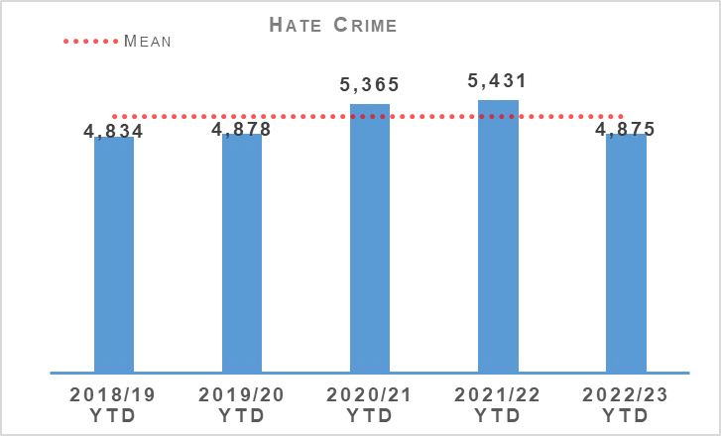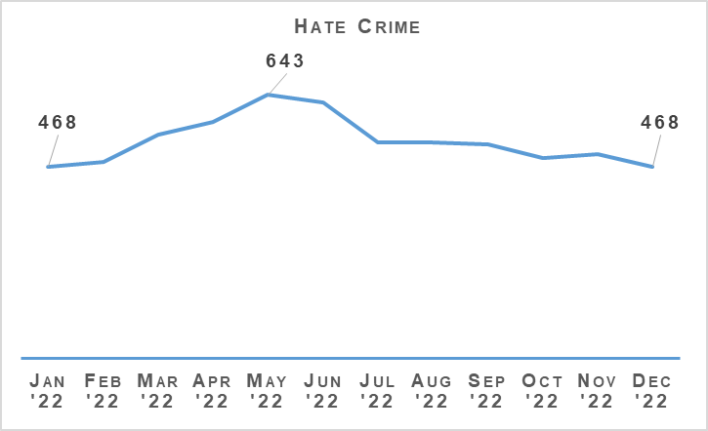
Hate incidents have decreased compared to the same period last year but remain above the five year mean. Police Scotland have actively encouraged the reporting of hate incidents over the past few years and as such the rise in incidents is not unexpected.
Hate crimes have decreased compared to last year and are also below the five year mean. The 12 month graph illustrates that crimes peaked in May 2022 and gradually declined over the rest of the year.
The hate crime detection rate is 3.5% lower than the previous year and 6.4% below the five year mean. Analysis remains ongoing and is being considered as part of the wider analysis regarding the fall in detection rates in all crimes.

Hate Aggravators
Aggravator | 2021/22 YTD | 2022/23 YTD | % Increase | % of Total Hate Crimes (2022/23)
Race | 3,185 | 2,758 | -13.4% | 56.6%
Religion | 280 | 304 | +8.6% | 6.2%
Race & Religion | 48 | 44 | -8.3% | 0.9%
Multiple aggravators including Race & Religion | 181 | 167 | -7.7% | 3.4%
Disability | 329 | 351 | +6.7% | 7.2%
Sexual Orientation | 1,229 | 1,098 | -10.7% | 22.5%
Transgender | 121 | 82 | -32.2% | 1.7%
Multiple aggravators excluding Race & Religion | 58 | 71 | +22.4% | 1.5%
Total Hate Crime | 5,431 | 4,875 | -10.2% | 100.0%
Hate crime with a race aggravator accounts for over 56% of all hate crimes however these crimes continue to decrease when compared to the same period last year (now 427 fewer). Religion has increased but remains below the five year mean.
These numbers are relatively small and thus it is difficult to attribute any specific explanation to the increases this year. Anecdotally this may be a result of an increase in Orange Order/Republican Marches and the large scale return of fans to football games.
Disability crimes are increasing however this coincides with Police Scotland’s drive to improve reporting of this type of crime with a number of media campaigns and enhanced partnership working.

Hate Crime Awareness Week
Hate Crime Awareness Week was 09 October to 15 October 2022. Police Scotland participated in social media messaging which was centred on the encouragement of reporting hate crime and the different routes available to access reporting to police.
Following a Twitter post on what protected characteristics were reportable under hate crime legislation, there was some negativity trending due to not listing all nine strands under the Equality Act and the protected characteristic of ‘sex’ in particular.
Given current media and political reporting in relation to misogyny and violence against girls and women, a further message from Police Scotland was posted confirming all protected nine characteristics and highlighted the five currently protected in hate crime legislation.

Anti-social Behaviour and Disorder
Anti-social Behaviour and Disorder | 2021/22 YTD | 2022/23 YTD | % Change from Previous Year
Number of antisocial behaviour incidents reported by the public | 255,031 | 214,203 | -16.0%
Number of complaints regarding disorder | 183,772 | 150,509 | -18.1%
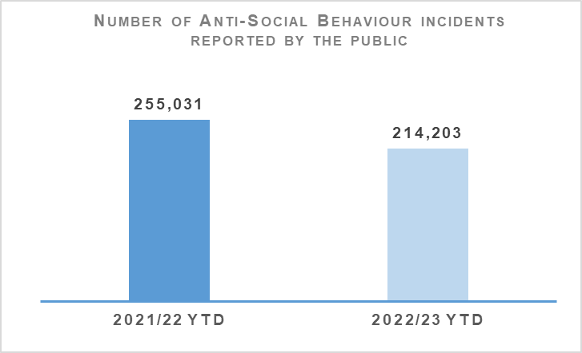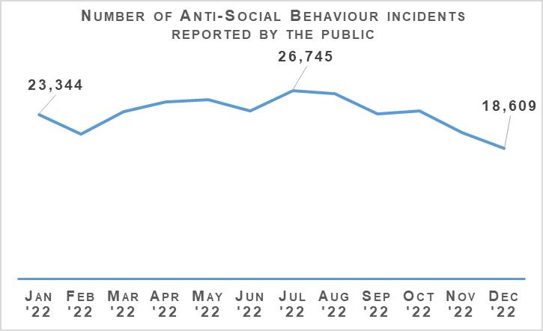
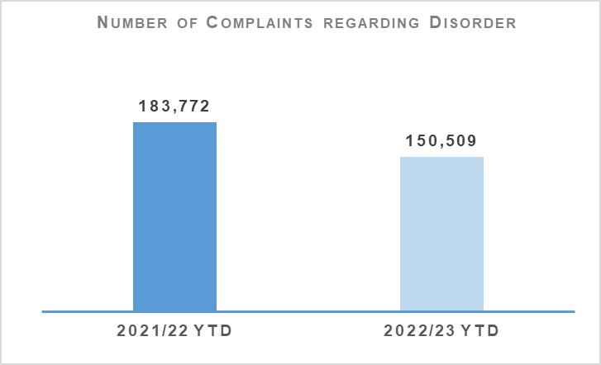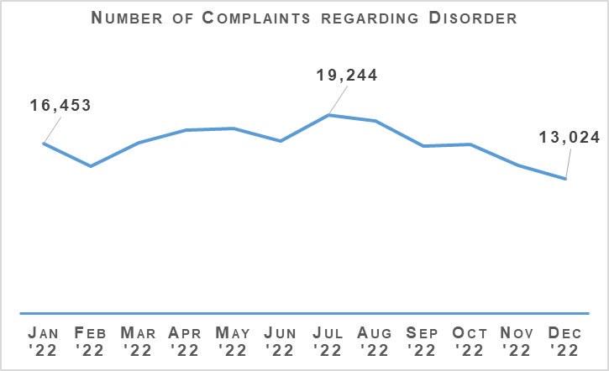
Both complaints of disorder and incidents of anti-social behaviour have been lower in the first three quarters of 2022/23 than in the same period last year.
The Fireworks and Pyrotechnic Articles (Scotland) Act 2022 is being introduced in stages throughout 2022 and 2023. Partnerships, Prevention and Community Wellbeing (PPCW) Division and National Football Information Point – Scotland continue to work collaboratively with the Scottish Government in respect of implementation of the new legislation. The proxy offence (Section 21 of the Act) and Section 44 of the Act providing an aggravation of offences against emergency workers went live on 10 October 2022.
Scottish Government are in the process of creating a guidance document and establishing a Short Life Working Group to discuss the implementation and enforcement of Firework Control Zones (FCZ). It is anticipated the restriction of days for the sale of fireworks will be introduced in conjunction with FCZ`s in early 2023. The provisions on prohibiting pyrotechnic articles in public and at certain places and events requires further legislation and scrutiny and as such will most likely commence in June 2023. The final provision of a fireworks licensing regime will be introduced in early 2024.
The steering group for the “It’ll cost you” Proxy Purchase campaign which is led by Scottish Grocers Federation, on behalf of Scottish Alcohol Industry Partnership, had its latest meeting on 15 December 2022. The evaluation report for the 2022 campaign was reviewed and agreed by all members and will be published in due course and will be accompanied by a short press release.
Building on the success of the 2022 campaign, which was the first nationally run campaign, the group have begun planning for 2023. 2023 will again be a national campaign with specific sample areas being identified to better evaluate the impact of the campaign at a more local level. Scottish Government are represented on the steering group and have again committed their full support for 2023 are hopeful of obtaining Ministerial backing.

Acquisitive Crime
Group 3 Crime | 2021/22 YTD | 2022/23 YTD | % Change from Previous Year | 5 Year Mean | % Change from 5 Year Mean
Number of crimes | 68,599 | 77,886 | +13.5% | 78,657.8 | -1.0%
Number of detections | 21,643 | 24,200 | +11.8% | 29,021.8 | -16.6%
Detection rate | 31.6% | 31.1% | -0.5% point | 36.9% | -5.8% point
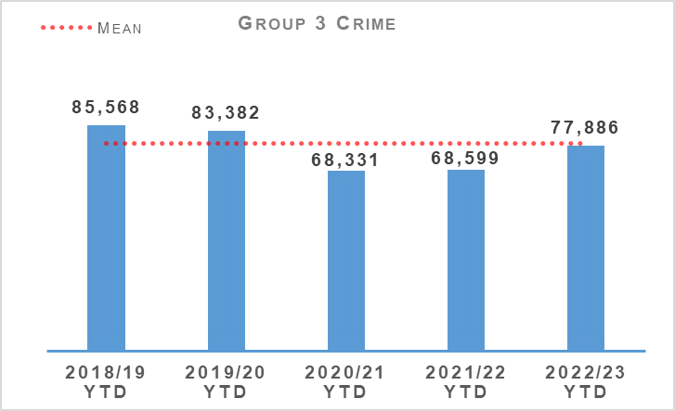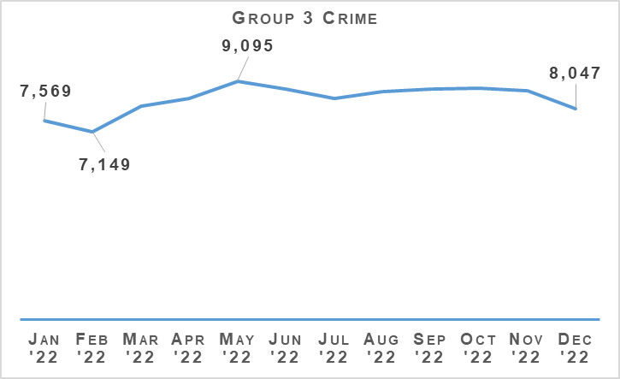
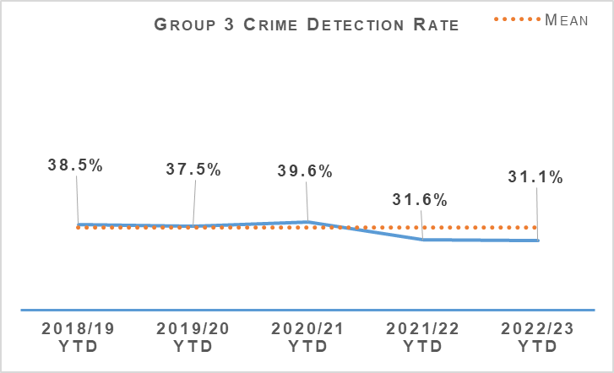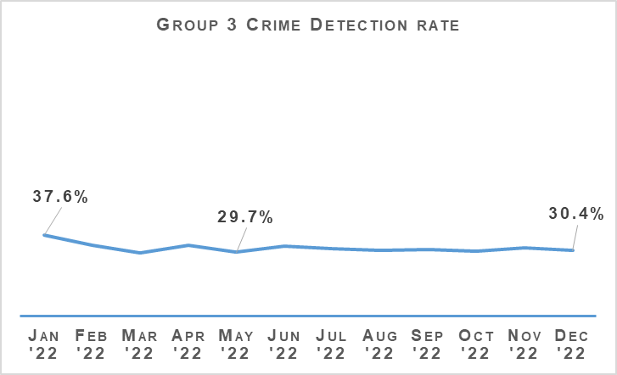
Acquisitive crime has increased significantly compared to the same period last year but is currently lower than the five year mean and pre-pandemic levels. Between April and December 2022 there have been 9,287 more crimes compared to the same period the previous year, and 771.8 less than the five year mean.
Group 3 crimes continue to follow similar monthly and seasonal patterns to that seen pre-pandemic. When compared to 2019/20 Quarter 2, 2019/20 Quarter 3 showed a 3.9% decrease to 26,652 (1,089 crimes). Comparison of the same periods this year have shown a 2.5% decrease (633 crimes).
If fraud is excluded, Group 3 crimes have still risen by 13.9% (7,902 crimes). Common theft and shoplifting crimes continue to be the main contributors to this increase from the previous year, with common theft increasing by 4,016 crimes and shoplifting by 3,904 crimes.
Despite the overall increase, some aspects of acquisitive crime have continued to fall compared to the same period last year. In building with intent to steal crimes have reduced from 2,116 crimes to 1,816 crimes (-300 crimes) and there have been 109 fewer currency offences, dropping from 311 to 202 crimes.

Shoplifting
Shoplifting crimes have continued rising to levels closer than those seen pre-pandemic. Between April and December 2022 there have been 20,741 crimes, 23.2% (3,904 crimes) more than the same period last year and 1.7% (348 crimes) fewer than the five year mean. This is still 2,895 crimes fewer than during the same period in 2019.
This increase is expected to continue as levels are still 12.2% lower than the most recent pre-pandemic year and the rise in this crime type could be accelerated by the current cost of living situation.
Detections over the period have increased from 9,376 to 11,462 compared to the same period last year. The detection rate is 55.3%, 0.4 percentage points lower than the same period last year and 10.1 percentage points lower than the five year mean.

Housebreaking
Housebreaking has experienced an increase year to date of 1.2% (76 more crimes) compared to last year. Over the period there has been a total of 6,469 housebreaking crimes. Despite this year to date increase, housebreaking is 29.0% lower than the five year mean and 16.1% lower than levels seen pre-pandemic (2019/20).
The main increase can be seen in non-dwelling domestic housebreakings, rising from 1,239 in 2021/22 to 1,334 in 2022/23. Commercial housebreakings have also experienced a small increase, with 1,739 crimes recorded between April and December 2021, rising to 1,742 crimes in the same period this year.
Domestic housebreakings remain lower than the same period last year, decreasing by 0.6% (22 crimes). Between April and December 2022, 3,393 domestic housebreaking crimes were recorded, compared to 3,415 crimes last year and the five year mean of 4,503 crimes. Domestic housebreaking remains at a much lower level than pre-pandemic, there has been 1,523 fewer crimes in 2022/23 than over the same period in 2019/20.
Domestic housebreaking contributes hugely to the fear of crime and this is particularly the case where minority communities correctly feel that they have been targeted due to their ethnic background, heritage and customs.
The targeting of domestic properties belonging to families from Asian communities is not a new phenomenon and for a number of years, criminals have sought to exploit the fact that certain communities, primarily from Asia, choose to keep significant wealth within the family home.
Operation VIRION seeks to support local policing divisions’ responses to investigate and co-ordinate with other policing divisions and national assets and complement acquisitive crime oversight and other operational responses to domestic housebreaking of this nature across the country.
During Quarter 3 2022/23, there was an increase in the number of the reported housebreakings which fall under Operation VIRION and all divisions continue to work closely with multiple forces and partners across the UK and Ireland to share information due to the cross border Organised Crime Group associations which have identified through the investigations to disrupt, detect and apprehend the individuals responsible.
This has recently led to the successful identification and apprehension of a number of offenders in North East, Tayside and Greater Glasgow policing divisions.

Vehicle Crime
Between April and December 2022 there has been 8,661 crimes, 10.0% (790 crimes) more than the same period last year and 10.4% (1,005.2 crimes) fewer than the five year mean. This increase has been due to rises in theft of a motor vehicle (479 more crimes), theft from a motor vehicle (158 more crimes) and opening lockfast place – motor vehicle (98 more crimes).
Detections over the period have increased from 2,327 to 2,344 compared to the same period last year which has had an impact in the detection rate. The rate is 27.1%, 2.5 percentage points lower than the same period last year and 1.2 percentage points above the five year mean.

Rural Crime
The number of rural offences recorded has decreased from 541 to 461 compared to the same period last year. The total cost of rural crime for April to December 2022 totalled £2,884,073 with a total of £442,337 recovered. Theft of agricultural and plant machinery, quad bikes and livestock offences account for the greatest number of offences.
Cross border activity continues through Operation HAWKEYE, which launched last summer. This operation involves the partnering of Police Scotland and forces from Northumbria, County Durham, Cumbria and Cleveland to share real time information regarding rural crimes that involved stolen property, agricultural vehicles and plant equipment for example, with the aim of tackling those individuals and organised gangs who specialise in cross-border crime more effectively.
A total of 37 bulletins were circulated during the Quarter 3 period bringing the total number of bulletins issued since April 2022 to 107. During the second reading of the newly proposed UK Equipment Theft Prevention Act within the UK Parliament, Operation Hawkeye was mentioned as being “a shining example of positive policing of rural crime”.

Fraud
Fraud | 2021/22 YTD | 2022/23 YTD | % Change from Previous Year | 5 Year Mean | % Change from 5 Year Mean
Number of crimes | 11,613 | 12,998 | +11.9% | 8,393.6 | +54.9%
Number of detections | 1,958 | 2,069 | +5.7% | 2,414.8 | -14.3%
Detection rate | 16.9% | 15.9% | -0.9% point | 28.8% | -12.9% point
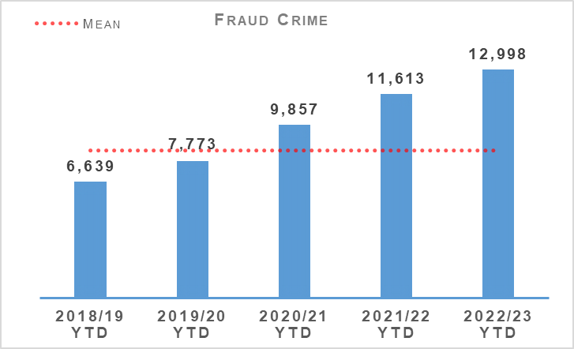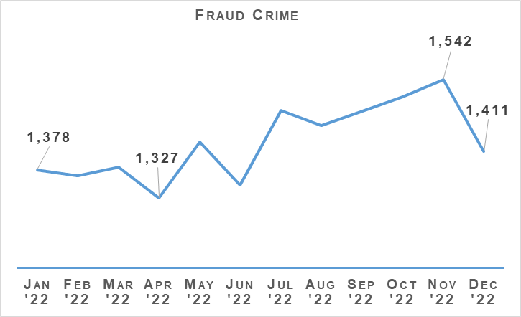
Fraud continued through Quarter 3 to be at a high level across the United Kingdom and in line with this trend, Scotland has experienced large numbers of the population falling victims to a variety of frauds including investment, romance and social engineering frauds.
The online space continues to be a hot spot for fraudulent activity with around 90-95% of frauds having an online cyber aspect to their commission. The continued effects of the COVID-19 pandemic and subsequent hybrid working models have meant that people are spending more time working from home and online engaging across a number of businesses and personal platforms.
This increased online activity has allowed fraudsters to intensify their criminal activity in the online space from an even greater arms-length. Much of the recorded fraud has a cross jurisdictional and often international element to it which provides the criminal with greater anonymity and poses even greater challenges to law enforcement in identifying the culprits and bringing them to justice.
In response to this threat Police Scotland is undertaking work to restructure and refocus the existing financial investigation model to provide a greater victim focused, efficient and effective model and greater strengthen relationships with partner agencies.
This includes aligning and working more closely with the National Crime Agency and the National Economic Crime Centre on the United Kingdom’s strategic fraud response contributing to enforcement intensification periods under the auspices of Project Henhouse II which has provided £20,000 funding to support intelligence development and executive action for fraud.
On 21 December 2022, five males were found guilty at Glasgow High Court for numerous money laundering charges linked to four separate incidents of fraud which occurred in England with the criminal proceeds of each fraud being moved into a solicitors client accounts and then onto other accounts. The matter was initially identified by Police Scotland through Suspicious Activity Reporting (SARs).
All five males were remanded in custody for sentencing on 18 January 2023. A separate Confiscation Hearing is set for Edinburgh High Court on 13 March 2023.
On 22 December 2022, a female was arrested and charged with eight offences for fraud, money laundering and serious and organised crime after being involved in a fraudulent scheme to obtain £986,032 from loan funds and credit cards. Her husband is scheduled to be interviewed on 11 January 2023.
Police Scotland continue to be a key partner on the Fraud Strategic Governance Group. This group, involving police, partners (including third sector) and the Scottish Government has been set up to understand and direct activity at a strategic level to combat the threats posed by the increases in fraud.
The group continues looks to provide a coordinated public awareness raising initiative to prevent fraud from being committed and also ensure appropriate governance around a consistent and joined up strategy across agencies and organisations is undertaken.
Engagement in these groups continues to ensure that fraud investigation is undertaken from a multi- disciplinary perspective and recognises the vital contribution that each partner can play in tackling fraud.

Cybercrime
Cybercrime presents a persisting and evolving threat across the United Kingdom and in line with this Scotland continues to see increases in crimes of this nature. Ransomware is the most significant cybercrime threat and attacks are typically directed towards businesses and organisations.
Fraud has continued to increase significantly in the last year. Cyber fraud is the most common form of financial crime where the perpetrator impersonates a trusted organisation to exploit the victim. Serious Organised Crime Groups (SOCGs) commonly undertake social engineering to commit fraud, large-scale fraudulent schemes, excise duty evasion and credit card fraud.
The CyberScotland Partnership is a collaboration of key strategic stakeholders, brought together to focus efforts on improving cyber resilience across Scotland in a coordinated and coherent way. CyberScotland Week is Scotland’s annual weeklong festival of events on cyber awareness, cyber careers and innovation in cyber security. This year the event will take place between 27 February 2023 and 05 March 2023 and has three main aims:
Protection - Improving cyber resilience knowledge, behaviours, awareness and practice.
Innovation - Showcasing innovative work happening across Scotland’s cyber sector.
- Skills and Careers - Promoting skills development and a career in cyber security.
Throughout the week, individuals will have the opportunity to participate in a wide range of interactive sessions, workshops, and panel discussions led by experts in the industry. Through these sessions and with the sharing of resources on the CyberScotland website there is great opportunities for individuals and businesses to increase their cyber awareness and resilience.

The Banking Protocol
The Banking Protocol is a multi-agency initiative between law enforcement, banking institutions and Trading Standards. Its aim is at the earliest opportunity to identify vulnerable victims who are in the process of being defrauded of funds from their bank accounts by unscrupulous criminals and to intervene to prevent these crimes.
If staff suspect customers are being coerced or the transaction is as a result of fraud, the transaction is stopped and the police are contacted. The protocol is designed to provide a standardised method for how these concerns are dealt with and reported to police and to stop multiple victimisation.
In terms of Quarter 3 of the reporting year 2022/23, the Banking Protocol recorded 279 incidents accounting for £624,864 of fraud being prevented. Year to date the Banking Protocol recorded 904 incidents accounting for circa £2,756,866 million pounds worth of fraud being prevented.
This initiative continues to succeed in protecting the vulnerable victims of fraud and its success demonstrates the value of the public/private partnership model.

Detection Rates
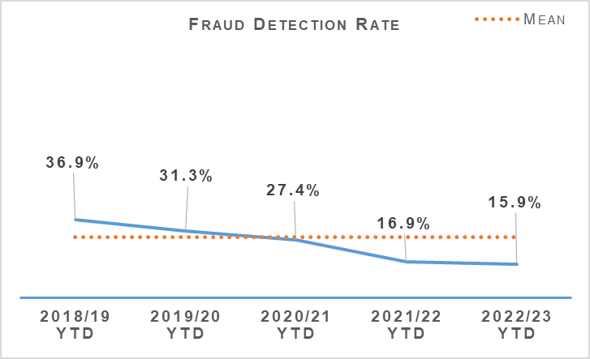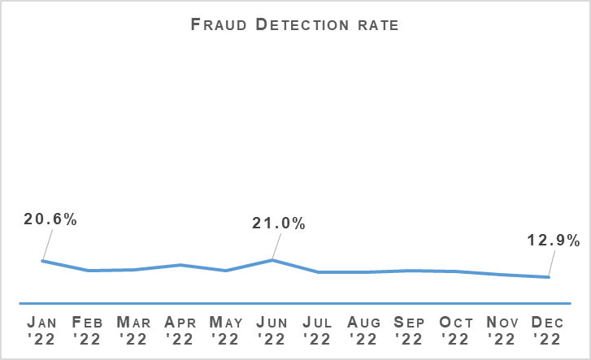
The fraud detection rate currently stands at 15.9%, down 0.9 percentage points on last year and 12.9 percentage points lower than the five year mean. This decrease has been driven by a significant rise in recorded crimes compared to the rise in detections. There have been 2.069 crimes detected between April and December 2022 compared to 1,958 last year. This is 5.7% (111) more than the same period last year and 14.3% (345.8) fewer than the five year mean. This is not an issue unique to Police Scotland and remains a challenge across UK forces due to how quickly the cyber-enabled element of fraud is evolving.

Police Custody

Criminal Justice
Criminal Justice | 2021/22 YTD | 2022/23 YTD | % Change from Previous Year
Volume of cases submitted into Criminal Justice System | 97,609 | 92,488 | -5.2%
There is a consistent national downward trend emerging in reported cases and whilst effective use of direct measures and alternatives to prosecution are a contributing factor, it is likely that resource challenges in the Case Management Unit (CMU) have a small part to play in this.

Arrested Persons
Arrested Persons Brought into Custody | 2021/22 YTD | 2022/23 YTD | % Change from Previous Year
Number of times arrested persons brought into custody | 70,888 | 73,340 | +3.5%
It is important to note that that number of arrested persons includes individuals who have appeared in custody on more than one occasion within the reporting period. This excludes voluntary attendance, S.23 MDA 1971 detentions and those in transit.
Custody throughput, having decreased steadily year on year, is now showing signs of levelling off as we emerge from the COVID-19 pandemic.
This is the third quarter which has seen an increase on throughput since 2016 and is up further from the 1.4% increase recorded in Quarter 1 2022/23 and 2.5% increase recorded in Quarter 2 2022/23.
There is no identified reason for these rises but it will be carefully monitored.

Arrested Persons Held for Court | 2021/22 YTD | 2022/23 YTD | % Change from Previous Year
Number of arrested persons held for court | 25,820 | 29,689 | +15.0%
Proportion of arrested persons held for court | 36.4% | 40.5% | +4.1% point
Number of arrested persons held for court in relation to a new case | 18,696 | 19,886 | +6.4%
Proportion of arrested persons held for court in relation to a new case | 72.4% | 67.0% | -5.4% point
Similar to Quarter 2, the proportion of arrested persons held for court has increased in comparison to last year’s period. This has been impacted considerably by the numbers being arrested on warrant issued and then executed as the pandemic recedes.
This will continue to be monitored closely in the coming months to establish whether this is an increasing or continuing trend, however it is worth considering that this is still down significantly on the percentage to court pre-pandemic which generally fluctuated around 50-52%. This appears supported by the 5.4% reduction in persons appearing in relation to a new case.
The Audit and Compliance Sergeants (ACS) are now fully embedded and are averaging circa 200 full, end-to-end custody record audits per week. This audit focuses on every aspect of a person’s care whilst in custody.
This continues to represent just over 10% of all custody records (total throughput) from the time they took up post and introduces a previously unprecedented level of quality assurance which also includes disposal review around those held for court.

Arrested Persons Released / Re-arrested | 2021/22 YTD | 2022/23 YTD | % Change from Previous Year
*Number of persons on electronic bail | n/a | 233 | n/a
Number of arrested persons released on an undertaking | 18,627 | 17,700 | -5.0%
Proportion of arrested persons released on an undertaking | 26.3% | 24.1% | -2.2% point
Proportion of persons released on investigative liberation | 0.6% | 0.6% | No change
Number of persons re-arrested | 396 | 453 | +14.4%
The term ‘re-arrested’ is defined as any occasion whereby a person, previously released without charge as a ‘Not-Officially Accused’ person, is subsequently re-arrested for the same offence due to the presence of further evidence. This is not to be confused with a person arrested more than once within a specified period on separate charges as defined by recidivism.
*Electronic Bail was introduced May 2022, therefore figures for year 2021/22 are not available.
There have been 500 electronically monitored (EM) bail orders granted across Scotland up to 31 December 2022. This figure does not reflect the number of persons who are currently being monitored as that figure is subject to a number of external factors, but currently there are 233 individuals being monitored.
There continues to be an increase in the numbers subject to EM Orders as their use increases across the country. A number of Local Authorities remain unable to provide the service at this time, but a further increase is anticipated as this rolls out nationally.
Use of undertakings have decreased and this coincides with the increase in percentage to persons held for court.
Use of investigative liberation has remained the same despite seeing a slight improvement in Quarter 2, which coincided with a well-publicised staff communications drive on the use / benefits of investigative liberation related to investigations. A Criminal Justice (Scotland) Act targeted staff communications package is planned in this regard which is likely to land in Quarter 4 which will hopefully see an improvement.
The increase in the number of persons re-arrested may be partially explained as a result of staff using the powers afforded by the Criminal Justice (Scotland) Act more effectively following increased guidance and communications about how and when powers can be used most effectively. Re-arrest can increase investigative opportunities and should be viewed in this context.

Children brought into Police Custody / Held for Court
Children brought into Police Custody / Held for Court | 2021/22 YTD | 2022/23 YTD | % Change from Previous Year
Number of Younger Children Arrested and Accepted into Police Custody (not held overnight) | 935 | 1,082 | +15.7%
Number of younger children arrested and held overnight | 114 | 115 | +0.9%
Number of younger children held over 24 hours | 35 | 21 | -40.0%
Number of Older Children Arrested and Accepted into Police Custody (not held overnight) | 1,254 | 1,272 | +1.4%
Number of Older Children Arrested and Held Overnight | 330 | 338 | +2.4%
Number of Older Children Held Over 24 hours | 158 | 181 | +14.6%
Definitions for clarity: Adult being defined as 18 or over; Older Child being defined as 16/17 and Not under Supervision; Younger Child being defined as Under 16 or 16/17 but subject to a Compulsory Supervision Order. The number listed as held over 24 hours are those who were held in a police cell and had a relevant certificate in terms of S.22 of the Criminal Justice (Scotland) Act 2016 issued indicating why they were so held and not at a place of safety. **Overnight is determined as the period of time spent in custody which exceeds four hours and includes the period between 0000 and 0400 hours.
Police Scotland’s position is that police custody is not a suitable place of safety for a child. We are working with partners to identify and develop alternatives. In the absence of those alternatives we focus our efforts on minimising any trauma a child may experience when arrested.
Only in the most serious of cases and where there is no other appropriate place of safety will a child be held overnight or longer than 24 hours in police custody and the figures reflect this.
We have seen a very significant reduction in the number of younger children held over 24 hours although an increase in older children held over 24 hours is apparent. There have been modest increases in numbers coming into custody which is broadly consistent with the transition out of pandemic arrangements and the wider increase in throughput observed.
CJSD proposed and delivered a “Children in Conflict with the Law” round table event on 15 November 2022, co-sponsored by the Scottish Police Authority and Police Scotland to mark International Children’s Day in Edinburgh and was jointly opened by Martyn Evans and DCC Graham.
Approximately 100 police officers and influential partners including Scottish Government departments and the Children’s Commissioner were in attendance. Delegates heard from a number of keynote speakers before taking part in table top exercises to look at both the current provision of places of safety for children, and also to generate discussion around future alternatives.
The broad topics of discussion were captured on the day and delegates have been invited to provide feedback to the SPA Strategy and Innovation Team following where a post event report will be generated. CJSD will continue to build on the work carried out at London Road Custody Centre in Greater Glasgow Division with a view to enhancing the provision for children and young people in the custody estate across the country.

Police Direct Measures
Police Direct Measures | 2021/22 YTD | 2022/23 YTD | % Change from Previous Year
Number of ASB Fixed Penalties issued | 7,928 | 3,903 | -50.8%
Number of Recorded Police Warnings issued | 15,216 | 15,434 | +1.4%
A significant proportion of the Fixed Penalties issued in 2020/21 and in to 2021/22 relate to the Health Protection (Coronavirus) (Restrictions) (Scotland) Regulations 2020.
The decrease in the issuing of ASB Fixed Penalty Tickets will be as a direct result in the easing of these restrictions which no longer create an offence for certain activities previously subject to such penalties. Accordingly the decrease is anticipated given these circumstances.

Vulnerability
Vulnerability | 2021/22 YTD | 2022/23 YTD | % Change from Previous Year
Number of persons arrested who have declared current or historic alcohol addiction issues | 7,997 | 8,759 | +9.5%
Proportion of persons arrested who have declared current or historic alcohol addiction issues | 11.3% | 11.9% | +0.6% point
Number of persons arrested who have declared current or historic drug addiction issues | 11,026 | 11,178 | +1.4%
Proportion of persons arrested who have declared current or historic drug addiction issues | 15.6% | 15.2% | -0.4% point
Number of persons arrested who have declared current or historic Mental Health issues | 29,307 | 31,027 | +5.9%
Proportion of persons arrested who have declared current or historic Mental Health issues | 41.3% | 42.3% | +1.0% point
Please note, each custody may have reported "yes" to each of the above categories.
The proportion of persons declaring one or multiple vulnerabilities remains broadly stable although increases can be seen in total numbers which may be partially explained by the increase in throughput. The numbers declaring previous or current alcohol addiction issues is perhaps the most noteworthy followed at some distance by those declaring mental health issues.
NHS Partners in Custody Centres | 2021/22 YTD | 2022/23 YTD | % Change from Previous Year
Number of people in custody seen by NHS partners in custody centres | 5,105 | 5,240 | +2.6%
Figures provided represent the numbers marked out of cell for medical assessment (excluding those to hospital). They do not include those individuals who are subject to several medical assessments as is often the case during longer periods in custody.
There continues to be a drive to make optimal use of health care professionals for healthcare and welfare decisions and management of risk. Figures from this area of business have risen which would be expected with the increase in person’s vulnerabilities detailed above in relation to alcohol and drug use and a deterioration in mental health.
We are committed to ensuring the safety and wellbeing of those in our care and custody. However, it is important to recognise that many of these people are vulnerable and have complex needs. As such, we work closely with healthcare professionals to provide an appropriate level of care based on an assessment of these needs and risks.
Police Scotland has highlighted that despite our national approach to police custody, the healthcare provision is supplied by 14 Health Boards each of whom provide Police Scotland with differing levels of service or delivery methods. We welcome the ongoing inspection by Her Majesty’s Inspectorate of Constabulary Scotland and Healthcare Improvement Scotland who will consider the provision available across Scotland and make appropriate recommendations.
Partner Referrals | 2021/22 YTD | 2022/23 YTD | % Change from Previous Year
Number of arrested persons referred to partners | 971 | 1,081 | +11.3%
Although the Harm Reduction Strategy focuses on four strands, namely reducing drug deaths, drug and alcohol use, mental health and social inequalities, there is much work being undertaken to increase the availability of access to support services after release from custody. This includes both increasing the number and range of services in partnership with Police Scotland, but also a greater focus on and scrutiny of the arrest referral service internally.
At the start of this quarter, Apex Scotland unfortunately lost their funding to provide their inclusive service in the West and East of Scotland. This left North and South Lanarkshire without any support in place and accounted for a large drop in referral numbers.
However partnership working in both North and South Lanarkshire has led to The Scottish Association for the Care and Resettlement of Offenders (SACRO) providing an inclusive service, with South Lanarkshire resident support going live on 16 December 2022 and a service for those residing in North Lanarkshire due to go live in early 2023.
Overall, while the number of referrals for Quarter 3 are down from Quarter 2 (and many of these would be attributed to losing Apex Scotland), overall YTD referrals are up by over 11%.
Further awareness inputs to staff continue, focused on what referral support is available in each geographical area, along with how to make the referrals. This coupled with a drive to have more link workers attend custody centres directly will improve service delivery.

Productions
Productions | 2021/22 YTD | 2022/23 YTD | % Change from Previous Year
Total number of productions received | 442,290 | 446,948 | +1.1%
Total number of productions disposed | 240,505 | 230,320 | -4.2%
Total number of productions accumulated | 201,785 | 217,258 | +7.7%
% of productions accumulated in terms of total received | 45.6% | 48.6% | +3.0% point
The number of productions seized in Quarter 3 of the current year has risen when compared to the same period last year. This may be affected by recovery from the pandemic.
The number of items disposed of has decreased slightly showing a comparative increase in PMO productivity. The constant accumulation of articles underlines the pressure on the Criminal Justice estate and the need for further discussion to review the need based on the long established principles of ‘best evidence’.

Summary Case Management (SCM)
SCM is continuing to run within the three pilot areas of Paisley, Hamilton and Dundee. The pilot started on 04 September 2022 and is now starting to produce green shoots of success despite some challenges.
COPFS are providing management information which has shown a reduction in new citations issued to police witnesses in all three pilot areas for domestic abuse cases.

First Cite Sheriff Summary – Police Witnesses
Location | All Cases (Apr to Aug 22) | DA Cases (Apr to Aug 22) | All Cases (Sep to Nov 22) | DA Cases (Sep to Nov 22) | All Cases (Variance) | DA Cases (Variance)
National | 7,992 | 3,939 | 6,485 | 3,188 | -19% | -19%
Dundee | 348 | 170 | 298 | 105 | -14% | -39%
Edinburgh | 866 | 470 | 882 | 414 | +2% | -12%
Hamilton | 625 | 288 | 408 | 190 | -35% | -34%
Paisley | 396 | 191 | 202 | 94 | -49% | -51%
The results are encouraging but should be read with the realisation that these are first time issued citations for domestic abuse cases only. The three pilot courts have been highlighted in yellow with Edinburgh being used as an example of an area outwith the pilot.
The number of citations issued to police officers in all three pilot areas has reduced due to better case management between crown and defence as cases will be agreed and a plea submitted or evidence could have been agreed and the case continued without plea.
In all of these cases previously we could have realistically expected the defence to tender a not guilty plea immediately triggering a trial date with automatic officer citations.
The need for officers to attach all key evidence and front load all key witness statements coupled with the new domestic abuse template which was introduced in June 2022 is enabling officers to produce a more comprehensive report which is being favourably received by our crown colleagues.

Demand
Work is continuing within the area of court demand. There are ongoing meetings and discussions between Police Scotland and COPFS in an effort to explore any practical methods of reducing the demand court attendance has on the welfare of officers and the abstractions from operational duties at key times of the week. The project team are also exploring the method and amount of additional court paperwork which is being passed to Police Scotland from COPFS to be delivered on their behalf.
The work in relation to the development of the new court scheduler is continuing with ICT reporting regularly back to the gold group on the work carried out and the advancements made.
Police Scotland is still working with COPFS colleagues in relation to the night shift citations issued to officers with more than 28 days before trial. To date COPFS have reviewed circa 60,000 records which have resulted in more than 5,000 officers receiving countermands.
A recent workshop organised by the project team and attended by colleagues from COPFS and local policing divisions looked at mapping out ways of reducing the demand court has on the operational numbers for front line policing.
Areas which were addressed included first day citations for sheriff and jury court along with the benefits of looking at the night shift citations only. There will be a follow up workshop during Quarter 4 of 2022/23 to discuss court excusals and the demand placed on officers delivering court documents.

Remote Provision of Witness Evidence (RPWE)
This is still an area of our business which is fully supported at the highest level of the judiciary and is seen as the way forward for police and professional witnesses to provide their evidence within the High Court.
However there remains challenges in seeking to achieve consistency in approach amongst all partners. To date for the High Court we have received over 10,000 citations with only 1,048 officers actually being required to attend a witness evidence room or a court. Of this number 316 (30%) have appeared virtually and 732 (70%) in person.
The RPWE process will be reviewed during Quarter 4 of 2022/23 to identify if the current process and procedures are fit for business as usual.

Strategic Outcome 3
The public, communities and partners are engaged, involved and have confidence in policing.
Objectives:
Embed the ethical and privacy considerations that are integral to policing and protection into every aspect of the service
Protect the public and promote wellbeing across Scotland by providing services that are relevant, accessible and effective
Work with local groups and public, third and private sector organisations to support our communities

Public Confidence and Satisfaction
Insight into Police Scotland’s approach to addressing public confidence and the importance the organisation places on this key aspect of policing and community engagement is detailed in the Public Confidence and Experience of Policing section at the beginning of this report.
The following table provides the survey results that have been identified by Police Scotland and the Scottish Police Authority as key measures of progress towards achieving this strategic outcome.
Public Opinion Statements | Q1 21/22 (n 3819) | Q2 21/22 (n 1289) | Q3 21/22 (n 822) | Q4 21/22 (n 14094) | Q1 22/23 (n 945) | Q2 22/23 (n 10243) | Q3 22/23 (n 3781) | Change from last Quarter
Feel either ‘very safe’ or ‘fairly safe’ in their area | 80% | 73% | 72% | 84% | 79% | 83% | 78% | -5% point
Strongly agree or agree that the police listen to concerns of local people | 33% | 29% | 36% | 29% | 31% | 32% | 28% | -4% point
Strongly agree or agree that local police are friendly and approachable | 67% | 65% | 64% | 61% | 64% | 64% | 60% | -4% point
Note: Confidence refers to how those who may not have directly engaged with the organisation. The numbers displayed in the headers relate to the number of respondents to the survey during that particular quarter feel about Police Scotland.
User Experience – Equality Outcome 2 | Q1 21/22 | Q2 21/22 | Q3 21/22 | Q4 21/22 | Q1 22/23 | Q2 22/23 | Q3 22/23 | Change from last Quarter
Percentage callers saying it was easy or very easy to contact the police | 75% | 67% | 75% | 76% | 72% | 69% | 73% | +4% point
Percentage callers satisfied or very satisfied with the way they were treated by staff member during initial contact | 85% | 82% | 86% | 87% | 84% | 84% | 85% | +1% point
Percentage callers who felt staff properly understood what they needed | 86% | 84% | 87% | 89% | 86% | 86% | 86% | No change
Percentage callers feeling that the police provided the appropriate response | 66% | 62% | 65% | 68% | 62% | 61% | 64% | +3% point
Percentage callers felt satisfied with the way they were treated by the officers who attended the incident (where applicable) | 81% | 78% | 80% | 83% | 81% | 80% | 81% | +1% point
Percentage callers felt they were adequately informed about the progress made (where applicable) | 59% | 55% | 60% | 63% | 47% | 45% | 51% | +6% point
Based on overall experience, percentage callers satisfied or very satisfied with Police Scotland | 68% | 64% | 68% | 70% | 67% | 66% | 69% | +3% point
Note1: Satisfaction refers to those who have contacted the police. This reflects on the organisation’s ability to handle individual incidents for an effective outcome for people, the police service and communities.
Note2: From April 2022, a new question has been added to the survey. Before question 6A within the survey is asked (about whether respondents feel they have been adequately informed about progress), respondents now answer a ‘screener question’ which asks “Did you expect to receive an update on the incident you contacted police about?” If respondents answer ‘yes’ they are asked if they feel they had been adequately informed. If ‘no’ they are skipped on to the next question. This means that people who did not expect to receive a response to the issue they made contact with police about are now excluded.

Quarterly Comparison
Since April 2020 measures of satisfaction with Police Scotland have remained consistently high. The change of survey methodology (from phone interviews to text in April 2020 due to the pandemic) resulted in changes in the data. It is important to note that these data changes do not always indicate a trend; overall satisfaction has remained between 64%-73% in each quarter over the past two years.
There has been an increase in nearly all contact points of the user journey, from initial contact with C3 staff, to contact with attending officers. The only point of the user journey which did not increase from the previous quarter, was respondents reporting that staff understood what they needed, which remained the same from the previous quarter (86%).
To understand the reasons for initial contact being easy or difficult, an open-ended survey question was introduced to the local policing User Experience Survey in September 2021. 3,932 responses were received to this additional question in Quarter 3 2022/23.
Among respondents who found it easy to contact police (n=2,877), qualitative analysis of responses has highlighted the following as reasons why contact was easy:
Service Accessibility. 60% (n=1,735) of respondents highlighted fast 101 / 999 answer times and found the automated menus easy to navigate. Respondents were also satisfied if they were able to report incidents online.
“Phoned 101 and explained situation and they took control and the situation was attended too quickly.”
“Got through to an operator very quickly she was nice and polite and dealt with my complaint very politely excellent service”
“Found information easily on internet and got to speak to someone in relevant team quickly.”
Effective Communication. 20% (n=584) of respondents praised service advisers for their ability to be helpful under pressure, whilst also helping keep the caller calm, providing advice and making them feel safe .
“999 easily remembered - phone was answered instantly. Operator awareness - calm and collected, knew her job and the brief, asked for time to allocate local resources i.e. let them know hazards in close Officers themselves professional and upstanding. Reassured me throughout and offered regular support should the need arise. Did not want me to worry about contacting Police Scotland in future.”
“They were very sympathetic to my circumstances and took their time to talk me through all that was going on”
“I just dial 999 and respond was very fast. Officer over the phone was professional and helpful. I was very stressed but the officer calmed me down in a good manner.”
Police Presence. 11% (n= 309) of respondents mentioned appreciating officers attending incidents in a timely response which they perceive to be appropriate. Responses also mentioned attending officers being attentive and helpful.
“Very well attended, quick response, put my mum at ease, can’t speak highly enough on the response. Thanks”
“Both officers were polite and open to hearing our concerns. They were aware too of the background to our complaints. Reassured by the follow-up from the local authority after their intervention.”
“The 2 officers that attended and took statements were really understanding and gave me good advice and reassurance. A credit to Police Scotland.”
Among respondents who found it difficult to contact police (n=587), qualitative analysis of responses has highlighted the following as reasons why contact was difficult:
Difficulties with connecting to a service advisor. 63% (n=386) of respondents referred to long waiting times using the 101 service for non-emergency incidents, the inability to connect to staff on their first attempt or giving up calling 999 instead.
“Calling the non-emergency number is a hit or miss - mostly a miss. It can ring for a long while, up to 30 mins, before anyone answers. Other times it connects right away...”
“The call took a long time to be answered & there were several points at which I nearly cut the call, but the nature of my call was important, so I persisted.”
Being kept up to date after initial contact. 24% (n=142) highlighted a lack of updates / follow up to their cases to know what was happening, with no call-backs or updates about their reported incident.
“Nothing was ever done to resolve any part of my complaints, and no communication, despite my trying hard to get it.”
“I did not receive any confirmation about my complaint, no contact has been made by police Scotland and since the problem is still happening, I’m not sure if police Scotland did anything about it”
Further comments provided by survey respondents highlight the importance of:
Listening to understand needs to provide the appropriate response.
Making access to the police service as easy and intuitive as possible.
The need for multiple ways of online (email, website), virtual (video calling) and in person (easy access to and relationships with local officers) contact with police.
Consistency of service delivery, with a high standard of service from all staff and officers in all parts of Scotland.
Being able to communicate with a call handler who has adequate geographical knowledge of where the incident is being reported.
Being informed and updated on aspects of work that Police Scotland is doing to respond to local areas of concern and reported incidents; highlighting the importance of a continuous engagement with the public.

Public Contact and Engagement Strategy
Ease of contact is a key area of focus in the Public Contact and Engagement Strategy. The introduction of accessible new contact channels and enhancement of how Police Scotland communicates and engages, will help to improve public experience and confidence in reporting crime and other incidents, enabled by digital services. For example, key programmes are continuing to ensure people are able to contact police in ways which are most accessible for individuals:
Fully accessible online reporting for getting information and advice, reporting low level crime and other incidents, receiving updates, and sharing evidence.
Investing in the replacement of our national contact platform (UCCP) to sustain contact assessment and call triage and to ensure our technology is a platform for innovation and supportive technologies in the future i.e. ‘next generation 999’ for connecting with mobile technology. Policing of the future in Scotland is expected to use video and text, activated by service advisors for easing emergency contact, in addition to phone contact.

Complaints about the Police
Complaints | 2021/22 YTD | 2022/23 YTD | % Change from Previous Year | 5 Year Mean | % Change from 5 Year Mean
Total number of complaints from members of the public | 5,141 | 4,951 | -3.7% | 4,936 | +0.3%
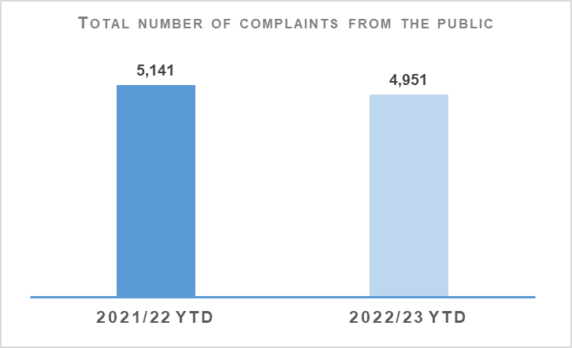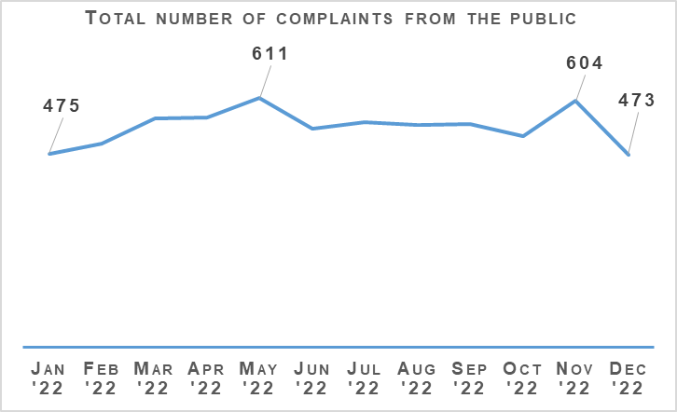
Complaints from members of the public decreased by 3.7% (190 fewer complaints) to 4,951 at the end of Quarter 3 compared to the same period last year but are up 0.3% (15 more complaints) on the five year mean.
The decrease in complaints in Quarter 3 compared to the same period last year is influenced by an elevated level of complaints in 2021/22 linked to Quality of Service related allegations. In particular, Service Outcome allegations, which have decreased notably from this period. Substantial decreases in Incivility and Irregularity in Procedure allegations have further impacted in this regard.
The Professional Standards Department (PSD) has resolved 2,231 complaints (45.1%) by Frontline Resolution (FLR) during the year to date 2022/23, compared with 48.6% in the same period last year. This includes early resolution and subsequent resolution by PSD/specialist officers.
Due to the launch of a new complaint handling model on 03 May 2021, FLR rates cannot be directly compared to data prior to this date. This is due to the provision of additional complaint categories which will provide PSD with more detailed analysis and understanding of the overall complaint handling process.

Allegations about the Police
Allegations | 2021/22 YTD | 2022/23 YTD | % Change from Previous Year | 5 Year Mean | % Change from 5 Year Mean
Total number of allegations from members of the public | 9,581 | 7,823 | -18.3% | 8,614 | -9.2%
% of closed allegations which were upheld | 7.4% | 6.8% | -0.6% point | 9.2% | -2.4% point
Note: A complaint case may include multiple allegations. A ‘Complaint’ relates to the overall expression of dissatisfaction provided by the complainer about an act or omission by the police or Quality of Service received. Allegations are the component parts of a complaint, which categorise what has happened and are separated to those capable of being independently Upheld or Not Upheld.
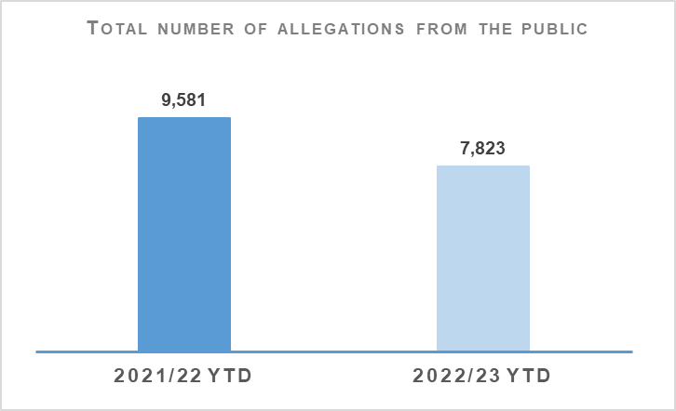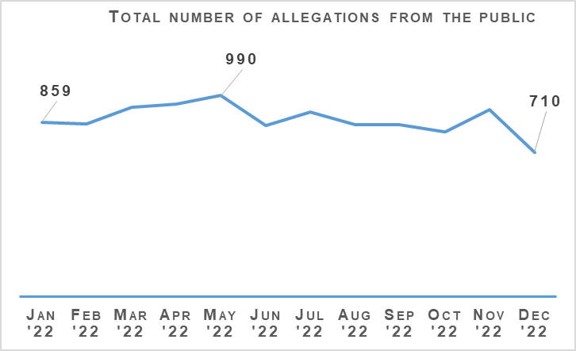
The total number of allegations has decreased by 18.3% (1,758 fewer allegations) compared to the same period last year, with 7,823 allegations recorded at the end of Quarter 3 2022/23. The number of allegations is also down 9.2% (791 fewer allegations) when compared to the five year mean.
Allegations closed totalled 7,969 at the end of Quarter 3 with 6.8% of these being upheld. Allegation outcomes (e.g. upheld) are based on closed allegations within the year to date period. Closure dates vary from the received dates, therefore closed and received data may not be directly comparable.
During this period, there were 3,180 non-criminal and FLR complaints closed with 66.8% closed within the 56 day statutory timescale. This is a 0.5 percentage point decrease from the same period in 2021/22. FLR complaints are now included in this measure to better reflect the overall demand in complaint handling. Moreover, this further reflects the key aim of frontline resolution in providing an informed response within a shorter timescale, whilst also enabling an amicable conclusion for both complainers and subject officers.

Police Investigations and Review Commissioner (PIRC)
Police Investigations and Review Commissioner | 2021/22 YTD | 2022/23 YTD | % Change from Previous Year
Number of PIRC Complaint Handling Reviews (CHRs) | 152 | 144 | -5.3%
Number of allegations considered by PIRC (CHRs) | 610 | 693 | +13.6%
% of reviewed allegations assessed as handled to a reasonable standard | 66.2% | 73.2% | +7.0% points
Number of On Duty Assault cases referred to PIRC | n/a | 283 | n/a
% of these cases subject to PIRC investigations | n/a | 19.8% | n/a
Note: Allegations of On Duty Assault – plus any associated criminal allegations have been referred to the PIRC since 04 October 2021. As such, Police Scotland are currently unable to make any comparisons to the previous YTD.
In total, 283 allegations of On Duty Assault referrals were made to the PIRC during the period April to December 2022. Of those, 56 are subject to the Police Investigations & Review Commissioner (PIRC) investigation (19.8%). However, as at 06 January 2023, a further 130 of these referrals are awaiting a decision from PIRC regarding possible investigation.
The PIRC submitted 144 Complaint Handling Reviews (CHRs) to Police Scotland for consideration during this period. This equates to 2.9% of all complaints. The 144 CHRs received from PIRC considered 693 allegations, with 507 (73.2%) assessed to have been handled to a reasonable standard. This is an increase of 6.9 percentage points from the same period in 2021/22. These CHRs included 172 recommendations.
Statutory referrals to PIRC facilitate independent and transparent scrutiny in relation to serious incidents involving the police. Police Scotland made 238 referrals to PIRC resulting in 44 investigations (18.5%) at the end of Quarter 3 of this reporting year. This is a decrease of 10.2 percentage points compared to the same period last year. Those referred to PIRC include:
Referrals to PIRC | 2021/22 YTD | 2022/23 YTD | % Change from Previous Year
Armed Policing Presentation of Firearm | 52 | 92 | +76.9%
Crown Directed Inference of Criminality | 25 | 25 | No change
Death following Police Contact | 6 | 9 | +50.0%
Death in Police Custody | 1 | 1 | No change
Serious Injury Following Police Contact | 25 | 22 | -12.0%
Serious Injury in Police Custody | 31 | 48 | +54.8%
STO Taser Discharged | 48 | 41 | -14.6%
Total Referrals to PIRC | 188 | 238 | +26.6%
Total referrals to PIRC have increased by 26.6% compared to the same period last year with the largest percentage increases recorded in Armed Policing Presentation of Firearm referrals, Death Following Police Custody and Serious Injury in Police Custody referrals.
Armed Policing Presentation of Firearm referrals have increased by 76.9% (40 more referrals) when compared to the same period last year. By way of context, the monthly average of Armed Policing referrals during 2021/22 overall was six, with a comparative monthly average of ten during 2022/23 to date.
Each individual month during the YTD has been above the 2021/22 monthly average, with further spikes during April (12), July (14), August (12) and September (13). The latter four are the highest monthly totals registered for Armed Policing referrals going back to April 2019. The monthly volumes have however reduced in Quarter 3 with eight referrals in both October and December respectively and nine referrals in November 2022.
Key themes of note amongst the Armed Policing referrals include:
Spontaneous incidents account for 75 (81.5%) of referrals compared to 13 (14.1%) planned operations and four (4.4%) accidental discharge in training / armoury environmental and the humane dispatch of an animal.
Individuals with a mental health concern and in possession of an offensive weapon account for 64.1% of total referrals
Subjects in possession of bladed weapons alone feature in 42 (45.7%) of referrals, reported firearms possession in 26 (28.3%) and referrals involving both in 11 (12.0%).
The majority of referrals relate to the presentation of firearms (87.0%, 80 in total). The remaining 12 referrals involved the discharge of firearms, six of which were Taser discharges by armed officers in response to non-compliant subjects threatening officers with bladed weapons. A further two referrals involved the discharge of conventional firearms to conclude serious incidents to prevent serious harm to officers and members of the public. The remaining four relate to accidental discharges in the Police training / armoury environment and the humane dispatch of an animal.
Of these 92 Armed Policing related referrals YTD, four are subject to PIRC investigation with a further three awaiting PIRC decision. This provides further independent assurance that the use of Armed Policing resources in response to these events, broadly, have been proportionate and justified.
The comparative volume of Serious Injury in Police Custody referrals is influenced by zero such referrals made during June 2021. The average number of those referrals across the full 2021/22 financial year was four per month, with the YTD (April to December only) having an average of five. This continues to be assessed as a relatively low volume increase and is not yet indicative of a broader increase within this referral category.
Likewise, a low volume increase has been observed in relation to Death Following Police Contact. This referral category remains at a relatively stable level and it is noted that in the last quarter there was only one referral submitted to PIRC.

Organisational Learning
PSD is committed to promoting a culture of organisational learning. Learning from CHRs and other sources are disseminated through bulletins, individual feedback and are also used to inform training packages. This learning can therefore influence and improve our service.
In Quarter 3 2022/23, PSD has disseminated learning from a variety of incidents with the following learning outcomes of particular note:
Officers should ensure that a custody is clear of the cell door before closing it and be fully aware of the Operational Safety Training (OST) options available to them - up to and including the final tactical option of the use of force - when dealing with non-compliant custodies, including those who are not aggressive.
Armed Firearms Officers (AFOs) have been reminded of the Weapon Safe Handling Procedures protocols and the absolute necessity to ensure that the safety officer’s instructions and directions are followed at all times during the weapons system function checks and the loading and unloading procedure.
It is important that officers inform the Area Control Room (ACR) of developing situations, allowing consideration for the deployment of additional police resources and ACR Supervisor authorisation of a vehicle pursuit in line with Police Scotland Vehicle Pursuits SOP.
During the initial assessment and allocation of complaints, steps must be taken at the outset to seize any CCTV footage that might be available.
Officers subject to a complaint should be provided full details of the allegations made, including any specific words or phrases alleged to have been used, in order to allow them to provide a full and thorough response.
Where a complaint investigation exceeds the 56-day statutory timescale, the final response letter should acknowledge the delay and provide the applicant with an explanation or apology.
Complaint enquiries should be carried out in a thorough manner, resulting in the complaint response containing full details, which allows PIRC to carry out a comprehensive review.
It is important that the information contained in complaint responses are accurate, which will allow PIRC to produce their review.

Strategic Outcome 4
Our people are supported through a positive working environment, enabling them to serve the public.
Objectives:
Prioritise wellbeing and keep our people safe, well equipped and protected
Support our people to be confident leaders, innovative, active contributors and influencers
Support our people to identify with and demonstrate Police Scotland values and have a strong sense of belonging

Assaults on Police Officers and Police Staff
Assaults of emergency workers (police officer / police staff) | 2021/22 YTD | 2022/23 YTD | % Change from Previous Year | 5 Year Mean | % Change from 5 Year Mean
Assault of emergency workers (police officer/police staff) - number of offences | 5,508 | 5,003 | -9.2% | 5,175.8 | -3.3%
Percentage of assaults leading to injury | 29.7% | 26.8% | -2.9% point | 37.2%* | 10.4% point
Number of assault RIDDORS | 39 | 25 | -35.9% | 29.7* | +15.8%
Number of assault RIDDORS per 1k employment | 1.7 | 1.1 | -35.3% | n/a | n/a
Note: The figures for crime incidents and injuries to officers / staff are obtained from two separate systems / databases and do not directly correlate, but that are representative of the issue.*Figures marked with an asterisk relate to the 3 year mean rather than 5 year.
Note: Prior to 21 March 2021 Highland and Islands Division data only includes detected assaults.
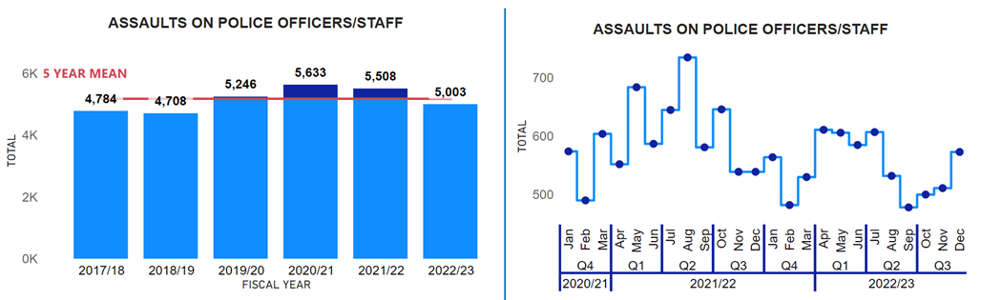
Assaults on officers / staff have decreased by 9.2% (505 fewer) compared to the same period last year and have decreased by 3.2% (327.2 fewer) against the five year mean. The Your Safety Matters (YSM) group continues to apply evidence based policing approach through continued analysis and engaging with partners which has been a key driver in the decreases.
The injury rate of assaults this year (26.8%) has continued to decrease compared to the previous year (29.7%, down 2.9 percentage points) and the three year mean (37.2%, down 10.4 percentage points). Therefore, not only are the number of assaults falling compared to the previous year and the five year mean, but the percentage resulting in an injury are also decreasing.
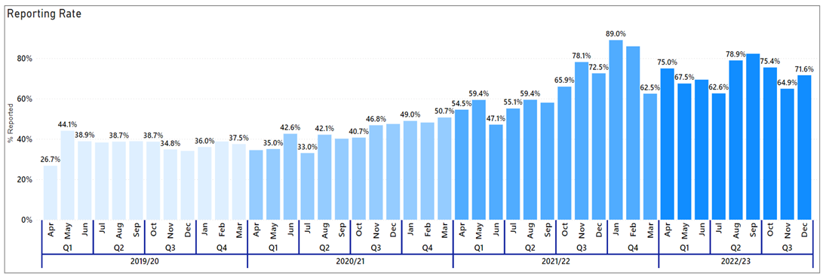
Police Scotland has maintained a high reporting rate in both Health and Safety and crimes of assault on officers / staff in 2022/23, with no month dropping below a 60% reporting rate. The improvement in the reporting can be seen from the previous graph, as before YSM was established, Police Scotland were only reporting around a quarter of assaults (April 2019, 26.7%).
YSM is committed to maintaining a high reporting rate as this provides an enriched dataset for Police Scotland to analyse, which has enabled YSM to better understand assaults on officers / staff and has been a contributing factor in YSM being able to better understand assaults against officers / staff and maintaining their safety.
YSM is also committed to expediting support given to officers / staff who have experienced hate crime. Work is underway to engage with staff associations to encourage reporting of hate crime by officers / staff and ensure they get the support required.

People and Development

Absence
Absence Management | 2021/22 YTD | 2022/23 YTD | Change from Previous Year
Percentage of working days lost for police officers | 7.8% | 7.5% | -0.3% point
Percentage of working days lost for police staff | 7.8% | 7.3% | -0.5% point
Average working days lost for police officers (Annualised) | 15.8 | 15.4 | -0.4
Average working days lost for police staff (Annualised) | 18.8 | 17.7 | -1.1
Percentage of work days lost due to Psychological Disorders for police officers | 1.4% | 1.7% | +0.3% point
Percentage of work days lost due to Psychological Disorders for police staff | 1.8% | 1.6% | -0.2% point
Percentage of work days lost due to COVID Related respiratory conditions for police officers | 2.6% | 1.3% | -1.3% point
Percentage of work days lost due to Non-COVID Related respiratory conditions for police officers | 0.5% | 0.8% | +0.3% point
Percentage of work days lost due to COVID Related respiratory conditions for police staff | 1.9% | 1.3% | -0.6% point
Percentage of work days lost due to Non-COVID related respiratory conditions for police staff | 0.6% | 0.8% | +0.2% point
Absence data this quarter highlights for police officers, the percentage of working days lost has decreased against the same period last year by 0.3% points to 7.5% and for police staff by 0.5% points to 7.3%.
COVID-related absence has continued to reduce for both officers and staff from the same period last year, down 1.3% points and 0.6% points respectively.
In terms of non-COVID-19 related absence, ‘Psychological Disorders’ remains the highest cause of sickness absence across both groups this quarter. There has been an increase of 0.3% points in percentage of working days lost for police officers who present this as their cause of absence and a slight easing on the percentage of staff working days lost (down 0.2% points).
Over the past year the Police Scotland’s health & wellbeing (HWB) team have completed an evaluation and review of all aspects of services programme. They have also undertaken detailed research into long term absence due to psychological issues. This is now complete and findings are being considered by the Executive leadership team due to be presented to the SPA People Committee for discussion in February.
Emerging from the programme review are a number of priorities, including:
Reducing the stigma which still exists around health and wellbeing, particularly mental health and the seeking of support.
Development and training of all officers and staff, with a specific focus on those in line management and senior ranks.
Recognising the importance and role of peer support amongst our people
We understand the role of sharing lived experiences and the unique knowledge and insight the sharing of lived experience can bring, has a valuable part to play in reducing the stigma around mental health. With this in mind we have developed a health and wellbeing ‘Lived Experience Series’ which will feature officers and staff sharing their own experiences over the coming months.
The first in this series was published on our intranet news pages just before Christmas and focused on wellbeing over the festive period, containing a written story from an experienced officer about struggles over this time and how he keeps himself well. Guidance was also provided on support pathways and how to support our colleagues and teams.
Our trauma risk management assessors continue to provide invaluable support to all our officers and staff across the organisation who experience trauma in the delivery of a high quality of service to the public. Demand remains high and so we have recruited and trained 38 more assessors. We are also recruiting more co-ordinators to ensure we support our workforce.
Our peer support network is driven through our Wellbeing Champion network and during this last quarter of the financial year we are refreshing our recruitment process and refresher training to ensure we continue to have an engaged and informed peer network across the geography of Police Scotland who can listen, support and sign-post our workforce with regard to all aspects of HWB.

Your Voice Matters: Recovery from Work Stressors – Quantitative Benchmark
The Recovery from Work Stressors is measured by ’disturbed sleep’ and insufficient sleep’. The scoring of recovery from work stressors for Police Scotland and England and Wales is scored from one to seven, one being extremely low and six being extremely high.
For disturbed sleep Police Scotland’s officers scored 4.35 (moderately high), and staff scored 4.27 (moderate); whereas, England & Wales officers scored: 4.76 (moderately high) and staff scored 4.73 (moderately high). Therefore, officers for Police Scotland and England/Wales have both shown moderately high levels of disturbed sleep. However, while Police Scotland’s staff have slightly lower level than England and Wales staff for disturbed sleep.
As for insufficient sleep Police Scotland’s officers (4.63) and England and Wales officers (4.91) both scored moderately high. Whereas, Police Scotland’s staff (4.22) and England and Wales staff (4.33) both scored moderate.
Responding to the survey results is a key organisational priority for Police Scotland and part of the Chief Constable’s Commitments for 2022/23. A key element of enhancing Police Scotland’s people wellbeing relates to sleep. Police Scotland have engaged and approached work place stressors strategically and focused on all the inter-connected work that ongoing within this space. For example, engaging with Police Scotland’s staff associations and the next iteration of the Police Scotland’s People Strategy.

Strategic Outcome 5
Police Scotland is sustainable, adaptable and prepared for future challenges.
Objectives:
Use innovative approaches to accelerate our capacity and capability for effective service delivery
Commit to making a positive impact through outstanding environmental sustainability
Support operational policing through the appropriate digital tools and delivery of best value

Finance

Maintaining a Balance Budget
The Corporate Finance and People Board monitor financial performance on a monthly basis and the overall financial position is regularly reported to the Scottish Police Authority (SPA) and Scottish Government.
There is also frequent engagement throughout the year to ensure that the accountable officer is aware of the overall financial position and seek their views on how any emerging issues should be dealt with.
The approved budget is reforecast on a quarterly basis to ensure the financial position continues to reflect what is actually happening across the organisation to enable better informed decisions.
The Board approved the 2022/23 budget on 23 March 2022. Despite setting a balanced budget, there were a number of significant challenges facing Police Scotland, including:
Officer and staff pay claims were not affordable within the original budget envelope – pay award has now been agreed at 5% with additional funding underwritten by the Scottish Government.
Current levels of inflation present a significant pressure on the 2022/23 budget. Although some provision was included in the budget, inflation is currently running significantly higher than anticipated - the most significant impact being utilities, fuel and supplies & services. Offsetting savings have been identified in 2022/23 and the ongoing impact is being considered as part of the 2023/24 budget development.
Officer attrition is significantly higher in 2022/23 due to changes in the Police pension regulations. As well as the operational consequences, this has significant financial implications for the organisation that will require careful management throughout the year.
Capital and reform funding allocations had been set as flat cash for 2022/23. When combined with capital receipts, the capital allocation for 2022/23 was originally £52.6m and reform was £25m. As part of the Spring Budget Revision (SBR) transfer process, Reform funding was reduced to £21.7m, with £2.8m of the funding re-directed to support capital expenditure investment.
Challenges faced in securing certain goods and services due to global supply-chain shortages will impact the speed of delivering planned investment. Similar to revenue, given the current impact of inflation, a flat cash settlement for capital and reform represents a real terms reduction in funding which will now pay for significantly less than the previous year.

2022/23 Quarter 3 Forecast
The Quarter 3 forecast break even position for revenue remains in line with budget.
The net expenditure forecast is £3.8m under revised budget. This is mainly due to an over-recovery of income (£6.4m), net underspends as noted below (£0.2m) offset by other funded pressures (£2.8m), compensated by a corresponding movement in GiA funding agreed through Autumn Budget Revision (ABR) and Spring Budget Revision (SBR) transfers.
There are a number of significant offsetting variances that form part of the Quarter 3 forecast, with £28.6m of cost pressures funded by underspends of £28.8m. The main variances are an underspend in police officer pay costs as a result of pension changes and a reduction in employers national insurance from 06 November 2022, offset by an increase in police officer overtime costs to support officer strength, unbudgeted legal costs, estate repairs & maintenance and ongoing inflationary pressures.
All known material threats have been built into the Quarter 3 forecast with the additional costs offset by additional income and other favourable variances, reducing the risk of deliverability to amber (previously heading towards red). The financial position, alongside any remaining threats and opportunities, will be closely monitored in the final quarter and forecast deliverability will be reviewed as appropriate.
Operational costs associated with the passing of Her Majesty the Queen (HMTQ) are highlighted separately. The costs of £15.4m have been covered in full by HM Treasury and has been dealt with as a SBR transfer.
The Quarter 3 reform forecast is £21.3m, £3.7m under budget with £2.8m of the funding re-directed to support capital expenditure investment.
The Quarter 3 capital forecast is £61.0m, £3.2m (fully funded) above the revised budget position of £57.8m, mainly due to additional fleet investment £5.6m offset by underspends on other capital expenditure items £2.4m.

Maintaining Financial Sustainability
Financial sustainability has been the primary objective of the medium / long term financial strategies developed since 2016, all of which highlighted the significant funding challenges facing the service.
Maintaining a balanced budget and the Government’s manifesto commitment to real terms protection formed the basis of the latest five year financial plan that was approved by the Authority in September 2021. The Resource Spending Review, published in May 2022, removed the real terms protection commitment and instead indicated a flat cash settlement for policing until Financial Year 2026/27.
Scottish Government’s 2023/24 draft budget published on 15 December 2022 confirmed a £80m core funding uplift for policing in Financial Year 2023/24 (6.4%).
Although this is a welcomed improvement on the flat cash position indicated by the Resource Spending Review, £37m of the uplift is ring-fenced to support the ongoing cost of the 2022/23 pay award, leaving only £43m for allocation in Financial Year 2023/24.
This level of funding represents a real terms reduction when set against unavoidable inflationary and other cost pressures, along with the expectations for 2023/24 pay award requiring difficult decisions to be made.
The immediate focus of financial planning is developing the annual budget for 2023/24. Although there is great value in longer term financial planning, it is very difficult in the current environment, which need to stabilise, to allow reasonable financial planning assumptions to be developed to inform longer term financial planning. Finance will continue to develop scenario modelling to understand the impact of 2023/24 funding settlement and future financial challenges.

Procurement
Compliance | 2022/23 Q2 YTD
% of regulated spend undertaken compliantly in line with purchasing policy | 94.3%
Police Scotland report retrospectively on spend compliance as a result of the data requiring to be analysed after the end of each quarter. The figure provided is an analysis of Quarter 2 2022/23. The compliance rate is down 0.2 percentage points from what was recorded in the previous quarter. Data for Quarter 3 2022/23 will be available in the 2022/23 Quarter 4 report.

Fleet
Fleet | 2022/23 YTD
% of Ultra-Low Emission Vehicles (ULEV) in our fleet | 23%
Average age of fleet | 4.46 years
Average % of vehicle availability | 98.4%
Police Scotland is working towards implementing the move to an Ultra-Low Emission Fleet as part of the Scottish Police Authority (SPA) approved Fleet Strategy. Work is ongoing with the Ultra-Low Emission Vehicle (ULEV) Board and the Fleet Implementation Group and key stakeholders. These include internal stakeholders and external agencies such as Transport Scotland, Scottish Fire and Rescue Service, Scottish Ambulance Service and city councils where sharing of resources is possible.
Our fleet is the first blue light fleet in the UK to make that commitment of greening the entire fleet of approximately 3,500 vehicles. The approved Fleet Strategy is to move to fully ULEV by 2030 in line with Scottish Government recommendations.
ULEV vehicles currently make up 23.0% of Police Scotland’s overall fleet at the end of Quarter 3 2022/23 (up 2.0 percentage points from the previous quarter). 35% of the ULEV vehicles are unmarked.
Work is ongoing with the roll-out of a Police Scotland dedicated charging infrastructure across our estate with a number of large sites completed. This will continue across Scotland from the central belt up to the Highlands and Islands as we move into phase two and three.
Police Scotland has currently got ULEV vehicles in stock and on order and these are allocated as charging sites are completed. Training is complete for all fleet staff on ULEV vehicle maintenance and repair.
Fleet is continuing to work with Health and Safety, Scottish Police Federation, Driver Training and other key stakeholders to have right vehicle, right place, right time.
The average age of the Police Scotland fleet in Quarter 3 2022/23 is 4.46 years (down 0.16 years from the figure reported last quarter). This will reduce further as new vehicles are introduced to the fleet and if the level of capital investment on the fleet is maintained in future years.
The average percentage of vehicle availability was 98.4% in Quarter 3 2022/23, this is up 1.52 percentage points from the average percentage available in Quarter 2.
Fleet is currently reviewing its Target Operating Model as we move to ULEV as there is a different skill required in ULEV vehicles. As the vehicle becomes the office and technology increases, and with less moving parts in a ULEV more mobile servicing will be the future.
This will ensure our vehicles are replaced in line with the Police Scotland Fleet Strategy to have a fit for purpose modern fleet.

Estates Co-locations / Collaborations
Shared Occupancy | 2022/23 YTD
% footprint of the Estate which is co-located/shared with our partners | 21%
As per our Quarter 2 report, we are now reflecting our co-locations based on the number of sites, as being a more representative metric. There has been no further changes to this measure in Quarter 3 with the percentage footprint remaining at 21%.

Percentage Footprint of the Estate that is in good or better Condition
Sanderson Weatherall LLP were appointed on 13 April 2022 to create an implementation plan for Priority 1 works and a 10 year Strategic plan for prioritisation of projects and future investment.
Phase 1 of the works (implementation plan for Priority 1 further investigation works) was anticipated to be completed during December 2022. Work on phase 2 (prioritisation of the works) is scheduled to begin in January 2023

Environmental - Total carbon emissions per m2 of estates
Consumption Data for Energy, Water and Fleet | 2021/22 YTD | 2022/23 YTD | % Change from Previous Year | 5 Year Mean | % Change from 5 Year Mean
Gas (per kWh) | 53,888,680 | 48,739,169 | -9.6% | 52,942,380 | -7.9%
Electricity (per kWh) | 39,253,900 | 37,679,719 | -4.0% | 40,326,152 | -6.6%
Water (per m³) | 230,778 | 243,486 | +5.5% | 243,840 | -0.1%
Fuel (litres) | 4,357,231 | 3,954,790 | -9.2% | 4,507,192 | -12.3%
As at the end of quarter 3 2022/23, Police Scotland have reduced our Gas consumption by over 5.1 million kWh (a decrease of 9.6%) compared to the same period last year. When compared to the five year mean, gas consumption has reduced by over 4.2 million kWh (a decrease of 7.9%).
Police Scotland has an Electricity consumption of 37,679,719 kWh in the reporting year to date. This is down 4.0% compared to the same period last year (a decrease of over 1.5 million kWh) and down 6.6% against the five year mean (a decrease of over 2.6 million kWh).
Water consumption increased by 5.5% (up 12,708 m3) when compared to the same period last year but has decreased by 0.1% (down 354 m3) against the five year mean.
In the year to date, Police Scotland has used 3,954,790 litres of fuel for our fleet. This is down 9.2% (402,441 fewer litres) on our usage in the same period last year and down 12.3% (552,402 fewer litres) on the five year mean.

Environmental – Reduction in Co2 emissions
Emissions | 2021/22 Quarter 1 | 2021/22 Quarter 2 | 2022/23 Quarter 1 | 2022/23 Quarter 2
Building Emissions (per tCO₂e) | 6,745 | 6,016 | 4,982 | 4,315
Total Emissions (per tCO₂e) | 10,497 | 9,133 | 8,529 | 7,516
Based on our emissions for the same quarters this year and last year, we can demonstrate that we have consistently reduced in building and total emissions over Quarter 1 and Quarter 2 of reporting year 2022/23 when compared to Quarter 1 and Quarter 2 of reporting year 2021/22.
The emissions figures are as at the end of Quarter 2 for both years and are based on a floor area of 426,907m2. Quarter 3 figures are not yet available.

