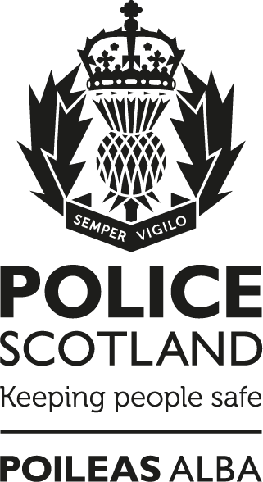

Anti-Corruption
Policy

Notice:
This document has been made available through the Police Service of Scotland Freedom of Information Publication Scheme. It should not be utilised as guidance or instruction by any police officer or employee as it may have been redacted due to legal exemptions

Owning Department: | Anti–Corruption Unit
Version Number: | 3.00 (Publication Scheme)
Date Published: | 23/02/2022

Anti-Corruption Policy
The Police Service of Scotland (hereafter referred to as Police Scotland) / Scottish Police Authority (SPA), recognises the need to maintain organisational and public trust and confidence in the integrity and impartiality of the service. This will be achieved by developing and upholding a culture where professional and ethical standards are afforded the highest priority.

Police Scotland / SPA is committed to protecting the integrity of the organisation, its officers, staff and partner organisations (including contractors) by preventing and detecting corrupt behaviour. To enable this, Police Scotland / SPA will put in place procedures that:
- identify and take appropriate action in relation to police officers and members of police staff / authority staff who engage in corrupt activities;
- identify and take appropriate action in relation to those who seek to corrupt police officers and members of police staff / authority staff;
- identify individuals, business areas, practices and processes within Police Scotland / SPA that are vulnerable to corruption and introduce or develop procedures to mitigate the associated threat, risk and potential harm;
- Information has been removed due to its content being exempt in terms of the Freedom of Information (Scotland) Act 2002, Section 35, Law Enforcement.
- enhance information sharing to maximise all intelligence and investigative opportunities;
- enhance the awareness, knowledge and understanding of organisational and personal vulnerabilities, potential threats to security and associated risks in order to prevent corrupt activities.

In support of the foregoing, Police Scotland / SPA will ensure structures are in place for police officers and members of police staff / authority staff to report any related suspicions or concerns confidentially in line with their responsibilities and supporting a culture of organisational learning.

The welfare / wellbeing of all police officers, police staff / authority staff is important and will be considered in this process which is covered under separate policies and documents.

For the purpose of police officers and police staff all Anti-Corruption Unit enquiries will take due cognisance of the Police Scotland Code of Ethics, which clearly articulates the organisation’s core values of Integrity, Fairness, Respect and Human Rights, as well as emphasising the importance of making values based decisions. For authority staff due cognisance will be taken of SPA's organisational values.

Compliance Record
Equality and Human Rights Impact Assessment (EqHRIA) Date Completed / Reviewed: | 21/10/2021
Information Management Compliant: | Yes
Health and Safety Compliant: | Yes
Publication Scheme Compliant: | Yes

Version Control Table
Version | History of Amendments | Approval Date
1.00 | Initial Approved Version. | 07/02/2014
2.00 | Re-worded as part of Policy Review. Renamed as Anti-Corruption Policy due to department restructure. | 09/12/2016
3.00 | Full review completed and formatting updated as per Formatting Standards. | 23/02/2022

