 | Freedom of Information Response  Our reference: FOI 25-3294  Responded to: 3rd November 2025
Your recent request for information is replicated below, together with our response.

Please provide the following information for the period 1 April 2020 to 31 March 2025, broken down by financial year:
First and foremost, the information sought prior to 2022 is not held by Police Scotland and section 17 of the Act therefore applies.
To explain, Police Scotland only holds information which relates to the current Hard Facilities Management (FM) contract which commenced in December 2021.

1) Total expenditure by the police force on pest control services, including both in-house provision and external/contracted services.
It is important to note that Police Scotland do not undertake any pest control activity in house - pest control services are delivered via the Hard FM services contract instead.
As such, the table below details Police Scotland spending on the contracted pest control service from 2022 to date, inclusive:
Maintenance Type | Year | Total Spend
Planned Preventative | 2022 | £39,369.16
Planned Preventative | 2023 | £63,280.56
Planned Preventative | 2024 | £67,590.12
Planned Preventative | 2025 | £44,960.80
Reactive | 2022 | £95,030.44
Reactive | 2023 | £86,108.58
Reactive | 2024 | £95,483.60
Reactive | 2025 | £41,852.31

2) If any services are contracted out, please provide the supplier name(s) and the contract value(s).
Pest control services are delivered via the Hard FM services contract with OCS group and are just one component of the much larger contract (which has a value of £158 million).
OCS Group undertakes the majority of the work themselves; however, I can confirm that Rentokil were sub-contracted for one job which cost £318.76.

3) The number of call-outs/treatments by species category (e.g. rats, mice, pigeons, gulls, foxes, grey squirrels, wasps, bedbugs, cockroaches—please use your own categories if recorded differently).

4) For any lethal control commissioned or carried out by the force, the number of animals killed by species and, where recorded, the method used (e.g. trapping, poisoning, shooting).
The table below details the number of jobs raised to pest control, broken down by pest type, treatment and lethal control method (where applicable) from 2022 to date, inclusive.
In terms of the number of animals killed by species however, this specific information is not held by Police Scotland and section 17 of the Act therefore applies as no data is available.

5) A copy of any policy, guidance, or standard operating procedure relating to the force’s pest control service or contractors.
Please refer to the images included below.

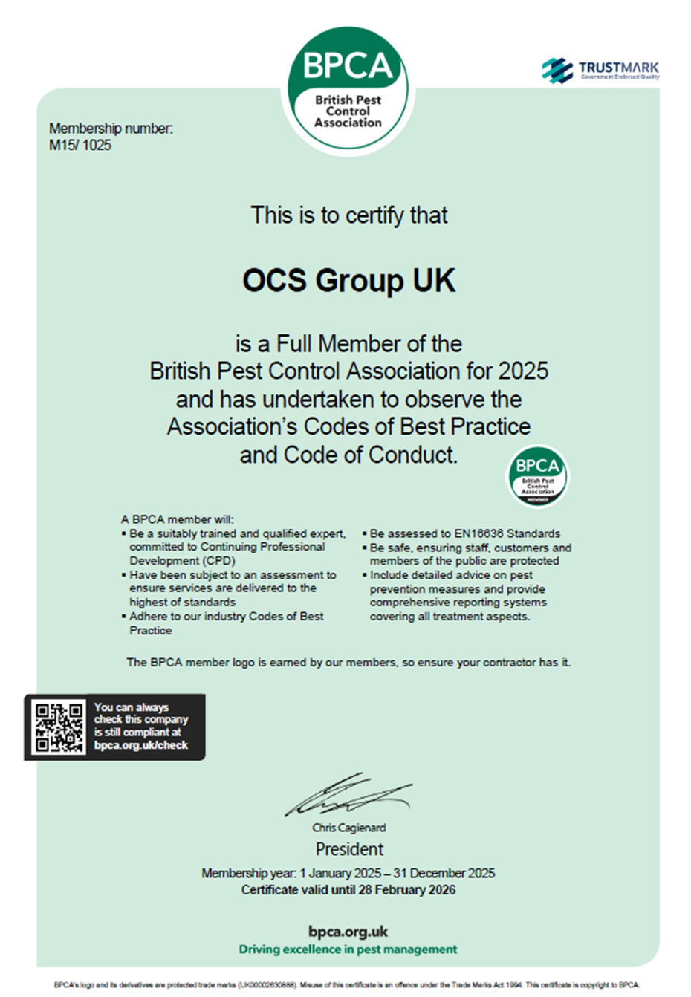
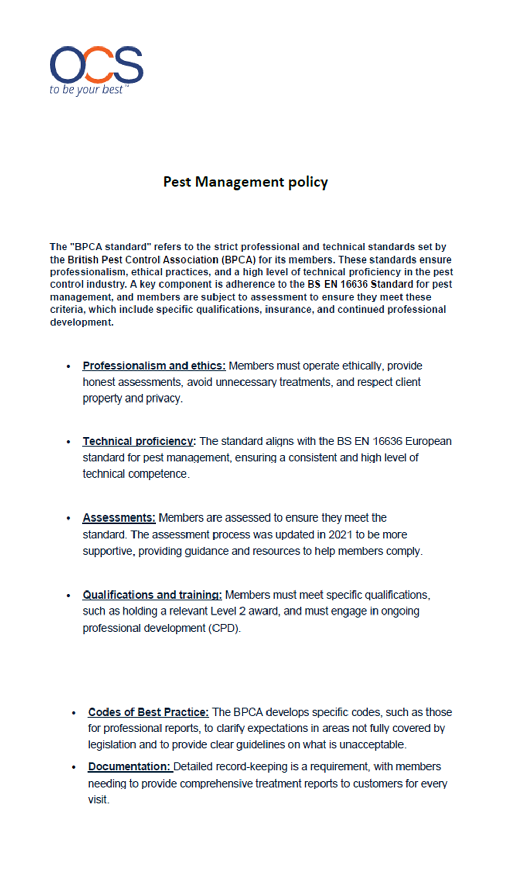
If you require any further assistance, please contact us quoting the reference above.
You can request a review of this response within the next 40 working days by email or by letter (Information Management - FOI, Police Scotland, Clyde Gateway, 2 French Street, Dalmarnock, G40 4EH). Requests must include the reason for your dissatisfaction.
If you remain dissatisfied following our review response, you can appeal to the Office of the Scottish Information Commissioner (OSIC) within 6 months - online, by email or by letter (OSIC, Kinburn Castle, Doubledykes Road, St Andrews, KY16 9DS).
Following an OSIC appeal, you can appeal to the Court of Session on a point of law only.
This response will be added to our Disclosure Log in seven days' time.
Every effort has been taken to ensure our response is as accessible as possible.
If you require this response to be provided in an alternative format, please let us know.

Year | Pest Type | Jobs Raised | Treatment | Lethal Control Method
2022 | Ants | 22 | Lethal control | Insecticide
2022 | Bats | 3 | No treatment by pest control (bat society investigate these issues) | N/A
2022 | Bees | 11 | Removal and relocation | N/A
2022 | Bird proofing | 2 | N/A | N/A
2022 | Fleas | 3 | Lethal control | Insecticide
2022 | Flies | 13 | Lethal control | Insecticide
2022 | Gull | 38 | Survey, clean, proofing, netting, bird alerts, egg removal | N/A
2022 | Maggot | 1 | Trapping | N/A
2022 | Mice | 25 | Lethal control | Rodenticide/ traps
2022 | Pigeons | 3 | Proofing/ culling | Shooting
2022 | Rats | 32 | Lethal control | Rodenticide/ traps
2022 | Rodent | 3 | Lethal control | Rodenticide/ traps
2022 | Routine visit | 3 | N/A | N/A
2022 | Silverfish | 1 | Lethal control | Insecticide
2022 | Squirrel | 2 | Lethal control | Spring trap
2022 | Wasps | 25 | Lethal control | Insecticide
2022 | Flying Ants | 2 | Lethal control | Insecticide
Total |  | 189
2023 | Ants | 24 | Lethal control | Insecticide
2023 | Bees | 3 | Removal and relocation | N/A
2023 | Bird proofing | 1 | N/A | N/A
2023 | Bluebottle | 1 | Lethal control | Insecticide
2023 | Dead animal | 6 | Disposal | N/A
2023 | Flies | 9 | Lethal control | Insecticide
2023 | Gull | 27 | Survey, clean, proofing, netting | N/A
2023 | Insects | 2 | Lethal control | Insecticide
2023 | Maggots | 1 | Trapping or live capture and dispatch | N/A
2023 | Mice | 33 | Lethal control | Rodenticide/ traps
2023 | Pigeons | 9 | Proofing/ culling | Shooting
2023 | Rats | 24 | Lethal control | Rodenticide/ traps
2023 | Rodent | 2 | Lethal control | Rodenticide/ traps
2023 | Routine visit | 2 | N/A | N/A
2023 | Silverfish | 1 | Lethal control | Insecticide
2023 | Spider | 1 | Relocation | N/A
2023 | Squirrel | 3 | Lethal control | Spring trap
2023 | Wasps | 35 | Lethal control | Insecticide
Total |  | 184
2024 | Ants | 28 | Lethal control | Insecticide
2024 | Bedbugs | 1 | Lethal control | Insecticide, steam, heat, freeze
2024 | Bees | 2 | Removal and relocation | N/A
2024 | Dead animal | 1 | Disposal | N/A
2024 | Fleas | 4 | Lethal control | Insecticide
2024 | Flies | 8 | Lethal control | Insecticide
2024 | Gull | 20 | Survey, clean, proofing, netting | N/A
2024 | Maggots | 1 | Trapping or live capture and dispatch | N/A
2024 | Mice | 30 | Lethal control | Rodenticide/ traps
2024 | Pigeons | 6 | Proofing / culling | Shooting
2024 | Rats | 34 | Lethal control | Rodenticide/ traps
2024 | Rodent | 1 | Lethal control | Rodenticide/ traps
2024 | Routine visit | 3 | N/A | N/A
2024 | Silverfish | 4 | Lethal control | Insecticide
2024 | Squirrel | 2 | Lethal control | Spring trap
2024 | Wasps | 23 | Lethal control | Insecticide
2024 | Worm | 1 | Relocation | N/A
2024 | Flying Ants | 3 | Lethal control | Insecticide
Total |  | 172
2025 | Ants | 4 | Lethal control | Insecticide
2025 | Flies | 1 | Lethal control | Insecticide
2025 | Gull | 5 | Survey, clean, proofing, netting | N/A
2025 | Mice | 10 | Lethal control | Rodenticide/ traps
2025 | Rats | 5 | Lethal control | Rodenticide/ traps
2025 | Rodent | 1 | Lethal control | Rodenticide/ traps
2025 | Routine visit | 2 | N/A | N/A
2025 | Silverfish | 1 | Lethal control | Insecticide
2025 | Woodlice | 1 | Lethal control | Insecticide
Total |  | 30

