Scottish Police Authority

Police Scotland

Procurement Strategy
2021 - 2023

Contents
Foreword 4
Executive Summary 5
EU Exit 5
COVID 19 6
Climate Emergency 6
Procurement vision 7
Organisational Context 7
Strategic Alignment 8
Procurement in Police Scotland 11
Police Scotland Category Management Model 13
Achieving our objectives 14
Creating a leading public sector procurement service 14
Our people 15
Supplier Support 15
Collaboration 16
Monitoring, reviewing and reporting 17
Our Strategic Procurement Objectives 18
Objective one: Deliver savings and best value outcomes 18
Objective two: Ensure compliance with procurement legislation with open, transparent and robust governance 18
Objective three: make procurement spend accessible to small and medium sized businesses and the third sector 19
Objective four: ensure fair working practices are adopted by suppliers 20
Objective five: Securing and Delivering community benefits 20
Objective six: Support Equality and diversity goals and principles 21
Objective seven: Enable innovation and best practice solutions 21
Objective eight: Contribute to national climate targets and Police Scotland’s Environmental Strategy 22
Policy Statements Required under the Procurement Reform (Scotland) Act 2014 23
SME, VCSE Sector and Supported Business Involvement 23
Innovation 24
Consultation and engagement 25
Community Benefits 26
Fair Work and Living Wage 27
Health & Safety at Work Act etc. 27
Fair and Ethical Trading 28
The provision of food 28
30-Day Payment 29
Climate change 30

Foreword
The Scottish Police Authority (SPA) and Police Scotland recognise the crucial role that procurement plays in delivering an effective policing service.
Since the creation of Scotland’s national police service, significant progress has been made in consolidating the separate procurement and contracting arrangements that existed in predecessor organisations.
Our Strategic Police Plan and Joint Strategy for Policing (2020), Policing for a Safe, Protected and Resilient Scotland, recognises our responsibilities as the second largest police force in the UK and one of the largest public services in Scotland. It describes how we will work together to build our support services for colleagues, delivering best value goods and services which meet operational and frontline requirements, in a way that is ethical and sustainable.
Policing is constantly evolving and must take account of the wider social, economic and political context. The Covid-19 pandemic and the UK exiting the EU have posed challenges not seen in generations, and are acutely felt within the procurement service.
This new procurement strategy describes not only how we will comply with our statutory responsibility, but recognises the wider benefits that procurement can have to the community and economy in Scotland. It describes our vision and ambition to develop our procurement service and sets out the strategic procurement objectives for the SPA and Police Scotland which align with our strategic policing plans and National Outcomes set out in the Scottish Government’s National Performance Framework.
We look forward to monitoring progress against the procurement strategy in the coming years and seeing the contribution that procurement will make to policing and the wider community.
David Page
Deputy Chief Officer
Police Scotland

Executive Summary
James Gray, Chief Financial Officer
As one of the largest public sector bodies in Scotland and the second largest police service in the UK, an efficient and effective procurement service is essential to deliver an effective policing service. The nature of our organisation requires our people are fully supported at all times with the provision of facilities, equipment and services in order to carry out their duties effectively. It is imperative that we utilise our available financial resources to ensure that we deliver a policing service which operates on a sound financial footing and provides value for money.
In this procurement strategy we set out how we intend to undertake procurement to meet those core responsibilities. In addition, we have set out 8 strategic procurement objectives with the actions that we intend to take over the period of the strategy to meet that core responsibility, as well as delivering the wider socio-economic benefits that public procurement can bring. Those wider benefits are particularly important in the current climate given world events over the last 18 months.

EU Exit
The exit of the UK from the EU has fundamentally changed our relationship in many ways for policing, including the legislative background to procurement. Whilst there has been minimal initial divergence in domestic procurement law due to the exit, this position may change in the coming years. We will continue to work with colleagues in Scottish Government to assess the potential for regulatory change and ensure our views are represented if changes are proposed.
A sharper impact has been felt at a transactional level where new customs and VAT arrangements have been put in place under the new EU-UK Trade and Cooperation Agreement. Police Scotland has reviewed its processes and procedures to ensure it can continue to secure the supplies and services it needs from the EU market under the new trading arrangements.

COVID 19
The Covid-19 pandemic has brought huge challenges to policing and this has been felt acutely within the procurement team. The initial response to the pandemic required immediate procurement decisions to be taken, whilst maintaining appropriate governance.
Police Scotland and the SPA worked closely with the Scottish Government and other public sector partners to collaborate where possible. Our focus now is to put in place medium term arrangements to ensure that supply of essential goods and services are maintained and the impact of the pandemic is minimised.

Climate Emergency
Since the Scottish Government declared a climate emergency in 2019, Police Scotland has been working to identify ways in which it can contribute to addressing that strategic national priority. Our 2020 Environmental Strategy lays out our approach to reducing emissions and is aligned with the Scottish Government’s Climate Change Plan 2018-32. Police Scotland also recognises the role that public spending and procurement has to play in addressing climate change. Police Scotland has a range of measures planned which includes leading the way within the public sector by investing in a green fleet. However, it is not just what we buy, but how much we buy which can help address climate change. Police Scotland will leverage its buying power to influence the market and address this strategic national priority wherever possible, working with other public sector partners to find collaborative opportunities, develop new tools and share best practice.
This procurement strategy builds on the progress which has been made under the SPA/Police Scotland Procurement Strategy 2017 – 2021 and sets out our ambition to continue to delivering value for money whilst securing the wider socio-economic benefits that public procurement and spending can bring.

Procurement vision
The aims of the SPA and Police Scotland are embodied in the vision laid out below which has been developed by the procurement service.
Police Scotland will deliver a Procurement service that promotes transparency, best practice and continuous development whilst delivering in a sustainable, accountable and equitable way to the benefit of our suppliers, customers, stakeholders and the public purse.

Organisational Context
The Scottish Police Authority and Police Scotland came into being on 1 April 2013, constituted under the Police and Fire Reform (Scotland) Act 2012, which had the strategic aims of:
- Protecting and Improving local services, despite financial cuts
- Creating more equal access to specialist support and national capacity
- Strengthening the communication between services and communities.
From a policing perspective, this meant merging eight separate police services and two central bodies into a single entity, Police Scotland.
The Scottish Police Authority (SPA) has statutory functions that include maintaining the police service, holding the Chief Constable to account and providing Forensic Science Services. This includes entering into contracts in order to carry out its statutory functions. Although the Scottish Police Authority is the Contracting Authority for all Police Scotland procurement, the SPA delegates the operation of a procurement function to put in place such contracts to Police Scotland.
Police Scotland is now the second largest police service in the UK with over 17,000 police officers and over 5,000 staff members. The service provides all policing functions nationally and is structured around 13 local policing divisions supported by national divisions and departments including Specialist Crime Division, Operational Support, Custody, Criminal Justice and Corporate Support Services. The Procurement Service sits within Corporate Support Services under the Finance function of Police Scotland.

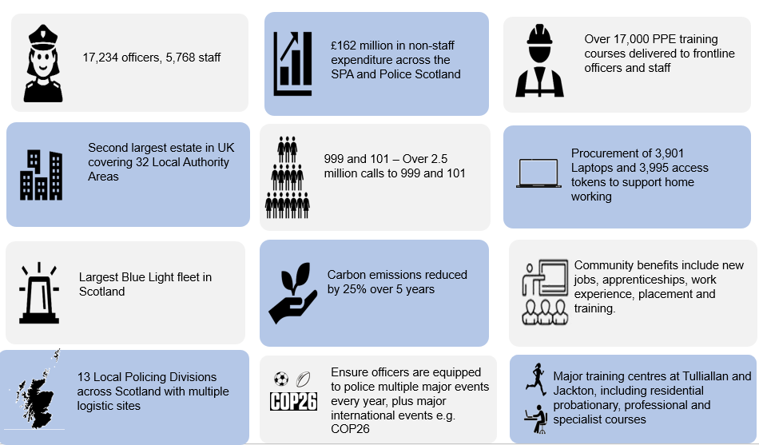

Strategic Alignment
The procurement strategy will support delivery of the Scottish Government’s National Outcomes. In particular, using the Scottish Government’s National Performance Framework, this strategy will help drive the following National Outcomes:
- Fair Work and business: We have thriving and innovative businesses with quality jobs and fair work for everyone;
- Economy: We have a globally competitive, entrepreneurial, inclusive and sustainable economy; and
- Environment: We value, enjoy, protect and enhance our environment.
Police Scotland and the SPA’s joint strategic direction is outcomes focused to show a golden thread from Scottish Government’s priorities through Police Scotland and the SPA’s corporate strategies and through this procurement strategy to provide a framework which aligns individual procurements to relevant national outcomes.
This alignment is embodied in the SPA’s Corporate Plan 2020 – 2023.
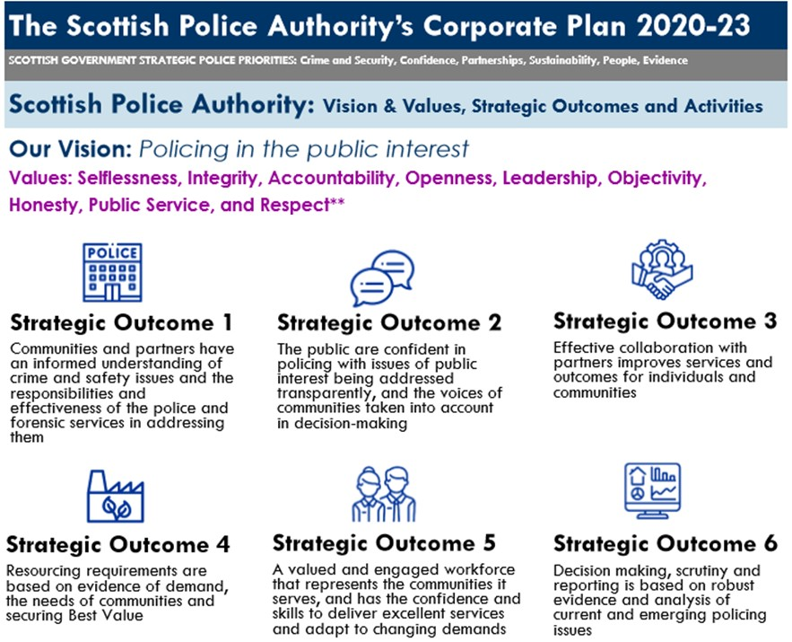
In addition, the Long Term Policing Strategy is aligned to national outcomes and is supported by enabling strategies and implementation plans within Police Scotland.
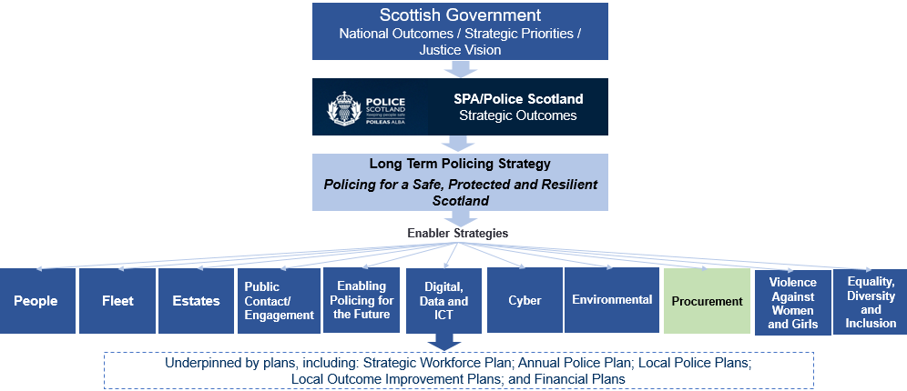

This procurement strategy fulfils a dual purpose in discharging the SPA’s statutory duty to publish a procurement strategy under the Procurement Reform (Scotland) Act 2014, but also ensures the alignment of procurement activity to those corporate plans and National Outcomes and Strategic Priorities.

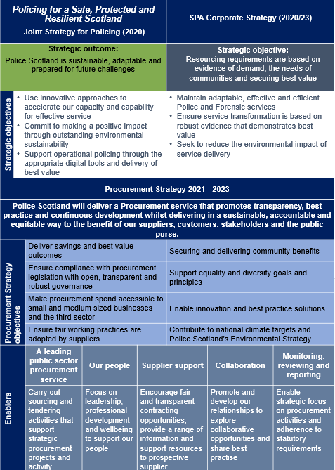

Procurement in Police Scotland
Within Police Scotland, (encompassing SPA Forensics) there is a centralised procurement service that holds responsibility for all procurement greater than £5000.
The role of the Procurement service is to:
- Ensure that value for money is achieved through appropriate procurement strategies and procedures and input into programme business cases;
- Advise, guide and support the development of and compliance with procurement policy, best practice and legislation;
- Provide professional, qualified procurement expertise, advice and services;
- Ensure that business needs are met through its procurement of goods, services and works;
- Contribute to the aims and objectives of the organisation, as detailed in the corporate plan;
- Pro-actively manage and develop the supplier base, including small and medium-sized enterprises (SMEs) and voluntary, community and social enterprise sector organisations, identifying and managing any supply risks or value add opportunities;
- Co-ordinate training development and registering of procurement officers;
- Assess procurement competencies across the organisation, using tools such as the Scottish Procurement Competency Framework;
- Promote and engage in collaboration and information sharing with relevant partner organisations;
- Support sustainable policies through procurement processes.
The main responsibilities of the procurement service within Police Scotland encompass the following activities are to:
- Act as the interface between the contracting organisation and the external marketplace on commercial matters;
- Determine requirements and establish specifications in collaboration with end-users;
- Challenge end-user requirements critically for need and cost effectiveness, taking account of whole life costs and corporate social responsibility and sustainability issues;
- Manage strategic supplier relationships;
- Manage procurement competitions, contract awards and contracts;
- Maintain a comprehensive contract register;
- Establish arrangements relating to authority to procure;
- Continually strive to develop improvements in process and procedures to ensure efficient and timely procurement;
- Measure and report procurement performance, including Best Practice Indicators (BPIs).

Police Scotland Category Management Model
Over the period of Police Scotland’s procurement strategy 2017 – 2021 a major objective was to develop and implement a category management approach to procurement. A category management model is now firmly embedded with Police Scotland and provides functional alignment with internal stakeholders bringing a range of benefits. The focus in the coming years is to further leverage that category management approach to develop medium and long term category strategies aligned with Police Scotland and the SPAs corporate plans and departmental strategies and implementation plans.
The figure below illustrates the high level segmentation of spend across category groups and scope of those categories.
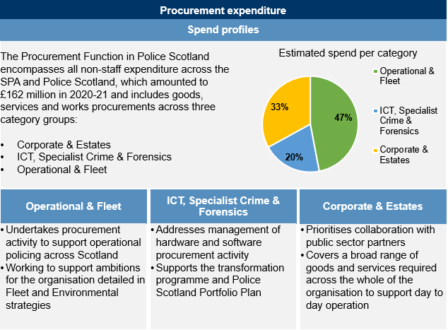
In addition to recurring strategic procurement across the various categories, Police Scotland regularly undertakes major projects which require extensive procurement support. This requires dedicated resource and will be an area of focus to develop a capability to support major projects in addition to the regular category teams. In financial year 2021/22 dedicated teams have been set up to facilitate procurement for COP 26 and the recently announced transfer of post mortem toxicology services to SPA Forensics Services.

Achieving our objectives
To deliver our vision and strategic procurement objectives we will focus on and develop the following areas:

Creating a leading public sector procurement service
The procurement service provides advice and support to customers across the SPA and Police Scotland to enable them to meet the appropriate purchasing and wider commercial requirements in carrying out our organisational functions. The service carries out strategic sourcing and tendering procedures and also monitors and challenges planned purchasing activity to ensure it is both effective and compliant. The service has a crucial role to play in enabling Police Scotland to maintain a balanced, sustainable budget but is also a key enabler for both operational policing in Scotland and Transformation. This has been ever more evident during the COVID pandemic where the agility, commitment and expertise of the service were critical to enable the policing response.
Police Scotland is the second largest police service in the UK with over 17,000 police officers and 5,000 staff. The police service provides a national policing service, delivered locally. There are 13 local policing divisions supported by national services which include Specialist Crime Division, Operational Support, Criminal Justice, People and Professionalism and Corporate Support Services.
The procurement service has been developing and building both capacity and capability over a period of time. There is now a need to focus on and invest in the service to enable a national policing service in an increasingly digital world.
To deliver effectively on our ambitions and strategy objectives, the service will be re-designed and where appropriate new delivery approaches and category focus will be introduced.
Once implemented, the refreshed service teams will continue to drive forward in making ongoing significant progress towards our ambition to be a leading public sector procurement service.

Our people
Our people are at the heart of supporting Police Scotland with purchasing and wider commercial requirements in carrying out our organisational functions.
A focus on leadership, professional development and wellbeing will be a critical element of our strategy implementation approaches. This includes a focus on support for procurement professionals and our people more widely who engage with the service and procurement processes to enable effective policing.
To deliver the Procurement Strategy the capacity and skills of procurement professionals and our people will continue to be developed and supported through:
- supporting continued and effective engagement with the SPA/ Police Scotland leaders;
- re-structuring to provide opportunities for modern apprentices and trainees to develop the skills needed;
- supporting continuing professional development of experienced individuals to ensure knowledge is up to date and aligned to developments in the sector;
- engaging with other public sector organisations and other relevant organisations to support knowledge transfer and good practice;
- providing mentoring, coaching and work shadow opportunities;
- working with colleagues in Legal Services, developing and delivering in-house workshops, training and guidance, for all our people, to support commercial awareness, best practice and legislative knowledge;
- continuing to assess procurement standards using self-assessment tools to ensure continuous improvement; and
- Providing ongoing training and support around contract management.
The procurement service will be invited to participate in workshops and briefings on the new tools and guidance and provide support to colleagues across the service on the application of these. This will enable the team to ensure best practice is achieved through procurement activity.

Supplier Support
Police Scotland encourages fair, open and transparent competition by advertising all relevant contract opportunities via the Scottish Government Procurement Portal Public Contracts Scotland (PCS) Public Contracts Scotland (PCS)
PCS website provides a range of information and resources at present to support suppliers who are interested in doing business with Police Scotland and key resources are outlined below:
- SPA Buyer Profile – details of our contract register which provides information on live contracts along with dates these are due to end providing insight to future tenderers;
- Contract Standing Orders; and
- Events, such as meet the buyer.
PCS website supplier resources will be developed on an ongoing basis throughout the period of our Strategy to ensure we have an open and transparent procurement information hub.
We also remain focused on the expansion of Supplier Relationship management to maximise the benefits of our commercial agreements with those suppliers we are contracting whilst bringing benefit to both parties. This may also offer scope to apply resource to develop marketplaces where required.

Collaboration
Our procurement service will seek to collaborate and share good practice with the public sector in Scotland and more widely across the United Kingdom, taking a pro-active approach. This includes our active promotion and engagement to share experience and information with our key partners including other blue light services, Scottish public bodies and the Scottish Government.
The service will continue to be a key member of the Scottish Government Procurement Collaboration Group (PCG) and cluster groups in a broader context.
We will collaborate by sharing ideas and our practices related to tendering activity to enhance knowledge and expertise related to sectoral activity.
Over the period of our Strategy we will seek to expand our collaborative approaches to identify new initiatives and where new models can enable excellent services for policing.
We will also collaborate with our public sector partners to promote sustainable procurement, support wider climate and circular economy ambitions and maximise collective purchasing power to provide an efficient and developing policing service to our people and our communities.

Monitoring, reviewing and reporting
This Strategy will be reviewed annually and Police Scotland will publish an Annual Procurement Report to meet statutory requirements set out in the Procurement Reform (Scotland) Act 2014.
Both the Procurement Strategy and Annual Procurement Report have important roles in setting out how Police Scotland develop their procurement service and ensure compliant practices. This also enables a strategic focus on procurement activities including contract and supplier management and an overview of how our approach to procurement enables and contributes to achievement of our strategic outcomes and objectives.
Progress to embed the strategic objectives set out in this strategy will be set out in more detail in the Procurement Service Development Plan.
The plan will inform the Annual Procurement Report which will be reported to the Police Scotland CFPB, the SPA Resources Committee and SPA Main Board.
In addition, the following information and reporting will be in place:
- procurement activity will be included, where appropriate, in regular reporting to the Resources Committee, and any other SPA committee as required; and
- Delivery of this Strategy will be regularly reviewed by the Chief Financial Officer with the Head of Procurement.

Our Strategic Procurement Objectives
This strategy sets out key procurement objectives and the actions that will deliver those objectives within the period of this procurement strategy.
Objective one: Deliver savings and best value outcomes
We will do this by:
- Creating Sourcing Strategies for all regulated spending
- Utilising competitive tendering where possible
- Collaborate where possible with others in the Scottish Public Sector and the wider UK blue light community to aggregate demand
- Utilising collaborative frameworks where they provide best value
- Working with our customers to identify saving opportunities and challenge current models of delivery;
- Challenging the demand for goods and services and seeking to rationalise core requirements;
- Supporting robust contract management actions to ensure contracts deliver to financial and non-financial performance requirements, including contractual commitments around social value and community benefits;
- Applying whole life costing methods to ensure end-to-end requirements are included.
Objective two: Ensure compliance with procurement legislation with open, transparent and robust governance
We will do this by:
- Ensuring all procurement requirements with a value in excess of £5,000 are dealt with by our central procurement service;
- Training and developing our people to be confident professional advisers on the procedures and policies which must be considered to ensure compliance requirements are consistently met;
- Providing our people with regular updates on statute, regulations, case law, statutory guidance, policy and social value outcomes;
- Ensuring all staff and officers are aware of organisational policies and procedures relating to procurement. In particular, training those with budget and financial responsibility in the key procurement requirements in terms of the regulations and internal policies;
- Continually reviewing and improving guidance and controls to ensure compliance with purchase systems and procedures, including the Contract Standing Orders;
- Strictly adhere to the required governance routes within Police Scotland, the SPA and Scottish Government to ensure effective oversight and scrutiny of the procurement process.
Objective three: make procurement spend accessible to small and medium sized businesses and the third sector
We will do this by:

- Ensuring that there are no disproportionate barriers to participation
- Carry out pre-tender market engagement, working with business and Third Sector to support “meet the buyer” events, workshops and awareness of contract opportunities;
- consideration of ensuring accessibility for SMEs and VCSEs within our Sourcing Strategies;
- continuing to use Public Contracts Scotland (PCS) as the principal advertising route and to explore alternative, appropriate advertising routes to reach those not currently registered;
- involvement of all key organisations in market engagement and consultation exercises;
- the use of appropriate lotting strategies in Invitations to Tender which are aligned to the market to facilitate access for SMEs and VCSEs
- facilitating joint and consortium bidding.

Objective four: ensure fair working practices are adopted by suppliers
We will do this by:
- Considering fair and ethical trading in all sourcing strategies;
- Improving training and awareness for all our people and bidding organisations;
- Applying appropriate weightings in the evaluation of tenders and including Fair Work First and Living Wage award criteria;
- Developing procedures which embed fair work practices in our procurement processes and contract management arrangements where appropriate;
- Applying the five Fair Work First criteria in regulated procurement processes, where relevant and proportionate to do so as follows:
- appropriate channels for effective voice, such as trade union recognition;
- investment in workforce development;
- no inappropriate use of zero hours contracts;
- action to tackle the gender pay gap and create a more diverse and inclusive workplace; and
- providing fair pay for workers (for example, payment of the Real Living Wage).
- Adopting the Fair Work First guidance issued by Scottish Governments and incorporating it into our sourcing strategy and tender documentation.
Objective five: Securing and Delivering community benefits
We will do this by:
- Building community benefits into the contracting process for all appropriate contracts with standard clauses introduced into relevant invitation to tender and similar documents;
- Increasing awareness and understanding of community benefits across Police Scotland and the SPA;
- Ensuring that community benefits are given sufficient weighting within tender evaluation methodologies which are proportionate to the contract and benefits being sought.
- Working collaboratively with Scottish Government, Local Authorities and our other key partners to support projects in development across Scotland.
Objective six: Support Equality and diversity goals and principles
We will do this by:
- Ensuring that equality impacts are identified in our sourcing strategy for all procurement processes and that the needs and impacts of all relevant groups are fully considered;
- Ensuring that recommendations within the Equality and Human Rights Impact Assessments (EqHRIAs) relating to the goods, works and services we are procuring are incorporated within the procurement process; and
- Participating in the Stonewall Workplace Equality Index (WEI) to embed equality in our procurement processes.
Objective seven: Enable innovation and best practice solutions
We will do this by:
- Engaging with business areas at the early stages of identification of need and scoping;
- Encourage innovation via outcome-based specifications;
- Collaborating effectively with the Police Scotland Innovation Team and seeking relevant examples of market innovations, sharing models and best practice;
- Utilising innovative approaches to procurement; and
- Allowing the opportunity for variant bids where there is potential technological and market advancement as appropriate.

Objective eight: Contribute to national climate targets and Police Scotland’s Environmental Strategy
We will do this by:
- Ensuring environmental sustainability sits at the heart of our procurement practices;
- Providing training to improve awareness of climate impacts for our people
- Utilising tools and guidance such as the Scottish Government’s sustainability toolkit to stay focused on developments;
- Engaging with the wider market to consider sustainable options and to encourage innovation, collaboration and partnership working to achieve shared goals as a net zero economy;
- Utilising a whole life costing approach to evaluation where appropriate; and
- Promoting and supporting a circular economy by considering potential for re-use, repair and recycling of goods and materials in scoping requirements on a routine basis to prevent waste.

Policy Statements Required under the Procurement Reform (Scotland) Act 2014
The above act requires Police Scotland/the SPA to state the following policies relating to its procurement duty.

SME, VCSE Sector and Supported Business Involvement
Where appropriate, Police Scotland will facilitate the involvement of small and medium sized enterprises (SMEs) and the Voluntary, Community and Social Enterprise (VCSE) Sector, (also referred to as the Third Sector), including supported businesses, in regulated procurement exercises.
Steps being taken to facilitate this involvement include:
- The inclusion of Sustainable Procurement Duty with Sourcing Strategies
- The use of Public Contracts Scotland (PCS) as the principal advertising route
- Participation in Supplier Development Programme events such as ‘Meet the Buyer’
- Involvement of relevant organisations in market engagement and consultation exercises
- The use of lots in ITTs and similar documents
- Creating opportunities for joint and consortium bidding
- The use of Dynamic Purchasing Systems (NPSs) and similar arrangements such as the NEPO Professional Services Framework
- Reporting in the Annual Procurement Report.

Example
An instance of supported business involvement is the current contract for the Provision of Services for the Disposal and Recycling of Redundant ICT and Waste Electrical Equipment. This was tendered on the open market exercising the right to reserve contracts for Supported Businesses and Supported Employment Programmes for the integration of disabled or disadvantaged persons.
This is a zero cost contract. There are no charges for the services being provided, including transportation, recycling, disposal, certificates and reporting of ICT and Waste Electrical and Electronic Equipment. In the return, the supplier is under no obligation to provide any value back on any equipment deemed resalable.

Innovation
It is Police Scotland policy to promote innovation in relevant market places and this reflected in a number of approaches including:
- innovative, but compliant, approaches to procurement such as the use of DPSs and livestreaming supply market engagement on a secure YouTube link
- clauses in ITTs and similar documents to encourage innovation in design, commercial arrangements and joint work
- support to specific Police Scotland initiatives such as the CAN DO Innovation Challenge Fund.

Consultation and engagement
It is Police Scotland policy to consult with and involve with customers, potential suppliers and others to help design procurements and this is a fundamental element to developing and signing off Sourcing Strategies.
Police Scotland takes a fit-for-purpose approach the consultation and stakeholder engagement and this can include:
- Stakeholder interviews and workshops
- ‘Voice of the Customer’ workshops
- Supply Market Analysis, which can be bought in where specific market knowledge is required
- Soft Market Testing including insight sessions with a sample of potential suppliers
- Pre-Tender Market Engagement including:
- Briefing documents
- Invitations to Express an Interest
- Telephone Conference Briefings
- Face-to-Face Briefing Sessions, which may be streamed on-line and recorded for the benefit of potential suppliers that are unable to attend in person and for the use of bid teams
- SRO and Head of Procurement sign-off to Sourcing Strategies
- Post-Tender Briefing, for both unsuccessful and successful suppliers
In the development of this strategy key stakeholders within the Authority and Police Scotland were asked to participate at a series of working sessions facilitated by the Head of Procurement and the Category Managers.

Community Benefits
The 2014 Act describes a community benefit as a contractual requirement by a contracting authority relating to training and recruitment or the availability of sub-contracting opportunities; or which is otherwise intended to improve the economic, social or environmental wellbeing in the authority’s area in a way additional to the main purpose of the contract.

Within Police Scotland, it is policy to build community benefits into the contracting process for all major contracts across all three categories, with standard clauses introduced into relevant invitation to tender and similar documents.

Going forward focus is being placed on contract lengths that will enable suppliers to recruit and train, flexible ITTs that will enable suppliers to form consortia with, or sub-contract to SMEs and other organisations within the community, and evaluation criteria that will include addressing community benefits.

The Sourcing Strategy document that is created for all regulated procurements includes a sustainability section that details opportunities relating to SMEs, Supported Businesses, Community Benefits, Environmental Benefits and Fair Working Practices for the individual tenders and contracts.

When an opportunity is highlighted as a viable option, this will flow through the procurement stages and be captured within the tendering, evaluation and contractual documents, which are also monitored and managed as part of the Contract Management process. There are still challenges in being able to implement community benefits in some commodities but this standardised approach for all regulated procurement will promote the consideration of this key topic within the stakeholder group and the supply base for Police Scotland.

Fair Work and Living Wage
Police Scotland has implemented the Scottish Government’s commitment to the Living Wage for staff under its direct control.

Fair Work is defined in five dimensions: fulfilment, security, opportunity, respect and effective voice.
It is Police Scotland policy to consider Fair Work practices in applicable procurements and to promote the payment of the Living Wage in relevant procurements.

Police Scotland is to include Fair Work and Living Wage award criteria in all appropriate contracts where they are relevant. This will involve developing procedures to help teams to consider Fair Work practices and monitor progress within relevant procurements.

Health & Safety at Work Act etc.
The Authority and Police Scotland are committed to promoting and implementing policy, procedures and guidance to ensure that workplace activities are carried out in such a manner that risks to the health, safety and welfare of staff, the public and those that deliver contracts are eliminated or reduced, so far as is reasonably practicable. This encapsulated in the 2016 Health, Safety and Wellbeing Policy.

It is a standard condition of Authority and Police Scotland contracts that suppliers must abide by all relevant legislation and industry good practice. In addition, contract management processes are being developed to include information about health and safety incidents and action being put in place to mitigate the incidents and prevent repeat.

Police Scotland contract management procedures will include information about health and safety incidents and action being put in place to mitigate them.

Fair and Ethical Trading
It is Police Scotland policy to source fairly and ethically traded good and services wherever relevant and to consider their implications through the stages of the procurement cycle. This includes the specification of fairly and ethically traded goods and service wherever relevant; considering the wider implications of procurements; relevant terms and conditions in contracts; and in contract management.
Whilst fair and ethical trading features in sourcing strategies, the following categories of expenditure are amongst those that are regarded as high risk and are therefore given proportionate consideration:
- All textiles, including uniforms
- Food and catering services
- Furniture and products with a timber content
- Hazardous substances
- Building materials
- Supply chains featuring organisations in developing countries

The provision of food
Within Police Scotland, food is provided:
- Via catering services, including vending machines, within soft facilities management contracts
- Within the Custody, Division, which is classified as a food business establishment and has implemented a food safety management system
- Via other arrangements including a retail shop at the Scottish Police College, and special operational requirements, such as the use of the procurement cards
- Dog food is supplied via a national contract addressing specific dietary requirements and horse feeding etc. via local suppliers.

To improve the health, wellbeing and education of communities in which Police Scotland operates and to promote the highest standards of animal welfare, in the procurement of food the policy is to:
- Ensure that contracts meet the requirements of customers, comply with applicable legislation and address other factors such as traceability, animal welfare, environmental standards, nutrition and waste
- Align with government policies on healthy eating and nutrition and the promotion of fresh, seasonal, fairly traded and local produce.

30-Day Payment
Police Scotland aims to pay all suppliers within 30 days from receipt of a valid invoice. Police Scotland’s standard contractual terms include payment within 30 days from receipt of a valid invoice which are adopted unless otherwise agreed in advance of awarding a particular contract.

Police Scotland’s standard contractual terms also require contractors, sub-contractors, sub-sub-contractors and so on, ensure that their suppliers are paid within 30 days.

Climate change
In response to our legal duties in relation to climate change and our recognition of the climate emergency, Police Scotland has developed a new Environmental Strategy that will develop and implement specific sustainability projects as well as interpret and support work underway across the organisation that will help to improve energy, resource and carbon efficiency including decisions on the procurement of these. Our new Strategy commits us to, as a minimum, a thirty-five percent (35%) reduction in our carbon emissions by 2026 against our baseline year of 2019/20. We are also committed to ensuring that environmental sustainability sits at the heart of our working practices.

Procurement recognises that it will be a key driver in achieving these goals through its existing supply chain, how it engages with the market, the relationships it develops with its suppliers and stakeholders, internal and external and in the way it procures goods, works and services to meet current and future requirements.
Aligning itself to these targets, Procurement are committed to ensuring that environmental sustainability sits at the heart of our working practices to support Police Scotland to comply with other relevant legislation in relation to the Procurement Climate Emergency Response such as the Climate Change (Scotland) Act 2009 and The Climate Change (Duties of Public Bodies: Reporting Requirements) (Scotland) Order 2015.
In order to ensure that environmental sustainability underpins and is included in all sourcing strategies, Procurement will procure goods and services that are as sustainable as possible and that comply with the principles of a circular economy, and to working with our suppliers to improve their own performance by:
- Averting, reducing, reusing, recycling or recovering value, in that order, where ever possible;
- Sourcing good, works and services responsibly and sustainably to prevent or reduce carbon emissions, mileage, waste or harmful toxins and chemical;
- Working closely with Estates to improve the energy/resource efficiency of our existing and future buildings through procuring goods, works and services that assist in ensuring that our estate is managed to enhance biodiversity;
- Encouraging staff to work in sustainable ways and ensuring that we procure the proper resources to allow them to do this;
- Working closely with Fleet and Operations to reduce our mileage in fossil fuel driven vehicles and achieving our commitment to procure and operate a fully electric fleet by 2030;
- Engaging with local suppliers to inform of opportunities and encourage participation, collaboration and partnership working;
- Engaging with suppliers to identify opportunities to reduce their environmental impact and generate carbon savings;
- Engaging with the wider market place to identify sustainable options and to encourage innovation, collaboration and partnership working to achieve shared goals and a net zero economy;
- Ensuring sourcing strategies that fully consider the environmental impact of procurement decisions whilst assessing total cost of ownership;
- Utilising Scottish Governments Guidance and tools such as the Sustainability Tool Kit, Sustainable Procurement Prioritisation Tool and Climate Literacy for procurers;
- Adhering to all national and international ethical supply chain standards and practices;
- Ensuring that training is made available to all procurement staff;
- Encouraging, and be open to, innovative and creative solutions to meet the procurement requirements of the organisation.

