
Scottish Police Authority

Police Scotland

Procurement Strategy
2025 - 2028

Contents
Scottish Police Authority 1
Police Scotland 1
Procurement Strategy 2025 - 2028 1
Executive Summary 4
Climate Emergency 4
Procurement vision 5
Organisational Context 5
Forensic Services 6
Strategic Alignment 8
Procurement in Police Scotland 11
Police Scotland Category Management Model 13
Achieving our objectives 14
Maintaining a leading public sector procurement service 14
Our people 15
Supplier Support 16
Collaboration 17
Monitoring, reviewing, and reporting. 18
Our Strategic Procurement Objectives 19
Objective one: 19
Objective two: 19
Objective three: 20
Objective four 21
Objective five: 21
Objective six 22
Objective seven 22
Objective eight 22
Policy Statements Required under the Procurement Reform (Scotland) Act 2014 24
SME, VCSE Sector and Supported Business Involvement 24
Consultation and engagement 25
Community Benefits 25
Fair Work and Living Wage 26
Health & Safety at Work Act etc. 27
Fair and Ethical Trading 27
The provision of food 27
30-Day Payment 28
Climate change 29

Executive Summary
James Gray, Chief Financial Officer
As one of the largest public sector bodies in Scotland and the second largest police service in the UK, a dynamic, efficient, and effective procurement service is essential to meeting the demands of modernisation and delivery. The nature of our organisation requires that our people are fully supported at all times with the provision of facilities, equipment, and services in order to carry out their duties effectively.
The continuing financial climate has presented significant budgetary pressures both in Police Scotland and across the wider public sector. Therefore, it is imperative that we utilise our available financial resources to ensure we deliver a policing service that will deliver our vision 2030 whilst operating on a sound financial footing and provides value for money to the public.
In this procurement strategy we set out how we intend to undertake procurement to meet our core responsibilities whilst acknowledging the challenging environment in the world today.
Our 8 strategic procurement objectives detail the actions we intend to take over the period of the strategy to meet these core responsibilities, as well as delivering the wider sustainability and socio-economic benefits that public procurement can bring.

Climate Emergency
Since the Scottish Government declared a climate emergency in 2019, Police Scotland has been working to identify ways in which it can contribute to addressing this strategic national priority. Our 2021 Environmental Strategy sets out our approach to reducing emissions and is aligned with the Scottish Government’s Climate Change Plan 2018-32.
We aim to reduce our emissions by 35% by 2026 based on our 2019/20 baseline. To date, we are on track to meet this target. As a “major player” in the Scottish public sector, Police Scotland is required to meet the Public Bodies Duties Regulations within the Climate Change (Scotland) Act 2009. This means that we must take any opportunity to act sustainably.
Police Scotland also recognises the role that public spending and procurement has in addressing climate change. Police Scotland has a range of measures planned which includes leading the way within the public sector by investing in a green fleet. However, it is not just what we buy, but how much we buy which can help address climate change. Procurement monitors all relevant legislation, such as the Circular Economy (Scotland) Act 2024 and ensures that all relevant processes and procedures are updated to comply. Police Scotland will leverage its buying power to influence the market and address this strategic national priority wherever possible, working with other public sector partners to find collaborative opportunities, develop new tools and share best practice.
This procurement strategy builds on the progress which has been made under the SPA/Police Scotland Procurement Strategy 2021 – 2024 and sets out our ambition to continue to deliver value for money whilst securing the wider socio-economic benefits that public procurement and spending can bring.

Procurement vision
The aims of the SPA and Police Scotland are embodied in the vision laid out below which has been developed by the procurement service taking account of the Public Procurement Strategy for Scotland 2023 to 2028.
Police Scotland will deliver a Procurement service that promotes transparency, best practice and continuous development whilst delivering in a sustainable, accountable, and equitable way to the benefit of our suppliers, customers, stakeholders, and the public purse.

Organisational Context
The Scottish Police Authority and Police Scotland came into being on 1 April 2013, constituted under the Police and Fire Reform (Scotland) Act 2012.
The Scottish Police Authority (SPA) has statutory functions that include maintaining the police service, holding the Chief Constable to account, and providing Forensic Science Services. This includes entering into contracts in order to carry out its statutory functions. Although the Scottish Police Authority is the Contracting Authority for all Police Scotland procurement, the SPA delegates the operation of a procurement function, to put in place such contracts, to Police Scotland.
Police Scotland is now the second largest police service in the UK with over 22,000 officers and staff members. The service provides for all policing and forensic functions nationally and is structured around 13 local policing divisions supported by national divisions and departments including Specialist Crime Division, Operational Support, Custody, Criminal Justice, and Corporate Support Services. The Procurement Service sits within Corporate Support Services under the Finance function of Police Scotland.

Forensic Services
The Police and Fire Reform (Scotland) Act 2012 states: “The Authority must provide forensic services to the Police Service, the Police Investigations and Review Commissioner and the Lord Advocate and procurators fiscal.”
SPA Forensic Services are the largest public sector forensic organisation in Europe and among the largest forensic organisations in the UK with over 600 highly trained and skilled scientists and staff committed to Scientific Excellence and work with Integrity, Professionalism, and Impartiality. The focus is on delivering world-leading, high-quality and value-for-money forensic services to meet the needs of our criminal justice partners and the expectations of the Scottish public.
Among the wide scope of scientific services provide are Biology; DNA; Chemistry and Documents; Drugs; Toxicology; Fingerprint Comparison; Finger Mark Enhancement; Firearms; Imaging and Multimedia Services; Postmortem Toxicology; and Scene Examination. Forensic Services operate from main five laboratory sites in Aberdeen, Dundee, Edinburgh, Glasgow, and at the Scottish Crime Campus in Gartcosh – these are supported by Scene Examiners based throughout Scotland.
The Director of Forensic Services reports to the Chair of the Scottish Police Authority. The SPA Forensic Services Committee, established in October 2018 by the Scottish Police Authority, provides oversight and scrutiny to the work Forensics Services and is open to the public. A yearly review of Forensic Services strategic performance is published as part of the SPA’s Annual Review and laid before Parliament.
The Scottish Police Authority approved the Forensic Strategy 2021-26 on 29 September 2021. This followed extensive consultation with staff and stakeholders. The strategy provides a clear vision for continuing to provide excellent forensic science for a safe, protected and resilient Scotland.
The Forensic Strategy is framed around four strategic outcomes showing the impact we aim to have, and the forensic service we want to be in the future:
- Our people are supported through a positive working environment, enabling them to provide excellent forensic services.
- Forensic Services are sustainable, adaptable, and prepared for future challenges.
- We deliver high quality, ethical services; and lead in order to advance forensic science.
- We work collaboratively with partners to serve the needs of the public and criminal justice in Scotland.

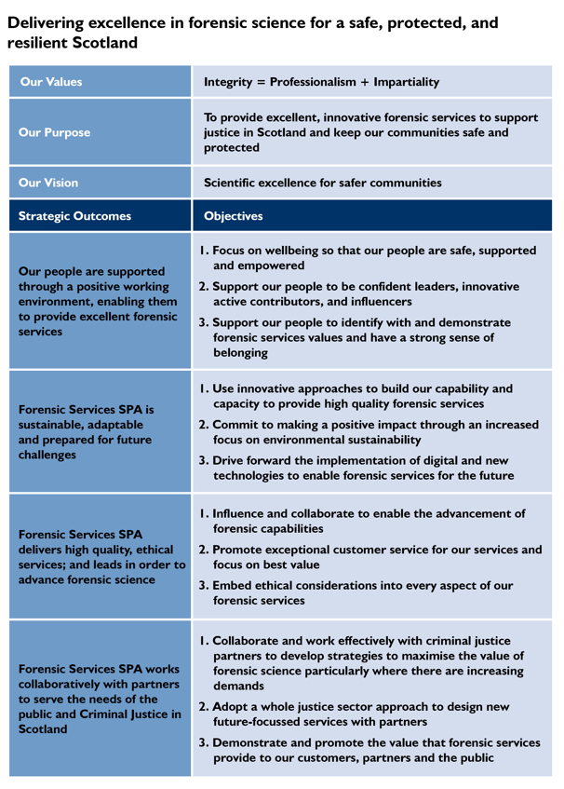

Strategic Alignment
This procurement strategy fulfils a dual purpose in discharging the SPA’s statutory duty to publish a procurement strategy under the Procurement Reform (Scotland) Act 2014, but also ensures the alignment of procurement activity to all relevant corporate plans, National Outcomes and Strategic Priorities.
Police Scotland and SPA’s shared strategic direction focuses on outcomes, creating a direct link from Scottish Government’s priorities through their corporate strategies to this strategy.
Police Scotland has recently created it’s 2030 Vision which provides a clear statement of the organisations direction of travel.

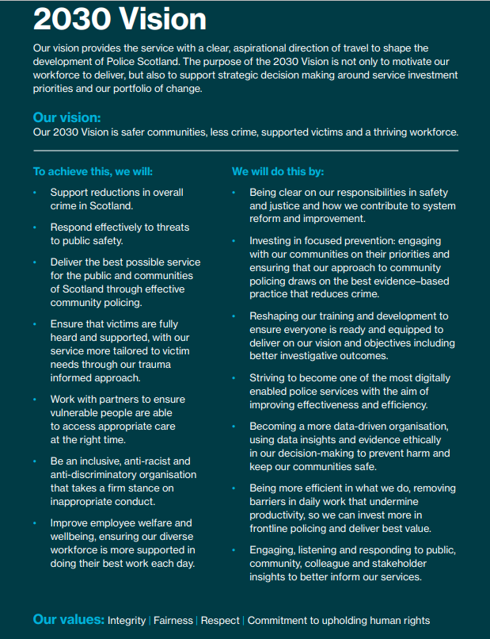
Whilst Police Scotland remain committed to the strategic outcomes jointly agreed with the Scottish Police Authority in the Joint Strategy for Policing (2023), Policing for a safe, protected and resilient Scotland, a commitment was made in the Annual Police Plan (APP) 2024/25 to develop an integrated long-term plan to further inform the second phase of transformation of the service. To guide us through this, the Chief Constable set out our long-term 2030 Vision. The vision outlines our ambitions for the future of policing in Scotland, putting the delivery of safer communities, less crime, being victim focused and building a thriving police workforce at the heart of everything we do. This has been supported by the creation of the first of two Three-Year Business Plans. Activity driven by our Procurement Strategy will support delivery of our 2030 Vision through our commitment to achieve value for money for the public and communities of Scotland as we move to a more sustainable and affordable model of policing

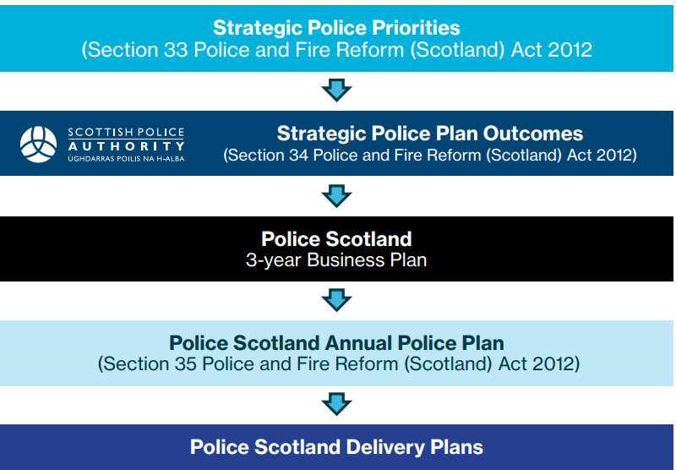

This Strategy has been developed to align with and support delivery of Police Scotland’s 2030 vision and the SPA’s Corporate Plan 2023-2026 as shown in the graphic below.

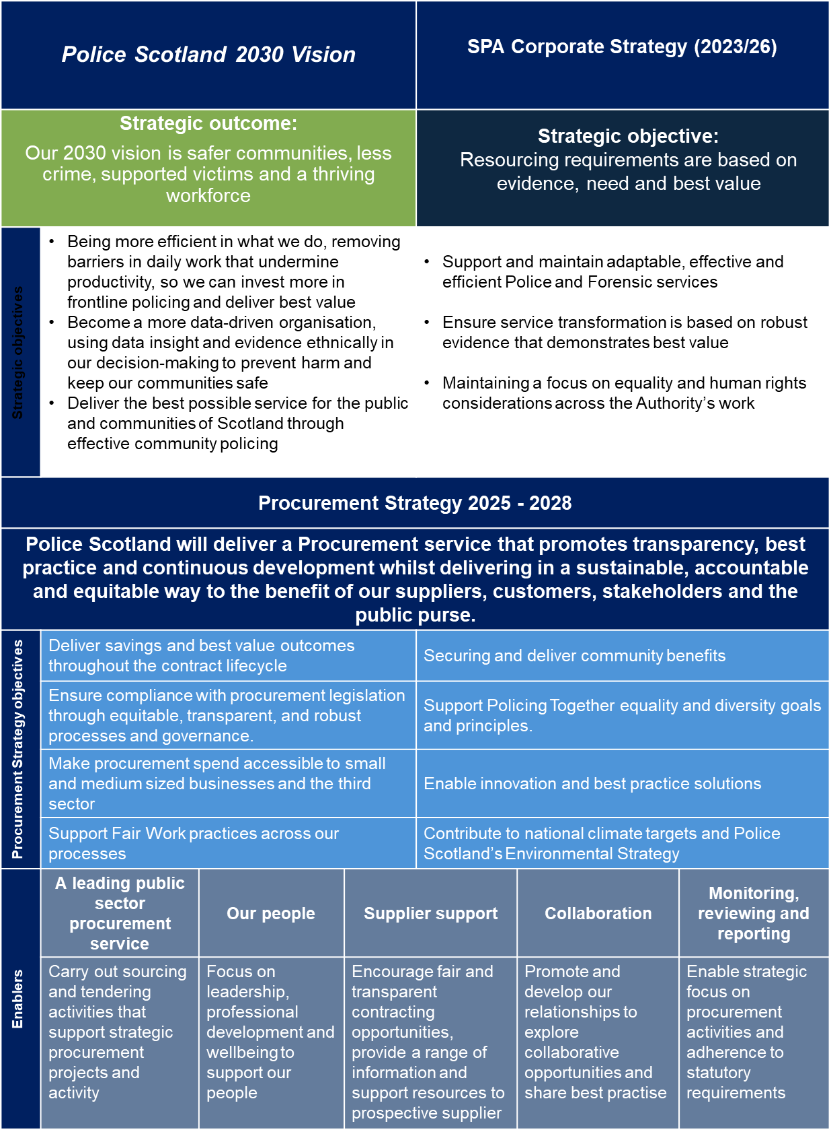

Procurement in Police Scotland
Within Police Scotland, encompassing SPA Forensics, there is a centralised procurement service that holds responsibility for all Procurement with a total value greater than £5000 with the exception of Digital Procurement where all requirements come to Procurement.
The main roles of the Procurement service are to:
  - Ensure that value for money is achieved through appropriate procurement strategies, procedures and input into programme business cases.
  - Advise, guide, and support the development of and compliance with procurement policy, best practice, and legislation.
  - Provide and develop professional, qualified procurement expertise, advice and services.
  - Support the Business by building efficient and compliant source to pay processes and development and maintenance thereof.
  - Reporting and Performance Management to enable continuous improvement and consultation.
  - Ensuring Police Scotland’s policies and procedures reflect all SPPN’s, legislative changes and external and internal governance.
  - Contribute to the aims and objectives of the organisation, as detailed in the corporate plan.
  - Pro-actively manage and develop the supplier base, including small and medium-sized enterprises (SMEs) and voluntary, community and social enterprise sector organisations, identifying and managing any supply risks or value add opportunities. Monitoring contract performance throughout the lifecycle of our contracts driving best value.
  - Promote and engage in collaboration and information sharing with relevant partner organisations.
  - Support sustainable policies through procurement processes.

The main responsibilities of the procurement service within Police Scotland encompass the following activities:
  - Act as the interface between the contracting organisation and the external marketplace on commercial matters;
  - Determine requirements and establish specifications in collaboration with end-users;
  - Challenge end-user requirements critically for need and cost effectiveness, taking account of whole life costs, demand, corporate social responsibility and sustainability issues;
  - Manage strategic supplier relationships;
  - Manage procurement competitions, contract awards and contracts;
  - Maintain a comprehensive contract register;
  - Establish arrangements relating to authority to procure;
  - Continually strive to develop improvements in process and procedures to ensure efficient, compliant and timely procurement;
  - Continually strive to develop improvements in process and policy to ensure efficient source to pay practices that deliver compliance;
  - Measure and report procurement performance;
  - Ensure governance remains appropriate and proportionate;
  - Ensure we remain up to date regarding policies and legal guidance.

Police Scotland Category Management Model
The category management model embedded within Police Scotland provides functional alignment with internal stakeholders bringing a range of benefits. This approach allows us to further leverage dynamic medium and long-term strategies aligned with Police Scotland and the SPAs corporate plans and departmental Strategies
The figure below illustrates the high-level segmentation of spend across category groups and scope of those categories.

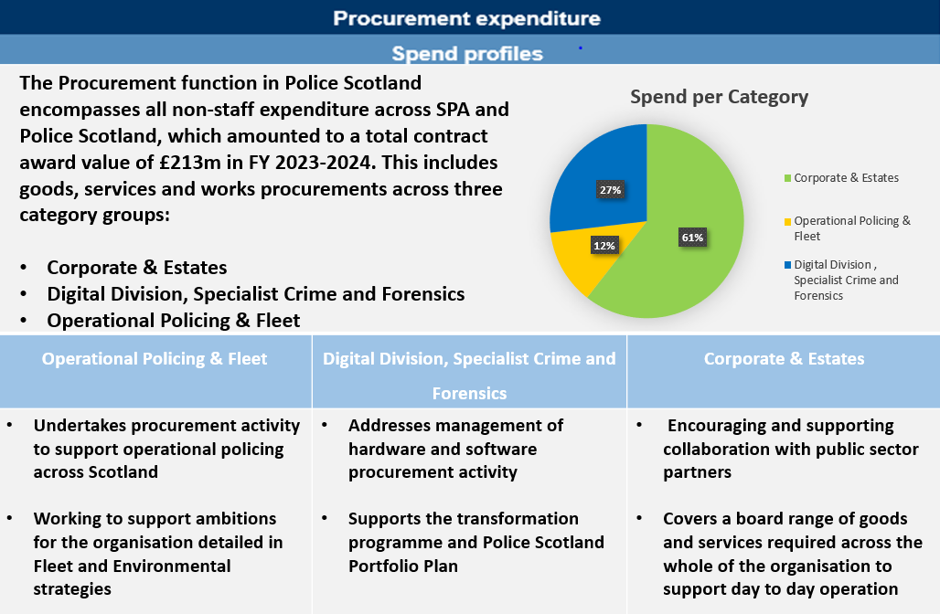

In addition to recurring strategic procurements across the various categories, Police Scotland regularly undertakes major projects which require extensive procurement support. A dedicated team is in place to support major projects to ensure swift mobilisation to large policing projects such as the successful delivery of COP26.

Achieving our objectives
To deliver our vision and strategic procurement objectives we will focus on and develop the following areas:

Maintaining a leading public sector procurement service
The procurement service provides advice and support to customers across the SPA, Forensics and Police Scotland to enable them to meet the appropriate purchasing and wider commercial requirements in carrying out our organisational functions. The service conducts strategic sourcing and tendering procedures, while also monitoring and challenging planned purchasing activities to ensure effectiveness, efficiency and compliance.
The service has a crucial role to play in maintaining a balanced, sustainable budget but is also a key enabler for both operational policing in Scotland and Transformation.
The centralised Procurement Service is responsible for ensuring all regulated procurement is carried out in accordance with regulatory requirements and internal policy. This includes goods, services, and works procurements across seven spend categories.

Strategic Procurement:
Specialist Category teams who deliver the tendering processes ensuring adherence to legal and statutory requirements whilst ensuring Best Value is achieved across cost, quality, service, how to purchase and delivery in as strategic fashion as possible. This is managed within three category procurement teams:
- Corporate & Estates
- Digital Division, Specialist Crime and Forensics
- Operational Policing & Fleet

Operational Procurement:
Procurement Services deliver a range of support services for the procurement function including e-Proc training/advice, policy advice and support, governance of sourcing and purchasing processes and setting of source to pay policy across Police Scotland, Forensics and SPA, delivering a programme of continuous improvement and enhanced performance reporting.
The Resilience & Project Procurement team provide capacity to deliver the support required for large policing operations and strategic projects which cross all categories. This increased strategic and specialist procurement support was designed to provide a responsive service, accessible and working in partnership with organisational stakeholders and ultimately add value to spending plans and requirements.
The Contract and Supplier Management team manage and optimise key contracts and supplier relationships on behalf of PS, SPA and Forensics. This team drive best practice ensuring that contracts are managed in a consistent manner maximising the value delivered through the contracts term.
The new operating model has facilitated enhancements to how we work as a team allowing us to develop in areas such as training, personal development, career progression, succession planning, data capture, standardisation, delivery, efficiency and so best value.

Our people
Our people are at the heart of supporting al areas with procurement, purchasing and wider commercial requirements in carrying out our organisational functions.
A focus on leadership, professional development and wellbeing is a critical element of our strategy implementation approaches. This includes a focus on support for procurement professionals and our people more widely who engage with the service and procurement processes to enable effective policing.
To deliver the Procurement Strategy the capacity and skills of our staff and customers will continue to be developed and supported through:
- continued and effective engagement with the SPA/ Police Scotland leaders;
- exploring opportunities for modern apprentices and trainees to develop the skills needed;
- supporting continuing professional development of experienced individuals to ensure knowledge is up to date and aligned to developments in the sector;
- engaging with other public sector organisations and other relevant organisations to support knowledge transfer and good practice;
- providing mentoring, coaching and work shadow opportunities where possible;
- working with colleagues in Legal Services, developing and delivering in-house workshops, training, and guidance, to support commercial awareness, best practice, and legislative knowledge across our customers;
- continuing to assess procurement standards using self-assessment tools to ensure continuous improvement; and
- Providing contract and supplier management ongoing training and support with standardised supplier management materials.

Supplier Support
Police Scotland encourages fair, open and transparent competition by advertising all relevant contract opportunities via the Scottish Government Procurement Portal Public Contracts Scotland (PCS)
PCS website provides a range of information and resources at present to support suppliers who are interested in doing business with Police Scotland and key resources are outlined below:
  - SPA Buyer Profile – details of our contract register which provides information on live contracts along with dates these are due to end providing insight to future tenderers;
  - Contract Standing Orders;
Our dedicated Contract and Supplier Management team work to ensure standardised supplier performance management across Police Scotland, together with providing a main point of contact for supplier issues whilst remaining focussed on tracking the benefits of our commercial agreements.
The team will engage with existing and new suppliers, including SME’s, and work to achieve public sector Social Value objectives, including sustainability and environmental goals.
Police Scotland are a member of the Supplier Development Programme (SDP) joining all 32 Scottish Local authorities and 16 other public bodies as members of the Programme.
SDP is a publicly funded partnership led by Local Authorities working in conjunction with Scottish Government and other public bodies, to bring Scottish SMEs support in all aspects of tendering. By assisting businesses to become tender ready for public procurement, SDP improves all-round efficiency, sustainability, and market potential.
Police Scotland work with SDP to pro-actively develop the supplier base and hence the marketplace, where possible, including small and medium-sized enterprises (SMEs) and voluntary, community and social enterprise (VCSE) sector organisations, identifying and managing any supply risks or value add opportunities.

Collaboration
Our procurement service will seek to collaborate and share good practice with the public sector in Scotland and more widely across the United Kingdom, taking a pro-active approach. This includes our active promotion and engagement to share experience and information with our key partners including other Scottish and UK blue light services, Scottish public bodies, and the Scottish Government.
The service will continue to be a key member of the Scottish Government Procurement Collaboration Group (PCG) and cluster groups in a broader context.
We will continue to collaborate with our Scottish Blue Light colleagues and other public sector bodies by sharing ideas and our practices related to tendering activity to enhance knowledge and expertise related to sectoral activity. We also continue work with wider UK policing and blue light organisations, both directly and through collaboration with BlueLight Commercial and Home Office national collaborative efficiency programmes.
Over the period of our Strategy, we will seek to maintain our collaborative approaches to identify new initiatives and where new models can enable excellent services for policing and maximum value for the public.
We will also collaborate with our public sector partners to promote sustainable procurement, support wider climate and circular economy ambitions, and maximise collective purchasing power to support an efficient and developing policing service to our people and our communities.

Monitoring, reviewing, and reporting.
This Strategy will be reviewed annually, and Police Scotland will publish an Annual Procurement Report to meet statutory requirements set out in the Procurement Reform (Scotland) Act 2014.
Both the Procurement Strategy and Annual Procurement Report have important roles in setting out how Police Scotland develop their procurement service and ensure compliant practices. This also enables a strategic focus on procurement activities including contract and supplier management and an overview of how our approach to procurement enables and contributes to achievement of our strategic outcomes and objectives.
Progress to embed the strategic objectives set out in this strategy will be set out in more detail in our Procurement Service Plan. Procurement are developing a detailed dashboard to track support and develop this improvement.
The plan will inform the Annual Procurement Report which will be reported to the Police Scotland CFPB, the SPA Resources Committee and SPA Main Board.
In addition, the following information and reporting will be in place:
- procurement activity will be included, where appropriate, in regular reporting to the Resources Committee, and any other SPA committee as required; and
- Delivery of this Strategy will be regularly reviewed by the Chief Financial Officer with the Head of Strategic Procurement.

Our Strategic Procurement Objectives
This strategy sets out key procurement objectives and the actions that will deliver those objectives within the period of this procurement strategy. These objectives will be prioritised in line with the strategic direction of the SPA and Policing in Scotland
Objective one: Deliver savings and best value outcomes throughout the contract lifecycle.

We will do this by:
- Creating Sourcing Strategies for all regulated spending;
- Utilising competitive tendering wherever possible;
- Collaborate where possible with others in the Scottish Public Sector and the wider UK blue light community to aggregate demand;
- Utilising collaborative frameworks where they provide best value;
- Working with our customers to identify saving opportunities and challenge current models of delivery;
- Challenging the demand for goods and services and seeking to rationalise core requirements;
- Supporting contract management actions to ensure contracts deliver to financial and non-financial performance requirements, including contractual commitments around social value and community benefits;
- Applying whole life costing methods to ensure end-to-end requirements are included;

Objective two: Ensure compliance with procurement legislation through equitable, transparent, and robust processes and governance.
We will do this by:
- Ensuring all procurement requirements with a value in excess of £5,000 are dealt with by our central procurement service;
- Training and developing our people to be confident professional advisers on the procedures and policies which must be considered to ensure compliance requirements are consistently met;
- Providing our people with regular updates on statute, regulations, case law, statutory guidance, policy, and social value outcomes;
- Ensuring all staff and officers are aware of organisational policies and procedures relating to procurement. In particular, training those with budget and financial responsibility in the key procurement requirements in terms of the regulations and internal policies;
- Continually reviewing and improving guidance and controls to ensure compliance with purchase systems and procedures, including the Contract Standing Orders;
- Strictly adhering to the required governance routes within Police Scotland, the SPA and Scottish Government to ensure effective oversight and scrutiny of the procurement process;
- The capture of system and performance data to enable reporting to our customers, supporting improvements.
Objective three: make procurement spend accessible to small and medium sized businesses and the third sector.
We will do this by:
- Ensuring that there are no disproportionate barriers to participation;
- Carrying out pre-tender market engagement, working with business and Third Sector to support “meet the buyer” events, workshops, and awareness of contract opportunities;
- Consideration of ensuring accessibility for SMEs and Voluntary, Community and Social Enterprises (VCSE’s) within our Sourcing Strategies;
- Continuing to use Public Contracts Scotland (PCS) as the principal advertising route and to explore alternative, appropriate advertising routes to reach those not currently registered;
- Involvement of all appropriate organisations in market engagement and consultation exercises;
- The use of appropriate lotting strategies in Invitations to Tender which are aligned to the market to facilitate access for SMEs and VCSEs;
- Facilitating joint and consortium bidding;
- Working with SDP to support SME/VCSE organisations.
Objective four: Support Fair Work practices across our processes.
.We will do this by:
  - Considering fair and ethical trading in all sourcing strategies;
  - Improving training and awareness for all our people and bidding organisations;
  - Applying appropriate weightings in the evaluation of tenders and including Fair Work First and Living Wage award criteria;
  - Developing procedures which embed fair work practices
and ensure compliance with the requirements of the Modern Slavery Act 2015 (MSA);
  - Applying the seven Fair Work First criteria in regulated procurement processes, where relevant and proportionate to do so.

Objective five: Secure and Deliver community benefits.
We will do this by:
- Building community benefits into the contracting process for all appropriate contracts with standard clauses introduced into relevant invitation to tender and similar documents;
- Increasing awareness and understanding of community benefits across Police Scotland and the SPA;
- Ensuring that community benefits are given sufficient weighting within tender evaluation methodologies which are proportionate to the contract and benefits being sought and that they support our Vision 2030 where appropriate;
- Working collaboratively with Scottish Government, Local Authorities, and our other key partners to support projects in development across Scotland;
- Improving our processes to support the delivery of community benefits.
Objective six: Support Policing Together equality and diversity goals and principles
We will do this by:
- Ensuring that equality impacts are identified in our sourcing strategy for all procurement processes and that the needs and impacts of all relevant groups are fully considered;
- Ensuring that recommendations within the Equality and Human Rights Impact Assessments (EqHRIAs) relating to the goods, works and services we are procuring are incorporated within the procurement process.
Objective seven: Enable innovation and best practice solutions.
We will do this by:
- Engaging with business areas at the early stages of identification of need and scoping;
- Encouraging innovation via outcome-based specifications;
- Collaborating effectively with the Police Scotland Innovation Team and seeking relevant examples of market innovations, sharing models and best practice;
- Utilising innovative approaches to procurement;
- Allowing the opportunity for variant bids where there is potential technological and market advancement as appropriate;
- Delivering a dedicated training plan ensuring focus on key themes and emerging issues and included investment in wider skills to enable innovation and sustainability;
- The Contract & Supplier Management Team incorporating learning from contracts through utilising supplier management performance monitoring and supplier feedback on innovation and best practice.
Objective eight: Contribute to national climate targets and Police Scotland’s Environmental Strategy
We will do this by:
- Ensuring environmental sustainability sits at the heart of our procurement practices partnering with the Sustainability team to review sustainability tender responses where practical;
- Providing training to improve awareness of climate impacts for our people; Utilising tools and guidance such as the Scottish Government’s sustainability toolkit to stay focused on developments;
- Engaging with the wider market to consider sustainable options and to encourage innovation, collaboration and partnership working to achieve shared goals as a net zero economy;
- Utilising a whole life costing approach to evaluation where appropriate.

- Promoting and supporting a circular economy by considering potential for re-use, repair and recycling of goods and materials in scoping requirements on a routine basis to prevent waste.

Policy Statements Required under the Procurement Reform (Scotland) Act 2014
The above act requires Police Scotland/the SPA to state the following policies relating to its procurement duty.

SME, VCSE Sector and Supported Business Involvement
Where appropriate, Police Scotland will facilitate the involvement of small and medium sized enterprises (SMEs) and the Voluntary, Community and Social Enterprise (VCSE) Sector, (also referred to as the Third Sector), including supported businesses, in regulated procurement exercises.
Steps being taken to facilitate this involvement include:
  - The inclusion of Sustainable Procurement Duty with Sourcing Strategies;
  - The use of Public Contracts Scotland (PCS) as the principal advertising route;
  - Participation in Supplier Development Programme events such as ‘Meet the Buyer’;
  - Involvement of relevant organisations in market engagement and consultation exercises;
  - The use of lots in ITTs and similar documents;
  - Creating opportunities for joint and consortium bidding;
  - The use of Dynamic Purchasing Systems (NPSs) and similar arrangements such as the NEPO Professional Services Framework;
  - Reporting in the Annual Procurement Report.
Innovation
It is Police Scotland policy to promote innovation in relevant marketplaces and this reflected in a number of approaches including:
- Innovative, but compliant, approaches to procurement such as the use of DPSs;
- Clauses in ITTs and similar documents to encourage innovation in design, commercial arrangements, and joint work;
- Support to specific Police Scotland initiatives.

Consultation and engagement
It is Police Scotland’s policy to consult with and involve with customers, potential suppliers, and others to help design procurements and this is a fundamental element to developing and signing off Sourcing Strategies.
Police Scotland takes a fit-for-purpose approach the consultation and stakeholder engagement and this can include:
- Stakeholder interviews and workshops;
- ‘Voice of the Customer’ workshops;
- Supply Market Analysis, which can be bought in where specific market knowledge is required;
- Soft Market Testing including insight sessions with a sample of potential suppliers;
  - Pre-Tender Market Engagement including:
- Briefing documents
- Invitations to Express an Interest
- Telephone conference briefings
- Face-to-Face briefing sessions, which may be streamed on-line and recorded for the benefit of potential suppliers that are unable to attend in person and for the use of bid teams.
  - SRO and Head of Strategic Procurement sign-off to Sourcing Strategies;
  - Post-tender briefing, for both unsuccessful and successful suppliers.

Community Benefits
The 2014 Act describes a community benefit as a contractual requirement by a contracting authority relating to training and recruitment or the availability of sub-contracting opportunities; or which is otherwise intended to improve the economic, social, or environmental wellbeing in the authority’s area in a way additional to the main purpose of the contract.

Within Police Scotland, it is policy to build community benefits into the contracting process for all major contracts across all three categories, with standard clauses introduced into relevant invitation to tender and similar documents.

Going forward focus is being placed on contract lengths that will enable suppliers to recruit and train, flexible ITTs that will enable suppliers to form consortia with, or sub-contract to SMEs and other organisations within the community, and evaluation criteria that will include addressing community benefits.

The Sourcing Strategy document that is created for all regulated procurements includes a sustainability section that details opportunities relating to SMEs, Supported Businesses, Community Benefits, Environmental Benefits and Fair Working Practices for the individual tenders and contracts.

When an opportunity is highlighted as a viable option, this will flow through the procurement stages and be captured within the tendering, evaluation, and contractual documents, which are also monitored and managed as part of the Contract Management process. There are still challenges in being able to implement community benefits in some commodities, but this standardised approach for all regulated procurement will promote the consideration of this key topic within the stakeholder group and the supply base for Police Scotland.

Fair Work and Living Wage
Police Scotland has implemented the Scottish Government’s commitment to the Living Wage for staff under its direct control.

Fair Work is defined in five dimensions: fulfilment, security, opportunity, respect, and effective voice.
It is Police Scotland policy to consider Fair Work practices in applicable procurements and to promote the payment of the Living Wage in relevant procurements.

Police Scotland is to include Fair Work and Living Wage award criteria in all appropriate contracts where they are relevant. This will involve developing procedures to help teams to consider Fair Work practices and monitor progress within relevant procurements.

Health & Safety at Work Act etc.
The Authority and Police Scotland are committed to promoting and implementing policy, procedures, and guidance to ensure that workplace activities are carried out in such a manner that risks to the health, safety, and welfare of staff, the public and those that deliver contracts are eliminated or reduced, so far as is reasonably practicable. This is encapsulated in the 2016 Health, Safety and Wellbeing Policy.

It is a standard condition of Authority and Police Scotland contracts that suppliers must abide by all relevant legislation and industry good practice.

Fair and Ethical Trading
It is Police Scotland policy to source fairly and ethically traded good and services wherever relevant and to consider their implications through the stages of the procurement cycle. This includes the specification of fairly and ethically traded goods and service wherever relevant; considering the wider implications of procurements; relevant terms and conditions in contracts; and in contract management.
Whilst fair and ethical trading features in sourcing strategies, the following categories of expenditure are amongst those that are regarded as high risk and are therefore given proportionate consideration:
- All textiles, including uniforms
- Food and catering services
- Furniture and products with a timber content
- Hazardous substances
- Building materials
- Supply chains featuring organisations in developing countries

The provision of food
Within Police Scotland, food is provided:
- Via catering services, including vending machines, within soft facilities management contracts
- Within the Custody, Division, which is classified as a food business establishment and has implemented a food safety management system
- Via other arrangements including a retail shop at the Scottish Police College, and special operational requirements, such as the use of the procurement cards
- Dog food is supplied via a national contract addressing specific dietary requirements and horse feeding etc. via local suppliers.
- Packed lunch contracts for provision of catering for policing operations
To improve the health, wellbeing, and education of communities in which Police Scotland operates and to promote the highest standards of animal welfare, in the procurement of food the policy is to:
- Ensure that contracts meet the requirements of customers, comply with applicable legislation, and address other factors such as traceability, animal welfare, environmental standards, nutrition, and waste
- Align with government policies on healthy eating and nutrition and the promotion of fresh, seasonal, fairly traded, and local produce.

30-Day Payment
Police Scotland aims to pay all suppliers within 30 days from receipt of a valid invoice. Police Scotland’s standard contractual terms include payment within 30 days from receipt of a valid invoice which are adopted unless otherwise agreed in advance of awarding a particular contract.

Police Scotland’s standard contractual terms also require contractors, sub-contractors, sub-sub-contractors and so on, ensure that their suppliers are paid within 30 days.

Police Scotland will utilise all available mechanisms to ensure prompt and efficient payment processing in accordance with the Scottish Public Finance Manual and the Contract Terms.

Climate change
In response to our legal duties in relation to climate change and our recognition of the climate emergency, Police Scotland has developed an Environmental Strategy. This will help us develop and implement specific sustainability projects as well as interpret and support work underway across the organisation that will help to improve energy, resource and carbon efficiency including decisions on the procurement of these. Our Strategy commits us to, as a minimum, a thirty-five percent (35%) reduction in our CO₂ emissions by 2026 against our baseline year of 2019/20. We are also committed to ensuring that environmental sustainability sits at the heart of our working practices.

Procurement recognises that it will be a key driver in achieving these goals through its existing supply chain, how it engages with the market, the relationships it develops with its suppliers and stakeholders, internal and external and in the way it procures goods, works and services to meet current and future requirements.
Aligning itself to these targets, Procurement are committed to ensuring that environmental sustainability sits at the heart of our working practices. This will support Police Scotland to comply with other relevant legislation in relation to the Procurement Climate Emergency Response such as the Climate Change (Scotland) Act 2009 and The Climate Change (Duties of Public Bodies: Reporting Requirements) (Scotland) Order 2015. We also recognise that Scottish Government has aligned legislative and policy outcomes to the United Nations Sustainable Development Goals, and so we will bear these aims in mind in relation to the social, economic and environmental topics included in this Strategy.
In order to ensure that environmental sustainability underpins and is included in all sourcing strategies, Procurement will procure goods and services that are as sustainable as possible and that comply with the principles of a circular economy, and to working with our suppliers to improve their own performance by:
- Averting, reducing, reusing, recycling, or recovering value, in that order, wherever possible;
- Sourcing good, works and services responsibly and sustainably to prevent or reduce carbon emissions, mileage, waste, or harmful toxins and chemical;
- Working closely with Estates to improve the energy/resource efficiency of our existing and future buildings through procuring goods, works and services that assist in ensuring that our estate is managed to enhance biodiversity;
- Encouraging staff to work in sustainable ways and ensuring that we procure the proper resources to allow them to do this;
- Working closely with Fleet and Operations to reduce our mileage in fossil fuel driven vehicles and achieving our commitment to procure and operate a fully electric fleet by 2030;
- Engaging with local suppliers to inform of opportunities and encourage participation, collaboration, and partnership working;
- Engaging with suppliers to identify opportunities to reduce their environmental impact and generate carbon savings;
- Engaging with the wider marketplace to identify sustainable options and to encourage innovation, collaboration and partnership working to achieve shared goals and a net zero economy;
- Ensuring sourcing strategies that fully consider the environmental impact of procurement decisions whilst assessing total cost of ownership;
- Utilising Scottish Governments Guidance and tools such as the Sustainability Tool Kit, Sustainable Procurement Prioritisation Tool, and Climate Literacy for procurers;
- Adhering to all national and international ethical supply chain standards and practices;
- Ensuring that training is made available to all procurement staff;
- Encouraging, and be open to, innovative and creative solutions to meet the procurement requirements of the organisation.

