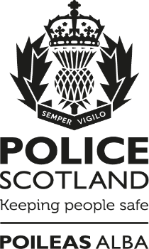

COP26

The work Police Scotland are doing to support a safe event.
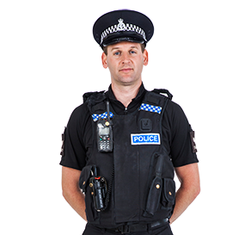
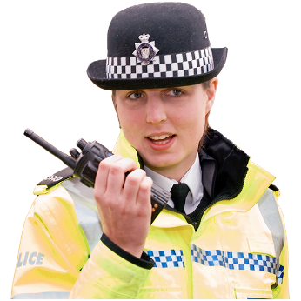

Copyright images © Photosymbols. Prepared by Disability Equality Scotland

What is COP26?
 | The United Nations Climate Change Conference is a meeting that happens every year.
 | The United Nations is an organisation that works to keep peace and safety between countries.
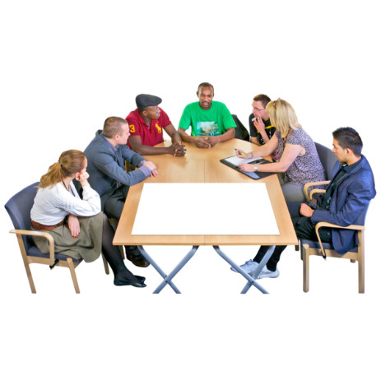 | This year will be the 26th meeting so it is called COP26.  COP stands for ‘Convention of the Parties’ which means a meeting.
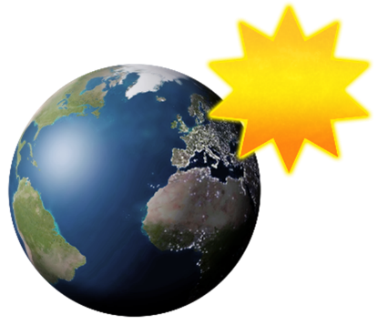 | Climate change is the way the weather in the world is changing and getting hotter.  This is because there is too much carbon dioxide gas in the air.
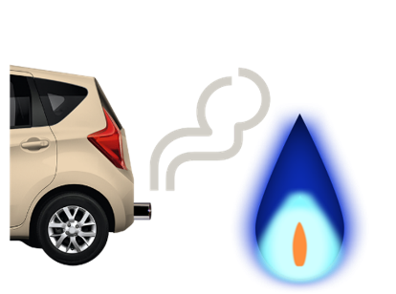 | Most carbon dioxide gas comes from heating our homes by gas and from vehicle exhausts.
 | COP26 is an important moment for countries to agree what work will be done to have less climate change.
 | The meeting lasts for 12 days.
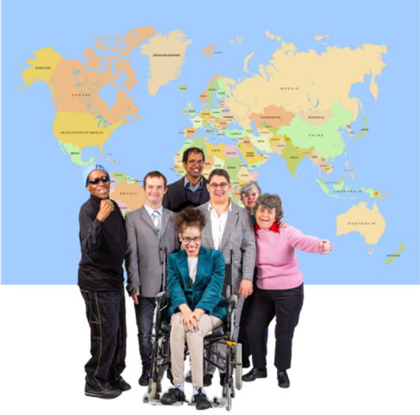 | People at the COP26 conference are:  - the people who lead countries, like Prime Ministers and Presidents  - people from governments  - businesses and people from different countries  - negotiators – someone who helps people to talk and agree
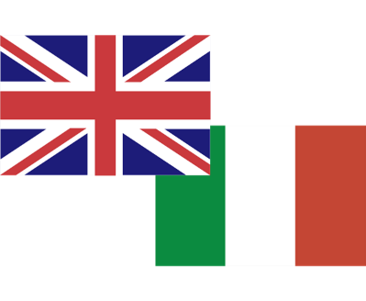 | COP26 is led by the UK Government, in partnership with Italy.
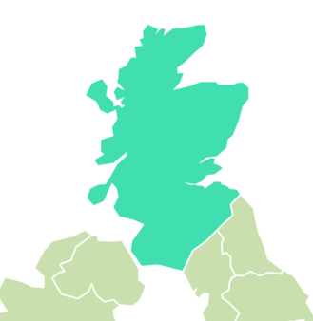  Glasgow | The conference is at the Scottish Event Campus – called the SEC for short. This is in Glasgow.  There are 2 different areas - the Blue Zone and the Green Zone.
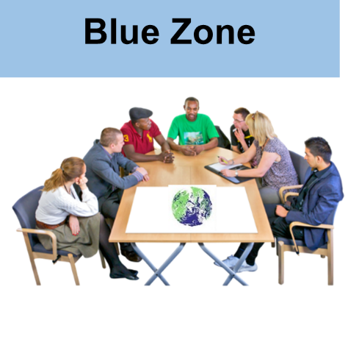 | The Blue Zone is where the official meetings happen.
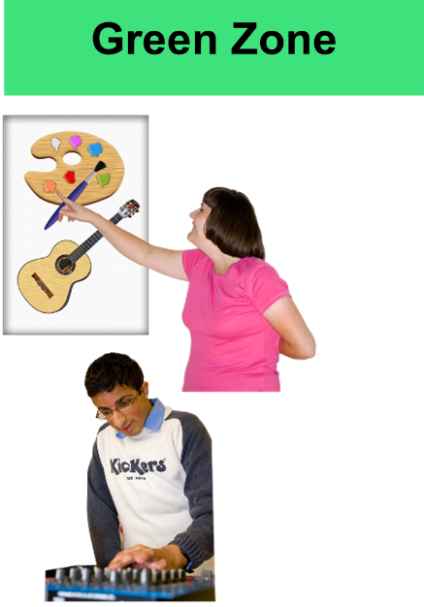 | The Green Zone is for the public so everyone can go there.  There will be:  - events  - exhibitions  - demonstrations of science and equipment  - and performances.
 | Read more about COP26 by visiting their website.

Policing COP26

Police Scotland’s job is to work with others to make sure COP26 is safe and secure.
We will do this at the SEC and other places and events that are part of COP26.
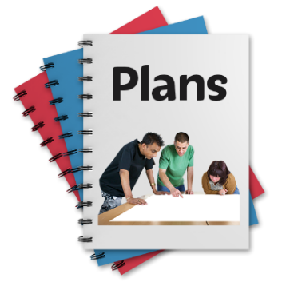 | We have been making plans and getting ready for this event for over a year.
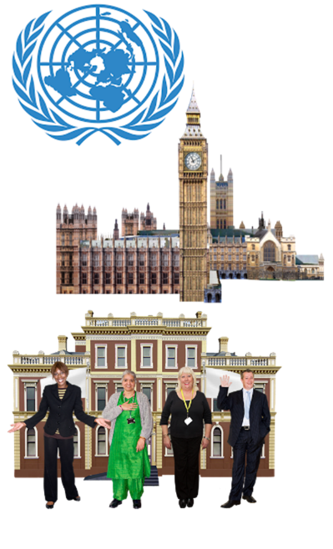 | We have been working closely with other organisations including:  - the United Nations  - UK Government  - Glasgow City Council.
 | COP26 will be one of the biggest and most important events that has happened in Britain.
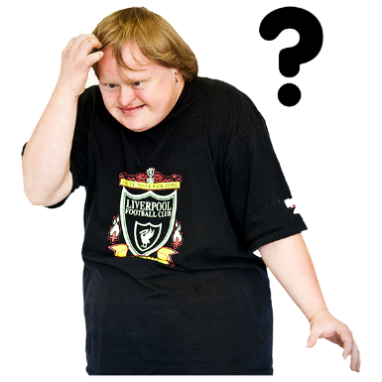 | People will see more police and security staff in and around Glasgow before the conference happens and when it is on.  You should not feel frightened or worried about this.  Our most important job is keep people safe.
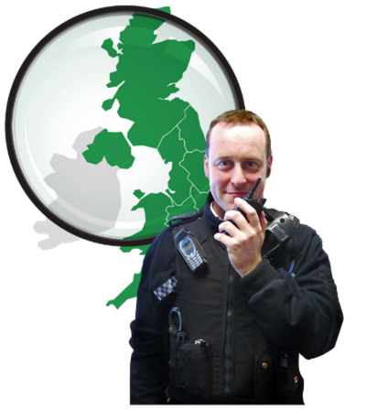 | There will be 10,000 police officers at the conference each day.  They will come from all over Britain.
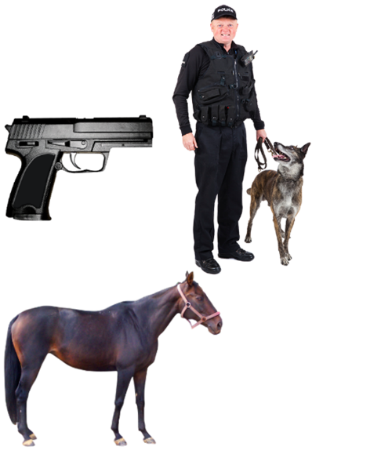 | You could see police officers who:  - carry guns  - have police dogs  - are on horses  - are on boats on the river  - are part of search teams who can look for dangerous things.
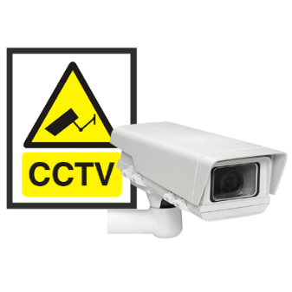 | There will also be:  - CCTV  - barriers to stop cars or lorries driving close to the meeting and other important places
 | We do not know that something dangerous will happen but we will be prepared.
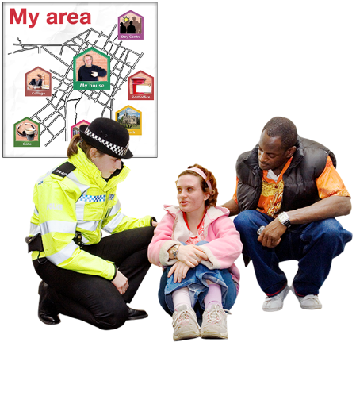 | Local police will still respond to calls and give people a high quality service.  This will not change because police are at COP26.
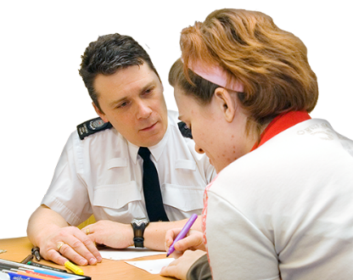 | We will be talking to people and listening to any worries before the conference and when it is on.
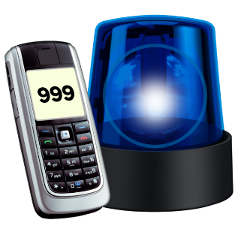 | We ask the public to look out for anything that seems out of place or unusual and report it to us.

Protest

Climate Change is in the news a lot.
There are more protests about climate change around the world
We expect there will be protests in Glasgow and in other places across Scotland.

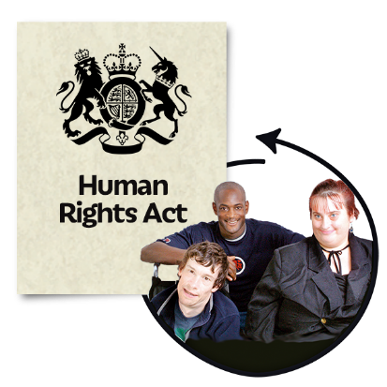 | Police Scotland is an organisation that looks after people’s rights.  We must protect the rights of people who want to peacefully protest.
We must look after the rights of everyone in the community.
We will have a balanced and sensible response to any protests.
We will try to work with groups to make sure they can protest in a peaceful way.

Copyright images © Photosymbols. Prepared by Disability Equality Scotland

