 | Freedom of Information Response  Our reference: FOI 25-0934  Responded to: 22 May 2025
Your recent request for information is replicated below, together with our response.

The number of calls Police Scotland has received since 13 January 2025 with concerns in relation to anti-social behaviour, public disorder and needle disposal around the premises of the Thistle drug consumption facility based on 55 Hunter Street in Glasgow.
The table below details recorded incidents for the period 13 January to 31 March 2025 in Hunter Street, Glasgow and the wider police beat area, BA18 as outlined in the map below.
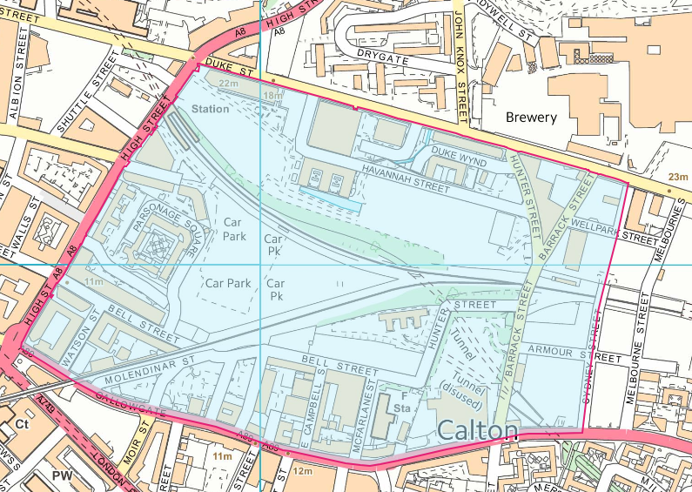
Data has been provided by incident classification.
Please note that we do not have a classification for ‘needle disposal’ specifically.
Incident | Hunter St, Glasgow | Beat BA18
Intruder | 2 | 4
Public Nuisance | 1 | 23
Drugs/substance misuse | 0 | 13
Disturbance | 1 | 19
Noise | 0 | 4
Neighbour dispute | 0 | 4
Hate Crime | 0 | 1
Abduction/ extortion/ sextortion | 0 | 5
Sexual offence | 0 | 2
Theft | 0 | 95
Vehicle crime | 0 | 8
Assault | 0 | 7
Damage | 0 | 3
Domestic incident | 0 | 6
All statistics are provisional and should be treated as management information.
Data was extracted from Police Scotland systems based on the incident raised date and are correct as at 14 May 2025.
If you require any further assistance, please contact us quoting the reference above.
You can request a review of this response within the next 40 working days by email or by letter (Information Management - FOI, Police Scotland, Clyde Gateway, 2 French Street, Dalmarnock, G40 4EH). Requests must include the reason for your dissatisfaction.
If you remain dissatisfied following our review response, you can appeal to the Office of the Scottish Information Commissioner (OSIC) within 6 months - online, by email or by letter (OSIC, Kinburn Castle, Doubledykes Road, St Andrews, KY16 9DS).
Following an OSIC appeal, you can appeal to the Court of Session on a point of law only.
This response will be added to our Disclosure Log in seven days' time.
Every effort has been taken to ensure our response is as accessible as possible. If you require this response to be provided in an alternative format, please let us know.

