Inverclyde Local Policing Plan 2023-26

Contents
Chief Constable’s Foreword 3
Divisional Commander’s Foreword 5
Introduction 7
National strategic alignment 8
Police Scotland’s strategic objectives 9
Local policing delivery context 10
Local priorities 12
Local objectives and activity 14
Threats to public safety and wellbeing are resolved by a proactive and responsive police service 14
The needs of local communities are addressed through effective service delivery 17
The public, communities and partners are engaged, involved and have confidence in policing 19
Our people are supported through a proactive working environment, enabling them to service the public 21
Police Scotland is sustainable, adaptable and prepared for future challenges 23
Governance and performance 25
Equality, diversity and inclusion 25
Engaging with us 26

Chief Constable’s Foreword
This Local Police Plan provides a clear statement to our citizens and partners about our commitment to developing our service and addressing areas that are of particular importance in this area. Throughout my time as Chief Constable, Police Scotland has continually developed to ensure we provide effective policing now and in the future.
Our communities are now better served and protected from the threats of today and of tomorrow. I have great confidence that the Police Service of Scotland will continue to build upon the progress made and the stability which now exists in policing.
In our recent Joint Strategy for Policing (2023), Policing for a Safe, Protected and Resilient Scotland, we describe how Police Scotland has people and communities at the heart of its vision for a better society, and will continue to provide modern, visible and accessible policing to local communities, supplemented with new support services that adapt and respond to societal shifts.
Policing in Scotland is incredibly varied, and we recognise the differences and strengths of communities across the country. Our people are vital members of those communities and our trusted relationship with the public and communities we serve is fundamental to maintaining their confidence in us to protect them at their most vulnerable and to keep us all safe from existing and emerging threats and harms.
This plan has been developed with partners and the local public using evidence, insights and professional expertise. We are committed to listening and responding to all communities across Scotland, including those who do not often engage with policing.
We understand our shared responsibility to ensure that our services are trauma-informed and person-centred as outlined in the Scottish Government’s Vision for Justice. Across society, and in part exacerbated by the challenging economic circumstances we all face, vulnerability, mental ill-health and substance misuse continues to impact on both individuals and wider society and on policing. We recognise that ours is very often not the most appropriate service to best support peoples’ needs and we will work our public sector partners to address challenges and support community wellbeing.
I am extremely proud of the service that we provide to our communities from Renfrewshire and Inverclyde Division and from the specialist and operational divisions that provide additional support to them. As colleagues deliver the priorities set out in this plan and respond to new developments, our commitment to keeping people safe and demonstrating our values of integrity, fairness, respect and to upholding human rights is unwavering.
Sir Iain Livingstone QPM
Chief Constable

Divisional Commander’s Foreword
As Divisional Commander I am pleased to introduce the Inverclyde Local Policing Plan (LPP) 2023-26. I was proud to be appointed Divisional Commander of Renfrewshire and Inverclyde in September 2022 and I would like to thank my predecessor Chief Superintendent Davie Duncan for his commitment and dedication to policing this area before my arrival in post.
Much has changed since the compilation of the last report in 2020, as such we have re-examined our priorities in order to respond to the current climate, considering the continued recovery from the COVID global pandemic and the current cost of living crisis along with the harm caused by both.
In Renfrewshire and Inverclyde Division we are committed to providing the highest level of service to our communities using our local policing teams, augmented by specialist support and this plan outlines how our officers and staff, working closely with partner agencies through the Community Planning process, will focus on local priorities for the next 3 years. Our local communities are central to everything we do and the people of Renfrewshire and Inverclyde are central to our guiding principles of providing a visible, accessible and responsive service. Our core values of integrity, fairness, respect and a commitment to upholding human rights continue to underpin all that we do.
The region constitutes a large and diverse area, featuring major towns such as Paisley, Renfrew and Greenock in addition to agricultural areas, rural communities and nature reserves. Inverclyde and Renfrewshire both enjoy a strong sense of community spirit, a deep sense of pride and histories steeped in centuries of industrial endeavour. Both areas' heritage have left them rich in cultural assets and social history; both also enjoy impressive natural heritage, offering outdoor sport and leisure choices for all. All of this provides a significant basis for the adoption of an asset based approach in achieving successful outcomes for communities
In developing our Local Policing Plans for 2023-26 we consulted widely with our stakeholders - the public, partner agencies and our staff. Accordingly, we developed our plans which identify our goals for the next three years, these plans will address priorities and tackle the things that you identified as mattering to you most. This plan builds on the strong foundations already in place, with a continuing emphasis on road safety, thefts – including Cyber and Digital Fraud, drug misuse, anti-social behaviour, disorder and crimes of violence. The introduction of the Contact Assessment Model (CAM) which examines the ‘Threat and Risk’ of each call has significantly improved how we protect vulnerable people and I expect to see continued improvements in other areas.
As your Local Policing Commander, I have a statutory responsibility under the Police and Fire Reform (Scotland) Act 2012 to work closely with Renfrewshire and Inverclyde Local Authorities to ensure our Local Policing Plan is linked with the Local Outcome Improvement Plans. In doing so, I remain committed to developing and enhancing the strong community spirit that exists by building close alliances with local communities and our partners across the public, private and third sectors as set out in the Community Empowerment (Scotland) Act 2015 to achieve better outcomes and reduce inequalities. Above all, our aim is to work with pride, diligence and professionalism to ensure Renfrewshire and Inverclyde remain safe places to work, live and visit.
Chief Superintendent Laura Waddell, Local Police Commander, Renfrewshire and Inverclyde Division

Introduction
Inverclyde is located on the west coast of Scotland and is one of the smallest local authorities in Scotland. Located at the mouth of the River Clyde, Inverclyde has a proud history in shipbuilding which continues to be evident throughout the area.
Local officers and staff provide policing to a population of 77,060 people covering an area of 62 square miles. The area is a mixture of urban and rural areas including Greenock, Port Glasgow, Gourock, Inverkip, Kilmacolm, Wemyss Bay and Quarriers Village.
Inverclyde is home to a number of popular visitor attractions including Finlaystone Park, Clyde Muirshiel Regional Park and the Waterfront Leisure Complex. The Ocean Terminal in Greenock is also a regular stop for cruise ships from all over the world with around 60 of the largest liners calling each year.
Inverclyde has a diverse and vibrant range of communities and we aspire to meet the needs and interests of communities across the area, from the heavily populated urban towns to the most remote rural locations.
Through engagement with communities, and from our own analysis of the demands being placed on policing, we have identified the issues that matter most to you. We will strive to provide the highest standards of policing in your communities.
This plan demonstrates Police Scotland’s commitment to delivering local and national outcomes and details how we will work collaboratively with our partners to deliver this. Although the plan outlines the priorities for the local area for 2023-2026, it will be subject to review, and change if required, throughout this time.

National strategic alignment
Our strategic outcomes provide a clear route from the Scottish Government’s outcomes and priorities, including the Justice Strategy, through Police Scotland’s strategies, plans and performance reporting, enabling us to demonstrate alignment and clearly articulate our ambitions and progress as demonstrated below.
In addition to the Annual Police Plan, Police Scotland’s thirteen local policing divisions produce Local Police Plans which reference distinct priorities, objectives, outcomes and performance measures. They link to wider community planning arrangements, with Local Outcome Improvement Plans taken into account in their development.
- Scottish Government National Outcomes/Strategic Priorities/Justice Vision
- SPA/Police Scotland Strategic Outcomes
- Long Term Policing Strategy: Policing for a Safe, Protected and Resilient Scotland
- Enabler strategies including People, Fleet, Estates, Public Contact and Engagement, Enabling Policing for the Future, Digital Data and ICT, Cyber, Environmental, Procurement, Violence against Women and Girls, Equality Diversity and Inclusion
These are underpinned by plans including the Strategic Workforce Plan, Annual
Police Plan, Local Police Plans, Local Outcome Improvement Plans, and
Financial Plans.

Police Scotland’s strategic objectives
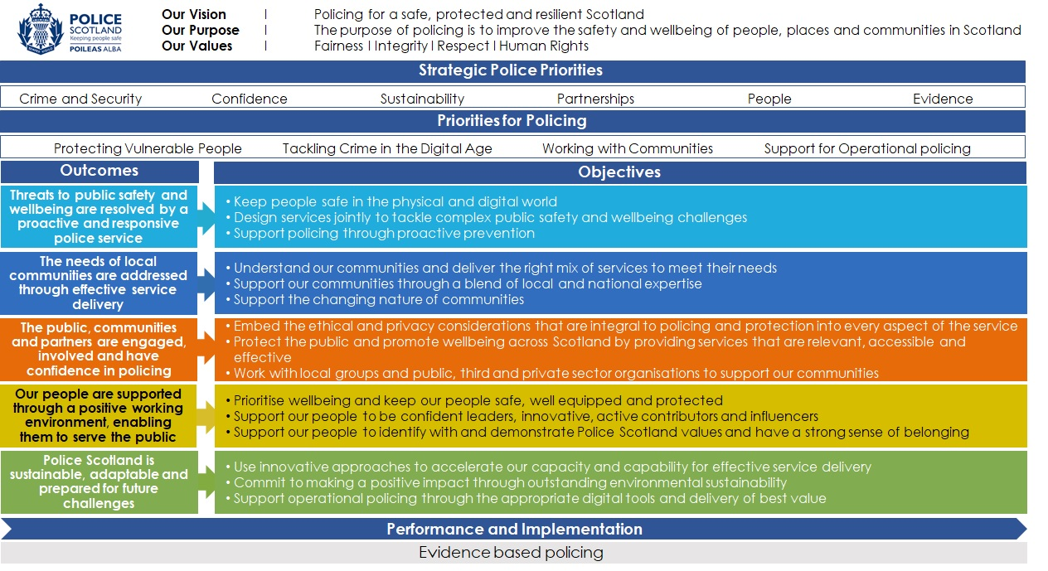

Local policing delivery context
About Inverclyde
Inverclyde is a popular tourist area of Scotland attracting visitors from all over the world. With an increasing number of cruise ships visiting the area, visitors are attracted to events such as the British Pipe Band Championship, Gourock Highland Games and the Meliora Festival.
Inverclyde has an estimated population of 77,060 which is predicted to decline by 6.1% in the following 5 years. With a higher than national average of the population being over 60 years old, 21% of Inverclyde’s population is of pensionable age.
There is a strong sense of community throughout the area and a recent survey indicated that 86% of residents believed Inverclyde was a very or fairly good place to live. 77% of respondents to our recent Renfrewshire & Inverclyde Police Survey said they feel safe or very safe in the local area.
Like many other local authorities, Inverclyde does have areas of deprivation and the associated social challenges. Life expectancy is lower than the national average for Inverclyde whilst 23% of children in Inverclyde are living in poverty.
The Scottish Index of Multiple Deprivation has highlighted that persistent levels of deprivation within a number of Inverclyde communities. With this in mind, tackling inequalities and building safer healthier communities is essential.

Renfrewshire and Inverclyde Police Divisional Structure
Renfrewshire and Inverclyde police division is led by a Chief Superintendent who holds the title of Local Policing Commander. They are supported by four Superintendents covering Operations, Support and Service Delivery, Partnerships and Serious Crime and Public Protection.
There are two sub-divisions. KC sub-division covers Inverclyde with KA sub-division covering the Renfrewshire are. Each sub-division has a Local Area Commander of Chief Inspector rank who has responsibility for local management operations and local policing engagement.
Two Detective Chief Inspectors support the Detective Superintendent for all serious crime and public protection matters. A further Chief Inspector sits within Divisional Headquarters, Paisley and holds responsibility for corporate functions including Licensing and Events Planning.
The benefit of being a national organisation allows the division access to a number of specialist resources who will deploy to the local area on a regular basis to assist with incidents or events. These are varied and include Air Support, Dog Branch, Mounted Unit, Negotiators and Firearms Units.

Inverclyde Local Outcome Improvement Plan (LOIP)
The Inverclyde Local Outcome Improvement Plan 2017-2022, was extended for a further year and will be refreshed in 2023. This is a key element in the delivery of service at a local level, sets a clear focus for Inverclyde with the vision of ‘Nurturing Inverclyde: Getting it right for every Child, Citizen and Community’.
Strategic priorities were identified:
• Population
• Inequalities
• Environmental, Culture and Heritage
Police Scotland is committed to working with our partners to deliver the outcomes for Inverclyde and will continue to collaborate with community partners to develop new and innovative ways of working. As key partners in the Inverclyde Community Partnership Hub we work closely with the local authority and various other partners. The group meets daily to review emerging concerns and ensure early intervention and resolution from the partners.
.

Local priorities
How we identified our priorities
As part of our planning approach we undertook a period of engagement throughout 2021-2022 to allow the public and our partners to provide feedback to us regarding our strategic direction and the content of this plan. The main source of this feedback was via ‘Your Police’ survey.
The survey allows us to gather the views and opinions of service users throughout the area. We also carried out engagement with previously seldom heard groups to ensure we capture the views of all the communities we serve.
This feedback was captured and used to shape the final version of the plan. To further shape our future priorities and outcomes referenced in this plan we also considered the following sources:
• Inverclyde Council’s Strategic Needs Assessment 2022
• Community consultations
• Inverclyde Community Planning Partnership Local Outcome Improvement Plan 2019-22
• Police Scotland’s Annual Police Plan
• Tri-partite Review of the Development of Local Policing Plans 2022
All of these sources have provided critical information in identifying what is important to the diverse communities within Inverclyde and how we will structure our resources to meet these demands.
The priorities identified are –
- Violence, disorder and Anti-Social Behaviour
- Protecting Vulnerable People
- Acquisitive, Cyber and Digital Crime
- Serious and Organised Crime
- Road Safety and Road Crime

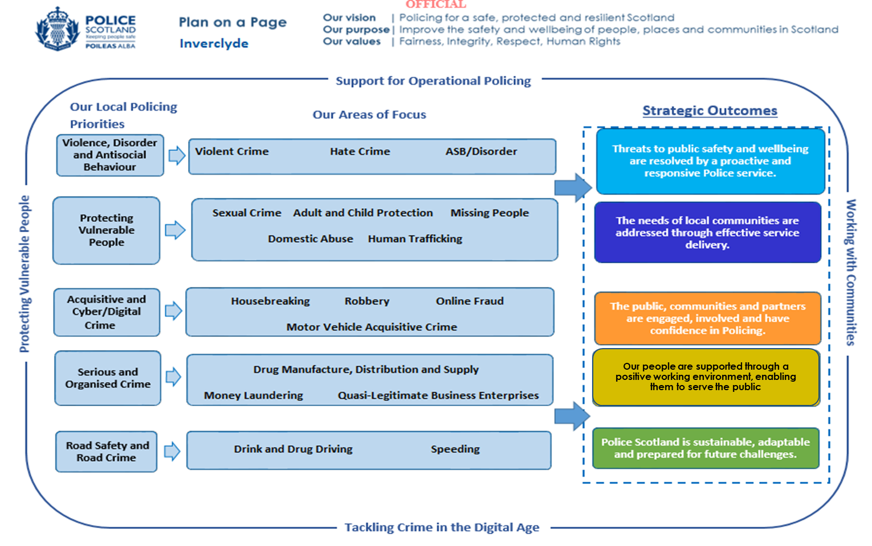

Local objectives and activity

Threats to public safety and wellbeing are resolved by a proactive and responsive police service
Objective: Keep people safe in the physical and digital world
Activity: Work with partner agencies to help reduce the risks to vulnerable persons
Key milestones:
- Increased preventative work to vulnerable groups
- Use of appropriate media campaigns and internal communications
- Ensure use of Banking Protocol through local officer engagement with banks
- Inputs to pupils on the subject of hate crime from their schools dedicated liaison officer
- Deliver regular scam inputs to residents at supported living accommodation
- Continue to support Trading Standards Scotland campaigns
- Support the ‘Fearless Campaigns’ the youth program of Crimestoppers
Update expected: Y1-3 Quarterly
Performance measures and insights:
- Feedback from members of the public, community groups and partners
- How affective has the banking protocol been in protecting vulnerable groups?
- Increased reporting from banks through implementation of banking protocols

Activity: Work cohesively with partners and stakeholders to support victims of
domestic abuse and sexual crime
Key milestones:
- Participation and support to ’16 days of action’ campaign against gender based violence
- Support to partners at Multi Agency Risk Assessment Conference meetings discussing high risk victims of domestic abuse and identifying actions to support victims
- Support to partners at Multi Agency Tasking and Coordination meetings to disrupt and deter high risk serial domestic offenders
- Increased promotion of Disclosure Scheme for Domestic Abuse Scotland legislation to highlight any abusive past behaviour to current partners
- Use of appropriate external media campaigns and internal communications
- Close management of offenders
Update expected: Y1-3 Quarterly
Performance measures and insights:
- How effective is divisional collaboration with partners in supporting victims?
- How well is the division working to eradicate domestic abuse crime?
- Has our approach to external communications affected public confidence in police?

Activity: Robustly deal with hate crime and ensure that victims, witnesses and partner agencies feel more confident in reporting such incidents to us
Key milestones:
- Work in partnership with ‘I Am Me’ to deliver the Ambassador Training in high schools raising awareness of hate crime
- Support to national ‘Hate Crime’ campaigns
- Raise awareness of reporting mechanisms and support services to public via social media channels
- Continual support and awareness training to our staff
Update expected: Y1-3 Quarterly
Performance measures and insights:
- Are Inverclyde providing an effective response to hate crime at a local level?
- How has our approach affected reporting and detection of hate crime?
- Are staff trained and equipped to deal with hate crime reports?

Objective: Design services jointly to tackle complex public safety and wellbeing challenges
Activity: To support partner agencies and facilitate early/effective intervention to
tackle drug related deaths, drug related harm
Key milestones:
- Develop a joint planning approach with local partners via the Community Planning Partnership
- Using intelligence led approach to deliver local policing initiatives to tackle those dealing drugs
- Implement Naloxone Programme within Inverclyde
Update expected: Y1-3 Quarterly
Performance measures and insights:
- What has the impact of activities been on those at risk from drug related harm?

Objective: Support policing through proactive prevention
Activity: Work in partnership with local stakeholders to ensure those suffering from mental health issues have access to appropriate support services
Key milestones:
- Develop improved collaborative approaches with NHS partners to mental health care.
- Deliver improved policing services to people experiencing mental ill health.
- Evaluate impact of new approach.
Update expected: Y1-3 Q4
Performance measures and insights:
- Has Police Scotland reduced the demand placed on officers for mental health related incidents?
- How effective are the processes in place to ensuring that people receive the correct care?
- Feedback from service users.

Activity: Engage with local communities and groups and raise awareness of
preventative measures to reduce commercial and residential housebreakings
Key milestones:
- Work with relevant housing partners to develop and disseminate guidance to assist residents in keeping their homes safe
- Crime prevention surveys with community safety partners
- With partners, support and advise elderly and vulnerable people of bogus callers
- Work with partners to provide security advice to commercial properties in the area
Update expected: Y1-3 Q4
Performance measures and insights:
- How effective has our guidance been in keeping properties secure?
- Have housebreakings to residential and commercial properties decreased?
- Has confidence in policing been improved?

Activity: Raise awareness of cyber-crime across all sections of the community
and promote initiatives for those most vulnerable
Key milestones:
- Increase cyber-crime awareness via police social media channels
- With partners, support and advise elderly and vulnerable people of online fraud
- Liaison officer inputs to pupils and parents raising awareness of on-line bullying
Update expected: Y1-3 Q4
Performance measures and insights:
- How effective has social media campaign been in increasing awareness?
- Increased public awareness of trends
- Feedback from partner agencies and pupils on effectiveness of awareness events

The needs of local communities are addressed through effective service delivery
Objective: Understand our communities and deliver the right mix of services to meet their needs
Activity: Engage with local communities and groups, especially those most
vulnerable, to understand and tackle their concerns and fears
Key milestones:
- Carry out Community Policing workshops with local communities
- Promote ‘Your Police’ survey throughout the year particularly with seldom heard groups
- Increase use of local social media on local initiatives and good work
Update expected: Y1-3 Q4
Performance measures and insights:
- What insights has Inverclyde obtained as a result of improved engagement?
- Have local police acted on community concerns?
- Has support for local police improved?

Objective: Support our communities through a blend of local and national expertise
Activity: Work with partners in Road Policing and reduce the number of persons
killed or injured on our roads
Key milestones:
- Support to national road safety initiatives
- Speed checks at priority locations identified by communities
- Carry out periodic road worthiness checks with partners in Road Policing
- Participation in the annual festive drink/drug driving campaign
Update expected: Y1-3 Quarterly
Performance measures and insights:
- Reduction in the number of persons killed or injured on Inverclyde’s roads
- Have local police acted on community’s road safety concerns, particularly in priority areas?
- How have roadworthiness checks influenced driver behaviour?

Activity: Engage with third sector groups and local authority partners to support
refugees including those displaced by the conflict in Ukraine
Key milestones:
- Participate in community planning to ensure that displaced people have a distinct route to accommodation, support and care
- Work with third sector groups to raise awareness of Police Scotland and the support services we provide amongst refugees
- Provide a single point of contact for refugee groups to discuss concerns
Update expected: Y1-3 Q3
Performance measures and insights:
- Does qualitative feedback from third sector refugee groups indicate that refugees feel supported by Police Scotland?

Objective: Support the changing nature of communities
Activity: Improve the prevention, detection and investigation of antisocial behaviour, and support those at increased risk of harm from this behaviour
Key milestones:
- Work with community planning partners to provide a collaborative approach to tackle anti-social behaviour, including school inputs via each schools liaison officers
- Continue to work with partner agencies to share relevant information and where appropriate taking action to protect individuals by providing support, intervention and referrals
- Continue to support and engage with licensed premises through visitations in order to create a safe night-time economy environment
Update expected: Y1-3 Q2
Performance measures and insights:
- How well does Police Scotland work with partners to support victims and those at risk?
- How well does Police Scotland work with partners to tackle ASB?

The public, communities and partners are engaged, involved and have confidence in policing
Objective: Embed the ethical and privacy considerations that are integral to policing and protection into every aspect of the service
Activity: Proactively engage with minority groups representative of local
demographics including seldom heard groups
Key milestones:
- Develop an approach plan
- Monitor and evaluate progress and benefits
- Design and implement local engagement initiatives
Update expected: Y1-3 Q2, Q4
Performance measures and insights:
- How well are we engaging with different groups?
- Feedback from members of the public, including seldom heard groups

Objective: Protect the public and promote wellbeing across Scotland by
providing services that are relevant, accessible and effective
Activity: Work with partner agencies (especially Local Authorities and Private Young
Person Care Homes) to help reduce the risk of those reported missing
Key milestones:
- Continue to ensure that robust divisional procedures are in place to support regular missing persons
- Ensure greater awareness and use of Herbert and Philomena Protocols
- Continual liaison with young Person Care Homes
Update expected: Y1-3 Quarterly
Performance measures and insights:
- Reduction in the number of missing person reports
- Improved awareness of Herbert and Philomena Protocols
- Improved information sharing with relevant partners and care providers

Objective: Work with local groups and public, third sector and private sector
organisations to support our communities
Activity: Support a multi-agency response to young people at risk of criminal
exploitation within Inverclyde
Key milestones:
- Commitment to continued use of Community Policing/Police Scotland Youth Volunteers to engage with young persons and deter them from drug misuse
- Explore diversionary measures to reduce risks of exploitation
- Robustly investigate instances of child exploitation
Update expected: Y1-3 Quarterly
Performance measures and insights:
- Feedback from Community Police/PSYV
- Feedback from stake-holders

Our people are supported through a proactive working environment, enabling them to service the public
As an organisation we are constantly looking at new and innovative ways of improving service delivery. We aim to provide our staff with the latest equipment and technologies enabling them to do their job and keep everyone safe. Some examples being;

Mobile Working
All operational officers within the division are now equipped with mobile devices, replacing the paper notebooks. Many of the tasks which were previously carried out at police stations can be completed whilst on patrol or at the scene of an incident, thus preventing the officer from returning to the station and ultimately increasing the hours spent on patrol within the communities.

Body Worn Video
Trials are underway across some departments within Police Scotland, including Firearms, where officers are equipped with Body Worn Video cameras. This enables the Police Service and the wider justice sector to deliver fast, fairer justice. It also has the potential to significantly enhance public confidence in the Police Service through more effective and transparent policing.
It is anticipated that a number of other departments, including response officers, will be equipped with the cameras from early 2024.

Taser
There are a number of Specially Trained Officers (STO’s) now deployed across the division. STO’s carry Taser as part of their deployment and are able to react to certain incidents which bring risk to the public or officers.
Our objectives and activities for this outcome will include-

Objective: Prioritise wellbeing and keep our people safe, well equipped and protected
Activity: Provide officers in the division with the latest technologies and equipment to deliver the best service to the communities
Key milestones:
- Support the roll out of body worn video
- Increase the number of STO’s within Inverclyde
- Maximise STO capabilities across the local area
Update expected: In format Y1-3 Q4
Performance measures and insights:
- Has public confidence in policing increased due to roll out of Body Worn Video?
- How well are we supporting our people?

Activity: Ensure our officers have a good working knowledge of partner agencies who can offer appropriate assistance
Key milestones:
- Continue to deliver awareness training to all staff on new partnerships
- Enhanced sign-posting procedures throughout division
Update expected: Y1-3 Q2
Performance measures and insights:
- Number of referrals to appropriate agencies
- Public confidence in policing via ‘Your Survey’

Objective: Support our people to be confident leaders, innovative, active
Contributors and influencers
Activity: Support colleagues’ performance and development through My Career
and associated promotion pathways
Key milestones:
- Design and implement local development forums around the My Career mechanism
- Overview of progress and benefits
Update expected: Y1-3 Q2, Q4
Performance measures and insights:
- How well are we supporting our people?
- Is My Career being used effectively in progressing officers’ careers?

Objective: Support our people to identify with and demonstrate Police
Scotland values and have a strong sense of belonging
Activity: Develop and implement divisional people plans to support the
implementation of the People and Equality, Diversity and Inclusion strategies
Key milestones:
- Review and evaluate existing approach
- Development of EDI Governance Group
- Creation of EDI Steering Group
Update expected: Y1-3 quarterly
Performance measures and insights:
- How does Police Scotland proactively promote and support equality, diversity and inclusion initiatives?
- How well are we supporting our people?

Police Scotland is sustainable, adaptable and prepared for future challenges
Objective: Use innovative approaches to accelerate our capacity and capability for effective service delivery
Activity: Seek out shared learning and training opportunities with partners
Key milestones:
- Overview of progress and benefits
Update expected: Y1-3 quarterly
Performance measures and insights:
- How effective is Police Scotland at continuous improvement and workforce development?
- How effective is Police Scotland at sharing learning with partners?
Objective: Commit to making a positive impact through outstanding environmental sustainability
Activity: Support the delivery and implementation of new technology and
environmental sustainability through our fleet
Key milestones:
- Support the roll out of ultra-low or zero emission vehicles
- Increase the number of defibrillators within police vehicles
Update expected: Y1-3 quarterly
Performance measures and insights:
- What progress has Police Scotland made to increase their number of ultra-low or zero emission vehicles?
- What progress has Police Scotland made to increase their number of defibrillators in vehicles?

Objective: Support operational policing through the appropriate digital tools and delivery of best value
Activity: Support the implementation of new technology across the division
Key milestones:
- Overview of progress and benefits
- Evaluation and learning
Update expected: Y1-3 Q1, Q3
Performance measures and insights:
- What progress is Police Scotland making at implementing new technology across the service?

Governance and performance
Effective scrutiny and oversight continue to be key elements to ensure that policing retains the trust and confidence of the communities of Scotland. The governance structures outlined below are designed to ensure that Police Scotland provides a service that is relevant, legitimate and consistent with the principle of ‘policing by consent’.
Each of Scotland’s local authorities have scrutiny arrangements in place to allow them to influence policing at a local level. Inverclyde Local Police and Fire Scrutiny Committee meet quarterly where local policing matters are discussed.
In addition to utilising an existing suite of performance tools developed by Police Statisticians, Planning and Performance Officers and the Demand and Productivity Unit, the Police Service of Scotland continues to develop its data and performance capabilities. The adoption of technology-driven business intelligence tools has resulted in data insights being increasingly accessible to Senior Management Teams and decision makers. The national Digital Drives Data project has the objective of enabling greater access and use of our data to improve organisational performance and keep people safe.
Internal governance for the division is managed through the Divisional Delivery Board (DDB) chaired by the Local Policing Commander. The newly adopted DDB model has streamlined Divisional governance into a more effective framework, better allowing Renfrewshire & Inverclyde Division to tailor local responses to local need, while also realigning reporting mechanisms to regional & national governance structures.

Equality, diversity and inclusion
The work of Police Scotland is underpinned by our commitment to equality, diversity and inclusion in our interactions with the communities we serve as well as our own staff.
We are committed to developing and promoting best practice in the refresh of our Equality outcomes for 2022. These can be found along with our commitment and duties to equality, diversity & inclusion at Equality and Diversity – Police Scotland.
This plan has been subject to an Equalities and Human Rights Impact Assessment (EqHRIA) in compliance with the Scottish Public Sector Equality Duty. Separate EqHRIAs will be undertaken for the activities described in this plan as required.

Engaging with us
There are a number of ways to get in touch with us:
Renfrewshire and Inverclyde Division Police
Police Scotland
Greenock Police Station
160 Rue End Street
Greenock
PA15 1HX

Dial 999 for an emergency that requires urgent police attention.
For non-emergency contact call the 24-hour non-emergency contact centre on 101.
If you have information about a crime in your area and wish to provide it anonymously, call Crimestoppers charity on 0800 555 111.
If you have any concerns or issues you wish to discuss, you can contact your local Community Policing Team by phoning 101.
For more detailed information about your local community policing team and other services that Police Scotland provides, please visit our website at www.scotland.police.uk
If you would like this information in an alternative format or language, please phone us on 101 to discuss your needs.
Service users who are deaf or have a hearing impairment can contact Police Scotland via Next Generation Text (NGT) on 18001, 101 for non-emergency, or 18000 in an emergency.
Meaningful and effective engagement involves genuine dialogue, respect, integrity, transparency and accountability. It provides an opportunity for people to shape our services and influence decisions made. Insight from effective engagement helps identify practical solutions and determine changes required to meet the needs of the communities we serve.
Police Scotland is committed to continuous improvement in all that we do. If you have something to tell us about our service, please contact us at Contact Us – Police Scotland.
Further information about our wider engagement can be found in our consultation and engagement hub at Engagement Hub – Police Scotland.
Police Scotland has a number of active social media channels that provide a range of information and insight into policing, both nationally and in your local area. A full list of our social media accounts can be found on our website. Our local channels can be found at:
Twitter: Renfrewshire & Inverclyde Police (@RenfrewInverPol) / Twitter
Facebook: Renfrewshire & Inverclyde Police Division | Facebook
Please note that our social media channels are not monitored 24/7 and should not be used for reporting crime. Please dial 999 in an emergency, and 101 in a non-emergency situation.
Inclusive and accessible engagement
We aim to embed accessibility and inclusivity into our services to make them work for everyone.
This Local Police Plan was subject to an Equality and Human Rights Impact Assessment (EqHRIA). A summary of the EqHRIA has been published alongside this document.
This Local Police Plan can be made available in various alternative formats. For more information, please contact us via Contact Us – Police Scotland.
Deaf, deafened, hard of hearing or speech-impaired callers can contact us via Text Relay on 18001101.

