| Police Scotland logo | Freedom of Information Response Our reference: FOI 23-0665  Responded to: 04 April 2023 |
| --- | --- |

Your recent request for information is replicated below, together with our response.

## I'm requesting a breakdown by month, year and class of vehicle (car, motorcycle, bus etc) the number of fines / summons for unauthorised vehicle use of the Forth Road Bridge.

## As well as the actual Forth Road Bridge I'd also like figures for the following restricted access roads 1 A90 westbound to B800 2 Echline Junction southbound to A9000

Following clarification with you, you requested the following:

## By month how many fines/notices etc have been generated by automated cameras on the 3 restricted roads below. If there aren't any cameras then the answer will be nil. Feel free to ignore any handed out by patrolling police officers / reports from the public etc.

## Forth Road Bridge (Pink below)

## Access road. A90 westbound to B800 (green)

## Access road. Echline Roundabout Junction southbound to A9000 ( turquoise )

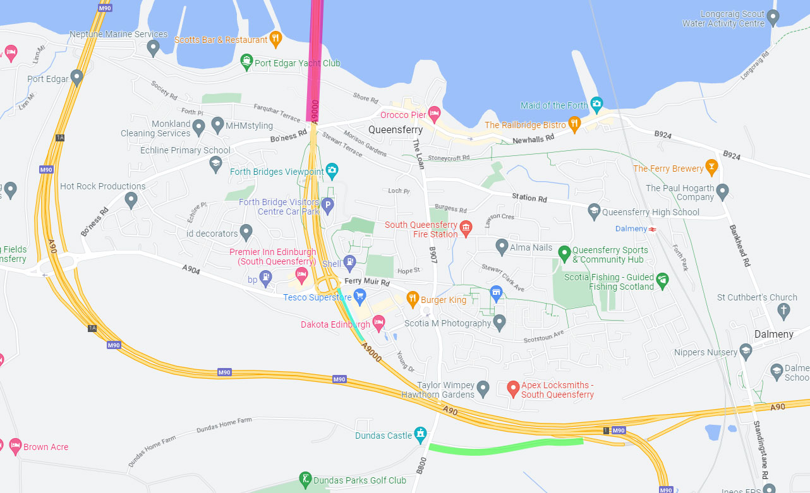

Figure 1 Showing map image of requested roadways.

In response to your request I can advise that the answer to your question is zero. There are no automated cameras on the access roads noted above for the purpose of deterring unauthorised use of the Forth Road Bridge.

If you require any further assistance please contact us quoting the reference above.

You can request a review of this response within the next 40 working days by [email](mailto:foi@scotland.police.uk) or by letter (Information Management - FOI, Police Scotland, Clyde Gateway, 2 French Street, Dalmarnock, G40 4EH). Requests must include the reason for your dissatisfaction.

If you remain dissatisfied following our review response, you can appeal to the Office of the Scottish Information Commissioner (OSIC) within 6 months - [online](http://www.itspublicknowledge.info/Appeal), by [email](mailto:enquiries@itspublicknowledge.info) or by letter (OSIC, Kinburn Castle, Doubledykes Road, St Andrews, KY16 9DS).

Following an OSIC appeal, you can appeal to the Court of Session on a point of law only.

This response will be added to our [Disclosure Log](http://www.scotland.police.uk/access-to-information/freedom-of-information/disclosure-log) in seven days' time.

Every effort has been taken to ensure our response is as accessible as possible. If you require this response to be provided in an alternative format, please let us know.