| Police Scotland logo | Freedom of Information Response Our reference: FOI 25-1706  Responded to: 19 August 2025 |
| --- | --- |

Your recent request for information is replicated below, together with our response.

**Can Police Scotland please confirm the number of calls/complaints received from Blebo Craigs, Fife in the last 12 months.**

The table below details recorded STORM incidents for Police Scotland beat 21B (as per the shaded area in the map below), for the period 01/08/2024 - 31/07/2025:

| **Initial Incident Type** | **No. recorded** |
| --- | --- |
| Intruder | 8 |
| Personal Attack Alarm | 4 |
| Audible Only | 1 |
| Public Nuisance | 7 |
| Drugs/Substance Misuse | 3 |
| Disturbance | 4 |
| Abandoned Vehicles | 3 |
| Noise | 28 |
| Neighbour Dispute | 6 |
| Communications | 10 |
| External Force Request | 1 |
| Lost/Found Property | 6 |
| Police Information | 12 |
| Special Events/Operations | 1 |
| False Call | 1 |
| Police Generated Activity | 2 |
| Assist Member Of The Public | 27 |
| External Agency Request | 8 |
| Fraud Incident | 7 |
| Wildlife Crime | 3 |
| Abduction/Extortion/Sextortion | 1 |
| Sexual Offence | 2 |
| Theft | 8 |
| Vehicle Crime | 7 |
| Housebreaking | 3 |
| Suspect Persons | 13 |
| Assault | 4 |
| Damage | 3 |
| Other Crime | 1 |
| Firearms Incident | 1 |
| Suspicious Incident | 1 |
| Planned Shoot / Pest Control | 33 |
| Fires | 2 |
| Animals | 19 |
| Missing Person/Absconder | 13 |
| Sudden Death | 2 |
| Domestic Incident | 5 |
| Abandoned/Silent 999 Call | 31 |
| Concern For Person | 41 |
| Child Protection | 1 |
| Drone/Uas/Uav Incident | 1 |
| Road Traffic Collision | 51 |
| Road Traffic Matter | 66 |
| Road Traffic Offence | 7 |
| **Total** | **458** |

All statistics are provisional and should be treated as management information.   
Data was extracted from Police Scotland systems and are correct as of 11/08/2025.  
Data was extracted using the incident's raised date.  
Error and transferred incidents have been removed.

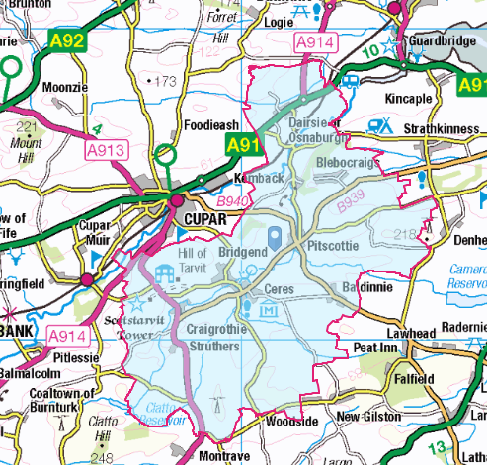

**Can Police Scotland please confirm the number of calls they have received regarding dogs in Blebo Craigs, Fife over the last 12 months.   
Please can this information be broken down by dog breed?**

17 of the 19 ‘Animal’ incidents listed above were recorded as involving dogs.

A breakdown of the breeds is provided in the table below:

| **Breed** | **No. related incidents** |
| --- | --- |
| Spaniel/ Springer Spaniel | 5 |
| Collie/ Collie cross | 4 |
| Bulldog | 1 |
| Not specified | 7 |

If you require any further assistance, please contact us quoting the reference above.

You can request a review of this response within the next 40 working days by [email](mailto:foi@scotland.police.uk) or by letter (Information Management - FOI, Police Scotland, Clyde Gateway, 2 French Street, Dalmarnock, G40 4EH). Requests must include the reason for your dissatisfaction.

If you remain dissatisfied following our review response, you can appeal to the Office of the Scottish Information Commissioner (OSIC) within 6 months - [online](https://www.foi.scot/appeal), by [email](mailto:enquiries@foi.scot) or by letter (OSIC, Kinburn Castle, Doubledykes Road, St Andrews, KY16 9DS).

Following an OSIC appeal, you can appeal to the Court of Session on a point of law only.

This response will be added to our [Disclosure Log](http://www.scotland.police.uk/access-to-information/freedom-of-information/disclosure-log) in seven days' time.

Every effort has been taken to ensure our response is as accessible as possible.   
If you require this response to be provided in an alternative format, please let us know.