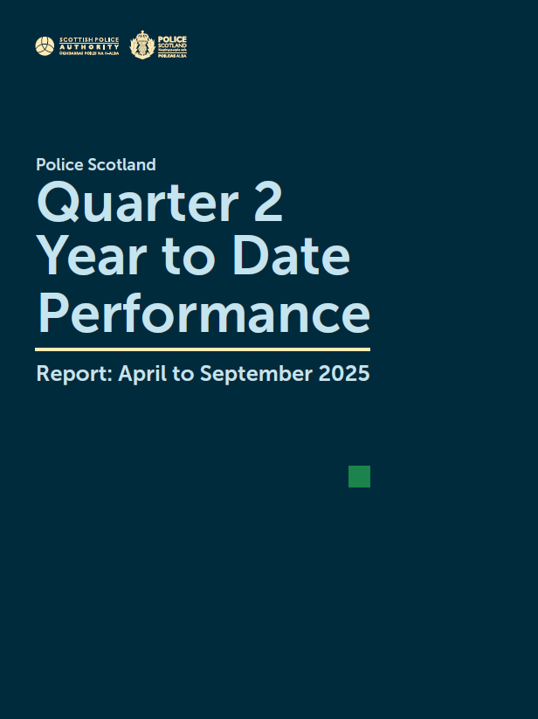

Contents
Deputy Chief Constable Foreword 3
Introduction 4
Executive Summary 6
Key Insights 8
Vision 2030: Safer Communities 14
Vision 2030: Less Crime 27
Vision 2030: Supported Victims 47
Vision 2030: Thriving Workforce 58
Appendix 68

This is the 2025/26 Quarter 2 performance report covering the period 01 April 2025 to 30 September 2025. All data is correct at the published date and was extracted at the start of October 2025. The data is extracted from Police Scotland internal systems which are dynamic and continuously updated as investigations progress.
This report contains the most up to date recorded crime data that was available at the start of October 2025 for Quarter 2 of the reporting year 2025/26.
Further detailed Police Scotland Management Information can be found here: https://www.scotland.police.uk/about-us/what-we-do/how-we-are-performing/

Deputy Chief Constable Foreword
Operating environments for our officers and staff have continued to intensify during the period of July to September 2025, particularly with an increase in all violent crimes and sexual crimes.
Despite an overall rise in violence, the number of children accused of violent crime continues to decrease. However, of note, the number of children accused of attempted murder continues to be higher than usual. We care deeply about violence and how it affects our young people, and significant activity is highlighted in the report as part of Operation Stardrop, detailing work with partners to deliver early intervention to safeguard children and young people and prevent future violence.
Police Scotland continues to prioritise protection of those who face the greatest threat, risk or harm, and respond to the growth of digitally enabled crime.
The report reflects a continued rise in online child sexual abuse, with an increase of over 20 per cent compared to the same period last year, and the requirement for policing to build new capabilities and capacity.
During this period there was also an eight per cent increase in reports of rape compared to the previous year. A considerable proportion of reports, over 40 per cent, were for non-recent rapes which often require an enhanced response.
Serious and organised crime and illegal drugs continue to blight our communities with a 20 per cent increase from the second quarter of the previous year.
This report highlights proactive activity to disrupt serious organised crime which resulted in uncovering the largest cannabis cultivation in Scotland to date, valued at almost £12 million.
The challenge for policing is evolving rapidly, as is illustrated during this period by increasing online harm, threat and violence. As highlighted by Chief Constable, Jo Farrell during pre-budget scrutiny discussions at Scottish Parliament, existing pressure on our performance and people can influence confidence in our ability to prevent and investigate crime, as is reflected in a small decrease in public confidence in this report.
At the same time, we’ve delivered proactive work to prioritise roadside drug testing with a significant increase in positive detections, safeguard over 100 people as part of County Lines Intensification Week and detect over 500 shopliftings since the establishment of our Retail Crime Taskforce six months ago.
Our officers and staff continue to respond with professionalism and commitment, and I want to thank colleagues for their unwavering dedication to keeping people safe.
This report seeks to provide meaningful insights into how we are delivering on our Annual Police Plan and vision to achieve safer communities, less crime, supported victims, and a thriving workforce.

DCC Jane Connors LVO QPM (Deputy Chief Constable Operational Policing)

Introduction
This is the second quarterly report of the 2025/26 performance cycle, reporting based on our Performance and Accountability Framework for 2025/26. This year’s Performance and Accountability Framework is set out to measure performance, progress and impact across all areas of Police Scotland’s 2030 Vision.
Our 2030 vision provides the service with a clear, aspirational direction of travel to shape the development of Police Scotland. The purpose of the 2030 Vision is not only to motivate our workforce to deliver, but also to support strategic decision making around service investment priorities and our portfolio of change.
Our 2030 Vision is for safer communities, less crime, supported victims and a thriving workforce with this report structured under each of these pillars. The 2030 Vision, along with the Chief Constable’s priorities (Trust, Confidence and Performance), remain aligned to the following five Strategic Outcomes set out in the Joint Strategy for Policing:
Public Safety and Wellbeing – Threats to public safety are resolved by a proactive and responsive service;
Needs of Local Communities – The needs of local communities are addressed through effective service delivery;
Confidence in Policing – The public, communities and partners are engaged, involved and have confidence in policing;
Working Environment – Our people are supported through a positive working environment, enabling them to serve the public;
Sustainable and Adaptable Service – Police Scotland is sustainable, adaptable and prepared for future challenges.
Although reporting will be displayed against the 2030 Vision, this alignment ensures Police Scotland will continue to operate, evidence progression and contribute to the overarching outcomes.
We are using overarching, targeted Strategic Indicators to draw together a suite of Key Performance Indicators (KPIs) which provides scope to detail the qualitative aspects of performance and show how we are performing in these areas. Management Information (MI) and supporting evidence will be used to highlight exceptions within the data.
In line with Scottish Government reporting, data comparisons within this report are now made, where possible, against both Quarter 1 (year-to-date vs previous year-to-date) and the rolling 12 month period (year-to-date vs previous year-to-date). We will no longer include five-year mean comparisons in the quarterly performance report.
The 12 month timeframe will always encompass the most recent 12 month period. It is a dynamic, shifting period which will remove any short-term effects of seasonality in our reporting. Within this report, the rolling 12 month period will compare October to September YTD against October to September PYTD.
We continue to identify and draw out key insights, with these displayed at the beginning of the report. During Quarter 2 the following key insights have been identified and highlighted:
Mental Health-Related Incidents
Motorcycle Safety Campaign
Assaults on Police Officers/Staff
- Partner Referrals from Police Custody
Examples of proactivity and/or preventative policing activity also continues to be highlighted, with the following of note during Quarter 2:
Operation SPOTLIGHT
Violence Prevention
- Engagement with Children and Young People
Retail Crime Taskforce (RCTF)
Cannabis Cultivation
County Lines Intensification Week
Proceeds of Crime
Proportionate Response to Crime
Professional Standards Disseminated Learning
Strong performance will show the steps we are taking to achieve the outcomes within the 2030 Vision. The Quarter 2 Performance Report illustrates how we are striving towards these outcomes through quantitative data analysis and qualitative supporting evidence.

Executive Summary
Figures in these tables are YTD (April to September 2025) unless otherwise stated. Comparisons in the second row are made against the same period last year.

Safer Communities
Suspected Drugs Related Deaths | Missing Persons Demand | Mental Health Related Incidents | CJ Volume of Cases Submitted | Stop and Search Compliance
596 DRDs  17.1% | 6,907 mispers  -13.3% | 122,735 inc.  0.5% | 81,253 cases  25.0% | 99.0%  0.1% pts

Group 6 Antisocial Offences | Antisocial Behaviour & Disorder | Road Safety Fatalities on our roads | Group 8  Road Traffic Offences | Positive Drug Wipes & Safety Camera Dets
28,229 offences  10.7% | 138,470 ASB  -0.6% | 92 people  10.8% | 65,878 offences  19.1% | 1,894 positive  26.6%
78.5% det rate  -0.6% pts | 96,628 disorder  -0.6% | 1 child  -50.0% | 87.3% det rate  no change | 47,381 dets  7.0%

Less Crime
Group 1 Non sexual crimes of violence | Group 2  Sexual  Crimes | Group 3  Crimes of dishonesty | Group 4  Damage & reckless beh. | Group 5  Crimes against society
38,970 crimes  5.0% | 8,378 crimes  10.5% | 59,572 crimes  4.3% | 20,256 crimes  -0.8% | 34,945 crimes  9.4%
67.7% det rate  -1.2% pts | 60.1% det rate  2.4% pts | 35.1% det rate  0.3% pts | 32.3% det rate  1.2% pts | 90.3% det rate  -4.0% pts

Children and Young People Crimes | Violence Against Women & Girls | Theft by Shoplifting | Hate  Crime | Supply of  drugs
14,872 crimes  -6.6% | 38,345 crimes  3.6% | 26,556 crimes  16.5% | 5,206 crimes  6.5% | 2,186 crimes  20.2%
9.1% of crimes  -1.6% pts | 17,571 domestic  7.0% | 48.5% det rate  0.2% pts | 63.3% det rate  -2.8% pts | 91.3% det rate  -3.7% pts

Supported Victims
User Experience Satisfaction | Your Police confidence in local policing | Your Police safety in  local area | Your Care Cards (YCC) issued | Victim Support Scotland (VSS) Referrals
67% (Q2)  -4% pts | 50% (Q2)  -4% pts | 62% (Q2)  no change | 40,589 issued  -2.5% | 5,036 referrals  9.8%

Volume of  999 calls received | 999 calls average speed of answer | Volume of  101 calls received | Digital online enquires received | Complaints received relative to C3
422,725 calls  6.5% | 9 seconds  no change | 850,491 calls  -2.9% | 123,015 online  2.6% | 151 complaints  -1.3%

Thriving Workforce
Assaults & Injuries officers/staff | Percentage of Working Days Lost (WDL) | Percentage turnover of officers/staff | PSD Complaints & Allegations | Financial Sustainability Underspends
4,088 assaults  7.0% | 7.2% officers  0.7% pts | 0.42% officers  0.02% pts | 2,806 complaints  -26.4% | Revenue budget  £1.1m
23.4% injured  -1.8% pts | 6.8% staff  0.1% pts | 0.82% staff  -1.26% pts | 5,108 allegations  -24.1% | Capital budget  £0.9m

Key Insights
Key Insight – Mental Health-related Incidents
The number of mental health-related incidents recorded across Police Scotland during Quarter 2 has increased by 121 (up by 0.2%) compared to the same recording period last year. Increases have also been noted for YTD (555 more, up 0.5%) against PYTD.
During Quarter 2, mental health-related incidents represented 18.2% of all incidents reported to Police Scotland which is an increase on last year for the same reporting period which recorded 17.3% of all incidents were mental health-related.
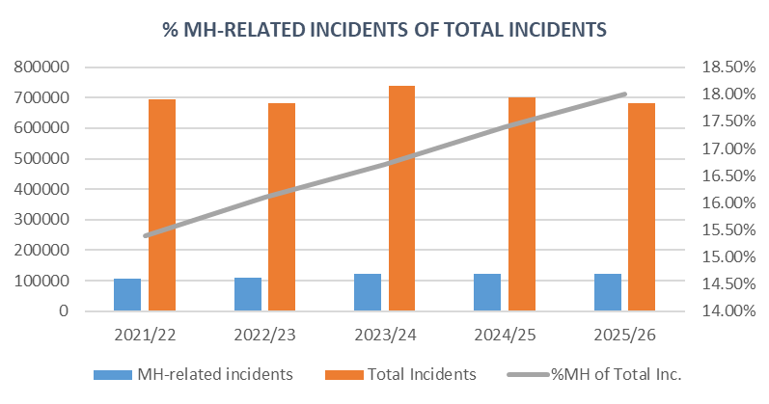
YTD figures across the previous five years show a steady increase in the percentage of mental health-related incidents against total incidents. Both recorded highest figures during 2023/24 and since then total incidents have continued to decline but mental health-related incidents have increased, in general, throughout this period.
Comparatively, 354 more mental health-related incidents occurred in Quarter 2 than in Quarter 1 this year, representing a 0.6% rise in reporting. However, although Quarter 2 noted higher volume overall, daily averages slightly decreased by approximately 3.5 incidents per day due to having one extra day within this recording period.
The Mental Health Pathway (MHP) is a Scottish Government funded collaboration between Police Scotland, the Scottish Ambulance Service and NHS24 whereby callers contacting C3 Division who are experiencing mental health crisis or distress can be referred to the NHS 24 Mental Health Hub, following a robust assessment to ensure any risk is identified and appropriately managed.
This trauma informed approach helps ensure members of the public access the right care at the earliest opportunity while also reducing the number of officer hours spent responding to mental health calls where they are not needed.

The Mental Health Taskforce continues to work closely with C3 Division and NHS24 to embed the pathway and drive improvements to ensure it is being used consistently on every occasion.
Key Insight – Motorcycle Safety Campaign
This quarter saw the conclusion of our Motorcycle Safety Campaign which ran from 21 March to 26 September. This was to coincide with the peak Spring/Summer riding period and promoted safe and responsible driving across Scotland.
Several weekends of action, targeting popular bank holiday riding dates were included, as well as a Fortnight of Action which ran from 02 to 15 June to coincide with the UK-wide 2Wheels initiative.
In total over the campaign 1,804 riders were stopped, with 300 offences detected amongst them. An additional 84 offences committed by other road users were also detected. Compared to the previous year’s campaign this was a slight decrease in motorcyclist offences detected, however an increase of 12 offences by other road users.
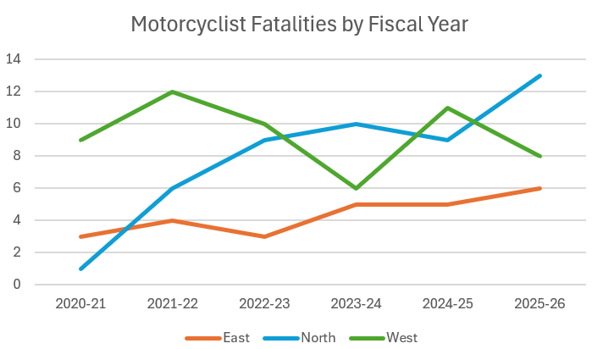
In the current Year-To-Date period there have been 27 motorcyclist fatalities, compared to 25 in the previous year. This is the highest number of deaths over the last five years. The previous chart shows the number of fatalities within each policing region of Scotland.
Fatalities in the West of Scotland have observed fluctuating numbers of fatal collisions involving motorcyclists, however both the East and North regions have seen strong evidence of an upwards trend.
The increase in deaths this year is largely due to a significant number of fatalities which occurred in August 2025.
Seven riders were killed during this month compared to three in the previous year, Similarly, in April 2025 six riders were killed compared to no riders in the previous year.
This significant increase in April was significantly higher than any previous year and was likely due to unseasonally sunny, dry weather which was observed in the Spring.
Utilising analysis on when motorcycle riders are most likely to use our roads, the Motorcycle campaign is annually timed to coincide with Spring/Summer periods.
After analysis indicated increasing numbers of motorcycle rider deaths Police Scotland analysts produced an in-depth motorcycle fatalities study which was completed and shared with partners in May 2025, the results of which will be used to seek to better safeguard motorcyclists.
The Scottish Government, in partnership with Police Scotland, have developed a working group to explore opportunities and develop engagement strategies moving forwards. One example is Rider Refinement, an initiative providing rider training by police and IAM RoadSmart instructors.
Key Insight – Assaults on Police Officers/Staff
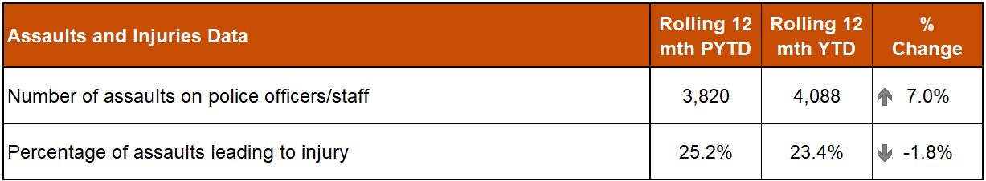
In the YTD, a total of 4,088 assaults on police officers/staff have been recorded. This is an increase of 268 assaults (up 7.0%) compared to the same period last year. This equates to an average of around 22 assaults on officers/staff per day (unchanged from the figures presented in Quarter 1).
Despite the increases in assaults, the YTD percentage of assaults leading to injury (23.4%) is down 1.8 percentage points compared to the previous YTD (25.2%).
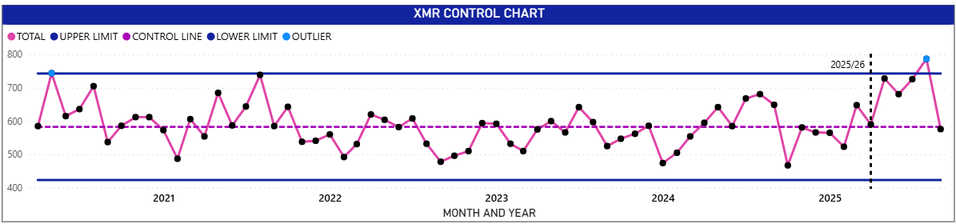
This XMR Control Chart shows the monthly trends for Assaults on Officers/Staff from April 2020 through to September 2025. For the majority of months, the volume has been within both upper and lower control limits.
In the YTD, crimes have been on an upward trend with a peak of 787 assaults recorded in August 2025. This is the highest monthly volume in the last six years and the first month since May 2020 that the volume of crimes has exceeded upper control limits.
September 2025 has however dropped to 576 crimes which is the lowest volume in the current reporting year.
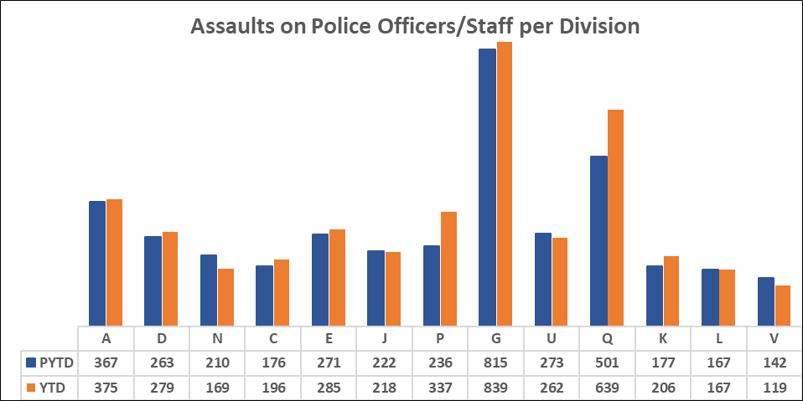
Eight of the thirteen Local Policing Divisions have recorded an increase in their volume of assaults on police officers/staff compared to the PYTD. The biggest YTD increases in assaults were in Q Division – Lanarkshire (138 more crimes, up 27.5%) in the West region followed by P Division – Fife (101 more crimes, up 42.8%) in the East region.
Q Division – Lanarkshire follows a similar trend to the Police Scotland position with an upward trend noted from April 2025 through to a peak of 143 assaults in August 2025. This is their highest monthly volume of assaults in the last six years and above upper control limits. The volume of assaults in September 2025 dropped however to 78.
A Lanarkshire Your Safety Matters snapshot report was compiled by the Strategic Analysts, covering the period: April to August 2025, which identified the following:
Increases have been seen in all four sub-divisions, with the greatest increase within Hamilton and Clydesdale (QB);
During the reporting period every month recorded an increase on assaults compared to the same month in the previous year;
August 2025 noted the largest increase from PYTD (50 more assaults, up 53.8%);
Assaults in police premises have decreased by 33.8% on PYTD;
Assaults in and around vehicles have increased by 38.3% on PYTD;
- Assaults per 1k incidents have increased from 10.8 PYTD to 14.8 YTD.
Fife (P Division) also follows a similar trend to the Police Scotland position with an upward trend noted from April 2025 through to August 2025. July 2025 (70 assaults) and August 2025 (76 assaults) are the division’s highest monthly volume of assaults in the last six years and above upper control limits. The volume of assaults in September 2025 dropped however to levels similar to April and May 2025.
A Fife Your Safety Matters snapshot report was compiled by the Strategic Analysts, covering the period: April to August 2025, which identified the following:
Increases have been seen in four of the six sub-divisions, with the greatest increase within West Fife (PD);
During the reporting period, increases were recorded in May, June, July and August 2025 compared to the same period in the previous year;
June 2025 noted the largest increase from PYTD (37 more assaults, up 185.0%);
43% of assaults occurred in a public place;
Assaults in/around a cell van have increased by 150% to 25;
Assaults per 1k incidents have increased from 7.8 PYTD to 11.1 YTD.
Operational Safety Training (OST) conducted an increased training pilot during 2024/25 in one Renfrewshire & Inverclyde subdivision; identified by analysts as one of the most violent subdivisions where assaults on officers and the subsequent time off recovering from those injuries were amongst the highest nationally.
The training would be conducted with a shift of officers for an hour, practicing refined tactics in areas identified as most at risk of assault and harm (custody, vehicles and multi-officer arrests).
Although this was a small sample size, it was found that the trial group were 53% less likely to be injured compared to the same group before the trial and 27% less likely to be injured than a neighbouring subdivision.
Key Insight – Partner referrals from police custody
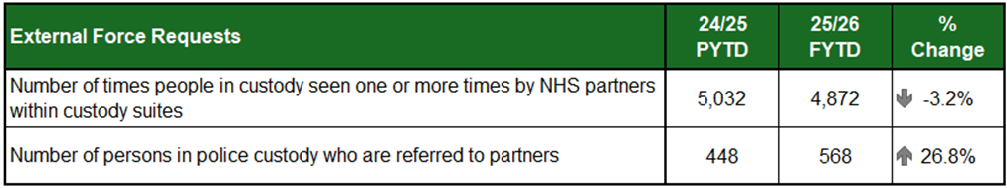
The reduction in the number of times people in custody are seen by Health Care Professionals is likely due to the overall reduction in throughput rather than any significant change to policing practice.
The Scottish Government National Strategy for Community Justice sets out deliverables that detail work to be undertaken to drive improvement nationally including actions in relation to person-centred care within police custody and driving an increase in referrals to services including substance use and mental health services.
In support of this, significant work has been completed over the last 12 months which accounts for the year-to-date increase in arrest referral numbers.
In July 2024, the Criminal Justice Services Division (CJSD) Healthcare and Interventions Team began a relaunch of Arrest Referral, an internal program of work which sought to educate custody staff on the importance of the arrest referral process with a trauma-informed approach.
This drew on positive stories of engagement and upskilling existing arrest referral “champions” with webinar resources on drug and alcohol misuse and head injuries, amongst other important topics.
CJSD Healthcare and Interventions Team have visited custody suites to provide face-to-face insights on the arrest referral process. They regularly review data to identify areas of good practice such as the Tayside service, which is continuing to contribute to the increase in figures, and identify opportunities to increase referrals.
This includes briefing the local area commanders and custody inspector on findings to improve performance. The importance of the arrest referral scheme and resources to support local understanding is frequently published on the CJSD divisional bulletin.
In April 2025, the first national “arrest-referral” event was hosted by SIPR and Police Scotland at Napier University.
This brought various cross-sector professionals together to discuss barriers, challenges, and the opportunity to understand through lived experience the positive changes the pathway has made. These connections have enabled further conversations to identify local gaps in service provision and further opportunities for collaboration.
This work has resulted in four new pathways being identified, which are on the cusp of being signed off into practice. These will be reported on in due course.
The continued engagement and focus of the Healthcare and Interventions Team both internally and externally has been paramount in contributing to the increased figures demonstrated this quarter.

Vision 2030: Safer Communities
We work with partner organisations to prevent harm and reduce demand
KPI: Partner demand – Percentage of non-crime incidents

Suspected Drugs Related Deaths
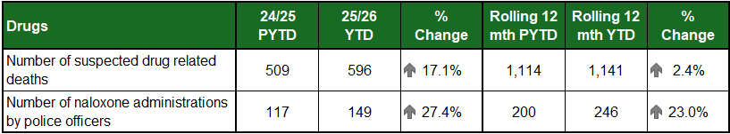

1,141 suspected drug related deaths in last 12 months, 596 in reporting year
The number of recorded suspected drug related deaths (DRD) have increased by 87 (17.1%) compared to the same period last year. The rolling 12 month figure also shows a smaller increase of 27 (2.4%) compared to the preceding period.
Public Health Scotland published their annual report on DRD in September 2025. This report shows a decrease of 155 deaths (13%) in 2024 compared to 2023. The report highlights that 46% (467) of those who died in 2024 were in the 35-49 year old age group, and that opioids continue to be the most common drug type implicated in drug-related deaths at 80%, a similar number to that observed in 2023.
Public Health Scotland produce regular Rapid Action Drug Alerts and Response (RADAR) reports on the current drug-related indicators in order to inform action to prevent drug harms and deaths.
In the latest release (July 2025) they include an alert following an increase in fatal and near fatal overdoses among people using heroin across multiple areas in Scotland. The RADAR report also features trend bulletins for nitazenes, ketamine, and speedballing to demonstrate some of the substances present in Scotland’s drugs market.

Naloxone used in 149 incidents in reporting year
All Police Scotland frontline officers, up to the rank of inspector, continue to carry naloxone as part of their regular equipment.
Compared to the previous year, reporting by division has shown an increase of 32 incidents where naloxone was administered by officers and staff.

Missing Persons Demand

6,907 missing persons investigations YTD
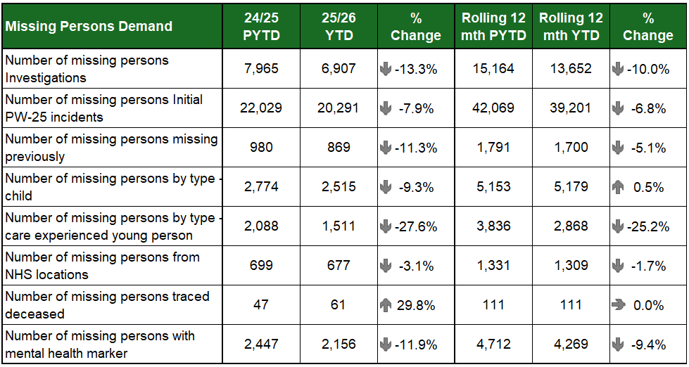
The number of missing person investigations in Quarter 2 has decreased by 807 (down 19.7%) compared to the same period last year. Decreases were also noted from the YTD (down 13.3%) and the rolling 12 month-YTD (down 10.0%).
The number of missing persons missing previously and the number of investigations with a mental health (MH) marker have all decreased compared to the same period last year and from the rolling 12 month period.
The number of missing persons traced deceased has increased by 14 from the PYTD (up 29.8%), however, when measured against rolling 12 month figures, 2023/24 data, and the 5-year average, there is no notable increase in this time frame. The National Missing Persons Unit will continue to monitor this area for any trends or notable causation factors that may be contributing to this increase.

Decrease in Care Experienced Children going missing
The notable decreases can be found when considering what ‘type’ of person goes missing. Care Experienced Young Person (572 less, down 27.5%) have recorded significant decreases compared to the same period last year. Investigations involving children and care experienced young people in Quarter 2 have decreased by 11.0% (235 less) from Quarter 1 and have decreased significantly by 24.2% (607 less) from Quarter 2 2023/24. Quarter 2 of this year has recorded the lowest figures for the last three years to date for children and care experienced young people.
The reduction in care experienced children being reported missing is significant and requires further exploration to understand this trend. However key areas of support in respect of care experienced children are effective in ensuring support for this demographic.
The “Not at Home” protocol allows for a tolerable risk to be carried by staff around some children not being home at a particular time but is only ever measured against the child’s particular circumstances and when not appropriate will not be used.
The Philomena protocol is another inclusive process where carers use a process to collate all relevant information in relation to a child’s vulnerabilities and other key information that ensures an investigation is properly informed from an early stage. Alongside more established strategies such as conducting effective return discussion, delivered by the right person at the right time, these approaches are aimed at reducing the occurrences of repeat missing episodes thus reducing risk of further harm.
Our divisional co-ordinators are working hard to ensure reporting protocols are consistent and appropriate prior to police involvement.

The National Missing Persons Framework for Scotland
The elements of support provided by the National Missing Persons Framework for Scotland (The Framework) which has been in place now for eight years; it delivers focus for missing and helps to ensure the implementation of best practice and information sharing between policing divisions and our partners.
The Framework’s refreshed publication was launched in September 2025 and Police Scotland will now work with national and local partners to continue to promote the implementation of the key strands of support the Framework provides. A Police Scotland launch event is planned for December 2025 where the updated Framework will be showcased at the Scottish Police College for our Divisional Commanders to consider how best to implement the Framework in their areas of responsibility.

Mental Health

122,735 Mental Health-related Incidents YTD

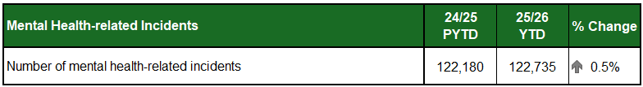
The number of mental health-related incidents recorded across Police Scotland during Quarter 2 has increased by 121 (up 0.2%) compared to the same recording period last year. Increases have also been noted for YTD (555 more, up 0.5%).
During Quarter 2, mental health-related incidents represented 18.2% of all incidents reported to Police Scotland which is an increase on last year for the same reporting period which recorded 17.3% of all incidents were mental health-related.
Mental Health Taskforce
The police are regularly the first point of contact for people in mental health distress or crisis, and we have a crucial role in working with and supporting those who seek assistance.
Many of these contacts have a policing purpose such as an allegation of criminality or increased levels of risk, however, there are occasions where Police are not best placed to meet those needs.
The Police & Fire Reform (Scotland) Act 2012 sets out the general duties expected of a police constable such as the prevention and detection of crime, maintain order in our communities as well as our primary objective of protecting the safety and wellbeing of people, places and communities.
The duty to protect life is reinforced by Article 2 of the European Convention of Human Rights (ECHR).
The Police Scotland Mental Health Taskforce was created to reset the parameters of our contribution to a system-wide approach to mental health, working closely with partners to ensure people get the right support at the earliest opportunity whilst also enabling officers to focus more on core policing duties.

Mental Health Dashboard
Mental health-related incidents are recorded on the mental health dashboard. The mental health dashboard methodology counts incidents where specific mental health associated keywords or phrases are recorded within the comment text of the incident.
The definition of mental health-related incidents within this dataset is therefore broad and does not imply the strength, or the extent of a mental health association. It captures multiple incident types and can include domestic incidents, missing person incidents, neighbour disputes and disturbances, amongst others, where mental health is an element within that incident.

Mental Health Pathway
The Mental Health Pathway (MHP) is a Scottish Government funded collaboration between Police Scotland, the Scottish Ambulance Service and NHS24 whereby callers presenting to C3 Division who are experiencing mental health crisis or distress can be referred to the NHS 24 Mental Health Hub, following a robust assessment to ensure any risk is identified and appropriately managed.
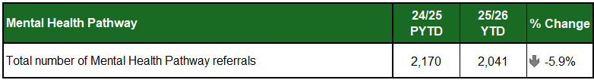
The YTD figures for the total number of referrals made this year have shown a reduction of 129 (down 5.9%).

Road Safety

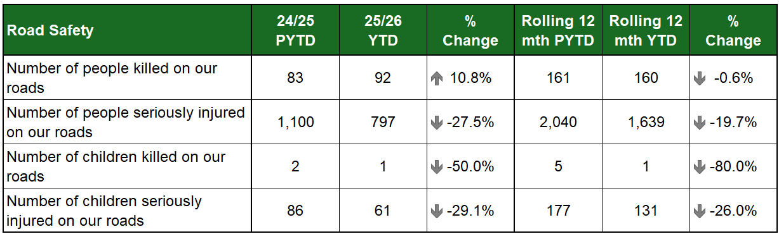
*Current YTD fatality statistics will be subject to revision / reduction once final cause of death is confirmed.

Road Safety Campaigns continue to focus on safety of vulnerable road users
There has been an increase of nine people killed on Scotland’s roads in the current period compared to the previous year. The rolling 12 month period however shows a decrease of one in comparison to the 12 months before.
Serious injury collisions have significantly reduced, both for adults and particularly within the separate child serious injury statistics. While the table shows an increase in current period fatalities in contrast to the rolling 12 month period, a number of the current period fatalities are suspected medical deaths / deaths caused by another factor. These are subject to confirmation through the ongoing governance processes.
This process has resulted in fatalities having been removed from prior year figures. It is anticipated that a number of the fatalities included for the current period will similarly be removed in due course, and that figures for the current period will be lower than those for the same period last year.
There has been an increase in the number of pedal cyclists killed, with six fatalities this year compared to one last year, and a five-year average of four. Police Scotland analysts are currently in the process of drafting a report on pedal cyclist deaths across the country which will feature in depth focus on the factors around the fatalities and recommendations. This paper will be made available to partner agencies when completed.
Police Scotland continues to work on specific campaigns and initiatives directed towards targeting the safety of all vulnerable road users, including pedal cyclists, motorcyclists and pedestrians.
Road Policing officers in partnership with Community Officers continue to work on the Operation Close Pass initiative, a long running campaign which sees officers deployed to monitor driver behaviour in the vicinity of cyclists, particularly when carrying out passing manoeuvres.
Drivers passing too closely, or otherwise placing the cyclist at risk, are provided with guidance during a ‘chat on the mat’ but may also be issued with a fixed penalty or reported to the Procurator Fiscal, depending on the circumstances.
The following table provides the target casualty reductions within the Road Safety Framework to 2030 (RSF2030) and the reductions achieved in previous years against the 2014-18 adjusted statistical baseline.
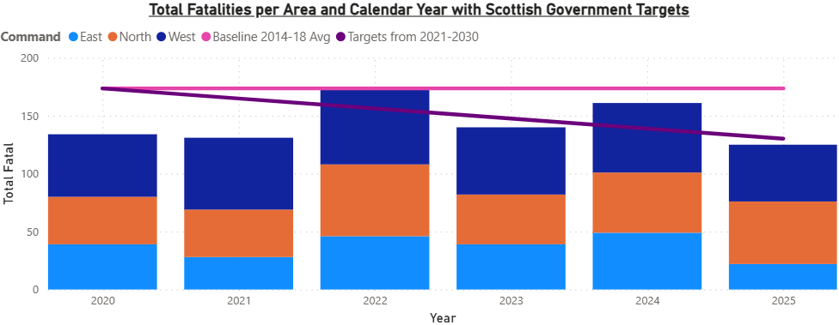
Scottish Government statistics published in June 2025 showed an increase of 13 in fatality numbers – 160 in 2024 compared to 147 in 2023, a 9% rise. Currently in 2025 we are not on track to meet the RSF2030 targets on reducing fatalities on Scotland’s roads.
In response to the rise in road fatalities Police Scotland continues to work in partnership with Transport Scotland. A dedicated road policing analyst has been working to further progress the in-depth Road Fatalities Study, which was first published in 2023, producing additional reports to supplement findings and generate recommendations. The analyst completed and shared a pedestrian fatality study in September 2025 which has been shared with partners.
Most of our upcoming campaigns which will run next quarter are focused on protecting vulnerable road users as well, such as the National Police Chiefs’ Council led Operation Dark Night (running from 27 October to 09 November, which focuses on pedestrian safety and driver eyesight) and our Festive Drink Drug Drive campaign which commences 01 December 2025.

Reduction in the number of children killed or seriously injured on Scotland’s roads
There has been one child killed on our roads this year compared to two in the previous year. In the rolling 12 month period there has been a reduction of four children killed compared to the preceding year. In terms of serious injuries there has been a large reduction of 25 (29.1%) in the current year compared to the previous year.

Criminal Justice

Volume of cases submitted into Criminal Justice System increases by 25%
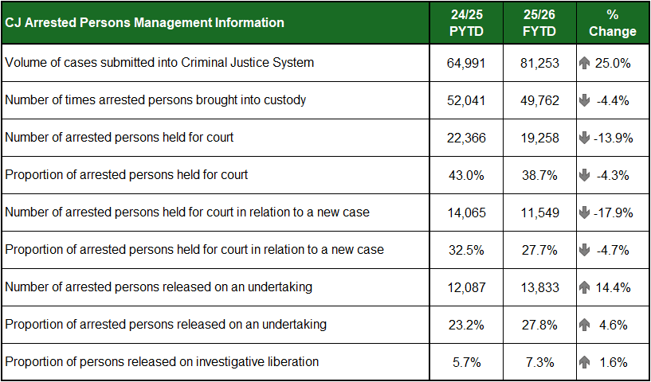
In April 2025, in response to an increase in the national backlog of Standard Prosecution Reports (SPR’s) awaiting quality assurance, a change of business process was implemented in two of the north divisions whereby first line managers and not Case Management were allocated the quality assurance role of checking Standard Prosecution Reports (SPR's).
In advance of this change, there has been a focus on reducing a backlog of SPRs with resources deployed to reduce this. The consequence is an increased number of SPRs to the Crown Office and Procurator Fiscal Service (COPFS) over the reporting period and this accounts for the significant increase in cases submitted into the Criminal Justice System.
This was anticipated to continue into this quarter of the year, until all divisions are directly reporting and a consistent volume of submissions is achieved.
The reduction in persons arrested brought into custody is assessed as a combination of contributing factors including the introduction of the Planned Voluntary Interview Pathway (PVIP) which has been in operation since November 2024. There has also been greater use of Police Direct Measures which have risen significantly over the first two quarters of the year.
Reductions in persons held for court and in relation to new cases are likely due to an enhanced audit and compliance regime which has been implemented. CJSD also achieved targeted disposal inputs for custody sergeants with the assistance of the Crown Office. This supports a reduction of almost 5% in the percentage to court compared with the past three years.

Fewer children being brought into and kept in custody
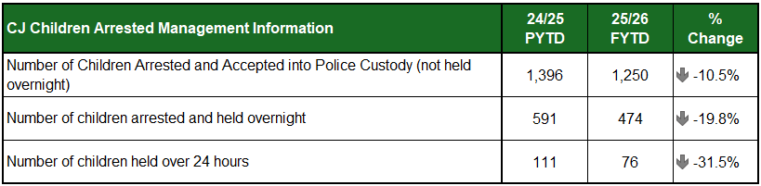
The number of children being brought into and kept in custody continues to decline across all measures.
This is a welcome and continuing trend which has been reasonably consistent of recent years and previous quarters.

Volume of individuals declaring addiction issues remains broadly static
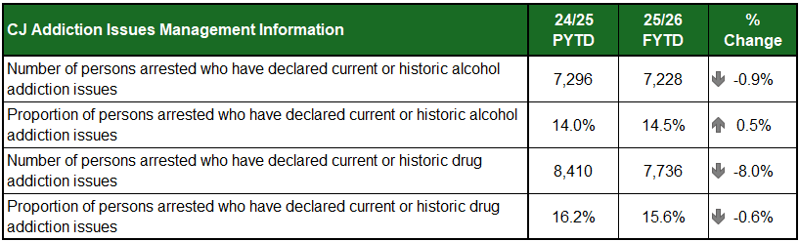
The numbers and proportion of individuals declaring vulnerabilities continues to remain broadly static.
The only significant change is to the numbers declaring current or historic drug addiction issues, however, the small reduction in the corresponding proportion of throughput indicates this is more likely linked to the overall reduction in throughput and this is likely the driver.
Engagement continues with NHS colleagues to improve access to healthcare in police custody and work is ongoing to embed the Arrest Referral Scheme, ensuring that those who need additional support receive it.

Increased usage of Fixed Penalty Notices and Direct Measures
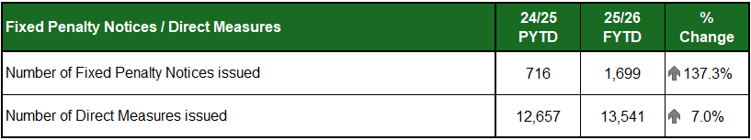
Both metrics have seen an increase in usage following the implementation of the revised Lord Advocates guidelines. These guidelines provide officers more discretion to deal with low level offending at the closest point to the commission of the offence.
Police Scotland are also working with partners in Community Justice Scotland on a street referral and support model to divert those who are issued direct measures from re-offending.

National Production disposal teams lead to reduction in productions
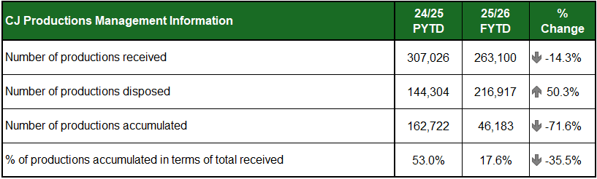
A decrease in productions received from the previous year can be attributed to the national rollout of DESC and the increase in items disposed can be attributed to the introduction of national production disposal teams.

Volume of individuals declaring mental health issues remains broadly static
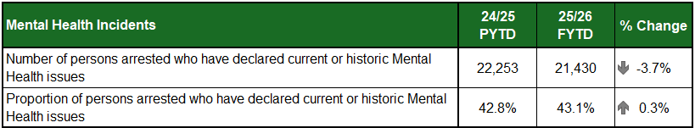
The numbers and proportion of individuals declaring current or historic mental health issues continues to remain broadly static.

26.8% increase in partner referrals
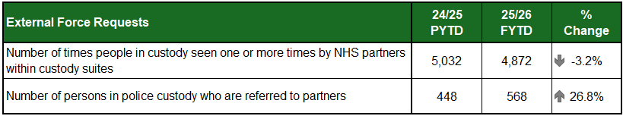
The reduction in the number of times people in custody are seen by Health Care Professionals is likely due to the overall reduction in throughput rather than any significant change to policing practice.
The number of persons referred to partners continues to increase, with the Tayside service continuing to contribute to these figures. Talks with other services remain positive with three new information sharing agreements having been submitted within Quarter 2 looking to build more pathways within West Lothian and also Renfrewshire.
We are also working with Edinburgh, Midlothian and East Lothian councils to consider options for adopting a similar model to that employed in Tayside. Regular meetings are taking place with Community Justice Scotland with a view to building on the recommendations from the National Arrest Referral Partnership Event held in Quarter 1.
KPI: Number of proactive crimes

Group 6 Crimes

Antisocial offences have increased by 10.7%
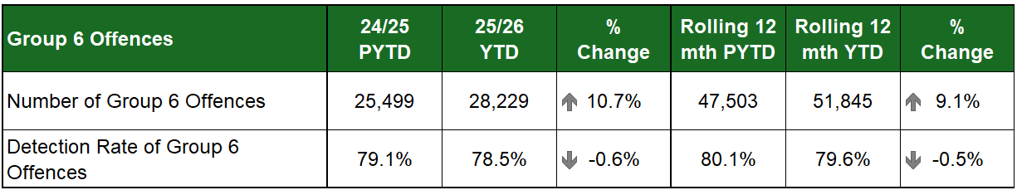
Antisocial offences continue to see an increase this period, albeit that has reduced slightly over the course of the second quarter. The number of offences has decreased slightly compared to the five-year-mean.
Threatening or abusive behaviour continues to account for the vast majority (82.9%) of all Group 6 offences, however most offence types, particularly breach of the peace, urinating in public, drunk & incapable, consuming alcohol in designated places and other alcohol related offences have increased.
While not counted under Group 6, the number of vandalism crimes (17,157) YTD has decreased by 3.0% from last year and 8.8% from the five-year-mean. This is the fewest number of vandalism crimes recorded for this period in recent years.

Antisocial behaviour and disorder down on both periods
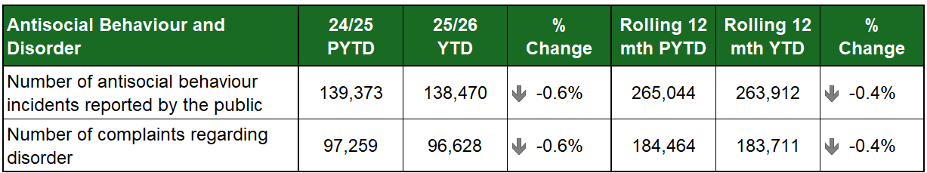
Publicly reported incidents of antisocial behaviour (ASB) and complaints of disorder have decreased slightly compared to the same period last year, although neighbour disputes, public nuisances and communications incidents are on the rise. Neighbour disputes in particular have increased in every police division compared to last year.
During the period, 39.1% of publicly reported ASB incidents were attended by Police Scotland. This has increased slightly (up 0.2% points) from the same period last year.

Stop and Search

Compliance with the Stop and Search Code of Practice at 99.0%

Intelligence-led stop and search is a valuable and effective policing tactic that helps us keep people safe.
Our approach is guided by the core principle that every person has the right to be treated with dignity and respect.
We are committed to transparency and accountability, ensuring that our decisions are objective and intelligence-led grounds.
By ensuring that every search is objective, intelligence led and in line with the Code of Practice, we aim to build public confidence and demonstrate that this tactic is used fairly and proportionately.
During the second quarter of 2025/26, 8,487 stop and search records were audited, bringing the year-to-date figure up to 19,905 records. An audit involves the records being reviewed by line managers and thereafter quality control checked by the National Stop and Search Unit to ensure their adherence to the Stop and Search Code of Practice introduced in May 2017.
445 records have been returned to local management for further details and are still awaiting responses. Suitable guidance and learning is given with each returned record and feedback is regularly provided to divisions in relation to any common issues when these are identified
Of the remaining 19,460 records, 90.3% were deemed compliant with the Code of Practice and another 8.7% were compliant but required amendment to their details to ensure they were appropriately recorded. The total compliance rate for stop and search that have finished the audit process year-to-date was 99.0%.
192 (1.0%) records were deemed as not recordable under the code of practice or recorded in error and deleted from the database. The typical reasons for deletion include where a person is searched after being arrested, as a result of a duplicate record or where no physical search of a person has actually taken place.
It should be noted that the total number of records audited for compliance will be lower than the total number of searches raised during the period due to the timescales required to fully review all records.

Road Traffic Offences

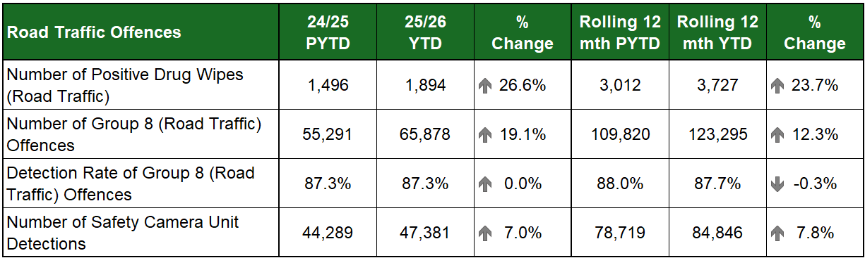

Positive drug wipes results continue to rise
Positive drug wipes have increased by 398 (26.6%) in the current period compared to the previous year. This increase is similarly reflected in the rolling 12 month figures, with 715 more than the preceding year.
Please note that not all positive drug wipes equate to a positive lab result or crime having occurred. A positive drug wipe provides an initial indication and grounds for a blood specimen being granted at a police station, which could prove negative at the lab.
The increase in the number of positive drug wipes has been due to more drug wipe testing kits being utilised as well as proactive work through our regular campaign work on Scotland’s roads alongside partners.
Proactive/Preventative Policing – Operation Spotlight
Operation Spotlight is a National Police Chiefs’ Council (NPCC) led UK-wide initiative which ran between 01 to 31 July. This campaign also incorporated our Summer Drink Drug Drive campaign and intended to educate and protect drivers against the risk taking deriving behaviours of drink and drug driving, speeding, using a handheld mobile phone, careless driving and not wearing a seatbelt. Each of these behaviours increase the likelihood of a collision and often its severity/survivability. This was the first occasion Police Scotland has participated throughout the entire duration of this NPCC initiative.
Operation Spotlight saw Scottish officers detecting a total of 3,609 Fatal 5 offences, with Safety Camera Unit colleagues detecting an additional 8,864 speeding offences. The Summer Drink and Drug driving campaign, running over the first fortnight of Operation Spotlight, provided a strong focus on two Fatal 5 behaviours, with 421 drink and drug driving offences recorded compared to 357 in the previous year’s campaign, an increase of 64.

Group 8 offences increase by 19.1% on PYTD
Group 8 offences have seen an increase of 10,587 (19.1%) compared to the same period last year. Rolling 12 month figures show an increase of 13,475 (12.3%) compared to the same period in the year before.
Large increases have been noted for vehicle defect offences (1,978 more, 52.5%), speeding offences (1,981 more, 30.9%) and careless/dangerous driving offences (1,322 more, 20.5%). Nearly all Group 8 offences have recorded increases in the current YTD compared to last year. This increase can be partly attributed to greater proactivity in policing divisions and extending the period over which Police Scotland’s road safety campaigns have been conducted.

Vision 2030: Less Crime
We work with partner organisations to prevent harm and reduce demand
KPI: Number of crimes/detection rate (by crime group i.e. Non-sexual crimes of violence, Acquisitive crime, Crimes against Society etc.)

Detection Rates
The crime tables in this section include the detection rate and the percentage changes from previous year to date and in the rolling 12 month period.
Processes around detection rates are multi-faceted and complex. They can be split into three broad headings: Demand; Organisational and Audit. The following could be considered some of the influencing factors both in terms of time to detect, and capability to detect: increases in historical crimes; training; cyber-related crime; resourcing challenges; and evidential demand increase.

Group 1-5 Crimes

4.2% increase in Overall Violent Crime
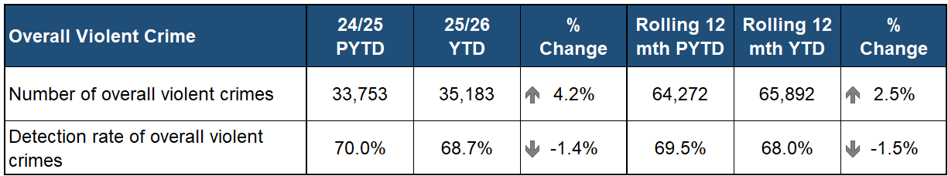
Overall violent crime has increased, predominantly driven by higher numbers of common assaults being recorded, which account for 92.5% of all violent crime. Attempted murders have also increased. Homicides have increased compared to the same period last year but are below five-year-mean and last year’s rolling 12 month figure.
There has been a decrease in the detection rate for violent crime, which sits at 68.7% for the year-to-date period with a decrease in detection rates in all violent crime types. That being said, the overall number of violent crimes detected (24,148) was the highest number for this period in recent years and has increased by 2.2% from last year, however the larger increase in crimes being recorded has resulted in the overall detection rate falling.

Three more homicides YTD compared to last year
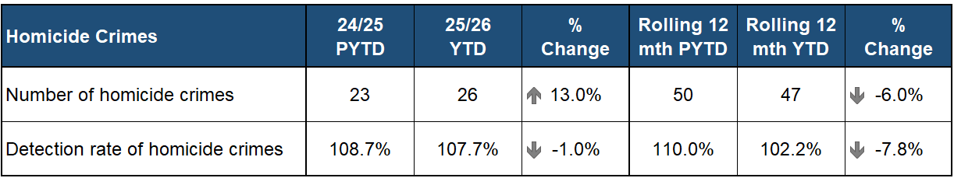
Seventeen murders were recorded during the second quarter of 2025/26, bringing the year-to-date homicide total up to 26. This now represents an increase from last year after having seen a reduction during the first quarter.
The second quarter saw four domestic homicides recorded, whereas Quarter 2 in 2024/25 had none. On average, nine domestic homicides occur each year in Scotland, and although this rate has been declining; it is likely set to rise in 2025/26. There was one child (under 18 years of age) homicide recorded during the period.
No serious organised crime related homicides have been recorded since 2023.
Seven homicides during the second quarter of 2025/26 were assessed as being alcohol related (five in the same period last year) and one homicide was identified as mental health related (two recorded in Quarter 2 of 2024/25).
Homicides in Scotland continue to occur predominantly indoors within private urban residential dwellings, and most, as continued to be the case during the most recent quarter, involved the use of a knife or sharp implement.
The detection rate for homicides is currently above 100% - this is due to crimes that were recorded in the previous reporting year being marked as detected during the current year. This also occurred last year. All homicides recorded during the quarter have been detected.

28.4% increase in attempted murders
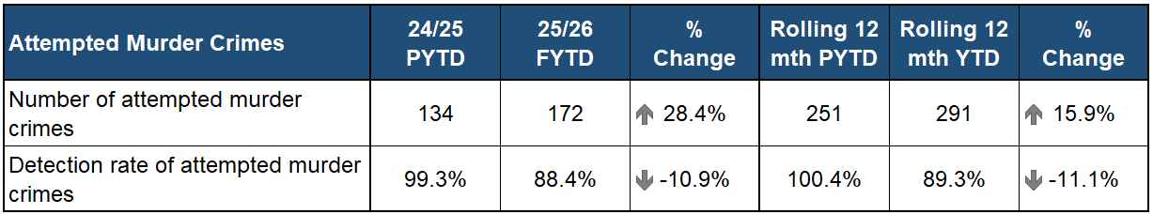
There have been 172 attempted murders recorded during the period. As was the case during the first quarter, this is the highest number of such crimes in recent years. July 2025 saw 36 attempted murders recorded, which is the highest number in any single month in recent years.
As was reported on in Quarter One’s report, the use of vehicles in attempted murders remains high.
While Lanarkshire Division continues to see the highest number of attempted murders recorded (30), it no longer constitutes such a large proportion of the total number of crimes as it did during Quarter 1 (17.4%, previously 22.9%) with crimes distributed across Scotland. Tayside has seen 20 attempted murders recorded which is eight more than last year and 11 more than its five-year-mean rate.
In Dumfries & Galloway there have been six attempted murders recorded which is higher than usual for that division. Four of these involved the use of a vehicle, of which one was against an on-duty police officer.

12.4% decrease in serious assaults
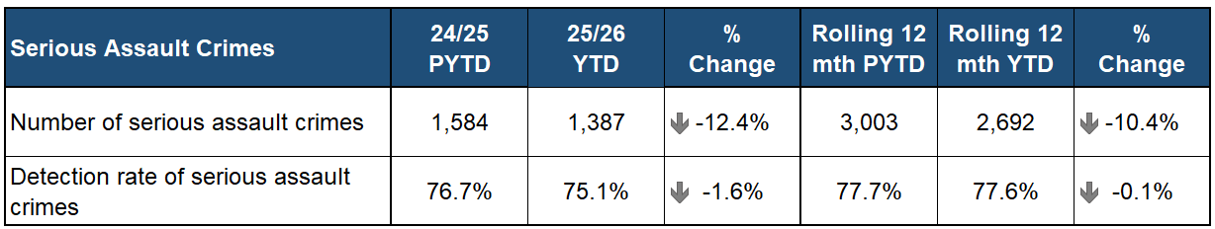
Serious assaults continue to be at their lowest level in recent years, with 1,387 crimes recorded YTD (a decrease of 12.4% from last year) and 2,692 recorded in the rolling 12 month period (a decrease of 10.4% from the previous rolling 12 months).
This reduction has reduced since the Quarter 1 period, however, when crime numbers were down more substantially, although September 2025 saw the fewest number of serious assaults recorded in any given month (198 crimes) in recent years.
While the detection rate for serious assaults has also fallen over the course of the second quarter, the rolling 12 month average detection rate remains consistent.

2.8% decrease in robberies
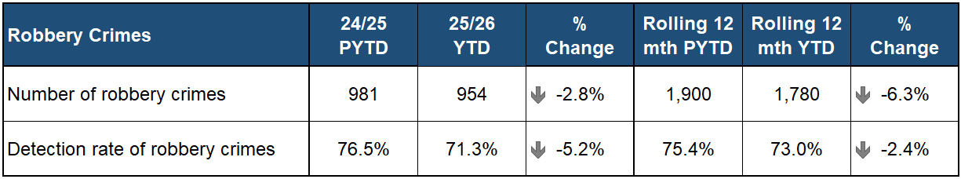
Robberies had been showing a slight increase during the first quarter and are now below last year’s level and the rolling 12 month level.
Some divisions have noted an increase in opportunistic robberies, robberies targeting employees at commercial locations and domestic robberies.

5.2% increase in common assault
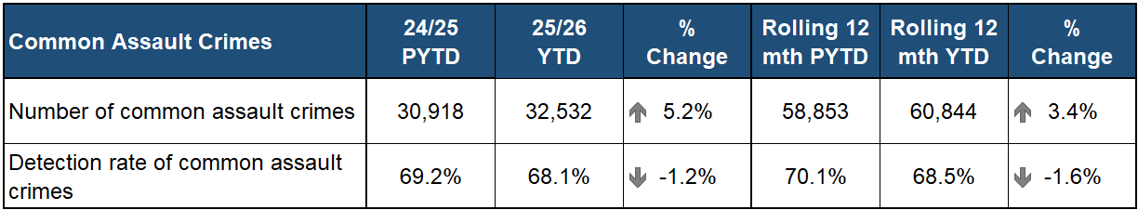
Common assaults continue to increase across most police divisions, with Ayrshire and Dumfries & Galloway the only areas to see lower than usual levels. Across Scotland there has been a 9.6% increase in domestic-related common assaults compared to the same period last year.
Common assaults of retail workers increased by 7.1% compared to PYTD and accounted for 5.0% of all common assaults. 16.0% of common assaults against retail workers resulted in an injury.
Forth Valley Division has seen the highest increase in common assaults compared to PYTD, up 25.6%. Analysis conducted prior to the end of the period indicated over half of victims were female and almost a third of these crimes were domestic in nature. The majority occurred in private spaces.
Fife has seen a 16.0% increase in common assaults compared to the same period last year, with domestic common assaults, residential (non-domestic) and public space (non-domestic) assaults increasing. Also rising was the number retail worker assaults recorded, particularly when retail workers attempted to challenge shoplifters.
North East Division has seen a 14.3% increase in common assaults this year, with this increase at least partially linked to an upward-trend in domestic-related assaults which account for approximately one-third of common assaults YTD. Governance structures for these crimes have been reviewed by the division and are deemed robust however plans for additional resources to address this issue are underway.

Possession of offensive weapons up 6.5%
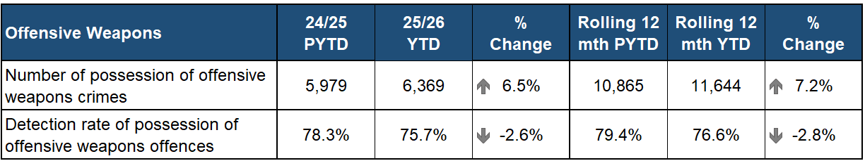
Weapons offences, particularly crimes involving the use of a weapon in another crime, continue to increase. Police Divisions in the West such as Ayrshire, Argyll and West Dunbartonshire and Lanarkshire have seen substantial increases in the number of weapons used in other crimes compared to the same period last year. In the East, The Lothians and Scottish Borders, Forth Valley and Edinburgh Divisions are seeing substantial long-term increases.
There were also 10 crimes relating to corrosive substances recorded during the second quarter, bringing the year-to-date figure up to 16. This is twice the number as the previous year saw. Twelve of these crimes related solely to possession of the substance and the other four involved it being used in another crime.
Proactive/Preventative Policing – Violence Prevention
As part of our wider violence prevention initiative, the Violence Prevention Licensing and Coordination Unit (VPLCU) have crafted a National Toolkit to guide local policing divisions on incidents involving weapons in schools.
The VPLCU have engaged with partners in education, and an Advisory Group has been established to form a collective and collaborative approach, focusing on safeguarding children and wider education community as well as prevention and intervention activities.
Examples include campaigns like ‘Quit Fighting for Likes, the Street Guardian project in Glasgow and school engagement programmes supported by the SVRU.
These initiatives work with education, health and social work partners to address online harm, promote pro-social behaviours and provide safe spaces.

KPI: Number/proportion of children accused of violent crimes

Overall decrease in children accused of violence, however an increase in the most serious violent crimes remains
Overall violent crimes where a child (under the age of 18) has been accused continues to show a decrease this year compared to last. For the April to September 2025 period, 3,897 violent crimes have been detected that involved at least one person under 18 being accused. This was a 10.3% reduction in such crimes compared to the same period last year.
Some of these crimes involved multiple accused and, in total, 4,601 children were accused of violent crimes that were recorded over the first two quarters of 2025/26. This was a reduction of 14.3% versus PYTD.
The vast majority (93.5%) of violent crimes where a child has been accused so far this year were common assaults. There was also 109 serious assaults for which 131 under 18s were accused (47.4% fewer children than PYTD) and 120 robberies for which 213 under 18s were accused (a decrease of 12.7% children compared to PYTD).
As was reported in the Quarter 1 report, however, under 18s being accused of attempted murders continues to be higher than usual. Year-to-date there have been 18 attempted murders involving 21 under 18s, compared to 8 crimes and 13 under 18s in the same period last year.
Most (16) of this year’s crimes were recorded during the first quarter, with two more crimes involving one child being accused for each being recorded in the Edinburgh and Greater Glasgow divisions during the second quarter.
One homicide was recorded that has had a child accused for it during the second quarter. This was in Edinburgh Division. As a result, the YTD number of homicides for 2025/26 is now three (the same as for this period last year) however the total number of children accused of homicide this year is five compared to three last year.
Policing Together have developed the National Violence Prevention Strategy for Police Scotland. It has now been agreed the strategy for 2025/26 will focus on four key themes:
Violence and ASB at Transport Hubs
Violence at Educational and Care Settings
Carriage of Weapons
Preventative Pathways and Interventions
Whilst there is a National Violence, Disorder and Antisocial Behaviour Gold Group, which provides leadership and direction designed to maintain and develop national workstreams, it is recognised that although we have a relatively low youth serious violence crime rate, the impact and wide-reaching consequence of it is significant.
Due to national crime and age trends identified, and to help drive thematic activity for both the National Violence Prevention Strategy and the National Violence, Disorder and Antisocial Behaviour Gold Group, the Operation STARDROP group have been tasked with addressing and coordinating work in relation to Youths Affected by Violence.
This group is aligned to the 2030 Vision of Safer Communities, Less Crime, and Supported Victims. Police Scotland are working with Academics, Partners and Campaigners to understand the issues, develop national prevention approaches, inform legislation and government policy.
Proactive/Preventative Policing –Engagement with Children and Young People
Police Scotland’s Children and Young People (CYP) team lead the delivery of Police Scotland’s priorities and commitments to over one million children and young people in Scotland. The CYP Team consult with internal and external stakeholders to influence and direct Police Scotland’s strategies, policies and standard operating procedures in relation to all aspects of policing that affect the lives of children and young people.
At the heart of what the team do are the principles of Getting It Right for Every Child (GIRFEC), children’s rights and our responsibilities as a corporate parent. The team work closely with partners on a local and national level to assist delivery of guidance to local Policing and specialist departments, to support officers engaging with children and young people or responding to incidents.
The CYP team develop and collate suitable resources deliverable to children and young people, including:
Anti-Social Behaviour Resource - developed by Police Scotland in partnership with I Am Me Scotland aimed at P7 age, hosted on the I Am Me learning platform.
No Knives Better Lives (NKBL) resources are promoted widely to School Engagement Officers and staff to deliver within the schools, providing violence prevention, knife crime and positive masculinity messaging as well as continuous professional development modules for professionals.
Medics against Violence (MAVS) is another partner promoted to School Engagement Officers, delivering projects within the school setting.
Mentors in Violence Prevention is a peer mentoring and leadership programme for secondary school settings.
Quit Fighting for Likes is a joint partnership with Scottish Violence Reduction Unit, No Knives Better Lives and Medics Against Violence to deter young people from anti-social behaviour and knife carrying. Working alongside young people and partners, a suite of packages has been developed to support young people in navigating social media safely and prevent violence.
Police Scotland works alongside Fearless to promote safety messages to children and young people throughout Scotland. Fearless provides children and young people aged 11 – 18 years with key information about crime and give them a safe place to speak up with information 100% anonymously online or by phone.
Secure Children’s House Collaboration: Police and SPA Forensics run a four-day course within secure care settings, building relationships and promoting understanding of forensic work. Programmes have been delivered at Rossie Trust, Kibble, St Mary’s and Good Shepherd with annual roll out to broaden the reach to other Children’s Houses.
Let’s Talk Workshops: In 2024, children and young people with care experience or from minority backgrounds participated in a series of workshops. These included stop and search to share insights with Police Scotland to provide more sensitive practices. The launch took place in Summer 2025 at the SVRU School Engagement Officer Event and is subsequently being delivered across the country.
Pitchin’ In: A programme created following a youth football disorder incident which promotes positive citizenship, decision-making, and reduces offending through partnerships with football organisations and schools.
Police Scotland Youth Volunteers (PSYV): Open to 13–15-year-olds, PSYV offers training, certification, and volunteering opportunities, fostering leadership and community safety.
I Am Me Scotland and Police Scotland’s development of the ‘You are not alone’ Resource focuses on raising awareness of child exploitation. This comprises of 3 resources, all relating to child exploitation, including gangs and violence:
S1-S3 Child Exploitation Resource - for Pupils
Child Exploitation Awareness Practitioners Toolkit - For Adults
Polmont Resource - Developed with children from secure children’s houses and young people currently residing within Polmont YOI.
Police Scotland understands that while engagement is vital, police powers must sometimes be used—but always proportionately and with a trauma-informed approach. Recognising the lasting effects of certain interactions, officers are trained to minimise harm and support recovery. In support of this, Police Scotland hosted a workshop in August 2025, bringing together professionals and researchers to improve services for children and young people affected by violence.
The Scottish Violence Reduction Unit (SVRU) is involved in a wide range of projects that work with young people to deter them from antisocial behaviour and violence, including:
Supporting Opportunities for Life (SOL): This is a new service delivered by Police Scotland alongside the charity Aid & Abet, working together to support young people in West Lothian aged 10-25 in making meaningful, positive changes in their lives. This will work with those young people who have been identified as benefitting most from receiving this support.
Glasgow Guardians: In partnership with Common Ground (Barnardos, Action for Children, Aberlour and Right There) the SVRU has been coordinating local organisations including G20, YMCA, Glasgow Girls Club and the Street Pastors to provide safe adults to support young people and reduce vulnerability through a contextual safeguarding model in the ‘four corners’ area of Glasgow.
The Way We See It: This is a national project led by Police Scotland’s Youth Engagement team in collaboration with the SVRU. The project seeks to enhance understanding of the impact on young people of the media narrative that there have been significant increases in violence amongst young people across Scotland.

KPI: Number of crimes/detection rate (by crime group i.e. Non-sexual crimes of violence, Acquisitive crime, Crimes against Society etc.) (continued)

Group 1 Non-sexual Crimes of Violence

Non-sexual crimes of violence up 5.0%
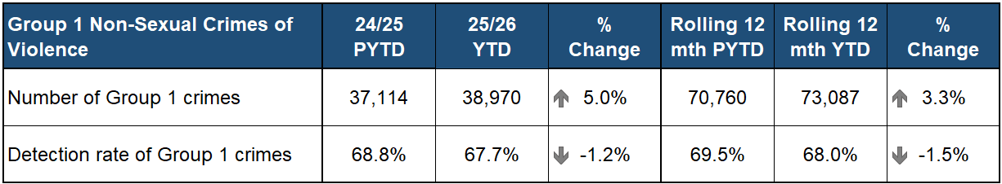
Common assaults continue to make up the vast majority of Group 1 crimes and account for 83.5% of this group’s recorded crime over the last 12 months.
The increase in total Group 1 is predominantly due to the increased numbers of common assaults, however there also continues to be an increase in Domestic Abuse Scotland Act crimes for both females and males.
Threats & extortion crimes (935) have increased by 6.4% from last year and 12.5% from the five-year-mean. Drugging crimes (72) have also increased. There were 73 crimes of slavery or force labour which is the highest number in recent years.
The number of cruel & unnatural treatment of children crimes (383) has reduced by 6.8% from the same period last year, however, remains 21.3% above the five-year-mean.

Group 2 Sexual Crimes

Sexual crime is up 10.5%
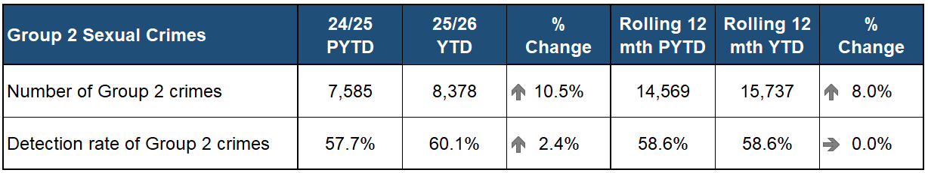
Group 2 crimes continue to note high levels of reporting, up 10.5% on last year and 8.0% on the rolling 12 months.
The detection rate has also increased in the year to date, however the rolling 12 month remains consistent.
The increase in Group 2 sexual crime continues to be driven by rape of a female over 16, communicating indecently, and taking, distribution, possession etc. of indecent photos of children (from Apr 2011).

Rape crimes increase 8.1%
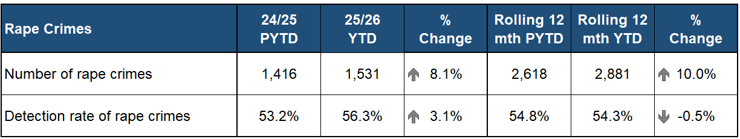
Rape continues on an upward trajectory, up 8.1% on the previous year, and notes an increase in the rolling 12 month figures.
Overall rape is driven by the increase in females over 16 years, up by 11.0% (107 crimes) compared to the previous year. Rape of a female under 13 years has increased by 17.5% (10 crimes) and rape of a female 13-15 years has increased by 11.8% (17 crimes).
Non-recent rapes account for 41.1% of all rapes reported, this is a slight increase of 1.3 percentage points when compared to the previous year.
The detection rate for rape has increased by 3.1 percentage points compared to the same period last year.

Sexual assault crimes

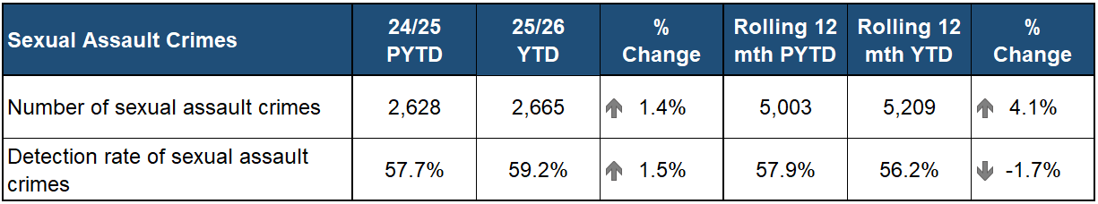
Overall, sexual assault crimes have increased against both last year (up 1.4%) and the 12 month rolling period (up 4.1%).
The increase in sexual assault crimes is driven by crimes committed against a female over the age of 16 which has increased by 4.1% (41 crimes) compared to the same period last year.

Online child sexual abuse
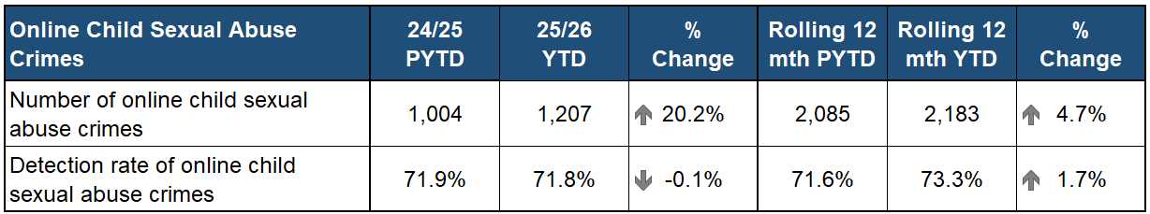
Online Child Sexual Abuse crimes have increased by 20.2% compared to the previous year and by 4.7% compared to the previous rolling 12 month period.
Taking, distribution, possession etc. of indecent photos of children (from Apr 2011) is the main driver for the increase in online child sexual abuse crimes, up 31.2% (110 crimes) compared to the previous year.
Communicating Indecently/cause see/hear indecent communications for male and female both 13-15 years and under 13 years has also noted increases against the previous year of 26.5% and 25.2% respectively.

Domestic abuse crimes increase by 10.0%
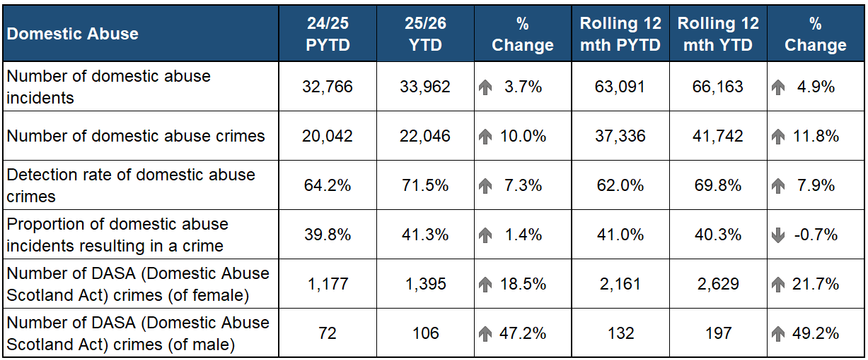
During the reporting period, domestic abuse incidents and crimes have both increased against the previous year and the rolling 12 months. The number of domestic abuse incidents has increased by 3.7% (1,196 incidents) and domestic abuse crimes has increased by 10.0% (2,004 crimes) when compared to the previous year.
The detection rate for domestic abuse crimes has increased by 7.3 percentage points compared to the previous year and by 7.9 percentage points compared to the rolling 12 month period.
The proportion of domestic abuse incidents resulting in a crime has increased in comparison to the previous year by 3.7 percentage points.
Domestic Abuse (Scotland) Act 2018 (DASA) crimes have increased 20.2% overall with DASA of a female being the main driver for the rise (up 18.5%, 218 crimes). DASA crimes over the rolling 12 month period has also increased, up by 23.2% overall.
Disclosure Scheme Domestic Abuse Scotland (DSDAS) applications have increased by 14.4% compared to the previous year. Both Power to Tell and Right to Ask application types have increased, with Right to Ask increasing by 30.2% over the period.
This increase in DSDAS applications highlights our continued use and greater awareness of the scheme aiding our ability to enhance prevention of domestic abuse in Scotland.

Violence against women and girls
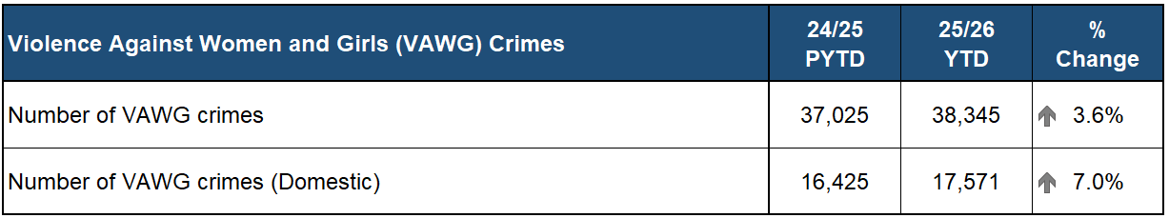
During Quarter 1 and 2 of 2025/26, crimes of violence against women and girls (VAWG) has increased 3.6% compared to the previous year. The number of VAWG crimes with a domestic element has increased by 7.0% compared to the previous year.
Of all crimes committed against a female victim, 61.6% were violent in nature, a slight increase compared to the previous year. This equates to an average of 210 crimes of violence being committed against a woman or girl in Scotland each day.
Common assault, threatening or abusive behaviour, and sexual assault are the most common crime types committed.

Group 3 Crimes of Dishonesty

59,572 Crimes of Dishonesty YTD (up 4.3%)
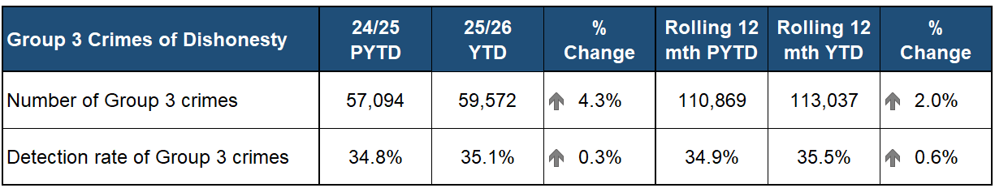
Crimes of Dishonesty have increased 4.3% compared to the same period last year, primarily driven by the rise in Shoplifting offences.
When Shoplifting is excluded, the remaining Crimes of Dishonesty show a 3.7% decrease.
Shoplifting, Fraud, and Common Theft crimes make up the largest proportion of Crimes of Dishonesty, collectively accounting for 78.2% of all Group 3 crimes YTD.

Fraud Crime up 3.4% on PYTD
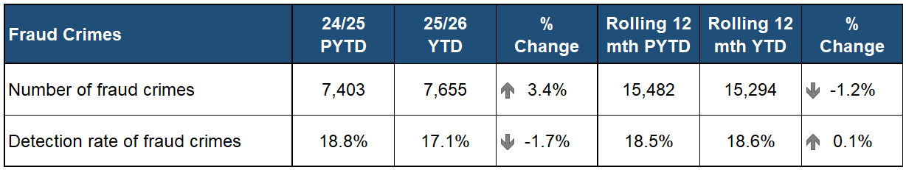
During the Quarter 2 period, Fraud crimes increased 3.4% compared to the same period last year. Despite this rise, levels stabilised overall and remain 6.9% lower than the peak of 8,226 crimes recorded in 2022/23.

The Banking Protocol prevented over £600,000 of fraud in Quarter 2
The Banking Protocol is a multi-agency initiative between law enforcement, banking institutions and Trading Standards. Its aim is to identify vulnerable victims at the earliest opportunity, who are in the process of being defrauded of funds from their bank accounts by unscrupulous criminals and to intervene to prevent these crimes.
If staff suspect customers are being coerced or the transaction is a result of fraud, the transaction is stopped, and Police are contacted.
In terms of Quarter 2 of the reporting year 2025/26, the Banking Protocol recorded 296 incidents accounting for £615,759 of fraud being prevented.
This initiative continues to succeed in protecting the vulnerable victims of fraud and its success demonstrates the value of the public / private partnership model.
Since April 2025, there have been 597 incidents accounting for £1,244,232 of fraud prevented.
A recent example during September, an individual attended the branch to transfer £2,800 having just taken out a loan. The customer wished to transfer to a third party however a Fraud was identified, and the transfer was prevented. A crime report and IVPD was raised.

Shoplifting crimes continue to rise (up 16.5% on PYTD)
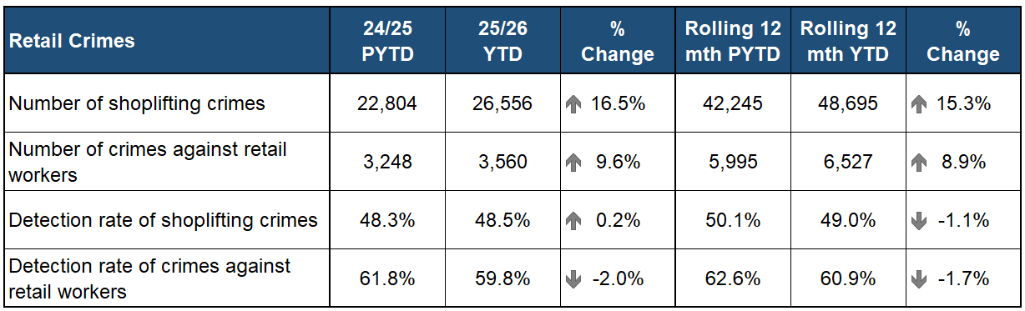
Shoplifting has continued to increase over recent years, remaining at an all-time high and now accounting for 44.6% of all Crimes of Dishonesty.
Common Assault of a Retail Worker has increased 8.5% (128 crimes) compared to the same period last year and Serious Assault of a Retail Worker has increased 150% from four crimes to ten crimes.
Threatening or Abusive Behaviour of a Retail Worker continue to make up the majority of these crimes with 1,913 crimes in Quarter 2, a 10.3% increase on last year.
The detection rate for Crimes Against Retail Workers has decreased to 59.8% despite a 5.0% increase in detections.
Proactive/Preventative Policing – Retail Crime Taskforce (RCTF)
Police Scotland has established a dedicated unit to tackle retail crime across the country. The Retail Crime Taskforce is now fully embedded and progressing key workstreams aligned to the 4Ps (Prevent, Pursue, Protect, Prepare) approach and bespoke workplan.
Over 500 shopliftings and Protection of Retail Workers Act offences have been detected as a result of Retail Crime Taskforce supported activity in the last six months.
In total 352 shopliftings across the country have been detected, as part of this work along with 157 retail worker offences, including assaults. Sixty-five arrests have been made as a result of Taskforce supported activity.
On 26 August 2025 the City Centre Community Policing Team worked with Retailers Against Crime (RAC) to deliver a Day of Action. This resulted in:
7 arrests, 4 of which were for shoplifting
12 stop searches conducted
Numerous intelligence logs submitted
15 proactive visits to retail premises
3 crime reports raised for Protection of Workers offences
1 crime report raised for another matter
1 warning issued for noise
2 missing persons traced and returned home

Group 4 Damage and Reckless Behaviour

Slight YTD decrease in Group 4 crimes
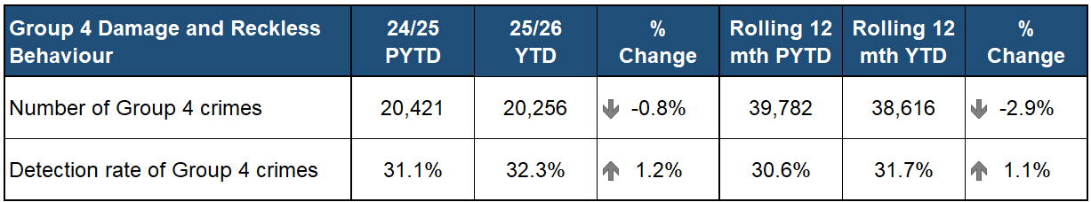
The volume of Group 4 crimes have decreased by 165 crimes in the YTD compared to the previous year, a decrease of 0.8%. There has also been a decrease in the rolling 12 month figures, with 1,166 fewer crimes than the corresponding 12 month period. Small increases are noted in the detection rates comparisons across both time periods.
The main factor is a drop in the number of vandalism crimes recorded (down 3.3%, 577 fewer crimes) in the YTD comparison, which is down considerably in both the North and West regions.
Increases continue however to be noted in Fireraising (up 16.8%, 217 more crimes), primarily due to a combination of serious organised crime activity and youth antisocial behaviour.
Culpable & reckless conduct – not firearms (up 9.6%, 133 more crimes) and Other Group 4 crimes (up 244.8%, 71 more crimes) have also both increased on PYTD.

Group 5 Crimes Against Society

Group 5 Crimes up 9.4% on PYTD
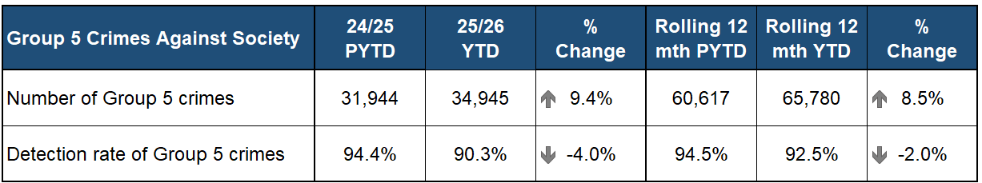
Policing proactivity has a positive impact on the crime types within Group 5 crimes, with YTD increases noted in 12 of the 13 local policing divisions. This is particularly prevalent for bail offences, bringing drugs into prison, offences relating to serious and organised crime, other crimes against public justice and other crimes against society.
The number of Group 5 crimes has increased by 3,001 compared to the PYTD, an increase of 9.4%. There has also been an increase in the rolling 12 month figures, with 5,163 more crimes than the previous 12 month period.
Drugs offences feature prominently amongst the main drivers for this increase. Production, manufacture or cultivation of drugs is up 19.0% on PYTD (40 more crimes); Supply of drugs is up 20.2% (367 more crimes); Bringing drugs into prison is up 48.3% (28 more crimes); Other drugs offences is up 10.4% (seven more crimes); and Possession of drugs is up 3.7% (379 more crimes).
Other crimes against public justice also note an increase of 16.9% (1,163 more crimes). This crime type is impacted by increased offending for Failing to appear after undertaking to police; General attempts to defeat/pervert the course ends of justice; and resisting arrest.

20.2% increase in Supply of drugs crimes
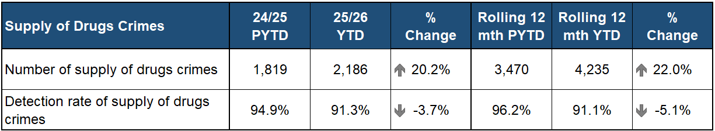
Supply of drugs crimes have increased by 367 (up 20.2%) compared to the PYTD, with the rolling 12 month figures also showing an increase of 22.0%. The detection rate has seen decreases of 3.7 percentage points from PYTD and 5.1 percentage points from previous rolling 12 months.
In July of this year Police Scotland uncovered the largest cannabis cultivation found in Scotland to date, valued at almost £12 million. Officers executed a warrant at a derelict building in Kirkcaldy with around 5,000 plants recovered, having an estimated weight totalling over 1,000kg.
In August three men were arrested and charged in connection with the supply of Class A drugs as part of an operation targeting serious and organised crime in Aberdeen and Aberdeenshire. This formed part of an ongoing operation, launched in January 2025, which has seen 21 arrests in relation to the supply of Class A drugs and the recovery of heroin and cocaine with total estimated street value of over £1.3 million.
At the end of the quarter in September of this year officers executed a warrant at a property in Glasgow where a large quantity of cocaine with an estimated street value of £3.68 million was discovered. Enquiries are ongoing to identify and trace those involved.

Bail offences up on PYTD and rolling 12 months comparisons
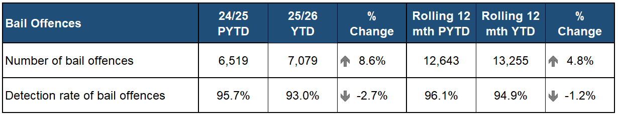
Bail offences are up 8.6% on the previous YTD (560 more offences), whilst a 4.8% increase is noted in the rolling 12 month figures comparison (612 more offences). YTD, there have been 1,716 repeat offenders (with a reoffending rate of 47.6%) and 488 new offenders.
Criminal Justice Services Division note that the following factors may have a bearing on the increase of bail offences being recorded:
An increase in the number of offenders being released on undertaking will naturally lead to greater numbers of people in the community who are subject to bail conditions.
An increase in G4S EM bail reporting, with subsequent breaches occurring.
Efforts by the courts to remand fewer people in custody will lead to greater numbers in the community under court-imposed bail conditions.
The YTD increase is driven by increased offending in all three regions, with the main drivers being Tayside Division in the North, Fife Division in the East and Greater Glasgow, Lanarkshire and Argyll & West Dunbartonshire Divisions in the West.
The only divisions currently recording a decrease compared to PYTD were Highland & Islands in the North and Ayrshire; Renfrewshire & Inverclyde and Dumfries & Galloway in the West.
All three regions record similar increases against the rolling 12 months with each contributing to the overall rise in bail offences in that comparable period.

Hate Crimes increasing
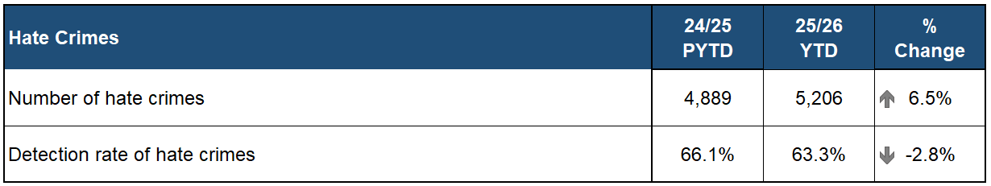
A total of 5,206 hate crimes have been recorded by Police Scotland in the current YTD. This is an increase of 6.5% (317 more crimes) from the same period last year.
The most notable increase is hate crimes with a racial aggravator (up 6.2%, 184 more).
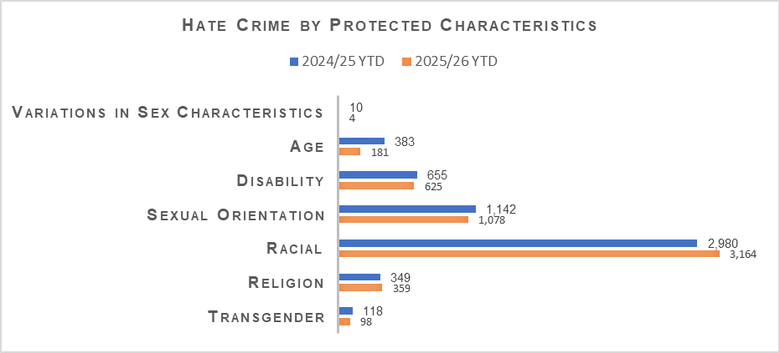
Hate Crimes at Asylum Seeker Accommodation
Year to date, there have been 32 hate crimes located at accommodation that house asylum seekers. 26 of which have been racially aggravated. The most publicised accommodation that has seen the focus of anti-immigration protests has recorded a total of 13 hate crimes recorded (11 racially aggravated).
The aforementioned crimes are only crimes linked to accommodation and didn’t necessarily take place at the time of the protests. Additionally it is not possible to determine from the data available how many hate crimes overall are the result of heightened protests regarding immigration.
Specialist resources have been deployed to support local policing and communities. Community relation specialists have worked closely with partners across various local communities to build community cohesion and defuse tensions.
Hate crime advisors have been deployed to protests across the country to ensure all incidents of hate are identified and dealt with appropriately.
KPI: Number of cyber crimes

5,712 Cybercrime Markers Applied YTD
Cybercrime is a crime type, not a crime itself, therefore recording of these crimes relies on a ‘Cyber’ tag being applied to the relevant crimes on our crime system by officers and staff.
As such, these figures are not official statistics. Work is constantly ongoing to improve the accuracy of cybercrime recording.
There have been 5,712 crimes with a cybercrime marker applied over the Quarter 2 period. This is a 35.4% decrease from the same period last year. Work is currently ongoing to analyse this change in numbers and the results will be included in the next Quarterly Performance report.
Of the crimes with the marker applied, Fraud remains the most common with 2,158 cyber tagged crimes followed by Community and Public Order Offences (1,349 crimes) and Threats and Extortion (527 crimes).

Ransomware
Overall, the ransomware landscape remains active and increases in sophistication. Ransomware continues to pose a significant threat to businesses and organisations across Scotland.
The pertinent threat actors during this period include the Qilin group and incidents that have yet to be linked by Police Scotland or partner cyber-security organisations to a specific criminal group. They continue to cause disruption to companies in several key industry areas including local government and retail.
During this reporting period, Police Scotland received eight new reports of ransomware incidents, which is a decrease of four on the number of incidents reported during the same period last year.
The number of active ransomware groups continues to increase, and ransomware continues to be the most critical cyber threat facing United Kingdom organisations. Cybersecurity remains a top priority for all organisations.

Cryptocurrency Tracking
The most prevalent cryptocurrency scams today are overwhelmingly driven by social engineering tactics and fraudulent investment scams. Investment scams involving cryptocurrency continue to be a common threat to communities, with criminals actively using social media to advertise fraudulent investment platforms.
Police Scotland continues to develop its recently expanded cryptocurrency tracking capability, with several officers across the country receiving training in the use of specialist tools and techniques to trace the movement of cryptocurrency assets.
By analysing transaction patterns, these specialist investigators can identify suspects, uncover criminal networks, and potentially identify opportunities to seize illicit funds.
During this reporting period, Police Scotland have supported 84 cryptocurrency tracking enquiries across the country.

KPI: Reoffending rate

Reoffending Rates down in four out of five Crime Groups
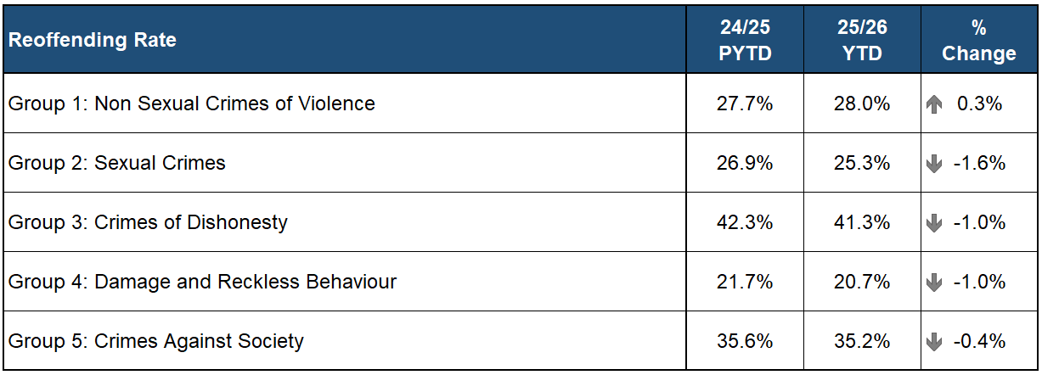
Groups 2-4 crimes all note slight decreases in their percentage of reoffending at the end of Quarter 2 2025/26 compared to the same period in the previous year, whilst a small increase is noted under Group 1 crimes.
The largest percentage of reoffending continues to be within Group 3 crimes (41.3%) however this remains 1.0 percentage point below the same period last year. The biggest contributory factor remains within Theft by Shoplifting with 49.8% reoffending recorded.
The increase under Group 1 crimes is influenced adversely by increased reoffending under Attempted Murder, Common Assault of an Emergency Worker and Serious Assault.
KPI: Level of threat, harm and risk

Serious Organised Crime Groups

Largest known cannabis cultivation in Scotland recovered
Proactive/Preventative Policing – Cannabis Cultivation
The largest cannabis cultivation found in Scotland to date has been valued at almost £12 million. Officers executed a warrant at a derelict building in Kirkcaldy, where the cultivation was discovered. Around 5,000 plants were recovered, with the estimated product weight totalling over 1,000kg.

Over 100 vulnerable people safeguarded from County Lines
Proactive/Preventative Policing – County Lines Intensification Week
Proactive action by Police Scotland saw officers safeguarding a number of vulnerable people who are exploited by drug dealers, during a national County Lines intensification week.
County Lines drug dealers from larger cities expand their criminal activity into smaller communities to exploit young and vulnerable people to sell drugs, carry cash and weapons – bringing violence, coercion and abuse. They can also take over a vulnerable person’s house – known as cuckooing.
Officers across Scotland safeguarded over 100 vulnerable people and engaged with almost 2,800 more. They also visited more than 40 addresses believed to be used by drug dealers as a cuckooing house.
Throughout the intensification week 42 people were arrested and 15 evidential search and apprehension warrants were executed.
More than 300 cannabis plants with a value of £280,000 were recovered.
Other illegal drugs, including £67,000 of herbal cannabis, more than £2,100 of cannabis resin, cocaine and crack cocaine with a street value of more than £85,000 and heroin worth around £45,000 were also seized.
Offensive weapons, including knives, an axe and a machete, were discovered during the activity by officers.

Proceeds of Crime opportunities result in seizure of over £4m
Proactive/Preventative Policing – Proceeds of Crime
SOC Specialist Proceeds of Crime Unit identify and exploit POCA Opportunities to assist in tracing assets derived from proceeds of crime.
During Quarter 2, 48 Restraints were submitted to Proceeds of Crime Unit, totalling £3,448,668. There were a further 163 Cash Seizures totalling £969,541, three Listed Assets totalling £37,100 which were all submitted to Civil Recovery
The total POCA figures during Quarter 2 was £4,455,309, significantly disrupting serious and organised crime.
During Quarter 2 of 2025/26 65 Confiscation Orders were granted, depriving £987,808 of ill-gotten gains from criminals. Since April 2025, there have been 130 Confiscation Orders granted, depriving £2,930,080 of ill-gotten gains from criminals.

Vision 2030: Supported Victims
Users are satisfied with the service provided
KPI: User Experience question – Based on your overall experience, how satisfied are you with your police service?

User Experience: Survey Results

Overall satisfaction down 4% points on previous quarter

User experience measures satisfaction with contacting the police across critical elements in the end-to-end journey and is lower than in the previous quarter, dropping below 70% for the first time since Quarter 1 2024/25. Reported satisfaction has decreased this quarter by four percentage points. Overall, 67% of respondents were satisfied or very satisfied with their overall experience.
Our breakdown of the contact touchpoints demonstrates what is driving these levels of satisfaction. Ease of contact 69% (down seven percentage points); Treatment by staff member during initial contact 83% (down three percentage point); Staff understanding what they needed 85% (down three percentage points); Police providing the appropriate response 61% (down three percentage points); Treatment by officers who attended the incident 80% (down five percentage points); and Being adequately informed about progress 47% (down two percentage points) when compared to Quarter 1 2025/26.
The reduction in ease of contact was influenced by lower satisfaction in several local divisions, particularly in relation to 101 calls. This decline has contributed to an overall drop in satisfaction with ease of contact. This was especially the case in Forth Valley, Renfrewshire & Inverclyde and The Highlands & Islands divisions, where satisfaction with ease of contact ranged from 47-48% compared to a national 63% in August 2025. These low levels of satisfaction help drive the low overall satisfaction rate.
Positive experiences are correlated most strongly with receiving an appropriate response, satisfaction with attending officers and feeling adequately informed about case progress. Respondents tell us their experience was positive because contact was ‘easy’ with quick answer times using 101/999; service advisors and attending officers taking the time to listen to and understand their needs, bringing empathy and compassion to interactions.
KPI: Your Police Question - % respondents that have confidence in local policing

Your Police: Survey Results

Confidence in local policing down 4% points on previous quarter

Public confidence is about our legitimacy and enables us to continue to police by consent. Quarter 2 saw a decrease in public confidence (down four percentage points) to 50%. We know that confidence is closely affected by how policing is perceived locally.
In Quarter 2, 80% (up one percentage point from the previous quarter) of our Your Police survey respondents reported feeling very safe or fairly safe in their area; 62% (no change) agreed that local police are friendly and approachable; and 24% (down one percentage point) agree local police listen to local concerns.
Pearson’s correlation analysis in Quarter 2 shows public confidence is associated with further areas measured using our Your Police survey. There is a strong positive relationship between public confidence and respondents’ perception of police doing a good job in their local area (r = 0.841).
The percentage of people thinking the police are doing a good job in their local area has decreased by six percentage points since the last quarter, 35% to 29%. The percentage of people saying they are well informed about local police activities over the last 12 months has declined by nine percentage points, from 22% to 14%.
When respondents are asked why they expressed a lack of confidence, open-text comments related to a lack of visible, local or accessible police. Respondents relay negative past experiences with the police or a sense that police aren’t dealing with or investigating crime in their local area, especially non-serious crime.
Over a third of respondents remain not certain about whether the police are addressing local concerns and how they are keeping people safe. This highlights the importance of maintaining regular and visible communication about what Police Scotland is doing nationally and locally to respond to concerns from the public.

Trust index score remains relatively stable

Public trust is about our brand and reputation, associated with organisational competence i.e. professionalism, responsiveness, reliability and knowledge.
Since 2022 Progressive runs a quarterly online quantitative survey using panel providers, Norstat and Pure Profile, to obtain a nationally representative sample of c. 1,000 people in Scotland. The data has a margin of error of between +/- 0.61% and +/- 3.09% at the 95% confidence interval (market research industry standard).
Results have remained relatively stable, between 75%-80% since the Trust Index survey was introduced in June 2022. The score in September 2025 of 76% was broadly consistent with our last wave (June 2025) and this time last September (June 2024). This means that 76% of people surveyed (a statistically representative group of around 1,000 adults living in Scotland) had trust in Police Scotland.
Most people continue to feel Police Scotland upholds its core values, measured by the proportion of respondents who felt police uphold the values of Respect (68%), Human Rights (66%), Fairness (66%), and Integrity (68%).
Most people perceive Police Scotland to be professional, experienced and knowledgeable. This is clearly positive however our data suggests that people would have higher trust in their police service if we were perceived as professional, caring and empathetic and reliable.
Progressive undertook key driver analysis to determine which brand characteristics was most associated to trustworthiness – i.e., which characteristic is best at predicting whether someone feels Police Scotland is a trustworthy organisation.
All characteristics were entered into the model and the R-squared values determine the reliability of the trend and accuracy of the forecast. The closer to 1.0 (or 100%), the greater the correlation between the dependent (trust) and independent variable(s).
From this it was determined that how professional the public believe Police Scotland is remains the strongest determinant of trust in the police service. How caring/empathetic and reliable the service is are the next strongest determinants.
These defining characteristics were developed from previous brand tracking research conducted by Progressive for NHS24 – that research covered NHS24 customers’ perceptions of several public sector ‘brands’, including Police Scotland, the SFRS, and the Scottish Ambulance Service.
KPI: Percentage of repeat victims by male/female

Your Care Cards (YCC)

Over 40,000 Your Care Cards issued YTD
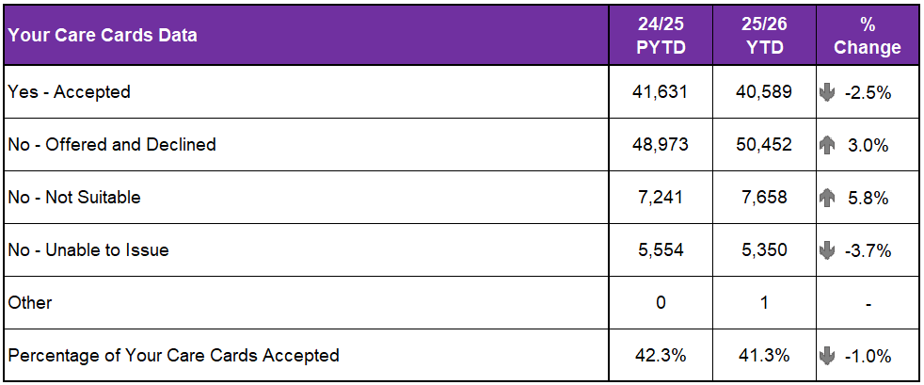
Police Scotland recently updated the ‘Your Care Card’ (YCC) (formerly the Victim Care Card) to be more accessible and person centred. This was due to specific feedback during victim consultation which supported modernisation, rebranding and improved accessibility.
Police Scotland undertook a review of the language and layout of the VCC and consulted with victims’ groups, which led to creation of the Your Care Card.
The card contains information and contact details for support services and links to the Victim’s Code for Scotland and the Standards of Service for Victims and Witnesses. It also includes a Quick Reference (QR) Code to access more information about support to victims or witnesses on the Police Scotland website.
Police Scotland now also offer the option to email the card directly to victims. Police Scotland continues to scope opportunities for further technical advancements to support officers in delivering a high-quality service to victims and witnesses of crime.
In 2024, 44% of those who were offered the YCC accepted, whereas 50% of those who were offered declined.
During the YTD, a total of 40,589 victims accepted Your Care Cards (YCC). This is 41.3% of the total cards offered (down 1.0 percentage points from the percentage accepted in the same period last year). Over 50,000 victims were offered a card but declined.
KPI: Number of victims referred to partners

Victim Support Scotland (VSS)

9.8% increase in victims and witnesses accepting a Victim Support Scotland referral
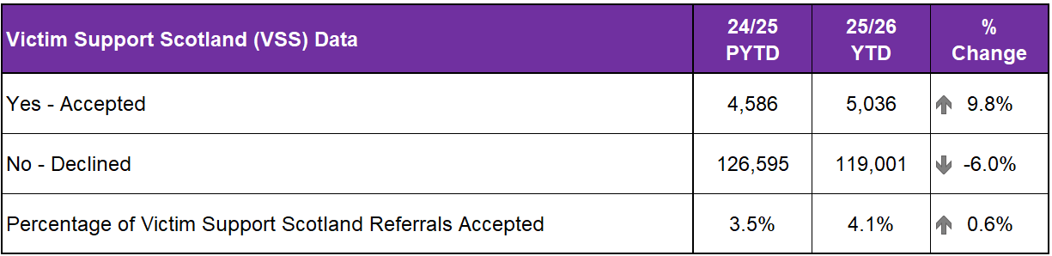
In total, 5,036 victims and witnesses accepted a referral to Victim Support Scotland in the YTD, this is up 9.8% on those accepting a referral in the PYTD. The percentage of victims and witnesses accepting a referral has also increased from PYTD (up 0.6 percentage points to 4.1%).
Alongside Victim Support Scotland referrals, Police Scotland also regularly refer to specialist support services (e.g. BRAKE, Women’s Aid and Rape Crisis Scotland etc.).

KPI: Number of contacts handled within service level agreements

Call Handling Data

999 calls up 6.5% on PYTD
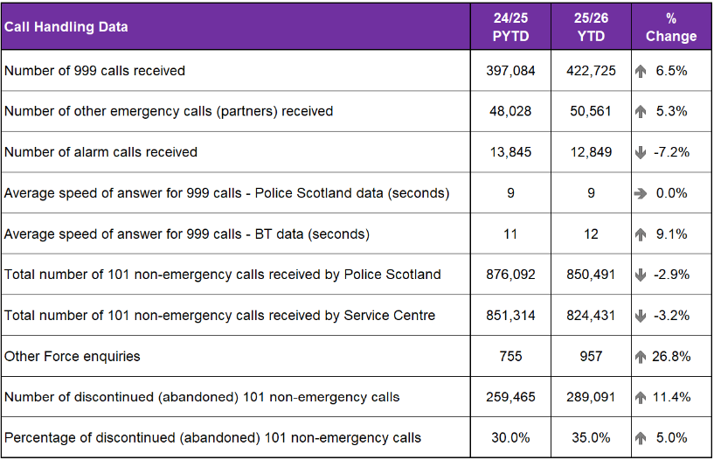
During the reporting period Police Scotland received a total of 1,336,626 calls, an increase of 0.1% when compared to the same period last year (up from 1,335,049 to 1,336,626). Of these calls, those routed via 999 increased by 6.5% when compared to the same period last year (up from 397,084 to 422,725). The volume of 101 calls received decreased by 2.9% (down from 876,092 to 850,491).
The handling of 999 calls remains our highest priority. Police Scotland aim to achieve an average speed of answer for 999 calls within 10 seconds, a standard for all 44 Police Forces across Scotland, England and Wales. During the reporting period Police Scotland achieved an average answer time of 9 seconds which is the same as the period last year.
For Police Scotland UK figures for average speed of answer for 999 calls was 12 seconds, it is important to note that figures which the Home Office publish and report on do not include all calls received from BT to Police Scotland. Therefore, Police Scotland’s performance includes all calls and will be different than reported in the UK monthly 999 figures.
During the months of July, August and September, 41 of the 44 UK forces experienced increases in 999s, with Police Scotland seeing an increase of 17%, which was the highest in the UK. This has greatly impacted our performance, undoubtedly attributing to the longer 999 average speeds of answer times.
Analysis was undertaken which confirmed that performance was adversely impacted by the increased demand on the 999 system set against a lower resource profile due to recruitment and training capacity being reduced due to the impact of significant operations including Operation Roll 2 and Operation Oclate. BAU training and recruitment was also impacted by the training requirements of significant change programmes which will undoubtedly enhance service provision over the longer term.
Additional factors included an increase in particular incident type calls, namely, Sexual Offences (15.6%), Concern for Person (8.4%) and Domestic Incidents (7%) which all take longer to deal with and impact average call handling times.
Other impacts on demand comprise of the extended sustained period of warm sunny weather, the start of the Scottish Premiership season with various football fixtures, Scottish and English school holidays, large-scale concerts, festivals and music events. These events also increase call volumes significantly which can impact our average speed of answer times.
In September, C3 Division commenced the roll out of training for a new call management system (UCCP), which is scheduled for go live in late November. This modern platform aims to transform how handlers receive, record and manage public contacts. This critical training must be given to all staff which subsequently causes abstractions from duty again impacting available resource.
The average answer time for 101 calls increased by 3 minutes 38 seconds to 08 minutes 40 seconds. Of note it is the same Service Advisors who handle all 999/101 calls and “ContactUs” emails. When there is a surge in 999 calls, we prioritise Service Advisors from Non-Emergency (101) calls and emails, as we aim to answer the 999 calls under 10 seconds. Therefore, there is a direct link between any increase in 999 volumes and the average speed of answer for 101 – non-emergency calls.
The 101 non-emergency discontinued rate increased by 5% (up from 30% to 35%) for this reporting period. During periods of high demand, a recorded message informs callers of increased waiting times for answer, and they may choose to discontinue the call and contact 101 later or use the online “ContactUs” facility. The number of enquiries diverted from 101 during this reporting period increased by 19% (up from 21,662 to 25,747).
Our call volumes and trends continue to be monitored closely to ensure that we are prepared for any unexpected changes in demand and maintain average speed of answer times within targets.

11.0% increase in the number of Contactus emails received
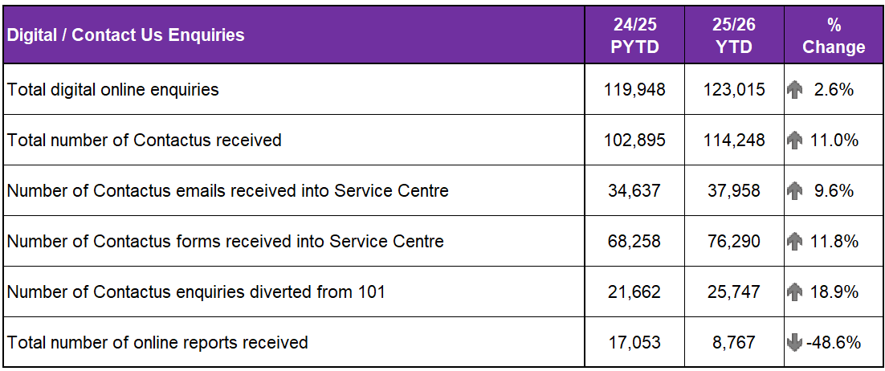
C3 Division handles additional contacts such as incoming calls from other partner agencies, alarm calls and other forces, there have been 64,367 of these types of contact for this reporting period, representing an increase of 5% in emergency service partner calls and a decrease of around 7% in total alarms calls when compared to 2024.
Emergency service partner calls are received via dedicated numbers from Scottish Fire and Rescue, Scottish Ambulance Service, Mountain Rescue, Coast Guard, Mental Health Pathway (NHS 24), OmniCrash and Oil Industry Agency. The reason for such calls varies and each is dealt with by a Service Advisor in the most appropriate manner.
The use of “ContactUs” emails has seen a significant increase in demand, different to the reduction in 101 non-emergency call volumes. Police Scotland received 114,248 emails in this reporting period; an 11% increase (up from 102,895 to 114,248) compared to the same period last year. Emails are assessed the same way as calls using the THRIVE assessment.
“ContactUs” emails and online reports, for some crime types, can be completed online. Each one of these reports is assessed by a Service Advisor using the Threat Harm Risk Investigation Vulnerability and Engagement (THRIVE) model.

Multiple contacts from unique individuals down 3%
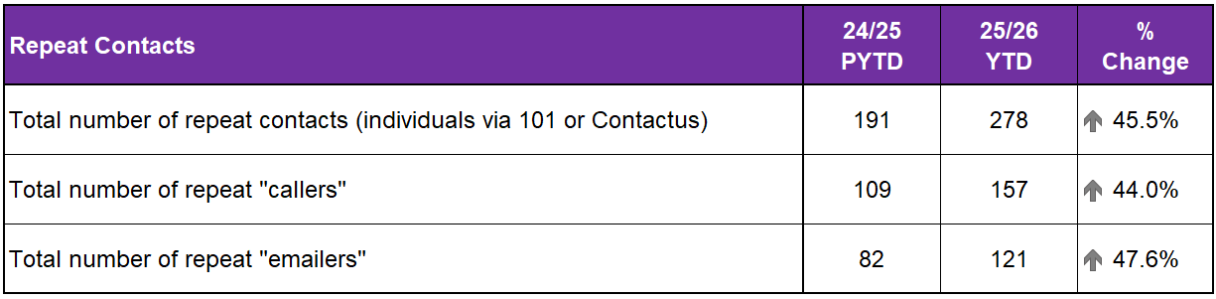
Repeat callers continue to be highlighted particularly where they are vulnerable, abusive and/or impacting average speeds of answer. The National 101 Working Group has recently agreed a definition of a Repeat Contact (five or more times in a calendar month via any channel) and Police Scotland will be able to obtain this data following system upgrades later this year.
Currently repeat contacts data is a manual count of individuals who make repeat contact via “ContactUs” or 101. This new measure is being captured to enable improvements in appropriate support for the associated individuals. During the reporting period there is a recorded decrease of 3% (down from 5,856 to 5,697) of unique individuals who have made multiple contacts.

Comparable % of calls resolved by C3 in YTD
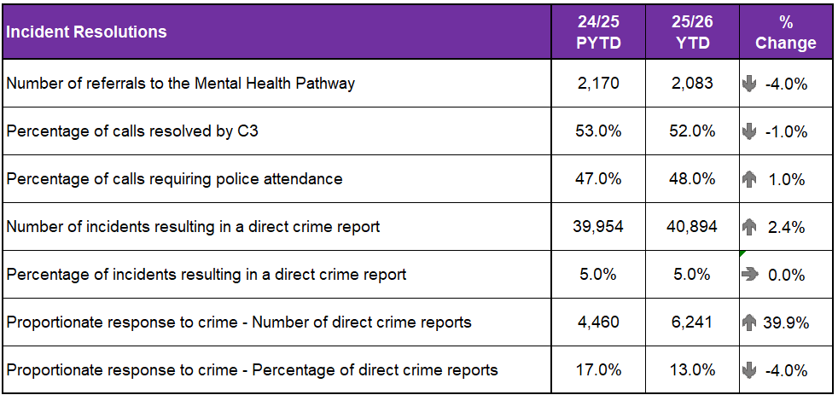
The Resolution Team evidenced a comparable position for the percentage of calls resolved by C3 Division, with similar levels of calls requiring the attendance of Police Officers.
A similar position remains in the volume of incidents received that resulted in a Direct Crime Report being recorded by Resolution Team Assistants.
Proactive/Preventative Policing – Proportionate Response to Crime
The Proportionate Response to Crime model is now embedded nationally. This is reflected in the increased number of crimes recorded during this quarter when compared to last year. Relevant crime reports are channelled through the PRTC process, which continues to deliver excellent service delivery , retains SCRS compliance and high standards in data quality.
Whilst more crimes were recorded by the Resolution Team in this quarter, fewer were appropriate for progressing under the Proportionate Response to Crime model as inquiries were progressed by local policing officers.
The Proportionate Response to Crime model continues to benefit our communities by reducing demand on Local Policing resources in line with the Chief Constables 2030 Vision.

C3 Quality Assurance Unit continues to support C3 Operations
The Quality Assurance Unit (QAU) continue to support C3 operations with daily quality checks and performance tracking. In the last quarter reporting period, the team have produced detailed reports and findings in relation to targeted reviews following several high-profile and impactive incidents.
These in-depth reviews are critical to providing an informed picture in terms of the Policing response to incidents of high harm and involving high risk. Where learning opportunities are identified, they are detailed and disseminated appropriately.
The positive evolution of the C3 QAU continues to realise benefits for the Division and our wider partners from Local and Specialist Policing divisions and those external to Police Scotland.

Police Scotland effectively handled over 25% of all dropped/abandoned 999 calls
During the quarter C3 Governance and Improvement have continued to support the implementation of the new resolution process for dropped/abandoned 999 calls reported on in Quarter 1.
Analytical reviews and data have been provided to monitor and manage the adoption of the new process, with data showing that the Police Scotland Service Centre effectively handled over 25% of all dropped/abandoned 999 calls in the first half of 2025. This has demonstrated the positive impact of the new process on service delivery.
The team have been heavily involved in many projects that are currently ongoing to implement new technology and processes to enhance C3’s capability and performance.
In addition to the national ICT infrastructure work, Governance and Improvement are leading the C3 response to the City of London’s ‘Report Fraud’ initiative which will see all frauds reported being directed to the City of London Police with their national expertise, whilst maintaining Police Scotland’s local response to safeguard and reassure victims and the public.
A collaborative initiative with SCD Intelligence Support and Home Office Immigration, Compliance and Enforcement has seen a new process designed that will reduce demand on Police Scotland while maintaining support to our partners and ensuring officer safety.
All new processes have been fully updated on the C3 Procedures Guide to support learning and understanding and enable effective implementation.

Slight decrease in complaints received relative to C3 handling of 999/101 calls
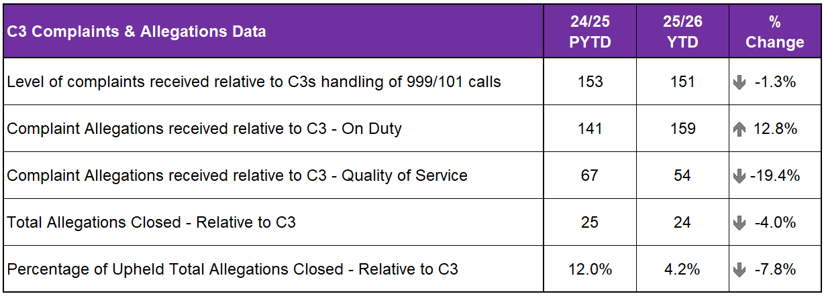
The volume of complaints against C3 Division has decreased by 1.3% YTD, with a total of 151 received compared to 153 received PYTD. Decreases are visible in the North (down 17.4%, 19 fewer cases) and the East (down 21.8%, 43 fewer cases). However, an increase was registered in the West (up 18.7%, 89 more cases).
In total, 81.5% of complaint cases received year-to-date for C3 Division were Frontline Resolved by the PSD National Complaints Assessment and Resolution Unit (NCARU). This rate rises to 82.1% when early and subsequent resolution by PSD or Specialist officers are included.
These figures demonstrate that most complaints against C3 Division during this period have been non-criminal and non-serious in nature, with a majority resolved through simple explanation, apology or assurance.
Incivility (107) remains the most common allegation type. This volume represents a 1.9% increase from the same period in 2024/25, accounting for an additional two allegations.
Irregularity in Procedure has also increased in this period, with 50 allegations received YTD, which represents a 47.1% increase (an additional 16 allegations). This relates to allegation sub-types, specifically: Insufficient Enquiry carried out (up nine allegations), ‘Officer did not provide name or shoulder number’ (up four allegations) and ‘Other’ (up three allegations).

Vision 2030: Thriving Workforce
We prioritise wellbeing and keep our people safe, protected, and well-equipped
KPI: Our Culture: Absence Rate (Short term / long term)

Absence Data

Working days lost (WDL) up slighty for both police officers and staff
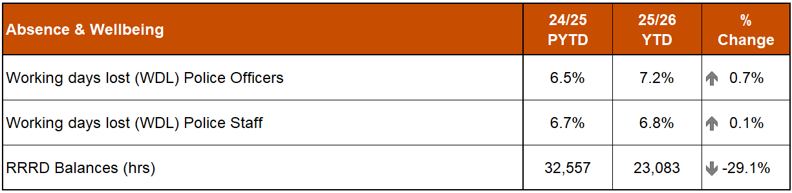
A 0.7% percentage point increase has been recorded in %WDL for Police Officers in comparison to PYTD. The most significant increase in Police Officer absence is in long term Psychological Disorders which has increased by 0.5% when compared to Quarter 2 last year (See following graph).
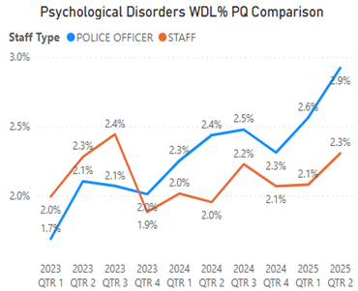
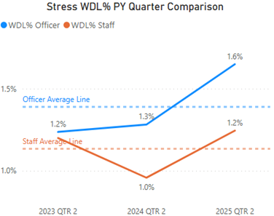
The % of WDL related to stress is currently at 1.6% for officers and 1.2% for staff. If we compare this with the same point in time over the past two years these figures are above the average. Officers represent the most significant increase when comparing both employee types which is up 0.3 percentage points in comparison to last year.

Supporting our workforce’s wellbeing
Our health and wellbeing teams continue to provide a suite of offerings to keep our people healthy and prevent ill-health and injury.
In Quarter 2 2025/26, our occupational health service:
Received 1,119 management referrals (for reports/reviews of complex cases) (888 Officers / 231 Staff).
The My OH portal is assisting line managers in the making and monitoring of referrals which enables them to support their people appropriately.

Your Wellbeing Assessment (YWA)
Your Wellbeing Assessment (YWA) is a confidential screening tool (an MOT, but for our mental health).
The objective of the assessment is to, with consent, put in place support, advice and guidance before an individual may realise that they need it. The assessment is reviewed by a member of Optima Health’s mental health team.
952 officers and staff have completed the Your Wellbeing Assessment during the period of February to September 2025.
With 24% and 31% identified (525 officers and staff in total) within the red and amber categories respectively and a proactive approach has been made.

Employee Assistance Programme (EAP)
We are keen that officers and staff can receive the right support at the right time and are aware of and proactively engage with the avenues of support, with EAP being one of the main pathways.
There have been 425 contacts with EAP during this period, with 263 new officers and staff progressing through the pathway.
We have enhanced the support offering for officers and staff with Eye Movement Desensitisation Reprocessing (EMDR) and Cognitive Behaviour Therapy (CBT) available to those if deemed clinically appropriate.
1,825 clinical sessions have been delivered during this period.
We have enhanced the support offering for officers and staff with EMDR and CBT available to those if deemed clinically appropriate, 101 sessions delivered in this period.
Counselling interventions appear to have led to positive improvements, with an improved average CORE-OM (clinical outcomes in routine evaluation – outcome measure) score from 16.35 (pre) to 11.78 (post), an average change of -4.57.
KPI: Our Culture: % turnover by Police Officers/Staff

Turnover Data

Fluctuation in turnover of police officers and police staff
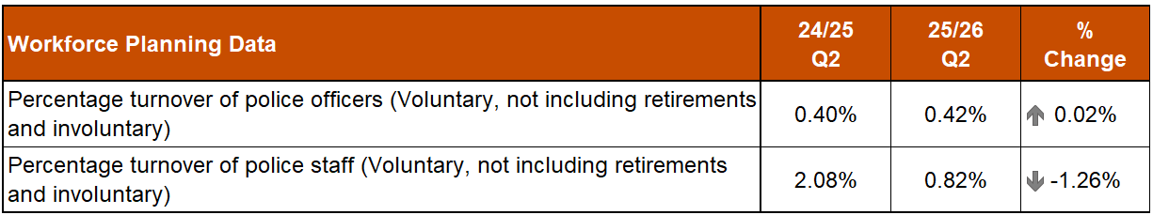
Police officer turnover has stayed relatively stable when compared to the same period last year. Police staff is showing a more significant decrease as a large number of voluntary redundancies were taken in Quarter 2 last year.

KPI: Our Culture: Number of Assaults on Police Officers/Staff

Assaults and Injuries Data

Assaults on police officers/staff up 7.1% on PYTD
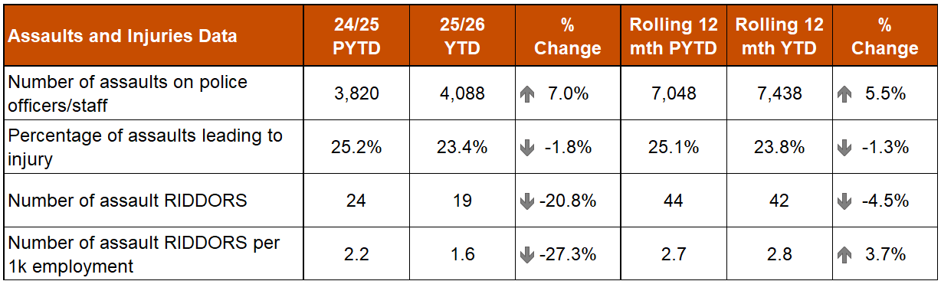
In the YTD, a total of 4,088 assaults on police officers/staff have been recorded. This is an increase of 268 assaults (up 7.0%) compared to the same period last year. This equates to an average of around 22 assaults on officers/staff per day (unchanged from the figures presented in Quarter 1).
Eight of the thirteen Local Policing Divisions have recorded an increase in their volume of assaults on police officers/staff compared to the PYTD. The biggest YTD increases in assaults were in Lanarkshire (138 more crimes, up 27.5%) in the West region followed by Fife (101 more crimes, up 42.8%) in the East region.
Smaller increases were noted in North East, Tayside, Forth Valley, Edinburgh, Greater Glasgow and Renfrewshire & Inverclyde divisions with decreases recorded in Highland & Islands, the Lothians & Scottish Borders, Ayrshire and Dumfries & Galloway divisions. Argyll & West Dunbartonshire remained unchanged from PYTD.
The rolling 12 month figures show 7,438 assaults on police officers/staff from October 2024 to September 2025, up 5.5% (390 more assaults) on the same period in the previous year. This is around 20 assaults per day on average.
Despite the increases in assaults, the YTD percentage of assaults leading to injury (23.4%) is down 1.8 percentage points compared to the previous YTD (25.2%) with a drop also in the number of assault RIDDORS (five fewer, down 20.8%).
KPI: Our Culture: Financial Sustainability, Improved Fleet Efficiency and Reduction in Utilities Consumption

Maintaining a Balanced Budget / Financial Sustainability
The 2025/26 budget was approved by the Board at the Authority meeting held on 27 March 2025.
The budget report highlighted the key budgeting assumptions that are sensitive to change, and which could result in a material change to the 2025/26 budget. The overall financial position will continue to be monitored and reported throughout the year

£1.1m YTD underspend against Revenue budget
The Quarter 2 forecast is reporting an overall breakeven position against budget and funding.
The Quarter 2 forecast position presents a number of challenges, particularly when viewed in the context of the emerging cost pressures. Key risk areas include overtime, ill-health pension costs, liability claims, and a potential inflation guarantee payment that may be triggered as part of pay award agreements.
It is critical that spend is tightly controlled over the remainder of the financial year to ensure a balanced position in line with funding.
The forecast will be closely monitored alongside the financial threats and opportunities, with appropriate action to be taken if required.
Funding discussions are ongoing with regards to Operation ROLL (POTUS visit) and Operation OCLATE (VPOTUS visit) totalling £24.1m. Confirmation of funding is not expected until the Spring Budget Review is completed in the early part of 2026.
At the end of Quarter 2 we are reporting a £4.5m year-to-date overspend against Quarter 1 forecast and a £1.1m year-to-date underspend against budget.

Capital spend over budget by £0.9m
The capital forecast at Quarter 2 is £73.1m, £2.1m above the budget position of £71.0m. The forecast overspend is fully funded by additional capital receipts and other grants.
Capital delivery plans and forecasts have been updated by business areas to accurately reflect current timelines and spend profiles at Quarter 2 forecast.
The capital forecast at Quarter 2 requires £5.9m of slippage to be achieved throughout the remaining part of the financial year.
Committed and uncommitted spend will continue to be monitored throughout the year.
Finance are engaging regularly with business areas to support delivery of their capital plans.
The year-to-date capital spend at September 2025 is over Quarter 1 forecast by £4.8m and over budget by £0.9m.

Reform spend under budget by £0.2m
The reform forecast at Quarter 2 of £20.8m, £0.4m (fully funded) above the budget position of £20.4m.
The reform forecast has removed £15.9m of the £16.2m overprogramming included as part of the approved budget, leaving only £0.3m of slippage still to be achieved across the remainder of the year.
Committed and uncommitted spend will continue to be monitored throughout the year.
The year-to-date reform spend at September 2025 is under Quarter 1 forecast by £0.4m and under budget by £0.2m.

Green miles used by electric vehicles up 2.6% on previous quarter
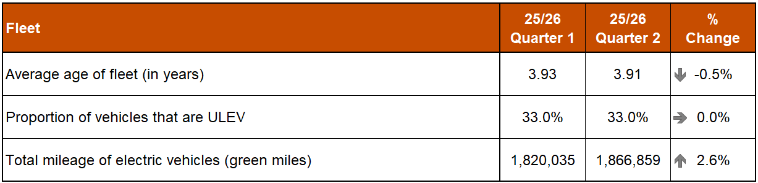
Police Scotland is working towards implementing the move to an Ultra-Low Emission Fleet as part of the Scottish Police Authority (SPA) approved Fleet Strategy. In Quarter 2 2025/26, 1,195 ULEV vehicles make up 33% of Police Scotland’s overall fleet. 47% of the unmarked fleet are ULEV (ultra-low emission vehicles).
The total mileage of electric vehicles (green miles) during Quarter 2 2025/26 is 1,866,859 miles. This is up 2.6% (46,824 additional miles) from the previous quarter.
The current average Fleet age for Police Scotland fleet is 3.91 years (down 0.2 years from the previous quarter). This fluctuates from one day to the next as it is a live figure taking on the day, considering vehicles awaiting to be replaced and sold. This will reduce as new vehicles are introduced to the fleet and if the level of capital investment on the fleet is maintained in future years.

Gas and electricity consumption down on both PYTD and rolling 12 months
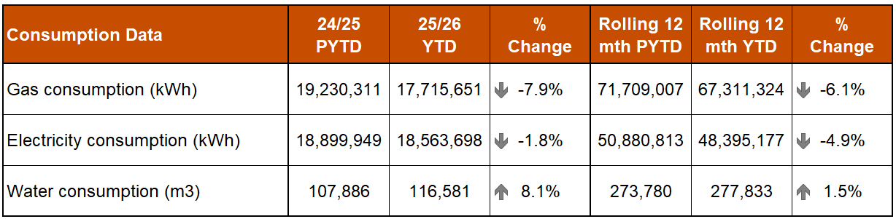
Gas consumption continues to show a reduction during the YTD and rolling 12 months in comparison to the same periods in the previous year. This is likely due to the warm spring and summer experienced this year. We expect a reduction in percentage change as we move into the heating season during the remainder of the financial year.
As with gas, we continue to see a reduction in electricity consumption compared to both periods. As previously stated, this is likely due to continual implementation of energy efficiency measures and building disposal. We also recognise that a portion of electricity savings in buildings has been offset by increased consumption due to EV operation.
We continue to see an increase in water consumption in comparison with the same period last year, and in comparison with the rolling 12 month periods for 2024 and 2025. This is possibly due to an increase in high baseline consumption at various sites across the estate because of issues with supply infrastructure. This is being addressed by Estates FM.
We have finalised our Public Bodies Duties Climate Change Report for 2024/25. This has now gone through full governance process, and we await final signatures before submitting to Scottish Government.
We are making progress with our Sustainability Strategy and Waste Plan documents and anticipate that these are on track to be on time next year.
We await the final outcome of our internal audit later this month and are in discussion with BDO regarding observations and recommendations.
KPI: Our Culture: Percentage of days undertaken on training priorities

Learning, Training and Development
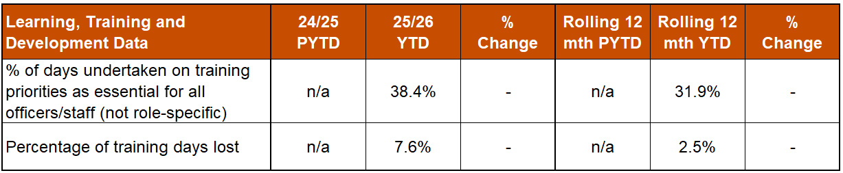
38.4% of time was spent on training identified as priority. This is higher than the rolling 12 month average of 31.9%. The actual time spent on priority training is similar to Quarter 1 however as there were much fewer training days overall. The fewer training days overall and increase in training days lost was impacted by Operation ROLL (Visit of the President of the USA) and Operation OCLATE (Visit of the Vice President of the USA).
KPI: Workforce Survey: Our organisation creates a safe environment and support systems for colleagues to raise concerns

Complaints and Allegations

Complaints & Allegations both down on PYTD and Rolling 12 months
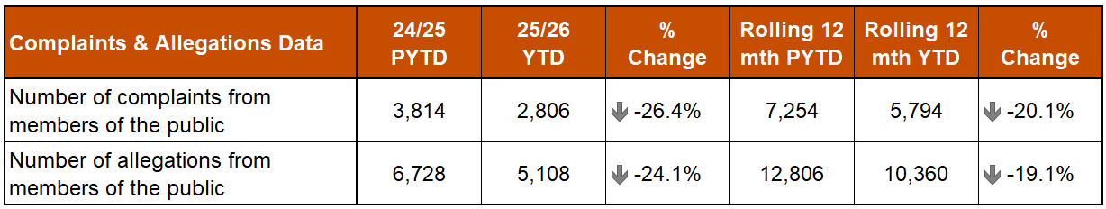
The total number of complaints from members of the public, at the end of Quarter 2 2025/26, are down 26.4% (1,008 fewer complaints) on the same period last year and down 20.1% (1,460 fewer complaints) against the rolling 12 months.
The total number of allegations from members of the public are down 24.1% (1,620 fewer allegations) on the same period last year and down 19.1% (2,446 fewer allegations) against the rolling 12 months.

3.2% point increase in complaints handled within statutory timescales and 6.6% point increase in complaints concluded at front line resolution
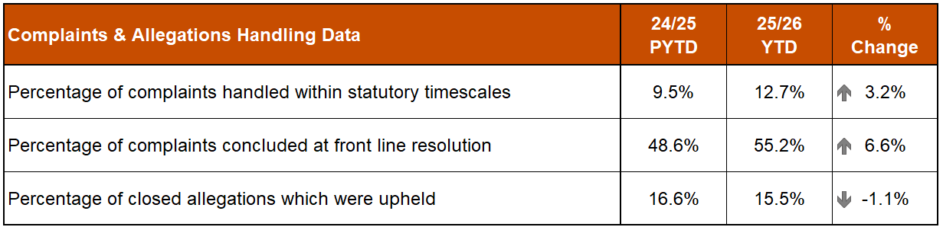
There were 300 non-criminal (not FLR) complaints closed, with 12.7% closed within the 56 day statutory timescale. This is 3.2 percentage points up on the same period in 2024/25.
A total of 1,548 complaints (55.2%) were frontline resolved (FLR), compared with 48.6% in PYTD (up 6.6 percentage points). This includes early resolution and subsequent resolution by PSD/Specialist officers.
In total, 1,499 allegations were attached to completed complaint investigations (criminal and non-criminal) with 15.5% upheld (down 1.1 percentage points on PYTD).

10.2% reduction in number of allegations considered by PIRC
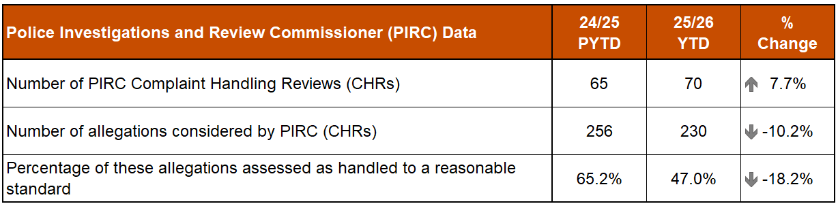
The Police Investigations and Review Commissioner (PIRC) have submitted 70 Complaint Handling Reviews (CHRs) to Police Scotland for consideration during this period (up 7.7% from PYTD). This notionally equates to 2.5% of all complaints, however some of these complaints may have been received prior to the YTD reporting period.
Overall, 230 allegations were considered (down 10.2% from PYTD), from the 70 CHRs received from PIRC. 108 (47.0%) were assessed to have been handled to a reasonable standard (an 18.3 percentage point decrease from the same period in 2024/25. These CHRs included 112 recommendations.

14.7% increase in Statutory PIRC Referrals
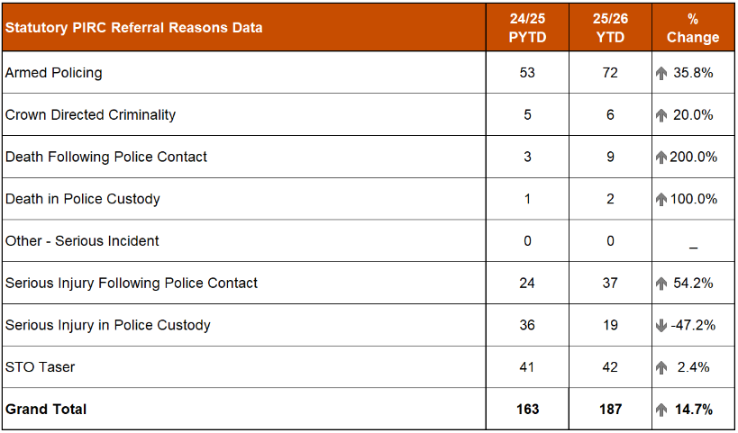
Statutory referrals to the PIRC facilitate independent and transparent scrutiny in relation to serious incidents involving the police. Police Scotland made 187 referrals to the PIRC.
Of those, 18 resulted in an investigation (9.6%). This is an increase of 1.0 percentage points compared to the same period in 2024/25.
Allegations of On Duty Assault (breaches of Article 3 of the European Convention on Human Rights), plus any associated criminal allegations, are now referred to the PIRC. In total, 108 of these referrals were made during this period (down 49.1% from 2024/25), with 75 subject to PIRC investigation (69.4%).
As of 01 October 2025, 16 of these referrals are awaiting a decision from PIRC regarding possible investigation. The remaining 17 cases have been marked as no investigation by PIRC.

Misconduct / Gross Misconduct Investigations unchanged from PYTD
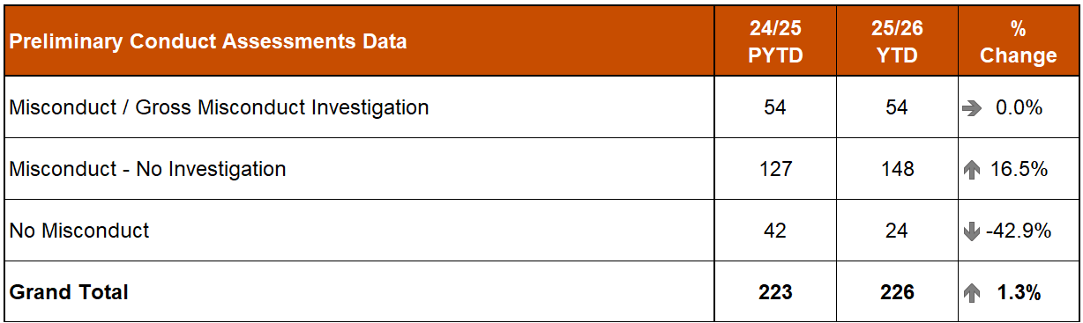
There have been 226 preliminary conduct assessments undertaken YTD which is down 1.3% (three fewer assessments) on the same period last year.
54 assessments have required a misconduct/gross misconduct investigation, this is unchanged compared to the same period last year. The remaining assessments resulted in either misconduct – no investigation (148 assessments, up 16.5%) or no misconduct (24 assessments, down 42.9%).
Proactive/Preventative Policing – Professional Standards Disseminated Learning
In the last quarter, PSD has disseminated learning from a variety of incidents. The following learning outcomes were of particular note:
All officers are reminded of the importance of completing all relevant persons checks when dealing with incidents or reports which potentially have a ‘domestic’ element, including checks of the UNIFI crime recording system.
All officers are reminded that; ‘Apprehension Warrants are to be executed as soon as practicable and without undue delay’, however where there are genuine concerns regarding the wanted persons health/wellbeing this should, in the first instance, be discussed with staff from Police Scotland’s Criminal Justice Services Division (CJSD), to ensure appropriate care can be provided while in police custody.

Appendix
Crime and incident data is included within this report, illustrating where possible, the Quarter 2 YTD comparison (April to September) and the rolling 12 months comparison (October to September) in the year-to-date vs previous year-to-date.
All data is classed as Management Information and is not considered official statistics. All data is sourced from Police Scotland internal systems. Disaggregated data is available in Police Scotland Management Information publication.

Notes:
Homicide crimes include the crime types murder and culpable homicide (common law).
Recent crimes of Rape are defined as being reported less than 365 days from the day committed. Non-Recent crimes of Rape are therefore any reported 366 days or more from the day the crime was committed.
- Crimes of Violence against Women and Girls refers to any female victim of a Group 1, Group 2, threatening and abusive behaviour crime or any other crime with a domestic element.
DASA of a female and DASA of a male crimes refers to crimes under the Domestic Abuse (Scotland) Act 2018. These crimes are a small part of the overall Domestic Abuse crimes.
Victim Support Scotland referrals: The number of accepted referrals is taken from our daily referral record and is the most accurate number of referrals sent to VSS. The number of declined referrals is taken from our ‘VSS Summary Report V3’ dashboard.
The complete Quarter 1 utilities (Gas, Electricity and Water) data is not yet available and so we have provided information based on April to August 2025 of Financial Year 2025/26 with a comparison over the same time period in the previous year. Considering this, all figures provided should be taken as indicative, until the Quarter 2 data set is complete.

