Police Scotland
Quarter 4 Year to Date Performance Report
April 2021 to March 2022

Contents
Introduction by the Deputy Chief Constable 4
Executive Summary 6
Introduction 6
Policing Demand during Quarter 4 2021/22 8
Public Confidence and Experience of Policing 12
Measures of Progress towards Strategic Outcomes 13
Exceptions Identified in Quarter 4 13
Performance Framework 22
Outcomes and Objectives 22
Policing during Quarter 4 2021/22 Key Insights 24
Key Insight 1: Assaults on Officers/Staff 24
Key Insight 2: Increase in ‘Use of Hands’ Type Force Applied 24
Key Insight 3: Recorded crime volumes remain at low levels 26
Key Insight 4: 999 average speed of answer has remained consistent despite higher volumes whilst 101 average speed of answer has risen 27
Public Confidence and Experience of Policing 29
High-level overview 29
Your Police 2020/21 & 2021/22 31
User Experience Survey 36
Measures of Progress towards Strategic Outcomes 38
Strategic Outcome: Threats to public safety and wellbeing are resolved by a proactive and responsive police service 38
Strategic Outcome: The needs of local communities are addressed through effective service delivery 81
Strategic Outcome: The public, communities and partners are engaged, involved and have confidence in policing 112
Strategic Outcome: Our people are supported through a positive working environment, enabling them to serve the public 123
Strategic Outcome: Police Scotland is sustainable, adaptable and prepared for future challenges 133
Operation TALLA – Police Scotland’s response to COVID-19 139
Operation TALLA Strategic Outcomes and Objectives 139

Introduction by the Deputy Chief Constable
The 2021/22 reporting period covers an exceptional time for policing and society as a whole. As the nation continued to tackle the coronavirus pandemic and begin the recovery, Police Scotland was not untouched by such an unprecedented event.
Like our fellow citizens, Police Scotland had to adapt to a new way of working during the pandemic to work effectively with partners. This report highlights a number of examples of successful partnership working and innovative approaches as we continued our efforts to improve the lives of people and our communities.
During this period, we have seen the hastening of some established crime trends – most notably in fraud and cyber-enabled crime. This has been mitigated by robust, long-term action including work streams advanced as part of our Cyber Strategy. This trend reaffirms that online policing is increasingly a key part of frontline policing.
The scale and complexities involved in fraud and other cyber-enabled crime cannot be underestimated. Our long term response in this area is focused on implementing our Cyber Strategy as well as establishing key partnerships and promoting cyber security proactively to a wide variety of audiences. Work to disrupt the activities of criminals and protect the public has continued during this reporting period, with £6.46 million of fraud prevented through the Banking Protocol alone.
We have recorded an increase of 11.2% in violent crimes, compared to the previous reporting period. Common assaults account for the majority of violent crimes and we have seen a reduction of homicides during this quarter. For the first year since 2014/15 we have recorded a decrease in assaults on officers, however, concerningly, assaults are still 8.6% higher than the five year mean. The increase in common assaults is likely due to the lifting of coronavirus restrictions against licenced premises and large events, which contributed to significantly lower levels of common assault than is typical.
During 2021/22, a reduction in overall domestic abuse has been recorded although we see an increase in Domestic Abuse Scotland Act offences. Police Scotland’s Domestic Abuse Task Force progressed over 200 investigations during this period, resulting in perpetrators being charged with over 300 crimes. So far, offenders have received sentences in excess of 100 years, with others yet to appear in court.
We continue to contribute towards changing societal attitudes on domestic abuse by supporting campaigns such as the 16 Days of Activism as well as awareness raising initiatives. Our Domestic Abuse campaign, launched in December, sought to warn perpetrators and encourage reporting but also aimed to motivate bystanders such as friends or relatives to report concerns for people who may be at risk.
Police Scotland has commissioned a comprehensive review of the policing response to Public Protection. This will become a programme of work to improve both our national and local approaches and allow us to continue to adapt and respond to shifting demand and vulnerabilities.
This reporting period records another rise in sexual crimes and analysis shows this is primarily being driven by recent reporting. We are committed to improving how we respond to reports of rape and sexual crime and engaging with survivor groups plays a key role in how we can improve. Since April 2021, Police Scotland has received feedback from nearly 490 rape survivors to better understand their experiences. The feedback received was 83.9% positive, but we recognise there is still much more to do as we seek to further develop our Violence Against Women and Girls strategy.
This report is designed to provide meaningful information and insight into the work Police Scotland is taking to improve the wellbeing of our citizens and communities. I hope it is of interest to people and enables a better understanding of the varied role that policing in Scotland contributes to society.

Fiona Taylor QPM
Deputy Chief Constable
Professionalism, Digital and Transformation

Executive Summary

Introduction
This is the final Quarterly report of the 2021/22 performance cycle, reporting on our revised Performance Framework and new Measures of Progress. Our outcomes focused Performance Framework is linked to our strategic planning processes and aligns to the Strategic Outcomes as detailed in the 2021/22 Annual Police Plan, these being:
Public Safety and Wellbeing – threats to public safety and wellbeing are resolved by a proactive and responsive police service
Needs of Local Communities – the needs of local communities are addressed through effective service delivery
Confidence in Policing – the public, communities and partners are engaged, involved and have confidence in policing
Positive Working Environment – our people are supported through a positive working environment, enabling them to serve the public
Sustainable and Adaptable Service – Police Scotland is sustainable, adaptable and prepared for future challenges
Throughout the document we have highlighted any updates that are linked to our new Joint Equality Outcomes.
Also included in this report are metrics from the Performance Framework that measure the demand placed upon Police Scotland, detailed as follows:

Incident Demand
146,084 concern for person incidents – up 3.7% (Link to Missing Persons Demand)
41,275 missing people incidents – up 15.7% (Link to Missing Persons Demand)

Missing Person Demand
17,239 missing persons investigations – up 19.9% (Link to Missing Persons Demand)
2,917 (29.6%) missing persons who have gone missing previously – up 4.3% (Link to Missing Persons Demand)
17.4hrs average length of time missing (Link to Missing Persons Demand)

Partner Demand
5,609 missing persons from NHS, Young Persons Units and Foster Care locations – up 14.0% (Link to Missing Persons Demand)
2,857 external force request incidents – up 13.1% (Link to Incident Demand)

Call Demand
1,485,687 incidents raised – down 2.2% (Link to Incident Demand)
Various incidents by response type (Link to Incident Demand)
26.5% of incidents which lead to a crime – up 0.9% (Link to Incident Demand)
97.0% of incidents requiring police response – no change (Link to Incident Demand)

Policing Demand during Quarter 4 2021/22
Quarter 4 concludes a remarkable and challenging year for Police Scotland in which changes to our operating environment, whether planned or unexpected, were met with appropriate and timely responses across the country. Large scale events like COP26, which saw 40,000 visitors welcomed to Scotland, were delivered safely and without incident; the hastening of several established crime trends, as seen in the significant growth of fraud and cyber-enabled crime, continued to be mitigated by robust, long-term action, such as the numerous work streams advanced as part of our Cyber Strategy; and further COVID-19 developments, as with the emergence of the Omicron variant, were countered by the effective structures and processes put in place over the last two years to share information, manage absence disruption, and keep members of our organisation and the communities of Scotland safe.
In recognition of the breadth of demand that Police Scotland routinely encounters, demand-based metrics were included in our Performance Framework for the first time this year, an approach that has allowed us to detail aspects of vulnerability, mental health, and partner demand throughout our reporting cycle. The success of this approach means that in the forthcoming year we plan to extend the number of these measures in our framework, in order to report as broadly as possible and provide a more complete profile of non-crime demand.
Levels of overall recorded crime and offences have remained low in 2021/22, virtually unchanged from last year and 6.1% lower than the five year mean for Crime Groups 1-5. This reflects in part the restrictions placed on events, gatherings and public events earlier in the year, but also longer term trends such as reductions in acquisitive crime. However, if crimes related to coronavirus legislation are included, this year observed a 7.1% fall in overall crime in Groups 1-5, reflecting the reduction in COVID-19 related enforcement across Scotland. These trends are explored further in Key Insight 3.
The ability to respond to demand is dependent on having adequate response available, something that many organisations have struggled with over the last year given the high number of short term absences resulting from COVID-19 infections and self-isolation periods. Police Scotland has managed this risk on multiple levels and across departments, including through extensive home working arrangements and a dedicated Outbreak Management Team that was stood up at various times of the year, as required. Absences have remained high during Quarter 4, as the influence of the highly contagious Omicron variant continued to be felt.
Necessary social distancing and COVID-19 related absences put a particular strain on C3’s capacity during 2021/22, with unfavourable circumstances further compounded by displaced demand on behalf of partner agencies. In response, Police Scotland prioritised the answering of 999 calls, and our performance in this area remained consistently strong, despite the number of 999 calls increasing 17.8% on the previous year. However, periods of high volumes of 101 calls has led to delays and a higher average answer time over the year for this call type (see Key Insight 4 for more details). Various steps have been taken to alleviate these wait times, including a fall back facility providing additional capacity and extensive efforts to signpost callers to the most appropriate method of contact. This approach has contributed to an increase of roughly 5.2% of additional public contacts from emails and online reports during the year.
Building a relationship with communities based on our values of integrity, fairness and respect drives our continual efforts to listen to, understand, and act on the concerns of the public. Through our Your Police 2021/22 and User Experience surveys, we are able to collect feedback, build on what we are doing well, and inform opportunities for improvement. Work in this area continues to develop, with various new surveys in progress, such as those aimed at capturing the experiences of individuals interacting with the police in specific circumstances (like victims and witnesses of serious crime, or people in police custody). Moving into next year, a new Your Police survey will be launched, alongside the publication of ‘We Asked, You Said, We Did’ feedback, detailing the actions taken as a direct result of people taking part in previous engagement. More information on these and other plans can be found in the Your Police Section.
The pressures placed on society by the pandemic over the last two years have highlighted the necessity for organisations like Police Scotland to work effectively with partners in order to combat threats and risks that are common across services. This report provides numerous examples of successful partnership working and innovative approaches, such as the public health approach taken by Police Scotland to tackling Scotland’s drug death crisis, including collaborating with charities on the production of naloxone awareness cards, rapidly sharing relevant information with Scottish Government, and supporting multi-agency discussions on safe drug consumption facilities (more details are supplied in the Drugs Harm section). Likewise, Police Scotland continues to work with numerous partners across the criminal justice system in support of the Justice Recovery Programme (as outlined in the Police Custody section).
Throughout the year we have reported in detail on hate crime figures, particularly following the increase observed during Quarter 1. On a monthly basis, hate crime followed a similar pattern to 2020/21 and rose overall by 2.5%. The HMICS Thematic Inspection of Hate Crime was published in June 2021, and following this our Hate Crime Improvement plan was presented to the SPA Policing Performance Committee (PPC) in December 2021.
Rising volumes of fraud (up 68.2% on the five year mean) remain a concern for Police Scotland, given the scale of the issue, the complexities involved and the vast array of different vulnerabilities that a fully cyber-enabled society presents to criminals. Our long term response in this area has focused on implementing the Cyber Strategy, establishing key partnerships and promoting cyber security proactively to a wide variety of audiences. This quarter we have also provided examples of the vital preventative work that Police Scotland regularly undertakes in response to new fraud types emerging, making sure we reach the right people quickly enough to make a difference (as detailed in the Fraud section).
In August 2020, Chief Constable Iain Livingstone made a pledge to police officers and staff that violence was not a part of their jobs and would not be tolerated. A large amount of activity has taken place in this area, including the formation of the oversight group, Your Safety Matters (YSM), the establishment of a network of YSM Champions, and the building of a Police Assaults dashboard suite, enabling in-depth analysis and identification of prolific offenders. 2021/22 marks the first year since 2014/15 to witness a decrease in the number of assaults on officers and staff, a drop explored in more detail in Key Insight 1.
Police Scotland is constantly looking for ways to raise our performance, whether that be by working with partners to reduce the number of repeat missing persons, supporting innovative community schemes across the country, or examining existing processes to identify areas for improvement. An example of this can be found in Police Scotland’s new Operational Safety Training programme, which focuses on de-escalation with the aim of giving officers and staff increased confidence in control of a subject when making an arrest. Whilst we saw an overall increase in use of force during 2021/22, this was driven by officers and staff using hand techniques, whilst the majority of other methods available (such as spit hoods and irritant sprays) saw a decrease, a shift explored more in Key Insight 2.
As the year comes to an end and we look forward to what will be a busy summer, with a full resumption of events expected, we are committed as an organisation to meeting every challenge and remaining focused on our core values. Only by delivering tangible progress towards our strategic outcomes and retaining the fleet of foot to respond to new issues as they emerge, can we continue to improve the safety and wellbeing of communities in Scotland.
This report comprises of four sections:
Policing During Quarter 4 2021/22 – Key Insights
Public Confidence and Experience of Policing
Measures of Progress towards Strategic Outcomes – Full Picture
Operation TALLA – Police Scotland COVID-19 Response

Public Confidence and Experience of Policing
(Link to Public Confidence section)
Challenge: How do we continue to engage and involve the public, communities and partners in policing through our ongoing national surveys and other engagement activities?
Response: The public confidence and user experience survey insights are considered each month at the Strategic Leadership Board for executive oversight and action. Data and insights are shared with Regional Delivery Boards and local policing for improvement planning and scrutiny, and working with partners and other relevant stakeholders. Feedback and insight helped shape the Annual Police Plan for 2022/23 and work is underway to ensure that data from communities informs the development of new Local Police Plans, as engagement on their renewal commences.
Our response to public and community feedback has been to:
Improve the way we share and use data and insights within Police Scotland.
Introduce a GIS Mapping Tool to our Your Police survey to identify the locations and reasons communities feel less safe.
Commission social action research within seldom-heard communities.
Establish reference sub-groups to implement actions for enhancing engagement within seldom-heard communities.
Lead on an Independent Advisory group focused on emerging technologies in policing.
Respond to local needs by piloting innovative approaches to involve communities.
Impact: The findings from the User Experience survey continue to show high levels of satisfaction with Police Scotland from those members of the public who have had some form of interaction with us throughout the reporting year.
All seven questions asked in the survey have recorded a positive upward trend from Quarter 2 to Quarter 4. Treatment by staff during initial contact (87%), being properly understood by staff (89%) and treatment by attending officers (83%) in particular recorded high levels of satisfaction in Quarter 4.
We also continue to develop our Public Contact and Engagement strategy. The introduction of accessible new contact channels and enhancements on how we communicate and engage are anticipated to have a positive effect on the overall public experience and further improve confidence in reporting crimes and incidents.

Measures of Progress towards Strategic Outcomes
Measures of Progress towards Strategic Outcomes have been identified by Police Scotland in collaboration with the Scottish Police Authority. This new suite of key measures have been identified from the available management information and aims to support consistent reporting from the Performance Framework. The following is a synopsis of exceptions identified with the Quarter 4 report.

Exceptions Identified in Quarter 4

Overall Violent Crime (Link to Overall Violent Crime section)
Challenge: What are Police Scotland doing to facilitate the implementation of the Offensive Weapons Act 2019?
Response: Police Scotland’s Violence Prevention and Licensing Coordination Unit (VPLCU) continue to engage with Scottish Government surrounding the implementation of the Offensive Weapons Act 2019. This will expand the range of items that can be deemed an offensive weapon, creates a new criminal offence of possessing a corrosive substance in a public place and the sale of corrosive substances, and will include a provision to allow the surrender of weapons newly deemed criminal.
The Scottish Government will publish details and guidance for the surrender and compensation scheme at the end of June 2022 with the intention that the weapons surrender campaign runs from 01 July 2022 to 30 September 2022.
VPLCU have also established an implementation group to ensure all impacted business areas are prepared to deliver the surrender campaign and enforcement of new weapons offences. Training and communications messaging are currently being prepared and will be circulated in advance of implementation of relevant offences in June 2022.

Sexual Crimes (Link to Sexual Crimes section)
Challenge: The number of Group 2 sexual crimes recorded in 2021/22 was the highest figure experienced in the last six years. Overall sexual crime increased by 13.7% (1,810 crimes) compared to last year and 17.0% against the five year mean. Whilst the number of detections has risen, these have not kept pace with the volume of additional reporting. As a result, detection rates have fallen 4.7 percentage points against the five year mean.
Response: A comprehensive review of the national policing response to Public Protection has been commissioned and will become a programme of work to improve national and local approaches, enabling Police Scotland to continue to adapt and respond to shifting demand and vulnerabilities. The first phase will establish the ‘As is’ and a comprehensive demand profile with key milestones identified during 2022.

Drugs Harm (Link to Drugs Harm section)
Challenge: Drug related harm continues to have a devastating effect on our communities, with the most recent figures from the National Records of Scotland demonstrating that 1,339 individuals died from drug-related causes in 2020. This is the highest figure on record and the highest per capita number in Europe.
Response: An array of work streams have been progressed in response to the drugs harm challenge being faced, including a high profile Test of Change in the carrying of naloxone. This training concluded with over 800 officers trained and 81% of those trained choosing to subsequently carry naloxone.
On 09 February 2022, the previously commissioned evaluation report was presented to Police Scotland’s Strategic Leadership Board, at which time approval was granted for all operational officers, up to and including the rank of Inspector, to be trained and equipped with naloxone.
As a result, Police Scotland will be the first police force in the UK to equip all front line police officers with naloxone. The full rollout of naloxone across Police Scotland will be implemented throughout 2022, with work currently ongoing into securing stock of naloxone as well as the training and equipping of 12,000 officers.
In support of this work, Police Scotland has collaborated with Scottish Families Affected by Drugs (SFAD) to create naxolone awareness cards. These have been distributed to custody and frontline officers to disseminate to at-risk persons. SFAD is a provider of Take Home Naloxone (THN) kits and also offer advice and information on overdose prevention, intervention, and naloxone training.
Impact: There have been 66 administrations of naloxone up to 18 April 2022, with no fatalities; this number continues to rise as Test of Change participating officers still carry naloxone prior to full national roll out. In a number of these incidents, the individual involved was deemed to have been in an immediate threat to life situation, however following the intervention of an officer and administration of naloxone, they recovered sufficiently to either receive further medical attention or leave the scene of their own volition.

Drugs Supply (Link to Drugs Supply section)
Challenge: Tackling Serious and Organised Crime (SOC) is a priority for Police Scotland and our officers continue to severely disrupt the activities of organised criminals and reduce the harm caused within our communities. Despite significant progress, we must constantly adapt to the significant complexities of current and future threats, and have a framework designed to respond. This work was recently brought to the fore with the changing environment posed by the global pandemic and exit from the EU, in which Police Scotland’s response was required to be dynamic and innovative.
Response: With COVID-19 restrictions being lifted, Police Scotland operational responses adapted rapidly and provided resilience in order to ensure public confidence was maintained. In particular, the response in dealing with drug supply and distribution, SOC related violence and cybercrime by serious and organised criminals, remained dedicated and driven at a national level.
Impact: Police Scotland continue to respond to the full range of SOC threats by utilising our capabilities and have seen a significant number of results through major drug recoveries and SOC related arrests.

Missing Persons (Link to Missing Persons section)
Challenge: The number of missing persons investigations in 2021/22 was 19.9% higher than the previous year. As reported and analysed in previous quarters, this correlates strongly with the conditions created by the pandemic. Missing Persons investigations are also up on 2019/20.
Response: Repeat missing persons account for nearly 30% of missing persons investigations. When missing persons are found it is important that appropriate safe and well checks are put in place that could help in the event of a repeat missing person.
Impact: National Missing Persons Unit (NMPU) is undertaking a study with Police Scotland’s Academic Research Unit and the University of Sunderland. The objective is to identify best practice, training ideas or the practical and realistic support needed by front line officers by providing the NMPU and managers with the realities faced by front line officers and missing person co-ordinators. The study will be published in 2022/23.

Call Handling (Link to Call Handling section)
During the reporting period, our service advisors received 2,413,900 calls via 999 or 101, a decrease of 152,102 on the same period last year. Alongside incoming calls, there have been over 268,000 additional public contacts dealt with by Contact, Command and Control (C3) Division during the reporting period, including online reports, alarm calls, partner demand and “Contact Us” emails.
Challenge: The average call answer time for 101 calls increased from 2 minutes 31 seconds to 3 minutes 17 seconds during the reporting period. This continues to be highlighted as a challenge for the division and measures have been put in place to alleviate this as detailed in the response. The increased 999 call demand during this reporting period (up 17.8% compared to the previous year) has exacerbated this issue which is the focus of ongoing work between C3, ICT and Estates.
C3 has been more deeply affected than other divisions by COVID-19 and the associated accommodations, given the structure of contact centres and the necessity of social distancing. Absences in particular have hampered our ability to respond, including high levels of COVID-19 absences observed into Quarter 4.
Response: Although every public service has suffered due to the conditions created by the pandemic, Police Scotland have continued to maintain all services throughout the period, despite increased and varied demands, high ongoing absences, and the difficulties created by necessary social distancing within the workplace. These conditions have been compounded by further displacement demand by those partners providing a reduced service. Police Scotland have prioritised the answering of 999 calls and our performance in this area remains strong.
Periods of high demand on the 101 number along with the requirement to prioritise 999 calls, has led to longer delays during busy periods. However, a further change to our Inter-active Voice Recording (IVR) system which provides dynamic anticipated wait times to callers phoning 101 will improve the customer experience and manage expectations at first point of contact.
Efforts continue to signpost callers to more appropriate methods of contact, including via Contactus and the force website, and likewise social media is used during periods of high demand to inform the public and provides the opportunity to educate the public on correct use of 101. Online contacts continued to rise during this reporting period, indicating the success of this approach.

Hate Crime (Link to Hate Crime section)
Challenge: The number of hate incidents has increased by 7.7% (540 more) and the number of crimes by 2.5% (171 more) compared to the previous year to date. Hate crimes with a transgender aggravator have increased by over 100% compared to the previous year (76 more).
Response: In light of the substantial increase in transgender hate crimes further analysis is being conducted to understand the reasons behind the increases.

Fraud (Link to Fraud section)
Challenge: The rising volumes of fraud remain a concern to Police Scotland (up 18.6% compared to last year and up 68.2% on the five year mean), given the scale of the issue, the complexities involved and the vast array of different vulnerabilities that a fully cyber-enabled society presents to criminals.
Response: The long term Police Scotland response is focusing on the implementation of the Cyber Strategy, establishing key partnerships and promoting cyber security proactively to a wide variety of audiences.
Understanding the challenges facing law enforcement and our partners, Police Scotland has initiated a Fraud Strategic Governance Group. This group, involving police, partners and the Scottish Government has been set up to understand and direct activity at a strategic level to combat the threats posed by the increases in fraud.
The group looks to provide a coordinated public awareness raising initiative to prevent fraud from being committed and also ensure appropriate governance around a consistent and joined up strategy across agencies and organisations is undertaken.
Police Scotland continues working with partners across law enforcement and the private sector with the aim of disrupting the activities of these criminals and protecting the public from falling victim in the first instance.

Criminal Justice Recovery (Link to Police Custody section)
Challenge: As part of the Justice Recovery Programme, Scottish Government has provided £50 million in additional cross-justice funding. This is providing necessary targeted resources towards courts, Crown Office and Procurator Fiscal Service (COPFS), Police and Community Justice to support the recovery programme.
It is clear that additional funding will be required over a multi-year basis if the backlogs in the system are to be addressed. The initial provision has been allocated and since September 2021, there has been an increased court programme, which will see an additional four High Courts, two Sheriff and Jury courts and ten Summary courts running each day.
Initial ambitious modelling of the increased court programme suggested this would return case backlogs to pre COVID-19 levels by 2024/25 albeit recent updates provide that solemn backlogs will not be addressed in these time scales without yet further increases in trial capacity and revised proposals are under review by Justice partners.
Response: A further £2 million has been allocated to Police Scotland from the justice recovery fund for 2022/23 to provide 18 additional resources to supplement the court officer cadre and wider justice transformation work. The allocation also includes a pro-rata uplift in overtime funding to support court attendance, however, this will not sufficiently mitigate the operational impact of increased numbers of officers requiring to attend court to provide evidence.
Within the 2022/2023 allocation, additional funding has been provided to support a further resource uplift and work is ongoing to ensure this is allocated so as to best support operational policing and mitigate the impact of the recovery programme. It is anticipated that Justice Recovery funding will also continue into next year 2023/24.
Success: A number of work streams under “Recover, Renew, and Transform” are focusing on supporting Criminal Justice recovery.
Summary Justice Reform – Evidence and Procedural Review (EPR)
The Evidence and Procedural Review Case Management Summary Pilot working group has reconvened and several working groups are in place. The intention and ability to frontload and disclose the case, statements and essential productions to COPFS and Defence Agents much earlier in the process will in turn prevent unnecessary trial dates being set to avoid additional churn which is associated with that process. This includes the unnecessary citing of witnesses. All domestic cases will be considered for this pilot as well as some other cases.
The pilot areas for this will be Paisley, Dundee and Hamilton.
A number of changes will be required to be made to the Legal Aid scheme to ensure Defence Agent engagement. The pilot has no confirmed roll out date but will not take place before June 2022.
Witness availability and Citations
A Short Life Working Group (SLWG) has been established with key representatives from Criminal Justice partners to review and refocus the way in which witnesses are cited for trial. In order to be effective, it is vital that as well as ensuring the correct witnesses are cited for trial, they are also cited on optimal dates.
All Criminal Justice partners recognise the need to improve the current system, with possibilities including an IT link between partners to assist in identifying an appropriate date and reducing the impact on frontline policing by minimising the time spent waiting for and giving evidence. Work is currently being undertaken between Police Scotland and COPFS in relation to content within Police reports to ensure all essential elements and key evidence is contained within police reports. It is vital only essential witnesses are added to reports.
Existing processes have an impact in terms of cost, something recognised at senior levels within both PS and COPFS and strategic discussions have commenced in order to review and improve this.
Remote Provision of Witness Evidence (RPWE)
On 17 January 2022, every High Court trial across Scotland was permitted to hear police witnesses’ evidence remotely. Police Scotland has created 55 Evidence Giving Rooms (EGRs) across the estate mainly based within selected police stations.
To date over 3,800 police officers have been allocated an EGR in or near their work place. Over 200 police officers have given evidence in these trials. There are some challenges still to be overcome no less with Scottish Courts and Tribunal Service (SCTS) ICT, some of which is simply operator error, but nonetheless impactful on proceedings. Troubleshooting and review of all IT has commenced by both Police Scotland and SCTS.
Unfortunately this issue and the very nature of some cases means that officers may still be required to attend in person. Each case is being reviewed individually for learning and improvement purposes.
To date there has been praise from numerous users including Lord Beckett, as well as officers having given evidence, who see the benefit in this pilot. It is most effective in preventing the unproductive loss of hours spent waiting in court and travelling time as well as associated costs. As such the pilot has been extended until June 2022.

Absence Management (Link to Absence Management section)
Challenge: Absence data this quarter shows an increase for both officers and staff against the same period last year. In this reporting year 38% of officer working days lost were COVID-19 related and 28% for staff; this represents 35% of the total workforce working days lost for 2021/22. Non COVID-19 related absences are also up on last year for both officers and staff.
Analysis of non COVID-19 absence shows that the main causes are broadly similar for both officers and staff with psychological disorders continuing to be the greatest cause of absence. This reinforces both Your Voice Matters results and HR staff observations that psychological disorders referenced across HR grievance, discipline and ill-health retirals casework.
Response: The organisation has a multi-faceted Mental Wellbeing Programme. Part of this includes resilience training, providing officers and staff with tools to help keep them well and minimise mental illness.
Given the complex nature of psychological illness, Police Scotland are commencing a detailed deep-dive of this issue to more clearly understand what Police Scotland can do to better support our workforce. The intention is that this will inform the new Occupational Health contract which will be subject to procurement throughout this financial year.

Operation TALLA – Police Scotland COVID-19 Response
(Link to TALLA section)
Throughout the majority of the quarter, the Service continued to operate as per the business as usual (BAU) processes detailed in the transition plans. Although many of the Operation TALLA Cells were stood back up as a result of the Omicron variant, the BAU processes stood up to all tests with the cells available for any advice or escalation requirements.
A combination of the Omicron variant and the Festive period meant that COVID-19 related absence rates were particularly high at the beginning of the quarter, peaking on 05 January 2022 at 2,136 officers and staff. COVID-19 absences then fell throughout the month of January, before increasing again throughout February and March. Towards the end of March 2022, COVID-19 related absences began to decline with 989 recorded.
In response to the increased absence rates across the Force, approval was given by the Chief Constable in December 2021 to re-establish the Conventional Response Unit (CRU) to support Local Policing. This was active from 10 January until 20 February 2022 with 465 officers and 255 probationers redeployed to local policing divisions.
The Outbreak Management Team (OMT) was reinstated on 15 December 2021 in response and remained active until 28 February 2022. The management of cases is now primarily carried out by line managers who have the support of guidance previously issued.
PPCW Division’s Equality & Diversity Unit continues to monitor tensions through engagement with local and national partners across all sectors, and daily monitoring of hate crime and incidents. The unit continue to prepare a weekly Community Tensions Report for the Force Executive and provide information to the National Community Tensions Team.

Performance Framework

Outcomes and Objectives
The following is a summary of the strategic outcomes and objectives contained within the Annual Police Plan 2021/22.
Outcome 1: Threats to public safety and wellbeing are resolved by a proactive and responsive police service.
Objectives:
Keep people safe in the physical and digital world.
Design services jointly to tackle complex public safety and wellbeing challenges.
Support policing through proactive prevention.
Outcome 2: The needs of local communities are addressed through effective service delivery
Objectives:
Understand our communities and deliver the right mix of services to meet their needs.
Support our communities through a blend of local and national expertise.
Support the changing nature of communities.
Outcome 3: The public, communities and partners are engaged, involved and have confidence in policing.
Objectives:
Embed the ethical and privacy considerations that are integral to policing and protection into every aspect of the service.
Protect the public and promote wellbeing across Scotland by providing services that are relevant, accessible and effective.
Work with local groups and public, third and private sector organisations to support our communities.
Outcome 4: Our people are supported through a positive working environment, enabling them to serve the public.
Objectives:
Prioritise wellbeing and keep our people safe, well equipped and protected.
Support our people to be confident leaders, innovative, active contributors and influencers.
Support our people to identify with and demonstrate Police Scotland values and have a strong sense of belonging.
Outcome 5: Police Scotland is sustainable, adaptable and prepared for future challenges.
Objectives:
Use innovative approaches to accelerate our capacity and capability for effective service delivery.
Commit to making a positive impact through outstanding environmental sustainability.
Support operational policing through the appropriate digital tools and delivery of best value.
Performance and Implementation
Gathering our data, narrative and insights together provides us with an evidence base that demonstrates how we are achieving our outcomes.

Policing during Quarter 4 2021/22 Key Insights

Key Insight 1: Assaults on Officers/Staff
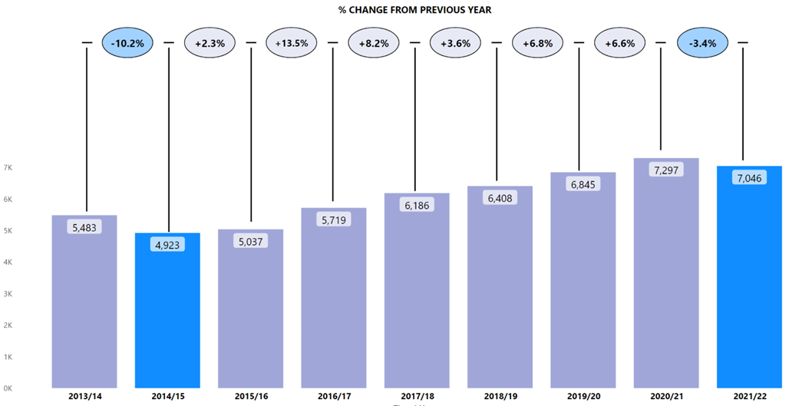
From 2014/15 to 2020/21 there was a gradual but sustained increase in the number of assaults committed against officers / staff; 2021/22 marks the first time since 2014/15 that there has been a decrease (down 3.4%) from the previous year.
The establishment of the Your Safety Matters (YSM) Police Assault Dashboard suite has enabled officers and staff to access the most accurate and up-to-date data around assaults of this kind. This has in turn led to more in-depth analysis. Through more detailed divisional criminal intelligence analysis, it has become possible to more effectively identify prolific repeat offenders, which is a potential contributory factor in the decrease in assaults against officers and staff. Please see Your Safety Matters section for further details.

Key Insight 2: Increase in ‘Use of Hands’ Type Force Applied
‘Use of Force’, for the purpose of recording, is defined as “any physical use of force, except compliant handcuffing” and ‘come along hold / escort hold’ and includes: Empty Hand Techniques, Batons, Irritant Sprays (including draws), Leg Restraints and Spit Hoods. Separate forms are completed for the use of Taser. Overall, there was an increase (+14.6%) in use of force during 2021/22 compared to the previous year. This increase is primarily down to the rise in officers / staff use of hand techniques (+22.5%), where the majority of other techniques saw decreases (-4.4%).
Police Scotland’s new Operational Safety Training programme emphasises de-escalation and aims to give officers and staff increased confidence in control of a subject when effecting an arrest. The reduction in use of other Personal Protective Equipment would suggest this approach is achieving a degree of success in directing Officer’s actions. Excluding the use of hands technique, the only other use of force technique to experience an increase was leg restraints (+4.5%). However, in 2021/22 kicking was the most used method to assault officers / staff, with kicking making up around a third (31.2%) of all assaults reported.
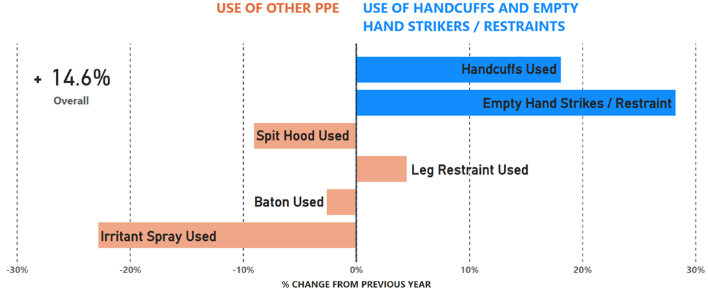

Key Insight 3: Recorded crime volumes remain at low levels
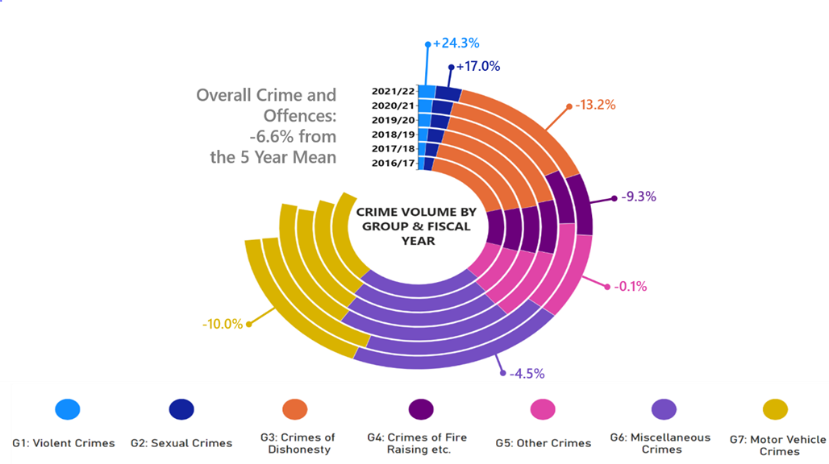Overall recorded crime in Scotland remains relatively low. The number of crimes and offences during 2021/22 (463,479) decreased very slightly from the previous year (154, 0.1%), but deviates further from the five year mean (-32,981, -6.6%).
The previous chart illustrates that five out of the seven crime groups have seen decreases longer term (highlighted percentages represent changes within those groups from the five year mean). It should be noted that if crimes related to coronavirus legislation are included in the figures, the overall decreases seen in 2021/22 are more stark, particularly from the previous year.
The five year mean has increased for ‘Group 1: Violent Crimes’ (+24.3%, 1,984.6) and ‘Group 2 Sexual Crimes’ (+17.0, 2,189.0). However, the five year mean for ‘Group 1: Violent Crimes’ is slightly skewed as the domestic abuse offences within this crime group were introduced in 2019/20. When the domestic offences are excluded there has been a +11.9% (894) increase in this crime group, largely driven by threats and extortion. Further details about these crime groups can be found in the Group 1 and Group 2 sections.

Key Insight 4: 999 average speed of answer has remained consistent despite higher volumes whilst 101 average speed of answer has risen
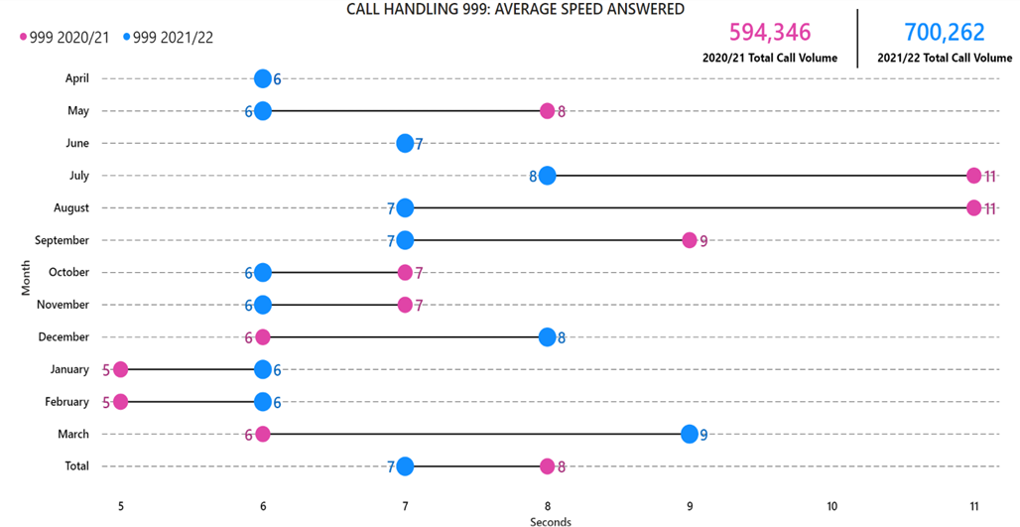
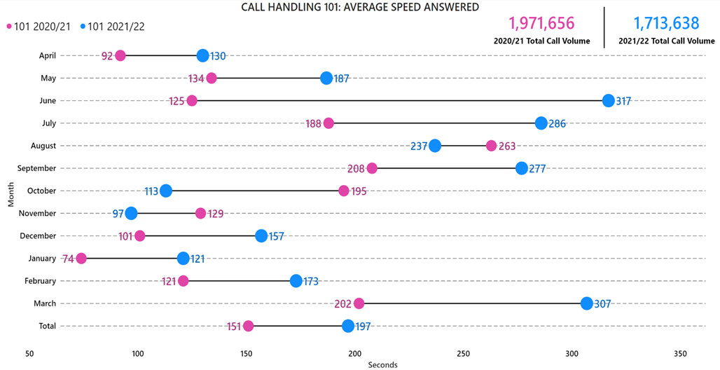The total number of calls to Police Scotland decreased by 5.9% compared to last year, however 999 calls have risen by 17.8%. Handling 999 calls are our highest priority, and throughout 2021/22 our service centres have consistently managed to maintain low average speed of answer, decreasing the average by one second compared to last year. Unfortunately, this prioritisation, alongside recognised capacity issues related to absence and pandemic related restrictions, was a factor in the increase observed in 101 average speed of answer.
C3 has been more deeply affected than other divisions by COVID-19 and the associated accommodations, due to the close seating arrangements previously in place at contact centres and the necessity of ensuring safe social distancing. Absences have also restricted our capacity, including high levels of COVID-19 absences observed into Quarter 4.
Numerous measures have been put in place to alleviate this issue and bring the average call answer time down further. These include changes to our Interactive Voice Recording (IVR) system to manage expectations at first point of contact, close monitoring of absence through a short life working group, and efforts made to signpost callers to more appropriate methods of contact. The ongoing rise in additional public contacts observed this year is viewed in part as a result of these efforts.

Public Confidence and Experience of Policing
Police Scotland’s Public Contact and Engagement Strategy sets out how we envisage our public contact and engagement activities and approaches to look now, and in the future. We have been clear in setting out what the public should expect from their police service and how we will continue to engage and involve communities and our partners. Our strategy sets out the ways in which we will seek to engage with communities so that their insights can be utilised in meaningful ways. Working in this way aims to aid operational and strategic decision-making, ensuring that Police Scotland operates using evidence-led principles in line with our values.
The Public Confidence Governance Board oversees the development of our engagement approaches to understand public confidence within communities and act on public feedback. We are paying particular attention to how we reach those who are often seldom-heard; by understanding where there are opportunities to do even better, more often and with partners who have specific and relevant expertise in key areas.

High-level overview
We continue to engage and involve the public, communities and partners in policing through our ongoing national surveys and other engagement activities:
Your Police 2021/22 survey - our refreshed local police survey for this year which builds on the great response from the public and communities. Anyone who lives in Scotland can influence local policing in their area through this survey. We use the feedback to understand public confidence, where we can improve and build on what we are doing well, and inform opportunities for partnership working and collaboration.
User Experience survey - our independent survey to enhance people’s experience of contacting Police Scotland, administered by Progressive Partnership Ltd. The survey is sent via text message to a sample of people who have made contact with police each month. This survey receives approximately 1,200 responses each month and has been recently expanded to include the people engaging with our complaints process. A new survey is in development with Specialist Crime Division (people who are victims and witnesses of serious crime) and Criminal Justice Services Division (people in police custody).
The public confidence and user experience survey insights are considered each month at the Strategic Leadership Board for executive oversight and action. Data and insights are shared with Regional Delivery Boards and local policing for improvement planning and scrutiny, and working with partners and other relevant stakeholders. Feedback and insight helped shape the Annual Police Plan for 2022/23 and work is underway to ensure that data from communities informs the development of new Local Police Plans, as engagement on their renewal commences.
Our response to public and community feedback has been to:
Improve the way we share and use data and insights within the organisation. PowerBI dashboards containing the survey data have been tested and developed with local divisions to support local policing planning, community engagement and partnership working.
Introduce a GIS Mapping tool to our Your Police survey to identify the locations and reasons communities feel less safe which will inform local partnership working and enhance police visibility. We are sharing data through Regional Delivery Boards and across our local policing divisions to support collaboration to address community concerns.
Commission social action research within seldom-heard communities to understand how we can improve our engagement practice to enhance confidence and trust. The joint research fund between Police Scotland, the Scottish Institute of Policing Research and the SPA awarded four studies which will be completed by October 2022. These include policing with empathy in conversation with LGBTQ and young people from disadvantaged backgrounds (Abertay University); refugee and asylum-seeker experiences, trust and confidence with Police Scotland (Queen Margaret University); inquiring together - collaborative research with BAME communities and serving officers (Dundee University); and, accounting for complexities - an intersectional approach to enhancing police practitioner reform (University of Glasgow).
Established reference sub-groups to implement actions for enhancing engagement within seldom-heard communities. Emerging activities include the enhancement of local communications; awareness campaign among operational colleagues to recognise and reinforce positive behaviours; the development of an engagement and participation framework which will be supported by a new resource to support operational colleagues policing in a diverse Scotland - this will be co-designed by officers, staff and the public throughout the summer of 2022.
Independent Advisory Group (IAG) on Emerging Technologies in Policing. Police Scotland is leading a work stream of the IAG focused on informed decision-making through consultation, community engagement and participation. The IAG are examining evidence and best practice to begin to develop recommendations for consideration in early 2022. The work stream led by Police Scotland has involved collaboration among expert organisations and academics in the fields of policing, digital technology, community engagement and participation. Reports will be publically available on the Scottish Government website shortly.
Respond to local needs by piloting innovative approaches to involve communities. For example, Police Scotland is working with Scottish Government and Caithness Voluntary Group to pilot a participatory grant scheme in the Caithness area within Highland and Islands Division. This will involve communities coming together to respond to local needs and inspire collective action to improve safety and wellbeing within the local area. The Research and Insight team and local policing colleagues are also supporting community development projects in Letham (Perth and Kinross) and Dunbar (East Lothian) to respond to concerns and develop approaches to our community engagement practice that can be further enhanced in the future.

Your Police 2020/21 & 2021/22
Your Police received 14,452 responses between 01 January 2022 and 31 March 2022. This included 358 British Sign Language (BSL) responses. A new campaign promoted via social media saw increased response rates during this quarter. The survey continues to be broadly representative of the population by age, gender, disability and geography. The Your Police survey influences local policing by enabling the public to highlight areas of concern, good practice and informs our approach to working with local partners. We gather data on public confidence levels through this survey.
The Research and Insight team is responsible for the design and delivery of this survey. Promotion is supported by Corporate Communications; Partnerships, Prevention and Community Wellbeing, local policing, and many external partners in maximising engagement with Scotland’s diverse communities. It is important to us that we make our public engagement activities inclusive so that our services meet the needs of the public we serve.
We are keen to ensure that the survey is reflective of best practice in research and engagement through its design. The Research and Insight team are open and collaborative and welcome public and stakeholder feedback.

Public Confidence
In 2019/20 the average public confidence level in local policing was recorded at 48% by the Your Police survey. This confidence level increased significantly in 2020/21 with an increased average public confidence level of 57%. Public confidence was then recorded as 41% in Quarter 1 of 2021/22, 38% in Quarter 2, 43% in Quarter 3 and 40% in Quarter 4.
We know from our own research and academic studies that wider public confidence and experience of contacting and interacting with police are not always connected. While confidence is likely to fluctuate, satisfaction scores gathered by our external, quality-assured, User Experience Survey remain positive and consistent. Overall satisfaction with contacting the police was 70% in Quarter 4.
Just over one third (35%) of respondents reported they ‘didn’t know’ or ‘neither agreed nor disagreed’ that they were confident in their local police. This proportion reflects that a substantial number of respondents who completed the survey had not interacted with police recently or had no opinion regarding their confidence in policing.
These findings show that although public confidence is important to measure, it is not a reliable indicator of operational performance. Service quality has remained consistent even though confidence levels have fluctuated throughout each Quarter. Public confidence is not always based on contact and engagement with police, but instead on public perception of policing and the wider policing narrative in society, nationally and internationally, at any given time.
Our findings show that confidence can be influenced by geographic and demographic factors. Whilst we capture a national level of confidence, there is much nuance within this picture. We know, for example, that people living in areas affected by poverty and where there are higher numbers of people affected by social injustice are less likely to feel confident in the police.
This is reflected across the UK and is evidenced-based. Work continues, in partnership with the Scottish Institute for Policing Research, the Centre for Policing Research and Learning, the Scottish Police Authority, and alongside community organisations to enhance our understanding of public confidence and trust in policing.
Understanding public confidence is important to us as it is one of the ways that we respond to emerging issues within communities. Maintaining confidence in policing is vital to ensure that we are policing in line with our values whilst maintaining or building trust and legitimacy for every person in our society.
Police Scotland is aware that confidence in policing is affected by events and media reports. This is likely to have had a particular impact in recent months due to a range of reported issues related to policing.
Policing in Scotland is built on our values of integrity, fairness and respect with a commitment to protecting and upholding human rights - where we police with consent and legitimacy from fellow citizens. If we are to maintain public confidence and strive to deliver high quality services that people are satisfied with then we must ensure we respond in appropriate ways to societal challenges, such as structural inequalities and violence against women and girls.
The confidence level derived from Your Police is comparable to confidence measures in the Scottish Government’s Scottish Crime and Justice Survey and from other UK policing organisations, most notably the Mayor’s Office for Policing and Crime (MOPAC).
At the start of Quarter 1 2022/23, a new Your Police survey will be launched on our Engagement Hub. ‘We Asked, You Said, We Did’ feedback for policing within local communities will also be published to reflect what has happened as a result of people taking part in our Your Police survey during 2021/22.

Factors influencing public perceptions of policing among people who feel unsafe in their local area
Survey respondents in Quarter 4 who said they feel unsafe in their local area (n=1,842) raised similar themes as in Quarter 3. The following themes remain important, on which we are taking action and using to inform local and strategic decision-making, with plans and projects for sustaining change over the long term.
Police visibility and presence
44% of respondents who felt unsafe in their local area highlighted greater police visibility as a way of making them feel safer and providing reassurance. Police presence is often mentioned within the context of prevention and targeting of drug-related crime and anti-social behaviour. The type of visibility (e.g. physical, online and virtual) was not always specified in the responses but a majority specifically mentioned physical presence including more foot patrols in local areas, at specific times (e.g. after dark/weekends) and locations (e.g. in parks, around transport hubs, and local crime ‘hot spots’) where communities tend to feel less safe.
The importance of police visibility in local areas was equally prevalent across respondents from areas of Scotland most affected by poverty (people living in SIMD 1 & 2 areas), with 57% of respondents living in these areas mentioning police visibility, compared to 26% of respondents from more affluent areas (people living in SIMD 4 and 5).
Community engagement and being kept informed
16% of respondents who felt unsafe in their local area highlighted communicating what we are doing as important. Respondents identified taking action on local issues as one of the key communication priorities. The public expect police to react promptly to reports and would like to be informed about when and if police are attending. Respondents also want to be updated on the course of action of their incident. This suggests a need to educate and manage public expectations about how police respond to incidents to effectively manage threat, risk and harm for individuals and the public.
15% of respondents who felt unsafe in their local area highlighted community policing and local engagement as important. This is highlighted alongside police visibility by respondents - for example, informal and friendly conversations with police officers on what matters to communities in local areas. Respondents highlight the importance of policing being accessible locally, having staff who are familiar with local needs and for training to be relevant to the specific issues affecting local communities. The public would like to be familiar with local officers and seek effective and trusting relationships with their local police officers.
7% of respondents who felt unsafe in their local area highlighted that how we ‘show up’ is important. Police officers and staff should continue to always bring empathy and understanding to their interactions with the public. Respondents expect people working in Police Scotland to be adequately trained, caring and professional. This includes cultural intelligence in understanding the lived experiences of communities. Respondents refer to how we are building trust and positive changes within minority, marginalised or excluded communities.
Work is progressing through our Public Confidence Governance Board to respond to these concerns in local areas.

Main areas of concern for local communities
There were 11,701 responses in Quarter 4 to the open-ended question – “What, if anything, worries you about your local area?” The common themes that emerged from analysis of these responses are set out as follows:
36% of respondents mention anti-social behaviour with alcohol, littering / fly tipping, young people causing disturbances and noise complaints. It’s important to have clear and accessible signposting to support and connect individuals with the right services delivered by a range of community partners. People may ask police to help with matters which are important to them, but we may not be the best service or be able to help in ways which are required. Police Scotland is committed to improving outcomes for people.
33% of respondents mention drug crime and related harms – the presence and effects of drugs within local communities and how local police are tackling drug dealing is crucial for community safety. The increased visibility of drug dealing and drug taking, particularly during the pandemic, has been a consistent theme over previous quarters, too.
18% of responses highlight speeding and driving related offences – ‘boy racers’, motorised scooters and dirt bikes were cited by respondents who also commonly express their concerns with speeding and reckless driving in their local area.
11% of respondents are concerned with little physical presence of the police – people would like to see regular foot and cycle patrols in their local areas. Several comments mentioned the need for police being visible and easily accessible within local communities.
9% of respondents express concern about local theft and break ins and want to be aware of the preventative measures they can take to keep their homes and businesses safe.

What we are doing well:
Your Police enables the public to tell us about our approach, which includes what we are doing well and getting right. The following key areas are highlighted in Quarter 4:
Consistent service delivery in the difficult circumstances policing is operating in. There is appreciation for local policing and the job they do within local communities to keep people safe. People also like that police are friendly and approachable.
Increased visibility and presence in the areas which require this approach. Many responses commend the enhanced visibility of police in their local area over recent months and highlight this as positive.
Increased responsiveness to reported issues. Responses indicate an increased response speed and appropriate reaction to reported incidents / crimes.
Value of community engagement. Respondents highlight the value of community policing and what community officers are doing to understand and tackle challenges in local areas together with partners and communities.
Our social media presence. Respondents point out the communication-enhancing role of social media, expressing appreciation for the guidance and updates that inform the public about the local initiatives.
Crime prevention and protecting people who may be vulnerable. Respondents appreciate the police response to domestic violence, harassment, and mental health crises - pointing out the support and protection available from police to people who are sometimes more vulnerable.

User Experience Survey

How the public are experiencing their police service
The User Experience Survey, administered by Progressive Partnership Ltd, reaches a representative sample of 1,200 individuals monthly. The survey is delivered via SMS to those who have contacted Police Scotland in the previous month. In this quarter, 3,927 respondents were surveyed about their experience of the policing service provided, from initial contact through to overall satisfaction.
The findings show continued high levels of satisfaction with contacting the police as follows:
Ease of contact – 76%
Initial contact treatment by C3 staff – 87%
Feeling properly understood – 89%
Being provided with the appropriate response – 68%
Satisfaction with attending officers – 83%
Feeling adequately informed about case progress – 59%
Overall satisfaction with Police Scotland – 70%

Measures of Progress towards Strategic Outcomes

Strategic Outcome: Threats to public safety and wellbeing are resolved by a proactive and responsive police service

Police Scotland’s objectives are to:
Keep people safe in the physical and digital world
Design services jointly to tackle complex public safety and wellbeing challenges
Support policing through proactive prevention
All data is classed as Management Information and is not considered official statistics. All data is sourced from Police Scotland internal systems.

Violent Crime

Overall Violent Crime
Overall Violent Crime – number of crimes: There were 57,369 crimes in 2020/21 and 63,789 crimes in 2021/22 with the percentage change from the previous year being plus 11.2%. The five year mean was 62,482.0 crimes with the percentage change from the five year mean being plus 2.1%.
Overall Violent Crime – number of detections: There were 41,633 detections in 2020/21 and 43,529 detections in 2021/22 with the percentage change from the previous year being plus 4.6%. The five year mean was 43,961.0 detections with the percentage change from the five year mean being minus 1.0%.
Overall Violent Crime – detection rate: The detection rate was 72.6% in 2020/21 and 68.4% in 2021/22 with the percentage point change from the previous year being minus 4.3 percentage points. The five year mean detection rate was 70.4% with the percentage point change from the five year mean being minus 2.1 percentage points.
Note: Overall violent crime is comprised of: murder, culpable homicide (common law), attempted murder, serious assault, robbery, common assault and common assault (of emergency workers).
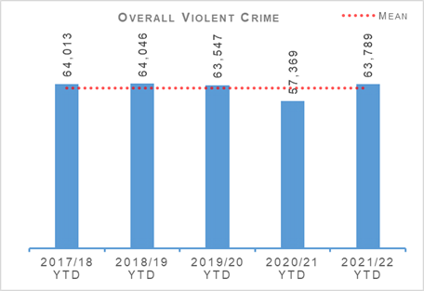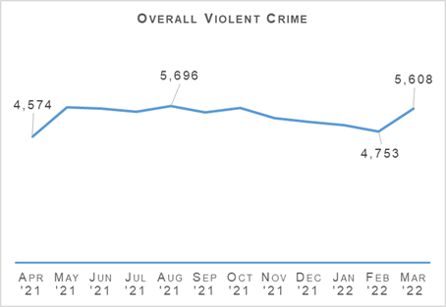
Overall violent crime levels for the year were broadly similar to those seen between 2017/18 and 2019/20 as well as the five year mean. Last year saw lower levels of overall violent crime than usual across the previous five years largely due to the impact of COVID-19 related lockdowns. While 4.6% more violent crime has been detected compared to last year, due to the increased numbers of recorded crimes the detection rate has decreased by 4.3 percentage points to 68.2%.
There were 51 homicides recorded during 2021/22 – 48 murders and 3 culpable homicides (common law). This is ten fewer homicides than was recorded last year and the lowest number of recorded homicides in any given year since the inception of Police Scotland. There has also been fewer attempted murders recorded this year, 264 crimes compared to 290 crimes last year (9.0% fewer) and the five year mean of 268.2 crimes (1.6% fewer).
Common assaults account for the majority (91.4%) of crimes counted under overall violence with. The 58,306 crimes, of which 7,858 (13.5%) were committed against emergency workers, is an increase of 12.0% compared to last year. The closure of licensed premises and large events last year due to COVID-19 did contribute to significantly lower levels of common assault than is typical. When compared to the five year mean, this year saw an increase in recorded common assaults of 2.9%.
Serious assaults have increased by 8.5% from last year however are 8.0% lower than the five year mean and robberies are down 4.3% from last year and down 1.6% from the five year mean.
Since coming into effect in August 2021, 1,924 crimes have been recorded under the Protection of Workers (Retail and Age-restricted Goods and Services) (Scotland) Act 2021. Most of these (1,130) were crimes of threatening or abusive behaviour of a retail worker. A further 786 involved common assault of a retail worker. There have been eight serious assaults of retail workers also recorded under the new legislation.
Police Scotland’s Violence Prevention and Licensing Coordination Unit (VPLCU) continue to engage with Scottish Government surrounding the implementation of the Offensive Weapons Act 2019. This will expand the range of items that can be deemed an offensive weapon, creates a new criminal offence of possessing a corrosive substance in a public place and the sale of corrosive substances, and will include a provision to allow the surrender of weapons newly deemed criminal. The Scottish Government will publish details and guidance for the surrender and compensation scheme at the end of June 2022 with the intention that the weapons surrender campaign will run from 01 July 2022 to 30 September 2022.
VPLCU have established an implementation group to ensure all impacted business areas are prepared to deliver the surrender campaign and enforcement of new weapons offences. Training and communications messaging are currently being prepared and will be circulated in advance of implementation of relevant offences in June 2022.

Non Sexual Crimes of Violence (Group 1)
Non Sexual Crimes of Violence (Group 1 Crime) – number of crimes: There were 9,039 crimes in 2020/21 and 10,137 crimes in 2021/22 with the percentage change from the previous year being plus 12.1%. The five year mean was 8,152.4 crimes with the percentage change from the five year mean being plus 24.3%.
Non Sexual Crimes of Violence (Group 1 Crime) – number of detections: There were 6,520 detections in 2020/21 and 6,524 detections in 2021/22 with the percentage change from the previous year being plus 0.1%. The five year mean was 6,020.6 detections with the percentage change from the five year mean being plus 8.4%.
Non Sexual Crimes of Violence (Group 1 Crime) – detection rate: The detection rate was 72.1% in 2020/21 and 64.4% in 2021/22 with the percentage point change from the previous year being minus 7.8 percentage points. The five year mean detection rate was 73.9% with the percentage point change from the five year mean being minus 9.5 percentage points.
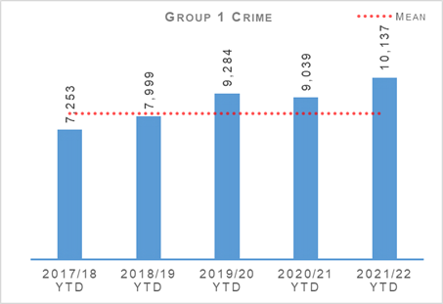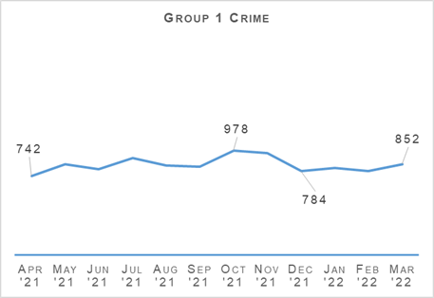
Non sexual crimes of violence increased by 12.1% compared to last year. This is the highest level in recent years and 24.3% above the five year mean. With crimes such as homicide, attempted murder and robbery all down and serious assaults also down across the longer term, it is other Group 1 crime types that are driving this increase.
There were 1,760 crimes recorded under the Domestic Abuse (Scotland) Act. While Domestic Abuse is covered later in this report (Link to Domestic Abuse section) it is worth noting that these crimes have only been recorded since 2019/20 which also skews any comparison to the five year mean for Group 1 crimes. If DASA crimes are not counted then total Group 1 crime has gone up 11.9% (894 crimes) against the five year mean. The largest drivers for this increase is threats and extortion, and crimes of drugging.
1,398 crimes of threats and extortions were recorded in 2021/22 – an increase of 48.3% from last year and of 187.5% from the five year mean. Changes in recording standard brought in at the start of last year and increased time spent online by people during the pandemic are the key drivers in this crime type increasing over the last two years and likely to increase further given trends in online offending.
There were 444 crimes of drugging reported to Police Scotland this year compared to 18 last year and a five year mean of 18.8. The vast majority occurred in Quarter 3, following national media reporting of concern around drugging by injection in licensed premises across the UK and the sharing of information via social media. As reported in our Quarter 3 Performance Report, Police Scotland took rapid and appropriate action to mitigate this threat and reassure members of the public.
The command structure for Police Scotland’s response to this issue (Operation Precept) stood down in February 2022, links with internal and external partners having been well established and lines of communication remaining open as and when required. The investigative processes and governance have now been established as business as usual. The nature of the structure itself is such that it can be stood up again if and when the need arises. The updated position was presented to the SPA Policing and Performance Committee in March 2022. Work is also ongoing to formulate a national approach ahead of Fresher’s Week 2022.

Public Protection – Equality Outcome 4

Overall Sexual Crimes (Group 2 Crime)
Overall Sexual Crimes (Group 2 Crime) – number of crimes: There were 13,239 crimes in 2020/21 and 15,049 crimes in 2021/22 with the percentage change from the previous year being plus 13.7%. The five year mean was 12,860.0 crimes with the percentage change from the five year mean being plus 17.0%.
Overall Sexual Crimes (Group 2 Crime) – number of detections: There were 7,706 detections in 2020/21 and 8,055 detections in 2021/22 with the percentage change from the previous year being plus 4.5%. The five year mean was 7,489.6 detections with the percentage change from the five year mean being plus 7.5%.
Overall Sexual Crimes (Group 2 Crime) – detection rate: The detection rate was 58.2% in 2020/21 and 53.5% in 2021/22 with the percentage point change from the previous year being minus 4.7 percentage points. The five year mean detection rate was 58.2% with the percentage point change from the five year mean being minus 4.7 percentage points.
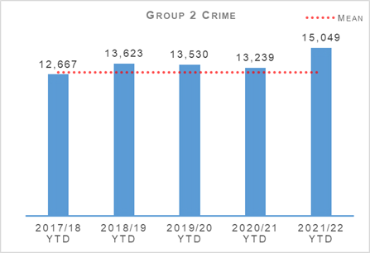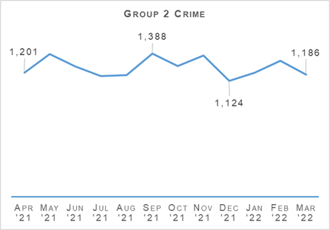
The number of recorded sexual crimes in 2021/22 was the highest figure experienced over the last six years.
Between April 2021 and March 2022, Group 2 crimes have risen by 13.7% (1,810 crimes) when compared to last year and by 17.0% compared to the five year mean. September recorded the highest number of Group 2 crimes (1,388 crimes) during any month over the 12 month period. December recorded the lowest number of Group 2 crimes (1,124 crimes) during any month over the 12 month period.
The number of detections of Group 2 crimes also increased, up 4.5% (349 detections) compared to last year and 7.5% on the five year mean.
Sexual assault and rape of females continue to be the main drivers for the overall increase in sexual crime. Coercing a person into being present/looking at sexual activity, communicating indecently and disclosure of an intimate image also noted increases compared to last year. Voyeurism continues to increase significantly against last year and previous years.

Recent / Non Recent Overall Sexual Crimes (Group 2 Crime)
Overall Sexual Crimes (Group 2 Crime) – number of recent crimes: There were 9,801 recent crimes in 2020/21 and 11,574 recent crimes in 2021/22 with the percentage change from the previous year being plus 18.1%. The five year mean was 9,487 recent crimes with the percentage change from the five year mean being plus 22.0%.
Overall Sexual Crimes (Group 2 Crime) – number of non-recent crimes: There were 3,438 non recent crimes in 2020/21 and 3,475 non recent crimes in 2021/22 with the percentage change from the previous year being plus 1.1%. The five year mean was 3,373 non recent crimes with the percentage change from the five year mean being plus 3.0%.
Overall Sexual Crimes (Group 2 Crime) – proportion of group 2 crime that were non recent: The proportion of non-recent Group 2 crimes was 26.0% in 2020/21 and 23.1% in 2021/22 with the percentage point change from the previous year being minus 2.9 percentage points. The proportion of non-recent Group 2 crimes over the five year mean was 26.2% with the percentage point change from the five year mean being minus 3.1 percentage points.
Note: Non-recent sexual crimes are defined as crimes that were reported more than one year after they were committed.
Recent and non-recent Group 2 crimes increased against the previous year and the five year mean, however as a proportion, non-recent crimes have decreased. This is in line with analysis we have reported previously, demonstrating that the rise in Group 2 crimes is being driven primarily by recent reporting.
Recent crimes are classed as any crime that occurred within one year of reporting, however 64.2% of recent crimes were reported within one week of them being committed and just under half of recent crimes (49.5%) were reported within two days of being committed. Recent Group 2 crimes continue to drive the overall increase in sexual crime.
The majority of divisions across the Force saw an increase in recent Group 2 crimes compared to last year. This increase is driven by higher numbers of rape, sexual assault of females in all age categories, communicating indecently, voyeurism, coercing a person into being present/looking at sexual activity, conspiracy to commit sexual acts outside the UK and sexual assault of males over 16 years. The volume of contact sexual offending continued to rise throughout 2021/22.
A comprehensive review of the national policing response to Public Protection has been commissioned and will become a programme of work to improve national and local approaches, enabling Police Scotland to continue to adapt and respond to shifting demand and vulnerabilities. The first phase will establish the ‘As is’ and a comprehensive demand profile with key milestones identified during 2022.

Rape
Rape – number of crimes: There were 2,190 crimes in 2020/21 and 2,370 crimes in 2021/22 with the percentage change from the previous year being plus 8.2%. The five year mean was 2,122.0 crimes with the percentage change from the five year mean being plus 11.7%.
Rape – number of detections: There were 1,294 detections in 2020/21 and 1,275 detections in 2021/22 with the percentage change from the previous year being minus 1.5%. The five year mean was 1,168.2 detections with the percentage change from the five year mean being plus 9.1%.
Rape – detection rate: The detection rate was 59.1% in 2020/21 and 53.8% in 2021/22 with the percentage point change from the previous year being minus 5.3 percentage points. The five year mean detection rate was 55.1% with the percentage point change from the five year mean being minus 1.3 percentage points.
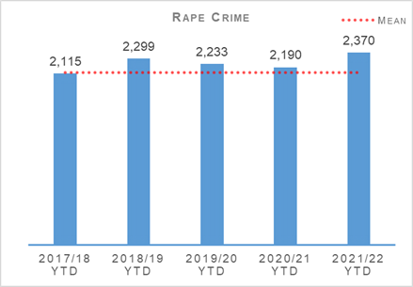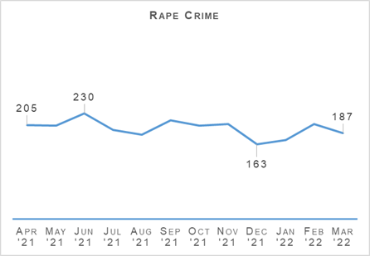
The number of reported rapes increased by 8.2% (180 crimes) against last year and by 11.7% against the five year mean. When compared to the same period in 2019/20, an increase of 6.1% (137 crimes) was noted. The number of rapes reported each month peaked in June 2021 with 230 crimes. The lowest month in the previous 12 month period was in December 2021 with 163 crimes.
During the reporting period, the number of rape detections have increased by 106.8 detections (9.1%) compared to the five year average.
Engagement with survivor groups across the Violence Against Woman and Girls network to listen to survivor feedback continues. Since April 2021, Police Scotland has received feedback from 482 rape survivors, 83.9% of which was positive. Feedback was sought in respect of our communication and engagement, explanation of the process, support provided and compassion / empathy demonstrated by our officers.
Police Scotland currently obtain feedback from those survivors who have been provided support from the Rape Crisis Scotland (RCS) helpline. The National Rape Review Team (NRRT) is in discussion with RCS to expand the feedback process to include those survivors who are supported via the National Advocacy Project and the various RCS offices throughout the Force. The NRRT is also looking to revise the process in regard to when the feedback is obtained from the survivor, for example at various points throughout the investigation. This will provide Police Scotland with qualitative information throughout the police investigation.
Any learning opportunities identified from the survivors’ feedback are used to improve the investigation of sexual offences and inform our national response.

Recent / Non Recent Rape Crimes
Rape – number of recent crimes: There were 1,221 recent crimes in 2020/21 and 1,425 recent crimes in 2021/22 with the percentage change from the previous year being plus 16.7%. The five year mean was 1,259 recent crimes with the percentage change from the five year mean being plus 13.2%.
Rape – number of non-recent crimes: There were 969 non recent crimes in 2020/21 and 945 non recent crimes in 2021/22 with the percentage change from the previous year being minus 2.5%. The five year mean was 863 non recent crimes with the percentage change from the five year mean being plus 9.5%.
Rape – proportion of rape crimes that were non recent: The proportion of non-recent rape crimes was 44.2% in 2020/21 and 39.9% in 2021/22 with the percentage point change from the previous year being minus 4.3 percentage points. The proportion of non-recent rape crimes over the five year mean was 40.7% with the percentage point change from the five year mean being minus 0.8 percentage points.
Note: Non-recent rape crimes are defined as crimes that were reported more than one year after they were committed.
Non-recent reporting of rape has decreased by 2.5% (24 crimes) compared to last year. The proportion has also decreased, by 4.3%.
The number of recent rapes increased by 16.7% (204 crimes) against last year and by 13.2% against the five year mean. A total of 49.4% of recent rapes were reported within one week of them being committed. Rape of a female over 16 and rape of a female aged between 13 and 15 years are the drivers for the increase in recent rapes accounting for over 90% of the recent rape crimes (74.7% and 15.4% respectively).

Child Sexual Abuse (online)
Child Sexual Abuse (online) – number of crimes: There were 2,059 crimes in 2020/21 and 1,918 crimes in 2021/22 with the percentage change from the previous year being minus 6.8%. The five year mean was 1,723.4 crimes with the percentage change from the five year mean being plus 11.3%.
Child Sexual Abuse (online) – number of detections: There were 1,319 detections in 2020/21 and 1,200 detections in 2021/22 with the percentage change from the previous year being minus 9.0%. The five year mean was 1,178 detections with the percentage change from the five year mean being plus 1.9%.
Child Sexual Abuse (online) – detection rate: The detection rate was 64.1% in 2020/21 and 62.6% in 2021/22 with the percentage point change from the previous year being minus 1.5 percentage points. The five year mean detection rate was 70.1% with the percentage point change from the five year mean being minus 7.5 percentage points.
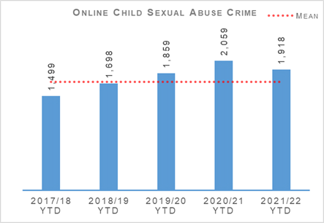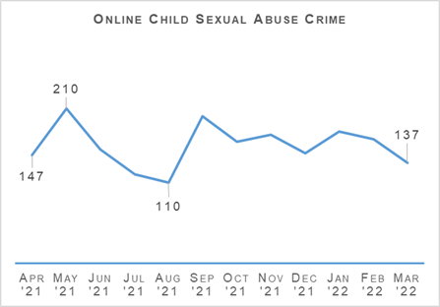
To date, 1,918 online child sexual abuse crimes were recorded, a decrease of 6.8% (141 fewer crimes) compared to last year and an increase of 11.3% on the five year mean. The number of crimes reported monthly reached the lowest point in the 12 month period in August 2021. The month of September 2021 recorded the second highest number of child sexual abuse crimes in the 12 month period. The detection rate of online CSA noted a decrease compared to last year, down 1.5 percentage points.

Child Sexual Abuse (Crime Types)
Cause to be Present Sex Act/To Look at Sex Image Male/Female under 13: There were 348 crimes in 2020/21 and 364 crimes in 2021/22 with the percentage change from the previous year being plus 4.6%. The five year mean was 294.0 crimes with the percentage change from the five year mean being plus 23.8%.
Cause to be Present Sex Act/To Look at Sex Image Male/Female 13-15: There were 198 crimes in 2020/21 and 164 crimes in 2021/22 with the percentage change from the previous year being minus 17.2%. The five year mean was 164.4 crimes with the percentage change from the five year mean being minus 0.2%.
Communicate Indecently/Cause see/hear Indecent Comms Male/Female under 13: There were 363 crimes in 2020/21 and 367 crimes in 2021/22 with the percentage change from the previous year being plus 1.1%. The five year mean was 275.2 crimes with the percentage change from the five year mean being plus 33.4%.
Communicate Indecently/Cause see/hear Indecent Comms Male/Female 13-15: There were 313 crimes in 2020/21 and 268 crimes in 2021/22 with the percentage change from the previous year being minus 14.4%. The five year mean was 265.6 crimes with the percentage change from the five year mean being plus 0.9%.
Grooming of children for the purposes of sexual offences: There were 58 crimes in 2020/21 and 93 crimes in 2021/22 with the percentage change from the previous year being plus 60.3%. The five year mean was 80.6 crimes with the percentage change from the five year mean being plus 15.4%.
Taking, distribution, possession etc. of indecent photos of children from April 2011: There were 779 crimes in 2020/21 and 662 crimes in 2021/22 with the percentage change from the previous year being minus 15.0%. The five year mean was 643.6 crimes with the percentage change from the five year mean being plus 2.9%.
Taking, distribution, possession etc. of indecent photos of children (from Apr 2011) accounts for the largest proportion of child sexual abuse crimes (34.5%). This crime type along with Cause to be Present Sex Act/Look at Sex Image M&F (13-15) and Communicate Indecently/Cause see/hear Indec Comm – M&F (13-15) have all noted decreases compared to last year. Communicate Indecently/Cause see/hear Indec Comm – M&F (<13) noted the largest increase on the five year mean, up 33.4%.
Police Scotland continues to provide extensive contribution to a number of significant multi-agency strategic improvement programmes within child protection. Firstly, the National Joint Investigative Interview Project (a multi-agency programme developed and delivered by Police Scotland, Social Work Scotland and COSLA) is now in its second year of training delivery and is live in practice within a number of local authority areas / policing divisions where feedback has been overwhelmingly positive in terms of victim experience.
In addition, Police Scotland is a key partner in the National Child Protection Guidance Improvement Plan for Interagency Referral Discussion (IRD) policy and practice. As joint co-chair of the IRD sub group, Police Scotland is working with partners and Scottish Government to convert the existing Police Scotland IRD training into a multi-agency programme.
Both of these aforementioned projects will provide the essential baseline requirements for development of the Scottish Government’s Bairns’ Hoose, a child friendly environment where victims of child abuse will attend to receive multi-agency support from start to finish through the criminal justice process. All of these programmes’ aims and objectives are designed to improve our child protection response and the experience of child victims many of whom are CSAE victims.

Get Help or Get Caught
During 2021/22, two further phases of the #GetHelpOrGetCaught online grooming campaign were implemented. This saw a further 32,000 unique individuals visit the Stop It Now! website from Scotland (the actual figure is probably significantly higher however accurate measurement is not possible due to cookie control opt-outs).
The campaign was also recognised in three national creative and marketing awards. In the Roses UK Creative Awards the campaign won two Gold awards and the Chairman's Award for best first time entry. In the Marketing Society Scotland Star Awards – it won a Silver in the Marketing in Society category. The campaign was also nominated in the international PR Week Purpose Awards.

Domestic Abuse
Domestic Abuse – number of incidents: There were 64,191 incidents in 2020/21 and 63,093 incidents in 2021/22 with the percentage change from the previous year being minus 1.7%. The five year mean was 60,846.4 incidents with the percentage change from the five year mean being plus 3.7%.
Domestic Abuse – number of crimes: There were 41,439 crimes in 2020/21 and 40,221 crimes in 2021/22 with the percentage change from the previous year being minus 2.9%. The five year mean was 38,657.6 crimes with the percentage change from the five year mean being plus 4.0%.
Domestic Abuse – number of detections: There were 29,045 detections in 2020/21 and 27,081 detections in 2021/22 with the percentage change from the previous year being minus 6.8%. The five year mean was 26,954.8 detections with the percentage change from the five year mean being plus 0.5%.
Domestic Abuse – detection rate: The detection rate was 70.6% in 2020/21 and 66.9% in 2021/22 with the percentage point change from the previous year being minus 3.8 percentage points. The five year mean detection rate was 69.8% with the percentage point change from the five year mean being minus 2.9 percentage points
Domestic Abuse – proportion of incidents resulting in a crime: The proportion of incidents resulting in a crime was 43.6% in 2020/21 and 42.8% in 2021/22 with the percentage point change from the previous year being minus 0.8 percentage points. The proportion of incidents resulting in a crime over the five year mean was 45.7% with the percentage point change from the five year mean being plus 2.9 percentage points.
Domestic Abuse – DASA of female – number of crimes: There were 1,567 crimes in 2020/21 and 1,627 crimes in 2021/22 with the percentage change from the previous year being plus 3.8%. Five year mean figures are not yet available for this crime type.
Domestic Abuse – DASA of male – number of crimes: There were 94 crimes in 2020/21 and 133 crimes in 2021/22 with the percentage change from the previous year being plus 41.5%. Five year mean figures are not yet available for this crime type.
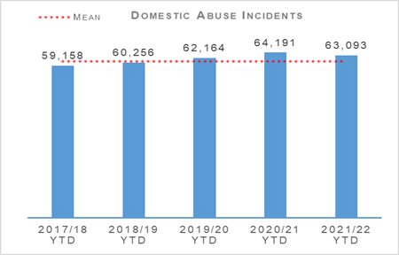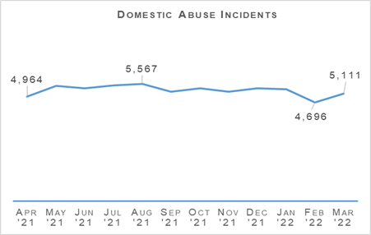
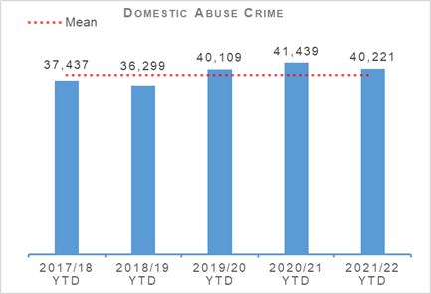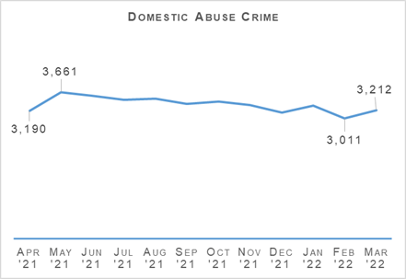
The number of domestic incidents decreased by 1.7% (1,098 less incidents) compared to last year, however increased by 3.7% compared to the five year mean. Domestic crimes also noted a decrease, down by 2.9% (1,218 less crimes) compared to last year. Domestic crimes have shown a decreasing trend since the highest number recorded in May (3,661 crimes). During the 12 month period, recorded domestic incidents were highest in the month of August (5,567 incidents).
The number of DASA crimes continue to increase compared to last year with DASA of a female increasing by 3.8% (60 crimes) and DASA of a male increasing by 41.5% (39 crimes).
Throughout the reporting period ten murders are assessed to be domestic related, compared to six during the same period last year.
At an operational level, Police Scotland utilises a ‘three tiered approach’ response to the policing of domestic abuse; local operational policing, divisional specialist domestic abuse investigation officers and national Domestic Abuse Task Force / Coordination Unit. This established tiered approach ensures domestic abuse victims across Scotland received a police response tailored to the particular circumstances of their case.
During 2021/22, Police Scotland’s Domestic Abuse Task Force progressed over 200 investigations across the country into high risk serial perpetrators of domestic abuse. Although some perpetrators have yet to be sentenced for their crimes, cumulatively, they were charged with over 300 crimes and received custodial sentences in excess of 100 years, some receiving true life sentences in the form of Orders for Lifelong Restriction (OLR) for their crimes.
Police Scotland continues to drive primary, secondary and tertiary prevention activity through the use of the Disclosure Scheme for Domestic Abuse Scotland, protection of victims through participation in Multi-Agency Risk Assessment Conferences (MARACs) and the targeting of high risk offenders through the Multi-Agency Tasking and Coordination (MATAC) process. Disclosure Scheme for Domestic Abuse Scotland (DSDAS) applications have increased by 12.4% overall with a 6.2% increase in Power to Tell (PTT) applications and a 30.3% increase in Right to Ask (RTA) applications compared to the same period last year.
Police Scotland contributed towards changing societal attitudes regarding Domestic Abuse, through supporting the 2021 16 Days of Activism campaign and creating high profile awareness campaigns including the Domestic Abuse campaign, launched on 20 December 2021. The aim of the Domestic Abuse campaign was to warn potential perpetrators and to encourage reporting of domestic abuse across Scotland. It also sought to motivate bystanders such as friends and relatives to report concerns for people who may be at risk of domestic abuse by any of the mechanisms available: either by calling police direct, reporting to support agencies or requesting a disclosure under the Disclosure Scheme for Domestic Abuse Scotland. Campaign phraseology and key messaging across multiple online and offline platforms included ‘Domestic abuse is everybody’s business’, ‘Reporting domestic abuse could save a life’ and #ReportDomesticAbuse.
The campaign approach reflects Police Scotland’s wider approach to tackling violence against women and girls providing reassurance to the public, communities and partner services that effective responses to domestic abuse remained a high priority for Police Scotland.

Human Trafficking
From 2020 onwards, the operating environment has proved particularly challenging as a result of changing working practices brought about by the COVID-19 restrictions. Engagement between Police Scotland and partners was recognised as a priority to tackle the increased risks posed to Potential Victims of Trafficking (PVoT) due to visibility in the community and legitimate work opportunities decreasing. As the COVID-19 restriction period progressed, trends in the number and make up of National Referral Mechanisms (NRMs) were closely scrutinised. Threat assessments highlighted that factors including COVID-19 restrictions and the UK leaving the European Union would effectively make victims of Human Trafficking and Exploitation (HT&E) less visible. There was an increase in reporting of potential victims of trafficking in the agricultural, off shore and on shore fishing sectors as the COVID-19 restriction period progressed which lead to several multi-agency investigations. Evidence from the investigations suggested that PVoT had previously been exploited in other sectors including nail bars and forestry or had been moved from off shore to on shore exploitation.
To mitigate the threat, risk and harm, Police Scotland’s response included:
External Communications via the Scottish Business Resilience Centre (SBRC) to those businesses involved in food supply / delivery and retail chains reminding them of the importance to undertake due diligence when hiring workers or agency staff and recognise the signs of potential HT or exploitation. The SBRC reached an audience of businesses with a combined staff of around 1.4 million.
Liaison with Gangmasters Labour Abuse Authority to seek information / intelligence in respect of the impact of COVID-19 on PVoTs involved in labour exploitation and to flag concerns over potential exploitation stemming from use of agencies without adequate oversight and due diligence checks due to the speed and nature of their needs.
Engagement with Police Scotland Safer Communities to liaise with homeless services and charities to be aware of PVoT using their services.
Establish from Scottish Local Authorities (COSLA) and Environmental Health Teams information available regarding houses of multiple occupancy. COSLA distributed a briefing produced by Police Scotland to the Chief Executives of all Scottish Local Authorities who then agreed to disseminate this to Housing Officers.
Execute Operation PERCEPTIVE which directly targeted labour exploitation in the Agriculture, Forestry and Fishing sectors. Officers visited over 50 premises, covering more than 5,000 staff and gathering information on 26 gangmasters to seek out PVoT and potential exploiters. The visits also served to improve the intelligence picture around labour requirements, sourcing and human trafficking indicators.
- Engagement with Police Scotland Safer Communities to liaise with homeless services and charities to be aware of PVoT using their services.
Since 2014, Vietnamese nationals have been the most frequently encountered nationality in the NRM in Scotland. To help address and understand the reasons for this situation, two Vietnamese Police Officers were seconded to Police Scotland for a six month period. The insight into Vietnamese culture, travel and migration patterns that the officers have provided has proven invaluable. The secondment provided Police Scotland with a unique learning experience and provides opportunities for further such exchanges in the future. A further secondment for Romanian Police Officers is in the planning stage by SCD International Unit. It is hoped that officers can be embedded within Police Scotland and provide assistance to the NHTU later in 2022.

’Break the Chain’ Campaign
A five week long labour exploitation media campaign entitled ‘Break the Chain’ was launched on 31 March 2021, highlighting modern slavery and its indicators. The campaign included TV advertising, national and local print media, social media and an internal awareness raising campaign using the #EndLabourExploitation. The campaign was launched through a webinar hosted by the Scottish Business Resilience Centre (SBRC) and featured speakers from the Modern Slavery Organised Crime Unit, Police Scotland, SBRC and the Scotland Against Modern Slavery Lead from Brightwork Recruitment.
The campaign was also supported by a dedicated webpage where additional information was made available to the general public and has received positive comment from the Independent Anti-Slavery Commissioner, elected members and Unseen, the charity which supports the Modern Slavery Helpline. The campaign has resulted in two major enquiries into labour exploitation including an operation which saw arrests for labour exploitation in farming of Romanian nationals and is the largest labour exploitation safeguarding operation for Police Scotland to date. The campaign has resulted in a steady increase in reporting of labour exploitation via our partners, businesses and the Modern Slavery Helpline.
Police Scotland and Justice and Care are working in partnership by exploring new ways to engage with and improve outcomes for victims of trafficking and exploitation with the appointment of two Victim Navigators within the NHTU. The secondments form part of a network of national and international navigators who offer additional support to victims of trafficking and exploitation, building confidence in and assisting them to engage with the criminal justice process.

Drugs Harm / Supply

Drugs Related Deaths
Police Scotland continues to work hard at fulfilling its duty to ensure the safety and wellbeing of all people within our communities. Tackling substance use and the harms they cause is complex, with COVID-19 restrictions having further exacerbated the issue through disruption to addiction services, poverty due to economic difficulties, and mental health vulnerabilities as a result of isolation.
Recent increases in the cost of living will have unfortunately compounded these issues further. It is acknowledged that it is necessary to adopt a public health, whole system approach, working alongside multiple external agencies to address longstanding issues and improve the life chances of individuals we interact with frequently.
Our focus in the area of drug related deaths is on identifying primary prevention and intervention opportunities, and working with partners to reduce the harm caused by substance use to individuals and communities.
These aims are forwarded through major internal and external forums such as the National Drug Strategy Board, the Drug Harm Prevention Group, and the multiagency Scottish Drugs Deaths Taskforce, whilst numerous other work streams continue across the force and are detailed as follows.

Naloxone Awareness Cards
Since the development of the Naloxone Awareness Cards, these continue to be distributed across Police Scotland for officers to issue to people who may be at risk or know someone with problematic drug issues and/or likely to suffer the effects of a drug overdose.
Police Scotland’s national carriage of naloxone will also see all front line officers equipped with a naloxone awareness card within their naloxone pouch.
Raising awareness in relation to Take Home Naloxone (THN) kits within general circulation remains a priority for Police Scotland. The distribution of the naloxone awareness cards provides people with the correct medical guidance when aiding someone who has suffered an opiate / opioid overdose, potentially saving a life.
To date, over 90,000 THN kits have been issued throughout local communities since the start of the programme. Partner agencies continue to provide positive feedback received by members of the public or people who may be at risk of an overdose in relation to the naloxone awareness cards.

Drug Related Death Dashboard
In January 2021, the Scottish Government announced a National Mission to reduce Scotland’s drug death rates. Part of this commitment was to improve data and surveillance. Police Scotland and the National Records for Scotland now provide the Scottish Government information to produce a public facing drug related death dashboard. This information is provided on a quarterly basis, one quarter in arrears.
The information provided relates to local policing division, sex and age group. The broad parameters set mitigate the risk of personal identification whilst still providing a more current picture of issues and trends. This provides partners, working in the drug treatment and harm prevention roles, a greater opportunity for earlier intervention and affords them the opportunity to align their substance harm prevention work streams to current issues.
The latest drug related death dashboard was published by the Scottish Government on 15 March 2022 and provided the following information:
The number of suspected drug deaths between January and December 2021 was 1,295. This was lower than the same period of 2020 where 1,411 suspected drug deaths were recorded. While the rolling annual total of suspected drug deaths has fallen over recent quarters, suspected drug deaths remain at a high level.
Over the calendar year 2021:
There were 1,295 suspected drug deaths, 8% (116) fewer than during the same period of 2020.
Males accounted for 73% of suspected drug deaths. This compares with 76% during 2020.
There were 356 suspected drug deaths of females, an increase of 3% (11) compared with 2020.
Over two thirds (67%) of suspected drug deaths were of people aged between 35 and 54.
There were 68 suspected drug deaths in the under 25 age group, 23% (20) fewer than during 2020.
The Police Divisions with the greatest number of suspected drug deaths were: Greater Glasgow Division (328); Lanarkshire Division (139) and Ayrshire Division (109).
Please note that numbers of suspected drug deaths fluctuate from quarter to quarter and care should be taken not to interpret movements between individual calendar quarters as indicative of any long term trend.

Pathfinders
The Criminal Justice and the Law Sub-Group of the Taskforce secured funding for a proposed Test of Change in the Inverness area which began on 05 July 2021. The Pathfinder pilot involves a police referral process, at the initial point of contact, for individuals subject of S5 (2) drug possession charges (or if an addiction associated vulnerability exists for an individual, who would benefit from a referral). This is not exclusive to people taken into police custody and extends to those dealt with at the scene.
The project aims to reduce drug related criminality, harm and deaths in Scotland through early intervention and a whole-system, multi-agency approach. Referrals will be made to local peer mentor / Navigators (Medics Against Violence), who will triage and offer ongoing support through the criminal justice pathway and signpost to relevant services.
Information regarding that person’s engagement / progress will be shared by Pathfinders with COPFS, ensuring that any subsequent case disposal decision by COPFS is fully informed. The project has been initially funded for two years with referrals underway.
An interim report on progress was produced during February 2022 by the first contact reporting system and shared with relevant partners. This progress report shows there has been 60 responses to date for the project with 58 of those agreeing to Pathfinder support. Further roll out of the project to Dundee and potentially South Lanarkshire in 2022 is still being progressed.

Safe Drug Consumption Facilities
Glasgow City Health and Social Care Partnership, supported by the Scottish Government, has proposed the introduction of a Safe Drug Consumption Facility in Glasgow city centre. Existing legislation, specifically the Misuse of Drugs Act 1971, presents limitations and challenges for Police Scotland.
Any such premises would be operated as an NHS medical facility and operate legally within the existing legislative framework. Discussions have been held between the Crown Office and Procurator Fiscal Services (COPFS) and Police Scotland around this proposal and subsequent approach to existing policy / legislation.
In preparation, Police Scotland has established a strategic working group, chaired at ACC level, and a tactical working group. They have also been represented at a number of workshop events hosted by the Scottish Government to discuss various scenarios likely to arise. It is anticipated that any local policing approach would not alter and the facility, and local area more broadly, would continue to be policed in a similar manner to any other medical facility or community.
Work is on-going to create a policy and guidance document to provide direction and reassurance to local policing on their response to any complaints received regarding the operation of the facility or any incidents, or criminality, reported in or around the premises.

Support Services Portal
Substance Harm Prevention (SHP) has compiled details of Support Services within Police Scotland Local Policing Divisions. This is to assist officers in signposting members of the public who may require support with regards to substance addiction, mental health, gambling addiction, trauma or bereavement problems.
This has been published on the Police Scotland Intranet for officers to access as required on their handheld devices in order that relevant contact details can be provided to any member of the public who requests it. Officers can also proactively provide these details to anyone they believe may require some form of support or intervention.

Substance Education Package
At present there is no recognised or approved drug awareness input delivered by police to school pupils, with officers delivering sessions through talks and presentations as part of their regular work. In response, Police Scotland intends to create a universal, corporate package to be delivered to every secondary school pupil each year.
Work between the registered charity ‘I Am Me’ and the Substance Harm Prevention Team continues, with a programme of relevant themes and a delivery method agreed for each year group. Specific content for each subject is being developed, including peer monitoring, with fifth and sixth year pupils assisting in delivery, as well as covering drug types and effects, personal safety, and lived experiences. The overall aim is to provide pupils with enough information to allow them to make safe and informed decisions.
The objective remains that every pupil across Scotland will receive at least one input per year, delivered by either teachers or on some occasions peer groups. This will provide an appropriate and incremental level of knowledge on substance (drugs, alcohol and tobacco) harm and the wider impacts around community and environmental impact, stigma, risks and personal safety.
The project is still on schedule for completion and delivery for the start of the new school term in July / August 2022.

Probationer Training (Tackling Stigma)
On 06 December 2021 the Scottish Government launched a national campaign calling for drug and alcohol problems to be treated as a health condition. Part of this campaign urges people to stop using inappropriate terminology when discussing people who use drugs or alcohol, thereby removing the barrier caused by stigma which affects individuals, families and communities.
In response to this, the Substance Harm Prevention Team have created an article for publication on the Police Scotland Intranet reminding all officers and staff that people struggling with an alcohol or drug problem should have access to the same support and treatment as those with any other health condition. This should be without fear of judgment or criticism.
Work continues between the Substance Harm Prevention Team, National Substance organisations (SDF, SRC, SFAAD) and the Scottish Police College, with a view to enhancing current Probationer training on substance misuse and misuse of drugs offences with a particular focus on stigma.
Discussions with the Scottish Recovery Consortium (SRC) continue to identify a person with ‘lived experience’ willing to take part in a video to be presented to probationers. This is with the aim of highlighting the challenges around stigma and the positive impact police officers can have on individuals with drug or alcohol problems by signposting them to support and treatment services. This video also highlights the benefits in a prevention as well as enforcement approach.

County Lines
County Lines is a method of dealing drugs that relies heavily on the criminal exploitation of children and vulnerable adults. There are a number of actions and operations to tackle County Lines being progressed across Scotland.
In August 2021 a new County Lines marker was placed on the Police National Computer (PNC). Officers encountering individuals or progressing information or intelligence where it is identified that an individual is at risk of exploitation by County Lines related crime must now generate a PNC information marker. This process will bring Scotland into line with the rest of the UK and encourages intelligence sharing across UK police forces, creating an additional safeguarding layer and providing an alert to officers who stop check an individual that the person may be at risk of exploitation or involved in exploiting others.
Police Scotland monitors the number of County Lines which operate throughout the country and seeks ways to tackle the issue. In response we have a number of on-going projects including:
Foyer Youth Outreach Workers, in consultation with Police Scotland, are now providing street-based engagement, in conjunction with street-based activity providers in areas where risk may be greatest. Pathways are developed and allow for referrals towards greater multiagency support for those identified as vulnerable including Priority Families initiative.
Community Safety Team, Criminal Justice Social Work service, Housing and Substance Misuse professionals in Aberdeenshire are now providing the same level of intervention service offered to victims of Cuckooing following the execution of Warrants. This means a visit from Substance Misuse Teams within 48 hours to support addiction. This approach, seen locally as an evolution to Cuckooing, is supported by the local Authority Community Safety Team using ASB measures as framework to divert those supplying controlled drugs towards support.
Multi-agency approach is now being adopted with regard to potential ASBOs for Serious Organised Crime offenders. This includes visits to HMP Peterhead between Police and the Aberdeenshire community safety team. The practice is subject to evaluation at this stage and early feedback sees this as a powerful demonstration of early intervention and a key factor in a number of recent successful ASBOs applications.
Child Criminal Exploitation (CCE) Harm Reduction Pathways towards support have been developed within statutory and third sector agencies. This approach sees referrals from police towards help that will address the needs of an individual identified as at risk or identified as involved. Aberdeenshire Local Authority is investing in an additional trained resource to specifically support young people identified as at risk or involved as victims of CCE to broaden and develop this approach. Multiagency CCE training is planned and an action plan is being developed that will see Substance Misuse Workers and Social Work colleagues co-ordinate Harm Reduction measures and Harm Reduction agencies into communities in response to identified issues. This action plan is being developed after a successful test of this approach within an impacted community.

Drug Type Analysis
Following the completion of the Minute of Agreement (MoA), regular contact has been maintained with both Robert Gordon and Abertay universities who had agreed to provide a rapid analysis of drugs. However, due mainly to staffing issues caused by COVID-19 and home working, neither university were in a position to assist with the project. Discussions have continued and on 03 March 2022 the pharmaceutical department at Robert Gordon University confirmed that they are now in a position to start receiving drugs for analysis.
This will be progressed through the three command area STOP units with initial assistance for the Substance Harm Prevention team to ensure any issues are identified and resolved. Any subsequent information or intelligence gathered during drug analysis will then be shared with the appropriate partners. A sample of drugs were conveyed to Robert Gordon University on 14 March 2022 for analysis, the results of which will be sent to Police Scotland when available. Abertay are unable to confirm a date of commencement.
This working partnership with the universities is only used to gather intelligence on identifying the drugs which are present within Scotland, determining their constitution and any additional information such as trends. Benefits of the MoA include:
Identification of illicitly or pharmaceutically made drugs.
Identification of composition and any bulking agents.
Commonality in colours and physical make up.
Analytical charting of all examined samples.
Fast test results, delivering contemporary intelligence opportunities and early harm prevention messages.

Positive Outcomes Project
The Positive Outcomes Project (POP) is a unique, partnership-based outreach team from Police Scotland, Glasgow City Health and Social Care Partnership (GCHSCP) and Sacro. The project aims to break the cycle between addiction and offending, currently offering two addiction support services.
The core POP team support persistent male offenders aged 16 years and above, who reside within the Glasgow City boundary and commit crimes to sustain a dependency on alcohol and/or drugs. This team of addiction workers, police officers and a lived experience Recovery Co-ordinator, offer intensive support to 45 service users at a time with the aim of reducing their substance misuse and offending behaviour. Analysis undertaken in September 2021 showed that of the 90 clients worked with intensively over the preceding 12 months, only one increased their offending behaviour.
In April 2020, external funding was approved for an 18 month trial project called POP Plus, a recruitment and training period commenced which included interviews and vetting with the project commencing in December 2020. POP Plus consists of two Custody Peer Mentors (CPM) with lived experience of addiction and the criminal justice system who use their life, recovery and work experience to engage with and support detainees within Greater Glasgow’s police custody cells. The CPMs’ ability to build rapport with detainees allows them to signpost them to agencies who can help tackle a whole range of issues such as addictions, bereavement, anger management, etc.
This trial period is now coming to a close and funding for an additional three years was approved in March 2022 through the CORRA Improvement Fund, with an option of applying for a further two years in the future. This amounts of just under £300,000 over three years. This money will support the continued employment of the POP Recovery Co-ordinator and two new Custody Peer Mentors. POP is currently establishing a new partnership with Sacro, who will employ the Peer Mentors and provide administrative and supervisory support.
Initial discussion are currently taking place with Local Area Commanders, Community Inspectors and Local Authority Liaison Officers concerning the expansion of the POP Plus model to East Dunbartonshire and East Renfrewshire.
COVID-19 severely impacted the nature of the custody suites in Glasgow and reduced the number of detainees held in custody for any period of time. The COP26 climate conference also impacted the project, with the restructuring of Custody Division during this time restricting the access of the CPMs. Against this background, the CPMs have still been able to speak with almost 500 detainees since 01 December 2020, offering support and wellbeing advice. The early impact of this work is displayed below.

Positive Outcomes Project Plus – Impact
Of the 499 detainees spoken to, 136 (27%) accepted ongoing outreach or onward referral to other services; 110 (22%) of the detainees disclosed to the CPM's alcohol addiction; 88 (18%) disclosed drug problems [38 (8%) heroin, 55 (11%) cocaine, 56 (11%) street Valium]; 57 (11%) disclosed poly drug use or mixing drugs and alcohol. Previous research has shown that 14% of detainees disclose alcohol issues and 15% drug problems to custody staff. Overall the opportunities to gain information and offer appropriate support to vulnerable individuals within custody has been greatly increased by POP Plus.
A Glasgow City Council Graduate is currently finalising a research project fully evaluating the effectiveness of POP and POP Plus and this report is anticipated to be available in the near future.

Drug Crimes

Total Drugs Supply
Total drugs supply – number of crimes: There were 4,718 crimes in 2020/21 and 3,876 crimes in 2021/22 with the percentage change from the previous year being minus 17.8%. The five year mean was 4,574.8 crimes with the percentage change from the five year mean being minus 15.3%.
Total drugs supply – number of detections: There were 4,078 detections in 2020/21 and 3,492 detections in 2021/22 with the percentage change from the previous year being minus 14.4%. The five year mean was 4,123.4 detections with the percentage change from the five year mean being minus 15.3%.
Total drugs supply – detection rate: The detection rate was 86.4% in 2020/21 and 90.1% in 2021/22 with the percentage point change from the previous year being plus 3.7 percentage points. The five year mean detection rate was 90.1% with no percentage point change from the five year mean.
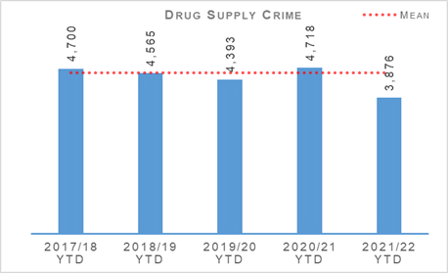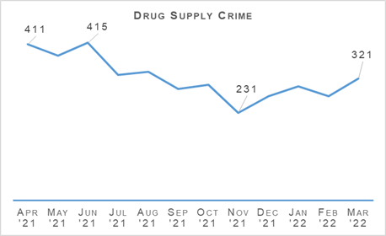
In comparison to the same period last year the number of drug supply crimes has decreased by 17.8%. There was also a decrease of 15.3% in comparison to the five year mean. This decrease was primarily caused by drops in the months leading up to and during the month of November 2021, when competing demands such as preparation and policing of the COP26 event, as well as officer absences due to COVID-19, restricted our capacity in this area. Additionally, several successful operations, such as Operation ERSO, have removed large volumes of equipment used in drug supply such as pill presses. Since November 2021 there has been a gradual increase in the number of crimes with the exception of a small decrease in February 2022.

Drugs Possession
Drugs possession – number of crimes: There were 29,916 crimes in 2020/21 and 23,747 crimes in 2021/22 with the percentage change from the previous year being minus 20.6%. The five year mean was 28,331.2 crimes with the percentage change from the five year mean being minus 16.2%.
Drugs possession – number of detections: There were 28,822 detections in 2020/21 and 22,473 detections in 2021/22 with the percentage change from the previous year being minus 22.0%. The five year mean was 26,765.6 detections with the percentage change from the five year mean being minus 16.0%.
Drugs possession – detection rate: The detection rate was 96.3% in 2020/21 and 94.6% in 2021/22 with the percentage point change from the previous year being minus 1.7 percentage points. The five year mean detection rate was 94.5% with the percentage point change from the five year mean being plus 0.2 percentage points.
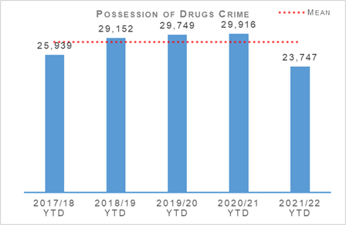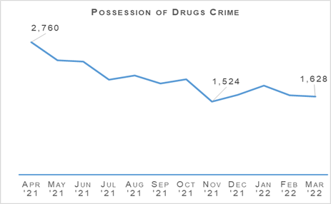
Drug possession crimes have decreased by 20.6% in comparison to the same period last year, and decreased by 16.2% compared to the five year mean. Successes targeting high-level organised crime and supply chains throughout the year have removed large quantities of drugs from our streets, and, similar to that observed with drugs supply, additional duties such as COP26 necessitated reductions in proactive capacity in other areas. Since November 2021 the number of drug possession crimes have increased slightly before smaller decreases observed in both February and March 2022.

Detection Rates
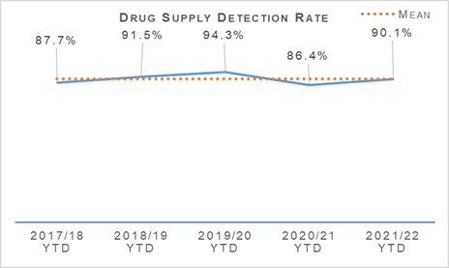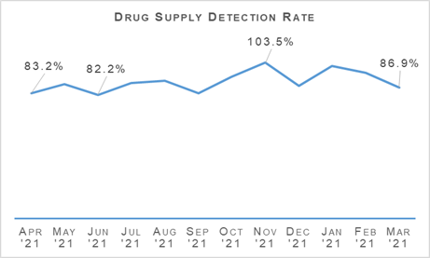
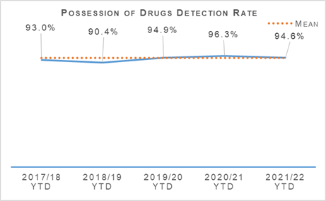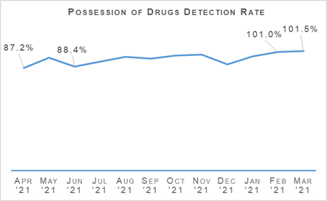
The number of detections of both drug supply and drug possession crimes have decreased by 14.4% and 22.0% respectively. Whilst the overall number of detections has decreased, due to the fall observed in overall reporting for both crime types, the detection rate for drug supply has increased by 3.7 percentage points compared to 2020/21. The detection rate for drug possessions has decreased 1.7 percentage points compared to last year however increased 0.2 percentage points over the five year mean.

Disruption Activity
Over recent months our officers have continued to work to severely disrupt the activities of organised criminals operating within Scotland, a few examples are outlined as follows:
In January 2022:
Officers executed a warrant at an address in Greenock and discovered a cannabis cultivation of approximately 1,530 plants with an estimated street value of £740,000. Three males were charged in connection.
Officers from Roads Policing carried out a vehicle stop on the M74 near to Ecclefechan and discovered 5kg of cannabis. Two males were arrested in connection.
Search warrants were executed at two addresses in the Aberdeen area and recovered 1.175kg of cocaine, 1,050 diazepam tablets and 140g of herbal cannabis with a total street value of £119,325. Two males were arrested in connection.
Officers executed a warrant at an address in Ayrshire. No drugs were recovered, however, £17,480 was recovered which was seized under POCA legislation.
In February 2022:
Officers from the Organised Crime Partnership (OCP) carried out a stop of two vehicles in the Fife area. Simultaneously, search warrants were executed at three addresses in the local area. During the course of the searches officers recovered heroin and cannabis, the total value of which was £410,000. Also recovered was approximately £100,000 cash and stolen property to the value of £40,000. Three males and a female were arrested in connection.
A search warrant was executed at a premises in the Lanarkshire area. During the search officers discovered a cannabis cultivation with an estimated street value of £126,000. One male was arrested in connection.
Officers stopped a vehicle in the Clackmannanshire area where the driver was found to be in possession of half a kilogram of cocaine with an estimated street value of between £12,000 and £35,000 (depending on purity).
Officers from Road Policing carried out a vehicle stop on the M74 near to Lockerbie and recovered 90kg of herbal cannabis. One male was arrested in connection.
In March 2022
A search warrant was executed at premises in the Fife area. During the course of the search herbal cannabis was recovered with a potential street value of £100,000. Three males were arrested in connection.
A significant Glasgow-based SOC nominal, who had been released on licence, was found to be continuing to associate with known criminals in breach of the conditions of his license. Following liaison with the parole board, a warrant was issued recalling the individual to prison. In response to the warrant being issued officers from the Organised Crime Partnership (OCP) located the subject who was subsequently arrested under the terms of the warrant. He was thereafter conveyed to HMP Barlinnie to complete his remaining sentence.

Serious Crime Prevention Orders (SCPO)
A Serious Crime Prevention Order (SCPO) can prevent involvement in serious crime by imposing various restrictions on a person. This can mean, for example, restricting who they can associate with, restricting their travel or placing an obligation to report their financial affairs to the police.
Since inception in 2017, a total of 85 SCPOs have been granted in Scotland following successful applications. A further 20 SCPO applications have been submitted and are awaiting judicial outcomes. There are now 23 ‘live’ SCPOs in the community. A number of notable successful applications have been completed recently including:
Operation XIPHIUS, a successful application was completed in relation to a high profile convicted terrorist in February 2022.
Operation SELECTIVE, where SCPOs were obtained in relation to a murder directly linked to rival Serious and Organised Crime groups, a first for such a case in Scotland. (March 2022).
Operation ESCALADE continues to see positive results with a further four SCPOs granted in relation to key members of the group. (March 2022).
Operation SUBTERFUGE, a cross divisional investigation in relation to vehicle thefts with an estimated value of stolen vehicles around £1 Million. (March 2022).

Operation ERSO
ERSO is the multi-agency taskforce established by Police Scotland. Under Operation ERSO the Drug Harm Tactical Taskforce leads the national focus to enhance our understanding and examine the harm associated with the illegal consumption of synthetic drugs, particularly benzodiazepines, across Scotland. This allows for continuous improvement in the investigation of Drug Related Deaths (DRDs), to include evidence capture, information sharing and collaboration across the Service to maximise intelligence development and operational opportunities.
Current intelligence provides that there are numerous SOCGs involved in the manufacture, distribution and supply of Benzodiazepines within Scotland. Benzodiazepines being used by the Scotland based groups include Diazepam / Valium, Etizolam and Alprazolam (Xanax). We have also seen a rise in the number of groups manufacturing their own illicit tablets.
Since January 2020 a total of 24 Pill Presses have been recovered in Scotland as a result of operational activity carried out. The capacity of the machines allow for mass production of these tablets. The removal of these machines from operation will undoubtedly have a positive impact on Scotland’s communities. SCD continues to work with NCA and SPA in relation to the adoption of an enhanced forensic examination of recovered pill presses. This will be cascaded to SIOs and Crime Scene Managers to ensure all available forensic opportunities are captured.
During January 2022, executive action was carried out at an address in Glasgow whereby both MDA and Firearms warrants were executed. No persons were located on the property, however during the search heroin, bulking agent and a bag containing approximately 10,000 pills suspected to be Etizolam were recovered. A male has since been traced and charged with drug supply offences.
Executive action carried out at an address in Lanarkshire Division in February resulted in the recovery of more than 28,000 Valium pills along with quantities of cocaine and cannabis. A male has since been arrested and charged.

Missing Persons
Number of missing persons investigations: There were 14,383 investigations in 2020/21 and 17,239 investigations in 2021/22 with the percentage change from the previous year being plus 19.9%. Five year mean figures are not available.
Number of people who have gone missing previously: There were 2,796 people in 2020/21 and 2,917 people in 2021/22 who had gone missing previously with the percentage change from the previous year being plus 4.3%. Five year mean figures are not available.
Percentage of people who have gone missing previously: 34.0% of those missing in 2020/21 had gone missing previously with 29.6% in 2021/22. The percentage point change from the previous year was minus 4.4 percentage points. Five year mean figures are not available.
Average length of time missing in hours: The average length of time missing was 20.1 hours in 2020/21 and 17.4 hours in 2021/22. Five year mean figures are not available.
Total number of missing persons from NHS, YPU and Foster Care: There were 4,921 people in 2020/21 and 5,609 people in 2021/22 missing from NHS, YPU and Foster Care with the percentage change from the previous year being plus 14.0%. Five year mean figures are not available.
Percentage of overall missing persons that go missing from NHS, YPU and Foster Care: 34.2% of missing persons in 2020/21 and 32.5% in 2021/22 were missing from NHS, YPU and Foster Care. The percentage point change from the previous year was minus 1.7 percentage points. Five year mean figures are not available
Number of concern for persons incidents (code 75): There were 140,938 incidents in 2020/21 and 146,084 incidents in 2021/22 with the percentage change from the previous year being plus 3.7%. Five year mean figures are not available.
Number of missing people incidents (code 25): There were 35,675 incidents in 2020/21 and 41,275 incidents in 2021/22 with the percentage change from the previous year being plus 15.7%. Five year mean figures are not available.
The number of missing persons investigations in 2021/22 was 19.9% higher than the previous year. As reported and analysed in previous quarters, this correlates strongly with the conditions created by the pandemic.
The increase is seen across all types of person with the exception of ‘wanted/absconder’ which have decreased (this is attributed to a policy change to reflect more accurate recording). This is true even when compared to 2019/20 (pre COVID-19 restrictions).
See following graph for further details.

Missing From Demand
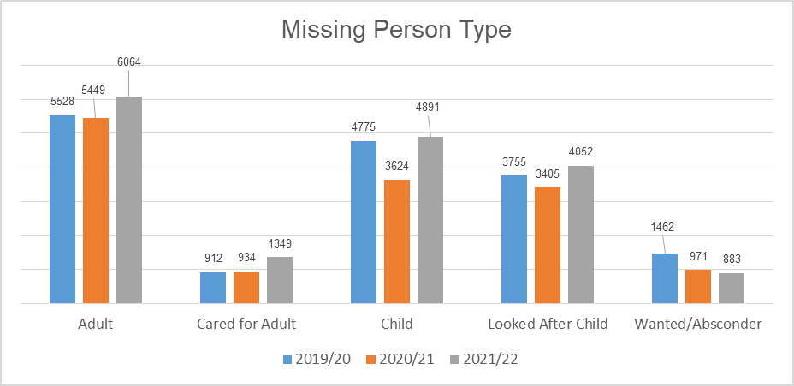
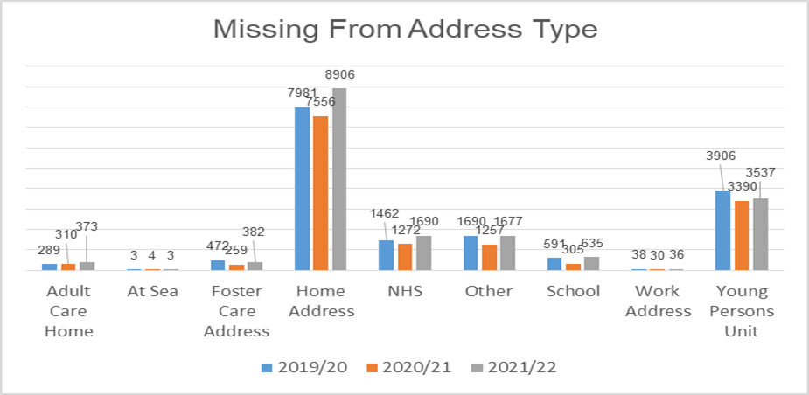
Most people go missing from their home address and this continues to increase from both last year and 2019/20. Numerically the next largest address type that people go missing from are missing from NHS and missing from Young Persons Units. People that go missing from NHS has increased from 2019/20 whereas people missing from Young Persons Units has decreased.
The increase in demand from NHS locations may be a result of an increase in demand across health care settings due to the COVID-19 pandemic being transferred to the Police. The decrease in people that go missing from Young Persons Units may be as a result of better partnership working between units, local authorities and Police Scotland to deal with low risk missing persons, for example through successful implementation of the Not At Home policy.
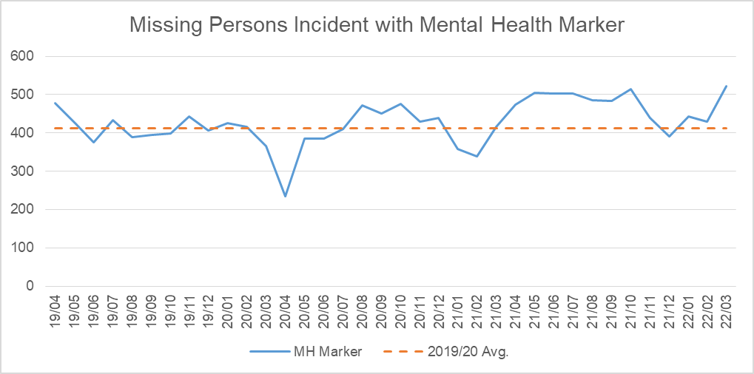

Percentage of Missing Persons Investigations that have a Mental Health Marker
In 2019/20, the percentage of missing persons investigations that had a mental health marker were as follows: Adult 49.3%; Cared for Adult 67.7%; Child 13.4%; Looked After Child 12.9% and Wanted/Absconder 32.9%.
In 2020/21, the percentage of missing persons investigations that had a mental health marker were as follows: Adult 49.8%; Cared for Adult 70.6%; Child 16.8%; Looked After Child 13.8% and Wanted/Absconder 35.5%.
In 2021/22, the percentage of missing persons investigations that had a mental health marker were as follows: Adult 49.1%; Cared for Adult 71.6%; Child 16.7%; Looked After Child 14.9% and Wanted/Absconder 36.6%.
The previous graph illustrates that missing persons investigations that have been marked mental health (from missing persons questionnaire) have increased since 2021. On average there were 413 missing persons investigations per month marked mental health in 2019/20, in 2021/22 this increased to an average of 474 per month.

Missing Person Return Home Interviews
Repeat missing persons accounted for nearly 30% of missing persons investigations in 2021/22. When missing persons are found it is important that appropriate safe and well checks are put in place that could help in the event of a repeat missing person. The National Missing Persons Framework for Scotland outlines the interagency responsibility for carrying out Return Home Interviews. Best practice is to give the missing person the option of who they would like to speak to, to discuss their missing episode to establish why they went missing and what happened to them when they were missing.
Varying practices are in place across Scotland, due to the number of resources (partner/police) available, but mainly due to interagency agreements and working practices that are in place. Links with local authorities, social work, health and education are crucial to making this process effective.
Divisional inspections and follow ups are conducted by the Missing People Charity on behalf of Scottish Government as part of the National Missing Persons Framework Project. In furtherance to this, the NMPU is undertaking a study with Police Scotland’s Academic Research Unit and the University of Sunderland to improve this process. The study is considering the practices in place across Police Scotland, looking specifically at safe and well checks and return home interviews for young people who have been missing.
The objective is to identify best practice, training ideas or the practical and realistic support needed by front line officers by providing the National Missing Person Unit and managers with the realities faced by front line officers and Missing Person Co-ordinator.

Road Safety
People Killed: There were 108 people killed on our roads in 2020/21 and 159 in 2021/22 with the percentage change from the previous year being plus 47.2%. The five year mean was 152 people killed with the percentage change from the five year mean being plus 4.6%.
People Seriously Injured: There were 1,372 people seriously injured on our roads in 2020/21 and 1,643 in 2021/22 with the percentage change from the previous year being plus 19.8%. The five year mean was 1,625.8 people seriously injured with the percentage change from the five year mean being plus 1.1%.
Children (aged under 16) Killed: There were two children under 16 people killed on our roads in 2020/21 and six in 2021/22 with the percentage change from the previous year being plus 200.0%. The five year mean was 4.8 children under 16 people killed with the percentage change from the five year mean being plus 25.0%.
Children (aged under 16) seriously injured: There were 121 children under 16 seriously injured on our roads in 2020/21 and 147 in 2021/22 with the percentage change from the previous year being plus 21.5%. The five year mean was 152.4 children under 16 seriously injured with the percentage change from the five year mean being minus 3.5%.
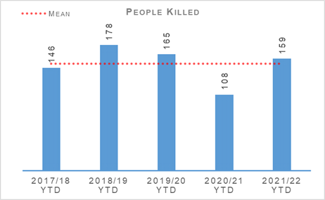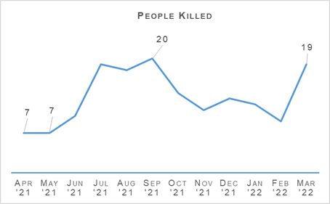
There was an increase of 51 people killed on Scotland’s roads this year compared to the same period last year. There have been six children killed on the road this year, an increase of four in comparison to the previous year. These increases are highly likely due to the significantly reduced volume of traffic observed on Scotland’s roads during COVID-19, with restrictions in place across 2020. Figures from Transport Scotland showed a decrease of 22% estimated volume of traffic in 2020 compared to 2019. As restrictions eased into 2021/22, larger volumes of traffic have been on roads and thus increased the likelihood of serious collisions. There has been an increase of seven fatal road collisions in the last year compared to the five year mean.
The numbers of those seriously injured on Scotland’s roads has increased by 19.8% in comparison to the previous year for those aged 16 and over, and increased by 21.5% for children. These increases are highly likely due to the increase in traffic numbers in comparison to 2020/21. There has been an increase of 1.1% in people seriously injured and a decrease of 3.5% in children seriously injured compared to the five year means.
Transport Scotland has published key road casualties figures showing the progress made against the Road Safety Framework targets that ran from 2010 to 2020. All five targets have been met as per the following table:

Scottish Road Safety Targets 2020
People Killed: The 2020 target for a reduction in the number of people killed on our roads was 40%. The actual reduction was 52%.
People Seriously Injured: The 2020 target for a reduction in the number of people seriously injured on our roads was 55%. The actual reduction was 68%.
Children (aged under 16) Killed: The 2020 target for a reduction in the number of children under 16 killed on our roads was 50%. The actual reduction was 76%.
Children (aged under 16) seriously injured: The 2020 target for a reduction in the number of children under 16 seriously injured on our roads was 65%. The actual reduction was 77%.
Slight Injury: The 2020 target for a reduction in the number of people slightly injured on our roads was 10%. The actual reduction was 67%.
Please note that due to changes in severity recording the number of seriously and slightly injured people cannot be directly compared to those reported in previous years. Progress against these targets has been calculated on the basis of adjusted figures provided by the Department for Transport.
The new Road Safety Framework with interim targets to 2030, RSF2030, has been published along with the 2021/22 delivery plan. This looks for the following interim reductions in those killed and seriously injured on Scotland’s roads from a 2014-18 baseline:
50% reduction in people killed
50% reduction in people seriously injured
60% reduction in children (aged under 16) killed
60% reduction in children (aged under 16) seriously injured
The interim reductions are challenging as they should be as we work with our partners toward Vision Zero - no deaths and no serious injuries on Scotland’s roads by 2050.
A few key risks have been identified via analysis and we will seek to mitigate these as we move forward:
The number of cyclists on our roads has increased during the COVID-19 pandemic as people move towards more eco-friendly sustainable modes of transport. As cycling increases we recognise the potential for collisions also increases, with cyclist collisions often resulting in serious injury.
Motorcycle casualties have remained steady over the past few years, aside from the drop in 2020/21 due to the reduced traffic during COVID-19 restrictions.
With an ageing population, who remain mobile longer and continue to drive, it is anticipated that there may be an increase in older casualties.
In an effort to mitigate the risks identified and reduce collisions on the road network, Police Scotland has identified a number of key opportunities.
During Quarter 4 Police Scotland Road Policing has worked with partners within the Road Safety Framework to strengthen Local Partnership Forums for the East, North and West, with the aim of improving communication and better informing our enforcement priorities. To date the feedback from partners has been positive.
An in-depth fatality study has been commissioned in partnership with Transport Scotland. With a dedicated analyst on the project there is an opportunity to identify learning from previous collisions which will assist Police Scotland and partners to introduce preventative measures to further mitigate road risk across all road users groups.
Road Policing works closely with Transport Scotland to understand trends and identify emerging threats in relation to all collision classes. Police Scotland analysts produce detailed problem profiles identifying specific casualty types, with particular focus on vulnerable road users. The information is shared with partners at forums such as the Tactical Options Working Group chaired by the Road Policing Superintendent and Road Safety Governance Board chaired by ACC Operational Support. This sharing allows resources to be allocated to the greatest areas of risk in an effort to reduce harm on our road, in partnership with local policing and assisted where appropriate by our key partners.
Acknowledging motorcyclists are a challenging group to engage with, the Scottish Government in partnership with Police Scotland has developed a working group to explore opportunities and develop engagement strategies moving forward.
Driver Engagement North aims to reduce casualties and collisions in the North of Scotland by engaging older drivers and their friends / families in an interactive workshop. This is a pilot project supported by funding from Transport Scotland’s Road Safety Framework Fund and, if successful, will be extended to other areas throughout Scotland.
The New Driver Early Intervention Scheme (NDEIS) is aimed at 17 to 25-year-olds to influence driver attitudes and behaviours whilst providing a reminder of the responsibilities a driver has for themselves and other road users. This has now been rolled out nationally and partners, such as Scottish Fire and Rescue Service, have adopted the scheme and deliver it in conjunction with Police Scotland to internal and external groups. Several local authorities have adopted the scheme for delivery to modern apprentice / skills and employability students.
All of the deliverable commitments that Police Scotland has made to the Road Safety Framework (RSF) 2030 have been completed to date, with appropriate adjustments having been made to ensure continuing public and officer COVID-19 safety. Our commitment within the RSF to incorporate specific campaigns, initiatives and directed activity targeting the safety of vulnerable road users (including cyclists, motorcyclists and pedestrians) has been met. The majority of the National Campaign Calendar activity was and will continue to be Fatal-Five focused. Each campaign during Quarter 4 was supported by Corporate Communications and social media, enhancing the reach of our safety messaging.

Road Policing Campaign Updates
Working in conjunction with partners and Corporate Communications, the road safety campaigns calendar and multi-agency days of action continue to be delivered in line with social distancing protocols. As we work through the campaign calendar, data will be collated by National Police Chiefs’ Council which will enable benchmarking by the Analysis and Performance Unit.

Operation TUTELAGE
Operation TUTELAGE is an ongoing national initiative aimed at reducing the number of uninsured drivers on the UK’s roads. Police Scotland joined the initiative in April 2021, initially as part of a six month project. It remains to be ratified on a permanent basis by the Executive but continues on a full time basis meantime.
Operation TUTELAGE centres on identifying uninsured vehicles using ANPR and subsequently writing an ‘Insurance Advisory Letter’ to the registered keepers to inform them that driving without insurance is an offence. Working on the principle of behavioural compliance, the operation is designed to encourage the majority of compliant individuals to insure their vehicles.
As of the end of February 2022, 15,178 letters had been issued with a compliance rate of 72.1%.
Key road safety benefits include:
Contributing to reducing the amount of uninsured vehicles utilising Scotland's road network using positive engagement and resolution.
Allows for more focused and targeted enforcement.
Optimising the Police Scotland investment in upgrading our ANPR capability and infrastructure.
Currently Operation TUTELAGE is running additional work in identifying vehicles which also have no MOT and excise licence, as well as supporting initiatives by Road Policing across Scotland.

ANPR Day of Action – Case Study
On 15 February 2022, Road Policing Unit, Stirling carried out an ANPR day of action on the M80. Static cameras were monitored using a back-to-back channel to intercept motor vehicles in real time. Four road policing crews were used in total between the hours of 08.00 and 10.00 and thereafter 12.30 and 13.30.
A total of 25 motor vehicles were stopped for no insurance. Among them were seven alerts for Operation TUTELAGE. As a result four were confirmed as being in order (with trade / fleet policies in place and an administration error with a registration number), and three motor vehicles were identified as having no valid policy of insurance in place.
The Operation TUTELAGE alerts are uploaded onto the ANPR system after having no response from the TUTELAGE advisory letter sent and as such the motor vehicles were seized under terms of section 165 Road Traffic Act 1988 and the drivers dealt with by means of fixed penalty notices. From other computer system searches 17 of them were confirmed in order with one further no insurance.

Festive Drink / Drug Drive Campaign – 01 December 2021 to 03 January 2022
Police Scotland and the Minister for Transport led the Festive Drink / Drug Drive Campaign launch in Glasgow on 01 December 2021, highlighting the case of Niki Smith, who kindly worked closely with Corporate Communications and our launch partners to outline the life-long impacts on her after she innocently accepted a lift from a drink-driver.
During this analysis and intelligence led campaign, Police Scotland officers carried out 2,965 roadside tests. Overall, 628 drivers were detected for drink or drug driving offences.

National Speeding Campaign – 17 January to 30 January 2022
The communications phase of this campaign commenced 17 January 2022, supported by Police Scotland social media users and Corporate Communications, and was sustained after the engagement and enforcement phase started on 24 January 2022.
Police Scotland officers, in partnership with the Safety Camera Unit (SCU), carried out appropriate targeting of speeding offences within their area of responsibility, with particular emphasis on speeding hotspots, community complaint locations and areas with a high volume of active travel.
1,063 speeding offences were detected by officers, with a further 1,636 detected by the SCU.

National Seatbelt Campaign – 07 February to 27 February 2022
Timed to coincide with Road Safety Scotland’s media campaign running throughout February, Police Scotland provided social media and communications support throughout our campaign period.
The engagement and enforcement phase from 21 February 2022 included partnership work with Good Egg Safety, who provided guidance to parents and carers on child car seats and optimising their safe fitting and use. 182 seatbelt offences were detected.

National Dashcam Safety Project

Road Safety Campaign – Impact
The new National Dashcam Safety Portal (NDSP) pilot was approved as a change project by the Demand Management Board and has gained funding approval from Transport Scotland. A project lead, seconded from Road Policing, was appointed in Quarter 4 to build on the development work already undertaken, with ICT resources anticipated to become available after April
NDSP is intended to optimise the ability for Police Scotland to identify illegal and risky behaviours by drivers and other road users from video footage submitted by the public, enabling enforcement action to be taken when appropriate. Cycling Scotland and Cycling UK led 33 organisations in seeking the introduction of an on-line camera footage submission and reporting system for Scotland

Stop and Search
Stop Search Compliance Rate (%): The stop search compliance rate was 99.1% in 2020/21 and 99.0% in 2021/22. The percentage point change from the previous year was minus 0.1 percentage points.
30,807 stop and search incidents have been recorded by Police Scotland this year. This is a decrease of 29.5% compared to the previous year. Just over one in three (34.7%) stop and searches in 2021/22 had a positive result although this was a slightly lower (-0.3% points) positive rate than last year.
All records are reviewed by line managers and thereafter quality control checked by the National Stop and Search Unit to ensure their compliance with the Stop and Search Code of Practice which was introduced in May 2017.
Of the stop and searches submitted this year, 26,650 (87.9%) were deemed compliant and recorded correctly on the stop and search database. A further 3,362 (11.1%) were compliant with the code of practice but required amendment to their details to ensure they were appropriately recorded.
312 (1.0%) records were deemed as not recordable under the code of practice or recorded in error and deleted from the database. Typical reasons for deletion include where a person is searched after being arrested, as a result of a duplicate record or where no physical search of a person has actually taken place.
It should be noted that the total number of records audited for compliance will be lower than the total number of searches raised during the period due to the timescales required to fully review all records.
The process for identifying all stop and search-related complaints was under review and prevented publication of accurate reporting throughout the last two quarterly reporting periods. The review has since concluded and found an anomaly in how the complaints were being categorised, however, all stop and search-related complaints have been managed through Police Scotland’s complaints process.
Data for the current reporting period has been revised using the new identification process. A total of 121 complaints relating to Stop and Search were received during 2021/22. Going forward, all stop and search complaints will be processed in this manner and ensures the accurate, consistent recording of any future complaints.

Strategic Outcome: The needs of local communities are addressed through effective service delivery

Police Scotland’s objectives are to:
Understand our communities and deliver the right mix of services to meet their needs
Support our communities through a blend of local and national expertise
Support the changing nature of communities

Call Handling
Total number of 999 calls: There were 594,346 calls to 999 in 2020/21 and 700,262 calls in 2021/22. The percentage change from the previous year was plus 17.8%.
Total number of 101 calls: There were 1,971,656 calls to 101 in 2020/21 and 1,713,638 calls in 2021/22. The percentage change from the previous year was minus 13.1%.
Average call answer time 999 calls: The average time to answer 999 calls was eight seconds in 2020/21 and seven seconds in 2021/22. The change from the previous year was minus one second.
Average call answer time 101 calls: The average time to answer 101 calls was 2 minutes 31 seconds in 2020/21 and 3 minutes 17 seconds in 2021/22. The change from the previous year was plus 46 seconds.
Number of 999/101 calls that do not result in an incident/crime: There were 1,046,942 calls in 2020/21 and 928,213 calls in 2021/22 that do not result in an incident/crime. The percentage change from the previous year was minus 11.3%.
Percentage of 999/101 calls that do not result in an incident/crime: There were 40.8% of calls in 2020/21 and 38.4% of calls in 2021/22 that do not result in an incident/crime. The percentage point change from the previous year was minus 2.4 percentage points.
Note: Following the nationwide rollout of CAM, new call gradings are being used. These were updated again during August 2020, this is reflected in the table above. A small percentage of incidents are still being categorised under the old grading and are therefore not included in the above figures. Comparison data is not available.
The total number of calls to Police Scotland decreased by 152,102 (from 2,566,002 to 2,413,900). This is a decrease of 5.9% compared to last year. As shown in the above table there has been an increase of 17.8 % for 999 calls received, however, the volume of 101 calls received is showing a decrease of 13.1%, both being compared to the same period last year. Of the calls received, 38.4% did not result in an incident or crime being raised. The total number of incidents has decreased by 33,373 (from 1,519,060 to 1,485,687) compared to the same period last year.
The handling of 999 calls remains our highest priority. Between 01 April 2021 and 31 March 2022, our service centres managed to maintain an average speed of seven seconds for answering 999 calls, one second less than the same period last year. The average call answer time for 101 calls has increased by 46 seconds compared to the same period last year. Having previously been highlighted as a challenge for the division, measures have been put in place to alleviate this and bring the average call answer time down further.
These include implementing a further change to our Inter-active Voice Recording (IVR) system, which provides dynamic anticipated wait times to callers phoning 101. This will improve the customer experience and manage expectations at first point of contact. A short life working group has also been set up to monitor absence and ensure the proper support is in place for staff and line managers.
Efforts continue to signpost callers to more appropriate methods of contact, including via Contactus and the force website, and likewise social media is used during periods of high demand to inform the public and provides the opportunity to educate the public on the correct use of 101. Online contacts continued to rise during this reporting period, indicating the success of this approach.

Incident Demand
Incident demand – total number of incidents raised: There were 1,519,060 incidents raised in 2020/21 and 1,485,687 incidents raised in 2021/22. The percentage change from the previous year was minus 2.2%.
Number of incidents by response type - immediate: There were 189,726 immediate incidents in 2020/21 and 169,899 immediate incidents in 2021/22. The percentage change from the previous year was minus 10.5%.
Number of incidents by response type - prompt: There were 685,171 prompt incidents in 2020/21 and 637,006 prompt incidents in 2021/22. The percentage change from the previous year was minus 7.0%.
Number of incidents by response type – standard local policing appointment: There were 39,554 local policing appointments in 2020/21 and 65,091 local policing appointments in 2021/22. The percentage change from the previous year was plus 64.6%.
Number of incidents by response type – standard direct crime recording: There were 55,015 direct crime recordings in 2020/21 and 75,738 direct crime recordings in 2021/22. The percentage change from the previous year was plus 37.7%.
Number of incidents by response type – standard resolution team involvements: There were 44,738 resolution team involvements in 2020/21 and 44,551 resolution team involvements in 2021/22. The percentage change from the previous year was minus 0.4%.
Number of incidents by response type – other resolution: There were 422,067 other resolutions in 2020/21 and 452,659 other resolutions in 2021/22. The percentage change from the previous year was plus 7.2%.
Incident demand - % of incidents that lead to a crimes: There were 25.6% of incidents in 2020/21 and 26.5% of incidents in 2021/22 which lead to a crime. The percentage point change from the previous year was plus 0.9 percentage points.
Incident demand - % of incidents requiring police response: There were 97.0% of incidents in 2020/21 and 97.0% of incidents in 2021/22 which required a police response. There was no percentage point change from the previous year.
Partner demand – total number of external force request incidents: There were 2,526 external force request incidents in 2020/21 and 2,857 incidents in 2021/22. The percentage change from the previous year was plus 13.1%.
Note: A small percentage of incidents are still being categorised under the old grading and are therefore not included in the above figures.
During the reporting period 185,380 standard incidents were recorded in total, an increase of 33.1% (46,073 more incidents) from the same period last year. The new process involves the allocation of Local Policing Appointment, Direct Crime Recording and Resolution Team involvement to standard incidents. This has now been fully integrated into daily business, leading to this continued increase. During the reporting period the most common crime types recorded for standard incidents are theft, road traffic collisions, assist member of the public and damage.
Looking at incident demand for the reporting period compared to the previous year, the percentage of incidents which lead to a crime report being raised and that require police attendance are consistent. Due to the process changes a comparison against the five year mean is not available. Demand from partners, in terms of external force request incidents, has risen 13.1% (331 more incidents) compared to the same period last year, a trend reflective of the strain placed on partner agencies over the last year by backlogs, COVID-19 related absences and other factors.

C3 Division Demand
In addition to the call numbers, there have been over 268,000 additional public contacts dealt with by Contact, Command and Control (C3) Division during the reporting period. C3 Division does not only deal with incoming calls from the public. Service advisors also deal with incoming calls from other partner agencies and alarm calls. There have been over 100,000 of these types of calls for this reporting period, including an increase of 11.7% (8,269 more calls) in Emergency Service Partner calls. Emergency Service Partner calls are received via dedicated numbers from Scottish Fire and Rescue, Scottish Ambulance Service, Mountain Rescue, Coast Guard, Mental Health Pathway (NHS 24), OmniCrash and Oil Industry Agency. The reason for such calls vary and each are dealt with by a service advisor in the most appropriate manner.
“Contact Us” emails and online reports, for some crime types, can be completed online. Each one of these reports is assessed by a service advisor using the Threat Harm Risk Investigation Vulnerability and Engagement (THRIVE) model. The service advisors then also have to take into account COVID-19 restriction considerations, to decide what resolution is required for each report. Over 136,000 “Contact Us” emails and 9,000 online reports have been submitted since 01 April 2021.
In December 2020 the section on the website to report possible COVID-19 restriction breaches online went live. During this reporting period, there were 10,422 online forms completed reporting restriction breaches, adding to the demand on the service centre. These are assessed by a service advisor in the same way as normal online reports.
Overall, additional public contacts rose around 5.2% from 2020/21.

Modernised Contact and Engagement
The Modernised Contact and Engagement (MCE) Programme is now established to support delivery of the Public Contact and Engagement Strategy.
ICT projects within this Programme include the delivery of the National Integrated Communications Control System (NICCS) and the replacement for the Police Scotland telephony system, namely the Unified Communications Client Platform project (UCCP). The delivery timeline for NICCS will commence in early 2022, while the Full Business Case (FBC) for UCCP has now been approved, with anticipated delivery of modules throughout 2022-2023.
Work continues on the development of a Target Operating Model for C3 Division. Research and Steering Groups have been established and work is ongoing to design a future operating model.
The Contact, Engagement and Resolution Project (CERP), also part of the MCE Programme, had its business case approved in December 2021 and a number of officers have joined the project in recent weeks. This will allow work on the approved work streams to commence with a focus on enhancing what was delivered by the Contact Assessment Model in the post pandemic environment to improve service to the public and includes the Mental Health Pathway (MHP).

Mental Health Pathway
Training commenced for the Mental Health Nurse Practitioners (MHNP) on 01 March 2022 and a ‘go live’ for the service went ahead on 15 March 2022. This provides MHNP to each of the five Resolution Teams at C3 in Govan with a roll out focused on West Command initially and dates for North and East Command to be agreed.

Complaints
Complaints allegations received relative to C3 – on duty: There were 269 complaint allegations received in 2020/21 and 230 complaint allegations received in 2021/22 relating to C3 on duty. The percentage change from the previous year was minus 14.5%.
Complaints allegations received relative to C3 – quality of service: There were 155 complaint allegations received in 2020/21 and 189 complaint allegations received in 2021/22 relating to C3 quality of service. The percentage change from the previous year was plus 21.9%.
Total allegations closed – relative to C3: There were 390 allegations closed in 2020/21 and 423 allegations closed in 2021/22 which were relative to C3. The percentage change from the previous year was plus 8.5%.
Percentage of total allegations closed which were upheld – relative to C3: There were 14.9% of allegations closed in 2020/21 and 6.9% of allegations closed in 2021/22 which were upheld, relative to C3. The percentage point change from the previous year was minus 8.0 percentage points.
Complaints against C3 Division have decreased by 6.8% in the year-to-date, with a total of 303 received during this period. Decreases are visible in the North (-58.7%, 26 cases in total) and West (-5.4%, 159 cases in total). However, the East registered a 25.5% increase, with 118 complaint cases in total YTD.
Incivility continues to be the most common allegation type, with 166 received during the year-to-date. This accounts for 39.6% of all allegations received within this period. The volume of incivility allegations YTD represents a 1.2% increase from the comparable period in 2020/21.
Consistent with the corresponding decrease in complaint cases, decreases are visible across many allegation categories. One notable exception was an 80.0% increase in Quality of Service – Service Delivery, with 108 allegations received YTD. It is assessed that this increase is primarily attributable to dissatisfaction over waiting times when members of the public have contacted 101. However, the volume of relevant allegations have since stabilised during Quarter 3 and Quarter 4.
In total, 62.0% of complaint cases received year-to-date for C3 Division were Frontline Resolved by the PSD National Complaints and Resolution Unit (NCARU). This rate increases to 68.3% when early and subsequent resolution by PSD or Specialist officers are included. These figures demonstrate that most complaints against C3 Division during this period have been non-criminal and non-serious in nature, with a majority resolved through simple explanation, apology or assurance.

Hate Crime – Equality Outcome 1
Hate Crime – number of incidents: There were 7,023 incidents in 2020/21 and 7,563 incidents in 2021/22 with the percentage change from the previous year being plus 7.7%. The five year mean was 6,587.6 incidents with the percentage change from the five year mean being plus 14.8%.
Hate Crime – number of crimes: There were 6,724 crimes in 2020/21 and 6,895 crimes in 2021/22 with the percentage change from the previous year being plus 2.5%. The five year mean was 6,567.2 crimes with the percentage change from the five year mean being plus 5.0%.
Hate Crime – detection rate: The detection rate was 68.8% in 2020/21 and 64.6% in 2021/22 with the percentage point change from the previous year being minus 4.2 percentage points. The five year mean detection rate was 68.7% with the percentage point change from the five year mean being minus 4.1 percentage points.
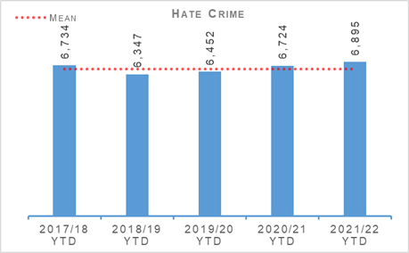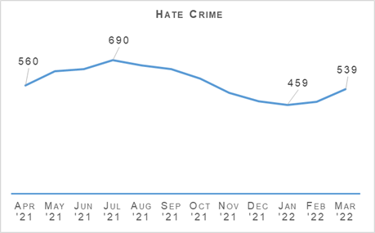
The number of hate incidents has increased by 7.7% (540 more) and the number of crimes by 2.5% (171 more) compared to the previous year to date. The month of July saw the highest number of hate crimes recorded in the past 12 months.
The following graph compares the monthly trends over the past two years. The months of January and April may be illustrative of the different restrictions at the time. Where the restrictions are more comparable the trend is more similar.
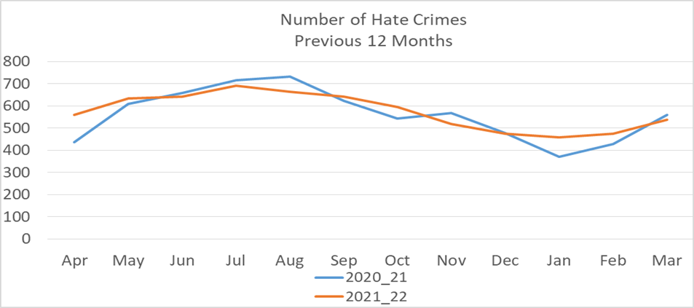

Hate Crime Aggravators
Race aggravator: There were 4,086 hate crimes in 2020/21 and 4,012 hate crimes in 2021/22 with a race aggravator. This is a percentage change from the previous year of minus 1.8%. Hate crimes with a race aggravator make up 58.2% of all hate crimes in 2021/22.
Religion aggravator: There were 434 hate crimes in 2020/21 and 357 hate crimes in 2021/22 with a religion aggravator. This is a percentage change from the previous year of minus 17.7%. Hate crimes with a religion aggravator make up 5.2% of all hate crimes in 2021/22.
Race & religion aggravator: There were 74 hate crimes in 2020/21 and 58 hate crimes in 2021/22 with a race & religion aggravator. This is a percentage change from the previous year of minus 21.6%. Hate crimes with a race & religion aggravator make up 0.8% of all hate crimes in 2021/22.
Multiple aggravator including race & religion: There were 210 hate crimes in 2020/21 and 221 hate crimes in 2021/22 with multiple aggravators including race & religion. This is a percentage change from the previous year of plus 5.2%. Hate crimes with multiple aggravators including race & religion make up 3.2% of all hate crimes in 2021/22.
Disability aggravator: There were 335 hate crimes in 2020/21 and 432 hate crimes in 2021/22 with a disability aggravator. This is a percentage change from the previous year of plus 29.0%. Hate crimes with a disability aggravator make up 6.3% of all hate crimes in 2021/22.
Sexual orientation aggravator: There were 1,440 hate crimes in 2020/21 and 1,583 hate crimes in 2021/22 with a sexual orientation aggravator. This is a percentage change from the previous year of plus 9.9%. Hate crimes with a sexual orientation aggravator make up 23.0% of all hate crimes in 2021/22.
Transgender aggravator: There were 74 hate crimes in 2020/21 and 150 hate crimes in 2021/22 with a transgender aggravator. This is a percentage change from the previous year of plus 102.7%. Hate crimes with a transgender aggravator make up 2.2% of all hate crimes in 2021/22.
Multiple aggravators excluding race & religion: There were 71 hate crimes in 2020/21 and 82 hate crimes in 2021/22 with multiple aggravators excluding race & religion. This is a percentage change from the previous year of plus 15.5%. Hate crimes with multiple aggravators excluding race & religion make up 1.2% of all hate crimes in 2021/22.
Total Hate Crimes: There were 6,724 hate crimes in total in 2020/21 and 6,895 hate crimes in total in 2021/22. This is a percentage change from the previous year of plus 2.5%.
As highlighted previously, hate crimes with disability and transgender aggravators have increased significantly in comparison with last year. However, due to the relatively low number of crimes in these categories, small volumetric increases can result in larger proportional change.
Precise reasons for these trends are unclear, but both categories have seen increased political and media coverage over the last year, and the COVID-19 pandemic has been associated with a rise in disability hate crimes relating to mask wearing exemptions.
Nationally, Police Scotland hold regular quarterly meetings with trusted partners from across the LGBT and LGBT inclusive community (Intersectionality). COVID-19 restrictions have previously curtailed attempts to improve engagement at local level. With restrictions now eased, local policing divisions are seeking to develop meaningful engagement between local officers and our LGBT communities throughout Scotland.

Community Impact Assessments
A Community Impact Assessment is a tool for assessing incidents and events to identify the associated risks. It helps to record, monitor and take appropriate action in relation to identified community tensions. Essentially, it facilitates a coherent and structured approach to developing interventions to address the impact on the community that might arise as a result of a major or critical incident, potentially mitigating any risk to the organisation from reputational harm and loss of public confidence.
Police Scotland utilise a range of tools to engage with the community to understand and mitigate impact. These include: monitoring of mainstream and social media, active engagement with individuals or groups (i.e. local officers visiting places of worship or similar), utilising community advisors to gain a better understanding of issues and how the community is reacting and providing tactical advice to Gold commanders to assist in decision making.
Partnerships Prevention and Community Wellbeing Equality and Diversity (PPCW E&D) department oversee national database of CIAs and over 250 CIAs were generated in the fiscal year 2021/22. CIAs are typically created and managed by local policing divisions or specialist divisions in response to a specific incident, such as a serious crime or incident, unexplained death, local event, or policing operation.
Many of these CIAs will run for a few months until it is assessed that any associated tensions have returned to normal and unlikely to re-surface. Some CIAs however, have been ongoing for several years as there continues to be developments potentially giving rise to tensions.
Alongside the mostly local CIAs there are a number of national CIAs which are monitored and updated by the PPCW E&D department. Recent examples include:
Response to Ukraine / Russia conflict
Violence Against Women and Girls
Afghanistan Resettlement
COVID-19 response
COP26
Scottish Child Abuse Enquiry
A timely and meaningful CIA can ensure that confidence in the police response to such incidents is maintained and, where possible, enhanced.
It is considered as a pro-active document in cases where information is available beforehand, and this consideration forms part of the dynamic risk assessment process.

HMICS Thematic Inspection
Police Scotland’s Hate Crime Improvement plan was presented to the SPA Policing Performance Committee (PPC) on 09 December 2021.
A tactical group has been established to progress the numerous actions contained within the improvement plan and have held regular meetings since December 2021.
Progress towards the recommendations is continuing but has been somewhat interrupted by reallocation of staff to assist with frontline duties as per Operation TALLA requirements.

Anti-social Behaviour and Disorder
Number of antisocial behaviour incidents reported by the public: There were 424,380 incidents in 2020/21 and 322,271 incidents in 2021/22 reported by the public regarding antisocial behaviour. This is a percentage change from the previous year of minus 24.1%. Five year mean figures are not available.
Number of complaints regarding disorder: There were 321,030 complaints in 2020/21 and 230,949 complaints in 2021/22 regarding disorder. This is a percentage change from the previous year of minus 28.1%. Five year mean figures are not available.
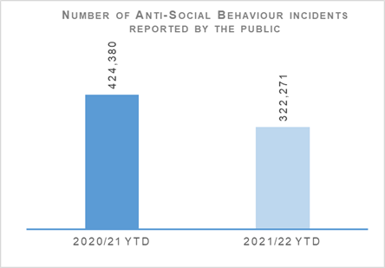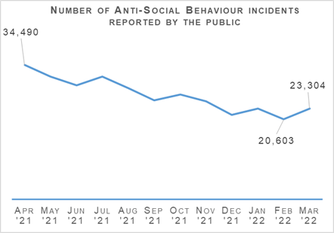
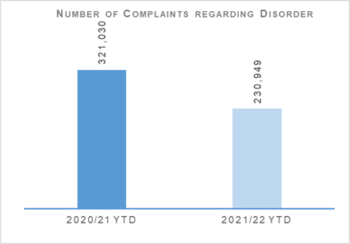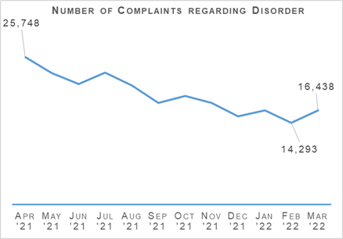
As previously reported, antisocial behaviour incidents and complaints regarding disorder continued to decrease throughout 2021/22 and is now closer to usual levels following their peak during the initial times of restriction associated with COVID-19.
Fewer restrictions over the course of this year has resulted in fewer Public Nuisance calls linked to non-compliance with restrictions, which was seen at high volumes in 2020/21.

Acquisitive Crime

Group 3 Crime
Group 3 Crime – number of crimes: There were 88,047 crimes in 2020/21 and 92,874 crimes 2021/22 with the percentage change from the previous year being plus 5.5%. The five year mean was 107,015.0 crimes with the percentage change from the five year mean being minus 13.2%.
Group 3 Crime – number of detections: There were 33,846 detections in 2020/21 and 29,307 detections in 2021/22 with the percentage change from the previous year being minus 13.4%. The five year mean was 40,399.0 detections with the percentage change from the five year mean being minus 27.5%.
Group 3 Crime – detection rate: The detection rate was 38.4% in 2020/21 and 31.6% in 2021/22 with the percentage point change from the previous year being minus 6.9 percentage points. The five year mean detection rate was 37.8% with the percentage point change from the five year mean being minus 6.2 percentage points.
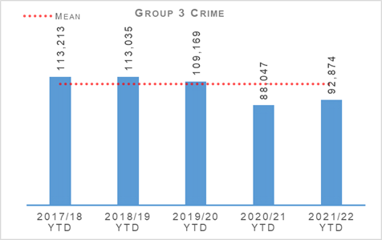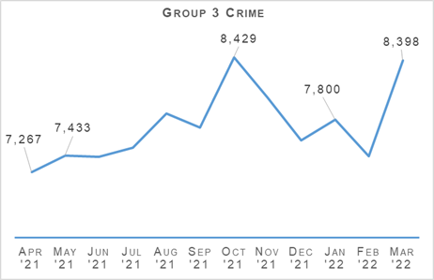
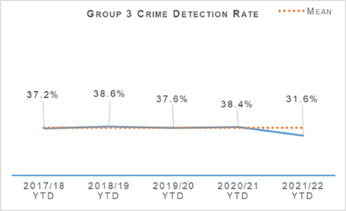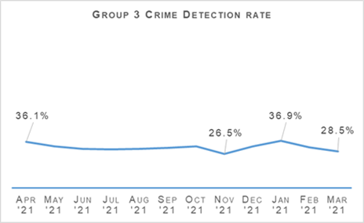
Acquisitive crime has increased slightly when compared to last year but is still largely down on the five year mean. Between April 2021 and March 2022 there have been 4,737 more crimes compared to the same period the previous year, and 14,141 less than the five year mean. Excluding fraud, which has risen by 2,598 crimes, common theft and shoplifting crimes have continued to be the main contributors to this increase from the previous year, with common theft increasing by 2,883 crimes and shoplifting by 2,412 crimes.
Despite the overall increase, the majority of acquisitive crime areas have continued to fall compared to the same period last year. Overall housebreakings have reduced by 11.9% (1,145 crimes), motor vehicle crime by 0.9% (96 crimes) and pedal cycle theft by 18.8% (1,026 crimes).
There have been 4,539 fewer detections between April 2021 and March 2022 compared to the same period last year. The detection rate for Group 3 crimes has decreased by 6.9 percentage points due to the drop in detections and the rise in recorded crime. COVID-19 has continued to affect operational and forensic resources over the period.

Shoplifting
Throughout the year, shoplifting crimes have gradually risen after the decrease seen during lockdown last year. Between April 2021 and March 2022 there has been 22,913 crimes, 11.8% (2,412 crimes) higher than the same period last year. This increase is expected to continue as shoplifting crimes remain 20.6% lower than the five year mean.
Detections over the period have decreased from 13,485 to 12,833 compared to the same period last year. Detecting shoplifting crimes has been far more difficult due to offenders wearing face masks and being much harder to identify through standard methods such as CCTV. This has had an impact in the detection rate which now sits at 56.0%. The rate is 9.8 percentage points lower than the same period last year and 11.8 percentage points lower than the five year mean.

Housebreaking
Housebreaking has experienced a significant decrease year to date of 11.9% (1,145 fewer crimes). Over the period there have been a total of 8,489 housebreaking crimes. This decrease means housebreaking is now 37.1% lower than the five year mean of 13,496.2 crimes and remains at its lowest level in the last five years.
The main decrease can be seen in non-dwelling domestic housebreakings decreasing from 2,495 to 1,639. Commercial housebreakings have also experienced a decrease, with 2,296 crimes between April 2021 and March 2022, compared to 2,775 crimes over the same period last year. Last year commercial properties were targeted during lockdown as many were closed and largely unattended for long periods of time.
Having been lower than the previous year in the first three quarters of the year, a slight increase can now be seen in domestic housebreakings, rising by 4.4%. Between April 2021 and March 2022 there was 4,554 domestic housebreaking crimes, compared to 4,364 crimes last year and the five year mean of 6,655 crimes. The continued reduction in housebreakings over the last year can be attributed to the COVID-19 restrictions that have been in place. With large numbers of the population staying at home and the shift to home-working this has meant neighbourhoods have been better guarded, making housebreaking less attractive to criminals.

Vehicle Crime
Between April 2021 and March 2022 there has been 10,497 crimes, 0.9% (96 crimes) less than the same period last year. This decrease has been due to reductions in theft from a motor vehicle (184 fewer crimes) and opening lockfast place – motor vehicle (168 fewer crimes). Theft of a motor vehicle has risen by 195 crimes and attempted theft of a motor vehicle by 61 crimes.
Detections over the period have decreased from 4,006 to 3,064 compared to the same period last year. The detection rate is now 8.6 percentage points lower than the same period last year but remains 2.4 percentage points above the five year mean.

Rural Crime
In terms of the cost of rural crime from estimated and actual figures for April 2021 to March 2022, the overall figure was £5,696,846 with a total of £1,203,190 recovered. This compares to a total cost of £3,714,018 and £800,900 recovered for the same period April 2020 to March 2021. It is assessed the significant increase in financial value is due to several factors:
A more accurate capture of reported rural incidents due to a pilot project devised by C3 involving an automated search of all recorded incidents reported to Police Scotland in a 24 hour period using key words.
A pro-active drive to encourage those living, working and enjoying Scotland’s rural communities and environments to report any crime, incident or offence to policing.
Targeted crimes by several mapped SOCGs located on both sides of the border who specialise in rural crimes being particularly active having been released from prison.
In terms of cross border activity, the total number of Operation HAWKEYE bulletins submitted from April 2021 to March 2022 was 208, many of which have directly resulted in the apprehension and disruption of known SOCGs plus local crime groups operating at a divisional level. Encouragingly, colleagues south of the border are fully engaging in sharing of information to Police Scotland NIB and have strengthened working relationships with the National Rural and Acquisitive Crime Unit plus territorial divisions bordering England. An Operation HAWKEYE header has now been added to SID and is being utilised. In addition 31 bulletins have been received and distributed from Operation Opal based in West Mercia.
Across the UK, data from Operational Opal indicates an 88% increase in fuel theft, a trend borne out in Scotland and linked to change in legislation regarding Construction Sites no longer allowed to use red diesel from 01 April 2022 and sharp rise in energy prices influenced by current events in Eastern Europe. PPCW preventions launched Construction Watch Scotland on the 23 March 2022 with partners at Neighbourhood Watch Scotland and the Scottish Business Resilience Centre.
This was developed as an alert platform targeting the construction industry. This was to address the emerging concerns relating to thefts of equipment large and small from building sites and the anticipated surge in fuel thefts from stored containers. This was pertinent due to the increase in fuel costs per litre and the forthcoming change in legislation reducing those lawfully permitted to use ‘red diesel on 01 April 2022. This will develop further with local messaging from divisions being shared along with a weekly national message to all those signed up highlighting trends and recommending prevention tactics to consider.

Fraud
Fraud – number of crimes: There were 13,938 crimes in 2020/21 and 16,536 crimes in 2021/22 with the percentage change from the previous year being plus 18.6%. The five year mean was 9,833.8 crimes with the percentage change from the five year mean being plus 68.2%.
Fraud – number of detections: There were 3,363 detections in 2020/21 and 2,746 detections in 2021/22 with the percentage change from the previous year being minus 18.3%. The five year mean was 3,304.6 detections with the percentage change from the five year mean being minus 16.9%.
Fraud – detection rate: The detection rate was 24.1% in 2020/21 and 16.6% in 2021/22 with the percentage point change from the previous year being minus 7.5 percentage points. The five year mean detection rate was 33.6% with the percentage point change from the five year mean being minus 17.0 percentage points.
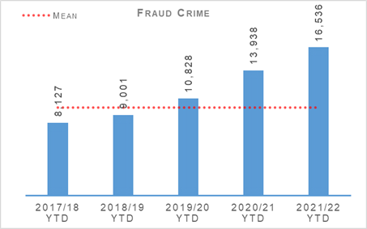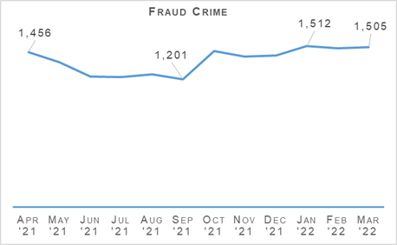
Fraud crimes continue to rise, increasing 18.6% compared to the same period last year and 68.2% from the five year mean. It remains that the UK public is more likely to experience fraud than any other crime type. Its widespread nature is partly because it is amplified by the internet, making it a cyber-enabled crime type.
This increase and use of digital devices provides challenges both in terms of investigation and in the provision of mitigating actions and awareness-raising so that potential victims of frauds are more adept at identifying suspicious sites or activities and report them to authorities.
The continued restrictions and limitations brought about through the COVID-19 pandemic has exacerbated the increases of cyber-enabled crime, as we all increasingly rely on technology as part of our everyday lives.
The flexibility provided through a fully cyber-enabled public and workforce has been of great benefit during the pandemic with a significant increase in working from home and flexible working practices through to online shopping and investment activity. However, it has also provided increased opportunity for fraudulent activity and has highlighted the many challenges facing law enforcement.
One significant aspect is the jurisdictional challenges and investigative or disruptive opportunities when victims of fraud may reside in Scotland but the perpetrators reside within other jurisdictions of the UK and often beyond the borders of the UK. This has reiterated the need for a cohesive and multi-faceted approach and sharing of learning and trends to combat this increasing crime type.
As criminals grow ever more sophisticated, investigating those responsible requires an equally sophisticated whole-system approach. Police Scotland continues working with partners across law enforcement and the private sector with the aim of disrupting the activities of these criminals and protecting the public from falling victim in the first instance. Police Scotland has established partnerships across the cyber ecosystem, including being a key partner in Cyber Scotland Partnership, with a focus on reaching public, private, third sector, learning and skills development, promoting cyber security and online safety.
Public awareness plays a huge part in ensuring that people can quickly identify when they may be subject to a fraud and how to report it to the appropriate enforcement agency. This allows enforcement bodies to track the fraud landscape, understand fraud trends and ensure appropriate enforcement and informative messaging is made available to limit the number of victims. The reach of under reporting spans all aspects of our communities from vulnerable citizens through to multinational companies.
The reasons for such under reporting ranges from embarrassment through to commercial implications and the need to protect organisational reputations. Police Scotland continues to support awareness raising campaigns through all of our social media channels. During the month of March 2022 we supported the UK wide Fraud Intensification period led by the National Economic Crime Centre (NECC) and carried out extensive enforcement activity across the country combatting money laundering.
Understanding the challenges facing law enforcement and our partners, Police Scotland has initiated a Fraud Strategic Governance Group. This group, involving police, partners (including third sector) and the Scottish Government has been set up to understand and direct activity at a strategic level to combat the threats posed by the increases in fraud.
The group looks to provide a coordinated public awareness raising initiative to prevent fraud from being committed and also ensure appropriate governance around a consistent and joined up strategy across agencies and organisations is undertaken. This group feeds into the National (UK) Economic Crime Board for fraud and Project PLUTUS which looks at maximising opportunities to investigate and combat money laundering across the UK and internationally.
Engagement in these groups ensures that learning, fraud patterns and trends and evolving investigative techniques to quickly identify crimes at an early juncture are maximised and shared so that appropriate executive action can be undertaken at a UK and/or international level.
In an effort to address concerns regarding frauds where offenders purported to be police officers and other officials, an impersonation awareness campaign was delivered at the end of January 2022. This focused on reaching the vulnerable members of the community who may not access or use social media and leaflets were produced. This was supported through local policing teams and community officers.
Additionally, support was provided from partners including Scottish Business Resilience Centre, Neighbourhood Watch Scotland Alert platform and UK Finance, reinforcing the banking protocol. An informative media clip produced by the Met Police was kindly shared for use by Police Scotland detailing the fraudulent methods used by criminals impersonating police officers and other officials such as HMRC and how to avoid being a victim of fraud which was also shared widely.
The Safer Communities department in East Kilbride carried out a leaflet drop providing crime prevention and fraud awareness advice, particularly aimed at unexpected calls asking for personal information. The leaflet drop was used to supplement social media messaging and to try and reach areas of the community who might not have access to social media.
An elderly member of the public got such a call and because they had read the leaflet, hung up straight away and contacted a family member, who in turn reported to police. Information was provided by the family that it was due to the awareness from the leaflet that prevented another victim.
In terms of serious and organised criminality in the fraud space, the Economic Crime and Financial Investigation Unit (ECFIU) is part of Specialist Crime Division (SCD) and is managed by the Head of the Organised Crime and Counter Terrorism Unit (OCCTU). To counter those involved in serious and organised financial crime the ECFIU have geographically spread teams which target five distinct areas. At present, the ECFIU have a total of 121 live investigations overseeing activity in excess of £172 million of value.

The Banking Protocol
The Banking Protocol is a multi-agency initiative between law enforcement, banking institutions and Trading Standards. Its aim is, at the earliest opportunity, to identify vulnerable victims who are in the process of being defrauded of funds from their bank accounts by unscrupulous criminals and to intervene to prevent these crimes. If staff suspect customers are being coerced or the transaction is as a result of fraud, the transaction is stopped and the police are contacted. The Protocol is designed to provide a standardised method for how these concerns are dealt with and reported to police and to stop multiple victimisation.
In terms of the reporting year 2021/22, the Banking protocol recorded 1,170 incidents accounting for circa £6.46 million worth of fraud being prevented.
Whilst the higher numbers continue and can cause concern it is encouraging to note that banking staff and front line officers are continuing to promote the aims of the Banking Protocol to protect people from becoming victims of crime.

Detection Rates
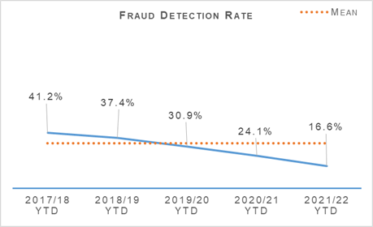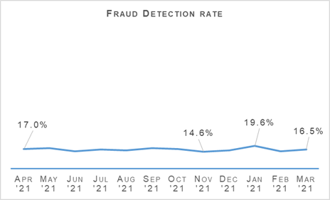
The fraud detection rate currently stands at 16.6%, down 7.5 percentage points on last year and 17.0 percentage points on the five year mean. This decrease has been driven by both recorded frauds increasing and detections falling. Between April 2021 and March 2022, 2,746 frauds were detected, which is 18.3% (617) less than the same period last year and 16.9% (558) less than the five year mean.
As reported in previous quarters, this is an issue seen across UK forces and the wider policing world, due to how quickly the cyber-enabled element of fraud is evolving and the complexities these cases often involve.

Serious Organised Crime Groups (SOCGs)
Serious Organised Crime Group Mapping (SOCGM) is a tool used by law enforcement in Scotland to map the characteristics of the individuals and groups that are known through intelligence and operational activity. The following figures are reflective of the SOCGM picture in Scotland as at Quarter 4 2021/22.

Mechanism to Recover Monies from SOCGs
Proceeds of Crime Act (POCA) led to the recovery of £36,301,089 from SOCGs in 2021/22.
Confiscation orders led to the recovery of £4,856,156 from SOCGs in 2021/22.
Civil Recoveries Unit recovered £5,051,235 from SOCGs in 2021/22.
There are 97 known Serious Organised Crime Groups (SOCGs) comprising of 1,827 individuals being investigated by police and partners in Scotland. The number of groups has increased by one this quarter and the number of individuals has seen a reduction of 6% compared with Quarter 3 2021/22. The number of SOCGs has been generally consistent throughout the performance year with the exception of Quarter 2 when it peaked at 106.
The greatest prevalence of Police Scotland SOCGs remains in the west of Scotland: 61% of groups are located in the west, 21% in the east of Scotland and 18% in the north.
Police and partners in Scotland adopted the tactical Management of Risk in Law Enforcement (MoRILE) model to score groups, individuals or vulnerabilities with effect from Quarter 1 2021/22. MoRILE methodology assesses impact, physical, psychological and financial harm to individuals, the community, public expectation and environmental impact; likelihood, confidence and organisational position, taking account of an organisation’s capacity and capability to respond to the threat.
The tactical model is a tool to enable law enforcement agencies to understand their operational and tactical risk and should be used in tasking processes.
With all law enforcement agencies in the UK using the MoRILE tactical model, it will facilitate the interoperability and the movement of operational and tactical work between law enforcement agencies whilst prioritising use of resources. This ensures resources are used to target the issues causing the greatest risk.
Throughout 2021/22, there have been a total of 123 SOCGs that have featured on SOCGM. Of these, almost one-third have seen a reduction in risk score (full year - 32%). As at Quarter 4 2021/22, 97 groups are recorded by SOCGM. 29% have experienced a reduction in their tactical risk score (Quarter 4 - 29%).
Five organisations have submitted SOCGs to SOCGM during the quarter. At Quarter 4 2021/22, 83% of SOCGs are being investigated by Police Scotland (n=80), 7% (n=7) by Her Majesty’s Revenue and Customs (HMRC), 7% (n=7) by Home Office Immigration Enforcement (HOIE), 2% (n=2) Trading Standards Scotland (TSS) and 1% (n=1) by British Transport Police (BTP).
SOCGs are involved in a diverse and wide range of known and emerging criminality. Over the course of 2021/22, SOCGs operating in Scotland have directed, facilitated and undertaken human trafficking; prostitution; organised immigration crime; the distribution, importation, storage and supply of firearms; the distribution, importation, manufacture, supply and transportation of drugs; violence; extortion; acquisitive crime including theft of motor vehicles and plant; reset; cybercrime, environmental crime including wildlife crime, illegal waste activity and illicit dog / puppy trade; the facilitation of counter-surveillance, false documentation, pill presses and employing illegal workers; counterfeit currency and goods; money laundering in a variety of forms; money lending and fraud including social engineering, benefit, excise duty evasion, VAT repayment, rogue trader / bogus workmen and COVID-19.
The most common criminality undertaken by mapped SOCGs continues to be drugs, money laundering and violence. Drugs has been the most common criminality throughout 2021/22. Drugs remains a high volume threat with 62% of SOCGs in Scotland involved despite the number of groups concerned in this criminality declining over the course of the performance year.
Comparison of Quarter 4 2021/22 to the previous quarter shows an increase in the number of groups in the following crime categories: fraud, immigration, environmental and cybercrime. The crime categories showing a reduction in the number of groups include drugs, violence, firearms & explosives, other facilitation, and counterfeiting / forgery. The crime categories remaining static in comparison to Quarter 3 are money laundering, human trafficking, theft, sexual offences and extortion.
Looking forward to 2022/23, a public facing version of the Scottish Multi-Agency Strategic Threat Assessment (SMASTA) will be published in 2022. This includes collaboration with 18 law enforcement partners in Scotland. In addition to this a multi-agency Serious Organised Crime (SOC) Conference will take place in 2022, the aim of which is to highlight SOC in Scotland and Police Scotland / partners response via case studies and presentations highlighting localism and community impact / improvements.

Cyber Strategy
Police Scotland’s Cyber Strategy (2020) was approved by the Scottish Police Authority (SPA) in September 2020. Work is currently ongoing to deliver a Strategic Outline Business Case and High-Level Target Operating Model to underpin the development of a better skilled workforce, partnerships, technologies and capabilities more able to mitigate the growing risks and threats which cybercrime presents to the people and communities of Scotland. These are currently being finalised and will be the subject of further internal and external engagement prior to being presented through formal governance over coming months.
Working in collaboration with national and international partners we are developing a deeper understanding of this complex and ever-changing criminal landscape and creating viable proposals to improve service delivery, the ability to disrupt, pursue and divert those who seek to engage in cybercrime. We also aim to build our ability, in conjunction with partners from a range of sectors, to prevent such crimes and reduce the impact on victims, many of whom are vulnerable. We are a key partner in supporting the creation of the Scottish Government led ‘Scottish Cyber Co-ordination Centre’ which will initially focus on strengthening public sector resilience through enhanced information/intelligence sharing and collaboration to mitigate cyber threats to our core national functions.
Progress to date has been in line with the agreed deliverables but through additional investment Professional Services support (via PricewaterhouseCoopers) has been commissioned to accelerate the achievement of key milestones and development of proposals for change. This has included a review of the Cyber Strategy (2020) which was assessed as relevant and viable within the constantly evolving threat picture and development of national strategic policies.
Since approval of the Cyber Strategy (2020) a number of key national strategies have been published, including;
Scottish Government – Cyber Resilient Scotland; Strategic Framework (2021)
UK Government - National Cyber Strategy (2022)
UK Government – Cyber Security Strategy (2022 – 2030)
Scottish Government - Vision for Justice in Scotland (2022)
These national policies provide a vision for dealing with the evolving threats from cybercrime. Work is ongoing to ensure that the Police Scotland approach both compliments and influences the national (UK) direction and that our links to national structures and developments, are deepened and beneficial, such as our growing links with NPCC leads and our current contribution to the development of a UK-wide Cyber Harm Reduction Strategy.
The threat landscape has continued to evolve since publication of the strategy, with growing societal dependency on technology, evolving crime trends, victim profiles and vulnerabilities. The changing nature of the cyber threat means that delivery of the Strategy has to be responsive and our ability to implement transformational change in a changing environment will need to be agile and supported by effective governance and technology.
Prevention, partnerships and safeguarding need to lie at the heart of our approach to ensure that the impacts of this global threat can be minimised locally. Implementing change within this fluid environment is, however, challenging.
As an illustration of the changing threat:
Proportionately, cybercrime now accounts for more reported crime; it accounted for an estimated one-in-three sexual crimes in 2020-21 and around one-in-ten crimes of dishonesty.
There are increasing links between SOC and Cybercrime – the number of Scottish-based SOCG’s involved in cybercrime and fraud is increasing. There is evidence of the SOCG use of cryptocurrency increasing each quarter and two mapped SOCG are actively involved in committing cybercrime.
There has been increase of 18.6% in fraud in the past 12 months, 95% of which is now online. Detection rates have decreased to 16.6%. Whilst the strategic approach is being refined some significant progress has been made in Strategy delivery.
A new Case Management system was delivered to Digital Forensics in November 2021, supporting improved processes and efficiency and ISO 17025 accreditation. In the three months to February 2022, use of Cyber Kiosk software increased by 50%, following increased impetus by Local Policing and SCD staff, reducing demand on Digital Forensics and supporting victims and witnesses.
Police Scotland is a rights-based organisation and has established governance processes that balance the requirement to comply with data protection and privacy regulations and ensure legitimacy for the police service.

Police Custody

Criminal Justice
Volume of cases submitted into Criminal Justice System: There were 137,297 cases in 2020/21 and 128,932 cases in 2021/22 submitted into the Criminal Justice System. The percentage change from the previous year was minus 6.1%.
Please note due to a technical fault with the recording system in Tayside Division, the figure for 2021/22 excludes figures from March 2022.
There is a consistent national downward trend emerging in reported cases and whilst effective use of Direct Measures and Alternatives to Prosecution are likely a contributing factor, the full extent of this is unclear in the context of the wider pandemic.

Arrested Persons

Arrested Persons Brought into Custody
Number of times arrested persons brought into custody: There were 98,124 times in 2020/21 and 93,719 times in 2021/22 that arrested persons were brought into custody. The percentage change from the previous year was minus 4.5%.
It is important to note that that number of arrested persons includes individuals who have appeared in custody on more than one occasion within the reporting period. This excludes voluntary attendance, S.23 MDA 1971 detentions and those in transit.
The decrease is modest but still notable and is in keeping with the general trend in previous years relating to the numbers coming through custody. It comes also despite the relaxation of COVID-19 restrictions for the majority of the period under review.

Arrested Persons Held for Court
Proportion of Arrested Persons Held for Court: There were 35.2% of arrested persons in 2020/21 and 36.9% of arrested persons in 2021/22 that were held for court. The percentage point change from the previous year was plus 1.8 percentage points.
The slight increase in the number of arrested persons held for court is reflective of the gradual return to normality as the Criminal Justice (CJ) sector continues its journey to recovery and business as usual (BAU). It remains considerably down on 2019/20 figures. The Quality Assurance Inspector (QAI) role was instrumental in driving a shift in culture towards ensuring that the presumption of liberty was robustly balanced with wider risks to victims and the public.
The QAI role has now been replaced by new Audit and Compliance Sergeant roles who continue to provide a live time focus on appropriate custodial decision making whilst also expanding to audit and quality assure all aspects of the custody journey to include areas such as arrest acceptance, rights of accused, care plan, observation levels, search level and appropriate healthcare assessment and intervention.

Arrested Person Released / Re-arrested
Proportion of arrested persons released on an undertaking: There were 25.6% of arrested persons in 2020/21 and 25.8% of arrested persons in 2021/22 that were released on an undertaking. The percentage point change from the previous year was plus 0.2 percentage points.
Proportion of persons released on investigative liberation: There were 0.4% of arrested persons in 2020/21 and 0.6% of arrested persons in 2021/22 that were released on investigative liberation. The percentage point change from the previous year was plus 0.2 percentage points.
Number of persons re-arrested: There were 469 persons in 2020/21 and 540 persons in 2021/22 that were re-arrested. The percentage change from the previous year was plus 15.1%.
The term ‘re-arrested’ is defined as any occasion whereby a person, previously released without charge as a ‘Not-Officially Accused’ person, is subsequently re-arrested for the same offence due to the presence of further evidence. This is not to be confused with a person arrested more than once within a specified period on separate charges as defined by recidivism.
Undertakings remain steady and consistent with the previous year which demonstrated a considerable improvement on 2019/20 levels (13.8%). The ability to make use of undertaking in a proportionate way is further evidence of justifiable custodial decision making since the implementation of the Criminal Justice (Scotland) Act 2016. Use of investigative liberation has also improved and this may be impacted by a recent well publicised staff communications drive on the use / benefits of investigative liberation related to investigations.
The increase in the number of persons re-arrested may be partially explained as a result of staff using the powers afforded by the Criminal Justice (Scotland) Act more effectively following increased guidance and communications about how and when powers can be used most effectively. Re-arrest can increase investigative opportunities and should be viewed in this context.

Children brought into Police Custody / Held for Court
Number of younger children arrested and brought into custody: There were 1,566 younger children in 2020/21 and 1,581 younger children in 2021/22 that were arrested and brought into custody. The percentage change from the previous year was plus 1.0%.
Number of younger children held for court: There were 128 younger children in 2020/21 and 80 younger children in 2021/22 that were held for court. The percentage change from the previous year was minus 37.5%.
Number of older children arrested and brought into custody: There were 2,429 older children in 2020/21 and 2,307 older children in 2021/22 that were arrested and brought into custody. The percentage change from the previous year was minus 5.0%.
Number of older children held for court: There were 547 older children in 2020/21 and 488 older children in 2021/22 that were held for court. The percentage change from the previous year was minus 10.8%.
Definitions for clarity: Adult being defined as 18 or over; Older Child being defined as 16/17 and Not under Supervision; Younger Child being defined as Under 16 or 16/17 but subject to a Compulsory Supervision Order. The number listed as held for court are those who were held in a police cell and had a relevant certificate in terms of S.22 of the Criminal Justice (Scotland) Act 2016 issued indicating why they were so held and not at a place of safety.
The definition of children in this context is a complex one but includes those aged 18 and under in particular circumstances. Police Scotland has no desire to hold children in our care and custody and only does so where there is no other alternative Place of Safety available. Only in the most serious of cases and where there is no other appropriate Place of Safety will a child be held in police custody.
On every occasion we work with our partners in the Local Authority to identify any other suitable alternatives. Where these cannot be provided it is sometimes necessary to keep children in our care and custody. Police Scotland are working with the Scottish Police Authority and partners to ensure that there is an appropriate provision of alternatives to custody available across Scotland.
We have seen a very slight increase noted in the number of young children brought into custody, and we anticipate this represents a stabilising of the new levels following substantial decreases from pre-pandemic. All trends are in keeping with CJSD and broader Criminal Justice sector aims to reduce the numbers of children coming into and being detained in custody and indicates improved compliance with the children's rights principles outlined within United Nations Convention on the Rights of the Child (UNCRC).

Antisocial Behaviour (ASB) Fixed Penalties
Number of antisocial behaviour fixed penalties issued: There were 24,040 fixed penalties issued in 2020/21 and 8,946 fixed penalties issued in 2021/22 for antisocial behaviour. The percentage change from the previous year was minus 62.8%.
A significant proportion of the Fixed Penalties issued in 2020/21 relate to the Health Protection (Coronavirus) (Restrictions) (Scotland) Regulations 2020. The decrease in the issuing of ASB Fixed Penalty Tickets will be as a direct result in the easing of these restrictions which no longer create an offence for certain activities previously subject to such penalties.
Accordingly the decrease is anticipated in the circumstances, and the figure for this reporting period is returning to levels around those reported in the same period as 2019/20 (7,251 ASB Fixed Penalties). In fact, when COVID-19 offences are removed, the figures for 2021/22 are almost identical to 2020/21, and represent a fall from previous periods, a trend observed for several years.

Vulnerability
Number of times persons arrested who have declared an alcohol addiction: There were 11,204 times in 2020/21 and 10,496 times in 2021/22 that persons arrested declared an alcohol addiction. The percentage change from the previous year was minus 6.3%.
Proportion of persons arrested who have declared an alcohol addiction: There were 11.4% of persons arrested in 2020/21 and 11.2% of persons arrested in 2021/22 that declared an alcohol addiction. The percentage point change from the previous year was minus 0.2 percentage points.
Number of times persons arrested who have declared drug addiction issues: There were 16,734 times in 2020/21 and 14,438 times in 2021/22 that persons arrested declared drug addiction issues. The percentage change from the previous year was minus 13.7%.
Proportion of persons arrested who have declared drug addiction issues: There were 17.0% of persons arrested in 2020/21 and 15.4% of persons arrested in 2021/22 that declared drug addiction issues. The percentage point change from the previous year was minus 1.6 percentage points.
Number of times persons arrested who have declared mental health issues: There were 40,711 times in 2020/21 and 38,841 times in 2021/22 that persons arrested declared mental health issues. The percentage change from the previous year was minus 4.6%.
Proportion of persons arrested who have declared mental health issues: There were 41.5% of persons arrested in 2020/21 and 41.4% of persons arrested in 2021/22 that declared mental health issues. The percentage point change from the previous year was minus 0.1 percentage points.
Please note, each custody may have reported "yes" to each of the above categories.
As a result of the total number of persons arrested being down on previous years, the number of persons arrested declaring alcohol and drug addiction or mental health issues are down on the same period. As a proportion of the total number of persons arrested, those declaring alcohol and drugs addiction and/or mental health issues remained relatively stable and slightly down.

NHS Partners in Custody Centres
Number of people in custody seen by NHS partners in custody centres: There were 6,115 people in 2020/21 and 6,702 people in 2021/22 that were in custody and seen by NHS partners in custody centres. The percentage change from the previous year was plus 9.6%.
Figures provided represent the numbers marked out of cell for medical assessment (excluding those to hospital). They do not include those individuals who are subject to several medical assessments as is often the case during longer periods in custody.
Within the past year there has been a drive to make optimal use of Health Care Professionals for healthcare and welfare decisions and risk assessment. This may have contributed to the rise, however, it is an area which is difficult to interpret owing to the complex nature of the healthcare needs of those in custody.
The increase may also be indicative of a shift back towards pre-pandemic levels or alternatively a new status quo. It is assessed as likely that it is too early and too complex a picture to draw reliable inference from the data at this stage.
We are committed to ensuring the safety and wellbeing of those in our care and custody. However, it is important to recognise that many of these people are vulnerable and have complex needs. As such, we work closely with healthcare professionals to provide an appropriate level of care based on an assessment of these needs and risks.
Police Scotland have highlighted that despite our national approach to police custody, the healthcare provision is supplied by 14 Health Boards each of whom provide Police Scotland with differing levels of service or delivery methods. We welcome the ongoing inspection by Her Majesty’s Inspectorate of Constabulary Scotland and Healthcare Improvement Scotland who will consider the provision available across Scotland and make appropriate recommendations.

Partner Referrals
Number of arrested person referred to partners: There were 702 arrested persons in 2020/21 and 1,238 arrested persons in 2021/22 that were referred to partners. The percentage change from the previous year was plus 76.4%.
Please note figures were not available prior to 2020/21 owing to the lack of consistent recording mechanisms available and used.
Although the Harm Reduction Strategy focuses on four strands, namely reducing drugs deaths, drug and alcohol use, mental health and social inequalities, there is much work being undertaken to increase the availability of access to support services after release from custody. This includes both increasing the number and range of services working with Police Scotland, but also a greater focus on and scrutiny of the arrest referral service internally.
This is evident by the addition of West Dunbartonshire Alcohol Drug Partnership to the fold. CJSD's Healthcare and Interventions Team continue to seek to broaden the referral processes to additional third sector partners where suitable, to ensure that those arriving in custody with alcohol, drugs or mental health issues have access to a range of meaningful support.
Since April 2021, a new arrest referral service has gone live in Dundee (Dundee CARS) and as of 01 June 2021, the division has appointed over 150 Custody Support and Intervention officers (CSIs) who are being offered support and training in all aspects of referral arrangements and practice, to allow them to increase the number of referrals offered and continue to raise awareness of available support for those in need.
Work continues to promote the Arrest Referral scheme across the country.

Strategic Outcome: The public, communities and partners are engaged, involved and have confidence in policing

Police Scotland’s objectives are to:
Embed the ethical and privacy considerations that are integral to policing and protection into every aspect of the service
- Protect the public and promote wellbeing across Scotland by providing services that are relevant, accessible and effective
- Work with local groups and public, third and private sector organisations to support our communities

Public Confidence and Satisfaction
Insight into Police Scotland’s approach to addressing public confidence and the importance the organisation places on this key aspect of policing and community engagement is detailed in the Public Confidence and Experience of Policing section at the beginning of this report.
The following provides the survey results that have been identified by Police Scotland and the Scottish Police Authority as key measures of progress towards achieving this strategic outcome.

Your Police Survey – Public Opinion Statements
Percentage of those surveyed who feel either very safe or fairly safe in their area: 88% In quarter 1 2020/2021; 81% in quarter 2 2020/2021; 70% in quarter 3 2020/2021; 75% in quarter 4 2020/2021; 79% in quarter 1 2021/2022; 72% in quarter 2 2021/2022; 70% in quarter 3 2021/2022 and 84% in quarter 4 2021/2022 all said they felt very safe or fairly safe in their area.
Percentage of those surveyed who strongly agree or agree that police listen to concerns of local people: 41% In quarter 1 2020/2021; 36% in quarter 2 2020/2021; 32% in quarter 3 2020/2021; 30% in quarter 4 2020/2021; 25% in quarter 1 2021/2022; 37% in quarter 2 2021/2022; 36% in quarter 3 2021/2022 and 25% in quarter 4 2021/2022 all strongly agree or agree that police listen to concerns of local people.
Note: Confidence refers to how those who may not have directly engaged with the organisation feel about Police Scotland. This is intended to reflect public mood and sentiment towards the organisation

User Experience Survey Responses
Percentage of those surveyed saying it was easy or very easy to contact the police: 82% In quarter 1 2020/2021; 76% in quarter 2 2020/2021; 75% in quarter 3 2020/2021; 81% in quarter 4 2020/2021; 75% in quarter 1 2021/2022; 67% in quarter 2 2021/2022; 75% in quarter 3 2021/2022 and 76% in quarter 4 2021/2022 all said it was easy or very easy to contact the police. The percentage point change from quarter 4 2021/22 to quarter 3 2021/22 was plus 1 percentage point.
Percentage of those surveyed satisfied or very satisfied with the way they were treated by staff member during initial contact: 87% In quarter 1 2020/2021; 85% in quarter 2 2020/2021; 88% in quarter 3 2020/2021; 87% in quarter 4 2020/2021; 85% in quarter 1 2021/2022; 82% in quarter 2 2021/2022; 86% in quarter 3 2021/2022 and 87% in quarter 4 2021/2022 all said they were satisfied or very satisfied with the way they were treated by the staff member during initial contact. The percentage point change from quarter 4 2021/22 to quarter 3 2021/22 was plus 1 percentage point.
Percentage of those surveyed who felt staff properly understood what they needed: 88% In quarter 1 2020/2021; 87% in quarter 2 2020/2021; 89% in quarter 3 2020/2021; 89% in quarter 4 2020/2021; 86% in quarter 1 2021/2022; 84% in quarter 2 2021/2022; 87% in quarter 3 2021/2022 and 89% in quarter 4 2021/2022 all said they felt staff properly understood what they needed. The percentage point change from quarter 4 2021/22 to quarter 3 2021/22 was plus 2 percentage points.
Percentage of those surveyed who felt that the police provided the appropriate response: 66% In quarter 1 2020/2021; 67% in quarter 2 2020/2021; 70% in quarter 3 2020/2021; 60% in quarter 4 2020/2021; 66% in quarter 1 2021/2022; 62% in quarter 2 2021/2022; 65% in quarter 3 2021/2022 and 68% in quarter 4 2021/2022 all said they felt the police provided the appropriate response. The percentage point change from quarter 4 2021/22 to quarter 3 2021/22 was plus 3 percentage points.
Percentage of those surveyed who felt satisfied with the way they were treated by officers who attended the incident (where applicable): 80% In quarter 1 2020/2021; 82% in quarter 2 2020/2021; 83% in quarter 3 2020/2021; 84% in quarter 4 2020/2021; 81% in quarter 1 2021/2022; 78% in quarter 2 2021/2022; 80% in quarter 3 2021/2022 and 83% in quarter 4 2021/2022 all said they felt satisfied with the way they were treated by officers who attended the incident. The percentage point change from quarter 4 2021/22 to quarter 3 2021/22 was plus 3 percentage points.
Percentage of those surveyed who felt they were adequately informed about the progress made (where applicable): 53% In quarter 1 2020/2021; 56% in quarter 2 2020/2021; 59% in quarter 3 2020/2021; 64% in quarter 4 2020/2021; 59% in quarter 1 2021/2022; 55% in quarter 2 2021/2022; 60% in quarter 3 2021/2022 and 63% in quarter 4 2021/2022 all felt they were adequately informed about the progress made. The percentage point change from quarter 4 2021/22 to quarter 3 2021/22 was plus 3 percentage points.
Percentage of those surveyed who based on overall experience, felt they were satisfied or very satisfied with Police Scotland: 71% In quarter 1 2020/2021; 72% in quarter 2 2020/2021; 73% in quarter 3 2020/2021; 73% in quarter 4 2020/2021; 68% in quarter 1 2021/2022; 64% in quarter 2 2021/2022; 68% in quarter 3 2021/2022 and 70% in quarter 4 2021/2022 all said that based on their overall experience, they were satisfied or very satisfied with Police Scotland. The percentage point change from quarter 4 2021/22 to quarter 3 2021/22 was plus 2 percentage points.
Note: Satisfaction refers to those who have contacted the police. This reflects on the organisation’s ability to handle individual incidents for an effective outcome for people, the police service and communities

Quarterly Comparison
Since April 2020 measures of satisfaction with Police Scotland have remained consistently high. The change of survey methodology (from phone interviews to text in April 2020 due to the pandemic) resulted in changes in the data. It’s important to note that these data changes do not always indicate a trend and overall satisfaction has remained between 64%-73% in each Quarter over the past two years.
The number of respondents in Quarter 4 2021/22, who ‘agree’ or ‘strongly agree’ that the police listen to concerns of local people was 25%, a significant decrease of 11% compared to the previous quarter (36%).
There has been a small increase in the number of respondents reporting it is ‘easy’ or ‘very easy’ to contact Police Scotland (76%) compared to Quarter 3 (75%). This increase is also reflected in levels of overall satisfaction, which saw an increase of two percentage points (70%) compared to the previous quarter (68%).
To understand the reasons for initial contact being easy or difficult, a new open-ended survey question was introduced to the local policing User Experience Survey in September 2021. 3,839 responses were received to this additional question in Quarter 4.
Among respondents who found it easy to contact police, qualitative analysis of responses has highlighted the following as reasons why contact was easy:
Service Accessibility. 37% (n=1,416) of respondents highlighted fast 101 / 999 answer times and praised the phone system, with its automated menus, for being easy to navigate.
Effective Communication. 14% (n=547) of respondents praised service advisers for their ability to be helpful under pressure, whilst also helping keep the caller calm and making them feel safe.
Among respondents who found it difficult to contact police, qualitative analysis of responses has highlighted the following as reasons why contact was difficult:
Difficulties with connecting to a service advisor. 14% (n=537) of respondents referred to long waiting times using the 101 service for non-emergency incidents, the inability to connect to staff on their first attempt or giving up calling 999 instead.
Being kept up to date after initial contact. 4% (n=140) of service users highlighted a lack of updates / follow up to their cases to know what was happening, with no call-backs or updates about their reported incident.
Further comments provided by survey respondents highlight the importance of:
Listening to understand needs to provide the appropriate response.
Making access to the police service as easy and intuitive as possible.
The need for multiple ways of online (email, website), virtual (video calling) and in person (easy access to and relationships with local officers) contact with police.
Consistency of service delivery, with a high standard of service from all staff and officers in all parts of Scotland.
Being informed and updated on aspects of work that Police Scotland is doing to respond to local areas of concern and reported incidents; highlighting the importance of a continuous engagement with the public.
Ease of contact is a key area of focus in the Public Contact and Engagement Strategy where the introduction of accessible new contact channels and enhancement of how we communicate and engage, will help to improve public experience and confidence in reporting crime and other incidents, enabled by digital services. For example, key programmes are continuing to ensure people are able to contact police in ways which are most accessible for individuals:
Fully accessible online reporting for getting information and advice, reporting low level crime and other incidents, receiving updates, and sharing evidence.
Investing in the replacement of our national contact platform (UCCP) to sustain contact assessment and call triage and to ensure our technology is a platform for innovation and supportive technologies i.e. ‘next generation 999’ for connecting with mobile technology. Policing of the future in Scotland is expected to use video and text, activated by service advisors for easing emergency contact, in addition to phone contact.
Ensuring the public can reach us using voice assisted technologies e.g. smart home devices and smart watches, in situations where they might not be able to reach a phone to dial 999.

Further projects to understand public insight and feedback

Focus groups on Police Scotland’s use of emerging technology in policing
Police Scotland commissioned Progressive Partnership Ltd. to facilitate a series of online focus groups in December 2021 which sought to understand attitudes towards police use of technology to inform future consideration at an early stage. Focus groups were useful to understand the factors which may lead to public support or non-support for the use of technology and what the public deem to be necessary for new developments in policing.
Participants were recruited to ensure a good mixture of age, gender, geography and socio-economic background. Four focus groups took place, one for each of the following age categories: 18-25 year olds, 26-40 year olds, 41-54 year olds and over 55s. People who were completely unaware of technology (e.g. doesn’t use the internet, email or have a mobile phone) were excluded from the sample as the aim was to ensure groups represented the ‘median’ person in Scotland. Groups took place with residents from the Borders, Glasgow, Edinburgh, Aberdeen, Dundee and the Highlands. Participants received £40 for taking part.
It’s important to stress when working with focus groups or any form of ‘qualitative’ data that it does not provide statistical data, but this type of research facilitates valid and extremely valuable insight and understanding. It is useful for explorative research where relatively little is known about an audience’s views on a subject.

Attitudes towards technology in policing
All groups feel positively about technology and recognise the benefits and see it as a force for good.
That said content of public messaging may need to be targeted and older people are likely to need higher levels of reassurance.
Facial recognition is used on an everyday basis and the benefits are fully understood.
Drones are understood as a concept and people are aware of the various uses they may have.
Artificial Intelligence (AI) is less well understood as a term and respondents didn’t connect it to facial recognition.
People sometimes find it hard to grasp how technology could be utilised by Police Scotland. This is particularly true for drones and AI.
Giving examples of how AI and drones are used by frontline services could open up people’s understanding (and therefore acceptance) of their use by Police Scotland.

How we can re-assure the public and communities
Technology freeing up police time to spend more time on the streets could be a strong message, but people also want reassurance that technology won’t be used as a means to absorb further cuts to frontline police services.
The public are open to the idea that technology speeds things up and can be more efficient. These are good platforms to base messages on.
Providing evidence of how it has informed better outcomes and giving reassurance that it is a complimentary tool will foster acceptance.
The public need to know that all use of technology is closely governed and that the police are rigorously trained in its use.
At all times, Police Scotland should be transparent about how and when they use these technologies because the public does not want technology being used indiscriminately for general surveillance-type activities.
With the right messaging, the public are likely to be supportive of Police Scotland adopting these technologies.
Key findings from this engagement are available to view here.

Complaints about the Police

Complaints
Total number of complaints from members of the public: There were 6,973 complaints in 2020/21 and 6,503 complaints in 2021/22 from members of the public with the percentage change from the previous year being minus 6.7%. The five year mean was 6,483 complaints with the percentage change from the five year mean being plus 0.3%.
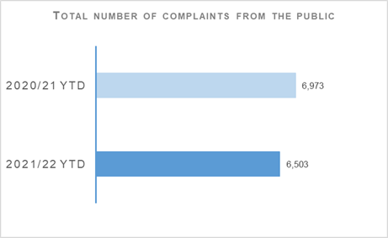 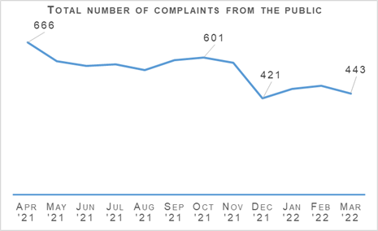Complaints from members of the public decreased by 6.7% to 6,503 at the end of Quarter 4 compared to the same period last year but are up 0.3% (20 more complaints) on the five year mean.
The volume of COVID-19 related complaints peaked during the early quarters of 2020/21 and this continues to be a key factor in driving the year to date decrease in total complaints received. A total of 131 COVID-19 complaints were received during the year to date 2021/22. This represents a decrease of 85.1% (748 fewer complaints) when compared to the same period last year where 879 COVID-19 complaints were received.
The Professional Standards Department (PSD) has resolved 3,110 complaints (47.8%) by Frontline Resolution (FLR) during the year to date 2021/22, compared with 50.7% in the same period last year. This includes early resolution and subsequent resolution by PSD/Specialist officers.
Due to the launch of a new complaint handling model on 03 May 2021, FLR rates cannot be directly compared to the same period in 2020/21. This is due to the provision of additional complaint categories which will provide PSD with more detailed analysis and understanding of the overall complaint handling process.

Allegations
Total number of allegations from members of the public: There were 12,432 allegations in 2020/21 and 11,027 allegations in 2021/22 from members of the public with the percentage change from the previous year being minus 11.3%. The five year mean was 10,948 allegations with the percentage change from the five year mean being plus 0.7%.
Percentage of closed allegations which were upheld: There were 8.3% of closed allegations in 2020/21 and 7.0% of closed allegations in 2021/22 which were upheld with the percentage point change from the previous year being minus 1.2 percentage points. The five year mean was 10,1% of closed allegations which were upheld with the percentage point change from the five year mean being minus 3.1 percentage points.
Note: A complaint case may include multiple allegations. A ‘Complaint’ relates to the overall expression of dissatisfaction provided by the complainer about an act or omission by the police or Quality of Service received. Allegations are the component parts of a complaint, which categorise what has happened and are separated to those capable of being independently Upheld or Not Upheld
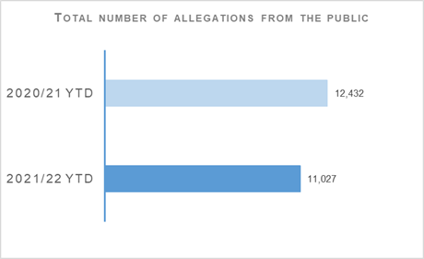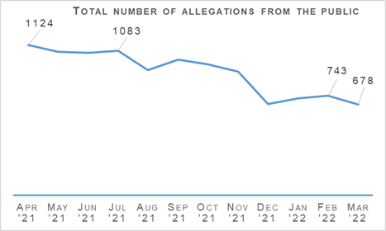
The total number of allegations have decreased by 11.3% (1,405 fewer allegations) compared to the same period last year, with 11,027 allegations recorded at the end of Quarter 4 2021/22. The number of allegations are however up 0.7% (79 more allegations) on the five year mean. As with the number of complaints, the peak COVID-19 related allegations in Quarter 1 of last year are assessed as being a major contributory factor in the year on year decrease.
Allegations closed totalled 11,150 at the end of Quarter 4 with 7.0% of these being upheld. Allegation outcomes (e.g. upheld) are based on closed allegations within the year to date period. Closure dates vary from the received dates, therefore closed and received data may not be directly comparable.
During this period, 1,457 non-criminal complaints were closed with 27.7% closed within the 56 day statutory timescale. A 10.8% decrease from the same period in 2020/21. This is influenced by service demand and an increased complexity of cases. Police Scotland continue to develop in terms of complaint handling with both the Criminal Allegations Against the Police Division (CAAPD) and the Police Investigations and Review Commissioner (PIRC), to ensure an enhanced and developed service providing a transparent and proportionate response to complaints.

Police Investigations and Review Commissioner (PIRC)
Number of PIRC Complaint Handling Reviews (CHRs): There were 226 CHRs in 2020/21 and 198 CHRs in 2021/22 with the percentage change from the previous year being minus 12.4%. Five year mean figures are not available.
Number of allegations considered by PIRC (CHRs): There were 900 allegations in 2020/21 and 788 allegations in 2021/22 considered by PIRC with the percentage change from the previous year being minus 12.4%. Five year mean figures are not available.
Percentage of reviewed allegations assessed as handled to a reasonable standard: There were 70.4% of reviewed allegations in 2020/21 and 66.9% of reviewed allegations in 2021/22 assessed as being handled to a reasonable standard with the percentage point change from the previous year being minus 3.5 percentage points. Five year mean figures are not available.
The Police Investigations & Review Commissioner (PIRC) has conducted 198 Complaint Handling Reviews (CHRs) which equates to only 3.0% of all complaints. The 198 CHRs conducted by PIRC considered 778 allegations, with 527 (66.9%) assessed to have been handled to a reasonable standard. This is down 3.6 percentage points from the same period in 2020/21. These CHRs included 248 recommendations.
Police Scotland made 250 referrals to PIRC resulting in 70 investigations (28.0%). This is an increase compared to the same period last year where 26.2% of referrals resulted in an investigation. Statutory referrals to the PIRC facilitate independent and transparent scrutiny in relation to serious incidents involving the police. Those referred to PIRC include:
Armed Policing Presentation of Firearm (72)
Crown Directed Inference of Criminality (34)
Death Following Police Contact (10)
Death in Police Custody (1)
Serious Injury Following Police Contact (29)
Serious Injury in Police Custody (42)
STO Taser Discharged (62)
As of 04 October 2021, allegations of On Duty Assault – plus any associated criminal allegations – are now referred to the PIRC. This follows recommendations made in the Independent Review of Complaint Handling, Investigations and Misconduct Issues by Dame Elish Angiolini in relation to alleged breaches of Articles 3 and 5 of the European Convention of Human Rights (ECHR).

Organisational Learning
PSD is committed to promoting a culture of organisational learning. Learning from CHRs and other sources are disseminated through bulletins, individual feedback and is also used to inform training packages. This learning can therefore influence and improve our service.
In Quarter 4, PSD has disseminated learning from a variety of incidents with the following learning outcomes of particular note:
All Officers involved in complaint handling are reminded, that in line with PIRC statutory guidance, Officers should be named in any response letters or their badge numbers referred to unless there is a specific officer safety reason for not doing so.
It is expected of officers to maintain an auditable record of enquires carried out during their processing of complaints. This should be borne in mind by complaint handlers when dealing with future complaints.
All staff involved in the handling of complaints are reminded that a Heads of Complaint form must be completed and that it is best practice to note a statement of complaint from the complainer.
Officers and staff who are dealing with complaints are reminded of the terms of the PIRC statutory guidance in relation to FLR and non-investigation provisions. This will help to ensure that the provisions are applied appropriately, thereby increasing public confidence in the complaint handling process.
While officers’ accounts may understandably be similar, they should not be copies of each other. In addition, Police Scotland’s Professional Standards Department has recently circulated a memorandum to all divisions in this connection. Officers are reminded of the importance of providing their own accounts to inform any future enquiry.
Officers involved in complaint handling are reminded of the importance of providing factually accurate responses which properly reflect the information that has been gathered during the complaint enquiry. This will help to ensure that the person who made the complaint is able to fully understand how the decision to uphold or not uphold the complaint has been reached. Furthermore, this approach will help to build public confidence in the police complaint handling system.

Strategic Outcome: Our people are supported through a positive working environment, enabling them to serve the public

Police Scotland’s objectives are to:
Prioritise wellbeing and keep our people safe, well equipped and protected
Support our people to be confident leaders, innovative, active contributors and influencers
Support our people to identify with and demonstrate Police Scotland values and have a strong sense of belonging

Assaults on Police Officers and Police Staff
Common assault of emergency workers (police officer / police staff) – number of offences: There were 7,297 offences in 2020/21 and 7,046 offences in 2021/22 with the percentage change from the previous year being minus 3.4%. The five year mean was 6,491.0 offences with the percentage change from the five year mean being plus 8.6%.
Percentage of assaults leading to injury: There were 34.3% of assaults in 2020/21 and 27.5% of assaults in 2021/22 which led to injury with the percentage point change from the previous year being minus 6.8 percentage points. Five year mean figures are not available.
Number of assault RIDDORS: There were 22 assault RIDDORS in 2020/21 and 45 assault RIDDORS in 2021/22 with the percentage change from the previous year being plus 104.5%. Five year mean figures are not available
Number of assault RIDDORS per 1k employment: There were 1.0 assault RIDDORS in 2020/21 and 2.0 assault RIDDORS in 2021/22 per 1k employment with the percentage change from the previous year being plus 100.0%. Five year mean figures are not available.
Note: The figures for crime incidents and injuries to officers / staff are obtained from two separate systems / databases and do not directly correlate, but that are representative of the issue. Prior to 21 March 2021 Highland and Islands Division data only includes detected assaults.

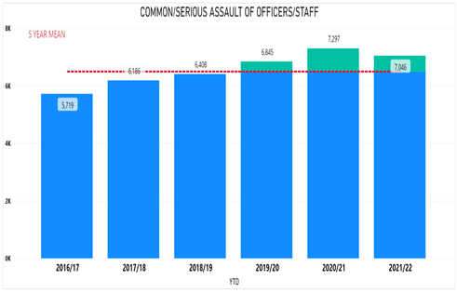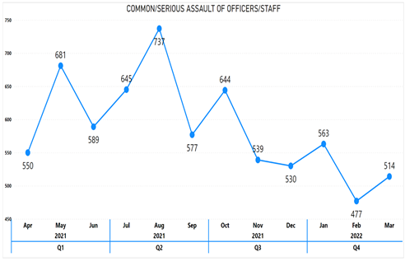

Your Safety Matters (YSM)
In August 2020, Chief Constable Iain Livingstone outlined his commitment to reduce the impact of violence and to improve the safety of officers and staff in the Your Safety Matters Assault Pledge. The YSM Assault Pledge highlighted that violence to officers and staff was not a part of their jobs and would not be tolerated.
Assaults against officers / staff have decreased by 3.4% (251 fewer) compared to the same time period last year. However, assaults against officers / staff are up 8.6% (555 more) above the five year average. Importantly, the injury rate of assaults against officers / staff has decreased by 6.8 percentage points. As noted in the Key Insights section the introduction of the YSM Dashboard suite and continued increased analysis can be viewed as a factor in the decreases observed in assaults and injuries.
Other initiatives have also contributed to these decreases such as the ‘Your Safety Matters Partnership Pledge’, which is a partnership public health approach with emergency / front line services and local authorities in order to reduce violence against emergency workers. However, the decrease in the injury rate could also be attributed to the increased reporting of assaults on officers / staff to Health and Safety.
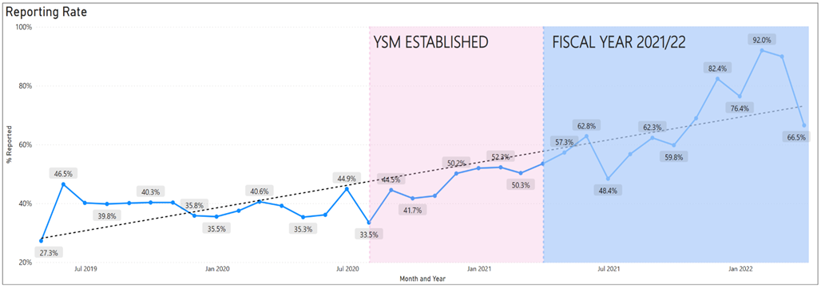
The reporting rate of assaults on officers / staff has continued to increase in 2021/22, with only one month (June 2021, 48.5%) with a reporting rate below that of the highest reporting rate in 2020/21 (March 2021, 53.5%). The rise in the reporting rate is a result of The YSM Divisional Champions, who have continued to have quarterly meetings to share / gain best practice in relation to assaults on officers / staff. Having a higher reporting rate enables Police Scotland to more accurately report on and analyse incidents of violence against officers / staff, to help further improve officer / staff safety and wellbeing.
YSM has continued to hold a Hate Crime Sub Group, which aims to expedite work around the support given to officers / staff who have experienced Hate Crime / Incidents at work. The Hate Welfare Support Assessment that is being developed by the YSM Hate Crime Group will provide line managers with an effective toolkit to structure support considerations and signpost to relevant support mechanisms. The Hate Welfare Support Assessment is currently in governance awaiting approval.

Use of Force

Spit Hoods
Police Scotland has encouraged officers and staff to make use of spit hoods. Since the beginning of the COVID-19 pandemic there has been an increase in assaults recorded which involve coughing or spitting. Incidents of spitting, where officers and staff are exposed to bodily fluids, can increase the risk of exposure to blood-borne viruses. The use of spit hoods can help reduce this risk.
The new Officer Safety Training programme emphasises de-escalation and aims to give officers and staff increased confidence in control of a subject when effecting an arrest. The reduction in use of spit hoods compared to the last two years, would suggest this approach is achieving a degree of success.

Use of Force Applied
Spit Hood / Mask Used: There were 798 spit hoods/masks used in 2020/21 and 726 spit hoods/masks used in 2021/22 with the percentage change from the previous year being minus 9.0%. There were 886 spit hoods/masks used in 2019/20 with the percentage change from 2019/20 being minus 18.1%.

People and Development

Absence Management
Absence data shows an increase for both officers and staff against the same period last year.
Percentage of working days lost for police officers: There were 6.2% of working days lost in 2020/21 quarter 4 and 10.1% of working days lost in 2021/22 quarter 4 by police officers with the quarter 4 percentage point change from the previous year being plus 3.9 percentage points. There were 6.1% of working days lost in 2020/21 and 8.3% of working days lost in 2021/22 by police officers with the percentage point change from the previous year being plus 2.2 percentage points.
Percentage of working days lost for police staff: There were 6.5% of working days lost in 2020/21 quarter 4 and 9.2% of working days lost in 2021/22 quarter 4 by police staff with the quarter 4 percentage point change from the previous year being plus 2.8 percentage points. There were 6.7% of working days lost in 2020/21 and 8.1% of working days lost in 2021/22 by police staff with the percentage point change from the previous year being plus 1.4 percentage points.
Average working days lost for police officers: There were 3.2 working days lost in 2020/21 quarter 4 and 5.1 working days lost in 2021/22 quarter 4 on average by police officers with the quarter 4 change from the previous year being plus 1.9 working days. There were 12.5 working days lost in 2020/21 and 17.0 working days lost in 2021/22 on average by police officers with the change from the previous year being plus 4.5 working days.
Average working days lost for police officers – COVID-19: There were 0.9 working days lost in 2020/21 quarter 4 and 2.6 working days lost in 2021/22 quarter 4 on average by police officers due to COVID-19 with the quarter 4 change from the previous year being plus 1.7 working days. There were 3.6 working days lost in 2020/21 and 6.4 working days lost in 2021/22 on average by police officers due to COVID-19 with the change from the previous year being plus 2.8 working days.
Average working days lost for police officers – non COVID-19: There were 2.3 working days lost in 2020/21 quarter 4 and 2.6 working days lost in 2021/22 quarter 4 on average by police officers due to non COVID-19 with the quarter 4 change from the previous year being plus 0.3 working days. There were 8.9 working days lost in 2020/21 and 10.5 working days lost in 2021/22 on average by police officers due to non COVID-19 with the change from the previous year being plus 1.6 working days.
Average working days lost for police staff: There were 3.9 working days lost in 2020/21 quarter 4 and 5.6 working days lost in 2021/22 quarter 4 on average by police staff with the quarter 4 change from the previous year being plus 1.7 working days. There were 16.3 working days lost in 2020/21 and 19.6 working days lost in 2021/22 on average by police staff with the change from the previous year being plus 3.3 working days.
Average working days lost for police staff – COVID-19: There were 0.7 working days lost in 2020/21 quarter 4 and 2.1 working days lost in 2021/22 quarter 4 on average by police staff due to COVID-19 with the quarter 4 change from the previous year being plus 1.4 working days. There were 4.1 working days lost in 2020/21 and 5.5 working days lost in 2021/22 on average by police staff due to COVID-19 with the change from the previous year being plus 1.4 working days.
Average working days lost for police staff – non COVID-19: There were 3.2 working days lost in 2020/21 quarter 4 and 3.5 working days lost in 2021/22 quarter 4 on average by police staff due to non COVID-19 with the quarter 4 change from the previous year being plus 0.3 working days. There were 12.2 working days lost in 2020/21 and 14.1 working days lost in 2021/22 on average by police staff due to non COVID-19 with the change from the previous year being plus 1.9 working days.

Officers

YTD 2020/21: ABSENCE RATE WITH COVID-19

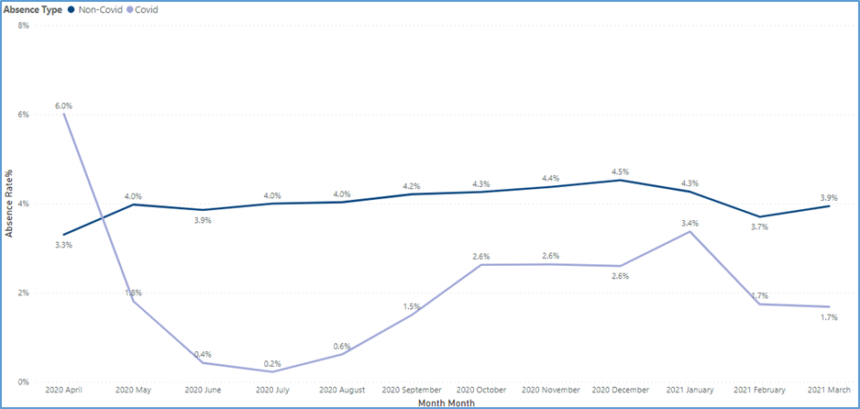

YTD 2021/22: ABSENCE RATE WITH COVID-19
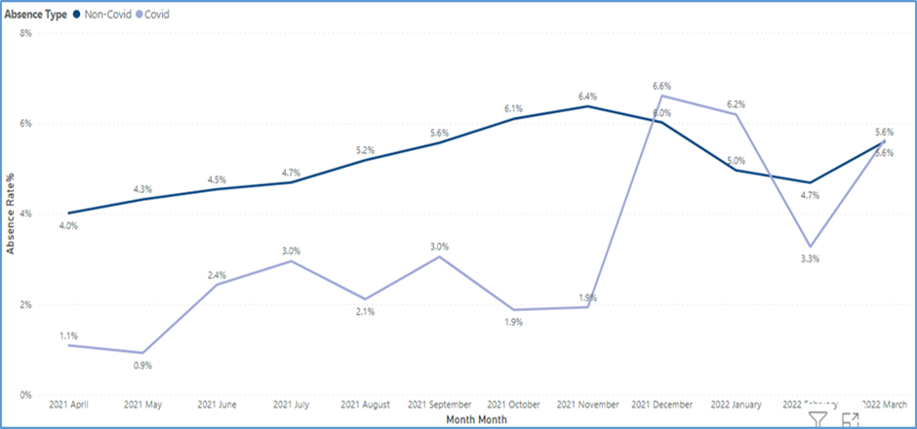

Staff

YTD 2020/21: ABSENCE RATE WITH COVID-19
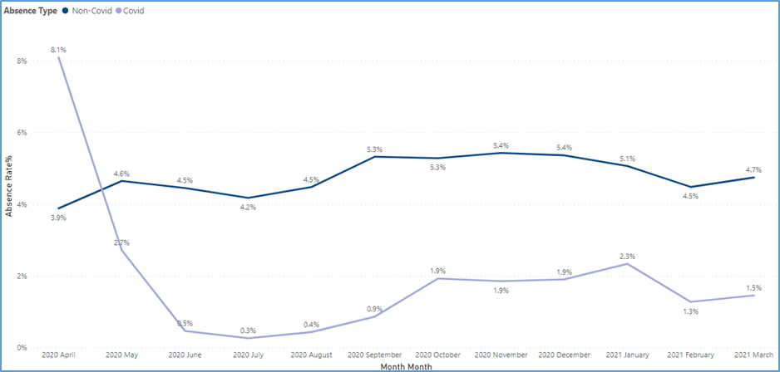

YTD 2021/22: ABSENCE RATE WITH COVID-19
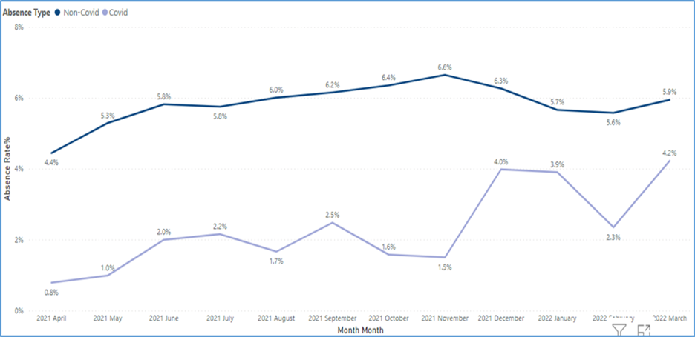
Absence data this quarter shows an increase for both officers and staff against the same period last year. The average working days lost at year-end 2021/22 has increased against the same period last year by 4.5 days for police officers and 3.3 days for police staff.
It can be noted that in this financial year 38% of officer working days lost were COVID-19 related and 28% for staff; this representing 35% of the total workforce working days lost for 2021/22.
Non-COVID related absences are also up on last year for both officers and staff. These will continue to be robustly monitored within the organisation across management and Primary Boards; and by all business areas supported by a professional People Partner assigned to assist local management teams to identify trends or hotspots and to take all appropriate action.
Analysis of non-COVID absence shows that the main causes are broadly similar for both officers and staff with psychological disorders continuing to be the greatest cause of absence. This reinforces both YVM results and HR staff observations that psychological disorders referenced across HR grievance, discipline and ill-health retirals casework.
The organisation also has a multi-faceted mental wellbeing programme and as part of this resilience training is available, providing officers and staff with tools to help keep them well and minimise mental illness.
Given the complex nature of psychological illness, Police Scotland are commencing a detailed deep-dive of this issue to more clearly understand what Police Scotland can do to better support our workforce. The intention is that this will inform the new Occupational Health contract which will be subject to procurement of the course of this financial year. This report will also be tabled at People Committee in November. This will commence with a year-end review with our occupational health and employee assistance service providers by the organisation’s Wellbeing Team, which are described in more detail as follows.

Occupational Health Provision

Occupational Health
Number of occupational health referrals: There were 3,716 referrals in 2019/20; 2,784 referrals in 2020/21 and 3,350 referrals in 2021/22 to occupational health. The percentage change from the previous year was plus 20.3%. Five year mean figures are not available.

Employee Assistance Programme
Number of Employee Assistance Programme (EAP) referrals: There were 2,449 referrals in 2019/20; 1,851 referrals in 2020/21 and 2,148 referrals in 2021/22 to the Employee Assistance Programme (EAP). The percentage change from the previous year was plus 16.0%. Five year mean figures are not available.
Occupational Health data above shows that in 2020/21 there was a substantial decrease in occupational health delivery due to the impact of COVID-19 but with the easing of restrictions delivery is returning to pre COVID levels.
The People and Development Health and Wellbeing team will be working with Optima Health to understand the data and identify a number of areas which require focus moving into 2022/23. The year-end review took place in May 2022, with initial areas of focus including:
Over 30% of physiotherapy referrals are for lower back issues - Adoption of a more preventative approach to our health and wellbeing work, with the provision of more information and support for all officers and staff to take action earlier. As part of this health and wellbeing will work with other areas within the organisation to review equipment usage.
Rejected referrals – during 2021/22 we have had over 400 rejected referrals. The team will work with Optima Health to understand why this is the case but health and wellbeing must also take a line manager and supervisor focus in terms of raising awareness of their role in the provision of occupational health in particular. This could be extended to a coordinated communications plan to increase officer and staff awareness and understanding of what occupational health can provide and support you with to manage expectations.
A blended model of delivery – whilst virtual consultations have provided efficiencies in some areas and enabled the service to continue we must recognise that in some cases officers and staff would like the option of both.
Use of data – health and wellbeing must ensure that all data available is analysed and utilised i.e. divisional and unit referral data sets per headcount can guide our work on awareness, targeting those with the highest rates.
An overview of HELP Employee Assistance Programme usage is also provided. Similarly to occupational health services 2020/21 saw a noted decrease in HELP EAP usage with 2021/22 showing a significant uplift in the number of calls in particular. COVID-19 was most certainly a factor with less officers and staff seeking help and support.
The People and Development Health and Wellbeing team will be working with Optima Health to analyse the data and identify a number of areas which require focus moving into 2022/23. The focus of the year-end review of EAP usage will include:
Use of data – similarly to occupational health data health and wellbeing must explore the ‘why’ behind trends and themes identified within the data. Two examples of how the data can shape our future focus are provided below.
Personal related issues – during 2021/22 there were 831 personal issues reported in relation to mental health (stress, anxiety, depression), it is clear that mental health must remain a key focus of work within learning, training and development.
Work related issues – 73 traumatic incidents at work were reported during 2021/22, we must ensure that Your Safety Matters and TRiM are informed and consulted in shaping of future support.
Calls not resulting in a mental health assessment – during 2021/22, 805 calls did not result in an assessment with referral / signposting to others services such as voluntary support, legal and debt support, and the GP / NHS taking place. Health and wellbeing must ensure that all support pathways are established and provide a reliable offer of support, with regular communication with all partners to understand any emerging officer and staff needs.
Feedback – the health and wellbeing team must have a mechanism by which it is an ‘ongoing conversation’ in terms of understanding how the service meets officer and staff needs i.e. a proposal to create a health and wellbeing advisory group has been tabled at the Wellbeing Governance Board, membership would include health and wellbeing representatives from throughout the organisations and staff associations.

Strategic Outcome: Police Scotland is sustainable, adaptable and prepared for future challenges

Police Scotland’s objectives are to:
Use innovative approaches to accelerate our capacity and capability for effective service delivery
Commit to making a positive impact through outstanding environmental sustainability
Support operational policing through the appropriate digital tools and delivery of best value

Finance

Maintaining a balanced budget: Financial monitoring report tracking and forecasting a balanced budget by Year End
The Corporate Finance and People Board monitor financial performance on a monthly basis and the overall financial position is regularly reported to the Scottish Police Authority (SPA) and Scottish Government. There is also frequent engagement throughout the year to ensure that the accountable officer is aware of the overall financial position and seek their views on how any emerging issues should be dealt with.
The approved budget is reforecast on a quarterly basis to ensure the financial position continues to reflect what is actually happening across the organisation to enable better informed decisions.
The provisional revenue outturn for the year ended 31 March 2022 shows a net expenditure position of £1,227.9m, £3.3m less than the Quarter 3 full year forecast. This is mainly due to the cost of additional untaken annual leave balances being lower than originally anticipated.
Of the £1,227.9m net expenditure, £1,216.2m relates to the core revenue budget which has broken even on a recurring basis, and £11.7m relates to the in-year impact of COVID-19 which is £3.3m under the £15m in-year funding allocation.
The full year outturn capital spend of £58.1m and funding of £58.4m are both primarily in line with Quarter 3 full year forecast, resulting in an underspend of £0.3m.
The full year outturn revenue reform spend of £22.8m is £0.3m under Quarter 3 full year forecast of £23.1m.

Maintaining Financial Sustainability
The medium and long term financial planning documents and annual budget submissions support this strategic outcome. Financial sustainability has been the primary objective of the medium/long term financial strategies developed since 2016, all of which highlighted the challenges facing the service in achieving financial sustainability.
These multi-year financial plans focused on the sustainable elimination of the Authority’s structural deficit by way of a combination of workforce reductions or a correct to revenue funding.
Following representations made to Scottish Government ministers and officials as part of spending review discussions, the Scottish Government’s 2021/22 budget included a significant uplift to police funding. This allowed the Authority to address the structural deficit without the need for workforce reductions.
A revised five year financial plan was approved by the Board at the Authority meeting of 29 September 2021. This demonstrates that a balanced budget can be sustained assuming that:
Scottish Government funding keeps pace with unavoidable pay pressures, including wage inflation, national insurance increases, SPRM and lost income.
The organisation managed the workforce size and mix within current pay budgets.
Cost pressures beyond Scottish Government funding are met from compensating savings from across the organisation.
The five year financial plan is an iterative document that will be refreshed on a regular basis to ensure that new services and any other significant changes are reflected when confirmed.
A financial planning framework was approved in March 2022 alongside the 2022/23 annual budget. An updated five year financial plan will be developed following the publication of the Scottish Government Spending Review in the Spring of 2022.
Development of a robust longer term financial strategy is highly dependent on a number of key enabling strategies, including the strategic workforce plan, the target operating model and the transformation roadmap. This will be prepared in line with the strategic business planning cycle.
Everyone in the organisation has a role to play in improving financial sustainability, making efficient use of resources and eliminating waste to deliver best value. Developing and actively managing the annual budget for revenue, capital and reform is a collaborative process involving consultation across the whole organisation as well as key stakeholders.
Once approved, budgets are allocated to nominated budget holders who are responsible for the management and control of that budget throughout the year. The approved budget represents the maximum financial resource for which budget holders have authority to allocate, prioritise and make financial commitments for their business areas.
Optimising the use of these resources is key in achieving best value. A robust process of budgetary control, undertaken on a monthly basis (with formal quarterly reviews) is in place to help ensure that divisions and departments make the most efficient use of their budgets and that each budget holder is accountable for spending of public money, in line with agreed budget at the outset of the financial year.
This approach enables Police Scotland to ensure that the financial position is monitored, with the appropriate checks and balances in place to maintain a financially sustainable position.
An overarching aim of our procurement strategy is to deliver value for money and best value outcomes by improving efficiency and reducing expenditure where possible. Key elements include sourcing strategies, market engagement, and contract and supplier management.
These procurement considerations, alongside the monthly monitoring of compliant spend undertaken across the organisation ensure that we deliver best value and support our financial sustainability objective.

Procurement
In Quarter 3 of this year, Police Scotland reported that 95% of regulated spend was undertaken compliantly in line with our purchasing policy.
Police Scotland report retrospectively on spend compliance as a result of the data requiring to be analysed after the end of each quarter. The figure provided is an analysis of Quarter 3 2021/22. Data for Quarter 4 2021/22 will be available in the 2022/23 Quarter 1 report.

Fleet
Ultra-Low Emission Vehicles (ULEV) make up 16% of Police Scotland’s fleet.
The average age of vehicles in our fleet is 5.12 years.
The average percentage of vehicle availability was 97.7% of vehicles available.
Police Scotland is working towards implementing the move to an Ultra-Low Emission Fleet (ULEV) as part of our Fleet Strategy. ULEV vehicles currently make up 16% of Police Scotland’s overall fleet with 25% of these being marked vehicles. Work remains ongoing with the ULEV Board and the Implementation Group.

Estates Co-locations / Collaborations
Police Scotland has 10% footprint of our Estate either co located / shared with our partners at the end of the reporting year 2021/22.
The collaboration leases have been concluded as part of the North East Division Integration Project (NEDIP) in Aberdeen at Marischal College and Woodhill House with Aberdeen City / Aberdeenshire councils respectively.
The overall percentage of footprint has reduced by 0.67% this quarter due to two additional properties (SPA Laboratory and OSD Coatbridge) coming online and being added to the overall estate figure. The estate was also reduced by the sale of properties in Johnstone.

Estates Condition Survey
A full condition survey for the Police Scotland Estates was concluded in 2020/21 by Ryden LLP. They evaluated 314 properties on the basis of condition looking at the major property components: roof, walls, electrical, mechanical etc. over a measured estate area of 438k square metres. The overall condition of the Police Estates was evaluated at 69% based on Scottish Government condition methodology. The survey results were first detailed in the Estates Life Cycle Management report submitted to the Senior Leadership Board (SLB) in October 2021.
Maintenance costs are estimated at £242.7m over the next 10-12 years to ensure that the Police Scotland Estate can fully reach and then maintain a satisfactory condition. This was valued at prevalent pricing in 2021 therefore this could be subject to increase due to current inflationary price impacts. An additional cost of £36.4m is estimated as the cost to deliver the programme including technical services covering detailed design and specification, contract management and procurement.
Following a detailed tender process in Quarter 4, a recommended Professional Estates Partner to support the initial planning phase will be appointed in Quarter 1 2022/23 which will allow us to create an implementation plan based on the Survey Outcomes, including full work specifications, for Priority 1 works for the next year and a 10 year Strategic Plan for prioritisation of projects and future investment.

Environmental - Total carbon emissions per m2 of estates
Police Scotland’s 2021/22 Buildings emissions tCO2e and per m2 are as follows:
Quarter 1 – 6,745 tCO2e and 15.8 kg/m2
Quarter 2 – 4,982 tCO2e and 11.66 kg/m2
Quarter 3 – 8,688 tCO2e and 20.3 kg/m2
Quarter 4 (actual) – 6,384 tCO2e and 14.9 kg/m2
Quarter 4 (estimate) – 9,062 tCO2e and 21.2 kg/m2
Police Scotland’s 2021/22 Total emissions tCO2e and per m2 are as follows:
Quarter 1 – 10,497 tCO2e and 24.5 kg/m2
Quarter 2 – 8,529 tCO2e and 19.97 kg/m2
Quarter 3 – 10,890 tCO2e and 25.4 kg/m2
Quarter 4 (actual) – 8,482 tCO2e and 19.9 kg/m2
Quarter 4 (estimate) – 12,134 tCO2e and 28.41 kg/m2
These figures represent the most up to date emissions based on data from our utilities bureau service and finance. Quarter 4 data is incomplete as we await information on March 2022 being validated and added to our reports. Therefore we have added an actual total representing known data to date and an estimated total based on a direct comparison with March data last year.
Buildings emissions data comprises of utilities consumption and waste production. Total emissions comprises of buildings related data, fleet fuel consumption and corporate travel. Full and accurate figures will be available in the coming weeks and this information will be updated to reflect March 2022 totals. m2 total is taken from the GIA figure provided in STC bureau service portal.

Environmental – Reduction in Co2 emissions
Total actual emissions for 2021/22 are currently 39,889 tCO2e with the final estimated emissions (including March 2022 projection) being 43,584 tCO2e. Total emissions for 2020/21 were 47,003 tCO2e. This means that we are projected to reduce our emissions this year by 7.3% against last year and by 12.8% against our baseline year.
Please note, total annual figures for 2021/22 have been estimated using figures for corresponding emissions sources from last year. Actual full year figures will be available shortly.

Operation TALLA – Police Scotland’s response to COVID-19
Over the last two years, Police Scotland have implemented the Operation TALLA Command Structure to manage the planning and response to the impact of COVID-19. This has been continuously reviewed and refined as our response to the pandemic evolved and restrictions were eased. Nine bespoke strategic objectives, aligned to our overarching strategic outcomes, are detailed below. This has provided a framework to focus operational activity associated with maintaining critical policing functions, serving changing public needs and supporting our staff to continue to provide a professional and effective service to our communities.
Due to the removal of restrictions, the Operation TALLA Command Structure has now stood down and all work streams have been incorporated into business as usual. As such, this is the final quarterly report that will feature an Operation TALLA section.

Operation TALLA Strategic Outcomes and Objectives

Outcome 1: Threats to public safety and wellbeing are resolved by a proactive and responsive police service.
Objectives:
Maintain critical policing functions to best serve the communities of Scotland throughout the pandemic.
Work in partnership providing an appropriate policing response at strategic, tactical and operational level, including to any incidents involving COVID-19.

Outcome 2: The needs of local communities are addressed through effective service delivery.
Objectives:
Support partners as part of local and national resilience arrangements to mitigate the impacts of COVID-19 and to safeguard community resilience and cohesion, through effective planning preparation, response and recovery.
Monitor and respond appropriately to any internal or external tensions.

Outcome 3: The public, communities and partners are engaged, involved and have confidence in policing.
Objectives:
Maintain officer, staff and public trust and confidence through effective proactive internal and external communications.

Outcome 4: Our people are supported through a positive working environment, enabling them to serve the public.
Objectives:
Protect, safeguard and support our officers and staff, throughout the period of the pandemic.

Outcome 5: Police Scotland is sustainable, adaptable and prepared for future challenges.
Objectives:
Renew and rebuild our working practices in a way that captures organisational learning and seeks out opportunities for continuous improvement.
Undertake financial planning, budgeting and monitoring to ensure that the financial impact of the organisation responding to the new demands of operating in a COVID-19 environment can be understood and managed, whilst ensuring that financial control, governance and discipline are maintained throughout the response.
- To ensure all residual Operation Talla related work is mainstreamed as the Force enters the recovery phase and transitions back to normality, post-pandemic. We will continue to safeguard our own people ensuring we continue to best serve the communities of Scotland.

Emergency Legislation – Co-operation Levels
Police Scotland’s approach to the use of COVID-19 legislation continues to be primarily based on engagement with the public, explaining the provisions, and encouraging compliance with the necessary restrictions. Enforcement action is only taken where absolutely necessary. This approach is commonly known as the Four Es (engage, explain, encourage, enforce).
Whilst the overall style and tone of policing the pandemic in Scotland has not changed since the inception of the public health emergency, during September 2020 an additional condition was added to the approach which enabled quicker acceleration through the Four Es for flagrant or repeated breaches.
The following table summarises police intervention action taken during the period: 01 April 2021 to 31 March 2022 with comparisons to the same period the previous year. Only 27 interventions were recorded during the Quarter 4 period this year:

Type of Interventions
There were six premises closed in 2021/22 which accounts for less than 0.1% of all interventions throughout that reporting year. This compares to 97 premises being closed in 2020/21 which accounted for 0.1% of all interventions during that reporting year.
There were 16 premises where intervention was required in 2021/22 which accounts for 0.1% of all interventions throughout that reporting year. This compares to 407 premises requiring intervention in 2020/21 which accounted for 0.3% of all interventions during that reporting year.
There were zero medical detentions in both 2021/22 and 2020/21.
There were 12,081 dispersals after being informed and requested in 2021/22 which accounts for 51.2% of all interventions throughout that reporting year. This compares to 82,589 dispersals in 2020/21 which accounted for 66.3% of all interventions during that reporting year.
There were 5,518 dispersals after being informed, requested and instructed in 2021/22 which accounts for 23.6% of all interventions throughout that reporting year. This compares to 23,301 dispersals in 2020/21 which accounted for 19.5% of all interventions during that reporting year.
There were 2,949 people removed from place or premises in 2021/22 which accounts for 12.2% of all interventions throughout that reporting year. This compares to 2,032 people removed in 2020/21 which accounted for 1.6% of all interventions during that reporting year.
There were 2,781 fixed penalty notices issued in 2021/22 which accounts for 11.9% of all interventions throughout that reporting year. This compares to 14,068 fixed penalty notices issued in 2020/21 which accounted for 11.3% of all interventions during that reporting year.
There were 97 arrests in 2021/22 which accounts for 0.4% of all interventions throughout that reporting year. This compares to 872 arrests in 2020/21 which accounted for 0.7% of all interventions during that reporting year.
There were 51 recorded police warnings in 2021/22 which accounts for 0.2% of all interventions throughout that reporting year. This compares to 253 recorded police warnings in 2020/21 which accounted for 0.2% of all interventions during that reporting year.
There were 23,399 total interventions in 2021/22 compared to 124,619 total interventions in 2020/21.
Note: Figures are indicative management information and may be subject to change. They should not be considered as Official Statistics.
Note - People removed from place or premises was previously recorded as People returned home using reasonable force.

Total Interactions
The lifting of restrictions has resulted in the significant reduction in the number of interactions recorded this year when compared to the previous year. No interactions were recorded during the Quarter 4 period.

Total Interactions Line Graph
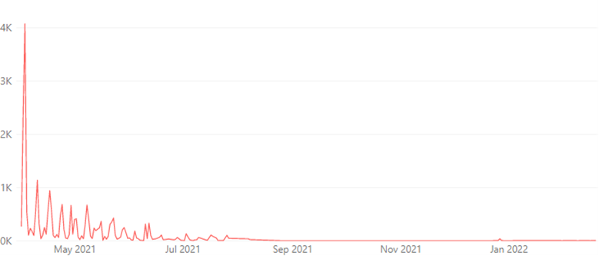
Note: Figures are indicative management information and may be subject to change. They should not be considered as Official Statistics.

OP TALLA Strategic Objective: Maintain critical policing functions to best serve the communities of Scotland throughout the pandemic

Absence
Absence levels remained high at the beginning of the quarter following a rapid increase at the end of Quarter 3, with absences peaking in early to mid-January. From mid-January, absence rates declined rapidly and settled throughout the rest of the month. From 06 January, new rules set by the Scottish Government meant isolation periods could be shorter if negative lateral flow tests were achieved and no symptoms were present. This may have aided a number of officers and staff to return to work sooner.
Absence rates gradually increased throughout February before a sharp increase in early to mid-March. After a mid-March peak, absence levels fell towards the end of the month. The end to contact tracing in Scotland from 21 March may have contributed to this.
At the beginning of the quarter, there were 2,041 COVID-19 related officer and staff absences across the Force, accounting for two thirds of all absences. Roughly 60% of COVID-19 absences were as a result of COVID-19 symptoms and/or confirmed COVID-19. The remaining 40% (842 officers / staff) were absent as a result of precautionary isolating or having being contacted or identified through contact tracing.
COVID-19 related absences peaked on 05 January at 2,136 officers and staff. COVID-19 absences then fell throughout the month of January, before increasing again throughout February and March. Towards the end of March, COVID-19 related absences began to decline.
By the end of the quarter, COVID-19 related absences account for just under half of all absences, with 989 officers / staff absent as a result of COVID-19. Almost 95% of these absences were due to symptoms or confirmed COVID-19. There were 53 officers / staff absent for precautionary isolation or due to being required to as a result of contact tracing.

Total absence line graph – comparison of 2019 to 2020 and 2021
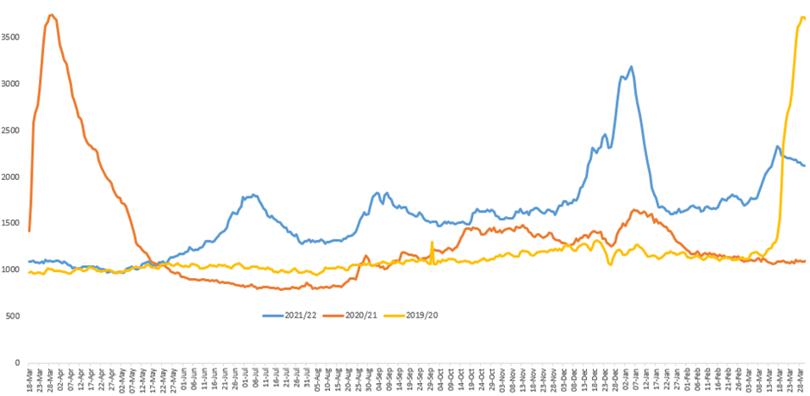

Resource Deployment
In response to the increased absence rates across the Force, approval was given by the Chief Constable in December 2021 to re-establish the Conventional Response Unit (CRU) to support Local Policing. Three hubs were established at Jackton, Scottish Police College (SPC) and Redford Barracks. The CRU model was not implemented in North Command area owing to geography, however officers from specialist and national divisions based in the North Command were deployed directly to Local Policing Divisions. The CRU were stood up from 10 January until 20 February 2022 with 465 officers re-deployed to the CRU from national and specialist divisions.
255 probationers who had completed six weeks of their initial training at SPC were also re- deployed to Local Policing Divisions. Those probationary officers stood down on 25 February, returning to SPC to complete their initial training.
Preparation for any further pandemic waves is in place with Business Continuity Lists consisting of 458 officers available. These officers can be re-deployed from national divisions in support of Local Policing should that prove necessary.

OP TALLA Strategic Objective: Work in partnership providing an appropriate policing response at strategic, tactical and operational level, including to any incidents involving COVID-19
Partnerships, Prevention and Community Wellbeing (PPCW) Violence Prevention and Licensing Coordination Unit (VPLCU) continue to liaise with divisions, who in turn work with licensed premises at an operational level as and when required regarding COVID-19 restrictions.

OP TALLA Strategic Objective: Support partners as part of local and national resilience arrangements to mitigate the impacts of COVID-19 and to safeguard community resilience and cohesion, through effective planning, preparation, response and recovery
As a key member of the Community Planning Improvement Board, Police Scotland attended a Scottish Government presentation in November 2021. The presentation highlighted that there were now three priorities that were of key importance in the COVID-19 Recovery Strategy:
Financial Security for Low Income Households.
Wellbeing of Children and Young People.
Good, green jobs and fair work.
These priorities are developed through public consultation and the presentation urged Community Planning Partnerships (CPPs) to re-examine their Local Outcome Improvement Plans (LOIPs) with these priorities in mind.
The limiting of priorities also comes with other notable differences in policy. There will be no specific tasks set within the priorities in order to allow for innovation and the only challenge will be for organisations to work together to dismantle any barriers.
To allow a concerted effort to tackle Covid-19 Recovery and these priorities, the Scottish Government is asking local systems to consider: ‘What can we stop doing?’
This information has been relayed to the Partnership Superintendents Forum at meetings and by email. Confirmation has been received that this is now being fed into local CPPs, primarily by Police Scotland officers, to help focus attention on the agreed government priorities.

OP TALLA Strategic Objective: Monitor and respond appropriately to any internal or external tensions
PPCW Division’s Equality & Diversity Unit continues to monitor tensions through engagement with local and national partners across all sectors, and daily monitoring of hate crime and incidents. The Unit continue to prepare a weekly Community Tensions Report for the Force Executive and provide information to the National Community Tensions Team.
In Quarter 4 hate crime aggravated by disability and transgender prejudice each increased significantly on PYTD figures. This mirrors a longer term increase in hate crime for both categories. Whilst increases in disability hate crime have some relation to the pandemic i.e. mask wearing, any link to transgender hate crime is less obvious.
Anti-government sentiment in relation to COVID-19 policy remains prevalent, albeit protest activity in Quarter 4 has been low level, having been overshadowed by events in Ukraine.

OP TALLA Strategic Objective: Maintain officer, staff and public trust and confidence through effective pro-active internal and external communications
With the removal of many restrictions during the Quarter 4 period, no external communication activity of note was conducted, however communications activity throughout Quarter 4 continued to support the operational response to COVID-19 and keep our officers and staff updated internally on issues which affect them.

Internal Communications
A dedicated intranet mini-site remains a main source of information, with updates posted on these pages and supported by emails and briefings sent directly to officers and staff.
Updates during Quarter 4 include information about physical distancing and home working, face mask usage and stand down of various Operation TALLA functions.

Professional Standards Department
The Professional Standards Department (PSD) has established a process to identify all complaints relating to COVID-19 and deal with these efficiently and timeously.
During the year-to-date, 131 complaint cases have been received in relation to COVID-19. The PSD National Complaint Assessment & Resolution Unit (NCARU) has resolved 38.2% of these by Frontline Resolution (FLR) through simple explanation, assurance or apology.
The overall volume of COVID-19 related complaints remains significantly below the volume received at the outset of the pandemic. The total of 131 such complaints received year-to-date represents an 85.1% decrease on the previous year-to-date.

COVID-19 Related Complaints Received, by Period
There were 449 COVID-19 related complaints in Quarter 1 2020/21 with a further 107 complaints in Quarter 2, 121 complaints in Quarter 3 and 203 complaints in Quarter 4 of reporting year 2020/21.
In comparison, there were 70 COVID-19 related complaints in Quarter 1 2021/22, 24 in Quarter 2, 16 in Quarter 3 and 12 in Quarter 4 of reporting year 2021/22.
PSD continue to identify the themes emanating from complaints and share these with the Operation Talla command structure in order to assist in shaping their communications strategy when issuing guidance to operational officers. The key theme identified during Quarter 4 of the year-to-date was:
Officers not wearing appropriate PPE and/or failing to socially distance from members of the public. These issues were cited in 66.7% of the COVID-19 related complaints received during this period.
With a number of Coronavirus regulations and relevant guidance in place across the country, all COVID-19 related complaints will continue to be monitored, managed and recorded.

OP TALLA Strategic Objective: Protect, safeguard and support our officers and staff, throughout the period of the pandemic

Outbreak Management Team (OMT)
The Outbreak Management Team (OMT) provide live support to divisions and departments on identification and management of positive test results.
As reported in Quarter 3, the OMT was stood down on 19 November 2021 however was reinstated on 15 December 2021 in response to the increased threat posed by the Omicron variant.
The OMT was again stood down on 28 February 2022. The management of cases is now primarily carried out by line managers who have the support of guidance previously issued.

Agile Working
As a result of the continued high transmission rates of coronavirus across Scotland and the large number of officers and staff who are absent, it remains critical that we take every step we possibly can to protect ourselves, our families and the public, while still ensuring we deliver a high quality policing service.
The introduction of a new hybrid approach to smarter working, initially scheduled for 01 April, has been postponed until 01 June, 2022. All staff who can work from home have been advised to continue to do so until then and should only attend the workplace if there is a critical requirement to do so.

OP TALLA Strategic Objective: Renew and rebuild our working practices in a way that captures organisational learning and seeks out opportunities for continuous improvement

Digital Division
Throughout Quarter 4, Digital Division has been supporting Operation TALLA from business as usual and have turned focus to planning to help support a phased return to office working for some staff on 01 June 2022. Work continues to ensure sufficient processes and stock to support a return to office environment. Engagement continues with partners to implement solutions to support combined physical and remote collaboration in a small number of meeting rooms across the estate (13). This work will cover an initial list of meeting rooms across primary sites and may be extended in due course. It was expected that these would be implemented across Quarter 4 however final testing is taking place with a view to implement ahead of 01 June 2022.
As we have now returned to a focus on BAU and Transformation, during Quarter 4 we have seen the continued development of priorities such as Digitally Enabled Sharing Capability (DESC), Unified Communications and Contact Platform (UCCP) and National Integrated Communications Control System (NICCS).

OP TALLA Strategic Objective: Undertake financial planning, budgeting and monitoring to ensure that the financial impact of the organisation responding to the new demands of operating in a COVID-19 environment can be understood and managed, whilst ensuring that financial control, governance and discipline are maintained throughout the response

Finance
The operational and financial implications of COVID-19 has been monitored closely throughout the financial year to determine the overall impact on our 2021/22 budget position.
The 2021/22 budget approved by the SPA Board on 24 March 2021 included £15m of additional one-off funding to support the in-year impact of COVID-19. The provisional outturn indicates that £11.7m of this funding will be required to cover the additional costs and loss of income attributable to COVID-19.
No incremental capital costs have been incurred during 2021/22.
Along with the focus on the longer term budgetary impact of operating in a COVID-19 environment, Finance continues to provide ongoing support and challenge to ensure that financial control, governance and discipline are maintained.

OP TALLA Strategic Objective: To ensure all residual Operation Talla related work is mainstreamed as the force enters the Recovery phase and transitions back to normality, post-pandemic. We will continue to safeguard our own people ensuring we continue to best serve the communities of Scotland

Re-escalation Plans and Triggers
Throughout the majority of the quarter, the Service continued to operate as per the business as usual (BAU) processes detailed in the transition plans. Although many of the Operation TALLA Cells were stood back up as a result of the Omicron variant, the BAU processes stood up to all tests with the cells available for any advice or escalation requirements.

