Police Scotland Quarter 4 YTD Performance Report: April 2022 to March 2023
Contents
Police Scotland Quarter 4 YTD Performance Report: April 2022 to March 2023 1
Introduction by the Deputy Chief Constable 2
Executive Summary 4
Performance Framework Outcomes and Objectives 12
Policing during Quarter 4 2022/23 – Key Insights 14
Public Confidence and Experience of Policing 18
Measures of Progress towards Strategic Outcomes 29
Strategic Outcome 1 29
Strategic Outcome 2 72
Strategic Outcome 3 101
Strategic Outcome 4 122
Strategic Outcome 5 129

Introduction by the Deputy Chief Constable
Our fourth and final Performance Report for 2022/23 concludes an exceptional and demanding period for policing, reflecting the changing needs of our communities.
Following the death of Her Majesty Queen Elizabeth, Police Scotland officers and staff played an important role to ensure significant events could be held safely, securely and with dignity.
The challenges from the COVID pandemic continued to be felt and new community needs posed by the cost of living crises have arisen.
The performance report highlights that the 48 homicides in 2022/23 is the lowest number recorded in any year since the introduction of modern crime recording standards in the 1970s and that Police Scotland’s extremely high detection rate continues.
During 2022/23 we have experienced a welcome reduction in the number of assaults on our officers and staff - there were 6,657 - a reduction of 438 (6.2%). The number of assaults is also down 2.1% on the five year mean. This is the lowest number of assaults on officers and staff since 2018/19 when 6,452 were recorded.
Our work will continue to be driven under our Your Safety Matters initiative, which aims to reduce the impact violence and abuse has on our officers and staff, and introduce further measures to improve their safety.
The Banking Protocol equips bank staff with the skills to spot the signs of a customer who may have fallen victim to a scam or who may be about to. Between January and March 2023, 294 incidents were reported meaning that over £750,000 of frauds were prevented. For the full year 1,200 reported incidents saw £3.5 million of frauds thwarted. This underlines the value of working in partnership with the banking sector to raise the awareness of the protocol and instigate it when the need arises.
The level of fraud remains high level and a significant challenge – increasing by 107% on the five-year mean. In 2022/23, 46 crimes of fraud were reported every day - 16,879 throughout the year.
The vast majority of frauds have a cyber element associated with them and our Policing in a Digital World programme will ensure we continue to protect communities and businesses in the digital world.
Sexual crimes have increased and we continue our work to improve the way we serve our communities in this area. In March our Violence Against Women and Girls strategy and implementation plan was approved and underlines our commitment to improve how sexual violence and domestic abuse is tackled. We will continue to work in partnership to further improve our response and support for women and girls to help end any form of violence against them.
Despite significant reductions in road fatalities between 2010 and 2020, there has been an increase in recent years. We continue to work with the Scottish Government, Transport Scotland and a range of other road safety partners to improve road safety in Scotland. Road safety will always be a priority with officers supporting this every single day through education and enforcement.
The report also highlights action by our officers to disrupt the activities of organised criminals, seizing illegal drugs and arresting those responsible, as policing continues to play our important role in reducing the harm of drugs on individuals and communities.
Our Performance Reports provide meaningful and accessible insight into the work of policing in Scotland as we work to keep people safe.
Fiona Taylor QPM
Deputy Chief Constable Professionalism, Strategy and Engagement

Executive Summary

Introduction
This is the final Quarterly report of the 2022/23 performance cycle, reporting on our revised Performance Framework and Measures of Progress. We continue to mature our approach with the introduction of benchmarking and a number of new measures in relation to demand. We made further improvements in relation to Equality, Diversity, Inclusion and Human Rights with better alignment of metrics to our Equality Outcomes.
Our outcomes focused Performance Framework is linked to our strategic planning processes and aligns to the Strategic Outcomes as detailed in the 2022/23 Annual Police Plan, these being:
Public Safety and Wellbeing – threats to public safety and wellbeing are resolved by a proactive and responsive police service
Needs of Local Communities – the needs of local communities are addressed through effective service delivery
Confidence in Policing – the public, communities and partners are engaged, involved and have confidence in policing
Working Environment – our people are supported through a positive working environment, enabling them to serve the public
Sustainable and Adaptable Service – Police Scotland is sustainable, adaptable and prepared for future challenges
Police Scotland remain committed to understanding demand in policing and as part of our progression towards this we have developed new ways to present demand data. Additional new metrics around demand have been added to the Performance Framework, some of which are included as follows.

Policing Demand during Quarter 4 2022/23
Quarter 4 concludes a challenging year for Police Scotland with many significant events taking place.

Operation Unicorn
Operation UNICORN was launched on 08 September, to effectively respond to the sad passing of Her Majesty the Queen. This was the first time Police Scotland implemented a no notice mass mobilisation of officers and staff. The close bond between Her Majesty and communities in Scotland was demonstrated through the memorial events across the country where an estimated 107,000 people were in the Edinburgh area on the day Her Majesty the Queen’s coffin was transferred to the Palace of Holyroodhouse. Operation UNICORN concluded with no security breaches; significant violence/disorder or safety issues. Communities supported Police Scotland during this operation with a large number of events and public gatherings taking place across the country. The delivery of this enormous and complex operation was greatly enabled by our structure as a single police service and highlights the significant benefits the Police Service of Scotland brings.

Financial Pressures
The Resource Spending Review, published in May 2022, removed the real terms protection commitment and instead indicated a flat cash settlement for policing until Financial Year 2026/27. Whilst the actual budget settlement for 2023/24 isn’t as severe as flat cash, high inflation is reducing the spending power of our budgets, and when considered alongside the expectation for future pay awards, anything below real terms protection represents a real-terms reduction in funding for policing requiring difficult choices to be made.

Naloxone
The use of Naloxone, an emergency first aid reversal agent for opioid-related overdoses, will become part of officer training and equipment. The national rollout of Naloxone to all operational officers, up to and including the rank of Inspector, began on 31 August 2022 and is nearing completion. We have supplied over 10,000 individual pouches to local policing divisions for all front line officers to be equipped with Naloxone. The project remains fully funded by the Scottish Government as part of their commitment to reduce drug related deaths. As opioids are implicated in 89% of drug related deaths within the country, the Naloxone nasal spray will help to save lives.

Policing Together Strategy
We are committed to addressing injustice and disadvantage in our organisation and society through our Policing Together Strategy. This strategy has been launched to improve the lives and wellbeing of our fellow citizens, for the benefit of all. Our detailed plans are under way to enhance recruitment, leadership and training to develop a culture which reflects its values of integrity, fairness, respect and commitment to upholding human rights. The strategy outlines the action we are taking to champion equality and inclusion so that we tackle discrimination and become a service where every officer and member of staff can flourish and thrive with the knowledge they are welcome and valued.

Violence Against Women and Girls (VAWG) Strategy
The Violence Against Women and Girls (VAWG) Strategy was approved in March 2023. Based on broad and unprecedented engagement with the general public, women and girls, survivors of violence, key partners, academics and experts, the strategy builds on our commitment to improve and future proof our response. The strategy shows Police Scotland’s commitment to act and to improve how we tackle sexual violence and domestic abuse that disproportionately affects women and girls. We will work closely with our partners to improve the opportunities and support available for women. We will continue to engage, work with our partners, improve our response and drive the change needed to end violence against women and girls.

Demands Based Metrics
In recognition of the breadth of demand that Police Scotland encounters, we have extended our demand based metrics in order to report as broadly as possible and provide a more complete profile of non-crime demand throughout the past year. This approach allows us to detail aspects of vulnerability, mental health, and partner demand throughout our reporting cycle.

Homicide
Since the early 2000s, the homicide rate in Scotland has been on a declining trend with the number recorded in 2022/23 experiencing a significant decrease. This year’s figure is the lowest number in any year since the introduction of modern crime recording standards in the 1970s (see Key Insight 1).

Call Handling
Answering 999 calls continues to be one of Police Scotland’s highest priorities. Police Scotland have benchmarked the percentage of 999 calls answered in under 10 seconds and are performing in-line with England and Wales. We will continue to use this benchmarking process to help to identify areas where we can continue to improve our call handling performance (see Key Insight 2). Efforts continue to signpost callers to the appropriate methods of contact, including via “Contact Us” and the force website. Social media is used during periods of high demand to inform the public and provides the opportunity to educate the public on correct use of our 999 and 101 contact methods.

Overall Recorded Crime and Offences
Levels of overall recorded crime and offences in 2022/23 have virtually unchanged from 2021/22, decreasing by 0.2% and are also down 4.7% compared to the five year mean. Five of the seven crime groups have decreased during this year compared to the previous year (see Key Insight 3). Group 1 and Group 3 are the two crime groups to have recorded increases against the previous year. The increase in Group 1, is mainly driven by threats of extortion however, the increase in Group 3 is widespread with most classifications within Group 3 increasing including housebreakings, theft (including from motor vehicles) and fraud.

Fraud
Rising volumes of fraud (up 107% from 2017/18) remain a concern for Police Scotland, given the scale of the issue, the complexities involved and the vast array of different vulnerabilities that a fully cyber-enabled society presents to criminals. In 2022/23, 16,879 crimes of fraud were reported in Scotland, which equates to an average of 46 cases per day. Given this, fraud remains a significant challenge for Police Scotland with more work required to address this issue. We are committed to working with our partners to identify and implement new methodologies to detect and prevent fraud (see Key Insight 4).

10th Anniversary of Police Scotland
This year marks the 10th anniversary of Police Scotland keeping people safe in line with our values of integrity, fairness and respect. This coming year will be no different as we strive to continue to provide the best policing response to the citizens of Scotland. There will be challenges ahead, both known and unforeseen, however we remain focussed on our core values and are committed to keeping the Scottish communities safe from harm.

This report comprises of three sections:
Policing During Quarter 4 2022/23 – Key Insights
Public Confidence and Experience of Policing
Measures of Progress towards Strategic Outcomes – Full Picture

Measures of Progress towards Strategic Outcomes
Measures of Progress towards Strategic Outcomes have been identified by Police Scotland in collaboration with the Scottish Police Authority. This new suite of key measures have been identified from the available management information and aims to support consistent reporting from the Performance Framework. The following is a synopsis of exceptions identified with the Quarter 4 report.

Sexual Crimes (Further details here)
Challenge: The work of Operation PARROR has been embedded into business as usual activity through the establishment of dedicated online CSAE enforcement teams. Demand levels have continued to rise beyond that experienced throughout the period of Operation PARROR, and, consequently maintaining proportionate levels of enforcement has proven challenging.
There has always been workflow with a number of National Online Child Abuse Prevention (NOCAP) packages awaiting enforcement action – this has become known as the ‘Enforcement Gap’ (EG), a consequence of demand exceeding resource capacity.
This has always represented a risk to the organisation and communities as it potentially represents individuals who may have been involved in the online abuse of children. Latterly, however, the cumulative effect of the increased demand has meant that this strategic risk to the organisation and communities has grown.
Response: The demand picture has changed beyond recognition and the current modelling and allocation policies need to be shaped accordingly. Digital Forensics (DF) has had an uplift in resources which has increased pressure on the NCAIU OCSAE teams to match DF’s enhanced capacity. Expanding the West and North NCAIU OCSAE teams would allow the NCAIU to meet demand and potentially subsume all suspect NOCAPs from Local Policing.

Drugs Harm (Further details here)
Challenge: Tackling substance use and the harms they cause is part of Police Scotland’s duty towards ensuring the safety and wellbeing of people within our communities. Issues such as the cost of living exacerbate problems related to drugs harm such as access to addiction services, poverty, and mental health vulnerabilities.
Response: Police Scotland work closely alongside partner agencies to create a whole system approach to public health. Through complimentary work and combined efforts we seek to address longstanding issues and improve the life chances of individuals we interact with frequently.
This is shown in our work with school children through the Substance Education Package, developed alongside registered charity ‘I Am Me’, which 350 police officers are now able to deliver.
Similarly, Operation PROTECTOR, run in conjunction with British Transport Police, Local Authority, National Health Service (NHS) and Third Sector organisations to tackle drug harm, has led to 349 outreach/safeguarding visits this quarter as well as over 300 interactions at dedicated outreach hubs.
On 14 March 2023 the Scottish Government Drug Related Deaths dashboard was published, with Police Scotland data showing a reduction of 16% (203) suspected drug related deaths from January to December 2022 compared to the same period the previous year.
Our National Naloxone roll-out programme is also reaching its conclusion with nearly all 12,500 operational officers soon to be equipped with Naloxone as standard equipment. Police Scotland officers have administered a total of 154 naloxone interventions since being equipped with the lifesaving equipment.

Road Safety (Further details here)
Challenge: The number of fatalities on Scotland’s roads has increased by 17.0% (26 fatalities) compared to the same period last year. Whilst the number of fatalities decreased during COVID-19 lockdown periods, this number remains 14 fatalities higher than the same period pre-COVID-19 in 2019/20.
Response: The new Road Safety Framework (RSF) with interim targets to 2030 has been published, with the 2022/23 delivery plan published in June last year. The RSF has challenging reductions in the number of adults and children killed and seriously injured from a 2014/18 baseline, working towards the Vision Zero target of no deaths and no serious injuries on Scotland’s roads by 2050.
To tackle the number of fatalities on Scotland’s roads Police Scotland has identified a number of key opportunities, including an in-depth Fatality Study supported by a Transport Scotland funded dedicated analyst and seconded Roads Policing Sergeant. The study will allow us to learn from previous collisions and introduce new preventative measures to further mitigate risk to all road users.
Results from our projects are shared with our partners through forums such as the Tactical Options Working Group and Road Safety Governance Board to allow resources to be best allocated to the greatest risk areas. To date, Police Scotland has delivered on all its commitments made to support the Road Safety Framework 2030.
Our annual Festive Drink/Drug Drive campaign took place this quarter between 01 December 2022 and 02 January 2023. The campaign was extensively supported through our Corporate Communications team and resulted in 3,049 roadside tests carried out, with 722 drivers detected for drink or drug driving offences. This was an increase of 15% (94) compared to the previous year’s campaign.

Call Handling (Further details here)
During the reporting period, our service advisors received 2,184,926 calls via 999 or 101, a decrease of 228,974 on the same period last year. Alongside incoming calls, there have been over 285,000 additional public contacts dealt with by Contact, Command and Control (C3) Division during the reporting period, including online reports, alarm calls, partner demand and “Contact Us” emails.
Challenge: The average call answer time for 999 calls increased from 7 seconds to 9 seconds during the reporting period. In addition the average call answer time for 101 calls increased from 3 minutes 17 seconds to 4 minutes 27 seconds during the reporting period.
This challenge has been highlighted throughout this year and measures are in place to alleviate this as detailed in the response. It is of note that BT have also continued to report increased 999 call demand nationally.
Response: Continued measures to alleviate average speed of answer include use of the Temporary Retain on Duty and Business Continuity payments which support retaining staff on duty during periods of high demand to assist with reducing the average speed of answer. Review of staffing levels has led to permanent re-alignment of posts to our higher demand periods to improve resource availability to better meet call demand.
Efforts continue to signpost callers to more appropriate methods of contact, including via “Contact Us” and the force website. Social media is used during periods of high demand to inform the public and provides the opportunity to educate the public on correct use of our 999 and 101 contact methods. Online contacts continued to rise during this reporting period, indicating the success of this approach.

Fraud (Further details here)
Challenge: Fraud is a significant global issue which is recognised as the most prominent crime type within the UK. Within Police Scotland we continue to see month on month increases in reported fraud and are now at their highest level, 46.8% above the five year mean. This rise coupled with limited resource locally to investigative fraud has led to our detection rate is falling, now sitting at 16.1%. The demand of lower level frauds is most prominent within local policing who are managing volume fraud investigations whilst also responding to the increased demand of vulnerability focused non-crime incidents.
We recognise that fraud trends have evolved with the majority of frauds now occurring online. While statistics represent victims that reside in Scotland, many of these online frauds are perpetrated from out with the UK, making enforcement and investigation much more challenging, particularly with our limited cyber capacity and minimal capability to investigate cryptocurrency crimes.
Response: We recognise that people in Scotland are targeted by scams every day, with the majority of attempted frauds going unreported to Police Scotland. Whilst on many occasions victims do not engage with the fraudster and for a proportion of those who do engage they are recompensed by financial institutions, however, fraud is not a victimless crime.
Fraud causes significant societal harm and finances the activities of other organised criminal enterprises. Behind these recorded fraud crime reports are victims who have lost life savings or significant amounts of money and businesses who have been crippled or forced to close due to this crime type.
Recognising that strengthening the protection of individuals, businesses and our Scottish communities against fraud requires to be our collective focus and that it cannot be achieved single-handedly by Police Scotland, we have now commenced a pilot of a multi-agency financial crime triage hub.
It was agreed that two meetings would be established, one weekly meeting referred to as the Cyber and Fraud Operational Call, coordinated by Cyber and Fraud Scotland, and the national threat picture with the second group meeting monthly, coordinated by Police Scotland. The multi-agency financial crime hub have discussed the under reporting of certain types of fraud. Police Scotland Partnerships, Prevention and Community Wellbeing (PPCW) identified that there hasn’t been specific messaging around this crime type and proposed a dual approach to safeguard messaging with Scottish Government and the third sector adult support and protection coordinator.

Performance Framework Outcomes and Objectives
The following is a summary of the strategic outcomes and objectives contained within the Annual Police Plan 2022/23.
Strategic Outcome 1: Threats to public safety and wellbeing are resolved by a proactive and responsive police service.
Objectives:
Keep people safe in the physical and digital world
Design services jointly to tackle complex public safety and wellbeing challenges
Support policing through proactive prevention

Strategic Outcome 2: The needs of local communities are addressed through effective service delivery.
Objectives:
Understand our communities and deliver the right mix of services to meet their needs
Support our communities through a blend of local and national expertise
Support the changing nature of communities

Strategic Outcome 3: The public, communities and partners are engaged, involved and have confidence in policing.
Objectives:
Embed the ethical and privacy considerations that are integral to policing and protection into every aspect of the service
Protect the public and promote wellbeing across Scotland by providing services that are relevant, accessible and effective
Work with local groups and public, third and private sector organisations to support our communities

Strategic Outcome 4: Our people are supported through a positive working environment, enabling them to serve the public.
Objectives:
Prioritise wellbeing and keep our people safe, well equipped and protected
Support our people to be confident leaders, innovative, active contributors and influencers
Support our people to identify with and demonstrate Police Scotland values and have a strong sense of belonging

Strategic Outcome 5: Police Scotland is sustainable, adaptable and prepared for future challenges.
Objectives:
Use innovative approaches to accelerate our capacity and capability for effective service delivery
Commit to making a positive impact through outstanding environmental sustainability
Support operational policing through the appropriate digital tools and delivery of best value

Evidencing progress towards our outcomes
Gathering our data, narrative and insights together provides us with an evidence base that demonstrates how we are achieving our outcomes

Policing during Quarter 4 2022/23 – Key Insights

Key Insight 1: Homicide
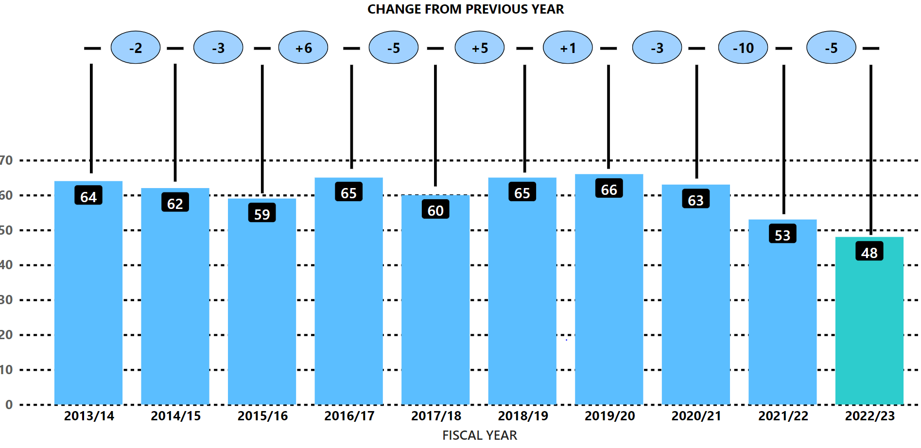
Historically, Scotland has experienced fluctuations in its recorded homicide rate. From the 1970s to the early 2000s, the number of homicides generally increased, peaking in the early 2000s. Since then, the homicide rate in Scotland has been on a declining trend with the number recorded experiencing a significant decrease.
There were 48 homicides (crimes of murder or culpable homicide (common law)) recorded in Scotland during 2022/23 comprising 47 murders and one crime of culpable homicide (common law). This was five fewer homicides than last year and 13.4 fewer than the five-year average. This year’s figure is the lowest number of homicides in any year since the introduction of modern crime recording standards in the 1970s.
In 2022/23 the detection rate for homicides was 91.7%. While this was the second lowest end of year detection rate since the inception of Police Scotland it is important to note that the decrease is due to a higher than usual number of homicides recorded in February and March 2023 some of which had not been detected as of the end of the financial year. It is likely that most, if not all, of the undetected homicides recorded this year will be detected in 2023/24.
There have been 605 homicides recorded since the inception of Police Scotland and 599 homicides detected. That gives an overall detection rate of 99.0% for the ten-year period.

Key Insight 2: Benchmarking: Percent of 999 Calls Answered in Under 10 Seconds
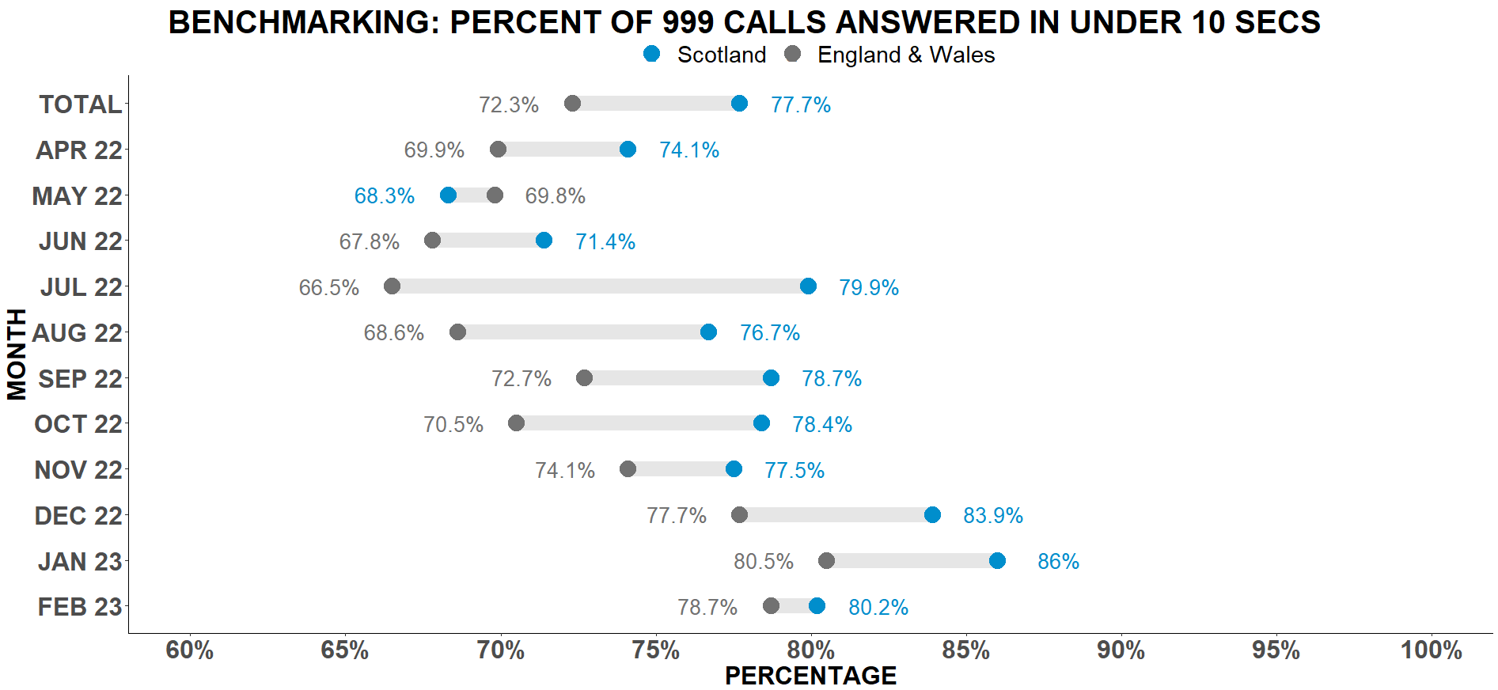
Answering 999 calls is one of Police Scotland’s highest priorities. Police Scotland have benchmarked the percentage of 999 calls answered in under 10 seconds against England and Wales figures.
Police Scotland are performing in-line with England and Wales, answering 77.7% of calls in under 10 seconds, compared to England and Wales who answered 72.3% of calls in under 10 seconds.
The benchmark indicates Police Scotland are performing well and our call handling procedures are efficient and effective. This benchmarking process will help identify areas where we can continue to improve our call handling performance.

Key Insight 3: Overall Crime Decreases Compared to Five Year Average
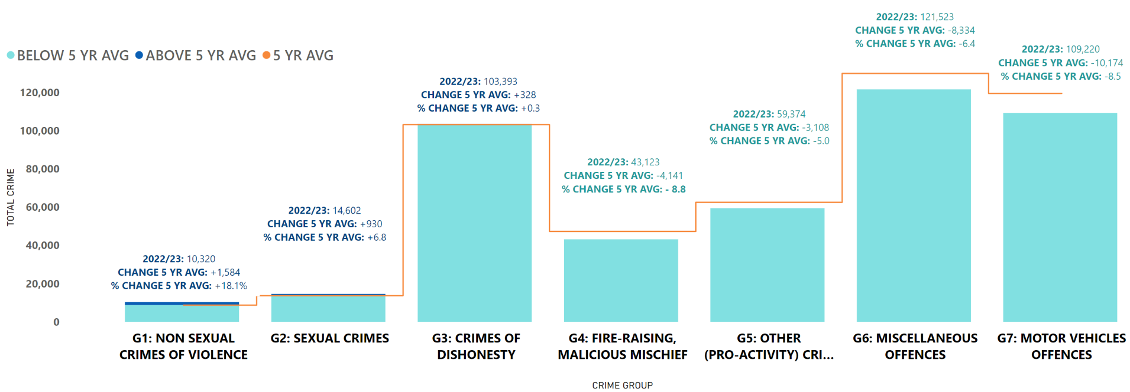
Overall, recorded crime in Scotland is down on last year and below the five year mean. During 2022/23 the number of crimes decreased by 0.2% (1,151 crimes) compared to the previous year and by 4.7% (22,914.6 crimes) compared to the five year mean.
Key insight 3 illustrates five of the seven crime groups have decreased during this year compared to the previous year. ‘Group 1: Violent Crimes’ and Group 3: Crime of Dishonesty’ were the only crime groups to show increases against last year, up 2.4% (243 crimes) and 13.3% (12,110 crimes) respectively.
The increase in Group 1, is mainly driven by threats of extortion which has increased by 44.1% (615 crimes) compared to the previous year. However, the increase in Group 3 is widespread with most classifications within Group 3 increasing including housebreakings, theft (including from motor vehicles) and fraud.

Key Insight 4: Fraud Increases Year on Year
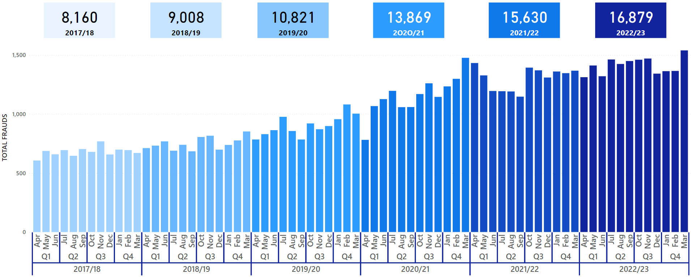
The number of fraud crimes reported in Scotland has increased by 107% (8,719 crimes) from 2017/18 to 2022/23, representing a significant challenge on Police Scotland.
In 2022/23, 16,879 crimes of fraud were reported in Scotland, which equates to an average of 46 cases per day.
Criminal intelligence analysis is conducted to help understand and tackle fraud including both qualitative and quantitative analysis. Despite these efforts, fraud remains a significant challenge for Police Scotland. It is recognised more work has to be done to address this issue, and we are committed to working with our partners to identify and implement new strategies to detect and prevent fraud.

Public Confidence and Experience of Policing
Police Scotland’s Public Contact and Engagement Strategy sets out how we envisage our public contact, engagement activities and approaches to look now, and in the future. We have been clear in setting out what the public should expect from their police service and how we will continue to engage and involve communities and our partners.
Our Public Engagement and Participation Framework sets out the ways in which we listen to and do things with communities to ensure policing meets their needs. Working in this way aims to inform operational and strategic decision-making, ensuring that Police Scotland operates using evidence-led principles in line with our values.
The Public Confidence Governance Board oversees our understanding of public confidence to influence change. Public insights are considered at the Strategic Leadership Board for executive oversight, at Regional Delivery Boards which include local policing divisions in the north, east and west regions, and directly with local policing divisions for responding to local needs and scrutiny.

Public Insights, Research and Engagement Activities
We continue to engage and involve the public, communities and partners in policing through our continuous national surveys and other engagement activities.
Your Police 2022/23 survey – our local police survey for this year continues to receive a robust and representative response from the public and communities. Anyone who lives in Scotland can influence local policing in their area through this survey.
User Experience Survey – our independent survey to measure and enhance people’s experience of contacting Police Scotland. The survey is sent via text message to a sample of people who have made contact with police each month. This survey receives approximately 1,200-1,400 responses each month.
Feedback and insight helped shape the Annual Police Plan for 2022-23, all 32 Local Police Plans as they launch in April 2023 for 2023-26 and the new Annual Police Plan for 2023/24.
We are paying particular attention to how we reach those who are often seldom-heard or find police hard to reach; by understanding where there are opportunities to enhance engagement and working with organisations with relevant expertise.
Recent commissioned research has focused on policing with empathy among LGBTQ+ and young people from disadvantaged backgrounds; refugee and asylum-seeker experiences, trust and confidence with Police Scotland; collaborative research with ethnic minorities and local police; and taking an intersectional approach to police practitioner reform.
At a local level, we have trialled a successful participatory approach to responding to community needs. The participatory grant scheme in the Caithness area within Highland and Islands Division with the Scottish Government and Caithness Voluntary Group brought communities together to improve safety and community wellbeing. We are aiming to develop other initiatives that build collaborative relationships with communities in 2023/24.
Police Scotland also carried out in-depth qualitative engagement with survivors of violence against women and girls to inform our strategy and enhance the user experience of contact and reporting.
Other related work for enhancing public confidence focuses on our culture, values and behaviours for upholding our professional standards of behaviour, enhanced regular vetting of our officers, and embedding equality, diversity and inclusion through our Policing Together initiative.

Our conversation with Scotland’s communities – Your Police Survey
Our Your Police survey continues to be the largest of its kind in the UK and involves the public in a conversation about policing and their local community. This enables them to highlight feeling of safety, areas of concern, what police are doing well and what might be impacting confidence in local police.
The survey is representative of the population by age, gender, disability and long-term conditions and geography. The survey received 16,993 responses between 12 April 2022 when it opened and 27 March 2023. This includes 95 British Sign Language (BSL) responses.
Responses are reviewed regularly by our Executive and service leads and have helped us act quickly in relation to emerging issues and community concerns.
Key activities have included:
Enhanced local police presence at identified locations with a focus on crime prevention and road safety. Police visibility and presence is important in making people feel safe. We have developed an insight dashboard that makes data available from the survey to local policing teams.
Keeping local community partners engaged and involved on a regular basis, through local police scrutiny boards in each local authority area – using the data to design an appropriate policing response for local needs and providing a multi-agency response to cross sector themes.
Shaping our communications and advice nationally and in local areas in response to concerns and feedback from the public – helping people stay safe. A new video on what happens when someone calls 101 was promoted online in November and December 2022 in response to public feedback about long wait times and police accessibility.
Providing information and advice on issues like hate crime, housebreaking and responsible use of vehicles (including off-road bikes and scooters) to reassure all communities.

Public Confidence
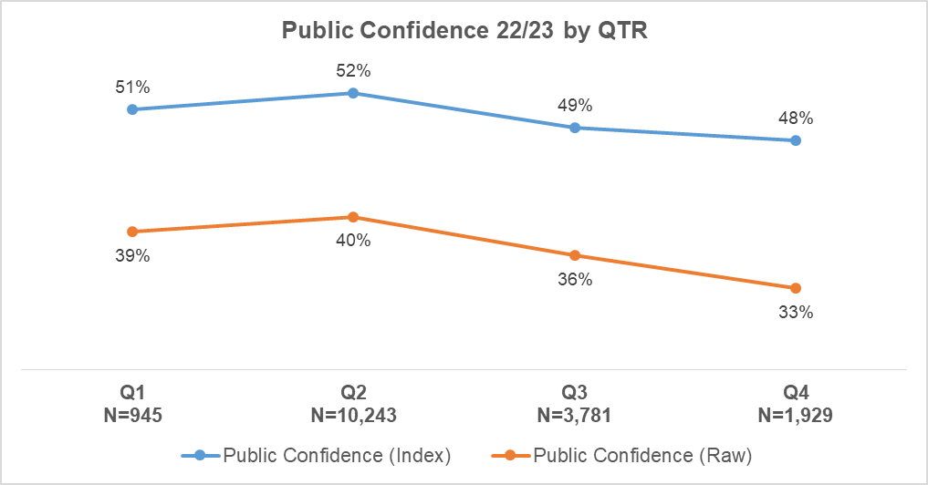
Our Your Police survey receives a high number of comparable responses each Quarter. Average public confidence (index) from Quarter 1 2022/23 to Quarter 4 2022/23 is 50%. Public confidence had a statistically significant drop between Quarter 2 and Quarter 3. The difference between Quarter 3 and Quarter 4 is not statistically significant.
In April 2022, a public confidence index score was introduced to be comparable with how confidence is analysed and measured in other national polling and surveys. This is more robust as it accounts for all responses (from ‘strongly disagree’ to ‘strongly agree’) excluding ‘don’t know’ by assigning values to all responses. This is the top line in the graph. The bottom line is the total number of people who said they ‘agree’ or ‘strongly agree’ that they have confidence in police (excluding ‘don’t know’), sometimes referred to as ‘raw data’.
For comparison, the YouGov survey asks respondents about “confidence in the police to deal with crime in local area”. In Quarter 4, the YouGov figure for Scotland was 50% (respondents who had a lot of confidence and respondents who had a fair amount of confidence).
In addition, 50% of YouGov survey respondents across the UK thought that “generally speaking, police were doing a good job” in Quarter 3. The YouGov figure for Scotland in Quarter 4 was 52%.
We know from our own research and academic studies that levels of public confidence and experience of contacting and interacting with police are not always connected. Overall satisfaction with contacting the police was at 70% in Quarter 4, with satisfaction having remained between 66%-70% in the 2022/23 financial year.
Figures gathered via Your Police shows just over one third (34%) of respondents reported they ‘didn’t know’ or ‘neither agreed nor disagreed’ that they were confident in their local police. This proportion reflects that a substantial number of respondents who completed the survey had not interacted with police recently or had no opinion regarding their confidence in policing.
Respondents aged 35-44 were the group reporting lowest levels on confidence in police in their local area. When asked what the police could do to support the community more, the key themes for this group was visibility as well as policing response to tackling crime. Responses mentioned wanting to see more done in regards to dealing with crime and/or reported incidents, and crime prevention. A responsive, accessible and visible police presence in local areas was important to respondents.
“More opportunities to engage with us one-to-one to discuss our concerns but also how we can try to help the police in return”
“Increase numbers, be more visible, deal with the problem and enforce the law.”
Our statistical analysis shows public confidence is associated with other factors measured in our Your Police survey. There is a strong relationship between public confidence and someone’s perception of police doing a good job in local area, perception of police listening to concerns of local people, and perception of police dealing with issues affecting local area. As these perceptions change, public confidence is likely to be affected.
A moderate relationship exists between public confidence and perceptions of police officers being friendly and approachable, levels of respect for local police, feeling of safety and concern about crime. Moderate correlations indicate that while there exists a relationship between factors, they affect each other to a lesser extent compared to strongly related variables. A negative correlation exists between public confidence and concern about crime, meaning people with an increased concern about crime, are likely to have a lower level of confidence in the police.

Strong Correlation with Public Confidence
Public Opinion Statements | Quarter 1 2022/23 (n=945) | Quarter 2 2022/23 (n=10,243) | Quarter 3 2022/23 (n=3,781) | Quarter 4 2022/23 (n=1,929) | Change from last Quarter
Police doing a good job in local area | 30% | 32% | 29% | 26% | -3% point
Listening to concerns of local people | 31% | 32% | 28% | 27% | -1% point
Dealing with issues affecting local areas | 24% | 23% | 21% | 18% | -3% point

Medium Correlation with Public Confidence
Public Opinion Statements | Quarter 1 2022/23 (n=945) | Quarter 2 2022/23 (n=10,243) | Quarter 3 2022/23 (n=3,781) | Quarter 4 2022/23 (n=1,929) | Change from last Quarter
Police officers being friendly and approachable | 64% | 64% | 60% | 58% | -2% point
Having respect for police in local area | 73% | 72% | 68% | 67% | -1% point
Feeling safe in local area | 79% | 83% | 78% | 75% | -3% point
Concern about crime | 61% | 56% | 58% | 59% | +1% point
Our findings show that confidence can be influenced by geographic and demographic factors. Whilst we capture a national level of confidence, there is much nuance within this picture. We know, for example, that people living in areas most affected by poverty and people affected by social injustice are less likely to feel confident in the police.

Factors influencing public perceptions and confidence in local police
Survey respondents in Quarter 4 2022/23 who said they feel unsafe in their local area (n=349) raised similar themes as in Quarter 3 2022/23. The following themes remain important, on which we are taking action and using to inform local and strategic decision-making, with plans and projects for sustaining change over the long term:
Police visibility and presence
48% of respondents who felt unsafe in their local area highlighted greater police visibility as a way of making them feel safer and providing reassurance. Police presence is often mentioned within the context of prevention and targeting of drug-related crime and anti-social behaviour.
“Yes, I think being more visible. When there was a major incident recently the police visibility shot up and things did feel safer.”
The majority of responses specifically mentioned physical presence including more foot patrols in local areas, at specific times (e.g. after dark/weekends) and locations (e.g. in parks, around transport hubs, and local crime ‘hot spots’) where communities tend to feel less safe.
“Be on foot and patrol town centres at night to make it safe to walk through the town”
“Be visible, regularly, evenings and weekends”
Community engagement and being kept informed
14% of respondents who felt unsafe in their local area highlighted community policing and local engagement as important. This is highlighted alongside police visibility by respondents - for example, informal and friendly conversations with police officers on what matters to communities in local areas. Respondents highlight the importance of policing being accessible locally, having staff who are familiar with local needs and the community and for training to be relevant to the specific issues affecting local communities. The public would like to be familiar with local officers and seek effective and trusting relationships. Also mentioned was the benefit of working with other partner organisations within the community to protect the most vulnerable.
“Give us back our community police officers, be visible and contactable at a local level. Communicate and engage with our community, especially when we specifically request additional support and help.”
“…Also work more collaboratively with their partnership services such as social work instead of just passing off and blaming the other service. It takes everyone working together to make a difference and my experience of this is that there is a big divide between the police service and social work service.”
Values and behaviours
27% of respondents who felt unsafe in their local area highlighted that how we ‘show up’ is important. Police officers and staff should continue to bring empathy and understanding to their interactions with the public. Respondents highlighted the importance of seeing how police respond to and deal with incidents/reported crimes. It was also highlighted that people want to receive feedback/updates about reported crimes, which may help increase feelings of safety.
“If there was an incident in the area that had been attended by Police Scotland it might be good to have a statement or briefing on the website to inform the public of the situation.”
11% of respondents who felt unsafe in their local area highlighted the importance of perceiving positive values and behaviours from police officers. Responses highlighted that witnessing negative behaviours from officers may affect how they perceive police to be dealing with crimes/incidents within the community. In comparison, respondents wanted to see police officers showing compassion, being friendly and approachable, and listening to people’s concerns.
“Be more receptive. Be less judgemental and offer better advice. Be more empathetic to those on the receiving end of antisocial behaviour.”
Work is progressing throughout the Service, including within local divisions, to respond to these concerns. Divisions are keeping their local communities informed about how crime is being managed and prevented, including “you said we’re doing” feedback on social media channels and in local newspapers via Divisional Commander columns.
We are working to ensure that services work together in new ways to ensure a collaborative approach, ensuring that individuals and communities can experience the benefit of services working together.
We have recently commissioned social research to explore how Police Scotland and partners in the health, social care and third sectors can work together to respond to the needs of people experiencing distress or poor mental health, to make sure people get the right help, at the right time, from the most effective service, meeting their individual needs.

Main areas of concern for local communities
There were 1,577 responses in Quarter 4 to the open-ended question – “What, if anything, worries you about your local area?” The common themes that emerged from analysis of these responses are set out as follows:
19% of respondents mention anti-social behaviour involving alcohol, littering and fly tipping, young people causing disturbances and noise complaints. It’s important to have clear and accessible signposting to support and connect individuals with the right services delivered by a range of community partners. People may ask police to help with matters which are important to them, but a police response might not be the appropriate service or be able to help in ways which are required.
“Growing stories in our community about youths in particular displaying anti-social behaviour - intimidating behaviour, damage to cars etc. And what worries me? - the lack of a police presence in the community.”
“The safety of young people in the evening out in the community from other YPs under the influence of drugs and alcohol.”
17% of responses highlight speeding and driving related offences – including use of motorised scooters and dirt bikes cited by respondents who also commonly express their concerns with speeding and reckless driving in their local area. Commonly mentioned as well was driving offences taking place often in rural areas.
“Kids driving dirt bikes at ridiculous speeds around the streets. Cars been driven far too fast for built up areas”
“Traffic speed on narrow rural roads, and agricultural tractors and implements too wide for the roads - and apparently oblivious to passing places!”
13% of respondents mention drug crime and related harms – the presence and effects of drugs within local communities and how local police are tackling drug dealing is crucial for community safety. The increased visibility of drug dealing and drug taking, particularly during the pandemic, has been a consistent theme over previous quarters.
“Drug use more prevalent and more overt. People openly chapping on particular doors to buy drugs and, everyone who lives nearby knows this is happening and knows it is not addressed. I am really wary leaving or entering my block as there is little predictable behaviour from people who are either under the influence or desperate for drugs.”
9% of respondents are concerned with little physical presence of the police – people would like to see regular foot and cycle patrols in their local areas. Several comments mentioned the need for police being visible and easily accessible within local communities, as well as having relationships with people/organisations within the community.
“Lack of visible policing. Never see officers except in cars passing by. No regular patrolling anymore.”
“I do feel relatively safe but I also think that I am uninformed as to the local crime. While I appreciate I would be updated at the SFCT meetings on these matters, is there anywhere else the information could be communicated? Also - never or rarely - see police drive through. May be a positive thing.”
8% of respondents express concern about local crimes, including home break-ins and car thefts and want to be aware of the preventative measures they can take to keep their homes and businesses safe.
“I am worried about increase in crime in my area such as car thefts, house burglaries, robberies, antisocial behaviour and drugs.”

What we are doing well:
Your Police enables the public to tell us about our approach, which includes what we are doing well and getting right. In Quarter 4, there were 1,442 open-ended comments to the question - “What are the police doing well in your local area?”
Police visibility, presence and accessibility
Responses relate to the impact of police visibility, presence and accessibility. Respondents’ value consistent service delivery in the difficult circumstances policing is operating in. There is appreciation for local policing and the job they do within local communities to keep people safe, including crime prevention and protecting people who may be vulnerable.
“They respond well to requests for help/support. Extremely friendly. Recently had ask for help in relation to support for Glasgow Reform Synagogue. I was extremely impressed by the immediacy of response, the thoughtful support and the friendliness...”
“Wherever possible they try and engage with the community and provide regular updates on crime and issues to the Community Council”
Many responses commend the enhanced visibility of police in some areas over recent months and highlight this as positive. Comments commonly mention increased responsiveness and appropriate action to reported crimes and other incidents.
“Local police are friendly and helpful. They seem to have been more visible in the past year, which is reassuring.”
“Any time we have called 999 / 101 or contacted our liaison officer, they have responded positively and quickly”
Community engagement and being kept informed
Respondents highlighted the value of community policing and what community officers are doing to understand and tackle challenges in local areas together with partners and communities. There is appreciation for being kept up to date with the reported issues. Respondents value police informing the communities on local initiatives and being kept up to date with the work of the police.
“Neighbourhood/Community Police have a high profile and attend events, making them well known, more approachable and very much part of the community, some live in the community too. They attend a Community Council 'Have Your Say' Forum to engage with Community Councils and the people they all serve...”
“As an educator, I think the Police do a good job at sharing their message in schools. Police do appear friendly and helpful.”
Values and behaviours
Respondents highlighted professionalism, compassion and care of the officers as an important factor, having an impact on their perception of the local police. Positive values and behaviours, particularly friendly and approachable policing, showing an understanding and knowledge of the issues affecting local communities, was observed and appreciated by respondents.
“A handful of decent Police. [Officer] is an absolute breath of fresh air, friendly, approachable, doesn't have a superior attitude, genuinely wants to make a difference to ALL in the community.”
“Any time I have been in contact with the police (usually due to a family member on drugs). They have been very approachable and understanding and showed a great deal of patience, calmness and tolerance when dealing with poor behaviour.”
“I think the manage situations with respect and dignity for those involved. There is not a high police presence but this can be viewed as positive as they may not be required. I think it all comes down to communication and if the police are polite and well mannered it goes a long way when dealing with vulnerable situations.”

User Experience Survey

How the public are experiencing their police service
The User Experience Survey, administered by Progressive Partnership Ltd, reaches a representative sample of 1,200 individuals monthly. The survey is delivered via SMS to those who have contacted Police Scotland in the previous month. In Quarter 4, 3,908 respondents were surveyed about their experience of the policing service provided, from initial contact through to overall satisfaction.
The findings show continued high levels of satisfaction with contacting the police as follows:
Ease of contact – 74%
Initial contact treatment by C3 staff – 85%
Feeling properly understood – 87%
Being provided with the appropriate response – 65%
Satisfaction with attending officers – 83%
Feeling adequately informed about case progress – 51%
Overall satisfaction with Police Scotland – 70%

Measures of Progress towards Strategic Outcomes

Strategic Outcome 1
Threats to public safety and wellbeing are resolved by a proactive and responsive police service.
Objectives:
Keep people safe in the physical and digital world
Design services jointly to tackle complex public safety and wellbeing challenges
Support policing through proactive prevention
All data is classed as Management Information and is not considered official statistics. All data is sourced from Police Scotland internal systems.

Violent Crime
Overall violent crime | 2021/22 YTD | 2022/23 YTD | % Change from Previous Year | 5 Year Mean | % Change from 5 Year Mean
Number of crimes | 63,642 | 62,854 | -1.2% | 62,458.4 | +0.6%
Number of detections | 43,417 | 43,373 | -0.1% | 43,528.8 | -0.4%
Detection rate | 68.2% | 69.0% | +0.8% point | 69.7% | -0.7% point
Note: Overall violent crime is comprised of: murder, culpable homicide (common law), attempted murder, serious assault, robbery, common assault and common assault (of emergency workers).
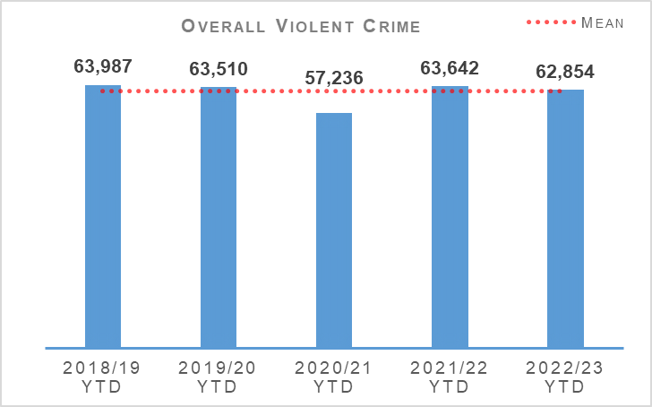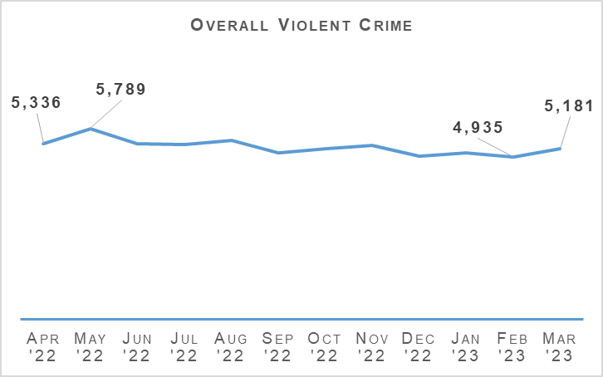
The number of overall violent crimes have been mostly consistent in recent years with the exception of 2020/21. That year saw a reduction due to COVID-19 and related lockdowns. Overall violent crime in 2022/23 continues to be at a similar level to last year and the five year mean.
Attempted murder has seen a slight rise (6.4%, 17 crimes) from last year and is also up slightly from the five year mean (+2.6%, 7.2 crimes). While robberies has also seen a slight (1.3%, 21 crimes) increase from last year the number of recorded robbery crimes has decreased by 3.1% (51.8 crimes) from the five year average.
Both categories of assault decreased from last year – serious assaults by 11.6% and common assaults by 0.7%. Serious assaults are also down from 15.7% from the five year mean although common assaults are up slightly on the five year mean by 1.9% (1,048.8 crimes).
Included in these figures are fifteen crimes of serious assault of a retail worker and 1,650 common assault of a retail worker. There have also been 2,106 recorded crimes of threatening and abusive behaviour of a retail worker during this period.
Whilst it is not counted within overall violent crime numbers, there has been 9,718 offensive weapons offences recorded this year which is a 4.0% reduction from last year and a 3.7% increase from the five year mean.
On 27 March 2023 Part 4 of the Offensive Weapons Act 2019 went live which prohibits the possession of certain dangerous knives in public or private spaces, amends the definition of a flick knife to ensure modern designs are prohibited, prohibits possession of certain offensive weapons in private spaces and expands the list of prohibited offensive weapons to include zombie knives.
Police Scotland’s Partnerships, Prevent and Community Wellbeing Division (PPCW) continues to provide support to local policing divisions as required with regards to the new offences introduced under the 2019 act.

Homicides
Historically, Scotland has experienced fluctuations in its recorded homicide rate. From the 1970s to the early 2000s, the number of homicides generally increased, peaking in the early 2000s. Since then, the homicide rate in Scotland has been on a declining trend with the number recorded experiencing a significant decrease.
There were 48 homicides (crimes of murder or culpable homicide (common law)) recorded in Scotland during 2022/23 comprising 47 murders and one crime of culpable homicide (common law). This was five fewer homicides than last year and 13.4 fewer than the five year average. This year’s figure is the lowest number of homicides in any year since the introduction of modern crime recording standards in the 1970s.
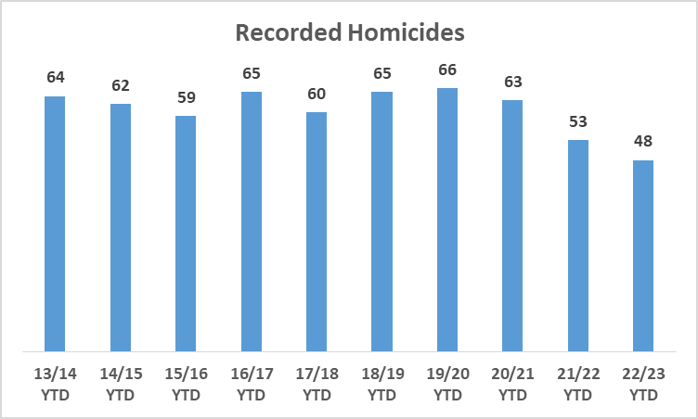
The detection rate for homicides this year is 91.7% compared to 111.3% last year and a five year mean positive rate of 98.7%. While this is lower than usual, it is mainly due to there being a short-term spike in homicides recorded in February and March 2023, some of which have yet to be detected. It is expected that most, if not all, of these will be detected in 2023/24.
In the ten years since Police Scotland’s inception, there have been 605 homicides recorded and 599 homicides detected. This gives an overall homicide detection rate of 99.0% for the ten year period.

Non Sexual Crimes of Violence (Group 1)
Non Sexual Crimes of Violence (Group 1) | 2021/22 YTD | 2022/23 YTD | % Change from Previous Year | 5 Year Mean | % Change from 5 Year Mean
Number of crimes | 10,079 | 10,322 | +2.4% | 8,738.2 | +18.1%
Number of detections | 6,544 | 6,345 | -3.0% | 6,224.8 | +1.9%
Detection rate | 64.9% | 61.5% | -3.5% point | 71.2% | -9.8% point
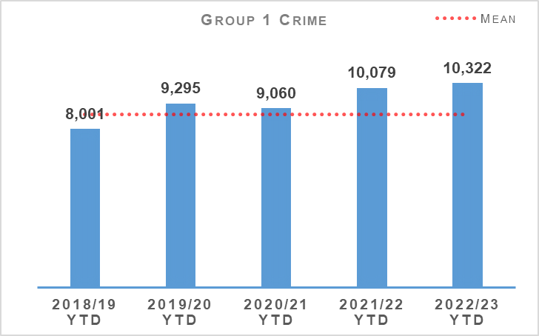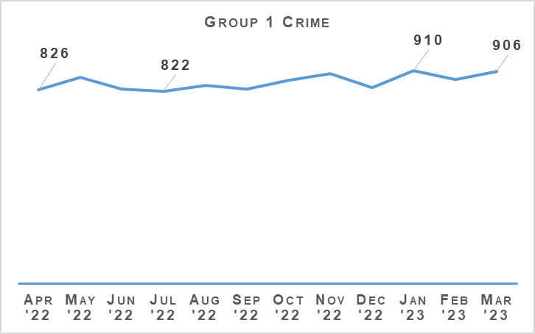
The number of non-sexual crimes of violence this period is only slightly higher (+2.4%) than last year but up 18.1% from the five year mean. This longer term increase continues to be due to high levels of reporting of drugging offences and threats & extortion in recent years rather than due to changes in more traditional violent crimes.
There have been 2,008 threats & extortions recorded this year, an increase of 44.1% from last year and 192.5% from the five year mean. Threats & extortions accounted for 19.5% of all group one crimes this year. In 2019/20 they only accounted for 4.2% of this crime group. Due to the challenge posed in detecting many threats & extortion crimes which often occur online and originate from outside the UK, this increase in the impact of threats & extortion on group one crimes has contributed significantly to the decrease in non-sexual crimes of violence’s detection rate.

Public Protection – Equality Outcome 4
Overall Sexual Crime (Group 2) – Equality Outcome 4 | 2021/22 YTD | 2022/23 YTD | % Change from Previous Year | 5 Year Mean | % Change from 5 Year Mean
Number of crimes | 15,170 | 14,602 | -3.7% | 13,671.6 | +6.8%
Number of detections | 8,083 | 7,792 | -3.6% | 7,751.2 | +0.5%
Detection rate | 53.3% | 53.4% | +0.1% point | 56.7% | -3.3% point
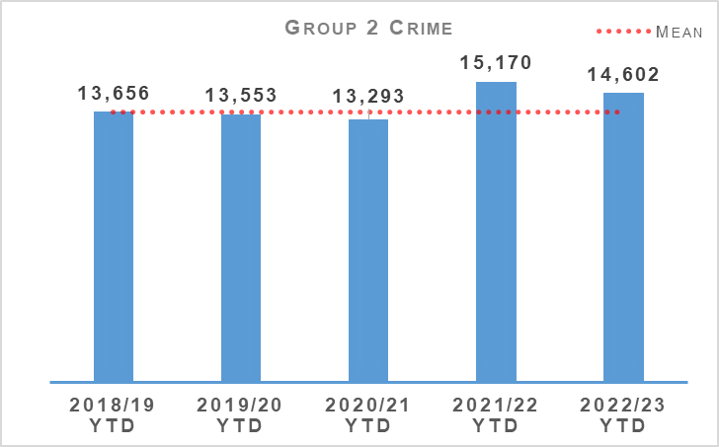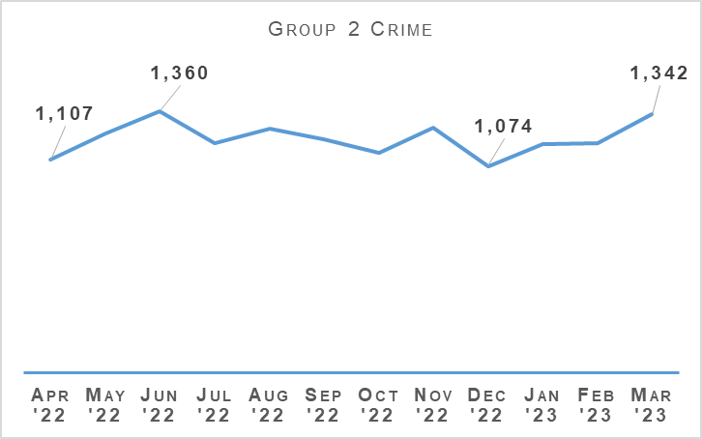
Overall, sexual crime is down when compared to last year. The number of crimes decreased by 3.7% (568 crimes) when compared to the same period last year but similar to previous quarters, increased against the five year mean (up 6.8%, 931 crimes). Crimes increased month on month throughout the recent quarter with June followed by March, recording the most sexual crimes in the 12 month period. December 2022 remains the month where the fewest number of sexual crimes (1,074 crimes) were recorded over the 12 month period.
The drivers behind this decrease are reductions in sexual assault (sexual assault of a female under 13 and common law pre 2009), coercing a person into being present/looking at sexual activity, communicating indecently, and threatening to disclose an intimate image. Conspiracy to commit a sex act outside the UK also contributed to the overall decrease in sexual crime however this is due to an exceptionally higher level last year returning to reporting levels noted prior to 2021.
Taking, distribution, possession etc. of indecent photos of children, sexual assault of male and female over 16 and rape of a female over 16 recorded notable increases when compared to the same period last year. Sexual assaults of a male 13 – 15 have also increased and, in general, noted a year-on-year increase over the past six years.
The number of detections decreased compared to last year, down 3.6% (291 detections) however, noted an increase against the five year mean (up 0.5%).
Overall Sexual Crime (Group 2) – Equality Outcome 4 | 2021/22 YTD | 2022/23 YTD | % Change from Previous Year | 5 Year Mean | % Change from 5 Year Mean
Number of recent crimes | 11,669 | 11,466 | -1.7% | 10,301 | +11.3%
Number of non recent crimes | 3,501 | 3,136 | -10.4% | 3,371 | -7.0%
Proportion of Group 2 crime non recent | 23.1% | 21.5% | -1.6% point | 24.7% | -3.2% point
Note: Non-recent sexual crimes are defined as crimes that were reported more than one year after they were committed.
Recent and non-recent reporting decreased compared to last year. Non recent, again noted the greatest decrease, down 10.4% (365 crimes) while recent reporting remained stable with a decrease of 1.7% (203 crimes). The proportion of non-recent reporting of sexual crime continues to decrease, down 1.6 percentage points. Over 50% of sexual crimes were recorded within one week with the vast majority of these recorded within two days.
When comparing the change against the five year mean, non-recent crimes also note a decrease (down 7.0%) however recent crimes are up (11.3%), emphasising the increase in recent reporting of sexual crime.

Rape
Rape – Equality Outcome 4 | 2021/22 YTD | 2022/23 YTD | % Change from Previous Year | 5 Year Mean | % Change from 5 Year Mean
Number of crimes | 2,406 | 2,411 | +0.2% | 2,252.2 | +7.1%
Number of detections | 1,278 | 1,291 | +1.0% | 1,219.6 | +5.9%
Detection rate | 53.1% | 53.5% | +0.4% point | 54.2% | -0.6% point
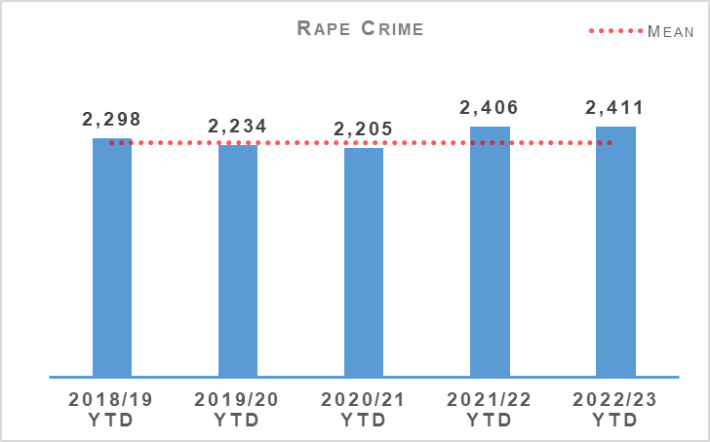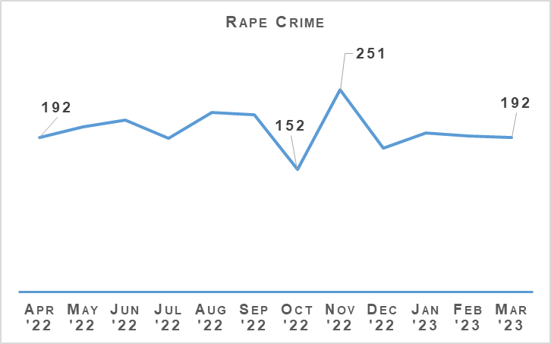
Year to date, 2022/23 noted a similar level of reporting compared to last year, however shows the highest level of recorded rapes over the last six years. During the reporting period rapes increased by 0.2% (five crimes) compared to last year and also increased by 7.1% (159 crimes) on the five year mean. In the last quarter it has been noted that the number of rapes reported monthly has been consistent. This is in contrast to Quarter 3 where the highest and lowest monthly totals were noted during November and October respectively.
Rape of a female over 16 is the driver behind the overall increase (up 47 crimes, 3.1%) of rape crimes. Rape of a female over 16 continues to increase, again noting the highest level of reporting over the last six years.
Rape – Equality Outcome 4 | 2021/22 YTD | 2022/23 YTD | % Change from Previous Year | 5 Year Mean | % Change from 5 Year Mean
Number of recent crimes | 1,467 | 1,539 | +4.9% | 1,355 | +13.5%
Number of non recent crimes | 939 | 872 | -7.1% | 897 | -2.8%
Proportion of Rape crime non recent | 39.0% | 36.2% | -2.9% point | 39.8% | -3.7% point
Note: Non-recent rape crimes are defined as crimes that were reported more than one year after they were committed.
Non recent reporting of rape decreased by 7.1% (67 crimes) compared to last year and by 2.8% against the five year mean. The proportion of non-recent rape continues to decrease, down 2.9 percentage points compared to last year and down 3.7 percentage points on the five year mean.
Recent rapes increased by 4.9% (72 crimes) against last year and by 13.5% against the five year mean.

That Guy campaign
The second phase of the sexual crime prevention campaign, that guy, launched on 17 October 2022. The campaign was aimed at men in Scotland aged 18 – 35, highlighting men can help to stop sexual offending before it starts by recognising inappropriate behaviour and challenging male sexual entitlement in a safe way, ultimately reducing sexual violence and the risk of offending.
An objective of the campaign was to drive traffic to a campaign website where the target audience could engage with the primary video and further articles and videos.
The primary campaign video received over one million views across social media channels such as Twitter, TikTok, YouTube and Facebook.
Social media influencers amplified the campaign by creating content based on key messages and through the sharing of the primary video.
The campaign also earned extensive media coverage including broadcast, print and online. Examples include BBC Reporting Scotland, STV Scotland Tonight, The Guardian, Metro and The Scotsman.

Partnership Working
Beira’s Place is a newly opened support agency run by women, for women over 16 only, based in Edinburgh and provides support to victims of sexual crime in the Lothians. We aim to create a direct referral procedure similar to the Rape Crisis Scotland (RCS) process and expand to obtain feedback from women supported by Beira’s Place.
The majority of feedback received from survivors who have engaged with RCS support is positive. We reviewed some processes based on RCS feedback and any learning, positive and negative, is shared with LPD and published in the national rape bulletin.
NRRT are also working closely with DACU in respect of victim survivor feedback for DA/Sexual offence victims.

Sexual Assault Response Co-ordination Service (SARCS)
The Forensic Medical Services (Victims of Sexual Offences) (Scotland) Act 2021 (FMS Act), was implemented on 01 April 2022, placing a statutory obligation on health boards to provide forensic medical examinations to people who have experienced rape or sexual assault. Forensic medical examination of victims of rape or serious sexual crime can no longer take place within a police facility and must always be carried out within NHS premises.
The National Self-Referral protocol for victims of rape and sexual crime was implemented in Scotland. This service gives people who have experienced rape or sexual assault the opportunity to access appropriate support and healthcare services. It also provides access to a Forensic Medical Examiner (FME) for the collection of potential evidence, at a time when a person may not feel ready to report to the police.
Police Scotland will not be informed of a self-referral unless the person wishes to engage with police, or where information disclosed by the person suggests there is an immediate risk to their safety, the safety of another person, or member of the public. The welfare and safety of the person and wider public must be the primary concern and overrides the self-referral process.
Working with our partners in the NHS, Police Scotland have created guidance that in the case of a victim of sexual crime is reporting an incident out with the forensic window (more than seven days), the Sexual Offence Liaison officer (SOLO) must ask the person whether they attended for an FME prior to reporting to Police, this will help to ensure that no evidence is lost or destroyed.
We continue to support the FMS Act and are reviewing the public facing internet site to ensure relevant information is available including how to report, the process and ability to signpost to other organisations for example the NHS in respect of National Self-referral protocol.

Partners Intelligence Portal (PIP)
Adopting a Collaborative approach Police Scotland created the Partnership Intelligence Portal (PIP), the Partners Intelligence Portal is a secure and confidential electronic system developed by Police Scotland for our Partner Agencies to submit key information they become aware of during the course of their work. This may include lifestyle habits, employment history, associations and contact information about perpetrators. To date training has been provided to NHS staff members nationally with representatives. Training in PIP has already been created and delivered to a number of personnel within different areas of the NHS.

Child Sexual Abuse (online)
Child Sexual Abuse (Online) – Equality Outcome 4 | 2021/22 YTD | 2022/23 YTD | % Change from Previous Year | 5 Year Mean | % Change from 5 Year Mean
Number of crimes | 1,911 | 1,928 | +0.9% | 1,808.2 | +6.6%
Number of detections | 1,200 | 1,215 | +1.3% | 1,197.0 | +1.5%
Detection rate | 62.8% | 63.0% | +0.2% point | 66.2% | -3.2% point
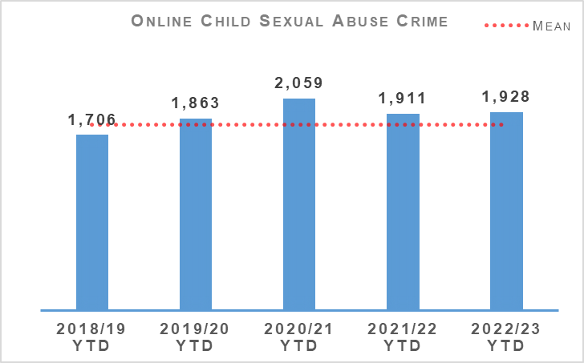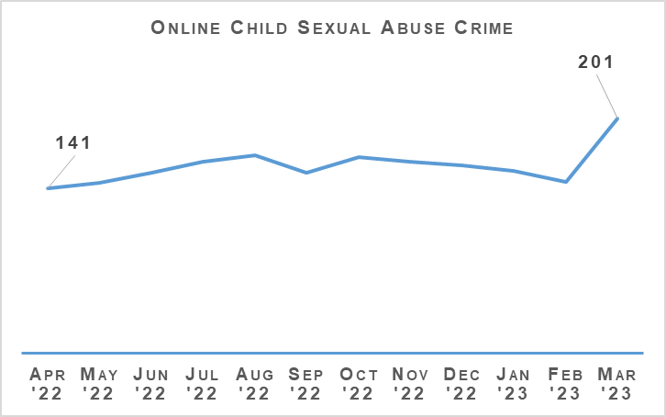
During the reporting year, 1,928 online child sexual abuse crimes were recorded in Scotland, an increase of 0.9% (17 more crimes) compared to last year and up 6.6% (120 crimes) on the five year mean. Throughout the reporting period, the month on month recording level was relatively consistent however during Quarter 4, March 2023 was the highest month for recorded online sexual abuse crimes and February 2023 noted the second lowest monthly total over the 12 month period.
The detection rate has also increased compared to the previous year, up 0.2 percentage points to 63.0% but down against the five year mean (down 3.2 percentage points).

Child Sexual Abuse (online) – Crime Types
Child Sexual Abuse (Online) – Equality Outcome 4 | 2021/22 YTD | 2022/23 YTD | % Change from Previous Year | 5 Year Mean | % Change from 5 Year Mean
Cause to be Present Sex Act/To Look at Sex Image -M&F (< 13) | 357 | 310 | -13.2% | 317.6 | -2.4%
Cause to be Present Sex Act/Look at Sex Image -M&F (13-15) | 160 | 180 | +12.5% | 172.2 | +4.5%
Communicate Indecently/Cause see/hear Indec Comm - M&F (< 13) | 363 | 285 | -21.5% | 304.4 | -6.4%
Communicate Indecently/Cause see/hear Indec Comm – M&F (13-15) | 267 | 309 | +15.7% | 275.0 | +12.4%
Grooming of children for the purposes of sexual offences | 96 | 79 | -17.7% | 90.6 | -12.8%
Taking, distribution, possession etc. of indecent photos of children (from Apr 2011) | 668 | 765 | +14.5% | 648.4 | +18.0%
Taking, distribution, possession etc. of indecent photos of children (from Apr 2011) continues to note high levels of reporting, increasing by 14.5% (97 crimes) and by 18.0% on the five year mean.
Communicate Indecently/Cause see/hear Indec Comm – M&F (13-15) (up 15.7%, 42 crimes) and Cause to be Present Sex Act/To Look at Sex Image - M&F (13-15) (up 12.5%, 20 crimes) also noted increases compared to last year. The other classifications within online child sexual abuse noted decreases. Communicate Indecently/Cause see/hear Indec Comm – M&F (<13) noted the greatest decrease (down 21.5%, 78 crimes) of all the online child sexual abuse crime classifications.
Work continues under Operation PARROR with enforcement action undertaken in respect of 709 investigations from 01 April 2022 to 31 March 2023. A total of 54.5% of these enforcements have led to the recovery of Indecent Images of Children (IIOC) and/or Child Sexual Abuse Material (CSAM); device examination is ongoing for 7.5% and 38% have yielded no recovery. A total of 486 arrests were made. The detection rates remain similar to 2021 and 2022 statistics.
Safeguarding measures recorded on iVPD ensured a comprehensive risk assessment of vulnerability with the most vulnerable being discussed at a Multi-agency IRD which led to 776 children being protected.

NOCAP Enforcement Gap
There has always been a number of National Online Child Abuse Prevention (NOCAP) packages awaiting enforcement action – this has become known as the ‘Enforcement Gap’ (EG), a consequence of demand exceeding resource capacity. This has always represented a risk to the organisation and communities as it potentially represents individuals who may have been involved in the online abuse of children. Latterly, however, the cumulative effect of the increased demand has meant that this strategic risk to the organisation and communities has grown.
During the most recent reporting period, a greater backlog has developed, causing a significant delay in converting referrals to actionable investigation packages. It is assessed when taking the backlog into account the number of NOCAP packages in 2022 is similar to the level reported in 2021. This represents a 54% increase in NOCAP packages since 2017.
The demand picture has changed beyond recognition and the current modelling and allocation policies need to be shaped accordingly. Digital Forensics (DF) has had an uplift in resources which has increased pressure on the NCAIU OCSAE teams to match DF’s enhanced capacity. Expanding the West and North NCAIU OCSAE teams would allow the NCAIU to meet demand and potentially subsume all suspect NOCAPs from Local Policing.

Victim Identification (VID)
We have professionalised our approach to OCSAE Victim Identification by moving this role under Public Protection and NCAIU.
Throughout 2022 an end to end OCSAE Victim Identification review was undertaken with a number of process improvements implemented.
Additional VID training has been delivered to staff and PSOS VID officers support UK wide training in conjunction with the Home Office Child Abuse Image Database (CAID) team. A VID education strategy has been developed and shared with each division and a Force wide CPD event held aimed at Local Policing officers.

Prevention Campaigns
Police Scotland remain committed to preventative activity, building on the success of the award winning #GetHelporGetCaught online grooming campaign with a new campaign for 2023. Our continued intention is to convey to perpetrators / potential offenders that grooming children for sexual purposes is not acceptable whether online or otherwise, and that they will be caught. This continued phase includes targeted platform activity and aims to achieve greater reach within the medical profession. This will be supported by our future Image Based Sexual Abuse Campaign.

Non-Recent Child Abuse Governance and Review
Police Scotland remains a core participant in the Scottish Child Abuse Inquiry (SCAI) in Edinburgh.
The Scottish Child Abuse Inquiry relates to the abuse of children within residential care settings, up to and including 17 December 2014, and as such all offending is non-recent. The Inquiry is entitled to consider all forms of abuse at its discretion, however the abuse examined primarily relates to physical abuse and sexual abuse.
Significant work continues within the Operation FORSETI team, including the review of 39 List-D / Secure Care establishments. The review is planned to be completed in time for the SCAI List D public hearings, anticipated to start in June 2023. The Police review of the List D /Secure Care phase of the public inquiry has so far revealed evidence of physical abuse and sexual abuse, perpetrated by both adults and peers. There is no clear pattern of abuse in respect of specific crime types.
To assist with the resultant List D investigations and other non-recent child abuse investigations (to be allocated to both NCAIU and Local Policing Divisions), learning from previous operations is being gathered and a ‘toolkit’ and CPD day developed in order to improve the effectiveness, efficiency and success of large scale non-recent investigations. Due to current demands the ‘toolkit’ and CPD day will not be available until later in the year.
The Scottish Child Abuse Inquiry recently announced that a public hearing in relation to Edinburgh Academy would commence in August 2023. The preparatory work is underway in relation to this establishment in anticipation of the service of a further Section 21 Notice.

Sex Offender Policing
Registered Sex Offenders (RSOs) | 2021/22 YTD | 2022/23 YTD | % Change from Previous Year | 5 Year Mean | % Change from 5 Year Mean
Number of Sex Offender Notification Requirements (SONR) offences committed | 477 | 538 | +12.7% | 503 | +7.0%
Number of RSO's who committed SONR offence | 427 | 455 | +6.5% | No count | No count
Number of Preventative Order offences committed (SOPO, RoSHO and equivalent issued out with Scotland) | 179 | 181 | +1.1% | 171 | +5.8%
Number of RSO’s who committed a Preventative Order offence | 139 | 126 | -9.4% | No count | No count
During the reporting period 455 registered sex offenders (RSO) committed a total of 538 Sex Offender Notification Requirements (SONR) offences. This is a 12.7% increase in recorded SONR offences and a 6.5% increase in the number of RSO’s committing these offences compared to the same period last year.
126 RSOs committed a total of 181 preventative order offences. This is a slight increase (1.1%) in preventative order offences committed but a 9.4% reduction in the number of offenders breaching preventative orders, down from 139 for the same period last year.
Police Scotland’s robust and investigative approach to the policing of offenders continues to ensure that the majority are compliant with requirements and conditions imposed on them. Those who fail to comply are identified, fully investigated, and reported to COPFS by divisional Sex Offender Policing Units.

Engagement with Partners
Police Scotland continue to support the Home Office to deliver the ViSOR replacement system, MAPPS (Multi-Agency Public Protection System) due to be implemented in Spring 2024.

Policing the Digital World
Developing technologies and changing lifestyles have seen an increase in internet facilitated offending. The National Sex Offender Policing Unit (NSOPU) are exploring partnership opportunities to police the inherent risks and challenges posed by these offenders and to exploit all new technologies to manage and mitigate risk. In addition, they have worked with the Risk Management Authority (RMA) and other partners to develop and pilot a bespoke risk assessment for RSOs convicted of Indecent Images of Children (IIOC) offences.

Sex Offender Notification Requirements (SONR)
Police Scotland are responsible for the operation and enforcement of SONR as specified in Part 2 of the Sexual Offences Act 2003. Police Scotland, through its NSOPU, are supporting the Scottish Government in a review of SONR to consider any changes or modernisation of the approach.

Domestic Abuse
Domestic Abuse – Equality Outcome 4 | 2021/22 YTD | 2022/23 YTD | % Change from Previous Year | 5 Year Mean | % Change from 5 Year Mean
Number of incidents | 63,084 | 61,888 | -1.9% | 61,755.2 | +0.2%
Number of crimes | 41,039 | 37,833 | -7.8% | 39,286.8 | -3.7%
Number of detections | 27,636 | 24,459 | -11.5% | 26,908 | -9.1%
Detection rate | 67.3% | 64.6% | -2.7% point | 68.5% | -3.8% point
Proportion of incidents resulting in a crime | 42.9% | 41.4% | -1.6% point | 44.3% | +2.9% point
DASA (of female) – Number of crimes | 1,657 | 1,689 | +1.9% | n/a | n/a
DASA (of male) – Number of crimes | 128 | 92 | -28.1% | n/a | n/a
Note: Recorded crime data relating to DASA have been refreshed as at 25 May 2023. Following the initial collation on 02 April it was identified that there was an issue with selecting the correct sex modifier on the new system. Changes to the system have been implemented to mitigate the risk of selecting the wrong modifier. In addition, extra quality assurance and validation will be added to the collation of routine data to monitor the recording of DASA crimes. No other recorded crimes or offences data has been refreshed.
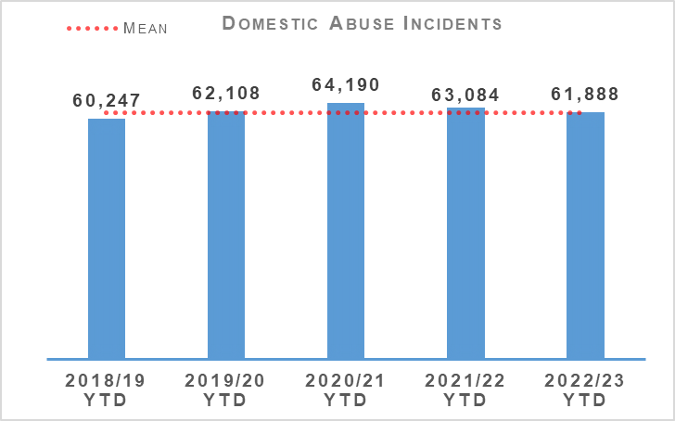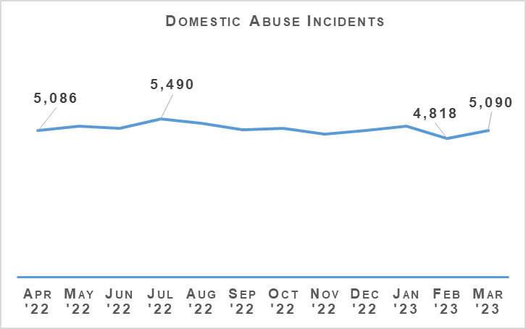
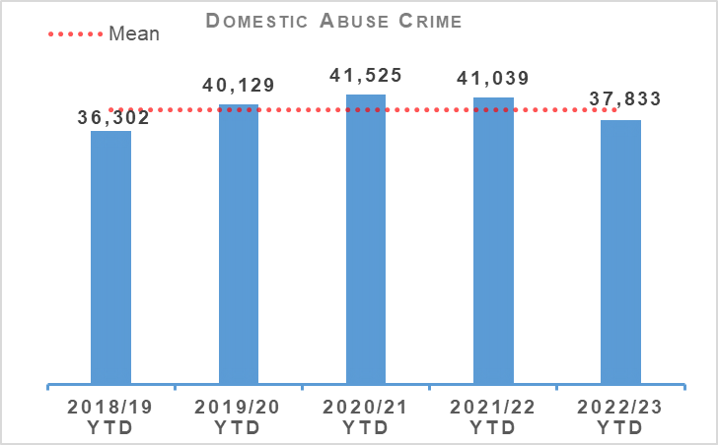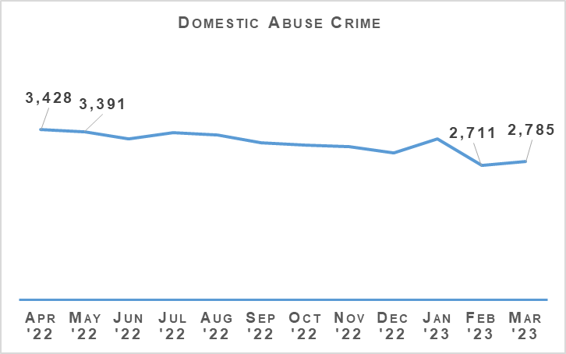
Domestic incidents and crimes continue to note decreases when compared to last year. Incidents decreased by 1.9% (1,196 incidents) compared to last year however, increased by 0.2% (133 incidents) against the five year mean.
Domestic crimes decreased by 7.8% (3,206 crimes) compared to last year and are also down 3.7% on the five year mean. February 2023 noted the lowest monthly total for both crimes and incidents.
Overall DASA crimes decreased by 0.2% (four crimes) compared to the same period last year. DASA of a female has increased by 1.9% (up 32 more crimes) whilst DASA of a male is down 28.1% (36 fewer crimes).
Throughout the reporting period, seven murders are assessed to be domestic related, compared to ten in the same period last year.
Disclosure Scheme for Domestic Abuse Scotland (DSDAS) applications have increased by 14.2% overall with a 10.8% increase in Power to Tell (PTT) applications and a 22.3% increase in Right to Ask (RTA) applications compared to the same period last year. Since the introduction of DSDAS, the percentage of disclosures to applications has been consistent ranging between 55% and 60%. A similar pattern is observed when we look at RTA and PTT applications in terms of consistency in disclosure percentages. During the reporting period, 57% of the total number of applications resulted in a disclosure.

Violence Against Women and Girls

Justisigns
The Justisigns2 project, led by Heriot Watt University (HWU) and supported by Police Scotland was successful in securing funding to roll out training materials to rural areas in Scotland and Ireland. HWU is responsible for coordinating and delivering the training.
The project is required to deliver three workshops to police and interpreters in rural areas in Scotland between now and the end of June 2023. Following consultation with HWU, Partnerships, Prevent and Community Wellbeing Division (PPCW) and DACU, the three rural areas in Scotland where training workshops will take place throughout the spring are the Borders, Inverness and the west coast of Scotland.
This will include explaining why deaf people may not understand information available in English and strategies for working with interpreters so that they are confident about dealing with the sensitivities and complexities around domestic abuse. Findings from the project highlighted the importance that British Sign Language (BSL) interpreters are confident in managing the sensitivities and complexities around domestic abuse and that any concerns they may have about correctly interpreting critical information are alleviated. Scheduled training sessions are scheduled to take place in Inverness, Dumbarton and Galashiels.
A ‘train the trainer’ session will take place in early summer 2023 as part of the project, led by HWU, supported by DACU to make ongoing training more sustainable. The training will focus on best practices for police officers and sign language interpreters in working together to support deaf women who report domestic abuse.
Additionally, in an effort to make the Domestic Abuse Questions (DAQ) risk assessment more accessible for deaf women, on 27 February 2023 officers from DACU and PPCW met with Heriot Watt University project leads to review the DAQ’s content. This work remains ongoing and has been renamed as ‘Silent Harm’.

New BSL Working Group
PPCW and People and Development’s ‘Equality, Diversity and Inclusion’ units have received approval from the Equality, Diversity and Inclusion Employment and Service Delivery Groups to establish a BSL working group. This working group is the basis upon which Police Scotland and the Scottish Police Authority (SPA) improve services to BSL communities across Scotland, meet our legal requirements under the Equality Act 2010, our strategic and equality outcomes and support our current and future diverse work force. The DACU is represented at, and remains a member of the working group where they participate in the development of a BSL action plan and support delivery and reporting of the actions.
DACU are currently reviewing the Police Scotland website pages in relation to Domestic Abuse and working on making these more accessible for the deaf community.

Scottish Commission for People with Learning Disabilities (SCLD)
On 15 March 2023, SCLD in partnership with People First (Scotland) launched their report – ‘Unheard, Unequal, Unjust – But Not Hidden Anymore: Women with Learning Disabilities Experience of Gender-Based Violence in Scotland’. The report, which interviewed 19 people, including women with learning disabilities, service providers and learning disability nurses uncovered the extent of sexual, physical, and emotional abuse and coercive control being experienced by women with learning disabilities across Scotland.
In this report, women with learning disabilities have courageously spoken about their experiences of severe, frequent and repeated abuse. The rape, sexual assault, domestic abuse and commercial sexual exploitation experienced by these women and many others detailed in this report are profoundly troubling and highlight some of the most severe human rights infringements facing women with learning disabilities in Scotland today.
The launch of the report coincided with the first SCLD conference. DACU attended the conference and delivered two short inputs and facilitated small workshops around justice. The workshops were well received and one of the biggest findings to come out of the day being that women with learning disabilities do not recognise domestic abuse, as they do not have access to the information / education about it. DACU also utilised the event to garner information from this seldom heard group in respect of how Police may better engage with this demographic.
While the findings of the report are distressing, the conference facilitators are hopeful that it will act as a catalyst for positive change for women with learning disabilities in Scotland, ensuring women with learning disabilities have equitable access to justice as their non-disabled peers. The research findings and the report’s recommendations are a culmination of the first year of a two-year project funded by Delivering Equally Safe.
DACU and Police Scotland’s ‘Academic Research’ team will meet to discuss police involvement and any learning going forward.

You, Me, Together
‘You, Me, Together’ created by Police Scotland in partnership with Education Scotland teaches secondary school pupils about domestic abuse in young relationships, including coercive control, inappropriate relationships and peer pressure.
Evidence demonstrates that domestic abuse can begin in relationships between young people. ‘You, Me, Together’ is aimed at young people and seeks to influence and address issues at a time when young people are starting to form relationships and behaviours are being learned. It talks about healthy relationships but also about the warning signs when things are not right. It aims to empower young people, giving them advice and information, and helping them make a choice and take action when something doesn’t feel right.
The programme was piloted in six schools in East Ayrshire and Renfrewshire during 2022 and feedback from teachers and pupils was used to help develop and refine the package into its final form. It will be delivered within the existing personal and social education (PSE) curriculum and is expected to be available for use in schools across Scotland from spring 2023. Teachers will have a number of resources to work with to help facilitate open and safe discussions about what can be an emotive subject for young men and women.
The package includes a short film which follows a story line of coercive control between young people in a school setting and shows the warning signs to look out for.
DACU have hosted online screenings with Question & Answer sessions to members of the Domestic Abuse Forum and also presented the resource to the Sexual Harm Forum which consisted of over 100 attendees. The screenings were extremely well received with high praise for Police Scotland.
The future delivery plans for this resource are to be devised.

Police Service of Northern Ireland (PSNI)
The DACU hosted representatives from PSNI, providing details of Police Scotland’s approach to Domestic Abuse. Over the course of two days, PSNI were provided with an overview of Police Scotland’s three tiered approach to Domestic Abuse, observed MATAC structure and meetings along with details on the recently piloted Education resource ‘You, Me, Together’ which looks at coercive control in young relationships.
PSNI were also afforded the opportunity to speak with and receive inputs from key stakeholders, learning more about the DSDAS process and associated communications developed to promote the scheme.

Domestic Homicide Review
On 20 February 2023, Police Scotland Public Protection representatives attended the first Domestic Homicide Review Workshop held by Scottish Government colleagues. This was a face-to-face opportunity for statutory and third sector partners to assist in the development of a multi-agency Domestic Homicide Review model for Scotland.

Human Trafficking
National Referral Mechanism (NRM) is a UK wide framework to identify victims of human trafficking and/or exploitation and ensure they receive the appropriate support and protection. NRM reporting is at its highest level since recording began. The most common nationalities in the NRM in Scotland are Albanian (22%), Vietnamese (19%) and UK Nationals (11%). Albanian nationals are the fastest growing nationality reported in the NRM in Scotland with most Albanian nationals encountered being adult males in immigration removal centres or the prison estate.
The increase on reporting has been heavily influenced by socio-political events including the UK leaving the EU, COVID-19 restrictions, migration from conflict areas, and the large increase in clandestine entry by small boats and other irregular migration matters.

Partnership Working
The growth in Albanian males entering the NRM has been steady over the past two years with strong trends for entering the UK clandestinely and being found in potentially exploitative situations. Police Scotland met with the Albanian Police Attaché in London and in Albania during Quarter 4 to discuss safeguarding issues for PVoT.
Police Scotland attended various human trafficking conferences across the UK and Europe. Best practice and practical assistance were shared as well as developing strong working relationships to tackle transnational crime. These partnerships have been instrumental in securing international cooperation to pursue offenders and safeguard victims.
We are preparing for the Chief Constable’s proposed interfaith National Human Trafficking Conference held in conjunction with the Catholic Church’s Santa Marta Anti-Trafficking Group. This will see political and faith leaders meet along with the Strategic leads for Modern Slavery and Human Trafficking (MSHT) of UK Police Forces to discuss tackling MSHT through engagement with civic society through more effective law enforcement collaboration.

Drugs Harm / Supply

Drugs Related Deaths
Police Scotland continues to work hard at fulfilling its duty to ensure the safety and wellbeing of all people within our communities. Tackling substance use and the harms they cause is complex. Poverty due to ongoing economic difficulties, and any mental health vulnerabilities can add to these complexities.
Recent increases in the cost of living will have unfortunately compounded these issues further. It is acknowledged that it is necessary to adopt a public health, whole system approach when addressing the harms caused by problematic substance use. We work alongside multiple external agencies to identify opportunities in which we can improve the wellbeing of those people that we come into contact with.
Our focus in the area of drug related deaths is on identifying primary prevention and intervention opportunities. Through working with partners we can reduce the harm caused by substance use to individuals and communities. These aims are forwarded through major internal and external forums such as the National Drug Strategy Board, the Drug Harm Prevention Group, and the multiagency Scottish Drugs Deaths Taskforce.
Numerous other work streams continue across the service and are detailed as follows.

Drug Related Death Dashboard
Police Scotland and the National Records for Scotland provide the Scottish Government information to produce a public facing drug related death dashboard. This information is provided on a quarterly basis, one quarter in arrears. This provides partners, working in the drug treatment and harm prevention roles, a greater opportunity for earlier intervention. Partners are also afforded the opportunity to align their substance harm prevention work streams to current issues.
The latest Scottish Government Drug Related Deaths (DRD) dashboard was published on 14 March 2023. Information provided by the Substance Harm Prevention team to the Scottish Government for the period September to December 2022 showed that Police Scotland recorded 295 suspected drug deaths. There were 1,092 suspected drug deaths over the period January to December 2022, 16% (203) fewer than during the same period of 2021.
In July 2022 the National Records for Scotland published the drug related deaths figures for 2021. There were 1,330 drug related deaths recorded, which is the first year-on-year fall in drug related deaths since 2013. This figure is however less than 1% lower than the previous year, with 1,339 drug related deaths recorded in 2020.
Please note that numbers of suspected drug deaths fluctuate from quarter to quarter. Care should be taken not to interpret movements between individual calendar quarters as indicative of any long term trend. The data are for suspected drug related deaths and are before any confirmation after toxicology / pathology.

National Naloxone roll-out
The national rollout of Naloxone to all operational officers, up to and including the rank of Inspector, began on 31 August 2022. To date the department has supplied over 10,000 individual pouches to local policing divisions for all front line officers to be equipped with Naloxone.
The roll out process is nearing completion with OSD being equipped at this stage which will see around 12,500 Operational officers equipped with Naloxone as standard equipment.
The project remains fully funded by the Scottish Government as part of their commitment to reduce Drug Related Deaths.
The roll out has included:
Probationer Officers now receiving training during the initial Scottish Police College course.
All officers have completed a Moodle online training package prior to being equipped.
The Divisional Champions continue to support officers within local divisions.
Naloxone now set within refresher segment within OST annual training.
The Naloxone Coordination Team continue to work in partnership with the Scottish Drug Forum, supporting any issues officers encounter with the online training package.
Administrations of Naloxone have continued since the conclusion of the Test of Change, with 154 Naloxone interventions on people experiencing an overdose. 149 persons have showed a sufficient recovery to either receive further medical attention by medical professionals or to leave the scene of their own volition.
Four people have succumbed to the effects of their overdose. Three of these people died at scene but were believed to have already been deceased on police attendance. One person was conveyed to hospital but died one month later in the care of the hospital, due to further health complications having not regained consciousness. Naloxone was administered to all four people in order to give the best opportunity to protect life. Following on from the Test of Change, there have been no concerns raised with regards to agreed processes involving police administering Naloxone or any of the post administration actions.
The National Rollout will be complete imminently.

Substance Education Packages
Work with registered charity ‘I Am Me’ and the Substance Harm Prevention Team is now complete. A programme of relevant themes and a delivery method has been agreed for each year group and work around specific content for each subject is now in place.
The aim remains that every pupil across Scotland has access to delivery by either teachers, police or on occasions their peers. This will provide an appropriate and incremental level of knowledge on substance (drugs, alcohol and tobacco) harm and the wider impacts around community, environmental impacts, stigma, risks and personal safety.
Access to the resources can be found on Police Scotland’s intranet and is obtained by contacting the Substance Harm Prevention team. Currently 350 Police officers have access to deliver the substance awareness education pack. The majority of these officers currently carry out some form of youth / school engagement as a part of their role.
It is anticipated that this number will increase throughout 2023 as the package will be re-promoted during the school summer break 2023. The Scottish Government have also offered to assist in raising awareness of the resource.

Probationer Training (Tackling Stigma)
On 06 December 2021 the Scottish Government launched a national campaign calling for drug and alcohol problems to be treated as a health condition. Part of this campaign urges people to stop using inappropriate terminology when discussing people who use drugs or alcohol. It is recognised that stigma is a barrier to a person seeking or receiving appropriate support and affects individuals, families and communities.
In response to this, the Substance Harm Prevention Team created an article for publication on the force Intranet, reminding all officers and staff that people struggling with an alcohol or drug problem should receive the same level of respect and have access to the same support and treatment services as those with any other health condition.
A probationer training substance awareness package has been developed with the first delivery to take place during the first quarter of 2023/24.
This work has involved the Substance Harm Prevention Team, COPFS, National Substance support organisations and the Scottish Police College, with a view to enhancing current probationer training on problematic substance use. The aim is to highlight the challenges of stigma and the positive impact police officers can have on individuals with drug or alcohol problems, by signposting them to support and treatment services; highlighting the benefits of a preventative as well as an enforcement approach to policing.

Support Services Directory
To enhance partnership working and promote support services available to people with addiction and their families, a support services directory has been created, published on the PPCW page of the Intranet.
The directory also offers details for other areas of support such as bereavement, mental health, homelessness, financial concerns and similar issues. This will be for the use of all officers and can be accessed via their personal handheld device.
The directory will allow police officers to signpost persons during instances of normal community engagement to an appropriate local support service. The provision of details does not replace an officer's standard procedures regarding vulnerable people. This approach will provide an earlier form of intervention, with the aim of diverting people who use drugs into recovery and treatment, or those experiencing trauma or serious life concerns, into support prior to them reaching crisis point. The directory launched during August 2022, with all divisions being made aware through a latest news article on the Police Scotland intranet and a divisional briefing circulated for inclusion in daily briefings around the country.

County Lines
County Lines is a method of dealing drugs that relies heavily on the criminal exploitation of children and vulnerable adults. There are a number of actions and operations to tackle county lines being progressed across Scotland.
Police Scotland monitors the number of county lines which operate throughout the country and seeks ways to tackle the issue. In response we have a number of ongoing projects. The following are updates from the previous quarter on some of the work carried out:
A dedicated County Lines Coordinator post has been created within Police Scotland to enable UK force partnership working, multi-agency engagement and coordinate the assessment of the threat, risk and harm posed by county lines across Scotland. A British Transport Police Officer has also been seconded to Police Scotland in a joint partnership to disrupt county lines criminality and use of the rail network to facilitate county lines.
Police Scotland continues to work closely with UK partners and the National County Lines Coordination Centre as part of the forces response to county lines, where best practice, national intelligence sharing and safeguarding opportunities can be explored.
Multi-agency intervention and support visits are continuing across Police Scotland in relation to communities and individuals impacted by county lines. Specific partnership days of action are planned to raise awareness of county lines and highlight support available locally.
In January, in the North East, Police Scotland hosted an event showcasing the drug and peer education materials created by the ‘DSM Foundation’, a London based foundation created following the death of a young male from a drugs overdose. The creation and implementation of a pilot of these resources is planned in schools across the Grampian region. The educational resource is focussed on preventative measures and tactics young people can use to avoid unnecessary risk involved in drugs and associated peer pressure, exploitation and harm. The pilot will be reviewed with an aim to support these resources being integrated in other areas of Scotland.
During March, Police Scotland engaged with BTP and Crimestoppers in joint promotion of a county lines Fearless campaign with engagement with members of the public and leafleting to highlight county lines and exploitation across a number of train stations. Promotional displays and social media interaction along with inputs on county lines and exploitation also took place across educational establishments in Scotland.
County Lines - Impact
During this quarter, seven days of partnership operations, under ‘Operation PROTECTOR’, were undertaken in Aberdeen City, Aberdeenshire and Moray in order to proactively address the effects of drug related harm on our communities.
During these operations, over 380 multi-agency staff (Police Scotland, BTP, Local Authority, NHS and Third Sector) were deployed which saw 349 outreach / safeguarding visits undertaken with a large number of individuals being brought into service, over 300 interactions with the public at dedicated outreach hubs, over 2,000 addresses visited and provided with Operation PROTECTOR specific literature relating to drug harm, cuckooing, exploitation and how to recognise / report these issues.

Positive Outcomes Project
The POP Plus initiative was relaunched in February 2023 with two new Custody Peer Mentors (CPM’s). After a couple of weeks induction with Sacro and the core POP team, the CPM’s started working within the custody suites with Glasgow City. They have been offering outreach and support to detainees and within two months have signed up over 70 potential service users. Whilst the Peer Mentors have a wealth of contact and referral routes within Glasgow City, they have limited contacts in surrounding areas. Work is on-going to develop referral routes for those detainees that reside out-with Glasgow.
The core POP team continues to support those who reside in Glasgow and are committing offences to support a drug or alcohol addiction. At this time, contacts are being developed with a Recovery Employability Service, Elevate, to see if POP can offer work experience opportunities for those individuals in recovery and looking to develop skills and gain qualifications.

Drug Crimes
Total Drugs Supply | 2021/22 YTD | 2022/23 YTD | % Change from Previous Year | 5 Year Mean | % Change from 5 Year Mean
Number of crimes | 3,764 | 3,974 | +5.6% | 4,414.2 | -10.0%
Number of detections | 3,503 | 3,583 | +2.3% | 4,005.4 | -10.5%
Detection rate | 93.1% | 90.2% | -2.9% point | 90.7% | -0.6% point
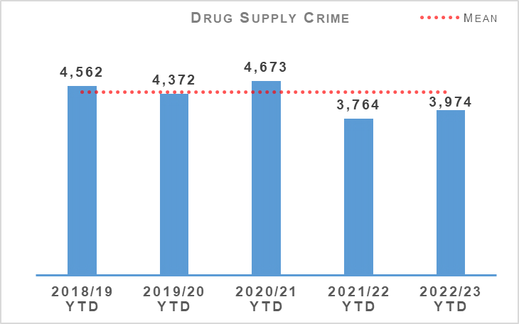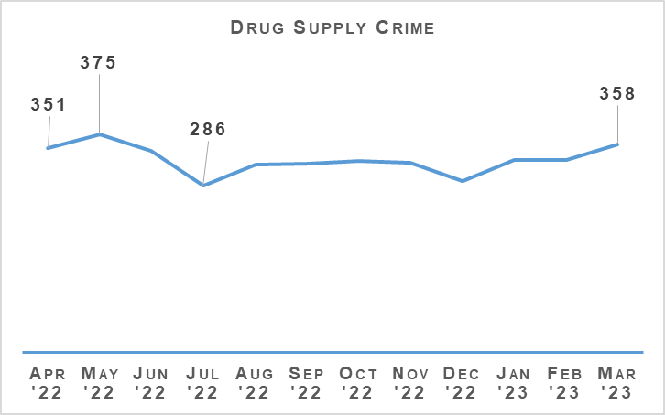
The number of drug supply crimes have increased by 5.6% (210 more crimes) compared to the previous year. In comparison to the five year mean the number of crimes decreased by 10% (440 fewer crimes). Within the grouping of crimes drugs supply covers, there was an increase of 11.6% (360 more crimes) in the number of crimes of supply of drugs (including possession with intent) with 3,474 in this year compared to 3,114 in the previous year. Crimes of production, manufacture or cultivation of drugs decreased by 26.1% (140 fewer crimes) compared to last year (397 in 2022/23 compared to 537 in 2021/22).
The number of detections increased by 2.3% (80 more detections) compared to the previous year and decreased by 10.5% (422 fewer detections) compared to the five year mean. The detection rate slightly decreased by 2.9 percentage points compared to the previous year and by 0.6 percentage points compared to the five year mean.

Serious Organised Crime Groups (SOCGs)
Serious Organised Crime Group Mapping (SOCGM) is a tool used by law enforcement in Scotland to map the characteristics of the individuals and groups that are known through intelligence and operational activity. The figures below are reflective of the SOCGM picture in Scotland as at 2022/23 Quarter 4.
Over the course of the year, 33% of SOCG’s have seen a reduction in tactical risk score and 38% of SOCG’s have been successfully disrupted and archived. The most common criminality undertaken by mapped SOCGs continues to be drugs, money laundering, violence and fraud.
SOCGs are involved in a diverse and wide range of known and emerging criminality. During 2022/23, SOCGs operating in Scotland have directed, facilitated and undertaken human trafficking in the forms of criminal, labour and sexual exploitation; prostitution; organised immigration crime; the distribution, storage and supply of firearms; the distribution, importation, manufacture, supply and transportation of drugs; violence; extortion; organised acquisitive crime including ATM theft, housebreaking, reset and theft of motor vehicles; cybercrime; environmental crime including animal cruelty, illicit dog / puppy trade, wildlife crime and illegal waste activity; the facilitation of tax evasion / avoidance; counterfeit goods and forged documents; money laundering in a variety of forms; money lending and fraud including social engineering, benefit, excise duty evasion, personal tax evasion, investment, credit card, fraudulent schemes, VAT repayment, and rogue trader / bogus workmen.

Operation SILVAN
Following an investigation which saw the recovery of cocaine and heroin with a street value of £1.3 million and £55,000 in cash from a criminal network, two men have been jailed. The men were both based in Glasgow and involved in Serious Organised class A drug crime across Aberdeen, Dundee, Fife and Kinross.
Following a six week trial at the High Court in Glasgow one male was found guilty of supplying cocaine and heroin between December 2015 and December 2016. He was also found guilty of money laundering, directing others to obtain, transport, adulterate and supply cocaine on his behalf as well as concealing the money received over the same time period. On 20 March 2023 he was jailed for 14 years at the High Court in Glasgow.
Another male was found guilty of using technology to carry out counter surveillance measures between September 2016 and November 2016. On 20 March 2023 he was jailed for five years at the High Court in Glasgow.

Operation GATESIDE
Seven people were arrested after warrants were executed at nine properties in Edinburgh, East Lothian, and Midlothian as part of a pre-planned operation following a series of violent incidents and fire-raising. On 14 March 2023, divisional officers, supported by specialist resources from Organised Crime and Counter Terrorism, attended at addresses in the Niddrie, Gracemount, and Craigmillar areas of Edinburgh, as well as Cockenzie and Gorebridge.
Five men, aged between 23 and 32, and a 16-year-old male youth, have been charged in connection with a series of offences. A report has been submitted to the Procurator Fiscal and all will appear at Edinburgh Sheriff Court on 15 March, 2023. A 23 year old man was released pending further enquiries.
Mechanism | Amount
Proceeds of Crime Act (POCA) – Year to date figures for POCA represent those provided to COPFS and CRU for consideration and forfeiture | £27,402,654
Confiscations Orders | £2,753,387
Civil Recoveries Unit | £8,879,350

Drugs Possession
Drugs Possession | 2021/22 YTD | 2022/23 YTD | % Change from Previous Year | 5 Year Mean | % Change from 5 Year Mean
Number of crimes | 23,372 | 22,356 | -4.3% | 27,615.0 | -19.0%
Number of detections | 22,632 | 22,543 | -0.4% | 26,043.6 | -13.4%
Detection rate | 96.8% | 100.8% | +4.0% point | +94.3% | +6.5% point
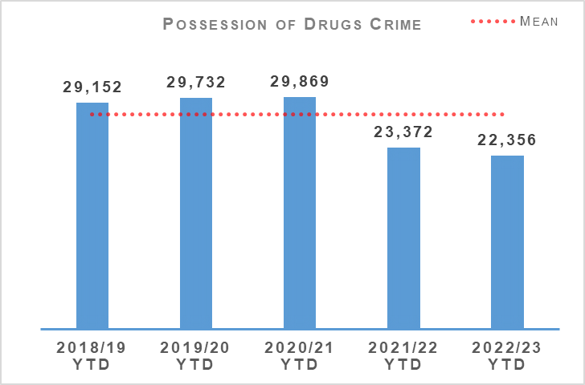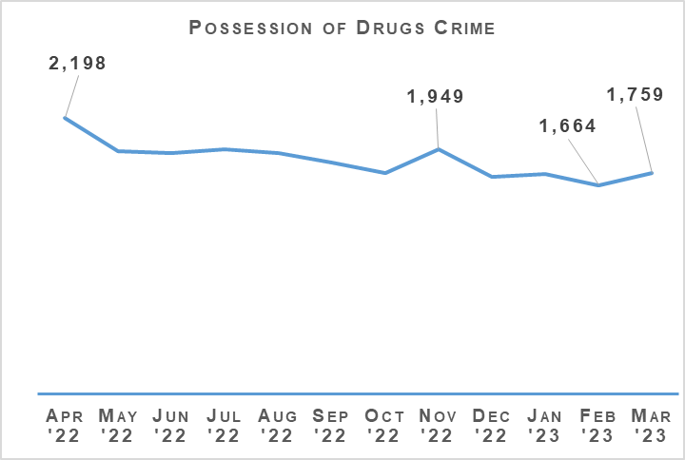
Drug possession crimes decreased by 4.3% (1,016 fewer crimes) compared to the previous year, and decreased by 19.0% (5,259 fewer crimes) compared to the five year mean. Detections similarly saw a slight decrease of 0.4% (89 fewer detections) compared to last year, and decreased by 13.4% (3,500 fewer detections) compared to the five year mean. The reduction in drug possession crimes is likely due to shifts in focus in the market towards a more synthetic drug, as well as counting of Recorded Police Warnings for drugs possession.

Disruption Activity
January 2023
As part of an intelligence led operation, officers took executive action at an address in the Clydebank area of Glasgow and recovered 13.2kg of herbal cannabis and £20,000 in cash.
Officers from the Organised Crime and Counter Terrorism Unit (OCCTU) took executive action in the Glasgow area and recovered 80kg of herbal cannabis.
Road Policing officers on the M74 stopped a vehicle linked to Serious and Organised Crime (SAOC) and recovered in excess of £75,000.
Road Policing officers provided assistance to OCCTU in the Dundee area and recovered 23.5kg of Cannabis from a vehicle travelling to Aberdeen.
Cybercrime Officers utilised the services of a Digital Detection Dog to recover hidden digital storage devices whilst effecting a search warrant.
February 2023
Road Policing officers on the M74 stopped a vehicle linked to SAOC and recovered 2.7kg of Cannabis and in excess of £84,000.
Officers from OCCTU North recovered around £24,000 in the Dundee area. The cash is linked to drugs and SAOC.
Joint operation between OCCTU and Border Policing recovered 25kg of controlled drugs.
OCCTU North as part of drugs operation took executive action and recovered 6kg of cannabis and £13,000 cash.
March 2023
Following spate of recent violent attacks linked to SAOC, executive action was undertaken at a number of addresses in the Edinburgh area with several persons arrested and remanded.
OCCTU officers recovered a cannabis cultivation in the Aberdeen area. A number of individuals have been reported to Crown Office Procurator Fiscal Service.
Officers from the Organised Crime Partnership (OCP) took executive action and recovered 5kg of Cocaine in the Glasgow area.

Operation ERSO
ERSO is the multi-agency taskforce established by Police Scotland. Under Operation ERSO the Drug Harm Tactical Taskforce leads the national focus to enhance our understanding and examine the harm associated with the illegal consumption of synthetic drugs, particularly Benzodiazepines, across Scotland. This allows for continuous improvement in the investigation of Drug Related Deaths (DRDs), to include evidence capture, information sharing and collaboration across the Service to maximise intelligence development and operational opportunities.
Current intelligence provides that there are numerous SOCGs involved in the manufacture, distribution and supply of Benzodiazepines within Scotland. Benzodiazepines being used by the Scotland based groups include Diazepam / Valium, Etizolam and Alprazolam (Xanax). We have also seen a rise in the number of groups manufacturing their own illicit tablets.
Since January 2020, a total of 29 pill presses have been recovered in Scotland as a result of operational activity carried out. Pill presses recovered through operational activity vary in technology and production capacity from manually operated pill presses capable of producing 1,000 pills per hour to automated industrial scale presses with an output in excess of 100,000 pills per hour. Provided that raw materials are available, it is possible for these high end presses to produce approximately one million pills in a typical working day. Recovery of these presses is likely to significantly impact the manufacture, supply and availability of illicit pills, including benzodiazepines, in our community.
Activity in January 2023 saw the execution of a drug search warrant resulting in the recovery of over 4,000 tablets assessed to be Street Valium, the execution of a drug search warrant resulting in the recovery of over 1,000 white Etizolam tablets and a parcel addressed to HMP Barlinnie for a prisoner was found to contain a pair of jeans with a concealed compartment. Within there were three bags of white powder believed to be Etizolam and Morphine with a total weight of 11kg.
Activity in February 2023 saw the execution of a drug search warrant resulting in the recovery of over 21,000 tablets, assessed to be Diazepam, the execution of a drug search warrant resulting in the recovery of over 2,600 tablets assessed to be Diazepam and the execution of another drug search warrant resulting in the recovery of over 3,000 white tablets.
Activity in March saw the recovery of a pill press during the execution of a drugs search warrant. A hydraulic press, moulds, mixing barrels and 67.8kg of mixing agents were recovered in Lanarkshire. Another drug search warrant in Lanarkshire resulted in the recovery of over 6,000 white tablets, whilst a drug search warrant in Glasgow resulted in the recovery of over 95,000 tablets.

Missing Persons
Missing Persons – Equality Outcome 3 | 2021/22 YTD | 2022/23 YTD | % Change from Previous Year
Number of missing persons investigations | 17,269 | 17,955 | +4.0%
Number of people who have gone missing previously | 3,484 | 3,345 | -4.0%
Percentage of people who have gone missing previously | 35.5% | 32.6% | -2.9% point
Average length of time missing (hrs) | 13.0 | 16.1 | n/a
Total number of missing persons from NHS | 1,691 | 1,797 | +6.3%
Total number of missing persons from YPU | 3,537 | 3,186 | -9.9%
Total number of missing persons from Foster Care | 382 | 478 | +25.1%
Percentage of overall missing persons that go missing from NHS | 9.8% | 10.0% | +0.2% point
Percentage of overall missing persons that go missing from YPU | 20.5% | 17.7% | -2.7% point
Percentage of overall missing persons that go missing from Foster Care | 2.2% | 2.7% | +0.5% point
Number of missing persons investigations with mental health marker | 5,709 | 5,511 | -3.5%
Missing Person Demand - Total FTE demand of missing persons investigations | 901.9 | 908.9 | +0.8%
Missing Person Demand - Children generated FTE demand of missing persons investigations | 371.6 | 405.9 | +9.2%
Missing Person Demand - Total FTE demand of missing persons investigations from Home Address | 521.4 | 523.0 | +0.3%
Missing Person Demand - Total FTE demand of missing persons investigations from Care Setting (Foster Care/Adult Care Home/Young Persons Unit/NHS) | 251.9 | 244.7 | -2.8%
Please note this was previously calculated against number of missing person investigations. It is now calculated against missing person IDs and gives a more accurate reflection of % of repeat missing persons.
The number of missing person investigations has increased by 686 compared to the same period last year. The number of repeat missing persons, the number of people who go missing from Young Persons Units and the number of investigations with a mental health (MH) marker have all decreased compared to the same period last year. There have however been increases in the number of persons that go missing from NHS and Foster Care.
The notable increases can be found when considering what ‘type’ of person goes missing. Children (not including Looked after Children) are recording significant increases as illustrated in the following chart.
The average number of hours missing has increased compared to last year. This is partly due to a large scale investigation in Quarter 4 this year. When you consider the median number of hours missing then it is 0.42hrs PYTD compared to 0.44hrs YTD.
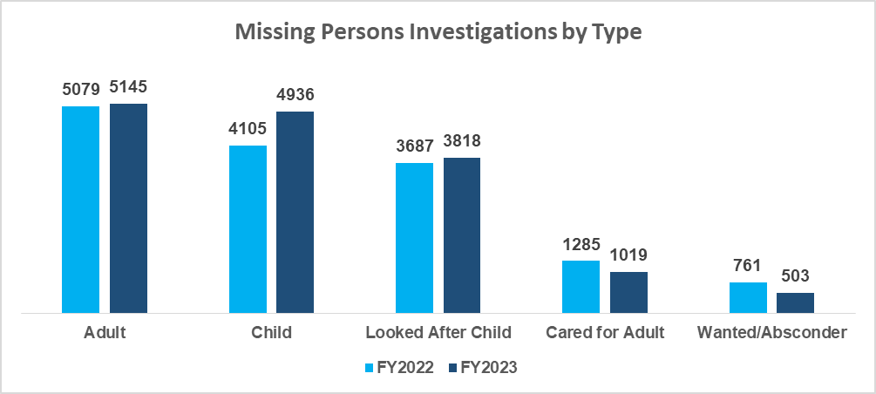
The large increases in number of children going missing could be attributed to certain lockdown restrictions being in place in Quarter 1 2021/2022 that were not in place in Quarter 1 2022/23. The following graph illustrates however that the number of missing child investigations has been consistently higher than it was last year.
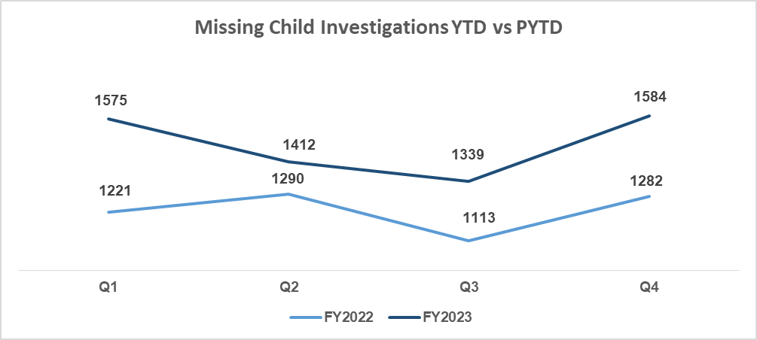
When considering where people go missing from it remains that the majority of people go missing from their home address. This has increased in the past year along with missing from NHS and missing from Foster Care.
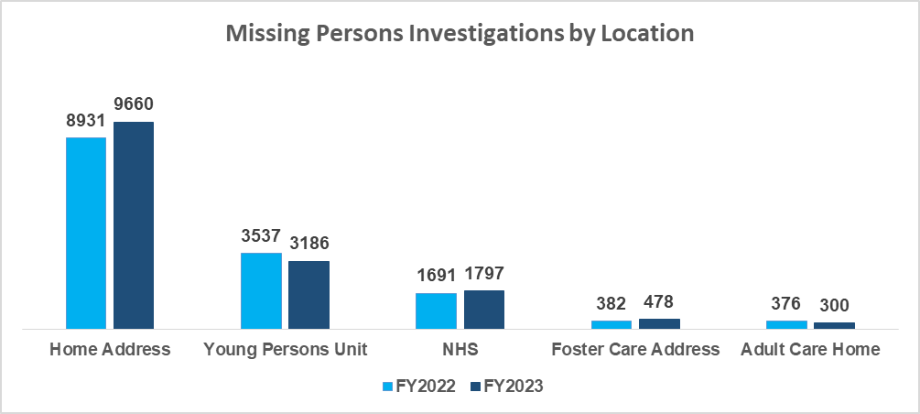

Philomena Protocol
Police Scotland is to begin delivering the staged roll out of the Philomena Protocol across the first six months of the 2023/24 financial year.
Building on the success and learning from the Herbert Protocol (an initiative to support adults who are at risk of going missing), the Philomena Protocol is being used in children’s homes across English force areas.
Working alongside partner agencies, it encourages carers, staff, families and friends to compile useful information which could be used in the event of a young person going missing from care. The streamlined approach protects vulnerable young people whilst respecting and understanding their need for independence.
Following its introduction in County Durham, there has been a 36% reduction in missing cases. Durham Constabulary estimate that it is expected that at least £500,000 will be saved each year.
The protocol has been recommended to other forces by both the Parliamentary committee in House of Commons and the National Police Chiefs Council and has been entered into a national awards scheme that recognises problem solving projects within police forces.

Autistic Missing Persons Protocol (AMPP)
The AMPP was piloted across the Lothians and Scottish Borders, launching in October 2021 in partnership with Education, Health and Social Care, and Social Work. It was developed by police in consultation with Scottish Autism and is a safeguarding scheme used to enhance the police response to an autistic person going missing, providing the police with specific vital information they may not consider or think to ask. The form is completed by the individual or parents, guardians, carers and is kept within the home / care / education / work setting ready to hand to police should the person go missing.
Police Scotland presented at the 2023 National Missing Persons Framework conference where the AMPP was highlighted as good practice. As a result a number of organisations have asked if they can use the protocol with some feedback as follows:
“The autism protocol is fantastic! I will certainly signpost families.”
“Yes so many good examples such as the autism protocol.”
“The Autism Missing Person Protocol sounds like such a super initiative.”
“The Autism awareness with the police force sounds like a progressive measure. I think autism and trauma training are vital within Police Scotland.”
Police Scotland were contacted by Silver Spring Police Department in Pennsylvania who is starting up an autism registry programme and was asking permission to use the AMPP form. They were very impressed with the details included and are going to adapt it for use within their communities.
The AMPP is currently going through an independent review by academics at Abertay University. The review consists of an overall assessment of the form and the questions asked by looking at completed forms then discussing their answers with the person responsible. The results of the review are due by the end of April 2023.

Road Safety
Road Casualties | 2021/22 YTD | 2022/23 YTD | % Change from Previous Year | 5 Year Mean | % Change from 5 Year Mean
People Killed | 153 | 179 | +17.0% | 150.0 | +19.3%
People Seriously Injured | 1,740 | 1,690 | -2.9% | 1,641.8 | +2.9%
Children (aged <16) Killed | 6 | 3 | -50.0% | 3.8 | -21.1%
Children (aged <16) Seriously Injured | 155 | 167 | +7.7% | 150.2 | +11.2%
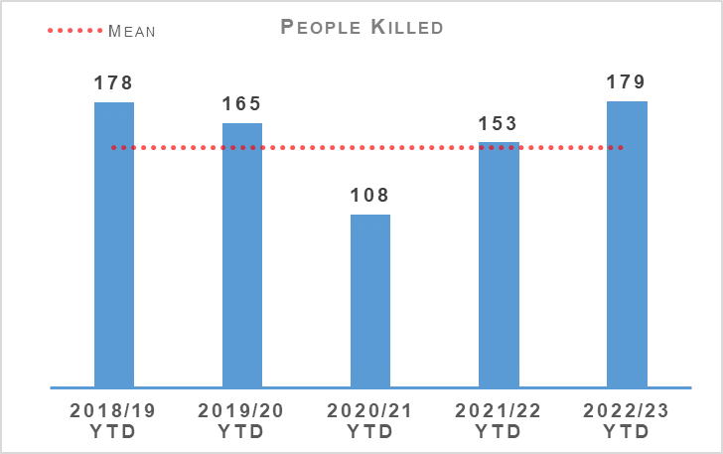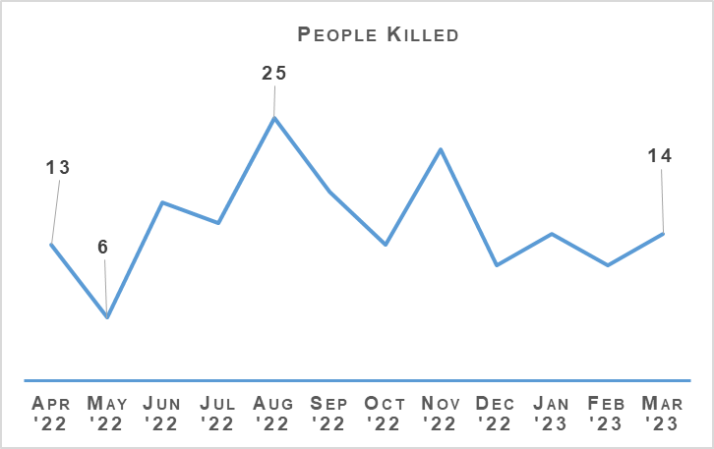
Over the year 2022/23 there have been a total of 179 fatalities on Scotland’s roads. This is an increase of 17.0% (26 more fatalities) compared to the previous year and an increase of 19.3% (29 more fatalities) compared to the five year mean. The five year mean is reduced due to the COVID-19 lockdown periods when there were restrictions on travel, however the number of fatalities is up 8.5% (14 more fatalities) compared to 2019/20 (the last pre-COVID-19 year). In Quarter 4 there were 14 recorded fatalities however some of these are still being investigated for possible medical-related causes or suicide.
The number of persons seriously injured has decreased by 2.9% (50 fewer serious injuries) compared to last year, and increased by 2.9% (48 more serious injuries) compared to the five year mean.
The number of children killed this year has decreased by 50% (three fewer fatalities) and decreased by 21.1% (one fewer fatality) compared to the five year mean.

Road Safety Framework (RSF)
Transport Scotland published key road casualties figures showing the progress made against the Road Safety Framework targets that ran from 2010 to 2020. All five targets on that previous framework were met, per the following table:
Scottish Road Safety Targets 2020 | Target Reduction | Actual Reduction
People Killed | -40% | -52%
People Seriously Injured* | -55% | -68%
Children (aged <16) Killed | -50% | -76%
Children (aged <16) Seriously Injured* | -65% | -77%
Slight Injury | -10% | -67%
Please note that due to changes in severity recording the number of seriously and slightly injured people cannot be directly compared to those reported in previous years. Progress against these targets has been calculated on the basis of adjusted figures provided by the Department for Transport.
The current Road Safety Framework (RSF) to 2030 along with the 2022/23 delivery plan published in June last year, build on this. The following interim reductions in those killed and seriously injured on Scotland’s roads, from a 2014/18 baseline, are sought:
50% reduction in people killed
50% reduction in people seriously injured
60% reduction in children (aged under 16) killed
60% reduction in children (aged under 16) seriously injured
The interim reductions are challenging, as they should be, as we work with our partners toward Vision Zero: no deaths and no serious injuries on Scotland’s roads by 2050.
A few key risks have been identified via analysis and we will seek to mitigate these as we move forward:
The number of cyclists on our roads was boosted by the COVID-19 pandemic and, more generally, by people opting toward more eco-friendly sustainable modes of transport. Cycling is anticipated to further increase as a consequence of recent fuel price rises. We recognise the potential for collisions to also increase, with cyclist collisions often resulting in serious injury.
Motorcycle casualties have remained steady over the past few years, aside from the drop in 2020/21 due to the reduced traffic during COVID-19 restrictions.
With an ageing population, who remain mobile longer and continue to drive, it is anticipated that there may be an increase in older casualties.
In an effort to mitigate risks and reduce collisions on the road network, Police Scotland has identified a number of key opportunities.
The In-depth Fatality Study continued to progress throughout Quarter 4, supported by a Transport Scotland-funded dedicated analyst plus seconded Road Policing Sergeant. This study affords the opportunity to identify learning from previous collisions, assisting Police Scotland and partners to introduce preventative measures to further mitigate risk across all road users groups. A draft report covering 2015 to 2020 data will be circulated for consultation shortly. This includes findings plus recommendations and countermeasures. A working group will be held to comprehensively review and inform the final report, anticipated within the prescribed funding period to July 2023.
Road Policing continues to work closely with Transport Scotland to understand trends and identify emerging threats in relation to all collision classes. Police Scotland analysts produce detailed problem profiles identifying specific casualty types, with particular focus on vulnerable road users. The information is shared with partners at forums such as the Tactical Options Working Group and Road Safety Governance Board. This sharing allows resources to be allocated to the greatest areas of risk in an effort to reduce harm on our roads, in partnership with local policing and assisted where appropriate by our key partners.
Acknowledging that some sections of the motorcycle community can be challenging to influence, the Scottish Government in partnership with Police Scotland have developed a working group to explore opportunities and develop engagement strategies moving forward. One example is Rider Refinement North, an initiative providing rider training by Police and Institute of Advanced Motorists instructors.
To date Police Scotland has delivered on all commitments made to support the RSF 2030. Our objective within the RSF to incorporate specific campaigns, initiatives and directed activity targeting the safety of vulnerable road users, including cyclists, motorcyclists and pedestrians, continues to be met. All Quarter 4 road safety campaigns on our National Calendar of Road Safety Activity were completed. The majority of Quarter 4 campaign work was Fatal-Five focused and all initiatives were supported by Corporate Communications / Social Media.

Road Policing Campaign Updates
The following campaigns took place during Quarter 4:

Festive Drink/Drug Drive Campaign - 01 December 2022 to 02 January 2023
Chief Superintendent Blakelock, Superintendent Mackie, National Motorcycle Unit, Road Policing and Local Policing officers attended the campaign launch at Inverurie on 30 November 2022. The launch was well attended by local and national media, with many photographs taken and comments to camera filmed. Road Policing worked in partnership with Local Policing throughout the campaign to ensure education, engagement and enforcement work was wide reaching. Corporate Communications developed social media content and supported the campaign throughout. The launch received favourable media coverage and we received additional social media support from partners at Transport Scotland, Road Safety Scotland and Traffic Scotland.
Across the campaign a total of 3,049 roadside tests were carried out, resulting in 722 drivers being detected for drink or drug driving offences, an increase of 15% from 628 detections during the previous Festive Campaign.

National Seatbelt Campaign – 09 to 22 January 2023
Communications for this campaign commenced 09 January 2023, with the enforcement phase running from 16 to 22 January 2023. In total 136 seatbelt offences were detected over the course of the campaign.

National Mobile Telephone Campaign – 20 February to 12 March 2023
The enforcement phase of the National Mobile Telephone Campaign, supporting this NPCC UK-wide initiative, ran from 27 February 2023, preceded by appropriate social media messaging. Across the campaign 221 mobile telephone offences were detected.

New Driver Early Intervention Scheme - ongoing
The New Driver Early Intervention Scheme (NDEIS) is being rolled out nationally and partners, such as Scottish Fire and Rescue Service, have adopted the scheme and deliver it in conjunction with Police Scotland to internal and external groups.
NDEIS is aimed at 17-25 year olds to positively influence this vulnerable group of road users whilst providing a reminder of their responsibilities toward themselves and other road users.
Several local authorities have adopted the scheme for delivery to modern apprentice / skills and employability students. Empowering young people with information allows them to make informed decisions when starting their driving careers with a view to improving road safety for all.

Operation TRAMLINE - ongoing
Operation TRAMLINE, involving an unmarked HGV with camera recording equipment, was delivered across all command areas. TRAMLINE continues to trend on social media platforms, raising the profile of road safety and highlighting unacceptable and dangerous driving behaviours.
Road Safety Campaign - Impact
Driver Engagement North was launched in Highland & Islands Division and has since been extended to North East and Tayside Divisions. The pilot has been funded by Transport Scotland’s Road Safety Initiative Fund. Participants in this person-centred initiative utilise a desktop driving simulator, with a fitness to drive input also included. The final external evaluation report was completed in December. 71% of those responding to an independent study reported that their participation had led to some or significant impact on their awareness of road hazards/vulnerabilities. This positive participant feedback led Transport Scotland to agree to fund additional simulators, permitting further roll-out.

Stop and Search
Stop Search | 2021/22 YTD | 2022/23 YTD | % Change from Previous Year
Stop Search Compliance Rate (%) | 99.0% | 98.9% | -0.1% point
29,926 stop and search incidents have been recorded by Police Scotland so far this year. This is a decrease of 3.0% compared to the same period last year. 32.2% of all stop and searches this year had a positive result although this was a slightly lower (-2.5% points) positive rate than the previous year. 769 of these searches have led to the recovery of offensive weapons.
29,116 stop and search records were audited for compliance during 2022/23. This involves the records being reviewed by line managers and thereafter quality control checked by the National Stop and Search Unit to ensure their adherence to the Stop and Search Code of Practice introduced in May 2017.
Of the stop and searches reviewed during the quarter, 25,645 (88.1%) were deemed compliant and recorded correctly on the stop and search database. A further 3,159 (10.8%) were compliant with the code of practice but required amendment to their details to ensure they were appropriately recorded.
312 (1.1%) records were deemed as not recordable under the code or practice or recorded in error and deleted from the database. Typical reasons for deletion include where a person is searched after being arrested, as a result of a duplicate record or where no physical search of a person has actually taken place.
It should be noted that the total number of records audited for compliance will be lower than the total number of searches raised during the period due to the timescales required to fully review all records.

Change Projects

Digital Evidence Sharing Capability (DESC)
The Digital Evidence Sharing Capability (DESC) six month pilot started in Dundee in January 2023 and will last six months. During its first eight weeks, DESC have raised well over 800 pieces of evidence, shared 29 cases to COPFS and one case has gone to trial. Feedback has been positive across the partnership.
Planning work for the next phase of delivery is underway along with a number of improvements following pilot reviews. A successful media launch was held on 07 March 2023 with the Cabinet Secretary which led to positive media coverage.
Planning work for the next phase integrations and longer term workstation solution is ongoing with roll out to the rest of Tayside Division and wider Divisions underway.

Policing in a Digital World
Policing in a Digital World aims to transform how Police Scotland respond to the evolving threat of cybercrime. The programme will enable us to continue keeping Scotland’s people, communities, businesses and assets safe in both the physical and virtual world. We will capture digital opportunities to keep people safe and enable Police Scotland, the public and organisations to proactively recognise and respond appropriately to cyber incidents. Included within this is the Cyber Kiosks Phase 2 as a business as usual change activity.

Vulnerable Witnesses Act
The Vulnerable Witnesses (Criminal Evidence) (Scotland) Act 2019 (VW) Project, currently in design with the VW Business Justification Case (BJC), is in development and is currently on track to be completed by August 2023.

United Nations Convention on the Rights of the Child (Incorporation) (Scotland) Bill (UNCRC)
The Initial Business Case (IBC) for the United Nations Convention on the Rights of the Child (Incorporation) (Scotland) Bill (UNCRC) Project is complete with the aim to commence through governance in June 2023 and on approval working towards Full Business Case by September 2023.

Age of Criminal Responsibility Act (ACRA)
The ACRA Project is in delivery and ACRA Incident Management Moodle package currently has a completion rate of 38%. Briefings and coms are being sent out to encourage all appropriate ranked officers and staff to complete this training. ACRA Investigative Training took place in March 2023. The ACRA basic Moodle course has a completion rate of 88.5%.

Strategic Outcome 2
The needs of local communities are addressed through effective service delivery.
Objectives:
Understand our communities and deliver the right mix of services to meet their needs
Support our communities through a blend of local and national expertise
Support the changing nature of communities

Call Handling
Call Handling | 2021/22 YTD | 2022/23 YTD | Change from Previous Year
Total Number of 999 calls | 700,262 | 741,801 | +5.9%
Total Number of 101 calls | 1,713,638 | 1,443,125 | -15.8%
Average 999 calls answer time | 7 seconds | 9 seconds | +2 seconds
Average 101 calls answer time | 3 minutes 17 seconds | 4 minutes 27 seconds | +1 minute 10 seconds
Number of 999/101 calls that do not result in an incident/crime | 928,213 | 689,676 | -25.7%
Percentage of 999/101 calls that do not result in an incident/crime | 38.5% | 31.6% | -6.9% point
Note: Following the nationwide rollout of CAM, new call gradings are being used. These were updated again during August 2020, this is reflected in the table above. A small percentage of incidents are still being categorised under the old grading and are therefore not included in the above figures. Comparison data is not available.
The total number of calls to Police Scotland decreased by 228,974 (from 2,413,900 to 2,184,926). This is a decrease of 9.5% compared to last year. As shown in the above table there has been an increase of 5.9% for 999 calls received, however, the volume of 101 calls received is showing a decrease of 15.8%, both being compared to the same period last year. Of the calls received, 31.6% did not result in an incident or crime being raised. The total number of incidents has increased by 9,563 (from 1,485,687 to 1,495,250) compared to the same period last year.
The handling of 999 calls remains our highest priority. Between 01 April 2022 and 31 March 2023, our service centres achieved an average speed of nine seconds for answering 999 calls, this has increased compared to the same period last year. The average call answer time for 101 calls increased by one minute ten seconds. Measures remain in place to alleviate this and reduce the average call answer time.
Efforts continue to signpost callers to more appropriate methods of contact, including via “Contact Us” and the force website. Social media is used during periods of high demand to inform the public and provides the opportunity to educate the public on correct use of our 999 and 101 contact methods.

Mental Health Pathway
The evaluation of the test of change for Phase 2 of the Mental Health Pathway (MHP) is ongoing with a summary evaluation report presented to the MHP Strategic Group on 01 March 2023. This identified a number of areas of work for both Police Scotland and NHS 24 to further develop the pathway and provide intervention at an earlier point in the call management journey. The full evaluation report is expected to be available in April 2023.

Incident Demand
Incident Demand | 2021/22 YTD | 2022/23 YTD | % Change from Previous Year
Incident Demand – Total Number of incidents raised | 1,485,687 | 1,495,250 | +0.6%
Number of incidents by response type - Immediate | 169,899 | 162,624 | -4.3%
Number of incidents by response type - Prompt | 637,006 | 598,540 | -6.0%
Number of incidents by response type – Standard Local Policing Appointment | 65,091 | 66,917 | +2.8%
Number of incidents by response type – Standard Direct Crime Recording | 75,738 | 84,645 | +11.8%
Number of incidents by response type – Standard Resolution Team Involvement | 44,551 | 37,109 | -16.7%
Number of incidents by response type - Other Resolution | 452,659 | 511,887 | +13.1%
Incident Demand - % of incidents which lead to a crime | 26.5% | 27.1% | +0.6% point
Incident Demand - % of incidents requiring police response | 97.0% | 97.4% | +0.4% point
Partner Demand – Total number of external force request incidents | 2,857 | 3,067 | +7.4%
Note: A small percentage of incidents are still being categorised under the old grading and are therefore not included in the above figures.
During the reporting period 188,671 standard incidents were recorded in total, an increase of 1.8% (3,291 incidents) from the same period last year. The new process involves the allocation of local policing appointments, direct crime recording and resolution team involvement to standard incidents. This has now been fully integrated into daily business, leading to this continued increase. The most common crime types recorded for standard incidents are theft, assist member of the public, damage, road traffic collisions, fraud and neighbour dispute.
The percentage of incidents which lead to a crime and those that require police attendance remain consistent when compared to the previous year. Due to the process changes a comparison against the five year mean is not available. Demand from partners, in terms of external force request incidents, has risen by 7.4% (210 incidents) compared to the same period last year.

C3 Division Demand
In addition to the call numbers, there have been over 285,000 additional public contacts dealt with by Contact, Command and Control (C3) Division during the reporting period.
C3 Division does not only deal with incoming calls from the public. Service advisors also deal with incoming calls from other partner agencies and alarm calls. There have been over 106,000 of these types of calls for this reporting period, although a slight decrease of around 2.6% in Emergency Service Partner calls and a decrease of around 3.7% in total alarms.
Emergency Service Partner calls are received via dedicated numbers from Scottish Fire and Rescue, Scottish Ambulance Service, Mountain Rescue, Coast Guard, Mental Health Pathway (NHS 24), OmniCrash and Oil Industry Agency. The reason for such calls vary and each are dealt with by a service advisor in the most appropriate manner.
“Contact Us” emails and online reports, for some crime types, can be completed online. Each one of these reports is assessed by a service advisor using the Threat Harm Risk Investigation Vulnerability and Engagement (THRIVE) model. Over 170,000 “Contact Us” emails and over 9,000 online reports have been submitted since 01 April 2022.
Overall, additional public contacts are up 6.4% from 2021/22.

Contact, Engagement and Resolution Project (CERP)
The Contact, Engagement and Resolution Project (CERP) was formed in 2021 and will seek to make improvements in service through Police Scotland's response to vulnerability, risk and public need at the earliest opportunity; maximising opportunities for remote engagement and resolution; reducing local policing demand and directing appropriate incidents to the right agency through pathway referrals and enhanced collaborative working.
The project is working on a number of changes that will improve the effectiveness of various business areas in C3 Division and will enhance the service provided to the public. A decision has recently been taken to provide a one day training course to all C3 staff and this will include inputs on much of the work being delivered by the project. Final approval for this proposal and securing associated funding is ongoing, with the start date of September 2023.

Modernised Contact and Engagement
The MCE and Service Design team have now finalised a Current Operating Model (COM) with C3 Division. This will lay the foundation for the future target operating model (TOM). Service designs blueprints have been created for the division and these together with the playbacks from the insight sessions were presented to C3 SMT in January 2023.
An options paper, prepared by the Unified Communications and Contact Platform (UCCP) Project, on whether to integrate or remove Aspire Customer Relationship Management software, used by the Service Centre, and procure an alternative was submitted and approved by the UCCP Steering Group & MCE Programme Board.
This includes a re-phased project timeline and authority to proceed with procurement. Four Data Protection Impact Assessments (DPIAs) have been submitted to Information Assurance and their feedback is being reviewed.
The National Integrated Communications Control Systems (NICCS) project is still in its testing phase and continues to work with the supplier, Frequentis, to address the remaining defects prior to moving into further integration testing.
The C3 training team continue to deliver relevant training packages within the division. The project team continue to work closely with C3 in regards to implementation dates, however until the defects are addressed and testing is completed definitive dates for implementation are yet to be confirmed.

Notable Incident Process Updates and reporting
Demonstrate applied learning and evolution of this to a more positive approach
Recommendation 26 of the HMICS Independent Assurance Review on Police Scotland – Call Handling stated that Police Scotland should promote an improvement culture where staff are encouraged to report adverse incidents or ‘near misses’ and introduce processes as soon as possible where these can be recorded, assessed and any improvement identified and implemented.
In April 2016 C3 Division responded to this with the implementation of the Notable Incident (NI) process which allows any incident, where the effectiveness of the C3 Division response is likely to have a significant impact on the reputation of the Division, Police Scotland or our partners, and from which learning could potentially be obtained, to be highlighted, captured and the learning gained for the benefit of the wider Division, Police Service and the public.
C3’s Notable Incident process was commended by HMICS in their subsequent review and C3 Division have sought to further enhance this process. In March 2023 a reviewed NI process was presented which maintains the principles and benefits of the process, however further emphasises the opportunities for growth through the proliferation of good practice and provides an appropriate level of structure and governance to ensure that all opportunities for learning or remediation are captured and acted upon in an effective and timely manner.

HMICS Work ongoing – Mental Health Review
In late February 2023 Police Scotland were notified by HMICS of some Key Lines of Enquiry for a thematic Inspection of Policing Mental Health in Scotland. As a key stakeholder in this area C3 have completed a self-assessment and throughout March and April, alongside colleagues force-wide, will be engaged in interviews and focus groups with HMICS to support this inspection, which is due to report in July 2023.

Casualty Treatment Reports and work ongoing
C3 Division have worked in close collaboration with PPCW and the Scottish Ambulance Service (SAS) to build strong partnership working to enable the most effective coordination of multi-agency responses to calls for service from the public.
Following a successful pilot in Lanarkshire Division, on 20 February 2023 a national Direct Contact From Scene protocol was launched by PPCW, supported by C3, to empower officers at the scene of an incident to have direct contact with the Ambulance Service, when safe and appropriate to do so. This protocol will support the swift and accurate assessment of any casualty and subsequently elicit the most appropriate response from the SAS.
Supporting this work has been a focused development of the Casualty Treatment Reports (CTR) to manage and track Direct Contact From Scene incidents. The CTR process is currently also being used to record issues experienced when seeking support from SAS however, this is currently under review with PPCW and SAS to ensure effective communication between agencies and the meaningful escalation of issues which require further scrutiny and may lead to learning and development.

C3 Complaints and Allegations
C3 Complaint Allegations | 2021/22 YTD | 2022/23 YTD | % Change from Previous Year
Complaint Allegations received relative to C3 – on duty | 250 | 170 | -32.0%
Complaint Allegations received relative to C3 – Quality of Service | 203 | 183 | -9.9%
Total Allegations closed - relative to C3 | 430 | 401 | -6.7%
Percentage of total Allegations closed which were upheld – relative to C3 | 7.4% | 7.0% | -0.4% point
Total Complaints received relative to C3 | 324 | 272 | -16.0%
Complaints against C3 Division have decreased by 16.0% in the year-to-date, with a total of 272 received during this period. Decreases are visible in the North (down 18.8%, 26 cases in total), East (down 17.5%, 99 cases in total) and West (down 14.5%, 147 cases in total).
Incivility (138) and Service Delivery (106) are the most common allegation types, together accounting for 68.9% of all allegations received during this period. However, both categories have registered a decrease against the comparable period in 2021/22, by 21.1% and 12.4% respectively.
Consistent with the corresponding decrease in complaint cases, the volume of allegations has decreased. This is primarily linked to the reduction of Irregularity in Procedure allegations and Incivility, as previously detailed. No notable increase has been identified across all allegation categories.
In total, 64.0% of complaint cases received year-to-date for C3 Division were Frontline Resolved by the PSD National Complaints and Resolution Unit (NCARU). This rate increases to 68.4% when early and subsequent resolution by PSD or Specialist officers are included. These figures demonstrate that most complaints against C3 Division during this period have been non-criminal and non-serious in nature, with a majority resolved through simple explanation, apology or assurance.

Hate Crime
Hate Crime – Equality Outcome 1 | 2021/22 YTD | 2022/23 YTD | % Change from Previous Year | 5 Year Mean | % Change from 5 Year Mean
Number of incidents | 7,576 | 7,211 | -4.8% | 6,781.8 | +6.3%
Number of crimes | 6,925 | 6,233 | -10.0% | 6,636.4 | -6.1%
Detection rate | 66.1% | 63.3% | -2.8% | 68.0% | -4.7%
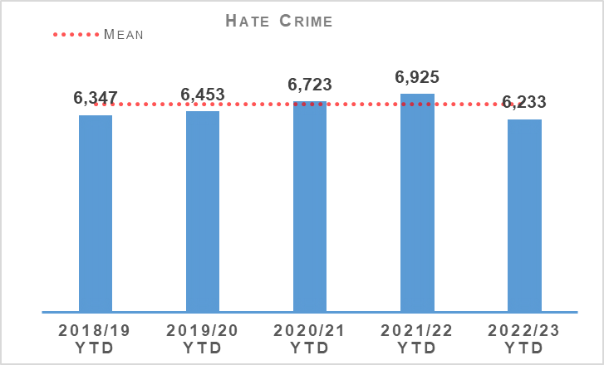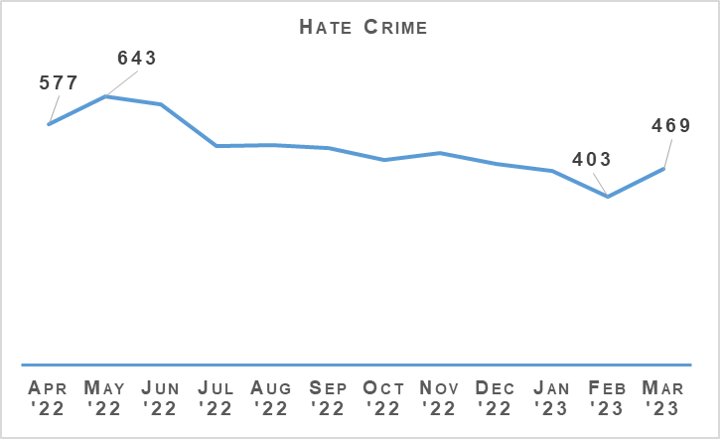
Hate incidents have decreased compared to the same period last year but remain above the five year mean. Hate crimes have decreased significantly compared to last year and are also below the five year mean. The 12 month graph illustrates that crimes peaked in May this year and have gradually declined since.
The hate crime detection rate is 2.8% lower than the previous year and 4.7% below the five year average.

Hate Aggravators
Aggravator | 2021/22 YTD | 2022/23 YTD | % Change | % of Total Hate Crimes (2022/23)
Race | 4,031 | 3,527 | -12.5% | 56.6%
Religion | 354 | 386 | +9.0% | 6.2%
Race & Religion | 59 | 58 | -1.7% | 0.9%
Multiple aggravators including Race & Religion | 223 | 212 | -4.9% | 3.4%
Disability | 435 | 446 | +2.5% | 7.2%
Sexual Orientation | 1,588 | 1,390 | -12.5% | 22.3%
Transgender | 154 | 121 | -21.4% | 1.9%
Multiple aggravators excluding Race & Religion | 81 | 93 | +14.8% | 1.5%
Total Hate Crime | 6,925 | 6,233 | -10.0% | 100.0%
Hate crime with a race aggravator accounts for over 56% of all hate crimes however these crimes have decreased significantly when compared to the same period last year (now 504 fewer). Transgender and Sexual Orientation aggravators have also decreased compared to the same period last year (33 and 198 fewer respectively). Religion has increased but remains below the five year average of 452. Anecdotally this may be a result of an increase in Orange Order/Republican Marches and the large scale return of fans to football games.
Disability crimes are increasing however this coincides with Police Scotland’s drive to improve reporting of this type of crime with a number of media campaigns and enhanced partnership working.

Anti-social Behaviour and Disorder
Anti-social Behaviour and Disorder | 2021/22 YTD | 2022/23 YTD | % Change from Previous Year
Number of antisocial behaviour incidents reported by the public | 322,691 | 275,421 | -14.6%
Number of complaints regarding disorder | 231,120 | 193,380 | -16.3%
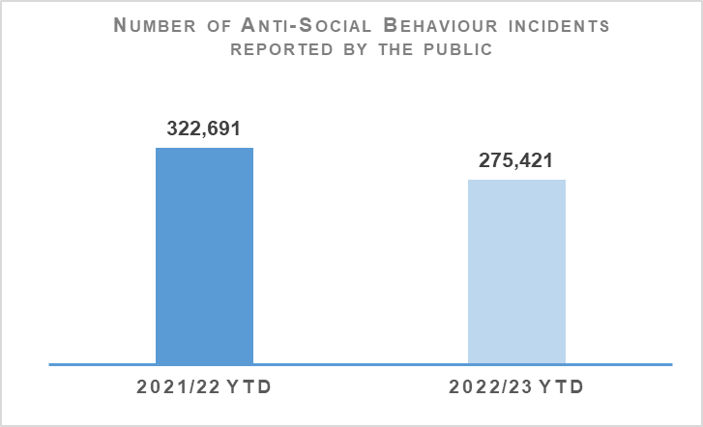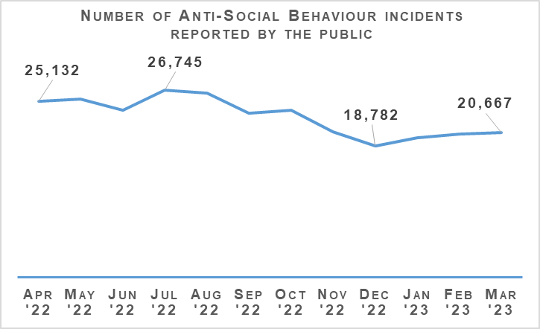
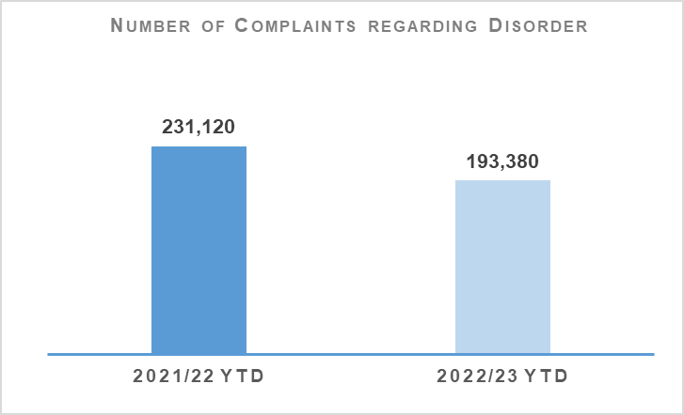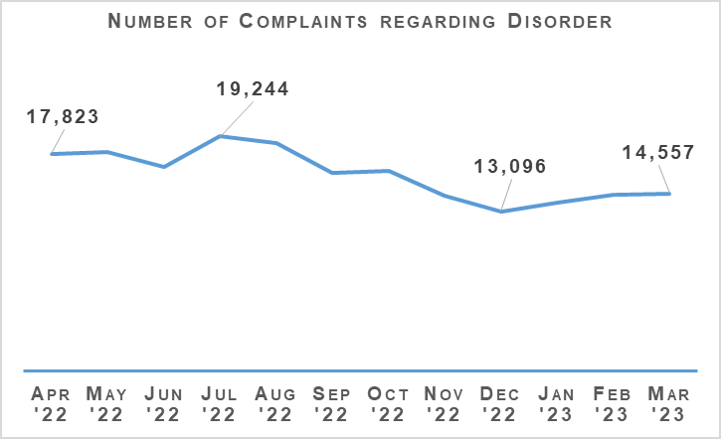
Both complaints of disorder and incidents of anti-social behaviour have been lower in 2022/23 than in the same period last year.
The Fireworks and Pyrotechnic Articles (Scotland) Act 2022 continues to be introduced in stages throughout 2022/23. PPCW Division and National Football Information Point – Scotland are working collaboratively with the Scottish Government in respect of implementation of the new legislation.
On 06 June 2023, Scottish Government have confirmed the pyrotechnic legislation will be implemented, specifically Section 35 making it an offence for a person, without reasonable excuse, to possess a pyrotechnic article in a public place and Section 36 making it an offence for a person, without reasonable excuse to possess a pyrotechnic article whilst they are in a designated venue or event.
Furthermore, Scottish Government chair a Short Life Working Group to discuss the implementation and enforcement of Firework Control Zones (FCZ). In consultation with stakeholders they are preparing guidance documents for local authorities to outline criteria for approving a FCZ and for community group to consider prior to requesting one for their respective area. It is anticipated this may be in place prior to bonfire night 2023.
Suitable messaging will be required prior to the introduction of a FCZ to ensure public expectations are managed appropriately in respect of FCZ`s being an additional option available for communities to consider and that these alone will not solely tackle the negative impact of fireworks.
The steering group for the “It’ll cost you” Proxy Purchase campaign which is led by Scottish Grocers Federation, on behalf of Scottish Alcohol Industry Partnership has been re-established for 2023. The campaign will run from 05 June to 18 August 2023 and will again be a national campaign with specific sample areas still to be confirmed to better understand and evaluate the impact of the campaign at a more local level. Scottish Government are represented on the steering group and have once more committed their full support for 2023 with ministerial backing still to be confirmed.

Acquisitive Crime
Group 3 Crime | 2021/22 YTD | 2022/23 YTD | % Change from Previous Year | 5 Year Mean | % Change from 5 Year Mean
Number of crimes | 91,283 | 103,393 | +13.3% | 103,065.4 | +0.3%
Number of detections | 29,202 | 32,073 | +9.8% | 38,025.8 | -15.7%
Detection rate | 32.0% | 31.0% | -1.0% point | 36.9% | -5.9% point
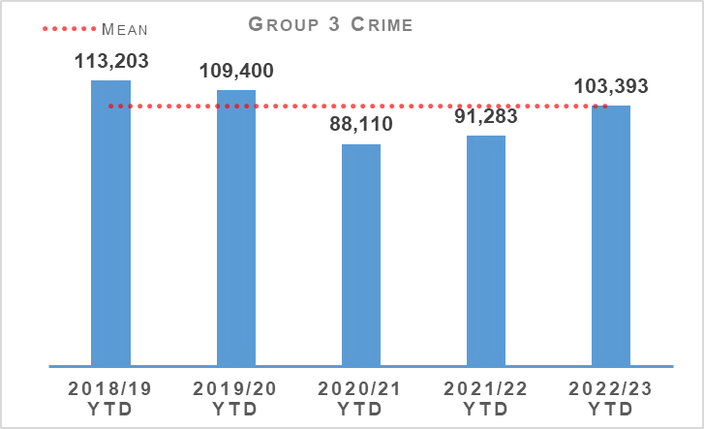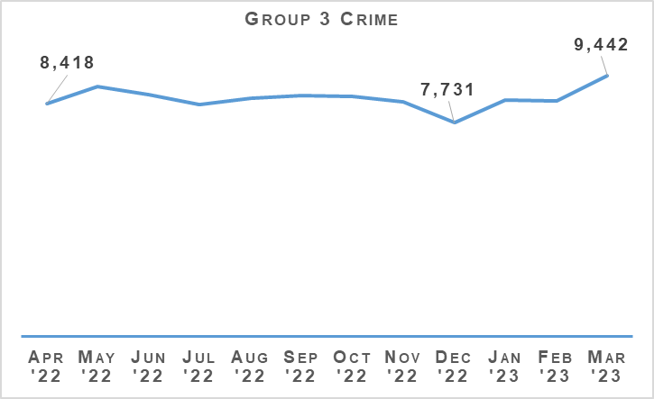
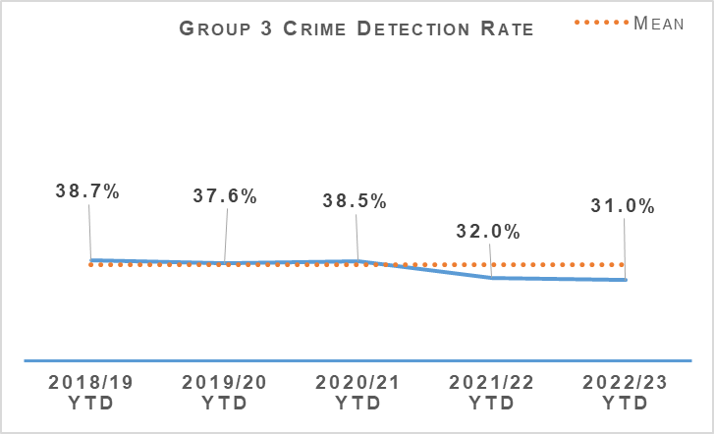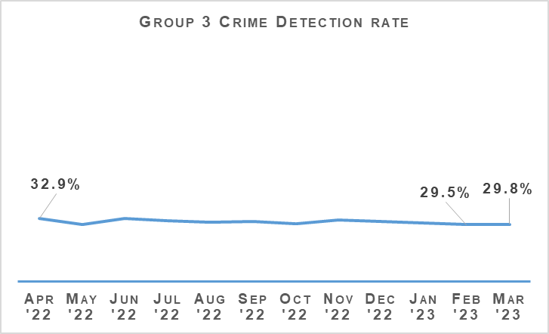
Acquisitive crime has increased significantly compared to the same period last year and is now at a similar level to the five year mean. Between April 2022 and March 2023 there have been 12,110 more crimes compared to the same period the previous year, and 327 more than the five year mean.
If fraud is excluded, Group 3 crimes have still risen by 14.4% (10,861 crimes). Shoplifting and common theft crimes continue to be the main contributors to this increase from the previous year, with shoplifting increasing by 5,691 crimes and common theft by 4,481 crimes.
Despite the overall increase, some aspects of acquisitive crime have continued to fall compared to the same period last year. Theft of pedal cycles have reduced from 4,439 to 3,960 (down 479 crimes), and there have been 250 fewer crimes of in building with intent to steal, reduced from 2,759 crimes to 2,509 crimes.
In recognition of National Acquisitive Strategies requiring local delivery, the Acquisitive Crime National structure with PPCW, SCD and Local Policing Divisions has been restructured to regional (North, East and West) groups with partners. Each Regional group is led by a Crime DCI and has partnership representation and divisional leads, supported by Analysis and Performance Unit, focusing on the coordination of preventions and tactics to tackle serious and organised acquisitive crime at the regional tactical level. They will identify trends, challenges and work closely with partners to prevent crime occurring. These groups will meet on a bi-monthly basis and feed the National Acquisitive Crime Meeting chaired by the national lead from Police Scotland to address the outcomes of the STRA.

Shoplifting
Shoplifting crimes have continued rising to levels closer than those seen pre-pandemic and are now higher than the five year mean. Between April 2022 and March 2023 there have been 28,619 crimes, 24.8% (5,691 crimes) more than the same period last year and 3.1% (860 crimes) higher than the five year mean. This is still 1,951 crimes fewer than during the same period in 2019. This increase is expected to continue as levels are now 6.4% lower than the most recent pre-pandemic year.
Detections over the period have increased from 12,834 to 15,324 compared to the same period last year. The detection rate is 53.5%, 2.4 percentage points lower than the same period last year and 11.5 percentage points lower than the five year mean.

Housebreaking
Housebreaking has experienced an increase year to date of 4.0% (335 more crimes) compared to last year. Over the period there has been a total of 8,796 housebreaking crimes. Despite this year to date increase, housebreaking is 26.5% lower than the five year mean and 31.6% lower than levels seen pre-pandemic (2019/20).
Increases can be seen in all areas of housebreaking with domestic and non-dwelling domestic housebreakings both rising by 158 crimes and commercial housebreakings rising by 19 crimes.
Domestic housebreakings are now 3.5% higher than the same period last year (158 crimes). Between April 2022 and March 2023, 4,682 domestic housebreaking crimes were recorded, compared to 4,524 crimes last year and the five year mean of 5,937.4 crimes. Domestic housebreaking remains at a much lower level than pre-pandemic, there have been 1,950 fewer crimes in 2022/23 than over the same period in 2019/20.
Non-dwelling domestic housebreakings are now 9.6% higher than last year, having risen from 1,638 in 2021/22 to 1,796 in 2022/23. Commercial housebreakings have also experienced a small increase of 0.8% YTD, with 2,299 crimes recorded between April 2022 and March 2023, rising to 2,318 crimes in the same period this year.

Vehicle Crime
Between April 2022 and March 2023 there has been 11,647 crimes, 11.9% (1,240 crimes) more than the same period last year and 7.7% (968.4 crimes) fewer than the five year mean. This increase has been due to rises in theft of a motor vehicle (661 more crimes), theft from a motor vehicle (368 more crimes) and opening lockfast place – motor vehicle (121 more crimes).
Detections over the period have increased from 3,053 to 3,153 compared to the same period last year which has had an impact in the detection rate. The rate is 27.1%, 2.3 percentage points lower than the same period last year and 0.9 percentage points above the five year mean.
There has been a notable increase in the keyless theft of high value vehicles in recent months. It appears to affect numerous policing divisions across Scotland and the UK. As such we have opted to instigate the overarching investigative model to ensure that all divisions are joined up and we maximise all possible investigative opportunities. Each division has identified SPOCs and we have wider support across SCD and SPA Forensic Services.
Crime Prevention advice was circulated, highlighting the theme emerging and what members of the community could implement themselves to prevent becoming a victim. Operation ENZONE is Police Scotland’s overarching response to these thefts and incorporates some localised operations already in place in a few divisions.
Operation ENZONE links in with Operation PADLOCK, which is the UK wide approach to this issue and led by the North East Regional Organised Crime Unit (ROCU). ENZONE is currently being scored according to the Management of Risk in Law Enforcement (MoRILE) and once we understand how this looks we will continue to link in at a UK level.

Rural Crime
The total cost of rural crime for April 2022 to March 2023 totalled £3,658,084 with a total of £523,837 recovered. This compares to a total cost of £5,696,846 and £1,203,190 recovered for the same period last year. This indicates an overall reduction in the financial harm to Scotland’s rural communities of £2,038,762, equating to a drop by 35.8%.
Over the period, the number of reported rural crimes, incidents and offences to Police Scotland was 1,182 compared to 1,466 in 2021/22, a reduction of 19.4% (284 fewer crimes incidents and offences). These figures highlight the effectiveness the prevention, intelligence, enforcement and reassurance model applied by the National Rural & Acquisitive Crime Unit have been.
The capture and recording of rural incidents has been more accurate throughout 2022/23 due to the successful pilot project devised by C3 involving an automated search of all recorded incidents reported to Police Scotland in a 24 hour period using key words. This has been in addition to a continued and pro-drive to encourage those living, working and enjoying Scotland’s rural communities and environments to report any crime, incident or offence to policing.

Fraud
Fraud | 2021/22 YTD | 2022/23 YTD | % Change from Previous Year | 5 Year Mean | % Change from 5 Year Mean
Number of crimes | 15,630 | 16,879 | +8.0% | 11,497.6 | +46.8%
Number of detections | 2,684 | 2,725 | +1.5% | 3,232.4 | -15.7%
Detection rate | 17.2% | 16.1% | -1.0% point | 28.1% | -12.0% point
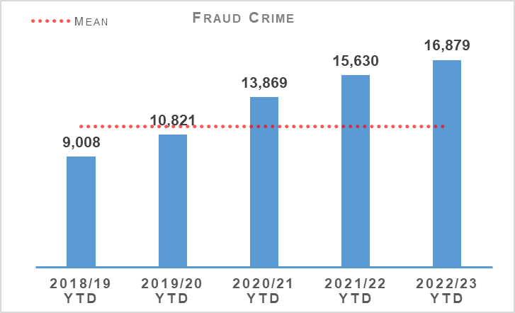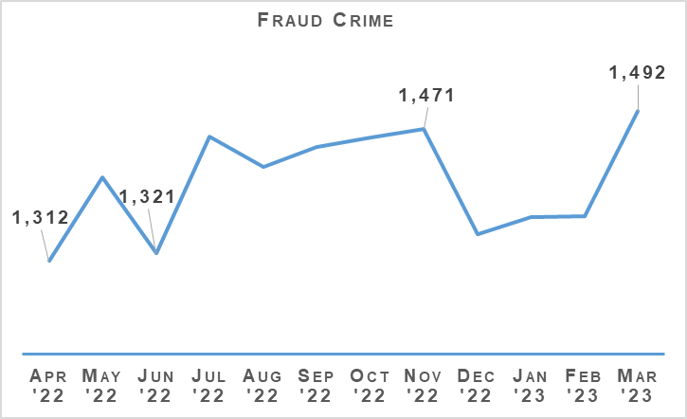
Fraud crimes have continued to rise, increasing 8.0% compared to the same period last year and 46.8% from the five year mean. Fraud is a significant global issue which is recognised as the most prominent crime type within the UK. Within Police Scotland we continue to see month on month increases in reported fraud and, coupled with limited resource locally to investigative fraud, our detection rate is falling. Police Scotland are keen to continue to play an intricate part in the UK and global effort to tackling fraud and are currently considering the new National Fraud Strategy, due to be published on 28 April 2023, with a view to adopting this as the strategic direction for Police Scotland.
Strong relationships already exist with our partners in the City of London and the NECC and a shared strategy would allow for more targeted efforts to tackle fraud and money laundering offences, having the highest impact in reducing harm across the communities and businesses of Scotland. Police Scotland continue to engage with the City of London Police and are actively considering the possibilities and opportunities of joining the Fraud & Cyber Crime Reporting and Analysis Service, due for implementation in March 2024. The service would assist in ensuring a true UK picture of fraud trends, intelligence and would enhance the targeting of offenders whilst providing more effective prevention and messaging campaigns to safeguarding vulnerable victims.

Cybercrime
Cyber Scotland Week was held between 27 February and 03 March 2023, and brought together cyber experts from Scotland and beyond. The Lead Conference was held on Monday at Glasgow University’s Technology and Innovation Centre and was attended by several distinguished individuals, including Deputy Assistant Director of the FBI’s Cyber Division and Director National Cyber Investigative Joint Task Force.
There was a soft launch of the Cyber Prevent programme Cyber Choices during Cyber Scotland Week. Cyber Choices uses educational engagements to divert those on the cusp of cybercrime in terms of the Computer Misuse Act. The Cybercrime Harm Prevention Team devised a week long Cyber Choices programme which also ran over the course of the week, this was delivered to 30 candidates from various schools.
Overall, Cyber Scotland Week 2023 delivered a series of over 120 events around Scotland, showcasing the strength in the partnership and the country's impressive talent pool and innovative spirit, to deliver on Scotland’s Cyber Strategy. The collaboration on a national and international level demonstrates the critical role that Police Scotland will play in protecting against cybercrime.

The Banking Protocol
The Banking Protocol is a multi-agency initiative between law enforcement, banking institutions and Trading Standards. Its aim is at the earliest opportunity to identify vulnerable victims who are in the process of being defrauded of funds from their bank accounts by unscrupulous criminals and to intervene to prevent these crimes. If staff suspect customers are being coerced or the transaction is as a result of fraud, the transaction is stopped and the Police are contacted. The protocol is designed to provide a standardised method for how these concerns are dealt with and reported to police and to stop multiple victimisation.
In terms of Quarter 4 of the reporting year 2022/23, the Banking Protocol recorded 294 incidents accounting for £777,273 of fraud being prevented. For the year 2022/23 (April 2022 to March 2023) the Banking Protocol recorded 1,199 incidents accounting for circa £3,534,139.14 worth of fraud being prevented.
This initiative continues to succeed in protecting the vulnerable victims of fraud and its success demonstrates the value of the public/private partnership model.
Police Scotland continue to be a key partner on the Fraud Strategic Governance Group. This group, involving police, partners (including third sector) and the Scottish Government has been set up to understand and direct activity at a strategic level to combat the threats posed by the increases in fraud. The group continues to provide a coordinated public awareness raising initiative to prevent fraud from being committed and also ensure appropriate governance around a consistent and joined up strategy across agencies and organisations is undertaken.
Engagement in these groups continues to ensure that fraud investigation is undertaken from a multi-disciplinary perspective and recognises the vital contribution that each partner can play in tackling fraud.

Multi-Agency Triage Hub
Recognising that strengthening the protection of individuals, businesses and our Scottish communities against fraud requires to be our collective focus and that it cannot be achieved single-handedly by Police Scotland, we have now commenced a pilot of a multi-agency financial crime triage hub.
The first meeting highlighted the objectives and aims of our stakeholders and what we hope to achieve from our multi-agency discussions. The terms of reference and structure of the meeting was reviewed to focus on high level threats and vulnerability.
It was agreed that two meetings would be established, one weekly meeting referred to as the Cyber and Fraud Operational Call, coordinated by Cyber and Fraud Scotland, to gain an understanding of the demand of financial institutions (Barclays, Lloyds and Nat West) and the national threat picture with the second group meeting monthly, coordinated by Police Scotland, and referred to as the multi-agency financial crime hub centred around vulnerability and what we as partners (Police Scotland Edinburgh Policing Division, PPCW, SOC FIU, Cybercrime, Scottish Government, Trading Standards, DWP, HMRC, Third Sector) can do to address ongoing and emerging threats to the people and communities of Scotland.
The multi-agency financial crime hub have discussed the prevalence of familiarity frauds, recognising that there is significant under reporting. Police Scotland PPCW identified that there hasn’t been specific messaging around this crime type and proposed a dual approach to safeguard messaging with Scottish Government and the third sector adult support and protection coordinator.
The emerging crime identified by financial institutions in relation to phishing scams targeting the farming and agricultural community was discussed with Police Scotland PPCW circulating immediate prevent messaging.
Sextortion was identified as an emerging threat causing financial harm to both children and adults. Again, it was identified that there has been no national campaign around this crime type for several years. Scottish Government have agreed to liaise with internal partners specialising in adult and child protection with a view to exploring prevent media campaign on a National level.
Trading standards are identifying scams in relation to the instalment of spray foam insulation and the impact on the most vulnerable and all partners agreed to consider what support they can provide to protect vulnerable individuals.
The two groups will continue to meet on a weekly/monthly basis and will report into the Fraud Strategic Governance Group chaired by Police Scotland.

Detection Rates
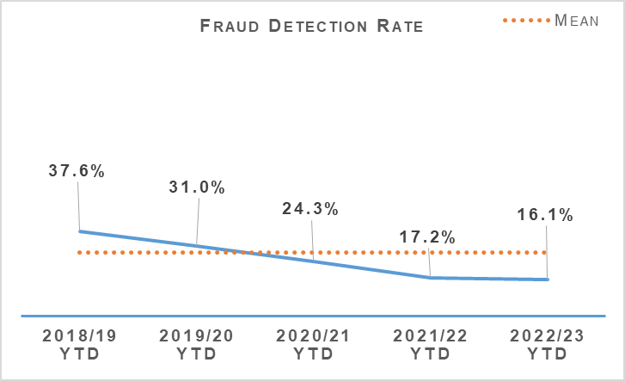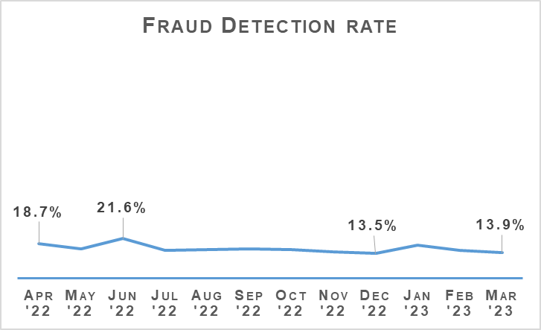
The fraud detection rate currently stands at 16.1%, down 1.0 percentage points on last year and 12.0 percentage points on the five year mean. This decrease has been driven by the continued increase in recorded frauds as the number of detected crimes has increased slightly compared to last year. Between April 2022 and March 2023, 2,725 frauds were detected, which is 1.5% (41) more than the same period last year and 15.7% (507) less than the five year mean.

Police Custody

Criminal Justice
Criminal Justice | 2021/22 YTD | 2022/23 YTD | % Change from Previous Year
Volume of cases submitted into Criminal Justice System | 130,168 | 123,874 | -4.8%
There is a consistent national downward trend emerging in reported cases and effective use of direct measures and alternatives to prosecution are anticipated to be a contributing factor. This use of direct measures and alternatives to prosecution and the associated reduction in court citations and police officer abstraction will be highlighted in a forthcoming Criminal Justice Act staff communications package planned for Quarter 1 of 2023/24.

Arrested Persons
Arrested Persons Brought into Custody | 2021/22 YTD | 2022/23 YTD | % Change from Previous Year
Number of times arrested persons brought into custody | 93,724 | 97,113 | +3.6%
It is important to note that the number of arrested persons includes individuals who have appeared in custody on more than one occasion within the reporting period. This excludes voluntary attendance, S.23 MDA 1971 detentions and those in transit.
Custody throughput, having decreased steadily year on year since 2016, has not only levelled off but for the fourth quarter in a row has seen an increase. Part of this was anticipated as a result of exiting the COVID-19 pandemic. Criminal Justice Services Division (CJSD) has noted an increase in arrest on warrants which fell during the pandemic quarters and this may partly explain the rise.
Arrested Persons Held for Court | 2021/22 YTD | 2022/23 YTD | % Change from Previous Year
Number of arrested persons held for court | 34,619 | 39,681 | +14.6%
Proportion of arrested persons held for court | 36.9% | 40.8% | +3.9% point
Number of arrested persons held for court in relation to a new case | 24,563 | 26,257 | +6.9%
Proportion of arrested persons held for court in relation to a new case | 71.0% | 66.2% | -4.8% point
Similar to Quarter 3, the proportion of arrested persons held for court has increased in comparison to last year’s period. This has been impacted by the numbers being arrested on warrant. The number arrested on warrant is also contributing to a rise in the percentage necessarily held for court.
This will continue to be monitored closely in the coming months to establish whether this is an increasing or continuing trend, however it is worth considering that this is still down significantly on the percentage to court pre-pandemic which generally fluctuated around 50-52%.
This appears supported by the 4.8% reduction in persons appearing in relation to a new case.
Arrested Persons Released / Re-arrested | 2021/22 YTD | 2022/23 YTD | % Change from Previous Year
*Number of persons on electronic bail | n/a | 282 | n/a
Number of arrested persons released on an undertaking | 24,177 | 23,216 | -4.0%
Proportion of arrested persons released on an undertaking | 25.8% | 23.9% | -1.9% point
Proportion of persons released on investigative liberation | 0.6% | 0.7% | +0.1% point
Number of persons re-arrested | 540 | 628 | +16.3%
The term ‘re-arrested’ is defined as any occasion whereby a person, previously released without charge as a ‘Not-Officially Accused’ person, is subsequently re-arrested for the same offence due to the presence of further evidence. This is not to be confused with a person arrested more than once within a specified period on separate charges as defined by recidivism.
*Electronic Bail was introduced May 2022, therefore figures for year 2021/22 are not available. The figure detailed is those who are currently being monitored on electronic bail.
The total number of EM bail orders granted between their introduction in May 2022 until 31 March 2023 was 743. The number of individuals subject to EM bail on 31 March 2023 was 282, with several individuals subject to more than one order.
Use of undertakings have decreased modestly and this coincides with the increase in percentage to persons held for court. Use of investigative liberation has increased only slightly after seeing a slight improvement in Quarter 3. This coincided with a well-publicised staff communications drive on the use/benefits of investigative liberation related to investigations. A Criminal Justice (Scotland) Act targeted staff communications package is planned and likely to land in Quarter 1 of Financial Year 2023/24. It is hoped this will contribute to a further improvement.
The increase in the number of persons re-arrested may be partially explained as a result of officers becoming accustomed and confident in using the powers afforded by the Criminal Justice (Scotland) Act more effectively. Re-arrest can increase investigative opportunities and should be viewed as positive in this context.

Children brought into Police Custody / Held for Court
Children brought into Police Custody / Held for Court | 2021/22 YTD | 2022/23 YTD | % Change from Previous Year
Number of Younger Children Arrested and Accepted into Police Custody (not held overnight) | 1,273 | 1,486 | +16.7%
Number of younger children arrested and held overnight | 157 | 150 | -4.5%
Number of younger children held over 24 hours | 46 | 28 | -39.1%
Number of Older Children Arrested and Accepted into Police Custody (not held overnight) | 1,645 | 1,685 | +2.4%
Number of Older Children Arrested and Held Overnight | 447 | 457 | +2.2%
Number of Older Children Held Over 24 hours | 204 | 240 | +17.6%
Definitions for clarity: Adult being defined as 18 or over; Older Child being defined as 16/17 and Not under Supervision; Younger Child being defined as Under 16 or 16/17 but subject to a Compulsory Supervision Order. The number listed as held over 24 hours are those who were held in a police cell and had a relevant certificate in terms of S.22 of the Criminal Justice (Scotland) Act 2016 issued indicating why they were so held and not at a place of safety. **Overnight is determined as the period of time spent in custody which exceeds four hours and includes the period between 0000 and 0400 hours.
Police Scotland’s position is that police custody is not a suitable place of safety for a child. We are working with partners to identify and develop alternatives to Police Custody. In the absence of those alternatives we focus our efforts on minimising any trauma a child may experience when arrested. Only in the most serious of cases and where there is no other appropriate place of safety will a child be held overnight or longer than 24 hours in police custody and the figures reflect this.
We have seen a welcome reduction in the number of younger children held overnight and over 24 hours although an increase in older children held overnight and over 24 hours is apparent. There have been modest increases in numbers coming into custody which is broadly consistent with the transition out of pandemic arrangements and the wider increase in throughput observed.
SPA and CJSD co-hosted a “Children in Conflict with the Law” round table event on 15 November 2022, co-sponsored by the Scottish Police Authority and Police Scotland to mark International Children’s Day in Edinburgh.
The broad topics of discussion were captured on the day and delegates have been invited to provide feedback to the SPA Strategy and Innovation Team and a post event report was generated. There is also forthcoming legislation in the form of the Children (Care and Justice) (Scotland) Bill which will make changes to the rights of children in police custody settings. The main impact for Officers and Police Scotland's Custody System (NCS) will be the removal of the 16/17 year old category of older child and they will subsequently be afforded identical rights to those under 16 years. There will be the possibility that anyone under 18 will be subject to a Compulsory Supervision Order (CSO), but that will not impact on the rights of the child. Child Detention Certificates (CDCs) will be required for all children being held in custody under the age of 18 once the bill receives Royal Assent.

Police Direct Measures
Police Direct Measures | 2021/22 YTD | 2022/23 YTD | % Change from Previous Year
Number of ASB Fixed Penalties issued | 8,946 | 4,760 | -46.8%
Number of Fixed Penalty Notices issued | 8,901 | 4,760 | -46.5%
Number of Recorded Police Warnings issued | 19,941 | 20,062 | +0.6%
A significant proportion of the Fixed Penalties issued in 2021/22 relate to the Health Protection (Coronavirus) (Restrictions) (Scotland) Regulations 2020. The decrease in the issuing of ASB Fixed Penalty Tickets will be as a direct result in the easing of these restrictions which no longer create an offence for certain activities previously subject to such penalties. Accordingly the decrease is anticipated given these circumstances. There is a marginal increase in Recorded Police Warnings.

Vulnerability
Vulnerability | 2021/22 YTD | 2022/23 YTD | % Change from Previous Year
Number of persons arrested who have declared current or historic alcohol addiction issues | 10,497 | 11,475 | +9.3%
Proportion of persons arrested who have declared current or historic alcohol addiction issues | 11.2% | 11.8% | +0.6% point
Number of persons arrested who have declared current or historic drug addiction issues | 14,439 | 14,856 | +2.9%
Proportion of persons arrested who have declared current or historic drug addiction issues | 15.4% | 15.3% | -0.1% point
Number of persons arrested who have declared current or historic Mental Health issues | 38,845 | 41,217 | +6.1%
Proportion of persons arrested who have declared current or historic Mental Health issues | 41.5% | 42.4% | +0.9%
Please note, each custody may have reported "yes" to each of the above categories.
The proportion of persons declaring one or multiple vulnerabilities remains broadly stable although increases can be seen in total numbers which may be partially explained by the increase in throughput. The numbers declaring previous or current alcohol addiction issues is perhaps the most noteworthy followed by those declaring mental health issues.
NHS Partners in Custody Centres | 2021/22 YTD | 2022/23 YTD | % Change from Previous Year
Number of people in custody seen by NHS partners in custody centres | 6,703 | 7,094 | +5.8%
Figures provided represent the numbers marked out of cell for medical assessment (excluding those to hospital). They do not include those individuals who are subject to several medical assessments as is often the case during longer periods in custody.
There continues to be a drive to make optimal use of health care professionals for healthcare and welfare decisions and management of risk. Figures from this area of business have risen which would be expected with the increase in persons’ vulnerabilities detailed in relation to alcohol and drug use and a deterioration in mental health.
We are committed to ensuring the safety and wellbeing of those in our care and custody. However, it is important to recognise that many of these people are vulnerable and have complex needs. As such, we work closely with healthcare professionals to provide an appropriate level of care based on an assessment of these needs and risks.
Police Scotland has highlighted that despite our national approach to police custody, the healthcare provision is supplied by 14 Health Boards each of whom provide Police Scotland with differing levels of service or delivery methods. We welcome the recommendations made following the inspection by Her Majesty’s Inspectorate of Constabulary Scotland and Healthcare Improvement Scotland and will continue to work collaboratively to improve provision and the level of service across the estate.
Partner Referrals | 2021/22 YTD | 2022/23 YTD | % Change from Previous Year
Number of arrested persons referred to partners | 1,238 | 1,339 | +8.2%
These figures are obtained by recording the number of Third Sector Organisation (TSO) forms received by the Healthcare and Interventions team. It does not include referrals made by healthcare staff, those referrals made directly between the TSO link worker and the person in custody or those referrals that the Healthcare and Interventions team do not receive due to human error (where the TSO form was not shared with the Healthcare and Interventions team email).
The move in the last financial year has been to provide person centred support for people passing through police custody, however many services we work with focus on alcohol and drug support and it is widely recognised mental health support services are lacking across the board, not only with respect to Police Scotland arrest referrals. Many service providers’ in place are funded by local area Alcohol and Drug Partnerships (ADPs) who by their nature focus on substance use.
Work remains ongoing to secure person centred link worker style support services in place with face to face referrals becoming more common. In July 2022, the Early Help Team came on board providing holistic support for anyone coming through custody in Inverclyde, and has been presented as a Test of Change with reviews ongoing. As of 02 April 2023, coinciding with the launch of an ADP led service in North Lanarkshire, there is now a pan-Lanarkshire approach in place, where two services from neighbouring local authorities (North and South Lanarkshire) are working together to provide support for all Lanarkshire residents, showing improved partnership working between local authorities and breaking down previous local barriers.
In the last financial year we have also worked with our third sector partners to get more link workers vetted which means there are many more referrals being made directly between the link worker and the person in custody. Work is still ongoing to ensure these referrals are also included as it is still believed the numbers below under represent the actual number of people referred when passing through custody at present.

Productions
Productions | 2021/22 YTD | 2022/23 YTD | % Change from Previous Year
Total number of productions received | 581,365 | 582,023 | +0.1%
Total number of productions disposed | 309,701 | 307,146 | -0.8%
Total number of productions accumulated | 271,754 | 274,697 | +1.1%
% of productions accumulated in terms of total received | 46.7% | 47.2% | +0.5% point
The number of productions seized in Quarter 4 has risen when compared to the same period last year. This may be affected by the continued recovery from the COVID-19 pandemic. The number of items disposed of has decreased only slightly showing a comparative increase in Production Management Officer (PMO) productivity. The constant accumulation of articles underlines the pressure on the Criminal Justice estate and the need for further discussion to review the need based on the long established principles of ‘best evidence’.

Criminal Justice Recovery
As part of the Justice Recovery Programme Scottish Government have continued to provide additional funding to all justice partners for 2023/24. This is providing necessary targeted resources towards courts, Crown Office and Procurator Fiscal Service (COPFS), Police and Community Justice which is supporting the recovery programme.
Whilst it is clear that the funding will be required over multi-year basis to address the backlog in the system there are areas of reform and change which must be committed to by all justice partners.
The current allocation of £2.1 million will be utilised in part for the increased solemn court programme which will see the additional six High Courts and eight Sheriff and Jury Courts running each day. Scottish Courts and Tribunal Service (SCTS) modelling is predicting that the High Court will return to pre-COVID levels by March 2025 and Sheriff and Jury by March 2026.

Summary Case Management Pilot
The Summary Case Management Pilot was launched in September 2022 within Dundee, Paisley and Hamilton Sheriff Courts. It was designed to improve the summary court process by resolving cases at the earliest opportunity, reducing the number of cases called for trial by disclosing evidence to the defence earlier eliminating the need for full disclosure where cases can be resolved. This process will also allow the court to preserve trial dates for cases which cannot be resolved by any other means.
The pilot will reduce the number of civilian and police witnesses unnecessarily called for court which will have a positive impact on civilian and police witnesses experience, ensuring that all witnesses cited are fully engaged as there will be more certainty of trials that have been set proceeding. Police resources will be deployed more appropriately instead of sitting at court unnecessarily leading to less shift variation causing less disruption to officers improving their wellbeing.
The results so far are encouraging with the number of citations issued to police officers in all three pilot areas reducing due to better case management between crown and defence as cases will be agreed and a plea submitted or evidence agreed and the case continued without plea. In all of these cases previously we could have realistically expected the defence to tender a not guilty plea immediately triggering a trial date with automatic officer citations.

Witness Availability and Citations
Work is continuing within the area of court demand. There are ongoing meetings and discussions between Police Scotland and COPFS in an effort to explore any practical methods of reducing the demand court attendance has on the welfare of officers and the abstractions from operational duties at key times of the week. The project team are also exploring the method and amount of additional court paperwork which is being passed to Police Scotland from COPFS to be delivered on their behalf.
Development work on a new court scheduler is continuing by Digital Division. This scheduler is a more interactive ICT designed package which is capable of interfacing between Police Scotland SCoPE, COPFS and SCTS databases. Digital Division are nearing the end of the development stage with demonstrations having taken place with justice partners of the new front screens and usability of the package. Digital Division development leads are liaising with their counterparts within COPFS in an effort to establish the conduit between both organisations allowing the interaction of SCoPE and available witnesses required by Crown for trials. No completion date is available at this time however once this phase of the project is complete, a court will be selected and a full user acceptance testing period will be carried out with an evaluation of the system reported on prior to any decision to implement.
Police Scotland are still working with COPFS colleagues in relation to the night shift citations issued to officers with more than 28 days before trial. To date COPFS have reviewed around 70,000 records which have resulted in more than 7,000 officers receiving countermands.
A recent workshop organised by the project team and attended by colleagues from COPFS and local policing divisions looked at mapping out ways of reducing the demand court has on the operational numbers for front line policing. Discussions are at an advanced stage with COPFS exploring the possibility of expanding the night shift countermand work to include late shift and rest day working officers. If this is agreed it will be trialled within a single division to test the process and the commitment between partners. This process will be demand driven by the divisional resource department in a hope that officers are countermanded and returned to operational duties in areas where they are required.
There are ongoing discussions between Crown and the project team in relation to the way that Police Scotland are submitting officer court excusals to try and maximise efficiencies. Currently there is no single method which is consistent across all divisions of Police Scotland. COPFS have recently introduced national Witness Engagement Teams whose remit will include timely processing of police excusals.

Remote Provision of Witness Evidence (RPWE)
Since January 2022, every High Court trial has permitted all police witnesses to provide their evidence remotely. These can be facilitated from specially equipped Evidence Giving Rooms (EGRs) based within selected police offices which are near to the officer’s base post.
Currently within the police estate there are 43 evidence giving rooms. RPWE is an area of business which is fully supported at the highest level of the Justiciary and is seen as the way forward for police and professional witnesses to provide their evidence within the High Court.
From January 2022 until December 2022 Police Scotland received over 10,000 High Court Citations with 1,043 officers actually being required to attend a witness evidence room or a court. Of this number, 316 (30%) have appeared virtually and 732 (70%) having to attend court in person. The RPWE process is currently under a Force review which is hoped will be completed by the end of April 2023.

Change Projects

Offender Management Unit (OMU)
On the Sex Offenders Policing Unit (SOPU)/Offender Management Unit (OMU) Project, Digital Division has updated Commander and Pathfinder software, have tested and deemed operational 30 laptops. Review of Divisional training for mobile device needs is required but this will not prevent initial roll out. An End of Project report is currently in progress.

Local Policing Programme (LPP)
The North East Division Integration Project is now closed. The End of Project report was approved through governance.

Strategic Outcome 3
The public, communities and partners are engaged, involved and have confidence in policing.
Objectives:
Embed the ethical and privacy considerations that are integral to policing and protection into every aspect of the service
Protect the public and promote wellbeing across Scotland by providing services that are relevant, accessible and effective
Work with local groups and public, third and private sector organisations to support our communities

Public Confidence and Satisfaction
Insight into Police Scotland’s approach to addressing public confidence and the importance the organisation places on this key aspect of policing and community engagement is detailed in the Public Confidence and Experience of Policing section at the beginning of this report.
The following table provides the survey results that have been identified by Police Scotland and the Scottish Police Authority as key measures of progress towards achieving this strategic outcome.
Public Opinion Statements | Q1 21/22 (3819) | Q2 21/22 (1289) | Q3 21/22 (822) | Q4 21/22 (14094) | Q1 22/23 (945) | Q2 22/23 (10243) | Q3 22/23 (3781) | Q4 22/23 (n1929) | Change from last Quarter
Feel either ‘very safe’ or ‘fairly safe’ in their area | 80% | 73% | 72% | 84% | 79% | 83% | 78% | 75% | -3% point
Strongly agree or agree that the police listen to concerns of local people | 33% | 29% | 36% | 29% | 31% | 32% | 28% | 27% | -1% point
Strongly agree or agree that local police are friendly and approachable | 67% | 65% | 64% | 61% | 64% | 64% | 60% | 58% | -2% point
Note: Confidence refers to how those who may not have directly engaged with the organisation. The numbers displayed in the headers relate to the number of respondents to the survey during that particular quarter and how they feel about Police Scotland.
User Experience – Equality Outcome 2 | Q1 21/22 | Q2 21/22 | Q3 21/22 | Q4 21/22 | Q1 22/23 | Q2 22/23 | Q3 22/23 | Q4 22/23 | Change from last Quarter
Percentage callers saying it was easy or very easy to contact the police | 75% | 67% | 75% | 76% | 72% | 69% | 73% | 74% | +1% point
Percentage callers satisfied or very satisfied with the way they were treated by staff member during initial contact | 85% | 82% | 86% | 87% | 84% | 84% | 85% | 85% | No change
Percentage callers who felt staff properly understood what they needed | 86% | 84% | 87% | 89% | 86% | 86% | 86% | 87% | +1% point
Percentage callers feeling that the police provided the appropriate response | 66% | 62% | 65% | 68% | 62% | 61% | 64% | 65% | +1% point
Percentage callers felt satisfied with the way they were treated by the officers who attended the incident (where applicable) | 81% | 78% | 80% | 83% | 81% | 80% | 81% | 83% | +2% point
Percentage callers felt they were adequately informed about the progress made (where applicable) | 59% | 55% | 60% | 63% | 47% | 45% | 51% | 51% | No change
Based on overall experience, percentage callers satisfied or very satisfied with Police Scotland | 68% | 64% | 68% | 70% | 67% | 66% | 69% | 70% | +1% point
Note: From April 2022, a new question was introduced to only ask respondents about their opinion on being kept informed if they had expected to receive an update on their reported incident.

Quarterly Comparison
Overall satisfaction of contacting Police Scotland has remained between 65%-73% in each quarter over the past two years.
Contact points throughout the user journey have remained mainly stable when compared to previous quarters, with all contact points either remaining the same, or increasing, including overall satisfaction with experience which increased by 1 percentage point (70%). Satisfaction with attending officers had the highest increase of 2 percentage points (83%).
To understand the reasons for initial contact being easy or difficult, an open-ended survey question was introduced to the local policing User Experience Survey in September 2021. 3,908 responses were received to this additional question in Quarter 4 2022/23.

Easy to Contact Police
Among respondents who found it easy to contact police (n=2,877), this was attributed to:
Service Accessibility
Respondents highlighted quick 101/999 answer times, easy to navigate automated menus and ability to report some incidents online.

Effective Communication
Respondents praised service advisors for their ability to be helpful under pressure, whilst also helping keep the caller calm, providing advice and making them feel safe.

Police Presence
Respondents appreciated officers who attended incidents in a timely response, were attentive and helpful.
Illustrative quotes highlighting Service Accessibility:
“I called the phone number and I spoke to someone who could help me. Everything was sorted very quickly, and it was evident that there was a clear process in place to handle my call and direct it to the right person, so it was handled. I got a call back the same day and found the whole experience to be professional and efficient. Thank you!”
“The message you get when waiting to be directed to an officer is straight forward & really clear when giving options for services, not complicated at all. Like that they say how long before call is answered, it's not a frustrating experience.”
“The website was clear about which number to call for various incidents”
Illustrative quotes highlighting Effective Communication:
“I was very scared and the contact on the phone reassured me and made me feel safe and understood my fear was valid.”
“The operator was so kind, and understanding was reporting something that was difficult and upsetting and she was calm and reassuring”
“Prompt reply to my call, call handler reassuring following my assault in my own home, stayed on the line speaking to me, telling me someone was on their way to assist me, I can’t thank her enough I was shaking following my assault”
Illustrative quotes highlighting Police Presence:
“After contacting about a welfare check for my son, I was so pleased to receive a call back from the police officer who went to his home. The police were quick, efficient & friendly. This also includes the lady officer who answered my original phone call. Thank you.”
“I dialled 101 and was passed through to the police. They took my information and told me that there would be someone out as soon as possible. Police arrived quick I told them what happened, and they said that they would have a look round my house. I am pleased with how quick they came out with. Thanks”
“The officers were a credit to your team. They were patient and took the time to listen to what I had to say. Even followed through with a call back later. Thank you for your assistance, it was appreciated.”

Difficult to Contact Police
Among respondents who found it difficult to contact police (n=551), this was attributed to the following factors:
Difficulties with connecting to a service advisor
Respondents referred to long waiting times using the 101 service for non-emergency incidents, the inability to connect to staff on their first attempt or giving up and calling 999 instead, or not reporting the incident/crime completely.

Negative interaction / communication
Respondents highlighted negative interactions with either service advisors or officers who attended the reported incident. Types of issues reported included; lack of sympathy/compassion, recording incorrect details of incident, being passed between a number of different staff/departments and not having adequate knowledge of the local area.

Being kept up to date after initial contact
Respondents highlighted a lack of updates/follow up to their cases to know what was happening, with no call-backs or updates about their reported incident.

Lack of action around reported incident
Respondents mentioned not feeling like the incident they reported was taken seriously enough by service advisors/officers. Responses mentioned incidents with officers taking ‘too long’ to attend or in some instances not at all, when it was perceived to be necessary.

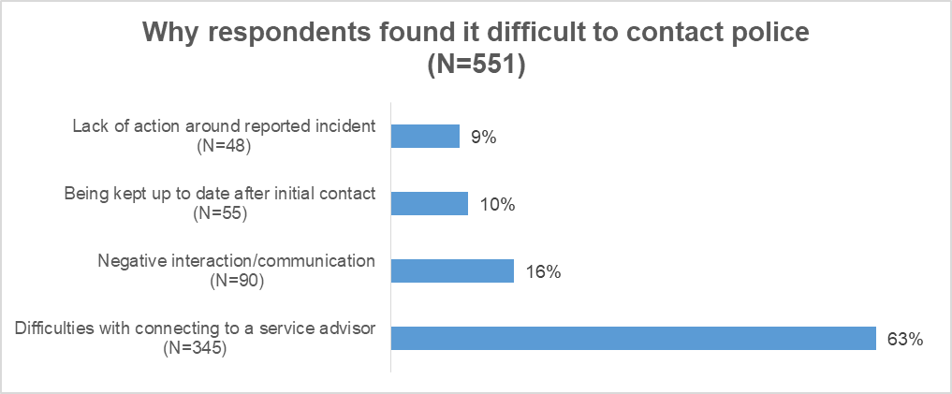
Illustrative quotes highlighting Difficulties with connecting to a service advisor:
“I couldn't get through when I called 101 and had to report it online. Too difficult to do this on my phone so had to wait until I could access Wi-Fi and my laptop. I still don't have a name or any contact info for who is dealing with the hit and run.”
“I would say the matter I was reporting was not an immediate emergency however required prompt attendance. The delay on the 101 service resulted in me hanging up and calling 999.”
Illustrative quotes highlighting Negative interaction/communication:
“I waited 30 minutes on the phone just to get an uninterested gentleman answer the phone and huff multiple times down the phone at me when I tried to explain the situation.”
“Kept on hold for more than 20 minutes before speaking to a human. The person who took initial details recorded some of them incorrectly.”
Illustrative quotes highlighting Being kept up to date after initial contact:
“Called 999, they advised someone would contact me. No one contacted me when they said they would. Then the wrong department contacted me 2 weeks after the incident. I am still currently awaiting the correct department to contact me.”
“I phoned them last month about an incident and they said they would phone me back and they never did. The police don’t really take their jobs serious enough to make a phone call back”
Illustrative quotes highlighting Lack of action around reported incident:
“No action or response from officers. Had to call on several occasions regarding offence for an update, still no update and violent criminal who has previous convictions still not been charged or witnesses contacted for statements”
“I was assaulted on the Monday and police didn’t arrive to take my statement till the Wednesday leaving me riddled with anxiety for over 24 hours”

Staff Properly Understood What You Needed
Respondents were asked Do you feel staff properly understood what you needed? In Quarter 4, there were a total of 3,908 responses to this question. Among these, 3,415 responded ‘yes’, 102 responded ‘not sure/can’t remember’ and 391 responded ‘no’.
From the 391 respondents who said ‘no’, qualitative analysis highlighted key areas as reasons why respondents did not feel their needs were understood.
Lack of response / action and follow up
Respondents referred to extended wait times for officers to arrive or no officers being sent out at all. Respondents also highlighted feeling like their concerns were not taken seriously and received minimal or no follow up with no call-backs or updates on the incident reported.

Negative attitudes and behaviours from call handlers and police officers
Respondents highlighted negative interactions with either call-handlers or police officers. Types of negative interactions included; abrupt and rude attitudes, lack of sympathy and compassion, and feelings of not being taken seriously.

Communication barriers
Respondents highlighted difficulties when sharing details of incidents with call-handlers. These difficulties included; lack of knowledge of local area, call-handlers being unsure of the computer systems used, being passed through to the wrong area or department regarding an incident and incorrect information/details being recorded or given.

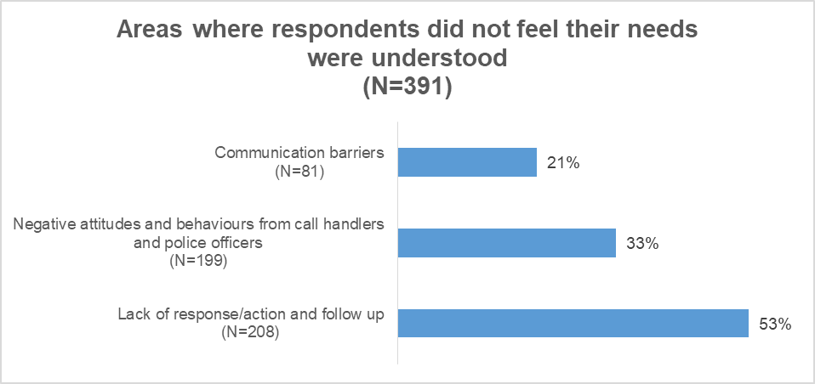
Illustrative quotes highlighting Lack of response / action and follow up:
“I was asking for assistance after an attempted break in I didn't know if the person was still at the house. I was told someone would phone me in 3 days’ time to ask about the incident.”
“I am reported an incident, I feel as though it’s just a day to day problem with the call handler but a very serious problem for my business.”
“I was robbed on king’s street in Perth. I haven’t yet had a phone call back from the police. 2500 of tools stolen and still have not been called back. There’s cameras surrounding kings street surely if effort was put in we could of seen somebody walking down the street with tools”
“They said the police would come and see me take my statement and hopefully look at CCTV, which is probably gone now, and I got ignored”
Illustrative quotes highlighting Negative attitudes and behaviours from call handlers and police officers:
“I was in shock and was asked questions that I wasn't sure of the answer and didn't feel the operator was considerate of my circumstances.”
“The control operative was rude, spoke to me like I was the one who committed the crime she was pushy shouty and clearly could not be bothered to even pretend she felt any empathy or understanding towards how upset and scared I was in the pitch dark on a road I wasn't familiar with.”
Illustrative quotes highlighting Communication barriers:
“They had to call me back because they had noted down the name of the incident (debris on a dual carriageway) incorrectly”
“Call handler had limited understanding of Glasgow geography and therefore kept asking questions about whether police teams would be aware of name of Clydeside expressway. My call was in relation to an elderly person being in central reservation and felt that the additional questions made me concerned about what might happen”
“Call handler didn't seem to realise someone was actually in my house (kept asking questions irrelevant to the situation) and needed police immediately.”

Make Their Experience Better
Respondents were also asked what Police Scotland could have done to make their experience better. There were 320 responses to this question. 29% (n=92) highlighted having a good overall experience, and praising both service advisors and officers on showing compassion, friendliness, and providing adequate and knowledgeable advice.
“Nothing I can think of. Everyone I spoke to was calm, reassuring and helpful, even when I was probably being a little incoherent due to anger that I had been attacked! Thank you for being there when I needed you.”
“The officers were amazing. I have no complaints about how they handled the incident or their response to said incident. They were professional courteous, took their time, explaining the processes and procedures, and give advice.”
The following issues were highlighted as areas of people’s experience which could have been improved/dealt with better:
More ‘action’ to be taken
Respondents mentioned wanting to see more being done around the incident they had reported. Quicker response times were also mentioned to prevent incidents from either escalating, or no longer being relevant by the time officers arrived.

Provide update / feedback
Respondents highlighted wanting more follow-ups after a crime / incident had been reported in order to know that it was being dealt with. The importance of adhering to timeframes in relation to feedbacks was also mentioned by some respondents.

Improve technology
Respondents reported improvements in technology would help when reporting crimes. Respondents mentioned more accessible ways of reporting crimes when 999/101 may not be best suitable, and other methods of being able to submit evidence, such as the Dash Cam Safety Portal. Increasing awareness of online reporting methods to the public may also prove to be useful.

Improve values / behaviours
Respondents highlighted negative experiences with either service advisors or attending officers. Issues included not being felt like they were being listened to, being taken seriously, or not being treated appropriately. This highlights the importance of promoting positive values and behaviours as it has a large impact on people’s experiences.

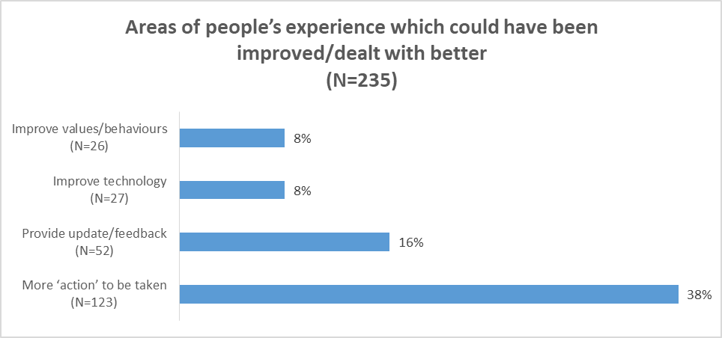
Illustrative quotes highlighting More ‘action’ to be taken:
“Police were incredibly slow to respond resulting in no chance of obtaining the thief. Matter was not cared about and passed around many officers. Not one cared to look into the incident.”
“It took 4 days for an officer came to see me. And by that time, steps had been taken to "hide" any evidence. The 2 officers who did attend to speak to me were pleasant and as helpful as possible, but due to the time lapse there was little could be done.”
Illustrative quotes highlighting Provide update / feedback:
“The incident was reported as a worry of an escalation. The officers contacted the person and things escalated online. I didn’t receive any update which has led to confusion as the person I had reported is publicly stating he was “cleared.” I feel like the report was completely pointless and left me feeling more exposed and not protected at all.”
“I have reported many things over the last few years which I hope to have helped the police deal with incidents (e.g., Fly tipping, vulnerable adult standing on edge of a bridge etc) & also prevent further harm or crimes occurring. I have usually received feedback or a follow up call. I will however not be so proactive because I don’t feel my recent reports have been valued.”
Illustrative quotes highlighting Improve technology:
“Felt as though I had to use the 999 system so that I got through to the police quicker than I would’ve done if I had used the 101 system. Public are getting very frustrated trying to contact the police this way (101) to report non urgent incidents, feels as though it is very overworked & understaffed”.
Illustrative quotes highlighting Improve values / behaviours:
“Lack of sympathy and containment after such a traumatic incident. The use of double questioning was uncomfortable and was extremely patronising. Further, I was also not listened to and has to request at certain points if I could speak. I got off the phone call and was in floods of tears due to the use of tone and language used.”
“The call handlers need to be more approachable and empathetic towards the public. The police should try to understand the caller's concerns and provide them with the necessary assistance. They should be patient and willing to listen to the caller's problems without being judgemental or dismissive. On this occasion, that is what has happened to me.”

Public Contact and Engagement Strategy
Ease of contact is a key area of focus in our Public Contact and Engagement Strategy. The introduction of accessible new contact channels and enhancement of how Police Scotland communicates and engages, will help to improve public experience and confidence in reporting crime and other incidents, enabled by digital services. For example, key programmes are continuing to ensure people are able to contact police in ways which are most accessible for individuals:
Fully accessible online reporting for getting information and advice, reporting low level crime and other incidents, receiving updates, and sharing evidence.
Investing in the replacement of our national contact platform (UCCP) to sustain contact assessment and call triage and to ensure our technology is a platform for innovation and supportive technologies in the future i.e. ‘next generation 999’ for connecting with mobile technology. Policing of the future in Scotland is expected to use video and text, activated by service advisors for easing emergency contact, in addition to phone contact.

Complaints about the Police
Complaints | 2021/22 YTD | 2022/23 YTD | % Change from Previous Year | 5 Year Mean | % Change from 5 Year Mean
Total number of complaints from members of the public | 6,679 | 6,621 | -0.9% | 6,491 | +2.0%
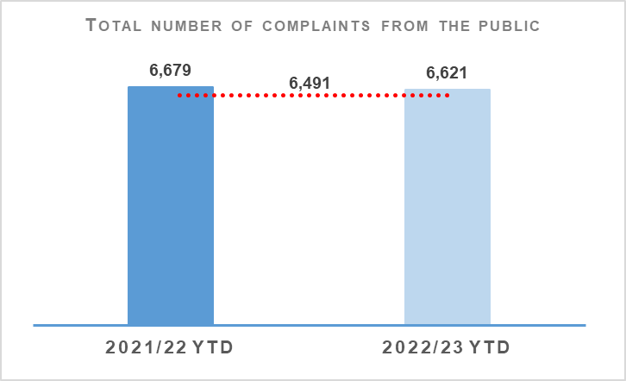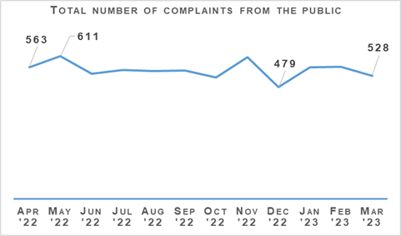
Complaints from members of the public decreased by 0.9% (58 fewer complaints) to 6,621 at the end of Quarter 4 compared to the same period last year but are up 2.0% (130 more complaints) on the five year mean.
The decrease in complaints at the end of Quarter 4 compared to the same period last year remains influenced by an elevated level of complaints in 2021/22 linked to Quality of Service related allegations. In particular, Service Outcome allegations, which have decreased notably from this period. Substantial decreases in Incivility and Irregularity in Procedure allegations have further impacted in this regard.
The Professional Standards Department (PSD) has resolved 3,119 complaints (47.1%) by Frontline Resolution (FLR) during the reporting year 2022/23, compared with 49.2% in reporting year 2021/22. This includes early resolution and subsequent resolution by PSD/specialist officers.
Due to the launch of a new complaint handling model on 03 May 2021, FLR rates cannot be directly compared to data prior to this date. This is due to the provision of additional complaint categories which will provide PSD with more detailed analysis and understanding of the overall complaint handling process.

Allegations about the Police
Allegations | 2021/22 YTD | 2022/23 YTD | % Change from Previous Year | 5 Year Mean | % Change from 5 Year Mean
Total number of allegations from members of the public | 12,418 | 10,686 | -13.9% | 11,339 | -5.8%
% of closed allegations which were upheld | 7.2% | 6.7% | -0.5% point | 9.3% | -2.6%
Note: A complaint case may include multiple allegations. A ‘Complaint’ relates to the overall expression of dissatisfaction provided by the complainer about an act or omission by the police or Quality of Service received. Allegations are the component parts of a complaint, which categorise what has happened and are separated to those capable of being independently Upheld or Not Upheld.
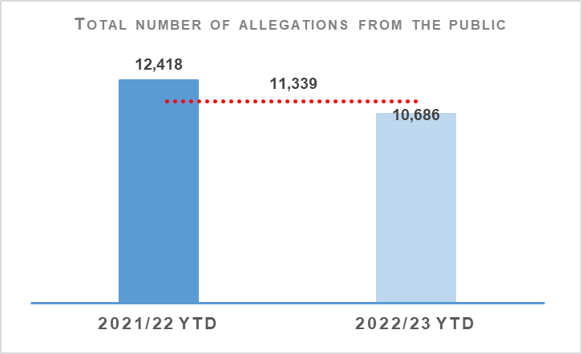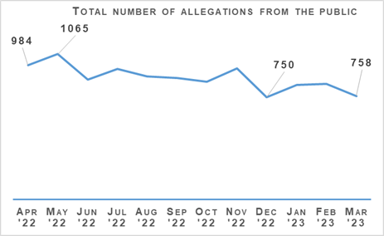
The total number of allegations has decreased by 13.9% (1,732 fewer allegations) compared to the same period last year, with 10,686 allegations recorded at the end of Quarter 4 2022/23. The number of allegations is also down 5.8% (653 fewer allegations) when compared to the five year mean.
Allegations closed totalled 11,395 at the end of Quarter 4 with 6.7% of these being upheld. Allegation outcomes (e.g. upheld) are based on closed allegations within the year to date period. Closure dates vary from the received dates, therefore closed and received data may not be directly comparable.
During this period, there were 4,473 non-criminal and FLR complaints closed with 67.5% closed within the 56 day statutory timescale. This is a 3.1 percentage point increase from the same period in 2021/22. FLR complaints are now included in this measure to better reflect the overall demand in complaint handling. Moreover, this further reflects the key aim of frontline resolution in providing an informed response within a shorter timescale, whilst also enabling an amicable conclusion for both complainers and subject officers.

Police Investigations and Review Commissioner (PIRC)
Police Investigations and Review Commissioner | 2021/22 YTD | 2022/23 YTD | % Change from Previous Year
Number of PIRC Complaint Handling Reviews (CHRs) | 198 | 199 | +0.5%
Number of allegations considered by PIRC (CHRs) | 788 | 943 | +19.7%
% of reviewed allegations assessed as handled to a reasonable standard | 66.9% | 74.2% | +7.3% point
Number of On Duty Assault cases referred to PIRC | n/a | 364 | n/a
% of these cases subject to PIRC investigations | n/a | 18.7% | n/a
Note: Allegations of On Duty Assault – plus any associated criminal allegations have been referred to the PIRC since 04 October 2021. As such, Police Scotland are currently unable to make any comparisons to the previous YTD.
Allegations of On Duty Assault (breaches of Article 3 of the European Convention on Human Rights), plus any associated criminal allegations, are now referred to the PIRC. In total, 364 allegations of On Duty Assault referrals were made to the PIRC during the period April 2022 to March 2023. Of those, 68 are subject to the Police Investigations & Review Commissioner (PIRC) investigation (18.7%). However, as at 03 April 2023, 129 of these referrals are awaiting a decision from PIRC regarding possible investigation. A further 167 cases have been marked as no investigation by PIRC with the majority classed as ‘no criminality established’ or ‘abandoned’.
PIRC submitted 199 Complaint Handling Reviews (CHRs) to Police Scotland for consideration during this period. This notionally equates to 3.1% of all complaints. The 199 CHRs received from PIRC considered 943 allegations, with 700 (74.2%) assessed to have been handled to a reasonable standard. This is an increase of 7.4 percentage points from the same period in 2021/22. These CHRs included 222 recommendations.
Statutory referrals to PIRC facilitate independent and transparent scrutiny in relation to serious incidents involving the police. Police Scotland made 325 referrals to PIRC resulting in 61 investigations (18.8%) at the end of reporting year 2022/23. This is a decrease of 9.3 percentage points compared to the same period last year. Those referred to PIRC include:
Referrals to PIRC | 2021/22 YTD | 2022/23 YTD | % Change from Previous Year
Armed Policing Presentation of Firearm | 71 | 118 | +66.2%
Crown Directed Inference of Criminality | 36 | 30 | -16.7%
Death following Police Contact | 10 | 14 | +40.0%
Death in Police Custody | 1 | 1 | No change
Serious Injury Following Police Contact | 30 | 31 | +3.3%
Serious Injury in Police Custody | 40 | 65 | +62.5%
STO Taser Discharged | 61 | 66 | +8.2%
Total Referrals to PIRC | 249 | 325 | +30.5%
Total referrals to PIRC have increased by 30.5% compared to the same period last year with the largest percentage increases recorded in Armed Policing Presentation of Firearm referrals (up 66.2%), Serious Injury in Police Custody Referrals (up 62.5%) and Death Following Police Custody (up 40.0%).
Armed Policing Presentation of Firearm referrals have increased by 66.2% (47 more referrals) when compared to the same period last year. By way of context, the monthly average of Armed Policing referrals during 2021/22 overall was six, with a comparative monthly average of ten during 2022/23.
Each individual month during the YTD has been above the 2021/22 monthly average, with further spikes during April (12), July (14), August (12), September (13) and January (12). These are the highest monthly totals registered for Armed Policing referrals going back to April 2019.
Despite the recent spike in January 2022, recent months have seen a broad levelling from the peak volumes noted above, during October-December 2022 and February-March 2023 (averaging eight per month during those particular months).
Key themes of note amongst the Armed Policing referrals include:
Spontaneous incidents account for 92 (78.0%) of referrals compared to planned operations (22, 18.6%) and accidental discharge in training/armoury environmental and the humane dispatch of an animal (4, 4.4%).
Individuals with a mental health concern and in possession of an offensive weapon account for 64.4% of total referrals.
Subjects in possession of bladed weapons alone feature in 49 (41.5%) of referrals, reported firearms possession in 42 (35.6%) and referrals involving both in 12 (10.2%).
The majority of referrals relate to the presentation of firearms (89.0%, 105 in total). The remaining 13 referrals involved the discharge of firearms, seven of which were Taser discharges by armed officers in response to non-compliant subjects threatening officers with bladed weapons. A further two referrals involved the discharge of conventional firearms to conclude serious incidents to prevent serious harm to officers and members of the public. The remaining four relate to accidental discharges in the Police training / armoury environment and the humane dispatch of an animal.
Of these 118 Armed Policing related referrals YTD, four are subject to PIRC investigation with a further three awaiting PIRC decision. This provides further independent assurance that the use of Armed Policing resources in response to these events, broadly, have been proportionate and justified.
The comparative volume of Serious Injury in Police Custody referrals is influenced by zero such referrals made during June 2021. The average number of those referrals across the full 2021/22 financial year was four per month, with the YTD (April 2022 to March 2023) having an average of five. This continues to be assessed as a relatively low volume increase and is not yet indicative of a broader increase within this referral category.
Likewise, a low volume increase has been observed in relation to Death Following Police Contact. This referral category remains at a relatively stable level and is assessed to represent a low volume increase.

Organisational Learning
PSD is committed to promoting a culture of organisational learning. Learning from CHRs and other sources are disseminated through bulletins, individual feedback and are also used to inform training packages. This learning can therefore influence and improve our service.
In Quarter 4 2022/23, PSD has disseminated learning from a variety of incidents with the following learning outcomes of particular note:
Officers’ accounts must be their own version of events and not a copy of another officer’s statement. While officer’s accounts may understandably be similar, they should not be copies of each other. Supervisors have also been reminded of the need to question accounts that appear to be copies of each other.
Officers should record sufficient detail and rationale in relation to Recorded Police Warnings. Issues in this regard have recently led to a number of complaints being upheld on the balance of probabilities.
For any incident closed as a Civil matter, officers must add their rationale in detail to the incident, consult with a supervisor or their Crime Management Team to support this view and also ensure those views are recorded on the Storm incident. This will ensure there is a clear, timestamped record of what is communicated to the reporter.

Outcome 3 - Change Projects

Unified Communications and Contact Platform (UCCP)
As part of the Modernised Contact and Engagement (MCE) Programme, the UCCP Project CRM Invitation to Tender is waiting on final procurement sign off before being issued. The C3 email service specification is making progress.

Chief Data Officer Target Operating Model (CDO TOM)
The CDO TOM Project within the Data Drives Digital (DDD) Programme provides the foundational services to deliver people, processes and training to provide best practice data management services and is progressing to closure with an End Project Report with Programme for review. CDO TOM went live in February 2022. All roles are now recruited and filled, with all staff completing the Data Governance Training. All new services which were in the Initial Business Case have been delivered.

Master Data Management
The MDM Project, also within the DDD Programme, seeks to provide the technology and processes to enable a single-view of key data, initially focussing on person data. A revised planning template is being produced in advance of prioritising deliverables. Multi View Product is currently being tested. The matching and merging rules have been agreed internally, and will be circulated with stakeholders for sign off.

Body-Worn Video (BWV) - National
As part of the Digitally Enabled Policing Programme (DEPP), the BWV (National) Project is currently progressing to next key milestone, gathering requirements in preparation for Invitation to Tender, expected to be released May 2023. Scottish Government have completed a Technical Assurance Framework (TAF) review, report is currently in draft.

The Contact Engagement and Resolution Project (CERP)
The Contact Engagement and Resolution Project (CERP), within the MCE Programme, will build on processes and capabilities established by CAM and use them to further improve outcomes for the public through strengthened pathways options, whilst reducing demand.
Research for online Crime Reporting proposal is complete. Focus Groups were held in March 2023 led by Service Design.
A training needs analysis has been completed with C3 and it is proposed that the training will be for one day and be undertaken in September 2023.

National Integrated Communications Control Systems (NICCS)
Also part of MCE Programme, the NICCS Project will facilitate control of Police Scotland’s operational communications via Airwave and C3 systems.
The NICCS project received Home Office approval in November 2022. NICCS User training has completed in the WEST and continues to be delivered in the EAST & NORTH regions. Combined testing with both Motorola and Frequentis continues as we try to resolve the remaining outstanding defects, which is the main factor causing delays. The next patch fix is due in mid-April 2023.

Strategic Outcome 4
Our people are supported through a positive working environment, enabling them to serve the public.
Objectives:
Prioritise wellbeing and keep our people safe, well equipped and protected
Support our people to be confident leaders, innovative, active contributors and influencers
Support our people to identify with and demonstrate Police Scotland values and have a strong sense of belonging

Assaults on Police Officers and Police Staff
Assaults of emergency workers (police officer / police staff) | 2021/22 YTD | 2022/23 YTD | % Change from Previous Year | 5 Year Mean | % Change from 5 Year Mean
Assault of emergency workers (police officer/police staff) - number of offences | 7,095 | 6,657 | -6.2% | 6,800.2 | -2.1%
Percentage of assaults leading to injury | 27.6% | 26.2% | -1.4% point | *35.3% | -9.1% point
Number of assault RIDDORS | 45 | 30 | +33.3% | *33.7 | +11.0%
Number of assault RIDDORS per 1k employment | 2.0 | 1.3 | -35.0% | n/a | n/a
Note: The figures for crime incidents and injuries to officers / staff are obtained from two separate systems / databases and do not directly correlate, but that are representative of the issue.*Figures marked with an asterisk relate to the 3 year mean rather than 5 year.
Note: Prior to 21 March 2021 Highland and Islands Division data only includes detected assaults.
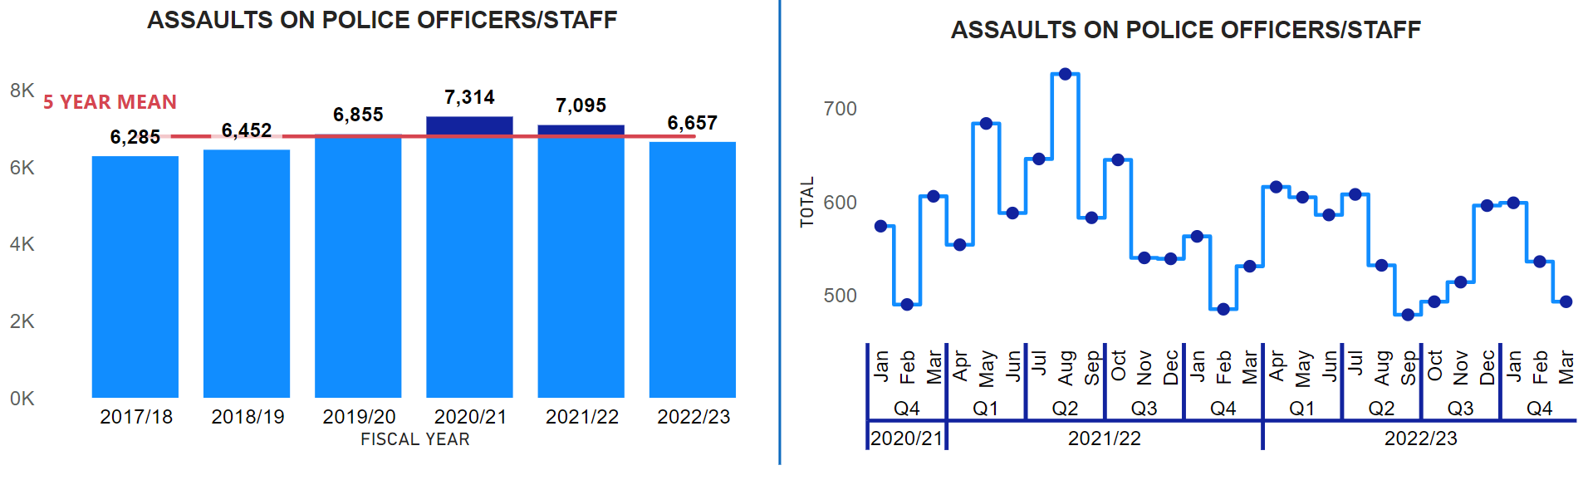
In 2022/23 there have been 6,657 assaults on officers / staff, that is an average of 18 assaults on officers / staff every day. However, assaults on officers / staff have decreased from the previous year (down 438, -6.2%) and the five year mean (down 143.2, -2.1%). This is the first time in the current reporting period that assaults are below the five year mean and the previous year. This is the lowest quantity of assaults on officers / staff since 2018/19 (6,452 assaults recorded). There have been a total of 26 serious assaults on officers / staff in 2022/23, that is a decrease of four compared to the previous year and a decrease of 1.4 compared to the five year mean. Serious assaults account for 0.4% of all assaults on officers / staff and were most prevalent in 2022/23 in May when five serious assaults were recorded across three different local divisions.
The 2022/23 injury rate (26.2%) has also decreased from the previous year (down 1.4 percentage points) and the three year mean (down 9.1 percentage points). The top three methods of assault that resulted in officer / staff injury for 2022/23 were:
Kicking (365, 22.5% of all kicking’s resulted in an injury).
Punch (181, 33.8% of all punch’s resulted in an injury).
Human Bites (151, 41.6% of all human bites resulted in an injury).
Kicking and Human Bites are prevalent assault methods towards officers / staff that result in injury as offenders can kick and bite whilst handcuffed.
In 2022/23, 225 officers / staff were hospitalised (one) or required hospital treatment as the result of being assaulted whilst on duty (224). Compared to the previous year (228) there is a slight decrease (down four, -1.3%) in officers / staff who were hospitalised (five) or required hospital treatment (223) as the result of being assaulted. This decrease is mainly driven by a decrease in officers / staff who were hospitalised. However, the difference is minimal.
The establishment of the YSM Police Assault Powerbi Dashboard suite has enabled officers and staff to access the most accurate and up-to-date data around assaults of this kind and in Quarter 4 of 2022/23 a Use of Force dashboard was added to the YSM dashboard suite. The YSM Use of Force dashboard enables easy access to the following items, but is not limited to:
Volume of use of force assault reports
Tactics used and effectiveness of tactics
Location of use of force
Impact factors for the use of force
Statistical process control chart (XMR chart)
Length of service against use of force
Employment type breakdown of use of force (police officer, staff etc.)
Subject data (officer gender and subject gender, subject ethnicity, subjects under 18)
This has in turn led to more in-depth analysis, as analysis has been conducted every quarter. Through more detailed divisional criminal intelligence analysis, it has become possible to more effectively identify prolific repeat offenders, which is a potential contributory factor in the decrease in assaults against officers and staff. YSM is moving towards a reporting by exception, rather than set quarterly reports. Therefore, YSM will monitor closely how this affects Police Scotland’s knowledge / understanding of assaults and thus, officer / staff safety.
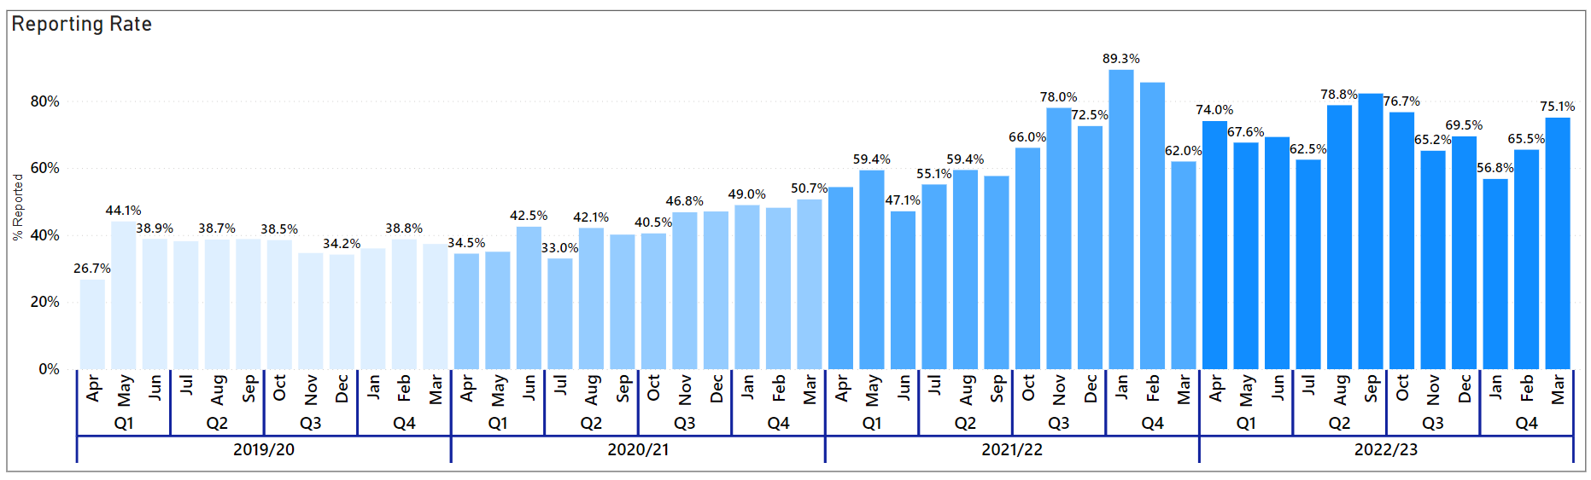
The reporting rate of assaults on officers / staff has continued to increase in 2022/23, with only one month (January 2023, 56.8%) recording a reporting rate below 60%. The rise in the reporting rate is a result of The YSM Divisional Champions, who have continued to have quarterly meetings to share and gain best practice in relation to assaults on officers / staff. Having a higher reporting rate enables Police Scotland to more accurately report on and analyse incidents of violence against officers / staff, to help further improve officer / staff safety and wellbeing.

People and Development

Absence
Absence Management | 2021/22 YTD | 2022/23 YTD | Change from Previous Year
Percentage of working days lost for police officers | 8.3% | 7.3% | -1.0% point
Percentage of working days lost for police staff | 8.1% | 7.1% | -1.0% point
Average working days lost for police officers (Annualised) | 17.0 | 14.8 | -2.2
Average working days lost for police staff (Annualised) | 19.6 | 17.1 | -2.5
Percentage of work days lost due to Psychological Disorders for police officers | 1.5% | 1.7% | +0.2% point
Percentage of work days lost due to Psychological Disorders for police staff | 1.8% | 1.6% | -0.2% point
Percentage of work days lost due to COVID Related respiratory conditions for police officers | 3.2% | 1.1% | -2.1% point
Percentage of work days lost due to Non-COVID Related respiratory conditions for police officers | 0.5% | 0.8% | +0.3% point
Percentage of work days lost due to COVID Related respiratory conditions for police staff | 2.3% | 1.1% | -1.2% point
Percentage of work days lost due to Non-COVID related respiratory conditions for police staff | 0.6% | 0.9% | +0.3% point
Absence data at the end of Quarter 4 highlights that absence for both police officers and staff has reduced compared to the same period last year. This is driven in part by the reduction in COVID-related absence which has continued to reduce for both officers and staff from the same period last year, down 2.1% and 1.2 percentage points respectively.
In terms of non-COVID-19 related absence, ‘Psychological Disorders’ remains the highest cause of sickness absence across the workforce. There has been an increase of 0.2 percentage points in percentage of working days lost for police officers who present this as their cause of absence and there is a slight easing of the number of staff working days lost (down 0.2 percentage points).
Over the past year the Police Scotland’s Health & Wellbeing (HWB) team have completed an evaluation and review of all aspects of service’s programme. They have also undertaken detailed research into long term absence due to psychological issues in order that the organisation can further strengthen both preventative and supportive interventions for our workforce to engage with.
Police Scotland remains committed to supporting the wellbeing of our workforce as they work relentlessly in challenging environments to meet the policing needs of Scotland’s communities.
Last quarter we described that emerging from the programme review are a number of priorities, including:
Reducing the stigma which still exists around health and wellbeing, particularly mental health and the seeking of support.
Development and training of all officers and staff, with a specific focus on those in line management and senior ranks.
Recognising the importance and role of peer support amongst our people.
Supporting these priorities, we have now launched a revised support offering via our People Direct Service which handles circa 5,500 wellbeing-related calls per month ranging from those that report sick/report fit and those that are looking for advice and guidance.
From March 2023, the team will undertake further training (‘Lifelines Scotland’ and ‘Scottish Mental Health First Aid’) enabling them to provide further advice on how to seek support and signpost the person through the right pathway.
Recent evaluations of the Lifelines Scotland development programme has been positive. The project seeks to establish a consistent approach to emergency services response in supporting those exposed to traumatic incidents. The Scottish Government have committed additional funding to extend the training provision and support until 30 September 2023.
A ‘train the trainer’ programme delivered by Lifelines Scotland is nearing completion and will further expand our capacity to continue to deliver crucial Lifelines resilience, self-care and post trauma support training through a Police Scotland and peer support lens.
The role of sharing lived experiences and the unique knowledge and insight the sharing of lived experience can bring, has a valuable part to play in reducing the stigma around mental health. With this in mind we will continue to deliver our ‘Lived Experience Series’ which will feature officers and staff sharing their own experiences over the coming months. Over the next quarter themes will be: coping with change due to bereavement; mental health resilience and building resilience; and the support of carers.
Our trauma risk management (TRiM) assessors continue to provide invaluable support to all our officers and staff across the organisation who experience trauma in the delivery of a high quality of service to the public. Demand remains high and so we continue to recruit and train more assessors and aim to have a further 80 assessors in place by June 2023.
To complement this an action plan to further develop our approach to trauma risk management has been developed including uplifting our number of trained assessors yet further; recruiting TRiM co-ordinators in our specialist divisions and developing support material for supervisors to enable them to confidently support and signpost employees to trauma risk support services.

Change Projects

Mobile Working (delivered/closed)
Within the DEP Programme, the Mobile Working (MW) Phase 1 & 2 Project rollouts are now closed. The Closure Report was approved through governance.

P&D: My Career / Leadership (delivered/closed)
MyCareer is being delivered under the Leadership Project, within the P&D Programme, and is an integrated system on SCoPE to replace PDC. The Leadership Programme is now closed. The End of Project Report was approved through governance.

Strategic Outcome 5
Police Scotland is sustainable, adaptable and prepared for future challenges.
Objectives:
Use innovative approaches to accelerate our capacity and capability for effective service delivery
Commit to making a positive impact through outstanding environmental sustainability
Support operational policing through the appropriate digital tools and delivery of best value

Finance

Maintaining a Balance Budget
The Corporate Finance and People Board monitor financial performance on a monthly basis and the overall financial position is regularly reported to the Scottish Police Authority (SPA) and Scottish Government.
There is also frequent engagement throughout the year to ensure that the accountable officer is aware of the overall financial position and seek their views on how any emerging issues should be dealt with.
The approved budget is reforecast on a quarterly basis to ensure the financial position continues to reflect what is actually happening across the organisation to enable better informed decisions.
The provisional outturn revenue position for the year ended 31 March 2023 currently shows net expenditure of £1,299.2m (including costs of £15.4m associated with the passing of Her Majesty the Queen) and total funding of £1,299.2m both of which is in line with the quarter three full year forecast, resulting in a break-even position.
The full year provisional outturn capital spend of £61.0m and funding of £61.1m are both primarily in line with quarter three full year forecast, resulting in an underspend of £0.1m.
The full year outturn revenue reform spend of £21.4m and funding of £21.5m are both primarily in line with quarter three full year forecast, resulting in an underspend of £0.1m.

Maintaining Financial Sustainability
Financial sustainability has been the primary objective of the medium / long term financial strategies developed since 2016, all of which highlighted the significant funding challenges facing the service.
A balanced budget along with a manifesto commitment to real terms protection provided policing with a stable platform and a route to maintaining financial sustainability over the longer term. These assumptions formed the basis of the five year financial plan that was approved by the Authority in September 2021.
The Resource Spending Review, published in May 2022, removed the real terms protection commitment and instead indicated a flat cash settlement for policing until Financial Year 2026/27. Whilst the actual budget settlement for 2023/24 isn’t as severe as flat cash, high inflation is reducing the spending power of our budgets, and when considered alongside the expectation for future pay awards, anything below real terms protection represents a real-terms reduction in funding for policing requiring difficult choices to be made.
The immediate focus of financial planning has been on developing the annual budget for 2023/24 which was presented and approved by the Authority on 23 March 2023.
Although there is great value in longer term financial planning, it is very difficult in the current environment which will need to stabilise to allow reasonable financial planning assumptions to be developed. Finance will continue to develop scenario modelling to understand the impact of 2023/24 budget and future financial challenges.

Procurement
Compliance | 2022/23 Q3 YTD
% of regulated spend undertaken compliantly in line with purchasing policy | 95.8%
Police Scotland report retrospectively on spend compliance as a result of the data requiring to be analysed after the end of each quarter. The figure provided is an analysis of Quarter 3 2022/23. The compliance rate is down 1.5 percentage points from what was recorded in the previous quarter. Data for Quarter 4 2022/23 will be available in the 2023/24 Quarter 1 report.

Fleet
Fleet | 2022/23 YTD
% of Ultra-Low Emission Vehicles (ULEV) in our fleet | 26%
Average age of fleet | 4.36 years
Average % of vehicle availability | 98.74%
Police Scotland is working towards implementing the move to an Ultra-Low Emission Fleet as part of the Scottish Police Authority (SPA) approved Fleet Strategy. Work is ongoing with the Ultra-Low Emission Vehicle (ULEV) Board and the Fleet Implementation Group and key stakeholders. These include internal stakeholders and external agencies such as Transport Scotland, Scottish Fire and Rescue Service, Scottish Ambulance Service and city councils where sharing of resources is possible.
Our fleet is the first blue light fleet in the UK to make that commitment of greening the entire fleet of approximately 3,500 vehicles. The approved Fleet Strategy is to move to fully ULEV by 2030 in line with Scottish Government recommendations.
ULEV vehicles currently make up 26% of Police Scotland’s overall fleet at the end of Quarter 4 2022/23 (up 3.0 percentage points from the previous quarter). 38% of the ULEV vehicles are unmarked.
Work is ongoing with the roll-out of a Police Scotland dedicated charging infrastructure across our estate with a number of large sites completed. This will continue across Scotland from the central belt up to the Highlands and Islands as we move into phase two and three.
Police Scotland has currently got ULEV vehicles in stock and on order and these are allocated as charging sites are completed. Training is complete for all fleet staff on ULEV vehicle maintenance and repair.
Fleet is continuing to work with Health and Safety, Scottish Police Federation, Driver Training and other key stakeholders to have right vehicle, right place, and right time.
The average age of the Police Scotland fleet in Quarter 4 2022/23 is 4.36 years (down 0.1 years from the figure reported last quarter). This will reduce further as new vehicles are introduced to the fleet and if the level of capital investment on the fleet is maintained in future years.
The average percentage of vehicle availability was 98.74% in Quarter 4 2022/23. Up 0.34 percentage points from last quarter.
Fleet is currently reviewing its Target Operating Model as we move to ULEV as there is a different skill required in ULEV vehicles. As the vehicle becomes the office and technology increases, and with less moving parts in a ULEV more mobile servicing will be the future.
This will ensure our vehicles are replaced in line with the Police Scotland Fleet Strategy to have a fit for purpose modern fleet.

Estates Co-locations / Collaborations
Shared Occupancy | 2022/23 YTD
% footprint of the Estate which is co-located/shared with our partners | 21%
As per our Quarter 3 report, we are now reflecting our co-locations based on the number of sites, as being a more representative metric. There has been no further changes to this measure in Quarter 4 with the percentage footprint remaining at 21%.

Percentage Footprint of the Estate that is in good or better Condition
Sanderson Weatherall LLP were appointed on 13 April 2022 to create an implementation plan for Priority 1 works and a 10 year Strategic plan for prioritisation of projects and future investment.
Phase 1 of the works (implementation plan for Priority 1 further investigation works) is still ongoing and is anticipated to be completed in Quarter 2 of 2023/24.

Environmental - Total carbon emissions per m2 of estates
Consumption Data for Energy, Water and Fleet | 2021/22 YTD | 2022/23 YTD | % Change from Previous Year | 5 Year Mean | % Change from 5 Year Mean
Gas (per kWh) | 72,423,876 | 62,993,544 | -13.0% | 72,276,312 | -12.8%
Electricity (per kWh) | 48,582,054 | 46,545,933 | -4.2% | 49,890,770 | -6.7%
Water (per m³) | 277,409 | 289,506 | +4.4% | 292,461 | -1.0%
As at the end of February 2023, Police Scotland have reduced our gas consumption by over 9.43 million kWh (a decrease of 13.0%) compared to the same period last year. When compared to the five year mean, gas consumption has reduced by over 9.28 million kWh (a decrease of 12.8%).
Police Scotland has an Electricity consumption of 46,545,933 kWh in the reporting year to date. This is down 4.2% compared to the same period last year (a decrease of over 2.03 million kWh) and down 6.7% against the five year mean (a decrease of over 3.3 million kWh).
Water consumption increased by 4.4% (up 12,097 m3) when compared to the same period last year but has decreased by 1.0% (down 2,955 m3) against the five year mean.
At the time of compiling this interim report, Fleet fuel data was unavailable. Similarly waste data, business mileage and rental car detail was unavailable and hence there are no Total Emissions data calculations possible at this time.

Environmental – Reduction in Co2 emissions
Emissions 2021/22 | 2021/22 Quarter 1 | 2021/22 Quarter 2 | 2021/22 Quarter 3 | 2021/22 Quarter 4
Building Emissions (per tCO₂e) | 6,745 | 4,982 | 8,688 | 6,942

Emissions 2022/23 | 2022/23 Quarter 1 | 2022/23 Quarter 2 | 2022/23 Quarter 3 | 2022/23 Quarter 4*
Building Emissions (per tCO₂e) | 6,016 | 4,315 | 7,431 | 4,940
Note: Interim values based upon two months consumption data (January & February 2023).
Based on our emissions for the same quarters this year and last year, we can demonstrate that we have consistently reduced in building emissions over each of reporting year 2022/23 when compared to the equivalent Quarter of reporting year 2021/22.
The emissions figures for 2022/23 are based on a floor area of 436,967m2. This area is slightly higher than the 426,907m2 area of 2021/22. This is essentially a consequence of timing where during Estate transformation there is an overlap of retaining ownership and responsibility of a property prior to lease termination or conclusion of sale.

Change Projects

Purchase to Pay (P2P)
The Procure to Pay (P2P) Project has delivered Procure to Pay in all Divisions/Areas within Police Scotland and has been handed over to Business as Usual with an End Project Report progressing through governance.

Middle Office, Custody and Productions Remodelling
The Criminal Justice Services Division (CJSD) Programme encompasses the Middle Office Remodelling Project, the Custody Remodelling Project and the Productions Remodelling Project.
FMOR: It has been agreed that Force Middle Office Review (FMOR) will be consumed into the Local Policing Service Design Review (LPSDR) as the remit of LPSDR would provide a better National platform to explore opportunities.
As a result CJSD Middle Office will be formally closed under an End of Project report by June 2023.
Custody: Custody was a project to redesign and deliver a sustainable model for custody which is resilient and future-proof. Under the recent reprioritisation review this was decided to be split out with CJSD taking on responsibility for operational matters under BAU and the current in flight Custody improvement building works transferred to Estates BAU to own and manage going forward. End of Project Report to be completed between now and June 2023 to bring formal closure to the original Project.
Productions: A Project to develop a single consistent process of National Productions Management. Phase 2 prioritisation now complete, with a plan in place. Planning is continuing for disposal team deployments to Renfrewshire & Inverclyde, Ayrshire and Highland & Islands Divisions.

Resource Deployment Unit (RDU)
The Resource Deployment Unit Redesign (RDU) Project is in initiation with work ongoing on the Initial Business Case.

Crime Management System (CMS)
Within the Technical Surveillance Programme (TSP), the Case Management System (CMS) Project is progressing, with a Procurement transaction process defined to procure additional licenses and associated development and configuration. User Acceptance Testing has commenced for Phase1B prior to release into live environment. Go Live for TSU/CCTV is scheduled for late April 2023. Final Comms plan has been drafted and is with Programme Lead for sign off.

Analysis and Demand Transformation (ADT)
ADT is currently on hold.

Digitally Enabled Policing Programme (DEPP)
The DEPP Programme encompasses Core Operational Solutions (COS), Mobile Working (MW) and Body-Worn Video (BWV).
COS: A group of Projects make up the COS Project/Sub-Programme:
Insight – MisPer MVP release is scheduled for August 2023.
Data Migration – in full delivery the next key implementation is Edinburgh and The Lothians & Scottish Borders Divisions. Go-live scheduled for April/May 2023.
Case and Direct Measures – delivery plan to be rebaselined.
Productions – in full delivery with Forth Valley and Fife Divisions completed February 2023. Although further enhancements are planned, the delivery of the initial module to the entire force is now complete.
Crime and Warrants – Base product has now been rolled out to Tayside, Highland & Islands, North East, Forth Valley and Fife Divisions with Edinburgh and The Lothians & Scottish Borders Divisions with a date of May 2023.
The Project aims to deliver a national integrated and modular Core Operational Solution to replace the disparate information management legacy systems utilised by Police Scotland.
MW / BWV: ref previous information.

Emergency Services Mobile Communications Programme (ESMCP)
The ESMCP Programme is a Home Office Programme to deliver the next generation of mission-critical communications, the Emergency Services Network (ESN) to replace the Airwave Communications Network used by the three emergency services.
The Police Scotland ESMCP Project discussions with Scottish Government and the Home Office for all externally funded posts for 2023/24 has now concluded and arrangements are being made to extend contracts where necessary.
A meeting took place at the end of March 2023 to discuss the Project Governance requirements and potential reporting structure through C3.

MS Teams and 365
Under the Digital Division Programme, the MS Teams Project has now closed. O365 Full Business Case has been approved and procurement is maturing. O365 Apps for Enterprise rollout is in progress, this is the latest version of Office suite to replace Office 2013.

