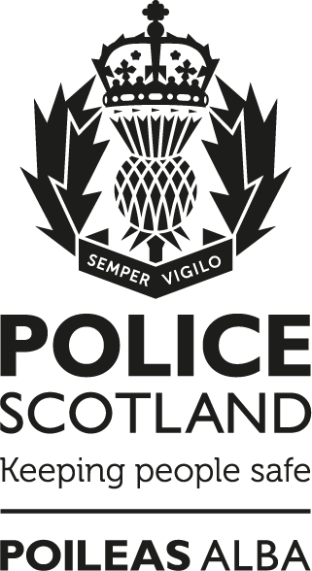

Contact, Command and Control
Policy

Notice:
This document has been made available through the Police Service of Scotland Freedom of Information Publication Scheme. It should not be utilised as guidance or instruction by any police officer or employee as it may have been redacted due to legal exemptions
Owning Department: Contact, Command and Control Division – Governance and Improvement
Version Number: 2.00
Date Published: 02/05/2023

Contact, Command and Control Policy
The Police Service of Scotland, hereafter referred to as Police Scotland, recognises that anyone contacting the service should experience a high level of service and satisfaction whilst ensuring that an appropriate response is provided.
To facilitate this Police Scotland will effectively and efficiently manage Contact, Command and Control systems to respond to incidents.
Police Scotland will provide advice and guidance, record crimes and incidents and may refer callers to other, more appropriate, agencies.

Compliance record
EqHIRA completion/review date: 28/04/2023
Information Management Compliant: Yes
Health and Safety Compliant: Yes

Version control table
Version | History of amendments | Approval date
1.00 | Initial Approved Version | 07/02/2014
2.00 | Cyclical review. Reference to PSOS changed to Police Scotland. No further amendments. | 28/04/2023

Feedback
All Police Scotland service delivery Policies, Standard Operating Procedures (SOPs) and National Guidance are subject to regular reviews. It is important that user feedback is taken into account when documents are reviewed.
If any officer / staff member wishes to provide comment, or make suggestions for improvements to this or any associated document, Force Form 066-014 should be used.

