East Renfrewshire Local Policing Plan 2023-26

Contents
Chief Constable’s Foreword 4
Divisional Commander’s Foreword 6
Introduction 8
National strategic alignment 10
Police Scotland’s strategic objectives 11
Local policing delivery context 12
Local priorities 14
Crime – Reducing crimes that cause greatest concern and detecting offenders 14
Protecting vulnerable people – Working with vulnerable people and partners to reduce harm 16
Local objectives and activity 19
Threats to public safety and wellbeing are resolved by a proactive and responsive police service 19
The needs of local communities are addressed through effective service delivery 21
The public, communities and partners are engaged, involved and have confidence in policing 24
Our people are supported through a positive working environment, enabling them to service the public 26
Police Scotland is sustainable, adaptable and prepared for future challenges 28
Governance and performance 29
Equality, diversity and inclusion 30
Engaging with us 30

Chief Constable’s Foreword
This Local Police Plan provides a clear statement to our citizens and partners about our commitment to developing our service and addressing areas that are of particular importance in this area. Throughout my time as Chief Constable, Police Scotland has continually developed to ensure we provide effective policing now and in the future.
Our communities are now better served and protected from the threats of today and of tomorrow. I have great confidence that the Police Service of Scotland will continue to build upon the progress made and the stability which now exists in policing.
In our recent Joint Strategy for Policing (2023), Policing for a Safe, Protected and Resilient Scotland, we describe how Police Scotland has people and communities at the heart of its vision for a better society, and will continue to provide modern, visible and accessible policing to local communities, supplemented with new support services that adapt and respond to societal shifts.
Policing in Scotland is incredibly varied, and we recognise the differences and strengths of communities across the country. Our people are vital members of those communities and our trusted relationship with the public and communities we serve is fundamental to maintaining their confidence in us to protect them at their most vulnerable and to keep us all safe from existing and emerging threats and harms.
This plan has been developed with partners and the local public using evidence, insights and professional expertise. We are committed to listening and responding to all communities across Scotland, including those who do not often engage with policing.
We understand our shared responsibility to ensure that our services are trauma-informed and person-centred as outlined in the Scottish Government’s Vision for Justice. Across society, and in part exacerbated by the challenging economic circumstances we all face, vulnerability, mental ill-health and substance misuse continues to impact on both individuals and wider society and on policing. We recognise that ours is very often not the most appropriate service to best support peoples’ needs and we will work our public sector partners to address challenges and support community wellbeing.
I am extremely proud of the service that we provide to our communities from Greater Glasgow Division and from the specialist and operational divisions that provide additional support to them. As colleagues deliver the priorities set out in this plan and respond to new developments, our commitment to keeping people safe and demonstrating our values of integrity, fairness, respect and to upholding human rights is unwavering.
Sir Iain Livingstone QPM
Chief Constable

Divisional Commander’s Foreword
As the Local Policing Commander for Greater Glasgow Division, I am delighted to introduce our East Renfrewshire Local Policing Plan for 2023-2026. This document details our Policing Priorities for the three year period ahead, highlighting the outcomes we aim to achieve over that period. The plan is based on our priorities, aligned with those of our partners, and the views of East Renfrewshire’s communities on what matters to them.
Chief Constable Sir Iain Livingstone has overall responsibility for policing in Scotland in accordance with the Police and Fire Reform (Scotland) Act 2012. As well as being responsible for providing policing services to the people of Scotland, the Chief Constable must designate local policing commanders, and ensure that adequate arrangements are in place for the policing of each local authority area.
I am proud to be the Police Commander for Greater Glasgow Division, which is comprised of Glasgow City Local Authority, East Dunbartonshire and East Renfrewshire. Greater Glasgow is a rich and diverse place and somewhere I have been honoured to serve the public for the majority of my police career. The demands within Greater Glasgow for policing and other public services, exceeds that of anywhere else in Scotland, they can be complex, challenging and resource intensive. However our officers work tirelessly to deliver policing in collaboration with many partners across all sectors, and the public, to ensure Greater Glasgow is a safe and enjoyable place to live, visit and work.
One of our national priorities is to protect vulnerable people and our officers continue to respond to such situations and individuals with professionalism, empathy and compassion. The harm of drugs in our communities continues to cause concern, which is one of the reasons why Greater Glasgow Division is promoting, engaging and delivering a public health approach to policing, in collaboration with our partners to better protect the public. Many of our officers now carry Naloxone and are able to intervene in life threatening situations reducing the impact and harm of drugs for people and communities.
The COVID-19 pandemic had a huge impact on our own workforce and communities in recent years and we will remain agile working closely with partners and the public to keep people safe and protected, whilst continuing to deliver policing services in response to community needs. Public confidence in policing rose during this period and I am determined to do all that we can to maintain and build on these levels of confidence in policing.
Our focus is on issues of greatest community concern, we are committed to being an accessible, visible and responsive police service. Our purpose is to improve the safety and wellbeing of people, places and communities in East Renfrewshire. We deliver this through working collaboratively with partners in order to provide the best possible services to the public. As members of the Local Community Planning Partnership, our priorities are linked closely to the Local Outcome Improvement Plan, with a key focus on the delivery of our shared outcomes.
This plan covers the years 2023-2026 however it will be reviewed and monitored periodically ensuring its relevance, allowing us to analyse and respond to emerging issues, identify and build on good practice. This will also ensure our policing activity compliments Local Community Planning.
I look forward to leading police services for the people of East Renfrewshire and working closely with all partner agencies and stakeholders to ensure that Police Scotland and Greater Glasgow Division continues to deliver a professional, high quality service, upon which individuals and communities can have confidence in.
Chief Superintendent Mark Sutherland
Local Police Commander
G Division

Introduction
This police plan relates to the East Renfrewshire area which encompasses widely contrasting communities from densely populated area such as Thornliebank, Clarkston and Newton Mearns to the semi-rural villages of Eaglesham and Uplawmoor.
Local policing services are provided from Giffnock and Barrhead Police Offices with specialist support provided by a variety of units from across the country.
East Renfrewshire has a population of around 96,000 and this is expected to grow faster than the Scottish average in the coming years. The number of people living in East Renfrewshire is projected to increase by 7.6% by the year 2026, this is higher than previously projected. By 2031 there is expected to be over 2,000 new homes.
East Renfrewshire is an attractive area to reside due to high quality schooling in the area and the open spaces which are available. These include the popular Whitelee Wind Farm, Roukenglen Park and Cowan Park.
Recorded crime rates in East Renfrewshire are amongst the lowest in Scotland. There are, however pockets of deprivation and associated social challenges. This local policing plan aims to highlight these challenges and some of the steps we intend to deal with them.
This Local Policing Plan aims to contribute to reducing the harm and building stronger more resilient communities through a public health approach. As key partners in the East Renfrewshire Community Planning Partnership, we share the vision of making East Renfrewshire an area of thriving resilient communities, where everyone can flourish.
This Local Policing Plan sets out the local policing priorities for East Renfrewshire for 2023-2026. The plan is a statutory requirement under the Police and Fire Reform (Scotland) Act 2012 and forms part of a broader planning process which takes account of the Scottish Governments vision for public services, the Police Scotland Annual Police Plan and Policing for a safe, protected and resilient Scotland, Police Scotland and the Scottish Police Authority’s Joint Strategy for Policing.
It details local and national priorities identified as being significant to the communities of East Renfrewshire, and the way in which Greater Glasgow Division will respond to reduce the associated threat, risk and harm. The views of the community were obtained through community engagement via ‘Your Police’ survey, which was promoted via our social media channels and through interaction with our local communities and partners.
The plan is designed to deliver positive outcomes for the people of East Renfrewshire. It is closely linked with the Fairer East Ren plan and the Locality Plans that detail more localised responses, in different parts of the city.

National strategic alignment
Our strategic outcomes provide a clear route from the Scottish Government’s outcomes and priorities, including the Justice Strategy, through Police Scotland’s strategies, plans and performance reporting, enabling us to demonstrate alignment and clearly articulate our ambitions and progress as demonstrated below. In addition to the Annual Police Plan, Police Scotland’s thirteen local policing divisions produce Local Police Plans which reference distinct priorities, objectives, outcomes and performance measures. They link to wider community planning arrangements, with Local Outcome Improvement Plans taken into account in their development.
- Scottish Government National Outcomes/Strategic Priorities/Justice Vision
- SPA/Police Scotland Strategic Outcomes
- Long Term Policing Strategy: Policing for a Safe, Protected and Resilient Scotland
- Enabler strategies including People, Fleet, Estates, Public Contact and Engagement, Enabling Policing for the Future, Digital Data and ICT, Cyber, Environmental, Procurement, Violence against Women and Girls, Equality Diversity and Inclusion
These are underpinned by plans including the Strategic Workforce Plan, Annual
Police Plan, Local Police Plans, Local Outcome Improvement Plans, and
Financial Plans.

Police Scotland’s strategic objectives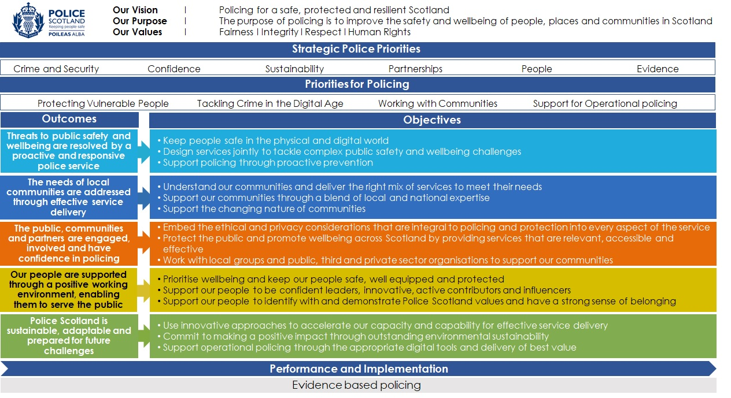

Local policing delivery context
Police Scotland’s purpose is to improve the safety and wellbeing of people and communities for a safe, protected and resilient Scotland. This is in line with our values of Fairness, Integrity and Respect and a commitment to upholding human rights.
This police plan relates to the East Renfrewshire Local Authority and together with East Dunbartonshire and Glasgow City, these areas are covered by Greater Glasgow Policing Division.
Greater Glasgow is led by a Local Policing Commander who holds the rank of Chief Superintendent. The Local Policing Command is supported by a command team of six Superintendents and two Detective Superintendents who each lead dedicated teams across various geographical or functional areas.
Uniformed policing is delivered in our communities through Local Area Commanders [LAC], and their respective teams, who are responsible for delivering the Local Policing Plans in their geographical areas and responding to community concerns.
In East Renfrewshire uniformed policing is delivered in the community by this Local Area Commander and dedicated community and response officers. In addition Greater Glasgow has a number of functional teams such as Divisional Violence Reduction Unit and Licencing.
The division has several functional and specialist departments including Divisional Violence Reduction Unit, Licencing, Criminal Investigation, Serious Organised Crime, Intelligence and Public Protection led by four Detective Chief Inspectors. The teams deployed in these specialist areas undertake investigations in relation to serious criminality, organised crime, sexual crime, domestic violence, exploitation and wider public protection concerns. Greater Glasgow is unique in having local resources dedicated to Human Trafficking and Economic crime.
Greater Glasgow Division is driving our innovative public health approach and we have appointed the first dedicated public health co-ordinator in local policing to ensure this work goes from strategy into making a difference in people’s every-day lives. This partnership approach led by a Chief Inspector, working along-side multiple partners, is key to improved outcomes and better services for the most vulnerable in our communities. A Local Authority Liaison Officer is co-located in the Council Headquarters and works with the Local Authority to deliver Community Planning Priorities.
Greater Glasgow Division has a number of school based officers who are engaging with and supporting our young people and education partners. This is an important role in delivering community reassurance, advice, and protecting young people from harm. Collectively these officers, staff and departments ensure a co-ordinated and professional approach to policing built on core values of integrity, fairness and respect.

Local priorities

Crime – Reducing crimes that cause greatest concern and detecting offenders
Violent crime - We will ensure our officers are effectively briefed, supported and deployed as part a Multi-Agency Tasking and Coordinating approach. We will focus on prevention and developing all investigative opportunities to bring offenders to justice, making use of all appropriate legislation and policing tactics, to proactively manage known violent offenders, concentrating on the greatest community concerns and impact.
Crimes of dishonesty- We will identify crime patterns in relation to robbery, house breaking and other acquisitive crimes. We maintain and will deploy specialist officers to ensure a knowledge of offences and offenders is developed and every effort is made to prevent crime by target hardening, raising awareness and managing known offenders.
Disorder and Antisocial Behaviour – We will engage with partner agencies to ensure that licensed premises are operating in a responsible manner and, not selling alcohol to young people. We will maximise opportunities to reduce disorder and antisocial behaviour through our weekly Tasking and Coordinating Partnership meeting.
Cybercrime - We will continue to develop our skills in cyber enabled and dependent crime. Key areas of focus include online sexual, hate and financial crime.
Hate crime - We will work with partners to deliver a person centred approach to all reports of hate crime or hate incidents. We will identify vulnerable communities and individuals providing appropriate advice, guidance and specialist support. Reports made to us will be prioritised and thoroughly investigated to obtain justice, where appropriate. Our approach will be compassionate and engaging with persons affected, ensuring safety and support for victims.
Road safety - We will utilise intelligence and analytical products to identify prominent crash locations and repeat offenders. We will communicate and engage with the public to improve driver behaviour, creating safer roads for our communities and using enforcement as a proportionate measure.
Sexual crimes - We will be supportive and compassionate to individuals who have been subject of a sexual offence, working with partners in a joint approach. We will deploy specially trained staff and conduct robust investigation. A dedicated unit will monitor offenders in the community. We will maximise the use of Sexual Harm Prevention Orders.

Delivering through our public health approach - We will endeavour to assess if vulnerability has been a contributory factor in offending behaviour. With a better understanding of the underlying reasons leading to involvement in criminality, we will seek support from our partners in an effort to reduce re-offending and promote rehabilitation.

Protecting vulnerable people – Working with vulnerable people and partners to reduce harm
Violence against women and girls – We will support and reassure the community to have the confidence to report to police. We will utilise intelligence and analytical products to identify and arrest offenders. We will robustly investigate all forms of violence and abuse of women and girls, including domestic and sexual crime, and work with partners to deliver safe spaces across East Renfrewshire. Our compassionate person-centred approach will support the national strategy, which will contribute towards a society where women and girls are safe from harassment, abuse and exploitation.
Adult and child protection – We will continue a multi-agency approach to child and adult protection, to ensure vulnerable adults, young people and children are protected and safeguarded. We will utilise all legislation and investigative opportunities to identify and arrest those involved in the exploitation of others.
Drugs harm – We will develop our approach to increase awareness of drug harm through a public health approach to policing. We will further develop our outreach and diversion activities through our Positive Outcomes Project and offer additional protection to vulnerable people through our Naloxone capability. We will provide methodical Senior Investigating Officer led investigations where deaths have occurred and work with other agencies to support affected families.
Young people – Police Scotland Youth Volunteers will continue to provide positive opportunities for young people. School liaison officers will continue to maximise awareness raising opportunities of matters which may affect our young people. Prevention work continues with vulnerable people to divert them from crime and provide alternatives, working in partnership with statutory and third party agencies.
Missing people – We will assess each missing person report, to allocate appropriate levels of priority and resources. A key consideration will be an ongoing assessment of the risk posed by the missing person to themselves or to others.
Vulnerable road users – We will utilise media platforms to educate the public about road safety initiatives. We will undertake planned activity to reduce the vulnerability of different road users. We will continue to work with partners to improve road safety around schools.
Human Trafficking – We will develop our approach to identifying those involved in human Trafficking and safeguarding victims. Our specialist officers will collaborate with partners at a local and national level to identify and protect the most vulnerable in our communities.
Child protection – We will work with public bodies and organisations as Corporate Parents to ensure vulnerable children are safeguarded and supported. All child protection concerns reported to Police Scotland will be thoroughly investigated. In addition we are committed to sharing information with other agencies to protect children.

Delivering through our public health approach- We will focus on three key priorities namely drugs and harm reduction; mental health including adult support and protection, children and young people; and contributing to reducing poverty. Each of these areas focus on significant public health issues which can have a devastating impact on the wellbeing of the communities we serve. As an emergency service, we understand our role in identifying vulnerability through our daily interactions with members of the public. We are uniquely placed to recognise vulnerability and will continue to refer individuals for support from the right agency at the right time and promote positive outcomes for the citizens of Greater Glasgow.

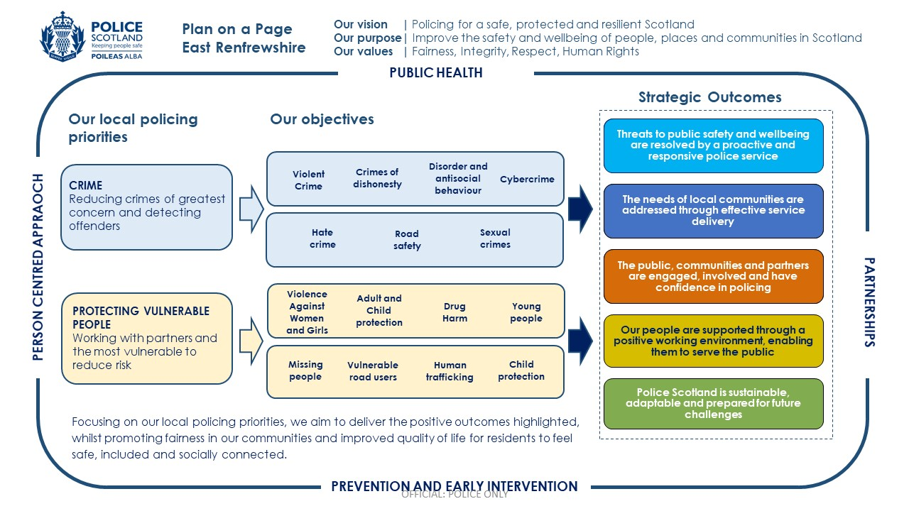

Local objectives and activity

Threats to public safety and wellbeing are resolved by a proactive and responsive police service
We find ourselves moving at an ever-increasing pace from the physical to the digital world; a move that creates new and complex crime types. It also affects traditional crime, much of which now has a digital element.
To protect our communities effectively, we will continue to explore innovative technologies and partnerships.
We will continue to be a key contributor to local joint planning and delivery, helping drive a shift to prevention and early intervention across services.

Objective: Keep people safe in the physical and digital world
Activity 1: Working with partners to improve the safety of persons and places in the physical environment.
Key milestones:
- Multi-agency open space deployments in key identified areas that pose the greatest risk. These areas will include ASB hotspots, licensed premises and public spaces.
- Roll out of NHS Trauma training to support frontline officers when dealing with people and places in crisis.
Update expected: Y1, Y2 & Y3 Q4
Performance measures and insights:
- How effective are we at reducing crime in open spaces?
- How well do we support trauma affected people?

Objective: Design services jointly to tackle complex public safety and wellbeing challenges
Activity 2: Work with partners to deliver a person-centred approach to hate incidents and support diverse communities.
Key milestones:
- Training of local businesses in ‘I Am Me’.
- Build on multi-agency information sharing and coordination.
- Strengthen our engagement with diverse community groups.
- Number of Keep Safe Premises.
Update expected: Y1, Y2 & Y3 Q2 and Q4
Performance measures and insights:
- How have we increased the safety of residents?
- Has there been an increase in reporting?
- How successful are we at detecting hate crimes?
- Have we increased the number of Keep Safe Premises?

Objective: Support policing through proactive prevention
Activity 3: Together with partners target acquisitive crime occurring in the community
Key milestones:
- Work with specialist divisional and national departments to support investigations and promote prevention.
- Work with Trading Standards, Community Safety Wardens, Youth Services and third sector organisations to develop intelligence and identify offenders who can be targeted to reduce the impact on our communities.
- Raising awareness and educating communities on acquisitive crime trends.
- Use Greater Glasgow Social media to educate people about acquisitive crime trends.
Update expected: Y1, Y2 & Y3 Q2 and Q4
Performance measures and insights:
- How successful are we at detecting offenders?
- Has there been a reduction in offences?
- Have acquisitive crime trends been identified, targeted and publicised?

The needs of local communities are addressed through effective service delivery
To create your Local Police Plan we have engaged and consulted with the public, stakeholders, community representatives and partners including other service providers to ensure we have a shared understanding of the local community and the role of policing within it.
We will continue to improve the services we provide as society evolves, embedding accessibility and inclusivity into all that we do.
We continue to be able to call upon additional operational support and specialist services to assist with incidents and investigations, large planned and unplanned events, and other situations where these resources are needed ensuring our focus remains on the needs of the local community.

Objective: Understand our communities and deliver the right mix of services to meet their needs
Activity 4: Through innovation and a public health approach we will continue to develop and improve practices to protect the most vulnerable people in our communities who are at threat, risk or harm of domestic abuse.
Key milestones:
- Delivery of Safe and Together Model for children and non-offending parents to ensure where possible children and parents are kept together.
- Partner with survivors of domestic abuse and stakeholders, such as the violence against women and girls group, to ensure their voices are heard as stakeholders in how we develop and improve practice.
- Coordinate a multi-agency approach which includes statuary and third sector partners to reduce domestic abuse through education, support and enforcement.
Update expected: Y1 – Y3 Q1 + Q3
Performance measures and insights:
- What is the feedback from survivors and partner agencies?
- How well are we supporting children and survivors of domestic abuse?

Objective: Support our communities through a blend of local and national expertise
Activity 5: Address offending, anti-social behaviour and risk taking behaviour.
Key milestones:
- Partnership approaches to address ASB and risk taking behaviour with Scottish Fire and Rescue Service, British Transport Police, Scottish Water and East Renfrewshire Council.
- Deliver and support the delivery of local inputs such as SMASHED and Anti Bullying Campaign at schools and other areas.
- Delivery of Safer Open Parks and Spaces for all to ensure a communities can use local spaces in a safe and responsible manner.
- Deliver effective working and support through the Greater results in Partnership Group. This group targets offenders and victims at risk of ASB and risk taking behaviour.
- Delivery of the East Renfrewshire Water Safety Partnership to build on the successful approach taken in previous years in promoting safe water activities.
Update expected: Y1 – Y3 Q1 + Q3
Performance measures and insights:
- Has public confidence and trust increased?
- Has the partnership approach resulted in the effective targeting of resources?
- How many inputs have been delivered to schools and the community?
- How effective has delivery of the Safer Open Parks and Spaces for All initiative been?
- How effective is East Renfrewshire Water Safety Partnership?

The public, communities and partners are engaged, involved and have confidence in policing
Our values are at the heart of everything we do. Our human rights based approach to policing along with ethical and privacy considerations are of the utmost importance to the service we provide. The communities we serve should feel confident that we will always police in a way that is fully underpinned by our values of fairness, integrity, respect and a commitment to upholding human rights.
The safety and wellbeing of the people we serve are enhanced by providing services that work efficiently. We will listen and seek to understand the changing needs of diverse communities, bringing both professionalism and empathy to our interactions making changes to our services when required. Engaging with people strengthens relevance, responsiveness and accountability and builds trust. We will improve and refocus our engagement activities where these are not reaching diverse communities and are not representative of the society we serve.

Objective: Protect the public and promote wellbeing across Scotland by providing services that are relevant, accessible and effective
Activity 6: Contribute to improving mental wellbeing of people in East Renfrewshire through a partnership approach.
Key milestones:
- Support delivery of Mental Health (SAMH) and Suicide Prevention (ASIST) training to officers.
- Promoting the public health approach to policing which recognises mental wellbeing is crucial to reducing offending.
- Delivery of East Renfrewshire Action on Alcohol workshops to impact positively on the health and wellbeing of those effected.
- Promoting the East Renfrewshire Alcohol and Drug Partnership to strategically and tactically address the wellbeing of those impacted by alcohol and drugs.
Update expected: Y1-3 Q2 and Q4
Performance measures and insights:
- Are we appropriately identifying and responding to those suffering from mental health issues?
- Have we increased the number of trained officers?
- Have we increased volume and quality of VPD referrals that recognise and address wellbeing issues within our communities?
- Have we increased the number of case conference meetings for those experiencing mental health crisis?

Our people are supported through a positive working environment, enabling them to service the public
The safety and wellbeing of our officers and staff are at the heart of Police Scotland’s commitments. The challenges for policing are significant and the part policing plays in daily life will become ever more important as Society faces huge challenges. Policing is also coming under increasing scrutiny and pressure in relation to our actions.
We will create the environment for our staff to be able to work effectively and equip them to make decisions, ensuring they are trusted and empowered to do so.

Objective: Prioritise wellbeing and keep our people safe, well equipped and protected
Activity 7: Deliver the Greater Glasgow Your Voice Matters Implementation plans, developed in response to the survey results, to ensure that the desired outcomes and progress is achieved.
Key milestones:
- Implementation of sub groups to lead on key themes; resourcing, incivility, estates and equipment, well-being and fear of making mistakes.
- Regular review and governance.
- Implementation of YVM local intranet page to improve communication.
Update expected: Y1 - 3 Q2 + Q4
Performance measures and insights:
- How will YVM results inform Greater Glasgow division’s wellbeing approach?
- How are results and response rates reflecting the effectiveness of the action plans?
- What are our Staff Associations, Unions and Diversity Network Chairs telling us?

Objective: Support our people to be confident leaders, innovative, active contributors and influencers
Activity 8: Support colleagues’ performance and development through My Career, and associated promotion pathways.
Key milestones:
- Introduction of My Career Champions.
- Deliver Continuous Professional Development (CDP) events for officers involved in promotion processes.
- Monitor My Career training and completion rates.
- Overview of progress and benefits.
Update expected: Y1 - 3 Q2 + Q4
Performance measures and insights:
- How effective is Greater Glasgow Divisions workforce development?
- How many CPD events have been delivered?
- How many officers have completed My Career Training?

Objective: Support our people to identify with and demonstrate Police Scotland values and have a strong sense of belonging
Activity 9: Ensure effective collaboration and communication with our Statutory and Diversity Staff Associations.
Key milestones:
- Develop improved accessible approach.
- Monitor and evaluate progress.
Update expected: : Y1-3 Q2, Q4
Performance measures and insights:
- How does Police Scotland proactively promote and support equality, diversity and inclusion?
- What are our Staff Associations telling us?

Police Scotland is sustainable, adaptable and prepared for future challenges
Ongoing political, technological, economic and societal changes as well as unforeseeable emergencies on a local and global scale require the police service to adapt and respond to future challenges in order to maximise the benefits of future opportunities. This includes working to reduce the impact of our activity, estates and fleet on the environment. Police Scotland aims to make a significant contribution to the Scottish Government’s 2040 carbon neutral target and 2045 zero greenhouse gas emissions target.
Everyone has a role to play in improving financial sustainability, making efficient use of resources and eliminating waste to deliver best value. Procurement of and demand for goods and services will remain under scrutiny, ensuring resources are used in the most efficient way possible to meet the greatest need.

Objective: Use innovative approaches to accelerate our capacity and capability for effective service delivery.
Activity 10: Improve and adapt our response and effectiveness in cyber dependent and cyber enabled crime.
Key milestones:
- Cyber Awareness Training for Workforce / Public / Business.
- Improved guidance via local channels.
- Work with partners to develop crime awareness training which will be embedded in our public health approach to policing.
Update expected: In format Y1 – Y3 Q1 + 3
Performance measures and insights:
- How effective is our Financial and Economic Crime Unit?
- How effective are we at dealing with cyber-enabled sexual related hate crime?
- What impact are we having to raise awareness to reduce harm surrounding cyber-enabled sexual & hate crime?

Objective: Support operational policing through the appropriate digital tools and delivery of best value.
Activity 11: Effectively deliver the implementation of new technology across Greater Glasgow Division and the impact of change on our workforce.
Key milestones:
- Delivery of Core Operational Solutions [COS].
- Training inputs for trainers on COS.
- Training sessions for our workforce on COS.
- Local COS Champions.
Update expected: Y1- Y3 Q4
Performance measures and insights:
- What percentage of our workforce have received training awareness sessions in COS?
- What has been the impact of COS in Divisional business?

Governance and performance
The Police and Fire Reform (Scotland) Act 2012 provides a framework for local scrutiny and engagement arrangements between Police, Fire and Rescue Service and the Local Authority.
The current format has been in place since April 2013 and will continue with annual meetings where the Local Policing Commander, supported by the Area Commander, presents a report to the Local Authority outlining police performance measured against the Local Policing Plan.
This provides opportunities for locally elected members to examine and hold police to account in relation to local policing services.

Equality, diversity and inclusion
Our work is underpinned by our commitment to equality, diversity and inclusion in our interactions with the communities we serve as well as our own staff.
Police Scotland is committed to developing and promoting best practice in advancement of our Equality Outcomes.
This plan will be subject to an Equalities and Human Rights Impact Assessment (EqHRIA) in compliance with the Scottish Public Sector Equality Duty in its final iteration in 2023. Separate EqHRIAs will be undertaken for the activities described in this plan as required.
In East Renfrewshire, we are committed to a policing style which meets the differing needs of the communities we serve and is dedicated to promoting equality within our own workforce.
We realise the every police officer, special constable and member of police staff is responsible for delivering a fair and professional service, promoting equality for all.

Engaging with us
Police Scotland
Giffnock Police Station
4 Braidholm Road
Giffnock
G46 6HA
Police Scotland
Barrhead Police Station
Main Street
Barrhead
G78 2RA

Dial 999 for an emergency that requires urgent Police attention.
For non-emergency contact, call 101, the single non-emergency number.
If you have information about crime in your area and wish to provide it anonymously, call CRIMESTOPPERS on 0800 555111.
Service users who are deaf or have a hearing impairment can contact Police Scotland via TEXTRELAY on 18001 101 for non-emergency, or 18000 in an emergency.
For more detailed information on how to contact your Local Policing Team please refer to the ‘Your Community’ section of our website at Police Scotland – Your Community.
Meaningful and effective engagement involves genuine dialogue, respect, integrity, transparency and accountability. It provides an opportunity for people to shape our services and influence decisions made. Insight from effective engagement helps identify practical solutions and determine changes required to meet the needs of the communities we serve.
Police Scotland is committed to continuous improvement in all that we do. If you have something to tell us about our service, please contact us at Police Scotland – Contact Us.
Further information about our wider engagement can be found in our consultation and engagement hub at Police Scotland – Engagement Hub.
Police Scotland has a number of active social media channels that provide a range of information and insight into policing, both nationally and in your local area. A full list of our social media accounts can be found on our website. Our local channels can be found at:
Twitter: @http://www.twitter.com.EastRenPolice
Facebook: @Greater Glasgow Police Division
Please note that our social media channels are not monitored 24/7 and should not be used for reporting crime. Please dial 999 in an emergency, and 101 in a non-emergency situation.
Inclusive and accessible engagement
We aim to embed accessibility and inclusivity into our services to make them work for everyone.
This Local Police Plan was subject to an Equality and Human Rights Impact Assessment (EqHRIA).
This Local Police Plan can be made available in various alternative formats. For more information, please contact us via our online form at Police Scotland – Contact Us.

