Aberdeen City Local Policing Plan 2023-26

Contents
Chief Constable’s Foreword 4
Divisional Commander’s Foreword 6
Introduction 7
National strategic alignment 9
Police Scotland’s strategic objectives 10
Local policing delivery context 11
Local priorities 12
Protecting Vulnerable People 13
Serious Organised Crime 16
Antisocial Behaviour, Violence and Disorder 19
Road Safety and Road Crime 22
Acquisitive Crime 24
Counter Terrorism & Domestic Extremism 26
Our people are supported through a positive working environment, enabling them to serve the public 29
Police Scotland is sustainable, adaptable and prepared for future challenges 30
Governance and performance 31
Equality, diversity and inclusion 32
Engaging with us 33

Chief Constable’s Foreword
This Local Police Plan provides a clear statement to our citizens and partners about our commitment to developing our service and addressing areas that are of particular importance in this area. Throughout my time as Chief Constable, Police Scotland has continually developed to ensure we provide effective policing now and in the future.
Our communities are now better served and protected from the threats of today and of tomorrow. I have great confidence that the Police Service of Scotland will continue to build upon the progress made and the stability which now exists in policing.
In our recent Joint Strategy for Policing (2023), Policing for a Safe, Protected and Resilient Scotland, we describe how Police Scotland has people and communities at the heart of its vision for a better society, and will continue to provide modern, visible and accessible policing to local communities, supplemented with new support services that adapt and respond to societal shifts.
Policing in Scotland is incredibly varied, and we recognise the differences and strengths of communities across the country. Our people are vital members of those communities and our trusted relationship with the public and communities we serve is fundamental to maintaining their confidence in us to protect them at their most vulnerable and to keep us all safe from existing and emerging threats and harms.
This plan has been developed with partners and the local public using evidence, insights and professional expertise. We are committed to listening and responding to all communities across Scotland, including those who do not often engage with policing.
We understand our shared responsibility to ensure that our services are trauma-informed and person-centred as outlined in the Scottish Government’s Vision for Justice. Across society, and in part exacerbated by the challenging economic circumstances we all face, vulnerability, mental ill-health and substance misuse continues to impact on both individuals and wider society and on policing. We recognise that ours is very often not the most appropriate service to best support peoples’ needs and we will work our public sector partners to address challenges and support community wellbeing.
I am extremely proud of the service that we provide to our communities from North East Division and from the specialist and operational divisions that provide additional support to them. As colleagues deliver the priorities set out in this plan and respond to new developments, our commitment to keeping people safe and demonstrating our values of integrity, fairness, respect and to upholding human rights is unwavering.
Sir Iain Livingstone QPM
Chief Constable

Divisional Commander’s Foreword
As Divisional Commander for North East Division, on behalf of the Chief Constable, it gives me great pleasure to present the Aberdeen City Local Policing Plan for 2023 – 2026. This plan aligns to Police Scotland’s priorities for policing and our Joint Strategy for Policing.
Local Policing plays a key role in delivering our strategic outcomes but they cannot be delivered in isolation, hence the continued importance of the Aberdeen City partnership arrangements, such as the Community Planning Partnership, Child and Adult Protection Committees, the Violence Against Women Partnership and the Alcohol & Drug Partnership, to ensure continued delivery of the preventative agenda.
Much has happened during the 3 years covered by the previous iteration of our Local Policing Plan. Some crime trends have changed with an increasing number of offences being either cyber related or cyber dependent, requiring us to respond to this growing threat. Brexit, the COVID-19 pandemic and the current cost of living crisis have, among other events, provided significant challenges to our communities and partners. Policing has had to adapt in these often testing circumstances, and while we have evolved, we remain committed to supporting the most vulnerable in the community. As such we are aligned to national strategies relating to violence against women and girls, mental health and reducing the impact of addiction, all as part of the broader public health agenda.
Aberdeen City remains a safe place to live and local Officers continue to provide initial responses to incidents and lead prevention work, whilst specialist divisions provide support in more acute or complex scenarios. The safety and wellbeing of these Officers, and indeed all our personnel, is something I am passionate about and I will continue to take action to reduce the impact of violence perpetrated against them.
North East Division is committed to improving the lives of all our communities whilst taking account of the views of those we serve and it is clear our continued strong bond with the City’s public is key to our legitimacy. Despite the challenges that undoubtedly lie ahead, it is a privilege to be involved with the diverse communities of Aberdeen.
Chief Superintendent Graeme Mackie, Local Police Commander, North East Division

Introduction
‘A place where all people can prosper’, remains the collective vision for Aberdeen, which is Scotland’s third largest city covering 186km² , with over 225,000 residents, making it the 8th largest local authority population in Scotland.

Aberdeen is a diverse city with an estimated 24% being born outside of the UK (compared to 9.8% for Scotland) and children representing over 15% of the total population.

Aberdeen faces the same challenges of an ageing population as other areas with estimated life expectancy at birth in Aberdeen being 81.4 years for females and 77.1 years for males, which is broadly in line with Scottish averages. In 2017-19, female Healthy Life Expectancy (HLE) was 62.5 years and male HLE, 60.6 years.

Aberdeen remains a competitive and productive city with GVA (Gross Value Added) per head being among the highest in Scotland. 41.4% of employees in Aberdeen City are in positions that can be done from home, which is a high proportion and the 7th highest in Scotland.

In the year from July 2019 to June 2020, 81.1% of Aberdeen’s working age population (16-64 years) was classified as economically active compared to 77.1% in Scotland. A higher proportion of males (84.7%) than females (77.7%) were economically active, 78.7% were in employment in Aberdeen City compared to 74.6% in Scotland.
In 2020, 89.9% of 16-19 year olds in the City were in Education, Employment or Training with 93.2% of school leavers in 2018/19 having a positive destination.
Of the City’s 37 neighbourhoods, 13 are recognised as deprived based on the Scottish Index of Deprivation (SIMD 2020) and fuel poverty affects 23% of the City’s households, 2% lower than the national average. Median gross weekly pay in the City is slightly less than the national average.
Aberdeen is the energy capital of Europe and has cemented itself as a leading centre of research and development for subsea technology and expertise. Production techniques and operations technologies developed in Aberdeen are used in oil and gas fields all over the world, setting a global standard.
In terms of infrastructure the airport at Dyce offers easy access for City residents and businesses. The airport neighbours the P&J Live, the region’s state-of-the-art events venue boasting world-class conference and exhibition facilities with a 15,000 capacity arena. Furthermore the City Centre and Beach Masterplan (CCMBP), a regeneration blueprint for transformation of the city centre, includes a new city market, the revitalisation of the beach area, plans for a pier, new green hub and sports area which could include a new stadium for Aberdeen FC. The CCMBP is extremely important to the City in terms of encouraging economic growth.

Like all areas of Scotland, public services in Aberdeen are facing increasing demand with reducing resources. The Community Planning Partnership’s response to these challenges is set out in the Local Outcome Improvement Plan 2016-26, which details 15 Stretch Outcomes under the priorities of, ‘Prosperous Economy’, ‘Prosperous People’ and ‘Prosperous Place’ and Police Scotland, North East Division remains a key partner

National strategic alignment
Our strategic outcomes provide a clear route from the Scottish Government’s outcomes and priorities, including the Justice Strategy, through Police Scotland’s strategies, plans and performance reporting, enabling us to demonstrate alignment and clearly articulate our ambitions and progress as demonstrated below. In addition to the Annual Police Plan, Police Scotland’s thirteen local policing divisions produce Local Police Plans which reference distinct priorities, objectives, outcomes and performance measures. They link to wider community planning arrangements, with Local Outcome Improvement Plans taken into account in their development.
- Scottish Government National Outcomes/Strategic Priorities/Justice Vision
- SPA/Police Scotland Strategic Outcomes
- Long Term Policing Strategy
- Enabler strategies including People, Fleet, Estates, Public Contact and Engagement, Enabling Policing for the Future, Digital Data and ICT, Cyber, Environmental, Procurement, Violence against Women and Girls, Equality Diversity and Inclusion
These are underpinned by plans including the Strategic Workforce Plan, Annual
Police Plan, Local Police Plans, Local Outcome Improvement Plans, and
Financial Plans.

Police Scotland’s strategic objectives
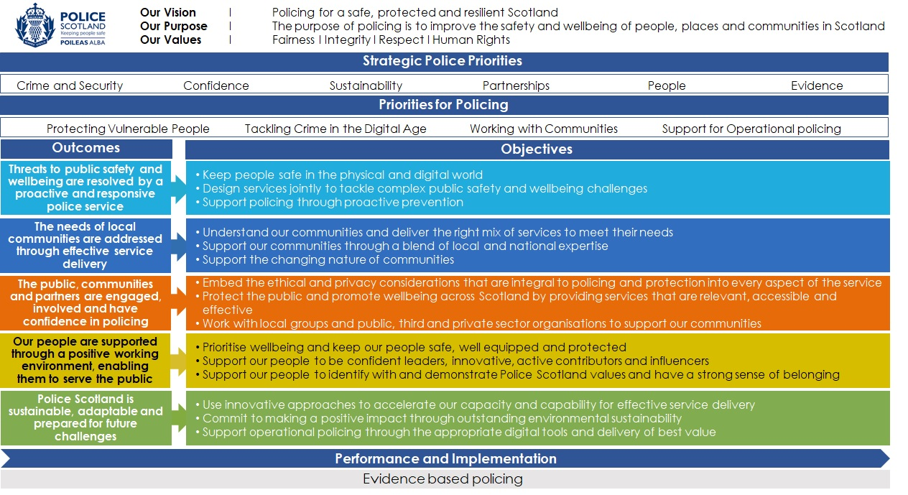

Local policing delivery context
The Local Policing structure is comprised of the Divisional Commander supported by three Superintendents who have ownership of Operational, Partnerships and Support functions. Aberdeen City has two dedicated Local Area Commanders, Chief Inspectors, covering the North and South respectively, who are responsible for day to day policing in the city. The local Criminal Investigation Department deal with the most serious and complex crime and are led locally by a Detective Superintendent aligned to the Specialist Crime Division. Local Policing is further supported by the following national Specialist Units, among others, many of which are based locally:

• Specialist Crime Division
• Criminal Justice Division
• Operational Support Division - Supports Local Policing with Armed Policing, Specialist Operations, Roads Policing
• Licensing and Violence Reduction Unit
• Emergency, Event and Resilience Planning
• Border Policing
• Contact, Command and Control Division
• Corporate Communications

In addition, the Special Constabulary play a vital part in the Policing of Aberdeen City. Our aim is to deliver policing that is visible, accessible and responsive to the needs of the people across the City. Listening and responding to the changing needs of our communities is key, and our local Community Policing Teams are empowered and encouraged to work with elected officials and community members to resolve local challenges.

Local priorities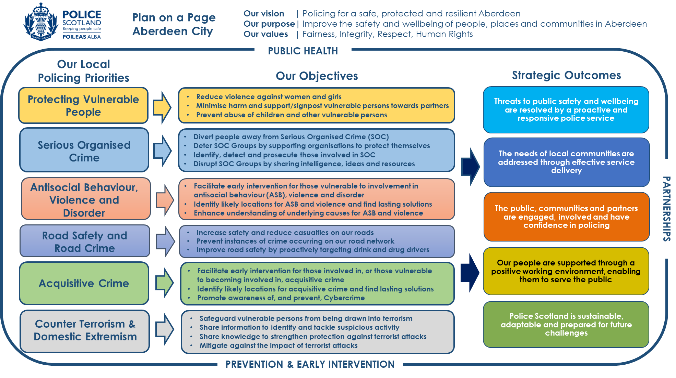
Local Priorities and activity

Protecting Vulnerable People
Activity: Work with statutory and third sector partners to reduce violence against women and girls
Key milestones:
- Increased confidence in reporting to police by criminally exploited women and girls, through work with partners involved in the Violence Against Women Partnership
- Enhancement of our victim-centred response to Domestic Abuse and improved opportunities for reducing domestic abuse by multi-agency delivery of approaches such as Multi-Agency Risk Assessment Conferencing (MARAC), Multi-Agency Tasking and Co-ordinating (MATAC), and Disclosure Scheme for Domestic Abuse Scotland (DSDAS)
Update expected: Y1-3 Q2 & Q4
Performance measures and insights:
- How has our work with the Violence Against Women Partnership increased confidence in reporting to police by criminally exploited women and girls
- Evidence how we have improved our victim-centred response to Domestic Abuse
- How have we enhanced opportunities for reducing domestic abuse by increasing the number of people referred into multi-agency approaches such as Multi-Agency Risk Assessment Conferencing (MARAC), Multi-Agency Tasking and Co-ordinating (MATAC), and Disclosure Scheme for Domestic Abuse Scotland (DSDAS)
Activity: Drive the development of multi-agency agendas to minimise harm and support/signpost those we identify as vulnerable towards partners
Key milestones:
- Enhanced collaboration with partners, particularly those involved in the Alcohol and Drug Partnership (ADP), across harm reduction related themes, including alcohol and drugs addiction and drugs death reduction
- Improved outcomes and quality of care for people experiencing mental health distress or suicidal ideation, thereby reducing the risk of criminalising mental health matters, by enhancing Officer awareness and increasing referrals and meaningful interactions with services
- Strengthened opportunities for collaboration with partners, including those in the Grampian Regional Equality Council, to protect people who may be vulnerable by reason of protected characteristic
Update expected: Y1-3 Q2 & Q4
Performance measures and insights:
- How have we collaborated with partners across harm reduction related themes and improved the quality and quantity of referrals into multi-agency preventative/intervention mechanisms
- Evidence our support to partners to improve outcomes and quality of care for people experiencing mental health distress or suicidal ideation
- Evidence how we are working with partners to reduce the risk of criminalising mental health matters, by enhancing Officer awareness, and increasing referrals and meaningful interactions with services.
- How have we strengthened opportunities for collaboration and protected people who may be vulnerable by reason of protected characteristic
Activity: Raise awareness of, and prevent abuse of, children and other vulnerable persons, ensuring a victim-centred approach
Key milestones:
- Successful delivery of a collaborative communications plan (involving internal and external partners) which highlights and mitigates risk to children and other vulnerable groups
- Improved service delivery, public confidence and effectiveness in relation to our trauma informed response to victims of crime and vulnerable people by effective training of our staff.
Update expected: Y1-3 Q2 & Q4
Performance measures and insights:
- Evidence our delivery of a collaborative communications plan and how it has highlighted and mitigated known risks to children and other vulnerable groups
- How have we improved trauma informed training for our staff
- Improved public confidence reporting from traumatised victims of crime and vulnerable people

Serious Organised Crime
Activity: DIVERT - Build an effective pan-Grampian partnership, with a view to diverting people away from involvement in Serious Organised Crime, making Aberdeen City a hostile environment for those who seek to exploit our communities
Key milestones:
- As part of the Alcohol and Drug Partnership, a reduction in the impact, risk and harm caused by drugs, addiction and associated criminality
- In partnership with statutory and third sector partners, adoption of an early intervention approach to educate and divert young people from engaging in, or being drawn into, Serious Organised Crime
- Delivery of work with partners, to identify and support individuals and families who are involved in, or impacted by, Serious Organised Crime, including those who are vulnerable to Cuckooing
- Enhancement of our work with statutory partners to support and strengthen communities at risk of Serious Organised Crime
Update expected: Y1-3 Q2 & Q4
Performance measures and insights:
- How has the partnership reduced the impact caused by drugs, addiction and associated criminality, risk and harm
- Evidence how the partnership has diverted young people from engaging or being drawn into Serious Organised Crime
- Highlight police and partners work to identify, work with and support individuals and families who are involved in or impacted by Serious Organised Crime, including those who are vulnerable to Cuckooing
- Evidence how the partnership has supported and strengthened communities at risk of Serious Organised Crime
Activity: DETER - Support private, public and third sector organisations to protect themselves and each other. Understand the drivers and emerging risks in respect of Serious Organised Crime and encourage a multi-agency approach to protect those vulnerable in our communities
Key milestones:
- Expanded partnership intelligence sharing, awareness and improved training in relation to Serious Organised Crime
Update expected: Y1-3 Q2 & Q4
Performance measures and insights:
- How have we developed intelligence sharing, awareness raising and training with partners in relation to Serious Organised Crime
Activity: DETECT - Work collaboratively with others to provide a coordinated response to identify, detect and prosecute those involved in serious organised crime
Key milestones:
- In conjunction with national partners, delivery of the North East Division County Lines strategy
- Development of a multi-agency media strategy raising awareness of Serious Organised Crime and how citizens can assist in safeguarding communities
Update expected: Y1-3 Q2 & Q4
Performance measures and insights:
- Evidence how delivery of the North East County Lines strategy has led to detections and prosecutions for those involved in Serious Organised Crime
- How is the multi-agency media strategy raising public awareness and safeguarding communities from Serious Organised Crime
Activity: DISRUPT - Deliver a collaborative multi-agency response to disrupt Organised Crime Groups by sharing intelligence, ideas and resources
Key milestones:
- Maximised enforcement tactics, including the use of the Proceeds of Crime Act, alongside partnership opportunities to disrupt Organised Crime Groups operating in Aberdeen City
Update expected: Y1-3 Q2 & Q4
Performance measures and insights:
- Evidence how enforcement tactics, including the use of the Proceeds of Crime Act, and partnerships opportunities have disrupted Organised Crime Groups

Antisocial Behaviour, Violence and Disorder
Activity: Reduce antisocial behaviour, violence and disorder by working with partners to facilitate early interventions for those involved in, or those vulnerable to becoming involved in, such behaviours
Key milestones:
- Refreshed collaborative arrangements and approaches with partners such as the Community Safety Partnership, Criminal Justice Partners, Local Authorities, Health, Third Sector and Voluntary Sector
- Implementation of multi-agency information and data sharing protocols and refreshed analytical products, allowing identification of high profile offenders and vulnerable victims
- Delivery of Multi-Agency Public Protection Arrangements (MAPPA) to effectively manage the risks associated with categorised violent offenders
Update expected: Y1-3 Q2 & Q4
Performance measures and insights:
- Improve public confidence by reducing antisocial behaviour, violence and disorder
- How have police and partners developed collaborative arrangements and delivered analytical products that have contributed to reducing antisocial behaviour, violence and disorder
- Evidence delivery of the MAPPA process and how the partnership has reduced violence among categorised violent offenders
Activity: With partners, identify locations where antisocial behaviour and violence is most likely to occur and work with communities and other agencies to find lasting solutions and enhance community safety
Key milestones:
- Expansion of licensed trade initiatives to promote good management and reduce instances of antisocial behaviour, violence and disorder
- Implementation of enhanced community projects and initiatives, including the Local Outcome Improvement Plan (LOIP) Locality Partnerships, to deliver positive outcomes for local communities susceptible to antisocial behaviour, violence and disorder
- Delivery of multi-agency analytical products identifying hot spots for violence and antisocial behaviour
Update expected: Y1-3 Q2 & Q4
Performance measures and insights:
- Evidence how licensed trade initiatives have reduced antisocial behaviour, violence and disorder at or near licensed premises
- Provision of outcomes from community initiatives and Locality Partnerships and how they have assisted in reducing incidents of antisocial behaviour, violence and disorder in relevant communities
- How have multi-agency analytical products assisted in identifying hot spots for violence and antisocial behaviour
Activity: Working with partners, we will enhance our understanding of the underlying causes of antisocial behaviour and violence and develop public health approaches to prevent these harms
Key milestones:
- Delivery of work to educate young citizens regarding the effects of violence and antisocial behaviour and to adopt an early intervention approach
- Improved and simplified data collection and sharing to understand the underlying causes of violence and antisocial behaviour
- Implementation of partnership alcohol intervention methodology to address the negative effects of alcohol, including violence, on service users
Update expected: Y1-3 Q2 & Q4
Performance measures and insights:
- How has our work with young citizens assisted in preventing them from becoming involved in antisocial behaviour and violence
- Outline the progress made in collecting and sharing relevant data between partners to understand the underlying causes of violence and antisocial behaviour
- Evidence our work in developing partnership alcohol intervention methodologies to address the effects of alcohol on violent behaviour

Road Safety and Road Crime
Activity: With partners in the North East Road Safety Strategy Partnership (NERSSP) increase safety and reduce casualties on our roads
Key milestones:
- Development and delivery of a North East Road Safety Strategy with key partners in the NERSSP
- Successful promotion of the principles of Operation CEDaR (Challenge, Educate, Detect and Reduce) to increase overall road safety
- Delivery of our collaborative work to increase the safety of vulnerable road users, such as young drivers, older drivers, bicycle users, motorcycle users and pedestrians
Update expected: Y1-3 Q2 & Q4
Performance measures and insights:
- How has the NERSSP reduced the number of casualties on our roads
- Evidence how we have implemented Operation CEDaR and increased road safety
- How have we worked with partners to increase the safety of vulnerable road users

Activity: Prevent instances of crime occurring on our road network
Key milestones:
- Improved targeting and disruption of criminal use of the roads network through intelligence led activity and proactive policing
Update expected: Y1-3 Q2 & Q4
Performance measures and insights:
- Evidence how we have successfully detected criminality on our roads

Activity: Improve road safety by proactively targeting drink and drug drivers
Key milestones:
- Enhancement of our intelligence gathering to identify individuals engaged in drink and drug driving on our roads
Update expected: Y1-3 Q2 & Q4
Performance measures and insights:
- Evidence how we have proactively targeted drink and drug drivers in our communities

Acquisitive Crime
Activity: Reduce acquisitive crime, by working with partners to facilitate interventions for those involved in, or those vulnerable to becoming involved in, acquisitive crime
Key milestones:
- Enhancement of our single-agency and multi-agency intelligence led approaches to identify offenders and provide preventative interventions
- Delivery of our collaborative work as a Corporate Parent which aims to reduce the number of juveniles identified as an accused and furthermore reduce reoffending through the use of multi-agency diversionary measures
Update expected: Y1-3 Q2 & Q4
Performance measures and insights:
- Improve public confidence by reducing the volume of acquisitive crime
- How have we identified those involved in, or vulnerable to involvement in, acquisitive crime and used appropriate disposals to prevent further crimes
- Evidence use of multi-agency diversionary measures and the resultant improvement, in reducing offending and reoffending rates

Activity: Reduce acquisitive crime, by identifying locations where acquisitive crime is most likely to occur and work with communities and partners to find lasting preventative solutions
Key milestones:
- Enhancement of our single-agency and multi-agency intelligence gathering, data sharing and analysis, to identify locations where acquisitive crime is likely to occur and provide preventative interventions
- Delivery of a multi-agency communication plan which raises awareness of current and emerging threats
- Empowered communities providing effective solutions to reduce acquisitive crime issues in their areas
Update expected: Y1-3 Q2 & Q4
Performance measures and insights:
- Improve public confidence by reducing the volume of acquisitive crime
- How have we identified locations as vulnerable to increased levels of acquisitive crime and provided interventions to prevent crime
- How is the multi-agency communication plan raising public awareness and reducing levels of acquisitive crime
- Evidence how police are working with empowered communities to reduce acquisitive crime

Activity: Raise public awareness, and prevent instances, of cyber enabled and cyber dependent acquisitive crime
Key milestones:
- Delivery of collaborative work with statutory and third sector partners, businesses, young people and vulnerable adults to prevent them becoming victims of acquisitive cybercrime
- Implementation of relevant and effective training to prepare our staff to meet increased cybercrime demand
- Development of our work with the Adult Protection and Child Protection Committee to protect groups vulnerable to acquisitive cybercrime, particularly children and vulnerable adults
Update expected: Y1-3 Q2 & Q4
Performance measures and insights:
- Evidence how we have raised public awareness and prevented instances of cyber enabled and cyber dependent crime
- How have we improved service delivery and effectiveness of cybercrime investigations by effective training of our staff
- Improve public confidence by increasing the number of detected cybercrimes year-on-year

Counter Terrorism & Domestic Extremism
Several Critical National Infrastructure sites are located across the North East Division area and given the significance of these locations, local delivery of the national CONTEST Strategy to reduce the risk of terrorism so people can go about their lives freely and with confidence is a local priority.
Activity: PREVENT - With partners safeguard vulnerable persons from being drawn into terrorism
Key milestones:
- With statutory Prevent partners, we will promote a community led approach to building stronger communities and responses to the issues that affect them
- Enhanced engagement with a wide range of sectors and institutions to ensure people who may be drawn into terrorism are safeguarded and offered appropriate advice and support
Update expected: Y1-3 Q2 & Q4
Performance measures and insights:
- Evidence how our multi-agency Prevent structures and processes have safeguarded vulnerable persons from being drawn into terrorism
Activity: PURSUE – With partners encourage and share information to identify and tackle suspicious activity
Key milestones:
- Improved collection, analysis and use of information and intelligence, to develop and improve understanding amongst partners, the private sector and the public on mechanisms available to promptly share information regarding concerning or suspicious activity that may be linked to Counter Terrorism and/or Domestic Extremism
Update expected: Y1-3 Q2 & Q4
Performance measures and insights:
- How have we improved our information sharing processes to identify and tackle suspicious activity
Activity: PROTECT – With partners we will share knowledge so that our communities and businesses can strengthen protection against terrorist attacks
Key milestones:
- To enhance physical protective security at critical infrastructure, publicly accessible location (PALs) and Hazardous Sites we will, with local CONTEST partners, review and refresh all plans and protocols in relation to building security and support messaging and provide advice to those responsible for PALs
- To enhance HR vetting arrangements to counter Insider Threat we will, with local CONTEST partners, review and refresh all recruitment policies
- To enhance cyber security and resilience to counter cyber threat, with local CONTEST partners we will, encourage sign up to the Scottish Business Resilience Centre (SBRC) for updates and inputs
- With local CONTEST partners we will prepare and participate in the Protect Consultation to ensure understanding of responsibilities should a Protect duty be implemented
Update expected: Y1-3 Q2 & Q4
Performance measures and insights:
- Evidence how our Protect structures and processes have strengthened local protection against terrorist attacks
Activity: PREPARE – With partners we will mitigate against the impact of terrorist attacks
Key milestones:
- With local CONTEST partners we will understand the threats to the North East
- With local CONTEST partners we will agree the vision for the capabilities and capacity required to mitigate the threat to the North East
- With local CONTEST partners we will test and maintain the improved capability and capacity to ensure it remains current, futureproof and effective through training, testing and exercising
Update expected: Y1-3 Q2 & Q4
Performance measures and insights:
- How has the partnership mitigated against the impact of terrorist attacks

Our people are supported through a positive working environment, enabling them to serve the public
The safety and wellbeing of our officers and staff are at the heart of Police Scotland’s commitments. The challenges for policing are significant and the part policing plays in daily life will become ever more important as society faces huge challenges. Policing is also coming under increasing scrutiny and pressure in relation to our actions.
We will create the environment for our staff to be able to work effectively and equip them to make decisions, ensuring they are trusted and empowered to do so.

Police Scotland is sustainable, adaptable and prepared for future challenges
Ongoing political, technological, economic and societal changes as well as unforeseeable emergencies on a local and global scale require the police service to adapt and respond to future challenges in order to maximise the benefits of future opportunities. This includes working to reduce the impact of our activity, estates and fleet on the environment. Police Scotland aims to make a significant contribution to the Scottish Government’s 2040 carbon neutral target and 2045 zero greenhouse gas emissions target.
Everyone has a role to play in improving financial sustainability, making efficient use of resources and eliminating waste to deliver best value. Procurement of and demand for goods and services will remain under scrutiny, ensuring resources are used in the most efficient way possible to meet the greatest need.

Governance and performance
In addition to internal governance processes which effectively record crime and direct the deployment of resources, we will continue to provide relevant performance information to the Aberdeen City Communities, Housing and Public Protection Committee, which is accessible to the public.
The Divisional Commander, or their deputy, will attend and provide an update on progress against this Plan, overall performance, and any other matters deemed relevant to the delivery of policing in Aberdeen City.
Through appropriate forums, the Local Area Commanders and the Local Area Inspectors, or their deputies, will engage with elected members, communities and other key stakeholders.

Equality, diversity and inclusion
The work of Police Scotland is underpinned by our commitment to equality, diversity and inclusion in our interactions with the communities we serve as well as our own staff.
We are committed to developing and promoting best practice in the refresh of our Equality and Diversity Strategy 2022-26.
This plan was subject to an Equalities and Human Rights Impact Assessment (EqHRIA) in compliance with the Scottish Public Sector Equality Duty. This document can be found at: North East - Police Scotland
Separate EqHRIAs were undertaken for the activities described in this plan as required.

Engaging with us
Police Scotland
North East Division
230 Abbotswell Crescent
ABERDEEN
AB12 3JD

If you have information about crime in your area and wish to provide it anonymously, call CRIMESTOPPERS on 0800 555 111. Service users who are deaf or have a hearing impairment can contact Police Scotland via TextRelay on 18001 101 for nonemergency, or 18000 in an emergency.
More detailed information on how to contact your Local Policing Team North East - Police Scotland is available on our website.
Meaningful and effective engagement involves genuine dialogue, respect, integrity, transparency and accountability. It provides an opportunity for people to shape our services and influence decisions made. Insight from effective engagement helps identify practical solutions and determine changes required to meet the needs of the communities we serve.
Police Scotland is committed to continuous improvement in all that we do. If you have something to tell us about our service, please contact us at: Contact Police Scotland - Police Scotland.
Further information about our wider engagement can be found in our consultation and engagement hub at: Police Scotland - Citizen Space.
Police Scotland has a number of active social media channels that provide a range of information and insight into policing, both nationally and in your local area. A full list of our social media accounts can be found on our website. Our local channels can be found at:
Facebook: @NorthEastPoliceDivision
Twitter: AberdeenCPolice, NorthEPolice
Please note that our social media channels are not monitored 24/7 and should not be used for reporting crime. Please dial 999 in an emergency, and 101 in a non-emergency situation.
Inclusive and accessible engagement
We aim to embed accessibility and inclusivity into our services to make them work for everyone.
This Local Police Plan was subject to an Equality and Human Rights Impact Assessment (EqHRIA). A summary of the EqHRIA has been published alongside this document at North East - Police Scotland
This Local Police Plan can be made available in various alternative formats. For more information, please contact us via our online form: Contact Police Scotland - Police Scotland.
Deaf, deafened, hard of hearing or speech-impaired callers can contact us via Text Relay on 18001101.

