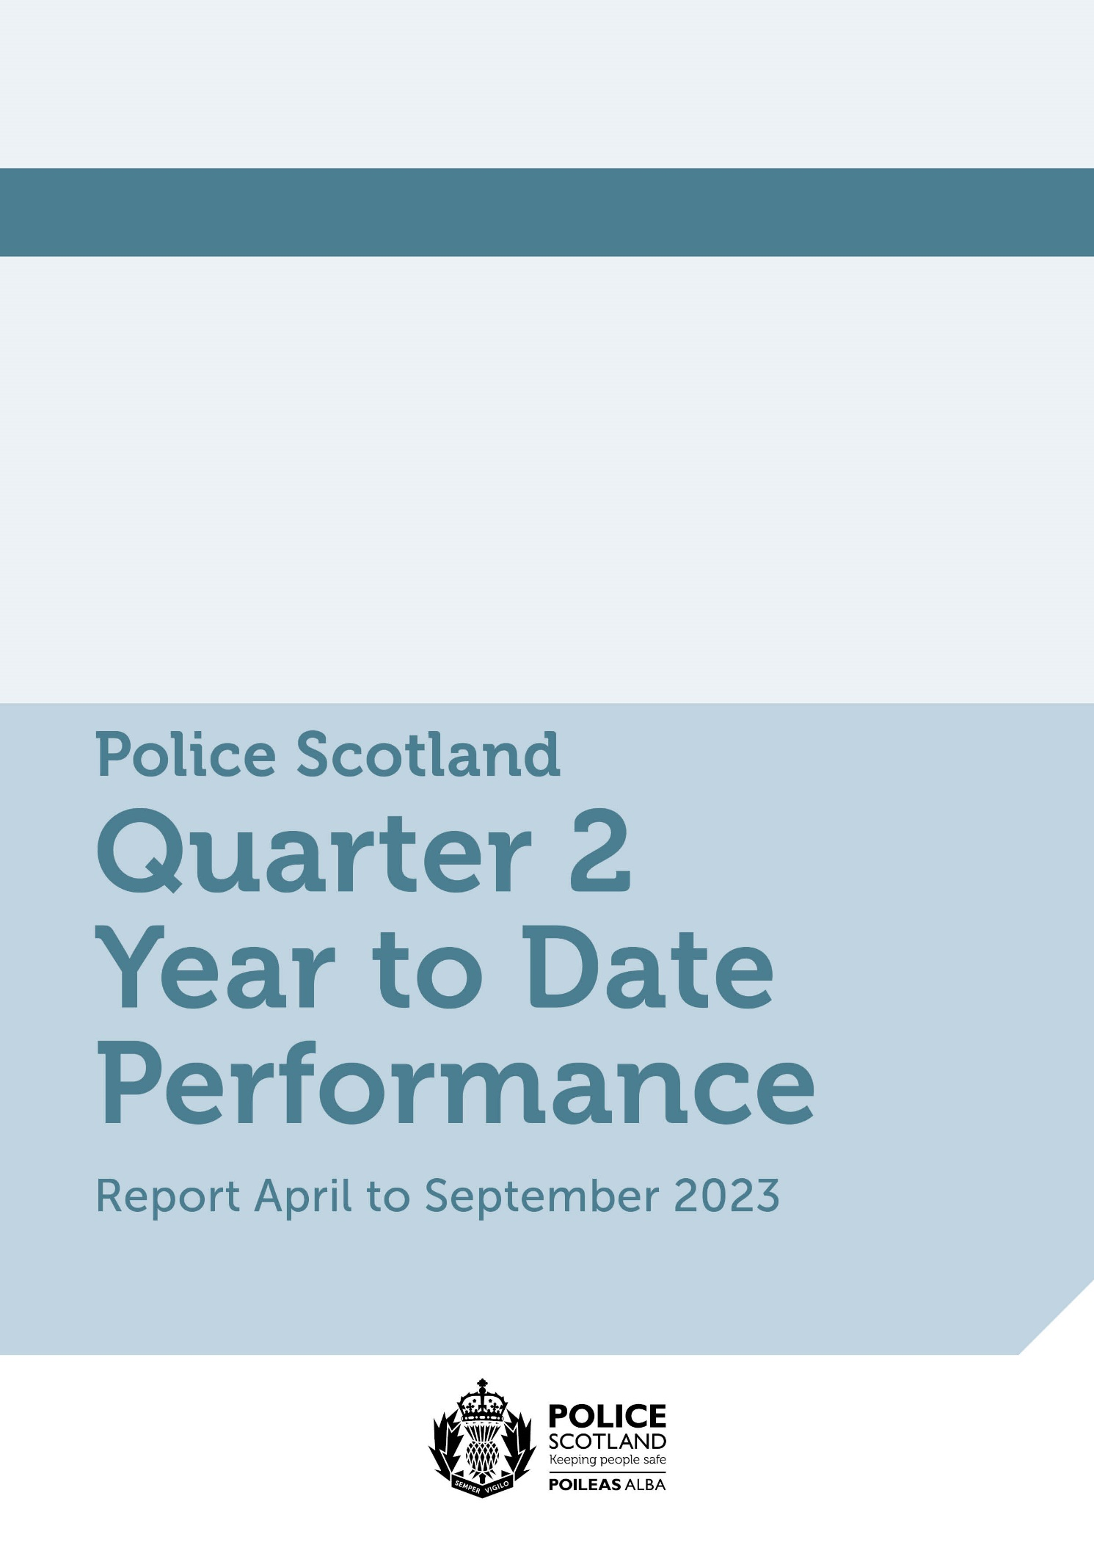
Contents
Police Scotland Quarter 2 YTD Performance Report: April to September 2023 1
Introduction by the Deputy Chief Constable 3
Executive Summary 4
Policing Demand during Quarter 2 2023/24 6
Measures of Progress towards Strategic Outcomes – Challenges 8
Performance Framework Outcomes and Objectives 13
Policing during Quarter 2 2023/24 – Key Insights 14
Policing during Quarter 2 2023/24 – Unlocking Insights – Local Focus 17
Policing Together 28
Measures of Progress towards Strategic Outcomes 31
Strategic Outcome 1 31
Strategic Outcome 2 63
Strategic Outcome 3 86
Strategic Outcome 4 112
Strategic Outcome 5 119

This is the 2023/24 Q2 performance report covering the period 01 April to 30 September 2023. All data is correct at the published date and was extracted at the start of October 2023. The data is extracted from Police Scotland internal systems which are dynamic and continuously updated as investigations progress.
This report contains the most up to date recorded crime data that was available at the start of October 2023 for Quarter 2 of the reporting year 2023/24. Further detailed Police Scotland Management Information can be found here: https://www.scotland.police.uk/about-us/what-we-do/how-we-are-performing/

Introduction by the Deputy Chief Constable
Our 2023/24 Quarter 2 Performance Report illustrates that Scotland is a safe place to live and work, with historically low levels of crime.
Despite low levels of overall crime, policing continues to respond to increased levels of community need, driven by vulnerability and increased complexity.
Increasing community need, and the public’s strong relationship with policing is evidenced by the continued increase in contacts we received, with more than 1.1m calls to Police Scotland between April and September.
As the public would expect we prioritise emergency 999 calls, which will inevitably result in longer wait times for responses to non-emergency 101 calls.
During the period of this report we experienced higher levels of overall violent crime, including increases in common assault, which makes up more than 90% of these reports.
The inclusion of threats and extortion, such as online sextortion, which have also increased significantly compared to last year and since changes in recording in April 2020, also contributes to the rise in overall violent crime.
Homicides, attempted murders and serious assault remain at similar levels compared to last year and lower than the five year average, while our world leading detection rate for homicides continued.
The report outlines action by officers to remove drugs from communities right across Scotland day in, day out, including a County Lines intensification week of action.
At the same time, we continue to play a contributory role in supporting those affected by addiction, including training and equipping all operational officers with the life-saving nasal spray Naloxone.
Road fatalities have decreased, with 13 fewer fatalities on Scotland’s roads than the same period last year while the number of people seriously injured has also reduced. Road safety is a priority and we are part of a crucial partnership approach. Our officers are out every day educating road users and carrying out enforcement.
Our performance reporting seeks to give meaningful and accessible insight into the depth and breadth of police work undertaken by committed and professional officers and staff and how the outcome of that work relates to our strategic outcomes.
Alan Speirs
Interim Deputy Chief Constable Professionalism, Strategy and Engagement

Executive Summary

Introduction
This is the second Quarterly report of the 2023/24 performance cycle, reporting on our revised Performance Framework and Measures of Progress. This report takes a more holistic approach on reporting against the five strategic outcomes as much of the activity reported will crossover and inform more than one strategic objective.
Our outcomes focused Performance Framework is linked to our strategic planning processes and aligns to the Strategic Outcomes as detailed in the 2023/24 Annual Police Plan, these being:
Public Safety and Wellbeing – threats to public safety and wellbeing are resolved by a proactive and responsive police service
Needs of Local Communities – the needs of local communities are addressed through effective service delivery
Confidence in Policing – the public, communities and partners are engaged, involved and have confidence in policing
Working Environment – our people are supported through a positive working environment, enabling them to serve the public
Sustainable and Adaptable Service – Police Scotland is sustainable, adaptable and prepared for future challenges
This approach provides a wider and more detailed picture of traditional policing performance measures, supplemented with additional insight and narrative to the many different aspects of policing and corporate support functions.
Our Performance Framework also reflects a renewed focus on Policing Together and Violence Against Women and Girls (VAWG). Development work is ongoing to progress and align new measures and insights in response to implementing strategies and achieving positive impacts and outcome.
As we move through 2023/24 the demand placed on officers within our operating environment becomes more challenging. Following the announcement of the Scottish Budget for 2023/24 it has been recognised that the delivery of effective policing will be demanding with reduced officer numbers and a reduced overtime budget. Improvements to our technology, buildings and vehicles will also continue to be challenging.
This report will continue to help the SPA Board and the public to understand the complexities of delivering an effective police service, how we are evolving as a service, how we face the challenges of modern policing and ensure we are delivering performance in line with our organisational values.

This report comprises of six sections:
Policing Demand during Quarter 2 2023/24
Measures of Progress towards Strategic Outcomes – Challenges & Responses
Policing During Quarter 2 2023/24 – Key Insights
Unlocking Insights – Local Focus
- Policing Together
Measures of Progress towards Strategic Outcomes 1-5 – Full Picture

Policing Demand during Quarter 2 2023/24
In the current economic climate, policing performance has been impacted by the decrease in funding and resources coupled with an increase in call volumes, the number and complexity of crimes reported and increasing cyber enabled/dependant crime.
As we move forward through 2023/24, prioritisation is key to ensure our officer and staff wellbeing and our response will need to be focused towards the areas of highest threat, risk and harm. A review of corporate support functions and delivery models across the whole organisation is underway along with work led by Partnerships, Prevention and Community Wellbeing to reduce the level of demand coming to Police Scotland from other agencies. The valuable contribution that police officers and staff continue to make in keeping people and communities across Scotland safe, has been recognised with a pay increase and a commitment to commission an independent review, considering police officer pay and benefits.
Police Scotland continues to lead work on our commitment to provide an environment that supports and enhances everyone's experiences at work. Tackling sexism and misogyny is a key strand of Policing Together, and the Oversight Board are using the lived experiences of colleagues to identify and tackle the issues faced within the Service and create an inclusive workplace, free from sexism and misogyny.
Multiple factors have attributed to the increase in call volumes including sporadic good weather which continued throughout the quarter, in addition to large scale events including the UCI Cycling World Championships and summer festivals. The National Police Chiefs Council (NPCC) noted record high 999 call volumes experienced by emergency services across the UK. Police Scotland remains committed to delivering efficient and timely responses to emergency calls and efforts continue to reduce call answer times and direct callers to the appropriate method of contact.
Crimes reported to Police Scotland have increased by over 10,000 compared to the same period last year (see Key Insight 1). Levels of overall crimes for Groups 1-5 have increased year to date, up 6.4% compared to last year and 4.8% compared to the five-year mean.
Levels of Group 3 (acquisitive) crimes have increased in Quarter 2 2023/24, 10.9% increase compared to the previous year. Nearly all local policing divisions have seen an increase in acquisitive crime per 10,000 of the population compared to the previous year (see Local Insight 1). Shoplifting crimes continues to be the main contributor to this increase, with increases also been seen in domestic housebreaking and motor vehicle thefts. Further details on motor vehicle thefts can be seen in Key Insight 2.
In this report we have expanded on the disaggregated data with a local element, focusing on specific key areas including, shoplifting crimes, robbery and common assault (see Local Insights).
We are now approaching Bonfire Night, typically one of the most demanding periods for police and other emergency services. Our public order response, Operation MOONBEAM, supports local policing divisions to deter and address fireworks-related disorder and criminal activity. The lighting of bonfires and the use of fireworks can be highly disruptive and potentially dangerous, leading to a marked rise in antisocial activity and disorder along with associated criminality, during the Halloween and Bonfire season.
As we move into Quarter 3 2023/24, we welcome our new Chief Constable, Jo Farrell, who has set out her priorities and operational objectives for Police Scotland and the communities we serve.

Measures of Progress towards Strategic Outcomes – Challenges
Measures of Progress towards Strategic Outcomes have been identified by Police Scotland in collaboration with the Scottish Police Authority. This suite of key measures has been identified from the available management information and aims to support consistent reporting from the Performance Framework. The following is a synopsis of exceptions identified within the Quarter 2 report.

Outcome 1 – Drugs Harm (see here)
Challenge: Police Scotland maintains a focus on tackling substance use and harms in our communities. Societal problems such as poverty, mental health vulnerabilities, and the ongoing increase in cost of living all add to the complexity of this challenge, and we acknowledge the need for a public health, whole system approach in addressing the harms caused by problematic substance use.
Our focus around drug related deaths is on identifying primary prevention and intervention opportunities. Through working with partners, we can reduce the harm caused by substance use to individuals and communities.
Response: The latest Police Scotland figures on drug related deaths, provided to the Scottish Government, show that between March and June 2023 Police Scotland recorded 302 suspected drug deaths. Over a 12 month period to June 2023 there were 1,130 suspected drug related deaths, a decrease of five (0.4%) compared to the same period the previous year.
Police Scotland has also finished the rollout of our naloxone program, with 12,500 officers and staff now equipped with the lifesaving equipment. Officers and staff have used naloxone a total of 372 times, and additional funding was recently received from the Scottish Government to ensure all non-front line officers are also equipped with naloxone in a high profile manner when attending policing events throughout the force.
We also continue to work in partnership with different organisations to meet our unified goals of assisting people in need. We are working with the University of Abertay on drug type analysis and with the charity I Am Me to educate children in schools to improve their knowledge on substance harm.
On 11 September 2023, the Lord Advocate for Scotland made public that they would be prepared to publish a statement of prosecution policy to the effect that it would not be in the public interest to prosecute users of such a facility for possession of illegal drugs in Safe Drugs Consumption Facilities. Therefore, Glasgow Health and Social Care Partnership is able to plan an implementation of a Safe Drugs Consumption Facility. Police Scotland will continue to work with Scottish Government and the proposers of the Safe Drugs Consumption Facility through their strategic and tactical working groups.

Outcome 1 – Serious Organised Crime (see here)
Challenge: Serious Organised Crime Group’s prey on vulnerable members of society and young people can be particularly at risk of exploitation. They endeavour to exploit young and vulnerable people to sell drugs, carry cash and weapons – bringing violence, coercion and abuse.
County Lines, a method of dealing drugs which relies heavily on the criminal exploitation of children and vulnerable adults, is a crime which is prevalent in the North of Scotland. Police Scotland monitors and assesses Serious Organised Crime Groups involved in County Lines across the country and run various projects and operations throughout the year to tackle the issue.
Response: The Serious Organised Crime Task Force (SOC Task Force) took place on 05 October 2023 chaired by the Cabinet Secretary for Justice and attended by a number of partners. The meeting was productive with work being progressed in relation to early intervention for children involved in Serious Organised Crime and further development of Intelligence Sharing Agreements between partners.
Between 09 and 15 October Police Scotland were involved in the national County Lines Intensification Week, which saw 17 vulnerable people safeguarded and a further 650 people engaged with. In addition, 373 addresses believed to be used for cuckooing were visited. The Intensification week also saw 25 people arrested for a variety of offences and drugs worth an estimated street value of over £313,000 seized, along with over £220,000 in cash and numerous weapons.

Outcome 1 – Violent Crime (see here)
Challenge: Overall violent crime has increased by 6.0% compared to the same period last year and is up 6.4% from the five-year mean. There were 34,154 crimes between April and September 2023 which fall under Overall Violent Crime. These are murder, culpable homicide (common law), attempted murder, serious assault, robbery and common assault.
Common assaults accounted for 91.5% of all violent crime. Common assaults rose by 5.6% compared to last year and 7.2% from the five-year mean.
Robberies have also seen a 35.8% increase from last year and 21.6% increase on the five-year mean. The 1,001 robbery crimes recorded during the six-month period accounts for 2.9% of overall violent crime.
Response: Despite the increased volume in violent crime being recorded, Police Scotland has been able to successfully detect higher levels of these crimes. 21,101 common assaults were detected during the six-month period, 856 more than last year. There have also been an additional 190 robbery detections compared to last year – 744 detections, up from 554. As a result of the increased level of crimes being detected, the detection rates for overall violent crime, common assaults and robberies have decreased by less than 1.0% point compared to last year and five-year means despite the increased number of these crimes.
Additionally, the number of common assaults includes crime types such as common assault of emergency workers and common assault of retail workers. Common assaults of retail workers, introduced in August 2021/22, accounted for 4.1% of all common assaults and has increased by 65.2% from last year.
Considerable work by Police Scotland and partner agencies has gone into encouraging emergency workers and retail workers to report assaults in recent years, so the increased volume of crime being reported may, in part, be linked to increased confidence and knowledge of the new retail workers legislation becoming more widespread.
This has included Police Scotland inclusion in a Scottish Government-led roundtable involving partners from across the retail sector and unions representing retail workers who have been very supportive of the police response to the new act. While few issues were raised, there has been some frustration at a lack of feedback around successful convictions and sentencing of crimes committed against retail workers, the provision of which could help promote the legislation.

Outcome 2 – C3 Demand (see here)
Challenge: During the reporting period, Police Scotland received a total of 1,179,417 calls which is an increase of 3.0% compared to last year. 999 calls increased by 20.5% when compared to the same period last year (up from 378,959 to 456,561), however, the volume of 101 calls received decreased by 5.7% (down from 766,584 to 722,856).
The average answer time for 101 calls increased by 2 minutes 48 seconds to 7 minutes 16 seconds. Additional public contacts have also increased, up 14.9% when compared to 2022/23.
Partner demand increased by 25.9% compared to last year with 1,891 external force requests made compared to 1,502 last year.
Response: The National Police Chiefs Council (NPCC) noted record high 999 call volumes experienced by emergency services across the UK.
Multiple factors have attributed to the increase in 999 calls, including sporadic good weather which continued throughout July, August and into September, large scale events including the UCI Cycling World Championships and summer festivals.
Police Scotland aim to achieve an average speed of answer for 999 calls within 10 seconds, a target also required by all 44 UK Forces. Due to the increase in 999 call volumes this remains a challenge to sustain and achievable only by de-prioritising non-emergency 101 calls. Therefore, the performance of 101 average speed of answer is being affected as the same advisors answer all call types.
Service Advisors are attending a continuous professional development event to consolidate the approach to THRIVE which has contributed to an increase in the average call handling time.
Efforts continue to signpost callers to more appropriate methods of contact, including via “Contact Us” and the force website. This is evident in the increase in the use of “Contact Us” Emails, up by 17% compared to the same period last year.

Outcome 3 – Public Confidence (see here)
Challenge: Public confidence and trust and what affects our results for policing in Scotland is a complex area. We know that confidence is closely affected by how policing is experienced and perceived locally.
Confidence, trust and user experience, considered together, provide a rich story about how policing is perceived and experienced. Public confidence is about our legitimacy and how we police by consent, while trust is associated with organisational competence i.e. professionalism, responsiveness, reliability and knowledge. User experience measures how we perform when people contact us. These data sets enable the service to understand what we do well and where we need to focus efforts for enhancing confidence to report crime and other incidents.
Our data and evidence show that there are key drivers of public confidence in policing: police visibility and accessibility, keeping the public and communities engaged and informed, and how we police in line with our values, putting human rights, compassion and understanding, at the heart of what we do.
The challenge is with meeting public expectations around visibility in the physical space and keeping people informed on all reported incidents. This is partly due to the changing nature of crime which has moved increasingly online and our capacity to provide personal updates for all incidents reported to police.
Response: The Police and Fire Reform Scotland Act (2012) emphasises collaborative working and engagement with communities in developing approach to future service delivery. Police Scotland’s strategic outcome three and our public engagement and participation framework enables the service to keep the public, communities and partners engaged and involved, so they continue to have confidence and trust in the service.
The Public Confidence Governance Board oversees our understanding of public confidence to embed change across the service. Public insights are considered at the Strategic Leadership Board for executive oversight, at Regional Delivery Boards and directly with local policing divisions for responding to local needs and scrutiny.
How we continue to maintain proactive, visible, and engaging policing in appropriate ways to support communities is being enhanced through our Local Policing Review Programme and Modernisation Contact and Engagement Programme. For example, how we communicate and engage with communities through fully accessible self-service so that we can spend time where this is needed most. How we engage with communities is focused on building relationships with police so that communities, particularly those who find police hard to reach, feel able to report crime and other incidents. These community engagement activities are also designed to work with communities to make their areas safer (see Engagement Hub).

Outcome 5 – Finance (see here)
Challenge: The Estates and Sustainability Teams are collaborating on a number of projects that will assist Police Scotland in further reduction of utilities consumption across the estate. In many cases we have been supported by Greening the Public Sector Development Scheme (GPSEDS) funding from the Scottish Government to achieve these projects.
Response: We have provided a list of the work undertaken to date and will continue to update on a quarterly basis going forward:
Lighting upgrades will be carried out at our Dalmarnock site following the securing of just under £540,000 of funding from this scheme. Work will include upgrading to standard LED technology, upgrade of outdated infrastructure and control software to support lighting throughout the building. High efficiency, low energy lighting will lead to substantial savings in Electricity costs.
In line with our housing strategy, we have secured £1.7m funding to improve our housing stock across the country. This will make our rented homes warm and dry and both energy and cost efficient.
We received £50,000 funding to assess our estate for suitability of installing solar panels with 16 buildings selected. We have submitted a funding application for this installation work which also includes lighting upgrades.
We are making progress to ensure physical and IT security at 33 sites ahead of connection to a centralised building energy control system that will help us to take immediate action to address energy management issues at sites such as reduction of room temperature and boiler operation.
At the end of Quarter 2 2023/24, Police Scotland has reduced our gas consumption by 5.1% compared to the same period last year and by 13.0% compared to the five-year mean. Similarly, we have reduced our electricity consumption by 5.9% and 8.0% and our water consumption by 33.3% and 15.0% respectively.
Police Scotland is working towards implementing the move to an Ultra-Low Emission Fleet as part of the Scottish Police Authority (SPA) approved Fleet Strategy. At the end of Quarter 2 2023/24, ULEV vehicles currently make up 30% of Police Scotland’s overall fleet (up 1.0% points from the previous quarter). 44% of the ULEV vehicles represent the unmarked fleet.
The total mileage of electric vehicles (green miles) during Quarter 2 2023/24 was 1,499,099 miles. This compares to 1,294,446 miles in Quarter 1 2023/24 and represents an increase of 204,653 miles (up 15.8%) compared to the previous quarter. Overall, the total mileage of green miles by our electric vehicles was 2,793,545 miles in the year to date.
The average age of the Police Scotland fleet in Quarter 2 2023/24 is 3.86 years. This is down 0.06 years from the figure reported last quarter. This will reduce further as new vehicles are introduced to the fleet and if the level of capital investment on the fleet is maintained in future years.

Performance Framework Outcomes and Objectives
The following is a summary of the strategic outcomes and objectives contained within the Annual Police Plan 2023/24.
Outcomes |  | Objectives
Threats to public safety and wellbeing are resolved by a proactive and responsive police service |  | - | Keep people safe in the physical and digital world
 |  | - | Design services jointly to tackle complex public safety and wellbeing challenges
 |  | - | Support policing through proactive prevention
The needs of local communities are addressed through effective service delivery |  | - | Understand our communities and deliver the right mix of services to meet their needs
 |  | - | Support our communities through a blend of local and national expertise
 |  | - | Support the changing nature of communities
The public, communities and partners are engaged, involved and have confidence in policing |  | - | Embed the ethical and privacy considerations that are integral to policing and protection into every aspect of the service
 |  | - | Protect the public and promote wellbeing across Scotland by providing services that are relevant, accessible and effective
 |  | - | Work with local groups and public, third and private sector organisations to support our communities
Our people are supported through a positive working environment, enabling them to serve the public |  | - | Prioritise wellbeing and keep our people safe, well equipped and protected
 |  | - | Support our people to be confident leaders, innovative, active contributors and influencers
 |  | - | Support our people to identify with and demonstrate Police Scotland values and have a strong sense of belonging
Police Scotland is sustainable, adaptable and prepared for future challenges |  | - | Use innovative approaches to accelerate our capacity and capability for effective service delivery
 |  | - | Commit to making a positive impact through outstanding environmental sustainability
 |  | - | Support operational policing through the appropriate digital tools and delivery of best value
Evidencing progress towards our outcomes
Gathering our data, narrative and insights together provides us with an evidence base that demonstrates how we are achieving our outcomes

Policing during Quarter 2 2023/24 – Key Insights

Key Insight 1: Report Crime Levels Increase by Over 10,000 on Previous Year

The key insight 1 highlights that reported crime to Police Scotland has increased by 10,646 (up 4.5%) on the previous year. This is the highest level of reported crime during the reported period since pre-covid years (2019/20 and 2018/19). Furthermore, pro-activity crimes (group 5) have increased from the previous year by 1,878 (up 6.1%). Additionally, the overall percentage of crime that is proactive has slightly increased in 2023/24 (13.1%), by 0.2 percentage points, compared to the previous year (12.9%).

Key Insight 2: Theft of Motor Vehicle Reaches Highest Levels Recorded During Reporting Period
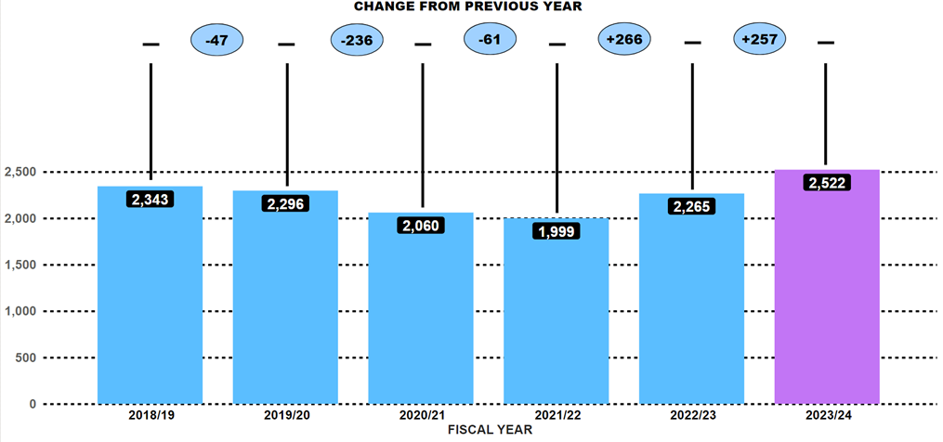

Theft of Motor Vehicle showed a consistent year-on-year rise over the past two years, increasing by 266 (up 13.3%) in 2022/23, followed in 2023/24 by an additional 257 (up 11.3%) crimes. The 2,522 crimes are the highest number recorded over the reporting period and is an average of 14 thefts of motors vehicles a day.
Criminal intelligence analysis has pinpointed keyless entry as the predominant method for motor vehicle theft. Through tactics like relay / jamming devices, on-board diagnostics (OBD) key programming devices, OBD emergency start devices, and lock key decoders, offenders are able to gain keyless entry to vehicles. The analysis also highlighted new advancement keyless entry devices that work through the offender touching the door handle of the target vehicle and the device can process the signal from the vehicle and calculate an unlock code. The device is also capable of starting the engine and does not require other equipment such as a relay device.

Key Insight 3: Hate Crime Decreases Compared to Previous Year
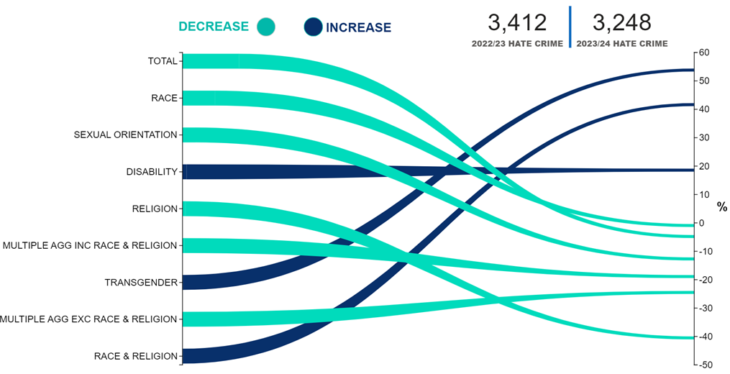

Police Scotland has recorded 3,248 hate crimes in 2023/24, this is a decrease of 4.8% (164) compared to the previous year. This reduction is largely driven by decreases compared to the previous year in hate crimes involving race (down 0.9%, 18 fewer), sexual orientation (down 12.7%, 101 fewer) and religion (down 40.5%, 92 fewer), which account for 84% of hate crime recorded in Scotland.
However, the increase in transgender related hate crime has seen the largest percentage increase (up 53.8%), albeit from a relatively low initial number (2022/23: 52, 2023/24: 80).
When dealing with small initial figures, a slight numerical change can result in substantial percentage increases. Nevertheless, when benchmarking transgender hate crime with the latest figures from England and Wales (year ending March 2023) they also noted an increase compared to the previous year.

Policing during Quarter 2 2023/24 – Unlocking Insights – Local Focus

Local Insight 1: Group 3 (Acquisitive Crime) Per 10,000 by Police Division
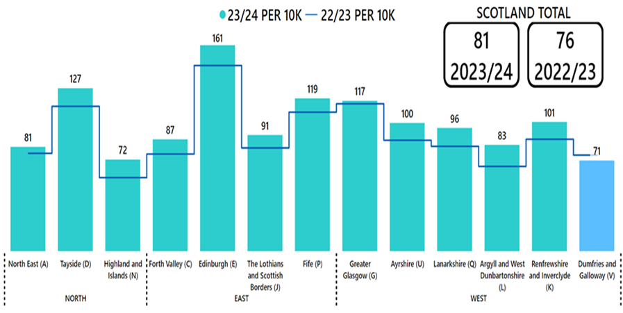

In 2023/24 there have been 57,414 Group 3 (Acquisitive) crimes, that is an average of 314 per day and an increase of 5,625 (up 10.9%) from the previous year.
Additionally, in a notable trend, all Police Scotland local divisions, except Dumfries and Galloway (V), have seen an increase in Acquisitive crime per 10,000 of the population compared to the previous year.
Edinburgh (E) Division in 2023/24 has seen the highest Acquisitive crime count per 10,000 among all divisions. In every 10,000 people in Edinburgh there are 161 reports of Acquisitive crime, highlighting that in relation to the local population Edinburgh has a higher rate of these crimes compared to all other divisions.

Local Insight 2: Shoplifting Crimes
Shoplifting crimes have continued rising and are now at higher levels than those seen pre-pandemic and are higher than the five-year mean. Between April and September 2023 there have been 19,244 crimes, 36.5% (5,141 crimes) more than the same period last year and 40.6% (5,560 crimes) higher than the five-year mean. This increase has seen shoplifting crimes rise to above those seen pre-pandemic, with 3,062 more crimes than during the same period in 2019.
The rise of shoplifting crimes has been experienced across the force and now make up 33.5% of all Group 3 crimes. All divisions have recorded a year-to-date rise, ranging from 5.2% in Dumfries and Galloway to 75.9% in Highland and Islands Division. The continued rise in shoplifting crimes has seen all divisions rise to levels above their respective five-year mean, ranging from 9.1% in Dumfries and Galloway to 73.4% in Tayside Division. As can be seen below, the rate per 10,000 population varies across the country with 52.8 crimes per 10,000 in Edinburgh to 20.2 crimes per 10,000 in Dumfries and Galloway Division.

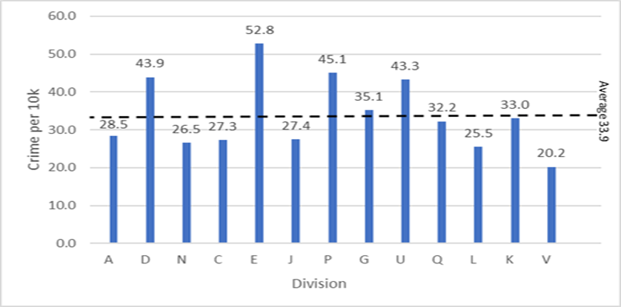

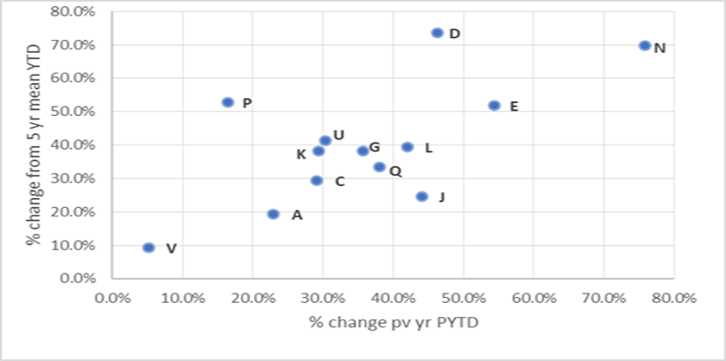

Although the majority of divisions have detected more crimes than last year, the significant increase has seen the overall detection rate drop from 53.9% to 48.3%. This is reflected across all divisions with only Lanarkshire Division recording an increased detection rate when compared with last year (+0.3 % points). Despite the increase in detected shoplifting crimes from last year, the number of detections remain 12.3% (1,299 detections) lower than levels seen pre-covid. Detections over the period have increased from 7,612 to 9,303 compared to the same period last year. The detection rate is 48.3%, 5.6 percentage points lower than the same period last year and 14.4 percentage points lower than the five-year mean.
Continued analysis in this area from local policing divisional analysts has found several factors that could be contributing to the rise in shoplifting crimes, including the current cost of living situation, repeat offenders and organised crime activity. Analysis and ongoing work with partners continue in this area to identify, assess and respond to the driving factors.

Local Insight 3: Robbery
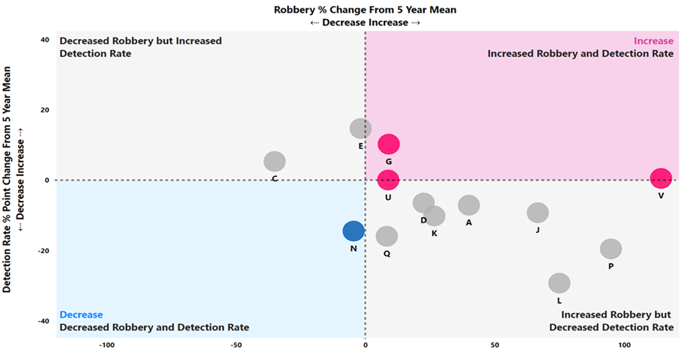

The number of robbery crimes recorded has also increased this year. The 1,001 crimes represent an increase of 35.8% from last year and 21.6% from the five-year mean, although it should be noted that last year’s number of robberies was considerably lower than usual. Every division except for Highlands & Islands (N Division) and Edinburgh (E Division) saw an increase in robberies compared to their five-year means.
Analysis of robbery crimes has been conducted by local policing analyst teams and most of these crimes continue to be amongst people known to each other and often linked to drugs and/or drugs debts. Some divisions have noted a slight increase in robberies amongst young people involving mobile phones however these types of crimes remain a small proportion of robberies.
As with common assaults, Police Scotland has been able to detect higher levels of robbery crimes this year compared to usual. As a result, the detection rate for robberies was 74.3%, a decrease of 1.0% from the five-year mean despite the increased volume in crimes being recorded. This is often due to the focus robbery crimes receives with local policing divisions, many of whom have dedicated units such as Greater Glasgow’s dedicated Robbery Unit and Edinburgh’s Violence Reduction Unit to name but a few.
One of the most frequent location types for robberies is city or town centres. In Forth Valley Division, their recent increase in robberies was mainly due to the volume of street robberies, some of which were linked to drug dealing activities, in Stirling city centre. These crimes also coincide with a recent escalation in anti-social behaviour in the city centre. Specific policing plans have been put in place with responses including additional high profile and plain clothes patrols. This has already resulted in an improving picture.
North East Division also noted a rise in robberies associated with juvenile anti-social behaviour over the summer months and responded using a multi-agency approach to proactively target and increase patrols in problematic areas.
Additionally, Forth Valley Division’s Proactive CID and Community Policing teams, have been working together to undertake intelligence-led house, street and vehicle searches in order to disrupt as much of this criminal activity as possible. There have been numerous successful cash and drug recoveries in recent weeks as a direct result of this focused activity.
Greater Glasgow division’s Violence Prevention Board have devised a robbery strategy focusing on the standards of investigation whilst bringing a consistency to the overall policing response. This ensures as part of the governance and scrutiny in prevention/detection of robberies, resourcing is reviewed ensuring reactive and proactive deployments of officers which is analytical informed and on an intelligence-led basis, with officers competent in the use of all legislative powers for stop and search.
Dumfries and Galloway Division recently formed a Divisional Violence Prevention Group which meets monthly to discuss all crimes committed during that reporting period and to discuss options around investigation and prevention. This not only covers robberies but also serious and common assaults to establish if there are any similar issues/common themes arising around those crime types.
Highland & Islands Division have improved their governance procedures around robberies with improved oversight of all such crimes put in place last year. This includes monthly reviews.
Renfrewshire and Inverclyde Division review robberies as part of their divisional violence governance meeting with a number of detections made following a review into historical robberies carried out in the division.
Argyll and West Dunbartonshire Division implemented a short term dedicated high profile anti-robbery team within the West Dunbartonshire area to focus on disruption tactics including execution of outstanding arrest warrants for violent offenders, effective and appropriate use of stop search and high profile patrols in areas where robberies and ASB have occurred.
Ayrshire Division are deploying high visibility patrols to known locations/areas that have been identified from intelligence or analysis. This work is also supported by the weekend night time plans developed by each sub-division.
Where there are trends identified in Lanarkshire Division, either MO or location analytical work will be highlighted to ensure possible additional patrols, opportunities to work with partners and any Safer Communities/ PPCW opportunities are exploited.
The VOW project, a bespoke partnership project between Police Scotland and prior offenders who now serve as mentors, have also been delivering talks in schools. These are delivered in partnership with “Turn Your Life Around” talks to advocate good decisions amongst young people. In Edinburgh, for example, this includes working with 29 people, many of whom have previously been involved in violent crime, on a one-on-one basis to divert them away from criminality.
Further work with young people includes campus officers in Greater Glasgow delivering inputs on personal safety to young persons within educational establishments, as well as working with education and partners where offenders are within schools to deter/prevent further escalation in behaviours.
Other prevention work has included a number of divisions attending, setting up stalls and even delivering talks on personal safety at University freshers’ events. Crime Prevention teams have also recently supported the Fearless campaign which focused on encouraging young people not to use knives and to report any knife crime they see. The crime prevention side have created a personal leaflet that gets used at a lot of in person events and is also shared online by police and partners.
Often, victims and/or offenders of violent crimes such as robberies are identified as being within homeless accommodation or sleeping on the streets. If there has been no previous engagement, they are signposted to street outreach teams within the voluntary and housing sectors to engage and deter them from criminality. Where vulnerable victims/offenders are identified, relevant referrals are also made to external partners.
Tayside Division continue to work with partners on prevention. Some of this work includes delivering inputs to sheltered housing complexes on personal safety and providing training to staff at supported accommodation such as Salvation Army regarding crisis recognition.
The Lothians and Scottish Borders Division shows that just over a third of their robberies have involved the use of a weapon with a knife being the main weapon type. Moving into Quarter 3, there may be opportunities during the festive campaigns to focus on knives through prevention and enforcement.

Local Insight 4: Common Assault
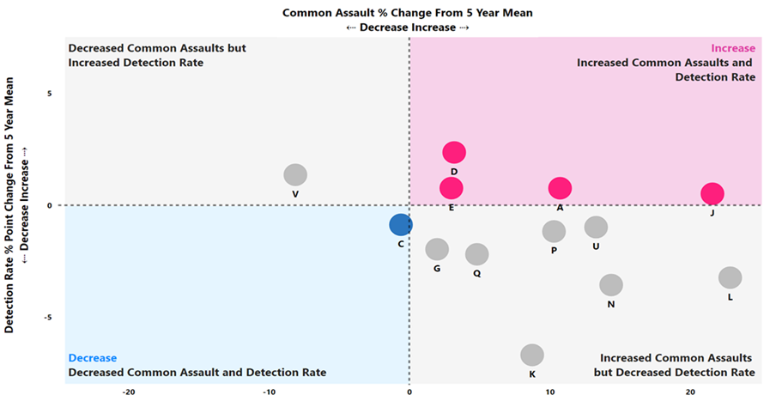

Overall violent crime has increased by 6.4% compared to the five-year mean – with an additional 2,054 crimes recorded. This is largely driven by an increase in common assaults and robberies.
There were 31,265 crimes of common assault recorded between April and September. This includes common assault of an emergency worker (4,009 crimes recorded) and common assault of a retail worker (1,279 crimes recorded). This was the highest level of common assaults recorded for the six-month period in recent years and marked an increase of 5.6% from last year and 7.2% from the five-year mean.
All local policing divisions except Tayside (D Division), Greater Glasgow (G Division) and Dumfries & Galloway (V Division) saw increases in common assaults recorded compared to the same period last year. Common assaults were above the five-year mean in every local policing division except for Forth Valley (C Division) and Dumfries & Galloway (V Division).
In addition to the increase in crimes of common assaults, the number of crimes detected has also increased. Police Scotland officers detected 21,101 common assaults in the six-month period, 1,160 more detections than the five-year mean and 956 more than in the same period last year. As a result of these increases, the detection rate for both common assault and overall violent crime has decreased by 0.9% points from the five-year mean detection rate, despite the higher volume of crimes being recorded.

Local Insight 5: Tackling Drug Harm
Over the last quarter Police Scotland has had multiple successes in disrupting drug operations within the country. The recovery of large amounts of drugs in our communities assists in preventing harmful substances from reaching vulnerable people and severely hampers the illegal activities of organised crime that prey upon them.
A list of successes in this area is provided within this report, however some highlights include the following:
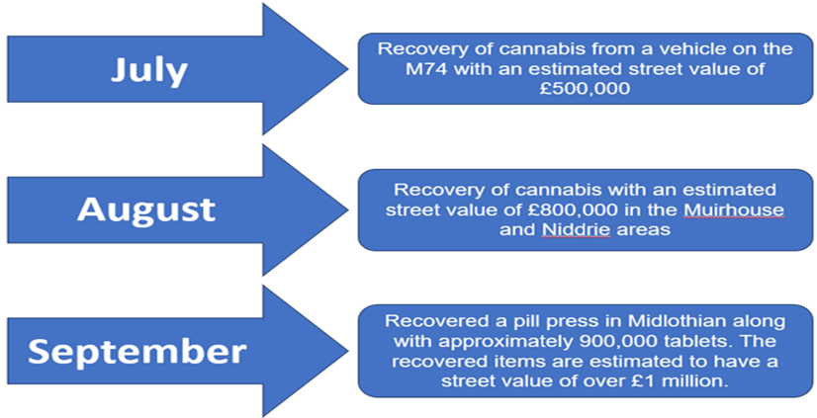

The recovery of the pill press was of high significance as some pill presses are capable of producing 1,000 pills an hour, whilst others on an industrial scale are capable of producing over 100,000 pills per hour. The recovery of such a machine is therefore highly impactive and removes significant quantities of drugs from potentially making their way into our communities.
As well as seeking to disrupt criminal activity in this area, Police Scotland also works to educate children on the dangers of substance harm. One such program is our Substance Abuse Awareness Education Package which is being delivered in partnership with the charity I Am Me and Renfrewshire Council. This work recently saw Police Scotland’s Substance Harm Prevention Team win a prestigious award at the COSLA 2023 Excellence Awards. The COSLA Excellence Awards celebrate Scottish Local Governments successes and recognise best practice and innovative service delivery. The award won by the Substance Harm Prevention Team, for tackling inequalities and improving health and wellbeing in Scotland, highlights the hard work ongoing every day to tackle the harms caused by drugs.

Local Insight 6: Road Fatalities
Road fatalities have decreased this year to date, with 13 fewer fatalities on Scotland’s roads than the same period last year. The below table highlights the Police Scotland Divisions and the number of fatalities which have occurred in each from 2019/20 to the current period.
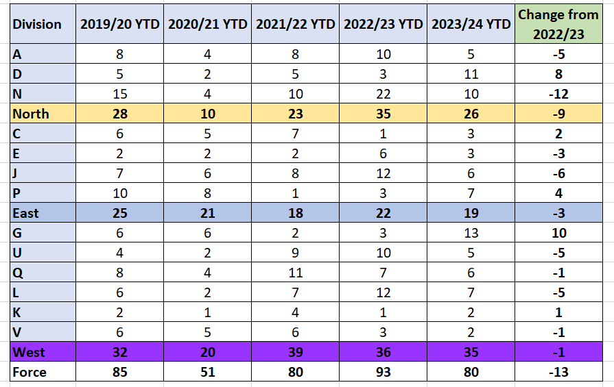
It can be seen that overall the majority of Policing Divisions have observed a decrease in road fatalities compared to the same period last year, with fatalities in the Highlands and Islands of Scotland (N division) having decreased by 12. There has unfortunately been a significant increase in G division (Glasgow) compared to the previous year. Each region within Scotland; North, East and West, have observed decreases.
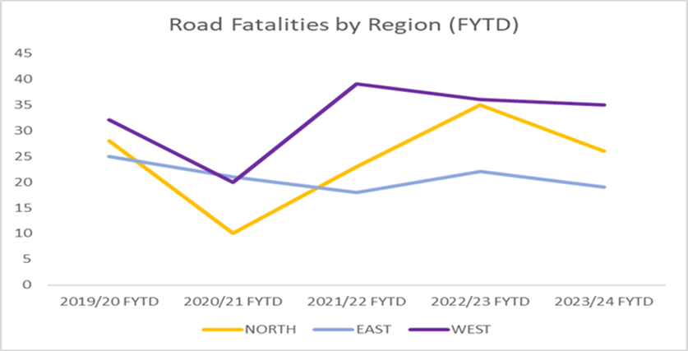
The chart Road Fatalities by Region (FYTD) shows the impact COVID-19 restrictions had on road fatalities. The reduced traffic during this period resulted in a significant decrease across all regions, and whilst the number of fatalities increased following the lifting of restrictions, we have seen another decrease this reporting period, with both the North and East regions below the number of fatalities pre-COVID-19 (being 2019/20).
Police Scotland continues to work with our partners toward Vision Zero - no deaths and no serious injuries on Scotland’s roads by 2050. An overview of our current campaigns and ongoing work is provided in the Road Safety section of this report.

Local Insight 7: Public Confidence
There is a strong relationship between public confidence and someone’s perception of police doing a good job in local area, perception of police listening to concerns of local people, and perception of police dealing with issues affecting local area. As these perceptions change, public confidence is likely to be affected.
The following table presents the responses from those who strongly agree or agree with these statements in the Your Police survey.

Strong Correlations with Public Confidence
Public Opinion Statements | Quarter 1 2022/23 (n945) | Quarter 2 2022/23 (n10,243) | Quarter 3 2022/23 (n3,781) | Quarter 4 2022/23 (n1,929) | Quarter 1 2023/24 (n276) | Quarter 2 2023/24 (n8,071) | Change from last Quarter
Police doing a good job in local area | 30% | 32% | 29% | 26% | 30% | 28% | -2% point
Listening to concerns of local people | 31% | 32% | 28% | 27% | 27% | 29% | +2% point
Dealing with issues affecting local areas | 24% | 23% | 21% | 18% | 23% | 21% | -2% point

Impact Pieces: Policing in Practice
The following impact pieces are presented to provide a snapshot of some of the activity taking place across Scotland to respond to the areas we know have the strongest impact on enhancing public confidence in police.

Understanding and responding to issues affecting local areas
Impact Piece: Fife EDI Engagement with Afro-Caribbean Network
The EDI Team in Fife have re-established connection with the Fife Afro-Caribbean Network. Following on from a launch event in Dunfermline, subsequent meetings have taken place both in person and over Microsoft Teams to advance partnership working and foster meaningful relationships. This is a positive step moving forward to ensure people who find police difficult to engage with are able to feedback any concerns.
This provides a platform where people now have contact with the Fife Division’s Equality, Diversity and Inclusion team to help raise awareness of hate crime and trends, third party reporting and signpost to other support services in the community. There are plans to include representatives from the Network as a member of the Hate Crime Core Group in Fife.

Police doing a good job in local area
Impact Piece: Youth Engagement Police Officer appointed in Helensburgh
Argyll & West Dunbartonshire Division have recently appointed a new Youth Engagement Officer to work alongside young people and staff at Hermitage Academy, as well as in the local community. This will be an important post for building strong and trusting relationships between young people and the police, which is important in maintaining trust and confidence in policing among young people. The officer will also take on the role of Group Co-ordinator for the local Police Scotland Youth Volunteers Group in Helensburgh who continue to support their local community in Helensburgh and beyond.

Listening to concerns of local people
Impact Piece: Counter-Terrorism Liaison Officer Engagement workshops with Dundee International Women’s Centre
Tayside Division’s Counter-Terrorism Liaison Officer hosted a series of engagement workshops throughout Angus and Dundee alongside colleagues from Dundee International Women’s Centre (DIWC) with several different groups from various communities in the local area. This provided an opportunity for people to discuss hate crime and how it impacts communities and what can be done to improve reporting and police-community relationships. Learning from these workshops will be taken forward for more opportunities in the future.

Policing Together
Following the launch of the Policing Together strategy on 30 September 2022, a number of recommendations were approved at the Policing Together Strategic Oversight Board to ensure the appropriate level of scrutiny was in place for delivery. This included approval for the EDI Action Plan to be subsumed into the Strategy Implementation Plan and a review of the terms of reference for the EDI Action Plan Oversight Group. The Group is now renamed the ‘Policing Together Implementation Group’ and is chaired by ACC David Duncan.
A process of mapping and de-confliction took place to subsume the EDI Action Plan into the Strategy Implementation Plan and to refine the Plan. Recommendations were approved at the Implementation Group on 07 July which streamlined the Implementation Plan, removed duplication and ensured the Plan was manageable by business areas.
The refined Implementation Plan prioritised into high, medium and low and assigned short, medium or long term timescales, was presented to the SPA People Committee on 29 August. The Plan also included insights and measures identified to assist Police Scotland in measuring its progress and impact.

Four Pillars
There are four pillars which underpin the work of the Policing Together programme, they are:
Leadership
Training
Prevention
Communications.
Standing updates on activity falling under the 4 pillars are reported to the PT Tactical Group on a quarterly basis ensuring oversight, alignment of activity, collaboration and sustained momentum.
The paragraphs below offer high level insight into the progress to date and direction of travel across the 4 Pillars. There is significant alignment to the Equality Outcomes, particularly the updates provided for EO6 - Leadership and further updates in respect of Leadership and Training can be obtained from this section of the report.
Leadership: Your Leadership Matters (YLM) is a programme designed to enhance leadership behaviours, providing the skills and tools necessary to build teams which deliver effective policing for all communities, it is underpinned by the Competency and Values Framework (CVF). YLM is a mandatory programme that represents a significant investment in leaders and a commitment to improving the existing workplace culture. It will empower leaders to lead inclusively and proactively, creating a more diverse and inclusive working environment, so that every team member can thrive and reach their potential. YLM was rolled out to senior leaders at Superintendent/Police Staff equivalent and above in 2021. In April 2023, the programme launched to Chief Inspectors and staff equivalents followed by the first-level leader (FLL) programme for approximately 5,000 Sergeants, Inspectors and police staff equivalent in August.
Training: An EDI e-learning module was launched in November 2022. All officers and staff are required to complete the training. The EDI e-learning module is now part of the mandatory training calendar and will be updated each year ensuring that all officers and staff have the opportunity to refresh their knowledge and re-set expectations aligned to Police Scotland values and standards of professional behaviour. A new mandatory EDI e-learning module will launch by the end of 2023. This new module covers the Police Scotland values in detail, with a range of scenarios on how these can be demonstrated positively and negatively in day-to-day business. The module will also explore the subject of institutional discrimination.
Preventions: A key element of the Policing Together initiative is the Professional Standards Department (PSD) led Preventions & Professionalism programme. This includes a governance structure with tactical and operational leads, driving prevention and awareness activities intended to influence positive cultures, whilst empowering the workforce to appropriately challenge and report harmful behaviours. It also highlights the key role that leaders and bystanders play in robustly and proportionately addressing concerns at the earliest opportunity, and the support available to do this. Part of this programme includes the Standards of Professional Behaviour Campaign which is a focused yearlong initiative which launched in November 2022. Each month has a spotlight on each of the 10 standards, providing relatable context of the behaviours expected of officers alongside examples of actions that fall below these standards.
As the initial campaign draws to a close, focus is now on evaluation and feedback and considering next steps to maintain momentum and to continue to reinforce positive behaviours in support of parallel national programmes such as ‘Your Leadership Matters,’ ‘Improving Climate’ and the ‘People Management Development Programme.’ As engagement takes place to gather feedback and evaluate the impact of activity, impetus will be maintained by delivering a rolling cycle of ongoing awareness / messaging consisting of:
1st month – publication of the quarterly newsletter, ‘The Standard’ – with content derived from the most prevalent issues identified through complaint and conduct investigations.
2nd month – publication of Misconduct Outcomes.
3rd month - focus on particular theme or issue causing most concern.
Communications: Notable work includes delivery of the Policing Together Cultural Calendar which ensures key dates which resonate with communities of Scotland are marked with internal and/or external activity or communications. Over recent months this has included content raising awareness of Eid-ul-Adha, Disability Awareness Day, Mental Health Awareness Week and Pride Month. Events, inputs and communications have been delivered offering opportunities for learning, support and engagement. Police Scotland’s Black History Month Launch event took place on 03 October 2023. Over the coming months Communications Plans will be developed with the aim of explaining and embedding the work of the Creating a Positive Workplace Short Life Working Group (SLWG) and the Human Rights Framework SLWG. The second phase of the internal values marketing campaign will also commence. A communication plan continues to be delivered in support of the Chief Constables statement on Institutional Discrimination.

Divisional/Departmental Delivery Tool
A Policing Together (PT) Divisional Workshop was held in June to share ideas and approaches to support local progress towards the organisational ambitions in relation to PT and Equality, Diversity and Inclusion (EDI). Following this session, work has been undertaken to draft a baseline tool to support divisions and departments to build EDI actions into People Plans. This tool provides suggested baseline activities structured around the ‘four pillars’ for delivery. This approach aims to simplify the delivery and reporting requirements locally and avoid any duplication that could arise due to the cross-cutting nature of activities against the various outcomes.
The tool was developed based on:
Actions from the PT Implementation Plan (which reference local delivery);
Activities from the employment Equality Outcomes (5-8) overview and ‘we will’ commitments in the recent mainstreaming report;
Activities that are already underway in divisions and departments to progress EDI;
Feedback from EDI HR Advisors, People Partners, Local Management Teams, and Policing Together Colleague Group members.
The tool will be reviewed regularly and updated based on feedback, progressing activity and ongoing learning.

Measures of Progress towards Strategic Outcomes

Strategic Outcome 1
Threats to public safety and wellbeing are resolved by a proactive and responsive police service.
Objectives:
Keep people safe in the physical and digital world
Design services jointly to tackle complex public safety and wellbeing challenges
Support policing through proactive prevention
All data is classed as Management Information and is not considered official statistics. All data is sourced from Police Scotland internal systems.

Violent Crime
Overall violent crime | 2022/23 YTD | 2023/24 YTD | % Change from Previous Year | 5 Year Mean | % Change from 5 Year Mean
Number of crimes | 32,234 | 34,154 | +6.0% | 32,099.9 | +6.4%
Number of detections | 22,166 | 23,310 | +5.2% | 22,189.8 | +5.0%
Detection rate | 68.8% | 68.2% | -0.5% point | 69.1% | -0.9% point
Note: Overall violent crime is comprised of murder, culpable homicide (common law), attempted murder, serious assault, robbery, common assault and common assault (of emergency workers).
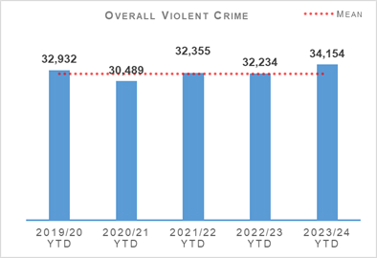 | 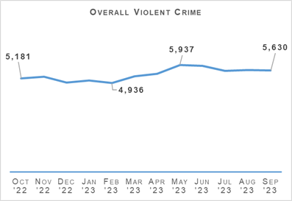
Overall violent crime recorded during April to September 2023 is at the highest level for this period in recent years – up 6.0% from the same period last year and 6.4% from the period’s five-year mean. The majority of Police Scotland’s local policing divisions have seen an increase in violence with only Tayside, Greater Glasgow and Dumfries & Galloway seeing decreases from last year. Every month between May and September saw higher levels of violence than usual however this was most notable in the months of May and June which coincided with particularly good weather.
The main drivers in the increase in overall violent crime was robbery and common assault. For more details on these crime types please see the key insights section.
There were 28 homicides recorded between April and September – four more than last year, although it should be noted that last year saw a record low number of homicides recorded. There have been four fewer homicides so far this year when compared to the five-year mean of 32. Enforcement action in the month of September resulted in the arrest and charge of four individuals for the murder of Anthony Ferns in Glasgow in April 2019. This brings the detection rate for all homicides committed since the inception of Police Scotland to 100%, a remarkable achievement.
The number of attempted murders recorded so far this year was 144 – two fewer than last year and seven fewer than the five-year mean. The same number of serious assaults was recorded between April and September this year as last year – 1,716, which is a decrease of 11.1% from the five-year mean. Twenty seven of the crimes this year were serious assaults against a retail worker.
Offensive weapons crimes are not included within the Overall Violent Crime figure however there have been 5,987 offensive/bladed weapons crimes recorded during the period. This is a 15.7% increase from the previous year and up 12.3% from the five-year mean.
Of these crimes, 56.0% relate to the use of offensive weapons or bladed/pointed instruments in another criminal activity. The other 44.0% are for carrying offensive weapons or the handling of bladed/pointed instruments.
Police Scotland’s Partnerships, Prevention and Community Wellbeing Division (PPCW) continue to work in collaboration with Youth Link Scotland with the ‘No Knives Better Lives’ programme. Throughout 2023 and 2024 ‘No Knives Better Lives’ are hosting various regional practitioner and police events.

Non Sexual Crimes of Violence (Group 1)
Non Sexual Crimes of Violence (Group 1) | 2022/23 YTD | 2023/24 YTD | % Change from Previous Year | 5 Year Mean | % Change from 5 Year Mean
Number of crimes | 5,037 | 5,993 | +19.0% | 4,691.6 | +27.7%
Number of detections | 3,136 | 3,470 | +10.7% | 3,252.4 | +6.7%
Detection rate | 62.3% | 57.9% | -4.4% point | 69.3% | -11.4% point

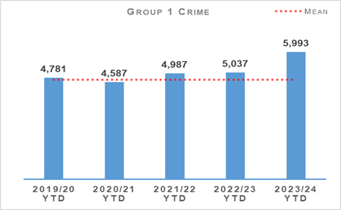 | 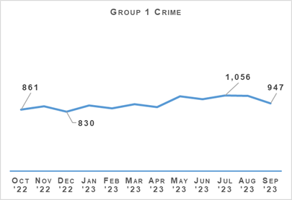
As has been highlighted in previous reports, the number of non-sexual crimes of violence continues to show an increase from previous years due to factors such as continual increase in threats & extortions and drugging crimes being recorded, although the increase in the number of robbery crimes described above has also had an impact.
There have been 1,430 crimes of threats & extortion recorded this year compared to 819 last year and a five-year mean of 443. This is a 74.6% and 223.1% increase respectively. The reasons for this, and nature of threats & extortion, were reported on in greater detail in the 2023/24 Quarter 1 report.
Drugging crimes being recorded have also stayed at a far higher level than they were historically, with 94 crimes recorded during the first six months of 2023/24. While this is 17 fewer crimes than in the same period last year, the five-year average for April to September is only 32, and no year before 2022/23 saw more than 16 such crimes recorded for this period. As has previously been reported, Police Scotland continually reviews the spiking communications toolkit to promote a consistent approach, reinforcing the importance of women and girls feeling and being safe in public places whilst ensuring there is no ‘victim blaming’ culture, and Partnership, Prevention and Community Wellbeing (PPCW) continue to work with the Business Crime Prevention Unit and Scottish Violence Reduction Unit on such things as ByStander awareness training to the licencing industry.
The detection rate for group one crimes was 57.9%, a slight increase from the detection rate at the end of Quarter 1 (56.5%). Overall, however, the detection rate is likely to continue decreasing owing to the increasing proportion of group one crimes being from crime types such as threats & extortion and drugging that are very difficult to detect due to their nature.

Public Protection – Equality Outcome 4
Overall Sexual Crime (Group 2) – Equality Outcome 4 | 2022/23 YTD | 2023/24 YTD | % Change from Previous Year | 5 Year Mean | % Change from 5 Year Mean
Number of crimes | 7,366 | 7,493 | +1.7% | 7,070.8 | +6.0%
Number of detections | 4,043 | 4,096 | +1.3% | 3,923.0 | +4.4%
Detection rate | 54.9% | 54.7% | -0.2% point | 55.5% | -0.8% point

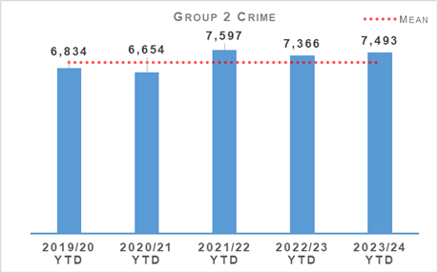 | 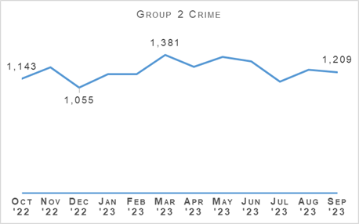
Overall sexual crime increased during the reporting period, up 1.7% (127 crimes) compared to last year and up 6.0% (423 crimes) compared to the five-year mean. December 2022 remains the month where the fewest number of sexual crimes were recorded however a decreasing trend is also noted between May and July 2023.
The drivers of the increase are sexual exposure, coercing a person into being present/looking at sexual activity and disclosure of an intimate image. During Quarter 2 the number of sexual exposure crimes was the highest number noted compared to the previous six years.
Although overall the number of sexual crimes increased compared to last year, notable decreases were recorded in the number of sexual assaults of a female over 16, rape of a female (13 – 15) and sexual assault (common law). During Quarter 2, the number of common law sexual assaults and rapes of a female (13 – 15) were the lowest recorded over the previous six-year period.
Overall Sexual Crime (Group 2) – Equality Outcome 4 | 2022/23 YTD | 2023/24 YTD | % Change from Previous Year | 5 Year Mean | % Change from 5 Year Mean
Number of recent crimes | 5,701 | 5,769 | +1.2% | 5,313.6 | +8.6%
Number of non recent crimes | 1,665 | 1,724 | +3.5% | 1,757.2 | -1.9%
Proportion of Group 2 crime non recent | 22.6% | 23.0% | +0.4% point | 24.9% | -1.9% point
Note: Non-recent sexual crimes are defined as crimes that were reported more than one year after they were committed.
Recent reporting increased compared to the same period last year and the five-year mean. Non-recent reporting also noted an increase against last year however is down slightly compared to the five-year mean. Non-recent noted the greatest increase against last year, up 3.5% (59 crimes) and recent reporting up 1.2% (68 crimes).
The proportion of non-recent reporting of sexual crime increased slightly up 0.4% points compared to last year, however, is down 1.9% points against the five-year mean.
The majority of sexual crimes were reported to the police within two days however, the proportion is slightly less than when compared to the same period last year.

Rape
Rape – Equality Outcome 4 | 2022/23 YTD | 2023/24 YTD | % Change from Previous Year | 5 Year Mean | % Change from 5 Year Mean
Number of crimes | 1,246 | 1,195 | -4.1% | 1,184.8 | +0.9%
Number of detections | 655 | 566 | -13.6% | 618.8 | -8.5%
Detection rate | 52.6% | 47.4% | -5.2% point | 52.2% | -4.9% point

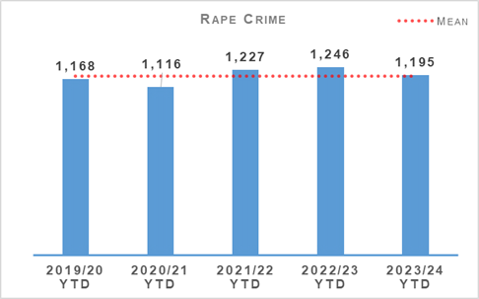 | 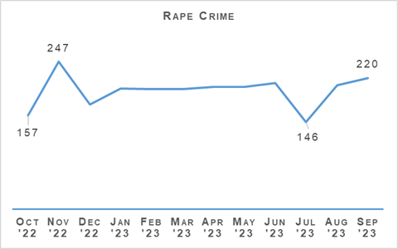
Reported crimes of rape decreased during the reporting period, down by 4.1% (51 crimes) compared to the same period last year. An increase was noted against the five-year mean, up 0.9% (11 crimes). The number of rapes reported month on month remain relatively stable since January 2023 however in the most recent quarter, July is noted to have the fewest number of rapes reported during the 12-month period.
Rape of a female 13 – 15 is the main driver behind the overall rape decrease, down almost 27% (42 crimes) against last year. Rape of a male over 16, Rape of a female over 16 and rape of a male under 13 all noted increases compared to last year. During the reporting period, rape of a male over 16 noted the highest number of crimes reported during the previous six years.
The number of rape detections decreased compared to the same period last year (down 13.6%, 111 detections) and the five-year mean (down 8.5%, 52 detections).
During the reporting period the detection rate for rape was 47.4%, a decrease against the same period last year (down 5.2 percentage points) and also compared to the five-year mean (down 4.9 percentage points).
Rape – Equality Outcome 4 | 2022/23 YTD | 2023/24 YTD | % Change from Previous Year | 5 Year Mean | % Change from 5 Year Mean
Number of recent crimes | 794 | 718 | -9.6% | 711.8 | +0.9%
Number of non recent crimes | 452 | 477 | +5.5% | 473.0 | +0.8%
Proportion of Rape crime non recent | 36.3% | 39.9% | +3.6% point | 40.0% | -0.1% point
Note: Non-recent rape crimes are defined as crimes that were reported more than one year after they were committed.
Non-recent reporting of rape increased by 5.5% (25 crimes) compared to last year and by 0.8% against the five-year mean. The proportion of non-recent rape also increased, up 3.6 percentage points compared to last year but down 0.1 percentage points on the five-year mean.
Recent rapes decreased by 9.6% (76 crimes) against last year but increased by 0.9% against the five-year mean. The proportion of rapes reported within two days is around 20.6%, a decrease when compared to the previous year and Quarter 1 2023/24.

Trauma Informed approach in policing
Collaborative learning takes place through the national Sexual Offences Liaison Officer (SOLO) Coordinator forum which seeks to maintain a victim-centred approach to all investigations. A short-life working group has been set up to review Trauma Informed training in collaboration with specialists from within the NHS Education for Scotland (NES) framework to upskill Sexual Offences Liaison Officers to ‘Trauma Enhanced’ level.
The National Rape Review Team (NRRT) have produced guidance and revised the question set utilised by C3 service advisors in relation to victims of sexual crime. The guidance includes the importance of a trauma informed approach, forensic capture and risk assessment to include both victim and suspect. The guidance also includes information on partner agencies to allow service advisors to signpost victims to the relevant support agency.

Continuous Professional Development (CPD) and Training
In January 2024 a ‘Rape and Sexual Crime’ CPD event will take place at the Scottish Police College which will provide valuable insights into recent case studies as well as inputs from COPFS and SPA Forensic Scientists.
We have regular forums with our Senior Investigating Officers to share learning and improve practice. Recently, our Professional Standards Department were invited to provide an awareness raising session at this forum in relation to Abuse of Power for Sexual Purposes and other recent inputs have included learning from COPFS relating to the evolving nature of consent in law, specifically around court findings relating to coercive external circumstances and submission not equating to consent.
We are working together with the SPA to produce an audio visual in respect of early evidence kits. This will help to educate first responders in the importance of early forensic capture and instruction on how to use the kit appropriately.

Victim Strategy Memos
Police Scotland continue to assist COPFS in supporting vulnerable witnesses through the judicial process in the submission of Victim Strategy Memos, within seven days of submitting a Standard Prosecution Report (SPR2). The document outlines the witnesses support mechanism and other areas where the victim could be supported to ensure minimal re-traumatisation and ensure continued victim engagement. In conjunction with COPFS, a pilot has been commenced across the force to try and increase our compliance rates by allowing officers to submit the Victim Strategy at the same time as the custody case. A pilot will run until the end of the year and we will review the results.

Partnership Working
We are in regular dialogue with Rape Crisis Scotland and local Rape Crisis Centres to resolve some communication issues with the referral process in order to provide the best service to survivors.
The NRRT recently met with the Women’s Support Project (WSP) regarding improving the response to prostitution, in support of our Violence Against Women and Girls strategy.
During this meeting we discussed how to educate officers in respect of breaking down barriers for women involved in selling sex to engage with services and how best to support them as victims of crime. We are aiming to form a Prostitution Working Group, involving key stakeholders, where we intend to convene face to face meetings to address issues and support women involved.
We plan to develop the following:
Resources information sheet which will include case studies, lived experience and useful sites to support women involved in prostitution.
Input within SOLO VRI course focusing on trauma, the impact for those involved in selling sex and how we can accommodate their needs.
Input for probationer training.
WSP will develop two pre-recorded sessions, outlining key points from above which will be included on our intranet site.
WSP / Police Scotland – recorded conversation between WSP and NRRT whereby women involved in selling sex will be able to ask anonymous questions to the Police to understand the processes, legislation and how we can best support them.
We continue to engage with the Scottish Government and partners in support of the Equally Safe Strategy to prevent and eradicate all forms of violence against women and girls (VAWG). Police Scotland are represented in various partnership groups with focus on reducing violence against women and girls in further education establishments. Quarterly meetings between Colleges and Universities, which includes Fearless Glasgow, are held with representatives from Public Protection which has resulted in a significant increase in the number of college and university staff undertaking PIP training.

Child Sexual Abuse (online)
Child Sexual Abuse (Online) – Equality Outcome 4 | 2022/23 YTD | 2023/24 YTD | % Change from Previous Year | 5 Year Mean | % Change from 5 Year Mean
Number of crimes | 921 | 992 | +7.7% | 919.0 | +7.9%
Number of detections | 644 | 687 | +6.7% | 603.2 | +13.9%
Detection rate | 69.9% | 69.3% | -0.7% point | 65.6% | +3.6% point

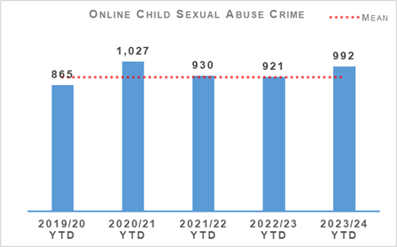 | 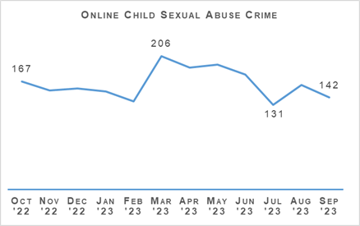
Online child sexual abuse crimes recorded in Scotland increased during the reporting period against the same period last year and the five-year mean. Overall, the number of online child sexual abuse crimes increased by 7.7% (71 crimes) compared to last year and by 7.9% (73 crimes) against the five-year mean.
The month on month recording level remains highest during March 2023 however July 2023 noted the lowest monthly reporting during the 12 month period.
The number of detections increased compared to last year (up 6.7%, 43 detections) and the five-year mean (up 13.9%, 84 detections). However, overall, the detection rate decreased compared to the previous year, down 0.7 percentage points to 69.3% but increased against the five-year mean, up 3.6 percentage points.

Child Sexual Abuse (online) – Crime Types
Child Sexual Abuse (Online) – Equality Outcome 4 | 2022/23 YTD | 2023/24 YTD | % Change from Previous Year | 5 Year Mean | % Change from 5 Year Mean
Cause to be Present Sex Act/To Look at Sex Image -M&F (< 13) | 148 | 153 | +3.4% | 160.4 | -4.6%
Cause to be Present Sex Act/Look at Sex Image -M&F (13-15) | 86 | 102 | +18.6% | 93.0 | +9.7%
Communicate Indecently/Cause see/hear Indec Comm – M&F (< 13) | 147 | 168 | +14.3% | 158.8 | +5.8%
Communicate Indecently/Cause see/hear Indec Comm – M&F (13-15) | 149 | 163 | +9.4% | 152.0 | +7.2%
Grooming of children for the purposes of sexual offences | 45 | 42 | -6.7% | 53.0 | -20.8%
Taking, distribution, possession etc. of indecent photos of children (from Apr 2011) | 346 | 364 | +5.2% | 301.8 | +20.6%
All classifications of online child sexual abuse noted an increase during Quarter 2 compared to last year, with the exception of grooming, with a 6.7% decrease noted against the previous year and 20.8% against the five-year mean.
Cause to be Present Sex Act/Look at Sex Image - M&F (13-15) noted the greatest percentage increase (up 18.6%, 16 crimes) compared to last year.

Bairn’s Hoose
We are now in Phase 3 of the Scottish Government’s Bairns’ Hoose project. Scotland’s first Bairns’ Hoose was opened on 29 August 2023. Childrens’ 1st led the project around this Bairns’ Hoose with support from partners in the local area and Victim Support (Scotland), the University of Edinburgh and Children England.

OCSAE Campaign - #GetHelpOrGetCaught
The latest campaign, targeting sexual predators who groom and abuse children online, launched on 25 September 2023. It has been designed to prevent online child sexual abuse by communicating to existing and potential perpetrators, encouraging them to contact Stop It Now! Scotland.
Stop It Now! has developed a short video which is being promoted on paid digital channels (Instagram, Facebook, X/Twitter, Snapchat, TikTok and You Tube) to engage with the campaign audience (males, over 18 years, living in Scotland). Part of the campaign strategy includes providing information for anyone affected by CSA and the Police Scotland webpage will provide information, guidance and signposting to relevant support services. This will be supported through messaging on Police Scotland social media channels.

Victim Identification (VID)
Over the past two years Police Scotland has invested heavily in promoting and supporting the OCSAE Victim Identification (VID) team. These officers investigate to identify children in images recovered during investigations whose identity is unknown. It is vital to resolve these identities to ensure the welfare of the children and invoke child protection processes and ensure safeguarding.
Consequently, the number of investigations supported by the VID team in Scotland has increased by over 300% in the past year and Police Scotland are now the second top performing force, of all UK forces, regarding formally identified victims from enquiries.
As a result, Police Scotland’s Digital Forensics team has significantly improved its compliance in terms of uploads to Child Abuse Image Database (CAID), and Police Scotland now features in the top ten performing forces in the UK.

Child Deaths
Police Scotland has supported a COPFS led Child Death Review. Part of the scope of the review has looked at the increase in the number of incidents where co-sleeping and parental/carer intoxication (through alcohol or drugs) feature, albeit not necessarily the determined cause of death. Whilst the COPFS review has been completed and will ultimately be published, work is ongoing with partners also assisting with this review to scope a reinforcement of previous messaging and any related campaign.
Work continues in relation to developing a Sudden Death Simulator suite at SPC for use during Detective and Child Death SIO training which will simulate the process of a child death from the home/locus to hospital and focus on the role and actions of partners. The importance of understanding the roles/responsibilities and limitations of our partners will ensure officers are better supported to conduct an investigation in an efficient but sensitive manner.

Domestic Abuse
Domestic Abuse – Equality Outcome 4 | 2022/23 YTD | 2023/24 YTD | % Change from Previous Year | 5 Year Mean | % Change from 5 Year Mean
Number of incidents | 31,466 | 32,189 | +2.3% | 31,871.2 | +1.0%
Number of crimes | 18,771 | 17,607 | -6.2% | 19,471.8 | -9.6%
Number of detections | 12,142 | 10,826 | -10.8% | 13,130.6 | -17.6%
Detection rate | 64.7% | 61.5% | -3.2% point | 67.4% | -5.9% point
Proportion of incidents resulting in a crime | 42.0% | 40.7% | -1.4% point | 43.3% | -2.6% point
DASA (of female) – Number of crimes | 866 | 905 | +4.5% | n/a | n/a
DASA (of male) – Number of crimes | 43 | 61 | +41.9% | n/a | n/a

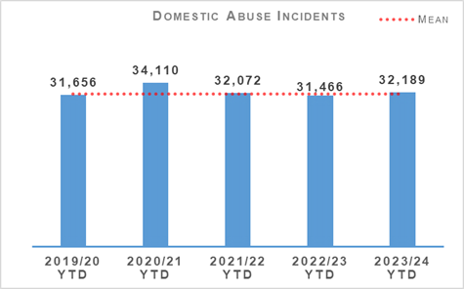 | 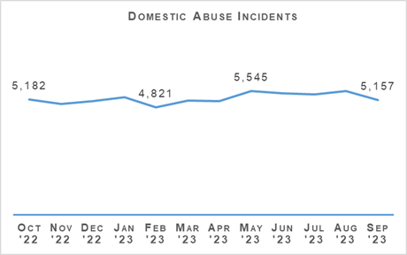
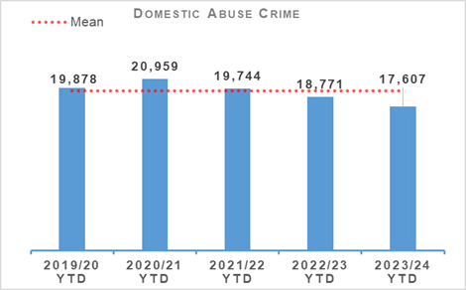 | 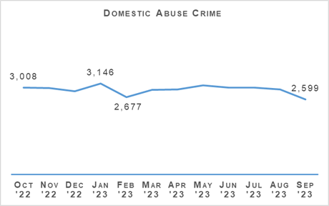
Domestic crimes continue to decrease compared to last year down 6.2% (1,164 crimes) however domestic incidents noted an increase compared to last year and the five-year mean up 2.3% (723 incidents) and 1.0% respectively.
Overall DASA crimes increased by 6.3% (57 crimes) with DASA of a female increasing by 39 crimes and DASA of a male increasing by 18 crimes compared to last year.
Four domestic murders have been recorded since April 2023 compared to three during the same period last year.
Analysis continues to identify potential drivers for reduction in number of crimes, including possible data/system issues.

Disclosure Scheme for Domestic Abuse Scotland (DSDAS)
The Disclosure Scheme for Domestic Abuse Scotland campaign was devised to coincide with the eight year anniversary of the scheme which took place on 01 October 2023. This is a three week social media focused campaign, highlighting the reach of DSDAS but focusing on bystander interventions. Information will be provided to partner agencies including the NHS and local authorities, as well as key support partners.
During the reporting period DSDAS applications have increased by 22.0% overall with a 23.3% increase in Power to Tell (PTT) applications and a 19.0% increase in Right to Ask (RTA) applications compared to the same period last year.

Victim Survivor Feedback
In May 2023 the online Victim Survivor Feedback Process was launched on the Police Scotland website to gain anonymous feedback from people who have reported crimes of domestic abuse, rape or other sexual crime to assist in providing a better quality of service. The question set is victim centred and trauma informed, with the language formed in partnership with internal and external agencies and stakeholders, reflective of other question sets that are currently in use. Responses shall be monitored by DACU and National Rape and Sexual Crime whereby anonymised information will be sent to Domestic Abuse Working Group (DAWG) Leads at Local Policing Divisions for note and action.

Stalking & Harassment
An online CPD event took place on 29 September 2023 to enhance officer’s awareness of the distinct behaviours associated with stalking, highlighting non-domestic stalking, with a view to identifying and reporting crimes committed under stalking legislation.
Action Against Stalking (AAS) have attended the Domestic Abuse Working Group (DAWG) and provided information to Domestic Abuse Working Group leads on the service requesting that information is shared with Tier 1 officers. Stalking and Harassment is now a standing Agenda item for the DAWG for discussion.

CPD Events
A National CPD event has been approved to take place to enhance the knowledge and skills of the current cadre of Domestic Abuse Champions (DACs) across Police Scotland. The intention is that officers attending the event will be recognised with a Domestic Abuse (DA) specialism on Scope. DACU shall commence event preparation with anticipation to take place early 2024.
DACU are also supporting C3 to arrange a DA Champions recruitment event to increase the cadre of DA Champions within C3, this will likely take place in October 2023. DACU are collaborating with (Contact Engagement Resolution Project) CERP and have reviewed and updated C3 Domestic Abuse ASPIRE prompts, ASPIRE guides and C3 procedure guides.

Human Trafficking
Under reporting of trafficking and sexual exploitation for prostitution of Romanian females is a particular problem encountered in Scotland resulting in a high number of potentially vulnerable females not engaging with Police and other authorities. The National Human Trafficking Unit (NHTU) have successfully applied to the Romanian Modern Slavery Fund administered by the Home Office and Romanian Embassy in London for funds to second two Romanian Police Officers to NHTU for six months beginning 08 January 2024. This secondment aims to increase reports of trafficking of Romanian Nationals and provide culturally sensitive information on rights and exploitation to encourage reporting when victims are at a stage in their journey to survivorship to come forward to report exploitation. On 21 September 2023 Home Affairs Police Attaché to the Romanian Embassy, Superintendent Andreea Ciobanu and Romanian Consul General Anton Barbu visited NHTU at SCC to discuss the forthcoming Secondment. This meeting confirmed arrangements and allowed progression of the secondment agreement. Recruitment of the two officers will now commence in Romania.
NHTU provided a training input at the Scottish Prison Service (SPS) HQ in Edinburgh to staff on what human trafficking is, how to spot potential victims of trafficking in the prison system and how trafficking and exploitation may potentially occur in the prison estate. Discussion took place at the conclusion of the input which was beneficial to both the NHTU and SPS who shared information and experiences.
NHTU hosted the Attaché for Homeland Security Investigation (HSI) from the US Embassy in London along with the USA HSI Head of the Centre for Countering Human Trafficking, financial crime investigation contractors to the US Government, Deloitte and SCD Financial Investigation Unit Officers at SCC. This meeting covered a number of business areas including potential support for US/UK joint investigations and had inputs from the HSI Human Trafficking Unit and Financial Crimes Unit. The meeting strengthened existing relationships between Police Scotland and the US and opened communications for future joint working.
On 29 September 2023 NHTU hosted the Brazilian Police Attaché and Deputy Attaché at SCC in response to the emerging threat posed to Brazilian nationals of trafficking and exploitation in Scotland, particularly sexual exploitation for prostitution. The meeting discussed the findings of the NHTU Intelligence Unit threat assessment on Brazilian exploitation along with findings and experiences reported by the Met, where a large proportion of the Brazilian diaspora are settled and travel to Scotland from. The visit also included representatives from the International Bureau, Fugitive Unit and Extradition Unit to discuss information sharing and partnership working opportunities.

Public Protection Development Programme PPDP
The first phase of police user research is complete in the four Local Policing Divisions identified for in depth review, along with National Divisions. There may be requirement for further research however this will be focused on any identified gaps.
Partner engagement continues with engagement sessions completed and further events scheduled. This is at both strategic and practitioner level. ACC Smith presented the current status to SPA Policing Performance Committee in September and a session is being scheduled for early 2024, as well as a presentation to COSLA Police Scrutiny Conveners Forum. The presentation/workshop for COSLA will be combined with Local Policing Service Delivery Review and Modernised Contact and Engagement.
PwC have concluded their time with the PPDP team on Friday 29 September 2023. The PPDP team will continue to work through problem statements and root cause analysis to produce opportunity statements with a focus on transformational change, addressing immediate risk, opportunities to create capacity and opportunities to reduce demand including early deliverables. We will then progress to ‘Design’ phase, scheduled November/December 2023.

Drugs Harm / Supply

Drugs Related Deaths
Police Scotland continues to work hard at fulfilling its duty to ensure the safety and wellbeing of all people within our communities. Tackling substance use and the harms they cause is complex. Poverty due to ongoing economic difficulties, and any mental health vulnerabilities can add to these complexities.
Recent increases in the cost of living will have unfortunately compounded these issues further. It is acknowledged that it is necessary to adopt a public health, whole system approach when addressing the harms caused by problematic substance use. We work alongside multiple external agencies to identify opportunities in which we can improve the wellbeing of those people that we come into contact with.
Our focus in the area of drug related deaths is on identifying primary prevention and intervention opportunities. Through working with partners, we can reduce the harm caused by substance use to individuals and communities. These aims are forwarded through major internal and external forums such as the National Drug Strategy Board, the Drug Harm Prevention Group, and the multiagency Scottish Drugs Deaths Taskforce.

Drug Related Death Dashboard
Police Scotland and the National Records for Scotland provide the Scottish Government information to produce a public facing drug related death dashboard. This information is provided on a quarterly basis, one quarter in arrears. This provides partners, working in the drug treatment and harm prevention roles, a greater opportunity for earlier intervention. Partners are also afforded the opportunity to align their substance harm prevention work streams to current issues.
The latest Scottish Government Drug Related Deaths (DRD) dashboard was published on 12 September 2023. During the period March to June 2023 Police Scotland recorded 302 suspected drug deaths. There were 1,130 suspected drug deaths over the 12 months to June 2023, 0.4% (five) fewer than over the 12 months to June 2022.
Please note that numbers of suspected drug deaths fluctuate from quarter to quarter. Care should be taken not to interpret movements between individual calendar quarters as indicative of any long-term trend. The data are for suspected drug related deaths and are before any confirmation after toxicology/pathology.
In August 2023 the National Records for Scotland (NRS) published the drug related deaths figures for 2022, where 1,051 drug misuse deaths were registered in Scotland. This was a decrease of 21% (279 deaths) compared with 2021. This is the lowest number of drug misuse deaths since 2017. The next annual drug misuse deaths National Statistics publication from NRS is due to be released in August 2024.

National Naloxone roll-out
The national rollout of Naloxone to all operational officers, up to and including the rank of Inspector, concluded on 31 August 2023.
The department have since trained and equipped officers within OSD and CJSD divisions, bringing the total number of officers trained and equipped to approximately 12,500. Additional funding has recently been secured from Scottish Government to ensure all non-front line officers within Police Scotland will be equipped with naloxone in a high profile manner when attending policing events throughout the force. The project remains fully funded by the Scottish Government as part of their commitment to reduce Drug Related Deaths.
All officers will continue to receive any additional updates, or training throughout their annual OST refresher course. The department continues to work in partnership with the Scottish Drug Forum, and NHS Health Boards to support officers with any issues they encounter in their training or in the carriage of Naloxone.
Administrations of Naloxone have continued to significantly rise since the conclusion of the Test of Change, with the total figure at this stage being 372. There have been 358 persons sufficiently recovered to either receive further medical attention by medical professionals or to leave the scene of their own volition. Eight people, who showed potential signs of overdose and were administered Naloxone in an effort to protect life, unfortunately died.
Substance Harm Prevention department will continue to have a national oversight of the carriage of naloxone moving forward, assisting local divisions with funding and any issues that arise. Local divisions are now responsible for ensuring all of their officers are equipped and any administrations, or purchases of naloxone are recorded accordingly and forwarded to Substance Harm Prevention.

Project Ingiving
Project Ingiving is the UK response to the problems caused by Benzodiazepines and is working towards the identification of trends and patterns in DRD, to enhance intelligence development and investigative opportunities. Police Scotland are working with NPCC partners to commence a pilot information sharing protocol to identify the impact of the Nitazenes on DRD to inform and promote harm prevention and enforcement work.
Operation Housebuilder is the pilot being run by NPCC to establish the extent of the impact of Nitazenes within the UK. This focuses on building an information sharing protocol which is fed into enforcement work.

Drugs Type Analysis
The Substance Harm Prevention (SHP) team will enter into Minute of Agreement (MOA) discussions with the University of Abertay as it is subject to annual review and renewal. The MOA will continue to support rapid analysis of drug types and inform the intelligence picture regarding drug types within Scotland, which will inform both Police Scotland harm prevention and law enforcement activity. Benefits include:
Identification of illicitly or pharmaceutically made drugs.
Identification of composition and ‘bulking agent’ content.
Commonality in colours and physical make up.
Analytical charting of all examined samples.
Fast test results, delivering contemporary intelligence opportunities and early harm prevention messages.
Public Health Scotland (PHS) have requested to enter into the discussion to assist in supporting the RADAR (Rapid Alert Drugs Advice Response) information sharing practices.

Support and Assistance
Police Scotland recently sent advice on substance misuse to thousands of phone numbers discovered on mobile phones seized as part of an intelligence-led drug operation. Mobile phone numbers which had been in contact with the devices were each sent a text message highlighting where support and assistance on drug misuse could be obtained. As part of our public health-led approach the aim is to ensure those who feel they need support are made aware of where assistance can be obtained.

Substance Education Packages
Work with registered charity ‘I Am Me’ and the Substance Harm Prevention Team was completed in July 2022. A programme of relevant themes and a delivery method was agreed for each year group and work around specific content for each subject is now in place.
The aim remains that every pupil across Scotland has access to delivery by either teachers, police or on occasions their peers. This will provide an appropriate and incremental level of knowledge on substance (drugs, alcohol and tobacco) harm and the wider impacts around community, environmental impacts, stigma, risks and personal safety.
Access to the resources can be found on Police Scotland’s intranet and is obtained by contacting the Substance Harm Prevention team/I Am Me. Currently 350 Police officers have access to deliver the substance awareness education pack. The majority of these officers currently carry out some form of youth/school engagement as a part of their role.
The package won the Tackling Inequalities and Improving Health and Wellbeing COSLA Award 2023. The package is currently being updated in conjunction with I Am Me to ensure that the content is relevant and up to date and will be relaunched in early 2024.

County Lines
County Lines is a method of dealing drugs that relies heavily on the criminal exploitation of children and vulnerable adults. There are a number of operations to tackle county lines being progressed across Scotland under divert, deter, disrupt and detect strands. This activity is most prevalent in the North of Scotland.
Police Scotland monitors and assesses the number of county lines which operate throughout the country and seeks ways to tackle the issue. In response, a number of projects are ongoing. The following are updates from the previous quarter relative to the work undertaken:
Police Scotland continue to work in collaboration with the National County Lines Coordination Centre (NCLCC) and other forces, particularly around the safeguarding of out of force juveniles. NCLCC act as a conduit to ensure that a joined-up approach is achieved.
The National County Lines Intensification Week took place between 09 and 15 October 2023, with Police Scotland engaging in activity focusing on vulnerability, safeguarding and enforcement. Proactive action by officers across Scotland saw 17 vulnerable people being safeguarded and 650 others engaged with. Additionally, 373 addresses believed to be used for cuckooing were visited. Overall 25 people were arrested for a variety of offences and drugs, including cocaine, heroin, ‘crack’ cocaine, cannabis, and tablets, with an estimated street value of over £313,000 were seized along with over £220,000 in cash.
Multi-agency intervention and support visits are continuing across Police Scotland with communities and individuals impacted by county lines. Specific partnership Days of Action are planned to raise awareness of county lines and highlight support available locally.
During the reporting period, the ‘Safe Space’ in Aberdeen City has been used twice to accommodate victims of county lines exploitation. On the first occasion the young person stayed for three hours until repatriation could be arranged, on the second the young person was accommodated overnight. The ‘Safe Space’ project is due to be reviewed in October 2023 to determine whether or not the property has positively impacted on the issue relating to the accommodation of county lines victims as an alternative to a criminal justice setting.
I Am Me Scotland – Partnerships, Preventions and Community Wellbeing (Children and Young Person) are developing an exploitation resource for S1-S3 on the charities online interactive platform for secondary schools. Hosting it on the platform would allow teachers to self-deliver inputs to pupils although school based police officers where available would also utilise this resource. Joint working is taking place with Merseyside Police to develop a platform in this area, and exploration with other forces.
Drug Education – During July 2023, confirmation of funding for a 12 month pilot of drug education materials/delivery by Daniel Spargo-Maggs Foundation and Police Scotland partnership was agreed. The funding included a considerable grant from a Local Authority funding stream and £10k funding from Scottish Government from SOC related recoveries. Plans are underway to start delivery of the materials in nine schools across Grampian, with the pilot concluding in June/July 2024.
County Lines – Impact
During this quarter, eight days of partnerships operations, under Operation Protector, were undertaken across Aberdeen City, Aberdeenshire and Moray to proactively address the effects of drug related harm and violence in our communities. During these operations, over 400 multi-agency staff were deployed which saw 456 outreach/safeguarding visits being conducted with a large number of individuals being brought into service, and over 700 interactions with the public at dedicated outreach hubs.
Additionally, a large number of private residence and businesses were visited by Community Safety Teams to raise awareness of county lines, cuckooing and how to report concerns. Over this period, 33 Drug Search Warrants were executed resulting in the recovery of over £100,000 of Amphetamine, Heroin, ‘Crack’ Cocaine, Cannabis and Cocaine, along with over £30,000 in cash. Of significance 13 arrests linked to drug supply and Human Trafficking/Exploitation were made and two exploited young persons were traced and safeguarded.

Serious Organised Crime Groups (SOCGs)
The Serious Organised Crime Task Force (SOC Task Force) took place on 05 October 2023 chaired by the Cabinet Secretary for Justice and attended by a number of partners. The meeting was productive with work being progressed in relation to early intervention for children involved in Serious Organised Crime and further development of Intelligence Sharing Agreements between partners.

New Prioritisation/Tasking Process
Specialist Crime Division and Organised Crime and Counter Terrorism Unit (OCCTU) have recently introduced a new prioritisation model, in the form of a GRID model.
This model will allow assessments of current operations as well as new and emerging threats with the outcome providing the rationale for deployment of resources for the week ahead.
In addition, this will allow for both a fluid and dynamic policing response to Serious and Organised Crime threats within the communities of Scotland, enhancing service delivery and ensuring priorities are focused on the greatest threat, risk and harm at any given time.
The GRID model was created internally, using current applications and populated by officers as part of their core role, with no financial implications. There is also no additional resource implications. This process marks a change in working practices on how work is prioritised for those already engaged in the targeting of Serious Organised Crime as opposed to the introduction of a working practice that would require additional capacity. All SOC activity is now recorded on the Agency and Partner Management Information System (APMIS) with the rollout of Unmet Demand in the pipeline. The ability to recognise and record Unmet Demand will allow Police Scotland to quantify and visualise any gaps due to capability and capacity issues, providing executive officers with a robust evidence base for future funding and spending reviews.

Operation ESCALADE
Operation ESCALADE is the Police Scotland investigation into one of the UK’s top-tier and most prolific serious organised crime groups. In June 2020, James White was arrested in Fortaleza, Brazil, during a joint operation with the Brazilian Federal Police. In August 2022 White was extradited back to Scotland and on 30 June 2023 he pled guilty at the High Court in Glasgow to offences including importing and supplying millions of pounds of controlled drugs, possessing firearms and explosives and money laundering dating back to 2011. In August 2023 White was sentenced to 9 years and 10 months in prison
His extradition and imprisonment were the result of extensive collaborative work between, Police Scotland, Brazilian Federal Police and the Crown Office.
In June 2023, Gerard McTaggart pled guilty to being involved in organised crime. On 07 August 2023, he was sentenced to 4 years 8 months imprisonment and a 5-year Serious Crime Prevention Order (SCPO) was granted.

Operation MILLE
In March 2023, the NPCC and NCA wrote to all UK Police Force Chief Constables asking law enforcement to revitalise Operation MILLE. The operation has the primary aim of creating an unprecedented boost in the strategic and tactical understanding of the West Balkan criminal business models whilst simultaneously disrupting and deterring broader related offending.
Throughout June, police located and searched large-scale cannabis cultivations in the most significant national operation of its kind ever run across UK law enforcement, aimed at unearthing and disrupting OCGs and their illegal revenue streams.
Operation Mille saw searches and arrests across the UK, with suspected OCG members arrested for offences including drugs supply, money laundering and possession of weapons. In Scotland, between 01 June and 31 August 2023 executive action was taken across seven divisions at 25 locations.
The exact value of the cultivations is not yet available for all of the seizures. However, the totals recorded on the database so far suggest upwards of £550,000. The size of cultivations ranged from one room up to four growing areas in residential properties. There were over 2,000 plants seized and over 33kg of herbal packed cannabis. The number of plants recovered at locations ranged from 67 to 192.
Nine of the properties were recorded to have bypassed electricity meters and one had dug up the road outside to add a connector to the main street, thus stealing electricity - demonstrating a level of specialist knowledge. Ten properties contained elements of technical sophistication such as electric equipment, lights, fans, ducts, dehumidifiers and pumps. One residential property in Aberdeen had false walls erected.
42 suspect nominals were identified, with ages for all suspects ranging from 19 to 59 years of age.

Proceeds of Crime
Mechanism | Amount
Proceeds of Crime Act (POCA) – Year to date figures for POCA represent those provided to COPFS and CRU for consideration and forfeiture | £12,644,574
Confiscations Orders | £1,843,596
Civil Recoveries Unit | £1,668,869

Disruption Activity
July 2023
A man was charged following the recovery of cannabis with an estimated street value of £500,000. Officers stopped his vehicle on the M74 and during a search found 90 kilograms of herbal cannabis.
Four men and a woman were sentenced to a total of 22 years after the seizure of a significant amount of cash and Class A drugs. Drugs with an estimated street value of over £350,000, along with £19,000 in cash, were seized as part of the investigation into a serious organised crime group in the Aberdeen area.
Two men were sentenced after being convicted of possessing a firearm with intent to endanger life in Edinburgh. One male received a sentence of six years and the other male a sentence of one year and nine months at the High Court in Edinburgh.
August 2023
A man and women were arrested and charged in Catrine in August. A quantity of cannabis, with an estimated five-figure street value, along with a four-figure sum of cash, were recovered.
Aberdeen officers, supported by colleagues in Edinburgh, charged two males in the Muirhouse and Niddrie areas in connection with a number of discovered cannabis cultivations in Aberdeen. The drugs had an estimated street value of over £800,000.
Officers recovered cocaine with an estimated street value of around £253,000 from a property in the Aberlour area of Moray. Elsewhere in the Bridge of Don area cannabis with an estimated street value of £333,000 were recovered, with a man being charged in connection.
September 2023
Drugs with an estimated street value of approximately £945,000 were recovered during searches in Monifieth and Dundee in September. Quantities of diazepam, cocaine, and a three-figure sum of cash were recovered in Monifieth, and a further five-figure sum of cash recovered in Dundee along with quantities of heroin, cocaine, and cannabis. Two men were arrested in connection to the offences.
In Midlothian two men were charged in relation to the production and supply of illegal drugs. A pill press and approximately 900,000 tablets were seized from an address. The recovered items are estimated to have a street value of over £1 million.
A large-scale cannabis farm was discovered in Glasgow and a large quantity of cannabis plants recovered in Livingston, with the cannabis farm estimated to be between £80,000 to £250,000 street value and the plants in Livingston an estimated street value of between £500,000 and £600,000. A male was arrested in connection.

Missing Persons
Missing Persons (Equality Outcome 3) | 2022/23 YTD | 2023/24 YTD | % Change from 5 Year Mean
Number of missing persons investigations | 9,299 | 9,148 | -1.6%
Percentage of people who have gone missing previously* | 38.8% | 41.9% | +3.1% point
Average length of time missing (hrs) | 19.2 | 16.8 | n/a
Percentage of overall missing persons that go missing from NHS | 5.3% | 4.2% | -1.1% point
Percentage of overall missing persons that go missing from YPU | 9.1% | 9.7% | +0.6% point
Percentage of overall missing persons that go missing from Foster Care | 1.4% | 1.4% | No change
Number of missing persons investigations with mental health marker | 2,904 | 2,828 | -2.6%
The number of missing person investigations has decreased by 151 compared to the same period last year.
The notable decreases can be found when considering what ‘type’ of person goes missing. Adult (293 less, down 9.1%) and Cared for Adult (78 less, down 12.6%) are recording decreases whereas Child (131 more, up 4.4%) and Looked After Child (113 more, up 5.1%) are recording slight increases as illustrated in the following chart:
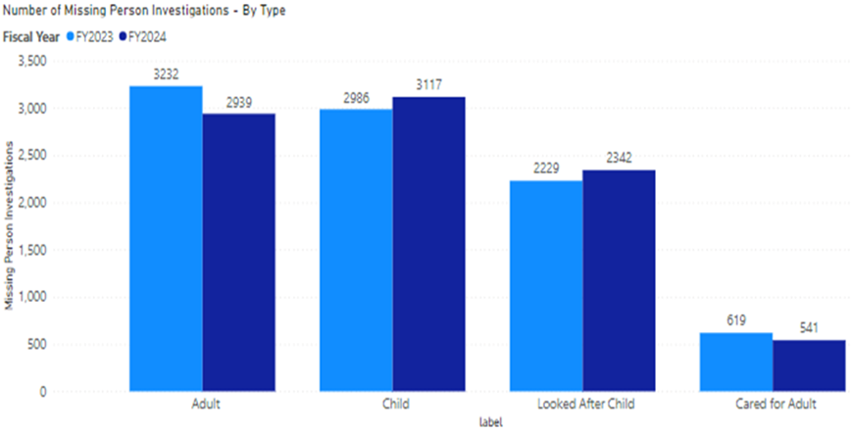
The following graph illustrates that in May and June this year investigations involving children and young people (CYP) were the highest they have been in the past two and a half years, however, have come down slightly over Quarter 2.
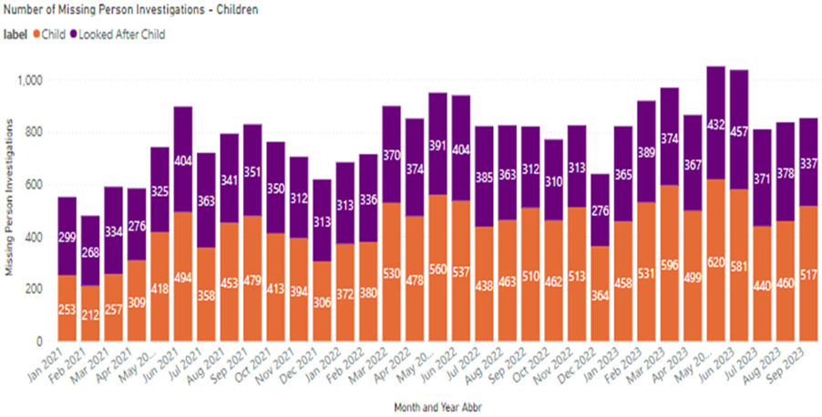
When considering the increases geographically there is no identifiable pattern. Some divisions have recorded significant increases where others have recorded large decreases.
When considering where people go missing from, slight increases can be seen in those that go missing from their home address or a young person unit.
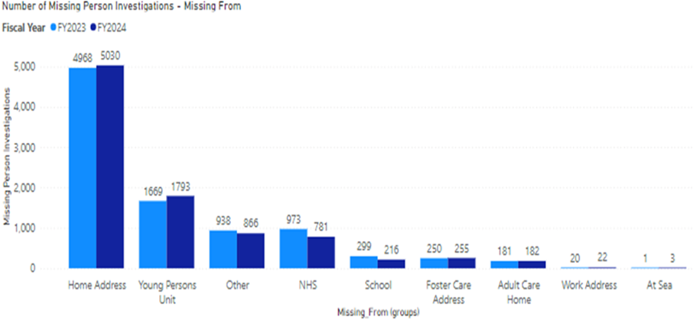

Health Check – Sharing Best Practice
Prior to the commencement of HMICS’ Inspection of Missing Person Investigations in Scotland, the National Missing Person Unit has conducted a health check with each territorial division and C3 division (Contact, Command and Control). Each division completed a questionnaire covering their use of the National Missing Person Application and Statistical Dashboard, their Quality Assurance Procedures and Partnership Working Solutions.
Individual feedback sessions were held with each division, where areas for improvement were highlighted and best practice shared, specifically, examining tactical and operational solutions to improve our response to missing persons’ investigations. Divisional quality assurances procedures were explored along with the use of all available data generated, targeting individuals and loci where preventative measures could be better implemented and by maximizing partnership working potential. Inputs and training was provided to staff in Care Houses regarding their responsibilities as Corporate Parents and the use of the Not at Home Policy for Care Experienced Children and Young People.
After the successful pilot in Edinburgh Division, Alzheimer’s Scotland will expend their return discussion interviews for persons living with Alzheimer’s to Fife and Lanarkshire Divisions in due course. Information Technology solutions continue to be sought to improve the operational effectiveness of officers attending missing person incidents; however, this is dependent on Digital Division’s capacity.

Road Safety
Road Casualties | 2022/23 YTD | 2023/24 YTD | % Change from Previous Year | 5 Year Mean | % Change from 5 Year Mean
People Killed | 93 | 80 | -14.0% | 79 | +1.3%
People Seriously Injured | 949 | 801 | -15.6% | 911 | -12.1%
Children (aged <16) Killed | 1 | 3 | +200.0% | 2 | +50.0%
Children (aged <16) Seriously Injured | 100 | 67 | -33.0% | 85 | -21.2%

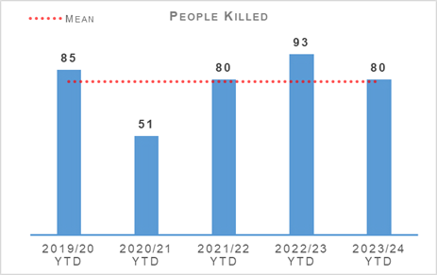 | 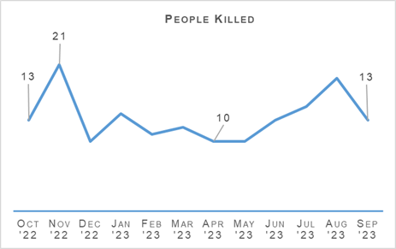
2023/24 FYTD there have been 80 fatalities on Scotland’s roads. This is a decrease of 13 compared to the same period last year and an increase of one fatality compared to the five-year mean. The five-year mean figure remains affected by the decrease in fatalities observed during COVID-19 restrictions where there was reduced traffic on the roads, however the number of fatalities has decreased by five compared to the figures from 2019/20 (being the last pre-COVID-19 year). Some fatalities recorded during the Quarter 2 period are still being investigated for possible medical-related causes or suicide and may reduce the total number of fatalities when enquiries are complete.
There have been three children killed on Scotland’s roads during this time, which is an increase of two compared to the previous year and an increase of one compared to the five-year mean.
The number of people seriously injured have decreased by 15.6% (148 fewer serious injuries) and decreased by 12.1% (110 fewer serious injuries) compared to the five-year mean. The recorded number of serious injuries for this Quarter are likely to rise due to there being records on police systems awaiting final authorisation before being added to final totals.
In Quarter 2 there were 4,001 Drink, Drug driving offences (including failure to provide a specimen). This is an increase of 14.8% (516 more crimes) compared to the five-year mean and an increase of 9.9% (359 more crimes) compared to the previous year.

Road Safety Framework (RSF)
Transport Scotland published key road casualties’ figures showing the progress made against the Road Safety Framework targets that ran from 2010 to 2020. All five targets on that previous framework were met, as per the following table:
Scottish Road Safety Targets 2020 | Target Reduction | Actual Reduction
People Killed | -40% | -52%
People Seriously Injured* | -55% | -68%
Children (aged <16) Killed | -50% | -76%
Children (aged <16) Seriously Injured* | -65% | -77%
*Please note that due to changes in severity recording the number of seriously injured people cannot be directly compared to those reported in previous years. Progress against these targets has been calculated on the basis of adjusted figures provided by the Department for Transport.
The current Road Safety Framework to 2030 (RSF2030) along with the 2022/23 delivery plan, the most recent published, built on this. The interim reductions sought regarding those killed and seriously injured on Scotland’s roads (from a 2014/18 baseline), together with the reduction achieved in 2022 are:
Scottish Road Safety Targets 2030 | Target Reduction | 2022 Reduction Achieved
People Killed | -50% | 0%
People Seriously Injured* | -50% | -37%
Children (aged <16) Killed | -60% | -17%
Children (aged <16) Seriously Injured* | -60% | -34%
* Please note that due to changes in severity recording the number of seriously injured people cannot be directly compared to those reported in previous years. Progress against these targets has been calculated on the basis of adjusted figures provided by the Department for Transport.
On 24 May 2023 the then Minister for Transport Kevin Stewart published his statement on the increase in overall fatalities from 141 in 2021 to 174 in 2022, accompanied by the above table. He outlined that this rise follows on from a long-term downward trend - since 2000, the number of people killed has decreased by 47%.
The interim reductions sought will remain challenging, as they should be, as we work with our partners toward Vision Zero - no deaths and no serious injuries on Scotland’s roads by 2050.
A few key risks have been identified via analysis and we will seek to mitigate these as we move forward:
The number of cyclists on our roads was boosted by the COVID-19 pandemic and, more generally, by people opting toward more eco-friendly sustainable modes of transport. Cycling is anticipated to further increase as a consequence of recent fuel price rises. We recognise the potential for collisions to also increase, with cyclist collisions often resulting in serious injury.
Motorcycle casualties have remained steady over the past few years, aside from the drop in 2020/21 due to the reduced traffic during COVID-19 restrictions.
With an ageing population, who remain mobile longer and continue to drive, it is anticipated that there may be an increase in older casualties.
In an effort to mitigate risks and reduce collisions on the road network, Police Scotland have identified a number of key opportunities.
Police Scotland's In-Depth Road Fatalities Study 2015-2020 has been supported by a Transport Scotland funded dedicated analyst and seconded Road Policing Sergeant. Working in partnership, a new road fatality database was established for this project, enabling a review of all fatalities on Scotland’s road network between 2015 and 2020. This deep-dive research affords a strong insight into fatal collision causes and outlines countermeasures toward the reduction of future collision risk and harm. Following a working group review, the full report and accompanying executive summary was published on 26 October 2023. Its recommendations will be progressed collaboratively with key partners.
Road Policing continues to work closely with Transport Scotland to understand trends and identify emerging threats in relation to all collision classes. Police Scotland analysts produce detailed problem profiles identifying specific casualty types, with particular focus on vulnerable road users. The information is shared with partners at forums such as the Tactical Options Working Group and Road Safety Governance Board. This sharing allows resources to be allocated to the greatest areas of risk in an effort to reduce harm on our roads, in partnership with local policing and assisted where appropriate by our key partners.
Acknowledging that some sections of the motorcycle community can be challenging to influence, the Scottish Government in partnership with Police Scotland have developed a working group to explore opportunities and develop engagement strategies moving forward. One example is Rider Refinement, an initiative providing rider training by Police and the Institute of Advanced Motorists instructors.
To date Police Scotland has delivered on all commitments made to support the Road Safety Framework (RSF) 2030. Our objective within the RSF to incorporate specific campaigns, initiatives and directed activity targeting the safety of Vulnerable Road Users (VRUs) - including cyclists, motorcyclists and pedestrians - continues to be met. During Quarter 2 the majority of campaign work has been focused toward protecting VRUs and/or targeting motorists committing Fatal-Five offences (Drink/Drug Driving, Careless Driving, Speed, Mobile Telephone, and Seatbelt). Our Engage/Educate/Enforce approach has been enhanced by Corporate Comms/Social Media support for all campaigns during this period.

Road Policing Campaign Updates

Motorcycle Safety Campaign – 14 April to 29 September
Support from Road Safety Scotland and Corporate Communications saw strong coverage of the launch event at Glenshee. With the intention of promoting safe and responsible riding and driving across Scotland’s road network, Road Policing and National Motorbike Unit officers carried out dedicated patrol activity on popular biker routes to engage, educate, encourage and enforce, with a strong focus on the contribution all road users can make to reducing rider casualties by adopting the right attitude and driving behaviours. During national initiatives across the campaign period, 2,993 riders were stopped with 372 offences detected amongst them. An additional 195 offences committed by other road users were also detected during these initiatives.

Summer Drink/Drug Drive Campaign – 26 June to 16 July
All operational police officers supported this initiative, interacting with drivers in order to educate and enforce legislation. High visibility and un-marked patrols were carried out on priority routes and at hotspots, combined with intelligence-led targeting. During the campaign a total of 408 drink and drug impairment offences were detected.

Commercial Vehicle Week – 17 to 23 July
Roadside checks, including initiatives in conjunction with the DVLA, HMRC, SEPA and others, were carried out during this week of action. In addition to engagement, education and enforcement action from partners, 104 offences relating to commercial vehicles and their drivers were detected by Road Policing officers during this work. Average speed camera thresholds at safety priority areas were reduced for the duration of this campaign. A total of 2,462 speeding offences were detected, the vast majority involving commercial light goods vehicles.

Drug Driving Week – 21 to 27 August
The aims of this campaign included educating motorists via both social media coverage and roadside interaction. This was combined with pro-active patrols/enforcement against all forms of impaired driving, but with a focus on those consuming drugs before driving. A total of 147 drink and drug impairment offences were detected during the campaign.

Vulnerable Road Users (VRU) Campaign – 18 to 24 September
This campaign focused on interaction with/protection of vulnerable road users, particularly pedestrians and cyclists. It also included hand-held laser speed checks in busy, pedestrian and cyclist rich areas and at previous VRU collision locations, impact speed being the main determinant of injury severity/survivability. A total of 434 speeding offences were detected by officers during the campaign.

Driver Engagement North – ongoing
Launched in the Highland and Islands and since extended to the Aberdeen and Dundee areas, the pilot has been funded by Transport Scotland’s Road Safety Initiative Fund. Participants in this person-centred initiative utilise a desktop driving simulator, with a fitness to drive input also included, to assist older road users and their families make informed choices about their fitness to drive safely. The simulators enable drivers to assess their hazard awareness in a safe virtual environment. This project has evaluated well and further funding has now been secured from Transport Scotland to expand Driver Engagement into the rest of Scotland.

Fitness to Drive Matters – ongoing
Considerable work is currently being progressed toward our Fitness to Drive Matters initiative, within our Older Road User Group, working with partners and older road users to reduce numbers killed or seriously injured in collisions. Road Policing have now secured funding from Transport Scotland’s Road Safety Framework Fund to support the roll-out of Fitness to Drive Assessments, in conjunction with the charity Driving Mobility’s DriveAbility Scotland team. The funding will cover 100 assessments in the north of Scotland, providing greater opportunity for older people there to access this help than would otherwise be possible from their Glasgow base.

New Driver Early Intervention Scheme – ongoing
The New Driver Early Intervention Scheme (NDEIS) is being rolled out nationally and partners, such as Scottish Fire and Rescue Service, have adopted the scheme and deliver it in conjunction with Police Scotland to internal and external groups. NDEIS is aimed at 17-25 year olds to positively influence this vulnerable group of road users, whilst providing a reminder of their responsibilities toward themselves and other road users. Several local authorities have adopted the scheme for delivery to modern apprentice/skills and employability students. Empowering young people with information allows them to make informed decisions when starting their driving careers, with a view to improving road safety for all.

Drive on the Left – ongoing
The 2023 Drive on the Left campaign continued in Quarter 2. Leaflets, wrist bands and stickers are given out to foreign drivers hiring a car whilst visiting Scotland. Bikers are also given reservoir covers as a visible aid to them regarding driving on the left. The campaign has received support from leading hire companies and funding from Road Safety Scotland.
Road Safety Impact
Operation TUTELAGE is a UK-wide initiative aimed at reducing the number of uninsured drivers. Police Scotland joined in April 2021.
This Criminal Justice led initiative centres on identifying uninsured vehicles using ANPR and subsequently writing an ‘Insurance Advisory Letter’ to the registered keepers, to inform them that driving without insurance is an offence. Working on the principle of behavioural compliance, the operation is designed to encourage the majority of compliant individuals to insure their vehicles.
From launch until end August 2023, the most recent month for which data is available, a total of 31,416 letters had been issued in Scotland. These produced a compliance rate of 67.9% within 14 days, above the UK average.
Key road safety benefits include:
Reducing the amount of uninsured vehicles utilising Scotland's road network, using positive engagement and resolution.
Optimising Police Scotland investment in upgrading our ANPR capability/infrastructure.
Collaborating with Road Policing to also facilitate pro-active, targeted enforcement.

Stop and Search
Stop Search | 2022/23 YTD | 2023/24 YTD | % Change from Previous Year
Stop Search Compliance Rate (%) | 98.9% | 99.2% | +0.3% point
16,348 stop and search incidents have been recorded by Police Scotland during the first half of 2023/24. This includes 539 searches under warrant. The number of searches recorded during the quarter was 16.5% more than in the same period last year but 12.8% fewer than the five-year mean.
30.5% of searches recorded during the period were positive – this is a decrease in the positive rate from this period last year of 3.7% points and a decrease of 5.7% points from the five-year mean positive rate. 4,130 searches led to the recovery of drugs, 479 recovered weapons and 294 recovered stolen property.
Nineteen of the searches that recovered weapons were conducted for a care & welfare reason, and a further six that recovered weapons was conducted for the protection of life reason.
6,586 stop and search records were audited for compliance during the second quarter of the year, bringing the 2023/24 YTD total number of searches audited to 15,435. This involves the records being reviewed by line managers and thereafter quality control checked by the National Stop and Search Unit to ensure their adherence to the Stop and Search Code of Practice introduced in May 2017.
Of the stop and searches reviewed so far this year, 13,723 (88.9%) were deemed compliant and recorded correctly on the stop and search database. A further 1,581 (10.2%) were compliant with the code of practice but required amendment to their details to ensure they were appropriately recorded.
131 (0.8%) records were deemed as not recordable under the code of practice or recorded in error and deleted from the database. Typical reasons for deletion include where a person is searched after being arrested, as a result of a duplicate record or where no physical search of a person has actually taken place.
It should be noted that the total number of records audited for compliance will be lower than the total number of searches raised during the period due to the timescales required to fully review all records.

Change Projects

Digital Evidence Sharing Capability (DESC)
The Digital Evidence Sharing Capability (DESC) pilot remains ongoing with a current national rollout scheduled for January 2024. During the pilot, DESC have raised over 6,279 pieces of evidence ingested from 944 cases, with 330 passed to COPFS and eight cases have gone to trial.

Policing in a Digital World
Policing in a Digital World aims to transform how Police Scotland respond to the evolving threat of cybercrime. Progress across the programme is going well with efforts concentrating on business case development in Cyber Training and Capability, Digital Forensics Data Sharing and Digital Forensics Structure projects, scheduled to go through governance towards the end of the calendar year.

Vulnerable Witnesses Act
The Vulnerable Witnesses (Criminal Evidence) (Scotland) Act 2019 (VW) Project is currently in a holding phase, with a Business Justification Case (BJC) in final stage of development pending further input from Scottish Government regarding scope and potential future phases. Feedback from the Expansion of the Pre-Recorded Evidence Working Group is also pending. The SRO/Business Team continue to engage with governmental stakeholders.

United Nations Convention on the Rights of the Child (Incorporation)(Scotland) Bill (UNCRC)
The Initial Business Case (IBC) for the United Nations Convention on the Rights of the Child (Incorporation) (Scotland) Bill (UNCRC) Project is complete, however, this may be replaced by a BJC, dependant on scope of Partnership, Prevention and Community Wellbeing (PPCW) and Criminal Justice Service Division (CJSD), therefore, submission through governance is scheduled for early 2024.

Age of Criminal Responsibility (ACRA)
The ACRA Project is in delivery and over 90% of officers have completed the mandatory basic ACRA training module. The supplementary ACRA Incident Management module currently has a completion rate of 57%. Briefings and comms are being sent out to encourage all appropriate ranked officers and staff to complete this training.

Strategic Outcome 2
The needs of local communities are addressed through effective service delivery.
Objectives:
Understand our communities and deliver the right mix of services to meet their needs
Support our communities through a blend of local and national expertise
Support the changing nature of communities

Call Handling
Call Handling | 2022/23 YTD | 2023/24 YTD | Change from Previous Year
Total Number of 999 calls | 378,959 | 456,561 | +20.5%
Total Number of 101 calls | 766,584 | 722,856 | -5.7%
Average 999 calls answer time | 10 sec | 11 sec | +1 sec
Average 101 calls answer time | 4 min 28 sec | 7 min 16 sec | +2 min 48 sec
Number of 999/101 calls that do not result in an incident/crime | 384,307 | 343,630 | -10.6%
Percentage of 999/101 calls that do not result in an incident/crime | 33.5% | 29.1% | -4.4% point
Note: Following the nationwide rollout of CAM, new call gradings are being used. These were updated again during August 2020; this is reflected in the table above. A small percentage of incidents are still being categorised under the old grading and are therefore not included in the above figures. Comparison data is not available.
The total number of calls to Police Scotland increased by 33,874 (from 1,145,543 to 1,179,417). This is an increase of 3.0% compared to the same period last year. The table shows 999 calls have increased by 20.5% when compared to the same period last year, however, the volume of 101 calls received decreased by 5.7%. Of the calls received, 29.1% did not result in an incident or crime being raised.
The handling of 999 calls remains our highest priority. Year to date our service centres achieved an average speed of 11 seconds for answering 999 calls which is a one second increase on the same period last year. The average call answer time for 101 calls increased by two minutes 48 seconds. This increase is partly due to increased 999 call volumes and as it is the same service advisors who take all 999/101 and ContactUs Emails therefore the wait time for non-emergency 101 can be longer.
Multiple factors have attributed to the 999 call increases; sporadic good weather continued throughout July, August and into September, large scale events including the UCI Cycling World Championships and summer festivals. This increase continues to be significantly higher than increase in 999 calls across the UK when comparing the same time period.
During this recording period service advisors are attending a continuous professional development event to consolidate the approach to THRIVE which has contributed to an increase in the average call handling time.
Efforts continue to signpost callers to more appropriate methods of contact, including via “Contact Us” and the force website. This is evident in the increase in the use of “Contact Us” Emails, which has increased by 21.1% when compared to Quarter 2 last year.

Incident Demand
Incident Demand | 2022/23 YTD | 2023/24 YTD | % Change from Previous Year
Incident Demand – Total Number of incidents raised | 761,236 | 835,787 | +9.8%
Number of incidents by response type - Immediate | 82,509 | 91,776 | +11.2%
Number of incidents by response type - Prompt | 311,334 | 309,135 | -0.7%
Number of incidents by response type – Standard Local Policing Appointment | 96,908 | 98,401 | +1.5%
Number of incidents by response type - Other Resolution | 252,547 | 320,477 | +26.9%
Incident Demand - % of incidents which lead to a crime | 27.2% | 26.8% | -0.5% point
Incident Demand - % of incidents requiring police response | 97.0% | 97.5% | +0.5% point
Partner Demand – Total number of external force request incidents | 1,502 | 1,891 | +25.9%
Note: A small percentage of incidents are still being categorised under the old grading and are therefore not included in the above figures.
Resolution Team (RT) follows a different data gathering process and the RT stats are reported separately. The qualifier codes available on STORM to achieve the split of the Standard incidents have now been removed, so it is not possible to extract the RT LPA, RT DCR and RT involved from Standard incidents. A small percentage of incidents are still being categorised under the old grading and are therefore not included in the above figures.

C3 Division Demand
In addition to the call numbers, there have been over 168,000 additional public contacts dealt with by Contact, Command and Control (C3) Division during the reporting period. C3 Division does not only deal with incoming calls from the public. Service advisors also deal with incoming calls from other partner agencies and alarm calls. There have been over 62,000 of these types of calls for this reporting period, an increase of around 18.1% in emergency service partner calls and a small decrease of around 4.3% in total alarms. Emergency service partner calls are received via dedicated numbers from Scottish Fire and Rescue, Scottish Ambulance Service, Mountain Rescue, Coast Guard, Mental Health Pathway (NHS 24), OmniCrash and Oil Industry Agency. The reason for such calls varies and each are dealt with by a service advisor in the most appropriate manner.
“Contact Us” emails and online reports, for some crime types, can be completed online. Each one of these reports is assessed by a service advisor using the Threat Harm Risk Investigation Vulnerability and Engagement (THRIVE) model. Over 101,000 “Contact Us” emails and over 5,500 online reports have been submitted since 01 April 2023.
Overall, additional public contacts are up by around 14.9% when compared to 2022/23.

Operation Lewintrick – UCI World Cycling Championships
Between 03 and 13 August, Scotland hosted 13 world championship cycle events which attracted over 8,000 participants. C3 Division hosted a National Co-ordination Centre whilst standing up and resourcing a Multi-Agency Co-ordination Centre and Police Only Control Centre supported by a dedicated Airwave Network cell. The event was a huge success with business as usual operations being largely unaffected.

C3 Continuous Professional Development Training
As part of the Modernised Contact and Engagement Program, the Contact, Engagement and Resolution Project completed a Training Needs Analysis (TNA) for C3 Division’s application of THRIVE. A bespoke course was created to provide comprehensive training to all C3 Division staff.
The course is running from September 2023, concluding in March/April 2024, and is delivered over one day and split into two modules. The morning session delivers training on the use of THRIVE within C3 Division. The afternoon session will train on the introduction the Mental Health Pathway Guidance Framework to support and assist with mental health related contacts.
This course will also provide the foundation and content for annual refresher training to be completed by all staff in C3 Division.

Police Scotland & NHS 24 Mental Health Pathway
Since 2020, the Mental Health Pathway has operated within C3 Division, whereby callers with a mental health need or in crisis can be referred, based on certain criteria, to the NHS 24 Mental Health Hub (MHH) for a mental health assessment over the telephone.
Since inception, Police Scotland and NHS 24 have continued to work in close collaboration to review and improve the pathway process and this has seen the development of the Mental Health Pathway Guidance Framework (MHPGF) for use in C3 Division.
From September 2023, officers and staff within C3 Division will be trained in this framework, facilitating a thorough assessment of the circumstances of a mental health incident, underpinned by a THRIVE assessment. Training will also incorporate mental health awareness to enhance knowledge and understanding when dealing with operational incidents with a mental health element.
C3 Division will seek co-operation of callers to refer to NHS 24 Mental Health Hub or signpost to other agencies in accordance with their training. Where there is an immediate risk or the caller refuses to engage with other services, the incident will be prioritised and dispatched.
Referral to the Mental Health Hub for those incidents assessed as meeting the criteria, provides the opportunity to better support individuals in mental health need or crisis.

Quality Assurance Framework
Following continual review of the Quality Assurance framework (QAF), C3 Division are increasing the volume of monthly quality assurance checks completed. Given the increasing complexity and changing demands of service delivery within C3 division, it is imperative to ensure we are providing the safest and most efficient service to the public and partners.
Every effort is made to maintain the highest levels of professional standards with ongoing support provided through:
Accessible, accurate and current guidance and information for all call and incident types.
A consistent emphasis on accurate THRIVE assessments at every point of contact through all C3 Division communication, team and individual briefings.
A dedicated complement of QAU staff who are able to identify, through intrusive reporting on trends, knowledge and performance gaps and business areas which may require supportive measures.
Additionally, the review identified a need for greater efficiency to the current quality assurance process. Initial scoping is underway with digital division and the Innovation Team at Dalmarnock to explore bespoke software solutions through Robotic Process Automation (RPA), which is a software technology to help drive efficiency and process improvements with digital systems and software.
Moving forward the proposal will seek to provide capacity for quality assurance to be more automated, efficient and scalable in line with demand whilst minimising the impact on supervisors. A prototype of this system has been developed and is currently in testing by C3 Division.

Notable Incident Process
Ongoing enhancements to the Notable Incident (NI) process were completed in the last quarter by C3 Division. A Summary of the changes made are as follows:
Notable Incident tracker redesigned – now provides increased management information and automatically highlights the number of Notable Incidents for each officer/member of staff during the current and the preceding calendar year
Notable Incident form redesigned to display relevant information from multiple business areas and to gather a greater degree of relevant information and streamline submissions and the administrative process
C3 Division’s Governance and Improvement (G&I) department have oversight from the start with an emphasis on learning and good practice through to conclusion
The introduction of a fortnightly C3 Learning and Review meeting to provide oversight and governance to the NI. This has evidenced an improvement in the average time taken to finalise a Notable Incident drop of 36 days in 2022, to 12 days in 2023, ensuring more timely learning and greater accountability
The introduction of the Notable Incident Intervention process provides local management with the information to appropriately intervene for welfare, training, performance support.
The introduction of a new NI Weekly Report provided to the C3 Division Assistant Chief Constable and Divisional Commander, providing greater detail in a more accessible format, along with an overview of current performance data.

Policing Together Campaign. Equality Diversity and Inclusion
C3 Division and Police Scotland have invested significant resource and energy in the Equality Diversity and Inclusion portfolio. Police Scotland’s Policing Together strategy sets out our commitments as an organisation in detail. Part of this has been the roll out of an Equality, Diversity and Inclusion (EDI) E-learning Module, for all officers and staff. The module provides key information to increase knowledge and awareness and also asks how lived experience plays a significant part in our decisions and actions each day. The module is within the training calendar and recertification takes place each year.
C3 ONE, is C3 Division’s commitment to Police Scotland’s EDI Strategy and Policing Together. Its vision is to ensure that C3 Division is welcoming, inclusive and representative of the communities we serve and that our people demonstrate our values, know that they belong and can fully be themselves.
The C3 ONE EDI Framework and Implementation plan outlines our strategy in more detail. The Framework is aligned to Police Scotland’s Equality and Diversity Strategy 2022-2026 and facilitates the capture and recording of our ED&I work being carried out within our Division.
C3 Division is currently the National pilot Division undertaking the LGBT Charter and working in conjunction with LGBT Youth Scotland enhancing awareness and working from a framework that can be applied to all protected characteristic groups. Part of the Charter journey will include training opportunities for leaders.

Trauma Informed Workforce
Working in partnership with Partnership, Prevention & Community Wellbeing (PPCW) (Children & Young People) a series of inputs are currently being delivered covering Trauma in childhood awareness training and will coincide with the work of the Care Experienced Colleagues group. The inputs will be tailored to meet the specific needs of C3 Division staff.
The experience and impact of trauma and adversity in the lives of those living in Scotland is more pervasive than has previously been recognised and has been exacerbated by the Covid pandemic. PPCW Division’s Children and Young People team are expanding delivery of trauma training currently delivered at SPC Tulliallan to include colleagues in C3 Division, Criminal Justice & Special Constables.
These sessions are part of the commitment to having a trauma informed workforce as part of the shared ambition of the Scottish Government, COSLA and partners from across Scotland to have a trauma informed and responsive nation. By being capable of recognising where people are affected by trauma and adversity we are able to respond in ways that prevent further harm while supporting recovery, addressing inequalities & improving life chances for all.
By looking at everything we do through a trauma informed lens we can be more understanding and improve our responses at every level of our organisation.
The training seeks to give all officers and staff a basic awareness and understanding of:
Trauma and what being trauma informed means
Adverse Childhood Experiences (ACEs)
Toxic stress and its impact on brain development in children and young people.

C3 Complaints and Allegations
C3 Complaint Allegations | 2022/23 YTD | 2023/24 YTD | % Change from Previous Year
Complaint Allegations received relative to C3 – on duty | 83 | 117 | +41.0%
Complaint Allegations received relative to C3 – Quality of Service | 117 | 116 | -0.9%
Total Allegations closed - relative to C3 | 48 | 25 | -47.9%
Percentage of total Allegations closed which were upheld – relative to C3 | 31.3% | 12.0% | -19.3% point
Total Complaints received relative to C3 | 150 | 170 | +13.3%
In total, 70.0% of complaint cases received year-to-date for C3 Division were frontline resolved by the PSD National Complaints Assessment and Resolution Unit (NCARU). This rate increases to 71.2% when early and subsequent resolution by PSD or specialist officers are included. These figures demonstrate that most complaints against C3 Division during this period have been non-criminal and non-serious in nature, with a majority resolved through simple explanation, apology or assurance.
Complaints against C3 Division have increased by 13.3% in the year-to-date compared to the same period last year, with a total of 170 received during this period. Regionally, there were 26 complaints in the North, 52 complaints in the East and 92 complaints in the West. North is up 136.4%, West is up 5.7% whilst East is unchanged from last year.
Incivility (90) and Service Delivery (82) remain the most common allegation types, together accounting for 73.8% of all allegations received during this period. Furthermore, both categories have registered an increase against the comparable period in 2022/23, by 32.4% (22 more allegations) and 22.4% (15 more allegations) respectively.
The increase in Incivility allegations is linked primarily to the North (up 12 allegations) and is assessed to be the key factor in the regional increase, which underpins the overall divisional increase. Furthermore, the increase in Service Delivery allegations – chiefly related to the Time of Response sub type - is attributable to the West (up ten allegations), which is assessed to influence the regional increase.
An additional increase at lower volume has been identified within Irregularity in Procedure allegations, with 23 received in total YTD (up 11 allegations). Primarily this rise relates to the sub types of Other (up four), Insufficient Enquiry Carried Out (up three) and Officer did not provide shoulder name or shoulder number (up three). However, each of these increases from the PYTD represent relatively low volumes and are therefore not currently assessed to represent a wider increase at this time.
Hate Crime
Hate Crime | 2022/23 YTD | 2023/24 YTD | % Change from Previous Year | 5 Year Mean | % Change from 5 Year Mean
Hate crime – number of incidents | 3,901 | 3,773 | -3.3% | 3,701.2 | +1.9%
Hate crime – number of crimes | 3,412 | 3,248 | -4.8% | 3,534.0 | -8.1%
Hate crime – detection rate | 63.2% | 58.9% | -4.3% point | 67.1% | -8.2% point

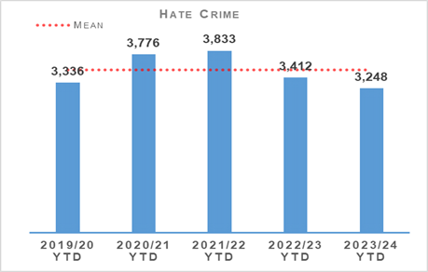 | 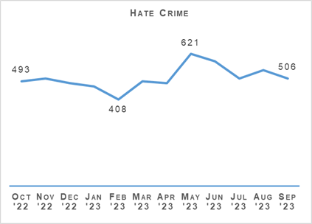
Hate incidents have decreased compared to the same period last year but remain slightly above the five-year mean. Hate crimes have decreased significantly compared to last year and are also below the five-year mean. The 12 month graph illustrates that crimes were high in May and June, however, have come down slightly over Quarter 2.
The hate crime detection rate is 4.3% lower than the previous year, however, was 7.4% lower at the end of Quarter 1. Context around investigations taking longer could be a factor in the detection rate being lower when compared to the previous year.
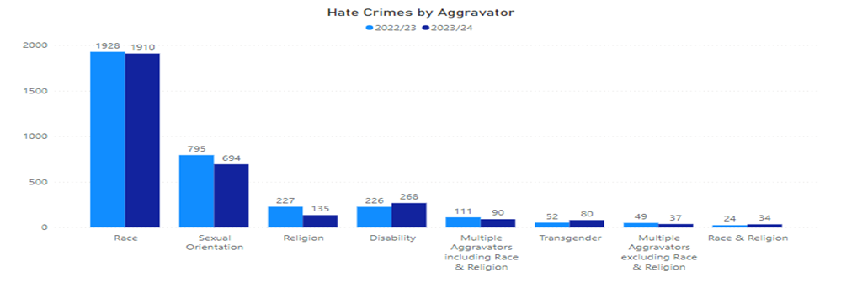
Hate crime with a race aggravator account for nearly 60% of all hate crimes, these crimes are marginally down on the previous year. The only aggravator types recording an increase compared to last year are Race & Religion, Disability and Transgender hate crimes. This coincides with Police Scotland’s drive to improve reporting of this type of crime with a number of media campaigns and enhanced partnership working.

Hate Crime and Public Order Legislation
Police Scotland continue to roll out Core Operational Solutions programme to enhance how we record operational information and will include enabling full implementation of the new Hate Crime and Public Order (Scotland) Act 2021. The Act will be implemented on 1st April 2024. In preparation for the Hate Crime Public Order (Scotland) Act being implemented, we have created a universal e-learning training package which is on schedule to be submitted to Leadership Training and Development. The package has been consulted on by internal departments, staff associations and external partners and all feedback has been evaluated accordingly. The Section 15 requirements for disaggregated data to be submitted to Scottish Government has been agreed upon by Police Scotland and Scottish Government and has been submitted to COS for inclusion on the required area within COS.

Hate Strategy for Scotland
Police Scotland continue to work alongside Scottish Government and the Strategic Partnership Group to deliver on our commitments within the ’Hate Strategy for Scotland’ which was published in March 2023 and sets out the vision for a Scotland where everyone lives free from hatred and prejudice.
Police Scotland continue to encourage people to report hate crime and for them to feel that the report will be dealt with appropriately. As such, as part of the commitments for the Hate Strategy for Scotland and for recommendations within the HMICS Inspection, Police Scotland have been progressing with a review of Third-Party Reporting (TPR). We have now sought volunteers from members of the Strategic Partnership Group to form a short life working group (SLWG) to conduct a full review of TPR including policy development, rebrand, project delivery and an annual review process.

Policing in a diverse society
Police Scotland are committed to learning from lived experience and understand that we cannot teach officers and staff an entire culture or values or cultural norms for every group in Scotland. As such, Police Scotland are working to deliver our ‘Policing in a Diverse Society’ resource, which focuses on officers and staff tailoring their approach to meet the needs of individuals and communities. ‘Policing in a Diverse Society’ is a 3-tiered approach which includes an overall toolkit, a knowledge hub and training module. This work stream is reporting to the Policing Together Communities Group and the Policing Together Tactical Group and internal and external consultation will be commencing soon.

British Sign Language (BSL) Interpreting Services
The BSL SLWG are in the process of drafting a national action plan. The group have met with interpreter providers to identify ways of improving provision of interpreting services. Police Scotland are working with providers on planning an ‘interpreter training day’ to encourage more interpreters to take on police work. The group have also hosted a number one day BSL introductory courses which it is open to anyone whom purpose is to improve service delivery and be a more inclusive employer. To date evaluations and feedback have been very positive and a full evaluation will be completed when the courses conclude in mid-July.
Other areas being reviewed is the use of video interpreting to improve service provision.

Recording of non-crime hate incidents
The recommendation to adopt the College of Policing interim guidance on the recording of non-crime hate incidents has been approved. Police Scotland are reviewing the guidance and training to identify impact to Police Scotland. Due to timescales this is unable to be done in conjunction with the Hate Crime and Public Order Legislation training. A further training/guidance will be developed in due course.

Anti-social Behaviour and Disorder
Antisocial Behaviour and Disorder | 2022/23 YTD | 2023/24 YTD | % Change from Previous Year | 5 Year Mean | % Change from 5 Year Mean
Number of antisocial behaviour incidents reported by the public | 151,026 | 145,871 | -3.4% | 184,112.8 | -20.8%
Number of complaints regarding disorder | 106,696 | 103,625 | -2.9% | 134,125.2 | -22.7%

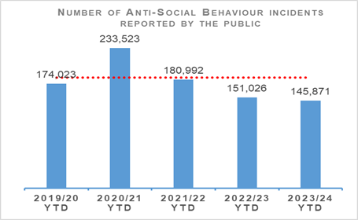 | 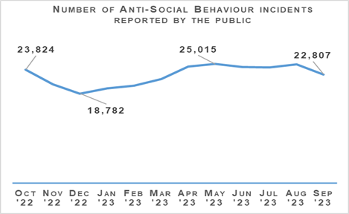
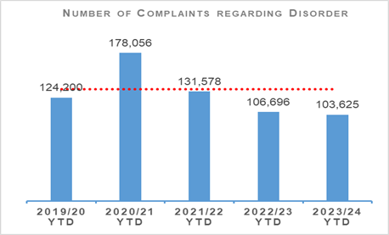 | 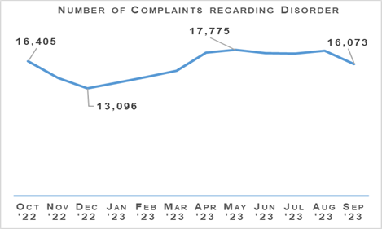
Both complaints of disorder and incidents of anti-social behaviour were slightly lower in the first half of 2023/24 than the same period last year. Disturbance incidents, followed by public nuisance incidents made up the majority of publicly reported ASB incidents, comprising 31% and 22% of the total respectively. The volume of disturbance incidents rose slightly compared to last year, although was below the five-year mean. Public nuisance incidents were at their lowest level in recent years. Other ASB incident types such as noise complaints, communications incidents, damage incidents and neighbour disputes were below the five-year mean for this period.
The “It’ll cost you” Proxy Purchase campaign ran from 05 June – 18 August 2023. An evaluation report will be completed, and results published later in 2023.
The Fireworks and Pyrotechnic Articles (Scotland) Act 2022 continues to be introduced in stages throughout 2022-24.

Acquisitive Crime
Group 3 Crime | 2022/23 YTD | 2023/24 YTD | % Change from Previous Year | 5 Year Mean | % Change from 5 Year Mean
Number of crimes | 51,789 | 57,414 | +10.9% | 51,174.8 | +12.2%
Number of detections | 16,191 | 17,965 | +11.0% | 18,282.6 | -1.7%
Detection rate | 31.3% | 31.3% | No change | 35.7% | -4.4% point

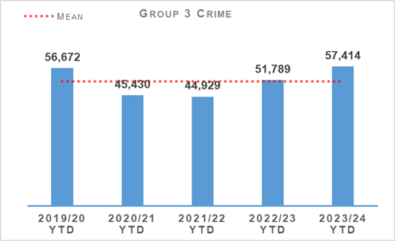 | 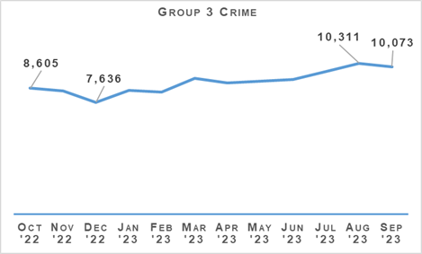
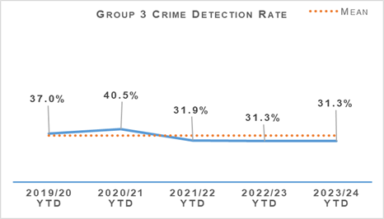 | 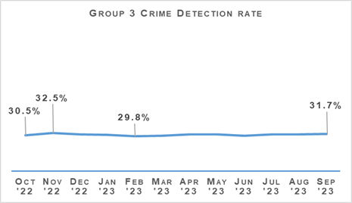
Acquisitive crime has continued to increase compared to the same period last year and is now 12.2% higher than the five-year mean, it should be noted however that the five-year mean has been affected significantly by decreases in acquisitive crime during the COVID-19 pandemic. Between April and September 2023 there have been 5,178 more crimes compared to the same period the previous year, and 6,239 more than the five-year mean.
If fraud is excluded, Group 3 crimes have still risen by 8.7% (5,307 more crimes). Shoplifting crimes continues to be the main contributor to this increase from the previous year, increasing by 5,141 crimes. Increases have also been seen in domestic housebreaking (up 281 crimes) and motor vehicle thefts (up 257 crimes).
Despite the overall increase, some aspects of acquisitive crimes have continued to fall compared to the same period last year. Common theft crimes have reduced from 14,701 to 14,129 (572 fewer crimes), and theft of pedal cycles have reduced from 2,283 to 2,055 (228 fewer crimes).

Shoplifting
Shoplifting crimes have continued rising and are now at higher levels than those seen pre-pandemic and are higher than the five-year mean. Between April and September 2023 there have been 19,244 crimes, 36.5% (5,141 crimes) more than the same period last year and 40.6% (5,560 crimes) higher than the five-year mean. This increase has seen shoplifting crimes rise to above those seen pre-pandemic, with 3,062 more crimes than during the same period in 2019.

Housebreaking
Housebreaking has experienced an increase year to date of 8.5% (363 crimes) compared to last year. Over the period there has been a total of 4,644 housebreaking crimes. Despite this year-to-date increase, housebreaking is 13.2% lower than the five-year mean and 27.4% lower than levels seen pre-pandemic (2019/20).
Increases can be seen in each area of housebreaking with domestic housebreakings rising by 281 crimes, commercial housebreakings rising by 70 crimes and non-dwelling domestic housebreakings rising by 12 crimes compared to 2022/23.
Domestic housebreakings are now 13.3% higher than the same period last year (72 more crimes). Between April and September 2023, 2,401 domestic housebreaking crimes were recorded, compared to 2,120 crimes last year and the five-year mean of 2,655.2 crimes. Domestic housebreaking remains at a much lower level than pre-pandemic, there has been 819 fewer crimes in 2023/24 than over the same period in 2019/20.
Non-dwelling domestic housebreakings are 1.3% higher than last year, increasing from 941 in 2022/23 to 953 in 2023/24.
Commercial housebreakings have also experienced an increase, rising 5.7% YTD, with 1,290 crimes recorded between April and September 2023, up 70 crimes on the same period this year.

Vehicle Crime
Between April and September 2023 there has been 6,266 crimes, 9.2% (530 crimes) more than the same period last year and 1.5% (93.2 crimes) more than the five-year mean. This increase has been due to rises in thefts from motor vehicles (257 more crimes), opening lockfast place – motor vehicle (228 more crimes) and theft from a motor vehicle (24 more crimes).
Detections over the period have increased from 1,587 to 1,783 compared to the same period last year which has had an impact in the detection rate. The rate is 28.5%, 0.8 percentage points higher than the same period last year and 0.4 percentage points below the five-year mean.
Police Scotland through the divisional, regional and national structures continue to identify and pursue opportunities to develop our tactics, knowledge and awareness on emerging technologies and where appropriate utilise technology to reduce risk and bring offenders to justice. Work continues to build on existing intelligence around the most frequently used transport routes out of the UK for stolen motor vehicles, working with ports and partner agencies to encourage the proactive sharing of information and best practice relating to vehicle crime. Through continued partnership working between COPFS and Police Scotland, prevention and early intervention opportunities should be sought to tackle reoffending with particular focus on those aged under 25 in order to fulfil our commitment to protecting vulnerable people while reducing the impact of this criminality on Scotland’s communities.

Rural Crime
The total cost of rural crime for April to September 2023 totalled £2,576,176 with a total of £434,590 recovered. This compares to a total cost of £1,628,927 and £206,837 recovered for the same period last year. This indicates an overall reduction in the financial harm to Scotland’s rural communities of £947,249. Over the period, the number of reported rural offences to Police Scotland was 553 compared to 452 in 2022/23, an increase of 22.3% (101 crimes incidents and offences).
The National Rural Week of Action was launched in Melrose with support from Scottish Borders Council, NFU Scotland, Neighbourhood Watch Scotland and our National Rural and Acquisitive Crime Unit (NRACU) team as Scottish Partnership Against Rural Crime (SPARC). The event aims to raise awareness of the impact of rural crime and deliver a crime prevention message. The launch gained significant interest with both national and local print media in attendance.

Fraud
Fraud | 2022/23 YTD | 2023/24 YTD | % Change from Previous Year | 5 Year Mean | % Change from 5 Year Mean
Number of crimes | 8,298 | 8,616 | +3.8% | 6,298.2 | +36.8%
Number of detections | 1,424 | 1,267 | -11.0% | 1,536.4 | -17.5%
Detection rate | 17.2% | 14.7% | -2.5% point | 24.4% | -9.7% point

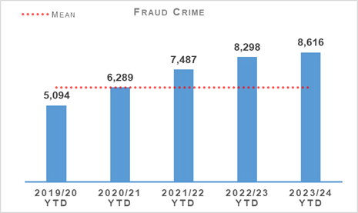 | 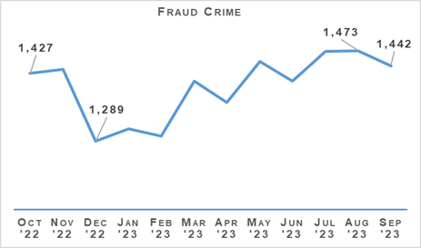
Fraud crimes have continued to rise, increasing 3.8% compared to the same period last year and 36.8% from the five-year mean. Fraud remains a significant global issue which is recognised as the most prominent crime type within the UK. Within Police Scotland we continue to see increases in reported fraud and, coupled with limited resource locally to investigative fraud, our detection rate is falling.
Police Scotland continue to engage with the City of London Police and are actively considering the possibilities and opportunities of joining the Fraud & Cyber Crime Reporting and Analysis Service, due for implementation in March 2024.
The service would assist in ensuring a true UK picture of fraud trends, intelligence and would enhance the targeting of offenders whilst providing more effective prevention and messaging campaigns to safeguarding vulnerable victims.

Cybercrime
Policing in a Digital World Project (PDWP) aims to transform how Police Scotland respond to the evolving threat of cybercrime. The programme will enable us to continue keeping Scotland’s people, communities, businesses and assets safe in both the physical and virtual world. We will capture digital opportunities to keep people safe and enable Police Scotland, the public and organisations to proactively recognise and respond appropriately to cyber incidents.
One of the top priorities of PDWP is to make sure all officers and staff, on the frontline and in specialist roles, have the appropriate skills, equipment, technology and support to prevent, respond to and investigate cybercrime. The training is a part of a whole system approach to combating cybercrime. This includes training that will provide awareness and tailored support so that officers and staff better understand their role in policing in a digital world and can respond effectively and support the changing nature of our communities.
The cyber threat is a major risk to Scotland’s economy and to our broader digital resilience. The establishment of the Scottish Cyber Co-ordination Centre (SC3) is a Ministerial commitment within the Covid Recovery Strategy which highlighted the need to build on our cyber resilience efforts, bringing forward the establishment of a recognised, authoritative and collaborative function to combat the accelerating threat of cyber-attack to Scotland. The SC3 will initially be hosted within the Scottish Government but will draw expertise from a number of key strategic partners including the Scottish Government and the National Cyber Security Centre and seek to maximise our ability to work together to improve the response to the emerging cyber threats and attacks.

The Banking Protocol
The Banking Protocol is a multi-agency initiative between law enforcement, banking institutions and Trading Standards. Its aim is to identify vulnerable victims at the earliest opportunity, who are in the process of being defrauded of funds from their bank accounts by unscrupulous criminals and to intervene to prevent these crimes.
If staff suspect customers are being coerced or the transaction is as a result of fraud, the transaction is stopped and the Police are contacted.
The Protocol is designed to provide a standardised method for how these concerns are dealt with and reported to police and to stop multiple victimisations.
In terms of Quarter 2 of the reporting year 2023/24, the Banking Protocol recorded 312 incidents accounting for £1,237,901 of fraud being prevented. To date this financial year has recorded 590 incidents, amounting to £2,150,651 of fraud being prevented.
This initiative continues to succeed in protecting the vulnerable victims of fraud and its success demonstrates the value of the public / private partnership model.

Multi-Agency Triage Hub
The multi-agency financial triage hub project was set up to tackle the upward trajectory of fraud reporting, predominantly across the cyber enabled/dependent landscape. The prime directive of the hub is to work alongside specialist banking departments, trading standards, business resilience organisations, Scottish Government and partner agencies to identify new and emerging crime trends, share information and build intelligence. This multi-agency approach, identifies vulnerabilities, allowing protective and preventative work to be carried out by all organisations increasing the intelligence picture. The specialist officers link previously unlinked crimes and associate these crimes to existing or newly formed crime groups committing fraud through daily triaging of all frauds reported to Police Scotland
The hub pilot has culminated in a final report which was approved at the Senior Leadership Board in July 2023. As a result of discussions across Police Scotland and the various elements of work ongoing in relation to Fraud, it was agreed at ACC level that Police Scotland’s Policing in a Digital World Programme (PDWP) would coordinate this activity in support of enhancing our ability to tackle Fraud and now lead the project moving forward. In September 2023, the Fraud Strategy and Operating Model Coordinating Group agreed that an expansion of the triage pilot be commenced in terms of the creation of an East Fraud Triage Hub.
The hub is resourced from Edinburgh, The Lothians and Scottish Borders, Forth Valley and Fife Divisions existing resources, to bring about the comprehensive change necessary to become a centre of excellence in the triage, management and recording of Fraud related crimes in Scotland. By exploring the different elements of our organisation and taking cognisance and learning from across Scotland we have developed our objectives and designed enablers to direct our transformation.
The benefits of the triaging and multi-agency approach is the creation of a sustainable model, that will create a future proofed approach to manage demand. This will provide relevant, useable data and intelligence to law enforcement and partner agencies on new and emerging trends. It will improve the victim experience and victim satisfaction, increase intelligence, increase policing capacity and reduce demand on policing and partner resources and improve criminal justice outcomes. The hubs operating model will prevent crime, reduce harm, will contribute to an improved understanding of the threat from serious and organised crime and will improve systems inter-operability and align with other national programmes of work.
By developing investigative standards, Police Scotland will be able to better manage demand and resource across the organisation to ensure the threat and risk of fraud reports are triaged at the outset with clear lines of responsibility for where they should be directed within the organisation. With proactive fraud capability in line with Police Scotland’s Cyber strategy and acknowledgement that prevention will play a pivotal role, we have developed a partnership approach to fraud that will deliver successful outcomes to our communities and enhance Scotland’s resilience.

Detection Rates
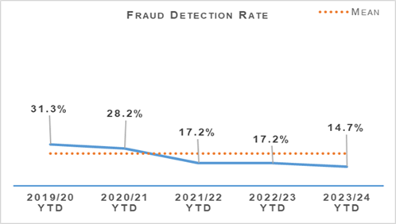 | 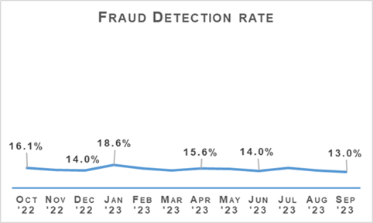
The fraud detection rate currently stands at 14.7%, down 2.5 percentage points on last year and 9.7 percentage points on the five-year mean. This decrease has been driven by a decrease in detected crimes and also the continued increase in recorded frauds. Between April and September 2023, 1,267 frauds were detected, which is 11.0% (157 detections) less than the same period last year and 17.5% (269.4 detections) less than the five-year mean.

Police Custody

Criminal Justice
Criminal Justice | 2022/23 YTD | 2023/24 YTD | % Change from Previous Year
Volume of cases submitted into Criminal Justice System | 60,534 | 56,795 | -6.2%
The volume of cases is down 6.2% on last year. At the end of Quarter 1 this fall was 18.8%, so whilst the volume continues to be down on the same period last year, it is not as stark as the last Quarter. There has been an improved use of Direct Measures on the last Quarter however this does not fully explain the difference.

Arrested Persons
Arrested Persons Brought into Custody | 2022/23 YTD | 2023/24 YTD | % Change from Previous Year
Number of times arrested persons brought into custody | 49,345 | 51,844 | +5.1%
It is important to note that the number of arrested persons includes individuals who have appeared in custody on more than one occasion within the reporting period. This excludes voluntary attendance, S.23 MDA 1971 detentions and those in transit.
Custody throughput continues to rise after the pandemic with this being the sixth consecutive quarter where it has done so.
Arrested Persons Held for Court | 2022/23 YTD | 2023/24 YTD | % Change from Previous Year
Number of arrested persons held for court | 20,055 | 22,144 | +10.4%
Proportion of arrested persons held for court | 40.6% | 42.7% | +2.1% point
Number of arrested persons held for court in relation to a new case | 13,619 | 14,744 | +8.3%
Proportion of arrested persons held for court in relation to a new case | 67.9% | 66.6% | -1.3% point
The figures for Quarter 2 continue to show an increase in the number of individuals arrested being held for court in comparison to the same period last year. The proportion of arrested persons held for court is sitting at 42.7% which is steadily rising.
Arrested Persons Released / Re-arrested | 2022/23 YTD | 2023/24 YTD | % Change from Previous Year
Number of arrested persons released on an undertaking | 11,873 | 12,181 | +2.6%
Proportion of arrested persons released on an undertaking | 24.1% | 23.5% | -0.6% point
Proportion of persons released on investigative liberation | 286 | 453 | +58.4%
Number of persons re-arrested | 0.6% | 0.9% | +0.3% point
The term ‘re-arrested’ is defined as any occasion whereby a person, previously released without charge as a ‘Not-Officially Accused’ person, is subsequently re-arrested for the same offence due to the presence of further evidence. This is not to be confused with a person arrested more than once within a specified period on separate charges as defined by recidivism.
Police Scotland is no longer in a position to provide figures related to electronic bail as this is managed on behalf of the Scottish Government by G4S. Police Scotland are only notified of relevant breaches.
Use of undertakings has increased slightly against the same period last year, in accordance with the presumption of liberty principles. Use of investigative liberation has also risen marginally, with a targeted campaign recently to promote its benefits to Divisional Senior Leadership Teams across the organisation. The objective leading into Quarter 3 is to target front line staff and supervisors to further improve its use.

Children brought into Police Custody / Held for Court
Children brought into Police Custody / Held for Court | 2022/23 YTD | 2023/24 YTD | % Change from Previous Year
Number of Younger Children Arrested and Accepted into Police Custody (not held overnight) | 722 | 855 | +18.4%
Number of younger children arrested and held overnight | 90 | 69 | -23.3%
Number of younger children held over 24 hours | 13 | 22 | +69.2%
Number of Older Children Arrested and Accepted into Police Custody (not held overnight) | 879 | 838 | -4.7%
Number of Older Children Arrested and Held Overnight | 247 | 244 | -1.2%
Number of Older Children Held Over 24 hours | 133 | 101 | -24.1%
Definitions for clarity: Adult being defined as 18 or over; Older Child being defined as 16/17 and Not under Supervision; Younger Child being defined as Under 16 or 16/17 but subject to a Compulsory Supervision Order. The number listed as held over 24 hours are those who were held in a police cell and had a relevant certificate in terms of S.22 of the Criminal Justice (Scotland) Act 2016 issued indicating why they were so held and not at a place of safety. **Overnight is determined as the period of time spent in custody which exceeds four hours and includes the period between 0000 and 0400 hours.
There has been a fall across the board in relation to older children in custody which is a vast improvement from the Quarter 1 period.
There has been an increase in the number of younger children held in custody over 24 hours. CJSD do however understand that police custody is not a suitable environment for young children and will continue to explore alternative options.
In contrast, the number of younger children held overnight has dropped by nearly a quarter.

Police Direct Measures
Police Direct Measures | 2022/23 YTD | 2023/24 YTD | % Change from Previous Year
Number of ASB Fixed Penalty Notices (FPNs) issued | 2,923 | 2,665 | -8.8%
Number of Recorded Police Warnings (RPWs) issued | 10,670 | 11,475 | +7.5%
Usage of alternatives to prosecution are on the increase from Quarter 1 with Fixed Penalty Notices up 157 and Recorded Police Warnings up 421 on the last quarter. Whilst FPNs have decreased compared to 2022 overall there has been an increase in their use over this Quarter. The increased use of RPWs from 3.6% in Quarter 1 compared to 2022 to an improved use of 7.5% demonstrates the benefits of CJSD continuing to positively engage with local policing divisions regarding their use. Police Scotland continue to explore ways of achieving justice for victims at the closest point to the crime.

Vulnerability
Vulnerability | 2022/23 YTD | 2023/24 YTD | % Change from Previous Year
Number of persons arrested who have declared current or historic alcohol addiction issues | 5,997 | 6,639 | +10.7%
Proportion of persons arrested who have declared current or historic alcohol addiction issues | 12.2% | 12.8% | +0.6%
Number of persons arrested who have declared current or historic drug addiction issues | 7,556 | 8,596 | +13.8%
Proportion of persons arrested who have declared current or historic drug addiction issues | 15.3% | 16.6% | +1.3% point
Number of persons arrested who have declared current or historic Mental Health issues | 20,849 | 22,363 | +7.3%
Proportion of persons arrested who have declared current or historic Mental Health issues | 42.3% | 43.1% | +0.8% point
Please note, each custody may have reported "yes" to each of the above categories.
The proportion of persons declaring one or multiple vulnerabilities is rising however this could be linked to more individuals being arrested and brought into custody.
NHS Partners in Custody Centres | 2022/23 YTD | 2023/24 YTD | % Change from Previous Year
Number of people in custody seen by NHS partners in custody centres | 3,477 | 3,773 | +8.5%
Figures provided represent the numbers marked out of cell for medical assessment (excluding those to hospital). They do not include those individuals who are subject to several medical assessments as is often the case during longer periods in custody.
As individuals with certain vulnerabilities rises, the number of healthcare referrals whilst in custody increases in conjunction.
Partner Referrals | 2022/23 YTD | 2023/24 YTD | % Change from Previous Year
Number of arrested persons referred to partners | 756 | 598 | -20.9%
The figures for Quarter 2 indicate an overall fall in TSO forms received since Quarter 1 in this reporting period. The decrease is across all services areas and not limited to a particular area.
Contact will be made with those services where numbers have dropped this quarter across the board. As these numbers record only the number of Third Sector Organisation (TSO) forms that have been submitted to the healthcare and interventions teams, it is also believed these numbers under report the number of actual referrals made to our partners, especially those where link workers visit the cells.
Along with working closely with partners to improve the accuracy of these figures we are also looking to have a re-launch of the interventions program to raise awareness of the arrest referral pathway with our staff once more.

Productions
Productions | 2022/23 YTD | 2023/24 YTD | % Change from Previous Year
Total number of productions received | 303,528 | 297,854 | -1.9%
Total number of productions disposed | 150,974 | 144,404 | -4.4%
Total number of productions accumulated | 152,554 | 150,800 | -1.1%
% of productions accumulated in terms of total received | 50.3% | 50.2% | -0.1% point
In the Quarter 2 reporting period there has been a continued decrease in the number of productions accumulated, with a continued steady fall of the number of productions received.
There has been a small decrease in the number of productions disposed of and this will be monitored over the coming months to identify any trends or improvements that can be made.

Summary Case Management Pilot
COPFS are currently undertaking a review of all three pilot courts, Dundee, Paisley and Hamilton which should be due for publishing during the Quarter 3 period.
Since the pilot began there have been over 2,300 domestic cases registered with over 1,600 specified evidence requests generated from other non-domestic cases.
Over 2,700 first issue police witness citations for domestic cases have been saved through early resolution of the case with over 2,300 first issue police witness citations for specified evidence cases also saved.
The project team are working closely with justice partners developing the next area for expansion of the pilot.

Witness Availability and Citations
Work is continuing within the area of court demand to explore any practical methods of reducing the demand court attendance has on the welfare of officers and the abstractions from operational duties at key times of the week.
Development work on a new court scheduler is continuing.
The Ayrshire Division pilot targeting court demand through assessing officers’ shifts against citations and Operating Base Level (OBL) has continued throughout Quarter 2.
In the first four months of the pilot, Police Scotland has requested 731 records to be reviewed with 264 countermands granted. This equates to a 36% reduction. A paper will be submitted in relation to the benefits to both Police Scotland and COPFS in due course.

Trauma Informed Domestic Abuse Court – Aberdeen
Work on the implementation of a Sheriffdom wide fully virtual domestic abuse court model remains at the discussion stage with the Scottish Courts and Tribunal Service asking all relevant parties to commit to a workshop day to advance this during the early part of Quarter 3.
This model would create a supportive environment for victims and witnesses who are particularly susceptible to trauma caused by having to attend court and give live evidence in close proximity to the accused and their supporters.

Change Projects

Offender Management Unit (OMU)
Digital Division continue to assist the Sex Offenders Policing Unit (SOPU)/Offender Management Unit (OMU) Project with Lifetime Management Support. The End of Project Report (EPR) is subject to delay; currently scheduled to progress through governance early 2024.

Strategic Outcome 3
The public, communities and partners are engaged, involved and have confidence in policing.
Objectives:
Embed the ethical and privacy considerations that are integral to policing and protection into every aspect of the service
Protect the public and promote wellbeing across Scotland by providing services that are relevant, accessible and effective
Work with local groups and public, third and private sector organisations to support our communities

Public Confidence and Experience of Policing
Police Scotland’s Public Contact and Engagement Strategy sets out how we envisage our public contact, engagement activities and approaches to look now, and in the future. We have been clear in setting out what the public should expect from their police service and how we will continue to engage and involve communities and our partners.
Our Public Engagement and Participation Framework sets out the ways in which we listen to and do things with communities to ensure policing meets their needs. Working in this way aims to inform operational and strategic decision-making, ensuring that Police Scotland operates using evidence-led principles in line with our values and service standards.
The Public Confidence Governance Board oversees our understanding of public confidence to influence change. Public insights are considered at the Strategic Leadership Board and Local Policing Management Board for Executive oversight, at Regional Delivery Boards which include local policing divisions in the north, east and west regions, and directly with local policing divisions for responding to local needs and scrutiny.
There are differences between trust, confidence and user experience, which considered together, provide a rich story about how policing is perceived and experienced. Public confidence is about our legitimacy and enables us to continue to police by consent while trust is about our brand and reputation, associated with organisational competence i.e. professionalism, responsiveness, reliability and knowledge. User experience captures people who have contacted the police. Gathering the data on these areas, which are outlined in this report, enable the service to understand what we do well, what is influencing confidence, and where we need to focus efforts for enhancing confidence to report crime and other incidents.
Police Scotland recognises the importance of keeping the public, communities, colleagues and partners engaged and involved in service changes and transformation. Our Policing Our Communities programme puts maintaining public trust, confidence and high levels of user satisfaction at the heart of its approach.

Public Insights, Research and Engagement Activities
We continue to engage and involve the public, communities and partners in policing through our continuous national surveys and other engagement activities.
Your Police 2023-24 survey – our local police survey for this year continues to receive a robust and representative response from the public and communities. Anyone who lives in Scotland can influence local policing in their area through this survey.
User Experience Survey – our independent survey to measure and enhance people’s experience of contacting Police Scotland. The survey is sent via text message to a sample of around 12,000 people who have made contact with police each month and receives approximately 1,200 responses each month.
Local Police Plans – All 28 Local Police Plans covering 32 local authority areas were enhanced using public feedback for the 2023-26 period and the new Annual Police Plan for 2023-24 was developed based on our insights.
In 2023/24 we are focusing on embedding our learning from research and engagement findings within the service. Areas of focus include how we respond to mental health and wellbeing needs; build confidence and trust in policing within minoritised communities; and keep the public, communities, colleagues and partners engaged and involved on what is needed for Police Scotland to be an anti-discriminatory police service.

Results from our Your Police and User Experience Surveys

Your Police: Our conversation with Scotland’s communities
Our Your Police survey continues to be the largest of its kind in the UK and involves the public in a conversation about policing and their local community. This enables them to highlight feelings of safety, areas of concern, what police are doing well and what might be impacting confidence in local police.
The survey is representative of the population by age, gender, disability and long-term conditions and geography. The 2022/23 survey received 16,993 responses between 12 April 2022 when it opened and 27 March 2023. This includes 95 British Sign Language (BSL) responses.
Our 2023/24 survey currently has 8,517 (up 8,226 since Quarter 1) responses. New communications resources are supporting Divisional Commanders and partnership activities locally will continue to drive a diverse response to our survey. An enhanced package of social media promotion went live in Quarter 2 to boost responses, and partnership superintendents have received more information that can be shared within their local networks. Corporate Communications have also provided support to tie key messaging and opportunities around public confidence and receiving feedback about policing with Black History Month planning.

Public Confidence in Policing
We know that confidence is closely affected by how policing is experienced and perceived locally. However, this is a nuanced picture. Our national Trust Index (a broadly representative sample of Scottish adults) highlights that media reporting of policing in other parts of the UK does have some influence in perceptions of Police Scotland.
Our analysis of public feedback shows confidence in police is shaped by experiences and perceptions of local policing. How effective local policing is perceived in keeping communities safe is strongly associated with perceptions and expectations of police visibility and accessibility in the physical, online and virtual spaces; keeping communities engaged and informed; how we demonstrate police values and behaviours. Actual and perceived interactions with police are important.
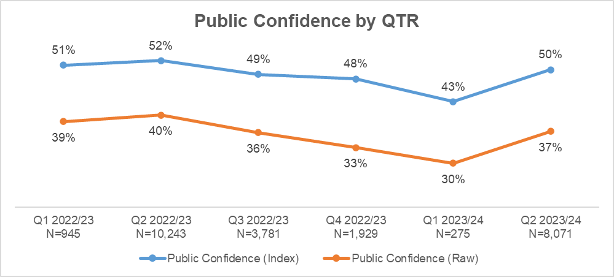
Our Your Police survey receives a high number of comparable responses each Quarter. Your Police received 81,950 responses from the public in Quarter 2 with public confidence rising by 7%. This represents a statistically significant increase.
A public confidence index score was introduced to reporting from April 2022 to ensure comparability with how confidence is analysed and measured in other national polling and surveys. This score accounts for all responses (from ‘strongly disagree’ to ‘strongly agree’ excluding ‘don’t know’) by assigning values to all responses to calculate the average. This is the top line in the graph. The bottom line in the graph is the total number of people who said they ‘agree’ or ‘strongly agree’ that they have confidence in police (also excluding ‘don’t know’), sometimes referred to as ‘raw data.’
For comparison, the UK YouGov survey asks respondents two tracker questions which are “Generally speaking, how much confidence do you have in the police to deal with crime in your local area?” and “Are the police doing a good job?” We have set out average confidence figures for Scotland and UK for Quarter 2 for both questions in the following table.

YouGov Monthly Tracker – Scotland and UK: Quarter 2
YouGov Question | Scotland | UK
How much confidence do you have in the police to deal with crime in your local area? | 48% (+1% point) | 41% (+1% point)
Are the police doing a good job? | 51% (no change) | 51% (+2% point)
Note: Question 1 includes respondents who had a lot of confidence and a fair amount of confidence. Question 2 includes respondents who said police were doing a good job.
Our own data, gathered through Your Police, shows just under one third (32%) of respondents reported they ‘didn’t know’ or ‘neither agreed nor disagreed’ that they were confident in their local police in Quarter 2 of 2023/24.
The two groups of respondents who reported the lowest levels of confidence in police in their local area were people aged 25-34 and those in the LGBTI+ category. When asked what the police could do to support the community more, the key themes for this group were related visibility and policing response to tackling crime.
The following table provides the Your Police survey results that have been identified by Police Scotland and the Scottish Police Authority as key indicators of progress. The numbers in brackets show number of respondents in each Quarter.
Public Opinion Statements | Q1 2022/23 (945) | Q2 2022/23 (10243) | Q3 2022/23 (n3781) | Q4 2022/23 (n1929) | Q1 2023/24 (n276) | Q2 2023/24 (n8071) | Change from last Quarter
Feel either ‘very safe’ or ‘fairly safe’ in their area | 79% | 83% | 78% | 75% | 67% | 80% | +13% point
Strongly agree or agree that the police listen to concerns of local people | 31% | 32% | 28% | 27% | 27% | 29% | +2% point
Strongly agree or agree that local police are friendly and approachable | 64% | 64% | 60% | 58% | 57% | 63% | +6% point
We know from our own research and academic insights that levels of public confidence and experience of contacting and interacting with police are not always connected. Not everyone responding to our Your Police survey has had contact or directly engaged with the police, so their view on confidence is shaped by other factors, such as community feeling towards the police, news and media reporting or hearing about others’ experiences.
This means that public confidence figures alone are not an accurate measure for the quality of service being provided in communities. However, research evidence suggests public confidence and perceptions can impact likelihood of someone contacting, approaching and cooperating with police.
Overall satisfaction with contacting the police was at 66% in Quarter 2. Satisfaction remained between 66%-70% in the previous 2022/23 financial year, detailed in the following section of this report.

User Experience Survey: How the public are experiencing their police service
The User Experience Survey, administered by Progressive Partnership Ltd, is sent to around 12,000 people each month and a representative sample of around 1,200 individual responses are collected. The survey is delivered via SMS to those who have contacted Police Scotland in the previous month. In Quarter 2, 3,826 respondents were surveyed about their experience of the policing service provided, from initial contact through to overall satisfaction.
The findings show levels of satisfaction with contacting the police as follows:
User Experience – Equality Outcome 2 | Q1 2022/23 | Q2 2022/23 | Q3 2022/23 | Q4 2022/23 | Q1 2023/24 | Q2 2023/24 | Change from last Quarter
Percentage callers saying it was easy or very easy to contact the police | 72% | 69% | 73% | 74% | 70% | 68% | -2% point
Percentage callers satisfied or very satisfied with the way they were treated by staff member during initial contact | 84% | 84% | 85% | 85% | 85% | 84% | -1% point
Percentage callers who felt staff properly understood what they needed | 86% | 86% | 86% | 87% | 86% | 86% | No change
Percentage callers feeling that the police provided the appropriate response | 62% | 61% | 64% | 65% | 63% | 61% | -2% point
Percentage callers felt satisfied with the way they were treated by the officers who attended the incident (where applicable) | 81% | 80% | 81% | 83% | 83% | 81% | -2% point
Percentage callers felt they were adequately informed about the progress made (where applicable) | 47% | 45% | 51% | 51% | 49% | 46% | -3% point
Based on overall experience, percentage callers satisfied or very satisfied with Police Scotland | 67% | 66% | 69% | 70% | 68% | 66% | -2% point

User Experience Insights

Making Contact Easy Is Important
Contact points have mainly all seen a slight decrease in percentage compared to Quarter 1. Over the longer term, high overall satisfaction has been maintained. However, ease of contact has seen the largest decrease since the end of 2022/23 (down 6% points).
Responses to an open-ended survey question helps understand the reasons for initial contact being easy or difficult. 3,826 responses were received to this question in Quarter 2 2023/24.
Among respondents who found it easy to contact police (n=2,580), this was attributed to:
Ensure it’s easy for people to get you when we need you
Respondents highlighted quick 101/999 answer times, easy to navigate automated menus and ability to report some incidents online.
“Number readily available. Options easy to follow. Call answered in a timely manner.”
“My call was answered relatively quickly considering it was not an emergency. Officers attended promptly.”
“I filled out a form online. It was relatively easy to find the form and submitting it didn’t take very long at all.”

Communicate with me effectively and make sure I fully understand
Respondents praised service advisors for their ability to be helpful under pressure, whilst also helping keep them calm, providing advice and making them feel safe.
“Got through quick enough and was extremely upset but the office was helpful and put me at ease and reassured me.”
“Quick response, very calm and my next steps were clearly explained to me”
“Did not have a long wait to get through to someone and they were very helpful and interested in my situation and very supportive.”
“Called on Police Scotland number and officer was extremely reassuring, ensuring I was safe with people in attendance, and asking if assistance was required. Once this was established he took details of the assault and confirmed the actions of the police”

Take the time to get things right
Respondents appreciated officers who attended incidents in a timely response, and who were attentive and helpful.
““They made me feel very at ease, they are very busy, so did appreciate that they took the time and care to talk to me. They were extremely helpful and supportive.”
“The lady I spoke to on the phone was clear and got all the information quickly. It was dealt with very fast.”
“Police were very quick at answering the phone and very helpful, officers were fast at responding given the circumstances, they were very helpful on the scene”
Among respondents who found it difficult to contact police (n=774), this was attributed to the following factors:
Sometimes I can’t get connected to anyone in the time I have available
Respondents referred to long waiting times using the 101 service for non-emergency incidents, the inability to connect to staff on their first attempt or giving up and calling 999 instead, or not reporting the incident/crime completely.
“The wait times to speak to someone was really long, one call was 20+ minutes another 40+. The first call I didn’t want to leave the area it had happened so I was hanging around ages”
“Attempted to call twice. Abandoned first call after 20 minutes. Then called couple of hours later and again over 20 minutes before someone answered”
“Taking up to thirty minutes to speak to someone on the call centre line is a disgrace. Staffing levels are not acceptable. Remember you needing to speak with someone urgently and this doesn’t happen”

Take me and my contact seriously
Respondents highlighted negative interactions with either service advisors or officers who attended the reported incident. Types of issues reported included; lack of sympathy/compassion, recording incorrect details of incident, being passed between a number of different staff/departments and not having adequate knowledge of the local area.
“Nobody made any attempt to do as promised and contact me with regard to the problem. This means I'll have the problem again and again in future and will not only have to suffer the problem again but will also have to waste time getting in touch again.”
“The call handler that felt with my call was very rude and dismissive, her tone was shocking, I would expect better from a call handler from any company let alone a police one which I would expect far higher standards, feel she completely let police Scotland down”

Let me know what will happen next so I understand
Respondents highlighted a lack of updates/follow-up to their cases to know what was happening, with no call-backs or updates about their reported incident.
“Took 45 minutes for anyone to answer the phone. Then 3 to 4 days before anyone contacted me to hear my complaint. Now no one has been in touch with me to update the status of my accident.”
“The initial contact was straight forward however the following up communication is disgraceful. A lot of promises are made and constantly not followed up. This has now been nearly 3 weeks since the incident and no visit has been made.”

Good Experience Matters
Overall satisfaction with experience with Police Scotland dropped by 2% in Quarter 2 2023/24 compared to the previous quarter. Respondents were asked what Police Scotland could have done to make their experience better.
The following issues were highlighted as areas of people’s experience which could have been improved/dealt with better:
Tell us if you’re not attending urgently, or not at all, and why not
Respondents mentioned wanting to see more being done around the incident they had reported. The need for quicker response times was also mentioned to prevent incidents from either escalating, or no longer being relevant by the time officers arrived.
The public require accessible information about how we assess and monitor calls using our THRIVE process to ensure resources are allocated to people who need us most. We also need to ensure that people who do not receive an immediate response feel valued as citizens and supported. Expectations must be clearly understood and managed suitably.
“A cop could have shown up. Nobody did and nobody ever called back.”

We need to know what is happening with what we reported as it eases our worry
Respondents highlighted needing more follow-ups after a crime or incident had been reported in order to know that it was being dealt with and to avoid having to call again, to avoid putting more strain on the system. The importance of adhering to timeframes in relation to when feedback has been promised was also mentioned by some respondents.
Our Modernised Contact and Engagement (MCE) Programme is developing our capability to enhance ‘self-service’ opportunities in line with our Public Contact and Engagement Strategy.
“Told me the outcome of the investigation/kept me informed of progress one way or another”
“At least contact me to update on what I reported. Pretty sure there was no interest or investigation. Won’t bother in the future!”

Use the best available technology to make reporting crime an easier process
Respondents reported improvements in technology would help when reporting crimes. Respondents mentioned more accessible ways of reporting crimes when 999/101 may not be best suitable and require other methods of being able to submit evidence, such as the Dash Cam Safety Portal, and alternative method of being able to check the status of reported incidents. Increasing awareness of online reporting methods to the public may also prove to be useful.
“One suggestion would be to have an online service where you can check the status of your police incident report, for example you enter your incident number into a website and it provides a status update. But appreciate this could create extra work and resources are tight.”

Think about how you make me feel
Some respondents highlighted negative experiences with either service advisors or attending officers – either directly towards them or behaviours which made them feel disrespected. Issues included not being felt like they were being listened to, being taken seriously, or not being treated appropriately.
Our colleague-focused Values and Standards Campaign to highlight the importance of adhering and embedding our Values of Integrity, Fairness, Respect and Human Rights in everything we do reminds policing colleagues that their behaviours, attitudes and words matter.
“I felt that the police were not interested in the issue I reported. I felt like I wasted my time and was made to feel like I was wasting the police officers time. It felt with the officer couldn’t be bothered dealing with the issue…”
“The female officer who called me was quite rude, and had me questioning if I had done the right thing, in contrast to the phone operator who assured me I had”

Factors Affecting User Satisfaction
Correlation analysis was used in order to understand what points of the user journey are strong predictors of an overall positive experience.
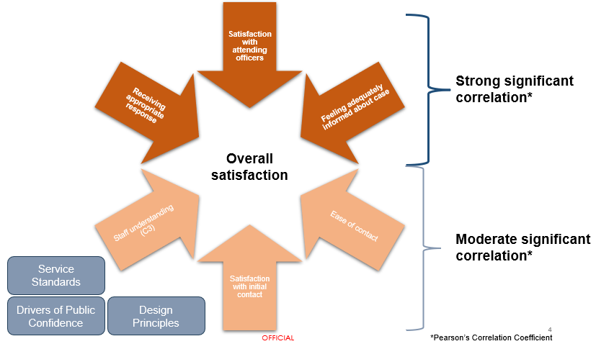 We know from this analysis that positive experiences are correlated most strongly with receiving an appropriate response, satisfaction with attending officers and feeling adequately informed about case progress.
Our Service Standards, as set out in our Public Contact and Engagement Strategy (2020), alongside our Drivers of Public Confidence and Design Principles create the space within how we deliver our services to focus on these areas that matter most to our users.

Factors Affecting Confidence in Police Scotland: Your Police
Our statistical analysis shows public confidence is associated with other factors measured in our Your Police survey. There is a strong relationship between public confidence and someone’s perception of police doing a good job in the local area, perception of police listening to concerns of local people, and perception of police dealing with issues affecting the local area. As these perceptions change, public confidence is likely to be affected.
A moderate relationship exists between public confidence and perceptions of police officers being friendly and approachable, levels of respect for local police, feeling of safety and concern about crime. Moderate correlations indicate that while there exists a relationship between these factors and public confidence, they affect each other to a lesser extent compared to strongly related variables.
A negative correlation exists between public confidence and concern about crime, meaning people with an increased concern about crime are likely to have a lower level of confidence in the police.
The following tables set out these areas and our responses from the public gathered via our Your Police survey.

Strong Correlation with Public Confidence
Public Opinion Statements | Quarter 1 2022/23 (n945) | Quarter 2 2022/23 (n10243) | Quarter 3 2022/23 (n3781) | Quarter 4 2022/23 (n1929) | Quarter 1 2023/24 (n=276) | Quarter 2 2023/24 (n=8071) | Change from last Quarter
Police doing a good job in local area | 30% | 32% | 29% | 26% | 30% | 28% | -2% point
Listening to concerns of local people | 31% | 32% | 28% | 27% | 27% | 29% | +2% point
Dealing with issues affecting local areas | 24% | 23% | 21% | 18% | 23% | 21% | -2% point

Medium Correlation with Public Confidence
Public Opinion Statements | Quarter 1 2022/23 (n945) | Quarter 2 2022/23 (n10243) | Quarter 3 2022/23 (n3781) | Quarter 4 2022/23 (n1929) | Quarter 1 2023/24 (n=276) | Quarter 2 2023/24 (n=8071) | Change from last Quarter
Police officers being friendly and approachable | 64% | 64% | 60% | 58% | 57% | 63% | +6% point
Having respect for police in local area | 73% | 72% | 68% | 67% | 62% | 71% | +9% point
Feeling safe in local area | 79% | 83% | 78% | 75% | 67% | 80% | +13% point
Concern about crime | 61% | 56% | 58% | 59% | 68% | 58% | -10% point*
*Note: 43% of the respondents in Quarter 1 were victim/witness to crime in past six months (higher than average). This figure has dropped to 36% for Quarter 2.

Understanding Local Needs
Respondents to our Your Police survey in Quarter 2 2023/24 who said they feel unsafe in their local area (n=1,394) raised similar themes as in Quarter 1 2023/24, though there was an increase in themes that featured in the media i.e., “XL Bully” concerns around dogs and fear of local crimes not being investigated by Police Scotland.

Police visibility and presence
21% of respondents who felt unsafe in their local area highlighted greater police visibility as a way of making them feel safer and providing reassurance. Police presence is often mentioned within the context of prevention and targeting of drug-related crime and anti-social behaviour.
“Speeding cars, motorcycles on pavements, gangs of youths walking about. Numerous reports of local crime on the local Facebook page. No visible deterrent ever seen in the area. Lack of cctv cameras to protect the community”
The majority of responses specifically mentioned physical presence including more foot patrols in local areas, at specific times (e.g., after dark/weekends) and locations (e.g., in parks, around transport hubs, and local crime ‘hot spots’) where communities tend to feel less safe.
“I don’t go out after dark as don’t feel safe. Too many issues about the park area. More police patrols needed to address the antisocial behaviour.”

Community engagement and being kept informed
13% of respondents who felt unsafe in their local area highlighted community policing and local engagement as important. This is highlighted alongside police visibility by respondents - for example, informal and friendly conversations with police officers on what matters to communities in local areas. Respondents highlight the importance of policing being accessible locally, familiar with local needs and the community and for training to be relevant to the specific issues affecting local communities. The public would like to be familiar with local officers and seek effective and trusting relationships. Also mentioned was the benefit of working with other partner organisations within the community to protect the most vulnerable.
“More partnership activity, be more visible during the day, early evening, request more CCTV in certain areas from Council....”

Values and behaviours
4% of respondents who felt unsafe in their local area highlighted that how we ‘show up’ is important. Police officers and staff should continue to bring empathy and understanding to their interactions with the public. Respondents highlighted the importance of seeing how police respond to and deal with incidents/reported crimes. It was also highlighted that people want to receive feedback/updates about reported crimes, which may help increase feelings of safety.
“Training and Sensitivity: Continued training on topics such as cultural competency, de-escalation techniques, and addressing implicit biases can help ensure fair and equitable treatment for all individuals within the community.”
Respondents who felt unsafe in their local area highlighted the importance of perceiving positive values and behaviours from police officers. Responses highlighted that witnessing negative behaviours from officers may affect how they perceive police to be dealing with crimes/incidents within the community. In comparison, respondents wanted to see police officers showing compassion, being friendly and approachable, and listening to people’s concerns.
“Attend to complaints more efficiently and with compassion and integrity..”

Using Insights to Shape What We Do
Work is progressing throughout the Service, including within local divisions, to respond to community feedback, needs and concerns. Divisions are keeping their local communities informed about how crime is being managed and prevented, including “you said we’re doing” feedback on social media channels and in local newspapers via Divisional Commander columns and flyers.
We are working to ensure that services work together in new ways to ensure a collaborative approach, ensuring that individuals and communities can experience the benefit of services working together.
Part of this work includes recent social research to explore how Police Scotland and partners in the health, social care and the third sector can work together to respond to the needs of people experiencing distress or poor mental health - to make sure people get the right help, at the right time, from the most effective service, meeting individuals’ needs.
This research and insight programme is now complete and has been viewed positively by both research participants and their organisations, as well as by our partners and stakeholders. DCC Local Policing will take forward these insights to be utilised as part of a new group set up to explore how the needs of the public can be met in the most appropriate ways.
Responses to our Your Police and User Experience surveys are reviewed regularly by our Executive and service leads and have helped us act quickly in relation to emerging issues and community concerns.
Key activities have included:
Data is now available in all local policing divisions from our Your Police survey highlighting locations in local areas where people have said they feel less safe. Divisional Commanders are supporting teams to take a proactive approach to respond and provide police visibility in locations where it is operationally possible to do so.
Keeping local community partners engaged and involved on a regular basis, through local police scrutiny boards in each local authority area – using the data to design an appropriate policing response for local needs and providing a multi-agency response to cross sector themes.
Shaping our communications and advice nationally and in local areas in response to concerns and feedback from the public – helping people stay safe. We are currently developing a suite of new resources to respond to feedback from our seldom-heard communities research programme to ensure information is available, relevant and accessible for all communities.
Work is progressing with council partners in Dundee, Aberdeenshire and in Glasgow to understand local needs and priorities in more detail. In Dundee we are exploring the community safety sub group model and how policing can play a role in enhancing local communities needs. In Aberdeenshire we are taking forward a new resource to support communities whose first language is not English. A presentation was delivered to local scrutiny conveners around public confidence, trust and user experience in more detail to enhance elected member understanding of our approaches and areas of focus.
We have also recently launched a feedback form for people who have experienced domestic abuse, rape or other sexual crime to provide feedback on their experience and interactions with the Service. This is the first of its kind for Police Scotland and is the result of a collaborative approach between Public Protection and Strategy, Insight and Engagement.
The feedback form will ensure we are continuing to monitor the service we provide to victim-survivors, improving our ability to understand our progress towards achieving the outcomes we have set out in our Violence against Women and Girls Strategy. We will provide further updates on our analysis on findings on an ongoing basis within future reports in 2023/24.

Factors Affecting Trust in Police Scotland: Trust Index
The Trust Index is a survey distributed by our social research partners at Progressive Partnership Ltd. to a broadly representative sample of around 1,000 adults in Scotland each Quarter. Respondents are asked for their views about the service to understand their sentiment towards policing and what may be impacting trust in Police Scotland as an institution.
Results have remained relatively stable, between 75%-80% since it was first introduced in June 2022. The Trust Index score in September 2023 was 75%. The Trust Index score provides one overall measure of performance, combining data from eight key organisational characteristics tested across other public sector organisations.
Professional
Caring
Responsive
Reliable
Knowledgeable
Experienced
Trustworthy
Modern
The Trust Index Survey, (collected between 01 to 14 September 2023), asked the 1,001 participants to provide an example of something in the media that had impacted their opinion of policing and Police Scotland in the news recently.
A minority of 185 respondents (18%) provided 265 references to discrimination related to policing and Police Scotland. These were synthesised into the following five themes:
Chief Constable’s Statement (33%)
Racism (39%)
Sexism (19%)
Sheku Bayoh (6%)
Homophobia (2%).
From the 18% (n = 185/1006) of Trust Index Survey participants that referenced institutional discrimination, most (87%) said the media influences their opinion to a small extent, with a smaller number (72%) saying the media influences their opinion to some extent and a smaller number still (25%) saying the media influences their opinion to a great extent.
Over half of respondents said there was a negative impact of their opinion of policing and Police Scotland as an institution from recent media across all levels of how the media influences their opinion.

Extent to which respondents feel Police Scotland upholds its values
Police Scotland Value | Q1 2022/23 | Q2 2022/23 | Q3 2022/23 | Q4 2022/23 | Q1 2023/24 | Q2 2023/24 | Change from last Quarter
Integrity | 71% | 73% | 70% | 70% | 64% | 67% | +3% point
Protecting Human Rights | 68% | 71% | 69% | 69% | 62% | 65% | +3% point
Fairness | 69% | 70% | 69% | 67% | 62% | 65% | +3% point
Respect | 69% | 69% | 69% | 67% | 61% | 63% | +2% point
Note: Figures show respondents who agreed to at least ‘some extent.’
Although most people continue to feel Police Scotland upholds its core values, the proportion of respondents who felt police uphold all these values to at least some extent decreased in Quarter 2 2023/24 compared to the same time in the previous year. This will continue to be monitored throughout the reporting year to identify and understand contributing factors.

Confidence in reporting crime
Confidence in reporting crime | Q1 2022/23 | Q2 2022/23 | Q3 2022/23 | Q4 2022/23 | Q1 2023/24 | Q2 2023/24 | Change from last Quarter
Confident | 67% | 68% | 67% | 65% | 61% | 62% | +1% point
Not confident | 29% | 29% | 30% | 34% | 37% | 35% | -2% point
Note: Changes not statistically significant when compared to previous Quarter. However, they are significant when compared to Quarter 2 2022/23.
Most respondents still report feeling confident when reporting a crime or incident to Police Scotland.

Attitudes towards crime
Attitudes towards crime | Q1 2022/23 | Q2 2022/23 | Q3 2022/23 | Q4 2022/23 | Q1 2023/24 | Q2 2023/24 | Change from last Quarter
Deterring / preventing crime in Scotland as a whole | 54% | 55% | 55% | 53% | 50% | 46% | -4% point
Deterring / preventing crime in local area | 57% | 55% | 55% | 54% | 50% | 49% | -1% point
Ability to communicate with public about what it is doing to deter / prevent crime in Scotland | 40% | 40% | 40% | 39% | 38% | 37% | -1% point
Note: Figures show respondents who answered ‘fairly satisfied’ or ‘very satisfied.’

Trust in Public Service Delivery
62% of respondents from the Trust Index survey stated they were worried to at least some extent about the financial pressures facing Police Scotland. Only a quarter of respondents stated that they would be confident that Police Scotland would be able to still provide effective policing services throughout Scotland with a reduced budget.
When asked if Police Scotland were to face a £50m reduction in its budget, only 15% of respondents stated they would be confident in policing as a public service.
The following were identified as key themes when respondents were asked what comments they have with regards to Police Scotland’s ability to continue to provide effective policing services throughout Scotland with a reduced budget:
34% stated it being a bad idea and would have an overall negative impact.
18% mentioned funding is already currently too low, with the service already struggling before facing even more budget reductions in 2024/25.
11% highlighted it would have a negative impact on police visibility. People also mentioned feeling that police presence is already lacking in their community, and they wanted to see police officers being more visible more often.

Public Institutions Trust Tracker
A key element of this work has been to understand, measure and learn about public perceptions of policing, particularly around public confidence, trust and user experience. Understanding more about trust and confidence enables the service to respond to community needs more effectively.
Our service draws together the strategic direction of policing with research, insight and engagement to enable the service to build a robust understanding of the drivers of trust and confidence, and what is needed to enable positive experiences with people who contact us for help.
Public sector comparison analysis has been undertaken with other Scottish and UK surveys to build upon our understanding of the landscape of trust and confidence in policing, and in public services more generally.

Scottish Household Survey 2021
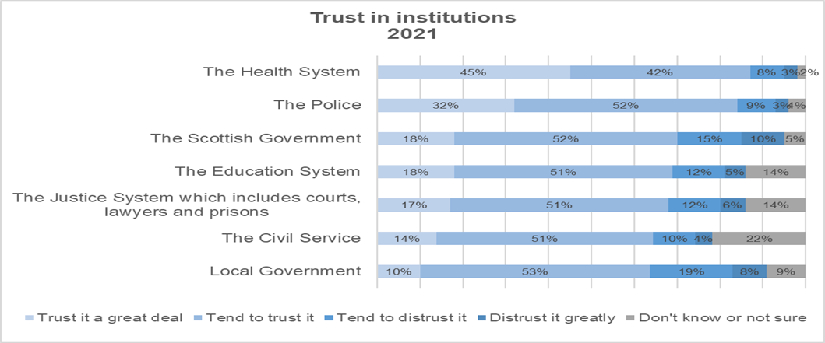
Note: Responses were collected from Scottish Household Survey in 2021 but published 2023.

Horizon Scanning – areas highlighted in feedback from Your Police survey
Accessible communication in terms of what the police service is doing locally to address concerns is key to improving these indicators. How we tell our story about what we are doing every day to keep people and communities safe is key. This is also a driver of public confidence, so any improvement in these areas will likely increase confidence, as well as trust, in Police Scotland.

The Future of Our Estates
2% (n=145) of respondents to our Your Police survey in Quarter 2 raised concerns with the accessibility of their local police station as something that specifically worried them. This ranged from their police station closing; not being staffed; too far away; uncertainty about the best ways of contacting police in an emergency and a perception that Police Scotland was becoming too centralised and withdrawing from their local communities.
Respondents in rural areas in particular raised concerns with using 101 to communicate local issues to service advisors not familiar with the area.
“Lack of any full time police presence and a local police station that is dilapidated and not fit for purpose- and it’s never open to the public”
“Lack of any officers in local villages (I live very rural). Police officers are only ever seen when in transit between main town police stations”
“…having to go through 101...which in my past experience never gets answered half the time. There is a local station which always has at least one police vehicle parked outside every day (often 2/3) so why can't there be a local number to use?”
“The inability to actually talk to a local police officer, the 101 system is completely useless in rural locations. I used to be able to phone Oban station now I get someone answering the phone in Glasgow who has no local knowledge. In fact I reported a traffic offence and was asked for the postcode so they could look it up online”
The review of our estate is driven by a desire to meet the needs of our communities and ensure that we have our staff located in the areas where they are needed most. Like many organisations, the way the public interacts with us has changed with the majority of requests for service coming to us via the telephone rather than by visiting a police building. It is important that we locate our staff in the areas where they can best service the needs of local communities. While reviewing our current estate, we have considered the level of service that is required at each location and the anticipated demand.
We are committed to maintaining a presence within our local communities, through police officers being able to patrol and respond to community needs. There are a range of alternative approaches we can consider to meet the needs of our different communities.
Hard choices are being taken to deliver effective policing within the revenue budget available to us. We understand and are sensitive to community concerns around changes involving police buildings as we bring forward our estates strategy proposals. Involving the public, communities and partners in the way we do things is vital if we are to maintain public confidence in policing.

Proportionate Response to Crime Pilot
A small number (n=26) of respondents reference the reporting in the media of the trial of a different approach to the way certain incidents are managed when they are reported to us. Some reports will be managed under a new process called the ‘Proportionate Response to Crime Investigation.’ The new process is being carefully monitored over 12 weeks and currently is limited to the North East of Scotland (Aberdeen City, Aberdeenshire and Moray Council areas). A robust evaluation of the pilot is taking place to support any future decisions about roll-out to other areas.
Open-text comments from our Your Police survey reveal that some are worried that Police Scotland won’t be investigating crimes or are now taking a “soft-touch” approach.
“Aberdeen city centre is a disgrace - full of teens running riot and drunk folk fighting and shouting and swearing. I'm appalled that it's recently been announced that minor crimes won't be investigated. If anything we need a lot more policing. What happened to using breach of the peace to get these folk off the streets?”
“Little Police presence and recent news reporting that some crime will no longer be investigated. What a time to be a criminal!”
Feedback from the public tells us that sometimes people simply want to report a crime but don't expect any police to attend, and we want to provide that service efficiently. This is about improving the way we do things to meet people's needs in the best ways with the resources we have available to us.
We want to give police officers more time to spend where people need us most - and to respond to the issues in our communities which cause greatest threat, risk and harm. We are clear that the public should still contact us to report crime. Police officers will always respond to emergencies and keep people safe.

Complaints about the Police
Complaints | 2022/23 YTD | 2023/24 YTD | % Change from Previous Year | 5 Year Mean | % Change from 5 Year Mean
Total number of complaints from members of the public | 3,367 | 3,831 | +13.8% | 3,366 | +13.8%

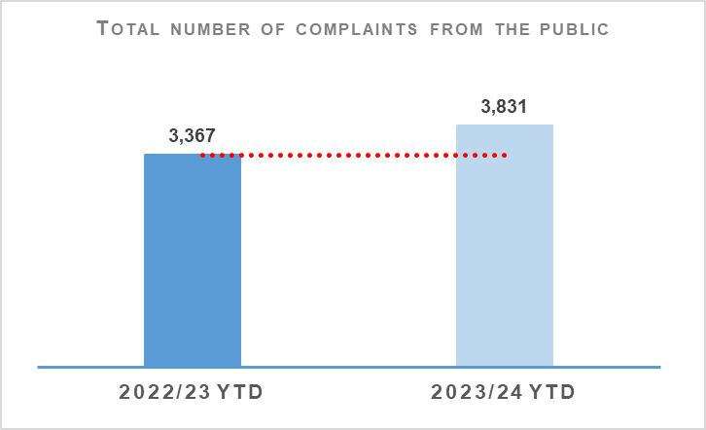 | 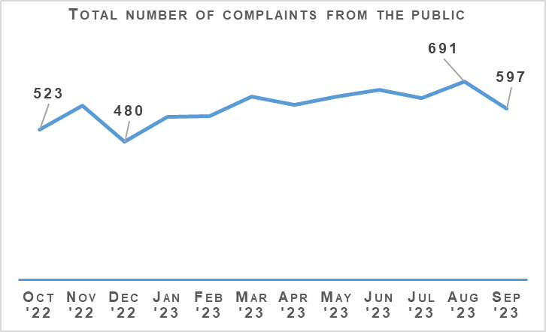
Complaints from members of the public increased by 13.8% (464 more complaints) to 3,831 at the end of Quarter 2 YTD compared to the same period last year and are up 13.8% (465 more complaints) on the five-year mean.
The Professional Standards Department (PSD) has resolved 1,895 complaints (49.5%) by Frontline Resolution (FLR) at the end of Quarter 2 2023/24, compared with 49.2% in the same period in 2022/23. This includes early resolution and subsequent resolution by PSD/specialist officers.

Allegations about the Police
Allegations | 2022/23 YTD | 2023/24 YTD | % Change from Previous Year | 5 Year Mean | % Change from 5 Year Mean
Total number of allegations from members of the public | 5,957 | 5,623 | -5.6% | 6,023 | -6.6%
% of closed allegations which were upheld | 16.0% | 15.5% | -0.5% point | 15.4% | +0.1% point
Note1: A complaint case may include multiple allegations. A ‘Complaint’ relates to the overall expression of dissatisfaction provided by the complainer about an act or omission by the police or Quality of Service received. Allegations are the component parts of a complaint, which categorise what has happened and are separated to those capable of being independently Upheld or Not Upheld
Note 2: Allegations closed and upheld refer to those which are attached to concluded complaints graded as criminal and non-criminal. Concluded complaints graded as Abandoned, Frontline Resolved (FLR), Not Relevant Complaint and Withdrawn are excluded from this measure. The latter grades of complaints are ones which cannot result in the attached allegations being upheld following a full enquiry.
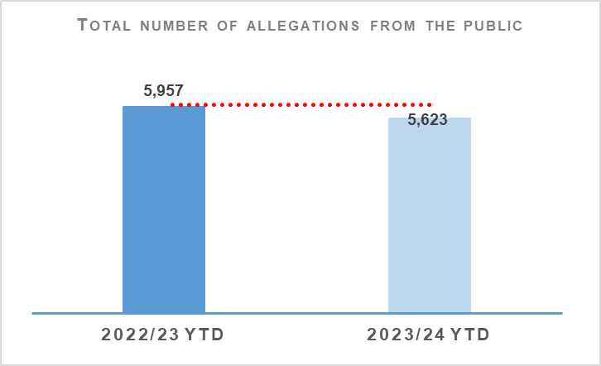 | 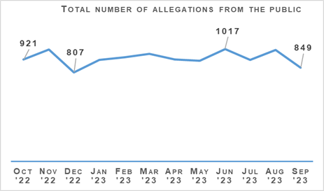
The total number of allegations has decreased by 5.6% (334 fewer allegations) compared to the same period last year, with 5,623 allegations recorded at the end of Quarter 2 2023/24. The number of allegations is also down 6.6% (400 fewer allegations) when compared to the five-year mean.
There were 2,094 allegations attached to completed complaint investigations (criminal and non-criminal) with 15.5% of these being upheld.
During this period, there were 466 non-criminal (not FLR) complaints closed with 12.4% closed within the 56 day statutory timescale. This is a 1.4 percentage point increase from the same period in 2022/23.

Police Investigations and Review Commissioner (PIRC)
Police Investigations and Review Commissioner | 2022/23 YTD | 2023/24 YTD | % Change from Previous Year
Number of PIRC Complaint Handling Reviews (CHRs) | 97 | 80 | -17.5%
Number of allegations considered by PIRC (CHRs) | 434 | 440 | +1.4%
% of reviewed allegations assessed as handled to a reasonable standard | 72.1% | 62.0% | -10.1% point
Number of On Duty Assault allegations referred to PIRC | 170 | 175 | +2.9%
% of these cases subject to PIRC investigations | 22.9% | 18.3% | -4.6% point
Allegations of On Duty Assault (breaches of Article 3 of the European Convention on Human Rights), plus any associated criminal allegations, are now referred to the PIRC. In total, 175 allegations of On Duty Assault referrals were made to the PIRC during this period. Of those, 32 are subject to the Police Investigations & Review Commissioner (PIRC) investigation (18.3%). However, as of 26 October 2023, 37 of these referrals are awaiting a decision from PIRC regarding possible investigation. The remaining 106 cases have been marked as no investigation by PIRC.
PIRC submitted 80 Complaint Handling Reviews (CHRs) to Police Scotland for consideration during this period. This notionally equates to 2.1% of all complaints. The 80 CHRs received from PIRC considered 440 allegations, with 273 (62.0%) assessed to have been handled to a reasonable standard. This is a decrease of 10.1 percentage points from the same period in 2022/23. These CHRs included 134 recommendations.

Statutory Referrals to PIRC
Statutory referrals to PIRC facilitate independent and transparent scrutiny in relation to serious incidents involving the police. Police Scotland made 162 referrals to PIRC resulting in 23 investigations (14.2%) at the end of Quarter 2 2023/24. This is a decrease of 1.8 percentage points compared to the same period last year. Those referred to PIRC include:
Referrals to PIRC | 2022/23 YTD | 2023/24 YTD | % Change from Previous Year
Armed Policing | 67 | 49 | -26.9%
Crown Directed Inference of Criminality | 14 | 5 | -64.3%
Death following Police Contact | 8 | 10 | +25.0%
Death in Police Custody | 1 | 2 | +100.0%
Serious Injury Following Police Contact | 16 | 15 | -6.3%
Serious Injury in Police Custody | 33 | 30 | -9.1%
STO Taser Discharged | 30 | 51 | +70.0%
Total Referrals to PIRC | 169 | 162 | -4.1%
Total referrals to PIRC have decreased by 4.1% compared to the same period last year, mainly attributed to a large decrease in Armed Policing referrals (down 26.9%, 18 fewer referrals). Of the 162 referrals made YTD, 23 were subject to PIRC investigation (14.2%, while the comparable rate PYTD was 16.0%).
Despite the overall decrease, a notable increase in referrals relating to Taser discharges by Specially Trained Officers (STO) has been identified, with 51 referrals made YTD. This represents an additional 21 referrals from the PYTD total of 30 (up 70.0%).
Notably, the volume of STO Taser referrals spiked during August 2023 (14), following an earlier spike in May 2023 (12). These are the highest monthly totals going back to April 2019 (the point where comparable data is available from). Conversely, in the latest month (September 2023) only three such referrals were made.
Further analysis indicates a prevalence of mental health factors, subjects under the influence of alcohol and/or drugs and subjects in possession of a bladed weapon or sharp object.
Whilst an increase has been recorded in the number of STO Taser referrals, Police Scotland have also noted a significant increase in the number of specially trained officers. At the end of September 2023, there were 1,512 trained officers which is up 63.6% from the 924 trained officers at the end of September 2022.

Preliminary Conduct Assessments
Preliminary Conduct Assessments – Decision | 2022/23 YTD | 2023/24 YTD | % Change from Previous Year
Misconduct/Gross Misconduct Investigation | 36 | 41 | +13.9%
Misconduct – No Investigation | 125 | 144 | +15.2%
No Misconduct | 38 | 70 | +84.2%
Grand Total | 199 | 255 | +28.1%
There were 255 preliminary conduct assessments undertaken YTD which is up 28.1% (56 more assessments) on the same period last year.
There were 41 misconduct/gross misconduct investigations carried out year to date which is up by five investigations on the same period last year. Misconduct – no investigations was noted from 144 assessments (up 15.2% on the previous year to date) whilst no misconduct was noted in 70 assessments (up 84.2% on the previous year to date).

Organisational Learning
PSD is committed to promoting a culture of organisational learning. Learning from CHRs and other sources are disseminated through bulletins, individual feedback and are also used to inform training packages. This learning can therefore influence and improve our service.
In Quarter 2 2023/24, PSD has disseminated learning from a variety of incidents with the following learning outcomes of particular note:
Subject officers should submit their own, independent statements to the complaint enquiry.
Police Scotland should consider whether formal documented guidance is required relating to the process for dealing with crime reports involving serving officers, particularly those reports of a sensitive nature. Guidance similar to that contained in the Complaints SOP, which states that the investigating officer must be suitably independent, would help to mitigate against allegations of bias during a criminal investigation where a serving officer is the alleged victim. This approach would serve to improve public confidence in policing. This is being progressed by Support & Service Delivery, PSD.

Change Projects

Unified Communications and Contact Platform (UCCP)
As part of the Modernised Contact and Engagement (MCE) Programme, the UCCP Project CRM Invitation to Tender is closed and evaluation completed with preferred supplier identified.

Chief Data Officer Target Operating Model (CDO TOM)
The CDO TOM Project within the Data Drives Digital (DDD) Programme provides the foundational services to deliver people, processes and training to provide best practice data management services and is progressing to closure with an End Project Report with Programme for review. CDO TOM went live in February 2022. All roles are now recruited and filled, with all staff completing the Data Governance Training. All new services which were in the Initial Business Case have been delivered.

Master Data Management
The MDM Project within the Data Drives Digital (DDD) Programme seeks to provide the technology and processes to enable a single view of key data, initially focusing on person data. A Change Request (CR) will be presented early 2024 in relation to schedule delay due to performance issues resolution, testing and resource challenges.

Body-Worn Video (BWV) – National
As part of the Digitally Enabled Policing Programme (DEPP), the BWV (National) Project is evaluating suppliers following the recent Invitation to Tender (ITT). Scottish Government Gateway Review (Gate 3: Investment Decision) is scheduled for late November 2023.

The Contact Engagement and Resolution Project (CERP)
The Contact Engagement and Resolution Project (CERP) within the Modernising Contact and Engagement Programme is progressing well with a new call-back process for Resolution Team telephone appointments implemented. Training delivery is ongoing.

National Integrated Communications Control Systems (NICCS)
Part of the Modernising Contact and Engagement Programme, the NICCS Project is progressing well, with the final Severity 2 defect resolved. The first cycle of End-to-end testing now complete. Technical Readiness Plan has been rebaselined, to be completed in December 2023, ready for proof-of-concept deployment early 2024.

Strategic Outcome 4
Our people are supported through a positive working environment, enabling them to serve the public.
Objectives:
Prioritise wellbeing and keep our people safe, well equipped and protected
Support our people to be confident leaders, innovative, active contributors and influencers
Support our people to identify with and demonstrate Police Scotland values and have a strong sense of belonging

Assaults on Police Officers and Police Staff
Assaults of emergency workers (police officer/police staff) | 2022/23 YTD | 2023/24 YTD | % Change from Previous Year | 5 Year Mean | % Change from 5 Year Mean
Assault of emergency workers (police officer/police staff) - number of offences | 3,705 | 3,790 | +2.3% | 3,853.2 | -1.6%
Percentage of assaults leading to injury | 28.2% | 25.8% | -2.4% Point | 31.7%* | -5.9% Point
Number of assault RIDDORS | 17 | 12 | -29.4% | 21.3* | -43.7%
Number of assault RIDDORS per 1k employment | 0.9 | 0.7 | -22.2% | n/a | n/a
Note: The figures for crime incidents and injuries to officers / staff are obtained from two separate systems / databases and do not directly correlate, but that are representative of the issue. *Figures marked with an asterisk relate to the 3 year mean rather than 5 year.
Note: Prior to 21 March 2021 Highland and Islands Division data only includes detected assaults.
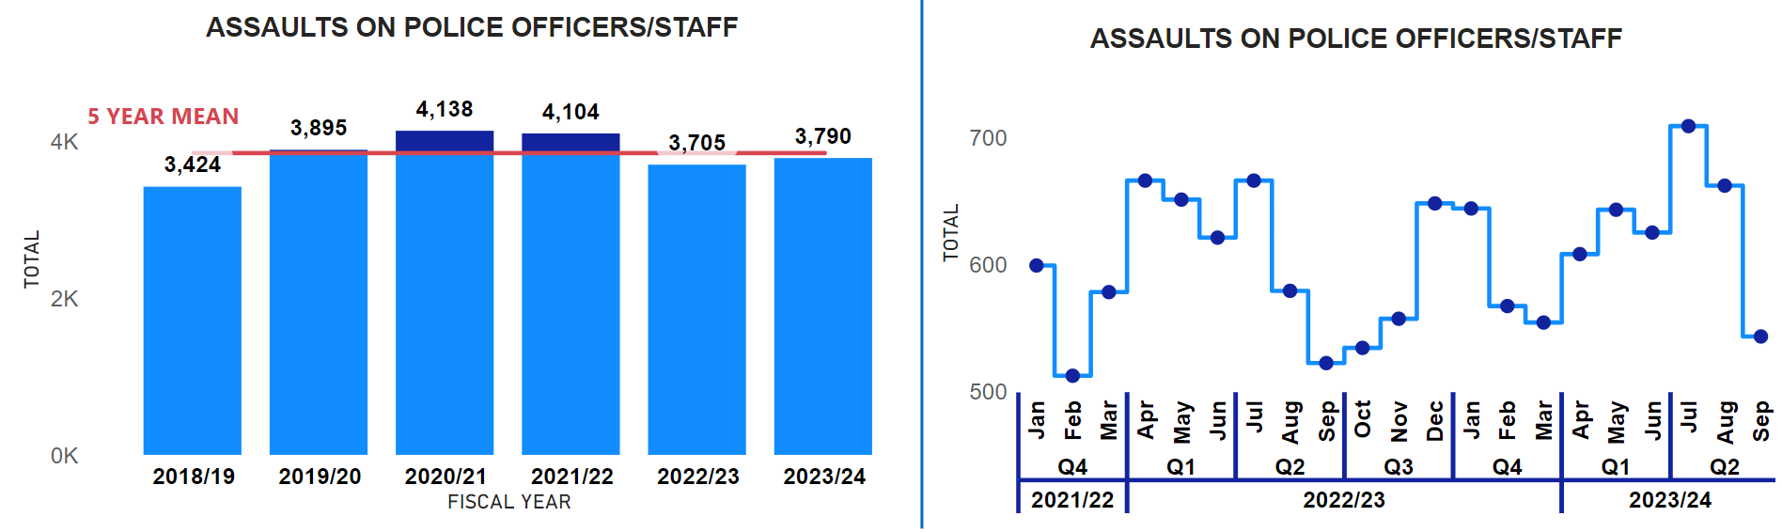 Assaults against officers/staff have increased from the previous year (up 85) but decreased from the five-year mean (down 63.2). This indicates that, while assaults have increased recently, they remain below the long-term average.
Importantly, while the assaults have increased the injury rate of assaults in 2023/24 (25.8%) have decreased from the previous year (28.2%) and the three-year rate (31.7%). Moreover, the number of officers and staff requiring hospital treatment (including hospitalised) due to assault in 2023/24 (107) has decreased by 32 compared to the previous year (139). This suggests that, when assaults do occur, the severity of injuries has reduced.
Police Scotland has also shared best practice with fellow police services across the UK during the ‘All Performance Group Meeting.’ Police Scotland showcased their utilisation of the YSM Powerbi dashboard suite that it has developed, illustrating our commitment to data-driven decision-making and how we have used these dashboards to enhance our understanding of assaults on officers and staff. This proactive approach has led to improvements in safety and overall wellbeing for officers and staff, as is highlighted through the decreased injury rate.
However, there has been an increase of serious assaults. In 2023/24, there has been an increase, reaching 26, in contrast to the previous year's count of 11. This represents an increase of 15 serious assaults. This increase was most pronounced in May 2023 (eight) and July 2023 (nine), surpassing any other month throughout the five-year period, including the current year. The YSM group are monitoring this increase closely, through analysis to increase the understanding to further protect the safety and wellbeing of officers/staff.
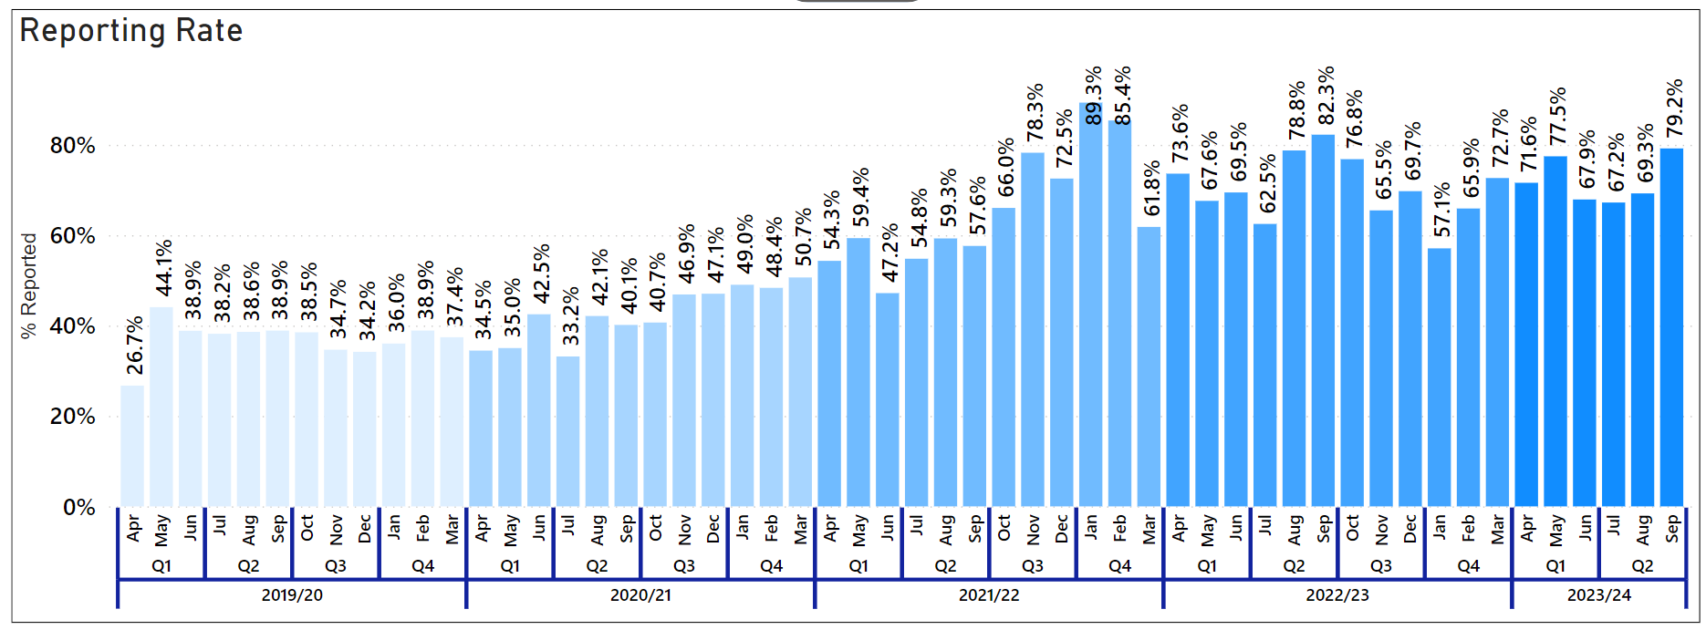 Police Scotland has maintained a high reporting rate in both Health and Safety and crimes of assault on officers/staff in 2023/24. The reporting rate in 2023/24 (71.9%) remained the same as the previous year, and no division has a reporting rate of below 50%. YSM is committed to maintaining a high reporting rate as this provides an enriched dataset for Police Scotland to analyse, which has enabled YSM to better understand assaults on officers/staff.

Your Leadership Matters (Phase 2)
Following delivery of Your Leadership Matters Phase 2 to our 250 executive and senior leaders in Quarter 1, focus in Quarter 2 has been on delivering of our Phase 2 core programme to mid-level leaders. Over 500 officers and staff participated in the programme from April to September 2023 when it concluded.
Since not all of our mid-level leaders were available to attend every summit, alternative dates have been offered within the first level leader programme.
As such, mid-level leaders’ attendance levels to date are as follows:
Event | Attendance %
Overall Launch Event | 81%
Summit 1 (Lead & Learn Inclusively) | 88%
Summit 1 Consolidation Session | 83%
Summit 2 (Have the Courage to Do the Right Thing) | 86%
Summit 2 Consolidation Session | 72%
Summit 3 (Collaborate for Growth) | 80%
Summit 3 Consolidation Session | 64%
Overall Close Event | 77%
Feedback on Summit 1 was provided in the Quarter 1 performance report and some changes were implemented based on the evaluation analysis including providing additional breaks and increasing the number of breakout groups. Participants were clear in responses that they appreciated the changes that had been implemented based on their previous feedback.
Summit 2 (Have the Courage to Do the Right Thing) concluded mid-July, with an attendance rate of 86%. Our evaluation shows that participants valued opportunities to hear the experiences of others, have open, honest, and safe discussions with peers with opportunities to reflect on the summit content.
Summit 3 concluded late August (Collaborate for Growth), with an attendance rate of 80%. The themes emerging from responses were similar of that in Summit 2, where guest speakers, followed by breakout rooms and networking with colleagues, were the most referenced highlights. The inclusion of practical tools and models was also welcomed by participants in Summit 3. However, the most common response referenced the level at which the content was pitched. Participants commented that they felt this was too generic, too low level or not relevant to them.
Overall, our evaluation of mid-level leaders shows that 80% rated the summits as good or above, 74% said that overall, their leadership skills have improved, and 81% said that they will be able to role model what they have learned in the programme.
The programme is now being rolled out to our first level leaders with approximately 3,800 participants divided into four rotations over a 15-month period. In total 1,149 participants within the first rotation attended Summit 1 (Lead and Learn Inclusively) over 10 sessions running between 04 September and 04 October 2023. Looking forward, we will evaluate Summit 1, while continuing to deliver Summits 2 and 3 (Have the Courage to Do the Right Thing and Collaborate for Growth) for the first rotation cohort.

Health and Wellbeing
The Health and Wellbeing of our officers and staff is fundamental to the delivery of policing in Scotland and the organisation remains committed to supporting our workforce as they work tirelessly in challenging environments to meet the policing needs of Scotland’s communities.
The two graphs below show the absence rate for both police officers and staff over the past three years. Pillars have been added to both graphs to indicate key vaccination milestones during the COVID-19 pandemic which, following 70% uptake of the second vaccination, began moving absence rates towards a general downward trend.
However, Over Quarter 2, there has been a 0.9% increase in working days lost for Police Officers and 0.5% increase for Police Staff when compared with the previous quarter. Psychological disorders remain the highest cause of sickness absence for Officers and Staff this quarter, with 2.1% being lost for officers and 2.3% for staff. This represents an increase by 0.4% for Officers since the last quarter, and 0.2% increase for Staff.
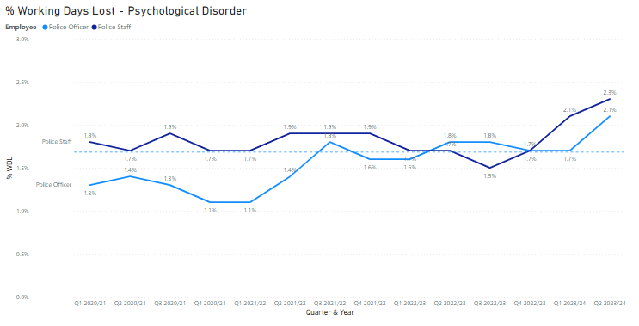

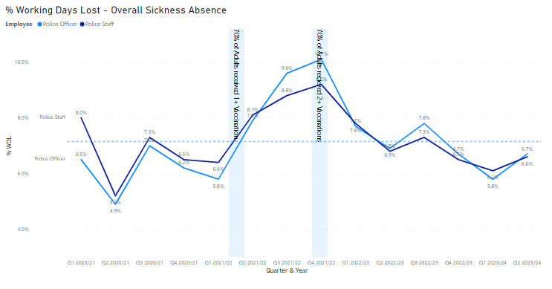
Acknowledging the prevalence of psychological ill-health, our Health & Wellbeing (HWB) programme continues to place focus on prevention and supporting psychological resilience. Over the last quarter, the following activity has been progressed in support of our people’s Health and Wellbeing:

Lifelines Facilitator Programme
Engagement has taken place with ‘Lifelines,’ a tri-service initiative offering advice and support to emergency responders, to develop our ‘facilitator’ programme. The programme will enable officers and staff to facilitate crucial Lifelines resilience, self-care and post trauma support training through a Police Scotland and peer support lens.
The programme will expand our capacity by 79 officers and staff within the organisation who can facilitate Lifelines Scotland sessions within their own areas. To date, 57 officers have completed the lifelines facilitator training, with another 22 booked onto courses during Quarter 3. To date, 10 individuals have been observed and are now signed off.
Our aim is to ensure a proportionate organisational spread within the facilitator cohort with a particular focus on probationer training. Probationary training instructors are all due to undergo Lifelines Scotland facilitator training during November which will enable the instructors to provide elements of the training as part of the probationer training programme at the Scottish Police College.

Wellbeing Champions Network
A refresh of our Wellbeing Champions Network is ongoing and remains a priority focus. The Wellbeing Champions will have a key role in the peer support of colleagues, providing health and wellbeing education/signposting in a clear and sensitive manner. We are currently engaging with the existing cohort of Champions, with many opting to remain as part of the network.
A series of network development workshops will run during Quarter 3 with a targeted recruitment drive to attract new members to the Network to be launched in mid-November. Our intention is to have an organisational spread of 230 Champions in the new network which is roughly a ratio of 1:100 officers and staff.

Occupational Health and Employee Assistance Programme
As reported last quarter, the tendering process for the new Occupational Health and Employee Assistance Programme contracts is underway with a new contract due to commence in April 2024.
The procurement process for an Occupational Health provider has advanced and a preferred supplier has now been identified. A ‘Contract Award Recommendation’ has been approved through internal governance and a paper is due to be presented at SPA Resource Committee on 15 November 2023.
In terms of the Employee Assistance Programme, the procurement process is now at the bid evaluation stage with seven bids received. Individual evaluations supported by supplier inputs will take place in October 2023.

Mental Health Support Service Pilot Programme
Internal approval has been provided for delivery of a nine month Mental Health Support Service (MHSS) pilot, delivered by Maximus UK and funded by the Department of Works and Pensions.
The service is remote based and aims to support people to become better equipped at managing their mental wellbeing through proactive strategies (non-clinical/non-counselling support). It offers confidential and vocational support for employees with mental illness, or signs and symptoms of, to retain/regain their ability to participate at work covering key areas such as coping strategies, workplace adjustments, practical advice and guidance, as well as setting out a plan to return to work if you are currently absent. The support is delivered by Vocational Rehabilitation Consultants (VRCs) who are experts in supporting people with mental health conditions.
The pilot will have a primary target audience of officers and staff who are currently absent (short, medium and long term) due to psychological matters. This is with a view to supporting people to return to work within shorter timescales, whilst supporting their specific needs within a working environment.
The pilot will aim to demonstrate the impact and effectiveness of the service, as well as the shift in the mental health and wellbeing of the individuals, to enable us to further roll out the service to the wider organisation considering other areas of absence.

Strategic Outcome 5
Police Scotland is sustainable, adaptable and prepared for future challenges.
Objectives:
Use innovative approaches to accelerate our capacity and capability for effective service delivery
Commit to making a positive impact through outstanding environmental sustainability
Support operational policing through the appropriate digital tools and delivery of best value

Finance

Maintaining a Balance Budget/Financial Sustainability

Revenue
The 2023/24 revenue budget was approved by the Board at the Authority meeting held on 23 March 2023.
A number of financial risks were highlighted as part of the budget approval process, some of which have materialised in the first half of the financial year causing significant pressure on the 2023/24 revenue position. At the end of Quarter 2 we are reporting a £7.7m year-to-date overspend against budget.
The Quarter 1 full year forecast originally highlighted net unfunded pressures of £18.9m, mainly due to overspends relating to pay; police staff costs, police officer overtime and police officer pensions.
Mitigating actions and savings plans have been agreed and these are being regularly reviewed and managed through our Policing Our Communities programme to bring spend back in line with the funded position.
The Quarter 2 forecast is reporting an overall breakeven position. However, this is very challenging as it requires all our mitigating actions and savings plans, some of which are out with the organisation’s control, to deliver in-year to achieve the savings necessary to balance the budget. This will require a continued significant effort across the organisation.

Capital
The capital forecast at Quarter 2 is £70.2m which is significantly higher than the £52.9m of funding available for 2023/24.
Over 65% of our funding has been spent to date, and when considered alongside the spend that is also committed for 2023/24, it is crucial that no further commitments are made in the current financial year if we are to land our funded position. Even after taking these steps, approximately £5m of slippage will still require to be managed and this will be closely monitored over the remainder of the financial year.
Any remaining capital expenditure will continue to progress through governance and procurement to create a pipeline of activity ready for delivery from 01 April 2024.
The overall position will be considered at the end of Quarter 3 and any further action will be taken as appropriate.

Reform
The revised Quarter 2 forecast highlights that the reform funding has reduced to £20.0m. This is due to the decisions and mitigating actions agreed to help balance the 2023/24 revenue position.
The Quarter 2 forecast is currently reporting an underspend of £0.9m against this funding which will be used to support the overall breakeven position reported by the Authority.

Procurement
% of regulated spend undertaken compliantly in line with purchasing policy | 2022/23 Q4 YTD | 2023/24 Q1 YTD | % Change from Previous Quarter | 5 Year Mean | % Change from 5 Year Mean
% Compliance | 97.2% | 96.9% | -0.3% point | 87.6% | +9.3% point
Police Scotland report retrospectively on spend compliance as a result of the data requiring to be analysed after the end of each quarter. The figure provided is an analysis of Quarter 1 2023/24 compared to Quarter 4 of the previous financial year and the five-year mean.
The compliance rate in Quarter 1 2023/24 decreased slightly by 0.3 percentage points from what was recorded in the previous quarter, however it is worth noting that the actual value of non-compliant spend reduced from £2.04m to £1.66m.
The percentage increase is only due to a reduction in overall spend between Quarter 4 and Quarter 1. This is also 9.6 percentage points higher than the five-year mean compliance rate of 87.6%. Data for Quarter 2 2023/24 will be available in the 2023/24 Quarter 3 report.

Fleet
Fleet | 2023/24 YTD
% of Ultra-Low Emission Vehicles (ULEV) in our fleet | 30%
Average age of fleet | 3.86 years
Average % of vehicle availability | 97.36%
Total mileage of electric vehicles (green miles) | 2,793,545 miles
Police Scotland is working towards implementing the move to an Ultra-Low Emission Fleet as part of the Scottish Police Authority (SPA) approved Fleet Strategy. Work is ongoing with the Ultra-Low Emission Vehicle (ULEV) Board and the Fleet Implementation Group and key stakeholders. These include internal stakeholders and external agencies such as Transport Scotland, Scottish Fire and Rescue Service, Scottish Ambulance Service and city councils where sharing of resources is possible.
Our fleet is the first blue light fleet in the UK to make that commitment of greening the entire fleet of approximately 3,500 vehicles. The approved Fleet Strategy is to move to fully ULEV by 2030 in line with Scottish Government recommendations.
ULEV vehicles currently make up 30% of Police Scotland’s overall fleet at the end of Quarter 2 2023/24 (up 1.0 percentage points from the previous quarter). In total 44% of the unmarked fleet is made up of ULEV vehicles.
Work is ongoing with the roll-out of a Police Scotland dedicated charging infrastructure across our estate with several large sites completed. This will continue across Scotland from the central belt up to the Highlands and Islands as we move into phase two and three.
Police Scotland currently has ULEV vehicles in stock and on order and these are allocated as charging sites are completed. Training is complete for all fleet staff on ULEV vehicle maintenance and repair.
Fleet is continuing to work with Health and Safety, Scottish Police Federation, Driver Training, and other key stakeholders to have right vehicle, right place, and right time.
The average age of the Police Scotland fleet in Quarter 2 2023/24 is 3.86 years. This is down 0.06 years from the figure reported last quarter. This will reduce further as new vehicles are introduced to the fleet and if the level of capital investment on the fleet is maintained in future years.
The average percentage of vehicle availability was 97.36% in Quarter 2 2023/24. The target is 95%. This is up 0.78 percentage points from the five-year average of 96.58% availability.
The total mileage of electric vehicles (green miles) during the year to date was 2,793,545 miles. In Quarter 2 2023/24 the total green miles was 1,499,099 miles. This compares to 1,294,446 green miles in Quarter 1 2023/24 and represents an increase of 204,653 green miles (up 15.8%) compared to the previous quarter.
Fleet is currently reviewing its Target Operating Model as we move to ULEV as there is a different skill required in ULEV vehicles. As the vehicle becomes the office and technology increases, and with less moving parts in a ULEV more mobile servicing will be the future.
This will ensure our vehicles are replaced in line with the Police Scotland Fleet Strategy to have a fit for purpose modern fleet.

Environmental - Total carbon emissions per m2 of estates
Consumption Data for Energy, Water and Fleet | 2022/23 YTD | 2023/24 YTD | % Change from Previous Year | 5 Year Mean | % Change from 5 Year Mean
Gas (per kWh) | 14,788,664 | 14,046,644 | -5.1% | 16,151,988 | -13.0%
Electricity (per kWh) | 12,338,621 | 11,618,655 | -5.9% | 12,622,911 | -8.0%
Water (per m³) | 104,596 | 69,756 | -33.3% | 82,093 | -15.0%
Police Scotland have reduced gas consumption by 742,020 kWh (a decrease of 5.1%) compared to the same period last year. When compared to the five-year mean, gas consumption has reduced by 13.0%.
Police Scotland has an Electricity consumption of 11,618,655 kWh in the reporting year to date. This is down 5.9% compared to the same period last year (a decrease of 719,966 kWh) and down 8.0% against the five-year mean.
Water consumption decreased by 33.3% (down 34,840 m3) when compared to the same period last year and has decreased by 15.0% against the five-year mean.
At the time of compiling this report fleet data, waste data, business mileage and rental car detail was unavailable and hence there are no Total Emissions data calculations possible at this time.

Project Update
The Estates and Sustainability Teams are collaborating on a number of projects that will assist Police Scotland in further reduction of utilities consumption across the estate. In many cases we have been supported by Greening the Public Sector Development Scheme (GPSEDS) funding from the Scottish Government in order to achieve these projects. We have provided a list of the work undertaken to date and will continue to update on a quarterly basis going forward.

Lighting upgrade (GPSEDS funded)
We have secured £539,569 from the Scheme in order to upgrade lighting at our Dalmarnock site to standard LED technology. This project will also include upgrade of outdated infrastructure and control software that supports lighting throughout the building. The result of this project will be high efficiency, low energy lighting that will improve our office environment as well as provide substantial savings in consumption of electricity.

Housing Upgrades (GPSEDS funded)
To date we have secured £1.7m of funding to improve our housing stock across the country. This is in line with our Housing Strategy that will bring the quality of our stock into line with other Registered Social Landlords in Scotland by making our rented homes warm and dry as well as energy and cost efficient. Our intention is to apply for funding for future housing projects that will be undertaken this year and the coming financial year.

Solar Panel Work (GPSEDS funded)
We received £50,000 funding to assess our estate for suitability of installing solar panels at 85 buildings across our portfolio. We have since selected the top 16 for installation and are moving ahead with this in this financial year and next. We have submitted a funding application for this installation work that also includes lighting upgrades previously mentioned. At the time of writing this report, we have not yet received information on the outcome of this funding application.
The next checkpoint for submission of GPSEDS funding applications is 31 October 2023. It is estimated that there will be at least one application to submit to the fund.

BeMS Upgrade
In the previous report we stated that 33 sites were ready for connection to a centralised building energy control system that will help us to take action to address energy management issues such as reduction of room temperature and boiler operation. We are making progress with this project and are working with our BeMS contractor (Craigalan Controls) and Digital Division to ensure physical and IT security of these sites in order to begin connection work later in the year.

Strategic and Report Work
We have completed our Public Bodies Duties Climate Change Report as per our obligations under Section 4 of the Climate Change (Scotland) Act 2009. This report will be submitted to the SPA Chief Executive for final sign off at the end of October 2023. As part of the amended regulations, we are also required to create a Net Zero Plan that set out how we intend to achieve net zero within the legislated timeframe. We are currently compiling this document and we will be able to provide this Plan later in the Financial Year.
We have completed our Adaptation Strategy and Implementation Plan and are in the process of formalising this document through our governance structure.
We are in the process of finalising our Biodiversity Report, as per our obligations under Part 1 of the Nature Conservation (Scotland) Act 2004.

Change Projects

Middle Office, Custody and Productions Remodelling
The Criminal Justice Services Division (CJSD) Programme encompasses the Middle Office Remodelling Project, the Custody Remodelling Project and the Productions Remodelling Project. End of Project Reports (EPRs) are currently underway for Middle Office and Custody and the Productions draft EPR is currently under discussion with business area.

Crime Management System (CMS)
Within the Technical Surveillance Programme (TSP), the Case Management System (CMS) Project is progressing, with an approved CR extending timeline to March 2024. User Acceptance Testing (UAT) activity continues as planned.

Analysis and Demand Transformation (ADT)
ADT is currently on hold.

Digitally Enabled Policing Programme (DEPP)
The DEPP Programme encompasses Core Operational Solutions (COS), Mobile Working (MW) and Body-Worn Video (BWV).
COS: A group of Projects make up the COS Project/Sub-Programme:
Insight – Work continues on iVPD and ACRA changes and Search Optimisation. Regular collaboration meetings with Data Drives Digital (DDD) Programme and C3/CERP ongoing.
Data Migration – in full delivery; Ayrshire Division successful and complete, Renfrewshire and Inverclyde, and Argyll and West Dunbartonshire Divisions planning complete, Lanarkshire and Greater Glasgow Divisions high-level planning complete, Dumfries and Galloway Division UAT on track with go-live planning to commence once Lanarkshire and Greater Glasgow plans are complete.
CASE Management – Recent updates (Court Excusal Dashboard, Supervisor Workbasket and Lead Area Tracking) have provided support for reporting and operational performance enhancements.
Direct Measures – phase 3 is progressing, including development with Motorola as part of MW solution.
Productions – rolled out to all divisions, with the exception of North East, Forth Valley and Fife which use Crimefile. Although further enhancements are planned for Productions, the delivery of the initial module to the entire force is now complete.
Crime and Warrants – Rollout of Warrants is dependant on rollout of Crime due to the integrated manner in which data is created, stored and retrieved. Warrants is ready to rollout.
The Project aims to deliver a national integrated and modular Core Operational Solution to replace the disparate information management legacy systems utilised by Police Scotland.
BWV: reference to previous information.

Emergency Services Mobile Communications Programme (ESMCP)
The ESMCP Programme is a Home Office Programme to deliver the next generation of mission-critical communications, the Emergency Services Network (ESN) to replace the Airwave Communications Network used by the three emergency services.
It has been agreed that ESMCP will be managed as a Business As Usual activity, reporting via C3.

MS Teams and 365
Under the Digital Division Programme, the O365 project is ongoing. O365 Apps for Enterprise deployment is on hold due to remediation activity with In-House and Third Party applications, with further review scheduled to take place.

