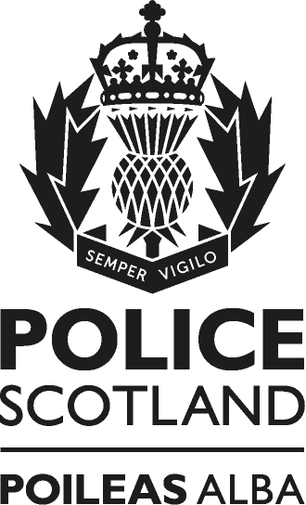

Firearms Licensing
Annual Statistical Publication
National Firearms and Explosives Licensing
2022/2023

Contents

Introduction 3
Firearm, Shotgun and Air Weapon Certificates on Issue 4
1. Firearms 4
1.1 Weapons covered by firearm certificates. 4
1.2 New applications, renewals and revocations. 4
2. Shotguns 5
2.1 Weapons covered by shotgun certificates. 5
2.2 New applications, renewals and revocations. 5
3. Air Weapons 5
3.1 Weapons covered by air weapon certificates 5
3.2 New applications, renewals and revocations 5
4. Registered Firearm Dealers 6
5. Visitors’ Permits 6
Table: Visitors permit yearly statistical comparison 6

Introduction
This report presents statistics on firearm, shotgun and air weapon certificates issued by Police Scotland under the Firearms Acts 1968 (as amended) and Air Weapon and Licensing Scotland Act 2015.
A firearm, shotgun or air weapon certificate is a type of licence issued by Police Scotland that allows the holder to possess firearms, shotguns or air weapons and associated ammunition. Certificates are valid for 5 years.
This publication details certificates on issue at 31st March 2023 and provides information on certificates granted, renewed and refused for all new grant and renewal applications processed between 01st April 2022 and 31st March 2023.
The publication also provides the number of certificates revoked, registered firearm dealers, visitors’ permits, during the period 01st April 2022 to 31st March 2023.
The data cannot at this time be produced by council or geographical area.
The statistical information in this report was extracted from SHOGUN which is Police Scotland’s national system for the management of firearms licensing. SHOGUN is a register of all people who have applied for, or have been granted, a certificate to possess or acquire a firearm, shotgun or air weapon. The system is a live operational database which is centrally updated therefore only represents a snapshot of time.

Firearm, Shotgun and Air Weapon Certificates on Issue
The information below reflects the number of certificates which were on issue in Scotland on 31 March 2023.
Firearm certificates
- There were 25103 firearm certificates on issue as at 31 March 2023.
Shotgun certificates
- There were 43796 shotgun certificates on issue as at 31 March 2023.
Air Weapon certificates
- There were 31959 air weapon certificates on issue as at 31 March 2023.

1. Firearms

1.1 Weapons covered by firearm certificates.
- There were 108051 firearms covered by firearm certificates as at 31 March 2023. Firearms can be categorised as rifles, handguns, muzzle-loading handguns, Section 1 shotguns, sound moderators and other firearm types.

1.2 New applications, renewals and revocations.
- There were 841 new applications for firearm certificates in the year from 1 April 2022 to 31 March 2023, of which 830 were granted and 11 refused.
- There were 5068 renewal applications for firearms certificates in the year from 1 April 2022 to 31 March 2023 of which 5058 were granted and 10 refused.
- A total of 70 firearms certificates were revoked in the year from 1 April 2022 to 31 March 2023
Firearm certificates can be revoked if, for example, the Chief Constable of Police Scotland is satisfied that the holder can no longer be entrusted with firearms in accordance with the Firearms Act 1968.

2. Shotguns

2.1 Weapons covered by shotgun certificates.
- There were 131253 shotguns covered by shotgun certificates as at 31 March 2023.

2.2 New applications, renewals and revocations.
- There were 1284 new applications for shotgun certificates in the year from 1 April 2022 to 31 March 2023 of which 1252 were granted and 32 refused.
- There were 8701 renewal applications for shotgun certificates in the year from 1 April 2022 to 31 March 2023 of which 8684 were granted and 17 refused.
- A total of 94 shotgun certificates were revoked in the year from 1 April 2022 to 31 March 2023.
Shotgun certificates can be revoked if, for example the Chief Constable of Police Scotland is satisfied that the holder can no longer be entrusted with shotguns, in accordance with the Firearms Act 1968.

3. Air Weapons
3.1 Weapons covered by air weapon certificates.
The Air Weapon and Licensing (Scotland) Act 2015 does not require the registration of individual weapons and therefore there is no data relating to the number of weapons covered by air weapon certificates.
3.2 New applications, renewals and revocations.
- There were 1515 new applications for air weapon certificates in the year from 1 April 2022 to 31 March 2023, of which 1498 were granted and 17 refused.
- There were 8440 renewal applications for air weapon certificates in the year from 1 April 2022 to 31 March 2023 of which 8416 were granted and 24 refused.
- A total of 69 air weapon certificates were revoked in the year from 1 April 2022 to 31 March 2023.

4. Registered Firearm Dealers
There were 335 registered firearm dealers in Scotland as at 31 March 2023.
- There were 14 new applications for registration in the year from 1 April 2022 to 31 March 2023, of which 14 were granted and 0 refused.
- There were 140 renewal applications for registration in the year from 1 April 2022 to 31 March 2023 of which 0 were refused.

5. Visitors’ Permits
Visitors’ permits allow visitors to Great Britain to possess a firearm, shotgun, air weapon or ammunition without holding a certificate. Visitors’ permits are usually granted enabling the holder to attend organised shoots such as deer stalking or competitive target shooting events. The following information relates to visitors’ permits issued in Scotland.
There were 1027 visitors’ permits granted for firearms as at 31 March 2023.
There were 2458 visitors’ permits granted for shotguns as at 31 March 2023.
There were 56 visitors’ permits granted for air weapons as at 31 March 2023.

Table: Visitors permit yearly statistical comparison

