Contents
Chief Constable Foreword 3
Case for Change 6
Significant events 6
Listening to our people and our communities……………………………… 7
External reviews and findings 8
Looking ahead 9
Timeline 10
Plan on a page 11
Outcome 1 12
Bullying and harassment 13
Anti-racism…………………………………………………………… 13
Tackling misogyny 15
Our commitments 16
Outcome 2 18
Cultural shifts 18
Supporting our people 19
Our commitments 21
Outcome 3 22
Cultural shifts 22
Supporting our people 23
Our commitments 24
Outcome 4 25
Cultural shifts 25
Supporting our people 26
Our commitments 27
Demonstrating progress ……………………………………………………………………………………………………….28
Reporting duties 28
Governance and performance……………………………………… 29
Ongoing engagement and insight 31
Publication 32
Our Standards of Professional Behaviour 33
Joint Equality Outcomes 2021-2023 34

Chief Constable’s Foreword
A society where everyone can thrive and flourish flows from Police Scotland’s purpose to improve the lives and wellbeing of our fellow citizens, for the benefit of all.
Discrimination should have no place in society and no place in policing.
Shamefully, disadvantage and injustice persist and policing has an important role to play as, collectively, we build a country where everyone knows they are safe and secure.
We have listened to our communities, including our own officers and staff, and of course all of us know policing is not immune from the challenges of racism, sexism, homophobia and discrimination.
Our values of integrity, fairness, respect and upholding human rights demand we meet these challenges head-on. We are resolute in our determination to do so.
Providing everyone with a fair, just and effective policing response is our moral responsibility and legal duty. It is also an operational imperative.
Effective policing is enabled and enhanced when all our communities have confidence in the police. Confidence to come forward; trusting that they will be listened to and treated fairly, with dignity and respect; assured that we will respond professionally, with high levels of operational competence.
Police legitimacy is drawn from the bond of trust with our communities. Building and maintaining that relationship with all our communities is vital.
Discrimination has no place in policing in Scotland. Our Policing Together strategy outlines the action we are taking to champion equality and inclusion so that we tackle sexism and misogyny and we become an actively anti-racist organisation.
A Service where every officer and member of staff can flourish and thrive with the knowledge they are welcome and valued for their true and authentic selves.
I am realistic about the challenges ahead – there are no quick fixes or easy answers for challenges with deep roots through history.
This strategy sets out how we will begin to address complex and insidious wrongs.
Leadership and commitment is required from every officer and each member of police staff across everything we do – a whole organisation effort driven with genuine commitment, rigour, persistence and energy.
A great strength of policing in Scotland is our diversity - anyone can be a police officer. We must attract, retain and promote a diverse workforce to reflect and represent our communities.
It is vital we provide our officers and staff with the tools and skills they need to create a positive workplace where people are able to challenge their own and each other’s behaviours and attitudes.
We will build a culture ready to understand and acknowledge when we get things wrong, and apologise and take proportionate and timely action to put them right.
We will establish a programme of training to enable and empower every officer and member of police staff to play their part, with the support and scrutiny of critical friends.
Building an anti-discriminatory Service is my ambition, direction and expectation for Police Scotland. It is demanded by our standards of professional behaviour; our code of ethics; and by our values and purpose.
We will continue to listen to our communities; to our officers and staff; to our dedicated and passionate staff associations; and to independent review as we apply the rigour, focus and leadership this essential priority needs.
Our officers and staff are the key to the success of policing in Scotland. We are Policing Together with our communities to build a better society and a better police service.

Case for change

Significant events
What unites the officers and staff of Police Scotland are our values of integrity, fairness, respect and our commitment to upholding human rights, alongside our shared mission to keep people safe. Policing is so often the service of first and last resort and we ask a lot of those who step forward to serve their communities.
We do not operate in isolation from the wider landscape in the UK and internationally and in order to maintain the bond of trust and confidence we enjoy with communities, we have a responsibility to reflect upon and respond to those events which have placed a spotlight on policing. Much has happened in recent years to bring us to this moment and the opportunity to set out our strategic direction for policing in Scotland.
The inequalities inherent within society and the needs and experiences of specific communities are factors to which we must pay close attention. We must also recognise the impact that the actions of individuals can have, putting at risk the confidence of the public in police services.
The murder of George Floyd by a police officer during his arrest in Minneapolis in 2020 sparked worldwide protest against police brutality and systematic racism. Across the United Kingdom, protestors also took to the streets in solidarity to protest against racial injustice in policing.
Events such as this must drive reflection and change. We will take full account of benchmarking analysis, the outcome of grievance investigations, PIRC enquiry conclusions, employment tribunal decisions and public inquiry findings. We will demonstrate our commitment to organisational learning, continuous improvement and the adoption of good practice at all levels.
When we get it wrong, we must accept our failings, apologise, learn, and do everything we can to put things right. This goes beyond simply delivering training in equality, diversity and inclusion. It is about following up training with a determination to seek out and combat discrimination in any form and embedding the right culture across our organisation which aligns to our values and purpose.

Listening to our people and communities
The Joint Strategy for Policing (2020) sets out commitments for Police Scotland to engage with our officers and staff, the individuals and communities we serve as well as our partners and other key stakeholders. In doing so, we must respond to concerns raised.
The shifting demographic of Scotland has a major influence on how public services must learn and adapt to the changing requirements of daily policing within our communities. Views gathered through public and colleague engagement have been crucial in how we strengthen our people policies, procedures and recruitment activity to ensure that we do not exclude any groups from communicating with or working in our organisation.
We have a duty under the Equality Act 2010 to identify and work towards Equality Outcomes for our staff and the communities we serve. They provide a focus on key areas of Equality, Diversity and Inclusion to eliminate discrimination, advance equality of opportunity and foster good relations. In 2021 Police Scotland and the Scottish Police Authority set Equality Outcomes for 2021-23, and these have been embedded within the Strategic Outcomes set out within this strategy.
To support the development of this strategy, extensive engagement work was undertaken to capture the views and experiences of our colleagues, including utilising the findings of the Your Voice Matters survey. We also involved partners, trade unions, statutory staff associations and diversity staff associations and we are grateful for their support and input.
Timeline – CAN THIS BE RECONSTRUCTED PLEASE? Preference is a simple timeline that shows 2013-2017, then 2018- 2022
These discussions helped establish key themes and specific areas to address within this strategy. We are grateful to colleagues and partners who shared their experiences and provided suggestions for improvement. It is evident that there is a shared commitment to cultural change and to ensuring our people are provided with the support and professional development they need to contribute to achieving our ambitions. Taking visible action and inspiring confidence amongst our officers and staff is necessary for all of us to truly be ourselves and perform at our best,
We will continue engagement with colleagues, sharing lived experiences and expected standards of professional behaviour through our Policing Together platform.
Prior to the engagement undertaken to develop this strategy, we embarked on a series of discussions with our colleagues to listen and learn more about their lived experiences. Our Truth to Power sessions are an invaluable resource and will help shape our response to these issues going forward.

External reviews and findings
External scrutiny of Police Scotland has provided much for us to learn from. The Independent Review of Complaints Handling, Investigations and Misconduct Issues in Relation to Policing, led by The Rt. Hon. Lady Elish Angiolini DBE QC, was published in November 2020. It concluded that incidents of discriminatory conduct within Police Scotland are under-reported. The report also raised concerns over “canteen culture” and how internally focused issues can impact upon public perception.
Her Majesty's Inspectorate of Constabulary in Scotland (HMICS) has provided recommendations to enable us to continue to tackle inequalities in the workplace. The Thematic Inspection of Hate Crime 2021, Thematic Inspection of Training and Development Phase 1 (2020) and Phase 2 (2021) highlighted areas for improvement with regard to support provided to people with protected characteristics, the provision of diversity training, and the recruitment, retention and career progression opportunities for people from under represented communities.

Looking Ahead
The Scottish Government’s Programme for Government 2021-2022 “A fairer, greener Scotland” highlights a number of proposed legislative factors that may impact how the organisation moves forward. These include the Hate Crime Strategy 2022, Gender Recognition Reform Bill, Human Rights Bill, Learning Disability, Autism and Neurodiversity Bill and Disability Equality Plan 2022.
The House of Commons Women and Equalities Committee has launched an inquiry into workplace issues surrounding menopause. The inquiry will consider workplace practices, whether enough is being done to support menopausal women, and the extent and nature of any discrimination that is being experienced. The inquiry will also consider whether further legislation is required, including potential amendments to the Equality Act 2010.
Baroness Kennedy’s Working Group on Misogyny and Criminal Justice in Scotland, published its findings in March 2022. Its recommendations included creating a Misogyny Criminal Justice (Scotland) Act containing a public misogynistic harassment offence; an offence of stirring up hatred against women and girls; an offence of issuing threats of, or invoking, rape or sexual assault or disfigurement of women and girls; and a new statutory aggravation of misogyny. The Scottish Government will consider the findings and recommendations in due course.
We will continue to monitor developments in these areas. Acting in accordance with our values, as well as responding to legislative change, will ensure we provide appropriate support to our officers and staff and continue to deliver a first class service to communities. Engaging and communicating with and amongst colleagues is important to our success, including the sharing of lived experience. We will use our Policing Together platform to do so. It will also provide access to key information, and reinforce expected standards of professional behaviour.

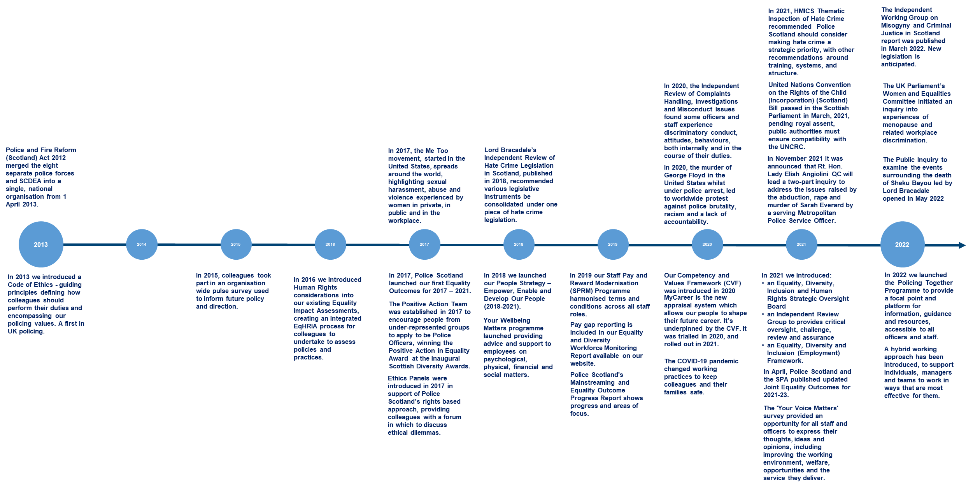
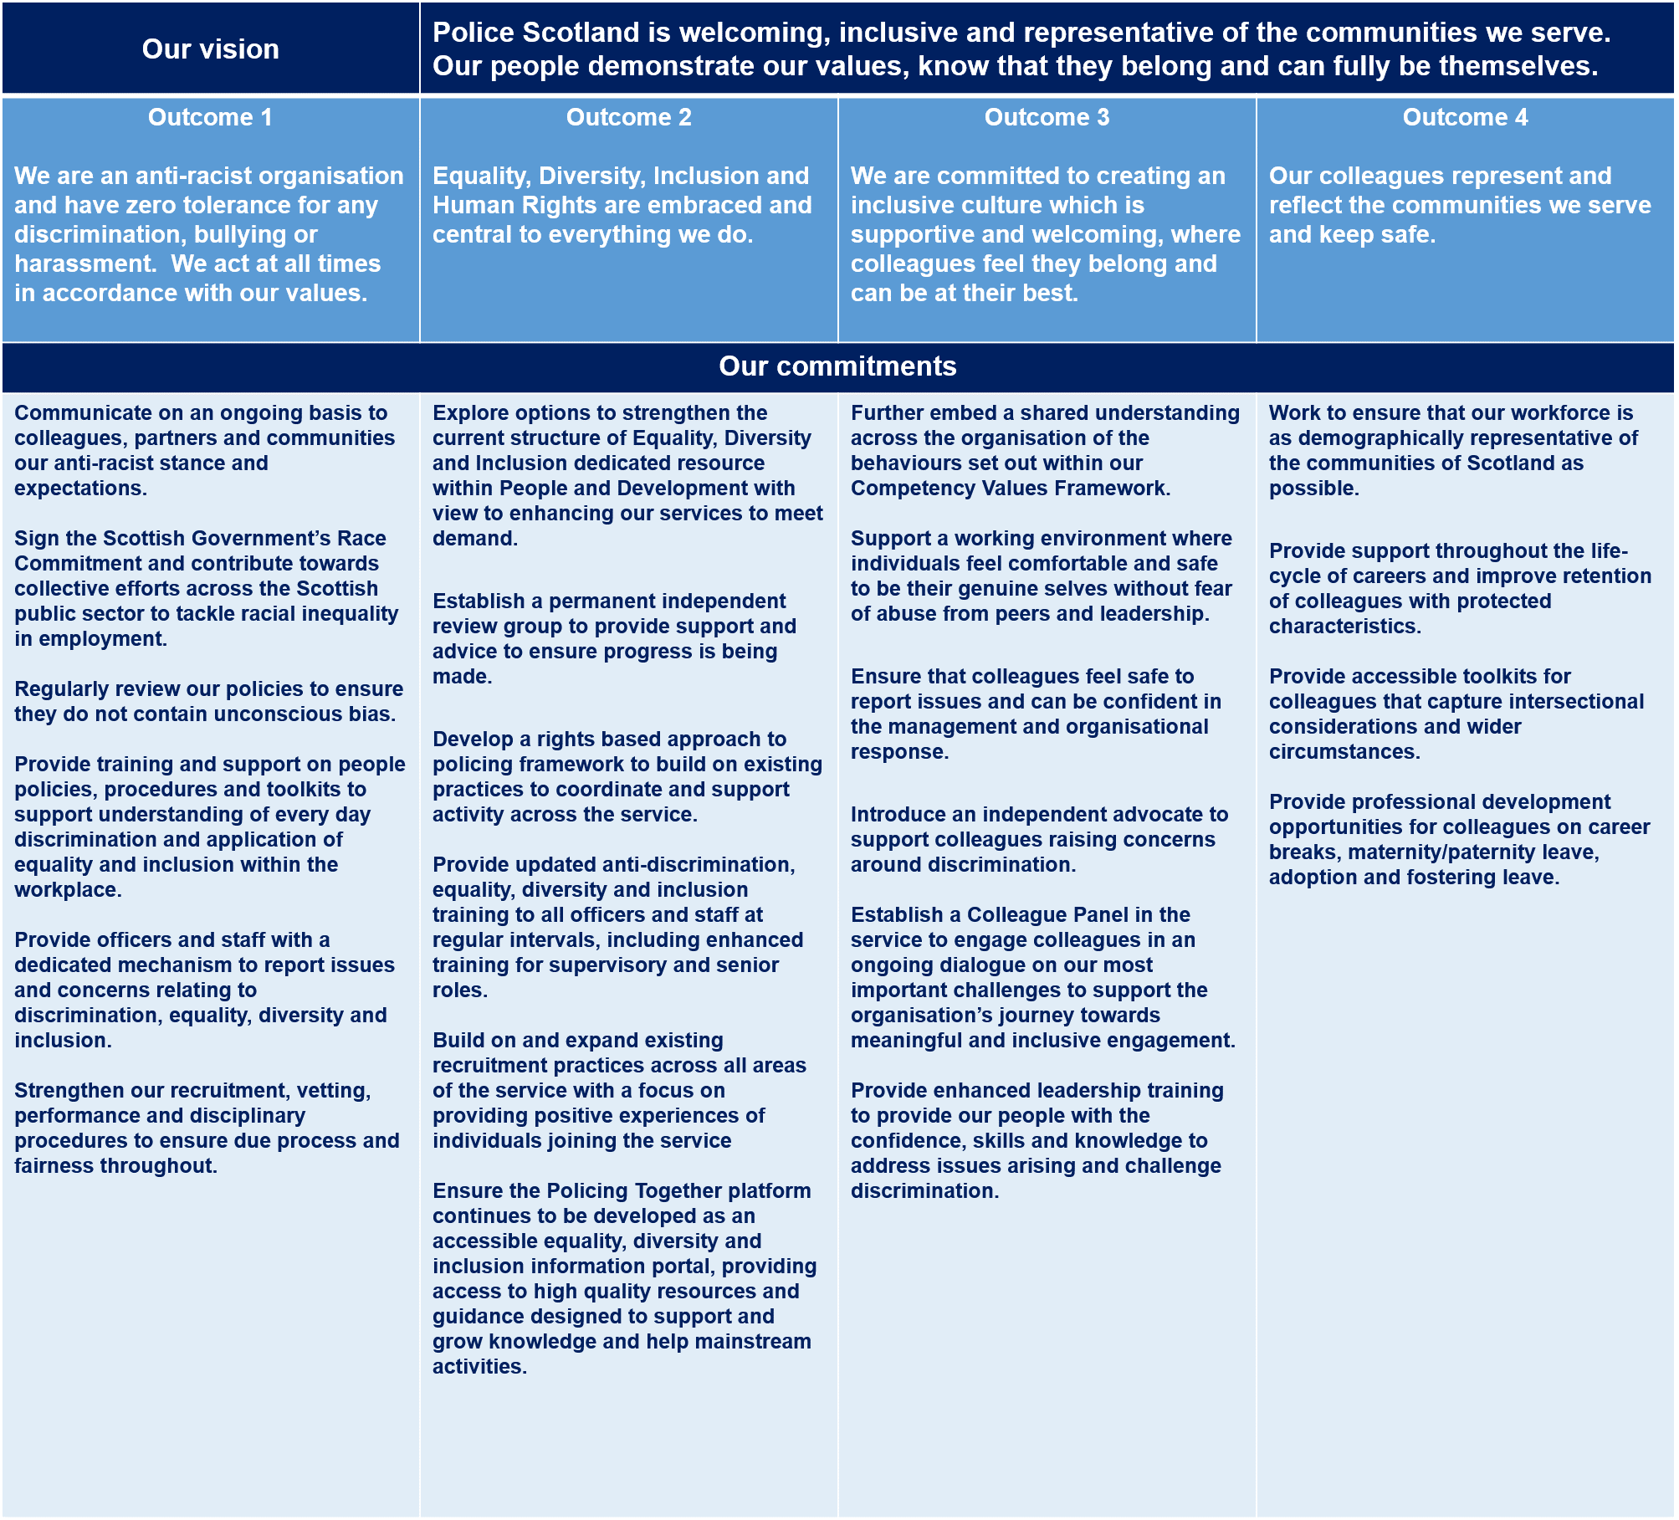

Outcome 1: We are an anti-racist organisation and have zero tolerance for any discrimination, bullying or harassment. We act at all times in accordance with our values.
Each and every one of us are protected from discrimination and harassment by the Equality Act 2010, including as we discharge our duties and in the workplace. No matter which protected characteristics an individual or group may possess, everyone, has the same rights to fair treatment in any aspect of life, both legally and morally.
While we will always adhere to the principles of fairness and due process, Police Scotland has a zero tolerance position towards all forms of discrimination, bullying or harassment in relation to an individual’s age, disability, gender reassignment, marriage and civil partnership, pregnancy and maternity, race, religion or belief, sex, sexual orientation, or any other characteristics that may be identified as being protected by law in future. There is no hierarchy of protected characteristics; all direct and indirect discrimination related to any, or a combination of, these characteristics is unacceptable.
Policing has a crucial influence in ensuring Scotland is a welcoming and fair place for all and we must reinforce the message to our people, partners and the communities that we serve that any form of discrimination is unacceptable.
Our culture will generate trust, with employees feeling safe and supported to report issues. Furthermore, all our processes and procedures, whether they relate to internal organisational issues or the services we provide, must be well communicated; and followed fairly and equally for all. Our approach will continue to encourage our people to lead inclusively and embed good practice in their service areas.
Although progress has been, and continues to be made, in improving equality, diversity and inclusion across the organisation, we recognise we must identify, acknowledge and challenge discrimination at all levels in our society. To uphold our shared values of integrity, fairness, and respect, we will ensure our culture and practices are anti-discriminatory.

Bullying and harassment
Bullying and harassment run in direct opposition to our values and will not be tolerated within Police Scotland.
In the summary report for Police Scotland’s Your Voice Matters survey, 2,651 respondents were asked if they had experienced being put down or treated in a condescending manner. The findings showed that 42.6% had answered that they had experienced this at least once within the previous 12 months of the survey. 6.8% of respondents reported experiencing this on a weekly or an even more frequent basis.
Alongside support for colleagues experiencing these issues, we recognise the need to provide training and guidance to support line managers. We will equip them with the skills and confidence to respond appropriately to incidents of bullying and harassment.
Our Policing Together platform will contain a definition of what constitutes bullying and harassment and be clear about the consequences of engaging in such conduct. It will set out our expectations of appropriate conduct for our officers and staff as well as support mechanisms for those who need them.
A particular focus of our work will be consideration of our grievance procedure, building upon a review already underway, we will deliver a straightforward, effective and fair process our people can have confidence in. Improved training and communication on the process will be provided in order to best support our colleagues.

Anti-racism
Our position on racism is, and always will be, that it has no place in society or in policing. We will be firm and progressive as we become an anti-racist organisation. Those with racist views do not belong in Police Scotland and they do not represent our organisation.
Public trust and confidence are the central measures of our success and legitimacy – we will seek to strengthen these through developing the organisational culture we describe in this strategy and will not hesitate to act where racism takes place.
The Black Lives Matter movement, which rose to prominence following the death of George Floyd, has highlighted the lack of trust some minority ethnic groups and individuals have in the police and called into question the legitimacy of actions taken by police officers across the world.
Within the United Kingdom, a UK Parliament Home Affairs Committee review of progress since the 1999 Macpherson Report highlighted the serious and deep rooted racial disparities that still exist. The report’s overall aim of demonstrating fairness across all aspects of policing, eliminating racist prejudice and racial disadvantage remains to be fully achieved.
Our approach to being an actively anti-racist workplace begins by continuing to develop our organisational culture by addressing any cultural or institutional racism; acknowledging there is a need for better representation in the service, particularly in senior roles and establishing clear objectives to work towards as an organisation.
Despite the 2010 Equality Act legally protecting people against discrimination, inequalities remain within society and workplaces. An independent review by Baroness McGregor-Smith, on race in the workplace, found a historic bias which favours white individuals over individuals of ethnic minority.
“There is discrimination and bias at every stage of an individual’s career, and even before it begins. From networks to recruitment and then in the workforce, it is there”.
Baroness McGregor-Smith

By listening to colleague experiences and by acknowledging events and issues impacting on black and ethnic minority colleagues, we can ensure there are safe spaces where colleagues feel valued and comfortable to bring their authentic selves to work.
We will support all officers and staff to improve their knowledge around these issues and encourage conversations on race, everyday racism and anti-racism. While we acknowledge that some topics surrounding racial inequality are particularly sensitive and should be approached with respect and consideration, we will not avoid such conversations.
We will consistently review our recruitment practices to ensure that they are non-discriminatory, and appreciate that unconscious bias can be harmful to our organisation and the people we serve. Our recruitment, retention and promotion policies will be underpinned by our race inclusive stance and subject to regular evaluation to help improve retention and provide paths for career development that are fair to all officers and staff.
We support the Scottish Government’s Public Sector Race Commitment. As one of the largest public sector organisations within Scotland, it is critical we continue to ensure our recruitment policies support minority ethnic people moving into, staying and progressing in our employment. To embed sustainable, long term change, we will look to secure additional expertise in race inclusion.

Tackling misogyny
The culture within policing has been the subject of widespread media coverage and in some cases criticism in recent years. Much scrutiny arose following the murder of Sarah Everard in the south east of England in 2021 by a serving officer from the Metropolitan Police Service. This event led many women to share their experiences with male officers and staff who not only hold misogynistic and sexist views but acted upon them.
Sexism and misogyny do not belong in our organisation. We will take every opportunity available to us to deliver a robust response, ensuring we rid policing of those who demonstrate discriminatory beliefs or have committed acts of violence or other forms of harm.
Our commitment extends to leading a range of initiatives to support and enable colleagues throughout the organisation across the following important areas, through our Sex Equality and Misogyny work programme:
Behaviours, culture and values;
- Leadership;
- Training, learning and awareness
- Supporting and reporting;
- Policies and procedures;
- Communication and engagement; and
- Data and insights.

We will strengthen our recruitment and vetting procedures to ensure unsuitable individuals cannot pursue or continue careers in policing. We will support external recommendations for transparency during misconduct investigations and explore options to support the creation of a list of barred individuals for the Scottish public sector to prevent unsuitable individuals pursuing careers within the public sector.
Work is also underway to develop Police Scotland’s Violence against Women and Girls strategy. This will set out how we will contribute towards a society where women are safe from harassment, abuse and exploitation as well as building and improving upon public trust and confidence.
Our external campaign, That Guy, launched with the focus on men accepting a greater amount of responsibility for their actions and the language they and other men around them use to help contribute to a culture change. To support the cultural changes our organisation requires, we will deliver an internal facing campaign to challenge and address unacceptable views and behaviour within the workplace.
Our commitments
- Communicate on an ongoing basis to colleagues, partners and communities our anti-racist stance and expectations.
- Sign the Scottish Government’s Race Commitment and contribute towards collective efforts across the Scottish public sector to tackle racial inequality in employment.
- Regularly review our policies to ensure they do not contain unconscious bias.
- Provide training and support on people policies, procedures and toolkits to support understanding of every day discrimination and application of equality and inclusion within the workplace.
- Provide officers and staff with a dedicated mechanism to report issues and concerns relating to discrimination, equality, diversity and inclusion.
- Strengthen our recruitment, vetting, performance and disciplinary procedures to ensure due process and fairness throughout.

Outcome 2: Equality, Diversity, Inclusion and Human Rights are embraced and central to everything we do

Cultural shifts
Human Rights are the foundation of our work and we have duty to protect and respect the fundamental rights of individuals. A human rights based approach to policing defines our relationship to the people and communities we serve and the obligations we have to respect and protect human dignity. Legislation plays a critical role in guiding and informing our work, however within a rights based approach to policing we must actively demonstrate our understanding of human rights in our interactions with the people we serve, and in our professional decision making.
The consent, support and co-operation of our fellow citizens lies at the heart of the identity and legitimacy of policing in Scotland. To ensure that bond is as strong as possible, policing must fully represent and reflect the communities it serves. We are committed to better understanding equality, diversity and inclusion issues as well as how we can effectively support those with protected characteristics.
The HMICS Thematic Inspection of Police Scotland Training and Development Phase 1 found that since the formation of Police Scotland in 2013, there has been no programme of leadership development training other than the First Line Managers Course. It recommended all officers and staff receive training on equality, diversity and inclusion as well as specific diversity training for senior colleagues on promotion.

Evidence heard by Lady Elish Angiolini’s review revealed that, although there was a drive to recruit officers from Black, Asian and minority ethnic communities, the experiences of some recruits led them to leave the organisation. The review recommended that enhanced diversity and unconscious bias training needs to be provided more widely, regularly and consistently across Police Scotland.
Police officers take an oath of office, adhere to a code of ethics and must adhere to the Standards of Professional Behaviour. They are subject to a strict regulatory framework which is essential for the preservation of public confidence and the proper discharge of their duties as police officers.
The Standards of Behaviour include the obligation to “report, challenge or take action against the conduct of other constables which has fallen below the Standards of Professional Behaviour.” Officers are expected to challenge colleagues who breach the standard of equality and diversity and exhibit racist or discriminatory behaviour, as are our staff.

Supporting our people
We all have a responsibility to better understand equality, diversity and inclusion as well as ensuring our professional decision making and actions align with our values and a human rights based approach. This goes beyond understanding our legal obligations towards listening and responding to the lived-experiences of colleagues to improve support provided and minimise unintentional harms.
Taking practical measures to embed and mainstream a human rights based approach into our strategies, policies and practices empowers our people and strengthens our capability to meet our legal obligations.
Significant value is placed on policing in Scotland and we have a strong bond with the public we serve. We stand in a unique position of trust where the onus is on our people to build and maintain the confidence of diverse communities. By remaining receptive to scrutiny and feedback from our partners, citizens and the communities we serve we can demonstrate ongoing transparency.
To continue to do so effectively we must provide our people with the opportunity to develop the skills needed, with access to expert advice and support. We commit to providing suitable training for our officers and staff, including enhanced provision for those in supervisory or management roles, on equality, diversity and inclusion and ensure this takes place on an ongoing basis in the form of refresher modules at regular intervals.
Beyond formal leadership development and training, we will also explore opportunities to provide our people with the tools they need to understand issues related to equality, diversity, inclusion and anti-discrimination on an ongoing, informal basis. This activity will include campaigns, empathy building, positive narratives, awareness building, rigorous adherence to legal duties, training and peer support all of which will be continuously assessed and evaluated for effect. Here we will provide easily accessible resources hosted on our Policing Together platform as well as signposting to diversity staff association resources and external organisations with specialist knowledge and expertise.
We will create opportunities for our people to communicate and share their lived experiences to better inform our policies and service provision. We remain committed to our responsibilities under The Equality Act 2010 to eliminate discrimination and advance equality of opportunity for those with protected characteristics, however we also recognise our people are shaped by multiple factors as well as those not recognised within current legislation.

Our commitments
- Explore options to strengthen the current structure of Equality, Diversity and Inclusion dedicated resource within People and Development with view to enhancing our services to meet demand.
- Establish a permanent independent review group to provide support and advice to ensure progress is being made.
- Develop a rights based approach to policing framework to build on existing practices to coordinate and support activity across the service.
- Provide updated anti-discrimination, equality, diversity and inclusion training to all officers and staff at regular intervals, including enhanced training for supervisory and senior roles.
- Build on and expand existing recruitment practices across all areas of the service with a focus on providing positive experiences of individuals joining the service
- Ensure the Policing Together platform continues to be developed as an accessible equality, diversity and inclusion information portal, providing access to high quality resources and guidance designed to support and grow knowledge and help mainstream activities.

Outcome 3: We are committed to an inclusive culture, which is supportive and welcoming, where colleagues feel they belong and can be at their best.

Cultural shifts
A career with Police Scotland can be incredibly rewarding but it is also challenging. Each day our people encounter difficult, often harrowing, situations unique to policing. They demonstrate professionalism and commitment within unpredictable and non-conventional working environments. At times, the demands of the role have not been supported by an internal culture that provides what our people need to feel respected, supported or valued at work.
As we seek to create a consistent, positive working environment for our people across the organisation we must also acknowledge sub-cultures which exist within shifts, teams or departments which have demonstrated unacceptable attitudes and behaviours.
Organisational culture is often understood as the way things are done within an organisation. It is influenced and shaped by values, behaviours and traditions, all of which build to help employees understand their organisation and connect with its purpose.
Lady Elish Angiolini’s review found a canteen culture within some parts of the organisation. Early research into “Canteen culture” within policing was also referenced in the MacPherson Report. It is defined as discriminatory attitudes shared by ordinary workers that the organisation officially disapproves of. The more recent identification here in Police Scotland demonstrates there is progress still to be made as we embed our strategy and associated work programme. How colleagues behave towards each other has the potential to impact on the service provided to the public.

Supporting our people
Police Scotland commits to building and maintaining a supportive workplace culture throughout our organisation where individual contributions and different perspectives are celebrated and valued. Our people should feel safe to express their full selves at work without fear of discrimination or other damaging consequences. Pockets of unacceptable conduct must be eradicated so that each and every division, department and team delivers a consistent experience for all colleagues.
To support our culture of inclusivity, we will avoid defensiveness in the face of criticism, be genuinely receptive to feedback and commit to delivering lasting change to improve the experiences of our officers and staff. We must enable and support those who speak up, who have a right to be heard without fear of detriment or victimisation.
In addition to current employee support, we will introduce an independent advocate to support those who feel that they have been the victim of discrimination. The advocate will have direct access to raise concerns to the Deputy Chief Constable Professionalism, Digital and Transformation, with appropriate safeguards in place, to ensure issues can be addressed swiftly.
Effective training and leadership development opportunities will be used to communicate expectations and standards of behaviour, supporting our people to develop the knowledge and skill sets needed to challenge discrimination and foster supportive and inclusive working environments throughout the organisation.
Our policing values are the foundation of our culture. They underpin our strategies, practices, policies, decision making and the individual interactions we have with colleagues and the communities we serve. We must demonstrate our values individually and collectively every day.
In 2021, we launched our Competency Values Framework (CVF), setting out the behaviours associated with an effective and ethical policing service. The CVF provides policing professionals with a consistent foundation and supports the delivery of a positive culture for the organisation as well as improvements to external service delivery.

Our commitments
- Further embed a shared understanding across the organisation of the behaviours set out within our Competency Values Framework.
- Support a working environment where individuals feel comfortable and safe to be their genuine selves without fear of abuse from peers and leadership.
- Ensure that colleagues feel safe to report issues and can be confident in the management and organisational response.
- Introduce an independent advocate to support colleagues raising concerns around discrimination.
- Establish a Colleague Panel in the service to engage colleagues in an ongoing dialogue on our most important challenges to support the organisation’s journey towards meaningful and inclusive engagement.
- Provide enhanced leadership training to provide our people with the confidence, skills and knowledge to address issues arising and challenge discrimination.

Outcome 4: Our colleagues represent and reflect the communities we serve and keep safe.

Cultural shifts
Changing demographics influence both the services Police Scotland provides to the public and the support we provide to our people. Our ability to understand, support and respond to the needs and experiences of the communities we serve and our own officers and staff has a significant impact on public trust and confidence.
Colleague insights and recent reports indicate that there is more to do to improve trust and confidence. Evidence to the Lady Elish Angiolini review recognised increased focus on recruiting officers from Black, Asian and minority ethnic communities, however there were concerns that there was insufficient understanding of the reasons for attrition.
The HMICS report on Hate Crime said police officers and staff who have not been subjected to hate crime themselves do not understand the cumulative impact of multiple “minor” incidents on their colleagues. It was found that little support is offered to victims and repeat victims are not routinely identified. We must address these issues urgently if we are to truly understand the impact incidents of hate crime have on our people.
There is a similar drive to recruit female officers. Over the last five years, recruitment intake for females averaged 44.8% however, retention continues to be a problem. Of officers with five to ten years’ service, 33% are female compared to 67% male. We must do more to support people from under-represented groups past initial recruitment stages and throughout the life cycle of their careers.

Supporting our People
It is essential to the legitimacy of policing and the maintenance of public trust and confidence that Police Scotland’s workforce both reflects and respects the diversity found within our communities. Working alongside people with different backgrounds, identities and experiences supports better, more reflective, decision making and generates improvements to the services we deliver.
We have initiatives underway to improve the diversity of our organisation. The Positive Action Team supports the delivery of high calibre recruits into the organisation by hosting bespoke events to provide opportunities for people from under-represented groups to learn about Police Scotland. We will identify and address the issues impacting on the career progression of people with protected characteristics and do the work necessary to ensure we retain and support these colleagues.
To better understand the diversity within our organisation and improve our ability to provide responsive services and support, we will do more to understand the impacts of intersectionality, the complex, cumulative way in which the effects of multiple forms of discrimination overlap in the experiences of marginalised groups.
Introducing policies and initiatives to support all of our people throughout their careers will be essential to addressing the retention problems we face. In the 2020/2021 exit survey data, ‘domestic circumstances, work-life balance’ was found to be the most commonly cited factor in people leaving the organisation. It is also important that we understand and help colleagues to adapt to significant life events, providing officers and staff with the support needed to ensure they can continue in careers they value.
We introduced the role of Hate Crime Champion to provide a network of officers and staff with enhanced understanding of hate crime who are readily available to support colleagues in identifying and tackling these issues. We are in the process of creating and reviewing a new Hate Crime Advisor (HCA) course to provide information, guidance and advice to all levels of the command structure.
We will do more to gain a better understanding of incidents where our officers and staff have become victims of hate crime, the impact these incidents have and the support our people need. The Hate Crime and Public Order (Scotland) Act 2021 will see updates to training programmes for officers and staff. A new curriculum was introduced for probationer training in December 2020 and will be updated to reflect wider training provision.

Our commitments
- Work to ensure that our workforce is as demographically representative of the communities of Scotland as possible.
- Provide support throughout the life-cycle of careers and improve retention of colleagues with protected characteristics.
- Provide accessible toolkits for colleagues that capture intersectional considerations and wider circumstances.
- Provide professional development opportunities for colleagues on career breaks, maternity/paternity leave, adoption and fostering leave.

Demonstrating progress
The Equality Act 2010, places a duty on public bodies to have due regard when exercising their functions to the need to:
- Eliminate discrimination, harassment, victimisation and any other conduct that is prohibited by or under the Act;
- Advance equality of opportunity between persons who share a relevant protected characteristic and persons who do not share it; and
- Foster good relations between persons who share a relevant protected characteristic and persons who do not share it.

This is known as the Public Sector Equality Duty. Although the subject matter of the Act is largely reserved to the UK Parliament, Scottish Ministers have the power (under section 153 of the Act) to supplement the Public Sector Equality Duty by placing specific duties on certain Scottish public authorities. Scottish Ministers used these powers to make the Scottish Specific Duties in 2012.
The Scottish Specific Duties are intended to provide a supporting framework to enable public authorities to better perform their Public Sector Equality Duties through enhanced data collection and evaluation and greater transparency and accountability. This should enable public authorities to better perform their duty with regard to the three needs of the Public Sector Equality Duties, and to mainstream equality in their everyday work.
We currently publish information to satisfy a number of regulations set out within the Scottish Specific Duties of the Public Sector Equality Duty. In addition to these statutory requirements, we also publish pay gap information on race, disability and sexual orientation.

The Programme for Government 2021-22, committed the Scottish Government to consulting on the operation of the Public Sector Equality Duty in Scotland and explore potential regulatory changes.
Police Scotland contributed to a consultation on these matters and will work to meet any future requirements, anticipated to come into force in 2025. In the meantime we will support inclusivity, celebrate the diversity of people and respect human rights.
In terms of other developments, we welcome the opportunity to sign up to the Scottish Government’s commitment to tackle race inequality in employment. The commitment was made following the publication of key recommendations made by the Scottish Parliament's Equalities and Human Rights committee in a report into race equality in the employment market.
We publish information on our ethnicity pay gap in line with existing Public Sector Equality Duty requirements; however, we will review our recruitment procedures and processes and continue to do more to understand and remove any structural barriers to ensure we fully adhere to the recommendations made.

Governance and performance
In our Annual Police Plan for 2022-23 we have committed to ensuring the delivery and mainstreaming of equality, diversity and inclusion in our workforce across the service, as well as exploring gaps in existing and forecast skills required.
We have designed an Implementation Plan in support of this strategy which focuses on the milestones and timelines for embedding our commitments. Linked to our plans, our outcomes focused performance framework describes how we monitor and measure our progress on our priorities for policing, outcomes and objectives to evidence the impact of our policing approach for the public and communities in Scotland.

Police Scotland’s outcomes focused performance framework is published annually and provides consistent reporting on the demands of policing, presenting appropriate insight to the SPA Board and the public for scrutiny. In addition, we have aligned measures regarding equality, diversity and inclusion into the framework to demonstrate the mainstreaming of delivery of our Joint Equality Outcomes. We will continue to report on progress.
Mainstreaming these measures into quarterly performance reporting will ensure that the SPA Board, public and communities receive an assurance of progress against these outcomes. Quarterly Performance Reports support legislative reporting
requirements but also provide a wider and more detailed picture of traditional policing performance measures, supplemented with additional insight and narrative to the many different aspects of policing and corporate support functions
The Equality, Diversity, Inclusion and Human Rights Strategic Oversight Board (EDI & HR SOB) was established in 2021 to coordinate work to improve equality, diversity and inclusion matters across the service. The Board will lead work to implement the strategy as well as continuing to ensure delivery against the Police Scotland’s performance framework.
The Board meets quarterly and draws together equality, diversity and inclusion activity across the service. It oversees the progress towards Police Scotland’s Equality Outcomes and the implementation of recommendations within the Lady Elish Angiolini report and HMICS’s thematic inspections. The EDI & HR SOB is also overseeing the creation of a Police Scotland EDI Strategy, EDI Performance Report, EDI Communications Strategy and the Police Scotland EDI Action Plan.
The Equality and Diversity team will track progress against our priorities through monthly People & Development business as usual reporting and organisational performance reporting. We routinely undertake monitoring and benchmarking and use the findings from engagement surveys to help measure progress. We have a number of specific performance measures set against our employment Equality Outcomes in support of the following areas:

- Workforce insights
- Leadership
- Officer / staff retention
- Recruitment and progression

Ongoing engagement and insight
Meaningful and effective engagement involves genuine dialogue, respect, integrity, transparency and accountability. It provides an opportunity for people to shape our services and influence decisions made. The insights gained from engagement activity helps to identify practical solutions and determine changes required to meet the needs of our officers and staff.
Extensive engagement activity, alongside the findings of the Your Voice Matters survey, helped shape our strategic ambition and activities. We intend to continue conversations with our people as work to implement the strategy progresses.
We will deliver a supportive, inclusive and anti-discriminatory culture where our people feel safe to be their true selves. We will identify and deliver appropriate engagement mechanisms to provide our officers and staff with ongoing opportunities to share their views and experiences.
The feedback gathered from this work will provide an invaluable and unique insight into the effectiveness of our initiatives as well as any challenges or opportunities we need to respond to.

Publication
Please contact us if you would like an alternative format of this document.
This strategy was subject to an Equalities and Human Rights Impact Assessment (EqHRIA) in compliance with the Scottish Public Sector Equality Duty. This document can be found at: https://www.scotland.police.uk/about-us/how-we-do-it/equality-and-diversity.
Separate impact assessments will be undertaken on work streams to deliver the commitments in the strategy. Please see the Equality, Diversity and Inclusion Implementation Plan for more detail.

