Police Scotland
Quarter 1 Year to Date Performance Report
April 2022 to June 2022

Contents
- Introduction by the Deputy Chief Constable 3
- Executive Summary 5
- Performance Framework Outcomes and Objectives 18
- Policing during Quarter 1 2022/23 – Key Insights 20
- Public Confidence and Experience of Policing 23
- Measures of Progress towards Strategic Outcomes 30
- Strategic Outcome: Threats to public safety and wellbeing are resolved by a proactive and responsive police service 30
- Strategic Outcome: The needs of local communities are addressed through effective service delivery 71
- Strategic Outcome: The public, communities and partners are engaged, involved and have confidence in policing 100
- Strategic Outcome: Our people are supported through a positive working environment, enabling them to serve the public 112
- Strategic Outcome: Police Scotland is sustainable, adaptable and prepared for future challenges 120

Introduction by the Deputy Chief Constable
The 2022/23 reporting period begins in the shadow of the coronavirus pandemic, which has significantly shaped policing demand during the previous two years.
The effect of the pandemic will continue to be felt for some time and we face new challenges, including the cost of living crisis, which will undoubtedly be reflected in recorded crimes during the 2022/23 reporting period.
Police Scotland is adapting to the changing nature of the needs of our communities, which are often complex.
Community needs arising from non-crime matters are a significant factor in calls to the Service, with many involving vulnerability, such as an individual in mental health distress, where a police response is provided in the absence of other services.
We continue to see an increase in displaced demand from partner agencies, impacting our ability to deal with crime-related matters with finite resources.
We are working closely with partner agencies to highlight these issues and ensure people are given the help they require and deserve. The Chief Constable has consistently underlined that, as the Service of first and last resort, Police Scotland will always be there for those in crisis.
Crime continues to evolve and we see the Quarter 1 2022/23 period record another increase in fraud offences, up 8.1% on the previous year and up 59% on the five-year mean. Around 90-95% of frauds have an online aspect and we are taking action to protect people from digital harm and crimes in the virtual world through our Policing in a Digital World programme.
The increase in fraud and the online aspect of these offences, as well as the continued threat, risk and harm from online child abuse and sharing of indecent images, reaffirms that online policing is becoming a bigger part of frontline policing every day. We have officers keeping people safe on their computers and smartphones in every community in Scotland.
Sexual offending and domestic abuse continue to be key priorities for Police Scotland. This reporting period highlights a decrease in sexual crime of -6.5% year on year but have increased against the five year mean (+7.3%).
A reduction in the number of domestic abuse incidents (-2%) and crimes (-8.3%) has been recorded again during this reporting period, however, we continue to see an increase in the number of Domestic Abuse Scotland Act crimes being recorded. DASA crimes have only been recorded since 2019/20 which skews any comparison to the five-year mean for non-sexual violent crimes.
Contributing towards changing attitudes on domestic abuse and violence against women and girls remains a key focus for Police Scotland and we will look to build on our successful Don’t Be That Guy campaign as a key strand in the development of our Violence Against Women and Girls strategy.
This Performance Report underlines that Scotland remains a safe place to live and work. While one life lost to violence is one too many, homicides are at the lowest level since the inception of Police Scotland in 2013. Overall violent crime levels were similar to recent years, with the exception of 2020/21 which saw a significant reduction to due to coronavirus and associated restrictions. Common assaults continue to account for the majority of overall violent crimes recorded, having increased by almost 5% this quarter.
While crimes such as homicide and serious assaults have decreased from last year, an increase in threats and extortion, up 26.2% from last year and up 158.5% on the five-year mean, account for an overall rise in non-sexual violent crimes. A substantial proportion of these are attempted crimes where no financial harm is suffered by complainers. We encourage reporting of this crime type to inform our understanding around new and emerging threats.
The Chief Constable consistently underlines that policing is relentless and places significant demand on the physical, emotional and mental wellbeing of officers and staff, and he takes every opportunity to thank them for their dedication to helping their fellow citizens.
The implications of pension changes increasing officer retirements and the effect of delays in recruitment because of coronavirus and the policing of COP26 mean we have fewer officers than would otherwise be the case.
A recruitment campaign is under way and we plan to increase probationer intakes from 200 to 300 per quarter. The last two intakes into the Scottish Police College were 300 strong; the most recent cohort welcomed into the Service by the Chief Constable at the end of July.
The Chief Constable has prioritised support into our Contact, Command and Control (C3) Division, into our response capability and into public protection, to ensure areas which encounter the greatest demand and carry the greatest risk are fully resourced.
These measures are similar to those taken throughout the pandemic and as demonstrated during that time and throughout COP26, Police Scotland is able to take quick action in the short term to maintain effective service for our citizens.

Fiona Taylor QPM
DCC Professionalism, Digital and Transformation

Executive Summary

Introduction
This is the first Quarterly report of the 2022/23 performance cycle, reporting on our revised Performance Framework and new Measures of Progress. We continue to mature our approach with the introduction of benchmarking and a number of new measures in relation to demand.
We made further improvements in relation to Equality, Diversity, Inclusion and Human Rights with better alignment of metrics to our Equality Outcomes.
Our outcomes focused Performance Framework is linked to our strategic planning processes and aligns to the Strategic Outcomes as detailed in the 2022/23 Annual Police Plan, these being:
Public Safety and Wellbeing – threats to public safety and wellbeing are resolved by a proactive and responsive police service
Needs of Local Communities – the needs of local communities are addressed through effective service delivery
Confidence in Policing – the public, communities and partners are engaged, involved and have confidence in policing
Positive Working Environment – our people are supported through a positive working environment, enabling them to serve the public
Sustainable and Adaptable Service – Police Scotland is sustainable, adaptable and prepared for future challenges
Throughout the document we have highlighted any updates that are linked to our new Joint Equality Outcomes.
Police Scotland remain committed to understanding demand in policing and as part of our progression towards this we have developed new ways to visualise and present demand data.
Additional new metrics around demand have been added to the Performance Framework, some of which are included as follows:

Incident Demand: Concern for Person Incidents
Concern for Person Incidents for Quarter 1 2022/23 have seen a slight decrease compared to the previous year (down 113, 0.5%).
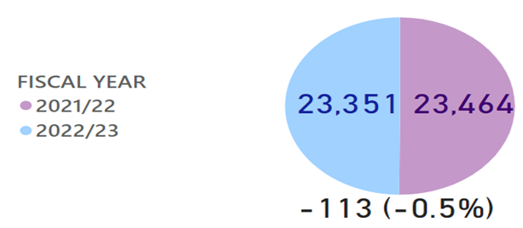

Partner Demand: missing persons from Young Persons Units, NHS and Foster Locations
Missing persons from Foster Care locations have increased with 62 more people missing in Quarter 1 2022/23 (up 72.1%) compared to the previous year. There has also been an increase in the number of people going missing from the NHS (up 26, 5.9%). The number of missing persons from Young Persons Units has however decreased by 57 (down 6.3%).
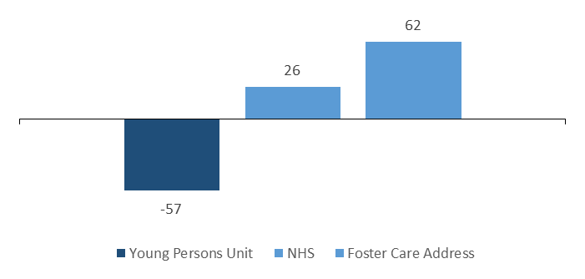

Missing Person Demand: Total FTE demand of missing persons investigations by location
Total FTE demand of missing persons investigations has slightly decreased compared to last year (down 8.6, 3.7%). Although, increases have been seen in NHS, School and Foster Care locations.
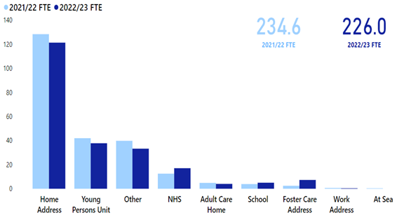

Call Demand: Total number of incidents raised
Quarter 1 of 2022/23 has seen a decrease in the total number of incidents raised. Total incidents raised to Police Scotland have decreased from the previous year by 2.6% (10,017 fewer incidents).
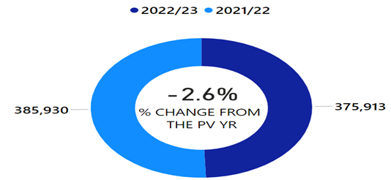

Policing Demand during Quarter 1 2022/23
Over the last year, Police Scotland faced a number of challenges and changes in our operating environment while continuing to meet the needs of our communities. An increase in violent crimes and crimes of dishonesty comes at a time where the demand on the police service is high and continues to increase.
Police Scotland continue to police and maintain order at public events, introduce and advocate campaigns to improve road safety, investigate historic crimes and enforce new legislation in our efforts to keep members of our organisation and the communities of Scotland safe.
Police Scotland continue to develop and report on the Measures of Progress and our understanding of demand continues to mature with enhanced demand-based metrics. We continue to mainstream our approach to equality, diversity, inclusion and human rights with better alignment of our activities and measures to our Equalities Outcomes.
The ability to respond to demand is dependent on having adequate response available. Against a backdrop of increasing demand, officer numbers are declining. There were 16,610 full-time equivalent (FTE) police officers in Scotland on 30 June 2022.
Police officer numbers decreased by 195 FTE officers (down 1.2%) in the last quarter and by 679 FTE officers (down 3.9%) in the last year from 30 June 2021. Staff turnover has almost doubled since March 2022, which is largely due to early retirements following the pension changes implemented on 01 April 2022.
Police Scotland are proactively addressing resource challenges with the launch of a new digital recruitment campaign to encourage people around the country to consider a career in policing.
Our new police constables could be anyone from school and university leavers, to experienced workers who are considering a career change. The campaign launched as Chief Constable, Sir Iain Livingstone QPM welcomed 300 new officers to Police Scotland as Course 2/22 took the Oath of Office at Police Scotland Headquarters, Tulliallan.
Levels of overall crimes for Groups 1-5 have remained low in Quarter 1 2022/23, 6.0% reduction compared to last year and 0.5% lower than the five year mean. These trends are explored further in Key Insight 1.
Total Offensive/Bladed Weapon crimes has increased 3.6% compared to the five year mean. The Offensive Weapons Act 2019 will be implemented in Scotland in stages throughout the year. The legislation forms part of the UK Government’s response to the rise in serious violence.
The Act introduces new offences relating to the possession and use of knives and corrosive substances, creates new powers and amends existing legislation to control their sale.
Possession of a corrosive substance in a public place will be a criminal offence without a reasonable excuse or lawful authority from the 28 June 2022. If officers have reasonable grounds for suspecting that a person is carrying a corrosive substance in a public place, they will have the authority to conduct a search.
Protecting the most vulnerable remains a priority for Police Scotland. During Quarter 1, the number of missing persons investigations rose by 8.7% (381 investigations) against the previous year, with numbers higher than levels seen before the pandemic. However, the average time each individual has gone missing has fallen.
During Quarter 1 there are significant increases in the number of Children and Looked after Children that have been reported missing, with the majority going missing from their home address.
Following the recommendations made in the HMICS Thematic Inspection of Hate Crime published on 03 June 2021, we are delivering hate crime advisor courses across the force and ran our national hate crime campaign for a period of six weeks.
Hate crimes are down 1.3% compared to last year however up 5.6% against the five year mean. The decrease is driven by ‘race’ aggravated hate crime during Quarter 1. These trends are explored further in Key Insight 2.
We are determined to tackle violence against women and girls and welcome the significant focus brought by society and the wider justice system to improve how these crimes are investigated and how we support the survivors and their families.
Work is ongoing towards the development of a Violence against Women and Girls Strategy for policing in Scotland. Online consultation with people who have experienced or witnessed this type of behaviour in their communities has taken place to gather attitudes and ideas which will inform the strategy.
Recent rapes continue to be a challenge for Police Scotland, with Quarter 1 2022/23 showing the highest number recorded over the last six years.
Tackling sexism and misogyny is a key strand of our Policing Together initiative. We are working to improve and enhance the experience of women within the workplace to create an inclusive working environment.
Internal engagement will underpin future activity, considering our leadership, how we recruit and train, and enabling people to speak up without fear of detriment.
C3 Division continue to have capacity challenges during Quarter 1, with reduced recruitment and a rise in absence levels contributing to an increase in average call answer times. Further remedial action is being implemented to ensure adequate resourcing levels during periods of high demand.
Proactively promoting different communication channels on social media has contributed to a 7.4% increase in additional public contacts via online channels. Benchmarking has been carried out on response times with forces in England and Wales, with Police Scotland answering 79.4% of 999 calls in under 10 seconds (see Key Insight 3).
Safety in the digital world is an increasing risk area due to the scale of social and financial transactions occurring online. Increased digitalisation will influence how criminals seek to operate during the cost of living situation. Fraud, alongside threats and extortion, increased not only against the five year mean but also from last year.
Around 90-95% of frauds have an online cyber aspect to their commission. In response to this growth area of cyber-enabled crime, it is imperative that we continue to invest in our Digital, Data and ICT strategy including a focus on core systems, our communications infrastructure and our approach to tackling cybercrime.
This report comprises of three sections:
Policing During Quarter 1 2022/23 – Key Insights
Public Confidence and Experience of Policing
Measures of Progress towards Strategic Outcomes – Full Picture

Cost of Living Impact
Challenge: Increases to the cost of living is a significant challenge affecting communities across Scotland which will increasingly impact our capability and capacity to respond to the additional vulnerability, crime and complexity this presents.
External research has highlighted the significance of poverty in influencing an individual’s likelihood of becoming a perpetrator and/or victim of violence. The current economic situation affecting Scotland will therefore have an impact on policing service and demand.
Expected increases across housebreaking (including attempts), shoplifting, crimes in the digital world and motor vehicle crimes are already starting to be realised during Quarter 1 of 2022/23 compared to the same period last year.
In addition, there is likely to be a continued increase in community tension leading to ongoing protest activity that will have an impact on our demand.
It has been assessed that both physical and mental health in communities are likely to decline due to the cost of living, and along with our partners, this also has the potential to increase demand on our services.
The potential to exploit the increased cost of living will be apparent to criminals including those involved in organised crime groups. These groups adapt quickly and have previously shown the ability to extract long term gain from crises.
Against a backdrop of increasing demand, officer numbers are declining. The impact of early retirement on establishment numbers could continue for a period of up to 18 months until officer numbers are fulfilled. This will influence our ability to re-invest any capacity created to support high priority areas of policing or to meet changing demand.
This coupled with the financial situation outlined in the next challenge, presents significant organisational capability and capacity challenges to address growing demand in vulnerability, traditional crime types and cyber crime.
It is essential that we continue to build our organisational capability to take action to protect people from digital harm and crimes in the virtual world through our Policing in a Digital World programme.
Response: Police Scotland are conducting ongoing research and analysis to increase our understanding of the impact the cost of living is having on the communities we police. Proactive horizon scanning will hopefully allow us to anticipate future challenges and identify measures we can put in place to try and mitigate these.
It is expected that the demand, on our already stretched resources, will be further impacted in the coming months.
Police Scotland must continue to ensure that our service delivery is designed to serve people and communities rather than the criminal justice system. Officers and staff should continue to signpost adults and children suffering from the effects of the cost of living to social services and other partners for support.
A national recruitment campaign is underway to ensure we continue to build a diverse workforce and we are already seeing a positive impact in relation to this.

Maintaining a Balanced Budget (further details here)
Challenge: The Scottish Government’s 2021/22 budget confirmed additional recurring funding for policing which allowed the service to set a balanced budget without the requirement for any workforce reductions.
The balanced budget, and the Government’s manifesto commitment to real terms protection, formed the basis of the five year financial plan that was approved by the Authority in September 2021.
The Scottish Government’s multi-year Resource Spending Review, published on 31 May 2022, sets out a flat cash settlement for the Police Authority over the remainder of the parliament.
As a consequence, Police Scotland is facing a number of significant challenges in financial year 2022/23 and beyond.
Response: Rising inflation is already reducing the spending power of our capital and revenue budgets, and when considered alongside the expectation for future pay awards, a flat cash settlement represents a real terms reduction for policing. This will have a significant impact on our operational service delivery requiring difficult decisions to be made.
Significant additional investment is required to implement the key investment strategies and transformation programmes, including DDICT, the estates strategy and the transition to 100% electric fleet.
The organisation’s ability to mitigate the operational impact of a flat cash funding settlement is therefore negatively impacted by flat capital and the potential loss / reduction of Reform funding.
The strategic direction following the publication of the resource spending review, along with the capital spending review published in 2021, will form the basis of an updated five year financial plan to be developed in the Autumn 2022.
Development of a robust longer term financial strategy will be prepared in line with the strategic business planning cycle.

Measures of Progress towards Strategic Outcomes
Measures of Progress towards Strategic Outcomes have been identified by Police Scotland in collaboration with the Scottish Police Authority. This new suite of key measures have been identified from the available management information and aims to support consistent reporting from the Performance Framework.
The following is a synopsis of exceptions identified with the Quarter 1 report.

Overall Violent Crime (further details here)
Challenge: Whilst engaging with partners at Scottish Government regarding implementation of the Surrender and Compensation Scheme, as required by the new Offensive Weapons Act 2019, a requirement was placed on Police Scotland to identify ‘designated police stations’ to facilitate public access to the scheme.
This presented challenges in identifying a suitable number of stations when considering station opening hours, geographical coverage and other local accessibility issues.
Response: In order to mitigate challenges with public accessibility, local policing divisions were asked to nominate stations using their local knowledge for suitable coverage.
An awareness package was created for all officers and front counter staff to view in the event a member of the public attended at a non-designated station to ensure quality of service.
C3 division established a process to be followed in the event when a member of the public contacted Police Scotland advising they wished to participate in the scheme but were unable to access a police station.
This ensured Police Scotland not only adhered to the Scottish Government’s requirement to designate specific police stations to the scheme but also ensured the scheme was accessible to all.

Sexual Crimes (further details here)
Challenge: The number of recent rapes recorded in Quarter 1 2022/23 is the highest number noted over the last six years. Recent rapes continue to be a key challenge for Police Scotland.
Overall, reporting of rape has returned to similar levels noted before COVID-19 however, the proportion of recent rapes has increased (from 58.0% in 2019/20 to 66.2% in 2022/23).
Response: Work on phase two of the That Guy campaign is well under way and is a key strand in the development of Police Scotland’s Violence Against Women and Girls strategy.
Police Scotland have created a communications toolkit to reinforce the importance of woman and girls feeling safe in public places and ensuring there is no victim blaming. Police Scotland have engaged with event organisers to ensure awareness packages and ByStander awareness training are included in their staff briefings.

Drugs Harm (further details here)
Challenge: Tackling substance use and the harms they cause is part of Police Scotland’s duty towards ensuring the safety and wellbeing of people within our communities. Issues such as the cost of living exacerbate problems related to drugs harm such as access to addiction services, poverty, and mental health vulnerabilities.
Response: Police Scotland adopts a public health, whole system approach. We work alongside multiple external agencies to address longstanding issues and improve the life chances of individuals we interact with frequently.
An array of workstreams have been progressed in response to the drugs harm challenge being faced, including the Pathfinder project and Positive Outcomes Project.
Additionally, Police Scotland is also in discussion with the Scottish Government around Safe Drug Consumption facilities. In preparation we have established a strategic working group and a tactical working group as well as participating in a number of workshops hosted by the Scottish Government.
We are also providing data for the Scottish Government Drug Related Dashboard to aid in the creation of a public facing report. Our workstreams aim to work in partnership with external agencies to provide early intervention and support where required.
The rollout of naloxone to all police officers is currently progressing with all officers expected to be equipped from September 2022 onwards. Officers involved in the Test of Change are currently still using naloxone as part of their work.
Impact: Recent figures provided to the Scottish Government Drug Related Dashboard for the last quarter show there is a reduction of 13 drug related deaths between January to March 2022 compared to September to December 2021 (275 compared to 288).
It is also anticipated official figures will show a decrease in the number of drug related deaths in 2021 compared to 2020.
As of July 2022 officers from the naloxone Test of Change have administered 79 doses of naloxone with 78 individuals having survived. In one incident officers were of the opinion the individual was already deceased but nevertheless administered naloxone to try and save their life.
Administrations of naloxone have been in various incidents, including drug search warrants, concern for person calls, and members of the public flagging down officers. No complaints or issues have been raised as a result of the administrations.

Drugs Supply (further details here)
Challenge: Tackling Serious and Organised Crime (SOC) is a priority for Police Scotland and our officers continue to severely disrupt the activities of organised criminals and reduce the harm caused within our communities.
Despite significant progress, we must constantly adapt to the complexities of current and future threats, and have a framework designed to respond. This work was recently brought to the fore with the changing environment posed by the global pandemic and exit from the EU, in which Police Scotland’s response was required to be dynamic and innovative.
Response: Given the changes in society following COVID-19, EU Exit, and cost of living, Police Scotland’s operational response has adapted rapidly and provided resilience to ensure public confidence is maintained.
In particular, the response to dealing with drug supply and distribution, money laundering, County Lines, SOC related violence and cybercrime by serious and organised criminals, remains dedicated and driven at a national level.
Impact: Police Scotland continue to respond to the full range of SOC threats by utilising our capabilities and have seen a significant number of results through major drug recoveries, cash seizures, and SOC related arrests.
This is shown through an investigation in June 2022 where cocaine, with an estimated value of £1million, was recovered from a property in Dundee. Following this a further vehicle stop resulted in £200,000 of cocaine and around £120,000 in cash seized. Two arrests were made in connection.

Call Handling (further details here)
During the reporting period, our service advisors received 571,721 calls via 999 or 101, a decrease of 94,786 on the same period last year.
Alongside incoming calls, there have been over 73,000 additional public contacts dealt with by Contact, Command and Control (C3) Division during the reporting period, including online reports, alarm calls, partner demand and “Contact Us” emails.
Challenge: The average call answer time for 999 calls increased from 6 seconds to 12 seconds during the reporting period. In addition the average call answer time for 101 calls increased from 3 minutes 25 seconds to 4 minutes 9 seconds during the reporting period.
This continues to be highlighted as a challenge for the division and measures have been put in place to alleviate this as detailed in the response. It is of note that BT have also reported increased 999 call demand nationally.
Response: C3 Division continues to feel the impact of reduced recruitment due to the current recruitment market and is looking at proactive social media to increase interest in posts. Absence levels of COVID-19 follow the national trend and have been continually observed into Quarter 1.
Although average call answer time for 999 calls has increased, and this is being experienced nationally across the UK, the handling of 999 calls remains our highest priority and additional steps have been put in place to ensure resourcing levels are increased at periods of high demand, both with staff incentives, resource and ICT changes.
Efforts continue to signpost callers to more appropriate methods of contact, including via Contactus and the Police Scotland website. Social media is used during periods of high demand to inform the public and provides the opportunity to educate the public on the correct use of 101 non-emergency number. Online contacts continued to rise during this reporting period, indicating the success of this approach.

Hate Crime (further details here)
Challenge: Hate incidents have risen slightly compared to the same period last year (27 more). Hate crimes have however fallen slightly (23 fewer). Both crimes and incidents have increased when compared to the five year mean.
Race hate crime accounts for over 50% of all hate crimes. These crimes are decreasing compared to the same period last year (73 fewer) and this is largely the reason for the overall decrease in hate crimes.
Where hate crimes are increasing (religion, disability, sexual orientation, transgender), these numbers are relatively small and thus it is difficult to attribute any specific explanation to the increases this year.
Response: The National Hate Crime Campaign launched on 28 March 2022 and ran for a period of six weeks.
The main objective of the campaign was to encourage people living in Scotland who had been affected by a hate incident to report it to Police Scotland or to a Third Party Reporting Centre.
Secondary audience groups were also identified, these being bystanders and officers / staff of Police Scotland, who were also encouraged to report instances of hate.
To encourage this behaviour we wanted the audience groups to know that Police Scotland take all incidents of hate seriously and we care about the impact that it has on the diverse communities across Scotland that we serve. Corporate Communications is carrying out an in-depth evaluation of the campaign, which will be reported in due course.

Fraud (further details here)
Challenge: Fraud continues through this quarter to be at a high level across the entire United Kingdom and in line with this trend Scotland has suffered with large numbers of the population falling victims to a variety of frauds including such crimes as investment frauds, romance frauds and social engineering frauds.
The online space continues to be a hot spot for fraudulent activity with around 90-95% of frauds having an online cyber aspect to their commission.
Response: In response to this threat Police Scotland is undertaking work to restructure and refocus the existing financial investigation model to provide a greater victim focused, efficient and effective model and greater strengthen relationships with partner agencies.
This includes aligning and working more closely with the National Crime Agency and the National Economic Crime Centre on the United Kingdom’s strategic fraud response.
Together this contributes to enforcement intensification periods under the auspices of Project Henhouse. This provided funding to support executive action for impersonation fraud, social engineering, human trafficking and drugs operations.
Project Henhouse has seen 18 arrests and the seizure of over £33,000 in designer goods, £20,000 cash, jewellery, electronic devices, drugs, firearms and counterfeit cigarettes.

Absence Management (Further details here)
Challenge: ‘Psychological Disorders’ remains the highest cause of sickness absence across both groups this quarter, with a higher percentage of work days lost to this category of illness in the Staff group than in the Officer group.
The absence rate for Psychological Disorders has increased by 0.5% for officers since the same period last year, and has remained stable for staff.
Response: Given the complex nature of psychological illness, Police Scotland is conducting a detailed deep-dive of this issue to more clearly understand what we can do to better support our workforce.
The study will make use of anonymised data held on the organisation’s HR system to provide comprehensive insights and will adopt a case study approach, using a benchmark sample of the absence data.
The aim of this study will be to identify absence patterns and trends, where the organisation can look to improve or change to support our people with mental health challenges, particularly if work related (directly or indirectly), analyse key causes and derive insights to enable us to develop an informed improvement plan. The ambition is then to develop and design our occupational health and wellbeing offering to meet these emerging needs.

Performance Framework Outcomes and Objectives
The following is a summary of the strategic outcomes and objectives contained within the Annual Police Plan 2022/23.
Outcome 1
Threats to public safety and wellbeing are resolved by a proactive and responsive police service.
Objectives
Keep people safe in the physical and digital world.
Design services jointly to tackle complex public safety and wellbeing challenges.
Support policing through proactive prevention.
Outcome 2
The needs of local communities are addressed through effective service delivery.
Objectives
Understand our communities and deliver the right mix of services to meet their needs.
Support our communities through a blend of local and national expertise.
Support the changing nature of communities.
Outcome 3
The public, communities and partners are engaged, involved and have confidence in policing.
Objectives
Embed the ethical and privacy considerations that are integral to policing and protection into every aspect of the service.
Protect the public and promote wellbeing across Scotland by providing services that are relevant, accessible and effective.
Work with local groups and public, third and private sector organisations to support our communities.

Outcome 4
Our people are supported through a positive working environment, enabling them to serve the public.
Objectives
Prioritise wellbeing and keep our people safe, well equipped and protected.
Support our people to be confident leaders, innovative, active contributors and influencers.
Support our people to identify with and demonstrate Police Scotland values and have a strong sense of belonging.
Outcome 5
Police Scotland is sustainable, adaptable and prepared for future challenges.
Objectives
Use innovative approaches to accelerate our capacity and capability for effective service delivery.
Commit to making a positive impact through outstanding environmental sustainability.
Support operational policing through the appropriate digital tools and delivery of best value.
Performance and Implementation
Gathering our data, narrative and insights together provides us with an evidence base that demonstrates how we are achieving our outcomes.

Policing during Quarter 1 2022/23 – Key Insights

Key Insight 1: Overall recorded crime remains below the 5 year mean
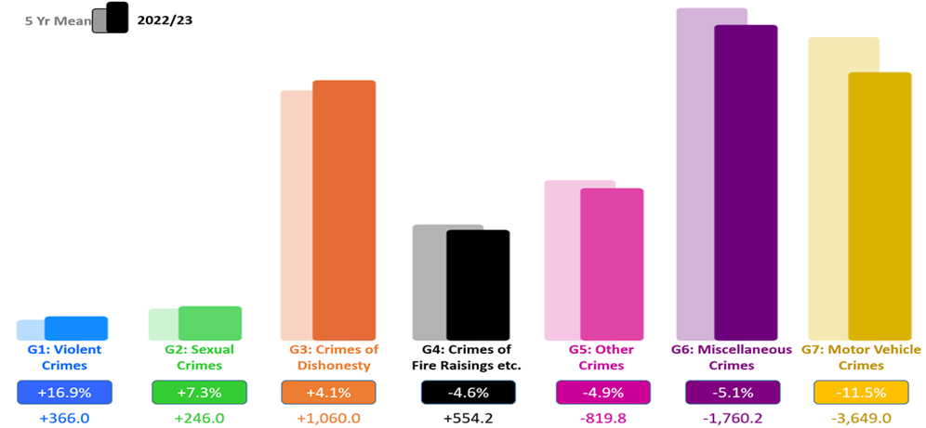
Overall recorded crime in Scotland remains relatively low and below the five year mean. The number of crimes and offences during Quarter 1 2022/23 decreased from last year by 1.6% (2,016 fewer) and are down on the five year mean by 4.0% (4,620.6 fewer).
Key insight 1 illustrates that four out of the seven crime groups have decreased this year compared to the five year mean. The five year mean has increased for ‘Group 1: Violent Crimes’ by 16.9% (366 more crimes), ‘Group 2 Sexual Crimes’ by 7.3% (246 more crimes) and Group 3: ‘Crimes of Dishonesty’ by 4.1% (1,060 more crimes).
Despite the increase in Group 1 crimes, it is important to note that the most serious violent crimes are down on the five year mean driven by decreases in the number of homicides, serious assaults and robberies.
The five year mean for Group 1 crimes remains affected by the introduction of domestic abuse offences in 2019/20. When these offences are excluded the increase is less profound at 8.5% (164 more offences).
Threats and extortion continues to be a key driver in the increase in Group 1 crimes, a substantial proportion of which are attempts with no financial harm suffered by the complainers. Increased reporting of this crime type is encouraged to inform our understanding around new and emerging threats, particularly from online crime.

Key Insight 2: Slight decrease in hate aggravated crime from the previous year
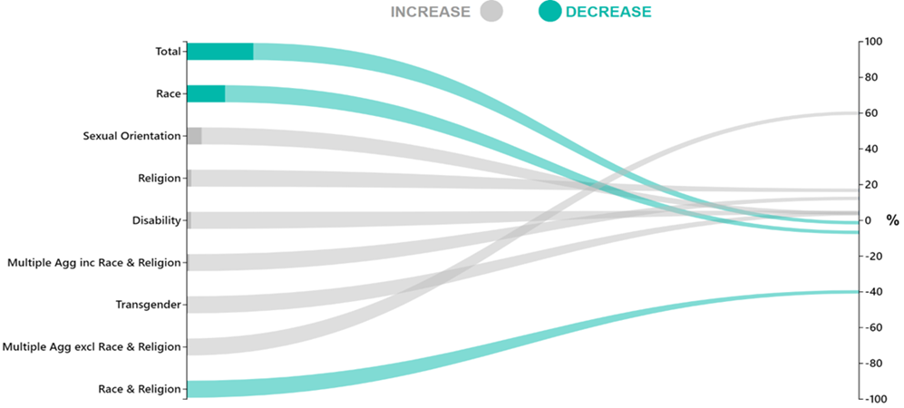
There were a total of 1,813 hate aggravated crimes in Quarter 1 2022/23 compared to 1,836 for the same time period last year, a decrease of 1.3% (23 fewer crimes). Hate aggravated crime increased from the five year mean (up 5.6%, 96.4 more crimes).
Key insight 2 highlights that out of the eight hate aggravators two have decreased (‘Race’ and ‘Race & Religion’) compared to last year. These two aggravators accounted for 56.5% of all hate crime in 2022/23, with ‘Race’ accounting for 55.8% of all hate aggravated crimes.
Therefore, the overall reduction in hate crime is mainly a result of the decrease in ‘Race’ aggravated hate crime, as six of the other hate aggravators have actually increased compared to last year.
Caution should be applied on viewing the key insight above as some of the percentage increases may appear to be more significant than they are due to small numbers.
For example, the aggravator of ‘Multiple Aggravators excluding Race & Religion’ has increased from 15 to 24 in 2022/23 and this is a percentage change of 60.0%, despite increasing by nine. For a further breakdown please see here.

Key Insight 3: Benchmarking call handling: Police Scotland performing in line with England and Wales
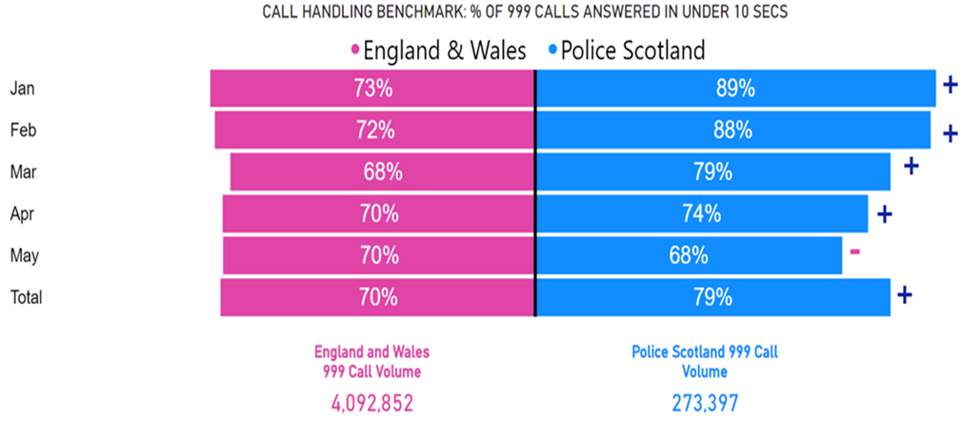
Call handling, in particular answering 999 calls, is one of Police Scotland’s highest priorities. Through Police Scotland’s focused work on benchmarking, the benchmark of ‘999 calls answered in under 10 seconds’ was introduced.
This will enable Police Scotland to gain additional insight into its handling of 999 calls through sharing learning and adopting best practice. It should be noted that at the time of writing, benchmarking data is not available for the month of June 2022. As a result, Police Scotland has examined data from the start of the 2022 calendar year.
From the above visualisation, Police Scotland is performing in line with police services in England and Wales, having answered 273,397 (79.1%) 999 calls in under 10 seconds, with England and Wales answering 2,881,092 (70.4%) of their total calls in under 10 seconds.

Public Confidence and Experience of Policing
Police Scotland’s Public Contact and Engagement Strategy sets out how we envisage our public contact / engagement activities and approaches to look now, and in the future. We have been clear in setting out what the public should expect from their police service and how we will continue to engage and involve communities and our partners.
Our Public Engagement and Participation Framework sets out the ways in which we will seek to engage with communities so that their insights can be utilised in meaningful ways. Working in this way aims to aid operational and strategic decision-making, ensuring that Police Scotland operates using evidence-led principles in line with our values.
The Public Confidence Governance Board oversees the development of our engagement approaches to understand public confidence within communities and act on public feedback.
We are paying particular attention to how we reach those who are often seldom-heard; by understanding where there are opportunities to enhance engagement and working with organisations with relevant expertise.
High-level overview
We continue to engage and involve the public, communities and partners in policing through our ongoing national surveys and other engagement activities:
Your Police 2022/23 survey - our local police survey for this year which builds on the great response from the public and communities in previous survey years. Anyone who lives in Scotland can influence local policing in their area through this survey. We use the feedback to understand public confidence, where we can improve and build on what we are doing well, and inform opportunities for partnership working and collaboration.
User Experience survey - our independent survey to measure and enhance people’s experience of contacting Police Scotland, administered by Progressive Partnership Ltd. The survey is sent via text message to a sample of people who have made contact with police each month. This survey receives approximately 1,200 responses each month and was expanded to include those engaging with our complaints process. A new survey is in development with Specialist Crime Division (people who are victims and witnesses of serious crime) and Criminal Justice Services Division (people in police custody).
The public confidence and user experience survey insights are considered each month at the Strategic Leadership Board for executive oversight and action. Data and insights are shared with Regional Delivery Boards and local policing for improvement planning and scrutiny, and working with partners and other relevant stakeholders.
Feedback and insight helped shape the Annual Police Plan for 2022/23 and work is underway to ensure that data from communities informs the development of new Local Police Plans, as engagement on their renewal commences.
Our response to public and community feedback has been to:
Improve the way we share and use data and insights within the organisation. Powerbi dashboards containing the survey data have been developed with local divisions to support local policing planning, community engagement and partnership working.
Introduce a GIS Mapping tool to our Your Police survey to identify the locations and reasons communities feel less safe which will inform local partnership working and enhance police visibility. We are sharing data through Regional Delivery Boards and across our local policing divisions to support collaboration to address community concerns.
Commission social action research within seldom-heard communities to understand how we can improve our engagement practice in supportive and appropriate ways. The joint research fund between Police Scotland, the Scottish Institute of Policing Research and the SPA awarded four studies which will be completed by October 2022. These include policing with empathy in conversation with LGBTQ and young people from disadvantaged backgrounds (Abertay University); refugee and asylum-seeker experiences, trust and confidence with Police Scotland (Queen Margaret University); inquiring together - collaborative research with BAME communities and serving officers (Dundee University); and, accounting for complexities - an intersectional approach to enhancing police practitioner reform (University of Glasgow).
Established reference sub-groups to implement actions for enhancing engagement within seldom-heard communities. Emerging activities include the enhancement of local external communications; awareness campaign among operational colleagues to recognise and reinforce positive behaviours; ongoing development of the engagement and participation framework which will support operational colleagues policing in a diverse Scotland – the framework is co-designed with officers, staff and communities and will be widely publicised.
Independent Advisory Group (IAG) on Emerging Technologies in Policing. Police Scotland is leading a workstream of the IAG focused on informed decision-making through consultation, community engagement and participation. The IAG are examining evidence and best practice to begin to develop recommendations. The workstream led by Police Scotland has involved collaboration among expert organisations and academics in the fields of policing, digital technology, community engagement and participation. Reports will be publically available on the Scottish Government website shortly.
Respond to local needs by piloting innovative approaches to involve communities. For example, Police Scotland is working with Scottish Government and Caithness Voluntary Group to pilot a participatory grant scheme in the Caithness area within Highland and Islands Division. This will involve communities coming together to respond to local needs and inspire collective action to improve safety and wellbeing within the local area. Strategy, Insight and Engagement with Local Policing are supporting community development projects in Edinburgh and East Lothian to respond to local concerns and enhance community engagement practice.

Your Police Survey
Your Police received 952 responses between 01 April 2022 and 30 June 2022. This included seven British Sign Language (BSL) responses. Promotion and marketing materials have been refreshed and shared through partner networks. The survey continues to be broadly representative of the population by age, gender, disability and geography.
The Your Police survey influences local policing by enabling the public to highlight areas of concern, good practice and informs our approach to working with local partners. We gather data on public confidence levels through this survey.
The Research and Insight team is responsible for the design and delivery of this survey. Promotion is supported by Corporate Communications; Partnerships, Prevention and Community Wellbeing, local policing, and many external partners in maximising engagement with Scotland’s diverse communities.
It is important to us that we make our public engagement activities inclusive so that our services meet the needs of the communities we serve.

Public Confidence and Perceptions of Police
In 2019/20 the average public confidence level in local policing was recorded at 48% by the Your Police survey. This confidence level increased significantly in 2020/21 with an increased average public confidence level of 57%.
Public confidence was then recorded as 41% in Quarter 1 of 2021/22, 38% in Quarter 2, 43% in Quarter 3 and 40% in Quarter 4. In Quarter 1 of 2022/23 confidence was at 39%.
In April 2022, a public confidence index score was introduced to be comparable with how confidence is measured in the Scottish Crime and Justice Survey, YouGov and The Mayor’s Office for Policing and Crime (MOPAC).
The index score accounts for all of the responses (from ‘strongly disagree’ to ‘strongly agree’) excluding the ‘don’t know’ responses by assigning numerical values and converting the overall response average into a percentage value.
Using the index score, public confidence was recorded as 54% in Quarter 1 of 2021/22, 51% in Quarter 2, 54% in Quarter 3 and 53% in Quarter 4. In Quarter 1 of 2022/23 confidence was at 51%.
For comparison, 55% (n=5,417) of YouGov survey respondents across the UK thought that “generally speaking, police were doing a good job” in Quarter 1. The YouGov figure for Scotland in Quarter 1 was 57% (n=466).
We know from our own research and academic studies that wider public confidence and experience of contacting and interacting with police are not always connected.
While confidence is likely to fluctuate, satisfaction scores gathered by our independently administered User Experience Survey remain positive and consistent. Overall satisfaction with contacting the police was at 67% in Quarter 1.
Just under one third (29%) of respondents reported they ‘didn’t know’ or ‘neither agreed nor disagreed’ that they were confident in their local police. This proportion reflects that a substantial number of respondents who completed the survey had not interacted with police recently or had no opinion regarding their confidence in policing.
These findings show that although public confidence is important to measure, it is not a reliable indicator of operational performance. Service quality has remained consistent even though confidence levels have fluctuated throughout each Quarter.
Public confidence is not always based on contact and engagement with police, but instead, on perceptions of local policing and crime, and to a lesser extent, the wider policing narrative in society, nationally and internationally.
Our findings show that confidence can be influenced by geographic and demographic factors. Whilst we capture a national level of confidence, there is much nuance within this picture.
We know, for example, that people living in areas affected by poverty and where there are higher numbers of people affected by social injustice are less likely to feel confident in the police.
This is reflected across the UK and is evidenced-based. Work continues, in partnership with the Scottish Institute for Policing Research, the Centre for Policing Research and Learning, the Scottish Police Authority, and alongside community organisations to enhance our understanding of public confidence and trust in policing.
Understanding public confidence is important to us as it is one of the ways that we respond to emerging issues within communities. Maintaining confidence in policing is vital to ensure that we are policing in line with our values whilst maintaining or building trust and legitimacy for every person in our society.
The confidence level derived from Your Police is comparable to confidence measures in the Scottish Government’s Scottish Crime and Justice Survey and from other UK policing organisations, most notably the Mayor’s Office for Policing and Crime (MOPAC).

Factors influencing public perceptions of policing among people who feel unsafe in their local area
Survey respondents in Quarter 1 2022/23 who said they feel unsafe in their local area (n=174) raised similar themes as in Quarter 4 2021/22. The following themes remain important, on which we are taking action and using to inform local and strategic decision-making, with plans and projects for sustaining change over the long term.
Police visibility, presence and Accessibility
60% of respondents who felt unsafe in their local area highlighted greater police visibility as a way of making them feel safer and providing reassurance. Police presence is often mentioned within the context of prevention and targeting of drug-related crime and anti-social behaviour.
The type of visibility or accessibility (e.g. physical, online and virtual) was not always specified in the responses but a majority specifically mentioned physical presence including more foot patrols in local areas, at specific times (e.g. after dark/weekends) and locations (e.g. in parks, around transport hubs, and local crime ‘hot spots’) where communities tend to feel less safe.
The importance of police visibility in local areas was most prevalent across respondents from areas of Scotland most affected by poverty (people living in SIMD 1 & 2 areas), with 57% of respondents living in these areas mentioning police visibility, compared to 43% of respondents from more affluent areas (people living in SIMD 4 and 5).
Community engagement and being kept informed
18% of respondents who felt unsafe in their local area highlighted community policing and local engagement as important. This is highlighted alongside police visibility by respondents - for example, informal and friendly conversations with police officers on what matters to communities in local areas. Respondents highlight the importance of policing being accessible locally, having staff who are familiar with local needs and for training to be relevant to the specific issues affecting local communities. The public would like to be familiar with local officers and seek effective and trusting relationships.
7% of respondents who felt unsafe in their local area highlighted that how we ‘show up’ is important. Police officers and staff should continue to bring empathy and understanding to their interactions with the public. Respondents expect people working in Police Scotland to be adequately trained, caring and professional. This includes cultural intelligence in understanding the lived experiences of communities. Respondents refer to how we are building trust and positive changes within seldom heard communities.
4% of respondents who felt unsafe in their local area highlighted communicating what we are doing as important. Respondents identified taking action on local issues as one of the key communication priorities. The public expect police to react promptly to reports and would like to be informed about when and if police are attending. Respondents also want to be updated on the course of action of their incident.
Work is progressing through local divisions to respond to these concerns in local areas.

Main areas of concern for local communities
There were 814 responses in Quarter 1 to the open-ended question – “What, if anything, worries you about your local area?” The common themes that emerged from analysis of these responses are set out as follows:
43% of respondents mention anti-social behaviour with alcohol, littering / fly tipping, young people causing disturbances and noise complaints. It’s important to have clear and accessible signposting to support and connect individuals with the right services delivered by a range of community partners. People may ask police to help with matters which are important to them, but we may not be the best service or be able to help in ways which are required. Police Scotland is committed to improving outcomes for people.
24% of respondents highlight speeding and driving related offences – ‘boy racers’, motorised scooters and dirt bikes were cited by respondents who also commonly express their concerns with speeding and reckless driving in their local area.
19% of respondents mention drug crime and related harms – the presence and effects of drugs within local communities and how local police are tackling drug dealing is crucial for community safety. The increased visibility of drug dealing and drug taking, particularly during the pandemic, has been a consistent theme over previous quarters, too.
19% of respondents are concerned with little physical presence of the police – people would like to see regular foot and cycle patrols in their local areas. Several comments mentioned the need for police being visible and easily accessible within local communities.
10% of respondents express concern about local theft and break-ins and want to be aware of the preventative measures they can take to keep their homes and businesses safe.

What we are doing well:
Your Police enables the public to tell us about our approach, which includes what we are doing well and getting right. In Quarter 1, there were 762 open-ended comments to the question - “What are the police doing well in your local area? “
49% (374) of responses mentioned aspects unrelated to the question, including answers such as “Don’t know” or areas for improvement as previously captured. 388 responses included positive aspects of local policing as described as follows:
Police visibility, presence and accessibility
53% of responses relate to the impact of police visibility presence and accessibility. Respondents’ value consistent service delivery in the difficult circumstances policing is operating in. There is appreciation for local policing and the job they do within local communities to keep people safe, including crime prevention and protecting people who may be vulnerable.
Many responses commend the enhanced visibility of police in some areas over recent months and highlight this as positive. Comments commonly mention increased responsiveness and appropriate action to reported crimes and other incidents. Positive values and behaviours particularly local police being friendly and approachable, was observed.
Community engagement and being kept informed
11% of respondents highlighted the value of community policing and what community officers are doing to understand and tackle challenges in local areas together with partners and communities. There is appreciation for being kept up to date with the reported issues. Respondents value police informing the communities on local initiatives and being kept up to date with the work of the police.

How the public are experiencing their police service
The User Experience Survey, administered by Progressive Partnership Ltd, reaches a representative sample of 1,200 individuals monthly. The survey is delivered via SMS to those who have contacted Police Scotland in the previous month.
In this quarter, 3,752 respondents were surveyed about their experience of the policing service provided, from initial contact through to overall satisfaction.
The findings show continued high levels of satisfaction with contacting the police as follows:
Ease of contact – 72%
Initial contact treatment by C3 staff – 84%
Feeling properly understood – 86%
Being provided with the appropriate response – 62%
Satisfaction with attending officers – 81%
Feeling adequately informed about case progress – 47%
Overall satisfaction with Police Scotland – 67%

Measures of Progress towards Strategic Outcomes

Strategic Outcome: Threats to public safety and wellbeing are resolved by a proactive and responsive police service
Police Scotland’s objectives are to:
- Keep people safe in the physical and digital world
- Design services jointly to tackle complex public safety and wellbeing challenges
- Support policing through proactive prevention
All data is classed as Management Information and is not considered official statistics. All data is sourced from Police Scotland internal systems.

Violent Crime
Overall violent crime | 2021/22 YTD | 2022/23 YTD | % Change from Previous Year | 5 Year Mean | % Change from 5 Year Mean
Number of crimes | 15,822 | 16,461 | +4.0% | 15,907.2 | +3.5%
Number of Detections | 10,596 | 11,369 | +7.3% | 11,077.4 | +2.6%
Detection rate | 67.0% | 69.1% | +2.1% point | 69.6% | -0.6% point
Note: Overall violent crime is comprised of: murder, culpable homicide (common law), attempted murder, serious assault, robbery, common assault and common assault (of emergency workers)
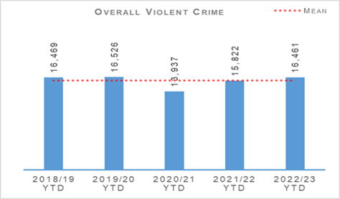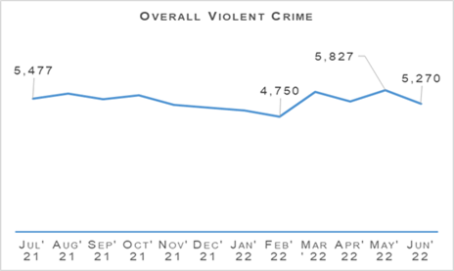
Overall violent crime levels for the quarter were broadly similar to recent years with the exception of 2020/21 which saw a significant reduction due to COVID-19 and related lockdowns. April to June 2022 saw violence levels consistent with pre-pandemic years.
There were 12 homicides recorded in the first quarter of 2022/23. This was three fewer than the previous year and also fewer than the five year mean of 16.8 homicides.
The 76 attempted murders recorded during the quarter represents a slight (three additional crimes) increase on last year and the five year mean. Detection rates for homicide and attempted murder are 100.0% and 105.3% respectively.
Serious assaults have reduced, down 7.0% from last year and 14.9% below the five year mean year. Common assaults, which account for 92.0% of overall violent crime, have increased by 4.9% compared to last year and the five year mean.
There were 407 robberies recorded during the quarter, the same number as last year and six fewer than the five year mean.
There have been 844 crimes recorded under the Protection of Workers (Retail and Age-restricted Goods and Services) (Scotland) Act 2021. Three of these were for serious assaults, 390 for common assaults and 451 for threatening and abusive behaviour against retail workers.
Crimes under the new act have increased steadily since the legislation was introduced in August 2021 with an average of nine a day now being recorded. Work with retail groups continues to ensure retail workers feel confident in reporting crimes to us.
28 June 2022 saw the commencement of provisions relating to the possession of corrosive substances in a public place and the relevant provision for the sale and delivery of knives.
Police Scotland’s Violence Prevention and Licensing Coordination Unit (VPLCU) is supporting the Scottish Government led initiative to coordinate the nationwide Offensive Weapons Surrender Campaign which runs from 01 July to 30 September 2022.
This allows members of the public the opportunity to surrender and apply for compensation for any listed weapons which become illegal under the legislative launch date scheduled for December 2022.
113 designated police stations are available across the 13 territorial divisions for members of the public to attend with their surrendered item.
Police Scotland’s Partnership, Prevention & Community Wellbeing department currently has a sergeant seconded to the Violence Against Women and Girls (VAWG) Taskforce at the National Police Chiefs Council (NPCC) for six months.
The department is directly involved in the ‘5 Nations approach’ (Scotland, England, Wales, Northern Ireland and the Republic of Ireland) which aims to build trust and confidence in policing. It is recognised that despite barriers, including numerous jurisdictions, VAWG exists across all organisations and communities and therefore activities are planned in all nations.
The 5 Nations approach being developed by VAWG NPCC Taskforce has four key objectives:
Putting the victims/survivors at the heart of decision making.
Sharing promising practice across the 5 Nations.
Driving cultural change in addressing misogyny and sexism within the workforce and promoting a ‘call out culture’.
Involving women in providing solutions and providing inclusivity from minority groups.
Non Sexual Crimes of Violence (Group 1) | 2021/22 YTD | 2022/23 YTD | % Change from Previous Year | 5 Year Mean | % Change from 5 Year Mean
Number of crimes | 2,394 | 2,533 | +5.8% | 2,167.0 | +16.9%
Number of Detections | 1,646 | 1,634 | -0.7% | 1,589.6 | +2.8%
Detection rate | 68.8% | 64.5% | -4.2% point | 73.4% | -8.8% point
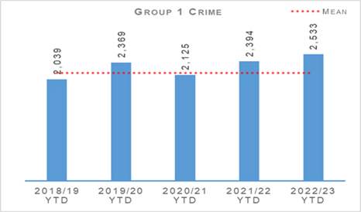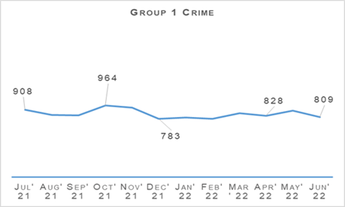
Non sexual crimes of violence increased by 5.8% compared to last year. This is the highest level in recent years and 16.9% above the five year mean. While crimes such as homicide and serious assaults have decreased from last year some crime types have gone up.
There were 445 crimes recorded under the Domestic Abuse (Scotland) Act (DASA) during the first Quarter of 2022/23 compared to 415 in the same period last year. More detail on domestic abuse is covered later in this report (see here).
As always it is worth noting that DASA crimes have only been recorded since 2019/20 which skews any comparison to the five year mean for Group 1 crimes. If DASA crimes are not counted then total Group 1 crime has actually decreased by 79 crimes compared to the adjusted five year mean.
During Quarter 1 this year 172 crimes of cruel and unnatural treatment of children were recorded. This is a 28.4% increase from last year and a 10.3% increase on the five year mean. A significant proportion of these crimes are non recent with some dating back to the 1950s.
381 crimes of threats and extortions were recorded between April and June 2022 – an increase of 26.2% from last year and of 158.5% from the five year mean. Changes in recording standard brought in at the start of 2020/21 and increasing time spent online means this crime type is likely to increase further given trends in online offending.
However, it should be noted that these figures also include attempted threats and extortions where no financial harm took place. The public reporting these attempts, even where they have not been harmed, is useful for identifying new methods and trends being used by online offenders and update and improve preventative messaging accordingly.
There were 66 crimes of drugging reported to Police Scotland during the Quarter compared to four in the same period last year and a five year mean of five.
Recorded drugging crimes have remained higher than usual since Quarter 3 of 2021/22 following national media reporting of concern around drugging by injection in licensed premises across the UK and the sharing of information via social media, albeit levels have reduced significantly since October/November last year.
Police Scotland created a communications toolkit to promote a consistent approach, reinforcing the importance of woman and girls feeling and being safe in public places whilst ensuring there is no ‘victim blaming’ culture.
Partnership, Prevention & Community Wellbeing (PPCW) continue to seek opportunities to promote ByStander awareness training to the licencing industry. Following concerts, festival and other events resuming following the pandemic, Police Scotland has started linking in with event organisers to ensure awareness packages are included in their staff briefings.
Wider engagement has included working with health partnerships to ensure wider understanding of the issue and to support evidence recovery. Links have also been made with other key partners including higher education, the licensing trade and local authorities, as well as the Scottish Violence Reduction Unit.
Police Scotland has developed and circulated a comprehensive Investigative Strategy to provide guidance and direction to staff responding to and investigating incidents of spiking.

Public Protection
Overall Sexual Crime (Group 2) – Equality Outcome 4 | 2021/22 YTD | 2022/23 YTD | % Change from Previous Year | 5 Year Mean | % Change from 5 Year Mean
Number of crimes | 3,849 | 3,598 | -6.5% | 3,352.0 | +7.3%
Number of Detections | 2,158 | 1,997 | -7.5% | 1,939.2 | +3.0%
Detection rate | 56.1% | 55.5% | -0.6% point | 57.9% | -2.4% point
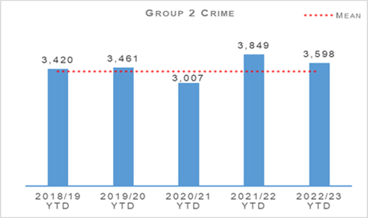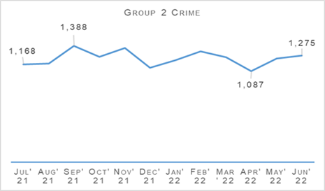
Overall sexual crime fell during Quarter 1 in comparison to Quarter 1 last year. Between April and June 2022, sexual crimes decreased by 6.5% (251 crimes) when compared to last year however increased by 7.3% against the five year mean.
April 2022 recorded the lowest number of sexual crimes (1,087 crimes) during any month over the 12 month period. September remained the month where most crimes were recorded.
The number of detections also decreased compared to last year, down 7.5% (161 detections) on last year, however again noted an increase against the five year mean (up 3.0%).
The decrease in sexual crimes is driven by decreases in lewd and libidinous (since April 11) (down 45 crimes, 18.0%), communicating indecently (down 58 crimes, 25.0%), cause to be present sex act / to look at sex image – M&F (<13) (down 31 crimes, 28.2%) and rape of a female over 16 (down 35 crimes, 8.5%).
Many sexual crimes however, have increased when compared to Quarter 1 last year with sexual assault of a female over 16 noting the greatest numerical increase, up by 136 crimes (35.7%) on last year and double the number recorded in 2020.
Overall Sexual Crime (Group 2) – Equality Outcome 4 | 2021/22 YTD | 2022/23 YTD | % Change from Previous Year | 5 Year Mean | % Change from 5 Year Mean
Number of recent crimes | 2,882 | 2,829 | -1.8% | 2,481.4 | +14.0%
Number of non-recent crimes | 967 | 769 | -20.5% | 870.6 | -11.7%
Proportion of Group 2 crime non-recent | 25.1% | 21.4% | -3.7% point | 26.0% | -4.6% point
Note: Non-recent sexual crimes are defined as crimes that were reported more than one year after they were committed.
Recent and non recent sexual crimes decreased compared to the same period last year with the overall proportion of non recent also decreasing compared to last year. This decrease is in contrast to what was noted at the end of the last reporting period where recent and non recent crimes increased.
Non recent reporting noted the greatest decrease, down 20.5% (198 crimes) while recent reporting remained stable with a decrease of 1.8% being noted. The proportion of non recent reporting of sexual crime is narrowing, indicating that recent reporting continues to drive sexual reporting.
Recent crimes are classed as any crime that occurred within one year of reporting, however almost half of all crimes were reported within one week of them being committed and 38% were reported within two days of being committed.
Rape – Equality Outcome 4 | 2021/22 YTD | 2022/23 YTD | % Change from Previous Year | 5 Year Mean | % Change from 5 Year Mean
Number of crimes | 637 | 583 | -8.5% | 557.8 | +4.5%
Number of Detections | 359 | 335 | -6.7% | 305.2 | +9.8%
Detection rate | 56.4% | 57.5% | +1.1% point | 54.7% | +2.8% point
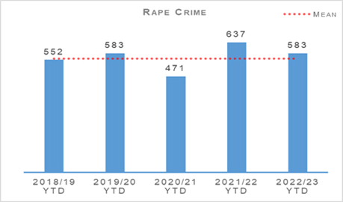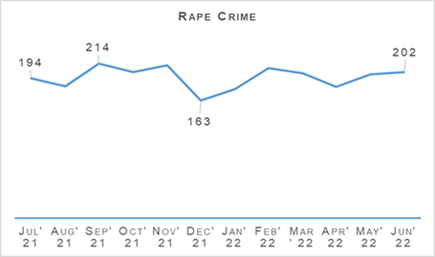
When comparing overall sexual crime and rape, a similar trend is noted with recorded rapes being down 8.5% (54 crimes) compared to last year but up 4.5% on the five year mean.
Last year, the reporting level of rape was exceptionally high in comparison to previous years and the number recorded this year is similar to reporting levels pre-pandemic. It should be noted that lower numbers of rapes and overall sexual crimes were recorded in April 2022 and have since increased monthly, throughout the quarter.
A decrease in rape of a female over 16 is driving the overall decrease in rape, while rape of a male over 16 and rape of a female aged 13 – 15 have increased when compared to last year.
Police Scotland’s That Guy campaign went viral almost immediately when it launched in October last year. The sexual crime campaign has become the most successful marketing campaign ever run by a police service in the UK.
To date the campaign has won 10 national and international awards out of 19 nominations, with the results of four of those nominations still to be announced.
Work on phase two of the That Guy campaign is well under way and is a key strand in the development of Police Scotland’s Violence Against Women and Girls strategy.
Rape – Equality Outcome 4 | 2021/22 YTD | 2022/23 YTD | % Change from Previous Year | 5 Year Mean | % Change from 5 Year Mean
Number of recent crimes | 365 | 386 | +5.8% | 326.8 | +18.1%
Number of non-recent crimes | 272 | 197 | -27.6% | 231.0 | -14.7%
Proportion of Group 2 crime non-recent | 42.7% | 33.8% | -8.9% point | 41.4% | -7.6% point
Note: Non-recent rape crimes are defined as crimes that were reported more than one year after they were committed.
Non recent reporting of rape decreased by 27.6% (75 crimes) compared to last year and by 14.7% against the five year mean. The proportion of non recent rape has also decreased, down 8.9 percentage points on last year and down 7.6 percentage points on the five year mean.
Recent rapes increased by 5.8% (21 crimes) against last year and by 18.1% against the five year mean.

Violence Against Women and Girls (VAWG)
Work has progressed to develop a strategic assessment of threat, risk and harm to ensure a robust evidence base underpinning the design and development of a Violence against Women and Girls Strategy for policing in Scotland.
As part of the development of the Strategy, online consultation and ideas platforms have been created to gather attitudes from people who have experienced or witnessed this type of behaviour in their communities.
This work has been supported by Scottish Women’s Aid as positive and meaningful engagement for Police Scotland to be leading. The responses and ideas received via the platforms will be analysed and contribute to the development of the strategy.
Police Scotland is also bringing together a range of voices to inform a number of stakeholder events.
The first Violence against Women and Girls Stakeholder Engagement Forum took place and was attended by a number of senior leaders from a range of services who will provide a coordinated strategic approach to Police Scotland’s response to tackle Violence against Women and Girls.
Areas of focus included BME, forced marriage, honour based violence and children and young people. A number of other events are arranged to take place over the coming months where themes of focus will include diversity and inclusion, LGBTQI+, stalking and harassment, and online harm.
There has been interest to participate from a number of universities around Scotland as well as Scottish Commission for People with Learning Disabilities.
Child Sexual Abuse (online) – Equality Outcome 4 | 2021/22 YTD | 2022/23 YTD | % Change from Previous Year | 5 Year Mean | % Change from 5 Year Mean
Number of crimes | 510 | 442 | -13.3% | 448.2 | -1.4%
Number of Detections | 351 | 305 | -13.1% | 293.6 | +3.9%
Detection rate | 68.8% | 69.0% | +0.2% point | 65.5% | +3.5% point
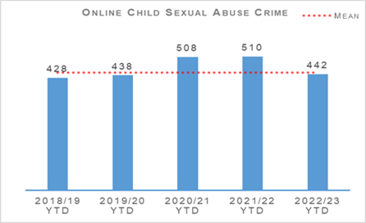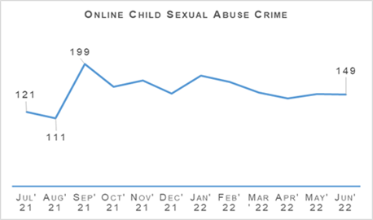
To date, 442 online child sexual abuse crimes were recorded, a decrease of 13.3% (68 fewer crimes) compared to last year and a decrease of 1.4% on the five year mean. Online sexual abuse crimes have, in general been declining month on month since January 2022.
The detection rate increased slightly in Quarter 1 up 0.2 percentage points to 69.0%.
Child Sexual Abuse Images – Equality Outcome 4 | 2021/22 YTD | 2022/23 YTD | % Change from Previous Year | 5 Year Mean | % Change from 5 Year Mean
Cause to be Present Sex Act/To Look at Sex Image -M&F (< 13) | 110 | 79 | -28.2% | 83.8 | -5.7%
Cause to be Present Sex Act/Look at Sex Image -M&F (13-15) | 44 | 42 | -4.5% | 44.4 | -5.4%
Communicate Indecently/Cause see/hear Indec Comm - M&F (< 13) | 92 | 75 | -18.5% | 79.8 | -6.0%
Communicate Indecently/Cause see/hear Indec Comm – M&F (13-15) | 69 | 74 | +7.2% | 69.6 | +6.3%
Grooming of children for the purposes of sexual offences | 44 | 14 | -68.2% | 27.2 | -48.5%
Taking, distribution, possession etc. of indecent photos of children (from Apr 2011) | 151 | 158 | +4.6% | 143.4 | +10.2%
Taking, distribution, possession etc. of indecent photos of children (from Apr 2011) again accounts for the largest proportion of online CSA crimes and is the only crime type to increase (up 4.6%, seven crimes) along with Communicate Indecently/Cause see/hear Indec Comm – M&F (13-15) (up 7.2%, five crimes).
The overall decrease in online CSA is driven by decreases in Cause to be Present Sex Act/To Look at Sex Image -M&F (< 13) (down 28.2%, 31 crimes) and Grooming of children for the purposes of sexual offences (down 68.2%, 30 crimes).
The National Joint Investigative Interview Project (a multi-agency programme developed and delivered by Police Scotland, Social Work Scotland and COSLA) continues to successfully deliver the new model of child interviews. Evaluation of the programme remains positive for those areas that have gone live in practice.
Police Scotland continue to be a key partner in the role out of the National Child Protection Guidance Improvement Plan and fully support the drive to bring consistency and equity of practice for children across all areas of Scotland who have experienced all types of abuse but particularly child sexual abuse and exploitation (CSAE).

Sex Offender Notifications

Sex Offender Notifications (SONR)
SONR is an automatic consequence of conviction for a relevant sexual offence. Any offender who has received a conviction or finding, in respect of a specified sexual offence is automatically subject to the Notification Requirements and identified as a Registered Sex Offender (RSO).
SONR requires an offender to notify police of details such as names used, address, passport Information and banking Information, annually or following change.

Sexual Offences Prevention Order (SOPO)
A SOPO is part of the statutory regime which operates to control the behaviour of those convicted of a relevant offence in order to protect the public or particular members of the public, from serious physical or psychological sexual harm from the person who is subject of the order.
A SOPO can be granted on conviction or at sentencing where the court is satisfied that it is necessary to protect the public or a particular member of the public from serious sexual harm.
It can also be granted by Civil Summary Application where the offender has, since the date of conviction for their relevant offence acted in such a way as to give reasonable cause to believe that it is necessary for a SOPO to be made. At the end of Quarter 1 a total of 678 SOPOs were in force.

Risk of Sexual Harm Order (RoSHO)
A Risk of Sexual Harm Order (RoSHO) is a Civil Order created under the Protection of Children and Prevention of Sexual Offences (Scotland) Act 2005, designed to protect children under 16 from those who present a risk of sexual harm towards them.
It is a preventative order which prohibits the person to whom it applies from doing anything and/or obliges them to do anything specified within the order. The conditions requested must, however, be necessary to protect children generally or any child from harm from the person subject to the order.
Each SOPO / RoSHO has restrictions / obligations bespoke to the risk posed by the offender and an offence is committed if they fail to comply with these.
Common offences include failing to disclose internet enabled devices, deleting or using privacy software to hide online activity, contact with children and being under the influence of alcohol in a public place. At the end Quarter 1, 23 RoSHOs were in place.
Registered Sex Offenders (RSOs) | 2021/22 YTD | 2022/23 YTD | % Change from Previous Year | 5 Year Mean | % Change from 5 Year Mean
Number of Sex Offender Notification Requirements (SONR) offences committed | 119 | 135 | +13.4% | 121.0 | +11.6%
Number of RSO's who committed SONR offence | 105 | 112 | +6.7% | n/a | n/a
Number of Preventative Order offences committed (SOPO, RoSHO and equivalent issued out with Scotland) | 41 | 62 | +51.2% | 48.0 | +29.2%
Number of RSO’s who committed a Preventative Order offence | 30 | 42 | +40.0% | n/a | n/a
During the reporting period 112 registered sex offenders committed a total of 135 Sex Offender Notification Requirements (SONR) offences.
This is an increase compared to the same period last year where 105 registered sex offenders committed a total of 119 SONR offences. Most common offences relate mainly to failing to notify of address change and banking information.
42 Registered sex offenders committed preventative order offences which is higher than last year where 30 registered sex offenders committed offences.
Domestic Abuse – Equality Outcome 4 | 2021/22 YTD | 2022/23 YTD | % Change from Previous Year | 5 Year Mean | % Change from 5 Year Mean
Number of incidents | 15,796 | 15,473 | -2.0% | 15,783.4 | -2.0%
Number of crimes | 10,429 | 9,561 | -8.3% | 9,973.0 | -4.1%
Number of detections | 7,170 | 6,207 | -13.4% | 6,918 | -10.3%
Detection rate | 68.8% | 64.9% | -3.8% point | 68.6% | -3.7% point
Proportion of incidents resulting in a crime | 42.9% | 41.7% | -1.2% point | 44.4% | -2.7% point
DASA (of female) – Number of crimes | 382 | 407 | +6.5% | n/a | n/a
DASA (of male) – Number of crimes | 33 | 38 | +15.2% | n/a | n/a
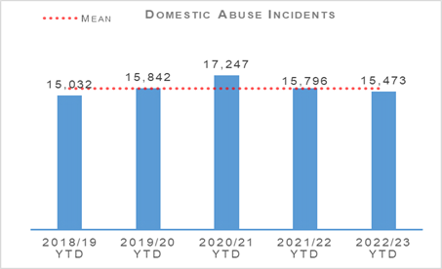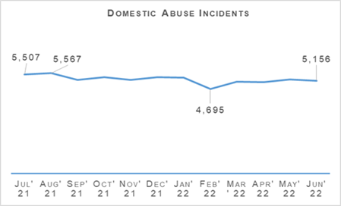
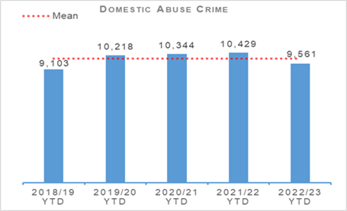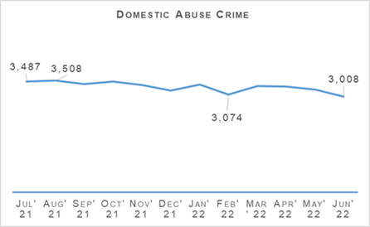
Domestic incidents decreased by 2.0% (323 incidents) compared to last year and are also down by 2.0% compared to the five year mean. Domestic crimes decreased by 8.3% (868 crimes) compared to last year and were down 4.1% on the five year mean.
Throughout the last 12 months the number of domestic crimes and incidents recorded monthly have been relatively consistent with domestic crimes on a slight decline throughout Quarter 1.
DASA crimes continue to increase with DASA of a female increasing by 6.5% (25 crimes) compared to the same period and DASA of a male up 15.2% (five crimes).
During Quarter 1, two domestic related murders were recorded compared to one the previous year.
Disclosure Scheme for Domestic Abuse Scotland (DSDAS) applications have increased by 12.7% overall with a 8.7% increase in Power to Tell (PTT) applications and a 22.5% increase in Right to Ask (RTA) applications compared to the same period last year.

You, Me, Together Educational Input provided by Domestic Abuse Co-ordination Unit
You, Me, Together is an educational input piloted at secondary schools across Scotland by Domestic Abuse Co-ordination Unit and is aimed at youths aged between 12-18 years. It targets domestic abuse in young relationships, including themes of coercive control, inappropriate relationships and peer pressure.
The short film follows a story line of coercive control between young persons in a school setting. It focuses on ‘warning signs’ of escalation, isolation and emotional abuse and the devastating effects it can have on a victim, their life and their family.
The film forms part of a national standardised interactive educational workshop which was delivered in schools to educate students around the issues of domestic abuse and its correlation to Violence Against Women and Girls.
The pilot was delivered to over 1,100 pupils within 20 schools and concluded at the end of June. An evaluation of the teacher and learner feedback is ongoing with early feedback being extremely positive. The resource will be presented at the next national VAWG network meeting and future planning is underway.

16 Days of Activism
Police Scotland continue to contribute towards changing societal attitudes to domestic abuse supporting the 16 days of activism campaign and creating high profile awareness campaigns including the Domestic Abuse Campaign, the aim of which is to warn potential perpetrators and to encourage reporting of domestic abuse across Scotland.
It is sought to motivate bystanders such as friends and relatives to report concerns for people who may be at risk of domestic abuse by the available reporting mechanisms.

Drugs Harm / Supply

Drugs Related Deaths
Police Scotland continues to work hard at fulfilling its duty to ensure the safety and wellbeing of all people within our communities. Tackling substance use and the harms they cause is complex, with COVID-19 restrictions having further exacerbated the issue.
The restrictions caused disruption to addiction services, poverty due to economic difficulties, and mental health vulnerabilities as a result of isolation.
Recent increases in the cost of living will have unfortunately compounded these issues further. It is acknowledged that it is necessary to adopt a public health, whole system approach.
We work alongside multiple external agencies to address longstanding issues and improve the life chances of individuals we interact with frequently. Our focus in the area of drug related deaths is on identifying primary prevention and intervention opportunities.
Through working with partners we can reduce the harm caused by substance use to individuals and communities. These aims are forwarded through major internal and external forums such as the National Drug Strategy Board, the Drug Harm Prevention Group, and the multiagency Scottish Drugs Deaths Taskforce.
Numerous other work streams continue across the service and are detailed as follows:

Drug Related Death Dashboard
In January 2021, the Scottish Government announced a National Mission to reduce Scotland’s drug death rates. Part of this commitment was to improve data and surveillance.
Police Scotland and the National Records for Scotland now provide the Scottish Government information to produce a public facing drug related death dashboard. This information is provided on a quarterly basis, one quarter in arrears.
The information provided relates to local policing division, sex and age group. The broad parameters set mitigate the risk of personal identification whilst still providing a more current picture of issues and trends.
This provides partners, working in the drug treatment and harm prevention roles, a greater opportunity for earlier intervention. Partners are also afforded the opportunity to align their substance harm prevention work streams to current issues. The latest Scottish Government Drug Related Deaths (DRD) dashboard was published on 14 June 2022.
Information provided by the Substance Harm Prevention team to the Scottish Government for the last quarter showed:
There were 275 suspected drug deaths during the period January to March 2022.
This is a reduction of 13 compared to 288 suspected drug deaths over the period of September to December 2021.
The National Records of Scotland (NRS) has recorded 1,339 Drug Related Deaths in Scotland during 2020.
Due to the figures already provided by Police Scotland to Scottish Government, it is anticipated that once official NRS figures are published this will show a decrease in numbers of Drug Related Deaths in Scotland during 2021 when compared to 2020.
Please note that numbers of suspected drug deaths fluctuate from quarter to quarter. Care should be taken not to interpret movements between individual calendar quarters as indicative of any long term trend.

National Naloxone roll-out
Following the success of the Test of Change Police Scotland has decide to train and equip all officers with naloxone. The national roll-out will take place across four phases. Phase one was to equip all trained officers with naloxone. This has now been completed and there are approximately 810 officers trained and carrying naloxone in the original test bed areas.
Phase two involved identifying an officer ranked Inspector or above to take on the role of naloxone champion for their area. Additional training to carry out this role has been provided and is now completed.
Phase three will be the creation of a bespoke training package for the naloxone training. This training package is still in development and is expected to be completed in August 2022.
Phase four, scheduled for September 2022 onwards, will see all officers trained and equipped with naloxone and an individual pouch to carry. Naloxone will be provided to each division by local health boards. It is expected divisions will receive naloxone at approximately the same time.
To date there have been 79 administrations of naloxone by Police Scotland officers. In 78 incidents the individuals have survived their order and made a full recovery.
In one incident the individual did not survive. In this incident officers were of the opinion that the victim was already deceased but nevertheless administered naloxone to try and save their life. No complaints or issues have been raised as a result of the administrations.

Pathfinders
The Taskforce sub-group, Criminal Justice and the Law, secured funding for a proposed Test of Change in the Inverness area which began on 05 July 2021.
The Pathfinder pilot involves a police referral process, at the initial point of contact, for individuals subject of S5 (2) drug possession charges (or if an addiction associated vulnerability exists for an individual, who would benefit from a referral). This is not exclusive to people taken into police custody and extends to those dealt with at the scene.
The project aims to reduce drug related criminality, harm and deaths in Scotland through early intervention and a whole-system, multi-agency approach. Referrals will be made to local peer mentor / Navigators (Medics Against Violence). These agencies will triage and offer ongoing support through the criminal justice pathway and signpost to relevant services.
Information regarding that person’s engagement / progress will be shared by Pathfinders with Crown Office and Procurator Fiscal Service (COPFS). This ensures that any subsequent case disposal decision by COPFS is fully informed. The project has been initially funded for two years with referrals underway.
An interim report on progress was produced during February 2022 by the first contact reporting system and shared with relevant partners. This progress report showed there has been 60 responses to date for the project with 58 of those agreeing to Pathfinder support.
Further roll out of the project to Dundee and potentially South Lanarkshire in 2022 is still being progressed with Pathfinders currently collating evaluative data for use in either area.

Safe Drug Consumption Facilities
Glasgow City Health and Social Care Partnership, supported by the Scottish Government, have proposed the introduction of a Safe Drug Consumption Facility in Glasgow City Centre. Existing legislation, specifically the Misuse of Drugs Act 1971, presents limitations and challenges for Police Scotland.
Any such premises would be operated as an NHS medical facility and operate legally within the existing legislative framework. Discussions have been held between COPFS and Police Scotland around this proposal and subsequent approach to existing policy / legislation.
In preparation, Police Scotland has established a strategic working group, chaired at ACC level, and a tactical working group. They have also been represented at a number of workshop events hosted by the Scottish Government to discuss various scenarios likely to arise.
It is anticipated that any local policing approach would not alter and the facility, and local area more broadly, would continue to be policed in a similar manner to any other medical facility or community.
Work is on-going to create a policy and guidance document to provide direction and reassurance. The document will assist local policing on their response to any complaints received regarding the operation of the facility or any incidents, or criminality, reported concerning the premises.
Approval on the policing style contained within the Policy and Guidance Document has been submitted to Police Scotland’s Local Policing Management Board during May 2022 and was supported. The proposal is now for the consideration of Police Scotland’s Senior Leadership Board.

Support Services Portal
Substance Harm Prevention (SHP) has compiled details of Support Services within Police Scotland Local Policing Divisions. This is to assist officers in signposting members of the public who may require support with regards to substance addiction, mental health, gambling addiction, trauma or bereavement problems.
This has been published on the Police Scotland Intranet for officers to access as required on their handheld devices in order that relevant contact details can be provided to any member of the public who requests it.
Officers can also proactively provide these details to anyone they believe may require some form of support or intervention. Currently 100,000 cards, which can be populated with service details, are on order to facilitate this process.

Substance Education Package
At present there is no recognised or approved drug awareness input delivered by police to school pupils, with officers delivering sessions through talks and presentations as part of their regular work. In response, Police Scotland intends to create a universal, corporate package to be delivered to every secondary school pupil each year.
Work between the registered charity ‘I Am Me’ and the Substance Harm Prevention Team continues, with a programme of relevant themes and a delivery method agreed for each year group.
Specific content for each subject is being developed, including peer monitoring, with fifth and sixth year pupils assisting in delivery, as well as covering drug types and effects, personal safety, and lived experiences. The overall aim is to provide pupils with enough information to allow them to make safe and informed decisions.
The objective remains that every pupil across Scotland will receive at least one input per year, delivered by either teachers or on some occasions peer groups.
This will provide an appropriate and incremental level of knowledge on substance (drugs, alcohol and tobacco) harm. The input will also provide information on the wider impacts around community and environmental impact, stigma, risks and personal safety.
The project is still on schedule for completion and delivery for the start of the new school term in July / August 2022.

Probationer Training (Tackling Stigma)
On 06 December 2021 the Scottish Government launched a national campaign calling for drug and alcohol problems to be treated as a health condition.
Part of this campaign urges people to stop using inappropriate terminology when discussing people who use drugs or alcohol. This helps to remove the barrier caused by stigma which affects individuals, families and communities.
Work continues between the Substance Harm Prevention Team, National Substance organisations (Scottish Drugs Forum, Scottish Recovery Consortium, Scottish Families Affected by Alcohol and Drugs) and the Scottish Police College. The aim is to enhance current Probationer training on substance misuse and misuse of drugs offences.
The training will also highlight the challenges of stigma and the positive impact police officers can have on individuals with drug or alcohol problems by signposting them to support and treatment services; displaying the benefits of a preventative as well as an enforcement approach to policing.

County Lines
County Lines is a method of dealing drugs that relies heavily on the criminal exploitation of children and vulnerable adults. There are a number of actions and operations to tackle County Lines being progressed across Scotland.
Police Scotland monitors the number of County Lines which operate throughout the country and seeks ways to tackle the issue. In response we have a number of on-going projects, the following are updates from the previous quarter on some of the work carried out:
Multi-agency intervention and support visits are continuing across Police Scotland in relation to communities and individuals impacted by County Lines. Specific partnership days of action are planned to raise awareness of County Lines and highlight supports available locally.
During this quarter, five days of partnership funded operations, under ‘Operation Protector’, were undertaken in Aberdeenshire in order to proactively address the effects of drug related harm on our communities. During these ‘Days of Action’ a total of 322 outreach visits were conducted, with a large number of individuals being brought into service; over 750 positive interactions at dedicated support hubs were set up in the communities targeted; and in excess of 1,000 pieces of specially designed safeguarding / support literature were distributed. In addition, approximately 20 naloxone kits have been provided to service users by NHS partners. Working with local and national British Transport Police officers, over 150 trains were checked / patrolled to deter individuals from using the rail network for County Lines activities and to safeguard any individual identified as being the victim of such activity. No victims were identified.
The Police Scotland partnership with Moray Council, NHS, and local alcohol and drug services has been instigated in the Moray area. The partnership provides a forum for discussion and actions to tackle drug related harm issues. A similar formatted operation as previously conducted in Aberdeenshire is planned for August 2022.
In Aberdeen City and Moray, new referral processes have been agreed between Police Scotland and local commissioned drug services. The Moray process is going through a period of trial and review with new referral booklets being distributed. A similar trial started in Aberdeen City on 01 July 2022 with a three month review in four areas identified by the city commission service.
In the Lothian and Borders area funding has been secured for a local football outreach program around County Lines safeguarding.
Dundee City Council has provided two years of funding to Positive Steps in Dundee to focus on County Lines and provision of support mechanisms.
The Pitchin’ In Programme is being delivered in schools, colleges and in conjunction with club community trusts. The Programme aims to encourage building of resilience in young people to help them resist the temptation of offending behaviour. The young people are also signposted towards personal and professional development opportunities.

Drug Type Analysis
Following the completion of the Minute of Agreement (MoA), regular contact has been maintained with both Robert Gordon and Abertay universities who had agreed to provide a rapid analysis of drugs. However, due mainly to staffing issues caused by COVID-19 and home working, neither university were in a position to assist with the project.
Discussions have continued and on 03 March 2022 the pharmaceutical department at Robert Gordon University confirmed that they are now in a position to start receiving drugs for analysis.
This will be progressed through the three command area STOP units with initial assistance for the Substance Harm Prevention team to ensure any issues are identified and resolved. Any subsequent information or intelligence gathered during drug analysis will then be shared with the appropriate partners.
A sample of drugs were conveyed to Robert Gordon University on 14 March 2022 for analysis. Abertay are unable to confirm a date of commencement.
Seven samples have been analysed to date with Substance Harm Prevention currently being in discussion with SPA Forensic Services for their reading and guidance on best use of the data.
This working partnership with the universities is only used to gather intelligence on identifying the drugs which are present within Scotland, determining their constitution and any additional information such as trends. Benefits of the MoA include:
Identification of illicitly or pharmaceutically made drugs.
Identification of composition and any bulking agents.
Commonality in colours and physical make up.
Analytical charting of all examined samples.
Fast test results, delivering contemporary intelligence opportunities and early harm prevention messages.

Positive Outcomes Project
Since the last quarterly report, Positive Outcomes Project (POP) has started working in partnership with Scottish Association for the Care and Resettlement of Offenders (SACRO) and transferred the employment of the Recovery Co-ordinator over accordingly.
A Memorandum of Understanding (MOU) is due to be signed and an Information Sharing Agreement has been agreed by all parties. Work is currently being progressed to advertise, recruit and vet the two new Custody Peer Mentors (CPM) and it is hoped that they will start working in the Glasgow Custody Suites in autumn 2022.
The independent evaluation of POP was recently completed by Dr Danni Glover from Community Justice Glasgow. The findings included:
POP is indeed a unique service due to its partnership between Police Scotland, Health and Social Care Partnerships (HSCP), and lived experience third sector staff who equally share case management and information sharing as well as placing a strong emphasis on lived experience mentors as a key pathway to recovery.
Analysis of Justice Star data revealed that POP service users felt they had improved the most in the areas of “Living a Crime Free Life” and “Drugs & Alcohol”, which corresponds to the expertise and specialisms of the POP staff.
Service user interviews highlighted:
All clients were very positive about their interactions with the POP addiction workers. This was linked to their ability to be open with the addiction workers, the perception that POP workers did not “give up on them”, the intensive knowledge the addiction workers had about their specific needs and the wealth of resources they were able to link them into.
The clients were universally positive about working with the lived experience staff. The specific interventions instigated by the lived experience staff, along with the trust input and feedback from those who had been in similar situations as the clients, ensured the clients “bought into” the project and empowered continued engagement.
The clients cited many positive engagements with the POP officers. This was linked to the fact that POP officers spent time talking to them, did not reduce them only to their addiction or offences, and did not look to arrest them for sharing information about their lives.

Positive Outcomes Project Plus – Impact
In partnership with HSCP, work is underway to find a suitable POP premise, with the Mercat Building, Glasgow being discussed. With the three years funding provided by the Corra Foundation Improvement Fund, further and continued analysis of offending behaviours, patterns, and changes in substance misuse will be progressed.
Any best practices identified will be instigated. POP has also widened the offending criteria away from focusing solely on acquisitive crime to “committing offences due to a drug or alcohol addiction”.
Work is being progressed by the Glasgow Division Public Health Co-ordinator and Local Authority Liaison Officers to see if the service could be offered to other local authority areas.

Drug Crimes
Total Drugs Supply | 2021/22 YTD | 2022/23 YTD | % Change from Previous Year | 5 Year Mean | % Change from 5 Year Mean
Number of crimes | 1,187 | 1,116 | -6.0% | 1,185.4 | -5.9%
Number of Detections | 1,024 | 950 | -7.2% | 1,037 | -8.4%
Detection rate | 86.3% | 85.1% | -1.1% point | 87.5% | -2.4% point
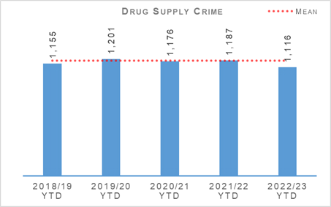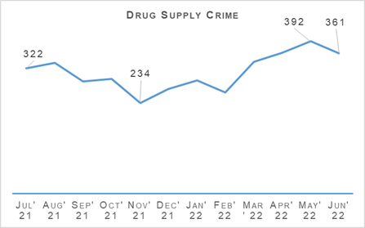
The number of drug supply crimes has decreased by 6.0% (71) in comparison to the same period in the previous year. Similarly, there has been a decrease of 5.9% (69.4) compared to the five year mean.
Within this group of crimes, Supply of Drugs has increased by 1.5% (966 in the current period compared to 952 in the same period last year) whilst crimes of Production, Manufacture or Cultivation of Drugs has decreased by 35.2% from the previous reporting period (118 and 182 respectively).
Aside from June 2022, there has been a general upwards trend in drug supply crimes since February 2022.

Serious Organised Crime Groups (SOCGs)
Serious Organised Crime Group Mapping (SOCGM) is a tool used by law enforcement to map the characteristics of the individuals and groups that are known through intelligence and operational activity.
There are 110 known Serious Organised Crime Groups (SOCGs) comprising of 1,927 individuals being investigated by police and partners in Scotland. The greatest prevalence of SOCGs remains in the west of Scotland: 59% of groups are located in the west, 19% in the north of Scotland and 22% in the east.
Management of Risk in Law Enforcement (MoRiLE) is the methodology used to assess impact, physical, psychological and financial harm to individuals, the community, public expectation and environmental impact; likelihood, confidence and organisational position, taking account of an organisation’s capacity and capability to address the threat.
MoRiLE is a tool to enable law enforcement agencies to understand their operational and tactical risk.
This facilitates the interoperability between law enforcement agencies whilst prioritising use of resources. This ensures resources are used to target the issues causing the greatest risk. During 2022/23 Quarter 1, 35% of SOCGs have experienced a reduction in tactical risk score.
The risk posed by SOCG related violence remains high. Violent incidents relate to long running feuds between rival families, personal grievances and retribution for perceived disrespect or previous violent acts.
The demand for firearms relates mostly to SOCG drug activity and violence/feuds. Despite robust police disruption tactics, enforcement action and firearms seizures, SOCGs continue to have access to firearms.
Drug trafficking is the largest criminal market in Scotland where SOCGs are involved in the production, procurement and distribution of illegal drugs. Cocaine, cannabis and heroin are the most commonly trafficked commodities. SOCGs continue to manufacture illicit benzodiazepine pills.
Opiates / opioids and benzodiazepines are present in a high number of drug related deaths. Poly drug use is prevalent. The north of Scotland is disproportionately impacted by county lines, with three-quarters of county lines active across Aberdeen City, Aberdeenshire and Moray.
The Scottish Multi-Agency Strategic Threat Assessment 2022 has been published. The report aims to provide a collaborative multi-agency strategic threat assessment to present a comprehensive picture of the scale and nature of the threat from SOC, significant vulnerabilities and emerging threats and to demonstrate successful partnership working.
The purpose is to provide a joint assessment of the strategic threats, drive forward operational business by identifying areas of threat, risk and vulnerability, highlight changes in the intelligence picture, identify and assess current and emerging trends affecting Scotland and assist the Multi-agency Tasking and Delivery Board (MATDB) to focus business on the key threats, make informed decisions and direct resources to areas of highest threat.
During Quarter 1, the MATDB agreed two new multi-agency taskings where a number of law enforcement agencies will work together on cross-cutting threat enablers to tackle organised crime in Scotland.
Mechanism | Amount
Proceeds of Crime Act (POCA)  (year to date figures for POCA represent those provided to COPFS & CRU for consideration of confiscation & forfeiture) | £8,343,748
Confiscations Orders | £364,841
Civil Recoveries Unit | £409,276

Possession of Drugs
Drugs Possession | 2021/22 YTD | 2022/23 YTD | % Change from Previous Year | 5 Year Mean | % Change from 5 Year Mean
Number of crimes | 7,463 | 6,156 | -17.5% | 7,607.4 | -19.1%
Number of Detections | 6,771 | 5,845 | -13.7% | 6,716.6 | -13.0%
Detection rate | 90.7% | 94.9% | +4.2% point | 88.3% | +6.7% point
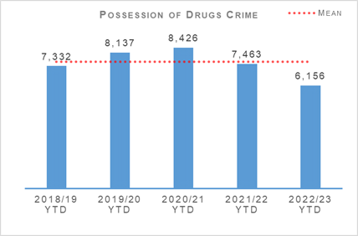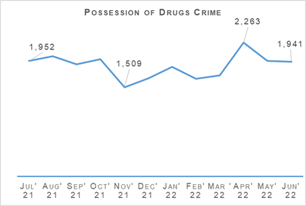
Drug possession crimes have decreased by 17.5% (1,307 fewer) in comparison to the previous year. There is a similar decrease compared to the five year mean, with a decrease of 19.1% (1,451.4 fewer). Numbers for possession of drugs crimes were lowest in the last year during the COP26 conference in November 2021.
The numbers of drug possession and drug supply crimes have both decreased compared to the previous year and the five year mean. These reductions are likely due to shifts in focus in the market towards a more synthetic drug, as well as counting of RPWs for drugs possession.

Detection Rates
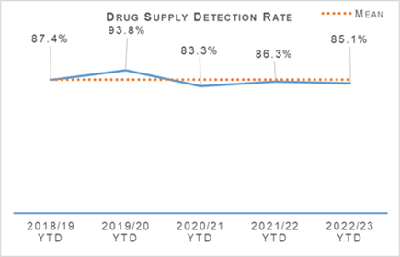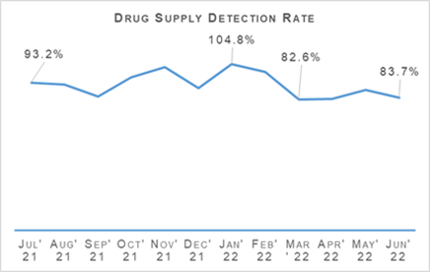
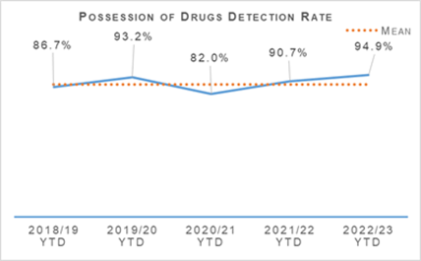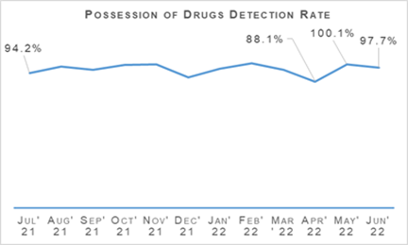
The detection rate for drug supply crimes has decreased by 1.1% points in comparison to the previous year, and decreased 2.4% points compared to the same period of the five year mean.
The detection rate for drug possession offences has seen an increase of 4.2% points compared to the same period last year, and an increase of 6.7% points compared to the five year mean.

Disruption Activity
Over recent months our officers have continued to work to severely disrupt the activities of organised criminals operating within Scotland. Some examples of recent work are outlined as follows:
April 2022:
Following a vehicle making off from officers in the Edinburgh area after a collision, the vehicle was stopped travelling on the M8. The male driver of the vehicle was subject to a search under Misuse of Drugs legislation. From within the vehicle, 18Kg of herbal cannabis was recovered with a street value between £180,000 and £270,000. The male was held in custody to appear at court.
Road Policing officers in Dumfries and Galloway recovered 1Kg of cannabis with an estimated street value of £100,000, during a routine vehicle stop on the M74 near to Junction 16. The male driver was held in custody to appear at court.
Officers executed a warrant at a property in Aberdeen and recovered a quantity of heroin and crack cocaine with an estimated street value of around £115,000. Three males and one female were arrested and charged in connection with drugs offences and held in custody to appear at court.
Following a vehicle stop in the Glasgow area, the male driver was subject to a search with a personal amount of herbal cannabis recovered. Additionally, £25,580 in cash was seized under Proceeds of Crime legislation.
Following a vehicle being stopped and searched in the Lanarkshire area, 2.7Kg of cocaine with an estimated street value of £80,000 was recovered. A male and female were held in custody to appear at court.
Officers executing a warrant at an address in the Fife area discovered a cannabis cultivation where 500 cannabis plants were recovered with an estimated street value of £500,000.
Following reports of a number of banking scams since the turn of the year and subsequent investigation, a male was arrested and charged in connection with a range of fraudulent schemes, including the impersonation of police officers following a warrant execution in the Glasgow area. The male was held in custody to appear at court.
May 2022:
Police officers recovered drugs with a total estimated street value of £20,000 after a stop and search in the Aberdeenshire area. Cocaine, worth £15,000 and diamorphine, worth £5,000 was seized. Three men, aged 17, 20 and 21 were held in custody to appear at court.
Officers executing a drugs search warrant at a property in the Fife area recovered cannabis cultivation with an estimated street value of over £1 million. Four men were charged with drugs offences and held in custody to appear at court.
Following a vehicle stop in the Lanarkshire area, the male driver was subject to a search where a small amount of herbal cannabis and £4,835 in cash was recovered, which was seized under Proceeds of Crime legislation.
Road Policing officers recovered approximately 6Kg of heroin and cocaine with an estimated street value of £400,000 following a vehicle stop in North Lanarkshire. The male driver was arrested and held in custody to appear at court.
Officers executing a drugs search warrant at a property in South Lanarkshire discovered a cannabis cultivation of approximately 1,000 plants with an estimated street value of £800,000.
June 2022:
Following a drugs search warrant being executed at an address in Ayrshire, approximately £13,000 in cash was recovered and subsequently seized under Proceeds of Crime legislation.
Following a warrant execution at an address in East Lothian, quantities of heroin, cocaine, cannabis and diazepam tablets were recovered with a combined estimated street value of around £10,000. Three men were arrested and charged in connection with drugs offences before being released on undertaking.
Officers executing a warrant at a property in the Edinburgh area seized a quantity of heroin, cocaine and crack cocaine with an estimated street value of £130,500. Three men were arrested and charged in connection, being held in custody to appear at court.
Officers searching a property in the Dundee area recovered a quantity of cocaine with an estimated street value of £1 million. A male was arrested and charged in connection. Following a subsequent vehicle stop, Roads Policing officers recovered a further quantity of cocaine with an estimated street value of £200,000 and around £120,000 in cash. A male was arrested in connection.
A man was arrested and charged following the recovery of class A drugs with a street value of £140,550 in Aberdeen. Following a vehicle search further searches were carried out an address in the city and overall, cocaine with a street value of £136,200 and heroin with a street value of £4,350 were recovered. The man was held in custody to appear at court.
Following a series of vehicle theft offences in the Lanarkshire area and subsequent police investigation, three men were arrested and charged in connection. The crimes happened across the region between March and June 2022. The offences included 28 vehicle thefts and a number of fuel thefts. The men were held in custody to appear at court.

Operation ERSO
ERSO is the multi-agency taskforce established by Police Scotland. Under Operation ERSO the Drug Harm Tactical Taskforce leads the national focus to enhance our understanding and examine the harm associated with the illegal consumption of synthetic drugs, particularly Benzodiazepines, across Scotland.
This allows for continuous improvement in the investigation of Drug Related Deaths (DRDs), to include evidence capture, information sharing and collaboration across the Service to maximise intelligence development and operational opportunities.
Current intelligence provides that there are numerous SOCGs involved in the manufacture, distribution and supply of Benzodiazepines within Scotland. Benzodiazepines being used by the Scotland based groups include Diazepam / Valium, Etizolam and Alprazolam (Xanax). We have also seen a rise in the number of groups manufacturing their own illicit tablets.
Since January 2020 a total of 24 Pill Presses have been recovered in Scotland as a result of operational activity carried out.
Pill presses recovered through operational activity vary in technology and production capacity from manually operated pill presses capable of producing 1,000 pills per hour to automated industrial scale presses with an output in excess of 100,000 pills per hour.
Provided that raw materials are available, it is possible for these high end presses to produce approximately one million pills in a typical working day. Recovery of these presses is likely to significantly impact the manufacture, supply and availability of illicit pills, including benzodiazepines, in our community.
During April 2022, executive action was carried out at an address in Glasgow with a Misuse of Drugs Act (MDA) warrant being executed. During a search of the property 56,000 white tablets, believed to be Etizolam were recovered along with 51.6g of heroin.
Executive action carried out at an address in May resulted in the recovery of more than 16,000 pills, believed to be Etizolam. Two males have since been arrested for MDA offences.
In June, following transfer of an operation relating to the supply of pill presses from Police Scotland to the National Crime Agency (NCA), six residential premises and industrial units within Wiltshire, West Mercia and Greater Manchester Police force areas were searched.
Four people were arrested for drug and Proceeds of Crime Act (POCA) offences. Searches recovered over 40 pill presses, approximately 2,000 tablets, consistent with being Etizolam, mixing agents and additives, supporting the use of premises for drug preparation. It is likely that a number of these presses were intended for the Scottish market.
Police Scotland is supporting the NCA in developing a UK strategy in regard to Benzodiazepines. Initial meetings are being arranged and Police Scotland has provided Drug Harm Threat Assessments and monthly reports to aid discussion.

Missing Persons
Missing Persons – Equality Outcome 3 | 2021/22 YTD | 2022/23 YTD | % Change from Previous Year | 5 Year Mean | % Change from 5 Year Mean
Number of missing persons investigations | 4,387 | 4,768 | +8.7% | n/a | n/a
Number of people who have gone missing previously | 1,280 | 1,261 | -1.5% | n/a | n/a
Percentage of people who have gone missing previously | 29.2% | 26.4% | -2.8% point | n/a | n/a
Average length of time missing (hrs) | 18.9 | 14.9 | n/a | n/a | n/a
Total number of missing persons from NHS | 442 | 468 | +5.9% | n/a | n/a
Total number of missing persons from YPU | 898 | 841 | -6.3% | n/a | n/a
Total number of missing persons from Foster Care | 86 | 148 | +72.1% | n/a | n/a
Percentage of overall missing persons that go missing from NHS | 10.1% | 9.8% | -0.3% point | n/a | n/a
Percentage of overall missing persons that go missing from YPU | 20.5% | 17.6% | -2.8% point | n/a | n/a
Percentage of overall missing persons that go missing from Foster Care | 2.0% | 3.1% | +1.1% point | n/a | n/a
Number of missing persons investigations with mental health marker | 1,479 | 1,459 | -1.4% | n/a | n/a
Missing Person Demand - Total FTE demand of missing persons investigations | 234.6 | 226.0 | -3.7% | n/a | n/a
Missing Person Demand - Children generated FTE demand of missing persons investigations | 81.3 | 104.7 | +28.8% | n/a | n/a
Missing Person Demand - Total FTE demand of missing persons investigations from Home Address | 128.4 | 121.4 | -5.5% | n/a | n/a
Missing Person Demand - Total FTE demand of missing persons investigations from Care Setting (Foster Care/Adult Care Home/Young Persons Unit/NHS) | 61.8 | 66.1 | +7.0% | n/a | n/a
The number of missing person investigations has increased by 381 compared to Quarter 1 last year. The number of repeat missing persons, the average length of time missing and the number of investigations with a mental health (MH) marker have all decreased compared to the same period last year.
The notable increases can be found when considering what ‘type’ of person goes missing. Children and Looked after Children are recording significant increases as illustrated in the following chart:
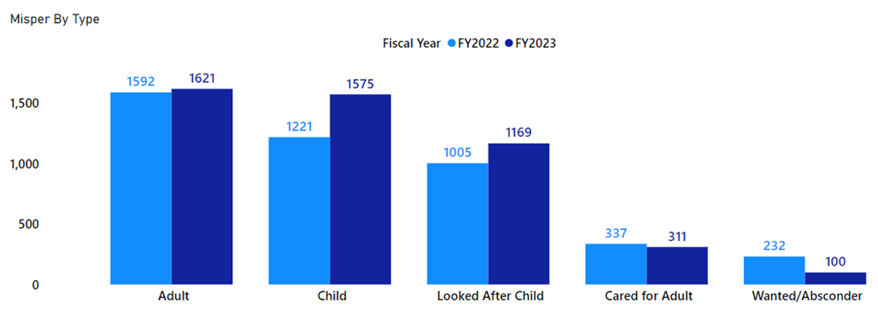
When considering where Children and Looked after Children go missing from it remains that the majority go missing from their home address, which has increased from Quarter 1 last year. There has also been notable increases in those that go missing from Foster Care and Schools.
The number of children that go missing from young person units continues to decrease, a pattern that was noted last year and could be attributed to the “not at home” policy.
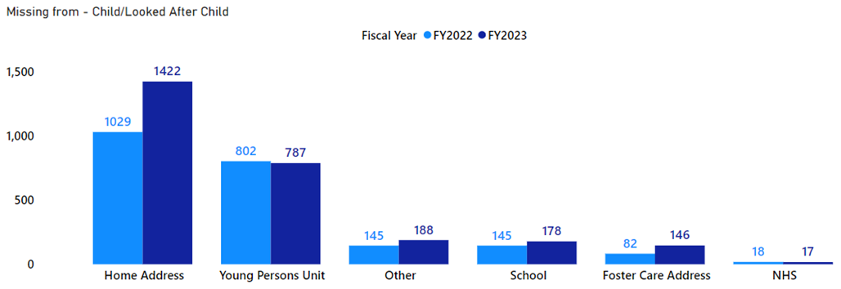
Why there has been such an increase in children going missing is due to a complex number of reasons. The risk assessment interviews conducted by an attending officer has noted significant increases to the following questions when compared to the same period last year.
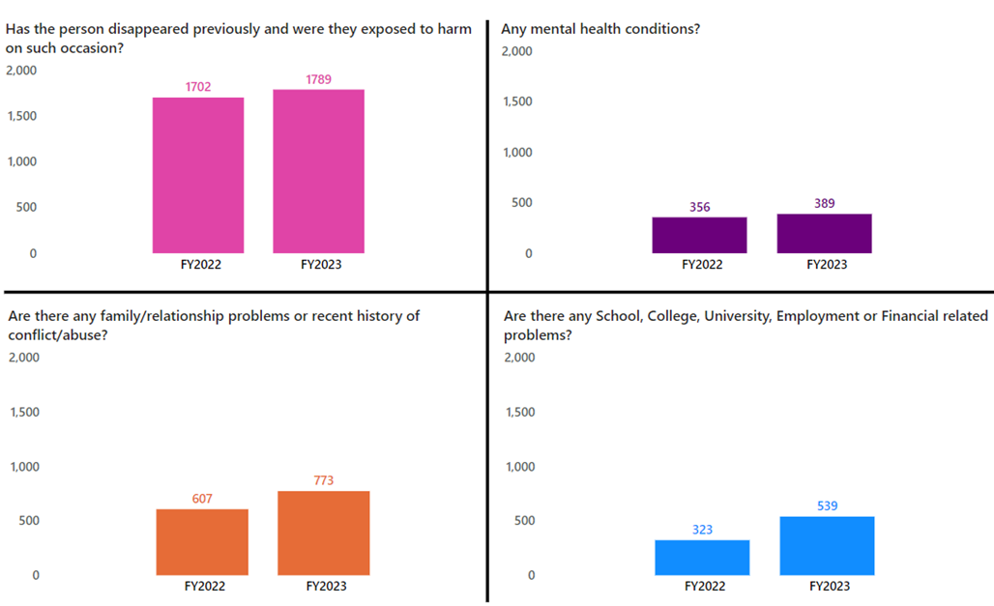

Missing Persons Demand
The FTE demand is reflective of the findings above. The volume increase in the number of missing persons investigations of children has created a 29.9% increase on demand of officers.
The following graph illustrates that children missing from home has seen the largest increase in demand compared to the previous year. There has been smaller increases in demand from children in foster care and a marginal increase in children that go missing from NHS.
It is interesting to note that although the number of children that go missing from Young Persons Units has decreased, the FTE demand has risen slightly.
The “not at home” policy introduced for low risk missing persons has resulted in fewer investigations being generated from young person’s unit that would have subsequent low demand on officers.
However given that the volume of children that go missing is still relatively high, the higher risk investigations will still create a high demand on police officers investigating. The “not at home” policy is being reviewed and work is ongoing with partners to improve the guidance around the use of “not at home”.
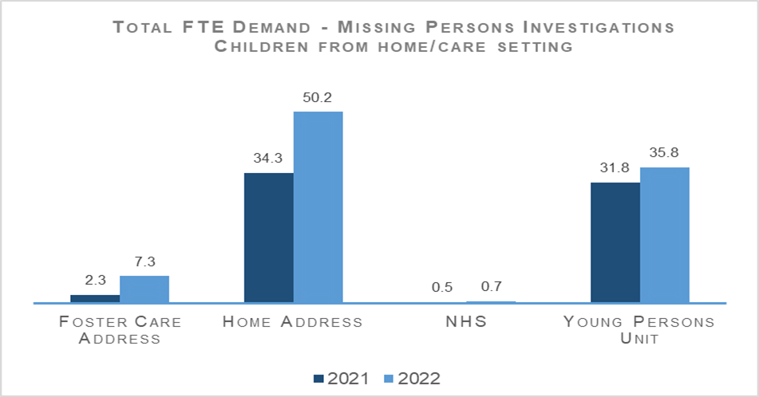

Road Safety
Road Casualties | 2021/22 YTD | 2022/23 YTD | % Change from Previous Year | 5 Year Mean | % Change from 5 Year Mean
People Killed | 24 | 41 | +70.8% | 30.6 | +34.0%
People Seriously Injured | 415 | 338 | -18.6% | 394 | -14.2%
Children (aged under 16) Killed | 2 | 0 | -100.0% | 1 | -100.0%
Children (aged under 16) Seriously Injured | 44 | 37 | -15.9% | 35.6 | +3.9%
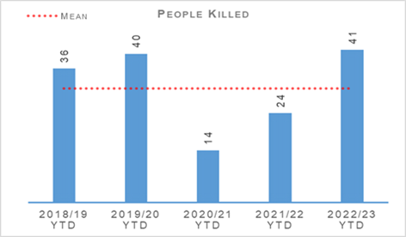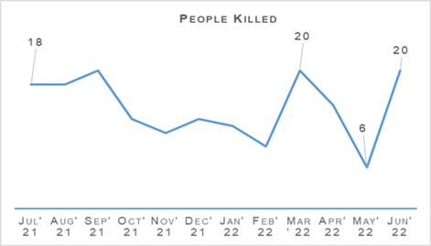
Year to date there have been 41 fatalities on Scotland’s roads, an increase of 17 in comparison to the same period last year. This is an increase of 70.8% on the previous year. Against the five year mean there has been an increase of 10 deaths, equating to an increase of 34.0%.
Whilst the number of fatalities has increased in comparison to the previous two years (which were both lower as a result of COVID-19 restrictions on travel within the country), the total number of deaths has increased by one more than 2019/20 (being the most recent year before COVID-19 restrictions).
Serious injuries have decreased by 18.6% (77 fewer) compared to the previous year. Similarly, there was a decrease of 56 people seriously injured compared to the five year mean. Updates are awaited on the system which logs serious injuries and this will likely raise the total observed this year to date.
Motorcycle riders account for 12 (29%) of the fatalities year to date, in comparison to ten the previous year. This is an increase of two, but a reduction of 12 percentage points of the total proportion of fatalities.
Police Scotland recognises the vulnerability of motorcycle riders on our roads and our Motorcycle Campaign specifically focuses on keeping motorcycle riders safe. Another of our key risk groups, pedal cyclists, has seen a reduction of one fatality year to date, with one pedal cyclist fatality compared to two in the previous year.
There have been no children killed on Scotland’s roads to date this year, which is a reduction of two deaths on the previous year. The number of children seriously injured has also decreased by seven compared to the previous year.
Transport Scotland has published key road casualties figures showing the progress made against the Road Safety Framework targets that ran from 2010 to 2020. All five targets have been met as per the following table:
Scottish Road Safety Targets 2020 | Target Reduction | Actual Reduction
People Killed | -40% | -52%
People Seriously Injured* | -55% | -68%
Children (aged under 16) Killed | -50% | -76%
Children (aged under 16) Seriously Injured* | -65% | -77%
Slight Injury | -10% | -67%
* Please note that due to changes in severity recording the number of seriously and slightly injured people cannot be directly compared to those reported in previous years. Progress against these targets has been calculated on the basis of adjusted figures provided by the Department for Transport.
The new Road Safety Framework with interim targets to 2030 (RSF2030), has been published along with the 2021/22 delivery plan (updated 2022/23 plan awaited). The following interim reductions in those killed and seriously injured on Scotland’s roads, from a 2014/18 baseline, are sought:
50% reduction in people killed
50% reduction in people seriously injured
60% reduction in children (aged under 16) killed
60% reduction in children (aged under 16) seriously injured
The interim reductions are challenging, as they should be, as we work with our partners toward Vision Zero - no deaths and no serious injuries on Scotland’s roads by 2050.
A few key risks have been identified via analysis and we will seek to mitigate these as we move forward:
The number of cyclists on our roads was boosted by the COVID-19 pandemic and, more generally, by people opting toward more eco-friendly sustainable modes of transport. Cycling is anticipated to further increase as a consequence of recent fuel price rises and Scottish Government funding of active travel initiatives. We recognise the potential for collisions also increases, with cyclist collisions often resulting in serious injury.
- Motorcycle casualties have remained steady over the past few years, aside from the drop in 2020/21 due to the reduced traffic during COVID-19 restrictions.
- With an ageing population, people remain mobile longer and continue to drive, it is anticipated that there may be an increase in older casualties.
In an effort to mitigate the risks identified and reduce collisions on the road network, Police Scotland has identified a number of key opportunities.
An in-depth fatality study in partnership with Transport Scotland is underway, with a dedicated analyst and Road Policing Sergeant recently joining the project.
There is an opportunity to identify learning from previous collisions which will assist Police Scotland and partners to introduce preventative measures. The measures will further mitigate road risk across all road users groups.
Road Policing works closely with Transport Scotland to understand trends and identify emerging threats in relation to all collision classes. Police Scotland analysts produce detailed problem profiles identifying specific casualty types, with particular focus on vulnerable road users.
The information is shared with partners at forums such as the Tactical Options Working Group chaired by the Road Policing Superintendent and Road Safety Governance Board chaired by ACC Operational Support.
This sharing allows resources to be allocated to the greatest areas of risk in an effort to reduce harm on our roads, in partnership with local policing and assisted where appropriate by our key partners.
The new National Dashcam Safety Portal (NDSP) pilot was approved as a change project by the Demand Management Board and has gained funding approval from Transport Scotland. A project lead, seconded from Road Policing, has now been appointed to build on the development work already undertaken.
The NDSP is intended to optimise the ability for Police Scotland to identify illegal and risky behaviours by drivers and other road users from video footage submitted by the public. This enables enforcement action to be taken when appropriate.
Cycling Scotland and Cycling UK led 33 organisations in seeking the introduction of an on-line camera footage submission and reporting system for Scotland. The project works in conjunction with the Road Safety Framework 2030 and Police Scotland’s Contact and Engagement Strategy.
The New Driver Early Intervention Scheme (NDEIS) is aimed at 17-25 year olds to influence driver attitudes and behaviours whilst providing a reminder of the responsibilities a driver has for themselves and other road users. The NDEIS has been rolled out nationally.
Partners, such as Scottish Fire and Rescue Service, have adopted the scheme and deliver it in conjunction with Police Scotland to internal and external groups. Several local authorities have adopted the scheme for delivery to modern apprentice / skills and employability students.
Acknowledging motorcyclists are a challenging group to engage with, the Scottish Government, in partnership with Police Scotland, has developed a working group to explore opportunities and develop engagement strategies moving forward.
One existing example is Rider Refinement North, an initiative providing rider training by police and the Institute of Advanced Motorists instructors, which we will seek to roll-out across Scotland.
Driver Engagement North aims to reduce casualties and collisions in the north of Scotland by engaging older drivers and their friends / families in an interactive workshop. This is a pilot project supported by funding from Transport Scotland’s Road Safety Framework Fund and if successful will be extended to other areas throughout Scotland.
All of the deliverable commitments that Police Scotland has made to the Road Safety Framework 2030 have been completed to date.
Our commitment within the RSF to incorporate specific campaigns, initiatives and directed activity targeting the safety of vulnerable road users - including cyclists, motorcyclists and pedestrians – continues to be met.
The majority of National Campaign Calendar activity was, and will continue to be, Fatal-Five focused. Campaigns during Quarter 1 have been supported by Corporate Communications and social media, enhancing the reach of our safety messaging.

Road Policing Campaign Highlights
Working in conjunction with partners and Corporate Communications, the road safety campaign calendar and multi-agency days of action continue to be delivered in line with social distancing protocols.
As we work through the campaign calendar, data will be collated by National Police Chiefs’ Council which will enable benchmarking by the Analysis and Performance Unit.

Operation TUTELAGE
Operation TUTELAGE is an ongoing national initiative aimed at reducing the number of uninsured drivers on the UK’s roads. Police Scotland joined the initiative in April 2021, initially as part of a six month project. It remains to be ratified on a permanent basis by the Executive but continues on a full time basis meantime.
Operation TUTELAGE centres on identifying uninsured vehicles using ANPR and subsequently writing an ‘Insurance Advisory Letter’ to the registered keepers to inform them that driving without insurance is an offence. Working on the principle of behavioural compliance, the operation is designed to encourage the majority of complaint individuals to insure their vehicles.
In March 2022, National Roads Policing Operations, Intelligence and Investigations (NRPOII) conducted an Operation TUTELAGE control group exercise that illustrated the effectiveness of this initiative.
NRPOII randomly selected identified vehicles and monitored their insurance status when a TUTELAGE letter was not issued. Only 31.5% of those selected became insured, compared against the 63.6% compliance achieved by Operation TUTELAGE that month from 1,221 letters issued. As of the end of April 2022, a total of 28,954 letters had been issued.
Key road safety benefits include:
Contributes to reducing the amount of uninsured vehicles utilising Scotland's road network using positive engagement and resolution.
Allows for more focused and targeted enforcement.
Optimises the Police Scotland investment in upgrading our ANPR capability / infrastructure.
Operation TUTELAGE also supports pro-active Road Policing initiatives across Scotland.

Motorcycle Safety Campaign
The 2022 Motorcycle Safety Campaign commenced on 15 April 2022. Intended to promote safe and responsible riding and driving across Scotland’s road network, and reduce the number of motorcyclists killed or seriously injured, the campaign will run throughout the summer and conclude on 30 September 2022.
Launched to coincide with the Easter weekend, traditionally seen as the start of the motorcycle season, Road Policing held a National Weekend of Action, with activity highlighted across media platforms. Officers carried out dedicated patrol activity on popular motorcycle routes to engage, educate, encourage and enforce.
During its first month, Road Policing carried out 42 periods of activity, ranging from an evening to entire weekends. 339 motorcycles were stopped in total. 265 offences were detected across all road users during these periods of activity.
Road Policing area commanders retain autonomy to optimise the frequency and timing of campaign activity based on factors such as local events, received intelligence, predicted good weather, and various other considerations.
The campaign is not exclusively targeted at motorcyclists. There is a strong focus on the contribution all road users can make to reducing motorcycle user casualties by adopting the right attitude and driving behaviours.

Road Safety Campaign - Impact
Drug driving legislation implemented under section 5A of the Road Traffic Act 1988 continues to prove an excellent road safety tool, with a high number of offences being recorded across the country.
Capacity issues remain within Forensics Services, along with a significant backlog in the testing of samples. The SPA funding bid to the Scottish Government has now been approved; this will enable additional contracting of toxicology work.
This is welcome news and will allow the laboratory to outsource whilst continuing to work to reduce their backlog. A Gold Group with representatives from Forensics Services, COPFS, Police Scotland, HMICS and the Scottish Government meet regularly to review backlog impacts and work collaboratively to improve laboratory testing systems and processes.

Stop and Search
Stop Search | 2021/22 YTD | 2022/23 YTD | % Change from Previous Year
Stop Search Compliance Rate (%) | 99.1% | 99.1% | no change
36,958 stop and search incidents have been recorded by Police Scotland this quarter. This is a decrease of 31.7% compared to the same period last year. Just over one in three (34.3%) stop and searches between April and June 2022 had a positive result although this was a slightly lower (-0.9% points) positive rate than April to June 2021.
5,954 stop and search records were audited for compliance during Quarter 1. This involves the records being reviewed by line managers and thereafter quality control checked by the National Stop and Search Unit to ensure their adherence to the Stop and Search Code of Practice introduced in May 2017.
Of the stop and searches reviewed during the quarter, 5,283 (88.7%) were deemed compliant and recorded correctly on the stop and search database. A further 617 (10.4%) were compliant with the code of practice but required amendment to their details to ensure they were appropriately recorded.
23 (0.9%) records were deemed as not recordable under the code or practice or recorded in error and deleted from the database. Typical reasons for deletion include where a person is searched after being arrested, as a result of a duplicate record or where no physical search of a person has actually taken place.
It should be noted that the total number of records audited for compliance will be lower than the total number of searches raised during the period due to the timescales required to fully review all records.

Strategic Outcome: The needs of local communities are addressed through effective service delivery
Police Scotland’s objectives are to:
- Understand our communities and deliver the right mix of services to meet their needs
- Support our communities through a blend of local and national expertise
- Support the changing nature of communities

Call Handling
Call Handling | 2021/22 YTD | 2022/23 YTD | Change from Previous Year
Total number of 999 calls | 174,531 | 185,110 | +6.1%
Total number of 101 calls | 491,976 | 386,611 | -21.4%
Average call answer time 999 calls | 6 seconds | 12 seconds | +6 seconds
Average call answer time 101 calls | 3 mins 25 seconds | 4 mins 9 seconds | +44 seconds
Number of 999/101 calls that do not result in an incident/crime | 280,577 | 195,808 | -30.2%
Percentage of 999/101 calls that do not result in an incident/crime | 42.0% | 34.2% | -7.8% point
Note: Following the nationwide rollout of CAM, new call gradings are being used. These were updated again during August 2020, this is reflected in the previous table. A small percentage of incidents are still being categorised under the old grading and are therefore not included in the above figures. Comparison data is not available.
The total number of calls to Police Scotland decreased by 97,786 (from 666,507 to 571,721). This is a decrease of 14.2% compared to last year. As shown in the previous table there has been an increase of 6.1% for 999 calls received, however, the volume of 101 calls received is showing a decrease of 21.4%, both being compared to the same period last year.
Of the calls received, 34.2% did not result in an incident or crime being raised. The total number of incidents has decreased by 10,017 (from 385,930 to 375,913) compared to the same period last year.
The handling of 999 calls remains our highest priority. Between 01 April 2022 and 30 June 2022, our service centres maintained an average speed of 12 seconds for answering 999 calls, this has increased compared to the same period last year.
The average call answer time for 101 calls has also increased by 44 seconds compared to the same period last year. Having previously been highlighted as a challenge for the division, further measures have been put in place to try and alleviate this and reduce the average call answer time.
These include an extension of the Temporary Retain on Duty and Business Continuity payments which support retaining staff on duty during periods of high demand to assist with reducing average speed of answer.
Review of staffing levels has led to a temporary realignment of posts to different shift patterns and increasing part time staff hours to support resourcing challenges.
C3 Division has removed questioning of callers around COVID-19 status and implemented a change to the verbal introductions (whisper) for geographical location of 999 callers. This is anticipated to improve average call answer time going forward.
Efforts continue to signpost callers to more appropriate methods of contact, including via Contactus and the force website, and likewise social media is used during periods of high demand to inform the public and provides the opportunity to educate the public on correct use of 101.
Online contacts continued to rise during this reporting period, indicating the success of this approach.

Incident Demand
Incident Demand | 2021/22 YTD | 2022/23 YTD | % Change from Previous Year
Incident demand – Total number of incidents raised | 385,930 | 375,913 | -2.6%
Number of incidents by response type - Immediate | 44,504 | 40,315 | -9.4%
Number of incidents by response type - Prompt | 171,256 | 154,983 | -9.5%
Number of incidents by response type – Standard Local Policing Appointment | 22,122 | 17,748 | -19.8%
Number of incidents by response type – Standard Direct Crime Recording | 18,482 | 19,892 | +7.6%
Number of incidents by response type – Standard Resolution Team Involvement | 10,067 | 9,127 | -9.3%
Number of incidents by response type – Other Resolution | 113,254 | 122,725 | +8.4%
Incident Demand - % of incidents which lead to a crime | 26.0% | 27.4% | +1.4% point
Incident Demand - % of incidents requiring police response | 97.0% | 97.0% | no change
Partner Demand – Total number of external force request incidents | 683 | 730 | +6.9%
Note: A small percentage of incidents are still being categorised under the old grading and are therefore not included in the previous figures.
During the reporting period 49,026 standard incidents were recorded in total, an increase of 5.1% (2,371 more incidents) from the same period last year. The new process involves the allocation of Local Policing Appointment, Direct Crime Recording and Resolution Team involvement to standard incidents.
This has now been fully integrated into daily business, leading to this continued increase. During the reporting period the most common crime types recorded for standard incidents are theft, road traffic collisions, assist member of the public, damage and neighbour dispute.
Looking at incident demand for the reporting period compared to the previous year, the percentage of incidents which lead to a crime report being raised and that require police attendance are consistent.
Due to the process changes a comparison against the five year mean is not available. Demand from partners, in terms of external force request incidents, has risen 6.9% (47 more incidents) compared to the same period last year.

C3 Division Demand
In addition to the call numbers, there have been over 73,000 additional public contacts dealt with by Contact, Command and Control (C3) Division during the reporting period. C3 Division does not only deal with incoming calls from the public.
Service advisors also deal with incoming calls from other partner agencies and alarm calls. There have been over 26,000 of these types of calls for this reporting period, although a slight decrease of 5.7% (1,147 less calls) in Emergency Service Partner calls.
Emergency Service Partner calls are received via dedicated numbers from Scottish Fire and Rescue, Scottish Ambulance Service, Mountain Rescue, Coast Guard, Mental Health Pathway (NHS 24), OmniCrash and Oil Industry Agency. The reason for such calls vary and each are dealt with by a service advisor in the most appropriate manner.
“Contact Us” emails and online reports, for some crime types, can be completed online. Each one of these reports is assessed by a service advisor using the Threat Harm Risk Investigation Vulnerability and Engagement (THRIVE) model.
The service advisors are then also required to take into account COVID-19 restriction considerations, to decide what resolution is required for each report. Over 44,000 “Contact Us” emails and 2,300 online reports have been submitted since 01 April 2022.
Overall, additional public contacts rose around 7.4% from 2021/22.

Contact, Engagement and Resolution Project (CERP)
The Contact, Engagement and Resolution Project (CERP) was formed in 2021 and will seek to make improvements in service through Police Scotland's response to vulnerability, risk and public need at the earliest opportunity; maximising opportunities for remote engagement and resolution; reducing local policing demand and directing appropriate incidents to the right agency through pathway referrals and enhanced collaborative working.
Training needs analysis work has commenced in C3 Division with the publication of a survey for staff to complete to assess understanding of key processes within the division. This will run for four weeks.

Modernised Contact and Engagement
The Service Design group met with heads of service recently to disseminate information and highlight that the replacement of the current systems is not just an IT upgrade but a whole modernisation of Police Scotland’s contact and engagement.
This service design led session was commended by the attendees as a “must have” to ensure that there is full understanding of the problems and needs of citizens and staff and any solution is co-designed and fit for policing in the future.
Both National Integrated Communications Control System (NICCS) and Unified Communications & Contact Platform (UCCP) form part of the wider MCE Programme.
NICCS is at delivery phase with a focus on User Acceptance Testing and training within C3 Division during 2022. UCCP continues to be actively engaged with the supplier. The project timeline has been baselined and training and testing plans are being developed.

Mental Health Pathway
NHS24 Mental Health (MH) Nurses were introduced to Police Scotland as part of Phase 2 of the Mental Health Pathway during March 2022. This is a phased proof of concept currently operating in the West region only, with a future roll out to North and East Command planned.
Each of the Resolution Teams (RT) has a Mental Health Nurse Practitioner (MHNP) assigned to the team. They are being assisted by Mental Health Resolution Team Officers (MHRTOs).
Following agreement with strategic partners, Phase 2 has been extended to run until 30 November 2022. The evaluation of the Mental Health Pathway is ongoing and is likely to be published in January 2023.

Complaints
C3 Complaint Allegations | 2021/22 YTD | 2022/23 YTD | % Change from Previous Year
Complaint Allegations received relative to C3 – on duty | 70 | 40 | -42.9%
Complaint Allegations received relative to C3 – Quality of Service | 35 | 32 | -8.6%
Total Allegations closed - relative to C3 | 107 | 93 | -13.1%
Percentage of total Allegations closed which were upheld – relative to C3 | 12.1% | 9.7% | -2.4% point
Complaints against C3 Division has decreased by 20.8% in the year-to-date, with a total of 61 complaints received during this period. Decreases are visible in the North (down 40.0%, three cases in total), East (down 48.3%, 15 cases in total) and West (down 0.0%, 37 cases in total).
The overall decrease in complaints follows a PSD analytical report briefed into C3 Division due to an increased volume during 2021/22, with divisional management implementing various measures to address the key issues identified therein.
For instance, actions have been progressed to raise awareness in relation to incivility and the development of staff, including completion of empower hours, access to CPD resources, staff association seminars and supervisory briefings on staff wellbeing.
Moreover, new staff to C3 receive a three hour input on customer care and an input from a member of the negotiator cadre, enabling advisors to deal appropriately with distressed, emotional and abusive callers.
Further key themes identified in relation to Quality of Service allegations have been analysed from a Resolution Team (RT) and Area Control Room (ACR) perspective.
Where a lack of understanding of process or procedure has been identified, resolution through one to one, group refresher briefings, Moodle training and reference to guidance within the C3 Procedures guidance has been reinforced.
Incivility continues to be the most common allegation type, with 32 received during the year-to-date. This accounts for 44.4% of all allegations received within this period.
C3 staff however received 571,721 calls to 999 or 101 in Quarter 1 with these allegations making up only 0.006% of these calls. The volume of incivility allegations YTD also demonstrates an improving picture from the comparable period in 2020/21 with a 30.4% decrease.
Consistent with the corresponding decrease in complaint cases, decreases are visible across almost all allegation categories. An increase in Service Delivery allegations was identified (up 61.5%).
However, the YTD total of 21 such allegations represents an additional eight allegations from the PYTD and is therefore a relatively low volume increase. The majority of the 21 allegations (12) were received in June 2022 within the Type of Response sub category and broadly relate to dissatisfaction with the level of service provided.
In total, 63.9% of complaint cases received year-to-date for C3 Division were frontline resolved by the PSD National Complaints and Resolution Unit (NCARU). This rate increases to 65.6% when early and subsequent resolution by PSD or Specialist officers are included.
These figures demonstrate that most complaints against C3 Division during this period have been non-criminal and non-serious in nature, with a majority resolved through simple explanation, apology or assurance.

Hate Crime
Hate Crime – Equality Outcome 1 | 2021/22 YTD | 2022/23 YTD | % Change from Previous Year | 5 Year Mean | % Change from 5 Year Mean
Hate Crime - number of incidents | 2,033 | 2,060 | +1.3% | 1,770.6 | +16.3%
Hate Crime – number of crimes | 1,836 | 1,813 | -1.3% | 1,716.6 | +5.6%
Hate Crime – detection rate | 66.8% | 57.6% | -9.1% point | 69.3% | -11.6% point
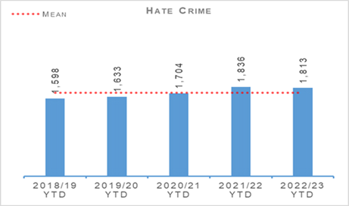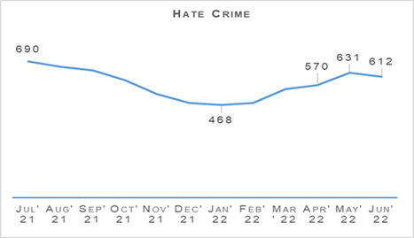
Hate incidents have risen slightly compared to the same period last year (27 more). Hate crimes have however fallen slightly (23 fewer). Both crimes and incidents have increased when compared to the five year mean. The hate crime detection rate is 9.1% lower than the previous year.
Detection rates are kept under regular review to determine if the rate returns to expected levels as time progresses and investigations conclude or otherwise. Further analysis is to be conducted regarding the hate crime detection rate to ascertain if any common themes are attributing to a lower detection rate.
Aggravator | 2021/22 | 2022/23 | % change from previous year | % of Total Hate Crimes (2022/23)
Race | 1,085 | 1,012 | -6.7% | 55.8%
Religion | 113 | 132 | +16.8% | 7.3%
Race & Religion | 20 | 12 | -40.0% | 0.7%
Multiple aggravators including Race & Religion | 65 | 73 | +12.3% | 4.0%
Disability | 112 | 117 | +4.5% | 6.5%
Sexual Orientation | 399 | 415 | +4.0% | 22.9%
Transgender | 27 | 28 | +3.7% | 1.5%
Multiple aggravators excluding Race & Religion | 15 | 24 | +60.0% | 1.3%
Total | 1,836 | 1,813 | -1.3% | 100.0%
Race hate crime accounts for over 50% of all hate crimes. These crimes are decreasing compared to the same period last year (73 fewer) and this is largely the reason for the overall decrease in hate crimes.
Where hate crimes are increasing (religion, disability, sexual orientation, transgender), these numbers are relatively small and thus it is difficult to attribute any specific explanation to the increases this year.
In the specific case of crimes aggravated by religious prejudice, the upward trend contradicts recent falls. Investigations into this recent upward trend cannot determine any specific reason for this increase. The matter will remain under review as the months progress with the caveat that the data set in Quarter 1 is relatively small.

HMICS Thematic Inspection
Police Scotland’s Hate Crime Improvement Plan was presented to the SPA Policing Performance Committee (PPC) on 09 December 2021. A progress report was presented to the SPA Policing Performance Committee on 07 June 2022 and a further update will be provided at the next committee.

Hate Crime Awareness Campaign
The National Hate Crime Campaign launched on 28 March 2022 and ran for a period of six weeks. The main objective of the campaign was to encourage people living in Scotland who had been affected by a hate incident to report it to Police Scotland or to a Third Party Reporting Centre.
Secondary audience groups were also identified, these being bystanders and officers / staff of Police Scotland, who were also encouraged to report instances of hate. To encourage this behaviour we wanted the audience groups to know that Police Scotland take all incidents of hate seriously and we care about the impact that it has on the diverse communities across Scotland that we serve.
Corporate Communications is carrying out an in-depth evaluation of the campaign, which will be reported in due course.

Hate Crime Advisors
Partnerships, Prevention & Community Wellbeing (PPCW) are delivering a number of Hate Crime courses across the Service. There are currently six Hate Crime Champions and five Hate Crime Advisors courses planned for 2022. The courses continue to evaluate well. An evaluation report can be provided on request.
The cadre of Hate Crime Advisors currently sits at 48 – this is expected to rise to between 80-100 when courses are complete and will provide coverage in all command areas.
There have been 14 Hate Crime Advisors deployments delivered or planned for 2022 (mostly in Greater Glasgow Division) so far. Now the cadre is established, PPCW will develop a further communication message to promote the specialism to Event Policing Leads and Commanders.

Hate Crime Benchmarking
As part of the HMICS (2021) Inspection into Hate Crime, recommendation was made for Police Scotland to consider establishing a dedicated Hate Crime Unit.
Police Scotland have considered best practice from outwith Police Scotland in relation to Hate Crime structures and are currently developing an options paper for the consideration of whether or not Police Scotland should establish a dedicated unit for hate crime.
This work continues as part of the Hate Crime Improvement Plan. SPA members will be provided an update at September’s SPA Policing Performance Committee.

Anti-social Behaviour and Disorder
Anti-social Behaviour and Disorder | 2021/22 YTD | 2022/23 YTD | % Change from Previous Year | 3 Year Mean | % Change from 3 Year Mean
Number of antisocial behaviour incidents reported by the public | 95,422 | 74,079 | -22.4% | n/a | n/a
Number of complaints regarding disorder | 69,841 | 52,375 | -25.0% | n/a | n/a
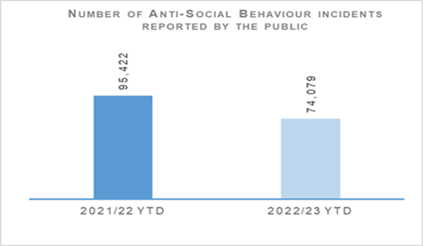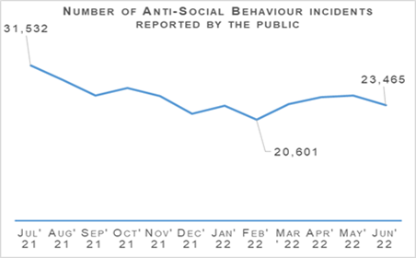
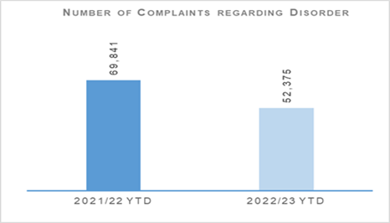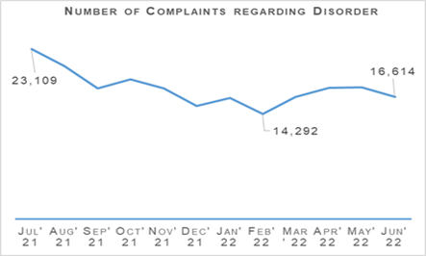
Both complaints of disorder and incidents of anti-social behaviour have been lower in Quarter 1 2022 than the same period last year. The level of anti-social behaviour and complaints decreased steadily between June 2021 and February 2022 before rising slightly between March and May 2022.
The Fireworks and Pyrotechnics Articles (Scotland) Bill passed Stage 3 in Parliament on Wednesday 22 June 2022 and will become law following Royal Assent. It will be introduced in stages throughout 2022/23.
The Violence, Prevention and Licensing Coordination Unit (VPLCU) and the National Football Information Point (NFIP) will continue to engage with Scottish Government through implementation groups.
This will provide support and guidance to address the impact the changes will have on Operational Policing and ensuring divisions are aware of the changes.
The Bill reflects recommendations from the Firework Review Group and includes legislation relating to proxy purchase, anticipated to be in place by November 2022. The remaining provisions including the introduction of ‘no firework zones’ and fireworks licences will be introduced throughout 2023.
The provisions on prohibiting pyrotechnic articles at certain places will undergo further legislation amendments and scrutiny. All dates are still to be confirmed and will be dictated following parliamentary scrutiny and any subsequent amendments.
The Scottish Government is introducing a licensing scheme for short-term lets and all local authorities are required to have a scheme in place by October 2022. All new operators and existing operators will have to apply for a licence to operate / continue operating. Existing operators have until April 2023 to apply.
Changes to the law around both pyrotechnics and short-term lets have the potential to impact on resources and consideration is being given as to how to mitigate this impact.
Work is ongoing between VPLCU and Alcohol Focus to engage with young people around issues with alcohol. An online survey has taken place and several young people have volunteered to take part in workshops to assist police and Alcohol Focus in understanding what young people would like to learn and the best medium for sharing this education.
A Proxy Purchase campaign named ‘It will cost you’ is operating in conjunction with the Scottish Alcohol Industry Partnership. This is running from 16 May to 14 August 2022 and is the first time the campaign has taken place nationally. VPLCU is supporting local licensing divisions throughout the campaign.

Acquisitive Crime
Group 3 Crime | 2021/22 YTD | 2022/23 YTD | % Change from Previous Year | 5 Year Mean | % Change from 5 Year Mean
Number of crimes | 22,058 | 27,121 | +23.0% | 26,060.4 | +4.1%
Number of detections | 7,274 | 8,399 | +15.5% | 9,763.6 | -14.0%
Detection rate | 33.0% | 31.0% | -2.0% point | 37.5% | -6.5% point
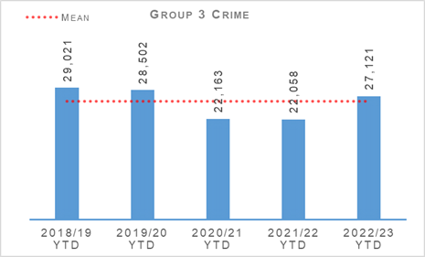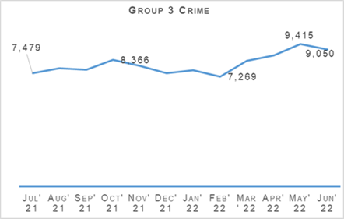
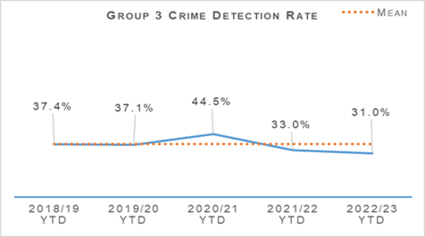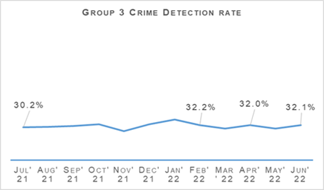
Acquisitive crime has increased significantly compared to the same period last year but remains similar to the five year mean. Between April and June 2022 there has been 5,063 more crimes compared to the same period the previous year, and 1,060 more than the five year mean.
If fraud is excluded, Group 3 crimes have still risen by 26.2% (4,737 crimes). Common theft and shoplifting crimes have been the main contributors to this increase from the previous year, with common theft increasing by 2,254 crimes and shoplifting by 1,949 crimes.
Despite the overall increase, some aspects of acquisitive crime have continued to fall compared to the same period last year.

Shoplifting
Shoplifting crimes have continued rising to levels closer than those seen pre-pandemic. Between April and June 2022 there has been 7,400 crimes, 35.8% (1,949 crimes) higher than the same period last year and 7.8% (536 crimes) higher than the five year mean.
This is still 979 crimes lower than during the same period in 2019. This increase is expected to continue as levels are still 11.7% lower than the most recent pre-pandemic year and the rise in this crime type could be accelerated by the current cost of living situation.
Detections over the period have increased from 3,165 to 3,978 compared to the same period last year. Detecting shoplifting crimes has been far more difficult due to offenders wearing face masks and being much harder to identify through standard methods such as CCTV.
This has had an impact in the detection rate. The rate is 53.8%, 4.3 percentage points lower than the same period last year and 12.7 percentage points lower than the five year mean.

Housebreaking
Housebreaking has experienced an increase year to date of 12.7% (244 more crimes) compared to last year. Over the period there has been a total of 2,170 housebreaking crimes. Despite this year to date increase, housebreaking is 28.9% lower than the five year mean of 3,279 crimes and remains lower than levels seen pre-pandemic.
The main increase can be seen in commercial housebreakings, rising from 497 to 648. Non-dwelling domestic housebreakings have also experienced an increase, with 501 crimes between April and June 2022, compared to 397 crimes over the same period last year.
Last year commercial properties were targeted during lockdown as many were closed and largely unattended for long periods of time.
Domestic housebreakings remain slightly lower than the same period last year, decreasing by 1.1% (11 fewer crimes). Between April and June 2022 1,021 domestic housebreaking crimes were recorded, compared to 1,032 crimes last year and the five year mean of 1,485 crimes.
The continued reduction in housebreakings over the last year can be attributed to the restrictions and change in behaviours and lifestyle that has come with COVID-19.
With large numbers of the population continuing to work from home and the increase in ownership of technology such as video doorbells this has meant neighbourhoods have been better guarded, making housebreaking less attractive to criminals.

Vehicle Crime
Between April and June 2022 there has been 3,075 crimes, 22.9% (573 crimes) more than the same period last year. This increase has been due to rises in theft from a motor vehicle (215 more crimes), theft of a motor vehicle (185 more crimes) and opening lockfast place – motor vehicle (146 more crimes).
Detections over the period have increased from 824 to 873 compared to the same period last year which has had an impact in the detection rate. The rate is 28.4%, 4.5 percentage points lower than the same period last year and 0.1 percentage points above the five year mean.
Over the period, an ongoing trend was noted whereby HGVs were being targeted and side curtains slashed to remove contents.
At the end of May 2022 support from the National Vehicle Crime Intelligence Service (NaVCIS) was received and existing advice in booklets and leaflets for foreign freight drivers was shared to preventions teams across Police Scotland.
Additionally joint events were scheduled to be held at specific hard hit service stations to improve awareness of staff, visitors and HGV drivers of the prevention steps to consider, delivered by NaVCIS staff and local policing preventions / community teams.

Rural Crime
The number of rural offences recorded has increase from 155 to 192 compared to the same period last year. The total cost of rural crime for April to June 2022 totalled £1,158,314 with a total of £83,100 recovered, the majority of which relates to stolen agricultural machinery and quad bikes.
This compares to a total reported rural crime figure of £949,845 and a total of £112,550 recovered over the same period last year. This increase highlights the continued criminal interest in more expensive and sophisticated machinery within rural locations.

Fraud
Fraud | 2021/22 YTD | 2022/23 YTD | % Change from Previous Year | 5 Year Mean | % Change from 5 Year Mean
Number of crimes | 4,003 | 4,329 | +8.1% | 2,723.0 | +59.0%
Number of detections | 674 | 777 | +15.3% | 818.8 | -5.1%
Detection rate | 16.8% | 17.9% | +1.1% point | 30.1% | -12.1% point
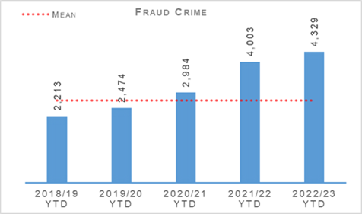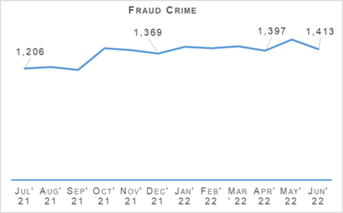
Fraud continues through this quarter to be at a high level across the entire United Kingdom and in line with this trend Scotland has suffered with large numbers of the population falling victims to a variety of frauds including such crimes as investment frauds, romance frauds and social engineering frauds.
The online space continues to be a hot spot for fraudulent activity with around 90-95% of frauds having an online cyber aspect to their commission.
The continued effects of the COVID pandemic and subsequent hybrid working models have meant that people are spending more time working from home and online engaging across a number of businesses and personal platforms.
This increased online activity has allowed fraudsters to intensify their criminal activity in the online space from an even greater arms-length.
Much of the recorded fraud has a cross jurisdictional and often international element to it which provides the criminal with greater anonymity and poses even greater challenges to law enforcement in identifying the culprits and bringing them to justice.
In response to this threat Police Scotland is undertaking work to restructure and refocus the existing financial investigation model to provide a greater victim focused, efficient and effective model and greater strengthen relationships with partner agencies.
This includes aligning and working more closely with the National Crime Agency and the National Economic Crime Centre on the United Kingdom’s strategic fraud response.
Together this contributes to enforcement intensification periods under the auspices of Project Henhouse. This provided funding to support executive action for impersonation fraud, social engineering, human trafficking and drugs operations.
Project Henhouse has seen 18 arrests and the seizure of over £33,000 in designer goods, £20,000 cash, jewellery, electronic devices, drugs, firearms and counterfeit cigarettes.
Operation HATPIN is an investigation targeting organised criminal entities who carry out high value frauds against vulnerable, elderly people.
The methodology used is to engage the victims by telephone purporting to be from the bank fraud department before referring them onto perpetrators who present as police officers carrying out an investigation in response to bank concerns.
Investigation of this crime series has identified 75 separate incidents across all 13 Divisions with financial losses identified of over £1.4m. A range of investigative strategies were deployed leading to the arrest of six key individuals.
Investigation has now identified 76 beneficiary accounts with criminal funds transferred into Bitcoin and Ethereum Crypto Currencies.
A strategy is being developed through Digital Forensics to seize the currencies estimated to be around £500,000. This will be a test case and papers are being prepared for the Crown Office and Procurator Fiscal Services (COPFS).
The coercion, coupled with police officer impersonation has undermined victims’ confidence to make rational, informed decisions and challenged independence. Prevention will continue to be a key element of target hardening. The resource impact has been significant across all divisions with more than 61 officers and staff deployed in various capacities.
Operation HATPIN was presented on 21 June 2022 at the UK Finance Internal Fraud Working Group, (formed by Security Managers of Financial institutions) and it has been agreed that victim data will be shared with respecting institutions to enable retrospective access audits and identify insider threats, thus stopping the flow of enabling data.
This investigation has affected all divisions across Police Scotland, requiring resources and support across Local policing Divisions as well as PPCW, Corporate Communications, Economic Crime Financial Investigation Unit (ECFIU), CYBER Investigations, Digital Forensics and now includes other areas of the United Kingdom.
PPCW and Trading Standards Scotland launched the joint campaign “Shut out Scammers”. The campaign was launched by Police Scotland and Trading Standards Scotland, covering a month for the first time having been a week long campaign in previous years. The campaign ran from 25 April 2022 – 25 May 2022 with each week focusing on recent trends.
Week 1 - Mis-selling of energy efficiency measures.
Week 2 - Doorstep Crime (extensions, kitchens, bathrooms).
Week 3 - Doorstep Crime Cold Calling (roofing, garden work, tarmacking, tree surgery).
Week 4 - Empowering Consumers (just say no, stop take advice, report concerns).

The Banking Protocol
The Banking Protocol is a multi-agency initiative between law enforcement, banking institutions and Trading Standards. Its aim is at the earliest opportunity to identify vulnerable victims who are in the process of being defrauded of funds from their bank accounts by unscrupulous criminals and to intervene to prevent these crimes.
If staff suspect customers are being coerced or the transaction is as a result of fraud, the transaction is stopped and the police are contacted. The Protocol is designed to provide a standardised method for how these concerns are dealt with and reported to police, helping to stop multiple victimisation.
In terms of the reporting year 2022/23, the Banking Protocol recorded 304 incidents accounting for circa £1.28 million worth of fraud being prevented in the first quarter.
Police Scotland continue to be a key partner on the Fraud Strategic Governance Group. This group, involving police, partners (including third sector) and the Scottish Government has been set up to understand and direct activity at a strategic level to combat the threats posed by the increases in fraud.
The group continues to provide a coordinated public awareness raising initiative to prevent fraud from being committed and also ensure appropriate governance around a consistent and joined up strategy across agencies and organisations is undertaken.
Engagement in these groups continues to ensure that fraud investigation is undertaken from a multi-disciplinary perspective and recognises the vital contribution that each partner can play in tackling fraud.

Detection Rates
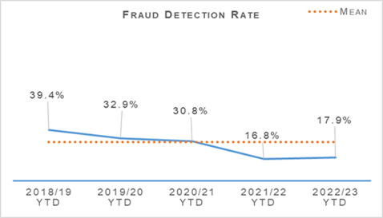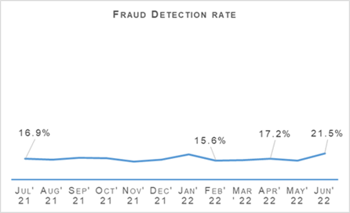
The fraud detection rate currently stands at 17.9%, up 1.1 percentage points on last year but 12.1 percentage points lower than the five year mean. This increase has been driven by an increase in detections compared to last year, with 777 crimes detected between April and June 2022 compared to 674 last year.
This is 15.3% (103 more detections) than the same period last year and 5.1% (41 fewer detections) than the five year mean. This is an issue seen across UK forces due to how quickly the cyber-enabled element of fraud is evolving.

Police Custody

Criminal Justice
Criminal Justice | 2021/22 YTD | 2022/23 YTD | % Change from Previous Year
Volume of cases submitted into Criminal Justice System | 35,358 | 32,708 | -7.5%
In line with reduced crime rates and slightly reduced detection rates, there is a consistent national downward trend in reported cases. The effective use of Direct Measures and Alternatives to Prosecution could be contributing factors, the full extent of this is unclear in the context of the wider pandemic.

Arrested Persons
Arrested Persons brought into Custody | 2021/22 YTD | 2022/23 YTD | % Change from Previous Year
Number of times arrested persons brought into custody | 24,290 | 24,626 | +1.4%
Note: It is important to note that the number of arrested persons includes individuals who have appeared in custody on more than one occasion within the reporting period. This excludes voluntary attendance, S.23 MDA 1971 detentions and those in transit.
Custody throughput, having decreased steadily year on year, may be starting to show signs of levelling off as we emerge from the coronavirus pandemic. A slight increase is seen in the first quarter of 2022/23 which is the first recorded in recent years.
Arrested Persons Held for Court | 2021/22 YTD | 2022/23 YTD | % Change from Previous Year
Number of arrested persons held for court | 8,451 | 10,018 | +18.5%
Proportion of arrested persons held for court | 35.1% | 40.7% | +5.6% point
Number of arrested persons held for court in relation to a new case | 6,505 | 6,886 | +5.9%
Proportion of arrested persons held for court in relation to a new case | 29.4% | 32.0% | +2.6% point
Those presented at court from custody showed a 5.6 percentage point increase to 40.7% of throughput in Quarter 1 compared to 35.1% in 2021 at the height of the pandemic. This has been impacted considerably by the numbers being arrested on warrant issued and then executed as the pandemic recedes.
This will be monitored closely in the coming months to establish whether this is an increasing or continuing trend however, it is worth considering that this is still down significantly on the percentage to court pre-pandemic which generally fluctuated around 50-52%.
The Audit and Compliance Sergeants (ACS) are now fully embedded and are averaging circa 200 full, end-to-end custody records audits per week.
This represents just over 10% of all custody records (total throughput) from the time they took up post and introduces a previously unprecedented level of quality assurance which also includes disposals. In Quarter 1, the changed disposal rate by the ACS is just less than 2% and this incorporates 2,443 full custody record audits.
Arrested Persons Released / Re-arrested | 2021/22 YTD | 2022/23 YTD | % Change from Previous Year
Number of persons on electronic bail | n/a | 60 | n/a
Number of arrested persons released on an undertaking | 6,570 | 5,761 | -12.3%
Proportion of arrested persons released on an undertaking | 27.1% | 23.4% | -3.7% point
Proportion of persons released on investigative liberation | 0.6% | 0.6% | no change
Number of persons re-arrested | 127 | 171 | +34.6%
Note1: The term ‘re-arrested’ is defined as any occasion whereby a person, previously released without charge as a ‘Not-Officially Accused’ person, is subsequently re-arrested for the same offence due to the presence of further evidence. This is not to be confused with a person arrested more than once within a specified period on separate charges as defined by recidivism.
Note2: Electronic Bail was introduced May 2022, therefore figures for year 2021/22 are not available.
Undertakings have seen a noticeable decrease in Quarter 1 this could be linked to the increases in the number of persons held for court, shown above. Although there is a decrease of 12.3% the percentage decrease as a proportion of throughput is more modest at 3.7%.
Use of investigative liberation may be impacted going forward by a recent well-publicised staff communications drive on the use / benefits of investigative liberation related to investigations.
The increase in the number of persons re-arrested may be partially explained as a result of staff using the powers afforded by the Criminal Justice (Scotland) Act more effectively following increased guidance and communications about how and when powers can be used most effectively. Re-arrest can increase investigative opportunities and should be viewed in this context.
Children brought into Police Custody / Held for Court | 2021/22 YTD | 2022/23 YTD | % Change from Previous Year
Number of Younger Children Arrested and Accepted into Police Custody (not held overnight) | 317 | 354 | +11.7%
Number of younger children arrested and held overnight | 40 | 61 | +52.5%
Number of younger children held over 24 hours | 14 | 10 | -28.6%
Number of Older Children Arrested and Accepted into Police Custody (not held overnight) | 469 | 429 | -8.5%
Number of Older Children Arrested and Held Overnight | 106 | 134 | +26.4%
Number of Older Children Held Over 24 hours | 59 | 58 | -1.7%
Definitions for clarity: Adult being defined as 18 or over; Older Child being defined as 16/17 and Not under Supervision; Younger Child being defined as Under 16 or 16/17 but subject to a Compulsory Supervision Order. The number listed as held over 24 hours are those who were held in a police cell and had a relevant certificate in terms of S.22 of the Criminal Justice (Scotland) Act 2016 issued indicating why they were so held and not at a place of safety. **Overnight is determined as the period of time spent in custody which exceeds four hours and includes the period between 0000 and 0400 hours.
The definition of children in this context is a complex one but includes those aged 18 and under in particular circumstances described above.
Police Scotland has no desire to hold children in our care and custody and only does so where there is no other alternative Place of Safety available.
Only in the most serious of cases and where there is no other appropriate Place of Safety will a child be held in police custody overnight / over 24 hours.
On every occasion we work with our partners in the local authority to identify any other suitable alternatives. Where these cannot be provided it is sometimes necessary to keep children in our care and custody.
Police Scotland is working with the Scottish Police Authority and partners to ensure that there is an appropriate provision of alternatives to custody available across Scotland and this work is ongoing at present.
We have seen a noteworthy increase in the number of younger children (and those on supervision) being brought into custody and held overnight and work is ongoing to identify the reasons for this. The numbers remain small however and it means that any rise or fall is reflected as a dramatic one.
The number of older children held overnight is also up by 26.4%. At present Audit and Compliance Sergeants are engaged in an in-depth analysis of National Custody System records for both younger and older children brought into custody aimed at accurately recording and presenting the complex reasons for this.
This work is scheduled to conclude by the end of Quarter 2 at which point it is intended to inform ongoing discussions with the Scottish Police Authority and other Justice partners.
The number of older children brought to custody is down 8.5% and there are decreases for both younger and older children in terms of the numbers of children held longer than 24 hours.
These trends are in keeping with CJSD and broader Justice Sector aims to reduce the numbers of children coming into and being detained in custody and indicates improved compliance with the children's rights principles outlined within United Nations Convention on the Rights of the Child (UNCRC).

Police Direct Measures
Police Direct Measures | 2021/22 YTD | 2022/23 YTD | % Change from Previous Year
Number of ASB Fixed Penalties issued | 5,048 | 1,484 | -70.6%
Number of Conditional Offer Fixed Penalty (Endorsable and Non Endorsable) Notices issued | n/a | 9,689 | n/a
Number of Recorded Police Warnings issued | 5,461 | 5,333 | -2.3%
Note: Number of Conditional Offer Fixed Penalty (Endorsable and Non Endorsable) Notices issued for year 2021/22 are not available at present.
A significant proportion of the Fixed Penalties issued in 2021/22 relate to the Health Protection (Coronavirus) (Restrictions) (Scotland) Regulations 2020.
The decrease in the number of ASB Fixed Penalty Tickets issued will be as a direct result in the easing of these restrictions which no longer create an offence for certain activities previously subject to such penalties.

Vulnerability
Vulnerability | 2021/22 YTD | 2022/23 YTD | % Change from Previous Year
Number of persons arrested who have declared current or historic alcohol addiction issues | 2,694 | 2,897 | +7.5%
Proportion of persons arrested who have declared current or historic alcohol addiction issues | 11.1% | 11.8% | +0.7% point
Number of persons arrested who have declared current or historic drug addiction issues | 3,836 | 3,837 | +0.03%
Proportion of persons arrested who have declared current or historic drug addiction issues | 15.8% | 15.6% | -0.2% point
Number of persons arrested who have declared current or historic Mental Health issues | 10,151 | 10,298 | +1.5%
Proportion of persons arrested who have declared current or historic Mental Health issues | 41.8% | 41.8% | no change
Please note, each custody may have reported "yes" to each of the above categories.
There is a small increase of 7.5% rise in persons declaring current or historic alcohol issues and a slight rise of 1.5% in those declaring Mental Health Issues. Broadly the proportions are relatively unchanged and have remained significantly so in previous quarters of past years.
NHS Partners in Custody Centres | 2021/22 YTD | 2022/23 YTD | % Change from Previous Year
Number of people in custody seen by NHS partners in custody centres | 1,661 | 1,735 | +4.5%
Note: Figures provided represent the numbers marked out of cell for medical assessment (excluding those to hospital). They do not include those individuals who are subject to several medical assessments as is often the case during longer periods in custody.
Within the past year there has been a drive to make optimal use of Healthcare Professionals (HCPs) for healthcare and welfare decision making and risk assessment. This may have contributed to the rise, however, it is an area which is difficult to interpret owing to the complex nature of the healthcare needs of those in custody.
The increase may also be indicative of a shift back towards pre-pandemic levels of face to face assessments or alternatively a new status quo. It is assessed as likely that it is too early and too complex a picture to draw reliable inference from the data at this stage.
We are committed to ensuring the safety and wellbeing of those in our care and custody. However, it is important to recognise that many of these people are vulnerable and have complex needs. As such, we work closely with healthcare professionals to provide an appropriate level of care based on an assessment of these needs and risks.
Police Scotland has highlighted that despite our national approach to police custody, the healthcare provision is supplied by 14 Health Boards, each of whom provide Police Scotland with differing levels of service or delivery methods.
We welcome the ongoing inspection by Her Majesty’s Inspectorate of Constabulary Scotland and Healthcare Improvement Scotland who will consider the provision available across Scotland and make appropriate recommendations.
Partner Referrals | 2021/22 YTD | 2022/23 YTD | % Change from Previous Year
Number of arrested persons referred to partners | 386 | 371 | -3.9%
As in previous quarters there is still much work being undertaken to increase the availability of access to support services in all four areas of the Harm Reduction Strategy after release from custody.
This includes both increasing the number and range of services working with Police Scotland, but also a greater focus on and scrutiny of the arrest referral service internally.
Criminal Justice Services Division’s Healthcare and Interventions Team continue to seek to broaden the referral processes to additional third sector partners where suitable, to ensure that those arriving in custody with alcohol, drugs or mental health issues have access to a range of meaningful support.
There has been a 3.9% decrease in referrals which equates to 15 across the entire country. Two service providers have withdrawn support: in Tayside, Apex lost funding and Tomorrow’s Women based in Glasgow have encountered significant challenges related to information assurance and sharing.
These services previously reported 31 referrals in Quarter 1 2021/22 and so this more than accounts for the decrease observed. Work continues to promote the Arrest Referral scheme across the country.

Productions
Productions | 2021/22 YTD | 2022/23 YTD | % Change from Previous Year
Total number of productions received | 162,336 | 154,384 | -4.9%
Total number of productions disposed | 80,036 | 70,478 | -11.9%
Total number of productions accumulated | 82,300 | 83,906 | +2.0%
% of productions accumulated in terms of total received | 50.7% | 55.0% | +4.3% point
The Quarter 1 2022/23 disposal rate is down compared to previous years however this has been impacted by reduced staffing owing to COVID-19 related absences within Productions Stores. This is something which is forecast to improve as the year continues.

Criminal Justice Recovery
As part of the Justice Recovery Programme, the Scottish Government is providing necessary targeted resources towards courts, Crown Office and Procurator Fiscal Service (COPFS), Police and Community Justice to support the recovery programme.
The Scottish Government and Justice Partners have a number of existing commitments which will help deliver against the new Vision for Justice as detailed in the Programme for Government.
Action to deliver these commitments will span several years. The year one delivery plan highlights the actions being taken forward in 2022/23 to help deliver the aims of the new Vision for Justice.
There will be an opportunity to review this one-year plan with our third sector partners, local authority partners and wider public sector in the subsequent development of a 3-year delivery plan.
This 3-year plan will seek to set the short, medium and long term actions required to accomplish the new Vision for Justice Plan. The work to develop this will be undertaken over the coming months.
A number of work streams under “Recover, Renew, and Transform” are focusing on supporting Criminal Justice recovery:

Summary Justice Reform – Evidence and Procedural Review (EPR)
Work on the Summary Case Management Pilot has been continuing with weekly working group meetings with Scottish Courts and Tribunals Service (SCTS) and COPFS.
Stemming from this, we have now established full end to end process maps along with participation from relevant partners. Consultation has been undertaken with all internal and external stakeholders seeking views and opinions on the planned processes.
Local Implementation Teams have been created and are being led by a local Sheriff. Digital Editing suites will be situated in each of the pilot areas to assist with key productions.
The Go-live date has been delayed until a review can be carried out in September 2022. This is in response to a delay in the legislative provision for Scottish Legal Assistance Board (SLAB) payments to Defence Agents.

Witness Availability and Citations
A new court scheduler is being proposed, with a full service request submitted to ICT for its development. This scheduling tool will integrate with COPFS and SCTS IT enabling the most appropriate date for a trial to be set. This will hopefully help ensure all police witnesses can be accommodated.
After an initial visit to Glasgow Ballater Street, it was established that it will take an officer managing the court scheduler approximately six to eight minutes to identify and select the optimal date for a trial.
Taking this into consideration and factoring in that there are hundreds of trials per day in all courts, this data gathering process is both time and labour intensive.
There has also been work undertaken to assess what Local Policing (LP) Divisions have done / are doing to try and minimise the level of abstractions experienced at the front line.
This exercise has resulted in a communication being sent out to local policing divisions highlighting good practice. Engagement with COPFS in areas where success has been achieved has begun to map out the process, also highlighting good practice with COPFS staff in these areas.
This has additional benefits through good practice solutions being circulated to other COPFS offices to establish if similar localised working successes can be achieved.

Remote Provision of Witness Evidence (RPWE)
This business area is continuing to be developed with a view that the current model will be evaluated prior to being proposed for business as usual. Lords’ Matthews and Beckett requested that the project was extended for a further two months (August 2022).
Both are keen supporters of the project and advocates of potential wellbeing and savings to police and expert witnesses that do not have to travel to court. Officer / witness wellbeing and finance are key elements in this area and feature highly on the agenda.
A number of workshops have been held with divisional management and SPOCS which included partners from COPFS. The workshops were well received and generated a lot of constructive feedback. In the main RPWE is being well received throughout the force area.
To date there has been 416 trials scheduled with a total of 5,318 Police witnesses cited with 434 giving evidence in person and 154 witnesses successfully giving evidence remotely. Therefore only 11.1% of those cited gave evidence.
At present there are 45 Evidence Giving Rooms in operation across the Service area. There are still a number of occasions officers are being asked to attend in person and the working group is working through each scenario as it arises to minimise these requests.

Strategic Outcome: The public, communities and partners are engaged, involved and have confidence in policing
Police Scotland’s objectives are to:
- Embed the ethical and privacy considerations that are integral to policing and protection into every aspect of the service
- Protect the public and promote wellbeing across Scotland by providing services that are relevant, accessible and effective
- Work with local groups and public, third and private sector organisations to support our communities

Public Confidence and Satisfaction
Insight into Police Scotland’s approach to addressing public confidence and the importance the organisation places on this key aspect of policing and community engagement is detailed in the Public Confidence and Experience of Policing section at the beginning of this report.
The following table provides the survey results that have been identified by Police Scotland and the Scottish Police Authority as key measures of progress towards achieving this strategic outcome.
Public Opinion Statements | Quarter 1 2021/22 | Quarter 2 2021/22 | Quarter 3 2021/22 | Quarter 4 2021/22 | Quarter 1 2022/23
Feel either ‘very safe’ or ‘fairly safe’ in their area | 80% | 73% | 72% | 84% | 79%
Strongly agree or agree that the police listen to concerns of local people | 33% | 29% | 36% | 29% | 31%
Note: Confidence refers to how those who may not have directly engaged with the organisation feel about Police Scotland. This is intended to reflect public mood and sentiment towards the organisation.

User Experience – Equality Outcome 2 | Quarter 1 2021/22 | Quarter 2 2021/22 | Quarter 3 2021/22 | Quarter 4 2021/22 | Quarter 1 2022/23 | Change from last Quarter
Percentage callers saying it was easy or very easy to contact the police | 75% | 67% | 75% | 76% | 72% | -4% point
Percentage callers satisfied or very satisfied with the way they were treated by staff member during initial contact | 85% | 82% | 86% | 87% | 84% | -3% point
Percentage callers who felt staff properly understood what they needed | 86% | 84% | 87% | 89% | 86% | -3% point
Percentage callers feeling that the police provided the appropriate response | 66% | 62% | 65% | 68% | 62% | -6% point
Percentage callers felt satisfied with the way they were treated by the officers who attended the incident (where applicable) | 81% | 78% | 80% | 83% | 81% | -2% point
Percentage callers felt they were adequately informed about the progress made (where applicable) | 59% | 55% | 60% | 63% | 47% | -16% point
Based on overall experience, percentage callers satisfied or very satisfied with Police Scotland | 68% | 64% | 68% | 70% | 67% | -3% point
Note1: Satisfaction refers to those who have contacted the police. This reflects on the organisation’s ability to handle individual incidents for an effective outcome for people, the police service and communities.
Note2: From April 2022, a new question has been added to the survey.
Before question 6A within the survey is asked (about whether respondents feel they have been adequately informed about progress), respondents now answer a ‘screener question’ which asks “Did you expect to receive an update on the incident you contacted police about?”
If respondents answer ‘yes’ they are asked if they feel they had been adequately informed. If ‘no’ they are skipped on to the next question.
This means that people who did not expect to receive a response to the issue they made contact with police about are now excluded. It is hoped this will provide a more accurate representation within reporting over future Quarters

Quarterly Comparison
Since April 2020 measures of satisfaction with Police Scotland have remained consistently high. The change of survey methodology (from phone interviews to text in April 2020 due to the pandemic) resulted in changes in the data.
It’s important to note that these data changes do not always indicate a trend; overall satisfaction has remained between 64%-73% in each Quarter over the past two years.
The number of respondents in Quarter 1 2022/23, who ‘agree’ or ‘strongly agree’ that the police listen to concerns of local people was 31%, an increase of 2% compared to the previous quarter (29%).
There has been a decrease in the number of respondents reporting it is ‘easy’ or ‘very easy’ to contact Police Scotland (72%) compared to Quarter 4 2021/22 (76%). This decrease is also reflected in levels of overall satisfaction, which saw a decrease of three percentage points (67%) compared to the previous quarter (70%).
To understand the reasons for initial contact being easy or difficult, an open-ended survey question was introduced to the local policing User Experience Survey in September 2021. 3,675 responses were received to this additional question in Quarter 1.
Among respondents who found it easy to contact police (n=2,680), qualitative analysis of responses has highlighted the following as reasons why contact was easy:
Service Accessibility. 63% (n=1,692) of respondents highlighted fast 101 / 999 answer times and praised the phone system, with its automated menus, for being easy to navigate. Responses also mentioned the ease of being able to report incidents online.
Effective Communication. 22% (n=393) of respondents praised service advisers for their ability to be helpful under pressure, whilst also helping keep the caller calm, providing advice and making them feel safe.
Police Presence. 11% (n= 289) of respondents mentioned appreciating officers attending incidents in a timely response which they perceive to be appropriate. Responses also mentioned attending officers being attentive and helpful.
Among respondents who found it difficult to contact police (n=612), qualitative analysis of responses has highlighted the following as reasons why contact was difficult:
Difficulties with connecting to a service advisor. 73% (n=447) of respondents referred to long waiting times using the 101 service for non-emergency incidents, the inability to connect to staff on their first attempt or giving up calling 999 instead.
Being kept up to date after initial contact. 24% (n=146) of service users highlighted a lack of updates / follow up to their cases to know what was happening, with no call-backs or updates about their reported incident.
Further comments provided by survey respondents highlight the importance of:
Listening to understand needs to provide the appropriate response.
Making access to the police service as easy and intuitive as possible.
The need for multiple ways of online (email, website), virtual (video calling) and in person (easy access to and relationships with local officers) contact with police.
Consistency of service delivery, with a high standard of service from all staff and officers in all parts of Scotland.
Being able to communicate with a call handler who has adequate geographical knowledge of where the incident is being reported.
Being informed and updated on aspects of work that Police Scotland is doing to respond to local areas of concern and reported incidents; highlighting the importance of a continuous engagement with the public.
Ease of contact is a key area of focus in the Public Contact and Engagement Strategy where the introduction of accessible new contact channels and enhancement of how we communicate and engage, will help to improve public experience and confidence in reporting crime and other incidents, enabled by digital services.
For example, key programmes are continuing to ensure people are able to contact police in ways which are most accessible for individuals:
Fully accessible online reporting for getting information and advice, reporting low level crime and other incidents, receiving updates, and sharing evidence.
Investing in the replacement of our national contact platform (UCCP) to sustain contact assessment and call triage and to ensure our technology is a platform for innovation and supportive technologies i.e. ‘next generation 999’ for connecting with mobile technology. Policing of the future in Scotland is expected to use video and text, activated by service advisors for easing emergency contact, in addition to phone contact.
Ensuring the public can reach us using voice assisted technologies e.g. smart home devices and smart watches, in situations where they might not be able to reach a phone to dial 999.

Complaints about the Police
Complaints | 2021/22 YTD | 2022/23 YTD | % Change from Previous Year | 5 Year Mean | % Change from 5 Year Mean
Total number of complaints from members of the public | 1,816 | 1,677 | -7.7% | 1,661 | +1.0%
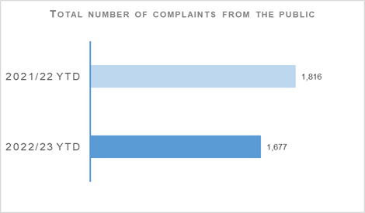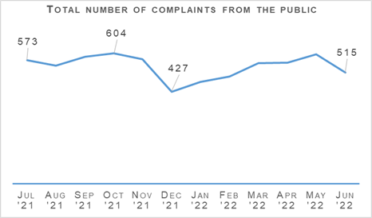
Complaints from members of the public decreased by 7.7% (139 fewer complaints) to 1,677 at the end of Quarter 1 compared to the same period last year but are up 1.0% (16 more complaints) on the five year mean.
The decrease in complaints in Quarter 1 compared to the same period last year is influenced by an elevated level of complaints in 2021/22 linked to Quality of Service related allegations. In particular, Service Outcome allegations, which have decreased notably during this period.
Comparing Quarter 1 figures over the last four years shows complaints are down from the COVID related peaks in the same period in 2021/22 and 2020/21 but remain at a relatively high level compared to the pre-COVID period in Quarter 1 2019/20 where 1,465 complaints were recorded.
The volume of complaints recorded does however indicate that we are beginning to see a levelling out to a different type of normality. With the force strength figures going down and the potential for COVID absences to spike at any time, resourcing challenges may continue to have a residual impact of the volume of complaints against police in the coming months.
The professional Standards Department (PSD) has resolved 728 complaints (43.4%) by Frontline Resolution (FLR) during the year to date 2022/23, compared with 45.0% in the same period last year. This includes early resolution and subsequent resolution by PSD/Specialist officers.
Due to the launch of a new complaint handling model on 03 May 2021, FLR rates cannot be directly compared to data prior to this date. This is due to the provision of additional complaint categories which will provide PSD with more detailed analysis and understanding of the overall complaint handling process.
Allegations | 2021/22 YTD | 2022/23 YTD | % Change from Previous Year | 5 Year Mean | % Change from 5 Year Mean
Total number of allegations from members of the public | 3,305 | 2,486 | -24.8% | 2,867 | -13.3%
% of closed allegations which were upheld | 7.1% | 6.1% | -1.0% point | 9.1% | -3.0% point
Note: A complaint case may include multiple allegations. A ‘Complaint’ relates to the overall expression of dissatisfaction provided by the complainer about an act or omission by the police or Quality of Service received. Allegations are the component parts of a complaint, which categorise what has happened and are separated to those capable of being independently Upheld or Not Upheld
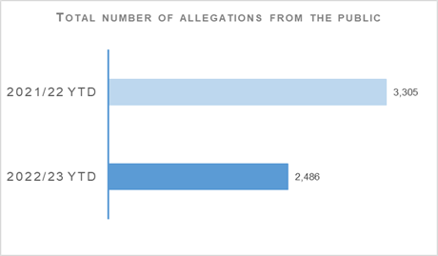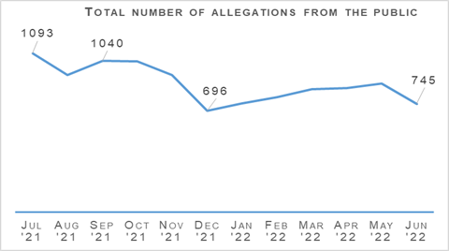
The total number of allegations has decreased by 24.8% (819 fewer allegations) compared to the same period last year, with 2,486 allegations recorded at the end of Quarter 1 2022/23. The number of allegations is also down 13.3% (381 fewer allegations) when compared to the five year mean.
Allegations closed totalled 2,692 at the end of Quarter 1 with 6.1% of these being upheld. Allegation outcomes (e.g. upheld) are based on closed allegations within the year to date period. Closure dates vary from the received dates, therefore closed and received data may not be directly comparable.
During this period, there were 1,118 non-criminal and Frontline Resolved (FLR) complaints closed with 70.8% closed within the 56 day statutory timescale. This is a 0.2 percentage point increase from the same period in 2021/22.
FLR complaints are now included in this measure to better reflect the overall demand in complaint handling. Moreover, this further reflects the key aim of frontline resolution in providing an informed response within a shorter timescale, whilst also enabling an amicable conclusion for both complainers and subject officers.
Police Investigations and Review Commissioner (PIRC) | 2021/22 YTD | 2022/23 YTD | % Change from Previous Year | 5 Year Mean | % Change from 5 Year Mean
Number of PIRC Complaint Handling Reviews (CHRs) | 66 | 46 | -30.3% | n/a | n/a
Number of allegations considered by PIRC (CHRs) | 256 | 197 | -23.0% | n/a | n/a
% of reviewed allegations assessed as handled to a reasonable standard | 65.2% | 76.6% | +11.4% point | n/a | n/a
Number of On Duty Assault cases referred to PIRC | n/a | 82 | n/a | n/a | n/a
% of these cases subject to PIRC investigations | n/a | 26.8% | n/a | n/a | n/a
Note: Allegations of On Duty Assault – plus any associated criminal allegations have been referred to the PIRC since 04 October 2021. As such, Police Scotland are currently unable to make any comparisons to the previous YTD.
In total, 82 allegations of On Duty Assault referrals were made to the PIRC during Quarter 1. Of those, 22 are subject to PIRC investigation (26.8%). However, as at 28 July 2022, 36 of these referrals are awaiting a decision from PIRC regarding possible investigation.
The Police Investigations & Review Commissioner (PIRC) submitted 46 Complaint Handling Reviews (CHRs) to Police Scotland for consideration during this period. This equates to 2.7% of all complaints. The 46 CHRs received from PIRC considered 197 allegations, with 151 (76.6%) assessed to have been handled to a reasonable standard. This is an increase of 11.4 percentage points from the same period in 2021/22. These CHRs included 44 recommendations.
Statutory referrals to PIRC facilitate independent and transparent scrutiny in relation to serious incidents involving the police. Police Scotland made 68 referrals to PIRC resulting in 14 investigations (20.6%) during Quarter 1 of this reporting year. This is a decrease of 18.1 percentage points compared to the same period last year. Those referred to PIRC include:
Referrals to PIRC | 2021/22 YTD | 2022/23 YTD | % Change from Previous Year | 5 Year Mean | % Change from 5 Year Mean
Armed Policing Presentation of Firearm | 17 | 26 | +52.9% | n/a | n/a
Crown Directed Inference of Criminality | 10 | 5 | -50.0% | n/a | n/a
Death following Police Contact | 1 | 3 | +200.0% | n/a | n/a
Death in Police Custody | 1 | 1 | No change | n/a | n/a
Serious Injury Following Police Contact | 7 | 6 | -14.3% | n/a | n/a
Serious Injury in Police Custody | 9 | 16 | +77.8% | n/a | n/a
STO Taser Discharged | 17 | 11 | -35.3% | n/a | n/a
Total Referrals to PIRC | 62 | 68 | +9.7% | n/a | n/a
Armed Policing Presentation of Firearm referrals have increased by 52.9% (nine more) when compared to the same period last year. By way of context, the monthly average of Armed Policing Presentation of Firearm referrals during 2021/22 overall was six.
The total registered during April (ten), May (eight) and June (eight) of 2022/23 remain above that monthly average. It is currently assessed that this represents a low volume increase; however, this will continue to be monitored.

Organisational Learning
PSD is committed to promoting a culture of organisational learning. Learning from CHRs and other sources are disseminated through bulletins, individual feedback and is also used to inform training packages. This learning can therefore influence and improve our service.
In Quarter 1 2022/23, PSD has disseminated learning from a variety of incidents with the following learning outcomes of particular note:
In line with PIRC Statutory Guidance, officers should be named in any response letters or their badge numbers referred to unless there is a specific officer safety reason for not doing so.
- The welfare of pets / animals in the care of a person in custody falls to the arresting officers and not to CJSD.
- Ensure compliance with the SCRS guidelines and the Disclosure of Evidence Manual in respect of the submission of exculpatory evidence to COPFS.
- Where the complaint investigation took longer than the 56-day timescale, the final response letter should acknowledge the delay and provide the applicant with an apology.
- The PIRC statutory guidance in relation to utilising the FLR provision will help to ensure that the provision is applied appropriately, thereby increasing public confidence in the complaint handling process.
- Keeping an accurate record of all contact with a complainer will assist in ensuring that a complete audit trail of any decisions made during the complaint enquiry is maintained.

Police Scotland National Volunteer Week
The first week of June 2022 was National Volunteers’ Week, a time to recognise and thank our Police Scotland volunteers who provide public service in local communities across the country and bring additional experience, skills and local knowledge to the policing family.

Special Constables
During the course of the week, Special Constables engaged in over 2,000 hours of deployments, supporting policing in local communities across Scotland.
Many Special Constables attended one of our bi-monthly Continuous Professional Development events, where training was delivered by the National Missing Persons Unit. This training demonstrated the use and navigation of the National Missing Persons Application along with sharing of good practice.
The national Special Constables’ Conference took place at the Police Scotland Headquarters in Tulliallan during May 2022. The Chief Constable thanked and acknowledged the contribution of our Special Constables especially in response to the COVID-19 pandemic where they collectively were deployed for over 162,000 hours.
The conference, attended by over 120 Special Constables, provided learning through a number of workshops and through sharing ideas and good practice.
During the weekend, a number of our Special Constables successfully completed their basic Police Driving Authorisation, which will enable them to provide additional support within their local communities.

Police Scotland Youth Volunteers (PSYV)
Volunteers’ Week also gave an opportunity to highlight the work of our Police Scotland Youth Volunteers (PSYV), who for the first quarter of the reporting year have attended 103 events and campaigns across the country. This involved engaging with the public and delivering crime prevention advice to local communities to help keep people safe.
PSYV supported campaigns from Police Scotland’s National Safer Communities including the following:
Proxy Purchase Campaign - IT WILL COST YOU! - Working with the Community Alcohol Partnership Team, this campaign focused around the proxy buying of alcohol for young people.
- Shut Out Scammers Campaign - A joint initiative with Trading Standards to help tackle doorstep and bogus worker offences. The PSYV groups supported local Community Police Teams on these campaigns by distributing leaflets and literature in communities.
In June 2022, a Young Drivers Event was held at Tulliallan with PSYV groups attending from all over Scotland. The event was held in conjunction with Road Policing, the Scottish Fire and Rescue Service (SFRS) and the Volunteer Coordination Unit.
Students learned about the legislation and processes governing and keeping drivers’ safe on the road and the dangers of peer pressure, encouraging them to speak up.
The Scottish Fire and Rescue Service ran a practical input with young volunteers assisting with scene assessment and protection and abstraction of a crash dummy from the car using body boards.
Through empowering the young people with information, it allows them to make informed decisions when starting their driving careers and ultimately helps keep people safe on our roads.

Strategic Outcome: Our people are supported through a positive working environment, enabling them to serve the public
Police Scotland’s objectives are to:
- Prioritise wellbeing and keep our people safe, well equipped and protected
- Support our people to be confident leaders, innovative, active contributors and influencers
- Support our people to identify with and demonstrate Police Scotland values and have a strong sense of belonging

Assaults on Police Officers and Police Staff
Assaults on Emergency Workers (Police Officer/Staff) | 2021/22 YTD | 2022/23 YTD | % Change from Previous Year | 5 Year Mean | % Change from 5 Year Mean
Assault of emergency workers (police officer/police staff) - number of offences | 1,825 | 1,788 | -2.0% | 1,719 | +4.0%
Percentage of assaults leading to injury | 37.3% | 26.6% | -10.7% point | 40.1%  (3 year mean) | -13.5% point
Number of assault RIDDORS | 15 | 12 | -20.0% | 10.7  (3 year mean) | +12.1%
Number of assault RIDDORS per 1k employment | 0.7 | 0.6 | -14.3% | n/a | n/a
Note1: The figures for crime incidents and injuries to officers / staff are obtained from two separate systems / databases and do not directly correlate, but that are representative of the issue.
Note2: Prior to 21 March 2021 Highland and Islands Division data only includes detected assaults.
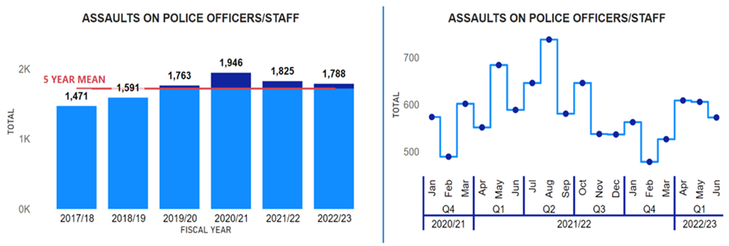
Assaults against officers / staff have continued to decrease in Quarter 1 for the second consecutive year, with assaults in 2022/23 falling by 2.0% (37 fewer) from the previous year. However, assaults against officers / staff have increased from the five year mean by 4.0% (68.8 more).
Importantly, the injury rate of assaults this year (26.6%) has decreased compared to the previous year (37.3%, down 10.7 percentage points) and the three year average (40.1%, down 13.5 percentage points).
Therefore, not only are the number of assaults falling but the percentage that are resulting in an injury are also decreasing. Police Scotland through Your Safety Matters has continued to put resource into.
Encouraging reporting
- Enriched dataset
- Increased analysis
- Data accessibility (via the Powerbi Dashboard suite)
- OST Training
All of this has been a contributory factor in the decrease in the number of assaults on officers / staff and the decreased injury.
However, as Police Scotland has put a lot of resource into encouraging reporting that has seen the reporting rate of assaults to Health and Safety increase by 19.9 percentage points from the previous year to 71.7%. As a result the decrease in the injury rate could also be a result of the increase in reporting rate.
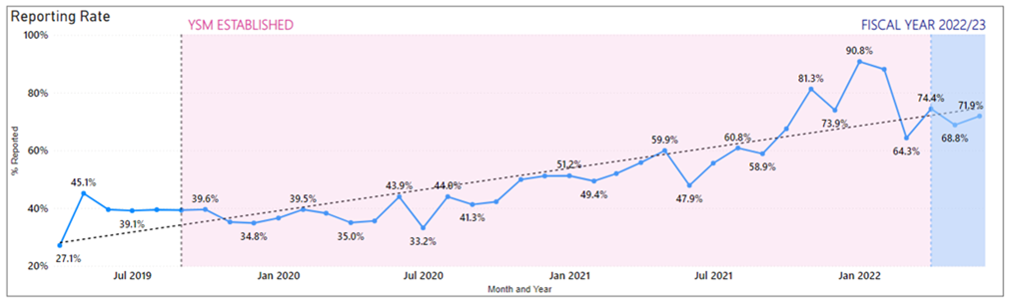
Police Scotland has maintained a high reporting rate in both Health and Safety and crimes of assault on officers/ staff in 2022/23, with every month having around a 70% reporting rate. The improvement in the reporting can be seen from the previous graph, as before YSM was established the highest reporting rate of assaults was below 50% (May 2019, 45.1%).
YSM is committed to maintaining a high reporting rate as this provides an enriched dataset for Police Scotland to analyse, which has enabled YSM to better understand assaults on officers / staff. YSM is also committed to expediting support given to officers/staff who have experienced hate crime.
Work is currently underway to engage with staff associations to encourage reporting of hate crime by officers / staff and ensure they get the support that is required.

Identify and Support Repeat Victims – Best Practice Benchmark
YSM has been engaging with the Operation HAMPSHIRE peer knowledge group in England and Wales around the importance of identifying and supporting repeat victims. All police forces have encountered similar issues with regards to data collection and identifying repeat victims.
A number of forces have developed new IT systems which record assaults on officers and staff with built in triggers to identify repeat victims and send a support package. Through engagement with the Operation HAMPSHIRE group it was deemed that having an automatic trigger to identify repeat victims and send them a support package was best practice.
In 2022/23, the YSM Diamond Group approved this approach as best practice and work is currently underway to build an automatic trigger function within Police Scotland’s IT system to identify and provide support to officers / staff who have been repeat victims of assault.

People and Development

Absence Management
Absence Management | 2021/22 YTD | 2022/23 YTD | % Change from Previous Year
Percentage of working days lost for police officers | 5.8% | 7.7% | +1.9% point
Percentage of working days lost for police staff | 6.4% | 7.8% | +1.4% point
Average working days lost for police officers (Annualised)* | 11.6 | 15.6 | +4.0
Average working days lost for police staff (Annualised)* | 15.6 | 18.8 | +3.2
Percentage of work days lost due to Psychological Disorders for police officers | 1.1% | 1.6% | +0.5% point
Percentage of work days lost due to Psychological Disorders for police staff | 1.7% | 1.7% | no change
Percentage of work days lost due to COVID Related respiratory conditions for police officers | 1.5% | 2.0% | +0.5% point
Percentage of work days lost due to Non-COVID Related respiratory conditions for police officers | 0.2% | 0.5% | +0.3% point
Percentage of work days lost due to COVID Related respiratory conditions for police staff | 1.3% | 2.0% | +0.7% point
Percentage of work days lost due to Non-COVID related respiratory conditions for police staff | 0.3% | 0.6% | +0.3% point
Note: Annualised is a projected figure for the year based on 12 months.
Absence data this quarter shows an increase for both officers and staff against the same period last year. The percentage of working days lost at the end of Quarter 1 2022/23 has increased against the same period last year by 1.9% for police officers and 1.4% for police staff.
COVID-related absence accounts for just over a quarter of all officer and staff absence and it can be noted that so far this financial year COVID-19 related absence is greater than the same period last year.
However, COVID-related absence has dropped significantly this quarter in comparison to the position at end of Quarter 4 for both officers and staff. May saw our lowest levels of COVID-related absences in the past 12 months although increases have been recorded in June for both groups.
Non-COVID sickness absence fell in April but has been gradually increasing then for Officers. Staff groups recorded a peak in May but has begun to fall in June.
In terms of non-COVID-19 related absence, the main causes of non-COVID sickness absence are similar across both Officer and Staff groups.
‘Psychological Disorders’ remains the highest cause of sickness absence across both groups this quarter, with a higher percentage of work days lost to this category of illness in the Staff group than in the Officer group.
The absence rate for Psychological Disorders has increased by 0.5% for officers since the same period last year, and has remained stable for staff.
Given the complex nature of psychological illness, Police Scotland is conducting a detailed deep-dive of this issue to more clearly understand what we can do to better support our workforce.
The study will make use of anonymised data held on the organisation’s HR system to provide comprehensive insights and will adopt a case study approach, using a benchmark sample of the absence data available i.e. 40% of recorded absence lasting longer than 28 days over the last three years.
The aim of this study will be to identify absence patterns and trends, where the organisation can look to improve or change to support our people with mental health challenges, particularly if work related (directly or indirectly), analyse key causes and derive insights to enable us to develop an informed improvement plan.
The ambition is then to develop and design our occupational health and wellbeing offering to meet these emerging needs.
More generally, health and wellbeing priorities and an accompanying framework have been developed to encapsulate the emerging priority areas and the shift in focus and approach to proactive health and wellbeing. The framework is driven by our core aim which is to support our people through a positive working environment enabling them to serve the public.
This proactive, preventative and person-centred approach intends to understand and consider what our people are experiencing both inside and outside of work.
Recognising the impact of significant moments on people’s lives and providing ‘fit for purpose’ tools and support which empowers and enables our people to take positive action in relation to their health and wellbeing.
The health and wellbeing evaluation and review has highlighted that a fundamental challenge in relation to health and wellbeing is communication channels within our workforce, and the accessibility of relevant platforms for officers / staff to table health and wellbeing matters.
The Strategic Leadership Board (SLB) has approved the establishment of a Health and Wellbeing Advisory Group to sit under the Wellbeing Governance Board.
The membership will be driven by key internal stakeholders and staff associations who demonstrate a direct commitment to health and wellbeing within their role, act as champions and role models, ultimately supporting us to understand needs and bring about positive change.
The intention of ensuring collective oversight of ongoing health and wellbeing activity and initiatives being undertaken within the organisation, both nationally and locally, and by having improved governance, the Health and Wellbeing Advisory group will be able to.
Ensure that all health and wellbeing activity is aligned with the national health and wellbeing framework and approach and meets the needs of officers and staff.
- Ensure that information and resources are used fairly, transparently and effectively.
- Ensure that any activity has relevant focus and measurable outcomes which actively support the aim and commitments of the health and wellbeing strategy. Avoid duplication of effort and oversee development of joined-up ways of working.
- Assist with the collection of relevant data and information in order to measure progress and monitor effectiveness.
- Encourage sharing of experience and expertise amongst stakeholders.

Your Voice Matters: Integrity and Inclusion – Quantitative Benchmark
The integrity and Inclusion benchmark is measured by ‘workplace incivility’. The scoring of workplace incivility for Police Scotland and England and Wales is scored from one to six, one being extremely low and six being extremely high.
For workplace incivility Police Scotland’s officers scored 2.06, and staff scored 1.98; whereas, England & Wales officers scored: 2.46 and staff scored 2.16. Therefore, officers and staff for Police Scotland and England/Wales have both shown low levels of workplace incivility.
However, while Police Scotland have scored at a slightly lower level than England and Wales, this is a key area of focus for the organisational response through specific activities within our Implementation Plan.
Responding to the survey results is a key organisational priority for Police Scotland and part of the Chief Constable’s Commitments for 2022/23. Therefore, an overarching Implementation Plan has been developed with the objective of delivering tangible and relevant improvement. The ‘behaviour’ theme within the Implementation Plan focuses on:
Relaunching our values with zero tolerance to incivility.
- Providing resources and guidance for line managers on how to create positive environments.
- Equipping our people to plan their career path and be all they can be.

Strategic Outcome: Police Scotland is sustainable, adaptable and prepared for future challenges
Police Scotland’s objectives are to:
- Use innovative approaches to accelerate our capacity and capability for effective service delivery
- Commit to making a positive impact through outstanding environmental sustainability
- Support operational policing through the appropriate digital tools and delivery of best value

Finance

Maintaining a balance budget: Financial monitoring report tracking and forecasting a balanced budget by Year End
The Corporate Finance and People Board monitor financial performance on a monthly basis and the overall financial position is regularly reported to the Scottish Police Authority (SPA) and Scottish Government.
There is also frequent engagement throughout the year to ensure that the accountable officer is aware of the overall financial position and seek their views on how any emerging issues should be dealt with.
The approved budget is reforecast on a quarterly basis to ensure the financial position continues to reflect what is actually happening across the organisation to enable better informed decisions.
The Board approved the 2022/23 budget on 23 March 2022. Despite setting a balanced budget, there are a number of significant challenges facing Police Scotland, including:
Officer and staff pay claims are not affordable.
- Current levels of inflation cannot be managed within the current budget allocation. Although some provision has been included in the 2022/23 revenue budget, inflation is running significantly higher than anticipated. The most significant revenue impact will be seen across utilities, fuel and supplies & services.
- Officer attrition is significantly higher in 2022/23 due to changes in the Police pensions regulations. As well as the operational consequences, this has significant financial implications for the organisation that will require careful management throughout the year.
Capital and reform funding allocations have been proposed as flat cash for 2022/23. When combined with capital receipts, the capital allocation for 2022/23 is £52.6m and reform is £25m.
Challenges faced in securing certain goods and services due to global supply-chain shortages will impact the speed of delivering planned investment. Similar to revenue, given the current impact of inflation, a flat cash settlement for capital and reform represents a real terms reduction in funding which will now pay for significantly less than the previous year.

2022/23 Quarter 1 Forecast
The Quarter 1 net revenue forecast is £2.3m under budget. The main variances are an underspend in police officer pay costs as a result of recent pension changes and an over-recovery of airport income, offset by an increase in police officer overtime costs to support officer strength, unbudgeted legal costs and ongoing inflationary pressures.
This underspend is compensated by a movement in budgeted COVID recovery funding offset by other GiA funding agreed through Autumn Budget Revision (ABR) transfers, resulting in the Quarter 1 forecast break even position remaining in line with budget.
The Quarter 1 capital forecast is £53.7m, £1.1m over the budget position of £52.6m. This is a fully funded overspend primarily compensated by other capital grants receivable (£0.8m) and an increase in capital receipts (£0.3m).
The Quarter 1 reform forecast is £25.0m which is in line with the approved budget.
Additional in-year funding and resource expenditure (revenue and reform) over a certain threshold is subject to approval through the Scottish Government’s AO template process. The purpose of this template is to enable the Accountable Officer to document decision making and set out the relevant approvals required for material spend decisions.
Finance and Procurement are working closely with the business to ensure that material spend decisions are documented as appropriate. However, there is a risk that approval for spend to be incurred may be delayed as part of this process.

Maintaining Financial Sustainability
Financial sustainability has been the primary objective of the medium / long term financial strategies developed since 2016, all of which highlighted the significant funding challenges facing the service.
The Scottish Government’s 2021/22 budget confirmed additional recurring funding for policing which allowed the service to set a balanced budget without the requirement for any workforce reductions.
The balanced budget and the Government’s manifesto commitment to real terms protection formed the basis of the five year financial plan that was approved by the Authority in September 2021.
The Scottish Government’s multi-year Resource Spending Review, published on 31 May 2022, sets out a flat cash settlement for the Police Authority over the remainder of the parliament.
Rising inflation is already reducing the spending power of our capital and revenue budgets, and when considered alongside the expectation for future pay awards, a flat cash settlement represents a real terms reduction for policing. This will have a significant impact on our operational service delivery requiring difficult decisions to be made.
Significant additional investment is required to implement the key investment strategies and transformation programmes, including DDICT, the estates strategy and the transition to 100% electric fleet.
The organisation’s ability to mitigate the operational impact of a flat cash funding settlement is therefore negatively impacted by flat capital and the potential loss / reduction of Reform funding.
The strategic direction following the publication of the resource spending review, along with the capital spending review published in 2021, will form the basis of an updated five year financial plan to be developed in the Autumn 2022.
Development of a robust longer term financial strategy will be prepared in line with the strategic business planning cycle.

Procurement
Procurement | 2021/22 Q4
% of regulated spend undertaken compliantly in line with purchasing policy | 94.5%
Police Scotland report retrospectively on spend compliance as a result of the data requiring to be analysed after the end of each quarter. The figure provided is an analysis of Quarter 4 2021/22. Data for Quarter 1 2022/23 will be available in the 2022/23 Quarter 2 report.

Fleet
Fleet | 2022/23 YTD
% ULEV | 18.0%
Average age | 4.8 years
Average % of vehicle availability | 96.1%
Police Scotland is working towards implementing the move to an Ultra-Low Emission Fleet (ULEV) as part of the Scottish Police Authority (SPA) approved Fleet Strategy. Work is ongoing with the ULEV Board and the Fleet Implementation Group and key stakeholders.
These include internal stakeholders and external agencies such as Transport Scotland, Scottish Fire and Rescue Service, Scottish Ambulance Service and city councils where sharing of resources is possible.
Our fleet is the first blue light fleet in the UK to make that commitment of greening the entire fleet of approximately 3,500 vehicles. The approved Fleet Strategy is to move to fully ULEV by 2030 in line with Scottish Government recommendations.
ULEV vehicles currently make up 18.0% of Police Scotland’s overall fleet at the end of Quarter 1 2022/23. 28% of the ULEV vehicles are unmarked.
Work is ongoing with the roll out of a Police Scotland dedicated charging infrastructure across our estate with a number of large sites completed. This will continue across Scotland from the central belt up to the Highlands and Islands as we move into phase two and three.
Police Scotland has currently ULEV vehicles in stock and on order and are allocated as charging sites are completed. Training is complete for all fleet staff on ULEV vehicle maintenance and repair.
Fleet is continuing to work with Health and Safety, Scottish Police Federation, Driver Training and other key stakeholders to have right vehicle, right place, right time.
The average age of the Police Scotland fleet in Quarter 1 2022/23 is 4.8 years. This will reduce as new vehicles are introduced to the fleet and if the level of capital investment on the fleet is maintained in future years.
Fleet is currently reviewing its Target Operating Model as we move to ULEV as there is a different skill required in ULEV vehicles. As the vehicle becomes the office and technology increases, and with less moving parts in a ULEV more mobile servicing will be the future.
This will ensure our vehicles are replaced in line with the Police Scotland Fleet Strategy to have a fit for purpose modern fleet.

Estates Co-locations / Collaborations
Shared Occupancy | 2022/23 YTD
% footprint of the Estate which is co-located / shared with our partners | 12.2%
Police Scotland has recorded a 2.2% increase in the percentage of the Estate which is co-located/shared with our partners when compared to the position at the end of Quarter 4 in 2021/22.
The increase since last quarter is a combination of a revised validation of our core data and an increase of Police Scotland dedicated estate, e.g. Project Waverly. Over the coming months, we are expecting a slight increase in the co-location percentage as dedicated Police Scotland sites are disposed of either through lease concluding or sale of the asset.
A new measure added for 2022/23 is the percentage footprint of the Estate that is in good or better condition (year-end update).
Sanderson Weatherall LLP were appointed on 13 April 2022 and are working to create an implementation plan for Priority 1 works for the next year and a 10 year Strategic Plan for prioritisation of projects and future investments.
A full update will be provided for this new measure in the 2022/23 Quarter 4 report.

Environmental - Total carbon emissions per m2 of estates
The following figures represent the most up to date total emissions based on data from our utilities bureau service and finance. Quarter 1 2022/23 data is incomplete as we await information being validated and added to our reports. Updated figures will be provided in the 2022/23 Quarter 2 report.
Building Emissions | Quarter 1 2021/22 | Quarter 2 2021/22 | Quarter 3 2021/22 | Quarter 4 2021/22 | Full Year 2021/22
Building emissions  (per tCO2e) | 6,745 | 4,982 | 8,688 | 6,942 | 27,357
Building emissions  (per kg/m2) | 15.8 | 11.66 | 20.3 | 16.2 | n/a

The total building emissions (per tCO23) for the previous reporting year of 2021/22 was 27,357 tCO2e.
Based on a floor area of 426,907m2, the building emissions per kg/m2 was 16.2kg/m2 in Quarter 4 2021/22.
Total Emissions | Quarter 1 2021/22 | Quarter 2 2021/22 | Quarter 3 2021/22 | Quarter 4 2021/22 | Full Year 2021/22
Total emissions  (per tCO2e) | 10,497 | 8,529 | 10,890 | 13,736 | 43,652
Total emissions  (per kg/m2) | 24.5 | 19.97 | 25.4 | 31.1 | n/a
The total emissions (per tCO23) for the previous reporting year of 2021/22 was 43,652 tCO2e.
Based on a floor area of 426,907m2, the total emissions per kg/m2 was 31.1kg/m2 in Quarter 4 2021/22.

Environmental – Reduction in Co2 emissions
Total emissions for 2021/22 were 43,652 tCO2e, compared with 47,004 tCO2e in 2020/21. This represents a reduction of 7.1%, or 3,352 tCO2e compared to the previous year.

